Within this assignment I will aim to evaluate the concepts of entrepreneurship, the entrepreneur and enterprise, taking into account historical and economic theories through a consideration of entrepreneurship within the field of Education in the Middle East. I will also aim to evaluate these theories by applying my own practical experience within the field and most importantly drawing on the first-hand experience of a local educational entrepreneur who I have interviewed for my research.
Personal values
‘You will never be a millionaire being a teacher’… something I have a few times throughout my career. I am proud enough to say I have met my own professional goals and targets thus far, however it goes without saying I am certainly not a millionaire, nor did I intend to be when I qualified as a teacher, it is fair to state that in most cases I chose the wrong profession if my path to inner success was financially motivated. My motivations have without doubt been rooted in wanting the best for the children I teach and the staff that work for me always being true to my belief that it is about them (the children) and not us (the teacher). This being said I am now working within a country that has bred not just educational millionaires but, billionaires.
The rise of Education in the Middle East – A market to exploit.
“The Middle East and North Africa Region (MENA) has taken great strides in education. It has quadrupled the average level of schooling since 1960, halved illiteracy since 1980 and achieved almost complete gender parity for primary education”. In addition to this the a report published by the World Bank also states “Enrolment in the region’s school systems has increased significantly over the past decade to the point where universal primary education has been achieved for girls and boys in most of the MENA countries”. The educational boom in the Middle East can be put down to factors such as economic growth which has led to a rise of Ex Patriates moving to the Middle East over the last 30-40 years. According to go-gulf.ae “As of 31st March 2016, Ex Pats now equate to 48.1% of total population in GCC countries…” With this rise has led to a demand for high quality international school placements supported by the UAE National Agenda which states “Education is a fundamental element for the development of a nation and the best investment in its youth. For that reason, the UAE Vision 2021 National Agenda emphasizes the development of a first-rate education system, which will require a complete transformation of the current education system and teaching methods”. UAE has one of the highest literacy rates (90%) among the developing countries — with an enrollment ratio of approximately 107% for primary education, and approximately 67% for higher education. “The country caters to approximately 33% of its population across various levels of education, and spends approximately 21% of its total government expenditure on education” meaning that from a private investment perspective there are huge amounts of investment potential in the market. This can be linked to the Taxonomy structure posed by Steve Gedeon (Gedeon S, 2010 -What is Entrepreneurship?) with particular reference made to the ‘Where factor’ that states “the environment has a powerful effect on the entrepreneurial process, the resources available and the markets involved”. An entrepreneur with both financial and social incentives can take full advantage of the ‘where factor’ within the Middle East, one for its location and huge capital market but two for its need for better schools in order to grow its future led by its youth. “Overall, the UAE has 601 international schools — second only to China, which has 638” However recent suggestions of a “slowing market” has also put downward pressure on school fees, Last month, Gulf News reported that 22 private schools, out of the eligible 159 in Dubai, chose not to increase fees this academic year. Schools also introduced a raft of fee discounts to attract and retain parents’ loyalty. This shift in the market demonstrates that it is now clear that those who wish to make profit from schools in the Middle East need a clear strategy and vision for success that sets them apart from the chasing pack. With this in mind I draw my attentions to educational entrepreneur Mr. VNP Raj and his company Athena Education whose motivations and recipe for success lie deeply in his religious beliefs and social inspirations. Refreshingly I was surprised, motivated but most importantly inspired by his values, supported the notion of the entrepreneur being driven by the ‘Weberian Framework’ outlined by (Day J, Sydnor S, Jaffe W 2016) who analyze the positions of entrepreneurial values being driven by “passion, integrity and spirituality”.
The Social Entrepreneur
“Why are we here?” (Interview – VNP Raj – October 2017) a question posed back at me from Mr. Raj when asked about his motivations for being an Entrepreneur. “We are here on this earth to contribute, to contribute to society as living being and to ensure we leave a legacy behind that somebody can follow, a legacy that teaches somebody something, giving them an opportunity to learn so that they can teach others” (Interview – VNP Raj – October 2017). Mr. Raj’s statement echoes the notion of entrepreneurial personality types as described by Elizabeth Chell (Chell, E – The Entrepreneurial Personality - 2nd ed. London : Routledge 2008) where she makes reference to the ‘Big Five’model of personality structure stating that “Extraversion is warmth, gregariousness, assertiveness, activity, excitement- seeking, positive emotions”. This supported the notion of the entrepreneur being by nature a positive risk taking individual who is prepared to have total faith in himself the people around him, something again supported by Liang and Dunn (Liang K, Dunn P 2008) when they state “…most researchers agree that optimism implies a general disposition to expect the best in all things”. Mr. Raj both as a person and as a business radiates a belief that all people were born for a reason, he states “every human has the potential to contribute; some may be born into privilege, others into situations beyond their control, meaning that some people have a duty of care to provide for others for the betterment of humanity” (Interview – VNP Raj – October 2017). This is further supported by the work of Day, Sydnor and Jaffe (Day J, Sydnor S, Jaffe W 2016) who indicate “entrepreneurship can be driven by deeply personal motives …and multidimensional mosaics of personal values”.
Motivation – The alleviation of fear to become an innovator
Previously a successful private banker, Mr. Raj’s core entrepreneurial business interests are centered around Education and Healthcare, sectors that would match or be best suited to his ideology or company mission that states “To be one of the leading quality K-12 (Kindergarten to Grade 12) School and Nursery Education providers in the Middle East by building truly exceptional schools which inspire, empower and enlighten students, and enrich the communities that we are part of”No fewer than seven privately funded schools and eight private hospitals give him a significant personal wealth enabling him to fund projects that will enable him to “help create a society that impacts an ever changing world”. Mr. Raj’s vision and ideologies enable him to have a clear view of his bigger picture as explained previously; however his business model and strategy is also deeply rooted in positive thinking, innovation and a total eradication of fear.
The importance of the team and not the individual is something that became a string feature of my discussions with Mr Raj. “The key to being a successful entrepreneur is having a direction, guiding your vision and surrounding yourself with good people”. This concept can be supported by Schumpeter (Schumpeter J, 1947) who in his creative response states “Success or failure has something to do (a) with the quality of personnel available in society”. This then takes me to Mr. Raj’s business model outlined below in Figure 1:
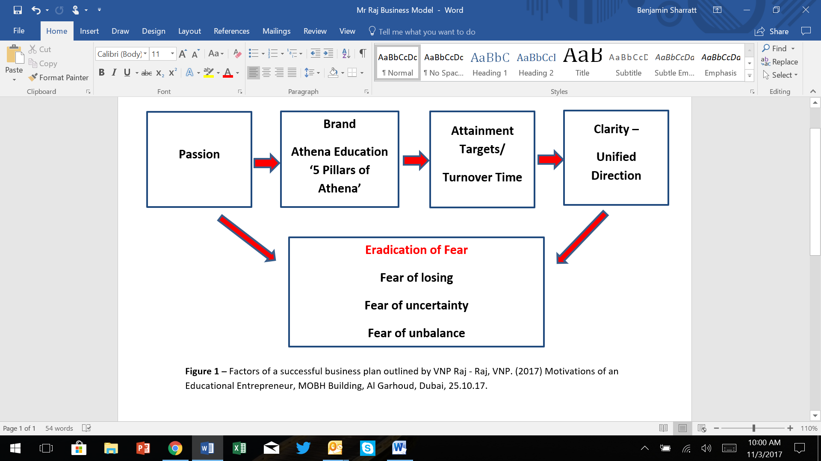

In reference to Figure 1 passion is identified as the first factor attributed by Mr. Raj as a motivator for entrepreneurial success, he states “passion means you never get bored, it provides continuous engagement and commitment to your brand”. The brand consists of the ‘5 Pillars of Athena Education’ consisting of Learning and Skill Development, Creativity, Independence, Home Values and the Alignment to Nature. These pillars again in my opinion speak of a traditionally Weberian view of entrepreneurship where religious and spiritual values guide the path to success. Most poignant to myself however was Mr. Raj’s reference to the total eradication of fear in the process of being a successful entrepreneur, he refers to it as “the get rid factors” this enables him to have complete faith and direction in the brand, a concept which he can then sell to others, gaining potential partners or investors financial trust where he can then focus using the “available means and calculating affordable losses”. Once these factors are in place he can then become the Innovator the person he describes as “the purveyor of positive change making things relevant and real in an ever changing world” This could be linked again to the work of Schumpeter (Schumpeter J, 1947) in his ‘creative response’ meaning that new brands, products in society are characterized by an innovative nature that will eventually overtake or destroy new concepts or ideas, echoed again by Mr. Raj’s comments that “innovators solve problems, they look at what is already out there and make it better”. The idea of the ‘5 Pillars of Athena’ give the impression of a more holistic approach to education, underpinned by the development of skills relevant to a changing world and from my own educational leadership experience it is vital that we are all evolving.
To conclude it was only at the very end of my time with Mr. Raj that having spoken so prominently about his social motivation, his business model and the ‘5 Pillars of Athena’ when he stated “get all of these things right and money will pour in like a funnel”. This was somewhat of a change of attitude, a shift in the dynamic of where the conversation had previously being rooted. Drawing me back to the idea that financial incentives are still a key motivator for any entrepreneur, who in many cases may be seeking economic backing from somebody else, so the financial stakes are still very high. Alleviating fear as outlined by Mr. Raj is yes, a strong psychological mentally to have, however this is a lot more simple if you have a huge amount of capital to start with. Although the moral and social values and beliefs that underpin the mentality, have clearly impacted very positively on this entrepreneur.

References
Astebro T, Holger H, Nanda R, Weber R, Seeking the Roots of Entrepreneurship, Insights from Behavioral Economics, The Journal of Economic Perspectives, Vol 28, No.3, 2014;American Economic Association.
Chell, E – The Entrepreneurial Personality - 2nd ed. London: Routledge 2008.
Day J, Sydnor S, Jaffe W , Examining the motivations of social entrepreneurship using Max Weber’s typology of rationality, International Journal of Contemporary Hospitality Management, Vol.28, No.6, 2016.
Gedeon S, What is Entrepreneurship?, Entrepreneurial practice review, Volume 1, Issue 3, Summer 2010.
Liang K, Dunn P - Are Entrepreneurs optimistic, realistic, both or Fuzzy – Relationship between entrepreneurial traits and entrepreneurial learning – Academy of Entrepreneurship Journal, Volume 14, Number 1, 2008.
Raj, VNP. (2017) Interview – Motivations of an Educational Entrepreneur, Conducted by Benjamin A Sharratt, MOBH Building, Al Garhoud, Dubai, 25.10.17, 18:00pm.
Rich M, Holtham C, New technology in learning; a decades experience in a business school, British Journal of Educational Technology, Vol 36, No.4 2005.
Schumpeter J, A Creative Response in Economic History, The Journal of Economic History, Vol 7, No.2, Nov 1947, Cambridge University Press
Websites/Online Literature
www.athenauae.com
www.go-gulf.ae/blog/expats-middle-east/-31-3-2016
www.indalytics.com/education-sector-in-uae-to-2019-market-size-and-intelligence-report/
www.uaecabinet.ae/en/national-agenda
www.worldbank.org/en/region/mena/brief/education-in-mena - 17-1-2014
Figures/Tables
Figure 1 – Factors of a successful business plan outlined by VNP Raj - Raj, VNP. (2017) Motivations of an Educational Entrepreneur, MOBH Building, Al Garhoud, Dubai, 25.10.17.

http://www.worldbank.org/en/region/mena/brief/education-in-mena - 17-1-2014
http://www.worldbank.org/en/region/mena/brief/education-in-mena - 17-1-2014
https://www.go-gulf.ae/blog/expats-middle-east/-31-3-2016
https://uaecabinet.ae/en/national-agenda
http://indalytics.com/education-sector-in-uae-to-2019-market-size-and-intelligence-report/
Gedeon S, What is Entrepreneurship?, Entreprenuerial practice review, Volume 1, Issue 3, Summer 2010, pg 25.
http://gulfnews.com/news/uae/education/parents-call-the-shots-in-uae-school-market-1.2100106
http://gulfnews.com/news/uae/education/parents-call-the-shots-in-uae-school-market-1.2100106
Day J, Sydnor S, Jaffe W , Examining the motivations of social entrepreneurship using Max Weber’s typology of rationality, International Journal of Contemporary Hospitality Management, Vol.28, No.6, 2016 – Figure 1 - Weberian Framework, pg 1107
Raj, VNP. (2017) Motivations of an Educational Entrepreneur, MOBH Building, Al Garhoud, Dubai, 25.10.17, 18:00pm.
Raj, VNP. (2017) Motivations of an Educational Entrepreneur, MOBH Building, Al Garhoud, Dubai, 25.10.17, 18:00pm.
Chell, E – The Entrepreneurial Personality - 2nd ed. London : Routledge 2008 – Pg 123.
Liang K, Dunn P - Are Entrepreneurs optimistic, realistic, both or Fuzzy – Relationship between entrepreneurial traits and entrepreneurial learning – Acedemy of Entrepreneurship Journal, Volume 14, Number 1, 2008 – Pg 51.
Raj, VNP. (2017) Motivations of an Educational Entrepreneur, MOBH Building, Al Garhoud, Dubai, 25.10.17, 18:00pm.
Day J, Sydnor S, Jaffe W , Examining the motivations of social entrepreneurship using Max Weber’s typology of rationality, International Journal of Contemporary Hospitality Management, Vol.28, No.6, 2016, Pg 1108.
http://athenauae.com/page.php/PAGE2/
Raj, VNP. (2017) Motivations of an Educational Entrepreneur, MOBH Building, Al Garhoud, Dubai, 25.10.17, 18:00pm.
Raj, VNP. (2017) Motivations of an Educational Entrepreneur, MOBH Building, Al Garhoud, Dubai, 25.10.17, 18:00pm.
Schumpeter J, The Journal of Economic History, Vol 7, No.2, Nov 1947, Cambridge University Press, Pg 150.
Figure 1 – Factors of a successful business plan outlined by VNP Raj - Raj, VNP. (2017) Motivations of an Educational Entrepreneur, MOBH Building, Al Garhoud, Dubai, 25.10.17.
Raj, VNP. (2017) Motivations of an Educational Entrepreneur, MOBH Building, Al Garhoud, Dubai, 25.10.17, 18:00pm.
Raj, VNP. (2017) Motivations of an Educational Entrepreneur, MOBH Building, Al Garhoud, Dubai, 25.10.17, 18:00pm.
Raj, VNP. (2017) Motivations of an Educational Entrepreneur, MOBH Building, Al Garhoud, Dubai, 25.10.17, 18:00pm.
Raj, VNP. (2017) Motivations of an Educational Entrepreneur, MOBH Building, Al Garhoud, Dubai, 25.10.17, 18:00pm.
Raj, VNP. (2017) Motivations of an Educational Entrepreneur, MOBH Building, Al Garhoud, Dubai, 25.10.17, 18:00pm.
Schumpeter J, The Journal of Economic History, Vol 7, No.2, Nov 1947, Cambridge University Press, Pg 150.
Raj, VNP. (2017) Motivations of an Educational Entrepreneur, MOBH Building, Al Garhoud, Dubai, 25.10.17, 18:00pm.
Raj, VNP. (2017) Motivations of an Educational Entrepreneur, MOBH Building, Al Garhoud, Dubai, 25.10.17, 18:00pm.

