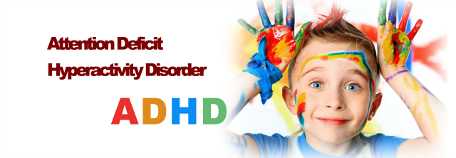
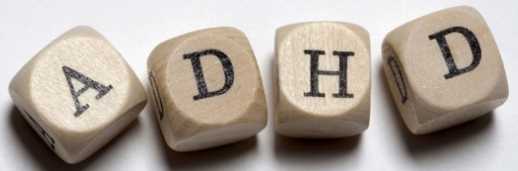
In Children









What is ADHD?

Patterns of inattention, hyperactivity and/or impulsivity which is persistent and interferes with functioning and/or development.
American Psychiatric Association (2013)

Who has it?

ADHD may be more common than you thought, prevelance rates are for children with ADHD are ranging from 2% up to 9%

Impacts of ADHD

Some of the ways that ADHD can affect someone’s life are

- Schooling

- Family life

- Social

- Economic

Schooling

Schooling is a big part of a child life. children with ADHD often have poor concentration and restlessness which could have a negative affect on their school life. There is evidence to say that children with ADHD do achieve less that that of a child without.
Children with ADHD are 3-7% more likely to either be suspended, receive special education (special learning classes within or out of school) or get expelled than that of a child without ADHD (LeFever, G. (2001)
There have been studies to see whether the academic performance ratings of children with ADHD are persistent. Studies on this have provided evidence that the lower academic performance of children with ADHD does in fact prove to be persistent from early childhood up to adulthood.

Family life

Having ADHD can be difficult. It is also difficult on their familly. The family are the main carers for children with ADHD and have to cope with all the difficulties that come along with the disorder.
Parents of children with ADHD often have larger stress levels and martial problems than that of families without an ADHD child. Parents of children with ADHD also are more likely to have depressive traits.
A servey on the mothers and fathers of 66 children, both with and without ADHD. Parents of the children with ADHD expressed more dissatisfaction whth their role than that of parents of the crontroled children (Podolski, CL. (2001).
Pelham et al also reported that iregular behaviours in their children resulted in hightend stress levels and parents of children with ADHD are linked with an increase of parental alcohol consumption

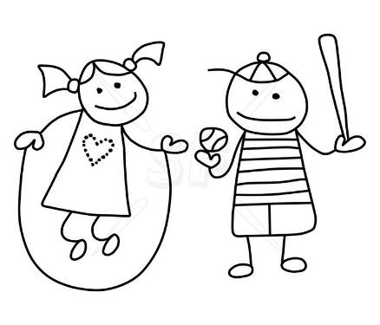
Social

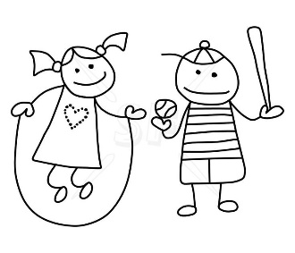
A child’s social life is very important. Children learn how to be cooperative, negotiate and conflict resolution amongst other skills. Children with ADHD often have difficulties when scoializing.
Studies on social status of children with ADHD found that 52% of ADHD sufferers fall in to the rejected category from peers, and only 1% being considered popular (Coie, D. 1982)
Peers problems for children suffering with ADHD are not just rejection. Compared to children without ADHD they score lower on social preference, higher on social impact, less well liked and fewer friendships. They were also disliked by children of a higher status, suggesting an exclution process by the more popular peers (Hoza, B. 2009). These results did not differ regardless of gender or age.


ADHD is amongst the most common mental health disorder in childood. This can have a high cost affect on the baord of child health services. These can include health service, educational services.
ADHD sufferers are estimated to cos around £100,000 per case. Two thirds of thst being heath and educational costs, where as the last remaining sum being that of reduced earnings.
High costs of ADHD support an economic case for early intervention, even though most families seek help, only a small percentage receive the appropriate treatments (Khong, B 2014)

Economic

There are a lot of helpful websites and helplines conducted for children with ADHD. These can be helpful for gathering more information about the disorder and strategies to help cope and provide a better life for children with ADHD. Family members and peers alike can find useful information to help either for themselves or sufferers close to them.
If you feel that your child is suffering with ADHD and have not yet been seen by a medical professional, then it is advised that the child should go to a doctor to get relevant information and diagnosis information.
Helpful websites and helplines
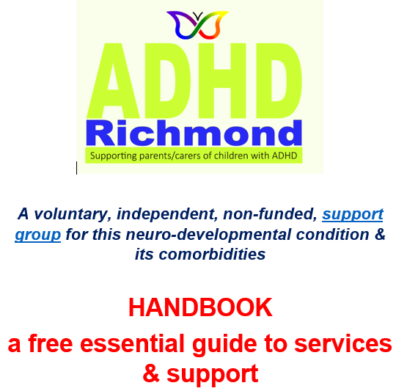
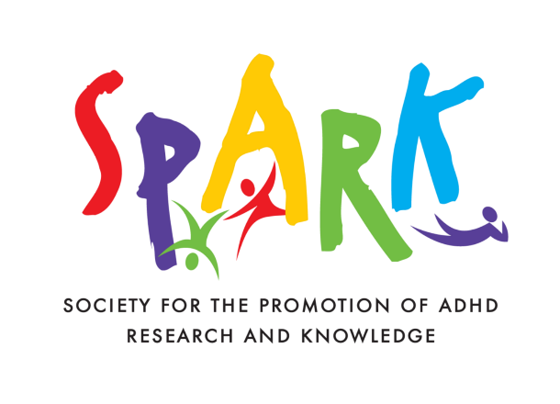



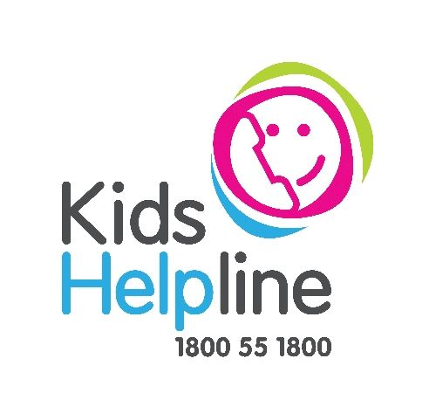
References

Biederman, J., Mick, E., & Faraone, S. V. (2000). Age-dependent decline of symptoms of attention deficit hyperactivity disorder: impact of remission definition and symptom type. American journal of psychiatry, 157(5), 816-818.
Biederman, J., Mick, E., Faraone, S. V., Braaten, E., Doyle, A., Spencer, T., ... & Johnson, M. A. (2002). Influence of gender on attention deficit hyperactivity disorder in children referred to a psychiatric clinic. American Journal of psychiatry, 159(1), 36-42.
Coie, J. D., Dodge, K. A., & Coppotelli, H. (1982). Dimensions and types of social status: A cross-age perspective. Developmental psychology, 18(4), 557.
Harpin, V. A. (2005). The effect of ADHD on the life of an individual, their family, and community from preschool to adult life. Archives of disease in childhood, 90(suppl 1), i2-i7.

Hoza, B., Mrug, S., Gerdes, A. C., Hinshaw, S. P., Bukowski, W. M., Gold, J. A., ... & Arnold, L. E. (2005). What aspects of peer relationships are impaired in children with attention-deficit/hyperactivity disorder?. Journal of consulting and clinical psychology, 73(3), 411.
Khong, B. (2004) https://www.centreformentalhealth.org.uk/costs-of-adhd
Klassen, A. F., Miller, A., & Fine, S. (2004). Health-related quality of life in children and adolescents who have a diagnosis of attention-deficit/hyperactivity disorder. Pediatrics, 114(5), e541-e547.
Konofal, E., Cortese, S., Marchand, M., Mouren, M. C., Arnulf, I., & Lecendreux, M. (2007). Impact of restless legs syndrome and iron deficiency on attention-deficit/hyperactivity disorder in children. Sleep medicine, 8(7), 711-715.
LeFever, G. B., Villers, M. S., Morrow, A. L., & Vaughn, E. S. (2002). Parental perceptions of adverse educational outcomes among children diagnosed and treated for ADHD: A call for improved school/provider collaboration. Psychology in the Schools, 39(1), 63-71.
Loe, I. M., & Feldman, H. M. (2007). Academic and educational outcomes of children with ADHD. Journal of pediatric psychology, 32(6), 643-654.
Pelham, W. E., Foster, E. M., & Robb, J. A. (2007). The economic impact of attention-deficit/hyperactivity disorder in children and adolescents. Journal of pediatric psychology, 32(6), 711-727.
Polanczyk, G. V., Willcutt, E. G., Salum, G. A., Kieling, C., & Rohde, L. A. (2014). ADHD prevalence estimates across three decades: an updated systematic review and meta-regression analysis. International journal of epidemiology, 43(2), 434-442.

