Chapters and other information to include within the dissertation:



Policing Mental Health – Are Police forces in England and Wales becoming the forefront agency to deal with the ongoing Mental Health Crisis in England and Wales.

Niall Christopher Watkins
(Student ID: 2023852)
BSC (Hones) Professional Policing Practice
January 2023 – January 2024

Acknowledgements: -
As I am ending my probation period along with the completion of my studies undertaken as a undergraduate with University of Wales Trinity Saint David, I would like to give my thanks to the support and guidance I have received from UWTSD in the completion of undergraduate degree.

Each individual supervisor or point of contact from UWTSD has been helpful and provided me with the guidance and support needed to complete the work provided.

There are numerous colleagues I have worked alongside in South Wales Police who have also provided me with guidance and knowledge while showing me that having the support is crucial from people who are in the same situation.

Finally, I would like to extend my gratitude to my family, the undergraduate degree along with a full-time job in Policing has been very difficult. Having 2 young girls to be a father to while having to dedicate a large proportion of my free time to complete the academic work has taken a toll on my relationship, so rebuilding the lost time is now crucial and looking to be more positive for the future. My children have been very understanding of the time I have needed to complete the relevant work and provided me with as much support as possible.

Declaration
This work has not previously been accepted in substance for any degree and is not being concurrently submitted in candidature for any degree.
Signed: Watkins. N
Date: 08/10/23

STATEMENT 1
This dissertation is being submitted in partial fulfilment of the requirements for the degree of BA.
Signed: Watkins. N
Date: 08/10/23

STATEMENT 2
This dissertation is the result of my own independent work/investigation, except where otherwise stated.
Other sources are acknowledged by footnotes giving explicit references. A bibliography is appended.
Signed: Watkins. N
Date: 08/10/23

STATEMENT 3
I hereby give consent for my dissertation, if accepted, to be available for photocopying and for interlibrary loan, and for the title and summary to be made available to outside organisations.
Signed: Watkins. N
Date: 08/10/23

STATEMENT 4
I hereby give consent for my dissertation, if accepted, to be available on the university’s IT system to those who have consent to use the system.
Signed: Watkins. N
Date: 08/10/23

Abstract

This dissertation investigates and examines research that has been available to the researcher, this is conducted by the researcher to find the relation between Police Forces in England and Wales to the Mental Health Crisis that is currently ongoing.

The research is to identify the current demand Police Forces are facing with a ongoing Mental Health Crisis in England and Wales, partly due to Covid-19 along with the diminishing work force and current recruitment that is being uplifted. It will also look at the training and facilities Police Forces must deal with the Mental Health Crisis and how this is going to change for the future. This is crucial in investigating to provide the best support, advice and safeguarding towards a person suffering a Mental Health Crisis.

The dissertation utilises a questionnaire completed by various Police Officers, Police Staff and members of the public who all provide their opinion and views on the current crisis.

Contents Table
Acknowledgements – Page 2
Declaration – Page 3
Abstract Page - 4
Contents Table – Page 4,5
Chapter 1: - Introduction
Introduction 1.1 – Page 6
Background 1.2 – Page 6
Aims and Objectives 1.3 – Page 7
Chapter 2: - Literature Review
Introduction 2.1 – Page 8
Past, Present, and Future Mental Health Crisis 2.2 – Page 8
Police attendance and powers 2.3 – Page 8
Mental Health intervention Teams 2.3 – Page 10
Mental Health within the Criminal Justice System 2.5 – Page 10
Conclusion 2.6 – Page 11
Chapter 3: - Methodology
Introduction 3.1 – Page 12
Research Strategy 3.2 – Page 12
Data Collection 3.3 – Page 13
Data Analysis 3.4 – Page 14
Limitations & Potential Problems 3.5 – Page 14
Conclusion of Chapter 3.6 – Page 15
Chapter 4: - Analysis of Results
Introduction 4.1 – Page 16
Results to Questionnaire 4.2 – Page 16
Conclusion 4.3 – Page 25
Chapter 5: - Conclusion and Recommendations
Introduction 5.1 – Page 26
Objective Achievement 5.2 – Page 26
Main Findings 5.3 – Page 26
Recommendations 5.4 – Page 27
Recommendation 1 5.4.1 – Page 27
Recommendation 2 5.4.2 – Page 27
Recommendation 3 5.4.3 – Page 28
Limitations 5.5 – Page 28
Conclusion 5.6 – Page 28
Bibliography – Page 30
Appendix one – Questionnaire – Page 38
Appendix two – Questionnaire Responses – Page 45
Appendix Three – Ethics/Proposal Form – Page 54

Chapter 1: - Introduction
Introduction 1.1
The research that is being conducted during this dissertation is focused on the current Mental Health Crisis and how the Police Service in England and Wales are currently dealing with the ongoing crisis.
Police officers during their day-to-day activities are becoming more aware of the ongoing crisis, a large majority of the calls that these Police Officers attend is related to a person in a mental health crisis. This literature review along with the research will answer the question of “Are Police Forces the correct agency to deal with the current Mental Health Crisis”. With the findings of the research, it will provide context to the area that is vitally important for now and in the future to help with the current ongoing crisis.
Background 1.2
So, what is Mental Health? Mental Health is described as “Mental health includes our emotional, psychological, and social well-being. It affects how we think, feel, and act. It also helps determine how we handle stress, relate to others, and make choices.” (Mentalhealth.gov, 2022). Mental health has been a prominent talking point for many of years with the Mental Health Act of 1959 being introduced to create a starting point on tackling the Mental Health Crisis.
Thomson, (2016) described the long-term vision of the transformation to help the National Health Service (NHS) care more for their patients in a hospital setting or from a community care point of view. The transition was initially slow and through the period of 1960s to 1970s with mental hospitals closing due to available beds with local hospitals then taking up the room for patients. From 1997, under a new labour government this is where the significant increase in expenditure on the NHS which still fell behind the overall trend.
It wasn’t until 2012 that the Health and Social Care Act of 2012 made it a requirement that mental health is to be on par with physical health, this improving access to psychological therapy which is a new kind of therapeutic armoury for the NHS to provide to persons suffering with mental health.
With mental health being an upward trend year on year since statistics were recorded. Poor mental health, it seems is a very common phenomenon and yet so many people find it hard to talk about and disclose mental health to friends, family, or professionals. It’s not until studies into suicides from celebrities or persons that are covered by media and social media that it become prevalent to others to speak out. There have been many people committing suicide over the years which is a result of poor mental health, Saleh, (2017) documented a few key points in how stigmatisation is key to mental health by the media along with popular figureheads such as Kurt Cobain and Avicii in the music industry, Caroline Flack in the celebrity industry and also a well-known American football player Aaron Hernandez which a Netflix documentary was published.
A more recent issue has played a large part in people understanding Mental Health and how it has affected individual people. A document was produced by Abolarin et al., (2022) which outlined how the Covid-19 Pandemic has played a large part in how people are affected and see mental health. This document provided examples of how individuals tried to cope with an unknown virus along with having lockdown restrictions. Since the pandemic over 16% of adults show signs of severe symptoms, compared with 10.9% pre pandemic. (ONS, 2021)
The Office of National Statistics (ONS) are keeping a up to date statistics on the trend of Mental Health, not only in adults but children also. The statistics published by ONS, (2021) show there were 5,223 suicides in England Wales, age-standardised mortality rate of 10.0 deaths per 100,000 people.
The policing role that is involved in Mental Health over the years has become a prominent feature of the Modern-Day Police Officer. Punch, (1977) described the police as “the social service”. This phrase captures the way the policing role is much more than apprehending offenders and becomes more of a social and public safety remit. It has always been an important role for Police Officers to deal with mental health as majority of calls that police officers attend results in victims and offenders potentially suffering with mental health. An introduction of the Mental Health Act 1983, this helped police officers deal with the vulnerable people that they encounter with having policing powers to back up their decision. This provided powers of detaining a person in a mental health crisis to escort them to a place of safety for an assessment by professionals.
Aims and Objectives 1.3
The aims and objectives I have set out for this project is to find out if the Police Forces the correct agency to deal with the current Mental Health Crisis. The objectives consist of.
- Explore statistics surrounding the amount of Mental Health incidents the Police attend e.g., Amount of calls Police are involved with where there is only a Mental Health concern, Amount of time dealing with a person in need of Mental Health advice.
- Discuss key points from Police Officers on how Mental Health incidents should be treated when the Threat, Risk or Harm has been removed.
- To investigate Police Officers views and roles in dealing with a vulnerable person in a Mental Health Crisis

One of the main focuses of this paper is to explore the findings and literature, of what statistics are currently out there to show how the current mental health crisis is affecting the Police Forces due to staffing levels of the Ambulance Service and staffing levels of Mental Health Crisis Teams.

Chapter 2: - Literature Review
Introduction 2.1
The literature review will be a review of scholarly sources on this specific topic. I will provide an overview of current knowledge, allowing myself to identify relevant theories, methods and provide any gaps in the existing research. Due to the studies of mental health over the years along with a recent pandemic, I will search for the relevant literature to suit my aims and objectives.
During the review I will also look to how the Mental Health crisis started and has led towards its current climate, it will show statistics to back up the literature that has already been researched.
Past, Present, and Future Mental Health Crisis 2.2
Mental Health is an ever much prominent in people’s lives. It affects all sorts of communities and has been transformed over the last 70 years (Venters, 2018). Persons having suffered with mental health in the past were believed to suffer with demonic possessions or displeasure from the gods as they had previously been believed to be. Mental Health has come a long way since people suffering with mental health were placed in a mental asylum, often treating them inhumanly and chaining them to the walls or keeping them in dungeons. Mental Health in general was shrouded with stigma, people who suffered with Mental Health problems, and mental disabilities as they were kept apart from their communities and away from public view. (National Institute for Health and Care Excellence, 2018)
It wasn’t until 1959, more than a decade after the NHS was established, parliament passed The Mental Health Act. This led to more of a hospital approach of treatment, Sir Winston Churchill set up a Percy Commission to review the detention of people with a mental illness. Sir Winston Churchill wanted a more community approach to the treatment of mental health rather than with institutions. (Royal Commission on the Law Relating to Mental Illness and Mental Deficiency, 1952)
World Health Organisation (WHO) has in recent years acknowledged that mental health plays in achieving global development goals (World Health Organization, 2022). WHO also has completed statistics surrounding depression and suicide rates, Suicide is the fourth leading cause of death among 15–29-year-olds while people with severe mental health conditions die prematurely.
At present, there has been a shift in society attitude towards mental health, it has become more accepting of mental health problems and more supportive of people with issues. (Venters, 2018b) The global pandemic of Covid-19 has affected most of the world, a large consideration was put into place for persons suffering with their mental health. Mind, (2022) completed a survey from research they completed in 2020 and launched a new survey in 2021 to find out how people with mental health problems are feeling and coping. There was a rise in people suffering with their mental health which included people under 18. Record number of children and adults sought NHS advice in 2021 with their being 53,239 new detentions under the Mental Health Act (NHS, 2021) this was a rise of 4.5% from 2020.

Police attendance and powers 2.3
A review into Policing and Mental Health from Her Majesty’s Inspectorate of Constabulary and Fire & Rescue Services (HMICFRS) was completed in 2018, this review outlined the Police attending mental health calls and how that “other services need stop relying on the 24/7 availability of the police” (HMICFRS, 2018). When this report was conducted in 2018, 43 Police Forces in England and Wales were already stretched with the number of officers on response teams with an already spiralling mental health crisis on the horizon.
Police Forces in England Wales have a vital role in protecting vulnerable people and ensuring that those at risk or abuse receive protection and support (IOPC, 2020). This includes Young People, Missing Persons, Those with mental health issues along with alcohol and drug addiction. There is a wide range of services the Police offer and a service that is continually running 24/7. Guidelines have been set by College of Policing (COP) on recognising individuals of harm and having a better understanding of the vulnerabilities of all those that the Police encounter. (College of Policing, 2022)
Lamb, Weinberger and DeCuir, (2002) produced an insight into the police attendance on dealing with mental illness, it explained about “their power and authority to protect the safety and welfare of the community, and their parens patriae obligations to protect individuals with disabilities” it furthers the explanation by saying “The police often fulfil the role of gatekeeper in deciding whether a person with mental illness who has come to their attention should enter the mental health system or the criminal justice system”.
Police are not specifically trained in dealing with a person in a mental health crisis where the large proportion of their knowledge comes from dealing with these individuals on potentially a daily basis. Police officers are provided basic training in dealing with mental health which consists of learning legislation of the Mental Health Act 1983 which includes Section 135 and Section 136 which is a police power of removing an individual with or without a warrant under certain circumstances. Due to these police powers are other agencies getting the police to become the “gatekeepers” when dealing with mental health calls to take the burden away from there selves.
When a police officer arrives at a mental health call, the police are there to reduce Threat, Risk or Harm to that individual when they are suffering a mental health crisis. This can be in the form of weapons, overdose or potential to take own life. Regardless of the individual the police must maintain integrity to the person and preserve life or limb, this is a difficult task due to the individuals mental state potentially wanting to commit suicide and the police are there to stop them. Edwards and Kotera, (2020) explained about the process and lack of mental health training within police forces shows the inexperience police officers will have when attending.
When the police officers are at the incident, yes, the police have powers to force entry into a property to save life or limb but when inside an individual suffering a mental health crisis is allowed to stay in their own home unless deemed to not have capacity through the Mental Capacity Act. At this stage the individual needs to be assessed by a mental health professional for advice, with factors of conducting a mental health assessment via a phone call or attending the address to check the capacity on the individual.
HMICFRS, (2018b) compiled a report to show the extent of the Mental Health Crisis on the police forces in England and Wales. The Metropolitan Police Service receives a call about a mental health concern once every four minutes and send an officer to a mental health call every 12 minutes with the average call then taking approximately 3 hours to deal with. This often led to a detention under 136 of the Mental Health Act and taken to a place of safety. This is where the main issue comes into place, taking a person to a place of safety then often takes hours depending on the other health agencies or having specialist beds for the person in crisis. (Metropolitan Police, 2018)

Mental Health Intervention Teams 2.4
People living with an illness of mental health, psychotic behaviour or had poor quality of life in communities were treated differently before the introduction of Mental Health Contacts and intervention teams in the 1960s. This new way of dealing with vulnerable people through an institution from community service agencies helped take the burned away from hospital and outpatient community groups.
Mind, (2018) is a leading organisation in the United Kingdom for helping and supporting the vulnerable people where they have introduced Crisis Teams to support an individual having a mental health crisis outside of a hospital. The crisis teams can assist with urgent mental health support which includes a phone call from a mental health professional, visit home or elsewhere in the community or even visit you in hospital if there are plans on being discharged. Having this 24/7 helpline has introduced a chance for people who are suffering to have that support and advice.
Since intervention teams have been introduced there has been scrutiny into how intervention teams are dealing with the mental health crisis. National Institute for Health and Care research, (2016) are a leading organisation into studying the ongoing crisis and how it is being managed. The study looked at the NHS expenditure, calculating in 2014/2015 to spend approximately £15 Billion, with a further study from Baker and Kirk-Wade, (2023) outlining that since 2016 year on year there has been an extra £15.5 billion inserted into mental health services.
Duncan et al., (2021) has recently investigated the current Public Mental Health (PMH) where it identified how to improve wellbeing and prevent poor mental health at population level. 407 interventions were identified across five high risk areas. These interventions to persons in a mental health crisis were shown to be persons suffering with social isolation and loneliness with most common being targeted towards older adults and people from minority ethnic backgrounds. In the conclusion there was clear evidence to suggest a partial responsiveness to national and local prioritising. This suggested addressing social and individual determinants of PMH with the lack of comprehensive evaluation of services to improve PMH needs to be urgently addressed in the communities they serve.
NICHR, (2019) studied the intervention of the police on attending mental health calls and found,
“The growing volume of mental health-related emergency calls is an increasing challenge for police services. In London, in 2018 there were about 4,200 uses of ‘section 136’ that allow the police to take people with mental illness to a place of safety; for example, a hospital or emergency department. Lack of appropriate skills can result in inappropriate handling of such situations.”
The study also showed the summary of intervention models need to be sought to achieve better situations for a joint emergency service. As there is minimal cost or comparative information it is difficult to find a correct approach to treat the users of the system.
Mental Health within the Criminal Justice system 2.5
NICE, (2015) compiled a report on the guideline of violence and aggression in adults (ages 18 and over), young people (aged 13 to 17) and children (aged 12 and under), this was all relevant to for mental health, health, and community settings. The report provided guidelines to safeguard services by helping to prevent violent situations and to manage safely when they occur. It also looked at a person suffering a mental health episode and committing a crime, it related to approximately 10% of offences are casually connected to a mental disorder.
When a person has committed a crime and is subsequently arrested, College of Policing, (2016) explains “Investigating officers should recognise that the law presumes all suspects to be sane and to be legally accountable for their actions, unless the contrary is proved in court. This is an underlying principle of the criminal justice system.”
Home Office circular 66/90 provision for mentally disordered offenders require officers and staff to consider a diversion for offenders who are mentally disordered before deciding on a charge. (Crown Prosecution Service, 2019). Police attendance to a mental health call where there has been a degree of criminal activity, Latham, (2017) described the joint working between police and mental health professionals. This providing the police officers with assistance by a “street triage” scheme. With this scheme Sweeney, (2015) who is chair of The British Psychological Society has provided an honest based approach towards the Police dealing with people suffering a mental health episode having had firsthand experience. Sweeney explained about “Street Triage” and how in 2013 it was launched by the Department of Health due to increased involvement police forces were having with individuals suffering from poor mental health. As little to no research has been conducted around the models of street triage it is an ever-changing service-user experience.
Street Triage is trying to help individuals have easier access to mental health care, this has not stopped the police attending in the first instance however the police may be unaware of some ethical considerations which include the major one of consent. This then relies on the police force using The Mental Health Act to detain a person or to sit with the individual until the threat, risk or harm has been reduced. By the Police continually using their powers on arrival due to the lack of mental health professionals to deal with the situation, Police forces in England and Wales are still continually dealing with Mental Health incidents resulting in added pressure on a demanding job.
Conclusion 2.6
This chapter has identified how mental health in the UK has continually been a problem for Police Forces in England and Wales with their only being a target since 2013 with the idea of “Street Triage” becoming available with funds to recruit and train people to a high standard of professionalism. Due to budget cuts in the NHS along with the Police Forces it has seen the lowest amount of officers patrolling the streets and attending emergency incidents.
With Mental Health taking up about 5.1% of recorded police contacts rising to 7.8% (Kane, Cattell and Wire, 2021) there is a definitive issue that needs resolving in an already state of crisis. On finding out statistical information it is evident that the police are a 24/7 emergency service where Mental Health professionals work basic hours. Where there are no mental health professionals it is down to the police to continue their work and deal with the most vulnerable until professionals become available.
Most studies or reviews are related to a multi-agency approach, where a mental health professional will attend a call with the police and use the correct powers and legislation to make sure the person who is suffering has the right treatment. From experience this is not accurate and consists of the police attending first and then dealing having to find the right contacts to provide further information on the correct treatment.

Chapter 3: - Methodology
Introduction 3.1
This chapter is going to look at the research surrounding the statistics and understanding of the Mental Health Crisis, whereby the previous chapter looked at the methods and methodology surrounding the research of previous academic work.
The reason why the research is currently being complete on the mental health crisis that is currently affecting the Police forces in England and Wales is due to the number of incidents the Police are attending which should and could be controlled by mental health teams or via street triaging. This then takes up a lot of resources due to time demand on each incident. Upon completing the research methodology, I was unable to find up to date information surrounding statistics on the police attending mental health calls, due to the demand of covid-19 on the police forces many of the research that was previously completed has not been sought. This is shown to be a gap in the research where since the covid-19 pandemic has started individuals and groups mental health has spiralled to the point mental health teams are also under increased pressure to deal with the persons involved. Legislation that has been introduced which include The Mental Health Act 1989 and Mental Capacity Act 2005 show that there is work to be done or updating the legislation surrounding the powers and policies the police, mental health teams must help individuals that are asking for help.
There is a clear lack of funding which shows that mental health is not being taken seriously by the government (GOV.UK, 2023). As of January 2023 this is the first funding of £150 million that has been directly inputted into mental health teams since 2014 which will not only support mental health emergency teams but also benefit tailored community care and support from the community.

Research Strategy 3.2
There are a number of different research methods that are available to a researcher, each different research method has its advantages and disadvantages which have been considered throughout the dissertation. Research has been used to support a wide range of different research projects including for educational purposes, existing government concerns to health and social care strategies. Gall, Gall, and Borg, (2003) explain what research is “Research is a scientific approach to answering a research question, solving a research problem, or generating new knowledge through a systematic and orderly collection, organization, and analysis of data to make research findings useful in decision-making”. (IEDUNOTE, 2020)
As there are time constraints to the dissertation a more practical approach is needed, a questionnaire a simple form of completing research where the researcher can target a wide audience in a short time frame. Other research methods have been considered which did include interview style questions along with focus groups, this bringing in a wide range of participants to answer the questions asked which would give me the research needed. With completing the interview or focus groups there are time constraints along with the answers being open ended rather than closed. Surbhi, (2018) outlined the issues with interviews over questionnaires is the open-ended questions that will be asked opposed to closed question via a questionnaire. A questionnaire will provide fact-based information from respondents and analytical information can be gathered through interviews.
There are several advantages to completing a questionnaire styled survey, questionnaires are a great way to collect information from a lot of people at once in a short period of time. They can be targeted to a specific audience by sending out emails to a brand, company or area or sent via a letter to houses or businesses. By sending out the questionnaire to a large area of people there is a big advantage to the data collection that the researcher would receive. Cost is always considered in any work that is carried out with a questionnaire coming in at a considerably cheaper price by considering material costs, printing, calls, and interview costs (Cornell, 2020). The biggest advantage is how a researcher can scale up the service, when considering time, a questionnaire can be sent instantly to 100, 500 or even 1000s of people within a space of a few minutes, whereas interview style questions there will be the possibility of a maximum of around 50 people a day unless on a large scale. Along with advantages there are also disadvantages towards questionnaires, response rates towards questionnaires are low where the participants who do answer majority may not answer correctly. This aligns with researchers attempting to win customers over by producing questions to make them feel comfortable to answer to favour the researcher (Jones, Baxter and Khanduja, 2013). Not only are the questionnaires sent out on large scale, they also will lack a personal touch as the questionnaires may seem too formal or even robotic where the customers may not answer at all.
The questionnaire that will be produced with relevant questions will be targeted at the front-line police officers of South Wales Police; it will be shared with local divisional officers along with other specialised officers. This does include any rank in South Wales Police who wanted to include themselves in the survey. This will prove to be biased in the sense of it directed towards Police personnel but will show the best evidence as it is the police who are currently taking the burden of a large portion of mental health calls.
The audience I will target will be notified about the questionnaire via email that will be circulated via divisional officers and via the internal intranet, this will in return target approximately 50 respondents. Having approximately 50 respondents from different internal departments would show a representative value for the majority of South Wales Police. Consideration has also been undertaken as the questionnaire could be published via public spaces via social media. The rate of response the researcher receives is crucial to analysing the data.
Data Collection 3.3
The data that will be collected from the questionnaire that the participants have inputted will be quantitative data which in turn will be formatted into graphs and tables to understand and interpret the data. Not only will it be quantitative data, but certain questions will allow for qualitative data where the participant can input a reason for their answer.
- Quantitative data is expressed in numbers and graphs and is analysed through statistical methods.
- Qualitative data is expressed in words and analysed through interpretations and categorizations. (Bhandari, 2020)
The questionnaire will be formatted to allow participants an easy and simple approach to answering the questions, due to the simple nature of producing a questionnaire it will explain how to answer and consider their answers at the end before finalising. Due to the targeted audience, participants will answer from their own experience and if unsure on the answer be able to complete the questions with N/A if the questions are not applicable to themselves. By providing a N/A box this will not interfere with any incorrect data where the participant will guess or just click a answer to go onto the next question.
As the questionnaire will be particularly a Yes/No answers, there will be options for the participants to produce an answer in the ‘Explain your answer’ box. This will show to the researcher why the participant has answered the question in a particular way. This will be used as quantitative data for the researcher to view. There will be an overview box at the end where the participant can enter in free text to share their own views on the mental health system, how the police deal with the current crisis and any improvements that can be made short and long term.
I will also ask participants on feedback from the questionnaire to determine if there are improvements to be made for the future research that will be relevant from this dissertation.
Data Analysis 3.4
Approaching the questionnaire with an understanding on how to analyse the data that has been collected is a crucial part into completing the questionnaire, the time and effort each participant puts into completing the questionnaire with their own real-life experiences will need the correct way to determine the data.
Questionnaire data will come from the closed questions and open questions. The closed questions will come from the 1-10 scale questions and yes/no answers, these can be inputted into a spreadsheet and shown as a graph or table for the researcher to compile their data and complete the research, this is a simple way to determining the data and compiling the research. The open questions which will come from the participants inputting their own words into the boxes provided which will be viewed by the researcher to look for key words or trends in their answers. (Wolff, 2022)
With both open and closed data being compiled they will also be kept together to show the results have a personal touch behind just numbers and graphs
Limitations & Potential Problems 3.5
Questionnaires as shown above have numerous advantages and disadvantages towards the completion of the questionnaire, for the research dissertation with the time constraints the questionnaire has been chosen as the more practicable choice. There have been considerations with the limitations of the questionnaire which have been researched to find a way to reduce the problems that may arise. (Agarwal, 2021)
The research method although helps with the time constrains for the research to be completed which helps the participants answer with ease due to the questions being simple and straightforward, this may to some participants change their willingness to answer the questions correctly or with careful consideration of the questions. There will also be limitations surrounding the participation rate that will take the questionnaire, as the research is being completed approximately 40-50 other researchers will be looking for participants on a similar study which will want to target a similar audience, this may in turn drop the response rates.
Covid-19 pandemic has had a massive impact on peoples lives from day one, there has been a concern in the amount of people being affected with mental health (Mind, 2022) which may also affect how people respond to the questionnaire or their willingness to participate in a subject that they themselves may be experiencing. The participants that I will be targeting are police officers/staff that have worked before, during and after the pandemic, this again is also a hard hitting subject to tackle with many of officers/staff being affected with the pandemic.
Conclusion of Chapter 3.6
The research surrounding the correct method to undertake for this dissertation has been carefully selected for the time constraint and the ease of completing a questionnaire, considerations have been put into place for the limitations and to try and reduce the potential problems by targeting specific groups of police offices/staff to participate in the questionnaire. For the questionnaire both qualitative and quantitative questions will be asked and hoping for the participants to enter in data that they think is relevant for the answer to show the emotional side behind a yes/no answer. Ethical considerations have also been considered due to the nature of the subject being around mental health and the questions will be suited for sensitive issue, participants will be reminded that they can withdraw any questions answered anonymously or refuse to participate.

Chapter 4: - Analysis of Results
Introduction 4.1
This section of the dissertation is to analyse the results that have been gathered from the questionnaire that was sent out to South Wales Police officers along with other members who wanted to participate in the questionnaire. The questionnaire was designed with simplicity and ease of use to gather more participants, it would take each participant approx. 3-6 minutes to complete.
The questionnaire was created using Google forms, after research this was a free tool to use and due to the sharing capabilities, it was the preferred method. To reach a high number of participants I shared the Questionnaire internally with local response teams along with the South Wales Police intranet BOB, due to low uptake in numbers after 2 days I shared the Questionnaire with external forums which can be accessed from other Police Officers in other forces, this provided the questionnaire with a wider range of participants. There were approx. 80 participants which answered most of the questions they felt suitable to themselves. In the questionnaire there was a mix of qualitative and quantitative questions. At the end of the questionnaire an open text box was offered for any participant to provide their own feedback.
Results to Questionnaire 4.2
Q1 – Age
With this question I wanted to target and gauge the participant’s age. I received 82 responses with a high proportion of the answers showing the age range 25-30 and no 55+ responses.
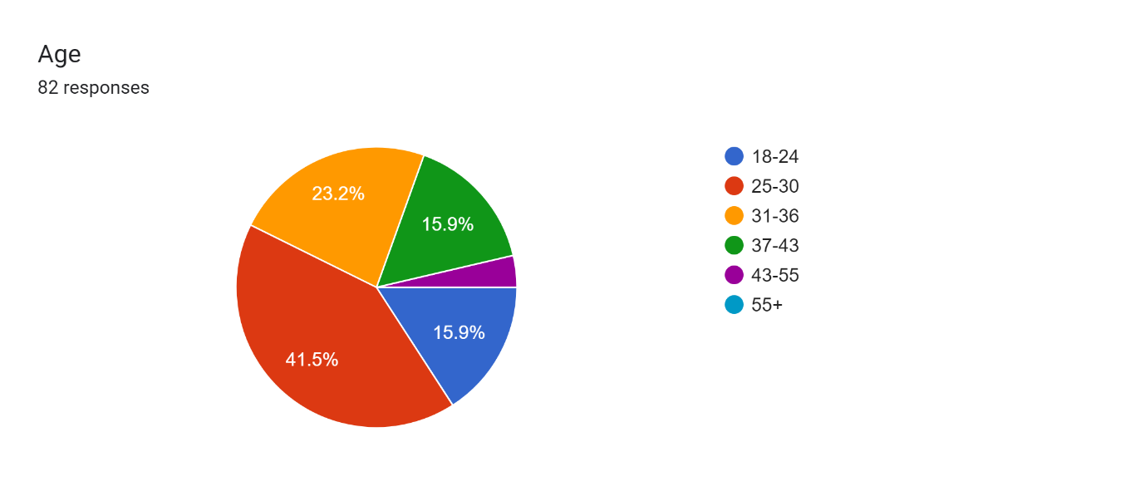
Q2 – Are you a serving Police Officer/Staff of any rank in South Wales Police
This question was targeted at gathering responses from Police Officers/Stagg from within South Wales Police, due to the low uptake when the Questionnaire was posted I wanted to have more responses so needed to provide the questionnaire to other forces.
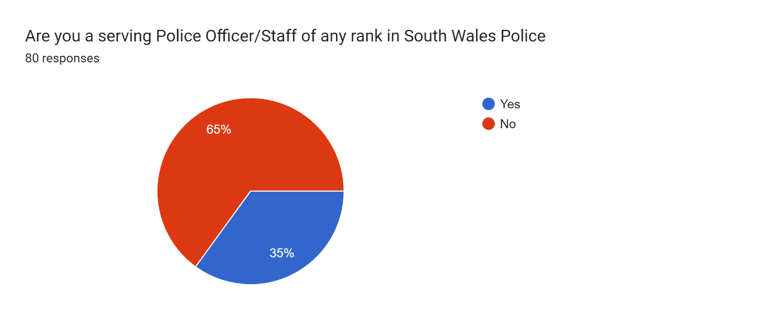
Q3 – Length of Service
Responses showed the length of service was a high proportion of between 0-2 years and 2-5 years, this shows that 72% of the responses are of being young in service with responses of 5-10 years being 14%.
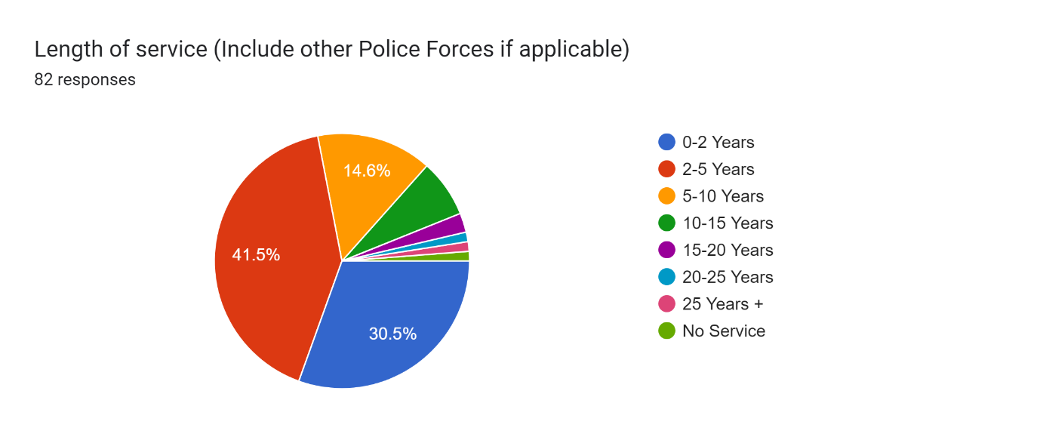
Q4 – Current Rank
I aimed this question to see what the majority of respondents who participated in the questionnaire were of what rank, as expected a high percentage of respondents 90.2% were from a Constable rank.
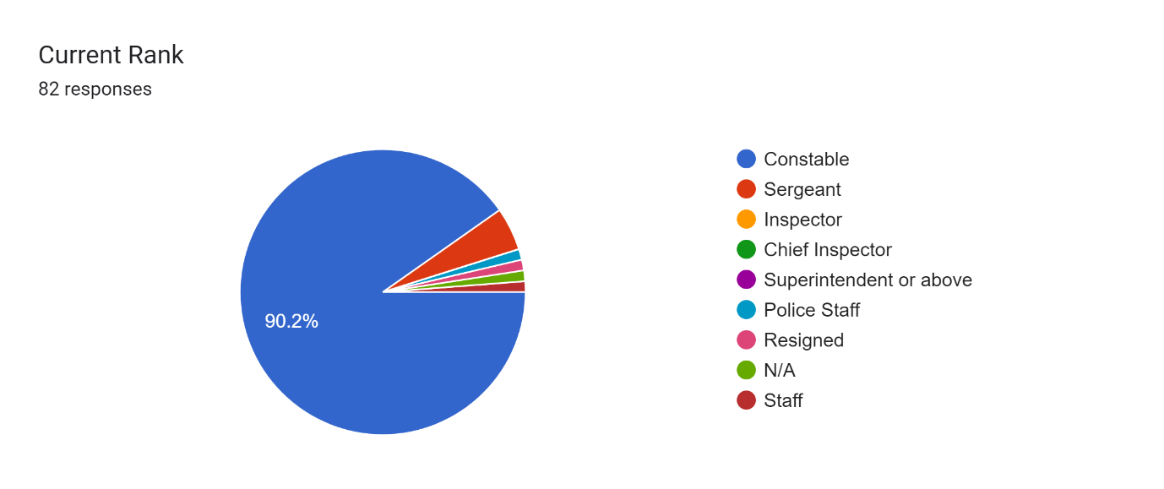
Q5 – Gender
This question was to gauge to respondents Gender along with a ‘Prefer not to say’ option. 81.7% respondents were male with 13.4% being female.
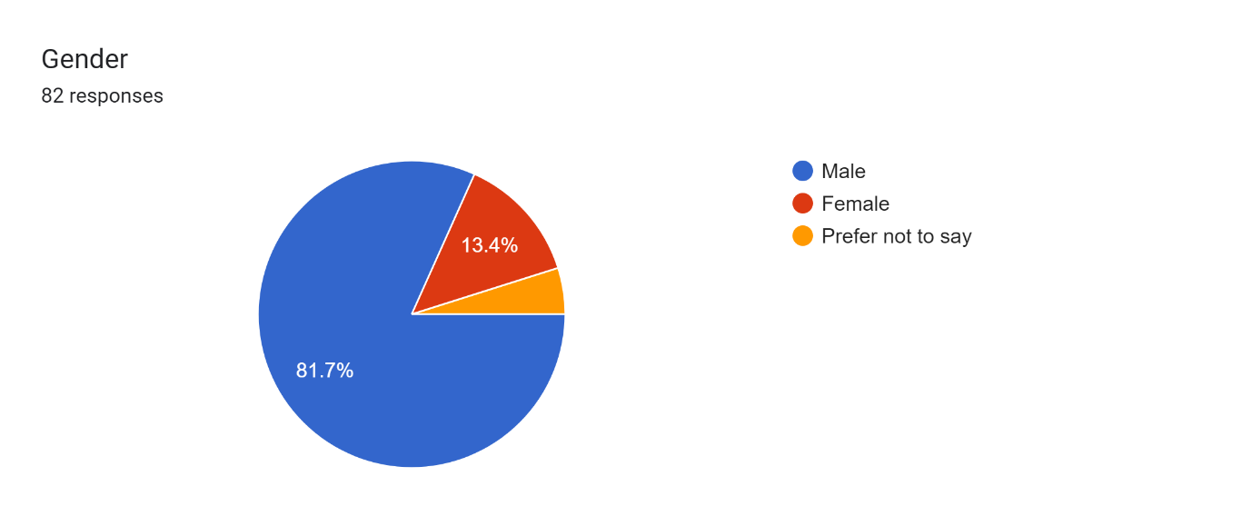
Q6 – Have you attended or dealt with a person dealing with a Mental Health Crisis?
This question was to gauge throughout the rest of the questionnaires how many respondents had dealt with a person in a Mental Health Crisis, 97.5% of respondents had dealt with a person. This shows that the majority of further questions will be answered by a respondent who has dealt with a mental health crisis and has a understanding.
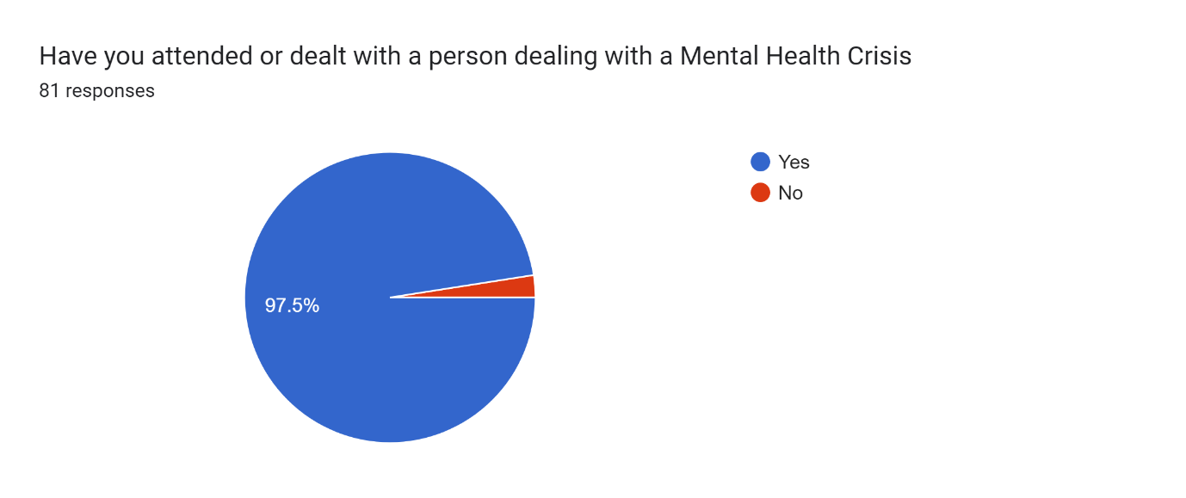
Q7 – Did you feel you had enough training or adequate support to deal with the person in a Mental Health Crisis
This question was targeted at the persons who have dealt with a person in Mental Health Crisis to feel if they have had enough support, 92.7% answered ‘No’ which out of 82 respondents shows the lack of training and support for Police offices to deal with the person suffering.
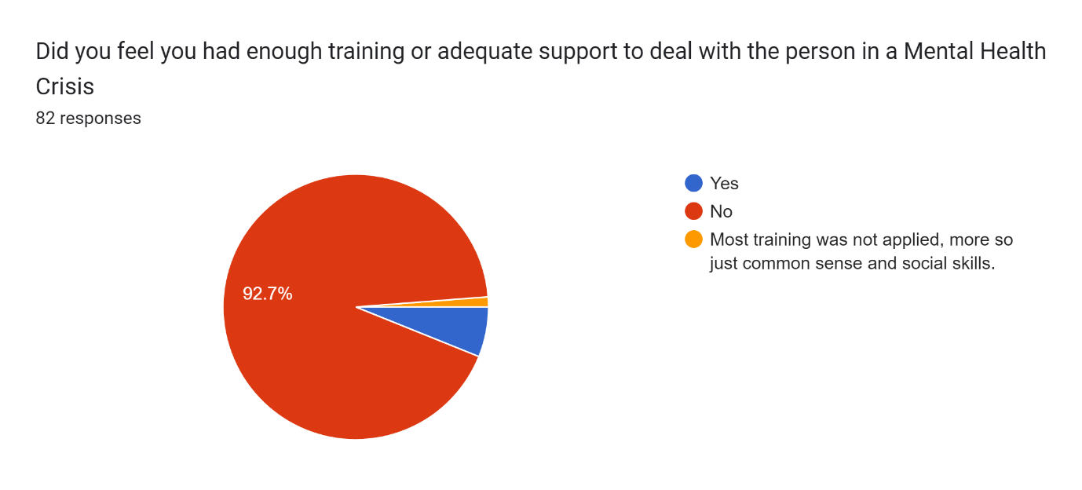
Q8 – Do you believe you are the right person to deal with a person in Mental Health Crisis
This question is also targeting the respondent on thinking about themselves are being the right person do deal with a person in a Mental Health Crisis. 90.1% responded with ‘No’, this relates to Q7 where 92.7% felt they did not have enough training. This shows a correlation of officers who are not only feeling supported with training but also feel they are not the right person to deal with the situation.,
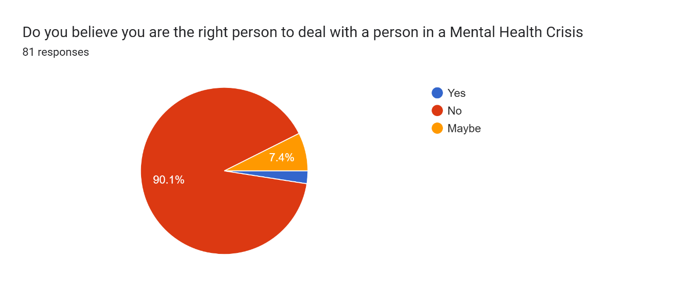
Q9 – Did you have support from a Mental Health Professional that dealt with your incident accordingly (Phone Call triage, Adequate Support to officers via mobile, Future Advice)
This question was designed for people’s responses to be their own as when dealing with a Mental Health Crisis, each incident is different, so I found it difficult to decipher an answer to base around the question. Majority of respondents answered ‘yes’ with 53.1% and ‘No’ with 34.6% with the remaining 85% responding to how their own incidents have been dealt with by a Mental Health Professional.
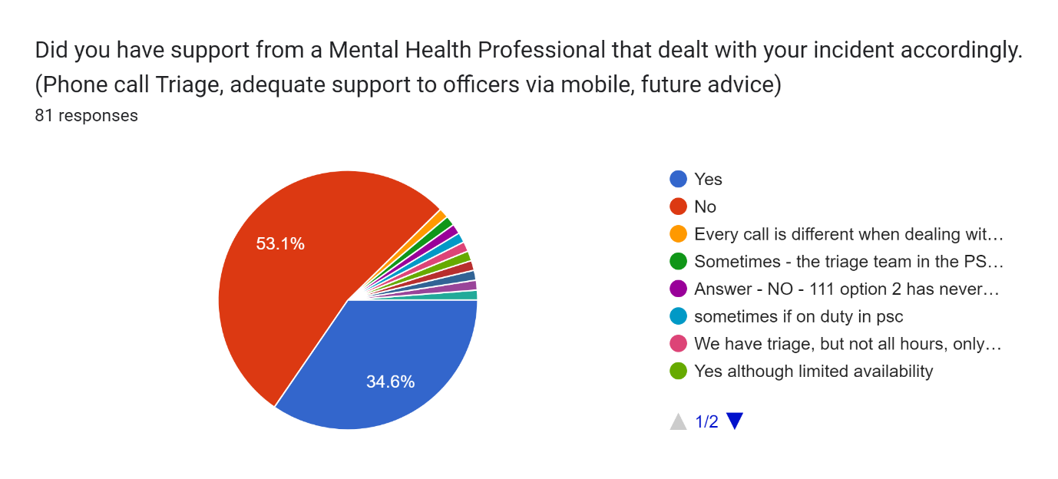
Q10 – Are the Police the right agency to deal with a person in a Mental Health Crisis
The question was aimed at the respondent’s response to thinking are the Police the right agency to deal with a Mental Health Crisis, due to a large proportion being a serving Police Officer this answer would largely be populated for a ‘No’ answer. 90.1% answered ‘No’ with other responses highlighting response times from Ambulance and also the potential threat to life.
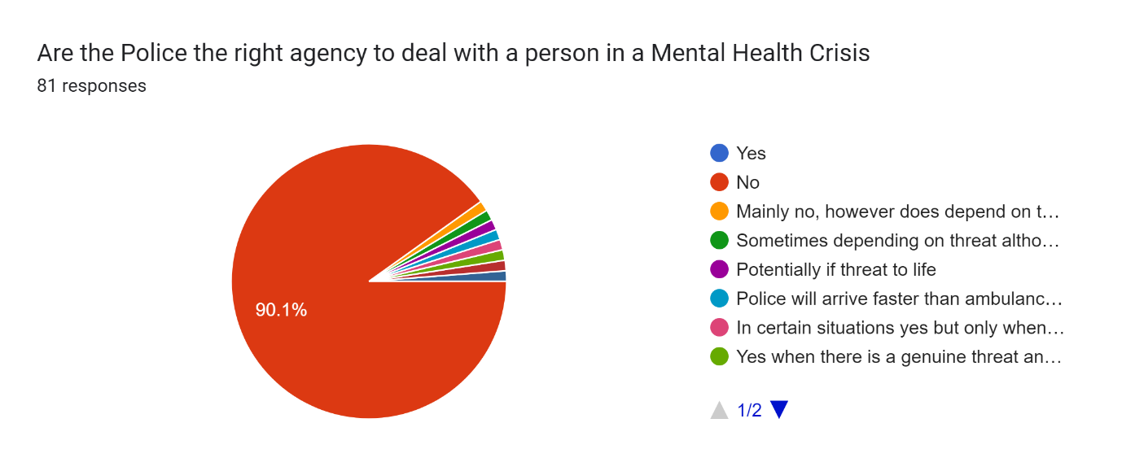
Q11 – Do you think the police are equipped with enough equipment and training to deal with a person suffering a Mental Health Crisis
Q11 and Q12 are based around a similar question but aimed at two groups, Q11 was aimed at any person particular Police Staff and Members of Public where Q12 was aimed at the Police Officer. Q11 and Q12 and similar results with regards to believing the police are not training or equipped in dealing with a person in a Mental Health Crisis, the responses are shown this way due to there being a 97.5% in Q6 answering ‘yes’ to attending a Mental Health call.
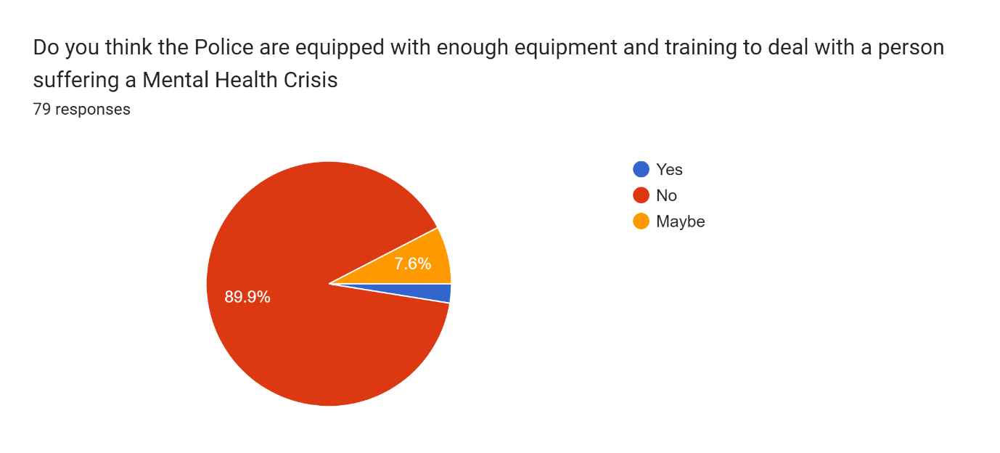
Q12 – If you are a Police officer, do you feel fully equipped with equipment and training to attend a Mental Health call.
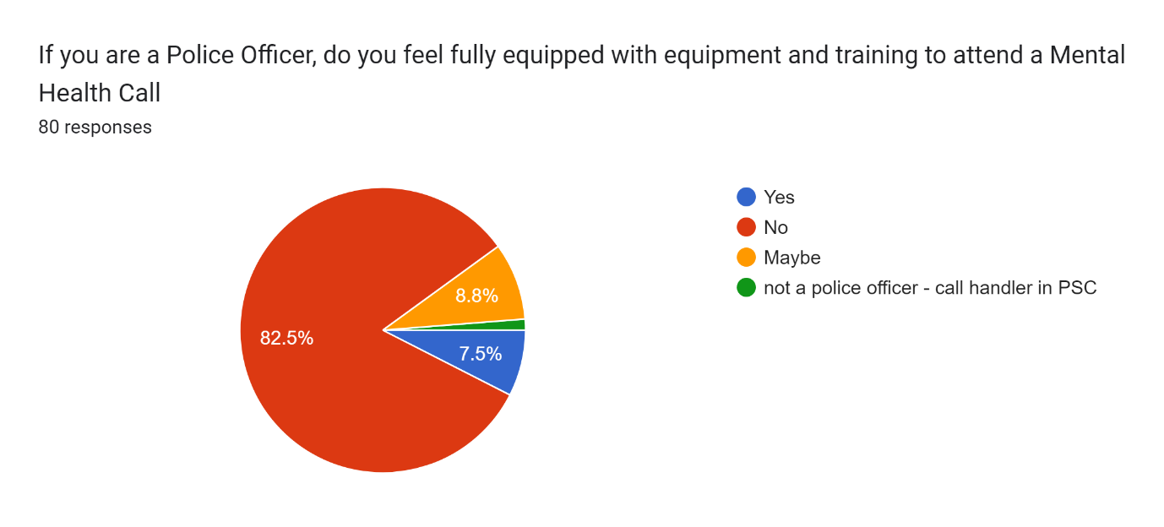
Q13 – When the ‘Threat, Risk, Harm’ has been taken away, should the Police let other agencies intervene to assess the person in a Mental Health Crisis
This is a question where due to there being high responses from a respondent attending a Mental Health call (Q6), this was a answer to show how the respondent would want action taken from other agencies when the ‘Threat, Risk, Harm’ was removed.
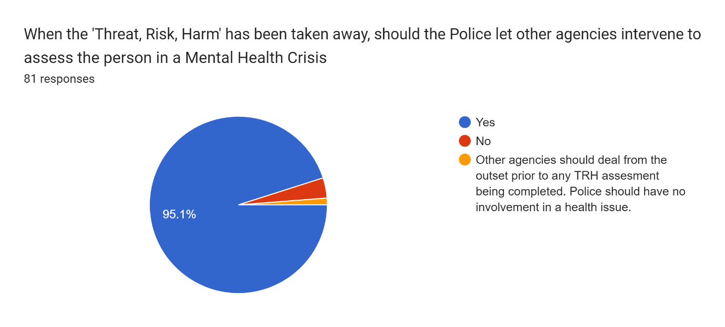
Q14 – How many calls do you attend during a working week involving a person suffering a Mental Health Crisis
This question was aimed at the respondents who have attended Mental Health calls, there is a variety of amount as shown below where each answer is around the same percentage. This shows that each officer has different experience in attending Mental Health calls throughout their tour of duty. This could be down to the specialised roles that each officer is attached to which will have different experiences.
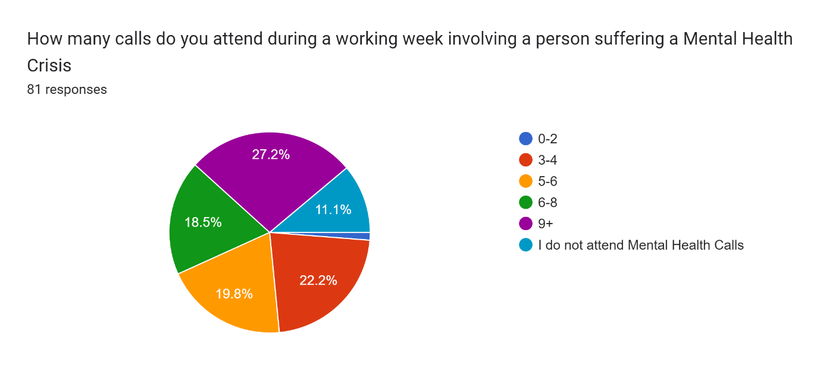
Q15 – How many calls do you think the Police attend in a month for a person suffering a Mental Health Crisis
This question will show from the respondents how many calls they believe the Police attend during a month. The average in 2020-2021 was 22% (Gov.uk). This is a statistic showing for forces in England and Wales where each force varies with the demographic. The average for the data shown below is 27.4% which is similar to the statistics of 2020-2021.
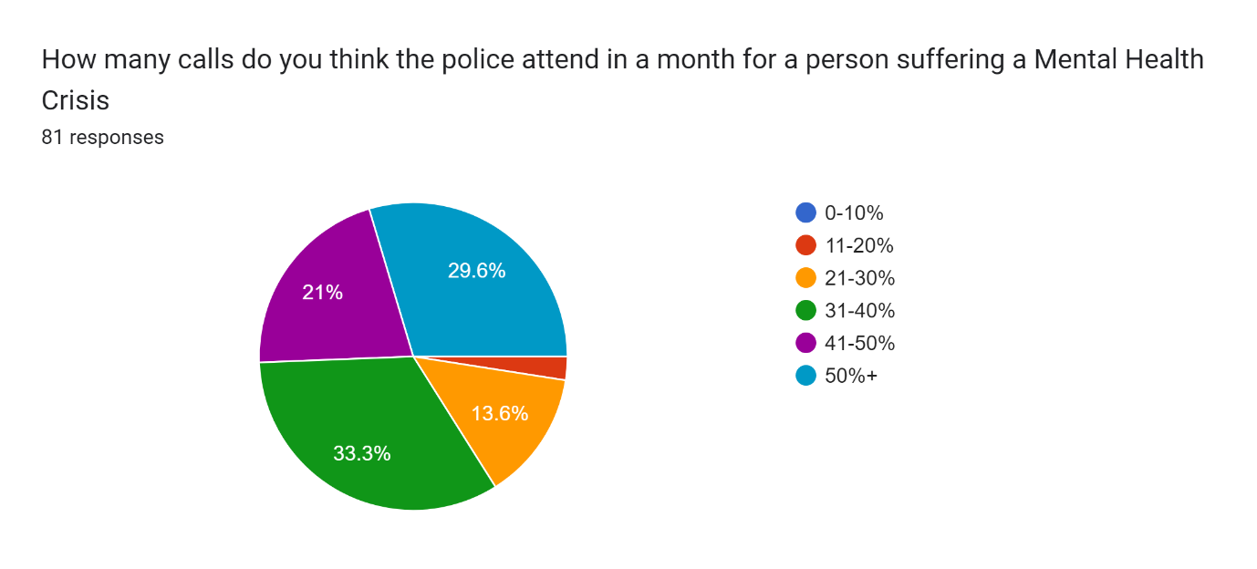
Q16 – Should there be a specific Ambulance Mental Health Team to deal with a person in a Mental Health Crisis
This question was a open question for respondents to collate their own answers as each respondent will have a different opinion to a ‘Ambulance Mental Health Team’. 1 respondent answered for a Mental Health Team to be designated and 97.5% responded with ‘Yes’.
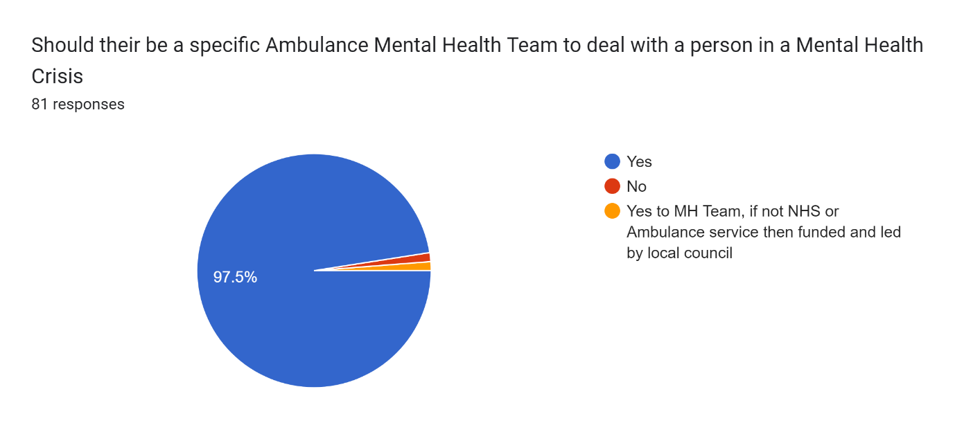
Q17 – What more can be done to provide a better service to a person suffering a Mental Health Crisis
This question is for the respondents to provide their feedback in relation to what more can be done for the individual who is experiencing a Mental Health issue. 53.1% provided the answer of ‘Additional funding for further Mental Health Support’. This shows a lot of the respondents wanting Mental Health Professionals to be funded and provide the correct support.
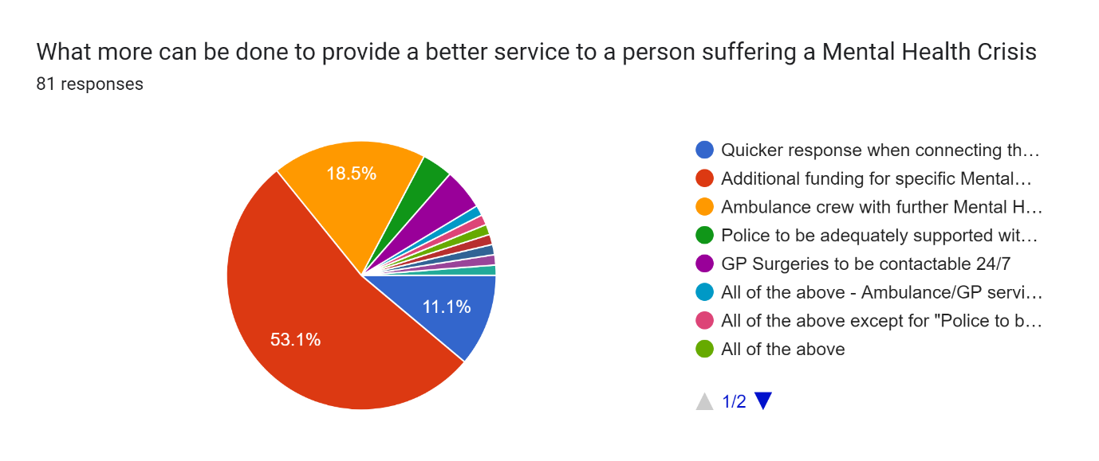
Q18 – If you suffer or have suffered with your Mental Health, who did you contact.
I aimed this question at respondents who have or haven’t suffered with their Mental Health and if they would provide details on who they would contact. 58.5% provided the answer of ‘I have not suffered with my Mental Health’ where 7.3% ‘Prefer not to say’. Another large proportion of 23.2% provided ‘GP’ as their answer if they have suffered with their Mental Health. This shows that who have suffered with their Mental Health contact the right professionals.
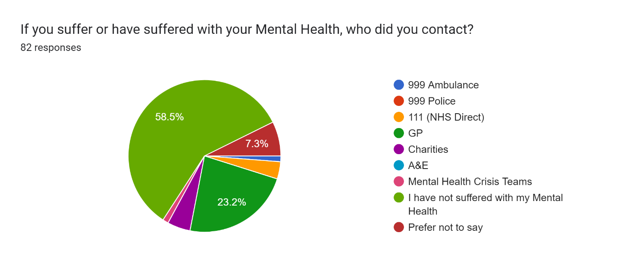

Q19 – Do you feel the Police have sufficient resources to deal with the current Mental Health Crisis
Due to there being 90.2% showing as ‘Constable’ in Q2 this question was aimed at a serving Police Officer having a understanding of the sufficient resources that a Police Force has and can they deal with the current climate of the Mental Health Crisis. 97.5% said ‘No’ for the Police having sufficient resources. This is shown from officers who deal with the crisis day in and day out.
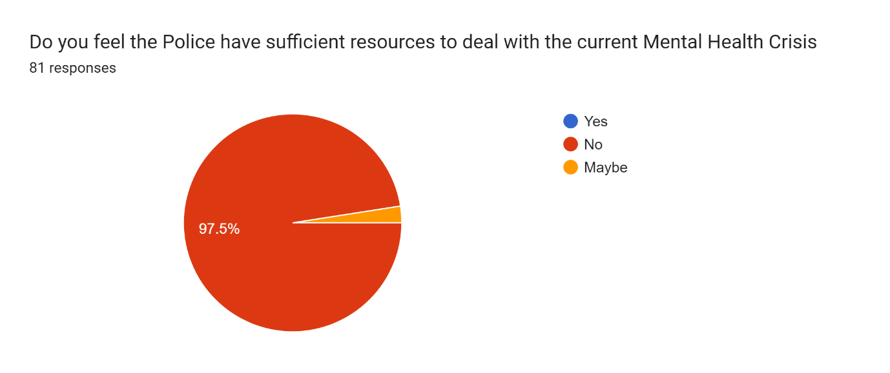
Conclusion 4.3
In conclusion, the results gained from the respondents with approx. 80 results throughout the questionnaire there is evidence to show that a high percentage believe that the Police are not the right agency to deal with a person in a Mental Health Crisis, especially with 82.5% of respondents believing that a Police Officer is not fully trained or equipped to deal with a person in a Mental Health Crisis. As the majority of respondents 90.2% are constables from a Police Force in England and Wales this shows there to be a concerning demand on the Police for persons in a Mental Health Crisis with there being no support from outside agencies to assist or take over when the ‘Threat, Risk, Harm’ has been taken away, it is down to the Police to use their powers of The Mental Health Act 1983 (Legislation.gov.uk) or Mental Capacity Act (2005). Due to there only being around 80 responses to the questionnaire this does not fully utilise most warranted officers who work for a Police Force in England and Wales, the research would greatly benefit more time to distribute such questionnaire to have a wider range of Ranks throughout a Police Force.
There are many factors that will affect the results of a questionnaire, with the questionnaire being published to a open forum there could be potential for respondents to inaccurately record their results or due to time scales not read the question correctly. As there is also time constraints on a questionnaire where I am trying to utilise Police Officers during their tour of duty this may have been difficult to capture where a longer period of time would have been more suffice. It would have been more beneficial to complete a open forum to Police Officers in England and Wales to gather their feedback on questions over a period of 1 month, then publicise the questions which would have been aimed specifically towards those officers.
Chapter 5: - Conclusion and Recommendations
Introduction 5.1
Throughout the dissertation I have documented the Introduction to the dissertation, completed literature reviews along with research methodology and findings from the questionnaire that was shared with various respondents. In this final chapter I will look at the overall dissertation to document my recommendations that I have highlighted throughout the dissertation.
Objective Achievement 5.2
To complete the objectives stated at the start of this dissertation, I wanted to find out if a Police Officer of any rank along with other professional organisations to determine if a Police Force is the right agency to attend a person in crisis that is suffering with their Mental Health.
- Explore statistics surrounding the amount of Mental Health incidents the Police attend e.g., Amount of calls Police are involved with where there is only a Mental Health concern, Amount of time dealing with a person in need of Mental Health advice.
- Discuss key points from Police Officers on how Mental Health incidents should be treated when the Threat, Risk or Harm has been removed.
- To investigate Police Officers views and roles in dealing with a vulnerable person in a Mental Health Crisis

I have completed these objectives throughout the dissertation where I researched literature that has already been pushed, majority of the research is from pre-covid 2019 where this is the gap I wanted to fill as since Covid-19 there has not been a lot of research completed on Police Forces in England and Wales attending Mental Health calls. The literature that was available clearly demonstrated a demand on the Police Forces before a epidemic put a massive strain on services throughout the UK, including NHS, Police Forces, Mental Health Services.
Main Findings 5.3
The research that has been conducted for the review of the dissertation project is used as material for future research which been already been undertaken and utilised in my current literature review along with their own. The findings of this dissertation project can be utilised more thoroughly to show how the UK NHS service or Mental Health Service has been and still is in a crisis. As the findings show there is a lot to be done from various agencies to combat the crisis to get it under control.
From the research carried out from the questionnaire, which was provided to various forces in UK, specifically England Wales where there was approx. 80 Respondents to each question. Within the respondents there was good understanding of respondents who had attended a mental health call which was 97.5%, this shows that the targeted audience was the correct audience to target. Within that 97.5%, 93.8% felt that they did not have the adequate training or support to deal with a person in a Mental Health Crisis. This is a worrying fact that there is person who are suffering with their Mental Health and are having Police Officers arrive who do not feel confident in dealing with the person who is looking to have professional advice and support. Along with not having enough training or support 90% believed that they were not the right person to do with a person in a Mental Health Crisis. Having dealt with a person in a Mental Health Crisis I agree with the statistics shown in the analysis of my results, there is not enough training or support for an officer of any rank to deal with a person who is suffering and looking to have support.
Training and equipment are another crucial part of dealing with a person in a Mental Health Crisis, 89.7% said ‘No’ to having enough equipment and training. Gov.uk (2023), has provided information on Police Officers in England and Wales having suitable training and equipment for the future. When a Police Officer has to section a vulnerable person under Section 135 or 136 of the Mental Health Act, this will be done quickly and efficiently by other agencies to assist the Police. This should improve the 82.3% that responded ‘No’ to being fully equipped with training to attend a mental health call. This will give Police Officers more help and support which can provide a much better service to the vulnerable that are in desperate need.
Finally, on asking persons who participated in the questionnaire about who the right agency to deal with a person in Mental Health Crisis, 97.5% responded with ‘Yes’ to a specific Ambulance Mental Health Team. Alongside this 53.8% provided a answer of ‘Additional Funding’ who what can be done to provide a better service. This is a clear indication that money will be well spent towards a specific Ambulance role where if needed assistance can be provided by the Police in case of any ‘Threat, Risk, Harm’ that has been indicated, 95% provided a ‘Yes’ to the Police being able to let other agencies intervene when there is no ‘Threat, Risk, Harm’ anymore towards the individual or persons supporting the vulnerable.
Recommendations 5.4
Recommendation 1 5.4.1 – Provide adequate training and equipment to Police Officers in England and Wales
As shown through the analysis of results, Police Officers who attend Mental Health calls where a individual is suffering with their mental health with the intention to self harm, harm others or commit suicide. Police Officers do not feel for one they are the right person to attend or that they have not had enough training to attend and deal with the individual. When a individual contacts a mental health team with the intention of taking their own life, when a weapon or drugs overdose is explained then this initiates a Police response as an emergency. From that point there is no further support, and the Police are the ones to deal with the individual. If more training and equipment were provided the Police Forces in England and Wales can suitably deal with the individual according to their needs.
Recommendation 2 5.4.2 – More funding for a specific Mental Health triage team to attend the individual.
Funding is a crucial part to having any agency assist the Police in tackling the Mental Health Crisis that is currently ongoing. Not only funding but having the funding to tackle the crisis over a long period of time. Gov.uk, (2023b) has published an article in August 2023 providing £13.6 Billion to transform the countries mental health services with will provide early quick access to NHS support. This is a step forward in providing the right support for the individuals who need it. Mind, (2019) is a leading charity in providing mental health support, Mind has welcomed the funding into not only their charity but also other charities who provide adequate support. Mind has promised increasing their support for mental health towards children and young people who need the specialist care 24/7.
Recommendation 3 5.4.3 – Multiple agency approach to a Mental Health call
Understandably in situations where an individual is harming themselves with weapons or is actively threatening themselves, ambulance or mental health professionals are not trained to attend these calls. This is for the Police to deal with as the ‘Threat, Risk, Harm’ is there and needs to either be reduced or taken away completely. Due to the Police having powers such as 135 and 136 Mental Health Act along with The Mental Capacity Act call handlers are getting Police to attend in the first instance to utilise their powers, if an individual is inside their own home, then it is difficult for Police to take positive action due to a individual needing to be in a public place to utilise the sections above. Ambulance should be assisting alongside the Police where when the individual is secure and the harm reduced, ambulance can carry out their observations and make a decision on what is either available to the individual or to take to hospital for a assessment.
Limitations 5.5
As with the majorities of studies, there will be limitations to which can changed by the researcher. The biggest limitation is the time scale, the dissertation was completed over a 9-month period which is a short time to provide and utilise all the information that has been provided. Along with the length of time there is also the word count that is restricted, so the information needs to be concise limited to be within the word count. Also, due to each respondent for the questionnaire having a different experience with a person in a mental health crisis, the results are determined by a specific answer with the respondent potentially having a different opinion, a interview style question would be more beneficial but time constraints would not allow this to happen.
Conclusion 5.6
To conclude, mental health is a crisis that has a long-standing issue which is a constant battle of finding the right balance to tackle the situation. Mental health pre-covid as described by Pierce et al., (2020) explains that there was a steady decline in individuals aged 16-24 who were suffering with their mental health with this rising 44% during the Covid-19 pandemic. This has then put a massive strain on not only the NHS but other services including the Police, Mental Health Services and Charities. Only recently there has been a big influx of contribution from the Government where they are not providing the money directly into Mental Health Services.
The foundations are there for a multi-agency approach to these individuals and having a correct strategy to deal with the individual needs to be implemented, this will then intertwine the Police, NHS and Ambulance services to correctly reduce the threat or harm, refer or detain the person and identify the right process to help the individual. There is already other services available which include the Street Triage Team and Crisis Teams, this unfortunately is dealt with by a phone call.
Police Forces in England and Wales are already struggling with the amount of crime that is being committed over the country, along with the Mental Health that is currently sweeping through the country at an alarming rate of 4.5% increase in detentions from 2020-21 (NHS, 2021). NHS and Mental Health services are already at capacity of dealing with individuals and they can utilise the police as the Police have to protect the public so will need to attend majority of Mental Health calls on an emergency basis which pulls the Police Officers away from their daily duties and focus on an individual who can be triaged swiftly by a mental health team.
Parliamentary and Health Service Ombudsman, (2018) explained in 2018 of the NHS failing individuals in a Mental Health Crisis, this was due to funds, capacity, skills and training. Hayes, (2021) provided further review into “The problem without Mental Health System” and provided the same update from 2018 where the NHS is lacking Funds, capacity, skills and training. Through the years with the closures of Mental Health hospitals and transferring the funds to other departments the NHS has finally had the funds to deal with the mental health crisis which will be a considerable relief to the Police Forces in England and Wales.
The police should only be attending Mental Health calls if the ‘Threat, Risk, Harm’ is there as the police have the correct powers and legislation to deal with the situation, as soon as the ‘Threat, Risk, harm’ is reduced then a multi-agency approach needs to take action swiftly. Other agencies cannot utilise the police due to being a 24/7 agency where they can attend at any time of the day.

Bibliography
Reference list
Abolarin, V., Foster, S., Jones, Al., Lugton, C., Miller, S., Peng, J. and Shamsuddin, S. (2022). About COVID-19 mental health and wellbeing surveillance. [online] Office for health improvement & Disparities. Available at: https://www.gov.uk/government/publications/covid-19-mental-health-and-wellbeing-surveillance-report/1-about-this-report [Accessed 17 Apr. 2023].
Agarwal, L. (2021). Advantages and Disadvantages (Limitations) of Questionnaires. [online] Prinsli.com. Available at: https://prinsli.com/advantages-and-disadvantages-limitations-of-questionnaires/ [Accessed 19 Jun. 2023].
Baker, C. and Kirk-Wade, E. (2023). Mental health statistics for England: prevalence, services and funding. [online] Parliament.uk. Available at: https://researchbriefings.files.parliament.uk/documents/SN06988/SN06988.pdf [Accessed 3 May 2023].
Bhandari, P. (2020). Data Collection | A Step-by-Step Guide with Methods and Examples. [online] Scribbr. Available at: https://www.scribbr.com/methodology/data-collection/ [Accessed 16 Jun. 2023].
Bibby, J. (2021). Latest data highlights a growing mental health crisis in the UK | The Health Foundation. [online] www.health.org.uk. Available at: https://www.health.org.uk/news-and-comment/news/latest-data-highlights-a-growing-mental-health-crisis-in-the-uk [Accessed 13 Feb. 2023].
College of Policing (2016a). Mental health and the criminal justice system | College of Policing. [online] College of Policing. Available at: https://www.college.police.uk/app/mental-health/mental-health-and-criminal-justice-system [Accessed 7 May 2023].
College of Policing (2016b). Mental Vulnerability and Illness. [online] College of Policing. Available at: https://www.college.police.uk/app/mental-health/mental-vulnerability-and-illness [Accessed 22 Feb. 2023].
College of Policing (2022). Vulnerability-related Risks. [online] College of Policing. Available at: https://www.college.police.uk/guidance/vulnerability-related-risks [Accessed 26 Apr. 2023].
Cornell, J. (2020). 12 Advantages & Disadvantages of Questionnaires. [online] ProProfs Survey Blog. Available at: https://www.proprofssurvey.com/blog/advantages-disadvantages-of-questionnaires/ [Accessed 15 Jun. 2023].
Crown Prosecution Service (2019). Mental Health Conditions and Disorders: Draft Prosecution Guidance | The Crown Prosecution Service. [online] Cps.gov.uk. Available at: https://www.cps.gov.uk/publication/mental-health-conditions-and-disorders-draft-prosecution-guidance [Accessed 7 May 2023].
Duncan, F., Baskin, C., McGrath, M., Coker, J.F., Lee, C., Dykxhoorn, J., Adams, E.A., Gnani, S., Lafortune, L., Kirkbride, J.B., Kaner, E., Jones, O., Samuel, G., Walters, K., Osborn, D. and Oliver, E.J. (2021). Community interventions for improving adult mental health: mapping local policy and practice in England. BMC Public Health, 21(1). doi:https://doi.org/10.1186/s12889-021-11741-5.
Edwards, A.-M. and Kotera, Y. (2020). Mental Health in the UK Police Force: a Qualitative Investigation into the Stigma with Mental Illness. International Journal of Mental Health and Addiction, [online] 19(4). doi:https://doi.org/10.1007/s11469-019-00214-x.
Futurecarecapital (2023). Police dealing with more people in mental health crisis than ever. [online] Future Care Capital. Available at: https://futurecarecapital.org.uk/latest/police-dealing-with-more-people-in-crisis-than-ever/ [Accessed 27 Feb. 2023].
Gall, M.D., Gall, J.P. and Borg, W.R. (2003). Educational Research: An Introduction. [online] Google Books. Allyn and Bacon. Available at: https://www.google.co.uk/books/edition/_/E9DhnQEACAAJ?hl=en [Accessed 13 Jun. 2023].
GOV.UK (2023). Mental health services boosted by £150 million government funding. [online] GOV.UK. Available at: https://www.gov.uk/government/news/mental-health-services-boosted-by-150-million-government-funding [Accessed 15 Jun. 2023].
Gov.uk (2021). Mental Health Act Statistics, Annual Figures - 2020-21. [online] GOV.UK. Available at: https://www.gov.uk/government/statistics/mental-health-act-statistics-annual-figures-2020-21 [Accessed 15 Aug. 2023].
Gov.uk (2023a). Agreement to support mental health care and free up police time. [online] GOV.UK. Available at: https://www.gov.uk/government/news/agreement-to-support-mental-health-care-and-free-up-police-time [Accessed 29 Aug. 2023].
Gov.uk (2023b). Government suicide prevention fund for charity sector to be boosted. [online] GOV.UK. Available at: https://www.gov.uk/government/news/government-suicide-prevention-fund-for-charity-sector-to-be-boosted [Accessed 30 Aug. 2023].
Hayes, S. (2021). Why the Mental Health System Is Failing Us. [online] Psychology Today. Available at: https://www.psychologytoday.com/us/blog/get-out-your-mind/202006/why-the-mental-health-system-is-failing-us [Accessed 30 Aug. 2023].
HMICFRS (2018a). Policing and Mental Health Picking Up the Pieces. [online] Available at: https://www.justiceinspectorates.gov.uk/hmicfrs/wp-content/uploads/policing-and-mental-health-picking-up-the-pieces.pdf [Accessed 26 Apr. 2023].
HMICFRS (2018b). Policing and Mental Health Picking Up the Pieces b. [online] Available at: https://www.justiceinspectorates.gov.uk/hmicfrs/wp-content/uploads/policing-and-mental-health-picking-up-the-pieces.pdf [Accessed 3 May 2023].
HMICFRS (2018c). Policing and mental health: Picking up the pieces. [online] HMICFRS. Available at: https://www.justiceinspectorates.gov.uk/hmicfrs/publicatipolicing-and-mental-health-picking-up-the-pieces/ [Accessed 13 Feb. 2023].
Home Office (2019). Home Office announces first wave of 20,000 police officer uplift. [online] GOV.UK. Available at: https://www.gov.uk/government/news/home-office-announces-first-wave-of-20000-police-officer-uplift [Accessed 14 Feb. 2023].
Home Office (2021). Police workforce, England and Wales: 31 March 2021. [online] GOV.UK. Available at: https://www.gov.uk/government/statistics/police-workforce-england-and-wales-31-march-2021/police-workforce-england-and-wales-31-march-2021 [Accessed 25 Jan. 2023].
IEDUNOTE (2020). Research: Definition, Characteristics, Goals, Approaches. [online] www.iedunote.com. Available at: https://www.iedunote.com/research-definition-characteristics-goals-approaches#1-research-definition [Accessed 13 Jun. 2023].
IOPC (2020). Welfare and vulnerable people | Independent Office for Police Conduct. [online] www.policeconduct.gov.uk. Available at: https://www.policeconduct.gov.uk/research-and-learning/key-areas-work/welfare-and-vulnerable-people [Accessed 26 Apr. 2023].
Jones, T., Baxter, M. and Khanduja, V. (2013). A Quick Guide to Survey Research. The Annals of The Royal College of Surgeons of England, [online] 95(1), pp.5–7. doi:https://doi.org/10.1308/003588413X13511609956372.
Kane, E., Cattell, J. and Wire, J. (2021). Mental health‐related police incidents: Results of a national census exercise in England and Wales. Criminal Behaviour and Mental Health, [online] 31(4). doi:https://doi.org/10.1002/cbm.2206.
Lamb, H.R., Weinberger, L.E. and DeCuir, W.J. (2002). The Police and Mental Health. Psychiatric Services, [online] 53(10), pp.1266–1271. doi:https://doi.org/10.1176/appi.ps.53.10.1266.
Latham, D. (2017). Mental health and fair trial A Report by JUSTICE Chair of the Committee Sir David Latham. [online] Available at: https://files.justice.org.uk/wp-content/uploads/2017/11/06170615/JUSTICE-Mental-Health-and-Fair-Trial-Report-2.pdf [Accessed 7 May 2023].
Legislation.gov.uk (2017). Mental Health Act 1983. [online] Legislation.gov.uk. Available at: https://www.legislation.gov.uk/ukpga/1983/20/section/136 [Accessed 15 Aug. 2023].
Mcdaniel, J.L.M., Moss, K. and K Pease (2020). Policing and mental health : theory, policy and practice. [online] Abingdon, Oxon ; New York, Ny: Routledge. Available at: https://doi.org/10.4324/9780429470882 [Accessed 14 Feb. 2023].
Mental Capacity Act (2005). Mental Capacity Act 2005. [online] Legislation.gov.uk. Available at: https://www.legislation.gov.uk/ukpga/2005/9/contents [Accessed 15 Aug. 2023].
Mentalhealth.gov (2022). What Is Mental Health? [online] Mentalhealth.gov. Available at: https://www.mentalhealth.gov/basics/what-is-mental-health [Accessed 13 Apr. 2023].
Metropolitian Police (2018). Cost and Demand of Mental Health to the MPS and Public. [online] pp.12–14. Available at: https://www.met.police.uk/SysSiteAssets/foi-media/metropolitan-police/disclosure_2022/june_2022/cost-demand-mental-health-mps-2018-publication.pdf [Accessed 3 May 2023].
Mind (2018). Crisis Teams (CRHTs). [online] www.mind.org.uk. Available at: https://www.mind.org.uk/information-support/guides-to-support-and-services/crisis-services/crisis-teams-crhts/ [Accessed 26 Apr. 2023].
Mind (2019). The NHS long term plan | Mind, the mental health charity - help for mental health problems. [online] Mind.org.uk. Available at: https://www.mind.org.uk/about-us/our-policy-work/the-nhs-long-term-plan/ [Accessed 30 Aug. 2023].
Mind (2022a). Survey - the impact of the pandemic on our mental health. [online] www.mind.org.uk. Available at: https://www.mind.org.uk/coronavirus-we-are-here-for-you/coronavirus-research/ [Accessed 18 Apr. 2023].
Mind (2022b). Survey - the impact of the pandemic on our mental health. [online] www.mind.org.uk. Available at: https://www.mind.org.uk/coronavirus-we-are-here-for-you/coronavirus-research/ [Accessed 19 Jun. 2023].
National Institute for Health and Care Excellence (2018). Mental health and the NHS. [online] indepth.nice.org.uk. Available at: https://indepth.nice.org.uk/mental-health-and-the-nhs/index.html [Accessed 18 Apr. 2023].
National Institute for Health and Care research (2016). Crisis care for people with mental health issues: some effective interventions but there is a way to go yet. [online] NIHR Evidence. Available at: https://evidence.nihr.ac.uk/alert/crisis-care-for-people-with-mental-health-issues-some-effective-interventions-but-there-is-a-way-to-go-yet/ [Accessed 3 May 2023].
NHS (2021a). Mental Health Act Statistics, Annual Figures - 2020-21. [online] NHS Digital. Available at: https://digital.nhs.uk/data-and-information/publications/statistical/mental-health-act-statistics-annual-figures/2020-21-annual-figures [Accessed 3 May 2023].
NHS (2021b). Mental Health Act Statistics, Annual Figures - 2020-21. [online] NHS Digital. Available at: https://digital.nhs.uk/data-and-information/publications/statistical/mental-health-act-statistics-annual-figures/2020-21-annual-figures [Accessed 30 Aug. 2023].
NICE (2015). Y Your responsibility our responsibility. [online] Available at: https://www.nice.org.uk/guidance/ng10/resources/violence-and-aggression-shortterm-management-in-mental-health-health-and-community-settings-1837264712389 [Accessed 7 May 2023].
NICHR (2019). Closer links between police and health services can improve experiences for people in mental health crisis. [online] NIHR Evidence. Available at: https://evidence.nihr.ac.uk/alert/closer-links-between-police-and-health-services-can-improve-experiences-for-people-in-mental-health-crisis/#:~:text=Most%20police-related%20mental%20health%20triage%20schemes%20involved%20police [Accessed 8 May 2023].
Office For National Statistics (2021). Suicides in England and Wales - Office for National Statistics. [online] www.ons.gov.uk. Available at: https://www.ons.gov.uk/peoplepopulationandcommunity/birthsdeathsandmarriages/deaths/bulletins/suicidesintheunitedkingdom/2020registrations [Accessed 17 Apr. 2023].
ONS (2021). Personal well-being in the UK - Office for National Statistics. [online] www.ons.gov.uk. Available at: https://www.ons.gov.uk/peoplepopulationandcommunity/wellbeing/bulletins/measuringnationalwellbeing/april2020tomarch2021 [Accessed 17 Apr. 2023].
Parliamentary and Health Service Ombudsman (2018). NHS failing patients with mental health problems | Parliamentary and Health Service Ombudsman (PHSO). [online] www.ombudsman.org.uk. Available at: https://www.ombudsman.org.uk/news-and-blog/news/nhs-failing-patients-mental-health-problems [Accessed 30 Aug. 2023].
Partnership, N.R. (2018). NPCC leads: policing mental health is at crisis point. [online] N8 Research Partnership. Available at: https://www.n8research.org.uk/npcc-leads-policing-mental-health-is-at-crisis-point/ [Accessed 22 Feb. 2023].
Pettitt, B., Greenhead, S., Drennan, V., Hart, T., Hogg, J., Borschmann, R., Mamo, E. and Moran, P. (2013). The criminal victimisation of people with mental health problems At risk, yet dismissed. [online] Available at: https://www.mind.org.uk/media-a/4121/at-risk-yet-dismissed-report.pdf [Accessed 14 Feb. 2023].
Pierce, M., Hope, H., Ford, T., Hatch, S., Hotopf, M., John, A., Kontopantelis, E., Webb, R., Wessely, S., McManus, S. and Abel, K.M. (2020). Mental health before and during the COVID-19 pandemic: a longitudinal probability sample survey of the UK population. The Lancet Psychiatry, 7(10), pp.883–892. doi:https://doi.org/10.1016/S2215-0366(20)30308-4.
Police Federation (2023). Mental health crisis in policing: Whose responsibility is it? [online] www.polfed.org. Available at: https://www.polfed.org/news/blogs/2023/mental-health-crisis-in-policing-whose-responsibility-is-it/ [Accessed 22 Feb. 2023].
Punch, M. (1977). SECRET SOCIAL SERVICE (FROM BRITISH POLICE, 1979). [online] www.ojp.gov. Available at: https://www.ojp.gov/ncjrs/virtual-library/abstracts/secret-social-service-british-police-1979-simon-holdaway-see-ncj [Accessed 17 Apr. 2023].
Royal Commission on the Law Relating to Mental Illness and Mental Deficiency (1952). Royal Commission on the Law Relating to Mental Illness and Mental Deficiency (Percy Commission): Minutes, Papers and Reports. [online] The National Archives (UK). Available at: https://discovery.nationalarchives.gov.uk/details/r/C10964 [Accessed 18 Apr. 2023].
Saleh, N. (2017). How the Stigma of Mental Health Is Spread by Mass Media. [online] Verywell Mind. Available at: https://www.verywellmind.com/mental-health-stigmas-in-mass-media-4153888 [Accessed 17 Apr. 2023].
Surbhi, S. (2018). Difference Between Questionnaire and Interview (with Comparison Chart) - Key Differences. [online] Key Differences. Available at: https://keydifferences.com/difference-between-questionnaire-and-interview.html.
Sweeney, F. (2015). Street triage - what, why and how? - The British Psychological Society. [online] www.bps.org.uk. Available at: https://www.bps.org.uk/psychologist/street-triage-what-why-and-how [Accessed 7 May 2023].
Thomson, M. (2016). Mental Health. [online] People’s History of the NHS. Available at: https://peopleshistorynhs.org/encyclopaedia/mental-health/ [Accessed 13 Apr. 2023].
University of Newcastle Library (2022). LibGuides: Research Methods: What are research methods? [online] Newcastle.edu.au. Available at: https://libguides.newcastle.edu.au/researchmethods [Accessed 27 Feb. 2023].
Venters, N. (2018a). The past, present and future of innovation in mental health. [online] NHS Digital. Available at: https://digital.nhs.uk/blog/transformation-blog/2018/the-past-present-and-future-of-innovation-in-mental-health [Accessed 17 Apr. 2023].
Venters, N. (2018b). The past, present and future of innovation in mental health Nick. [online] NHS Digital. Available at: https://digital.nhs.uk/blog/transformation-blog/2018/the-past-present-and-future-of-innovation-in-mental-health [Accessed 18 Apr. 2023].
Wolff, R. (2022). How to Analyze Questionnaire Data: A Step by Step Guide. [online] MonkeyLearn Blog. Available at: https://monkeylearn.com/blog/how-to-analyze-questionnaire-data/ [Accessed 16 Jun. 2023].
World Health Organization (2022). Mental Health WHO. [online] WHO. Available at: https://www.who.int/health-topics/mental-health#tab=tab_1.

Appendix One – Questionnaire
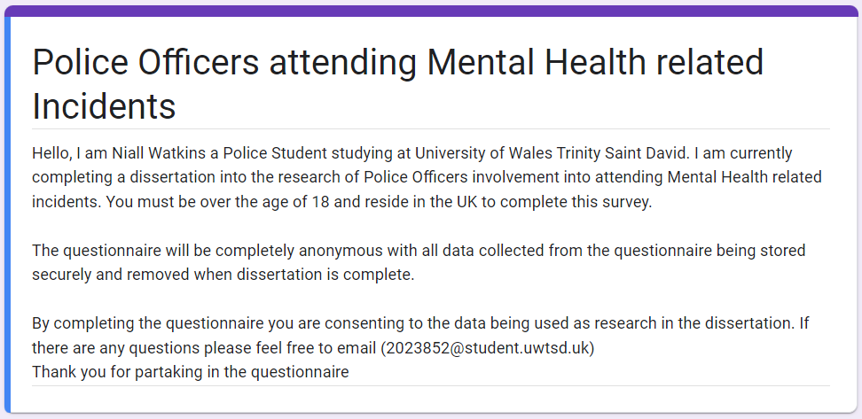
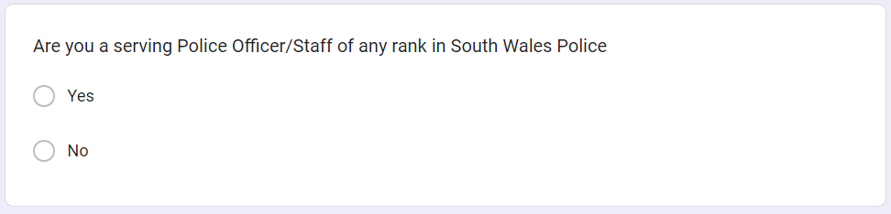
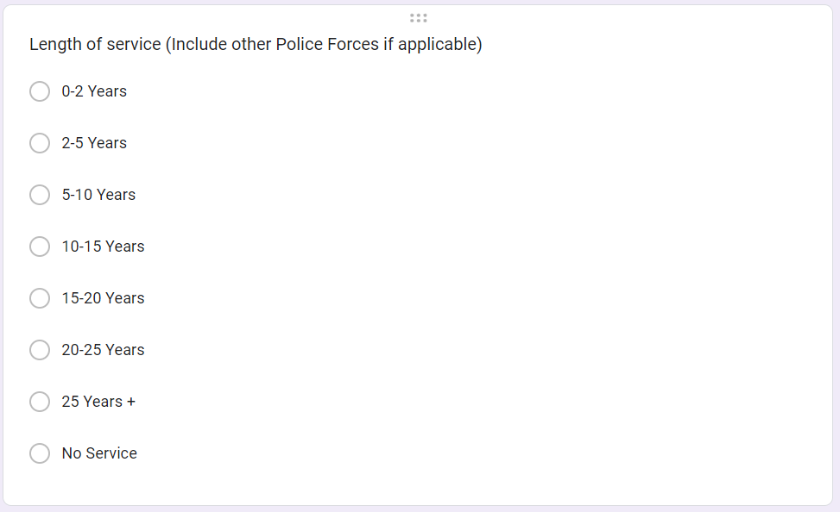
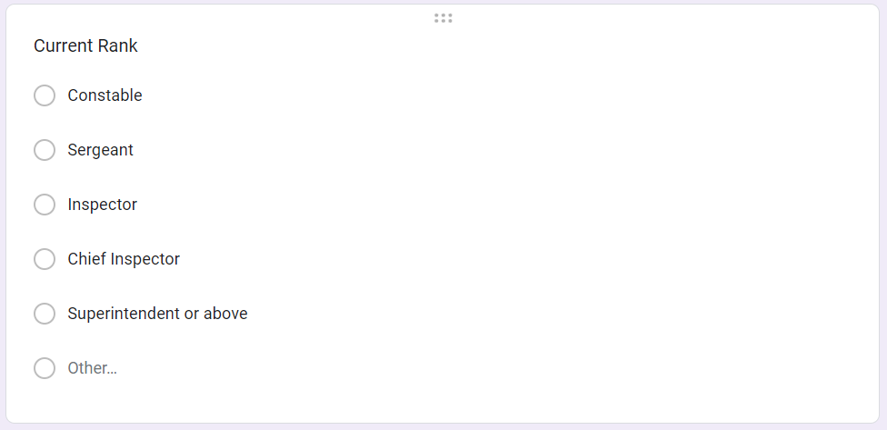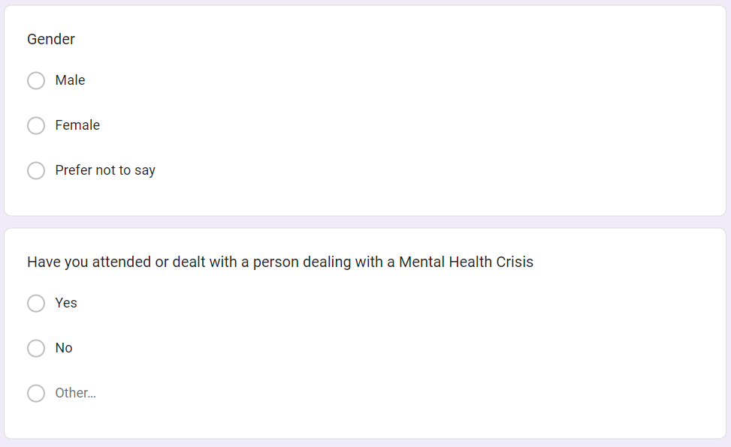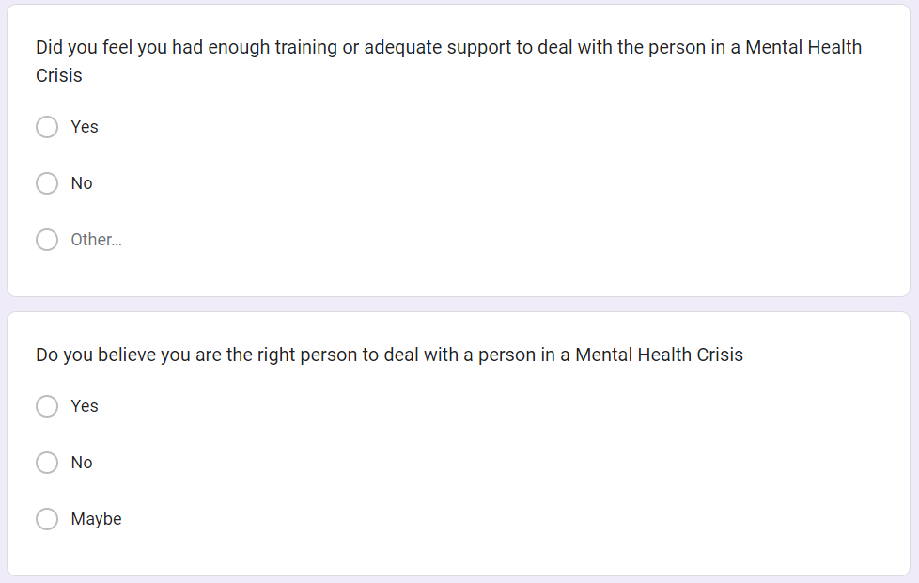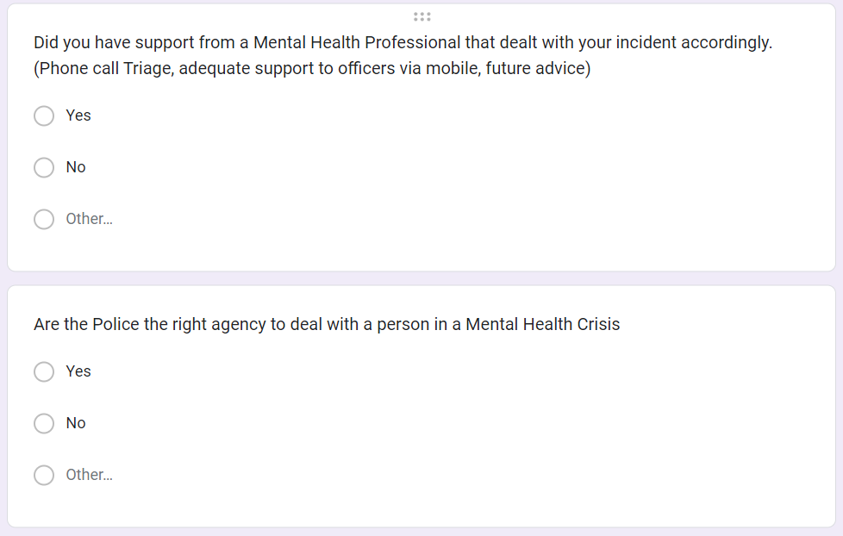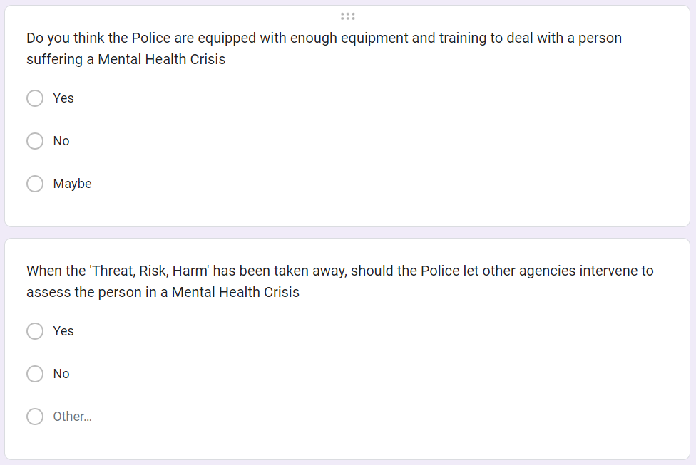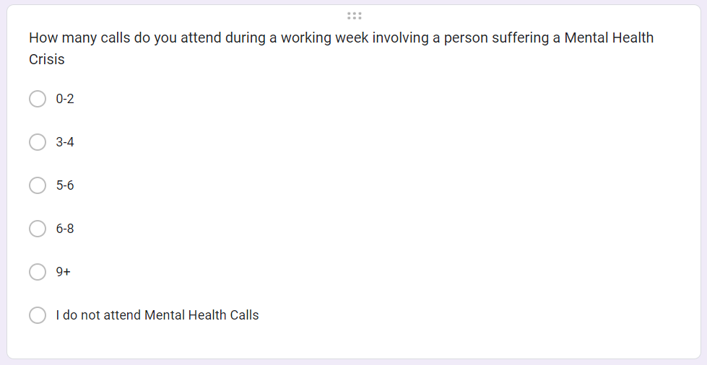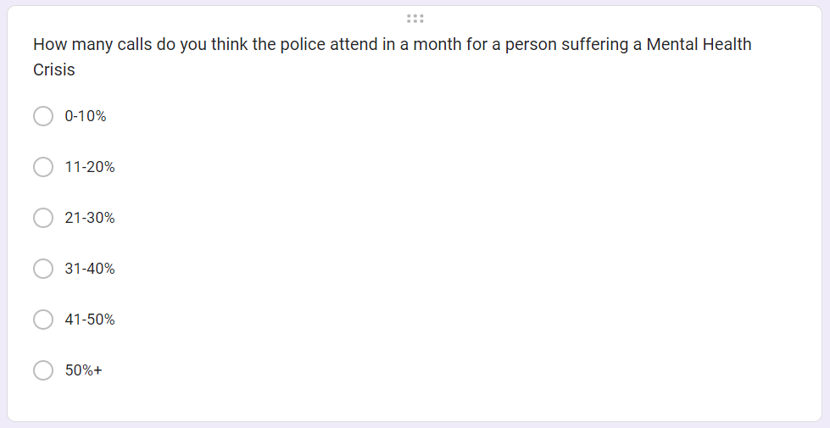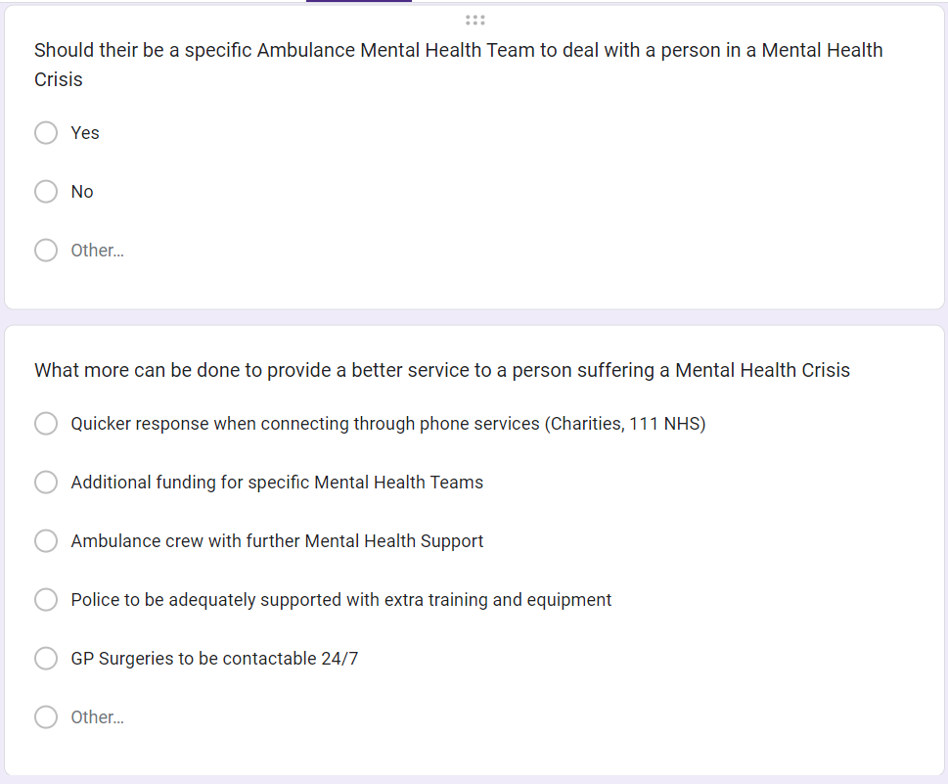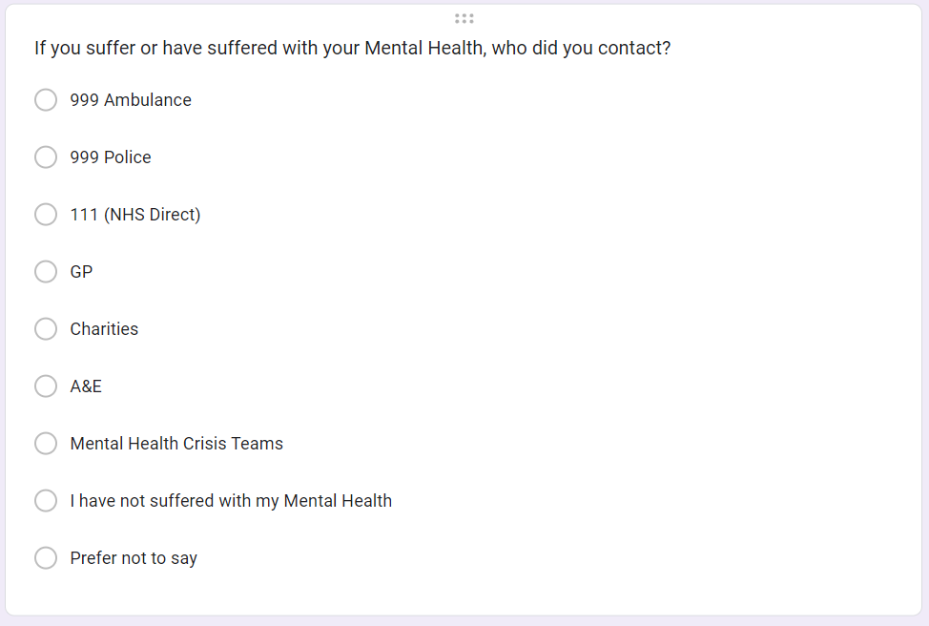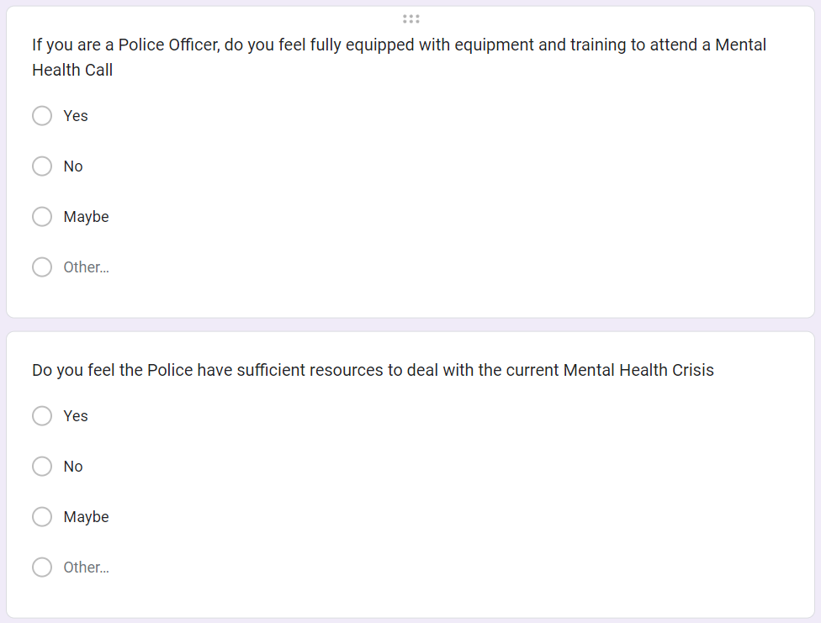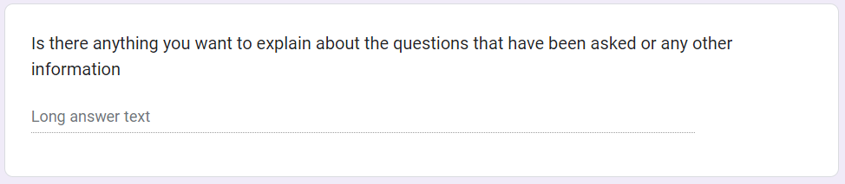
Appendix two – Questionnaire Responses
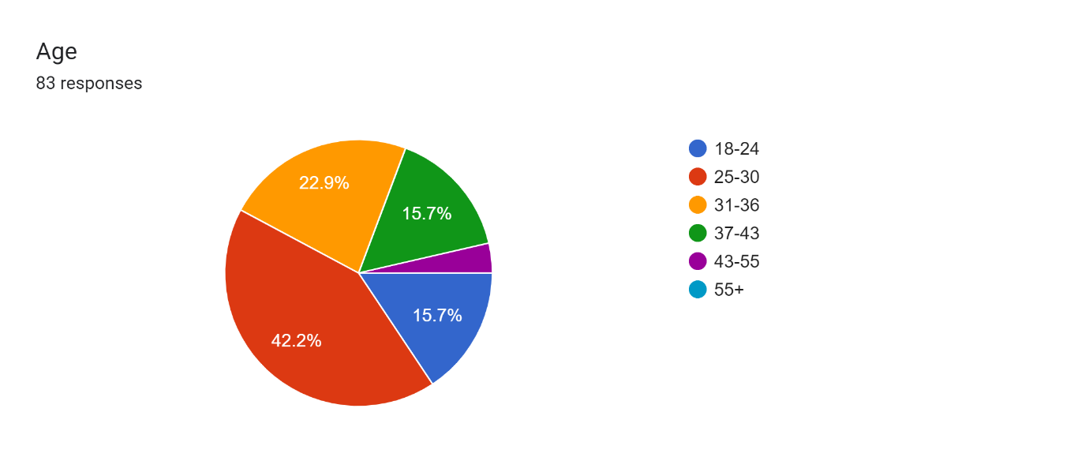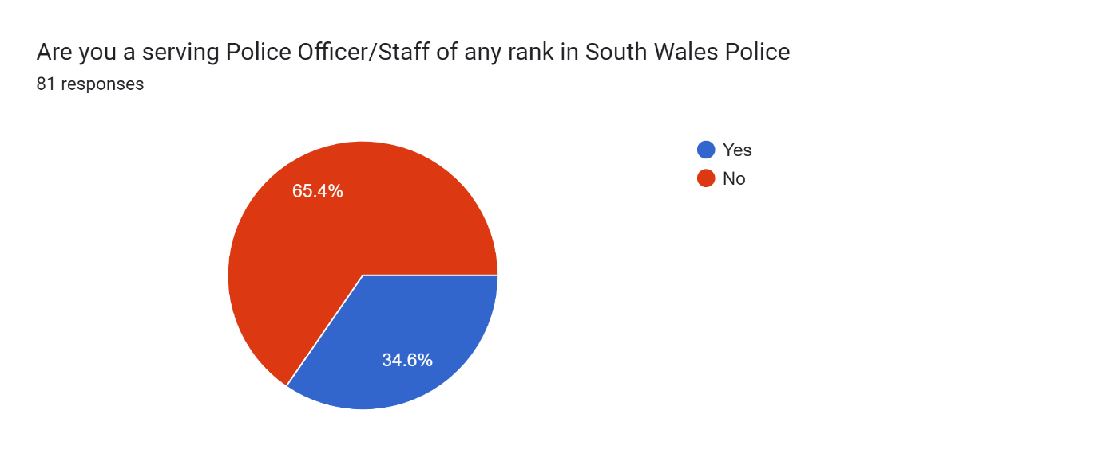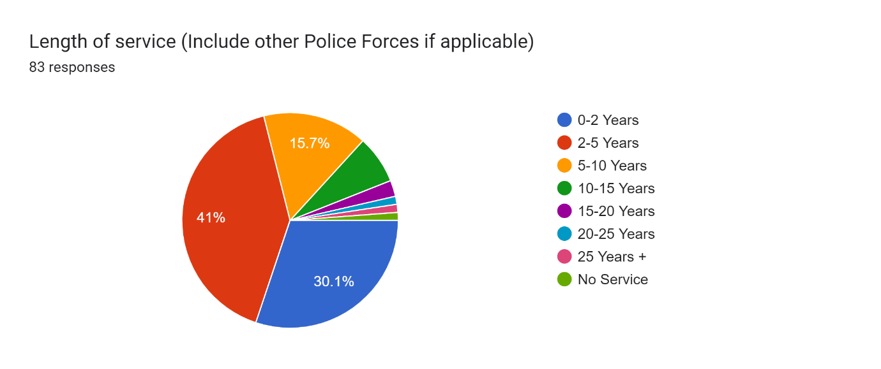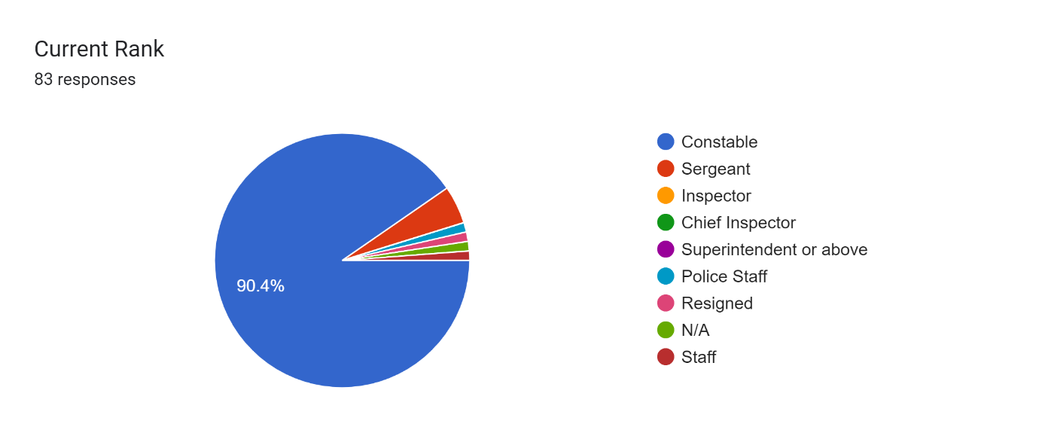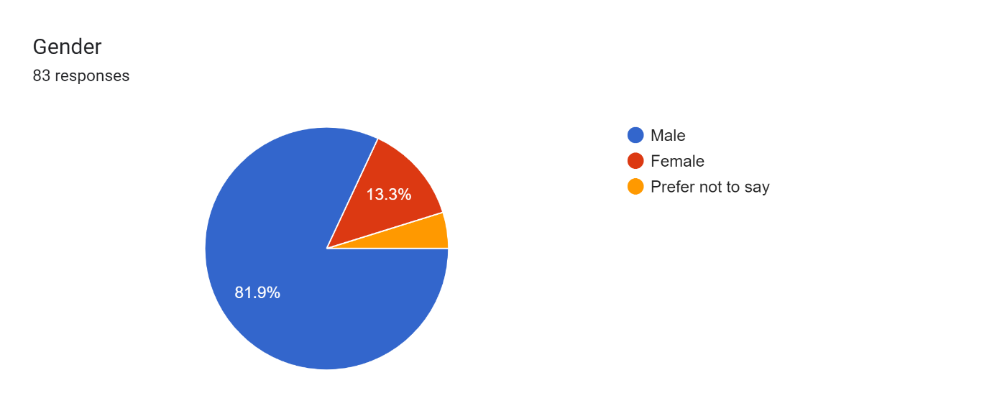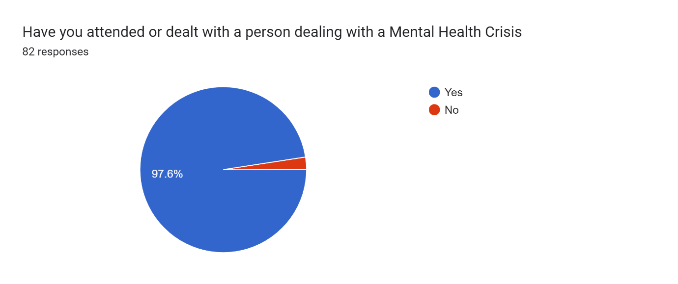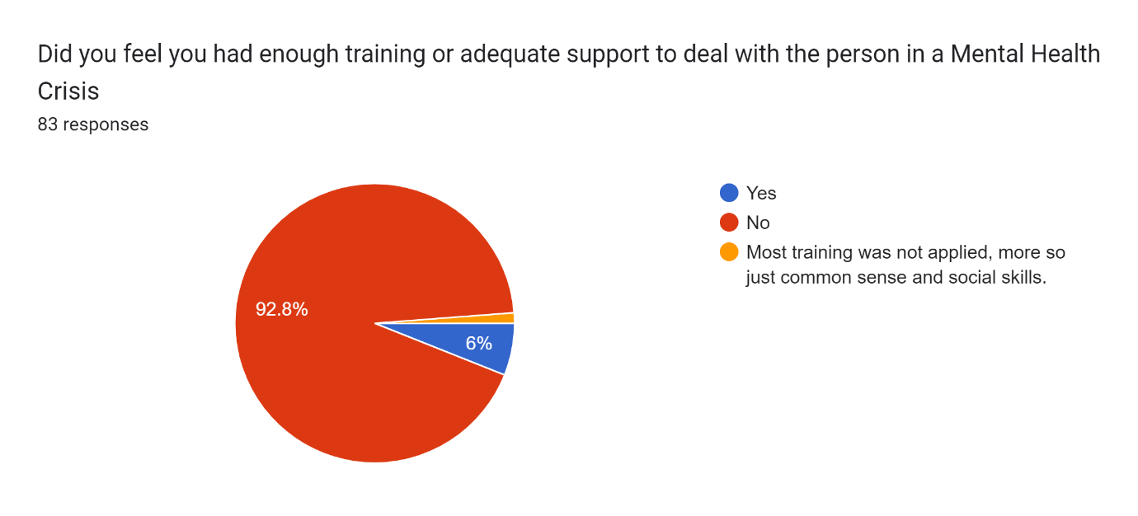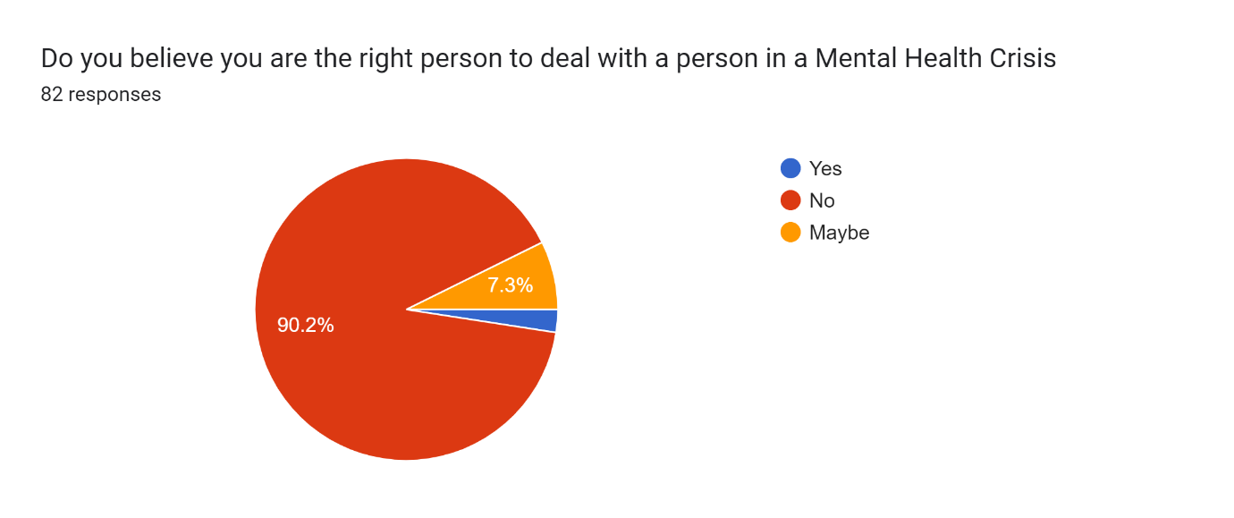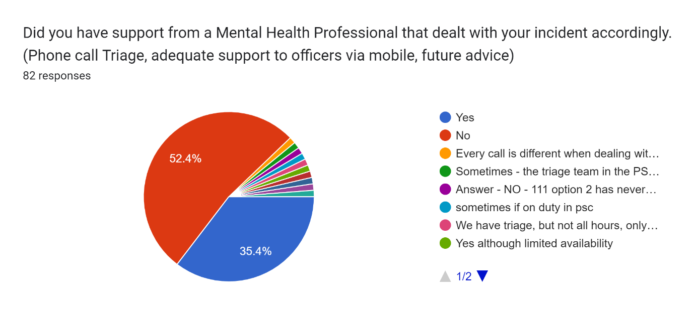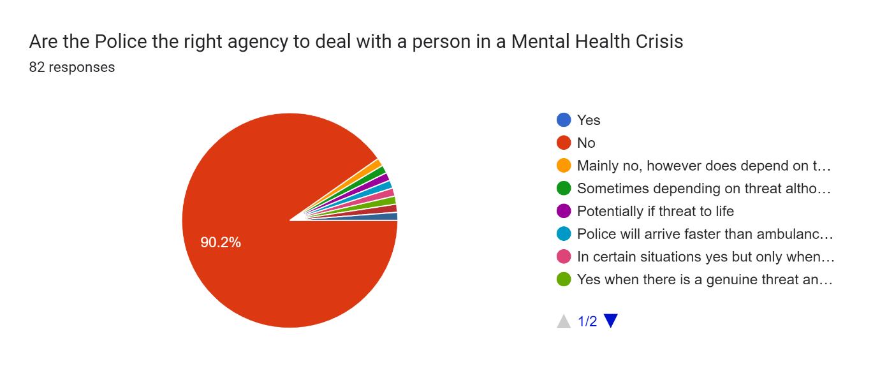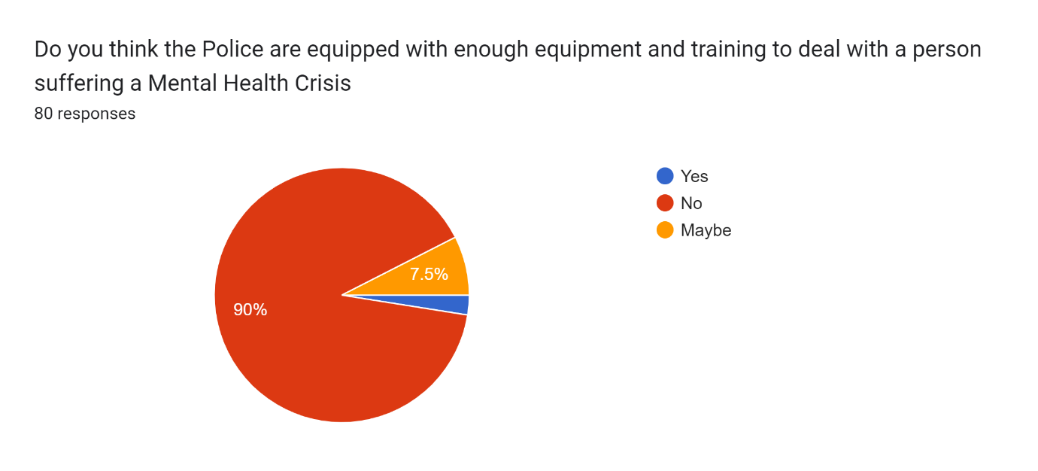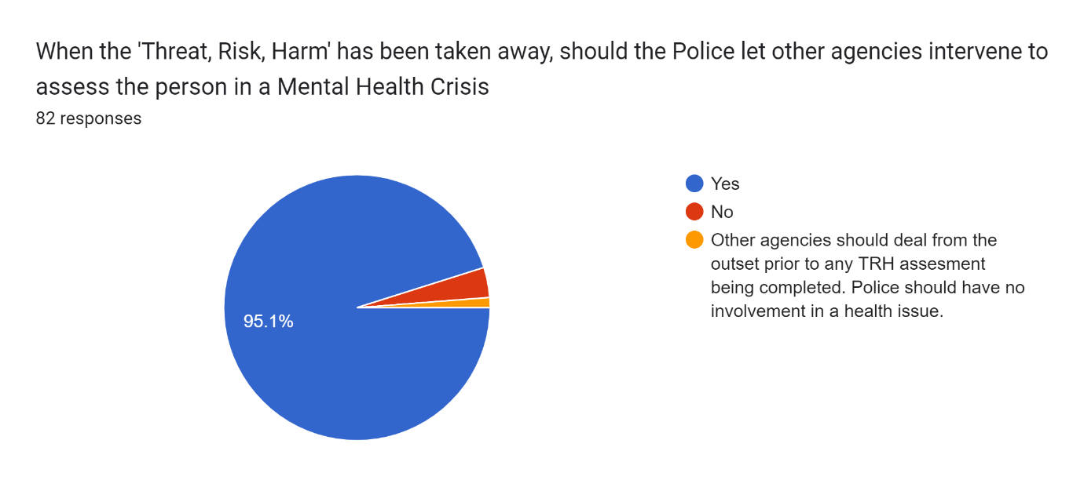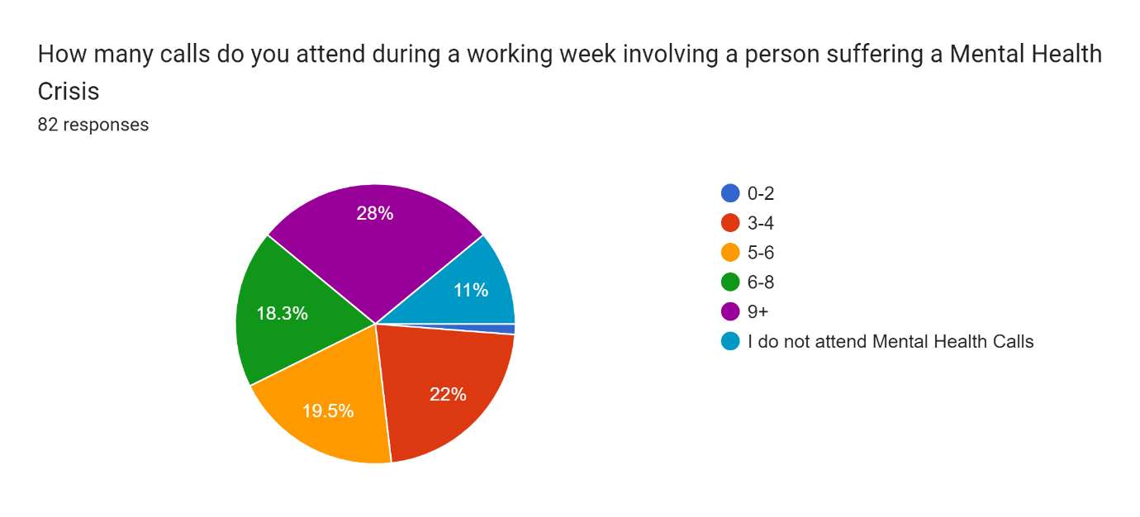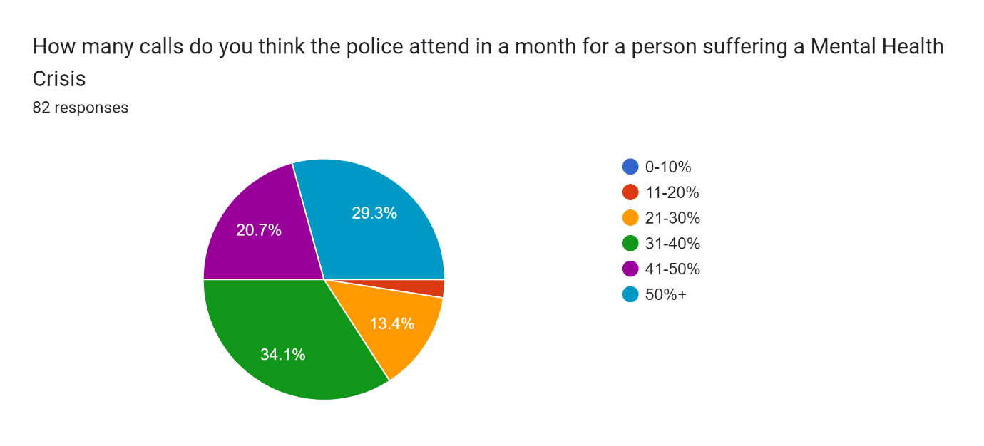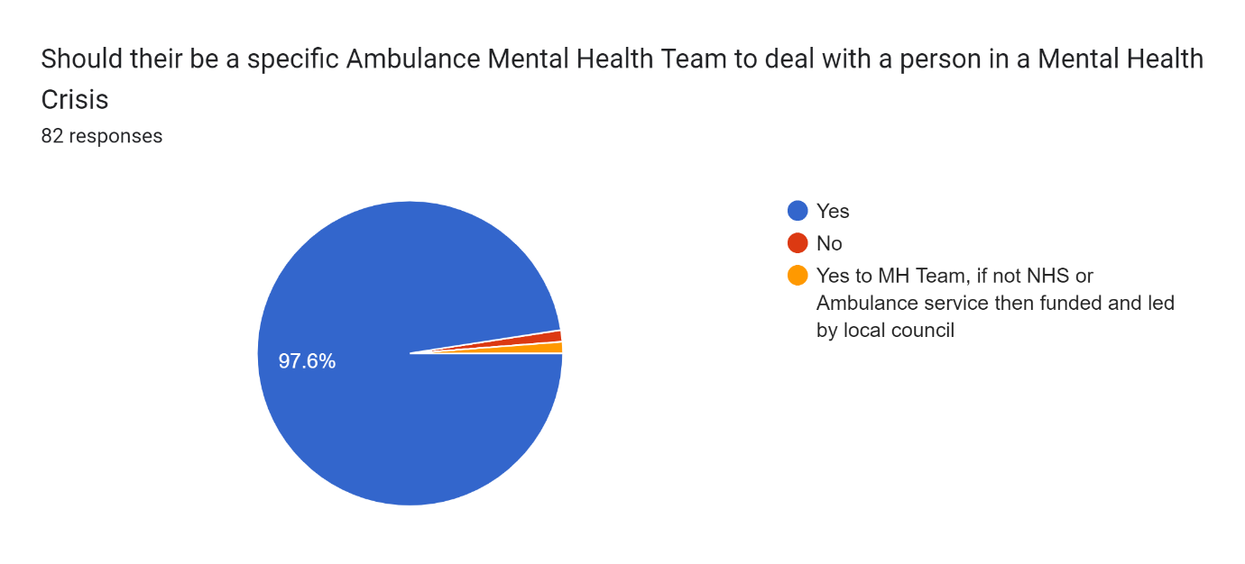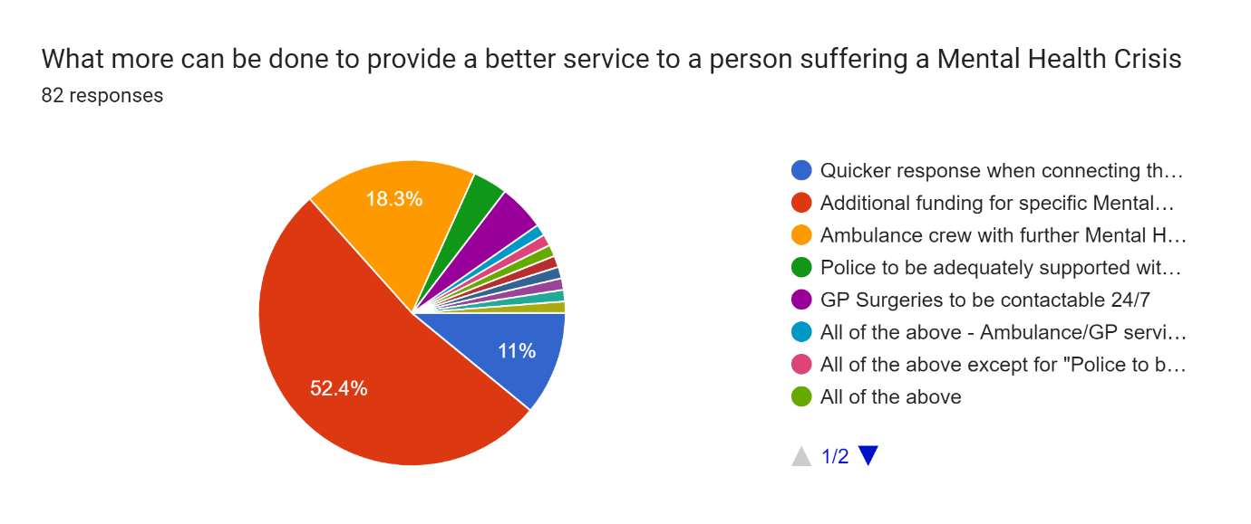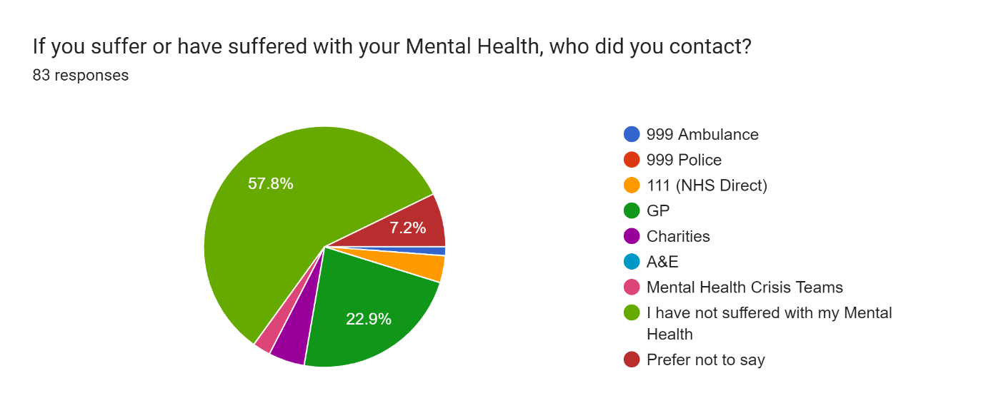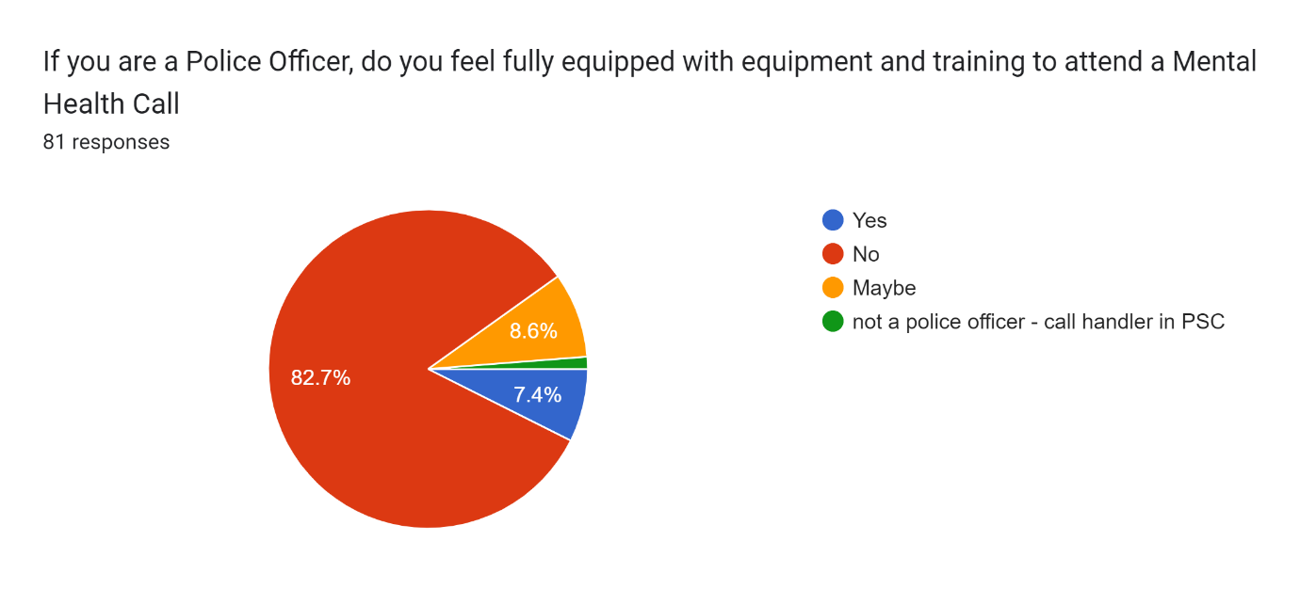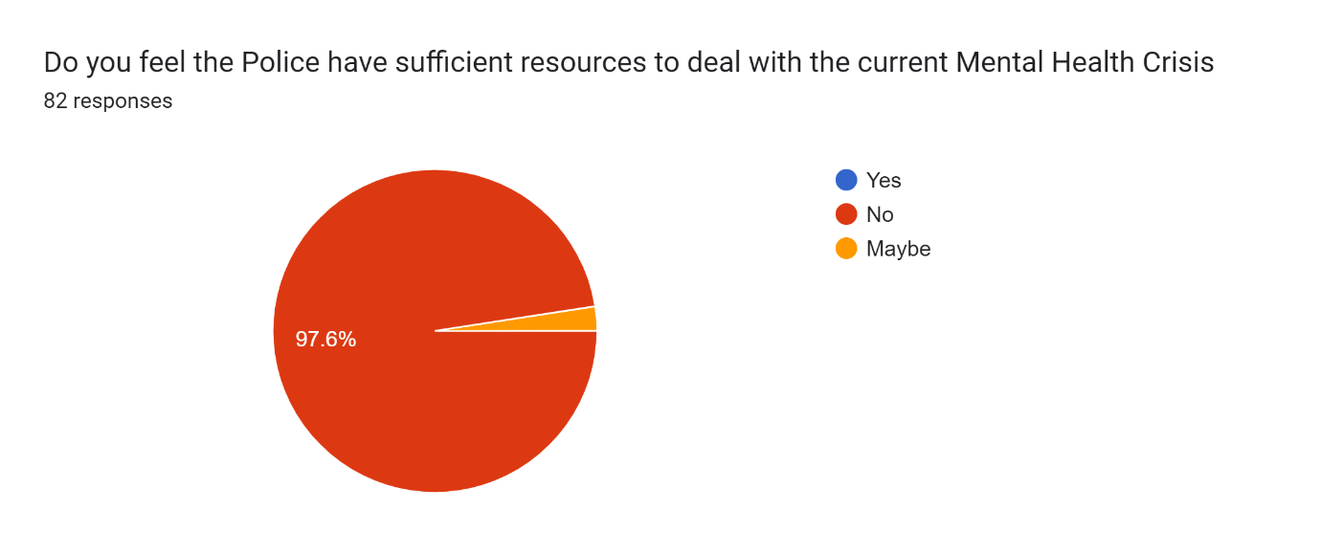
Is there anything you want to explain about the questions that have been asked or any other information20 responses
The Police deal with a lot of Mental Health calls, it is difficult to decipher the difference between a person in crisis explaining they want to kill themselves or that they want advice and support. Every person is different and each call is dealt with differently
mental ill health and it's impact cannot be underestimated in policing. The calls we attend with people at their lowest ebb to the drugs and alcohol issues that stem from, or impact upon mental wellbeing. The vast majority of policing has ties to mental ill health due to persons commiting crime to support habits that stem from these issues to the impact of drugs and alcohol on people in the moment. We should have a more 'joined up' approach with mental health practitioners attending calls with us rather than policing taking the slack for understaffed health issues

N/A

no thanks for the opportunity

no thankyou

Mental health response practitioners need to be put in place to deal with these types of calls, not police.

Police Officers are frequently used as the first port of call for MH related incidents which we are woefully unprepared to deal with. The training mainly consists of identifying it’s a MH incident, requesting help from a mental health professional for them to decline, requesting help from ambulance service, for them to decline, being forced to s136 the patient who then begins to assault officers causing them injury but we can’t arrest them as they have been s136. Having to wait anywhere between 24 to 48 hours to have two assessments done and wait for a place of safety that can take them whilst the detained person is actively trying to run away, fight emergency workers and tell you in one recent incident I have “I know where you live, I know you working nights in 2 days time, whose going to protect your wife and kids when I’m r***ing them when you’re at work?” Or “Thank you for helping me today, but if you leave I’m going to try and run away again” this was after the detained person was having a calm conversation with us before she calmly got up and with no warning and still smiling punched my colleague on the face before I got up and had to restrain her as she kept trying to assault my colleague. This is draining work which we’re not equipped for or adequately compensated for and assaults against us face no repercussion as CPS deem them to have no intent to cause harm as they “did not have capacity otherwise why would you S136 them?”.
It's not necessarily training - police powers for MH end at a person's property. I dealt with the same person 5 times who was having a MH crisis, every time they were at home and the NHS refused to attend. There's nothing police can do in these circumstances, unless the person voluntarily admits to hospital. Then if they abscond there's insufficient funding for officers to locate them before they get back home, meaning you're back to square one and they get no help. And of course, the police get the blame if it goes wrong.

Additional funding is required for more MH professionals and bed spaces, currently Officers are sat with MH patients for up to 24 hours if a Police Officer has placed the patient under a s136.

I work for the metropolitan police, the correctly trained team to deal with mental health crisis is the mental health services, the vast majority of mental health calls, the subjects do not have wepons, or threatening violence towards anyone else apart from themselves, they are suitable for NHS to attend without police attendance, Police officers should be on the streets dealing with crime. Not attending medical calls.

The police is currently filling the space of a non existent mental health triage team, and we are not being given sufficient training to deal with mental health. This also means if something goes wrong at these calls because of lack of training, the police then get plastered all over the news for the failing. Attendance at multiple MH calls also stops us being available to other high risk criminal incidents. With a S136 patient, you will lose a minimum of 6 officers in 24hrs. Hospitals are very slow to assess MH patients when police are present, which means we lose three shifts worth of police just sitting in hospital. We also have officers getting assaulted by patients, because the patients are getting agitated at being stuck in a room for hours with no doctors involvement. We have recently had a lot of hospitals let the S136 expire because of being so slow, which means a vulnerable person is back out on the streets and could harm themselves.

NHS and health circles are quick to put the responsibility to police. It's beyond breaking point.

No

The only reason I don't attend mental health calls now is because I work on PPU. On response and neighbourhood I attended many.

The police are an agency that deals with crime and criminals when it’s boiled down to the bare essence. At the moment we seem to be a catch all for other agencies who aren’t a 24hr service or don’t have the funding. Policing has changed over the last few years and mental health calls are more prevalent everyday. The police are not the right agency to be dealing with this. We aren’t trained for it and don’t have the staff numbers to cover it. It says it in the title mental HEALTH. This is a health issue and should be dealt with as such by the appropriate agencies namely NHS and mental health teams NOT the police.

Control room are sent mh jobs to make sure the risk is covered, implausible situation but we have to believe the caller
things will not change the police function is not being met cause they are dealing with every other service issue cause they are struggling and can't cope. the system is broken and will continue to be broken for a long time, money will not solve it but finding the right people to do the jobs will do.

Mental Health is clearly an issue that needs to be dealt with by Health. Its my opinion that police are the 'goto' agency that will not say no to MH calls, even when there is no immediate threat to life.

I can confirm first hand that mental health occupies an unreasonable amount of police time - time that should be spent on combatting crime across our nation.

The police are the police, we deal with crime and help to ensure that vulnerable victims of crime are protected and safeguarded. We do not have the necessary equipment or powers in order to deal with those suffering with their mental health. Where there is an elevated TRH then police should be utilised to negate any TRH with MH staff taking primary thereafter.

Appendix Three – Proposal Form
APPLICATION FOR ETHICAL APPROVAL

In order for research to result in benefit and minimise risk of harm, it must be conducted ethically. A researcher may not be covered by the University’s insurance if ethical approval has not been obtained prior to commencement.

The University follows the OECD Frascati manual definition of research activity: “creative work undertaken on a systematic basis in order to increase the stock of knowledge, including knowledge of man, culture and society, and the use of this stock of knowledge to devise new applications”. As such this covers activities undertaken by members of staff, postgraduate research students, and both taught postgraduate and undergraduate students working on dissertations/projects.

The individual undertaking the research activity is known as the “principal researcher”.

Ethical approval is not required for routine audits, performance reviews, quality assurance studies, testing within normal educational requirements, and literary or artistic criticism.

Please read the notes for guidance before completing ALL sections of the form.

This form must be completed and approved prior to undertaking any research activity. Please see Checklist for details of process for different categories of application.

Delete the Guidance Notes at the end of the form BEFORE submitting your application

SECTION A: About You (Principal Researcher)
Full Name: |  | Niall Christopher Watkins
Tick all boxes which apply: |  | Member of staff: | ☐ | Honorary research fellow: | ☐
Undergraduate Student | ☒ | Taught Postgraduate Student | ☐ | Postgraduate Research Student | ☐

Institute/Academic Discipline/Centre: | IMH
Campus: | Swansea
E-mail address: | 202385@student.uwtsd.ac.uk
Contact Telephone Number:
For students:
Student Number: | 2023852
Programme of Study: | BSC Honours Professional Policing Practice
Director of Studies/Supervisor: | Laura Shobiye

SECTION B: Approval for Research Activity
Has the research activity received approval in principle?  (please check the Guidance Notes as to the appropriate approval process for different levels of research by different categories of individual) |  | YES | ☒ | NO | ☐
 |  |  |  | Date
If Yes, please indicate source of approval (and date where known): Approval in principle must be obtained from the relevant source prior to seeking ethical approval | Research Degrees Committee |  | ☐
 | Institute Research Committee |  | ☐
 | Other (write in) |  | ☒ | Laura Shobiye

SECTION C: Internal and External Ethical Guidance Materials
Please list the core ethical guidance documents that have been referred to during the completion of this form (including any discipline-specific codes of research ethics, and also any specific ethical guidance relating to the proposed methodology). Please tick to confirm that your research proposal adheres to these codes and guidelines.
UWTSD Research Ethics & Integrity Code of Practice | ☒
UWTSD Research Data Management Policy | ☒
 | ☐

SECTION D: External Collaborative Research Activity
Does the research activity involve collaborators outside of the University? |  | YES | ☐ | NO | ☒
If Yes, please provide the name of the external organisation and name and contact details for the main contact person and confirmation this person has consented to their personal data being shared.as part of this collaboration.
Institution
Contact person name
Contact person e-mail address

Has this individual consented to sharing their details on this form? |  | YES | ☐ | NO |  |  | ☒
Are you in receipt of a KESS scholarship? |  | YES | ☐ | NO |  |  | ☒
Is your research externally funded |  | YES | ☐ | NO |  |  | ☒
Are you specifically employed to undertake this research in either a paid or voluntary capacity? | Voluntary | YES | ☐ | NO |  | ☒
 | Employed | YES | ☐ | NO |  | ☒
Is the research being undertaken within an existing UWTSD Athrofa Professional Learning Partnership (APLP) | If YES then the permission question below does not need to be answered. | YES | ☐ | NO |  |  | ☒
Permission to undertake the research has been provided by the partner organisation | (If YES attach copy)  If NO the application cannot continue | YES | ☐ | NO |  |  | ☒

Where research activity is carried out in collaboration with an external organisation
Does this organisation have its own ethics approval system? | YES | ☐ | NO | ☒
If Yes, please attach a copy of any final approval (or interim approval) from the organisation

SECTION E: Details of Research Activity
Indicative title: | Are Police Forces in England and Wales becoming the forefront agency to deal with the current Mental Health Crisis
Proposed start date: | 2nd January 2023 | Proposed end date: | 13th November 2023
Introduction to the Research (maximum 300 words)
Ensure that you write for a Non-Specialist Audience when outlining your response to the three points below:
- Purpose of Research Activity
- Proposed Research Question
- Aims of Research Activity
- Objectives of Research Activity
Demonstrate, briefly, how Existing Research has informed the proposed activity and explain
- What the research activity will add to the body of knowledge
- How it addresses an area of importance.
Purpose of Research Activity

During project research, I will be making use of several research articles, books and reports which has previously highlighted the Mental Health Crisis that is currently ongoing. This Mental Health Crisis is affecting the Police Forces in England and Wales whereby a large proportion of calls are attending a person in a mental health crisis. Part of the research for this dissertation will require me to carry out a questionnaire for police officers who are either currently working or retired in the United Kingdom.

(this box should expand as you type)
Research Question
My Research Question is surrounding the current Mental Health Crisis and is the Police Forces in England and Wales becoming the forefront agency to deal with the ongoing crisis.

(this box should expand as you type)
Aims of Research Activity

The aim of my research will be to provide a better understanding of how Police Forces deal with a Mental Health Crisis and what steps are being put into place for the future where the Threat, Risk or Harm has been taken away for the Police to be supported by the mental health advisors to come away from the individual rather than spend many hours sitting with them until support has arrived.

(this box should expand as you type)
Objectives of Research Activity
The research that I will conduct during my dissertation is how the current Mental Health crisis is not only affecting Crisis Teams but how it has an impact on the Police Service who are already understaffed and when the Police are involved the sheer amount of time consumed dealing with a person who needs expert Mental Health advice rather than Police support.

- Explore statistics surrounding the amount of Mental Health incidents the Police attend e.g., Amount of calls Police are involved with where there is only a Mental Health concern, Amount of time dealing with a person in need of Mental Health advice
- Discuss key points from Police Officers on how Mental Health incidents should be treated when the Threat, Risk or Harm has been removed
- To investigate Police Officers views and roles in dealing with a vulnerable person in a Mental Health Crisis

(this box should expand as you type)
Proposed methods (maximum 600 words)
Provide a brief summary of all the methods that may be used in the research activity, making it clear what specific techniques may be used. If methods other than those listed in this section are deemed appropriate later, additional ethical approval for those methods will be needed.
There are many types of research that can be used the conduct studies. These proposed methods are the strategies, processes or techniques used to collect data or evidence for analysis to create a better understanding of a topic. There are 2 specific types of research, Qualitive and Quantitative.

Qualitive gathers data about lived experiences, emotions, or behaviours. This assists in enabling researchers to gain a better understanding of concepts, social interactions. This type of research is useful in exploring of how or why they have occurred where you can interpret and describe the actions

Quantitative is numerical based which can be ranked, measured, or categorised through statistics. This data can then be turned into numbers. Its objectives involve hard facts with the data then analysed to draw conclusions.

These are some of the techniques used to gather research data.
- Interviews
With interviews the researcher will have a written list of questions for their subjects during the interviews, these questions are structured around the research setting. These interviews can be analysed qualitatively or quantitatively depending on what questions are to be asked.
- Focus Groups
Like an interview this is gathering participants together to ask the questions to the group. Depending on how the researcher wants to conduct the group the researcher may observe the focus group while taking notes or facilitate the group by heading the group with the questions
- Surveys or Questionnaires
A survey or questionnaire can target a large audience or individuals. These questions that are asked are typically used to measure quantitative data. The researcher will translate the answers into numerical data where they data can then be observed to complete their research. This is a good way of targeting a high number of participants where the questionnaire can be completed at any time of the day if the individual is busy and can return the questionnaire later.
- Experiments
Experiments involve testing a theory in a lab environment in a controlled area with willing participants. By asking participants verbally, on paper or via a computer to get the answers.

Having researched different proposed methods, I believe that the Questionnaire/Survey is best applicable for my research. Being able to target many participants who can input answers anonymously where they would be free to provide the correct answer. By targeting a larger audience, I will have a larger quantitative data to complete my research and gather the results to formalise my dissertation.

(this box should expand as you type)

Location of research activity
Identify all locations where research activity will take place.
The research will be conducted with the Police Forces in England and Wales, the questionnaire will be designed specifically for Police Forces in England and Wales

(this box should expand as you type)
Research activity outside of the UK
If research activity will take place overseas, you are responsible for ensuring that local ethical considerations are complied with and that the relevant permissions are sought. Specify any local guidelines (e.g. from local professional associations/learned societies/universities) that exist and whether these involve any ethical stipulations beyond those usual in the UK (provide details of any licenses or permissions required). Also specify whether there are any specific ethical issues raised by the local context in which the research activity is taking place, for example, particular cultural and/or legal sensitivities or vulnerabilities of participants.
N/A

(this box should expand as you type)
Use of documentation not in the public domain: Are any documents NOT publicly available? | NO | ☒
 | YES | ☐
If Yes, please provide details here of how you will gain access to specific documentation that is not in the public domain and that this is in accordance with prevailing data protection law of the country in question and England and Wales.

(this box should expand as you type)

SECTION F: Scope of Research Activity
Will the research activity include: | YES | NO
Use of a questionnaire or similar research instrument? | ☒ | ☐
Use of interviews? | ☐ | ☒
Use of diaries? | ☐ | ☒
Participant observation with their knowledge? | ☐ | ☒
Participant observation without their knowledge? | ☐ | ☒
Use of video or audio recording? | ☐ | ☒
Access to personal or confidential information without the participants’ specific consent? | ☐ | ☒
Administration of any questions, test stimuli, presentation that may be experienced as physically, mentally or emotionally harmful / offensive? | ☐ | ☒
Performance of any acts which may cause embarrassment or affect self-esteem? | ☐ | ☒
Investigation of participants involved in illegal activities? | ☐ | ☒
Use of procedures that involve deception? | ☐ | ☒
Administration of any substance, agent or placebo? | ☐ | ☒
Working with live vertebrate animals? | ☐ | ☒
Other primary data collection methods, please explain in this box  For example, ‘focus groups’. Please indicate the type of data collection method(s) in this box and tick the accompany box. | ☐ | ☒
Details of any other primary data collection method:  (this box should expand as you type) | ☐ | ☒
If NO to every question, then the research activity is (ethically) low risk and may be exempt from some of the following sections (please refer to Guidance Notes).

If YES to any question, then no research activity should be undertaken until full ethical approval has been obtained.

SECTION G: Intended Participants
Who are the intended participants: | YES | NO
Students or staff at the University? | ☒ | ☐
Adults (over the age of 18 and competent to give consent)? | ☒ | ☐
Vulnerable adults? | ☐ | ☒
Children and Young People under the age of 18? (Consent from Parent, Carer or Guardian will be required) | ☐ | ☒
Prisoners? | ☐ | ☒
Young offenders? | ☐ | ☒
Those who could be considered to have a particularly dependent relationship with the investigator or a gatekeeper? | ☐ | ☒
People engaged in illegal activities? | ☐ | ☒
Others (please identify specifically any group who may be unable to give consent) please indicate here and tick the appropriate box. | ☐ | ☒
Other – please indicate here:  (this box should expand as you type) | ☐ | ☒

Participant numbers and source
Provide an estimate of the expected number of participants. How will you identify participants and how will they be recruited?
How many participants are expected? | 30-50 participants are expected to be surveyed for my questionnaire. This is considered a acceptable sample size for the amount of time to conduct and conclude a questionnaire  (this box should expand as you type)
Who will the participants be? | Colleagues/Students who are either currently serving as a Police Officer of any rank and who have previously been a Police Officer of any rank. These are the most knowledge about the current Mental Health Crisis and will provide raw feedback on their own experiences and solutions.  (this box should expand as you type)
How will you identify the participants? | University, Intranet, Social Media  (this box should expand as you type)

Information for participants: | YES | NO | N/A
Will you describe the main research procedures to participants in advance, so that they are informed about what to expect? | ☒ | ☐ | ☐
Will you tell participants that their participation is voluntary? | ☒ | ☐ | ☐
Will you obtain written consent for participation? | ☐ | ☐ | ☒
Will you explain to participants that refusal to participate in the research will not affect their treatment or education (if relevant)? | ☐ | ☐ | ☒
If the research is observational, will you ask participants for their consent to being observed? | ☐ | ☐ | ☒
Will you tell participants that they may withdraw from the research at any time and for any reason? | ☒ | ☐ | ☐
With questionnaires, will you give participants the option of omitting questions they do not want to answer? | ☒ | ☐ | ☐
Will you tell participants that their data will be treated with full confidentiality and that, if published, it will not be identifiable as theirs? | ☒ | ☐ | ☐
Will you debrief participants at the end of their participation, in a way appropriate to the type of research undertaken? | ☒ | ☐ | ☐
If NO to any of above questions, please give an explanation
(this box should expand as you type)

Information for participants: | YES | NO | N/A
Will participants be paid? | ☐ | ☒ | ☐
Is specialist electrical or other equipment to be used with participants? | ☐ | ☒ | ☐
Are there any financial or other interests to the investigator or University arising from this study? | ☐ | ☒ | ☐
Will the research activity involve deliberately misleading participants in any way, or the partial or full concealment of the specific study aims? | ☐ | ☒ | ☐
If YES to any question, please provide full details
(this box should expand as you type)

SECTION H: Anticipated Risks

Outline any anticipated risks that may adversely affect any of the participants, the researchers and/or the University, and the steps that will be taken to address them.

If you have completed a full risk assessment (for example as required by a laboratory, or external research collaborator) you may append that to this form.
Full risk assessment completed and appended? |  | Yes | ☐
 |  | No | ☒
Risks to participants
For example: emotional distress, financial disclosure, physical harm, transfer of personal data, sensitive organisational information
Risk to Participant:  No risk identified to any participant  (this box should expand as you type) | How will you mitigate the Risk to Participant  (this box should expand as you type)
If research activity may include sensitive, embarrassing or upsetting topics (e.g. sexual activity, drug use) or issues likely to disclose information requiring further action (e.g. criminal activity), give details of the procedures to deal with these issues, including any support/advice (e.g. helpline numbers) to be offered to participants. Note that where applicable, consent procedures should make it clear that if something potentially or actually illegal is discovered in the course of a project, it may need to be disclosed to the proper authorities
(this box should expand as you type)
Risks to investigator
For example: personal safety, physical harm, emotional distress, risk of accusation of harm/impropriety, conflict of interest
Risk to Investigator:  N/A  (this box should expand as you type) | How will you mitigate the Risk to Investigator:  (this box should expand as you type)
University/institutional risks
For example: adverse publicity, financial loss, data protection
Risk to University:  On completion of this Ethics Form I do not believe there are any ethical issues that will transpire from this research.  (this box should expand as you type) | How will you mitigate the Risk to University:  (this box should expand as you type)

Disclosure and Barring Service
If the research activity involves children or vulnerable adults, a Disclosure and Barring Service (DBS) certificate must be obtained before any contact with such participants. | YES | NO | N/A
Does your research require you to hold a current DBS Certificate? | ☐ | ☒ | ☐

SECTION I: Feedback, Consent and Confidentiality
Feedback
What de-briefing and feedback will be provided to participants, how will this be done and when?
Feedback from the questionnaire can be provided at the end of the dissertation date provided above. Although the results are not intrusive there would be no requirements to de-brief

(this box should expand as you type)
Informed consent
Describe the arrangements to inform potential participants, before providing consent, of what is involved in participating. Describe the arrangements for participants to provide full consent before data collection begins. If gaining consent in this way is inappropriate, explain how consent will be obtained and recorded in accordance with prevailing data protection legislation.
Consent will be provided at the start of the questionnaire.

(this box should expand as you type)
Confidentiality / Anonymity
Set out how anonymity of participants and confidentiality will be ensured in any outputs. If anonymity is not being offered, explain why this is the case.
No confidential information will be held

(this box should expand as you type)

SECTION J: Data Protection and Storage
In completing this section refer to the University’s Research Data Management Policy and the extensive resources on the University’s Research Data Management web pages (http://uwtsd.ac.uk/library/research-data-management/).
Does the research activity involve personal data (as defined by the General Data Protection Regulation 2016 “GDPR” and the Data Protection Act 2018 “DPA”)? | YES | NO
“Personal data” means any information relating to an identified or identifiable natural person (‘data subject’). An identifiable natural person is one who can be identified, directly or indirectly, in particular by reference to an identifier such as a name, an identification number, location data, an online identifier or to one or more factors specific to the physical, physiological, genetic, mental, economic, cultural or social identity of that natural person. | ☐ | x
If YES, provide a description of the data and explain why this data needs to be collected:
(this box should expand as you type)
Does it involve special category data (as defined by the GDPR)? | YES | NO
“Special category data” means sensitive personal data consisting of information as to the data subjects’ –  (a) racial or ethnic origin,  (b) political opinions,  (c ) religious beliefs or other beliefs of a similar nature,  (d) membership of a trade union (within the meaning of the Trade Union and Labour Relations (Consolidation) Act 1992),  (e) physical or mental health or condition,  (f) sexual life,  (g) genetics,  (h) biometric data (as used for ID purposes), | ☐ | x
If YES, provide a description of the special category data and explain why this data needs to be collected:
(this box should expand as you type)
Will the research activity involve storing personal data and/or special category data on one of the following: | YES | NO
Manual files (i.e. in paper form)? | ☐ | ☒
University computers? | ☒ | ☐
Private company computers? | ☐ | ☒
Home or other personal computers? | ☐ | ☒
Laptop computers/ CDs/ Portable disk-drives/ memory sticks? | ☐ | ☒
“Cloud” storage or websites? | ☐ | ☒
Other – specify: | ☐ | ☒
For all stored data, explain the measures in place to ensure the security of the data collected, data confidentiality, including details of password protection, encryption, anonymisation and pseudonymisation:
(this box should expand as you type)
All Data Storage
Will the research activity involve any of the following activities: | YES | NO
Electronic transfer of data in any form? | ☐ | ☒
Sharing of data with others at the University? | ☐ | ☒
Sharing of data with other organisations? | ☐ | ☒
Export of data outside the European Union or importing of data from outside the UK? | ☐ | ☒
Use of personal addresses, postcodes, faxes, emails or telephone numbers? | ☐ | ☒
Publication of data that might allow identification of individuals? | ☐ | ☒
Use of data management system? | ☐ | ☒
Data archiving? | ☐ | ☒
If YES to any question, please provide full details, explaining how this will be conducted in accordance with the GDPR and DPA (and/or any international equivalent):
(this box should expand as you type)
List all who will have access to the data generated by the research activity:
N/A

(this box should expand as you type)
List who will have control of, and act as custodian(s) for, data generated by the research activity:
N/A

(this box should expand as you type)
Give details of data storage arrangements, including security measures in place to protect the data, where data will be stored, how long for, and in what form. Will data be archived – if so how and if not why not.
N/A

(this box should expand as you type)
Please indicate if your data will be stored in the UWTSD Research Data Repository (see https://researchdata.uwtsd.ac.uk/ ). If so please explain. (Most relevant to academic staff)
(this box should expand as you type)
Confirm that you have read the UWTSD guidance on data management (see https://www.uwtsd.ac.uk/library/research-data-management/) | YES | ☒
 | NO | ☐
Confirm that you are aware that you need to keep all data until after your research has completed or the end of your funding | YES | ☒
 | NO | ☐

SECTION K: Declaration
The information which I have provided is correct and complete to the best of my knowledge. I have attempted to identify any risks and issues related to the research activity and acknowledge my obligations and the rights of the participants.

In submitting this application I hereby confirm that I undertake to ensure that the above named research activity will meet the University’s Research Ethics and Integrity Code of Practice which is published on the website: https://www.uwtsd.ac.uk/research/research-ethics/
Signature of applicant: | Watkins. N | Date: 08/10/23

For STUDENT Submissions:
Director of Studies/Supervisor: |  | Date:
Signature: |  | Date:

For STAFF Submissions:
Academic Director/ Assistant Dean: |  | Date:
Signature: |  | Date:

Checklist: Please complete the checklist below to ensure that you have completed the form according to the guidelines and attached any required documentation:
☒ | I have read the guidance notes supplied before completing the form.
☒ | I have completed ALL RELEVANT sections of the form in full.
☒ | I confirm that the research activity has received approval in principle
☐ | I have attached a copy of final/interim approval from external organisation (where appropriate)
☐ | I have attached a full risk assessment (and have NOT completed Section H of this form) (where appropriate) ONLY TICK IF YOU HAVE ATTACHED A FULL RISK ASSESSMENT
☒ | I understand that it is my responsibility to ensure that the above named research activity will meet the University’s Research Ethics and Integrity Code of Practice.
☒ | I understand that before commencing data collection all documents aimed at respondents (including information sheets, consent forms, questionnaires, interview schedules etc.) must be confirmed by the DoS/Supervisor, module tutor or Academic Director.
☐ | I have deleted the guidance notes before submitting the PG2 for consideration

