University of Wales
Trinity Saint David

Understanding The Gender Pay Gap Within Birmingham City Council

Professor Pepple
Peolita Douglas- 1911615

Contents
1.1 Chapter 1 Introduction , Page 3
1.2 Background Equal Pay and Gender , Page 5
1.3 Background Birmingham City Council, Page 8
1.4 Birmingham City Council Cases, Page 14
1.5 Rationale , Page 16
1.6 Chapter Summary, Page 17
2.1 Introduction, Page 19
2.2 Literature Review/ Systamatic, Page 21
2.3 Data Collection Report , Page 23
2.4 Literature Gap, Page 25
3.1 Study Design, Page 26
3.2 Research Approach, Page 28
3.2a Inclusion - Exclusion, Page 29
3.3 Methods of Data, Page 30
3.4 Data Analysis , Page 31
4.1 Introduction , Page 33
4.1.1 Systematic Review, Page 34
4.2 Gender Pay Gap Data, Page 48
4.3 The Effects of Gender Pay Strategies, Page 52
4.4 Gender Findings of periodical data of Gender Gap Reports , Page 55
4.5 Gender Gap Pay Globally, Page 57
4.6 Findings of periodical data of Gender Gap Reports, Page 58
4.7 Findings of Successful Cases Won Against Birmingham Council, Page 59
4.8 Findings of where Equal Rights was Noted Publicly, Page 60
4.9 Research Gap, Page 62
5. Conclusion , Page 63
5.2 Contributions to Literature on Gender Gap Pay, Page 64
5.3 5.3 Recommendations for Resolving Gender Pay Gap, Page 65
6. Bibliography, Page 66

1.1 Chapter 1: Introduction
This report aims to discuss equal pay as this is a subject of equality that cannot be ignored, this is a topic that has been returning every decade globally, to the workforces who employ both sectors, however only one sector is being paid a fair wage, women are not being equally paid globally and presently now locally in the largest European Local Authority, Birmingham City Council. There have been numerous demonstrations and strikes where women are fighting for the gender pay gap to be dropped and the Equal pay act to be put into actual action. Background in regard to Birmingham City Council, background about the gender gap pay.
Another objective is for women to know what equal rights they are entitled to, this includes what policies need to be known to prevent sexual discrimination in their careers. Another objective is for women to review in their present company what equality and conclusions are provided, women need to know the knowledge including the responsibility for the managers and departments.
It is valid to have hope through this research and report that there will be a sense of clarity, a reason and reassurance that local authorities like Birmingham City Council will not make mistakes in years to come regarding gender pay again. There should be an example for the future generation of women in the inner-city community to feel more secure this will not happen for another four decades.
The research questions as first sated was, what is Gender Pay Gap? This was the first research question so that there can be an order to understand what it is and where it originated, from alongside how this has come about. The next questions were about the managers and departments, what have the departments done to be fair? Who are the decision makers? Who are responsible for offering equal rights for women? What factors show the influence of Gender Gap Pay?
These questions are collected to highlight the objectives and aims throughout the report of the Gender Gap Pay. The departments collected had various research in both public and private sector, however the data and research suggest that the gender pay gap has been shadowed other the years. It is suggested the departments all the way to government and parliament have ignored the law of equal rights or there would not be so many cases opened within the local authorities of the U.K.
Although the Equal Pay act was introduced in 1970 in the legislation of the UK to give women the right to equal pay, one questions does it make any sense of decades for women to be underpinned in regard to facing the same discrimination in regard to equal pay with men and women. Demonstrating equal work in regard to men and women shows the same value in regard to the job for instance ACAS, (2022) ; ‘'work of equal value' – work that is not similar but is of equal value. This could be because the level of skill, training, responsibility or demands of the working conditions.
Choudhry (2020), highlights the history of why the legislation act of equal pay was created in the beginning of 1968, female mechanics at Ford Factory in Dagenham found out they were being paid 15% less than their male colleagues for the same amount of work, due to this outburst there was a strike created by the female workers, this created the need for an equal pay act because the strikes had affected other women in other departments of work.
This information shows progression to enhance equality, however equality of pay was not reciprocated in action due to the overload of companies globally, specifically in this report it will be highlighted throughout the U.K regarding equal pay requested.
However this has not been demonstrated positively due to open cases of unequal pay for women in the public sector of Birmingham city council. As stated by Partridge, J. (2023),
There has been a divide of equal pay regarding the pay rights of women for over three decades, one does question why it has not been dealt with so many years. States by McGrath, (2023); ‘Europe’s largest local authority said all new spending, with the exception of protecting vulnerable people and statutory services, must stop. Birmingham City Council has declared itself in financial distress over multimillion-pound liabilities to settle equal pay claims.
I declare that this dissertation has been written solely by myself and that is has not been submitted, in whole or in part, in any previous application for a degree in this university or any other institutions. In addition, I have acknowledged all main source/s-author/s appropriately in parts of this dissertation where I have quoted work from others.

1.2 Background Equal Pay and Gender
This chapter is to talk about the different research and history regarding equality, about equality pay and about Gender.
Back in the 1940s it was renowned for companies to be recruiting females to do what previously was known as ‘Male jobs’ and this was paid by the government rate at the time.
In the mid-40s advertisements were displayed around the country for women to join Air Force and Royal Navy, the training was resilient due to resources, 90% of single women and 80% of married women started to work, this had impact for women balancing their family life, As stated by Eng. H (2020), ‘The National Service Act of December 1941 legalised the conscription of women for war work. At first, only single women aged 20 to 30 were called up’.
There was no such law or statement made regarding equality as this was around the time men were culturally. During the first world war women were paid less for their work that was equally the same responsibility as men.
Silkin, L(2021) stated.
‘As jobs returned to being strictly segregated by gender with routine, repetitive and care work categorised as “women’s work”, it follows that pay disparity continued. The gender pay gap was not limited to the working classes; while it was recommended in a 1946 report by the Royal Commission on Equal Pay that women who were teachers or who were in the civil service receive equal pay, this was not until 1961 where female teachers achieved earning the same equal rate as male teachers.
These actions have stemmed from the 1940s during the world war where it was established that women were enrolled to do men’s work due to the shortage of male population, regarding fighting and severe injuries. Women were considered suitable to take on work in other industries that were not addressed as “women’s work”, this was many industries from factories, aircraft, tank factories, shipbuilding, farming, some women were not paid as this was titled to be voluntary.
Companies like Ford indicate that women will be used to do the specialist jobs of engineering knowing this is a highly skilled position, however they will not give them the expected salary for these types of qualifications.
‘The wage gap has been an issue since the 1960s, men and women have been divided because of gender for doing the same work, gender the pay gap is not the same as equal pay. Equal pay - that men and women doing the same job should be paid the same - has been a legal requirement for 47 years. wage gap with all the differences and cases open through research has been collected’. Jones. L (2018) states, ‘The principle of equal treatment means that there shall be no discrimination whatsoever on grounds of sex either directly, or indirectly by reference in particular to marital or family status, in particular as concerns. Birmingham (2005)’.
A gender gap is when there is discrimination and difference of pay between females and males, even if the job is the same description and work hours, men would be paid more than women doing the same job. As stated by Government Equalities Office (2016), ‘Women are still less likely to progress up the career ladder into high-paying senior roles. The gender pay gap is the percentage difference between average hourly earnings for men and women’.
During 2022, it was recorded that even the U.K parliament, House of Commons only released their evaluation of their own department regarding men and women with equal pay rates, this showed men are in favour of wages by 1.7 % of their wages where as women are of 0.9 %, this demonstrates a large issue even within the government, this may conclude why there has been fair fight regarding equal pay within the U.K as a whole, furthermore policies have not addresses a sanction the equal pay act, Parliament (2023).
Carolyn Fairbairn, (2013) states this was just a box ticking exercise, this is evident due to the 8,000 companies within the U.K, alongside the data showing only a fraction of cases being opened and addressed regarding the gender gap pay.
Choudhry (2020) highlights that, ‘ The pay gap between men and women can be attributed to a variety of factors, such as women being more likely to work part-time, or fewer women in managerial positions. Since the Office of National Statistics began collecting gender pay gap data in 1997, it has shrunk from 27.5% to 17.3% overall and from 17.4% to 8.9% for those in full-time work’.
‘Gender Pay Gap – the comparison of the difference in hourly pay between males and females where the average hourly pay for each gender covers all jobs regardless of their value, aggregating the lowest and highest paid together within their gender group i.e. from cleaners right up to the chief executive’. Birmingham City Council Gender Pay Gap Report (2017).
Gender Gap pay is a term used for when men have been paid while women have been paid less for the same work responsibilities, the gender pay gap is about the difference between a man and woman’s pay on an hourly basis on an average level.
‘The influence of public sector employment on the gender pay gap in the UK and seeks to uncover the mechanisms underlying this impact: whether through a lower gender wage gap within the public sector and/or through a relative concentration of women in more highly paid public sector jobs’, Jones, Makepeace and Wass, (2018). This highlights that the jobs in the public sector, are created for people who may have gone into further education, and there was expectation for people, men or women to have skills and jobs created by the public sector. These types of jobs were created so that men and women were paid the same, through cases open this had not been done. Gender differences has created a divide recently due to the community expressing their views on the gender gap over the years.
Some job roles have been challenged in regards to different pay rise despite men and women having the same qualifications, such as school cleaners, domestic cleaning aimed at women and supervisors or head of department are ran by men, despite these jobs within the public sector, even nurses have placed strike for being paid differently, universities and this highlights men and women are still not being paid equally despite teaching on the same academic level.
It is highlighted through journal by Bishu and Alkadry (2017) Regarding U.K Gender Pay Gap (2016), alongside Brewis (2010). For instance Bishu and Alkadry (2017), states from research of women in high education regarding their review on the workforce as women that.
‘Female finalists in higher education are already aware of the potential impact that their gender might have on their future careers and in light of this have begun to develop plans to cope with them’, Brewis (2010).
It is recognised there is similarities regarding the cases why some women have challenged their work department in regard to pay, promotion and equality, as research has shown there has only been a statement of fair equality, but no actions portrayed to female workers, which highlights being a part of the issue in the gender pay gap. There is acknowledgement through research there is larger cases shown in the private sector compared to the public sector.
“In these interpretations we tend to blame the individual for being prejudiced, Wildman and Davis (2000). A new vocabulary is needed to understand the ways in which men as a group benefit t from gender inequality. The concept of privilege is a more useful way to name male dominance than the concepts of discrimination, women’s disadvantage or diversity”. Flood and Pease, (2005).
“While such changes have been contested and resisted, they also allow men to claim organisational authority, naturalising male dominance, and marginalising women. In such cases, certain “valid” skills and privileged knowledges come to speak to a dominant form of masculinity, a condition that results in maintaining women’s exclusion from the realm of “the professional” and from similar powerful positions in the public sphere (Whitehead 2002, 135)”. This suggests that men in high authority within the laws may have made statements for equality and not follow equality, it is recognised that men of power condone women having less pay for similar job roles. There is a statement in this showing that men see themselves as high privilege.
‘The managers, directors and senior officials' occupation group has experienced the largest fall in gender pay gap since the pre-coronavirus pandemic April 2019 figure, especially for those aged 50 and over; this group has previously been identified as having a notable impact on the pay gap’, (White, 2022). This could highlight that some data has been lost, due to the economic stages and this suggest that this age group particularly has an impact on backdated case.
White (2022), states regarding data of gender gap pay that; during the pandemic earnings were affected by the changes of the workforce and the impact of the job retention scheme via (furlough). Data collection caused disruption and low response rates which implies that during 2020, and 2021 data was an uncertain and this should be cautious to calculate.
White (2022) stated that; ‘Among full-time employees the gender pay gap in April 2022 was 8.3%; this was 7.7% in April 2021 and 9.0% in April 2019 (pre-coronavirus (COVID-19) pandemic); however, we recommend looking at the longer-term trend’.
This suggests that the gender pay gap changed between female and male workers within the years of COVID-19, there was a gap around 2% decreasing and increasing, this highlights the data should not be valid because during COVID-19 and the furlough years, the gender gaps salaries dropped, this may have shown a fair pay, however due to furlough being closed the gender gap went back up. This is why long-term data should be a stronger rate for cases to evaluate, due to this being short term data it should not be highlighted in long term cases regarding Birmingham City Council.
“2020 marked the 50th anniversary of equal pay law in the UK. One of the first examples of equalities legislation in the United Kingdom, the Equal Pay Act 1970 eventually gave women a route to bringing a claim for ‘equal pay for work of equal value’. Equal pay provisions are now contained in the Equality Act 2010”. Grabham (2022).
‘Unequal pay based on the gendering of job roles and occupations would remain a large-scale social and economic problem after decertification and that it would still need to be addressed through legislation and a range of policy and activist measures. One interviewee put it this way: “If you take away the label of gender, you don’t take away the centuries of oppression against women as women’, Grabham (2022)
This opinion reported by Grabham (2022) shows that due to the large scale of gender pay, despite Birmingham City Council making procedures to reduce gender gap pay and to address the issue, this may not make a difference to some of victims that feel oppressed and not supported over the years, which clarifies why there is a large scale of concern to the government and high parliament of Birmingham city council and councils within the U.K, as well as globally.
“Participants expressed concern in interviews that decertification could undermine data that is used to track pay inequalities and that this would affect equal pay law. As one interviewee put it: I think the difficulty for equal pay laws is that how would you collect data, how will you decide if you no longer have classes of men and women, how will you recognise that there is a gender pay gap at all”.
This implies that there is no way of collecting the data for a particular victim, should the same colleagues still work there after the six months, or after twelve months if the person wishes to continue their career. This is because if a person recognises their own individual circumstances of net worth.

1.3 Background Birmingham City Council
This is about the background of chosen local authority Birmingham City Council. This will be explained within the gender gap pay and the cases that has opened within the four decades in regard to unequal pay.
In this report there will be an evaluation on why there has been a gender gap within Birmingham City Council, alongside collected data and the issues addressed of women being paid less than men and how it first started. This was also including the comparison of cases of unequal pay globally and throughout the four decades of cases open in the Birmingham City Council public sector. It is in the interest of the general public why there has to be an investigation n it started and why presently this has continued.
It has been reported from 2007 there was a case opened from women employees who were underpaid in their public sector Birmingham City Councill, by 2008 the Supreme Court agreed payment of tens of thousands of pounds to over 170 women employees.
‘Vanessa Hogan of Hogan Lovells considers the implications of the Supreme Court’s decision in Birmingham City Council v Abdullah and others, in which it ruled that 170 women who worked for Birmingham City Council can proceed with equal pay claims against their former employer in the civil courts’. Hogan (2012)
This demonstrates cases opened regarding the gender pay gap and equal pay has been approved to be opened against Birmingham City Council within the Supreme Court. This has highlighted that Birmingham City Council have been breaking the law by not demonstrating the equal pay act of 1970. This shows the departments who have unpaid these women are aware they have data and the knowledge yet still have not abided by the law.
Stated by Hogan (2012), Once women have left their job position at Birmingham city council, employees are still able to return beyond six years and make claim for non-equal pay and be addressed at civil courts, supreme court has given employees the right to address these cases.
It also addressed that a claim could leave the city council within six months and the employee could file a claim for equal pay, however the claimant could still return with a claim against them after five and a half years of them waiting. This implies no reassurance for the council to address other cases on their status. To conclude this article, it highlights that ex-employees have up until six years after the leaving date to file claims for unfair pay.
In 2012, it was discovered that Birmingham City Council publicly addressed for the under payment of women employees within the last six years stemmed from 2012, alongside 1000 claims pending in Birmingham alone, this was stated by Jane Croft (2012).
It has been highlighted by Jones. L (2018), ‘Companies can't be punished for a wide gender pay gap. But they might be punished for failing to publish their data, or for publishing inaccurate or misleading figures’. This statement suggests that due to companies not showing their collected data for could be penalised, however this the actual act of not giving fair pay to women shows companies can get away with due to not having no act upon this issue. This statement highlights a possible reason why Birmingham City Council has been held accountable for their billion bankruptcies of having to clear cases open regarding the gender pay gap.
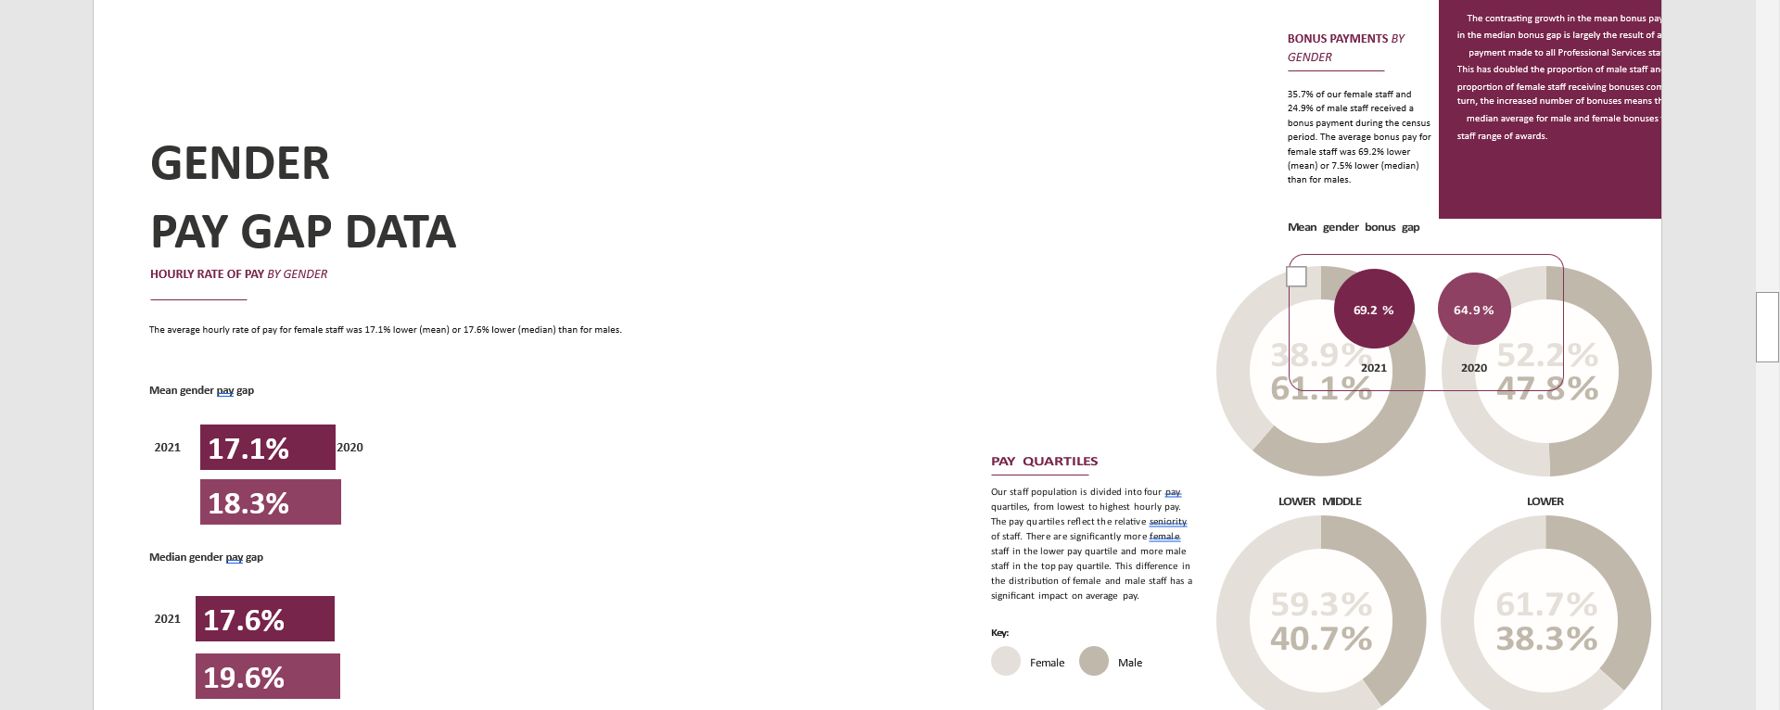
As stated by reports monitoring gender pay gap such University of Birmingham, (Gender Pay Gap, 2021) states, ‘In 2017 the university showed a report of the gender pay gap and wanted to commit on reducing their gender pay gap between the males and female staff, stating they recognise the issue and wanted to reduce the problem.
This example instigates that all departments and not just public sector have been affected by the gender pay gap, the progression of data being monitored should not have stopped the head of departments from paying women equally.
‘The “predicted” female line plots the rate of public sector employment based on female characteristics but male behaviour and tracks slightly above the male rate indicating that the sector employment gap is predominately unexplained’, (Jones, Makepeace and Wass, 2018). This implies that there was no valid reason for the gender gap to be justified as there has been no data indicating why this has gone on for so long.
From the statement described by Birmingham City Council report from 2022, discussion of the gender pay gap there is suggestion that due to jobs having a different set of responsibilities to be done compared to a woman was a justified reason to pay men more and women less, this is shown through, (Birmingham City Council Gender Pay Gap Report 2022 , n.d.)
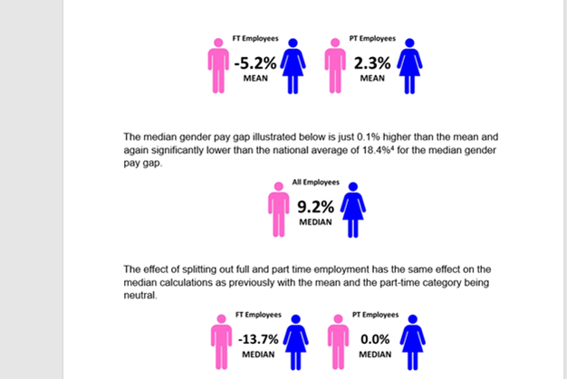
‘Birmingham City Council has more female employees than male employees. When split by gender our workforce is 58% female and 42% male. There is a significant difference between the gender make-up of employees that work fulltime and part-time roles. Women make up 81% of part-time employees and 44% of full-time employees.
This implies that the department within the Birmingham City Council made excuses to not pay women equally despite their research showing the percentage of employment in women is higher whether part time or full time, this should imply for women to be paid what they are entitled to even more so.
‘The new gender pays gap reporting obligations have been introduced alongside the existing requirements for specified public bodies. For the public sector gender pay gap reporting is a requirement of the Equality Act 2010 (Specific Duties and Public Authorities) regulations 2017 for employers with 250 employees or more as at a ‘snapshot date’.

‘Birmingham City Council is the largest local authority in the U.K. in terms of budget size. In 2012, a U.K. Supreme Court ruling allowed thousands of women to sue the city over equal pay — and now, after £1.1 billion ($1.4 billion) has already been paid out, the city has effectively declared bankruptcy in the face of even more pay claims, amounting to as much as £760 million ($950 million). Salmon, F (2023).

1.4 Birmingham City Council Open Cases
This is about the feedback regarding some research showing the results of Birmingham City Council and the gender gap pay.
A case such as Farmah vs Birmingham City Council, from journal author such as Rehman (2017), states that when victims of the equal pay make claims, it has been reported that the amount claims of unfair pay cannot be conducted one single claim form. Therefore each party has to make their own claim.
This case was addressed by the author, ‘Jawaid specialises in equal pay, implementing pay schemes and advising on major restructuring projects. He has project managed change initiatives that have involved over 15,000 employees and a group action of over 2000 equal pay claims. Rehman (2017)
Rehan supports the idea that multiple claims are wrongly included on the same claim form, so all forms would be treated individually. The tribunal considered some cases as irregularity. Irregularities doclaim orssarily render proceedings void, but the Tribunal can take any such action as they consider just, including (but not limited to) waiving or varying the requirement, striking out the claim, or awarding costs.
This suggests that the courts will not take multiple claims, which could lack the motivation of victims to bring themselves forward, as the process may seem too long or difficult to proceed. The decade age of victims between the age of 50 and 60 over the four decades, these specific set of victims may not have the knowledge or support.
Rehman (2017) states that; the set of claims brought by Birmingham City Council was 48 claims on the same claim form. When this was shared there was 23 who had the same job. The rest of the jobs was a variety of jobs from teaching assistant, support manager, lunchtime supervisor and working in HR. The Employment Tribunal found that the 23 claims were based on the same facts and that the cases should be allowed to proceed. The other claims did not comply with the Tribunal rules were struck out.
This demonstrates why claims cannot be processed the same due to different job titles and responsibilities, descriptions and different salaries agreed. Therefore this shows that the individual putting an unequal pay to identify claims which job roles that are the same.
‘The Employment Appeal Tribunal disagreed with this approach, holding that that it is not possible to save some claims that are based on the same set of facts and strike out the others. It also held that if claims are put on different legal bases (e.g. ‘like work’ or ‘equal value’ claims) they will not be considered to be on the same set of facts. If some claims are not based on the same set of facts, the claim form will be ‘irregular’. Rehman (2017)
This suggests the reason that individuals need to have their own claims, is because if their employment is not based on the same facts, including job descriptions. This makes the job description easy for the cases to be irregular and not judged the same.
The large amount in Employment Tribunals seem to be equal pay claims, it has been explained that the same standards apply to other context, (for example where multiple claims include holiday pay or unfair dismissal or looking over a redundancy. From Rehman (2017), it is also highlighted that over the last few years claims and their solicitors representing them have so many claims and this has affected the order, therefore the courts had to reduce the cost of Tribunal fees.

‘Birmingham City Council v Abdulla & Ors [2012] UKSC 47, Appeal against refusal to strike out Equal Pay claims made in the High Court on the grounds that they should be heard in the Employment Tribunal and, in that case, would be time barred. Appeal dismissed by a majority (Lords Sumption & Carnwarth dissenting)’. Employment Cases Update, (2012).
“The respondents are former employees of the appellant council ('Birmingham'), 170 of them women and 4 men. They left their employment on various dates between 2004 and 2008. They allege that Birmingham was in breach of the 'equality clause' inserted into their contracts of employment by section 1(1) of the Equal Pay Act 1970 ('the Act'), as substituted by section 8(1) of the Sex Discrimination Act 1975, by failing to provide certain benefits and other payments which were payable to workers of the opposite sex employed on work rated as equivalent. The respondents could have brought their claims in the employment tribunal, provided that they did so within the time limit applicable to them of up to six months after leaving their employment”, Employment Cases Update (2012).
This case of Abdulla & Ors (2012) vs Birmingham City Council suggests that due to the claims not being applicable due to six months after leading, as there were different job descriptions.
Overlooking both cases from Farmah vs Birmingham (2017) and Abdulla & Ors (2012), this appears the claims are not being processed properly and equal pay gap cases are still being pushed aside, therefore the cases are not being met due to victims having to fill out different claims, and claims not being shown the same job description, due claims being addressed be put forward by Employment Tribunal.
1.5 Rationale
Through this report there will be a breakdown of theory to why there is a gender gap over the years within Birmingham City Council, this is to find a conclusion to why this has not been addressed before within Birmingham Local authority.
This report is to find a conclusion to enable women in the future to be aware of the laws and policies within equal pay act, this includes challenging their department or HR resources should there be any queries of wage gender gap disputes. This is to make sure women feel empowered to ask questions regarding their salary and making sure their career choice has equal pay rate, and this also informs women to express for men to have the same equal rate within the same job responsibilities.
This issue of the gender pay gap within Birmingham City Council should be investigated because job description requires men and women to have the same qualification or training and skills needed for this specific job role, therefore both genders should be paid the same rate, regardless of gender.
The methods used are to highlight the research and where there are similar data is monitored that portrays the equal law act, also collected cases opened at Birmingham City Council and past twenty years will be highlighted, where it can show recommendation for women employees to learn the about the cases of backpay should they also need to evaluate their own work fields and contract terms and conditions, should this need to be addressed in their own job.

1.6 Chapter Summary
Summarising the data I have researched, it was brought to the attention of the male workforce that women were being paid less for doing the same job, there is evidence of data collected from 1940s up until the present time of 2023, equal pay has always been discussed within the workforces regarding equality of women.
‘The gender pay gap is higher in every English region than in Scotland and Northern Ireland’, White (2022). This shows that nationally the gender pay gap is much larger within England than Scotland and Northern, Ireland. This demonstrates there are still more cases in England than anywhere else.
This objective is so that people in particularly women have knowledge regarding the unfairness of equal pay throughout the years, this includes the future generation and community, to reassure the female population cases that have been noted and analysed to create justice and a fair world of equal rights.
When taking to account the amount of cases with the small pockets of cases opened from the different departments, although there are more women who should open cases which is highlighted from chart (Figure 3), there does not seem to be any movement due to claims being few compared the data showing the large amount of women who may have not opened a claim, or still working for a job in Birmingham City Council and have not addressed in the last six months or over six years.
This also highlights although there is data collectively shown through various reports from Birmingham City council, alongside different categories from age difference, part time and full time employee difference and the years stemmed from 1997- 2022, it represents that some women that work for Birmingham City Council may not have the motivation to fight heads of departments, or the time and money to go to the supreme court or civil court, this can suggest due to the lack of movement within the council to change policy or push the equal act.
It has been discovered regarding the data collected, cases opened that there has been no valid reason to why the gender gap has not moved forward in preventing the issue to continue. Furthermore an exploration because it has lasted nearly fifty years prior to the number of employees still being addressed in the present of 2023, despite an equal law act from 1970.
The female population being the working population of Birmingham city council being larger than males, despite part time hours and full-time hours, despite women having the same qualifications, there is no valid reason why this is still an issue for women, locally and globally.
There is also recognition through the cases open from Birmingham City council, this is not the entire female population within Birmingham city council that are claiming the money. Although some employees are mature and may not be motivated to fight, other employees who lack the knowledge of support or where to address and collect their work data to collective join the other women and help change the process of lower age and equal pay for women.
Looking over the aim and objective of this report, hopefully it can be achieved that more women will speak up for themselves and believe there is a process that is fair, and they can query their job position if the fellow women find out a male counterpart is being paid more than them.
The factors show throughout this report, the gender pay gap will still exist and still be ignored by mail head of services, especially when it is highlighted the gender pay gap is also actively shown through U.K Parliament, Education, Private and Public Sector. Which highlights the head departments do not seem to care and show the leaders and governors are mainly ran by male, which have upper level of change and for men who need to support the situation and actively give sanctions and create consistent process of the equal pay act.

Chapter 2
2.1 Origin of Gender Pay Gap
A gender gap is when there is discrimination and difference of pay between females and males, even if the job is the same description and work hours, men would be paid more than women doing the same job.
Gender pays orientated back in the 1940s, it was approached for females to do the same job roles as men during the first and second world war, ordered by government as there was more women living than men, however women were not paid the same rate at this time.
Women had to join the Air Force and Royal Navy, majority of the women were married and had to balance a family life. There was no law or statement to suggest equal pay or equality.
It was stated by Silkin, L (2021) that jobs that were segregated by gender with routine , this was care work and domestic work that was categorised as “women’s work” this includes many industries such as factories, shipbuilding, farming.
The gender pay gap was not limited to the working classes. In 1946 a report by Royal Commission on Equal Pay opened doors as female teachers where the first in this time to received equal rate by 1961. These actions have stemmed from the 1940s to present time as female workers in the retail sector have also spoken out in regards unequal pay from male employees
Stewart (2023) stated that “There has been another baby step forward in the long-running equal pay case brought by more than 40,000 female employees at Asda. A battle being fought across the retail sector. Female staff recently won the right to take their cases to its final stage. These cases raise broader questions about how we value “women’s work”, even in 2023 – more than half a century after the Dagenham machinists walked out of the Ford factory to demand equal pay”.
Men and women have been divided as an equal working nation due to the gender pay gap, women have not been paid equally when doing the same job description, or job qualification equal to a male colleague. Equal pay - that men and women doing the same job should be paid the same - has been a legal requirement for 47 years.
Government Equalities Office (2016) highlights that, ‘Women are still less likely to progress up the career ladder into high-paying senior roles. The gender pay gap is the percentage difference between average hourly earnings for men and women’.
Carolyn Fairbairn, (2013) states this was just a box ticking exercise, this is evident due to the 8,000 companies within the U.K, alongside the data showing only a fraction of cases being opened and addressed regarding the gender gap pay. This supports that no conclusion has not been solved in regard to gender gap pay, laws have not been changed with firm action and policies to be activated properly throughout society, this is why there is high levels of cases being opened and not being followed, whether this is public sector or private sector.
There is evidence that the world is more lead by men than women as stated by ,
Matthew Hutson, (2018) “a study published in 2018 in Personnel Psychology analysed more than 100 papers on leadership emergence published between 1957 and 2017. In the papers, samples of students or co-workers were asked to select group leaders or to rate one another on the extent to which they led a group. Some of the papers also measured group participation and personality traits such as assertiveness. As predicted, men emerged as leaders more often than women. But that gap varied depending on the length of interaction and other factors”.
The Gender Pay Gap has been overlooked in the population over the many decades, there has been an issue to why gender pay gap has not been addressed for decades any faster. Since the Office of National Statistics began collecting gender pay gap data in 1997, it has shrunk from 27.5% to 17.3% overall and from 17.4% to 8.9% for those in full-time work’.
There is recognition that similar cases highlight the challenges of departments purposely referring to male employees instead of equally giving a woman employee the same opportunity to exceed in their status of promotion or pay rise in their job role and responsibility.
‘Unequal pay based on the gendering of job roles and occupations would remain a large-scale social and economic problem after decertification and that it would still need to be addressed through legislation and a range of policy and activist measures. One interviewee put it this way: “If you take away the label of gender, you don’t take away the centuries of oppression against women as women’, Grabham (2022).
‘The managers, directors and senior officials' occupation group has experienced the largest fall in gender pay gap since the pre-coronavirus pandemic April 2019 figure, especially for those aged 50 and over; this group has previously been identified as having a notable impact on the pay gap’, (White, 2022). It is evident that the pay gap of sexes has been evident for the last century, evolving to 2023 it is evident that the gender pay gap still exists , is widely recognised all over the world.

2.2 Theory of Gender Pay Gap
The theory of Gender Pay Gap is centred around inequality and sexual discrimination towards women, men not respecting women in senior roles working alongside male employees and getting the equal same pay despite doing the same job description.
“Traditionally more men than women continue to pursue careers in the IT sector. There is a national and well documented shortage of qualified and experienced females for technology roles such as Software Engineering, Software Architecture and Cyber Security and this is reflected at MHR with a higher proportion of men in senior and senior technical roles. mhrglobal.com, (2022)
This statement shows that this company are making a bias opinion, judging that women are not qualified in the area, whereas it can be suggested during the interview process, this company would not hire a female for this type of job due to statistics showing that mostly men doing this job.
“Globally, 40% of people thought men made better business executives. In the UK, 25% of people thought men should have more right to a job than women and said men made better business executives than women did. The number of female heads of government is lower today than five years ago with only 10 women in such positions in 193 countries, down from 15 in 2014, Latin America and the Caribbean had the highest share of seats in parliament held by women with 31%.”. BBC, (2020)
This suggests that globally equality is an issue that has been passed down even from world leaders and parliaments all over the world, economically, culturally. This can suggest is there any hope next four decades due to some countries still not addressing the issue.
Birmingham City Council locally authority, publicly announcing closure of payouts and making some progress in showing the city that they do not wish to continue the gender pay gap.
Collected data is there for people to be aware, and this suggests that collected data does not make a difference to fair cases of equal pay because not many of the population were aware that this data existed for support to their circumstances. Think the difficulty for equal pay laws is that how would you collect data, how will you decide if you no longer have classes of men and women, how will you recognise that there is a gender pay gap at all.

“While such changes have been contested and resisted, they also allow men to claim organisational authority, naturalising male dominance, and marginalising women. In such cases, certain “valid” skills and privileged knowledges come to speak to a dominant form of masculinity, a condition that results in maintaining women’s exclusion from the realm of “the professional” and from similar powerful positions in the public sphere (Whitehead 2002, 135)”. This highlights that men see their masculinity as an inferior towards women, where women would not be able to meet their standards in the profession questioned, this shows a setup of naturally thinking women are not equal as men.

2.3 Factors Driven Gender Pay Gap
The factors that contribute to the gender pay gap are unseen data collected from work departments, sexual discrimination, employees not paying the same wage to women who do the same job responsibility as men.
Discrimination because of gender, within the local authority in this report regarding Birmingham City Council, there has been a range of cases where women have been rejected for equal rights, refused interviews or promotion status of their job role due to head of departments, not giving awareness to female employees what qualifications are required, nor has the female employee been given the opportunity for females to get a high status of work compared to the male employee with the same job role but may have less qualifications to the female employee, however the male employee will still get the status of promotion or given opportunity for an interview.
Another factor is where departments are fixed on giving women the less value jobs in terms of domestic work, minuscule jobs, these are all low paid jobs just like cases open through Birmingham City Council, as well as not looking over a female level of education and skills compared to a man.
Furthermore nepotisms contribute to the gender pay gap, this is because head of departments can show discrimination by not giving female employees a chance to develop their job role, ‘Nepotism is a form of discrimination in which family members or friends are hired for reasons that do not necessarily have anything to do with their experience, knowledge, or skills’. Hamlett, (2019).
Another factor towards the Gender pay gap is head of department not giving awareness to female employees regarding their equal rights, without giving a training opportunity or paying promotions. For example a female employee may ask what is the policy in regards to equal rights and promotion salary increase, the manager would have to show data collected between a female and male, highlighting the correct terms and conditions for that female employee to apply for promotion or pay rise, this would be addressed with now tension inequality in the workplace, alongside the manager giving the right data and support to that female colleague.
There is no clarity in the evidence of the gender pay gap showing where the future generation should not need to worry due to only some nations making firm choices to prevent inequality in their workplace. For example Birmingham City Council are following procedure to pay out all cases that have been discovered and addressed publicly to the local authority.
According to Grabham (2022), there is a great deal of concern among the government, high parliament of Birmingham City Council, councils across the United Kingdom, and other councils worldwide because of the widespread gender pay gap. Even though the council has taken steps to address the issue and reduce gender gap pay, some victims may still feel oppressed and unsupported over time.
This research can help women know how to ask and benefit from the updated and backdated data regarding gender gap pay, this also enables women specifically in inner city areas such as Brimingham City Council, in regard to their job to apply the procedures and challenge the query if men doing the same job. This part of the research has posed the question, do women feel enabled to ask the relevant question at the interview stage?
‘Part-time employees and workers are entitled to equal pay. If a part-time worker is paid less than someone of the opposite sex, it could be indirect sex discrimination’. ACAS, (2022)
‘The gender pay gap is a global economic issue affecting women in every country. Most recent estimates suggest women earn on average 16% less than their male counterparts globally1 , although this percentage is far greater in many places’. Action Aid (2023)
Gender Gap Pay has portrayed itself to be a global issue in general, through the research it was significant to recognise the topic of this report is only addressing specifically within Birmingham City Council, however this is a global issue around the world, and highlights how much needs to change.

2.4 Gender Pay in Public and Private Sector
Theoretically there is not a lot of evidence which suggests that policies are going to be input to change the gender gap, it shows a lot of bias action towards men compared to women whether the career sector is in private or public sector. No actions portrayed to female workers, which highlights being a part of the issue in the gender pay gap. There is acknowledgement through research there is larger cases shown in the private sector compared to the public sector.
This shows that between the public sector and private sector that there is a gender gap, and this also implies that despite departments of companies having knowledge that women regarding higher education or qualification should be receiving promotions or bonus in their job, however they are not receiving their pay this add to the gender pay gap.
The research has been important because the effected part of women in the society have been given no support and there has been lack of knowledge for women in the public sector, to be treated fairly in terms of their pay and qualification to have equal rights and equal pay.
Studies on the topic have shown that there is a gender wage difference in the public as well as the private sectors. This indicates that women must lead the way in order to end the discrimination against them and ensure that they have equal access to the workforce. Even though there have been protests, equality has been brought up since the 1940s in historical events starting with the Second World War. Despite this, it is still acknowledged as a fight and has created many problems. Women's rights campaigns continue to be a raging problem.
The gender pay gap is still being practice throughout the workforce both in public sector and the private sector, Birmingham City Council females have not achieved an overall success of fair pay in all departments for women, this would be a future conclusion. Within Birmingham city council the gender pay gap continues regardless of the work department that employee is in, ranging from cleaners, administrators, team managers, supervisors and directors, no matter what qualification or status of the job, female workers are still paid less.
It also highlighted in this article that the gender gap pay is more acknowledge and acclaimed for in the public sector than the private sector. Trade unions have been active to support equality and unfair pay, this can be a positive aspect for women who still wish to address their case even after six months, as reported by Hogan (2012).

Chapter 3
3.1 Study Design
The research design had changed due to the outcome of research discovered through this report, there was an aim to find a conclusion to why the Gender Gap pay keeps showing a repetition of decades of the Gender Gap Pay, also the research study design was about finding specific data in regard to Birmingham City Council looking over numerus cases being paid out for the two decades, this is from discovering the cases over the last four decades.
The research had globally shown through articles, and journals and local authorities and companies being exploited due to the different voices becoming advocates unequal pay and inequality.
The research has been explored through the last century 1940 onwards up until present time, however after the introduction in regards to the history of gender equality, there was a calculation of information within the last two decades to present , showing the highs than lows in regards to the gender gap pay, and when the equal act law was established in regards to when the equal pay law was proceeded in 1968 for the first time, and addressed through nations from
In terms of research design overall after looking over the research material and resources of graphs and statements portrayed within the report to support statements, the research shown was descriptive, correlational research, via secondary data where there was no need to provide new interviews or questionnaires or forms in regard to woman locally, as this would take too much time to calculate and gather feedback as evidence.
Through the correlation research it does identify that these research topics , cannot be controlled or manipulated by the researcher due to the personal evidence and individual data regarding the companies who showed lack of support to the female employees opening the cases to unequal both public and private.
White (2022), states regarding data of gender gap pay that; during the pandemic earnings were affected by the changes of the workforce and the impact of the job retention scheme via (furlough). Data collection caused disruption and low response rates which implies that during 2020, and 2021 data was an uncertain and this should be cautious to calculate. the data should not be valid because during COVID-19 and the furlough years, the gender gaps salaries dropped, this may have shown a fair pay, however due to furlough being closed the gap went back up, this is why long term data should be a stronger rate for cases to evaluate, due to this being short term data it should not be highlighted in long term cases regarding Birmingham City Council.
This suggests the data should not be valid because during COVID-19 and the furlough years, the gender gaps salaries dropped, this may have shown a fair pay, however due to furlough being closed the gap went back up, this is why long term data should be a stronger rate for cases to evaluate, due to this being short term data it should not be highlighted in long term cases regarding Birmingham City Council.
It was discovered during the research to not use data provided in regard to Gender Pay gap during COVID-19, this is because Birmingham City Council the data during pandemic was not valid due to companies not being able to update their data or evaluate every employee, therefore this research around this year would not be fair evidence to use.
Such research like survey, personal interviews this type of data collection would not be beneficial because too much data individually to collect in terms of permission forms, safeguarding, confidentiality, finding the time.
Descriptive research can be used to support the various attitudes of the gender pay gap in regard to subtopics such as, the local authority and the closed cases and opened cases, the various companies being exposed to unequal pay towards women in all categories of career choices such as domestic, social work, education, retail, warehouse, and many more.

3.2 Research Approach
In terms of research approach the first goal initially was to find out when the first gender gap pay started and why gender gap even existed and still presently carrying on. Through the inductive research it started to represent the amount of gender gap pay both in public sector and private sector that exists. This supported the idea to further explore all advocates and journalists speaking on behalf of female roles both in high tier and middle tier still fighting for equal rights despite their level education, level of expiration.
Goals of the research approach was to find if any companies, or local authorities were able to find a permanent conclusion to closing the pattern of the gender gap pay, this was in regard to the amount of information highlighted in regard to gender gap within Birmingham City council.
These reports show a theme of the evaluation of graphs charts, and calculation of figures and numbers of women and men in the Local authority that has been a part of the Gender Gap Issue within the last twenty years and up to date. This research demonstrates the gaps specifically in the charts, however there was no specific data in terms of the individuals, how many cases have been opened and how many has been closed.

3. 2 A Inclusion the Exclusion
In regard to Inclusion criteria, topics shown has given a highlight to the number of years there has been a gap, alongside monitoring the low tier, middle tier or hight tier of pay in regards to men and women, with clear views of low pay in all areas, this includes age of women and the years shown over the years through Birmingham City Council, (See chapter 1.3 and 4.2). Specifically there are figures and highlights of the Gender Pay Gap shown.
When thinking about exclusion of criteria there was numerous research highlighting little information of gender pay gap, race pay gap and looking over the ethnicity of women that have been paid low also regarding local authority. However due to this information coming off topic and entering a different perspective with both race and gender, this information and resources could not be used as this would come off topic to the specific aims and objectives of the gender pay gap.

3.3 Methods Data
Chetty ,(2020) stated “a step-by-step plan of action that gives direction to the researcher’s thought process. It enables a researcher to conduct the research systematically and on schedule. The main purpose is to introduce the principal components of the study such as the research topic, areas, major focus, research design and finally the research methods”.
This includes thinking about step-to-step questions to locate the type of information to be provided, for example when typing gender pay gap there was a total of 1.5 million resources this where key words had to narrow in order to find specifically the research in regards to gender pay gap Birmingham, or specifically the gender gap and where it originated from.
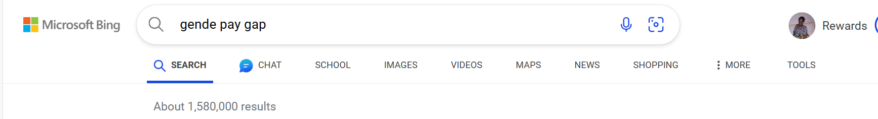
https://www.bing.com/search?pglt=41&q=gende+pay+gap&cvid=559ed93d7cfb40df8e0bc97a09f4700f&gs_lcrp=EgZjaHJvbWUyBggAEEUYOTIGCAEQLhhAMgYIAhAAGEAyBggDEAAYQDIGCAQQABhAMgYIBRAAGEAyBggGEEUYQTIGCAcQRRhBMgYICBBFGEHSAQg3NDczajBqMagCALACAA&FORM=ANNTA1&PC=HCTS
Qualitative data was used throughout this report there was a lot of key findings in regard to the gender pay gap reports located on the Birmingham Local authority website, this had calculations and graphs monitoring the gender pay gap within the local authority departments, these reports are also accessible to any citizen who wishes would locate and check or evaluate their own department of work.
This is beneficial as the general public and access the information and be aware of what is going on in regard to equality, this suggests that Birmingham City as a local authority want to be seen as an example of solution and against gender gap pay rather than support the idea of sexual discrimination. This research was beneficial to the step-in regard to researching Birmingham City as a council because the information as easy to access and evaluate alongside supporting other journals from Birmingham.
Qualitative data is data that can be collected and evaluated in words and images observations, this was generally shown through gender gap reports held by Birmingham City Council and U.K parliament and GOV.UK, (See Chapter 3.2, Qualitative data under Gender Gap Data.

3.4 Data Analysis
Through my data analysis reflecting on the Gant chart, enabled me as the researcher to keep up to date with my resources in topic order.
After analysing the collected information, it was discovered that data specifically used for evaluation and support the monitoring of the Gende pay gap, there was specifically evidence in regard to Birmingham city council, paying off opened cases from forty years back, alongside data shown through various companies private and public within Birmingham city as a society in regard to gender pay gap. ‘
First official question was, what is Gender Gap Pay? This had changed to different various questions like, why is the head of department not addressing the Gender gap? And what factors showed influence on the Gender Gap pay?
These questions are generally collected and highlighted through the theory, this is so that no equal pay in Gender has been going on for years, and the data so far from research, one suggests this could be shadowing the gender pay gap. The departments were good research collected due to the sector ignoring the law of data being collected and avoided showing women their entitlement of pay.
Results
Keywords | Gender, Gap Pay, Equal Rights, Women employees, fair pay, local authority, wage difference, data, monitored wage data, report of unequal pay
Outcome | The purpose of the results through google scholar, Local authority, Government websites, journals articles embodied how Gender Pay Gap never had a one specific date to when it originated, however the research highlighted public sector and private showing similar cases of unequal pay regardless of job roles and level of education.
Context | Locally, specially within Birmingham City Council

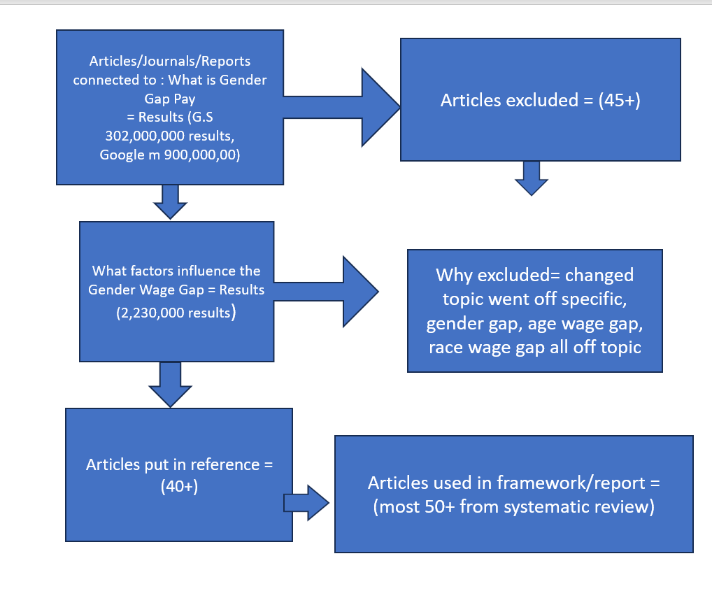

Chapter 4 – Analysis of systematic review findings

4.1 Introduction
In this systematic review there will be a highlight of evaluating collected reports that demonstrate the gender within Birmingham Local Authority, throughout all departments social care, education, health, public sector. There will be evidence of the gender gap pay within the last four decades.
There is also highlight that the female population have been exploited and this will be shown through the monitored collective data and reports of women who are qualified and getting underpaid as well as the women who are highly qualified, working part time, working the same tasks and job responsibilities as their male colleagues and still being misled and getting less pay. Another highlight will be about Birmingham City Council overview to the numerous cases being opened over the decades. Below is the Literature review alongside purpose and guideline to why these journals were chosen.

4.1.1 Systematic Review
Number | Type | level | Purpose | Date Accessed
1 | Website | Beginning | This report page was showing the facts regarding the male and female population within the U.K.  The purpose of this information is to highlight the differences in wages of males and females as well population. | 25/10/2023
2 | Website | Beginning | Facts about male and female population in Birmingham.  The purpose of this report was to look at the differences of population within Birmingham. | 25/10/2023
3 | Journal | Middle | Journal about the gender wage gap in America.  The purpose of this journal was to highlight internationally how the gender pay gap is a global issue. | 25/10/2023
4 | Journal | Beginning | Equal pay: the women who won case against Birmingham city council.  This purpose was to highlight some individuals who are being publicised about equal pay within their workplace and compensated for the lack of not having pay in the first place. | 25/10/2023
5 | Report | Middle | Regarding the gender wage gap within the U.K parliament ,  This highlights as high as house of Commons are, Gender gap still exists. | 25/10/2023
6 | Journal | Middle | Through the looking glass on gender pay gap transparency,  this purpose was just to highlight the numerous examples of gender gap throughout the work force. | 26/10/2023
7 | Report | Beginning | UK Gender Pay Gap report on GOV This one example of Birmingham Local Authority showing the figures and employees monitored of their data wage gap through the years.  The purpose of this research is to specifically look over cases opened withing Birmingham City Council. | 26/10/2023
8 | News article | Beginning | What is the gender pay gap? BBC News  This is opening introduction to what Gender Gap is and the purpose of this research was to get more understanding. | 26/10/2023
9 | Journal | Beginning | But some are more equal than others’ — The Equal Treatment Directives and equalising the state pension.  This was about the state pension of males and female shaving the same wages, this is a highlight of another gender gap issue amongst all areas and not just through Birmingham City Council. | 26/10/2023
10 | Report | Middle | House of Commons and Parliamentary Digital Service publish 2022 pay gap data.  This is a highlight of house of commons publishing their own gender gap pay data, this purpose of research was to recognise the different areas of departments being affected by equal pay regardless of what genre of career the woman is. | 26/10/2023
11 | Journal | Beginning | Women in the Workforce During the Second World War: Taking on Men’s Roles  This journal was about the historical beginning of women taking over male dominant roles as well as being asked to do these jobs due to lack of male population.  This purpose of research is to highlight the beginning of equal right alongside where women questioned their equal rights from. | 26/10/2023
12 | Journal | Beginning | Prime Minister's Office, 10 Downing Street and Ministry of Defence (2015). The women of the Second World War  This is another historical event of how house common have repeatedly been involved within their feedback and view regarding equal rights to women. | 26/10/2023
13 | Journal | Beginning | The UK Gender Pay Gap 1997-2015: What Is the Role of the Public Sector? Industrial Relations: A Journal of Economy and Society, 57(2), pp.296–319.  This is about the relations of the economy and society regarding equal rights and equal pay within the public sector within the last four decades.  This purpose of research was understanding the findings of where the gender gap to where women started to oppose the unfair pay. | 29/10/2023
14 | Journal | Beginning | Decertifying Gender: The Challenge of Equal Pay. Feminist Legal Studies, 31(1  This highlights how women from legal perspective highlights their concerns and factors with wanting equal pay and equal rights for women regardless of their gender.  The purpose of this research was to highlight in this report the recognition of women who are highlighting the issue and wanting change. | 29/10/2023
15 | Report | Beginning | Birmingham City Council Gender Pay Gap Report 2017  This is report showing the figures, graphs highlight date of women and men from 2017 within Birmingham City council regarding gender gap pay.  The purpose of this was to research any specific data in the gender gap reports. | 29/10/2023
16 | Report | Beginning | Gender Pay Gap Report 2021. (2021). University of Birmingham Creative Media. Birmingham : University of Birmingham.  This report highlights the gender gap report within the university of men and women with unequal pay rights.  The purpose shows another highlight of unequal pay in another sector. | 29/10/2023
17 | Report | Beginning | Birmingham City Council Gender Pay Gap Report 2022  This is a Gender Pay Gap Report showing the graphs and chart sand comparison of jobs part time, full time with difference in wages and time scale within 2022 of Birmingham City Council.  The purpose of this research is to be updated with the cases opened. | 29/10/2023
18 | Report | Beginning | What does gender equality look like today? UN Women.  This is about gender equality with advocation of change and unequal pay of women.  The purpose of this research was to highlight another reported questioning why unequal pay have not been pushed for change over the years. | 29/10/2023
19 | Article | Beginning | What is happening in ‘bankrupt’ Birmingham? (2023). BBC News  This report was about Birmingham City Council being highlighted the fact that Birmingham City Council have had to pay out women who have been waiting so long, and showing the neglect, this is showing how Birmingham City council is being a mad an example of for other U.K authorities to recognise the difficulty that can occur with local councils when equal pay is being ignored.  The purpose was to highlight Birmingham City Council specifically. | 30/10/2023
20 | Article | Beginning | ‘Bankrupt’ Birmingham council must pay hundreds of millions in gender pay dispute. The Telegraph  This highlights how over cities where local councils are having to address their own issues within their council regarding gender gap pay.  The purpose was to show another highlight about Birmingham City Council regarding their issue of paying out closed cases and losing money economically as local authority/ | 31/10/2023
21 | Article | Beginning | For one UK city, the cost of underpaying women is bankruptcy.  The purpose of this report was about Birmingham paying out the cases open due to unequal pay. | 31/10/2023
22 | Website | Beginning | Equal Pay and the Law  About the equal pay and the definition about equal law, the purpose of this research was to understand more about it. | 5/11/2023
23 | Website | Beginning | Birmingham City Council in financial distress over equal pay claims. [online] Evening Standard  This research was about Birmingham city council as a local authority organising pay claims. | 5/11/2023
24 | Website | Beginning | Gender pay gap at council continues to reduce. [online] www.birmingham.gov.uk | 5/11/2023
25 | Article | Beginning | Partridge, J. (2023). Women still have right to equal pay, says UK government, despite scrapping of EU law. The Guardian  The purpose of this research is to highlight about the Government in EU and Globally other than the U.K fighting for equal rights to equal pay. | 5/11/2023
26 | Article | Beginning | Women in Work: a brief history of women in the workplace. Future of Work Hub  The history of women as workers and where equal pay and law was opening as an issue to address from the beginning of women working more as a population. | 5/11/2023
27 | Journal | Beginning | Brewis, D.N. (2010). Performing Professional: University Student Perceptions of Gender . Discrimination in their Future Careers.  The purpose of this journal is about people in different procession addressing the issue of unequal pay in various sectors of jobs. | 5/11/2023
28 | Journal | Beginning | Deakin, S. (2012). What is Equal Pay Strategies of equal pay.  The purpose of this research is about strategies being created to reduce the equal pay act. | 7/11/2023
29 | Journal | Beginning | Bishu, S.G. and Alkadry, M.G. (2017). A Systematic Review of the Gender Pay Gap and Factors That Predict It. Administration & Society, 49(1), pp.65–104.  The purpose of this review was about the review about the factors of the gender pay gap | 12/11/2023
30 | Journal | Beginning | The UK Gender Pay Gap 1997-2015: What Is the Role of the Public Sector? Industrial Relations: A Journal of Economy and Society, 57(2), pp.296–319.  The purpose of this review is about the economic role of gender pay gap within the U.K and demonstrating through the U.K how the Gender Pay Gap has been affected. | 12/11/2023
31 | Journal | Beginning | Flood, M. and Pease, B. (2005). Undoing Men’s Privilege and Advancing Gender Equality in Public Sector Institutions. Policy and Society, 24(4), pp.119–138.  The purpose of this research is about the question of Gender being paid fairly from a male perspective speaking about women being unfairly paid in high job status. | 12/11/2023
32 | Website | Beginning | Legal Q&A: What does Birmingham City Council v Abdulla mean for equal pay claims?  The purpose of this report was about the feedback and evaluation about a won case within Birmingham city council. | 15/11/2023
33 | Website | Beginning | Croft, J. and Wild, J. (2012). Birmingham loses ‘historic’ equal pay case. Financial Times. Financial Times. Available at: https://www.ft.com/content/35f20504-1db9-11e2-8e1d-00144feabdc0.  The purpose of this report is about the historic cases of equal pay cases within Birmingham city council. | 15/11/2023
34 | Website | Beginning | (2023). BBC West Midlands. 24 Sep. Available at: https://www.bbc.co.uk/news/uk-england-birmingham-66896733  The purpose of this report is about the new nationally addressing about Birmingham as a local authority regarding the equal gender pay. | 15/11/2022
35 | Report | Beginning | Carmichael, F., Ercolani, M. and Taylor, S. (2019). CLOSING THE GENDER PAY GAP: ARE WE NEARLY THERE YET? University of Birmingham: University of Birmingham, pp.1–2. Available at: https://www.birmingham.ac.uk/Documents/research/Public-Affairs/Gender-Pay-Gap.  The purpose of this report is about the Gender Pay gap and if there is a conclusion to closing the amount og cases regarding Birmingham in education of the gender pay gap. | 15/11/2023
36 | Report | Beginning | White, N.J. (2022). Gender pay gap in the UK: 2022. ONS. Office for National Statistics: Census2021. Available at: https://www.ons.gov.uk/employmentandlabourmarket/peopleinwork/earningsandworkinghours/bulletins/genderpaygapintheuk/2022  The purpose of the report for Gender Pay gap is to bring the attention to those that have been misinformed and mistreated, and that are direct to see if people want to appeal and get the rightful pay. | 15/11/2023
37 | Report | Beginning | Office For National Statistics (2022). Gender pay gap in the UK - Office for National Statistics. www.ons.gov.uk. Available at: https://www.ons.gov.uk/employmentandlabourmarket/peopleinwork/earningsandworkinghours/bulletins/genderpaygapintheuk/2022.  The purpose of this information is for people to know more regarding the date of different wage due to the gender pay gap updated in 2022. | 15/11/2023
38 | Website | Middle | Rehman (2017). Equal Pay Update: Three New Cases You Need To Know About. Available at: https://www.weightmans.com/media-centre/news/equal-pay-update-three-new-cases-you-need-to-know-about/.  The purpose of this article was to explain the three new cases that have been acknowledge and paid for, won cases. | 21/11/2023
39 | Website | Middle | Employment Cases Update. (2012). Employment Cases Update: Birmingham City Council v Abdulla & Ors [2012] UKSC 47. Available at: https://employmentcasesupdate.co.uk/content/birmingham-city-council-v-abdulla-ors-2012-uksc-47.1d63ed6baea342319ce99e8712d6ccbb.htm.  The employment cases had a purpose due to Birmingham city council closing some payments of the local authority cases in 2012 that were addressed. | 20/11/2023
40 | Journal | Middle | Grabham, E. (2022). Decertifying Gender: The Challenge of Equal Pay. Feminist Legal Studies (2023) 31:67–93, 31, pp.67–93. Doi: HTTPs://doi.org/10.1007/s10691-022-09516-3.  Another purpose as an example equal right being addressed and spoken passionately in regard to fairness of victims within women workers. | 20/11/2023
41 | Journal | Beginning | Kräft, C. (2022). Equal pay behind the ‘Glass Door’? The gender gap in upper management in a male‐dominated industry. Gender, Work & Organization, 29(6). Doi: HTTPs://doi.org/10.1111/gwao.12890.  An example of unfair pay between managers that were female having the same job description as men being paid lower than male managers. | 26/11/2023
42 | Journal | Beginning | Cambridge Core. (n.d.). Business and Politics: Volume 25 - Issue 1 | Cambridge Core. Available at: https://www.cambridge.org/core/journals/business-and-politics/issue/5FDDFA6E1D8F944AC61B72D07B0256AF  The purpose of this journal was to discuss the civil servants, of female workers that have been paid unfairly compared to male civil servants. | 26/11/2023
43 | Journal | Beginning | Raile, A.N.W., Austin, C.G. and Bratton, V.K. (2023). Can We Talk About Pay Discrimination/Equal Pay/Strategic Compensation Practices? An Exploratory Study on Framing Gender Pay Inequity. Business and Politics, pp.1–17. doi: https://doi.org/10.1017/bap.2022.21.  The purpose of this study was to oversee the strategies that have been put in place amongst other gender gap pay globally. | 26/11/2023
44 | Journal | Beginning | Archer, A. and Prange, M. (2019). ‘Equal play, equal pay’: moral grounds for equal pay in football. Journal of the Philosophy of Sport, 46(3), pp.1–21. doi: https://doi.org/10.1080/00948705.2019.1622125.  The purpose of this journal was to see another example of unfair pay from other various job roles, this was an example in sports between female and male footballers. | 26/11/2023
45 | Report | Beginning, Middle | Council, B.C. (2023). Birmingham City Council statement on Equal Pay update. [online] www.birmingham.gov.uk. Available at: https://www.birmingham.gov.uk/news/article/1353/birmingham_city_council_statement_on_equal_pay_update.  The purpose of this report is to look at the feedback of Birmingham City Council’s response in regard to the equal pay act. | 26/11/2023
46 | Report | Middle | GOV.UK (2017). The Equality Act 2010 (Gender Pay Gap Information) Regulations 2017. Legislation.gov.uk. Available at: https://www.legislation.gov.uk/ukdsi/2017/9780111152010.  The purpose of this report was looking over data and in regard to the gender gap pay in 2010. | 26/11/2023
47 | Report | Middle | Striking Women (2013). Gender pays gap and the struggle for equal pay | Striking Women. Striking-women.org. Available at: https://www.striking-women.org/module/workplace-issues-past-and-present/gender-pay-gap-and-struggle-equal-pay.  The purpose of this report is to acknowledge the women who have been striking past and present historically in regard to unequal pay and equal rights. | 26/11/2023
48 | Report | Middle | University of Birmingham. (n.d.). Gender and ethnicity pay gaps. Available at: https://intranet.birmingham.ac.uk/collaboration/equality/monitoring-and-reporting/gender-pay-gap.aspx  The purpose of this report is about the unfair pay in Gender and ethnicity. | 26/11/2023
49 | Journal | Middle | Grabham, E. (2022). Decertifying Gender: The Challenge of Equal Pay. Feminist Legal Studies (2023) 31:67–93, 31, pp.67–93. doi:  https://doi.org/10.1007/s10691-022-09516-3.  The purpose of this journal was seeing the challenges that female employees face in all different job roles. | 29/11/2023
50 | Report | Middle | Birmingham City Council. (2017). Available at: https://assets.publishing.service.gov.uk/media/60a77e718fa8f520bc5f2839/Ms_D_Campbell_v_Birmingham_City_Council_-_1300104_2020_-_Judgment_and_Reasons.pd  The purpose of this report was looking at some of the cases that have been publicly opened and won where Birmingham City Council are paying their victims. | 29/11/2023
51 | Report | Middle | UN Women (2020). Everything You Need to Know about Pushing for Equal Pay. UN Women. Available at: https://www.unwomen.org/en/news/stories/2020/9/explainer-everything-you-need-to-know-about-equal-pa  The Purpose of this report was looking at equal pay globally. | 29/11/2023

4.1 Departments Justify Not Following Policy for Fair Pay
It has been recognised through the evaluation of journals, reports, departments are justifying paying women a less wage compared to men because most of the women work part time, although their job description is the same as male colleagues as well as the qualifications for the job is the same.
This demonstrates no matter what area of employment, and the department women are in, that changes have not been made to comeback the unfair pay, despite Birmingham City Council paying their victims, people are still being employed where the salary is larger for men than women. Even with the average of 6% males being paid more than women, this is still a high percentage which should have been changed before it escalated to stations where companies or local authorities are paying out paramount.

4.2 Gender Pay Gap Data
The data shown through reports from Birmingham City Council as well as other departments such as University of Birmingham, House of Parliament, , shows the there is no equality within the salaries between men and women, as well as all levels of departments have proved although the data exist, the departments have not shown publicly or shared with their fellow women colleagues, this suggests that the department such as Birmingham City Council, have not addressed equality for pay in their policy and shadowed the standards of equal rights.
It is highlighted within the report stated by Simon Deakin (2012), although there is a list of strategies to be used for the departments for terms of equal pay, there is evidence this has still not been adhered to by any companies, this due to the Birmingham City Council not following the procedure with the result of bankruptcy due to having to pay out claims to women.
In private sector jobs it has been expressed the higher the rank of job is the more the person gets paid, whereas the public sector only gets 5% lower. It has been highlighted in regard to equal pay, part time workers may not be even addressed in terms of equality pay and following policy, this suggested from statement Mark Stewart (2014),
‘To sum up, beyond the headline difference between the gender pay gaps in the public and private sectors, there is also variation in this difference across the distribution, between central government and local authorities, and according to whether or not part-time employees are included in the analyses.
This highlights that whether it is public sector or private sector there is still an issue regarding equal pay and gap in payments, this suggests that the equal rights law has not been adhered to in either sector of work for women.
Charts will be monitored, and reports of the gender pay gap will be shown and highlighted in comparison to the job fields and public sector of jobs, this will be analysed from when Birmingham City Council agreed to back pay the women who were underpaid in their public sector jobs.
“The gender pay gap was 19.1 % in 2013, having risen from 18.6 per cent the previous year. This means for every £1 earned by a man in the UK, a woman earned only 81p. Gender pay gap is higher when part-time workers are included because of the low hourly rates of pay in part-time work and the concentration of women in these jobs due to the occupational segregation of the labour market (for e.g., 'the five C jobs' are mostly done by women - cleaning, cashiering, caring, clerical work and childminding - and these jobs are poorly paid)”.
The jobs that are concentrated of part time work which dominantly lead by women who work part time. However due to part time low wage hours, as well as women working in this labour market of jobs, the head of department. This suggests that the market in these jobs is already being directed at women to carter for women who need to work part time, however this could also lead a disadvantage for victims should they need collect data.

For instance:
Figure 1: The gender pay gap has been declining slowly over time; over the last decade it has fallen by approximately a quarter among full time employees and all employees.
Gender pays gap for median gross hourly earnings (excluding overtime), UK, April 1997 to 2022
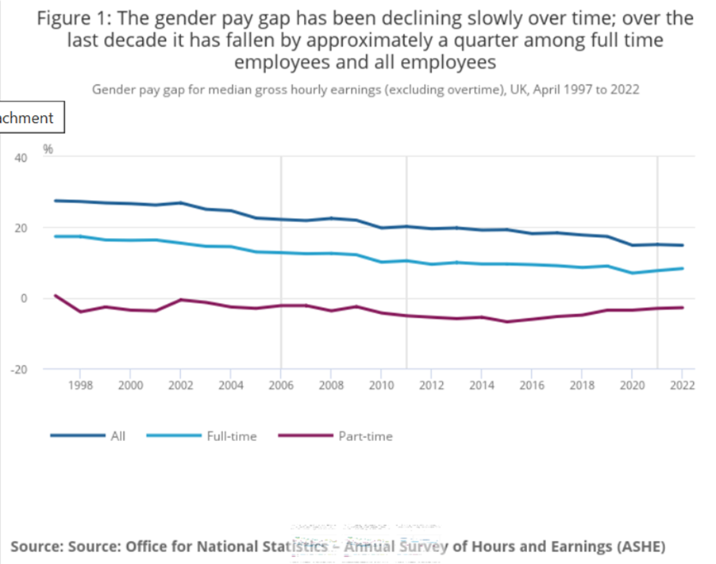

Office For National Statistics, (2022)

Overlooking this chart it shown that part time female worker spays from 1997-2022, there has not been a consistently equal number of good years, the part time is consistently low. Full time workers shown a decrease and levelled from 2012- 2020 where it was even, overall the part time employees have seemed to have suffered the most.
“Among all employees, the gender pay gap decreased to 14.9%, from 15.1% in 2021, but is still below the levels seen in 2019 (17.4%). The gender pay gap for part-time employees also reduced from negative 3.0% to negative 2.8%. The upward trend in the part-time gender pay gap seen since 2015 is continuing”. White (2022).
This highlights the lack of improvement for the gender gap to decrease over the years rather than increase, there has been no consistent support or sanctions made for those who hold the data for changes to be made, and although there are various reports of changes in the cases opened, departments have still not made any changes.
Another chart analysed is showing the age of employees combined to the gender pay gap from 1997-2022.
Figure 2:

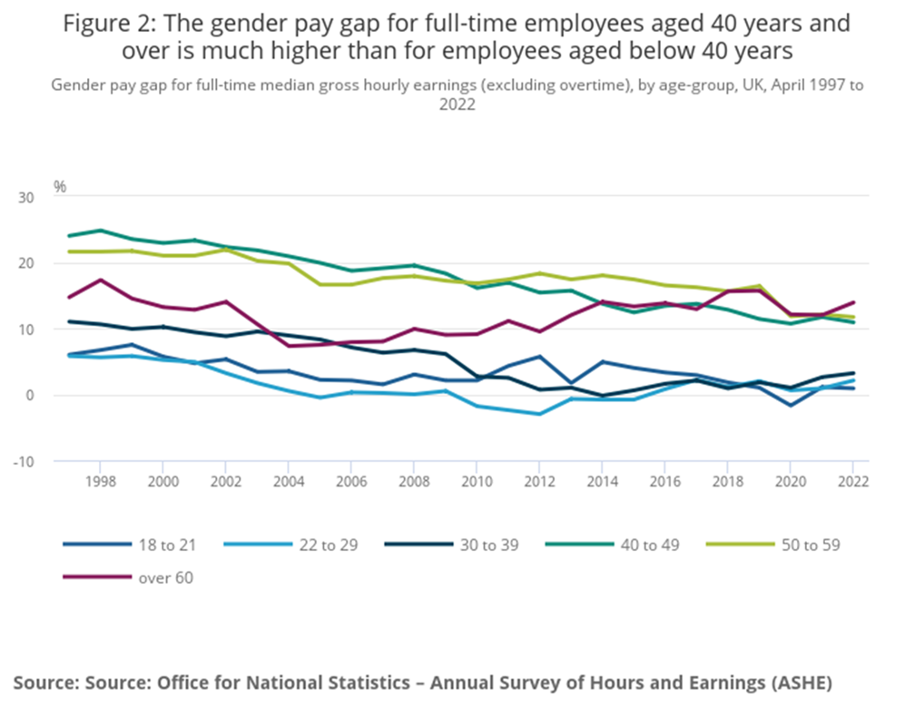
Office For National Statistics, (2022)

The calculation of the age gap chart shows that female employees in question over the age of 60 had decreased from 2002-2005, however from 2008-2022 this showed inconsistency going higher and lower over the years. Furthermore the employees that stayed on a level seems to be the employees aged 50-59 which demonstrates that the employees were able to challenge their equal pay.

Figure 3: Gender pays gap for full-time median gross hourly earnings (excluding overtime), by occupation, UK, April 2019 and 2022
This chart is showing the difference from the difference career occupations of employees from 2019- 2022, during the pandemic gap.

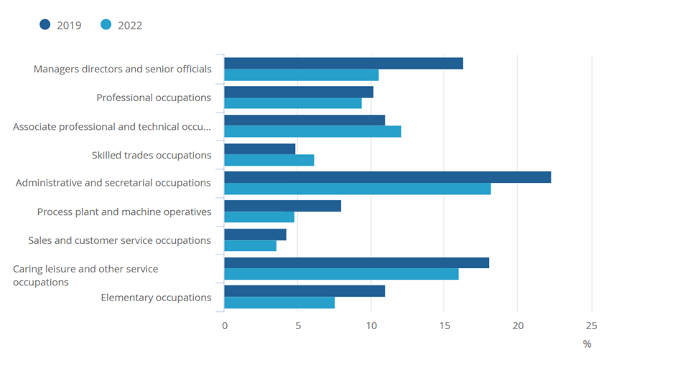
Office For National Statistics, (2022)
This chart demonstrates that managers, directors have the largest gap alongside administrative and secretarial occupations.

4.3 The Effects of Gender Pay Strategies
Overlooking Journals by Brewis (2010) and Stewart (2014), there is recognition with the theory of women feeling impact of pressure of being a woman and feeling not to question their equal pay right and policy within their work department. Whether the woman works public or private the woman in question may feel no compulsion to complain the union or HR regarding her equal rights.
‘Female finalists in higher education are already aware of the potential impact that their gender might have on their future careers and in light of this have begun to develop plans to cope with them’, Brewis (2010).
“Currently, UK public sector employers and private and voluntary sector employers with over 250 employees have an obligation to analyse their gender pay gap each April and report on it within 12 months. 44 Public and private sector employers are under an obligation to calculate and publish annually: mean gender pay gap each April and report on it within 12 months”, Grabham (2022).
This proves that public, private and voluntary job sectors of employees, the head of department although this implies, they are supposed to show the analysis of gender pay. This safely shows through the gender gap itself that the procedures of data. This could be suggested to be a pacifier than a strategy for a conclusion. This because although this has been set as a standard, it clear that victims of the gender gap were not aware of this information to place forward.
“On 6 September 2023, Birmingham City Council became the seventh council in the last three years to declare itself in a state of “effective bankruptcy”. The Council issued a s114 notice which confirmed that it does not have enough resources to meet its financial liability relating to equal pay claims”, www.farrer.co.uk (2023).
Overlooking this situation of Birmingham City Council paying out towards the cases being opened, this could still suggest being conflict due to not being able to possibly pay out every victim. Although this has resulted to the council already paying £1.1 billion equal pay claim compensation. Though this has been recognised that a settlement of payouts is one strategy that Birmingham city council has used the issue, due to the conclusion of this, this may not help the issue due to the local authorities being bankrupt in doing so, therefore this suggests a payout settlement as strategy is also a disadvantage.
‘The first step in ensuring equal pay is identifying whether there is a problem within your organisation. To do that it’s important to carry out an equal pay audit, which the Equality and Human Rights Commission recommends is done regularly’. This suggests although there is meant to be a pay audit for a company to monitor equal pay, however just the same equivalent statement to Grabham, (2022), should victims not know of this information they would not know who to address at their company for the data.
“Transparency within companies in criteria and decisions regarding pay can also help prevent gender bias. Ensuring workers to organize and bargain collectively is an important part of the solution. It is crucial that women be involved in employer and union leadership, enabling legislation that establishes comprehensive frameworks for gender equality in the workplace”. UN Women, (2020). This implies by being open and transparent meaning by seeing through how they operate as a company and how they treat their staff, transparency will give everyone the same information, regarding the job description and the work being done, therefore all employees whether female or male will know the same information. This can benefit the companies’ grading employees by their skills and salary rather than their wages being measured on their gender.

4.4 Gender Gap Pay Globally

- Daugherty, G. (2021).
- The History of the Gender Wage Gap in America, ActionAid (2023).
- The Gender Pay Gap, Partridge, J. (2023).
- Women still have right to equal pay, says UK government, despite scrapping of EU law.
- Striking Women (2013)
- Raile, Austin and Bratton, (2023).
Nationally and internationally it has been recognised that both journals had mirrored the information with similar unfair issues regarding women in America, Africa, Europe, and other local authorities in England, all repeating the same information about women being paid less than men and doing the same job description.
Furthermore historically in other countries there was patterns of the same repeated data not being publicly shared or shown to female employers, globally in the workplace.
This has shown reflection that unequal pay is globally a large issue of decades and possibly even more than the information that has been searched and not documented. Even in female predominantly careers, there are still issues of males being paid more than females. This is shown through University of Birmingham, where women who have status of a higher qualification of teaching are still being paid less than male higher counterparts despite the job qualifications being the same level.
‘Worldwide, female workers are significantly underpaid compared to their male counterparts.Footnote1 Some governments are taking action to address this issue.Footnote2. For example, in June 2017, Iceland became the first country to mandate a “Pay Equality Certificate” for employers, which requires proof of equal pay for men and women’. Raile, Austin and Bratton, (2023).
“Equal Pay Act in 1963 and the Civil Rights Act in 1964 Footnote 8 legislated equal pay. In 2009, the Lilly Ledbetter Fair Pay Act additional protection for female workers, primarily through clarifications of laws and judicial rulings already in place. In 2010, President Obama established the National Equal Pay Task force; in 2014”. Raile, Austin and Bratton, (2023).
This highlights globally although there are changes made in the U.S for enforcing proof of equal pay and with Iceland being the first internationally to make changes regarding equal pay, nationally England has not made these changes which can prevent the pattern of gender gap pay in general, this questions why England has not pushed this issue as strongly as over countries who has taken serious action like Iceland and U.S.

4.5 Findings of periodical data of Gender Gap Reports
• Gender Pay Gap Report 2021. (2021),
• Highlights of Birmingham City Council Equalities Office (2016),
• Birmingham City Council Gender Pay Gap Report 2022 . (n.d.).
• Birmingham city council : BCC, pp.1–12, Council, B.C. (n.d.).
• Gender pay gap at council continues to reduce and Birmingham City Council Gender Pay Gap Report 2022 (2022).
• Birmingham City Council Gender Pay Gap Report 2017 (2017).
• Gender Gap Report 2021 (2021).
• Bishu, S.G. and Alkadry, M.G. (2017). A Systematic Review of the Gender Pay Gap and Factors That Predict It. Administration & Society, 49(1
• The UK Gender Pay Gap 1997-2015:

These reports show a theme that in the Local authority that has been a part of the Gender Gap Issue within the last twenty years and up to date. This research demonstrates the gaps specifically in the charts, however there was no specific data in terms of the individuals, how many cases have been opened and how many has been closed.

4.6 Findings of Successful Cases Won Against Birmingham Council
- What is happening in ‘bankrupt’ Birmingham? (2023).
- Smith, B. (2023). ‘Bankrupt’ Birmingham council must pay hundreds of millions in gender pay dispute.
- Rehman (2017). Equal Pay Update: Three New Cases You Need To Know About.
- Employment Cases Update. (2012). Employment Cases Update: Birmingham City Council v Abdulla & Ors [2012] UKSC 47

The cases of the information in regard to cases that have been won and able to access publicly by Birmingham City Council. It has been recognised that a lot of employees have been paid, the percentage of increase was not great for the domestic female workers, compared to managers in the same area the difference was not as large in scale.
However the benefit of these won cases highlight that over twenty thousand to fifty thousand have been given to those individuals that vary from age 25 to age 60.

4.7 Findings of Various Job Roles that have been documented with Unequal Pay for Women against Men
- Birmingham , B. (2005). But some are more equal than others’ — The Equal Treatment
- Directives and equalising the state pension, Kräft, C. (2022).
- Equal pay behind the ‘Glass Door’? The gender gap in upper management in a male‐dominated industry. Gender, Work & Organization, 29(6).
- UN Women (2020). Everything You Need to Know about Pushing for Equal Pay,
- Brewis, D.N. (2010). Performing Professional: University Student Perceptions of Gender
- Deakin, S. (2012). What are Equal Pay Strategies of equal pay.
- Flood, M. and Pease, B. (2005). Undoing Men’s Privilege and Advancing Gender Equality in Public Sector Institutions. Policy and Society, 24(4), pp.119–138.
- Flood, M. and Pease, B. (2005). Undoing Men’s Privilege and Advancing Gender Equality in Public Sector Institutions. Policy and Society, 24(4), pp.119–138.
- Archer, A. and Prange, M. (2019). ‘Equal play, equal pay’: moral grounds for equal pay in football.
From these journals there have concerns of employing women to do the minimum hours, with the most qualifications, still try to justify not paying the men with the same responsibilities minimum wage. Alongside highlighting regardless of status whether a woman has a qualification, or more experience in their job role, there is similarities of women in what is classed as domestic to academic are all still being wrongfully underpaid over the years.

4.8 Findings of where Equal Rights was Noted Publicly
- Weightmans. (n.d.). Equal pay update: three new cases,
- Croft, J. and Wild, J. (2012).
- Birmingham loses ‘historic’ equal pay case, ACAS (2022).
- Equal Pay and the Law, Council, B.C. (2023). Birmingham City Council statement on Equal Pay update

According to the research, and in regard to this theme of equal rights being publicly noted, there was no specific date to when Birmingham City Council was first notified in regard to what company and which first person opened their first case against Birmingham in the inner city.
This highlighted the first equal rights was publicly noted historically through the 1930s as a topic but addressed as women opening publicly until the 1970s according to the reports and journals.
‘A detailed and fresh analysis of the council’s ongoing equal pay claims has been conducted in light of issues raised as a result of the implementation of the Oracle financial system’, Council, B.C (2023).
‘The council has already paid out a total of £1.1bn in relation to the settlement of Equal Pay claims over the last decade. However, the refreshed analysis has revealed that significant additional Equal Pay costs will need to be provided for by the council.
It is estimated that as of 31 March 2023 the council’s current equal pay liability is in the region of £650m and £760m with this liability continuing to accrue at an estimated rate of between £5 million and £14 million a month’. Council, B.C (2023)
Looking other the statement published recently, June (2023), It suggests that Birmingham City council bill for unfair payment is rising between 5 to 14 million a month, this highlights that certain services such as social services will be lost in regard to implanting fair pay for this that have claimed and open cases. It also showing that Birmingham in the future predict bankruptcy for another few decades to pay out more cases and the recent ongoing cost of unfair pay.
Services, resources will be lost due to the financial conflict of the council being able to afford paying out the cases and losing services in other departments of Birmingham City Councill.
It is also recognised that the Gender Gap pay has been the most challenging situations the local authority has faced, although there are apologies there has been no specific conclusion other than paying as much cases as possible.

4.9 Research Gap
After overlooking the research based on unequal pay and Birmingham City Council exploitation to paying out victims over the four decades. it is recognised not one department has made a legitimate change regarding unequal pay, this is highlighted in all areas of careers for women, this includes public and private sector.
Furthermore during the research to the number of cases opened against Birmingham City Council. The website shows data of the gap existing between each year, with gap, age and how many years apart. there is still no specific information to how many cases have been opened and concluded to individuals, alongside there has been no specific information to any cases of victims’ feedback to what was resolved, and no specific information to what data the victims had to bring in the court cases.
It is also recognised that there was no information so far, regarding the very first case opened against Birmingham City Council, as much as there is highlights through social media and correspondence with a statement of change from Birmingham City Council. There is still no clarification to why there has been no stopping to the pattern and reputation of gender gap pay over the years.

5 Conclusion
Overall it has the conclusion it shows that the Gender Gap Pay has been circulating in society from the second world war when women were assigned to do more male dominant roles, therefore historically the continuous pattern of the gender gap pay has presented Itself to be an additional battle of the sexes regarding equality and equal rights.
Gender Pay Gap Reports are similar within the information of data of women and men, there are similarities of what people have experienced regardless of age or decade the case has been opened. There has been an ideal theory of conclusion to make sure women know the rights and equal pay policy in regard to asking for the correct data to be highlighted by the work HR, Departments to prevent these cases arising for the next four decades.
Birmingham City Council as a local authority in conclusion it suggests the council have tried to avoid addressing the unfair pay for as long as they could, through the reports, with no aware bouts of the employees knowing what data and evidence to find.
England clearly shown that as a society they have not accepted equality for women, which is a high disappointment for female citizens within the U.K. although there are many cases opened and resolved, as much as 15,000 cases that have been won, there are still hundreds of thousands of women who are still battling the gender wage difference of men being paid more than them, despite the same job responsibility within the work institute.
Although the strategy from Birmingham City Council to pay out victims, this has been a disadvantage due to the local authority become bankrupt, in conclusion there should be a new process in place for the future so local authorities will not have to pay out female employees. The companies in the future should be transparent with the same information regarding wages and salary and fair rights of pay.
“Unequal pay is a stubborn and universal problem. In spite of significant progress in women’s education and higher female labour market participation rates in many countries, closing the gender pay gap has been too slow. At this pace , it will take 257 years to achieve economic gender parity”, UN Woman (2022)
This suggests because there was no establishment from the beginning, therefore there was no equal rights pay. There is a suggestion that it will take two and half centuries to end this cause of equal pay within the working environment. This research feedback regarding the information globally, to right this wrong this could push from the feedback to agree, as it took decades for a local council to recognise.

5.2 Contributions to Literature on Gender Gap Pay
Research of equal rights have been publicly noted, there was data specially showing about Birmingham City Council, when information was first opened and notified to the public view and inner-city communities. Birmingham city council never seemed to identify the first case opened. Furthermore equal rights were publicly noted historically through the 1930s as a topic but addressed as women opening publicly until the 1970s according to the reports and journals.

5.3 Recommendations for Resolving Gender Pay Gap
One recommendation would be for information to be accessible to victims, authorities need to make an apology, a public statement for the people who have been affected alongside, people to be aware of the entitled claims and backpay.
Departments needs to reassure victims that they are supported for future job positions, this includes any danger of losing their current position should they decide to make a claim from past cases of unequal pay.
Another suggestion is for managers and head departments to offer equal pay, showing employees salary increases, or correct policies that are transparent for both female and male colleagues in the work ethic.
Companies should advertise their salary increments for all staff and showing the same level of qualification, this enables female colleagues to see the same work value as a male colleague from their manager’s information and policy being actively shown. Furthermore equal pay statements should be shown on their company information and website for future applicants to see companies following equal rights.

6. Bibliography
ACAS (2022). Equal Pay and the Law. Acas. Available at: https://www.acas.org.uk/equal-pay/equal-pay-law.
(Accessed 5th November 2023)
ActionAid (2023). The Gender Pay Gap | ActionAid UK. [online] www.actionaid.org.uk. Available at: https://www.actionaid.org.uk/our-work/womens-economic-rights/gender-pay-gap.
Accessed 12th November 2023
(2023). BBC West Midlands. 24 Sep. Available at: https://www.bbc.co.uk/news/uk-england-birmingham-66896733
(Accessed 15 November 2023)
Archer, A. and Prange, M. (2019). ‘Equal play, equal pay’: moral grounds for equal pay in football. Journal of the Philosophy of Sport, 46(3), pp.1–21. doi:https://doi.org/10.1080/00948705.2019.1622125
(Accessed 26th November 2023)
Birmingham City Council Gender Pay Gap Report 2022 . (n.d.). Birmingham city council : BCC, pp.1–12.
(Accessed 29th October 2023)
BBC (2020). Study finds 90% of people are biased against women. BBC News. 5 Mar. Available at: https://www.bbc.co.uk/news/world-51751915.
(Accessed 28th December 2023)
Birmingham , B. (2005). But some are more equal than others’ — The Equal Treatment Directives and equalising the state pension . Pensions, 10, pp.262–274.
(Accessed 26th October 2023)
Birmingham City Council. (2017). Available at: https://assets.publishing.service.gov.uk/media/60a77e718fa8f520bc5f2839/Ms_D_Campbell_v_Birmingham_City_Council_-_1300104_2020_-_Judgment_and_Reasons.pd
(Accessed 29th November 2023)
Birmingham, B. (2005). ‘But some are more equal than others’ – The Equal Treatment Directives and equalising the state pension age. Pensions: An International Journal, 10(3), pp.262–274. doi: https://doi.org/10.1057/palgrave.pm.5940294.
(Accessed 12th December 2023)
Bishu, S.G. and Alkadry, M.G. (2017). A Systematic Review of the Gender Pay Gap and Factors That Predict It. Administration & Society, 49(1), pp.65–104. doi:https://doi.org/10.1177/0095399716636928.
(Accessed 15th November 2023)
Bishu, S.G. and Alkadry, M.G. (2017). A Systematic Review of the Gender Pay Gap and Factors That Predict It. Administration & Society, 49(1), pp.65–104. doi:https://doi.org/10.1177/0095399716636928.
(Accessed 12th November 2023)
Brewis, D.N. (2010). Performing Professional: University Student Perceptions of Gender . Discrimination in their Future Careers.
(Accessed 7th November 2023)
BBC News. (2023). Birmingham City Council facing £760m equal pay bill. Available at: https://www.bbc.com/news/uk-england-birmingham-66042403.amp
(Accessed 24th September 2023)
Cambridge Core. (n.d.). Business and Politics: Volume 25 - Issue 1 | Cambridge Core. Available at: https://www.cambridge.org/core/journals/business-and-politics/issue/5FDDFA6E1D8F944AC61B72D07B0256AF
(Accessed 26th November 2023)
Chetty, A.W., Priya (2020). How to formulate a research strategy? Knowledge Tank. Available at: https://www.projectguru.in/how-to-formulate-a-research-strategy/#:~:text=A%20research%20strategy%20refers%20to%20a%20step-by-step%20plan.
(Accessed 28th December 2023)
Council, B.C. (n.d.). Gender pays gap at council continues to reduce. www.birmingham.gov.uk. Available at: https://www.birmingham.gov.uk/news/article/975/gender_pay_gap_at_council_continues_to_reduce
(Accessed 5th November 2023)
Council, B.C. (2023). Birmingham City Council statement on Equal Pay update. [online] www.birmingham.gov.uk. Available at: https://www.birmingham.gov.uk/news/article/1353/birmingham_city_council_statement_on_equal_pay_update.
(Accessed 26th November 2023)
Council, B.C. (n.d.). Birmingham City Council statement on Equal Pay update. [online] www.birmingham.gov.uk. Available at: https://www.birmingham.gov.uk/news/article/1353/birmingham_city_council_statement_on_equal_pay_update
(Accessed 25th September 2023)
Croft, J. and Wild, J. (2012). Birmingham loses ‘historic’ equal pay case. Financial Times. Financial Times. Available at: https://www.ft.com/content/35f20504-1db9-11e2-8e1d-00144feabdc0.
(Accessed 15th November 2023)
Carmichael, F., Ercolani, M. and Taylor, S. (2019). CLOSING THE GENDER PAY GAP: ARE WE NEARLY THERE YET? University of Birmingham: University of Birmingham, pp.1–2. Available at: https://www.birmingham.ac.uk/Documents/research/Public-Affairs/Gender-Pay-Gap.pdf
(Accessed 15th November 2023)
Daugherty, G. (2021). The History of the Gender Wage Gap in America. [online] Investopedia. Available at: https://www.investopedia.com/history-gender-wage-gap-america-5074898.
(Accessed 25th October 2023)
Deakin, S. (2012). What are Equal Pay Strategies of equal pay.
(Accessed 7th November 2023)
Employment Cases Update. (2012). Employment Cases Update: Birmingham City Council v Abdulla & Ors [2012] UKSC 47. Available at: https://employmentcasesupdate.co.uk/content/birmingham-city-council-v-abdulla-ors-2012-uksc-47.1d63ed6baea342319ce99e8712d6ccbb.htm.
(Accessed 20th November 2023)
Engl, H. (2020). Women in the Workforce During the Second World War: Taking on Men’s Roles. [online] Heritage Calling. Available at: https://heritagecalling.com/2020/03/01/women-in-the-workforce-during-the-second-world-war-taking-on-mens-roles/.
(Accessed 26th October 2023)
Faragher, J. (2023). ‘Bankrupt’ councils and equal pay: what’s the impact for HR? Personnel Today. Available at: https://www.personneltoday.com/hr/bankrupt-councils-equal-pay/
(Accessed 29th October 2023)
Flood, M. and Pease, B. (2005). Undoing Men’s Privilege and Advancing Gender Equality in Public Sector Institutions. Policy and Society, 24(4), pp.119–138. doi:https://doi.org/10.1016/s1449-4035(05)70123-5.
(Accessed 12th November 2023)
Francis-Devine, B. (2022). The gender pay gap. Parliament.uk. Available at: https://researchbriefings.files.parliament.uk/documents/SN07068/SN07068.pdf.
(Accessed 12th December 2023)
Fredman, S. (2008). Reforming Equal Pay Laws. Industrial Law Journal, 37(3), pp.193–218. doi: https://doi.org/10.1093/indlaw/dwn008.
(Accessed 27th September 2023)
Government Equalities Office (2016). UK Gender Pay Gap. GOV.UK. Available at: https://www.gov.uk/government/news/uk-gender-pay-gap.
Accessed 26th October 2023
Gender Pay Gap Report 2021. (2021). University of Birmingham Creative Media. Birmingham : University of Birmingham .
Accessed 29th October 2023
Grabham, E. (2023). Decertifying Gender: The Challenge of Equal Pay. Feminist Legal Studies, 31(1). doi:https://doi.org/10.1007/s10691-022-09516-3.
Accessed 29th October 2023
Grabham, E. (2022). Decertifying Gender: The Challenge of Equal Pay. Feminist Legal Studies (2023) 31:67–93, 31, pp.67–93. doi:https://doi.org/10.1007/s10691-022-09516-3.
(Accessed 20th November 2023)
Grabham, E. (2022). Decertifying Gender: The Challenge of Equal Pay. Feminist Legal Studies (2023) 31:67–93, 31, pp.67–93. doi:https://doi.org/10.1007/s10691-022-09516-3
(Accessed 29th November 2023)
GOV.UK (2017). The Equality Act 2010 (Gender Pay Gap Information) Regulations 2017. Legislation.gov.uk. Available at: https://www.legislation.gov.uk/ukdsi/2017/9780111152010.
(Accessed 26th November 2023)
Guru, S., Housee, S. and Joshi, K. (2020). Birmingham Black Sisters: Struggles to end injustice. Critical Social Policy, 40(2), pp.196–214. doi: https://doi.org/10.1177/0261018319897038.
(Accessed 25th November 2023)
Hamlett, C. (2019). Nepotism in the Workplace With Friends. smallbusiness.chron.com. Available at: https://smallbusiness.chron.com/nepotism-workplace-friends-13206.html.
(Accessed 28th December 2023)
Hogan, V. (2012). Legal Q&A: What does Birmingham City Council v Abdulla mean for equal pay claims? [online] Personnel Today. Available at: https://www.personneltoday.com/hr/legal-qa-what-does-birmingham-city-council-v-abdulla-mean-for-equal-pay-claims/.
Accessed 15th November 2023
Jones, M., Makepeace, G. and Wass, V. (2018). The UK Gender Pay Gap 1997-2015: What Is the Role of the Public Sector? Industrial Relations: A Journal of Economy and Society, 57(2), pp.296–319. doi:https://doi.org/10.1111/irel.12208
Accessed 29th October 2023
Jones, M., Makepeace, G. and Wass, V. (2018). The UK Gender Pay Gap 1997-2015: What Is the Role of the Public Sector? Industrial Relations: A Journal of Economy and Society, 57(2), pp.296–319. doi:https://doi.org/10.1111/irel.12208.
(Accessed 12th November 2023)
Kräft, C. (2022). Equal pay behind the ‘Glass Door’? The gender gap in upper management in a male‐dominated industry. Gender, Work & Organization, 29(6). doi:https://doi.org/10.1111/gwao.12890.
(Accessed 26th November 2023)
Legislation.gov.uk. (2017). The Equality Act 2010 (Gender Pay Gap Information) Regulations 2017. Available at: https://www.legislation.gov.uk/uksi/2017/172/introduction/made.
(Accessed 29th September 2023)
Leaker, D. (2008). The gender pay gap in the UK. Economic & Labour Market Review, 2(4), pp.19–24. doi: https://doi.org/10.1057/elmr.2008.54.
(Accessed 29th September 2023)
Matthew Hutson (2018). Why Are There So Few Female Leaders? Scientific American. Available at: https://www.scientificamerican.com/article/why-are-there-so-few-female-leaders/.
(Accessed 28th December 2023)

Mylearning.org. (2019). Munitions Factories in WW2 – ‘Canary Girls’ • Women at War: The Role of Women During WW2 • MyLearning. Available at: https://www.mylearning.org/stories/women-at-war-the-role-of-women-during-ww2/743.
(Accessed 29th October 2023)

McGrath, D. (2023). Birmingham City Council in financial distress over equal pay claims. Evening Standard. Available at: https://www.standard.co.uk/news/politics/birmingham-city-council-financial-distress-europe-equal-pay-b1104916.html#:~:text=A%20Birmingham%20City%20Council%20spokesperson%20said%3A%20%E2%80%9CBirmingham%20City
(Accessed 5 November 2023)
mhrglobal.com. (n.d.). Gender Pay Gap Report | MHR. Available at: https://mhrglobal.com/uk/en/gpg?network=o&msclkid=fe27ce84916a17d3424fab09183bb63e&utm_source=bing&utm_medium=cpc&utm_campaign=ID_Search_UK_Product_HR_ph&utm_term=HR&utm_content=HR%20-%20Dynamic
(Accessed 28th December 2023)
News, I. (2023). Birmingham City Council face £650 million black hole as new equal pay claims surface. [online] ITV News. Available at: https://www.itv.com/news/central/2023-06-28/birmingham-city-council-face-650-million-cost-as-new-equal-pay-claims-surface
(Accessed 12th December 2023)
Office For National Statistics (2022). Gender pay gap in the UK - Office for National Statistics. www.ons.gov.uk. Available at: https://www.ons.gov.uk/employmentandlabourmarket/peopleinwork/earningsandworkinghours/bulletins/genderpaygapintheuk/2022
(Accessed 15th November 2023)
O’Reilly, J. ed., (2013). University of Bri. Through the looking glass on gender pay gap transparency, ghton Business School, University of Brighton.
(Accessed 26th October 2023)
Prime Minister's Office, 10 Downing Street and Ministry of Defence (2015). The women of the Second World War. GOV.UK. Available at: https://www.gov.uk/government/news/the-women-of-the-second-world-war.
(Accessed 26th October 2023)
Partridge, J. (2023). Women still have right to equal pay, says UK government, despite scrapping of EU law. The Guardian. 30 Aug. Available at: https://www.theguardian.com/society/2023/aug/30/women-still-have-right-to-equal-pay-says-uk-government-despite-scrapping-of-eu-law?ref=biztoc.com (Accessed 5 Nov. 2023)
Raile, A.N.W., Austin, C.G. and Bratton, V.K. (2023). Can We Talk About Pay Discrimination/Equal Pay/Strategic Compensation Practices? An Exploratory Study on Framing Gender Pay Inequity. Business and Politics, pp.1–17. doi:https://doi.org/10.1017/bap.2022.21.
(Accessed 26th November 2023)
Raile, A.N.W., Austin, C.G. and Bratton, V.K. (2023). Can We Talk About Pay Discrimination/Equal Pay/Strategic Compensation Practices? An Exploratory Study on Framing Gender Pay Inequity. Business and Politics, pp.1–17. doi: https://doi.org/10.1017/bap.2022.21.
(Accessed 12th December 2023)
Rehman (2017). Equal Pay Update: Three New Cases You Need to Know About. Available at: https://www.weightmans.com/media-centre/news/equal-pay-update-three-new-cases-you-need-to-know-about/.
(Accessed 20th November 2023)
Salmon, F. (n.d.). For one UK city, the cost of underpaying women is bankruptcy. [online] Available at: https://www.axios.com/2023/09/09/why-birmingham-uk-bankrupt-underpaying-women
(Accessed 9 September 2023).
Silkin, L. (2021). Women in Work: a brief history of women in the workplace. Future of Work Hub. Available at: https://www.futureofworkhub.info/comment/2021/7/6/women-in-work-a-brief-history-of-women-in-the-workplace.
(Accessed 5th November 2021)
Smith, B. (2023). ‘Bankrupt’ Birmingham council must pay hundreds of millions in gender pay dispute. The Telegraph. [online] 13 Oct. Available at: https://www.telegraph.co.uk/news/2023/10/13/bankrupt-birmingham-city-council-pay-millions-equ/
(Accessed 31st October 2023)

Stewart, H. (2023). Why, even now, do we think a woman’s work is worth less? The Guardian. 11 Aug. Available at: https://www.theguardian.com/world/2023/aug/11/why-even-now-do-we-think-a-womans-work-is-worth-less.

(Accessed 28th December 2023)

Striking Women (2013). Gender pays gap and the struggle for equal pay | Striking Women. Striking-women.org. Available at: https://www.striking-women.org/module/workplace-issues-past-and-present/gender-pay-gap-and-struggle-equal-pay

(Accessed 26th November 2023)
the Guardian. (2014). Equal pay: the women who won case against Birmingham city council. Available at: https://www.theguardian.com/money/2014/apr/11/equal-pay-women-birmingham-city-council.
(25th October 2023)
Ukpopulation.org. (2019). Birmingham Population 2019 | Population UK. Available at: https://www.ukpopulation.org/birmingham-population/.
(25th October 2023)
UK parliment. (2023). House of Commons and Parliamentary Digital Service publish 2022 pay gap data. Available at: https://www.parliament.uk/business/news/2023/march-2023/house-of-commons-and-parliamentary-digital-service-publish-2022-pay-gap-data/.
(Accessed 26th October 2023)
UN Women (2021). What does gender equality look like today? UN Women. 6 Oct. Available at: https://www.unwomen.org/en/news/stories/2021/10/feature-what-does-gender-equality-look-like-today.
(Accessed 29th October 2023)
UN Women (2020). Everything You Need to Know about Pushing for Equal Pay. UN Women. Available at: https://www.unwomen.org/en/news/stories/2020/9/explainer-everything-you-need-to-know-about-equal-pa
(Accessed 29th November 2023)
University of Birmingham. (n.d.). Gender and ethnicity pay gaps. Available at: https://intranet.birmingham.ac.uk/collaboration/equality/monitoring-and-reporting/gender-pay-gap.aspx
(Accessed 26th November 2023)
What is happening in ‘bankrupt’ Birmingham? (2023). BBC News. [online] 6 Sep. Available at: https://www.bbc.com/news/uk-england-birmingham-66730165.
(Accessed 30th October 2023)
www.ft.com. (n.d.). Subscribe to read | Financial Times. Available at: https://www.ft.com/content/35f20504-1db9-11e2-8e1d-00144feabdc0. (Accessed 5th November 2023)
White, N.J. (2022). Gender pays gap in the UK: 2022. ONS. Office for National Statistics: Census2021. Available at: https://www.ons.gov.uk/employmentandlabourmarket/peopleinwork/earningsandworkinghours/bulletins/genderpaygapintheuk/2022
(Accessed 15th November 2023)
Weightmans. (n.d.). Equal pay update: three new cases. Available at: https://www.weightmans.com/media-centre/news/equal-pay-update-three-new-cases-you-need-to-know-about/.
(Accessed 20th November 2023)
www.ethnicity-facts-figures.service.gov.uk. (n.d.). Male and female populations. Available at: https://www.ethnicity-facts-figures.service.gov.uk/uk-population-by-ethnicity/demographics/male-and-female-populations/latest#main-facts-and-figures
(Accessed 25th October 2023)

