11/08/2026
Cert HE Computing skill for workplace
Module Name, Software Solution for Business
Module Code, ACCA4026
Lecturer’s Name Kwame Ass-AGEI Fahed Ahmed
Group 3



Contents
Introduction 1
Software Solutions in Business 1
Benefits of Software Solutions in Business 1
Challenges of Using Business Software 1
Task 1. e-Commerce Website builders/software solutions 1
Features 1
How e-commerce works 1
Types of e-commerce 1
• Types of E-Commerce 1
• 1. Business-to-Consumer (B2C) 1
• 2. Business-to-Business (B2B) 1
• 3. Consumer-to-Consumer (C2C) 1
• 4. Consumer-to-Business (C2B).[5] 1
Key Features of WooCommerce 1
Advantages 1
Limitations 1
Common Uses 1
1.2 Google site 1
Features 1
Uses 1
Advantages 1
Disadvantages 1
Importance of Google Sites in Business 1
Task 2. Mind-map of contemporary software applications 1
2.1 Describe mind mapping and explain the benefits of using mind mapping 1
Purpose of a Mind Map 1
Mind Map of Contemporary Software Applications 1
Categories of Contemporary Software Applications 1
1. Productivity 1
2. Business Software 1
3. Communication Software 1
4. Educational Software 1
5. Entertainment Software 1
6. Security Software 1
Importance of Contemporary Software Applications 1
2.2 Create a mind map of contemporary software applications 1
Task 3. Office Applications 1
3.1 Four office software solutions for business operations 1
Ms Word 1
Features of Microsoft Word 1
Uses of Microsoft Word 1
Advantages 1
Disadvantages 1
Importance of Microsoft Word in Business 1
Conclusion 1
Ms Excel 1
Features 1
Uses 1
Advantages 1
Disadvantages 1
Importance of Microsoft Excel in Business 1
Conclusion 1
Ms PowerPoint 1
Features 1
Uses 1
Advantages 1
Disadvantages 1
Importance of Microsoft PowerPoint in Business 1
Features 1
Uses 1
• Advantages 1
• Disadvantages 1
• Importance of Microsoft Access in Business 1
• Difference Between Microsoft Access and Microsoft Excel 1
3.2 Test any two features 2
Mail Merge 2
IF Statement 2
Task 4. Communication and Collaboration applications 2
4.1 One contemporary Communication and one Online Collaboration 2
Microsoft outlook 2
Features 2
Uses 2
Advantages 2
Disadvantages 2
Importance of Microsoft Outlook in Business 2
4.2 Test one feature of a freely available Communication (1) and one feature of a Collaboration (1) application 2
Gmail 2
Features 2
Uses 2
Advantages 2
Disadvantages 2
Importance of Gmail in Business 2
Zoom 2
Features 2
Uses 2
Advantages 2
Disadvantages 2
Importance of Zoom in Business 2
References 2

Introduction

Software Solutions in Business
Software solutions have become essential for modern business operations because they improve efficiency, productivity, and organizational performance. Businesses increasingly rely on software applications to automate routine tasks, manage data, and support strategic decision-making in an increasingly competitive digital environment (Laudon & Laudon, 2022). Organizations of all sizes use software to streamline operations, reduce costs, and enhance customer satisfaction.
Business software includes Enterprise Resource Planning (ERP) systems, Customer Relationship Management (CRM) software, accounting systems, Human Resource Management Systems (HRMS), and cloud-based collaboration tools. These applications enable organizations to integrate business processes, improve communication, and increase operational efficiency. Furthermore, technological innovations such as cloud computing, artificial intelligence (AI), and big data analytics have transformed how businesses collect, analyse, and use information to gain a competitive advantage (Stair & Reynolds, 2023).
Despite the many benefits, implementing software solutions presents several challenges. Organizations often face high implementation and maintenance costs, employee resistance to change, and the need for continuous staff training. In addition, businesses must address cybersecurity risks and data privacy concerns to protect sensitive organizational information from cyber threats (Turban et al., 2021). Effective planning, employee engagement, and ongoing technical support are essential for successful software implementation.
Overall, software solutions play a significant role in helping Companies improve operational performance and achieve long-term business objectives. By adopting appropriate software systems and integrating emerging technologies, businesses can enhance productivity, improve customer service, and remain competitive in a rapidly changing marketplace. Although implementation challenges exist, the long-term benefits generally outweigh the costs when software is carefully selected, managed, and maintained (Laudon & Laudon[1]

Types of Software Solutions in Business
- Accounting Software
  - Helps businesses manage financial transactions, payroll, tax calculations, and budgeting.
  - Examples include QuickBooks, Xero, and Sage.
- Customer Relationship Management (CRM) Software
  - Stores customer information, tracks interactions, and improves customer service and sales.
  - Examples include Salesforce and HubSpot.
- Enterprise Resource Planning (ERP) Software
  - Integrates core business functions such as finance, inventory, purchasing, production, and human resources into one system.
  - Examples include SAP ERP, Oracle ERP Cloud, and Microsoft Dynamics 365.
- Project Management Software
  - Assists teams in planning, assigning, tracking, and completing projects efficiently.
  - Examples include Trello, Asana, and Monday.com.
- Human Resource Management Systems (HRMS)
  - Helps organisations manage employee records, recruitment, attendance, payroll, and performance.
  - Examples include BambooHR and Workday.
- E-commerce Platforms
  - Allow businesses to sell products and services online while managing orders, inventory, and payments.
  - Examples include Shopify, WooCommerce, and Magento.

Benefits of Software Solutions in Business
- Improves operational efficiency
- Reduces manual errors
- Saves time and operational costs
- Enhances customer satisfaction
- Provides real-time business information
- Improves communication and collaboration
- Supports strategic decision-making
- Increases business productivity and competitiveness

Challenges of Using Business Software
- High implementation costs
- Employee training requirements
- Cybersecurity and data privacy risks
- Ongoing maintenance and software updates
- Compatibility with existing systems
- Resistance to organisational change [2][3]

Task 1. e-Commerce Website builders/software solutions
Electronic commerce (e-commerce) refers to the process of buying and selling goods and services through the internet. It also involves the electronic exchange of information, payments, and business transactions between organisations and customers. E-commerce enables businesses to operate online, allowing consumers to purchase products and services at any time and from any location using internet-connected devices such as computers, smartphones, and tablets. Over the years, e-commerce has significantly transformed the business environment by improving convenience, expanding market reach, and reducing operational costs.

Features
E-commerce systems provide several important features that support online business operations. These include online product catalogues that display goods and services, shopping carts that allow customers to select products before purchasing, secure electro

E-commerce website builders are software solutions that enable businesses to create and manage online stores without requiring advanced technical skills. These platforms provide tools for website design, product management, secure payment processing, and inventory control, allowing businesses to establish an efficient online presence (Laudon & Traver, 2024). Popular platforms such as Shopify, WooCommerce, Wix, and BigCommerce also include features such as mobile optimisation, search engine optimisation (SEO), and analytics, helping businesses improve customer experience and increase sales (Chaffey, 2022).[4] References

How e-commerce works
- A customer visits an online store.
- They browse products or services.
- They add items to a shopping cart.
- They pay using an online payment method (such as a credit card, digital wallet, or bank transfer).
- The seller processes the order.
- The product is shipped or the digital service is delivered.

Types of e-commerce
- Business-to-Consumer (B2C): Businesses sell directly to customers (e.g., online clothing stores).
- Business-to-Business (B2B): Businesses sell products or services to other businesses.
- Consumer-to-Consumer (C2C): Individuals sell to other individuals through online marketplaces.
- Consumer-to-Business (C2B): Individuals provide products or services to businesses, such as freelance work.
- communication for individuals, businesses, educational institutions, and organisations.
- Attachment support for documents, images, and videos
- Integration with Google Drive for sharing large files
- Smart Compose and Smart Reply features
- Multiple email account management
- Access from computers, tablets, and smartphones
- Two-factor authentication for enhanced account security
- Personal communication
- Business correspondence
- Educational communication
- Sending and receiving documents
- Registering for online services
- Customer support communication
- Scheduling meetings through Google Calendar
- Collaborating using Google Workspace applications
- Sharing files through Google Drive
- Business operations.
- Customer accounts and order tracking
- Search and filtering tools
- Mobile-friendly websites
- Customer reviews and ratings
- Inventory management
- Integration with delivery and logistics services
- Marketing and promotional tools

Types of E-Commerce

1. Business-to-Consumer (B2C)
- Businesses sell products or services directly to individual consumers.
- Example: A customer buying clothes from an online fashion store.

2. Business-to-Business (B2B)
- Businesses sell products or services to other businesses.
- Example: A manufacturer selling office supplies to a retail company.

3. Consumer-to-Consumer (C2C)
- Individuals sell products or services to other individuals through online marketplaces.
- Example: Selling second-hand items on eBay or Facebook Marketplace.

4. Consumer-to-Business (C2B).[5]

WooCommerce is an open-source e-commerce plugin designed for WordPress that enables businesses to create and manage online stores efficiently. It provides a flexible and cost-effective solution for selling physical and digital products, managing inventory, processing secure payments, and handling customer orders (Laudon & Traver, 2024). Because it is open source, WooCommerce allows businesses to customize their online stores through a wide range of themes, plugins, and extensions, making it suitable for small and medium-sized enterprises. WooCommerce is a scalable and widely adopted e-commerce solution that supports business growth by providing flexibility, affordability, and extensive customization options for online retail operations.[4]
Originally launched in 2011, WooCommerce has become one of the world's most widely used e-commerce solutions because of its flexibility, ease of use, and extensive customization options. It is particularly suitable for small and medium-sized businesses, although many large enterprises also use it.

Key Features of WooCommerce
- Product Management: Add, edit, organise, and display unlimited physical or digital products.
- Secure Payments: Supports multiple payment gateways, including credit/debit cards, PayPal, Stripe, Apple Pay, and bank transfers.
- Inventory Management: Tracks stock levels, manages product availability, and sends low-stock notifications.
- Order Management: Allows store owners to process orders, handle refunds, manage shipping, and communicate with customers.
- Shipping Options: Supports flat-rate shipping, free shipping, local pickup, and integration with major courier services.
- Tax Management: Automatically calculates taxes based on customer location and local tax regulations.
- Marketing Tools: Includes discount coupons, promotional campaigns, customer reviews, and integration with email marketing platforms.
- Reporting and Analytics: Provides sales reports, revenue tracking, customer insights, and product performance data.
- Customisation: Thousands of themes and plugins allow businesses to extend functionality without rebuilding the website.

Advantages
- Free to install and use.
- Highly customisable and scalable.
- Large community support and extensive documentation.
- Seamless integration with WordPress.
- Suitable for businesses of all sizes.
- Supports multiple languages and currencies.

Limitations
- Requires a WordPress website.
- Advanced features may require paid extensions.
- Store owners are responsible for website hosting, security, backups, and updates.
- Performance may slow if too many plugins are installed without proper optimisation.

Common Uses
WooCommerce is commonly used by businesses to sell:
- Clothing and fashion items
- Beauty and skincare products
- Electronics
- Books and digital downloads
- Handmade crafts
- Food and beverages
- Online courses and memberships
- Professional services [6]

1.2 Google site
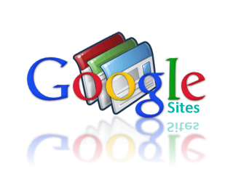Google Sites is a web-based website-building platform developed by Google that enables users to create and publish websites without requiring advanced programming skills. The service was first launched in 2008 following Google's acquisition of Jot Spot, a collaborative website creation tool, in 2006 (Google, n.d.). Google integrated Jot Spot's technology into its suite of online productivity applications, making it easier for individuals, educational institutions, and businesses to build and share websites. Today, Google Sites is widely used for educational projects, business intranets, portfolios, and informational websites because of its ease of use, cloud-based accessibility, and integration with Google's ecosystem.[7]

Features
Google Sites offers several features that make website creation simple and accessible:
- Easy drag-and-drop editor for building webpages.
- No coding required, making it suitable for beginners.
- Responsive design, ensuring websites work well on computers, tablets, and smartphones.
- Integration with Google Workspace, allowing users to embed files from Google Drive.
- Real-time collaboration, enabling multiple users to edit a website simultaneously.
- Automatic saving of changes.
- Secure hosting provided by Google.
- Customisable themes and layouts to create attractive websites.

Uses
Google Sites can be used for various purposes, including:
- Creating business websites
- Building personal portfolios
- Developing educational websites for teachers and students
- Creating project management pages
- Publishing company intranet sites
- Sharing training materials
- Hosting event information
- Creating team collaboration websites

Advantages
- Free to use with a Google account
- User-friendly interface
- No programming knowledge required
- Easy collaboration with team members
- Secure cloud-based hosting
- Automatic updates and maintenance by Google
- Integrates with other Google applications
- Mobile-friendly websites

Disadvantages
- Limited design flexibility compared to advanced website builders
- Fewer customisation options than WordPress or Wix
- Limited support for third-party plugins
- Basic SEO features
- Not ideal for large e-commerce websites
- Limited advanced web development features

Importance of Google Sites in Business
Google Sites helps businesses improve communication and information sharing by providing a simple platform for creating websites. Organisations use it to:
- Share company information
- Display products and services
- Create employee portals
- Manage internal documentation
- Support project collaboration
- Build knowledge bases
- Communicate with customers and stakeholders
Because it integrates with Google Workspace, employees can easily access and share documents, calendars, presentations, and forms from a single website. [8]

Task 2. Mind-map of contemporary software applications

2.1 Describe mind mapping and explain the benefits of using mind mapping
A mind map is a visual tool used to organize information, ideas, and concepts around a central topic. It helps people brainstorm, plan, study, solve problems, and understand relationships between different ideas. Instead of writing information in long paragraphs or lists, a mind map displays ideas in a branching structure that is easier to remember and understand. References (APA 7th Edition)
Software Applications—and branches into categories such as productivity, communication, business management, education, entertainment, and security. Mind maps help users understand relationships between software applications, making complex information easier to learn, remember, and analyse.

Purpose of a Mind Map
A mind map is designed to:
- Organise information visually.
- Show the relationship between different software applications.
- Improve understanding and memory retention.
- Support brainstorming, planning, and problem-solving.
- Simplify complex concepts for learning and presentations.

Mind Map of Contemporary Software Applications
Contemporary Software Applications
│
──────────────────────────────────────────────────────────────────
│ │ │ │ │ │
Productivity Business Communication Education Entertainment Security
Software Software Software Software Software Software
│ │ │ │ │ │
├─ MS Word ├─ ERP ├─ Zoom ├─ Moodle ├─ Netflix ├─ Norton
├─ Excel ├─ CRM ├─ Teams ├─ Google ├─ Spotify ├─ McAfee
├─ PowerPoint├─ Accounting ├─ Slack │ Classroom├─ YouTube ├─ Windows
├─ Google ├─ HRM ├─ Gmail ├─ Canvas ├─ Steam │ Defender
│ Docs └─ Inventory └─ WhatsApp └─ Kahoot └─ TikTok └─ Bitdefender

Categories of Contemporary Software Applications

1. Productivity
These applications help users create documents, analyse data, prepare presentations, and collaborate with others.
Examples:
- Microsoft Word
- Microsoft Excel
- Microsoft PowerPoint
- Google Docs

2. Business Software
Business software supports organisational operations by managing finance, customers, inventory, and employees.
Examples:
- Enterprise Resource Planning (ERP)
- Customer Relationship Management (CRM)
- Accounting software (QuickBooks, Sage)
- Human Resource Management Systems (HRMS)

3. Communication Software
Communication software enables users to exchange information through messaging, video conferencing, and email.
Examples:
- Microsoft Teams
- Zoom
- Slack
- Gmail
- WhatsApp

4. Educational Software
Educational software supports teaching, learning, and assessment.
Examples:
- Google Classroom
- Moodle
- Canvas
- Kahoot

5. Entertainment Software
Entertainment applications provide digital media such as videos, music, games, and social networking.
Examples:
- Netflix
- Spotify
- YouTube
- TikTok
- Steam

6. Security Software
Security software protects computers, networks, and data from cyber threats.
Examples:
- Norton Antivirus
- McAfee
- Bitdefender
- Windows Defender

Importance of Contemporary Software Applications
Modern software applications are essential because they:
- Increase productivity and efficiency.
- Improve communication and collaboration.
- Support business operations and decision-making.
- Enhance online learning experiences.
- Protect digital information from cyber threats.
Provide entertainment and access to digital media .[9]

2.2 Create a mind map of contemporary software applications
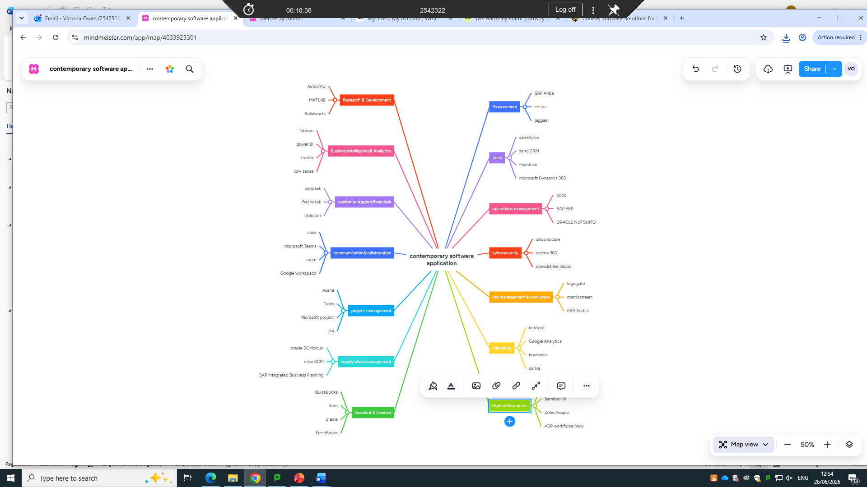

Task 3. Office Applications

3.1 Four office software solutions for business operations

Ms Word
MS Word is an essential tool in both academic and professional environments. Students use it to prepare assignments, dissertations, and presentations, while businesses rely on it to create contracts, reports, correspondence, and other official documents. Its advanced editing, formatting, and collaboration features make it one of the most important productivity applications available today. Microsoft Word is a word processing application developed by Microsoft. It is part of the Microsoft 365 it suite and is one of the most widely used programs for creating, editing, formatting, and printing text-based documents. References (APA 7th Edition)[10]

Features
Microsoft Word provides many features that make document creation efficient and professional:
- Create and edit text documents
- Format text using different fonts, colours, and styles
- Insert tables, charts, pictures, SmartArt, and shapes
- Add headers, footers, and page numbers
- Perform spelling and grammar checks
- Find and replace text quickly
- Create tables of contents and indexes
- Track changes and add comments for collaboration
- Save documents in multiple formats, including DOCX and PDF
- Share and collaborate on documents through Microsoft 365

Uses
Microsoft Word is used for a wide range of purposes, including:
- Writing reports and assignments
- Creating business letters
- Preparing resumes and cover letters
- Designing newsletters and brochures
- Producing meeting agendas and minutes
- Creating certificates and invitations
- Writing books and research papers
- Preparing legal and official documents

Advantages
- Easy to use with a user-friendly interface
- Provides professional formatting tools
- Includes spelling and grammar checking
- Supports collaboration through cloud services
- Offers templates for different document types
- Compatible with many file formats
- Regularly updated with new features
- Integrates with other Microsoft Office applications

Disadvantages
- Requires a licence or Microsoft 365 subscription for full features
- Can be expensive for some users
- Advanced features may require training
- Large documents may slow performance on older computers
- Formatting issues may occur when opening documents in other word processors

Importance of Microsoft Word in Business
Microsoft Word plays an important role in business because it helps organisations create professional documents efficiently. Businesses use MS Word to:
- Prepare business reports
- Write letters and proposals
- Create contracts and agreements
- Produce training manuals
- Develop company policies
- Prepare meeting minutes
- Design forms and templates
- Communicate professionally with clients and stakeholders
Using Microsoft Word improves productivity, ensures document consistency, and supports effective communication within organisations.

Conclusion
Microsoft Word is one of the world's leading word processing applications. Its powerful editing, formatting, and collaboration features make it an essential tool for education, business, and personal use. By enabling users to create professional documents quickly and accurately, Microsoft Word continues to be a key software application in today's digital workplace.[11]

Ms Excel
MS Excel is one of the most widely used spreadsheet applications worldwide. In business, it supports financial planning, budgeting, inventory management, and performance analysis. In education, students and researchers use Excel to organise data, perform statistical analysis, and present findings clearly. Its versatility and powerful analytical features make it an essential software application for academic, professional, and personal use.[12]

Features
Microsoft Excel offers a wide range of features that help users manage and analyse data efficiently, including:
- Creating spreadsheets with rows and columns
- Performing calculations using formulas and functions
- Sorting and filtering data
- Creating charts and graphs for data visualisation
- Using PivotTables to summarise large datasets
- Conditional formatting to highlight important information
- Data validation to reduce entry errors
- Importing and exporting data from different sources
- Collaboration through Microsoft 365 and OneDrive
- Protecting worksheets and workbooks with passwords

Uses
Microsoft Excel is used in many fields for various purposes, including:
- Budgeting and financial planning
- Accounting and bookkeeping
- Payroll management
- Inventory management
- Sales and marketing analysis
- Data analysis and reporting
- Project planning and scheduling
- Student record management
- Scientific and statistical analysis
- Business forecasting

Advantages
- Easy to organise and manage data
- Performs complex calculations quickly and accurately
- Saves time through automation using formulas and functions
- Creates professional charts and reports
- Handles large amounts of data efficiently
- Supports collaboration through cloud-based sharing
- Compatible with many file formats
- Integrates with other Microsoft Office applications

Disadvantages
- Can be difficult for beginners to master advanced features
- Large spreadsheets may become slow or difficult to manage
- Manual data entry can lead to errors
- Not ideal for managing extremely large databases
- Some advanced features require training

Importance of Microsoft Excel in Business
Microsoft Excel is an essential business tool because it helps Companies analyse information and make informed decisions. Businesses use Excel to:
- Prepare financial statements and budgets
- Track sales performance
- Analyse customer data
- Monitor inventory levels
- Forecast future business performance
- Prepare payroll calculations
- Create business reports and dashboards

Conclusion
Microsoft Excel is a powerful spreadsheet application used for organising, analysing, and presenting data. Its advanced features, including formulas, functions, PivotTables, and charts, make it an indispensable tool for business, education, finance, and research. By improving accuracy, productivity, and decision-making, Microsoft Excel continues to play a vital role in modern organisations.[13]

Ms PowerPoint
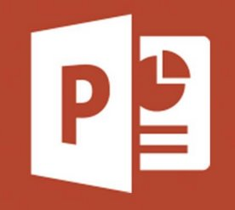 Microsoft PowerPoint is an essential presentation tool in both academic and professional settings. Students use it to present assignments, research findings, and project work, while businesses use it for meetings, training sessions, sales pitches, project proposals, and strategic planning. Its user-friendly interface and powerful design features make it one of the most widely used presentation applications worldwide. PowerPoint enables users to present complex information in a visually engaging format. It includes a variety of built-in templates, themes, and design tools that allow users to create attractive and well-organized presentations.
Since its release in 1987, Microsoft PowerPoint has become one of the world's most popular presentation tools due to its ease of use and powerful design features.

Features
Microsoft PowerPoint provides numerous features that make presentations engaging and professional, including:
- Creating slide-based presentations
- Choosing from a variety of themes and templates
- Inserting text, images, tables, charts, SmartArt, and shapes
- Embedding videos, audio, and screen recordings
- Applying animations and slide transitions
- Using Presenter View for effective presentation delivery
- Adding speaker notes
- Collaborating with others in real time through Microsoft 365
- Exporting presentations as PDF or video files
- Printing handouts and presentation notes

Uses
Microsoft PowerPoint is used for many purposes, including:
- Classroom teaching and learning
- Business meetings and presentations
- Employee training sessions
- Marketing and sales presentations
- Project proposals
- Research presentations
- Conference presentations
- Product demonstrations
- Seminars and workshops

Advantages
- Easy to create professional presentations
- Offers attractive templates and themes
- Supports multimedia content such as videos and audio
- Makes information easier to understand through visual aids
- Encourages audience engagement
- Allows collaboration through cloud-based sharing
- Integrates with other Microsoft Office applications
- Can be presented in person or online

Disadvantages
- Overuse of animations may distract the audience
- Requires electricity and presentation equipment
- Poorly designed slides can reduce audience understanding
- Large presentations with multimedia may be slow to load
- Full features require a Microsoft 365 subscription or Office licence

Importance of Microsoft PowerPoint in Business
Microsoft PowerPoint is an essential business communication tool. Organisations use it to:
- Present business reports
- Deliver sales pitches
- Train employees
- Explain company strategies
- Showcase products and services
- Present financial performance
- Conduct meetings and conferences
- Communicate project updates
Its ability to combine text, graphics, and multimedia helps businesses communicate ideas clearly and professionally. [14]

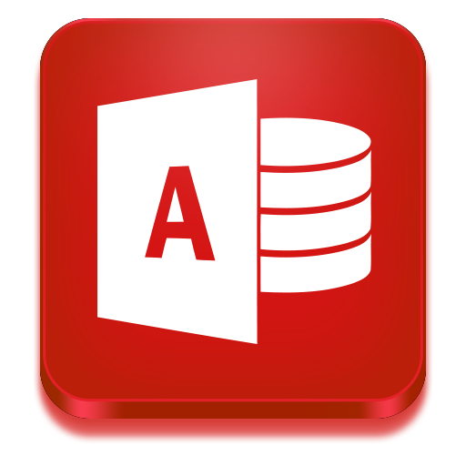Microsoft Access is widely used in business to manage customer information, inventory, employee records, and sales databases. In educational settings, it helps students learn database concepts, relational database design, and data management skills. Its integration with other Microsoft Office applications makes it an effective tool for creating database-driven solutions for a wide range of organizational needs. MS Access enables users to create databases for storing information such as customer records, employee details, inventory, sales, and financial data. It provides tools to design tables, create relationships between data, build forms for data entry, generate queries to search and analyse information, and produce reports for decision-making.
Unlike Microsoft Excel, which is designed primarily for spreadsheets and calculations, Microsoft Access is specifically designed to manage relational databases, where information is stored in related tables.

Features
Microsoft Access provides several features that simplify database creation and management, including:
- Creating relational databases
- Designing tables to store data
- Creating forms for easy data entry
- Running queries to search, filter, and analyse data
- Generating professional reports
- Establishing relationships between tables
- Importing and exporting data from Excel, Word, SQL Server, and other sources
- Using macros to automate repetitive tasks
- Creating custom database applications
- Protecting databases with passwords and user permissions

Uses
Microsoft Access is widely used for managing structured information in many settings, including:
- Customer databases
- Employee records
- Student information systems
- Inventory management
- Sales and order tracking
- Library management systems
- Hospital and patient records
- Membership databases
- Asset management
- Small business information systems

Advantages
- Easy to learn and use
- Suitable for small and medium-sized databases
- No advanced programming knowledge required
- Supports data relationships for better Companies
- Integrates well with Microsoft Office applications
- Provides built-in templates for quick database creation
- Allows automation through macros
- Generates customised reports and queries

Disadvantages
- Not suitable for very large databases or Companies with thousands of simultaneous users
- Limited scalability compared to enterprise database systems such as Oracle or Microsoft SQL Server
- Primarily available for Windows operating systems
- Multi-user performance may decrease with very large datasets
- Requires a Microsoft Office Professional or Microsoft 365 subscription that includes Access

Importance of Microsoft Access in Business
- Microsoft Access plays an important role in business by helping Companies organise and manage data efficiently. Businesses use Access to:
- Store customer and supplier information
- Track inventory and stock levels
- Manage employee records
- Monitor sales and purchases
- Generate business reports
- Improve data accuracy
- Support decision-making through organised data analysis
- Reduce paperwork by digitising records
- Its ability to organise related information makes it an effective tool for managing business data and improving operational efficiency..[15]

Difference Between Microsoft Access and Microsoft Excel
Microsoft Access | Microsoft Excel
Database management system | Spreadsheet application
Stores data in related tables | Stores data in worksheets
Best for managing large structured datasets | Best for calculations and data analysis
Supports relationships between tables | Limited relational capabilities
Ideal for multi-user database applications | Ideal for individual data analysis and reporting

3.2 Test any two features

Mail Merge
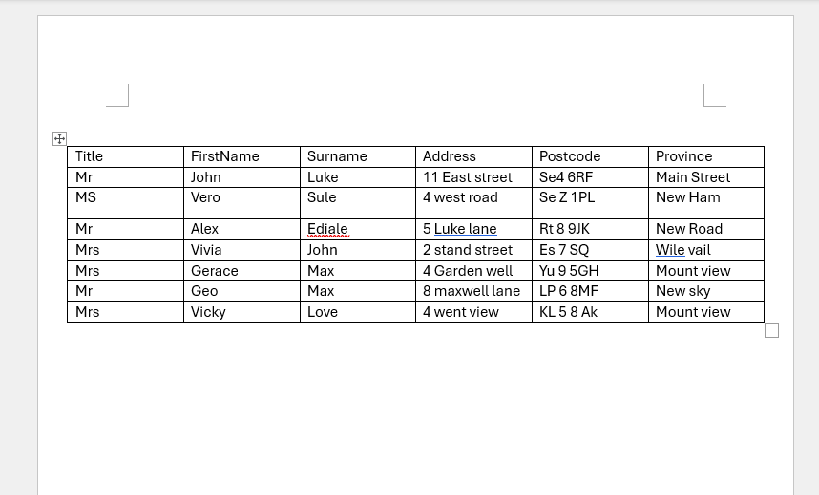
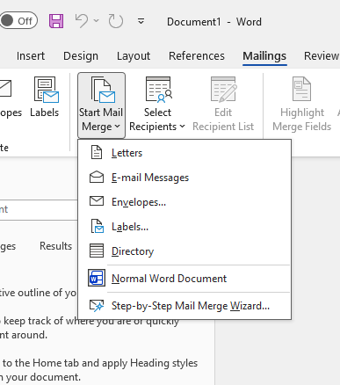

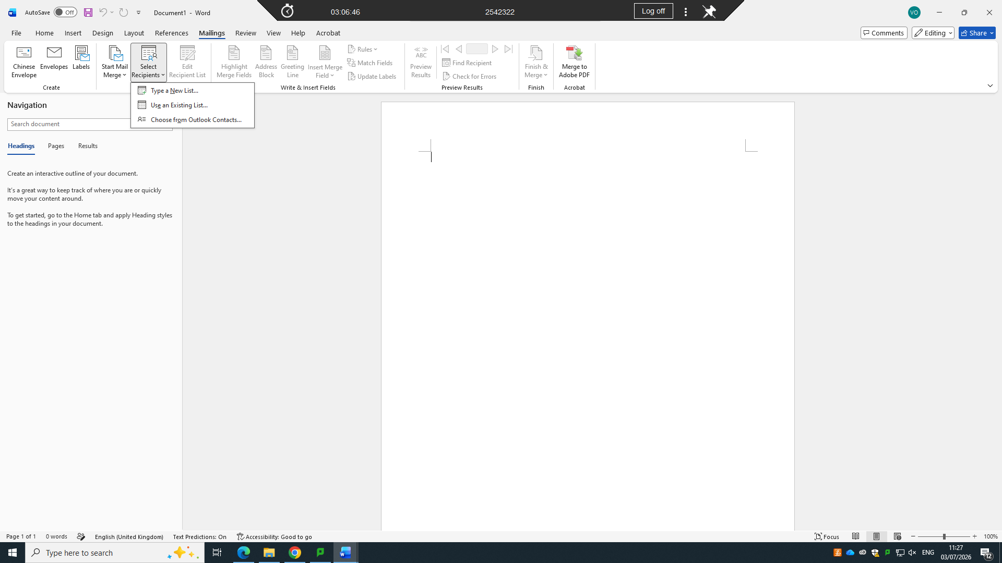
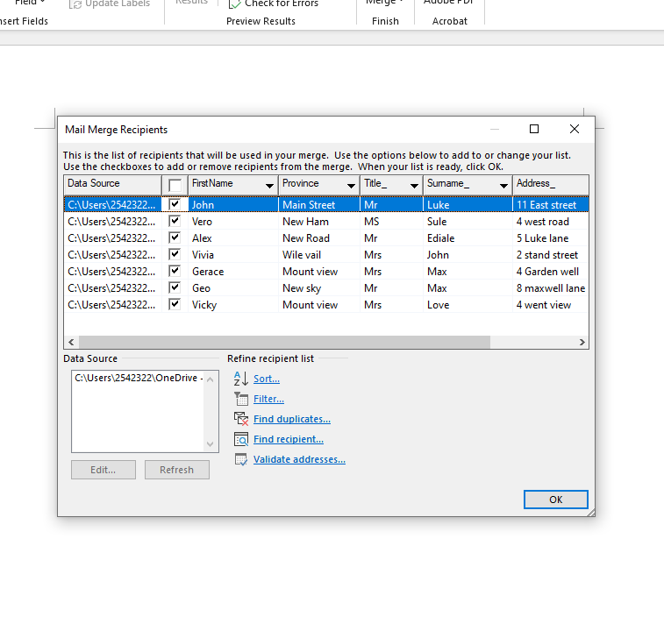
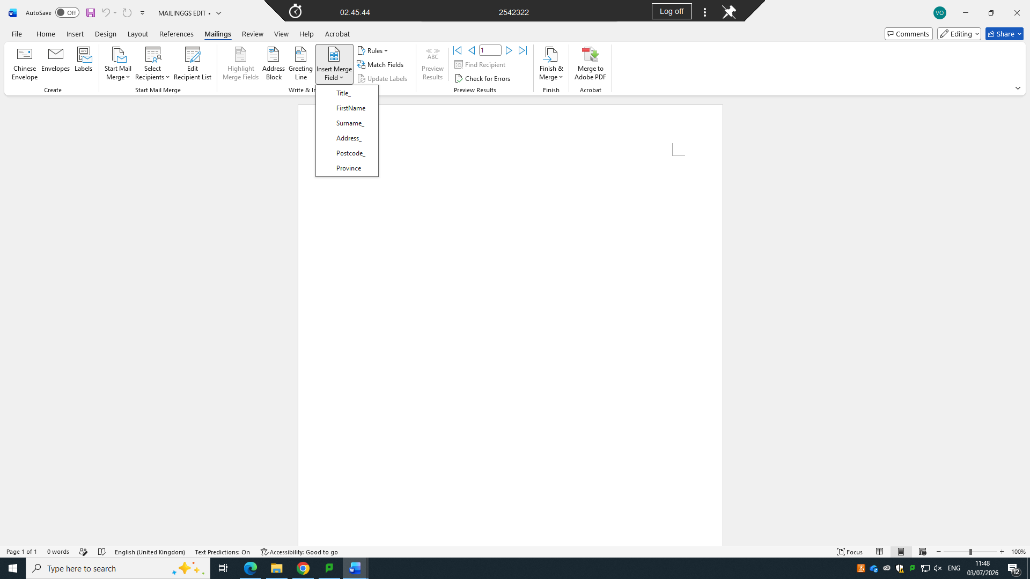

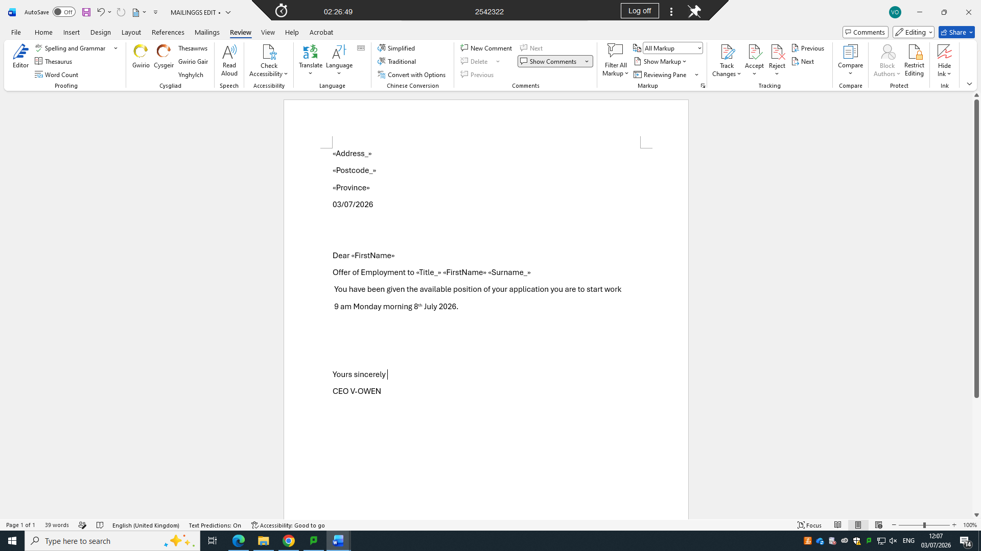

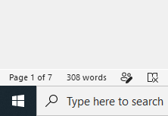

IF Statement

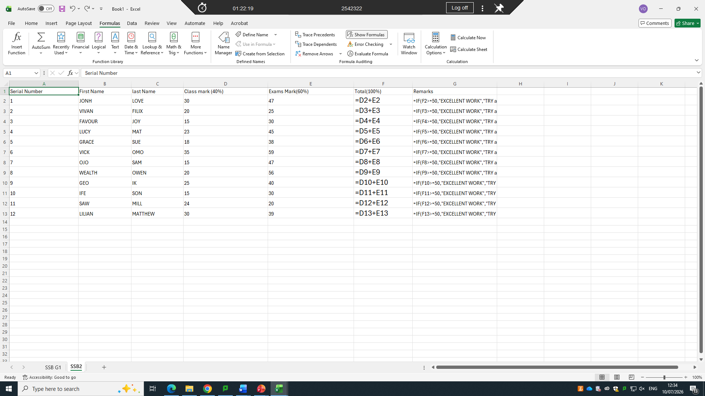

4.1 One contemporary Communication and one Online Collaboration

Microsoft outlook
Microsoft Outlook is a personal information management and email application developed by Microsoft as part of the Microsoft Office and Microsoft 365 suites. It is primarily used for sending and receiving emails, but it also includes features for managing calendars, contacts, tasks, notes, and appointments. Microsoft Outlook is widely used by individuals, businesses, educational institutions, and government organisations to improve communication, organisation, and productivity.
Outlook is available as a desktop application, a web-based service (Outlook on the web), and a mobile app, allowing users to access their emails and schedules from almost any device.

Features
Microsoft Outlook offers a variety of features to support communication and time management, including:
- Sending and receiving emails
- Organising emails into folders and categories
- Managing calendars and scheduling meetings
- Creating and managing contacts
- Setting reminders for appointments and tasks
- Sharing calendars with colleagues
- Searching and filtering emails quickly
- Managing multiple email accounts in one application
- Integrating with Microsoft Teams and other Microsoft 365 applications
- Protecting emails with security and spam filtering

Uses
Microsoft Outlook is commonly used for:
- Business communication through email
- Scheduling meetings and appointments
- Managing work and personal calendars
- Organising contacts
- Tracking tasks and deadlines
- Sending invitations for meetings
- Managing multiple email accounts
- Collaborating with colleagues and clients
- Accessing shared mailboxes and calendars

Advantages
- Easy-to-use interface
- Professional email management
- Integrated calendar and scheduling tools
- Supports multiple email accounts
- Strong security and spam protection
- Synchronises across computers and mobile devices
- Integrates with Microsoft Office and Microsoft 365 applications
- Supports offline access to emails and calendars

Disadvantages
- Some advanced features require a Microsoft 365 subscription
- May be complex for new users
- Large mailbox files can affect performance
- Requires regular updates and maintenance
- Full functionality works best within the Microsoft ecosystem

Importance of Microsoft Outlook in Business
Microsoft Outlook is an essential communication and productivity tool for businesses because it helps organisations manage email communication and schedules efficiently. Businesses use Outlook to:
- Communicate with employees, customers, and suppliers
- Schedule meetings and video conferences
- Manage appointments and deadlines
- Share calendars among team members
- Organise contacts and business information
- Improve collaboration through Microsoft 365 integration
- Increase productivity by managing tasks and reminders
Its integration with Microsoft Teams, OneDrive, and other Microsoft 365 services makes Outlook a central tool for modern work places..[16]

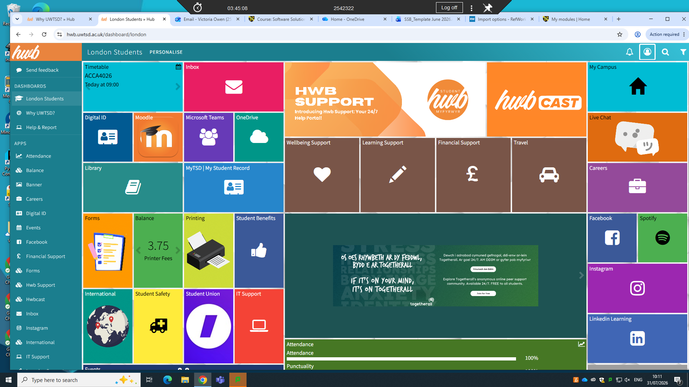

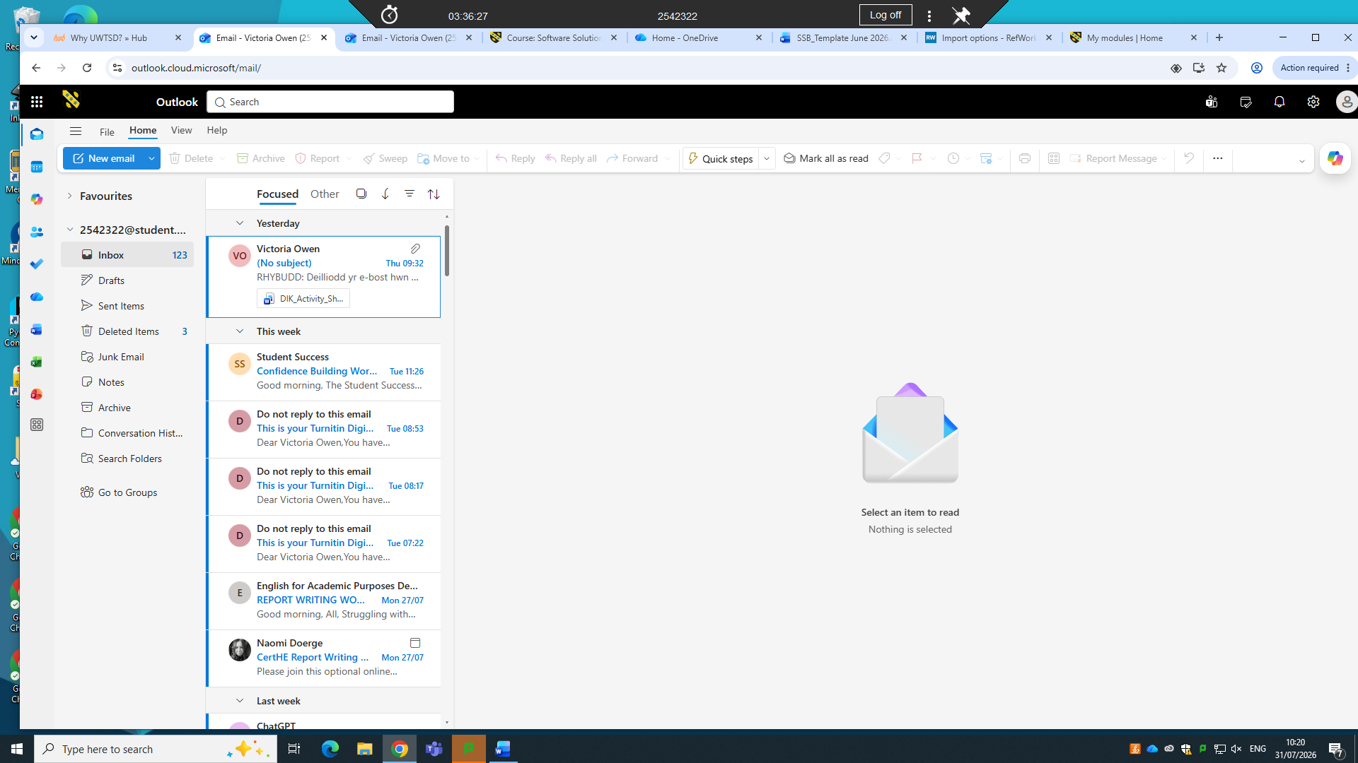

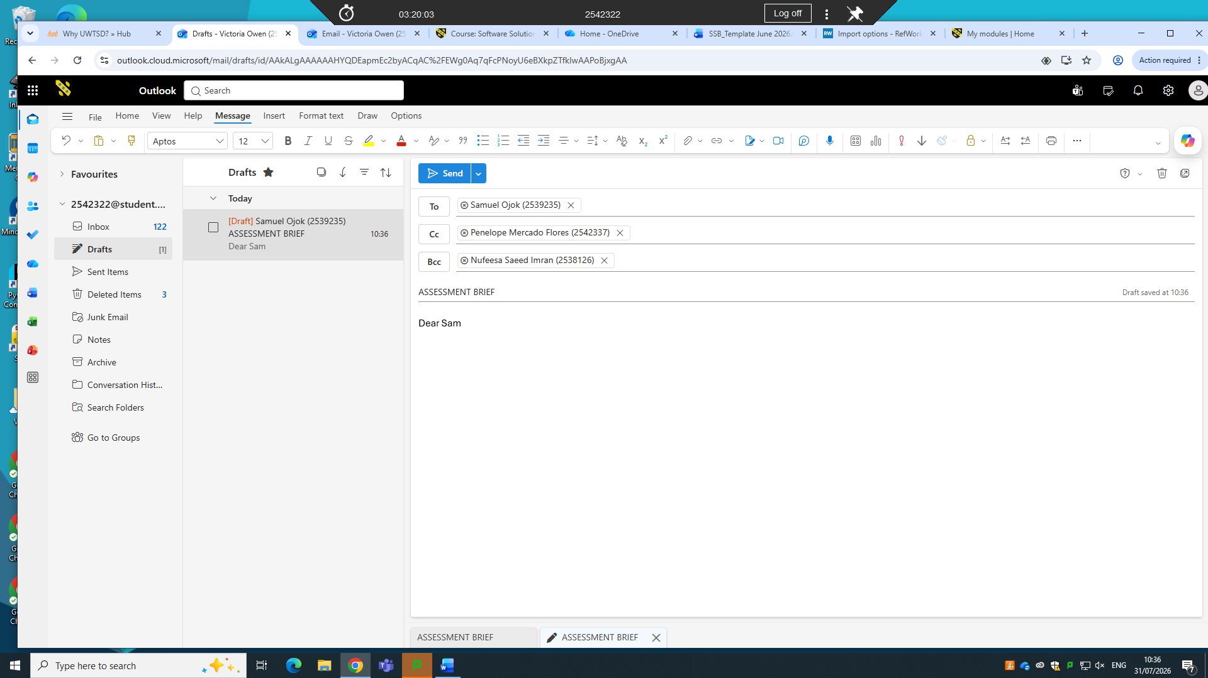
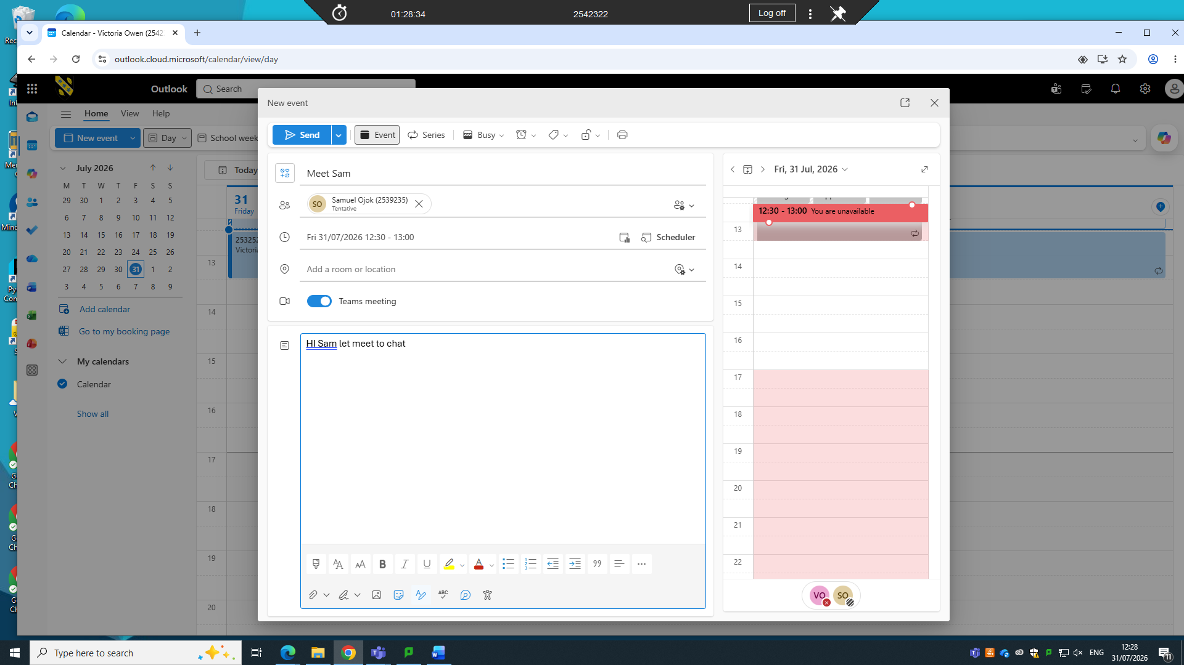
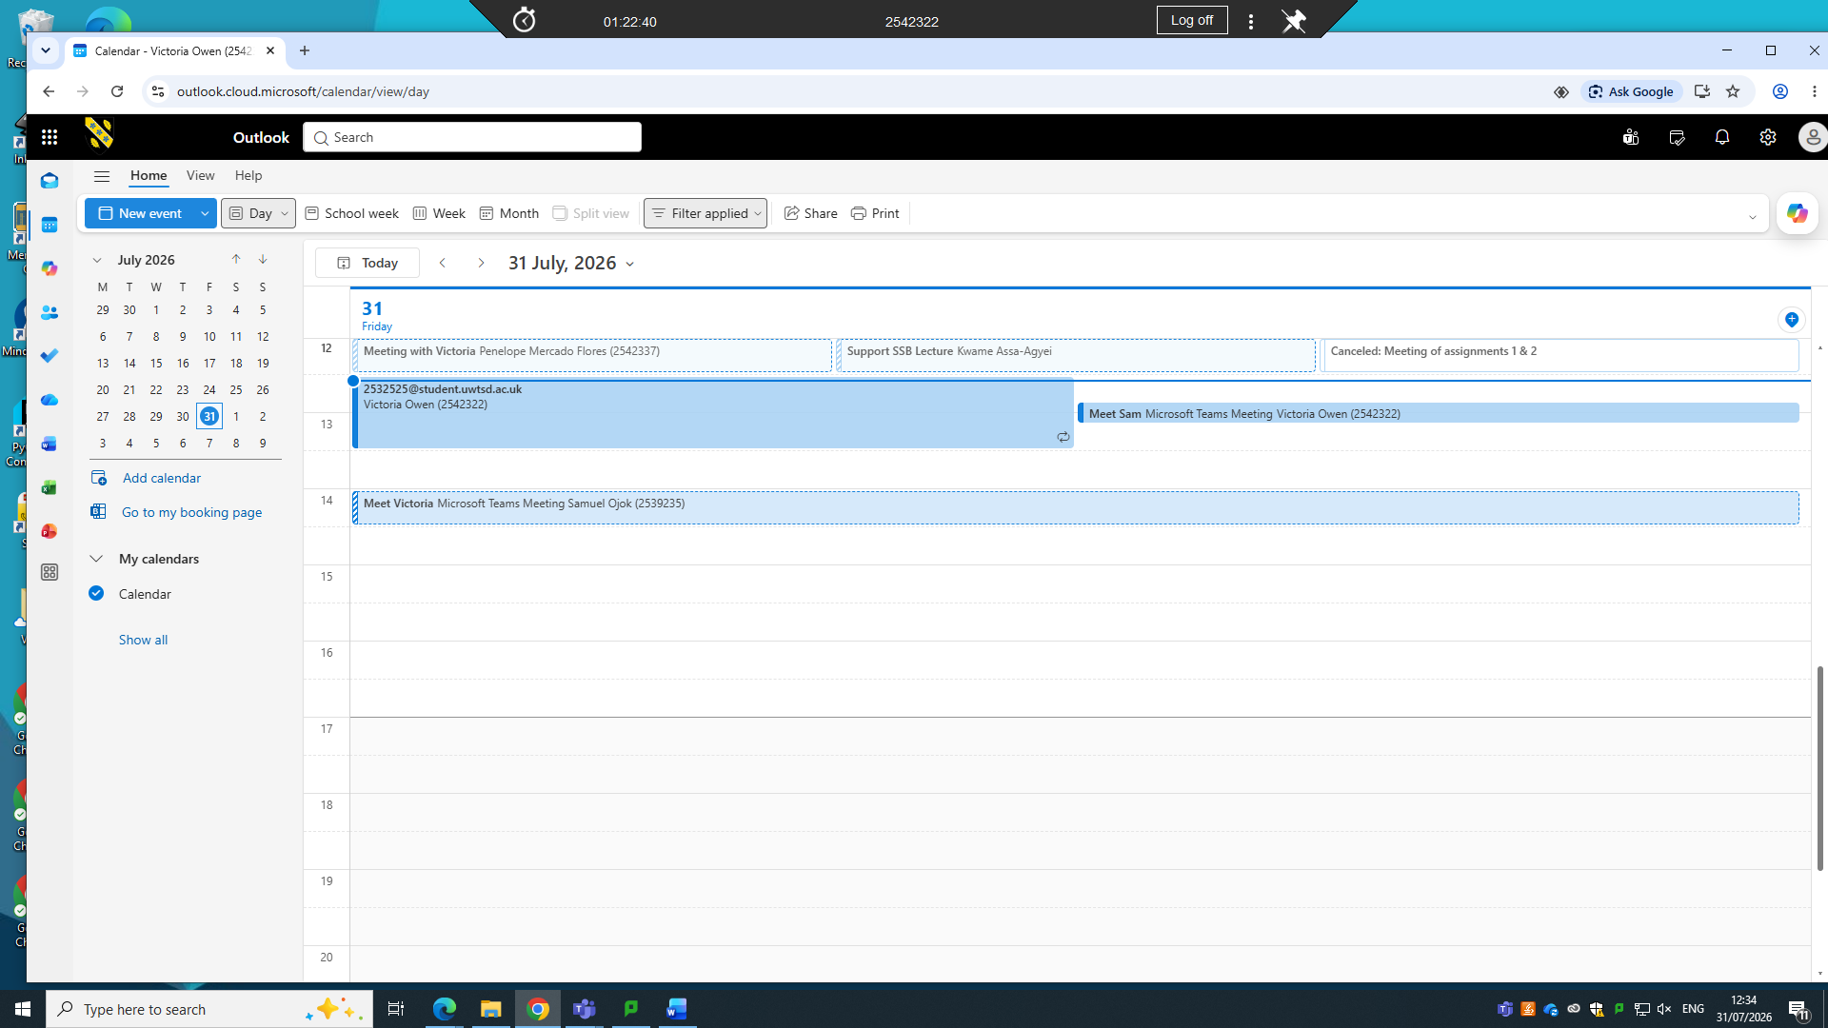
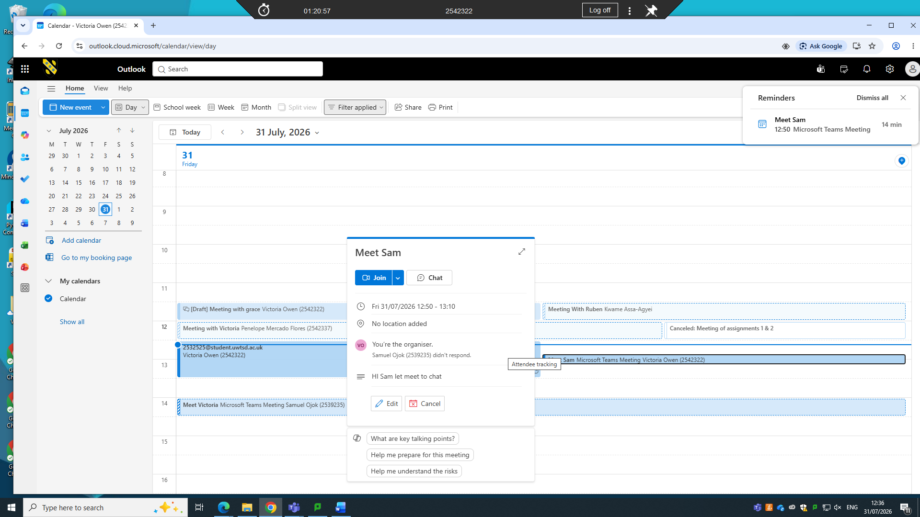
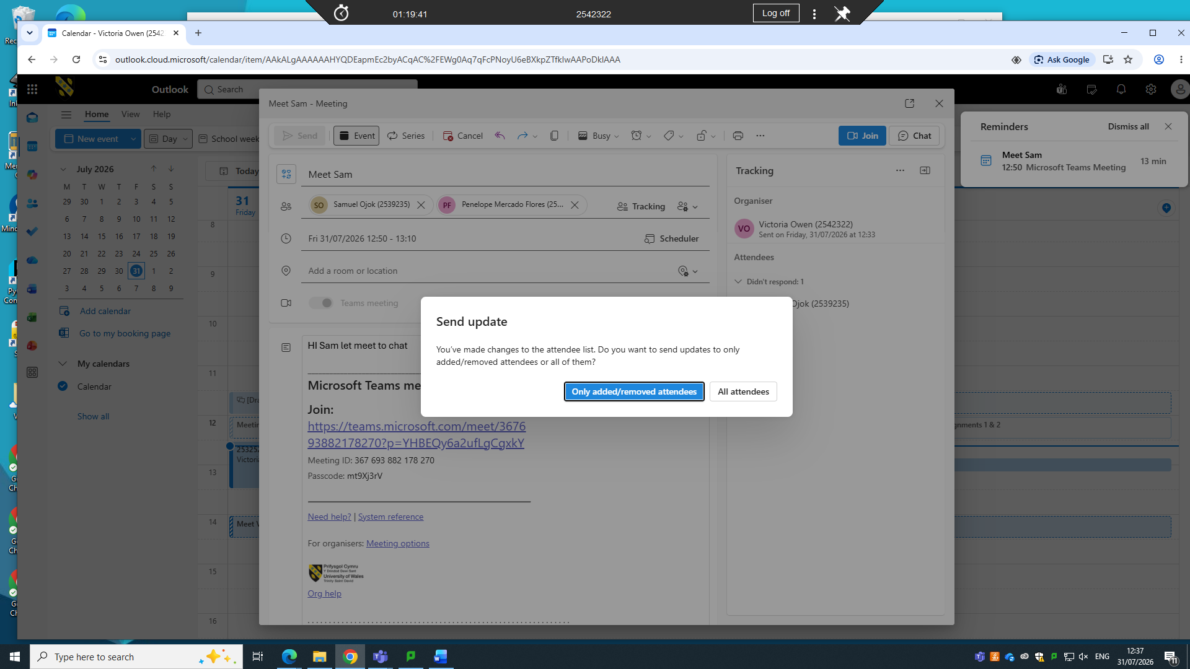
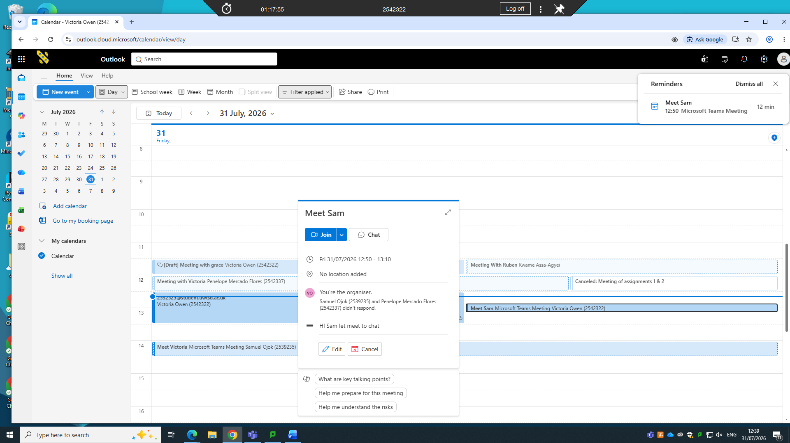
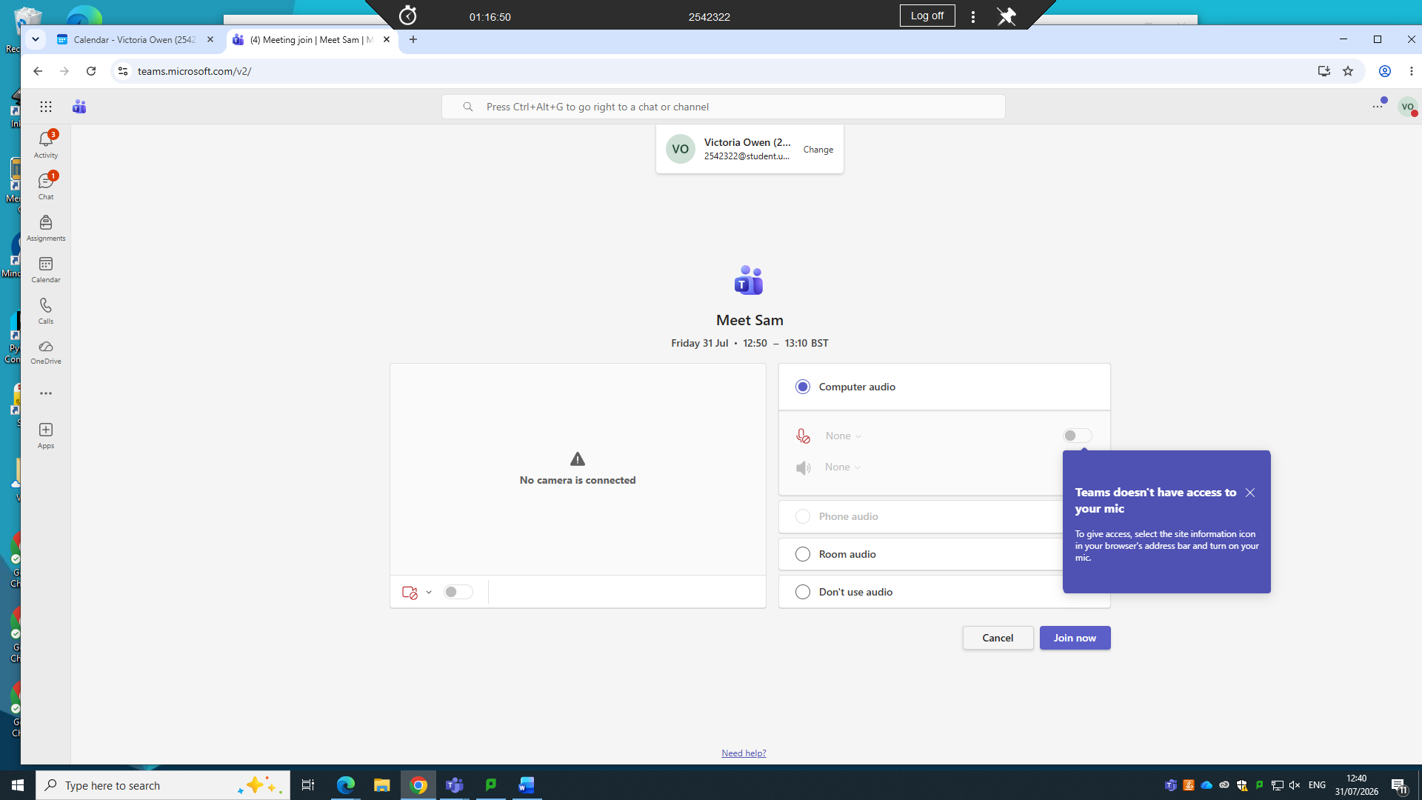
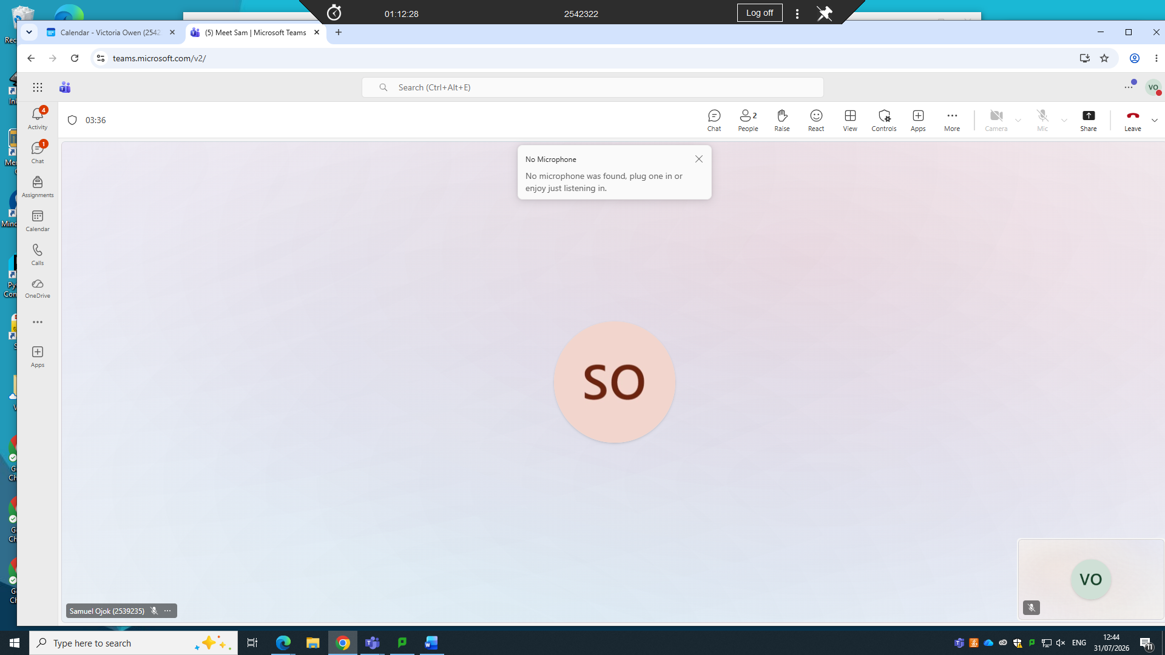
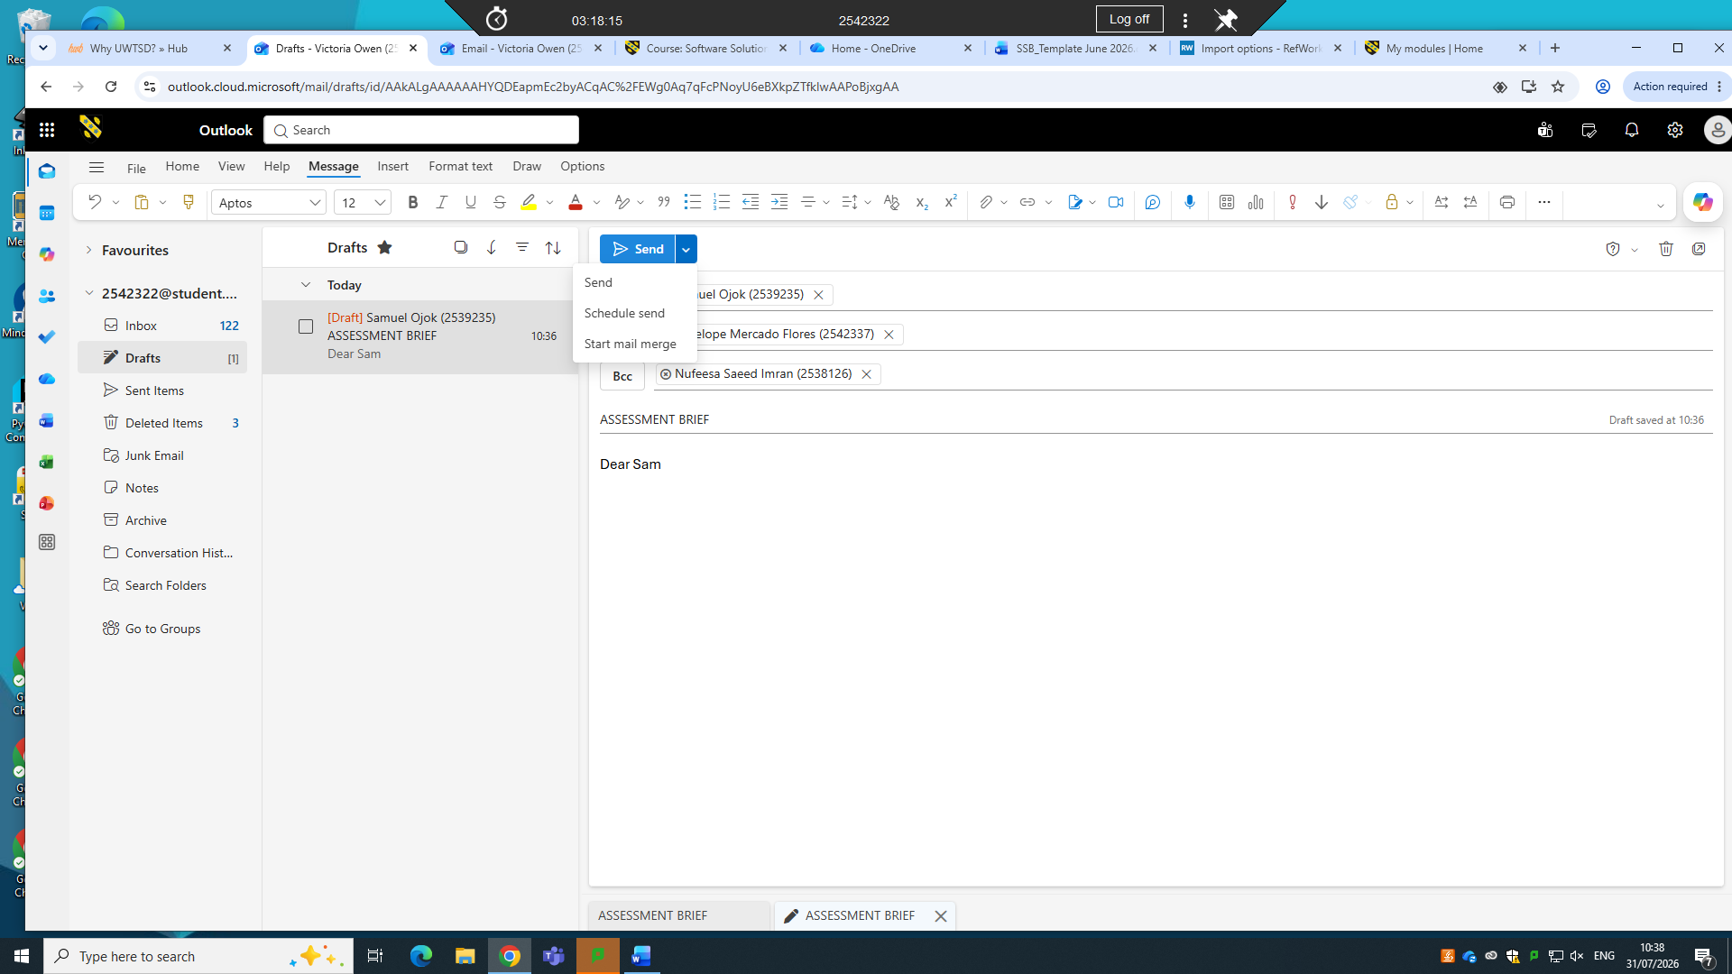
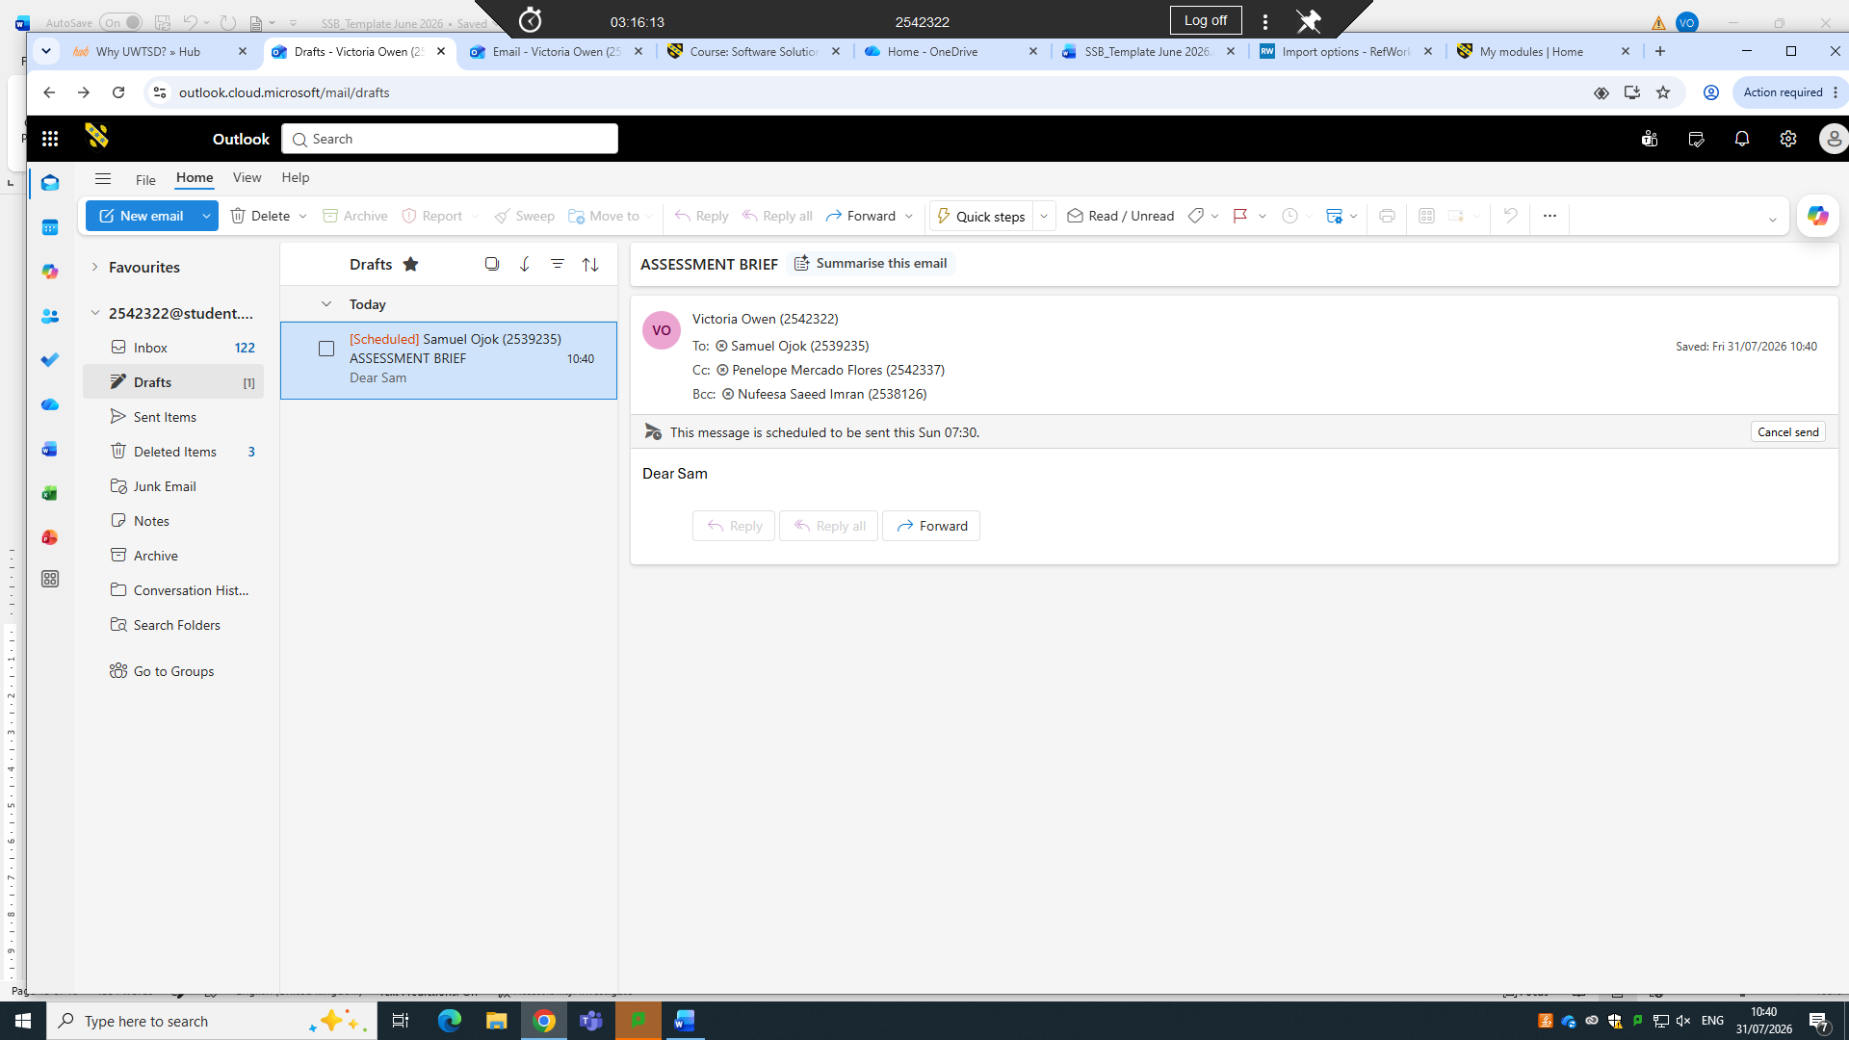
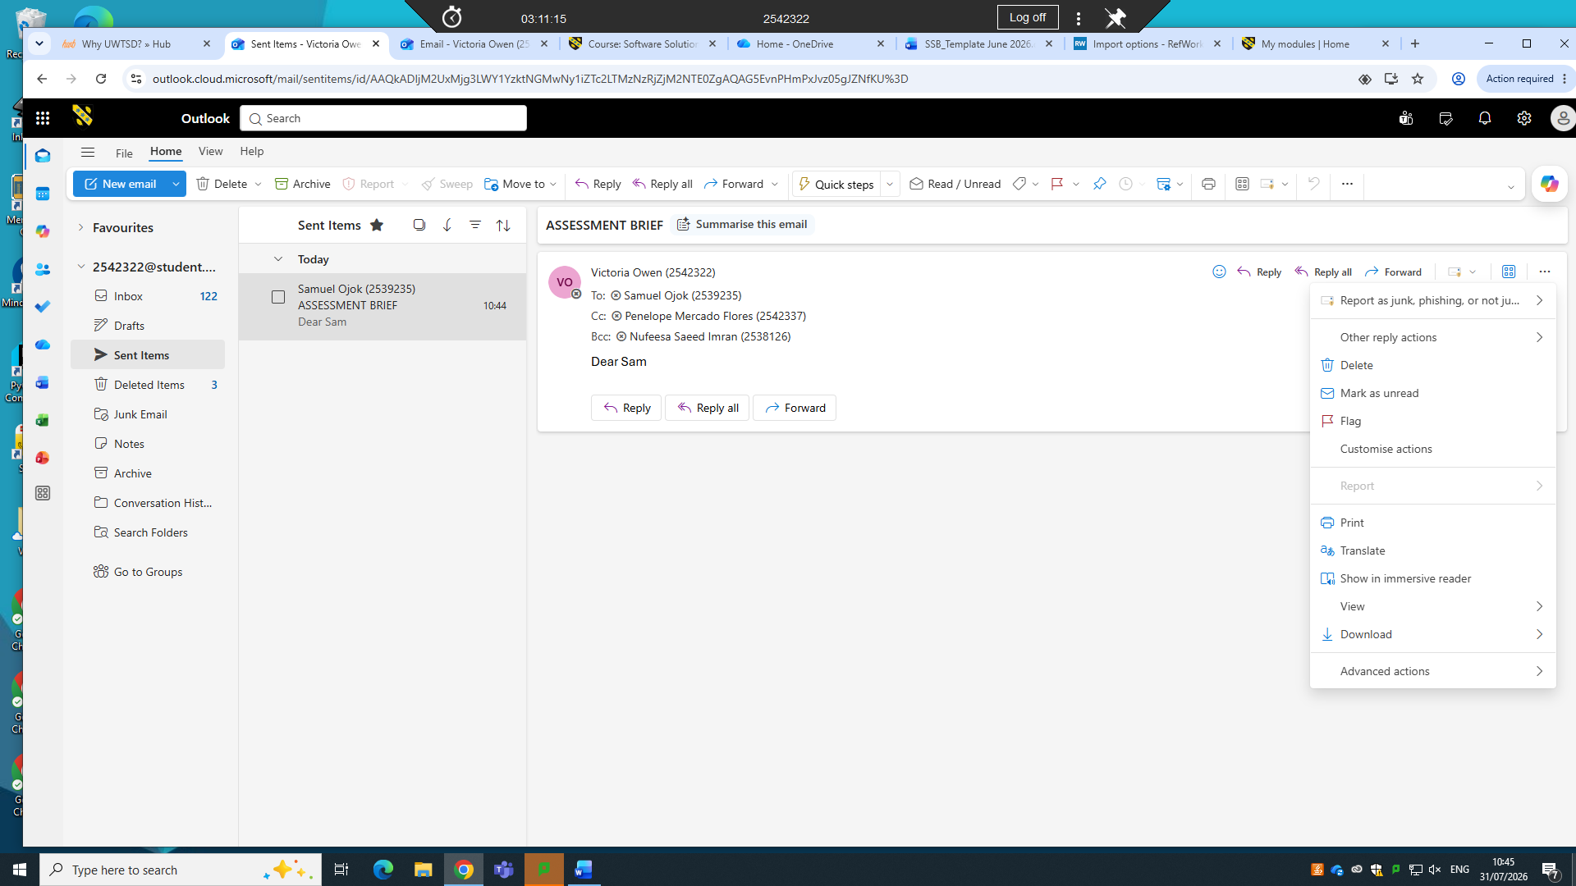Ms team
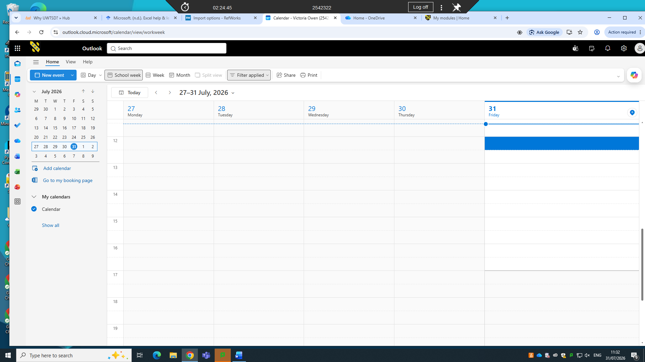
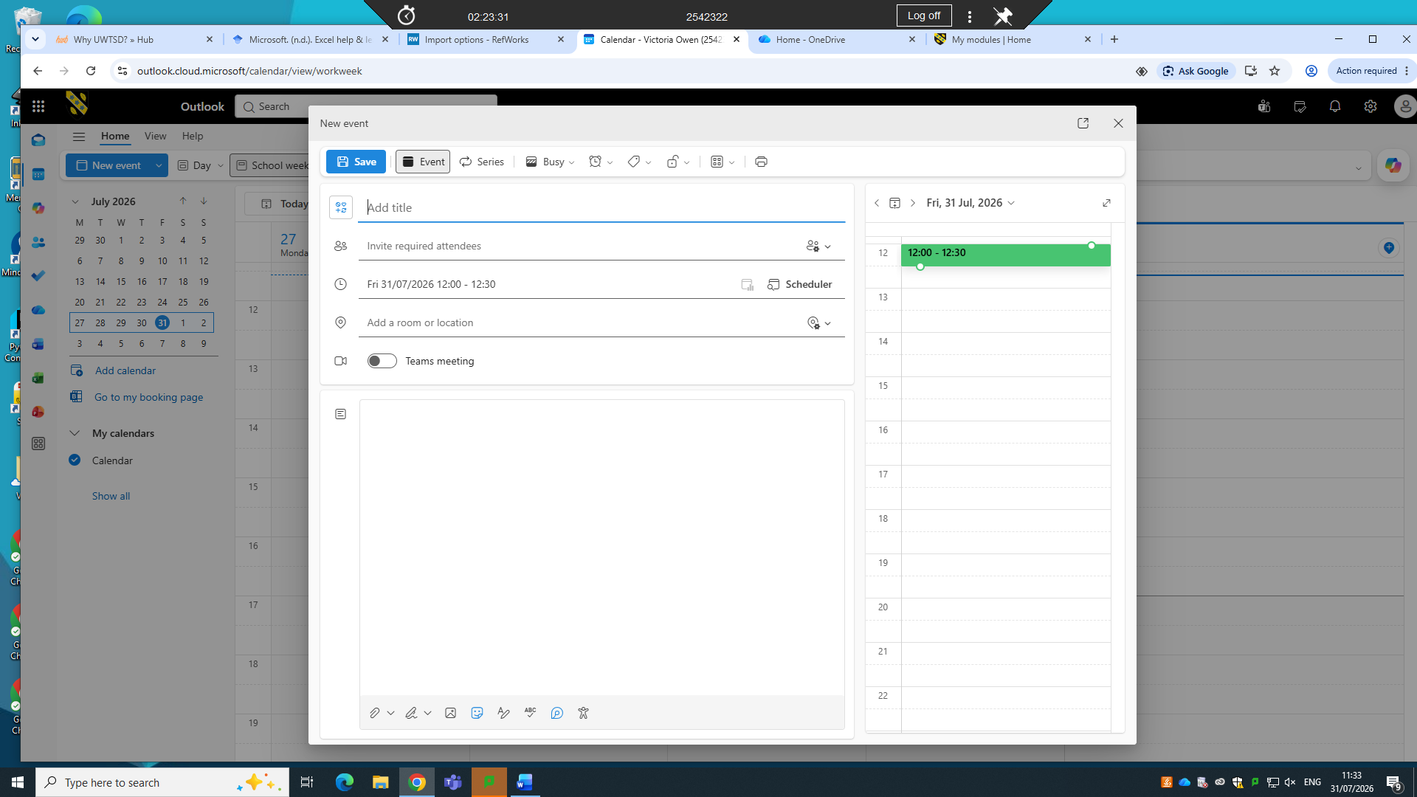
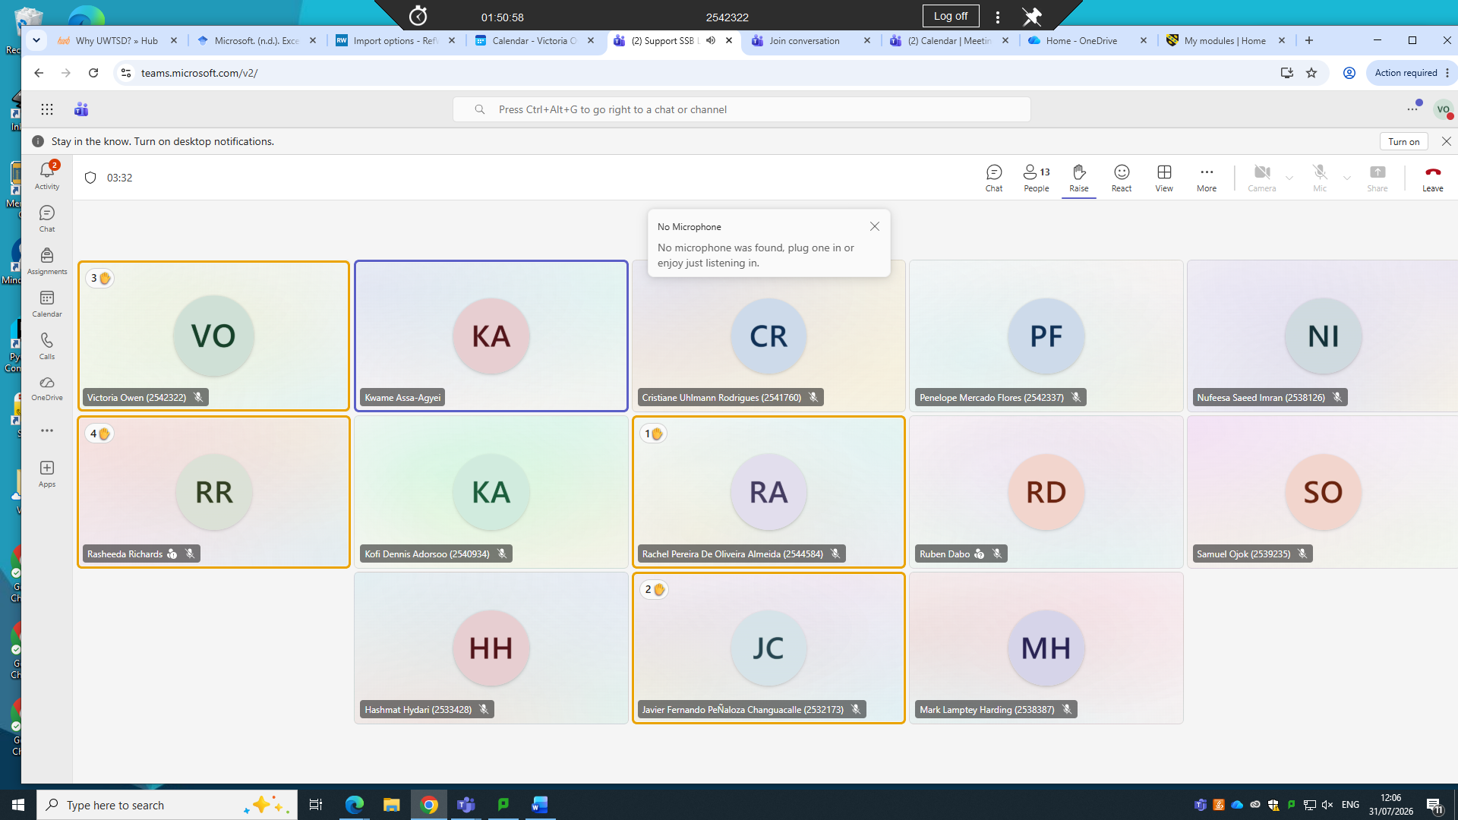
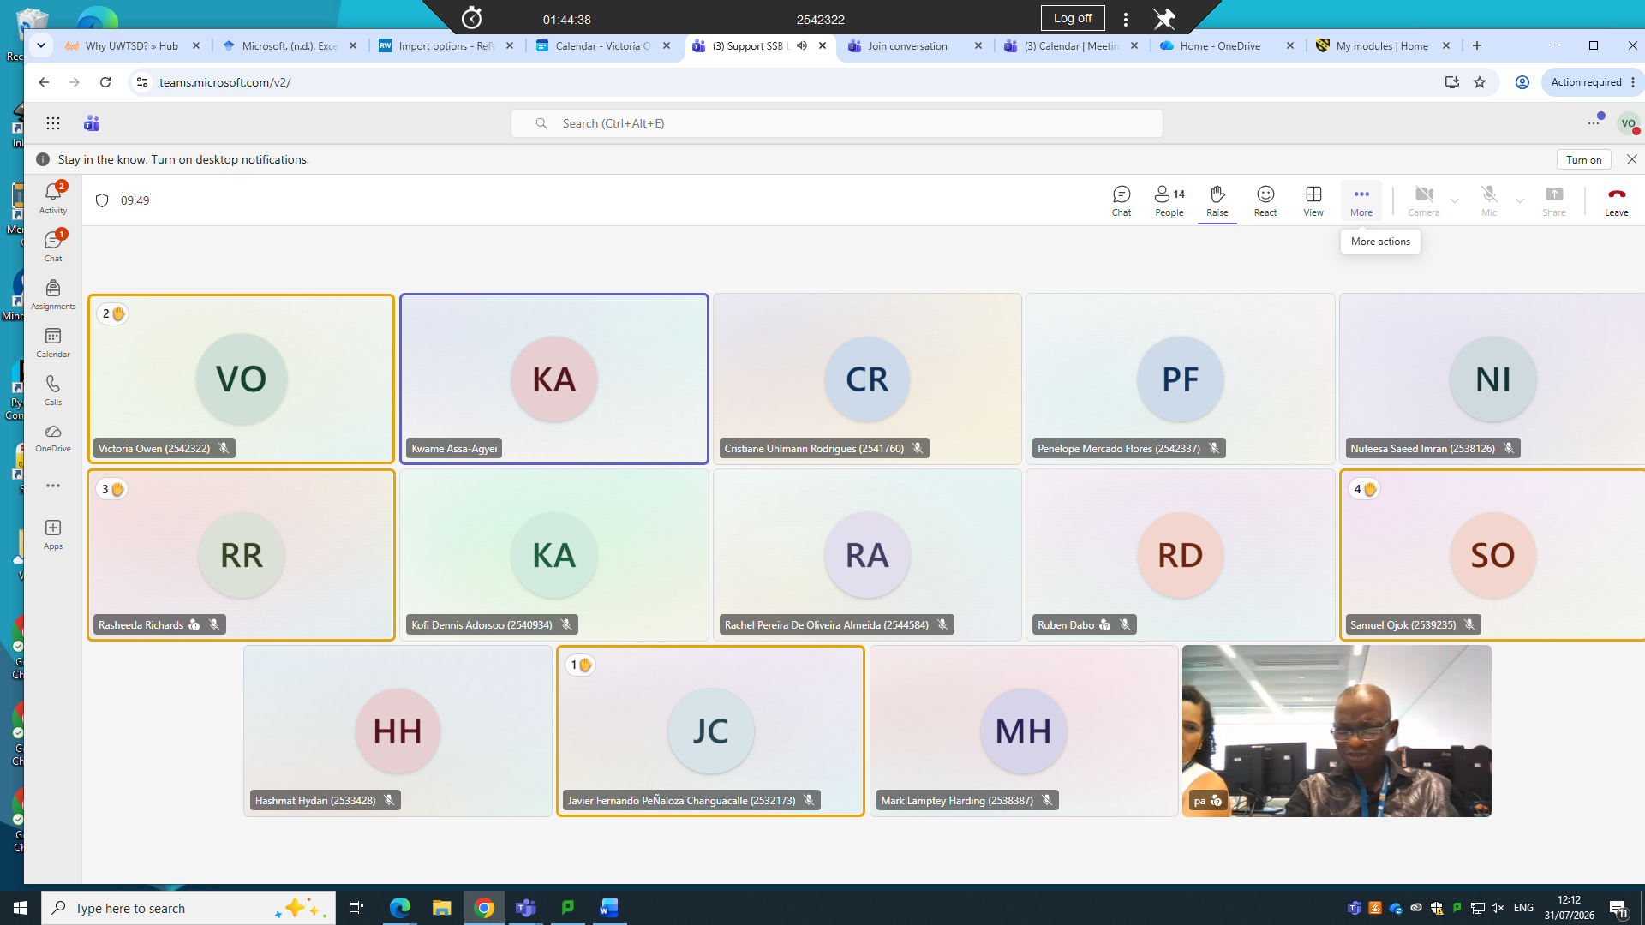
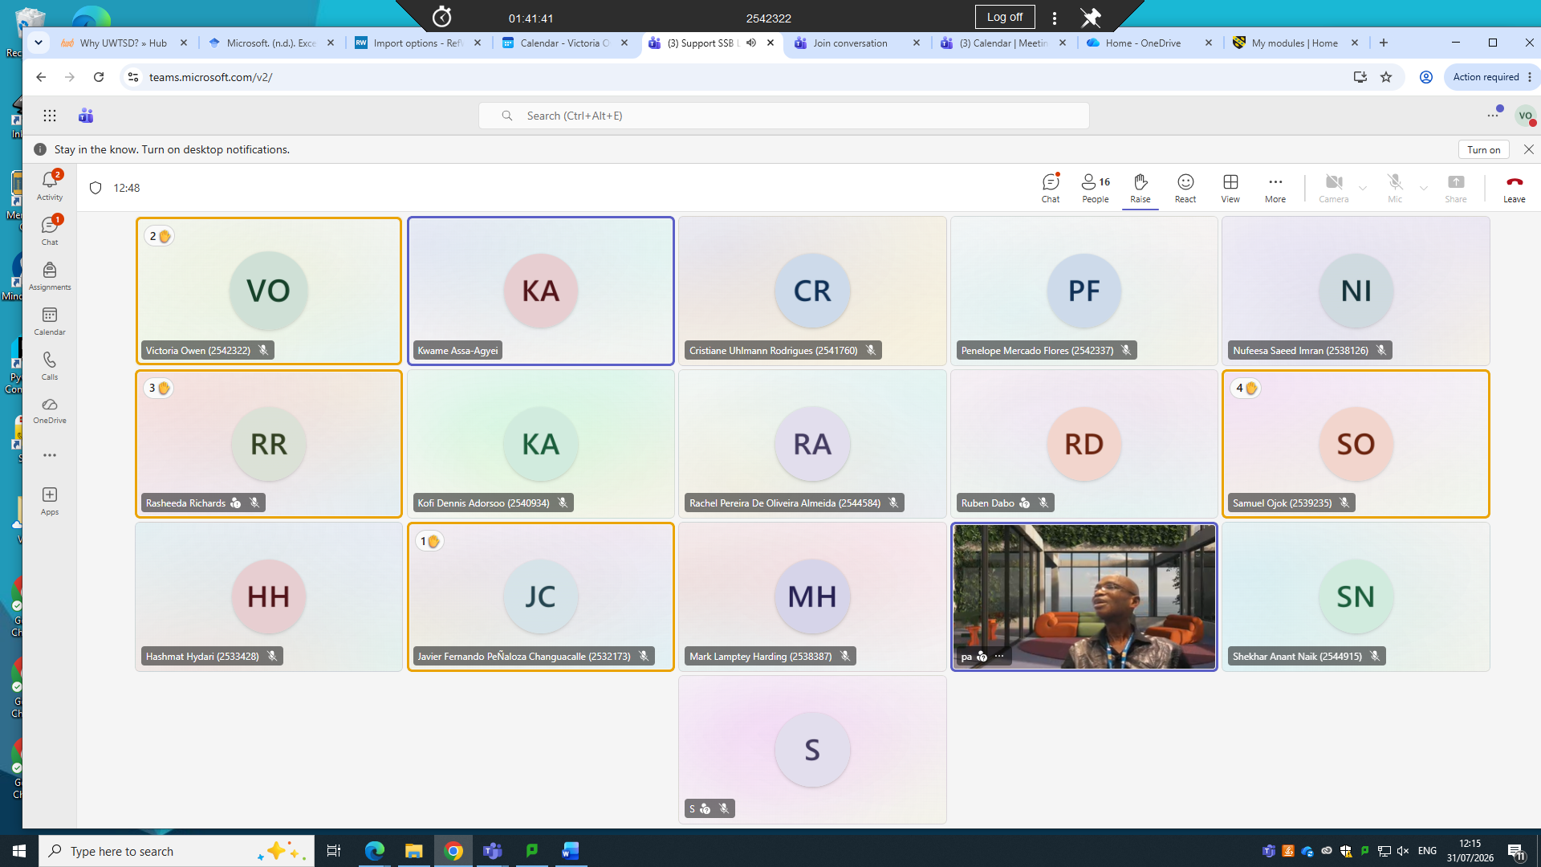

4.2 Test one feature of a freely available Communication (1) and one feature of a Collaboration (1) application

Gmail
Gmail is a free email service developed by Google that allows users to send, receive, organise, and manage electronic mail (email) over the internet. It was launched on 1 April 2004 and has become one of the world's most widely used email platforms. Gmail is part of Google Workspace, which includes other productivity tools such as Google Drive, Google Docs, Google Sheets, Google Meet, Google Calendar, and Google Sites.
Gmail is accessible through web browsers, mobile applications, and email clients such as Microsoft Outlook. It provides secure, reliable, and cloud-based communication for individuals, businesses, educational institutions, and organisations.

Features
Gmail offers a variety of features that improve communication and productivity, including:
- Sending and receiving emails
- Large cloud-based storage capacity
- Spam filtering and phishing protection
- Powerful search functionality
- Email labels and folders for organisation
- Attachment support for documents, images, and videos
- Integration with Google Drive for sharing large files
- Smart Compose and Smart Reply features
- Multiple email account management
- Access from computers, tablets, and smartphones
- Two-factor authentication for enhanced account security

Uses
Gmail is widely used for:
- Personal communication
- Business correspondence
- Educational communication
- Sending and receiving documents
- Registering for online services
- Customer support communication
- Scheduling meetings through Google Calendar
- Collaborating using Google Workspace applications
- Sharing files through Google Drive

Advantages
- Free to use with a Google account
- User-friendly interface
- Large storage capacity
- Strong security and spam protection
- Accessible from any internet-connected device
- Integrates with Google Workspace applications
- Fast and reliable email delivery
- Supports collaboration and file sharing

Disadvantages
- Requires an internet connection for full functionality
- Free accounts have limited storage shared across Google services
- Privacy concerns for some users regarding cloud-based services
- Advertisements may appear in free accounts
- Some advanced business features require a Google Workspace subscription

Importance of Gmail in Business
Gmail plays a significant role in business communication by providing a reliable and secure platform for email management. Businesses use Gmail to:
- Communicate with customers and suppliers
- Exchange business documents

- Schedule meetings using Google Calendar
- Collaborate through Google Workspace
- Manage customer enquiries
- Share files using Google Drive
- Improve teamwork and productivity
- Maintain professional communication
Its integration with other Google Workspace applications makes Gmail a valuable tool for modern business operations. [17]

Zoom
Zoom is a cloud-based video conferencing and online communication platform that enables users to conduct virtual meetings, webinars, video conferences, phone calls, and instant messaging over the internet. It was developed by Zoom Video Communications and launched in 2013. Zoom became one of the world's most widely used communication tools, especially during the COVID-19 pandemic, when businesses, educational institutions, and organisations relied on it for remote work and online learning.
Zoom is available on computers, smartphones, and tablets, making it easy for users to communicate from virtually anywhere with an internet connection.

Features
Zoom offers a wide range of features that support virtual communication and collaboration, including:
- High-quality video and audio conferencing
- One-to-one and group meetings
- Screen sharing for presentations and demonstrations
- Virtual backgrounds and background blur
- Meeting recording and playback
- Breakout rooms for group discussions
- Live chat and file sharing during meetings
- Webinars for large online events
- Polling and reactions for audience engagement
- Calendar integration with Google Calendar and Microsoft Outlook
- End-to-end encryption and meeting security features

Uses
Zoom is widely used for various purposes, including:
- Online business meetings
- Remote work and team collaboration
- Virtual classrooms and distance learning
- Webinars and online conferences
- Customer support and consultations
- Job interviews
- Online training sessions
- Telehealth and virtual healthcare consultations
- Social events and family gatherings

Advantages
- Easy to install and use
- High-quality video and audio communication
- Supports large meetings and webinars
- Screen sharing enhances collaboration
- Available on multiple devices and operating systems
- Allows meetings to be recorded for future reference
- Integrates with many productivity applications
- Supports remote work and learning effectively

Disadvantages
- Requires a stable internet connection
- Free accounts have time limits for group meetings
- Security concerns can arise if meetings are not properly protected
- Premium features require a paid subscription
- Large meetings may consume significant internet bandwidth

Importance of Zoom in Business
Zoom has become an essential communication tool for businesses because it enables employees, clients, and partners to collaborate regardless of their location. Businesses use Zoom to:
- Conduct virtual meetings
- Collaborate with remote teams
- Deliver employee training
- Hold client consultations
- Organise webinars and product launches
- Interview job applicants
- Reduce travel costs
- Improve communication and productivity
Its ability to support real-time collaboration has made Zoom an important part of modern business operations.[18]

Conclusion
Software solutions have become an essential part of modern business operations by improving efficiency, communication, collaboration, and decision-making. Applications such as Microsoft Word, Microsoft Excel, Microsoft PowerPoint, and Microsoft Access enable businesses to create professional documents, analyse data, prepare presentations, and manage databases effectively. Communication platforms such as Zoom, Microsoft Outlook, and Gmail support seamless communication, virtual meetings, email management, and collaboration among employees, customers, and business partners regardless of their location.
In addition, e-commerce platforms and WooCommerce have transformed the way businesses sell products and services by providing secure online shopping experiences, managing customer orders, processing payments, and expanding business operations to global markets. These software applications help businesses increase productivity, reduce operational costs, improve customer satisfaction, and enhance overall organisational performance.
In today's digital economy, selecting and effectively using the right software solutions is essential for business success. As technology continues to evolve, organisations that adopt modern software applications will be better positioned to improve their competitiveness, respond to changing customer needs, and achieve long- term growth and sustainability.

References

[1] A. B. Orok and H. O. Ikpan, "Digital Technologies for Strategic Financial Control: A Review of Concepts, Applications, and Emerging Challenges,"
[2] H. Bhandari and S. Mathema, "Role of information System in Decision Making Proces," vol. 8, no. 3, pp.43–46, 2022,
[3] M. Wynn and C. Weber, "Information systems strategy for multi-national corporations: Towards an operational model and action list," vol. 15, no. 2, pp.119, 2024,
[4] I. R. Iyobosa and O. E. Patrick, "Digital Marketing Strategy and Sales Performance of E-commerce SMEs in Benin City," vol. 23, no. 1, 2025,
[5] M. S. Witarsa and F. Ramadian,Sistem Informasi Manajemen, PT KIMHSAFI ALUNG CIPTA, 2026.
[6] I. R. Iyobosa and O. E. Patrick, "Digital Marketing Strategy and Sales Performance of E-commerce SMEs in Benin City," vol. 23, no. 1, 2025,
[7] T. S. GUSMIAENY, "PENGEMBANGAN MULTIMEDIA PEMBELAJARAN BERBASIS GOOGLE SITES UNTUK MENINGKATKAN MOTIVASI DAN,"
[8] S. Ranganathan, "Agile Methodologies," pp.299, 2025,
[9] L. Lee and G. Casterella, "A mental model approach to teaching database querying skills with SQL and Alteryx," vol. 64, pp.100858, 2023,
[10] S. R. Kodandaram, J. Zhou, X. Bi, I. V. Ramakrishnan and V. Ashok, "Finding the Signal in the Noise: An Exploratory Study on Assessing the Effectiveness of AI and Accessibility Forums for Blind Users’ Support Needs", in Proceedings of the 2026 CHI Conference on Human Factors in Computing Systems, pp. 1–20.
[11] I. O. IYANYA, "DESIGN AND IMPLEMENTATION OF ONLINE COURSE FORM REGISTRATION SYSTEM FOR THE DEPARTMENT OF COMPUTER SCIENCE, COLLEGE OF EDUCATION, OJU, BENUE STATE," vol. 1, no. 1, pp.54–58, 2026,
[12] R. Kumar, Master Data Storytelling: Skyrocket Your Business Impact with Data Visualization, Jamba Academy, 2025.
[13] H. Korhonen et al., , "Star-Planet Interactions: The Instrumentation Perspective," 2026,
[14] J. Bitiyong and E. Dodo, "MIS ENTREPRENEURSHIP AND NIGERIA’S DIGITAL ECONOMY: A SYSTEMATIC REVIEW," vol. 2, no. 3, pp.407–427, 2026,
[15] H. Korhonen et al., , "Star-Planet Interactions: The Instrumentation Perspective," 2026,
[16] H. Korhonen et al., , "Star-Planet Interactions: The Instrumentation Perspective," 2026,
[17] J. Bitiyong and E. Dodo, "MIS ENTREPRENEURSHIP AND NIGERIA’S DIGITAL ECONOMY: A SYSTEMATIC REVIEW," vol. 2, no. 3, pp.407–427, 2026,
[18] J. Bitiyong and E. Dodo, "MIS ENTREPRENEURSHIP AND NIGERIA’S DIGITAL ECONOMY: A SYSTEMATIC REVIEW," vol. 2, no. 3, pp.407–427, 2026,

