
Adverse Childhood Experiences: Later Life Impact and Services Available
Abbie Flavell - 2107832

Introduction to health research – bmns4005

lecturer - gareth morgan
Contents
1. Introduction 2
2. Summary of Knowledge 2
3. Later Life Impact 3
4. Services Available to Survivors 5
5. Suggestions for the Future 6
6. Reference List 8

Introduction
Adverse Childhood Experiences are the stressful and traumatic experiences of children and young people and so this report looks at what ACEs are, the different categories of trauma or familial dysfunction, as well as reflecting the collected data on the impacts of these types of traumas on their later life and what services are available to support those who are survivors, followed by what suggestions I have for the future. Literature from the Resilient Child Fund, Victim Support, the CDC and the Office for National Statistics as well as data from many other sources will be included throughout this report.

Summary of Knowledge
Adverse childhood experiences (ACEs) are traumatic events that occur within a person’s life before they reach the age of 18, these events are usually separated into 10 categories, with 5 being forms of child abuse and neglect and thus punishable by law, and the other 5, forms of family dysfunction that may result in higher exposure to trauma. These according to the Resilient Child Fund (2016) are known as follows:
- Physical abuse  - Sexual abuse  - Psychological abuse  - Physical neglect  - Psychological neglect | - Witnessing domestic abuse  - A close family member who misused drugs or alcohol  - A close family member with mental health problems  - A close family member who served time in prison  - Losing a parent to separation, divorce, or death
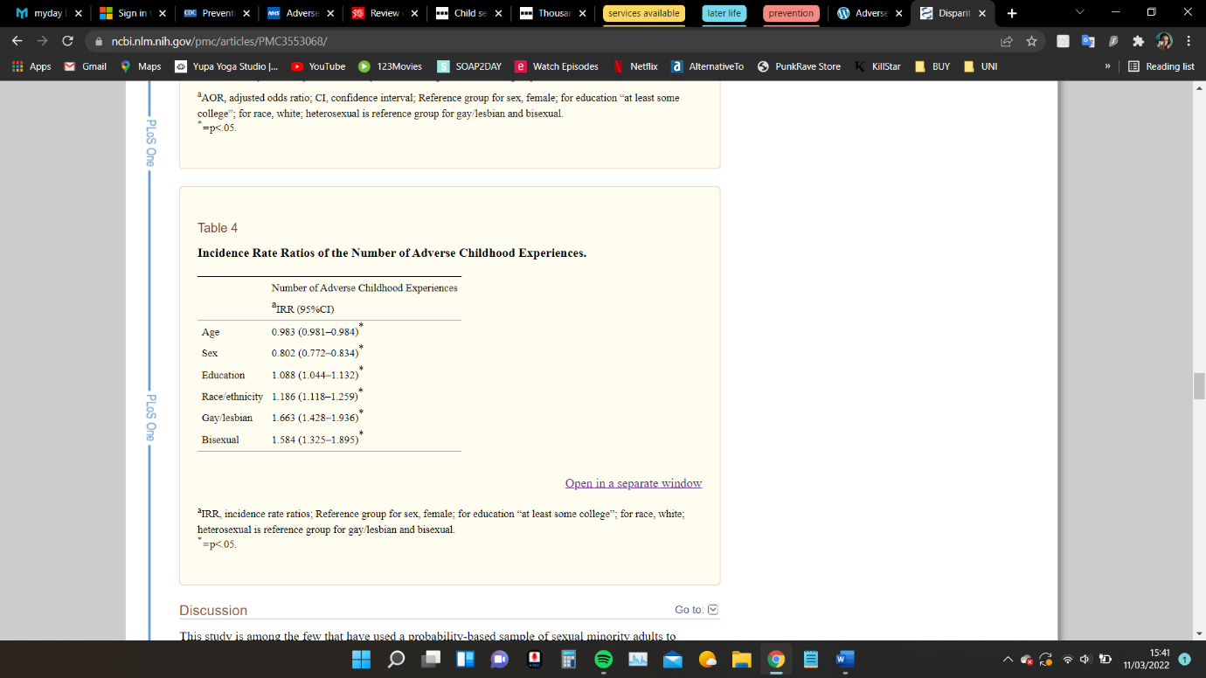
Research by Asmussen et al, (2020) shows that ACEs are prevalent with over 80% of 399,500 children in need within England having experienced at least one ACE, meaning that at least 2.5% of all children that live in England are experiencing some form of maltreatment at any given time. Bellis (2016) as part of Public Health Wales also conducted a study of ACE experiences within Wales, and they found that 47% of those who took part in the survey had experienced at least one ACE and 14% had experienced four or more. It is important however to note that these statistics reflect just the tip of the iceberg, with the majority of child maltreatment cases going unreported. The fact that cases go unreported is supported by research by Victim Support (2021) where in an estimated 1.3 million children in England who have been a victim of sexual abuse by the age of 18, one third of them only become aware they had been abused once they reached adulthood. The research shows that the occurrence of ACEs are common and unfortunately also means that experiencing one ACE increases a person’s probability of experiencing multiple. A study in the United States of America by Andersen and Blosnich (2013) looking at ACEs, people who are gay, lesbian, and bisexual had nearly 1.7- and 1.6-times the adverse childhood experiences, compared to heterosexual people as shown by table 4 of their study (pictured). Additionally, another study by Vervoort-Schel et al, (2021) highlighted that 81.7% of children with an intellectual disability and 92.3% of children with a borderline intellectual functioning have experienced at least one ACE with 20% experiencing 4 or more.
As you can imagine the experience of any ACEs can leave a child with a lot of tension and stress which can even disrupt their physiological response to stress, often called ‘toxic stress’ which is the prolonged or permanent overstimulation of the flight, fight, or freeze response (Franke, 2014) and may lead to chronic overactivation leading to even non-threatening interactions being interpreted as threatening, such as loud noises or touches.

Later Life Impact
As a result of ACEs there are negative long-lasting effects on survivors’ health and well-being in addition to life opportunities including education and careers whilst also increasing the risk of suicide, diabetes, and heart disease. The toxic stress from ACEs can also potentially change how survivors’ brain develops and therefore impact their attention span, decision-making, and learning, and so it is likely that these children who have grown up with toxic stress have difficulty in the formation of healthy and stable relationships as well as suffering from post-traumatic stress injury and some may face further exposure to toxic stress through historical or ongoing traumas as a result of systemic racism or poverty (CDC, 2021).
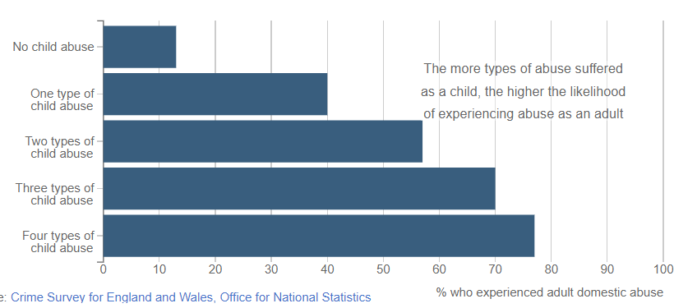
According to the Office for National Statistics (2017), survivors of multiple types of ACEs are more likely to experience domestic abuse in later life, with 77% of survivors having experienced domestic abuse compared to the 40% of those who survived one type of ACE as shown by the graph provided.
Further the analysis shows that survivors of ACEs who are women are more likely than men to experience abuse during adulthood, in that women are four times more likely (43%) to experience sexual assault after the age of 16 than men (11%). Rape Crisis England & Wales (2021) have identified that more than 1 in 5 women and 1 in 20 men have experienced rape or sexual assault meaning that more than 70 women in England and Wales are experiencing one of these offences every hour, 86% of which are perpetrated by people they know. The organisation also notes that at least 1 child in every school classroom has experienced sexual abuse in the United Kingdom, that is 1 in 20 children. Every survivor of ACEs will respond in a different way and the knock-on impact will be portrayed differently too, however; common later life impacts may include:
- Sleep problems such as insomnia  - Withdrawal or Isolation  - Panic/Anxiety attacks | - Dissociation  - Suicidal thoughts or feeling  - Self-harm  - Alcohol or drug misuse
As discussed briefly earlier, post-traumatic stress injury (PTSI) may also be a common impact of ACEs. People who develop PTSI might feel like they are experiencing the traumatic event again and may feel ‘on edge’, irritable or ashamed. Research by the Substance Abuse and Mental Health Services Administration (2018) has demonstrated a strong link between ACEs and substance-related behaviours, including the early initiation of alcohol use and with every additional ACE score, an increase of 62% in the number of prescription drug use in addition to lifetime illicit drug use and drug dependency.
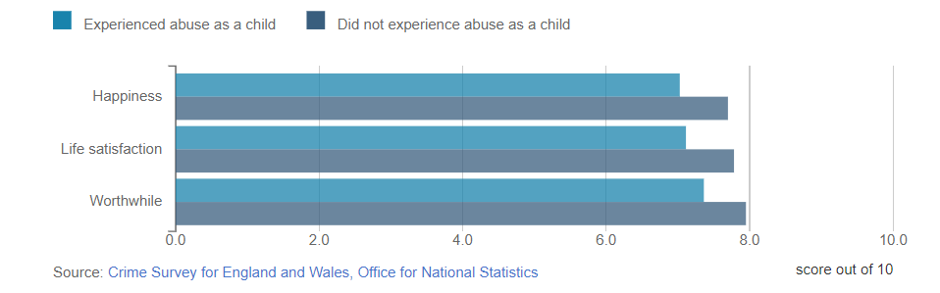
Another analysis by the Office for National Statistics (2016) agrees with the Substance Abuse and Mental Health Services Administration and shows that those who have experienced ACES were 12% more likely to have taken illegal drugs compared to those who had not experienced ACEs (8%). Although more likely to have substance abuse issues, 78% of ACE survivors said that their health, in general, was “very good” or “good” compared to the 87% of those without ACEs, however, survivors rated their well-being as lower and their lives less worthwhile than those who did not experience ACEs.

Services Available to Survivors
There are in theory many services available to survivors of ACEs, focusing on alternatives to the police or regular doctor, there are Sexual Assault Referral Centres (SARC). SARCs are centres where survivors are able to have access to pregnancy tests, emergency contraception, and testing for sexually transmitted infections, there is also the option to have a forensic medical examination where evidence is collected for if the survivor decides to report the assault to the police. Anything that happens within a SARC is private and confidential, there is no pressure on survivors to report anything to police unless that is what they decide they want, the SARC will store any collected evidence until the survivor is ready to move onto reporting (Rape Crisis England & Wales, 2022). Although rape charges have risen by almost 5% between 2020 and 2021, there were 330 less convictions because of court closures during the Coronavirus pandemic lockdown (The Crown Prosecution Service, 2021), and so it is no wonder why most survivors do not go onto report the crime to the police considering the prosecution rate of reported crimes before Coronavirus were at only 1.4% (Russell, 2020). This gap is unacceptable. Offences have been dramatically increasing since 2013 in the United Kingdom, with 2018/19 being the highest at just under sixty thousand reported (Statista Research Department, 2022), which could have been a result of the trailblazing MeToo movement and spin-off MeTooK12 that increased willingness of victims to come forward (Collins, 2022). As of 2018 there has been funding for 8 SARCs across Wales, however, the Cardiff and Colwyn Bay centres are the only ones suitably qualified with experienced medical staff to provide the medical examination of children, and so as a result of this, survivors often have to wait or travel to receive specialist care and treatment and even then waiting times at services available are often too long with only 150 counselling sessions being run per week, 553 children waiting for appointments and the waiting times themselves varying from 3 month to even 3 years in certain areas of Wales (Children’s Commissioner for Wales, 2018).

Suggestions for the Future
With an estimated half of the adult population in England experiencing at least one ACE (Bellis et al, 2014), and there being such low prosecution or conviction rates the criminal justice system sends the message that these types of crimes are acceptable. These crimes have far-reaching consequences and so I feel that we should be aiming for prevention when the ‘cure’ is evidently not working. Although more funding for SARCs, counselling services, general and mental health support is definitely needed to help survivors, as within our patriarchal society these crimes will never be eradicated, I believe that funding should also be aimed towards trauma informed care training. When I say funding should be aimed towards trauma informed care, I mean that any profession that deals with survivors of any kind such as health care professionals, police, military, teachers, volunteers, and charity organisations should have the access to training to help those in need, which will require not just a behavioural shift, but a cultural one (Sweeney et al, 2016). Education is an important factor in lessening the frequency of ACEs as well as understanding the impact of them, the autonomic nervous system influences every organ in the body which is the reason for traumas such as ACEs being associated with not just mental health problems, but physical health problems too. Neurochemicals like adrenaline help to engrain a traumatic event into the memory and so neuroeducation may help individuals understand what and why the nervous system reacted to a threat in a certain way, this may also motivate individuals to learn approaches to help regulate their reactions (Leitch, 2017). Education is not just on survivors though; public education campaigns can be used to help the cultural shift that is needed to reframe how people think and talk about ACEs and help engage the community to promote safe and stable relationships for all children and enhance connectedness therefore reducing stigma (CDC, 2019).
The data we have looked at shows the importance of why there needs to be a shift and better support available for young people who have experienced these types of adversity and trauma, and so with the problem being so vastly unacceptable in any terms, I do not see why funding could not or should not be increased and focused in these areas to avoid not only the chronic impacts on survivors but also to limit the use of health services as a result of chronic illnesses like heart disease as discussed earlier, from either ACEs or other traumas later in life.

Reference List
Andersen, J. and Blosnich, J. (2013) ‘Disparities in Adverse Childhood Experiences Among Sexual Minority and Heterosexual Adults: Results from a Multi-State Probability-Based Sample’, The Public Library of Science, 8(1), pp. 1-7. Available at: https://www.ncbi.nlm.nih.gov/pmc/articles/PMC3553068/ (Accessed 11 March 2022).

Asmussen, K., Fischer, F., Drayton, E. and McBride, T. (2020) Adverse Childhood Experiences: What We Know, What We Don’t Know, and What Should Happen Next. Available at: https://www.eif.org.uk/report/adverse-childhood-experiences-what-we-know-what-we-dont-know-and-what-should-happen-next (Accessed 9 March 2022).

Bellis, M (2016) Welsh Adverse Childhood Experiences (ACE) Study. Available at: https://www2.nphs.wales.nhs.uk/PRIDDocs.nsf/7c21215d6d0c613e80256f490030c05a/d488a3852491bc1d80257f370038919e/$FILE/ACE%20Report%20FINAL%20(E).pdf (Accessed 9 March 2022).

Bellis, M., Hughes, K., Leckenby, N., Perkins, C. and Lowey, H. (2014) ‘National Household Survey of Adverse Childhood Experiences and their Relationship with Resilience to Health-Harming Behaviours in England’, BMC Medicine, 12(72), pp. 1-10. Available at: https://bmcmedicine.biomedcentral.com/track/pdf/10.1186/1741-7015-12-72.pdf (Accessed 16 March 2022).

CDC (2019) Preventing Adverse Childhood Experiences (ACEs): Leveraging the Best Available Evidence. Available at: https://www.cdc.gov/violenceprevention/pdf/preventingACES.pdf (accessed 16 March 2022).

CDC (2021) Preventing Adverse Childhood Experiences. Available at: https://www.cdc.gov/violenceprevention/aces/fastfact.html (Accessed 16 March 2022).

Children’s Commissioner for Wales (2018) Children Who Have Been Raped or Sexually Assaulted Face Unacceptable Waiting Times for Medical Examinations and Support. Available at: https://www.childcomwales.org.uk/2018/10/children-raped-sexually-assaulted-face-unacceptable-waiting-times-medical-examinations-support/ (Accessed 16 March 2022).

Collins, E. (2022) The Employment Law Review: The Global Impact of the #MeToo Movement. Available at: https://thelawreviews.co.uk/title/the-employment-law-review/the-global-impact-of-the-metoo-movement (Accessed 16 March 2022).

Crown Prosecution Service (2021) Prosecution Statistics Published for 2020-21. Available at: https://www.cps.gov.uk/cps/news/prosecution-statistics-published-2020-21 (Accessed 16 March 2022).

Franke, H. (2014) ‘Toxic Stress: Effects, Prevention, and Treatment’, Children (Basel), 1(3), pp. 390-402. Available at: https://www.ncbi.nlm.nih.gov/pmc/articles/PMC4928741/ (Accessed 11 March 2022).

Leitch, L. (2017) ‘Action Steps Using ACEs and Trauma-Informed Care: A Resilience Model’, Health Justice, 5(5), pp. 1-10. Available at: https://healthandjusticejournal.biomedcentral.com/track/pdf/10.1186/s40352-017-0050-5.pdf (Accessed 16 March 2022).

Office for National Statistics (2016) Adult Survivors of Child Abuse and Levels of Health and Well-being. Available at: https://www.ons.gov.uk/peoplepopulationandcommunity/crimeandjustice/articles/peoplewhowereabusedaschildrenaremorelikelytobeabusedasanadult/2017-09-27#:~:text=Adult%20survivors%20of,ending%20March%202016 (Accessed 16 March 2022).
Office for National Statistics (2017) People Who Were Abused as Children Are More Likely to be Abused as an Adult: Exploring the Impact of What Can Sometimes be Hidden Crimes. Available at: https://www.ons.gov.uk/peoplepopulationandcommunity/crimeandjustice/articles/peoplewhowereabusedaschildrenaremorelikelytobeabusedasanadult/2017-09-27 (Accessed 16 March 2022).

Rape Crisis England & Wales (2021) Statistics: Sexual Violence and Abuse. Available at: https://rapecrisis.org.uk/get-informed/about-sexual-violence/statistics-sexual-violence/ (Accessed 16 March 2022).

Rape Crisis England & Wales (2022) What is a SARC?. Available at: https://rapecrisis.org.uk/get-help/looking-for-information/sexual-assault-referral-centres-sarcs/what-is-a-sarc/ (Accessed 16 March 2022).

Resilient Child Fund (2016) What are Adverse Childhood Experiences (ACES)?. Available at: https://www.resilientchildfund.org/top-10-aces/ (Accessed 9 March 2022).

Russell, K. (2020) Without Our Consent [video]. Available at: https://www.youtube.com/watch?v=7UxEcPBiQb4 (Accessed 16 March 2022).

Statista Research Department (2022) Number of Police Recorded Rape Offences in England and Wales from 2002/03 to 2020/21. Available at: https://www.statista.com/statistics/283100/recorded-rape-offences-in-england-and-wales/ (Accessed 16 March 2022).

Substance Abuse and Mental Health Services Administration (2018) The Role of Adverse Childhood Experiences in Substance Misuse and Related Behavioural Health Problems. Available at: https://mnprc.org/wp-content/uploads/2019/01/aces-behavioral-health-problems.pdf (Accessed 16 March 2022).

Sweeney, A., Clement, S., Filson, B. and Kennedy, A. (2016) ‘Trauma-informed Mental Healthcare in the UK: What Is It and How Can We Further Its Development?’, Mental Health Review Journal, 21(3), pp. 174-192. Available at: https://openaccess.sgul.ac.uk/id/eprint/108219/3/MHRJ-01-2015-0006.pdf (Accessed 16 March 2022).

Vervoort-Schel, J., Mercera, G., Wissink, I., Van der Helm, P., Lindauer, R. and Moonen, X. (2021) ‘Prevalence of and Relationship Between Adverse Childhood Experiences and Family Context Risk Factors Among Children with Intellectual Disabilities and Borderline Intellectual Functioning’, Research in Developmental Disabilities, 113, pp. 1-12. Available at: https://reader.elsevier.com/reader/sd/pii/S0891422221000846?token=47DD8AB3A533D287972CCC6A2C55A929F3021F03435F777BC59C9038D5D9D4DBF26DC9D10D57472F4FDF279B3478EE40&originRegion=eu-west-1&originCreation=20220311162732 (Accessed 11 March 2022).

Victim Support (2021) Children and Young People Affected by Crime. Available at: https://www.victimsupport.org.uk/wp-content/uploads/2021/04/Crimes-affecting-CYP-Policy-Statement.docx.pdf (Accessed 10 March 2022).

