Name: Nikole Atkinson
Module Introduction to physiology
Module code: BMHP50003_BIRM
Lecturer: Giridhar Katti
Assignment title: Health Assessment report

Table of content

Page 3 Introduction / case Study
Page 4 Care plan
Page 5 Care plan
Page 6 Care Plan
Page 7 Care plan
Page 8 Care plan / Recommendation
Page 9 Recommendation / conclusion
Page 10 references
Page 11 Appendix

Introduction
In this essay, I, Nurse N. Atkinson, a district nurse, will create a case study based on Mr E. Paterson, who I will refer to as patient x. Mr E. Paterson is an outpatient patient at We are Hearts with our private home care package, he suffers from heart disease that has resulted in heart failure and is also developing other problems that are affecting Mr E Paterson's condition, there has been a full health assessment questionnaire which has been completed, Mr Paterson has given his complete agreement for us to be able to determine normal and abnormal physiological states from our findings, and we have reassured him that his data would be safeguarded under the General Data Act 2018, and that this paperwork will be provided in the appendix. Recommendations will be made based on positive lifestyle changes as well as a care plan, and I will summarise my findings and reflect on my results at the conclusion.
Case study
Patient X is 67 years of age 6FT 2 (193 cm) Height 22 stone (139kg) giving a BMI OF 37.32 which put the service user on the spectrum of obesity. Patient X suffers with heart disease he also suffers with high blood pressure, which is stage 1 Hypertension, has also previous history of smoking up to 39 per day but has stopped smoking 5 years ago due to two clots on the major lung arteries so he decided to quit. Patient x also has family history of diabetes, heart diseases but does not have diabetes himself, there is a life expectancy of 60, with siblings and parent not living over 60 years due to heart disease, his lifestyle habits are not too good as he does not frequently exercise as he also suffers with arthritis and fluid on his knees which restrict him from doing so, Patient X has a balanced diet he don’t eat meat just fish and eats vegetables and fruit, does not really eat greasy foods as his children and sister will cook home food and freeze them or fresh food on the day, but Patient X does like to snack a lot meaning lots of savoury food like crips and also lots of chocolates and biscuits, alcohol has never been something of interest so there is no alcohol intake only rarely on special occasions. Patient x is on Medication warfarin (blood thinner) this is for his clotting more,

Care plan
From the case study you can see that Patient X suffers with Heart Fail started to encounter other serious symptoms alongside his Heart it is important to ensure that the care plan is always up to date to ensure that the right level of care and intervention is given, as his District Nurse I will be creating a care plan for his needs Jaarsma, Huijer, Halfens and Dracup, (1996) states “It's critical that these patients' nursing care includes treatments that address their physiological and emotional requirements. In the acute phase of pulmonary edoema, patients with heart failure require high-acuity care as well as education and support on their medication regimen and dietary restrictions”. This is why it is essential that care plans are put in place and always followed.
According to Cohn, (1996) Heart failure is a set of symptoms that include exhaustion, shortness of breath, and congestion, all of which are caused by insufficient tissue perfusion and, in some cases, fluid retention. The main reason is a cardiac condition that makes it difficult for the heart to adequately fill or empty the left ventricle. There are many risk factors that MR X has got they may be contributing to his overall health condition of (HF) heart failure such as Obesity which is making Patient x’s heart work harder to pump blood and nutrients throughout the body. Other heart-related risk factors, the main cause of heart failure is high blood pressure. Furthermore, those with uncontrolled blood pressure are twice as likely as those with normal blood pressure to have heart failure. When blood pressure is high, the heart muscle has to work harder to pump blood through narrowed blood arteries.
ECG Electrocardiogram
chest x-rays A chest x-ray is required to rule out heart enlargement and pulmonary congestion, especially if the patient has left heart failure. Similarly, aberrant cardiac contractions would be detected by the ECG, which would be represented by deviant ECG graphs.

Below is a structured care plan that will be carefully monitored, due to the severity of Patients X’s condition and other conditions that having a major impact on his health Patient x’s care plan should be reviewed after 6 months

Results

Diagnosis | Goals and outcomes | Intervention | rational | Evaluation
Blood pressure | Want to ensure that Patient X blood pressure is managed and under control to reduce the stress rate on his heart. | Educate Patient X on stress management, deep breathing, exercises, and relaxation techniques. | Stress can increase higher blood pressure and also cortisol levels which is all linked to people with cardiac issues | Reducing stress will help to manage his Bp which will then help lessen the risk of other health concerns
Hypertension | Reduce Bp and help balance sodium levels in the body | Hypertensive medication | this eliminates sodium and water through your urine leading to a decline in blood volume | There is a lot of evidence that there is a link between salt intake and blood pressure (BP). Many nations currently consume between 9 and 12 grammes of salt per day. In both hypertensive and normotensive people, lowering salt consumption to the recommended range of 5–6 g/day decreases blood pressure. Feng J. He, Michel Burnier, Graham A. MacGregor,(2011)
Obesity | managing size proportion and to reduce bloating. | Encourage smaller portion of meals more frequently | To avoid abdominal distention and diaphragm elevation which lead to a decrease in lung capacity | This should help manage size proportions, balance out his meals and also the amount of sodium intake also by doing this should gradually help to maintain the other condition of heart failure (HF)
 | For patient X to lose weight and to reduce pressure on the rest of the body | Encourage patient X to move around more so that he is becoming active throughout the day. | According to patient x, moving can aid with joint pain reduction. It aids in the development of lean body mass, which raises the rate of basal metabolism (BMR). It has the potential to improve a person's psychological attitude. It lowers the risk of morbidity and death associated with a wide range of illnesses and conditions. | Packer and Kitzman, (2018) states that “Obesity-related HFpEF is caused by two fundamental pathophysiological abnormalities: salt retention and systemic inflammation. Obese individuals have increased renal tubular sodium reabsorption and plasma volume expansion, which is proportional to their BMI”. This is why it is important to reduce Patient x’s weight at it has a big impact on his heart and putting more pressure this is why
Heart Failure | Ensuring that any early detection of abnormalities is identified. | Assess the patient vital signs and characteristics of the heartbeat at least every 4 hours | To Assist in creating an accurate diagnosis and monitor effectiveness of medical treatment. | Regular examinations will aid in the early detection of any problems, allowing appropriate therapy to be delivered.
 | To keep oxygen at a normal rate to allow patient X to breathe easier, reduce the risk of breathlessness | Administer supplemental oxygen, as prescribed | To address the underlying conditions and reduce the symptoms of heart failure  Increasing oxygen levels and achieving a Sp02 of at least 94% | Providing oxygen to keep stats overall will help patient X to breath easier in the night, and also help throughout the day making tasks easier  for Patient X to complete without him feeling restless and having lac of energy.
 | Keeping on top of Patient X’S Condition and reduce any flare up that could happen | Administer cardiac medication | To alleviate the symptoms of heart Failure and to treat  underlying conditions | Administration medication will Help maintain the condition and to reduce pain too the Patient. According to SAMUEL MCKELVIE, (2002)  ACE inhibitors have been shown to lower mortality, hospitalisation for heart failure, and ischemia events in persons with heart failure in two systematic reviews and recent RCTs.

Possible medication that could be considered that patient x should be on based upon NHS (2021)
- ACE inhibitors
- angiotensin-2 receptor blockers (ARBs)
- beta blockers
- mineralocorticoid receptor antagonists
- diuretics
- ivabradine
- sacubitril valsartan
- hydralazine with nitrate
- digoxin

finding the best suited medication for Patient X will him long term and als
Recommendation
My Recommendation for Patient X is that they should start off with weight loss as this is a huge risk factor to his health and will help with the reducing the risk of other health condition such as hypertension, which will make it easier for Patient X to control his condition of HF. According to D Giovanni et al., (2013) “Obesity, particularly abdominal obesity, has recently been discovered to be an independent risk factor for the development of heart failure in epidemiological research (HF). Higher myocardial oxidative stress is the first sign of obesity-related heart disease”. I recommend that patient x Consider enlisting the help of a dietitian to help with meal planning and portion management.
Making dietary changes can help Patient X lower your risk of getting heart failure, Increase your intake of whole grains, fruits and vegetables, and nuts in your diet. It also requires substituting healthy fats with unhealthy ones. Consuming more mono- and polyunsaturated fats while avoiding saturated and trans fats is one way to do this. Cholesterol levels are raised by bad fats, which block arteries and make your heart work harder.
Here's a list of foods to stay away from:

- Baked goods that contain egg yolks and butter
- Fried foods such as fried chicken, French fries, and potato chips
- Fatty red meats or organ meats, such as liver
- Saturated oils like coconut oil, palm oil, and palm kernel oil

Conclusion
According to my findings, MR Paterson has had previous health issues such as clotting on his lungs for which he was prescribed warfarin and is still taking, as a result of which he changed his lifestyle and decided to stop smoking. Mr Paterson is also at an age (67) where these conditions are more difficult to control, and he is also obese and suffers from high blood pressure, which puts significant pressure on his heart, as stated by D Giovanni et al., (2013) and does not help him. Advising Mr Paterson to see a dietitian will help him manage his weight and see progress of weight loss, which was the best solution for him because he also rarely exercises due to fluid on his knees and arthritis, it may also help with sodium intake and help lessen the pressure in relation to his heart condition. Having a care plan that will be reviewed on a shorter period of time of 6 moths rather than a longer period of time will help keep on top of his medication and also see what is helping Patient x and what can be changed to help him have a better quality of life
.

Reference
Amakali, K., (2015). Clinical Care for the Patient with Heart Failure: A Nursing Care Perspective. Cardiovascular Pharmacology: Open Access, 04(02).
Cohn, J., (1996). The Management of Chronic Heart Failure. New England Journal of Medicine, [online] 335(7), pp.490-498. Available at: <https://www.nejm.org/doi/full/10.1056/NEJM199608153350707> [Accessed 7 December 2021].
D Giovanni, P., Francho, S., Castiglione, M., Giagulli, A. and Angelo, v., (2013). Obesity and Heart Failure. Bentham science publisher, [online] 13(1), pp.51-57. Available at: <https://www.ingentaconnect.com/content/ben/emiddt/2013/00000013/00000001/art00007#Refs> [Accessed 12 December 2021].
Feng J. He, Michel Burnier, Graham A. MacGregor, Nutrition in cardiovascular disease: salt in hypertension and heart failure, European Heart Journal, Volume 32, Issue 24, December 2011, Pages 3073–3080, https://doi.org/10.1093/eurheartj/ehr194
Jaarsma, T., Huijer, H., Halfens, R. and Dracup, K., (1996). Maintaining the balance nursing care of patients with chronic heart failure. [ebook] Pergamon, p.213.
nhs.uk. (2021). Heart failure - Treatment. [online] Available at: <https://www.nhs.uk/conditions/heart-failure/treatment/> [Accessed 12 December 2021].
Packer, M. and Kitzman, D., (2018). Obesity-Related Heart Failure With a Preserved Ejection Fraction. JACC: Heart Failure, 6(8), pp.633-639.
SAMUEL MCKELVIE, R., (2002). Heart Failure. AFP, [online] pp.99-103. Available at: <https://www.aafp.org/afp/2002/0101/p99.html> [Accessed 13 December 2021].
Sites.google.com. 2021. Abnormal ECGs - Electro cardiology Instruction. [online] Available at: <https://sites.google.com/site/electrocardiologyinstruction/abnormal-ecgs> [Accessed 17 December 2021].

Appendix
- Health assessment questionnaire 2.
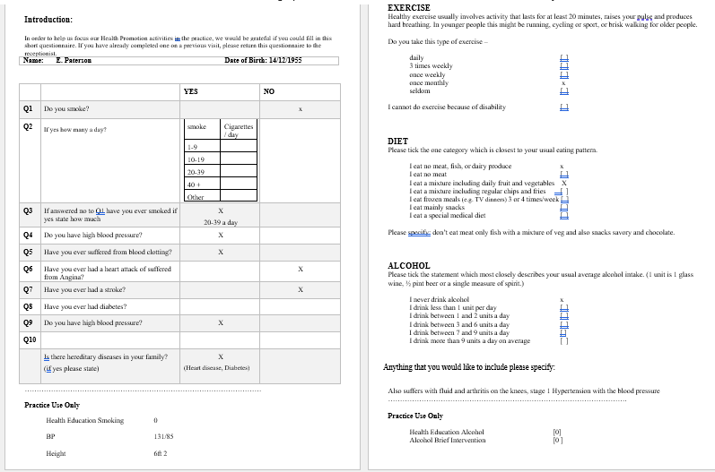
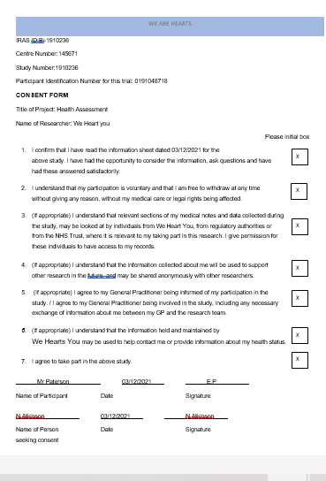
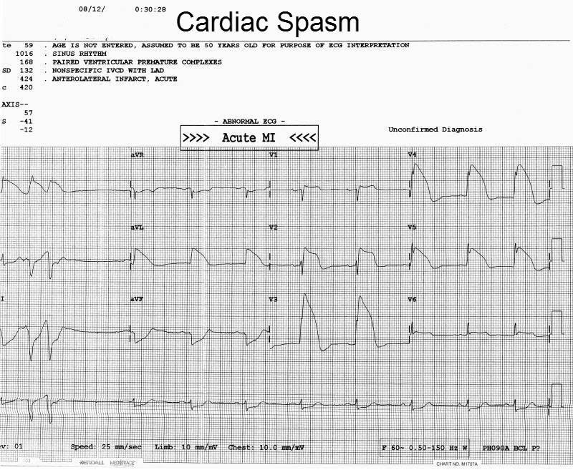
3. Abnormal ECG
2. Consent form/ data protection

