Module Name: Academic Skills in the Digital Era
Module Code: BMSW4013
Assessment 1: E-Portfolio
Student Name:
Student Number:
Lecturer: Scott James
Deadline: Friday 21st November 23:59PM
AI Acknowledgement
I confirm that I have not presented any AI-generated materials as my own work.

Component 1

Source Exploration
The Study Skill Handbook, 6th Edition, written by Stella Cottrell. It is a highly relevant resource for students studying in the digital era, although the book was originally published in 1999. This edition has been updated to address modern learning. Its primary purpose is to help students develop effective study habits. The author gives guidance on planning, time management, note-taking, research techniques, and the use of checklists. Additionally, the book explains how to make the most of digital tools, including online databases, search engines, and eBooks, and offers strategies for using them effectively. The book also explores challenges students face in the digital era, including distractions and information overload, while emphasising opportunities. I chose this book because of Cottrell's skill in breaking down complex academic skills. Combining digital literacy and personal management makes this book an effective guide for students seeking success within a university. Reading this book allowed me to understand different challenges students may encounter and to develop practical strategies to overcome them, enhancing both my academic skills and confidence.

Key Challenge for Students
One significant challenge is faced by those born before the widespread use of computers. As digital learning is often acquired through education, these individuals may have fewer digital skills and knowledge than the younger generation. As a result, they may encounter difficulties navigating online resources effectively, using digital learning platforms, evaluating information, and completing online assignments. The process of learning new technology can cause frustration without these skills; students risk falling behind in their studies. In addition, students of all ages face frequent distractions, such as notifications from email, Teams, messages, and social media. These interruptions can reduce focus, hinder time management and compromise the quality of work completed. Collectively, challenges help recognise strengths and weaknesses, allowing students to understand where they need support and where they do well. Over time, facing and overcoming difficulties builds confidence, resilience and a stronger ability to adapt to different learning situations. As Cottrell states, “being aware of such challenges means you can prepare for them and better manage your studies” (Cottrell, 2024, p.67)

Key Opportunity for Students
One major benefit that digital tools offer students is flexible and convenient access to learning resources. From my own experience, using online resources such as Moodle allows me to revisit course content material whenever necessary to strengthen my understanding. The online library has been particularly valuable. it's more convenient than visiting a library because it gives me access to resources at any time. I am able to access e-books, enabling me to search chapters and individual keywords. This saves significant time compared to browsing through a library and a book. These digital tools provide flexible access to learning materials, supporting both my preferred pace and style of learning. Overall, these digital tools contribute to my academic development and help me prepare for future success.

Planning Your Report
The focus of the report will be on both challenges and opportunities. The reason for this is that both aspects are important. By looking into both positive and negative the report can demonstrate how digital tools contribute to the modern world. For component 2, I will use digital tools such as the digital library to look for e-books and articles. I will structure the report with the relevance of digital learning, I will highlight the opportunities and benefits, discuss distractions and how students can adapt, along with a conclusion.

Timeline for Component 2
Task | Date/ Deadline
Finish research | 26TH October 2025
Draft first section | 7th November 2025
Complete first draft | 14th November 2025
Final editing | 20th November 2025

Component 2

Introduction
Digital literacy refers to an individual's capacity to proficiently utilise information and communication technology for effective access, evaluation, and processing of information presented in diverse digital formats (Joseph and Thomas, 2020a; Manubey et al., 2022; Su, 2023). Digital learning has become increasingly important in an academic setting. Advanced technology provides students with access to a wide range of online resources. My report will cover the key challenges and opportunities presented by digital tools in education. It will also discuss practical ways students can adapt their study habits and skills to make the most of these tools while overcoming potential difficulties.

Challenges Students Face
One major challenge would be that all students have different digital literacy skills. While digital tools are widely used. Not all students have the ability to use them effectively. Which can make navigating online platforms, access resources and completing assignments more difficult.
Another significant challenge is digital distraction. Smartphones, messages, social media platforms and constant notifications compete for students' attention, making it difficult to stay focused. When students have difficulty separating their free time and study time, their productivity suffers, deadlines can be missed, and learning becomes less efficient. Research indicates that individuals who frequently juggle multiple streams of digital content tend to have diminished attention, memory, and task management capabilities compared to those who concentrate on one task at a time (Hart,2022). Maintaining focus is crucial as it helps students remember information, complete tasks on time and develop effective study habits.

Opportunities Digital Tools Provide

Digital tools in education offer several benefits that enhance students' learning process. One major development is the integration of artificial intelligence. Artificial Intelligence (AI) is rapidly transforming various aspects of life, and education is no exception (Patil, 2025). AI encompasses the emulation of human intelligence by machines or computer systems (Urmeneta, Romero, 2024). A key advantage for students is the availability of an AI-powered Research Assistant, which is a digital tool that enables students to search across multiple credible sources to find relevant material for their research. Research assistant helps locate relevant academic sources and suggests related reading material. Providing students with related reading expands their understanding of a topic and promotes deeper engagement with the material. This improves the quality of the research and encourages critical thinking. Students can dedicate more time to analysing information instead of searching for resources. Another digital AI tool would be Notebook LM, which allows students to turn a book or article into a podcast. Catering to different learning preferences allows students to engage with content in a more flexible and accessible way. Together, these AI tools save time and support the development of critical research and learning skills. These innovations are not only enhancing the learning experience but also transforming the traditional educational model (Marougkas et al., 2023).

How Students Can Adapt
Studies suggest time management is regarded as an important prerequisite for effective and efficient learning in higher education (Trentepohl et al., 2022). Digital applications such digital planners or the pomodoro technique which suggest working for 25 minutes then take a break for 5 minutes, helps students avoid distractions and maintain concentration. By using these tools students can engage more purposefully with academic tasks and meet assignment deadlines with greater consistency. In turn time management supports academic outcomes while reducing stress and the risk of burn out. At the same time digital tools such as AI with pre-programmed responses can restrict opportunities for independent problem-solving and the development of critical thinking. The increasing reliance on AI tools for information retrieval and decision-making raises questions about how these technologies influence users’ critical thinking abilities (Gerlich, 2025). Learning to critical evaluate online information helps students avoid mistakes and develop critical thinking skills. Critical thinking involves the ability to analyse information deeply, present arguments objectively, and make evidence-based decisions. (Kusumawati et al., 2025) in addition to these approaches learning and academic support services along with disability support are widely available at universities. Workshops and one to one support allow students to enhance academic skills mange assignments and develop study skills. Disability support ensures that all students to have equal access to learning through personalised support and learning adjustments. Accessing support helps students feel confident in the digital learning environment and collectively these services enhance student success.

Conclusion
In summary digital tools present challenges and opportunities for students in university these challenges include the lack of digital literacy skills and distractions from notifications, social media which can affect focus and productivity. Opportunities such as learning resources, Ai research assistant, digital library and digital tools facilitate learning promote critical thinking allow flexible engagement with material. Students can adapt by managing time effectively, critically evaluate online information and make use of learning support services applying these strategies will help students succeed academically, build confidence and develop lifelong skills.

Component 3

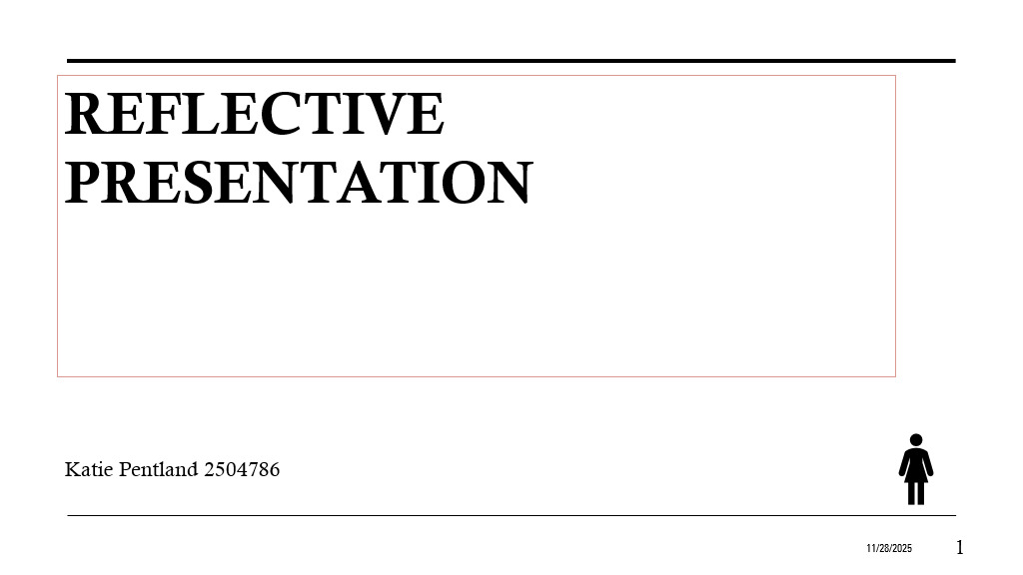
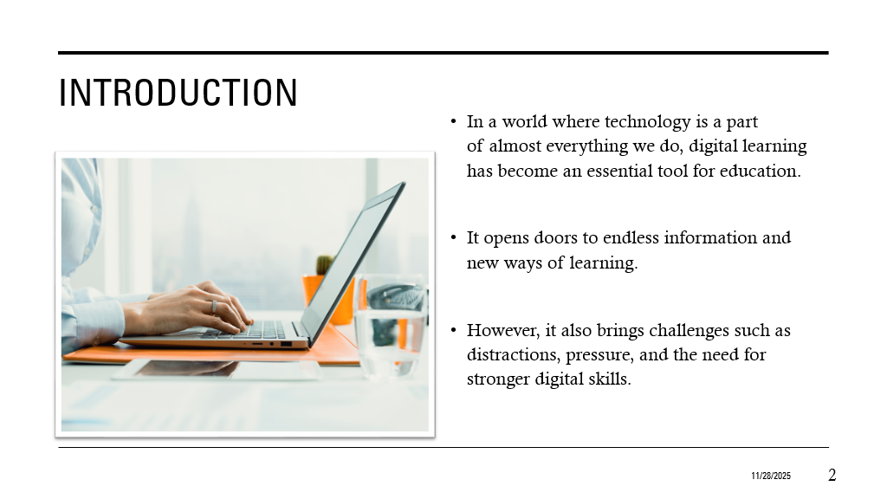
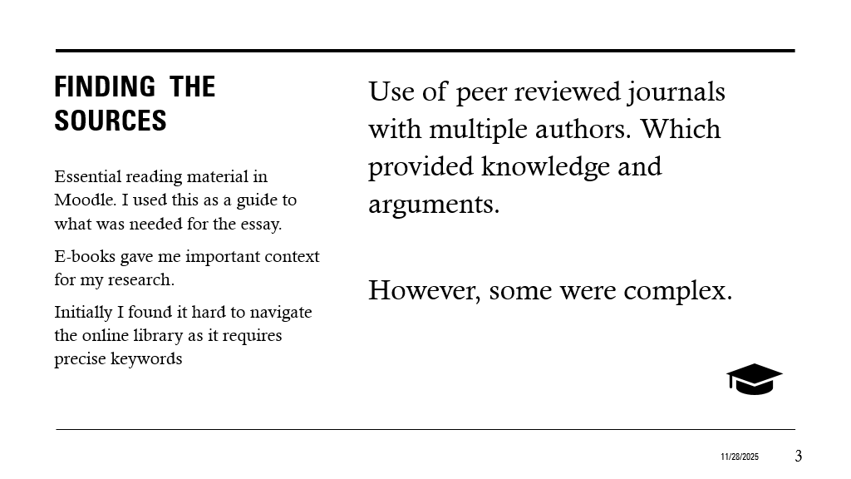
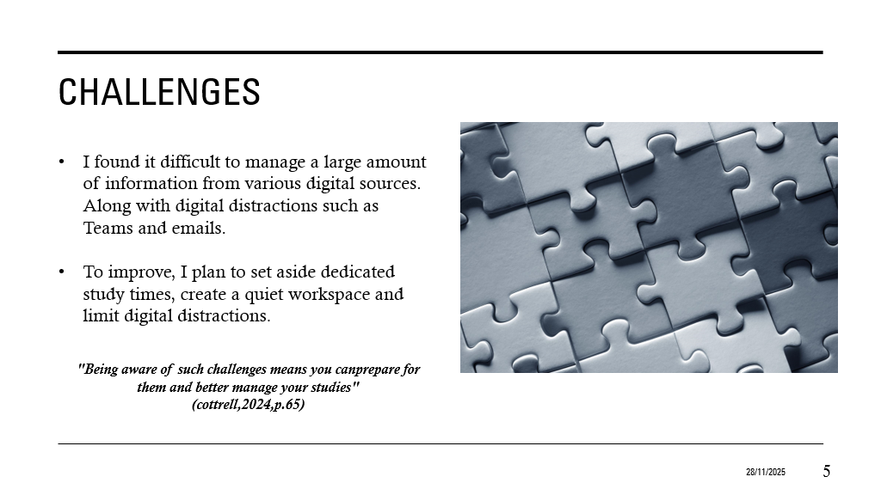

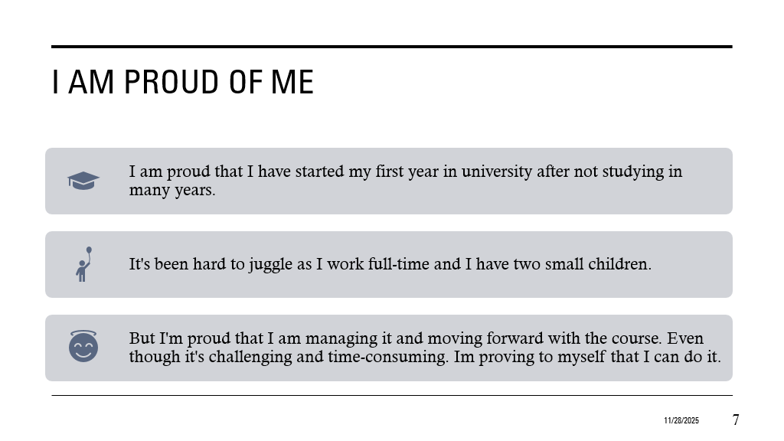
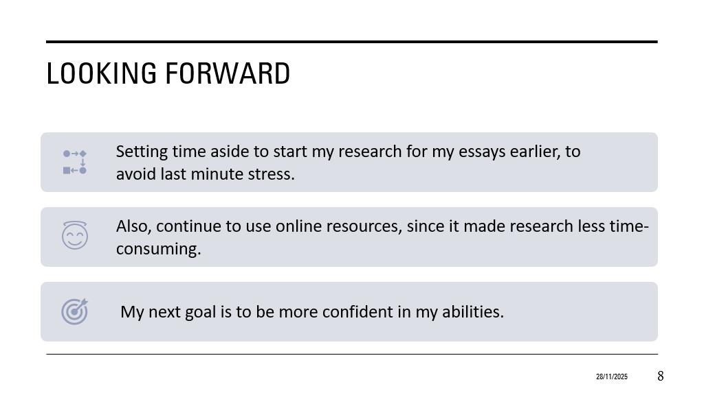
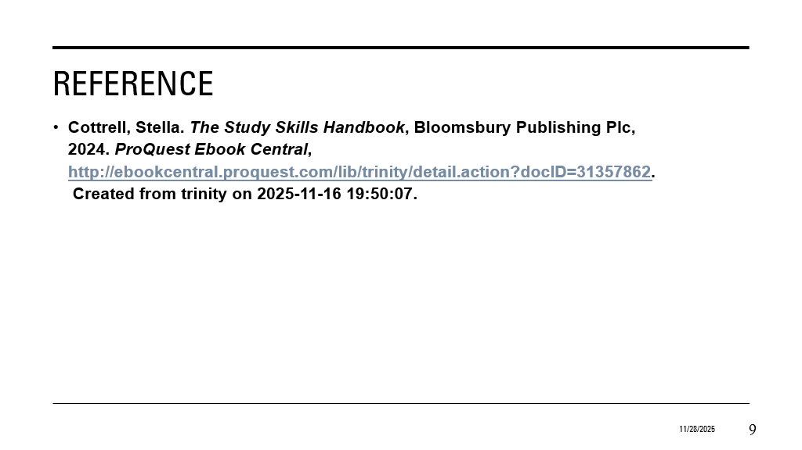

Reference List
Alex Urmeneta, & Margarida Romero. (2024). Creative Applications of Artificial Intelligence in Education. Springer Nature Switzerland. (Accessed 28/11/2025)

Cottrell, Stella. The Study Skills Handbook, Bloomsbury Publishing Plc, 2024. ProQuestEbookCentral,http://ebookcentral.proquest.com/lib/trinity/detail.action?docID=31357862.
Created from trinity on 2025-11-16 19:50:07.

GERLICH, M., 2025. AI Tools in Society: Impacts on Cognitive Offloading and the Future of Critical Thinking. Societies, 15(1), pp. 6.

HART, M., 2022. 8 tips for fending off digital distractions. Journal of Accountancy, 233(7), pp. 1-5. (Accessed 27/11/2025)

JOSEPH, G.V., P, A., M, A.T., JOSE, D., ROY, T.V. and PRASAD, M., 2024. Impact of Digital Literacy, Use of AI tools and Peer Collaboration on AI Assisted 0Learning: Perceptions of the University students. Digital Education Review, (45), pp. 43-49. (Accessed 25/11/2025)

Kusumawati Shindi Nur Rahmawati, Suratno and Rizki Putri Wardani (2025). Critical thinking transformation in the digital era: The effectiveness of e-module based on read-STEM in elementary school. Primary: Jurnal Pendidikan Guru Sekolah Dasar, 14(5), pp.627–642. doi:https://doi.org/10.33578/jpfkip.v14i5.p627-642. (Accessed 28/11/2025)

Murtadho, M.I., Rohmah, R.Y., Jamilah, Z. and Furqon, M. (2023). The Role Of Digital Literacy In Improving Students’ Competence In Digital Era. AL-WIJDÃN Journal of Islamic Education Studies, 8(2), pp.253–260. doi:https://doi.org/10.58788/alwijdn.v8i2.2328. (Accessed 27/11/2025)
Patil, V.C., 2025. Artificial Intelligence in Digital Learning Platforms in Education: Impact, Benefits, Limitations and Future Prospects. Asian Journal of Advanced Research and Reports, 19(6), pp.244–254. Article no. AJARR.138011. ISSN: 2582-3248.
TRENTEPOHL, S., WALDEYER, J., FLEISCHER, J., ROELLE, J., LEUTNER, D. and WIRTH, J., 2022. How Did It Get So Late So Soon? The Effects of Time Management Knowledge and Practice on Students’ Time Management Skills and Academic Performance. Sustainability, 14(9), pp. 5097. (Accessed 28/11/2025)

Zou, Y., Kuek, F., Feng, W. and Cheng, X. (2025). Digital learning in the 21st century: Trends, challenges, and innovations in technology integration. Frontiers in Education, 10(10). doi:https://doi.org/10.3389/feduc.2025.1562391. (Accessed 25/11/2025)

