

Student name: Ghazala Hussain
Component 1: Online Portfolio of Set Exercises
Student ID: 2408113
Module title: Changemakers: Creativity and Value Creation
Module Code: BMHP5024
Tutor’s details: Tomy Adattu Chacko
Module leader: Parese Ahmed

Task 1 – Concept Map
Create a concept map outlining the relationships among creativity, value creation, and health and social care improvement. Within the concept map, explain how these concepts interact in a health and social care context.
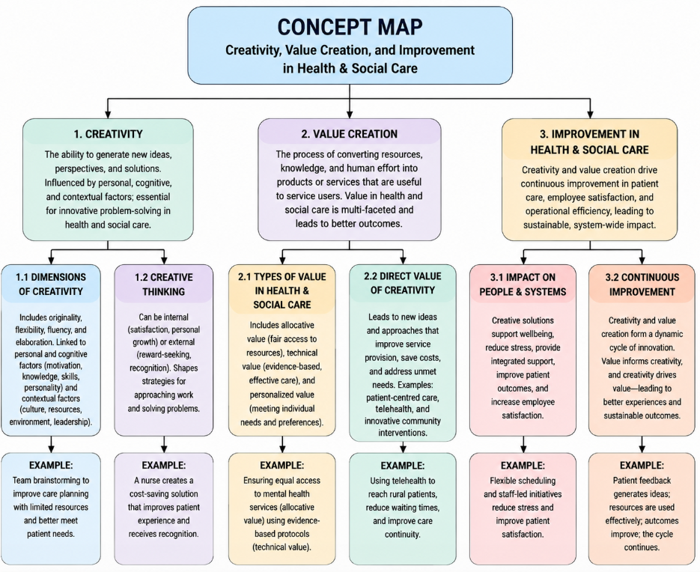
This concept map shows creativity, value creation, and improvement in health and social care woven together. There are many dimensions of creativity (as a phenomenon), and some of them have connections with personal and cognitive factors and contextual factors. In the field of health and social care, creativity also plays a crucial role in innovative solutions and problem-solving to improve patient care, employee satisfaction, and operational efficiency. Creative thinking can be either internal, a satisfaction of the individual, or external, a reward-seeking approach, and it can affect strategies for approaching work and problem-solving. The 4Ps of creativity (Person, Process, Product, and Press) emphasize people, processes, products, and environments that support creativity and innovation.
Value Creation is the process of converting resources, knowledge, and the effort of humans has become a product/service useful to the service users. Value in health and social care has a multi-faceted meaning, and this involves allocative value, which is the provision of resources for patients and an equal opportunity to avail of these resources, and the technical value and personalized value. The direct value of creativity is found in the introduction of new ideas and approaches for improved service provision, efficiency savings, and addressing unmet patient needs, which may include introducing patient-centered care, telehealth, or innovative community interventions.
Creativity and value creation are key to the improvement of health and social care. Creative solutions allow staff to make interventions that support wellbeing, minimize stress, and provide integrated support, and through value-focused interventions, ensure resources are effectively used to achieve optimal outcomes. Creativity and value creation create a dynamic and continuous cycle of innovation, improved patient experiences, and sustainable system-wide value, with creativity driving value creation and value informing creativity.

Task 2 - Self-Reflection of Group Activity
Complete a self-Reflection on the Convergent/Divergent paperclip thinking class activity using a reflective model.

In Activity-2, paperclip, I did divergent and convergent thinking. I came up with many uses for the paperclip and then chose the ones that seemed to be the most "doable" or "creative". I was initially a bit uncomfortable, as it was because I didn't know how to get out of my own head and take a different perspective on some thinking. A discomfort for me was seeing how much I was resorting to old patterns to solve a problem. As I did, I began to think of really weird ways to use a paperclip, for like maybe holding a phone up with one paperclip and picking the lock with the other paperclip, and it started to occur to me. This was a stage that enabled me to see the positive sides of divergent thinking to widen the scope of possibilities and accept creativity. As part of the convergent stage, I assessed the ideas I had developed in relation to their applicability, originality, and relevance, and chose the most innovative ideas that appeared to be practically applicable. I discovered that the mix of the two styles will help facilitate a balance between creativity and smart moves. Being made to do group work allowed me to think more, as I could hear the ideas others had, and they would give me more ideas, and then by listening more than they talked to me, I could combine my thoughts.
This was my lesson on the importance of being flexible in one's thinking and having a bit of critical thinking, as these are vital parts of creativity. I now know about tools and approaches that can systematically develop and evaluate and develop concepts, including the Osborn-Parnes Creative Problem-Solving model. For the next time I solve a problem, I intend to clearly differentiate and leave space for the emergence of new ideas and their examination, creating a space in which new ideas can be encouraged prior to being evaluated. Working collaboratively can also improve creativity and solutions. In this regard, the activity proved to be important in gaining the value of divergent and convergent thinking to improve the quality of creativity and value creation in practical situations (Adler and Chen, 2011).
Task 3 - Case Study of a UK innovation
Write a concise case study analysis of an innovative project or initiative within the NHS or UK social care. Focus on how creativity was used to drive change and the value it created for patients or service users.

NHS at home is an innovative and pioneering approach to the NHS in the UK. There was a risk that the strain on hospitals would become even more acute as demands from individuals with more complex chronic long-term health conditions like heart and lung disease, diabetes, and respiratory disease increase, but do not necessitate hospital contact. This led to the development of a new ‘digital-first' approach to care, which utilizes digital technologies to deliver remote monitoring and clinical supervision directly to the patient’s home. Unlike more traditional reactive care, this model focuses on proactive management, ongoing data insight, and patient empowerment, which help to minimize over-hospitalization and enhance outcomes (Padros et al., 2021).
HSN at Home is about incorporating a few innovative elements at its core. Wearable and home monitoring equipment collect vital signs, like heart rate, blood pressure, and glucose, and transmit them securely to online platforms available both to service users and clinicians for continuous monitoring. In more complicated instances, certain home tools can provide more sophisticated evaluations of the body at home, such as portable electric cardiograms and spirometry machines. This is complemented by the application of AI and predictive analytics, which analyze data in real-time, alert to signs of deterioration early, and promote timely clinical action (HIMSS, 2026). The programme is accompanied by extensive patient education so that people can learn to understand their personal health information and be better informed about their care and self-management.
Ways to be creative within the initiative include rethinking the traditional care pathway in a digital and patient-centered way. The NHS leveraged new technologies to deliver a combined model of care at home. The NHS Virtual wards, which were built using a combination of clinical knowledge and emerging technology and moved care from the hospital into the homes of those in need. This will involve utilizing real-time data, anticipatory clinical decision making, and increased patient autonomy to personalize care (Padros et al., 2021). A strong impact is suggested from wider experience of remote monitoring in the NHS, which has found results of substantial reductions in emergency department attendance and hospital admissions, and the ability to manage thousands of high-risk patients safely in the home.
Value created for patients is often faceted. A care and recovery at home setting can help individuals to feel comfortable and familiar and may result in a better psychological outcome and reduced risk for complications from the care they receive in the hospital setting, such as functional decline or infection. The pressure on beds is reduced at the system level, and clinical resources are optimized with remote monitoring. To conclude, NHS at Home is a very concrete illustration of the possibilities of rethinking health service provision in a more sustainable, proactive, and personalized way, by daring to think outside the box with digital technology.

Task 4 - Research Task
Identify a current issue in health and social care (e.g., mental health stigma, access to care for vulnerable populations). Find two pieces of academic research (journal articles) that explain the reason for this problem. Paraphrase the findings of each article (300 words, 2 sources).

One of the topical health and social care issues in England at present is that the National Health Service (NHS) and social care services are low in resources. These all-affect waiting lists, hospital beds, discharge, and timely access to treatment.
The stress on services is due to unprecedented demand, old age, and inflationary pressures, according to Baker, Foster, and Powell (2024). According to reports, there were approximately 7.8 million people on the waiting list for hospitals in September 2023. This indicates a lack of capacity to respond to patients' demands promptly in the NHS. Delayed discharge is also one of the big issues faced by hospitals, as explained in the article. There's an issue with some patients emerging physically but not emotionally, and then there are patients who emerge emotionally but not physically. This is because the social care provision, care in the community, and assessment service may not be in place at all times. That translates to beds that are already occupied, and even more new patients will have to wait longer. These findings indicate that there is little integration between the health and social care services, creating a strain on the system.
The increased demand and underfunding of the NHS over the long term are the focus of Ham (2023). NHS services, because of greater funding, higher staffing levels, and good performance targets, have improved in the 2000s, according to the report. There was a much more volatile rise and fall of money since 2010, however. Meanwhile, population ageing and broadening social demands drove demand for care to rise. The report says austerity affected local authorities, social care services, housing, and public health services. These areas are crucial as they have an impact on the health of people and their need for NHS services. As demand grew, there were capacity problems from the mismatch of funding, staffing, and planning of services.
To sum up, neither source suggests that NHS pressures are present due to only one problem. These relate to demand with ageing, funding, social care issues, and poor system integration.

Task 5 - Podcast
Record a two-minute Podcast introducing your idea for component 2 using https://www.rev.com/onlinevoicerecorder. The MP3 audio must be downloaded and embedded as a file (see guidance video on how to do this here: https://www.youtube.com/watch?v=D21isId0agw) or an accessible OneDrive link if using a Chromebook (make accessibility – anybody) before inserting into your portfolio. Check the accessibility of the link before submitting.

My audio file
my-recording (2).mp3

Task 6 - NHS Leadership Framework Analysis
Write a summary (200 words) explaining the key components of the NHS Leadership Framework. Then, choose one component and describe (150 words) how a leader might use it to encourage creativity and improve care in the NHS (2 sources).

Summary
The NHS Leadership Framework is an extensive model of leadership development, applicable at every level of the NHS and health and care services. It is grounded on the idea that leadership is not a restricted title given only to those in formal leadership and management roles, but that leadership is the responsibility of every member of staff to assist in service improvement. It is intended to deliver a common language and leadership approach by defining seven domains of leadership: Demonstrating personal qualities, working with others, managing services, improving services, setting direction, Creating the vision, and delivering the strategy. These affect all employees and focus on behaviors, such as self-awareness, teamwork, service management, innovation, and decision making – the first 5 domains. The final two are specific to Senior leaders who drive the vision and add strategies. The NHS values of respect, compassion, quality of care, and working together for the benefit of patients support the framework. Its purpose is to help good leadership take place, to work together, to provide learning and developing services, and to set expectations for service improvement to enhance patient outcomes. Moreover, the framework enables staff development by implementing measures like self-assessment, feedback systems, training courses, and appraisal systems (NHS Leadership Academy, 2011). Overall, it contributes to establishing a culture of shared leadership, a patient-centered and patient-first approach to providing safe, high-quality healthcare services.
Using the “Improving Services” Component to Encourage Creativity and Improve Care
Fostering a culture of innovation and ongoing improvement can drive creativity and better care for patients through a leader's use of the Improving Services element of the NHS Leadership Framework. This emphasis will be on patient safety, which is a critical reflection, improvement, innovation, and transformation of practice. A healthcare leader can support other healthcare professionals to brainstorm solutions to issues that may arise in service, strategies that can help streamline service, and/or ways to enhance patient experience collaboratively. Leaders can foster opportunities for discussion and appreciate employee ideas, which will help employees step forward with ideas. Patient feedback, performance data, and evidence-based information can also inform the leaders to reflect and pinpoint what they are doing well and where they need to make improvements and develop new strategies. For instance, the introduction of new digital systems in health could result in better outcomes, or quality redesigns in the pathway for patients, or staff-based quality improvement could result in better outcomes (West et al., 2017). Leaders have the potential to utilize collaboration, learning, and innovation to think creatively about how they can enhance the quality, safety, and effectiveness of NHS services.

Task 7 - Self-Reflection Journal Entry
Write a short journal entry about what you learned in this module. Focus on how your understanding of creativity and value creation within H&SC has changed and how it has informed your professional practice (200 words).

An understanding of creativity and value creation in health and social care settings was greatly enhanced by this module. I used to think of creative thinking as a type of art, but now, I see how important it is in the professional world. The module demonstrated that creativity could create innovative solutions, improve healthcare services, and ensure healthcare outcomes. During this learning, I felt there was a great connection between creativity and innovation, and in the context of current healthcare, it was possible for me to build this awareness. Understood how technology contributes to improving patient care, communication, efficiency, and services. My healthcare challenges experience has made me see how innovative ways to address the stress on health care labor force can be found. The conversations delved into the theme of innovation, highlighting actionable strategies for tackling intricate healthcare challenges. I also gained an understanding of how leadership can facilitate and drive creativity through collaboration, change, and continuous service improvement. Divergent thinking and convergent thinking enabled me to consider a problem from a number of different perspectives. This module made me aware of new technologies that are budding, including technology, AI, and Telemedicine. This has influenced my working approach, making me more innovative and solution focused. I now value the importance of value creation through better services, better processes, and patient-centered approaches. Overall, this module has given me confidence in the use of creativity and innovation to enhance health and social care practices.

Reference List
Adler, P.S. and Chen, C.X. (2011). Combining creativity and control: Understanding individual motivation in large-scale collaborative creativity. Accounting, Organizations and Society, 36(2), pp.63–85. https://doi.org/10.1016/j.aos.2011.02.002.
Baker, C., Foster, D., and Powell, T. (2024). Capacity pressures in health and social care in England. [online] House of Commons Library. Available at: https://commonslibrary.parliament.uk/capacity-pressures-in-health-and-social-care-in-england/.
Ham, C. (2023). The rise and decline of the NHS in England 2000–20. [online] Available at: https://moodle.uwtsd.ac.uk/pluginfile.php/962568/mod_resource/content/1/rise_decline_nhs_england_2000-20_2023.pdf.
HIMSS (2026). Transforming Patient Care at Scale: How Frimley ICS, Part of the NHS in South England, is Delivering Proactive, Integrated Healthcare Through Remote Monitoring, Population Health, and a Connected Digital Ecosystem. [online] Himss.org. Available at: https://www.himss.org/resources/transforming-patient-care-at-scale-how-frimley-ics-part-of-the-nhs-in-south-england-is-delivering-proactive-integrated-healthcare-through-remote-monitoring-population-health-and-a-connected-digital/ [Accessed 3 Jun. 2026].
NHS Leadership Academy (2011). Leadership Academy Leadership Framework. [online] pp.1–68. Available at: https://www.nwpgmd.nhs.uk/sites/default/files/NHSLeadership-Framework.pdf.
Padros, C.V. -, Sidhu, M.S., Georghiou, T., Sherlaw-Johnson, C., Singh, K.E., Tomini, S.M., Ellins, J., Morris, S. and Fulop, N.J. (2021). The implementation of remote home monitoring models during the COVID-19 pandemic in England. EClinicalMedicine, 34(1), pp.1–12. https://doi.org/10.1016/j.eclinm.2021.100799.
West, M., Chowla, R., Eckert, R., and Collins, B. (2017). Caring to change: how compassionate leadership can stimulate innovation in health care. [online] The King’s Fund. Available at: https://www.kingsfund.org.uk/insight-and-analysis/reports/caring-change.
Yusuf, A., Olaniyan, L., Hamzat Sakiru Ayobami, Hudallah, K., and 5Latifat Abolore Igbin (2025). The Role of Technology in Enhancing Healthcare Administration and Service Delivery. CogNexus, 1(02), pp.37–50. https://doi.org/10.63084/cognexus.v1i02.77.

