Case Studies - Applying QI thinking / methodology in practice
Case studies are a useful learning tool to see how theory can be turned into practice, especially in work to make improvement happen as we can learn from what others have done. Here are four examples of where tests of change have been used across NHS in UK.
Case Study 1: Housebound Vaccination Programme, Milton Keynes – how PDSA cycles helped us to get our kit just right!
Community Health Services in Milton Keynes (MK) were asked if they could support to primary care colleagues, and provide a number of teams to deliver covid vaccines to housebound patients across the city. Within 3 weeks, the CHS had managed to recruit, train and equip teams and start first vaccinations in partnership with the MK Primary Care Networks.
CHS were aware that the speed of creating the teams meant that they had not road tested any of the processes associated with the service. This included the provision of kit for the teams who were out on the road each day.
CHS needed to provide kit that:
- Protected staff and patients at all times in line with IPC guidance on use of PPE
- Minimised the amount of items brought into each home to reduce risk of contamination
- Was easy to access for each patient visit
- Allowed them to stay out on the road to finish each vial of vaccine at a time
- Minimised waste of equipment and PPE
CHS used PDSA cycles to help test out different ways of providing kit to vaccination teams. This is summarised in the diagram below. This PDSA ramp shows how, over 2 and a half weeks, the team carried out 5 complete PDSA cycles to move from a prototype kit, to the kit that is now agreed to be used by the teams for all future vaccination.
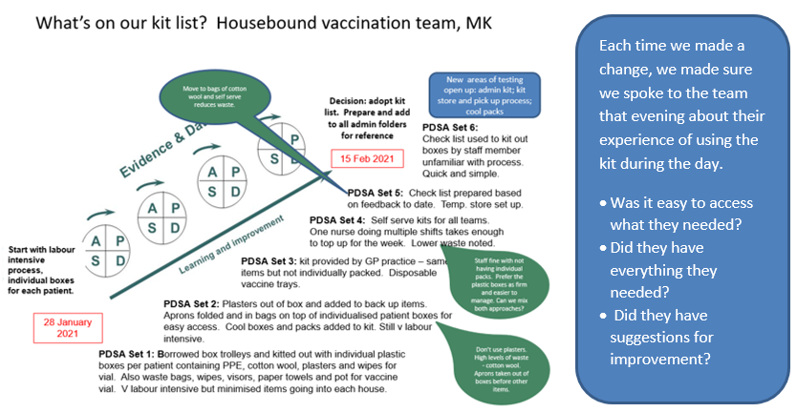

CHS moved from a really time-consuming process to pack individual kit boxes, which were wasteful and very bulky to transport, to a more efficient, sustainable way of providing kit which allows staff to pick kit for each patient as they need. As well as being less labour intensive to prepare, this has reduced waste and made the kit easier to transport. CHS have now written up the kit list and included this in all packs of information for teams. This is the first step in a new set of PDSA cycles – making it easy for teams to access, replenish and return their kit.
Key to our success – communication and feedback!!
- We explained what we were doing, we asked for feedback as soon as possible to keep it fresh, and we acted on it as soon as feasible.
- We kept staff informed at all times about why the kit might look different from day to day.

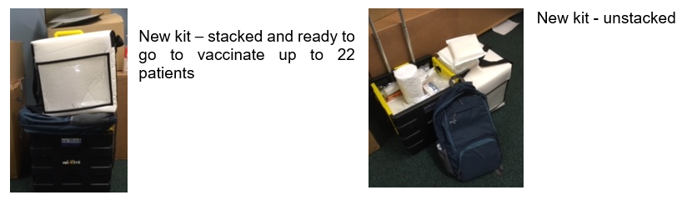
Case Study 2: Vaccine delivery in Camden
Over two weeks in March 2020, Improvement Coach Sarah McAllister was redeployed into the Camden community vaccination team, working alongside both local and redeployed staff to vaccinate community patients around Camden. The work is fast paced, having to ensure the vaccine is stored at the correct temperature, and bringing all the right equipment to vaccinate people in their homes. This can feel chaotic for some staff.
In the first week, Sarah noticed that she was working with colleagues from a variety of backgrounds; new and existing bank staff, staff returning to a nursing role and staff who had not administered vaccines to patients in a long while. Sarah described having to train up several new people as more staff became involved in the vaccine rollout.
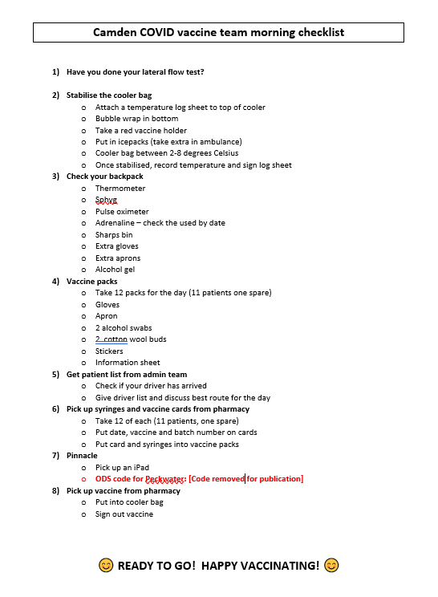
Sarah quickly recognised the need for some documentation or checklist to make sure everyone knew what needed to be done for each shift; from doing a lateral flow test to recording delivery of the vaccine jab on Pinnacle, the National Vaccination Database. So Sarah devised a process checklist (pictured above) and put it up on the wall to provide a prompt to all staff. The process was being standardised!
Listening to staff working in the team, Sarah gained feedback about an issue that needed improvement; that staff did not all know what the Organisation Data Service (ODS) code was for entering on Pinnacle. This was vital to ensure accurate recording of where the vaccines were being delivered. So the checklist was altered to include the code and as it is in red, it is difficult to miss it. We have removed the code for publication in the example. In effect, Sarah was using improvement principles; identifying a problem that needed improving, testing whether a change idea worked by gaining direct feedback and adapting it to refine the process.
Case Study 3: Covid staff testing
The COVID staff testing team (in operation since March 2020) has taken many opportunities to apply QI theories and principals. The team has had to adapt quickly to a constantly changing work environment as they respond to the challenges arising from the pandemic.
One particular component of the QI model for improvement, Plan Do Study Act (better known PDSA) has informed pretty much every change and innovation within the staff testing team. PDSAs have enabled the team to plan and implement new systems and processes quickly, collectively testing and refining processes until the team can agree they are good enough to be standardised and added to Standard Operating Procedures (SOP). These processes have included co-ordinating priority symptomatic testing for CNWL staff; asymptomatic tests for staff, patients, and partner agencies; reporting to commissioners and Public Health England (PHE), and most recently, managing patient and staff positive COVID19 results.
PDSA cycles (as with all things QI) require a team approach, whereby everybody contributes their ideas and where every stakeholder involved in the system or process is consulted either before or after implementation.
A good example of this was when the team needed to deliver an antibody drop-in site at Argo House. By including everyone involved in delivering the service at the planning stage, the team were able to open this facility within a week. The service started on 11 June 2020 and about a half dozen sessions were delivered by the end of July that year.
The team then refined and continually improved the drop-in facility at Argo House by listening to and acting on feedback from staff using the service.

CNWL Argo House
The SOP for COVID+ staff and patient testing has been constantly reviewed and revised using the principles of applying PDSA cycles and feedback from users.

Case Study 4: Covid-19 Redeployment Process
Our colleagues in Human Resources have been working on the process of redeploying staff around CNWL to support services as they respond to the Covid pandemic since March 2020. During the first Covid wave, many services were temporarily changed or even closed down. This meant that there were a good many staff available to redeploy into Covid hotspots.
Subsequently, the second Covid wave placed some severe strain on resources as services cope with increased demand and the effects of more staff needing time off or shielding due to Covid. The importance of the Redeployment Team was once again become critical to coping with these demands.
With the help of the QI Team, a number of improvements change ideas have been introduced to help maximise the effectiveness of the Redeployment process:
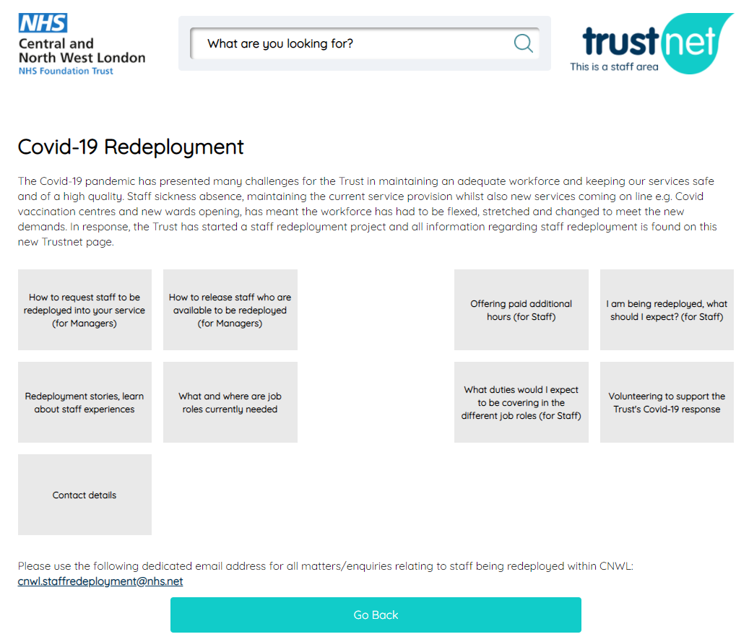
- Redeployment Web pages – taking the approach of asking ‘what do I need?’ and ‘what do I want to do?’, the web pages were redesigned to help staff quickly find what they need. User feedback was used to make sure the content was right. The correct information is now less than ‘three clicks away’.
- Process Mapping – using a process map to understand your process is a detailed way of identifying parts of the process that can be improved.
- User feedback survey – setting up a short questionnaire on survey monkey to gain feedback about how staff and managers experience the process is invaluable to knowing what is working and what is not; allowing informed decisions about what to adopt, adapt or abandon.
- Data – gathering data about the numbers of requests for redeployment and successful redeployments and then plotting the data over time allows you to see what is changing and if you have improvement in your system.
- Communications – targeting communications for specific reasons, for example to encourage staff and managers to identify themselves as available for redeployment, has a great impact on the way the process performs.
- Standard Operating Procedures (SOP) – one of the steps that you can take at the end of some improvement work is to ‘write up’ your process into a SOP document. Being able to write down and describe how your system works does two very important things: it confirms that you understand your system and it standardises they way people work within the system. Effectively a SOP document can become the ‘manual’ for how you are making your process work, so that if new staff come in to the team, they have a set of guidance to work to. A SOP for the Covid-19 redeployment process was developed and remains available for use if the Redeployment team needs to be reinstated.

