University of Wales Trinity Saint David
School of Engineering



Design for X Project
Manufacturing Design & Technology
BEng Part-Time Engineering Programme’s
(ACMA500)

Tia Ball
2220258
July 2024

Abstract
Due to the rapid improvements in robotic automation, production solutions that are both scalable and efficient are now required. This study details how a top manufacturer completely redesigned and optimised a mechanical gripper, increasing output from tiny batches to a weekly goal of more than 1,000 units. The main goal is to improve the gripper's productivity, manufacturing capacity, and dependability while maintaining compliance with client demands and industry norms.
Performance, economy, and environmental sustainability are all integrated into the design process using Quality Function Deployment (QFD) and other systematic approaches. Premium materials, such as lightweight polymers and aluminium alloys, adaptable and ergonomic design for ease of maintenance, and efficient production techniques, including CNC machining, injection moulding, and 3D printing, are important areas of attention.
SCAMPER analysis and Design for Assembly (DFA) concepts are used to further optimise the design, resulting in fewer parts and easier assembly.
Failure Modes Effects Analysis (FMEA) predicts and mitigates potential risks, improving the gripper's operational lifespan and dependability. The design also incorporates safety and compliance regulations with features like failsafe systems and overload avoidance. Recyclable materials and energy-efficient production methods prioritise environmental concerns.
With its enhanced performance, scalability, and decreased environmental effect, the redesigned gripper not only meets but exceeds the demanding requirements of contemporary industrial contexts. This all-encompassing strategy guarantees the gripper's competitive advantage in the worldwide market, offering producers and end users reliability and value. Future developments will be guided by ongoing feedback and technological breakthroughs, preserving the gripper's location.

Contents
Abstract 2
Figures table 5
Task One 6
Introduction 6
Aims & Objectives 6
Concept Design Appraisal 7
QFD 7
Design Specification 8
Manufacturing Process Proposal 10
Design and Development Work Undertaken 12
Assembly Analysis 12
FMEA 12
Design for Assembly (DFA) 12
SCAMPER Analysis 13
Design for X 14
CAD 15
Conclusion 17
Task Two 18
Introduction 18
Design for Additive Manufacturing 18
Key DfAM Principles 18
Application of DfAM Principles 19
Ergonomic Enhancements 19
Benefits of DfAM 20
Enhanced Performance 20
Additive manufacturing benefits 21
Design changes using DfAM principles 22
Selections and Justification 25
Selection of Additive Manufacturing Process 25
Material Selection 25
Justification for Process and Material Selection 26
DFMEA 28
Conclusion 29
References 30

Figures table
Figure 1- QFD. 7
Figure 2 - Robot Gripper FMEA 12
Figure 3 - Exploded view of Robot Gripper 15
Figure 4 - Assembled Robot Gripper 15
Figure 5 - 3D Model 22
Figure 6 - Basic Steering Wheel Design 22
Figure 7 - Redesigned Steering Wheel using Generative Design 22
Figure 8 – DFMEA 28

Task One

Introduction
In response to rapid advancements in robotic automation, there has been an increased demand for efficient and scalable production solutions. A leading manufacturer of robotic tooling has initiated a comprehensive review and redesign of one of its mechanical gripper solutions to meet this growing market need. Previously, the gripper was produced in small volumes, but now it is required to optimise it for mass production, with a target output of over 1,000 units per week. This report aims to enhance the gripper's design for improved efficiency and manufacturability, ensuring that it meets customer requirements and aligns with industry standards. The initial design, provided through model files, will serve as the foundation for further development and optimisation.

Aims & Objectives
The report aims to optimise the gripper's efficiency, manufacturability, and reliability by carefully addressing these objectives, guaranteeing that it satisfies the high standards necessary for mass manufacturing. This report's comprehensive strategy will not only improve the gripper's performance but also guarantee its economic viability and environmental sustainability, satisfying the demands of end users and manufacturers alike in a competitive marketplace.

Concept Design Appraisal

QFD
The systematic approach used in operations management and product development is called Quality Function Deployment, or QFD. To improve overall customer satisfaction, QFD makes sure that every phase of product development, including design, manufacturing, marketing, and even service after the sale, aligns with the needs and expectations of the consumer (Muscad, 2022). Organisations can save time and money by employing QFD to find and fix possible flaws early in the product development process, which also boosts consumer loyalty. Deploying quality functions is a crucial point of differentiation for companies trying to beat their rivals in today's highly competitive business environment. Its customer-centric approach is what makes it so important. Businesses can transform their deep understanding of client wants into precise product qualities with QFD. This procedure guarantees the creation of high-quality items that appeal to the target market (Muscad, 2022).
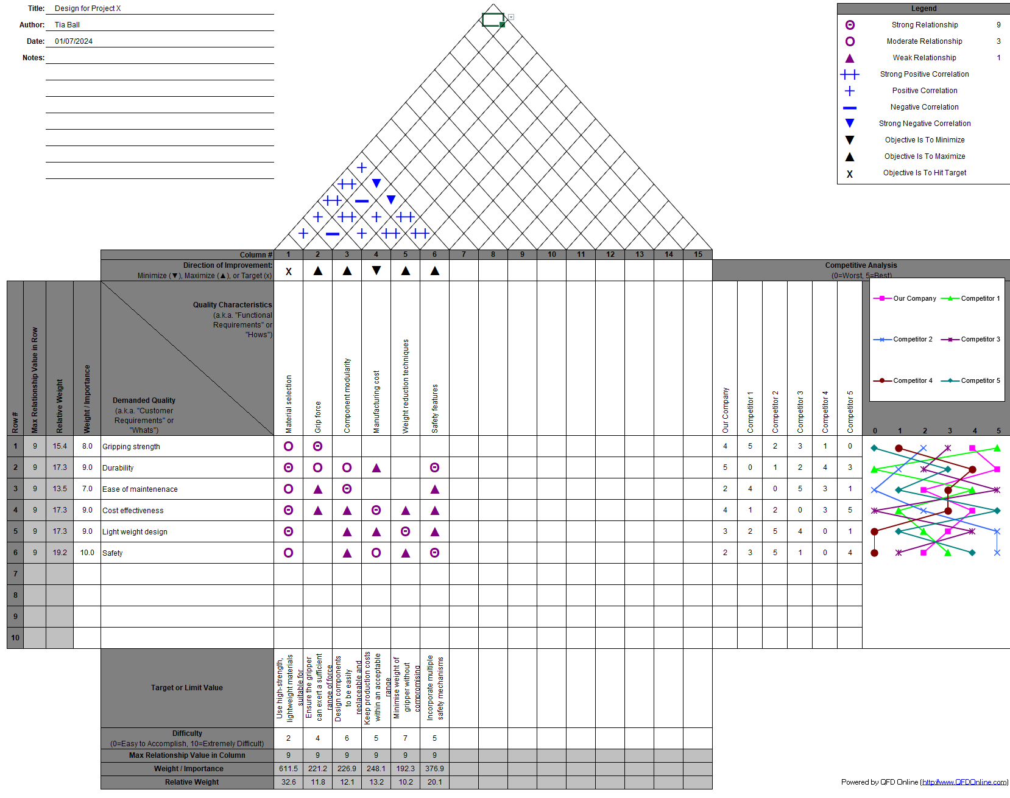
Figure 1- QFD.

Design Specification
Design specifications are comprehensive documents that list all necessary conditions, limitations, and guidelines that goods must follow. In product development, they serve as essential blueprints that direct teams from creation to completion. In order to coordinate efforts and promote a more efficient development process, specifications make sure that all parties involved, including designers, developers, and clients have a clear grasp of the product goals (Interaction Design Foundation, 2021).
The robot gripper is designed to handle a variety of objects in an industrial automation setting. To ensure its effectiveness in mass production and daily operations, it must meet specific requirements related to performance, reliability, cost, and user needs.

Performance Requirements
Ensure the gripper can accommodate objects of different weights and sizes by providing adjustable gripping force. It should enable quick and efficient handling by offering fast actuation speed. The gripper must have internal tolerance control and maintain a high level of precision. Additionally, it needs to have a minimum lifespan of five years under typical working conditions and be capable of sustaining continuous operation in industrial settings (Interaction Design Foundation, 2021).
Material and Construction
High-grade plastics or aluminium alloys are excellent examples of lightweight, highly durable materials that should be used to manufacture the gripper components. The total weight of the gripper should not exceed 1 kg to minimise energy consumption and facilitate effortless interaction with robotic arms. Furthermore, for endurance under varied climatic conditions, it is essential that all materials used are corrosion-resistant (RICS, 2013).

Design and Ergonomics
The gripper should have a modular design with easily interchangeable parts so that common tools can be used for maintenance and part replacement in under ten minutes. To ensure user-friendliness and reduce operator strain during manual adjustments or maintenance, the gripper should be designed with ergonomics in mind (BBC Bitesize, 2022).
Manufacturing Requirements
The gripper's manufacturing cost per unit should not exceed that of similar leading manufacturers to ensure cost-effective mass production. At least 80% of the parts should be standardised and compatible across models to reduce inventory costs and streamline the supply chain. The design should emphasise reducing the number of fasteners and simplifying the assembly and disassembly process for easy manufacturing and maintenance (BBC Bitesize, 2022).
Safety and Compliance
The gripper must have various safety features, including overload prevention and failsafe releases, to guarantee safe operation in all circumstances. The design must also comply with relevant industry norms and laws, such as the BSI requirements for the UK market and the CE marking for the European market (Peninsula Group, 2021).
Environmental Considerations
Reducing the environmental impact of materials and processes, including energy-efficient production techniques and recyclable materials, is crucial. Design should consider product recycling and end-of-life disposal (European Environment Agency, 2024).
Customer and Market Requirements
To satisfy the target market, the gripper needs to be efficient, dependable, and easy to use. It is important to routinely gather and incorporate user input into design enhancements. Although functionality is of the utmost importance, the gripper should also have an aesthetically pleasing design that complements the aesthetics of contemporary industrial equipment.
This design specification defines the major requirements and considerations for the robot gripper, ensuring it fits the needs of both the manufacturer and end-users. The gripper is designed with performance, longevity, affordability, and user pleasure in mind. This makes it ideal for large-scale manufacturing and a range of industrial automation applications (BBC Bitesize, 2022).

Manufacturing Process Proposal
The market for industrial automation needs robotic grippers that are dependable and effective. In order to meet this demand, this project will create a gripper that is more user-friendly, flexible and performs better. In an industry where competition is fierce, the product will stand out thanks to its creative design and cutting-edge materials. Cost-effective materials and production techniques will be taken into consideration to ensure affordability without sacrificing quality because cost efficiency is essential.

The choice of materials has a direct impact on the total cost. Lightweight, highly durable materials such as premium plastics and aluminium alloys would be a great option. To reduce expenses, scalable and efficient manufacturing processes would be prioritised. The design will prioritise modularity and ease of assembly to save on labour and maintenance costs. Additionally, using standardised components will streamline supply chain management.

CNC machining would be a preferred method due to its accuracy, versatility in handling different materials, and adaptability for intricate shapes and close tolerances. This will ensure high accuracy and repeatability, which are crucial for the gripper's functionality (Hess, 2021).
Because of its great reproducibility and inexpensive cost per unit, injection moulding is the method of choice for producing plastic components in large quantities. For big manufacturing runs, the substantial unit cost decrease justifies the initial mould investment (TWI Global, 2024).
3D printing makes prototyping and low-volume manufacturing runs possible. It enables quick iteration and testing of design changes and can handle intricate shapes that would be costly or challenging to create using conventional techniques (TWI Global, 2024).
Automation of the assembly line is used to reduce labour expenses and increase output. It helps to minimise human errors, ensures consistent quality, and enhances manufacturing speed and reliability. (PubNub, 2022).
Overall, CNC machining is suitable for both low-volume and high-volume manufacturing and offers the required precision and flexibility. Injection moulding provides robust parts at a reasonable cost while producing large quantities. Rapid prototyping and complex geometries are supported by 3D printing, which makes customisation possible without the need for pricey equipment. Assembly line automation saves labour costs and manufacturing time by ensuring uniformity, efficiency, and scalability.

Design and Development Work Undertaken

Assembly Analysis

FMEA
A systematic methodology called Failure Modes Effects Analysis (FMEA) is used in engineering projects' design and development phases to identify and rank potential failure modes of a system, component, or process. By evaluating the effects of failures and putting preventative measures in place early in the design lifecycle, it seeks to foresee and reduce risks (Quality-One International, 2024). Next, each failure mode is assessed according to its detectability, occurrence likelihood, and severity. A number scale, such as one ranging from 1 to 10, is frequently used to quantify these three criteria, allowing the objective evaluation and prioritisation of risks. A Risk Priority Number (RPN) is determined by multiplying the severity, occurrence, and detectability ratings given to each failure mode. As a quantitative indicator of risk, the RPN assists teams in determining which failure modes need to be addressed right away in order to focus mitigation efforts. Elevated RPN values indicate crucial failure modes that require targeted remedial efforts, such as alterations to the design, improved testing protocols, or deployment of redundancy controls (Quality-One International, 2024).

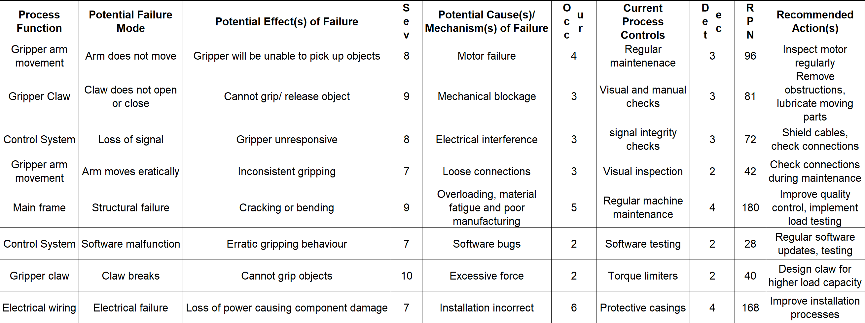
Figure 2 - Robot Gripper FMEA

Design for Assembly (DFA)
The goals of Design for Assembly (DFA) are to minimise assembly time, reduce the number of parts, and simplify the assembly process (Velling, 2021). The following DFA principles are implemented for the robot gripper:
Part Reduction: This involves decreasing the total number of parts by identifying and removing non-essential components from the current assembly.
Standardisation: This entails streamlining the assembly process using identical components and fasteners.
Ease of Handling: To minimise assembly errors, parts should be designed for easy handling and proper orientation during assembly.
Example: In the current gripper design, snap-fit connections allow for fewer screws to secure the gripper arms, reducing both the number of parts and the assembly time (Velling, 2021).

SCAMPER Analysis
The SCAMPER approach systematically improves and innovates robot gripper design. Every SCAMPER component is investigated for possible improvements.
Identify which gripper components can be replaced with superior ones to either save costs or enhance performance. To reduce weight without compromising strength, consider using high-strength composites instead of metal components. For applications requiring high-speed operation, consider using pneumatic actuators instead of electric motors. For example, replacing aluminium gripper arms with carbon fibre composites can significantly decrease weight, leading to faster response times and reduced energy consumption (Elmansy, 2015).
To enhance a design's effectiveness, consider combining two or more elements or functions. For simpler wiring, integrate position and force sensors into a single unit. Develop gripper fingers with the capability to detect the presence and characteristics of objects. For example, integrating a force sensor within the gripper fingers can allow for more precise adjustments to the control algorithm, potentially reducing the need for separate sensor mounts. This integration also enables real-time input on the gripping force (Elmansy, 2015).
The objective of adaptation is to modify current elements or designs to suit novel uses or settings. For harsh environments, modify the gripper design to operate at extremely high or low temperatures or underwater, using suitable sealing and material choices.
Another option is interchangeable gripper pads. By creating readily interchangeable gripper pads, the gripper can be modified to accommodate a variety of items.
For instance, by including detachable silicone pads in their design, the gripper can be used for a variety of applications by handling both sturdy and delicate objects, including metal parts (Elmansy, 2015).

Modifying objectives involves making changes to the design to improve its usability or aesthetics. Ergonomic enhancements could include resculpting the gripper fingers to better fit the contours of frequently handled objects. A compact design and arrangement would minimise the gripper's overall footprint, making it suitable for space-constrained applications. As an illustration, bending the gripper fingers to resemble the curves of spherical objects more closely can increase grasp stability and lower the risk of slippage (Elmansy, 2015).
Medical applications include handling fragile tissues and using the gripper in robotic surgical systems. The agricultural industry is also a possibility; modifying the gripper for automated harvesting systems would ensure that produce is picked gently and without damage. An agricultural robot equipped with a gripper, for instance, can automate the harvesting process, boosting productivity and cutting labour expenses (Elmansy, 2015).

The goal is to simplify the design, so remove any unnecessary parts or features. Always remove duplicate parts to get rid of any extra structural components that don't really add much to the gripper's strength. Simplifying control systems requires getting rid of intricate control algorithms that fail to provide appreciable gains in performance. For example, Weight and manufacturing costs can be lowered without sacrificing strength by eliminating unnecessary structural components from the gripper arms (Elmansy, 2015).

Reverse the orientation or process of the components to find new methods of assembly or operation. Reverse the order of gripper actions to optimise for particular tasks, such as recognising the existence of an object before closing the gripper. Reverse the gripper's mounting orientation to accommodate various robotic arm designs. For instance, the gripper's application range can be increased by reversing the mounting position to make it compatible with overhead robotic arms (Elmansy, 2015).

Design for X
Design for X (DfX) is a systematic approach that aims to optimise the design of products or systems to enhance specific attributes or address challenges. The design process focused on improving ergonomics to ensure user-friendly operation and maintenance, thereby reducing potential downtime during industrial applications (Velling, 2021). Additionally, considerations for manufacturability were made to streamline production processes and minimise material waste. The gripper's design also incorporated features that enhance performance under various environmental conditions, contributing to the overall effectiveness of the design. It's critical that businesses take sustainability into account at every turn, from design to disposal. This guarantees that the robot gripper complies with environmental regulations and favourably supports international sustainability initiatives (Velling, 2021). Among the strategies to mitigate environmental effects are:
• Material selection: recycling materials can help cut down on environmental footprints.
• Putting into practice efficient manufacturing techniques to reduce waste and energy usage.
• Ensuring that the product is created dependable and lasting, which will lower the need for replacements and cut down on waste.
• Putting in place appropriate disposal techniques and recycling programmes to reduce environmental harm.

CAD
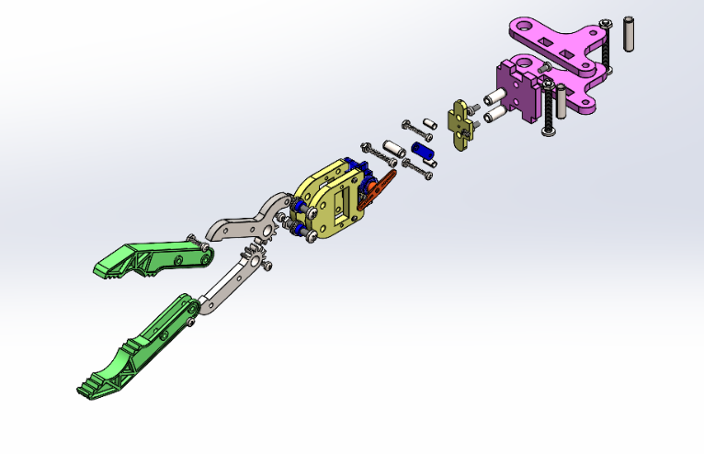
Figure 3 - Exploded view of Robot Gripper
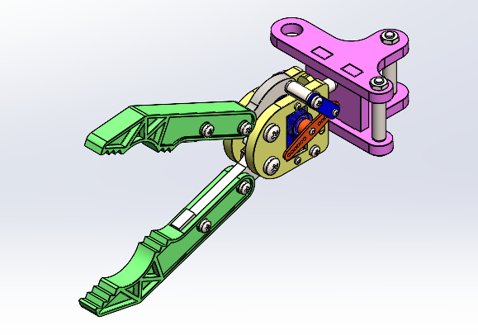
Figure 4 - Assembled Robot Gripper

As shown by the colour coding in figures two and three, the design could be changed in many ways to optimise manufacturability. Standardising the size of all screws used on the parts would save cost and time as the manufacturer would either only have to purchase one size or produce one size, also saving in material. As stated previously, using injection moulding is great for reproducibility and cost. By combining all pink highlighted parts, this method could be implemented to create a new plastic part. This can also be achieved by combining the yellow parts highlighted and, again, changing from machined parts to plastic. The green highlighted parts shown above could be made from a more durable, robust material as it’s more prone to wear and tear. For the orange highlighted part, removing all other holes and keeping one standard position will ensure that the part is always assembled in the correct way. Instead of having two holes on the grippers, reduce it to one to remove complexity. Finally, adding as many poke-yoke designs as possible will eliminate any quality mistakes.

Conclusion
The original emphasis on moving from low volume to mass manufacturing with a goal of producing more than 1,000 pieces weekly, highlighted the necessity of substantial design improvements and manufacturability advancements. Critical aspects like performance, reliability, cost-effectiveness, and environmental sustainability were methodically addressed and integrated into the development of the gripper through the use of rigorous design methodologies like Quality Function Deployment (QFD), Design for X (DfX), Failure Modes Effects Analysis (FMEA) and SCAMPER.
User-centric elements, like ergonomic improvements and modular construction, were given priority during the iterative design process to ensure ease of use, compatibility with various industrial automation systems, and maintenance. High precision, scalability, and cost-efficiency without sacrificing quality were made possible through strategic material selection and manufacturing process optimisation, which included CNC machining, injection moulding, and 3D printing. Furthermore, our dedication to sustainability throughout the product lifespan is demonstrated by paying close attention to safety regulations and environmental considerations, which range from material recyclability to energy-efficient production procedures.
Thanks to the alignment of these efforts with industry standards and consumer expectations, the revised gripper not only meets but surpasses the demanding requirements of contemporary industrial environments. Its improved performance capabilities, combined with efficient production methods and reduced environmental impact, provide it a competitive edge in the international market. Going forward, constant improvement and modification in response to user input and technical developments will guarantee that the gripper stays at the forefront of innovation and keeps providing clients with value and dependability.

Task Two

Introduction

Design for Additive Manufacturing

Key DfAM Principles
Complexity for Free
Additive manufacturing allows for complex geometries without additional cost. The design can incorporate intricate features that would be difficult or impossible to produce with traditional manufacturing methods (DiManEx, 2024).
Current Design: The steering wheel has a relatively simple structure with integrated controls.
DfAM Opportunity: Incorporate complex ergonomic grips and customisable textures to improve user comfort and control. Add internal channels for wiring or sensors directly into the structure.
Minimise Material Usage
Using additive manufacturing, the material can be precisely placed only where needed, reducing waste and weight while maintaining strength (DiManEx, 2024).
Current Design: Likely uses a combination of metal, plastic, and possibly wood for aesthetic purposes.
DfAM Opportunity: Use a lattice structure within the steering wheel to reduce weight while maintaining structural integrity. Combine multiple materials (e.g., a robust inner core with a softer outer layer) for optimised performance.
Part Consolidation
Combining multiple parts into a single printed piece reduces assembly time and potential points of failure.
Current Design: Composed of multiple parts assembled (e.g., central hub, outer ring, integrated buttons).
DfAM Opportunity: Integrate the central hub, outer ring, and button mounts into a single print. This can reduce assembly steps and improve durability.
Customisation
Additive manufacturing allows for easy customisation of each part, which can be particularly useful for ergonomic components like a steering wheel (DiManEx, 2024).
Current Design: Standard design used across multiple vehicles.
DfAM Opportunity: Customise the steering wheel to fit individual driver preferences or specific vehicle models. Adjust grip size and button placement, and even add personalised aesthetic features.

Application of DfAM Principles
Ergonomic Enhancements
Current Design: Standardised grip and shape.
DfAM Application: Design ergonomic grips that conform to the driver’s hands. Use biometric data to create a tailored fit for enhanced comfort and control.
Integration of Sensors and Electronics
Current Design: Separate housing for buttons and electronics.
DfAM Application: Embed electronic pathways and sensor mounts directly into the steering wheel structure. This can streamline the design and protect sensitive components (DiManEx, 2024).
Lightweight Design
Current Design: Likely includes solid sections of metal and plastic.
DfAM Application: Implement a lattice or honeycomb structure inside the steering wheel to reduce weight without sacrificing strength. This can improve vehicle fuel efficiency and handling (DiManEx, 2024).

Benefits of DfAM
Reduced Manufacturing Time and Cost
By consolidating parts and reducing the need for assembly, manufacturing time and cost can be significantly reduced.
Enhanced Performance
Customisable ergonomic features and lightweight structures can enhance driver comfort and vehicle performance.
Increased Durability
Integrating multiple parts into a single structure can reduce potential failure points, increasing the steering wheel's overall durability (DiManEx, 2024).

Additive manufacturing benefits
Additive manufacturing, also referred to as 3D printing, is a game-changing technology for a variety of sectors and scholarly studies because of its many advantages. Its capacity to create intricate geometries that would be difficult or impossible to do with conventional manufacturing techniques is one of its main features. Since this complexity doesn't come with extra expenses, creative designs that improve functionality and performance are possible. In addition, additive manufacturing uses a lot less material because it creates objects layer by layer, resulting in a considerable waste reduction as compared to subtractive processes. This feature helps to promote more environmentally friendly manufacturing techniques while also reducing the cost of materials. Rapid prototyping, which shortens time-to-market, speeds up design repetitions, and encourages a more flexible approach to product development, is another benefit of the technology (Gayette, 2022).

Furthermore, mass customisation is made easier by additive manufacturing, which makes it possible to produce personalised objects that are made to order without the need for costly moulds or equipment. Because it may be used to manufacture medical implants and devices that are unique to each patient, this customisation potential is very valuable in the healthcare industry. Moreover, by lowering assembly stages and possible sites of failure, the capacity to combine several components into a single, integrated structure can improve product reliability. When taken as a whole, these advantages show how additive manufacturing has a big influence on enhancing productivity, creativity, and sustainability in contemporary engineering and manufacturing settings (Gayette, 2022).

Design changes using DfAM principles
The three images show different steering wheel designs: the first is a basic design, the second is a 3D model designed in CAD, and the third is an enhanced version for additive manufacturing using generative design.
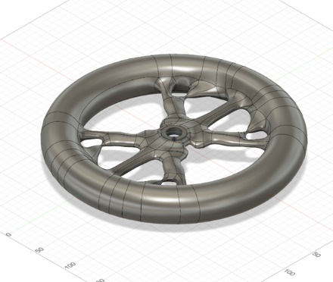
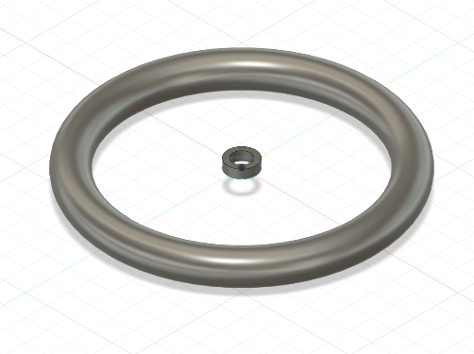
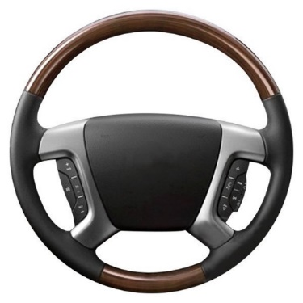
Figure 5 - 3D Model
Figure 6 - Basic Steering Wheel Design
Figure 7 - Redesigned Steering Wheel using Generative Design

The following are the primary and redesigned steering wheel’s improvements and differences, articulated in terms of Design for Additive Manufacturing (DfAM) principles:

Material Usage Optimisation
Traditional Design: Usually constructed from a mix of materials, including metal, plastic, and wood, the original steering wheel has a solid outer ring with a uniform cross-section.
Additive Design: A more intricate, hollow construction with internal supports is used in the second steering wheel design. As a result, less material is required, which lightens the wheel and may lower material costs.

Complex Geometries
Conventional Design: The first steering wheel is simpler to make with traditional techniques such as metal casting, injection moulding, or machining because of its simple shape.
Additive Design: Tough or impossible to do with traditional production, the second design has complex interior architecture and maybe optimised ergonomics. These complicated geometries are possible with additive manufacturing (AM) without significantly raising the production challenge.

Integration of Functions
Conventional Design: The initial design could have distinct parts for additional functions and structural support.
Additive Design: The second design combines several features into a single unit, including internal wiring routes and structural stability. This can increase overall robustness and lessen the requirement for assembly.

Weight Reduction
Conventional Design: The initial steering wheel's sturdy build and use of thick materials likely made it heavier.
Additive Design: The second steering wheel's internal lattice construction considerably saves weight without sacrificing strength. Lighter components can enhance vehicle performance and efficiency.

Customisation and Ergonomics
Conventional Design: There is little room for customisation, and it usually involves costly tooling modifications.
Additive Design: The second design is readily adaptable to meet various ergonomic needs or aesthetic preferences without the need for new tools. AM enables design modifications on demand.

Assembly Reduction
Conventional Design: The initial design could call for several pieces and assembly stages.
Additive Design: The second design reduces the number of parts by merging features into a single printed component. As a result, assembly time and possible failure spots are decreased.

Sustainability and Waste Reduction
Conventional Design: Reductive techniques such as machining used in traditional manufacturing procedures can result in considerable waste material.
Additive Design: The second design is more environmentally friendly since AM methods usually produce less waste by utilising only the material required to manufacture the part layer by layer.

Selections and Justification

Selection of Additive Manufacturing Process
For the current project, the Selective Laser Sintering (SLS) method was determined to be the most suitable additive manufacturing (AM) process for the design of the steering wheel. SLS presents various advantages, making it the best choice for this use. As stated by Protolabs, the SLS machine works by ‘sintering each layer of part geometry into a heated bed of nylon-based powder using a laser. After each layer is fused, a roller moves across the bed to distribute the next layer of powder’ (PROTOLABS, 2023). The process is repeated layer by layer until the build is complete’ Some benefits of this approach include:
The redesigned steering wheel features ergonomic grips, integrated buttons, and internal wiring channels. It can be easily manufactured using SLS, a process that is excellent at producing intricate features and internal structures such as lattice grids without requiring support structures.
SLS can process a wide range of engineering-grade thermoplastics, such as Nylon 12 (PA 12). Nylon 12 offers a good balance of strength, durability, and flexibility, which is critical for components like the steering wheel. These components must withstand mechanical stresses, wear and tear, and environmental conditions over time (PROTOLABS, 2023).
SLS allows for the consolidation of multiple components, such as the steering wheel's hub, ring, and button mounts, into a single printed piece. This reduces assembly time, minimises potential failure points, and enhances the final product's structural integrity (PROTOLABS, 2023).
The selective laser sintering process creates components with high resolution and smooth surface finishes, which are crucial for ergonomic parts such as steering wheels. Additional post-processing techniques like sanding or chemical smoothing can further improve the tactile quality of the grips.

Material Selection
Nylon 12 (PA 12), processed through SLS, was selected as the ideal material for the steering wheel application. A few reasons for this are as follows:
Nylon 12 has a high strength-to-weight ratio. It provides an excellent balance of mechanical strength and flexibility, making it suitable for structural components like the steering wheel. These components must resist deformation and impact while maintaining lightweight properties for better vehicle performance (Abigail, 2024).
PA 12 offers excellent fatigue resistance, crucial for a steering wheel enduring repetitive stress and mechanical loads, ensuring its durability throughout its lifespan (Abigail, 2024).
Nylon 12 also provides excellent abrasion resistance, crucial for components that are constantly in contact with the driver's hands, buttons, and other elements within the car's interior (Abigail, 2024).
The steering wheel must withstand oils, grease, and other chemicals encountered during regular use. Nylon 12’s chemical resistance properties ensure it will not degrade when exposed to such substances (Abigail, 2024).
Steering wheels endure a wide range of temperatures inside a vehicle. PA 12 is capable of withstanding high and low temperatures, making it suitable for various environmental conditions (Abigail, 2024).

Although SLS is a great option for this project, it does come with some disadvantages, including:
Shrinkage caused by cooling after production. The print bed is preheated to reduce temperature gradients and shrinkage; however, cooling after the entire process is finished may cause the manufactured product to shrink significantly in size (May, 2022).
Additionally, respiratory issues may arise from the tiny powder used in selective laser sintering, especially when metal is involved. Several safety precautions and tools should be in place because certain powders have the potential to be explosive and a respiratory hazard (May, 2022).

Justification for Process and Material Selection
The following DfAM principles justify the selection of Nylon 12 as the material and SLS as the manufacturing process.:
A lattice structure can be implemented within the steering wheel with SLS and Nylon 12, saving material while preserving structural integrity. This is in line with the DfAM objective of minimising weight and improving material placement (Unionfab, 2024).
Using SLS and PA 12, additive printing makes it simple to modify the steering wheel's ergonomics, grip sizes, and button locations to fit individual tastes or certain car models.
The mechanical properties of Nylon 12, combined with the precision of the SLS process, ensure that the final steering wheel will have the necessary strength, durability, and fatigue resistance to perform well in real-world driving conditions (Unionfab, 2024).

DFMEA
The Design Failure Mode and Effects Analysis (DFMEA) is a structured method used by engineers to systematically identify potential failure modes in the steering wheel, evaluate their possible impact on the vehicle's safety and performance, and prioritise mitigation efforts. This rigorous process aids in enhancing design robustness, ensuring safety and reliability, and guiding design improvements. Ultimately, it leads to the development of a more effective and reliable steering wheel component, contributing to overall vehicle safety and customer satisfaction.
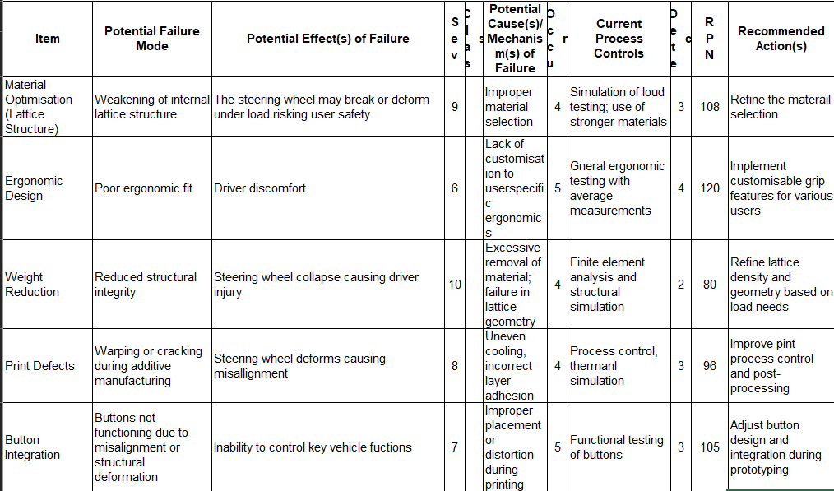
Figure 8 - DFMEA

This DFMEA framework will guide the transition of the steering wheel design to successful additive manufacturing, enhancing both the product's performance and the manufacturing process.

Conclusion
In conclusion, the integration of Design for Additive Manufacturing (DfAM) principles offers significant opportunities to enhance the design and functionality of the steering wheel. By leveraging additive manufacturing techniques, particularly Selective Laser Sintering (SLS) with Nylon 12, it is possible to introduce more ergonomic, lightweight, and customisable features while reducing waste and simplifying assembly. The proposed changes, such as the use of complex internal structures, part consolidation, and material optimisation, highlight the ability of additive manufacturing to create innovative designs that would be challenging to produce through conventional methods. Additionally, adopting DfAM enhances user comfort and performance and contributes to sustainability by minimising material usage and reducing manufacturing time. As a result, the redesigned steering wheel is better suited to meet the demands of modern automotive applications, offering improved durability, customisation options, and overall performance. This approach demonstrates the transformative potential of additive manufacturing in engineering design, facilitating for more efficient, sustainable and user-centred products.

References
Abigail, 2024. SLS Nylon 3D Printing: Advantages and Limitations. [Online]
Available at: https://3dspro.com/resources/blog/sls-nylon-3d-printing-advantages-and-limitations
[Accessed 28 September 2024].
BBC Bitesize, 2022. Investigating - AQA. [Online]
Available at: https://www.bbc.co.uk/bitesize/guides/zbn6pbk/revision/3
[Accessed 01 July 2024].
DiManEx, 2024. Design for Additive Manufacturing: the basics & the benefits. [Online]
Available at: https://www.dimanex.com/post/design-additive-manufacturing
[Accessed 05 September 2024].
Elmansy, D. R., 2015. A Guide to the SCAMPER Technique for Design Thinking. [Online]
Available at: https://www.designorate.com/a-guide-to-the-scamper-technique-for-creative-thinking/#google_vignette
[Accessed 01 July 2024].
European Environment Agency, 2024. Resource use and materials. [Online]
Available at: https://www.eea.europa.eu/en/topics/in-depth/resource-use-and-materials
[Accessed 01 July 2024].
Gayette, M., 2022. Top 10 Advantages of Additive Manufacturing. [Online]
Available at: https://www.ptc.com/en/blogs/cad/10-additive-manufacturing-advantages
[Accessed 28 September 2024].
Hess, B., 2021. Astro Machine Works. [Online]
Available at: https://astromachineworks.com/what-is-cnc-machining/
[Accessed 01 July 2024].
May, V., 2022. Selective Laser Sintering: Advantages And Disadvantages. [Online]
Available at: https://prototaluk.com/blog/selective-laser-sintering-advantages-and-disadvantages/
[Accessed 28 September 2024].
Peninsula Group, 2021. Health & Safety Compliance. [Online]
Available at: https://www.eea.europa.eu/en/topics/in-depth/resource-use-and-materials
[Accessed 01 July 2024].
PROTOLABS, 2023. Advantages and Disadvantages of Selective Laser Sintering. [Online]
Available at: https://www.protolabs.com/resources/blog/advantages-and-disadvantages-of-selective-laser-sintering/
[Accessed 28 September 2024].
PubNub, 2022. What is Assembly Line Automation. [Online]
Available at: https://www.pubnub.com/learn/glossary/assembly-line-automation/
[Accessed 01 July 2024].
Quality-One International, 2024. Failure Mode and Effects Analysis. [Online]
Available at: https://quality-one.com/fmea/
[Accessed 01 July 2024].
RICS, 2013. Design and Specification. [Online]
Available at: https://www.rics.org/profession-standards/rics-standards-and-guidance/sector-standards/building-surveying-standards/design-and-specification
[Accessed 01 July 2024].
TWI Global, 2024. What are the Advantages and Disadvantages of 3D Printing. [Online]
Available at: https://www.twi-global.com/technical-knowledge/faqs/what-is-3d-printing/pros-and-cons
[Accessed 01 July 2024].
TWI Global, 2024. What is Injection Moulding? Definition, Types and Materials. [Online]
Available at: https://www.twi-global.com/technical-knowledge/faqs/what-is-injection-moulding
[Accessed 01 July 2024].
Unionfab, 2024. Nylon 12 for SLS 3D Printing: Benefits and Applications. [Online]
Available at: https://www.unionfab.com/blog/2022/08/nylon-12-for-sls-3d-printing
[Accessed 28 September 2024].
Velling, A., 2021. Design for assembly. [Online]
Available at: https://fractory.com/design-for-assembly-dfa/
[Accessed 01 July 2024].
Velling, A., 2021. Design for X (DFX) Methods. [Online]
Available at: https://fractory.com/design-for-x-dfx/#:~:text=Learn%20what%20design%20for%20X%20(DFX)%20is%20and%20how%20it
[Accessed 12 June 2024].

