John Hughes
1708241
Networking & Cybersecurity

Build, deploy, configure and manage a Type 2 Hypervisor platform based Virtualised network

Dr. Nitheesh Murugan Kaliyamurthy

Semester 2

ACCA5023

Table of Contents

- Practical Work
  - Task 1 Building a Virtual LAN Using Hypervisor Management Software
    - Create Virtual Machines
    - Virtual Network Configuration

  - Install Critical Network Services
    - Pre-requisite
    - Deploying Active Directory
    - Creating User Account Objects
    - Object Attributes of Interest
    - Adjoining the Domain and Testing Logins

- Observational Tasks
  - Hypervisors

  - Cloud Computing

  - DNS

  - Roles Within an Enterprise Network

  - Terminologies, Descriptions and Comparisons

  - Practical Work Description

- References

- Practical Work

The first part of this assignment is to build and configure a virtual network using type 2 hypervisor management software. In this case, Oracle VirtualBox was chosen to complete the task

    - Create Virtual Network Machines

Using the Chosen software, the first step to creating the virtual network was to create two virtual private networks consisting of a server and client for each network. Windows Server 2019 was chosen for the server machines and Windows 10 for the clients with each machine named according to the topology.

Each machine was assigned 4GB RAM and dynamically allocated 25GB memory which is utilised sufficiently from the hosts 32GB RAM and 1TB hard drive

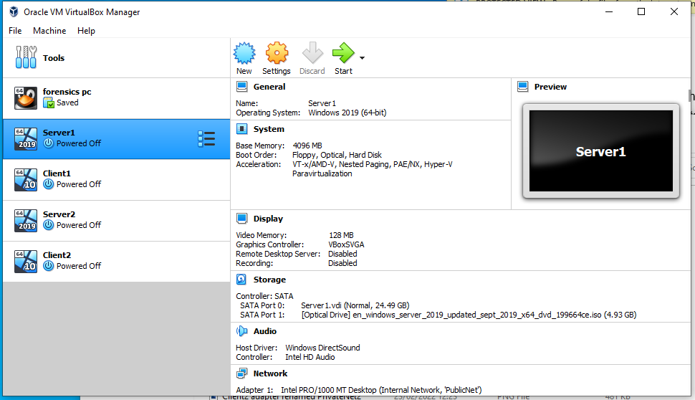

To optimise frame rate of the virtual machines, the maximum display memory was selected, allowing for smoother visual performance

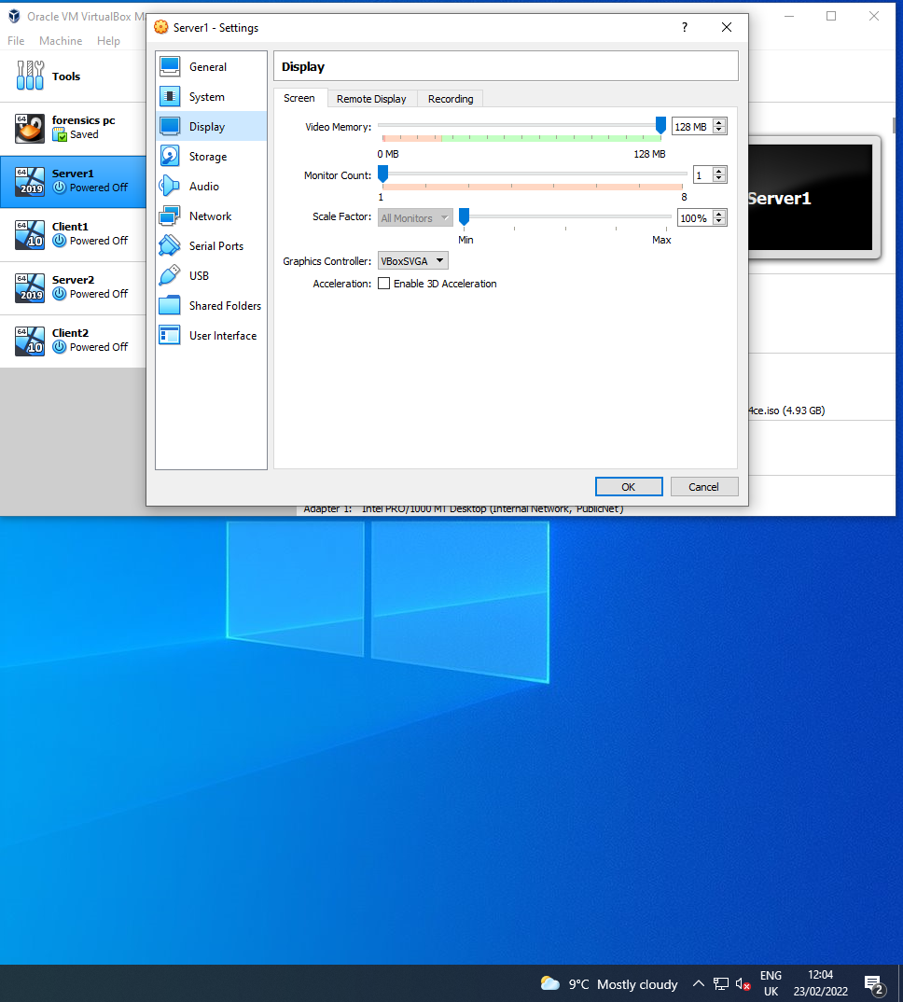

Also, to optimise the machines performance, additional processor features were enabled such as PAE/NX

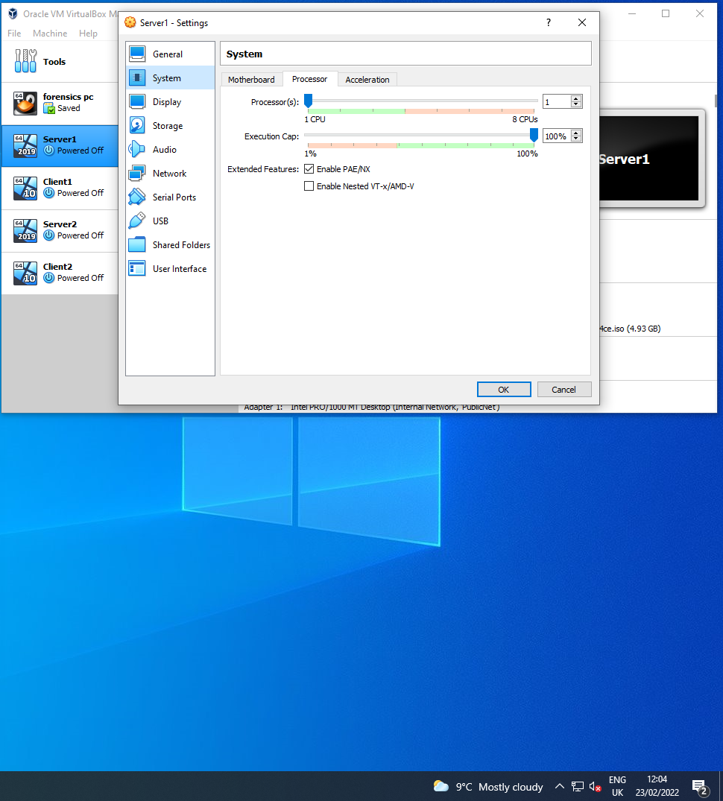

This process was repeated for the other three machines. With the 4 machines created, operating systems installed, and optimisation settings, the build stage was complete

    - Virtual Network Configurations
The next stage is to configure the networks in accordance with the following topology

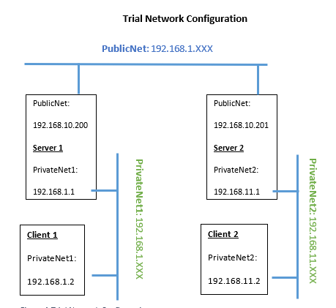

As shown, this involves three virtual networks. The server machines requiring two network adapters. One for PublicNet and another for the respective private network.

The client machines only needing one adapter for the private network connecting to the respective server

This involves enabling and renaming adapter 1 for the public network that connects the server machines

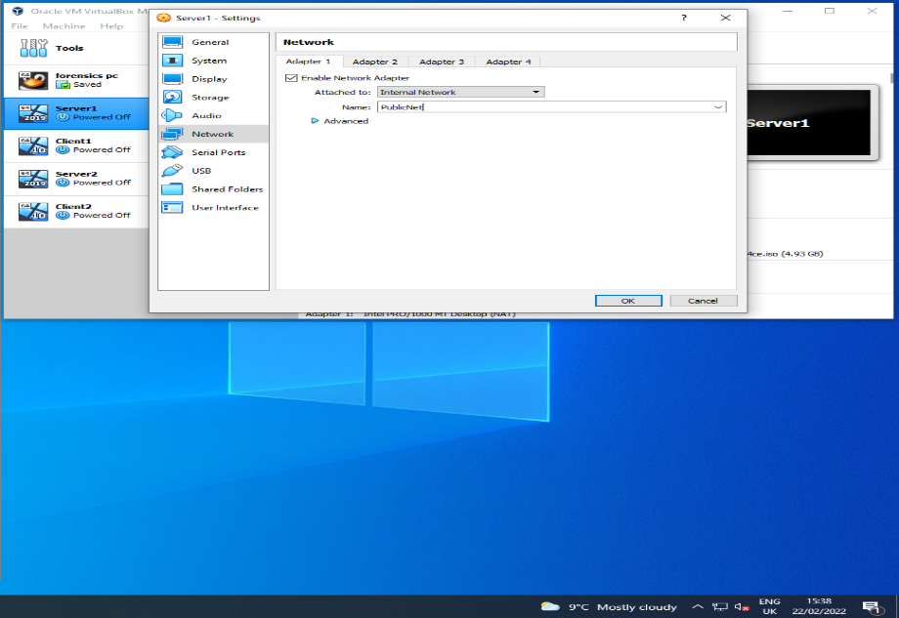

The internal network interface is now set up as a virtual switch, allowing the machines on PublicNet LAN to communicate

server1 is now ready to run and rename the network connection to PublicNet and the IP address is statically assigned as 192.168.10.200 , with subnet mask automatically filled as 255.255.255.0 for a Class C IPv4 IP address as required for a small LAN, as shown below
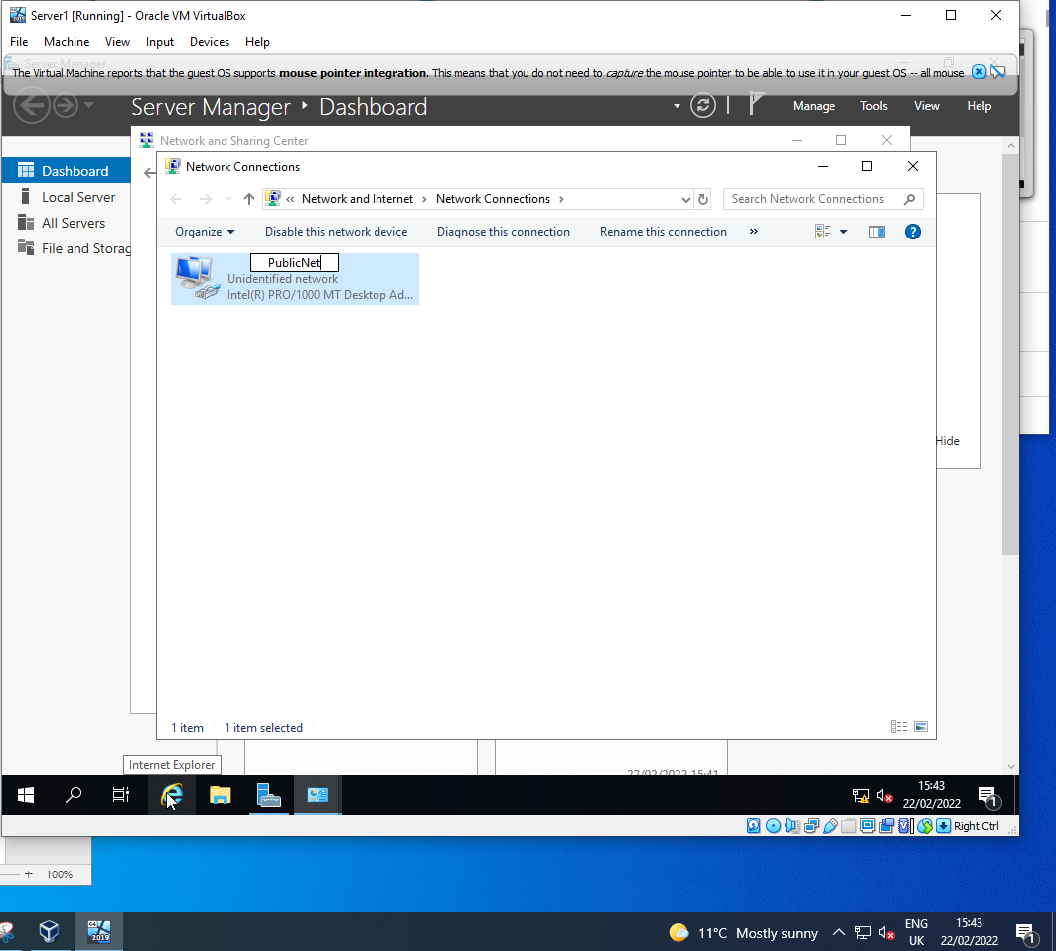

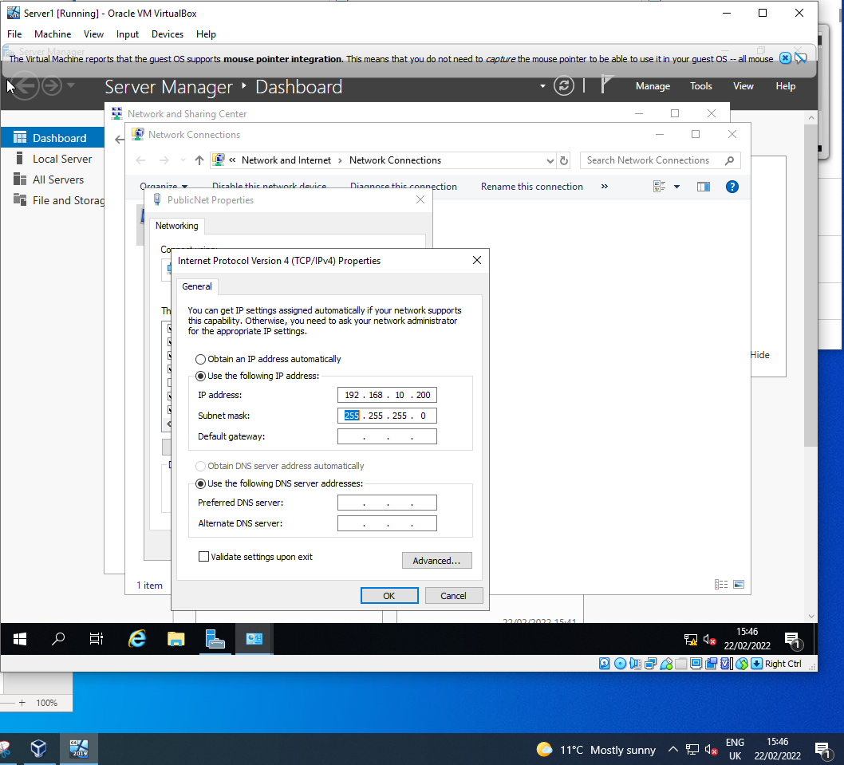

The next stage of configuration Is for the servers second adapter, allowing connection to the client via PrivateNet1 network.

With Server1 shutdown, Adapter 2 is enabled and renamed to PrivateNet1. This is again attached to an internal network acting as a separate virtual switch

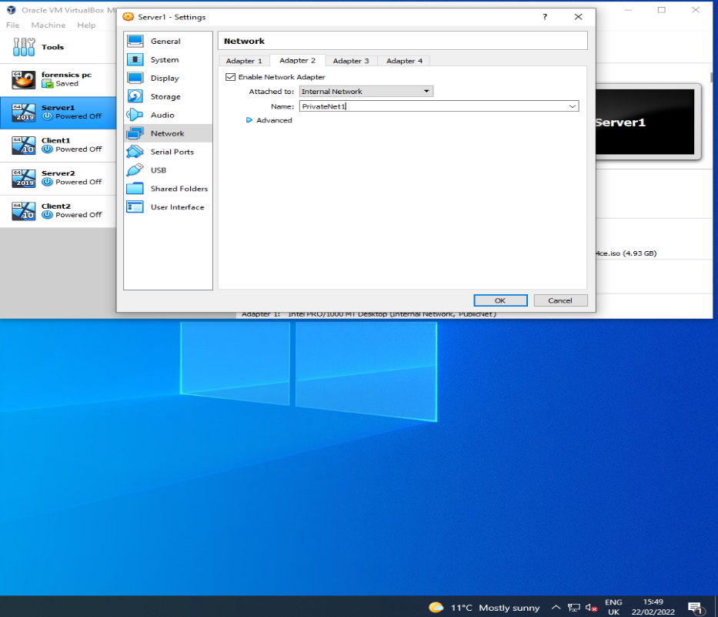

For this network connection, the same process is required for Server1. In Windows Server, the second network connection is renamed PrivateNet1 as shown below
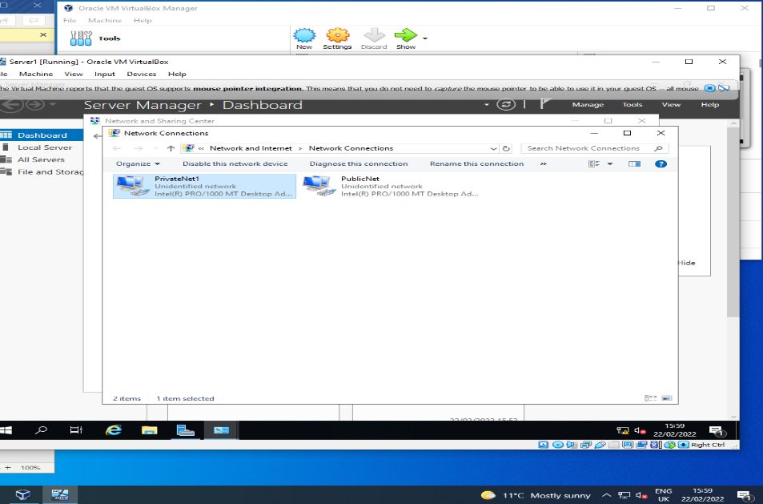
Again, the IP address is statically assigned, this time as 192.168.1.1

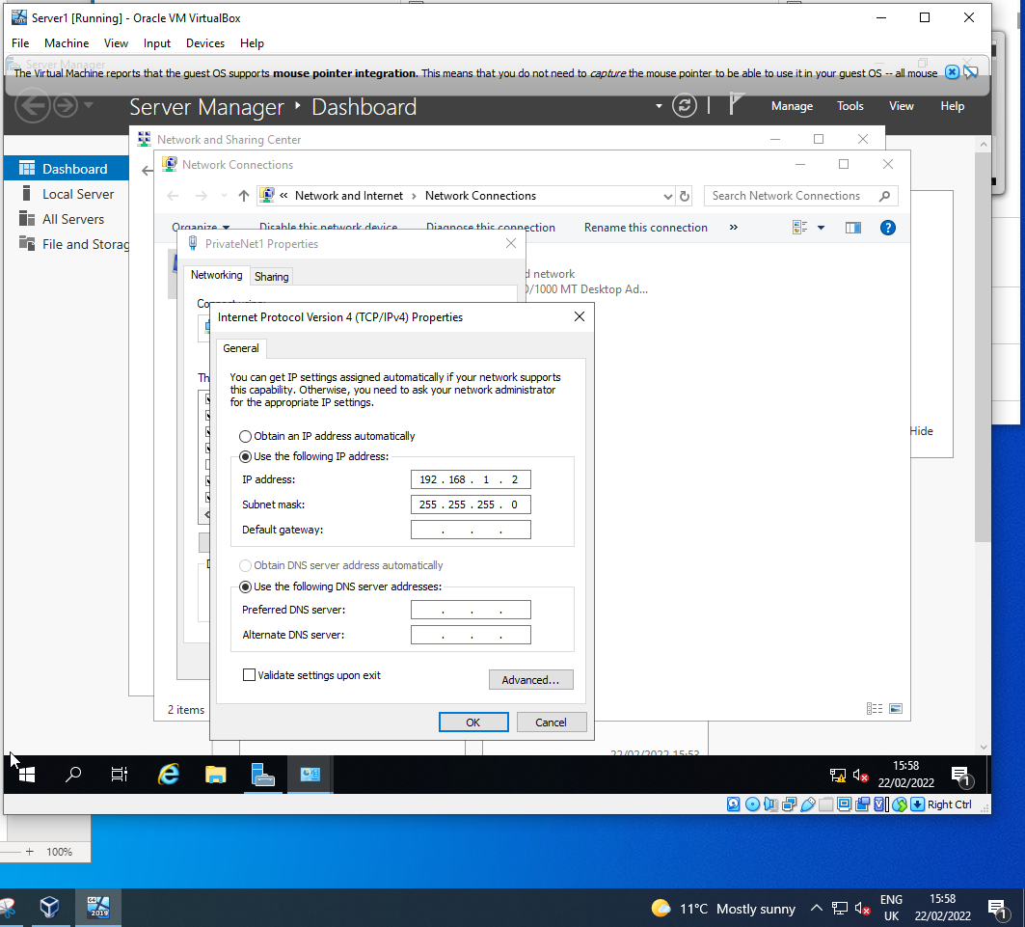

This completes the network configuration for server 1.

Similar to Server1, Client1 now needs configuration except this machine only has one adapter required.
With the machine shut down, adapter 1 is enabled, PrivateNet1 is chosen.

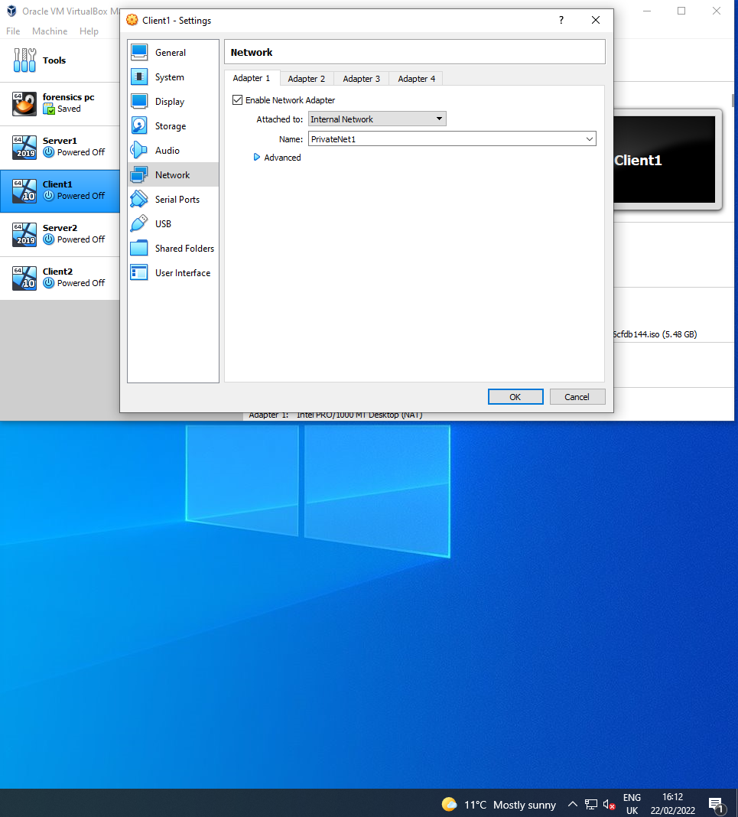

In Windows 10, Client1 network connection is now renamed to match PrivateNet1 and the IP address is statically assigned according to the topology

The same process was performed for Server2 and Client2, the only difference being according to topology
With the configurations complete, testing connectivity is required by sending ping between machines.
For this to be successful, the firewalls must be turned off
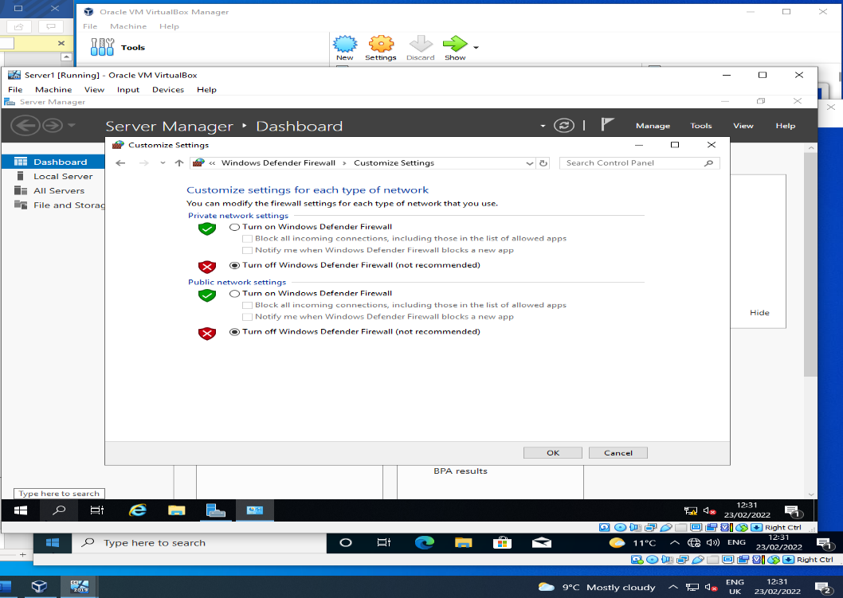
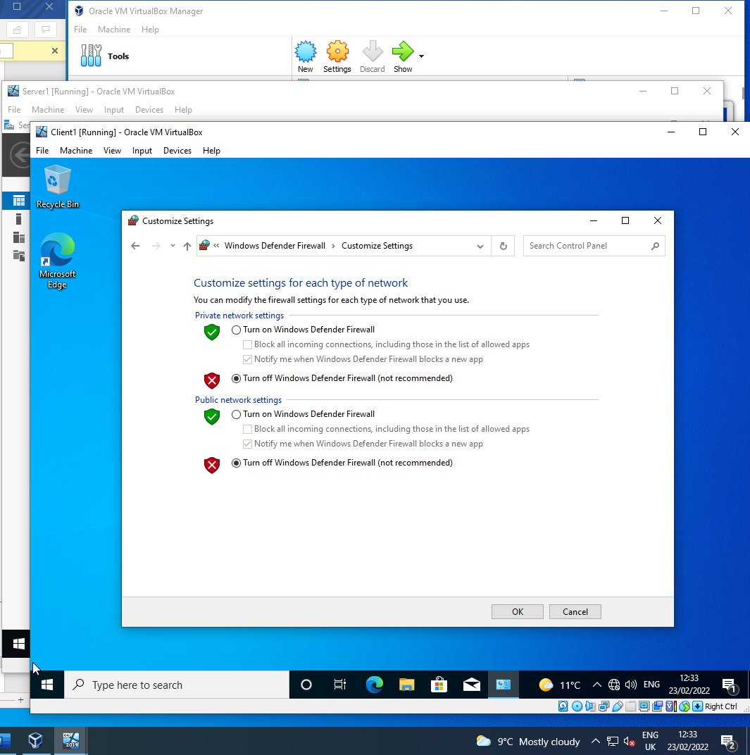

The ping command from Server1 to Client1 is successful
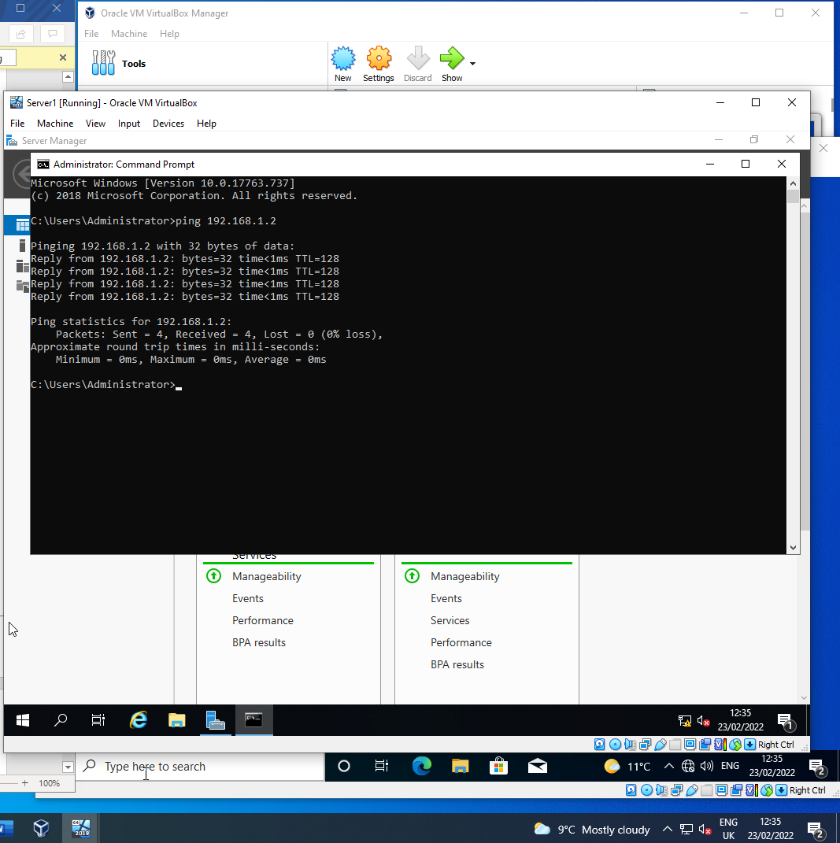

The ping from Client2 was unsuccessful. This is due to the DNS service not set up and the issue is shown to be fixed later.
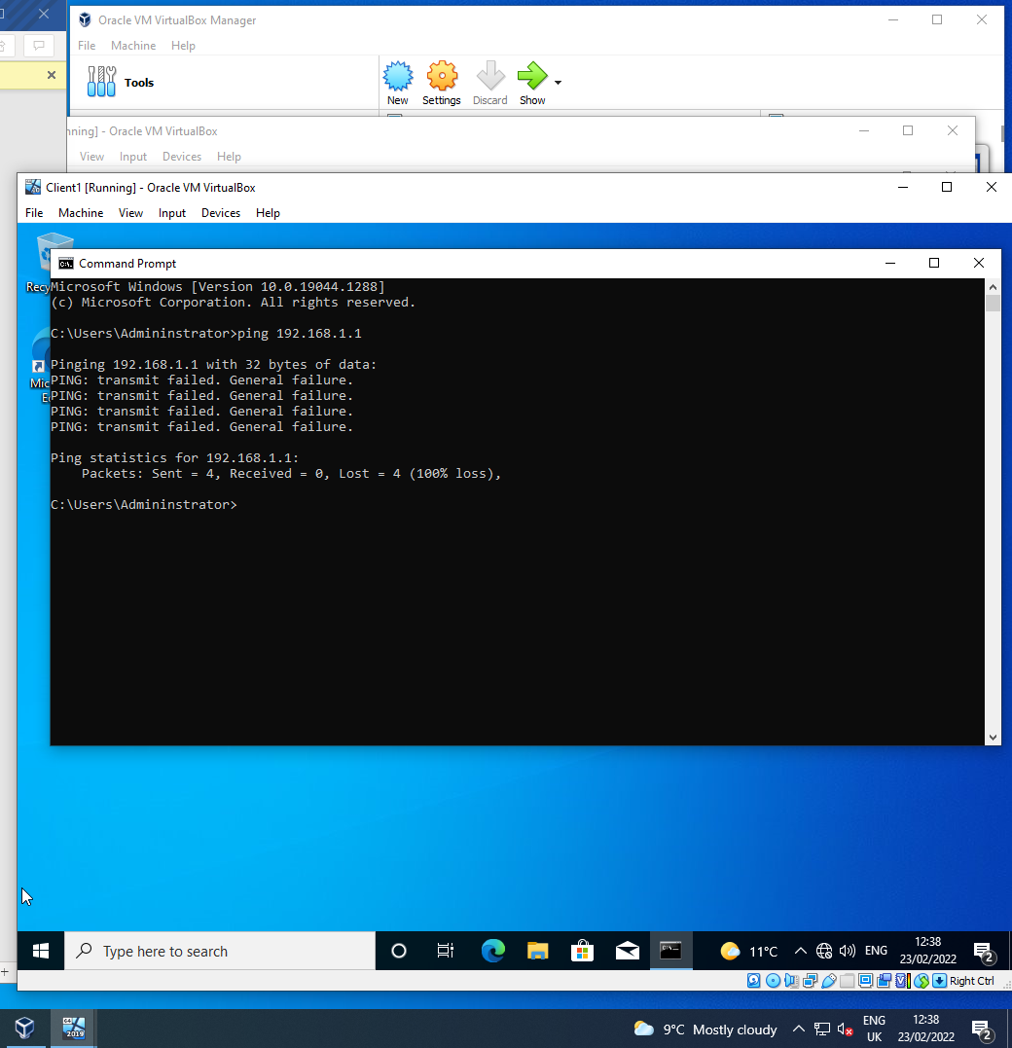

The first ping was unsuccessful due to firewall settings. With firewall turned off, ping was successful, as shown in second attempt
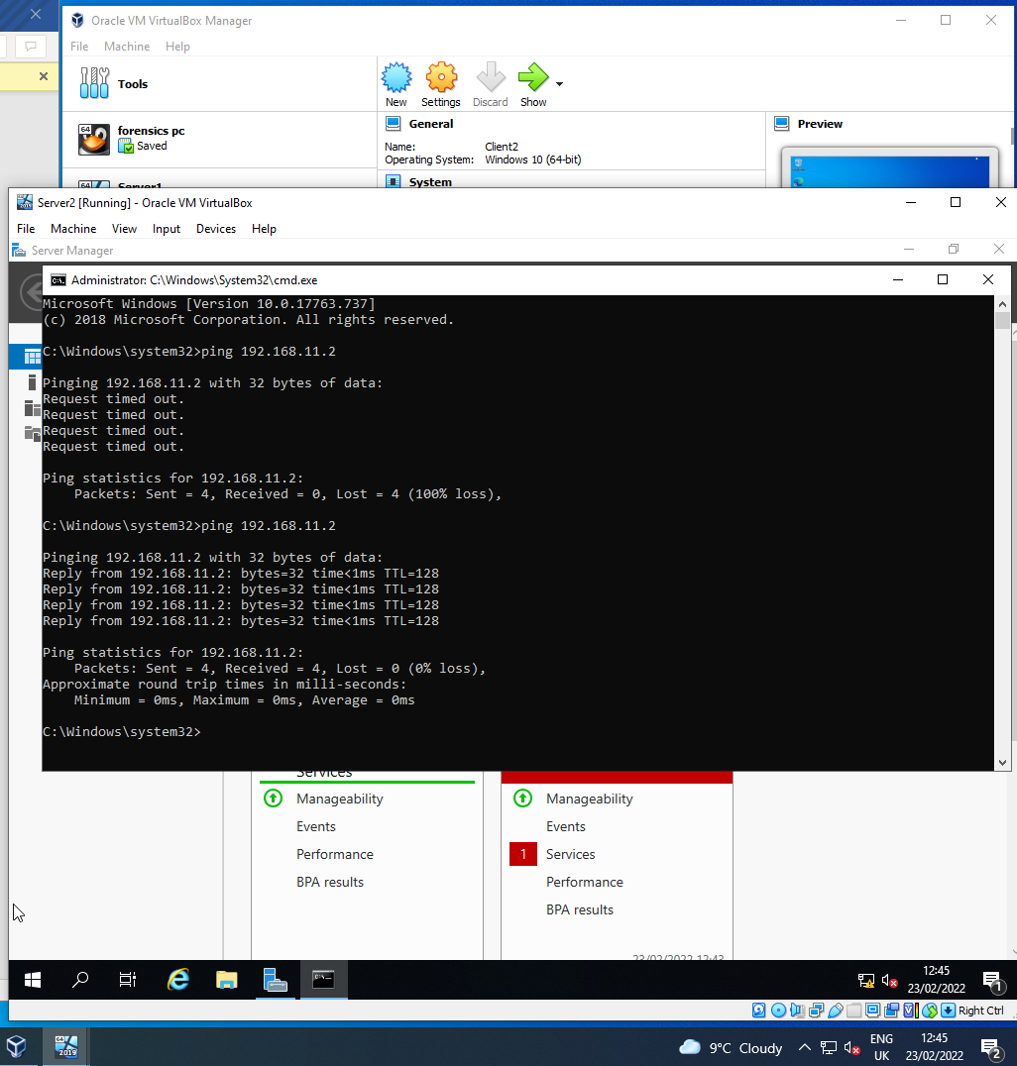

  - Install Critical Network Services

    - Prerequisite

The domain controller must be renamed to identify it as the server that provides critical services

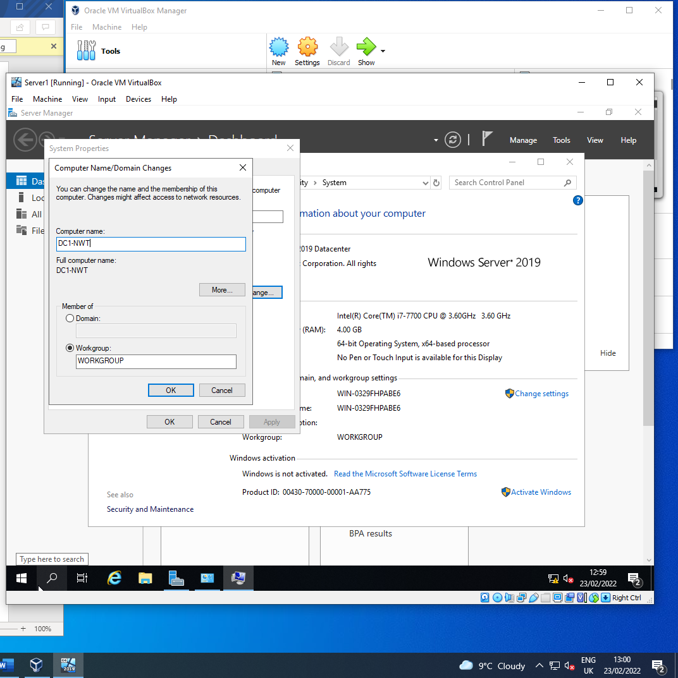

In Windows server, this verifies the name change
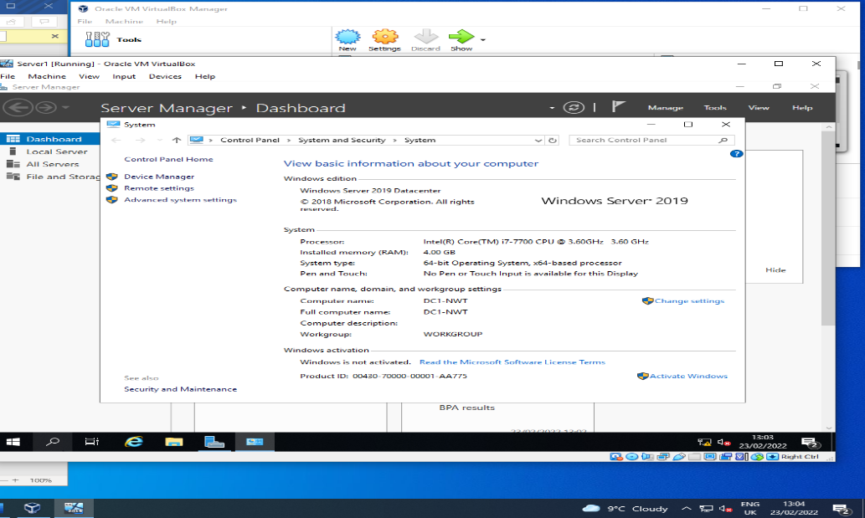
    - Deploying Active Directory

Active directory is needed as a register for all objects on the network

This process begins with choosing the desired roles provided by Active Directory

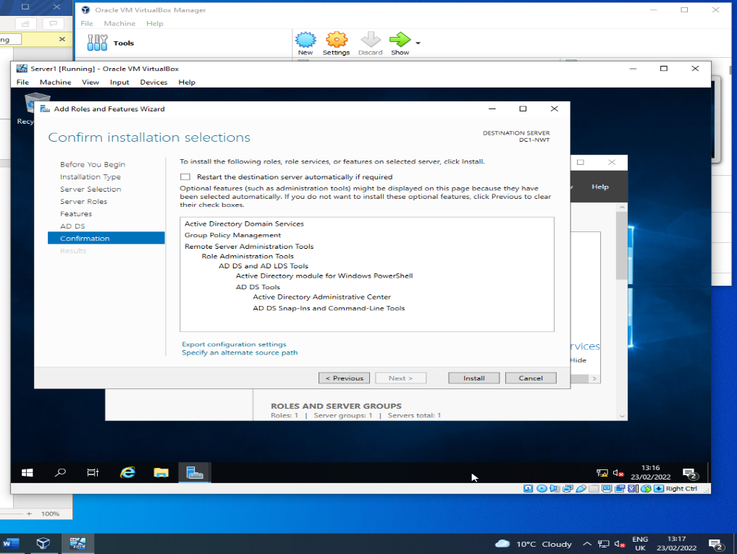

As the Server1 machine will be used for DNS, AD DS is chosen for the computer named DC1-NWT
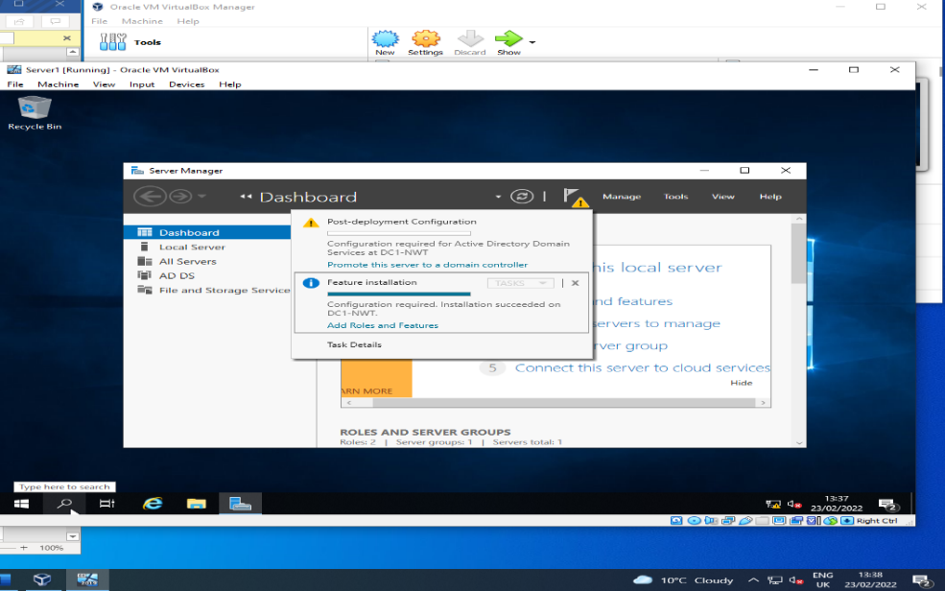

This screenshot shows the features chosen from Active Directory, specifically Domain Services AD DS

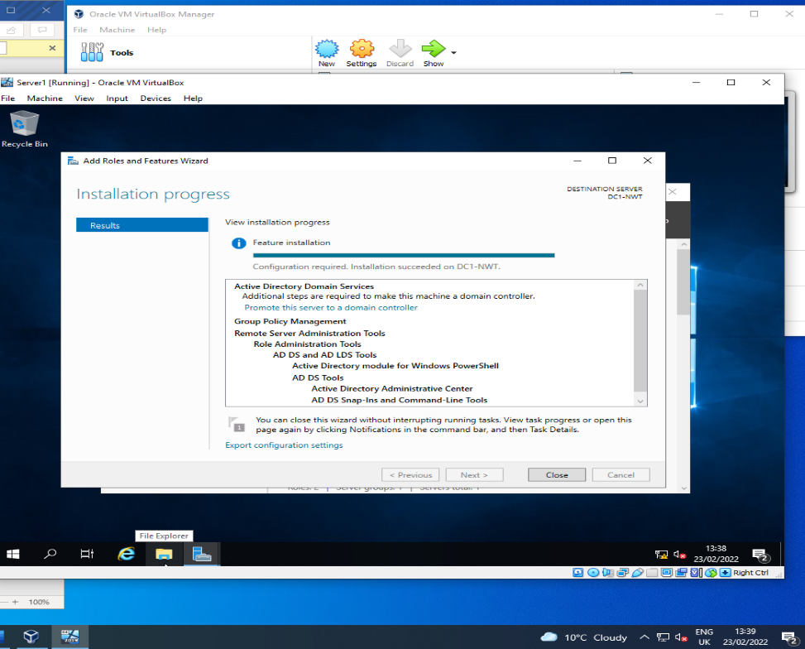

With AD DS installed it is now deployed by creating a new forest which is named nosstask.msft
This also shows that Windows server was selected for Forest & domain function level with Global catalog and DNS switched on
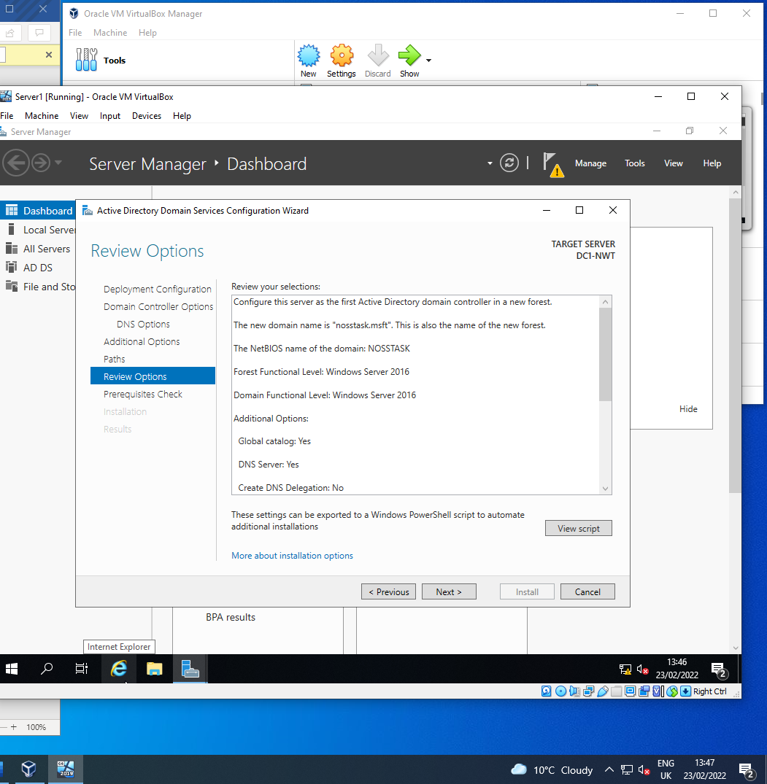

    - Creating User Account Objects

With a domain name installed, the machine reboots and must login to the new domain, in this case NOSSTASK/Administrator

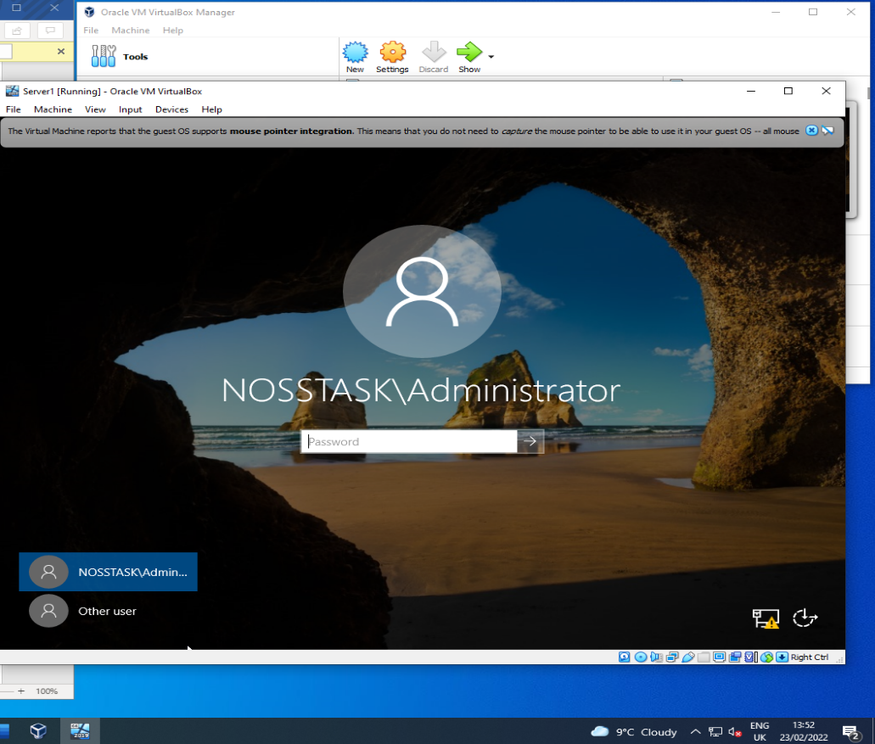

Server DC1-NWT must be listed in the Domain Controllers object as the domain controller
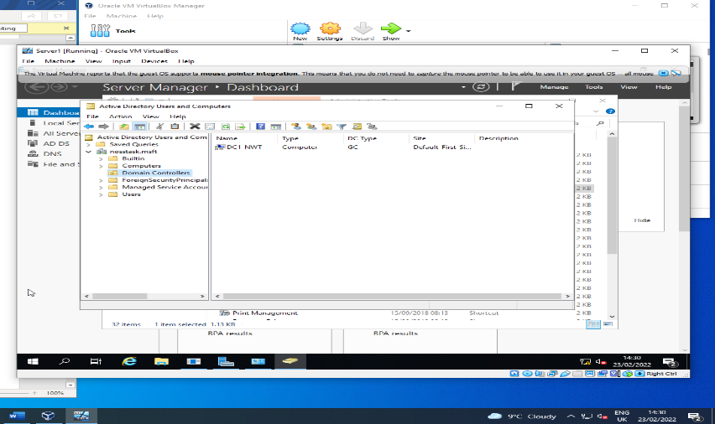
This screenshot shows an additional account has been created as a failsafe and listed in domain admin object

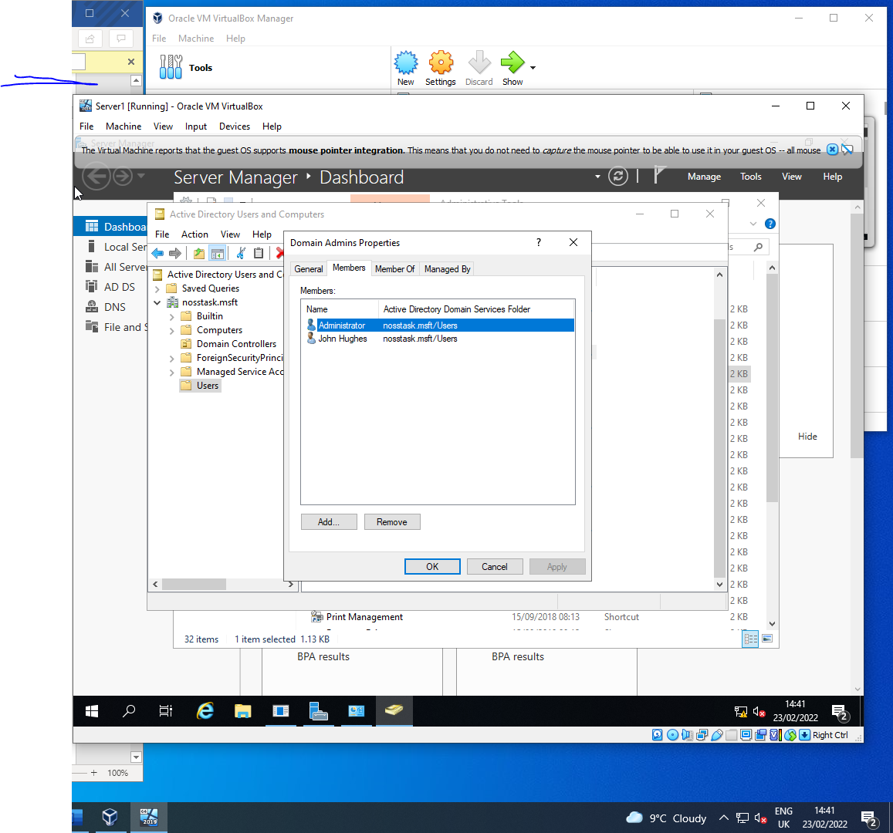

    - Object Attributes of Interest

Another user account was created without admin privileges and will be used to utilise network policy options. This account resides within the users folder and is named Peter Venkman
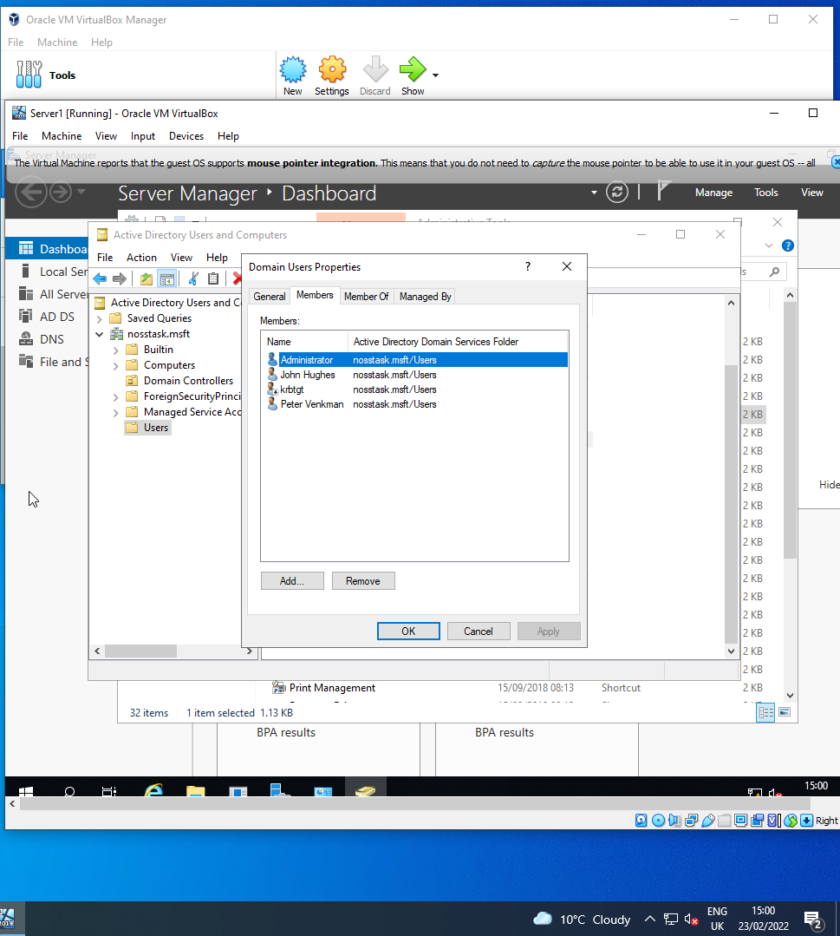

In the Users folder within Active Directory, as an example of restrictions, the logon hours have been changed to deny logon between 11am and 12pm Wednesday-Friday
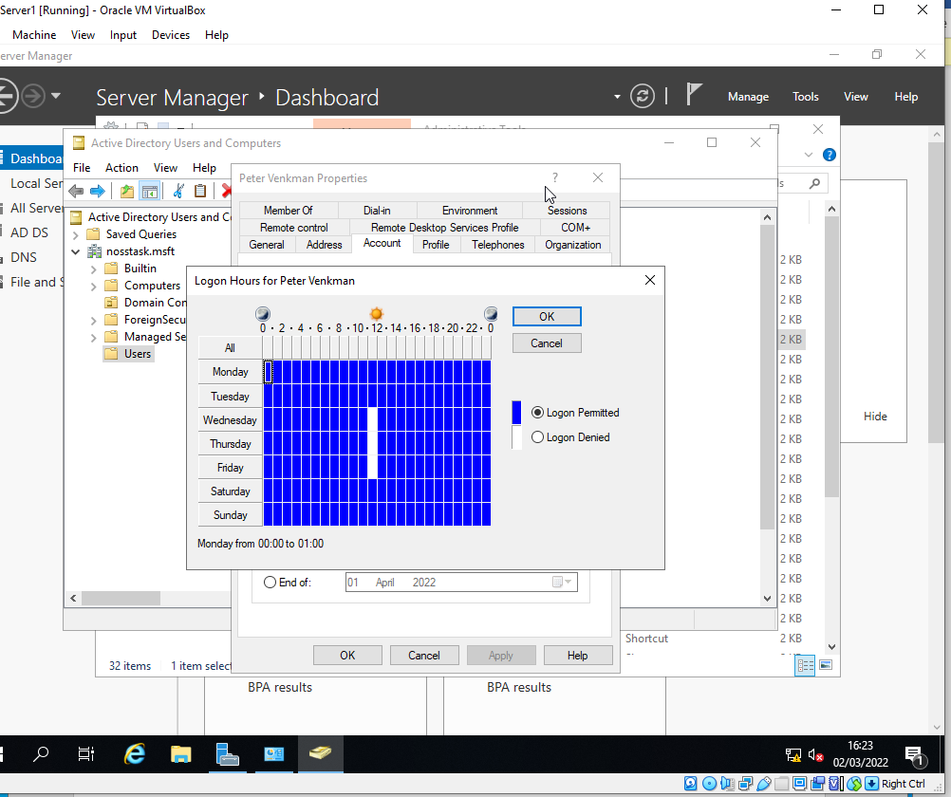
This user account also has restricted password change
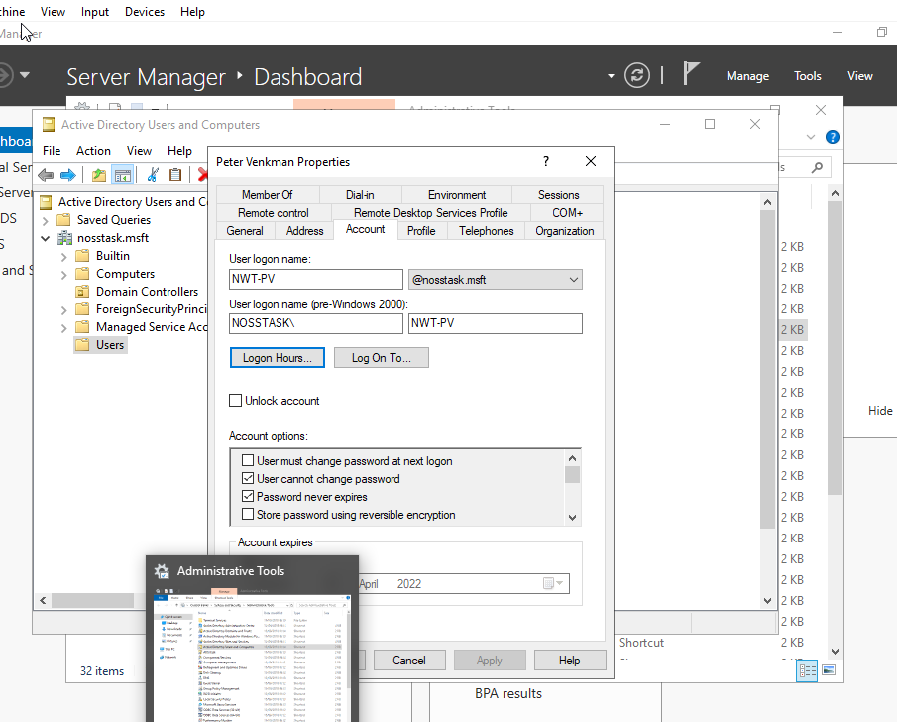

    - Adjoining the Domain and Testing Logins

This stage adjoins the domain to the existing machines in the network

This screenshot verifies that no account is created for Client1 or Client2
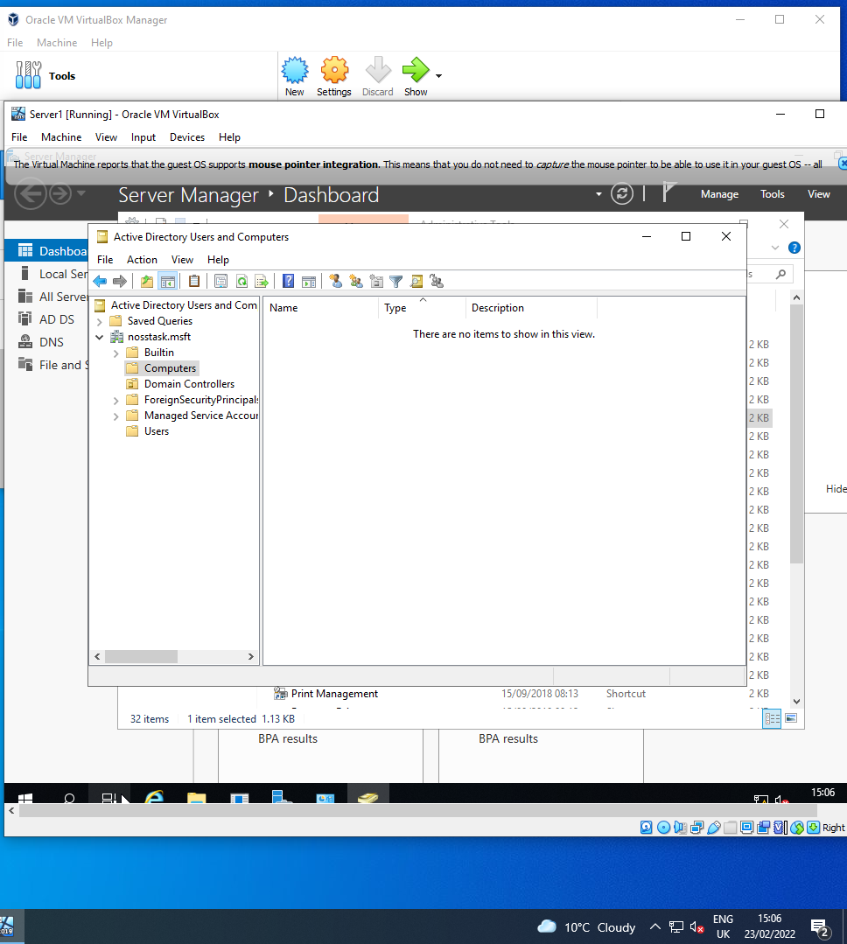

With an account created for Server1, it now needs to join the domain

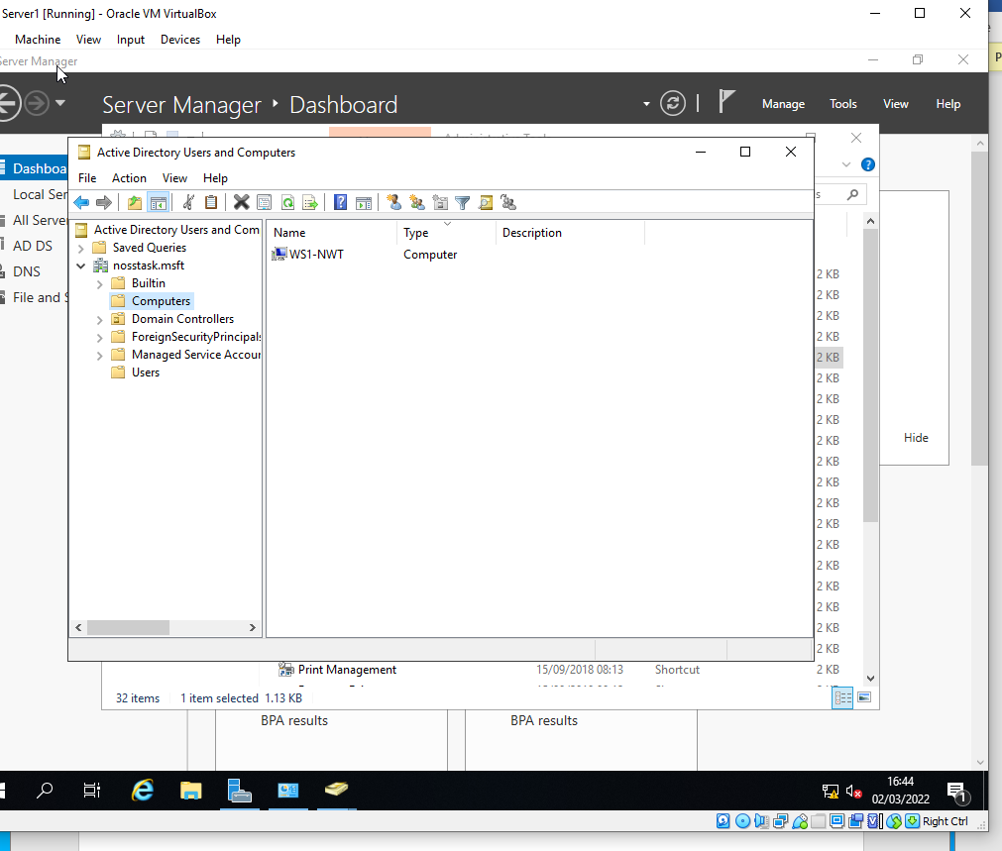
Having logged into Client1 admin account, the computer name WS1-NWT is chosen and added to the domain name nosstask
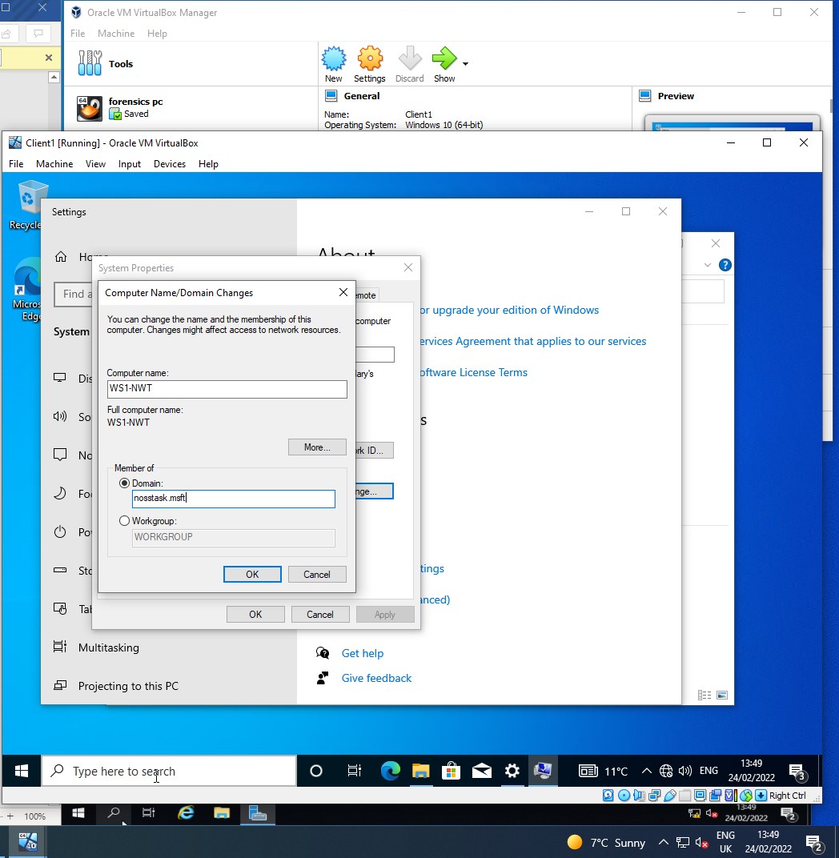

Once the computer is rebooted, the IP Address must be changed for client1 to receive DNS services provided by Server1

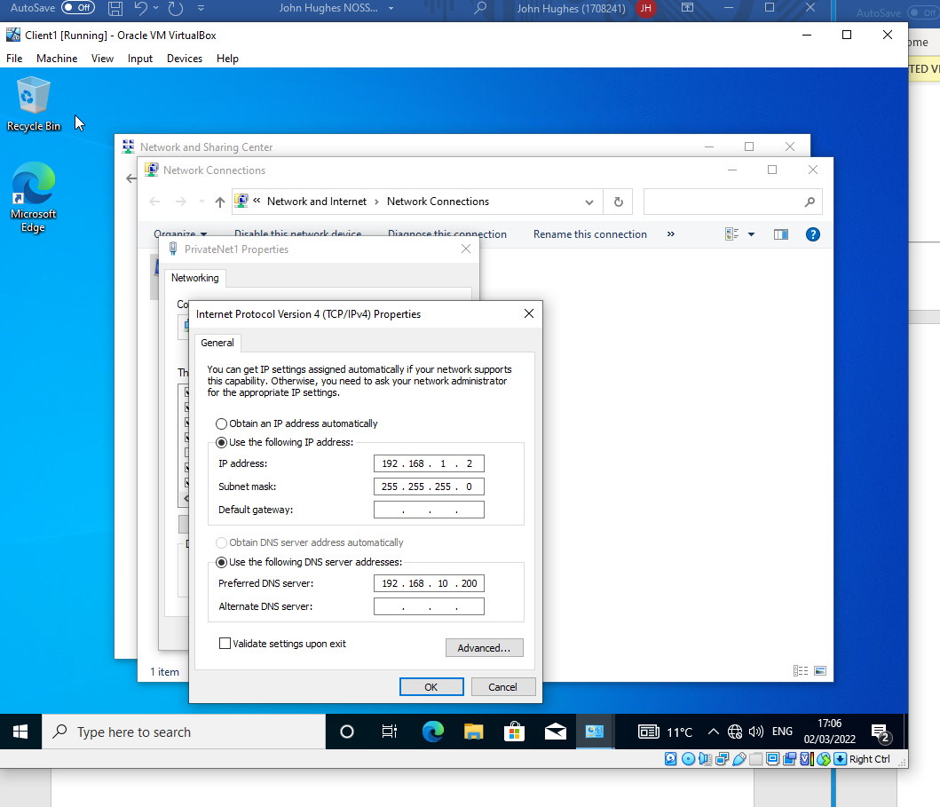

The DNS server address set to 192.168.10.200 as set out in the task sheet created an issue when changing the domain name to nosstask.msft, as shown below
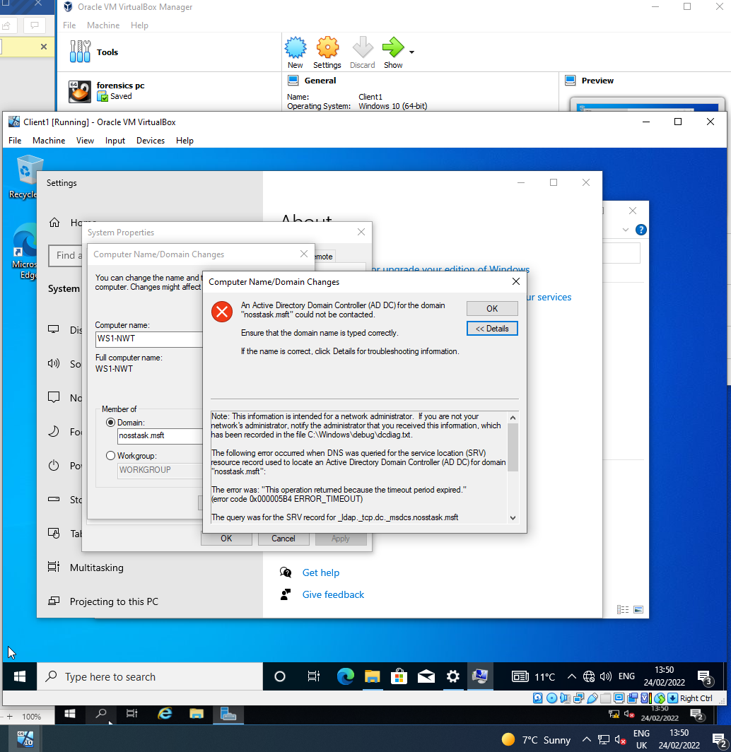

This issue was corrected by changing the DNS IP address to 192.168.1.1 as shown below
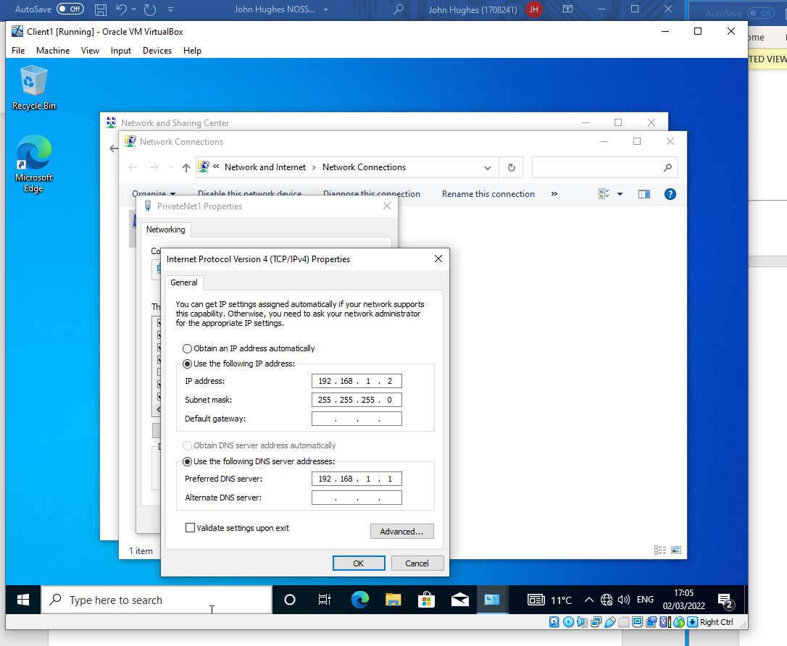

The IP address resulting in success when changing the domain name as shown
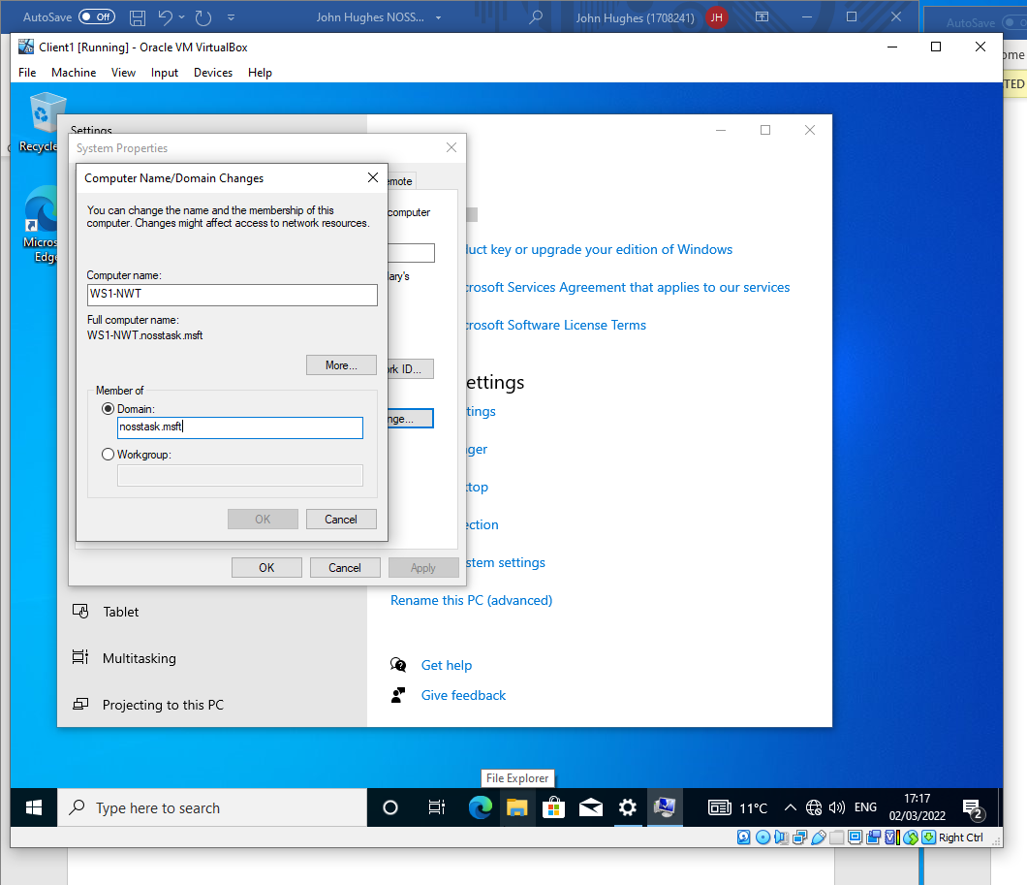

Lastly, attempts to log on to the Server1 without administrative privileges are shown to be unsuccessful
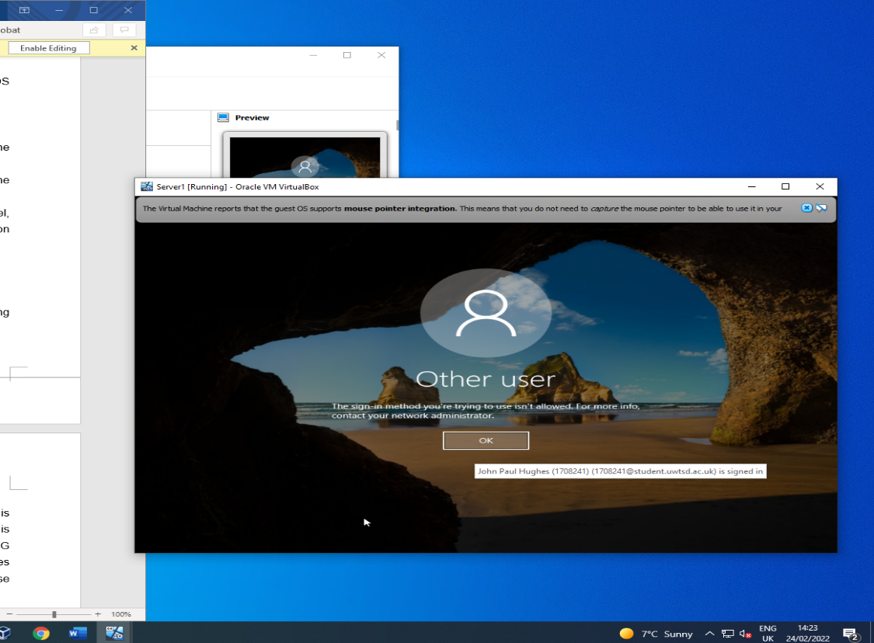

- Observational Tasks

    - Hypervisors

In the book Virtualisation Essentials, by Matthew Portnoy, a hypervisor is
described as software that allows a host computer to run virtual machines(VM) by controlling the VMs access to the hosts hardware. The software creates a new layer between the VM and the hardware, preventing a chaotic situation of multiple VMs trying to use the same resources at once [1]. Each VM acts as a guest with its own separate operating system managed by the hypervisor.

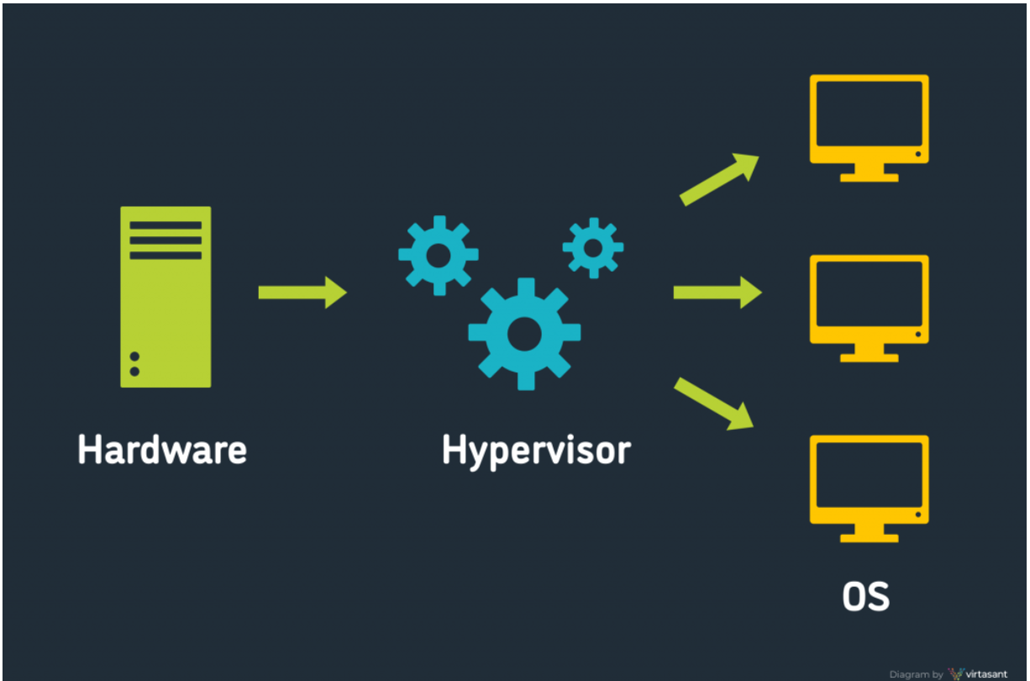
Fig 1. Hypervisor environment

    - Type 1 Hypervisors

Otherwise known as a bare-metal hypervisor, this runs with no operating system between the hosts hardware and hypervisor. This provides maximum efficiency by allowing the hypervisor direct access to the hosts hardware with no intermediary to slow down performance. This reduction in processing overhead can also result in a greater capacity for multiple clients on the software. Examples of Type 1 hypervisors include Microsoft Hyper-V and VMware ESXi

Another advantage of the type 1 hypervisor is security. As Portnoy states, operating systems on each client are limited to the boundaries of each VM they reside on, preventing any interference between one client and another. In the event of a crash, each individual VM can only damage itself [1].

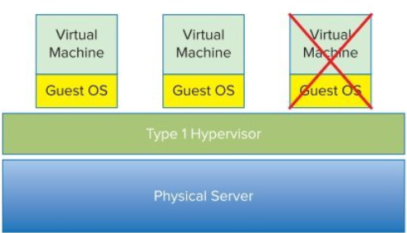
Fig.2 Guest Failure

    - Type 2 Hypervisors

Type 2 hypervisors run on a hosts existing operating system. In the book Hardware and Software Support for Virtualization, this is described as a hosted hypervisor. This host hypervisor can leverage the capabilities of the host machines OS which has already configured most of the hardware. As such, the hosted hypervisor is easier to install and can support a large range of hardware that is already dealt with by the hosts OS [2].

Although simpler and easier to install on a wide range of host machines, type 2 hypervisors are obviously less efficient. The request of each individual client must pass through the hypervisor first, then the host OS before being performed at hardware level. Also, hosted hypervisors are also less secure as every client shares and relies on the host machines OS. As such, events on the host OS are likely to be felt on each of the hypervisors clients [2].

  - Cloud Computing

According to an industry arcticle by Microsoft Azure, cloud computing is on-demand computing services/resources provided online by a vendor such as data storage, networking, software, analytics and other such computing power [3]. With scalability such an important economical factor, organisations are provided with a wide range of services to fit their needs. It reduces or even eliminates the need for large capital spent on software/hardware purchases, installation and maintenance.

Public clouds such as Microsoft Azure are accessed by organisations on a pay as you go basis. The software and hardware infrastructure are owned and maintained by the third party vendor allowing clients to access the resources in accordance with their needs [3].

Private clouds are used exclusively by a single organisation that may be owned by the organisation or leased from a third party provider. These are typically used by large organisations that may require greater resources such as their own data center [3]. An example of private clouds are Hewlett Packard Enterprises (HPE) or VM Ware.

Hybrid clouds perhaps offer the greatest scalability. Rather than expand the physical resources of a data centre, the private cloud environment can upscale by adding public cloud resources as well. This can give a best-of-both scenario for organisations that choose to store sensitive data in multiple locations or operate within the industry requirements of a private cloud whilst utilising the economical advantages of a public cloud [3].

Some of the drawbacks of cloud computing include industry restrictions on what data is considered cloud worthy as some sensitive data may not be legally allowed to store with third party providers.
Some organisations may also have difficulty with budgeting for such services. Large organisations may struggle with bandwidth and the larger your IT resource pool, the less likely you are to benefit from outsourcing resources [4].

  - DNS

The Domain Name System is a hierarchical protocol that uses a directory storage to match the names of a domain with the IP address of their location. Each DNS server provides part of the directory whilst regularly communicating with one another to provide updates and redundancies within its cache [5]

When a client attempts to reach a web address, it sends a request to its recursive DNS server

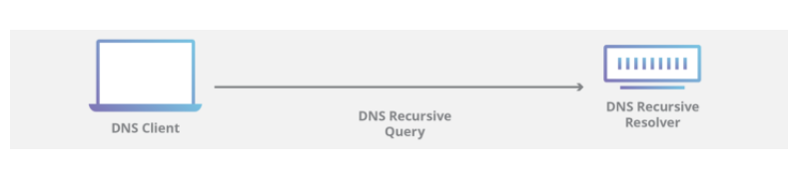
Figure 3 Recursive Query

If the web address is not found in its cache, the server sends multiple requests to other root servers until it resolves the query and returns the IP address associated with the requested domain name

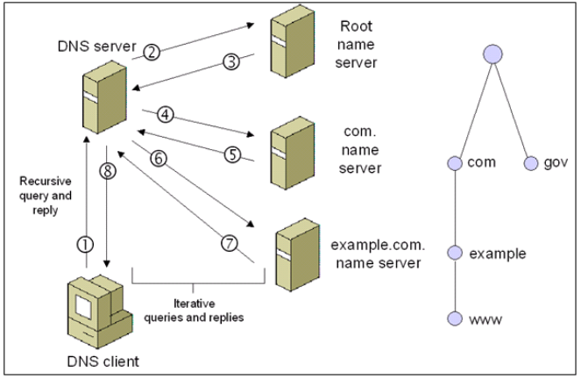
Figure 4 DNS Hierarchy

As stated in Microsoft Docs, DNS is one of the roles is used used by Active Directory. AD DS uses DNS to allow domain controllers to communicate with each other and allow clients to access them [6].

  - Roles Within an Enterprise Network

Another role within an enterprise network is security. A key component of any network, it is required to defend from both internal and external threats.

Internally, threats can be reduced with the utilisation of access control. By placing restrictions on user accounts, you can control users access to network resources and reduce the threat from bad actors.

To protect from external threats, networks require features such as firewalls and antivirus software.

  - Terminologies, Descriptions and Comparisons

    - Firewalls

Windows Defender Firewall is installed on Microsoft operating systems and provides two-way filtering of network traffic for both inbound and outbound protection. A lot of the features are automated and therefor require less configurations by the user [7].

A linux firewall on the other hand is not preinstalled and uses the netfiller kernel subsystem to filter incoming connections only. It’s advantages are better performance by using less memory space than Windows Defender and more advanced features such as ICMP echo request delaying [8].

    - Ping

The ping command works by sending an ICMP request to the address that is specified in the command. Once the request is received by the target host, it returns a packet reply. This command is useful for testing and establishing connections between hosts and identifying the nature of any packet drops by the information received in the CLI response such as the round trip delay for where a packet is lost or the message in the result of packet loss.

    - PAE/NX
Physical Address Extension is a feature that allows more than 4GB memory for 32bit Windows on x86 processors. It is not required for 64bit Windows operating systems as they will have infrastructure that natively access more than 4GB RAM [9].
The NX bit stands for No eXecute and is used to segregate areas of memory, preventing the hardware from executing certain regions of code.

  - Practical Work Reflection

The work conducted in this task involved an introduction to the use of hypervisors, specifically hosted hypervisors for ease of access and installation on campus machines.
The hypervisors were used to create four VMs required to build a virtual network, with the VMs optimised by utilising features such as PAE/NX.

With the VMs created, the network configurations were required to create three subnets. Two private networks of server and client, and a public network to connect between the private networks by activating the relevant network adapters configured with the network topology acting as virtual switches.
Network configurations were then verified by deactivating the firewalls and ping testing between machines.

Having configured the virtual network, renaming a machine as the domain controller and deploying Active Directory services were required to create a database of network resources categorised into objects consisting of a domain named nosstask and a forest containing user accounts. Active Directory roles were utilised such as Domain Services and Domain Name System for identifying the nosstask network domain.

Other Active Directory features were used within Users and Computers to place restrictions on user accounts.
The final stage of the task was to adjoin the admin accounts to the domain w

- References

References

[1] | M. Portnoy, "Understanding Hypervisors," in Virtualisation Essentials, Indianapolis, Indiana: Sybex, 2012, pp. 19-35.
[2] | J. Nieh and D. M. M. B. E. Tsarfrir, in Hardware and Software Support for Virtualization, Morgan & Claypool, 2017.
[3] | M. Azure. [Online]. Available: https://azure.microsoft.com/en-gb/overview/what-is-cloud-computing/. [Accessed 3rd March 2022].
[4] | N. W. M. East, "Cloud computing: Pros and cons," 20th May 2009. [Online]. Available: https://www.proquest.com/docview/211034032. [Accessed 3rd March 2022].
[5] | K. Shaw and J. Fruhlinger, Network World, 26 August 2020.
[6] | Microsoft, "Microsoft Docs," 10th January 2022. [Online]. Available: https://docs.microsoft.com/en-us/windows-server/networking/dns/dns-top#:~:text=Active%20Directory%20Domain%20Services%20(AD,locate%20Active%20Directory%20domain%20controllers.. [Accessed 4 March 2022].
[7] | Microsoft, "Microsoft Docs," 28 October 2021. [Online]. Available: https://docs.microsoft.com/en-us/windows/security/threat-protection/windows-firewall/windows-firewall-with-advanced-security. [Accessed 4 March 2022].
[8] | Ibuntu, Ibuntu, [Online]. Available: https://ubuntu.com/server/docs/security-firewall. [Accessed 4 March 2022].
[9] | M. Docs, "Physical Address Extension," 7th January 2021. [Online]. Available: https://docs.microsoft.com/en-us/windows/win32/memory/physical-address-extension. [Accessed 4th March 2022].

