Emily Parkins
1900657
Surface Pattern Design
Module: ADAD4018
Julia Lockheart

Tasks in the order I received them
Task 1: Manifesto writing = 526 words
Task 2: Observational writing = 549 words
Task 3: Practice – based writing = 497 words

Task 1: Manifesto Writing

- We need to focus on our inspiration and not allow distraction to take over.

- The world is still a beautiful, unique and inspiring place.

- Do not overcomplicate the places you look to for inspiration.

- Way up high and deep down low, there is something interesting to look at, research and discover.

- Look at the simplest of things and you will find detail.

- Everything around us tells a story.

- Do not let anyone pull you away from the beauty of nature.

- Open your eyes, mind, heart, and explore creation.

3 areas of exploration:
We need to focus on our inspiration and not allow distraction to take over.
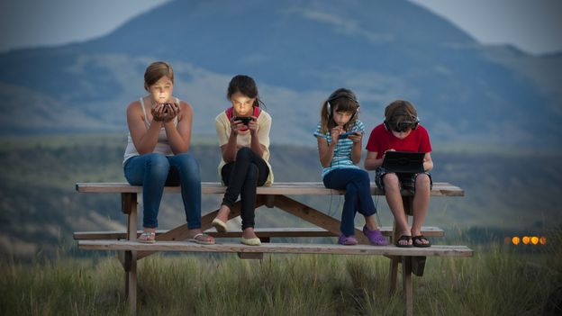
Figure 1: Relaxing in the countryside for the next generation (Credit: Stephen Simpson / Getty Images)

Due to the development of technology today, screen time both at work and leisurely is increasing. The result of increased use of technology is resulting in a range of distractions, from education, work and appreciating the world around us. According to a Microsoft survey, “Technology can distract workers rather than make them more productive” Microsoft warns firms of technology 'distractions' BBC (2018). This shows that using technology in the work place causes more distraction than work ethic to complete tasks and reach deadlines. Cornish, (1994) states “Technological progress has encouraged many people to think that nature hardly matters”. For years the development of technology is having an impact on the way our mindsets are seen to appreciate nature. It is important for us to take time away from technology to refresh our minds and to be able to properly recharge. Our inspiration and motivation will increase and we will be able to get tasks done with less distractions.
Way up high and deep down low, there is something interesting to look at, research and discover.
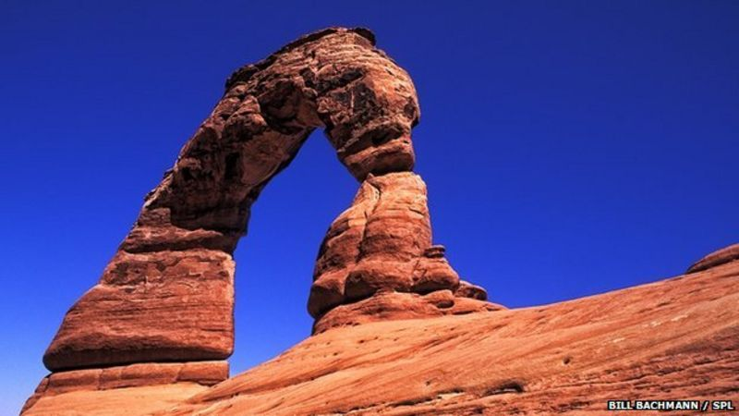
Figure 2: The famous Delicate Arch - gravity's answer to Michelangelo?
So many countries around the world have different aspects of nature. Rainforests, deserts, mountains and oceans. Each aspect of the world deserves to be acknowledged. We are so good at understanding the importance of nature and instantly disrespecting it immediately. It takes a walk to the park to spot litter and fly-tipping. Stecker, (2019), p. 131 says “Let us grant that recognizing and respecting nature as having its own reality is at least in part a moral capacity or stance.” Naturally, as humans, we should be taking in and appreciating the creation around us. The environment is so intelligent and there is always something we can learn from it, whether it be deep in the ocean or high in the mountains. Webb, (2014) states, “By studying cubes of sand in the lab, they showed that areas squeezed by vertical stress are protected from erosion, while others wash away.” This shows evidence that the environment and world is constantly changing around us, meaning there is always something interesting to appreciate.

Look at the simplest of things and you will find detail.
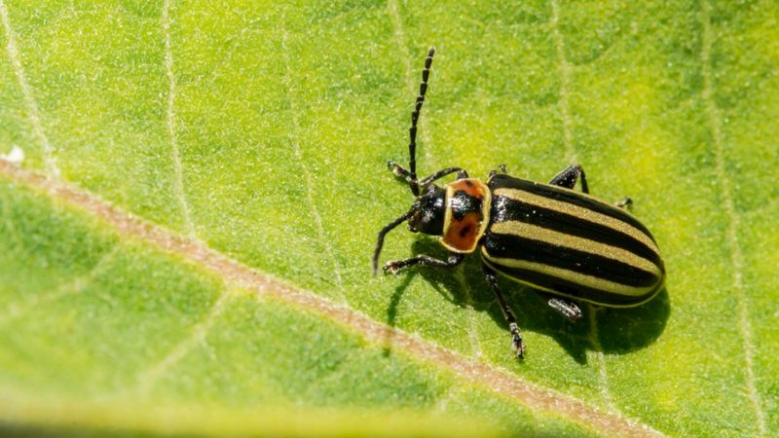
Figure 3: Global trends for insects are not known, but large declines have been recorded in some locations
Distractions are high in society. Our mindsets can often be focussed on getting things done and overlooking basic surroundings in life. With a mentality like this, we often ignore the basic beauty of nature. The image above shows a bug sitting on a leaf - for most people, this would often be ignored or shooed away due to the fear of bugs in some people. Richardson & McEwan, (2018) state “Beauty lies within the characteristics of the object, and the interaction between the object and the person’s cognitive and affective processes.” This expresses the important of opening out minds and outlooks of nature. We need to begin back at the basics and have a childlike attitude towards understanding, viewing and appreciating each creation that surrounds us.

Bibliography
BBC (2018) Microsoft warns firms of technology 'distractions'. Available at: https://www.bbc.co.uk/news/technology-42945863 (Accessed on 24 November 2020)
Cornish, E. 1994. ‘Man vs. nature – Nature, Technology, and Society: Cultural’. The Futurist, January/February, p. 39. Accessed 24 November 2020. Available at: https://search-proquest-com.ezproxy.uwtsd.ac.uk/docview/218587835?accountid=130472&rfr_id=info%3Axri%2Fsid%3Aprimo
Richardson, M. McEwan, K. (2018) ‘30 Days Wild and the Relationships Between Engagement With Nature’s Beauty, Nature Connectedness and Well-Being’, Frontiers in Psychology, 9 (2018-09-01)
Stecker, R. (2019) Intersections of Value: Art, Nature, and the Everyday. United States of America: Oxford University Press.
Webb, J. (2014) Sandstone shapes 'forged by gravity', BBC. Accessed 24 November 2020. Available at: https://www.bbc.co.uk/news/science-environment-28365410

Figure 1. Relaxing in the countryside for the next generation (Credit: Stephen Simpson / Getty Images) Accessed from: http://www.bbc.co.uk/earth/story/20150703-can-nature-and-technology-be-friends [Accessed on 24 November 2020]
Figure 2. The famous Delicate Arch - gravity's answer to Michelangelo? Accessed from: https://www.bbc.co.uk/news/science-environment-28365410 [Accessed on 24 November 2020]
Figure 3. Global trends for insects are not known, but large declines have been recorded in some locations. Accessed from: https://www.bbc.co.uk/news/science-environment-48133143 [Accessed on 25 November 2020]

Task 2: Observational Writing
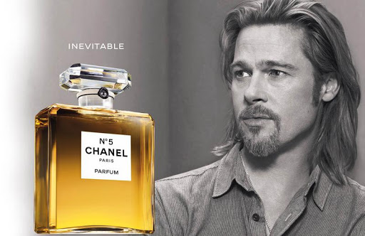
Figure 1: N°5 Chanel Perfume advert
In this N°5 Chanel Paris Parfum advertisement, there are many connotations. “There are several views or basic concepts underlying Saussure’s theory of sign, namely the two-dimensional system, the consensus or conventional system, the networking relationship between signs system and the arbitrary system.” Yakin & Totu (2014) The signifier of this advert is of the perfume bottle, it is ‘inevitable’. There are many messages you can take from this advertisement, such as the perfume is going to make you feel like the centre of attention. This idea comes from the expression of Brad Pitt as he is looking away and seems distracted, giving the impression that the perfume is so breath taking it makes you, the wearer eye catching.
The text is very bold and basic which makes the word ‘inevitable’ be remembered when we think of the perfume. In her analysis, Oswald, (2012) wrote “The text is the minimal unit of semiotic analysis … semiotics focuses on the codes organizing meaning production in complete messages.” The image shows this word has been thought through and adds to the viewer’s interpretation of the perfume.
John Thomas Smith discovered and important rule of thirds in photography. Harris, (2014) “I have found the ratio of about two thirds to one third, or of one to two a much better and more harmonizing proportion, than the precise formal half.” The layout of the N°5 Chanel Paris Parfum advert has been thought out as the rule of thirds is clearly seen. The perfume bottle and the model are at either side of the image. The model’s eyeline directs us straight to the perfume. This shows that each aspect of an advert needs to be linked and thought through properly.
Judith Williamson believes that a sign is something that we take upon ourselves to interpret an advertisement “Advertisements work by simultaneously creating meaning and drawing on the reader's already-existing meanings.” Harvey, (1990). One way the advert can be interpreted is the wearer of the perfume overwhelms the room with the scent causing the entire room to place eyes upon the wearer and become the centre of attention. We could also interpret that the perfume is very personal and special, meaning it will only be worn for a special occasion or a special person. The main sign we can take upon ourselves to interpret from this advertisement is that there is a reversed iconic sign. Typically, perfume advert models are women who are elegant and beautiful. However, this advertisement clearly shows the typical female model has been replaced by Pitt, a handsome and sharp male figure. This adds a more modern spin on the advertisement the symbol of the wearer has changed. In the video advertisement of the no5 perfume Pitt states “the world turns, and we turn with it”, The Telegraph (2012). This quote can be interpreted in many ways however with the idea of Williamson’s theory, and the reversed iconic sign, this could be indicating a change in stereotypes and the original and expected female model in perfume adverts. In modern times like today, who is right to say that women wear feminine scents and males wear masculine? This advertisement can be a turning point in society and opening people’s eyes to a more diverse and inclusive society.

Bibliography
Harvey, L. (1990). Critical Social Research. London: Unwin Hyman.
Harris, J. (2014). Who Wrote the Rule of Thirds? Available at: https://www.bhphotovideo.com/explora/photography/tips-and-solutions/who-wrote-rule-thirds%3F#:~:text=The%20Rule%20of%20Thirds%20posits,thirds%2C%20both%20horizontally%20and%20vertically. (Accessed on: 25 November 2020).
H. S. M. Yakin & A. Totu. (2014) ‘The Semiotic Perspectives of Peirce and Saussure: A Brief Comparative Study’, Procedia - Social and Behavioral Science, 155 (18-20 October) p. 4 – 8
Oswald, L.R. (2012). Marketing Semiotics, Oxford: Oxford University Press.
The Telegraph. (2012). Brad Pitt stars in Chanel No 5 advert [video]. Available at: https://www.youtube.com/watch?v=oF8NAyqxGfk (Accessed: 1 December 2020)
Figure 1. N°5 Chanel Perfume advert. Available at: https://www.pinterest.co.uk/pin/157344580702627646/ [Accessed on 25 November 2020]

Practice Based Writing
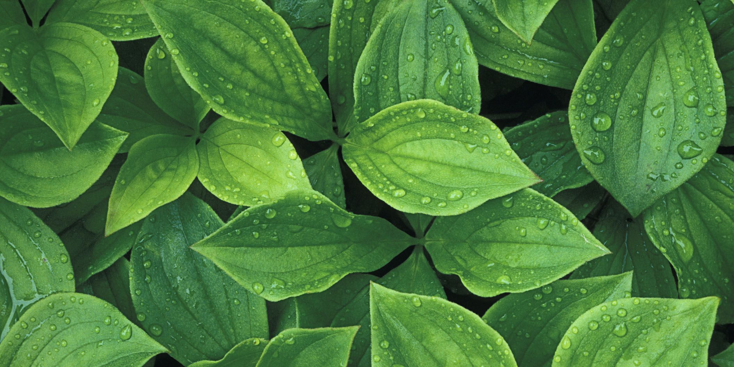
Figure 1: Getty Images
Leaves and Inspiration
Each day we live and explore we are surrounded by nature. Sometimes we recognise it, sometimes we get caught up and forget about the living organisms that are also a part of our world.
Leaves are some of the most intricate, delicate, and detailed plants around us. Each leaf has a different shape, and each tells a unique story. Being surrounded by nature springs many ideas and inspiration to develop our own personal artistic creations. Stonard (2018) “Art is a record of our changing encounter with nature”. Every little aspect of our surroundings we take in can change in an instance. Natural changes such as weather, temperature and wind can change the way the environment looks. We could appreciate the warm glow of a leaf at one point and the next person could appreciate the fresh raindrop that has just landed on its surface. The way we see nature is constantly changing and every day we can subconsciously appreciate and recognise something different.
Furthermore, there are many studies and suggestions expressing that nature and art is beneficial to individual’s mental health. By combining these two aspects together there is an incredibly positive outcome. (Arts Council England, 2016) “Findings suggested that exposure to natural sounds may be beneficial to mental health, by reducing the likelihood of self-referential and evaluative thoughts, while improving broad attentional focus.” This information gives a clear point that natural sounds benefit our mental state and by doing so, our attention focus may also improve. From a creative’s point of view, these two aspects go hand in hand. Being able to focus on our inspiration and creative projects is so important. Therefore, gathering inspiration from nature and our environmental surroundings will be a major benefit to us.
Leading on from this point, there are multiple ways we can view nature. For example, viewing nature in an artistic way is appreciating and researching the detail on the surface of plants, trees, water, and the ground. However, a scientific approach to nature and its view is more in depth and about the inside of plants, trees, the movement of water and erosion of the ground. Flodin, C., (2018) states “the experience of natural beauty indicates a different approach to nature than the scientific one.” This gives evidence that nature can be observed in different ways by many people. Depending on our mindset and interests, what we perceive is completely unique to us. Nature has such a benefit to us without us even realising, as humans we will always have nature in common. No matter our practice or our interests, by looking at leaves, plants, and different aspects of nature we can gather information and inspiration to develop our knowledge in our practice. Nature has the power to bring two completely different people together, to appreciate the world around us and can give the opportunity to share the way we perceive the environment, and the personal meaning nature has to us.

Bibliography
Arts Council England 2016, How art that reflects nature can be good for us. Accessed 26 November 2020. Available at: https://www.artscouncil.org.uk/news/can-art-make-us-feel-better-how-art-reflects-nature-can-be-good-our-wellbeing#
Flodin, C., (2018.) ‘Adorno and Schelling on the art-nature relation.’ British journal for the history of philosophy, 26(1), pp. 9.
Stonard, J.P. (2018). Opinion: Art and Nature. Available at: https://www.tate.org.uk/tate-etc/issue-43-summer-2018/opinion-art-nature (Accessed 26 November 2020)
Figure 1. Getty Images. Available at: https://www.goodhousekeeping.com/home/gardening/g2681/plant-leaves/ [Accessed on 26 November 2020]

