JavaScript-enabled website

Application Development

Student: Kyle Garmey

Lecture: Paul John

Contents
JavaScript components 3
First component 3
Second component 4
Third component 5
Fourth component 5
Fifth component 6
Methodology 7
First component 7
Second component 7
Third component 8
Fourth component 8
Fifth component 8
Annotated code listing 9
First component 9
Second component 10
Third component 11
Fourth component 12
Fifth component 12
Bibliography 13

Introduction
In this report I am going to be discussing the creating of my dynamic webpage, with JavaScript functionality, I will also discuss how I approached these problems. The website is based on event management, with a series of events being displayed on the home page, a page for secret events that happen on the day & a contact page in case anyone needs to contact the site owner. All together my website contains about 5 JavaScript components with varying levels of complexity. I have simple functions but also complicated arrays.

JavaScript components

First component
Rollover Image

A image roll over that turns blue when the mouse is hovered over the image
After
Before

Second component
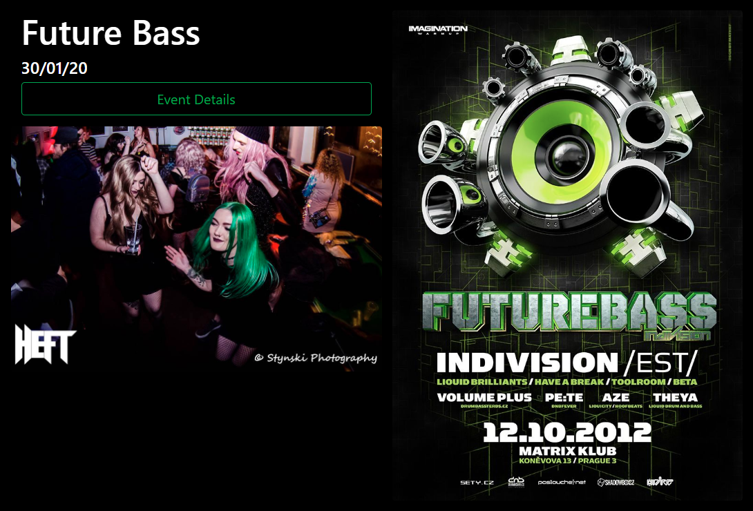
Event display
When a button is clicked content that shown
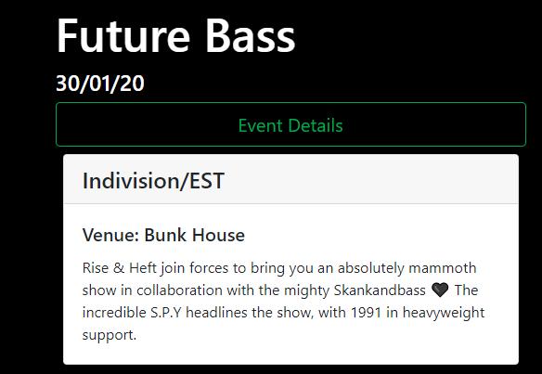
The button is more of a subcomponent because the whole event is loaded through an array
Extra content that’s shown

Third component
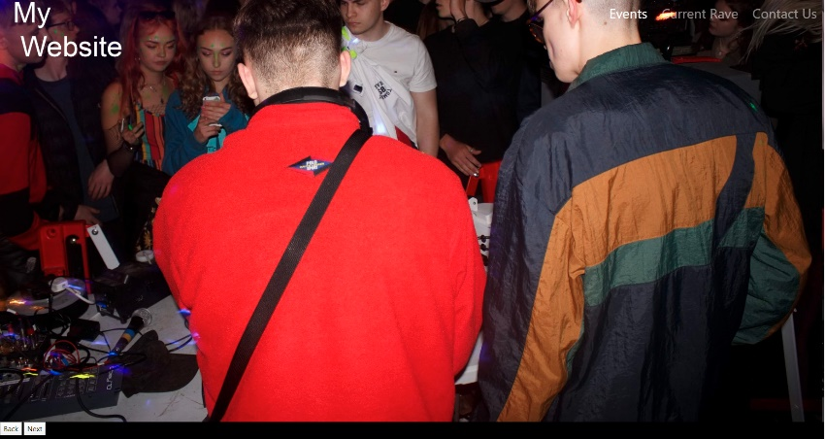
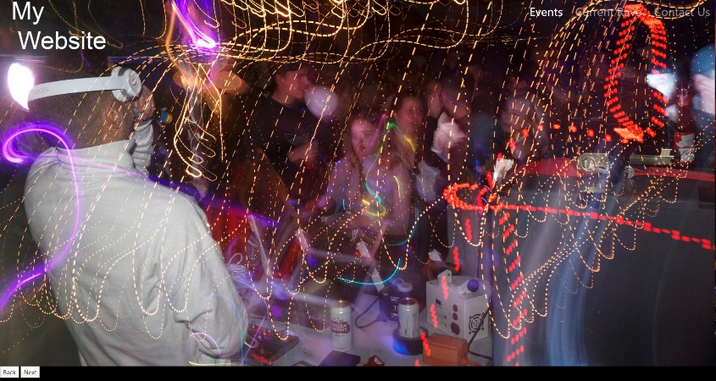
image carousel
Second image in the carousel
There are 4 images all together that loop
First image in the carousel

Fourth component
Audio & information display
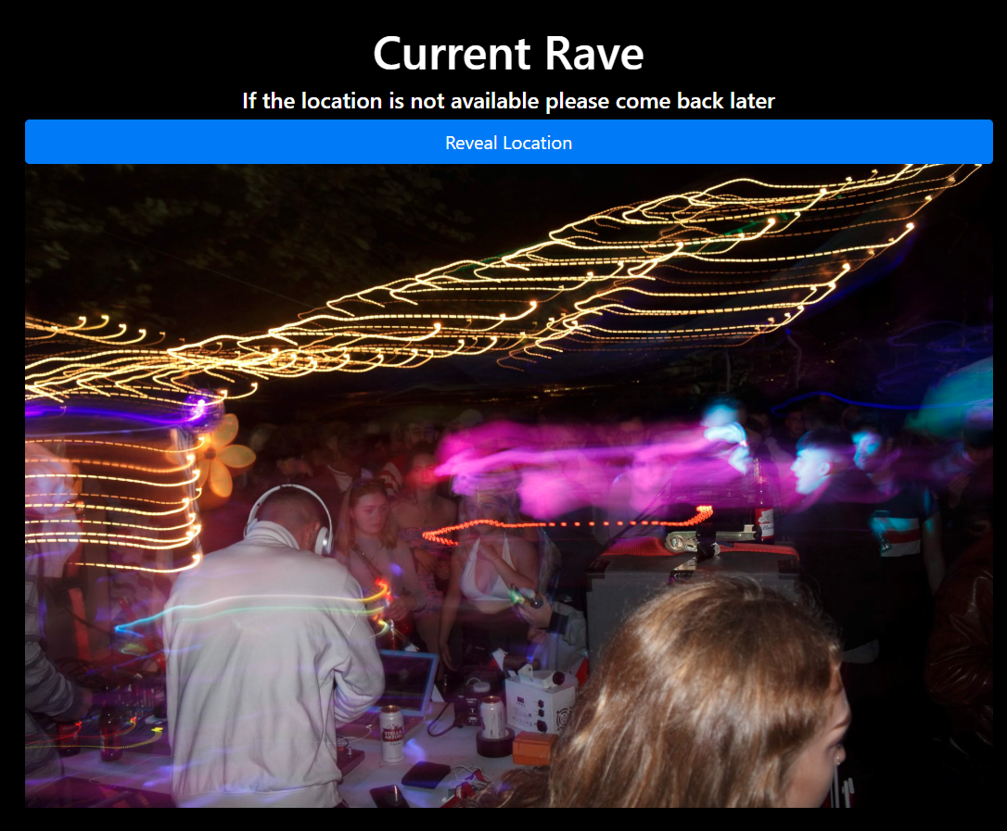
When the button is clicked an audio, clip is played then once a certain point in the track is reached it will reveal the content
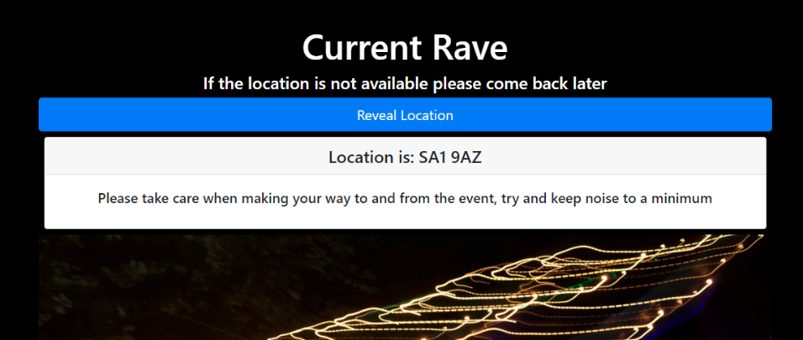
Content that is shown

Fifth component
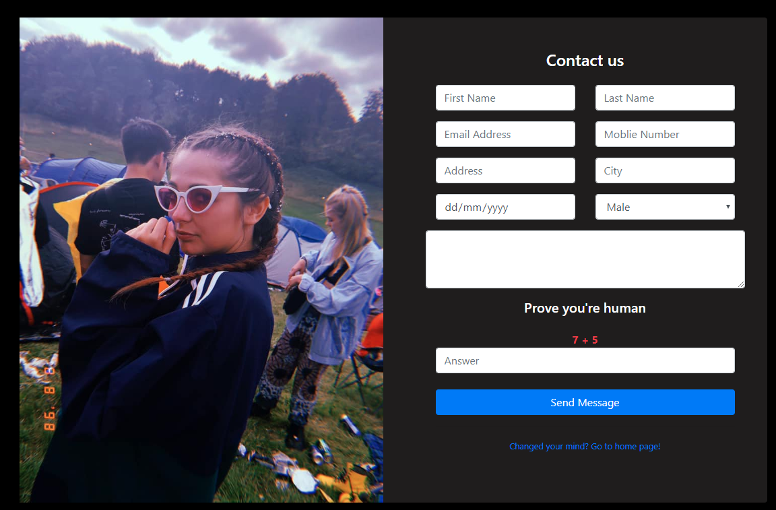
Contact form
Human verification
Link back to home page
Required to enter in all fields
200

Methodology

First component
My first component is a rollover image, when I was thinking about how to approach it, it was more of a matter of just doing it, the code is fairly simple with two if statements under one function, I usually like to just write the code and fix error’s as they come for very simple pieces of code that I understand. The way this component manipulates the website is when the mouse is hovered over the logo it changes the color to indicate that it does something, if they click on It, they are then taken to the home page.

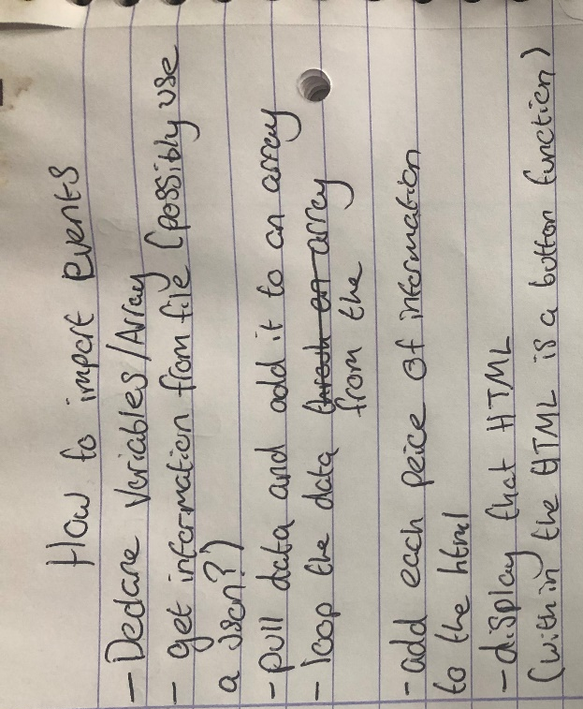
Second component
The second component of my website got very complicated, I thought the best way to approach this would to write some pseudo code, I wrote down a rough idea of what I would have to do in order to get it working. Once completed the component would list events from the JSON file, however I still needed to add a button that showed more content for each event and it had to be done so no matter how many events I added it would still automatically add the more content feature.

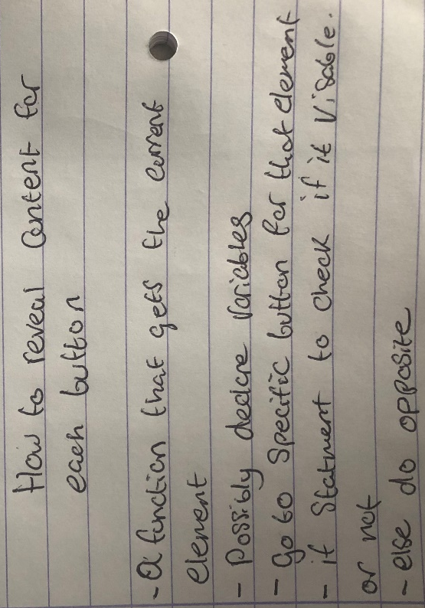
The button was also quite complicated to implement so pseudo code was once again the best option for me, once done the final result was automatic event generation based on a JSON file.

Third component
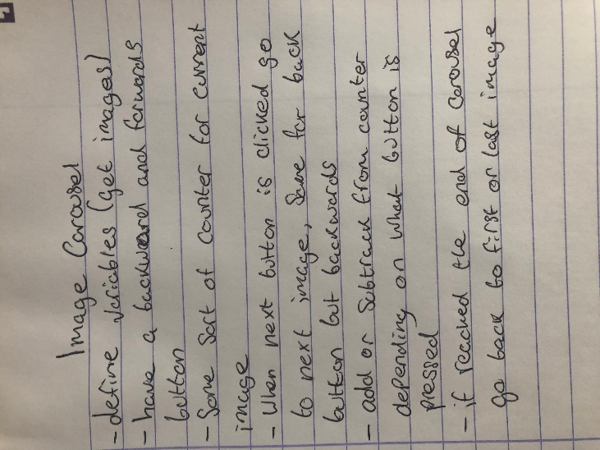
My third component was an image carousel, my approach was first to try typing the code, but it got complicated and confusing, so I decided to break it down into pseudo code and try again. The purpose of this component was to be able to go back and forth through 4 images, but also have it loop if it reached either end of the carousel.

Fourth component
This component was very simple and partly based off the second component’s button, in my mind I tried to break it down as much as I could into small bits, I knew that some sort of function would need to be there and there would also be a listen event, The point of this component was to play audio and 27 seconds into the audio it would reveal content, this added a fun element to webpage and makes it way more interactive for the use.

Fifth component
The approach taken for the last component was trial and error, I knew what I needed to do as it was checking for empty fields, there was also a human verification that needed to be done where the user adds the two number that it’s given (numbers are generated randomly) which is then checked against the added answer of the code. If everything is correct the user is then sent back to the home page.

Annotated code listing

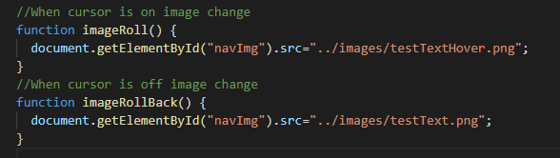
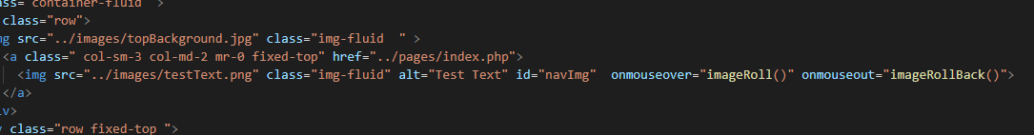
First component

In the first component within the image tag on the navbar, there are two event onmouseover and onmouseout that activate two different function’s, if the users cursor is on the image then it will change it to the second one, but once the mouse is taken off the image then it reverts back to the original image.

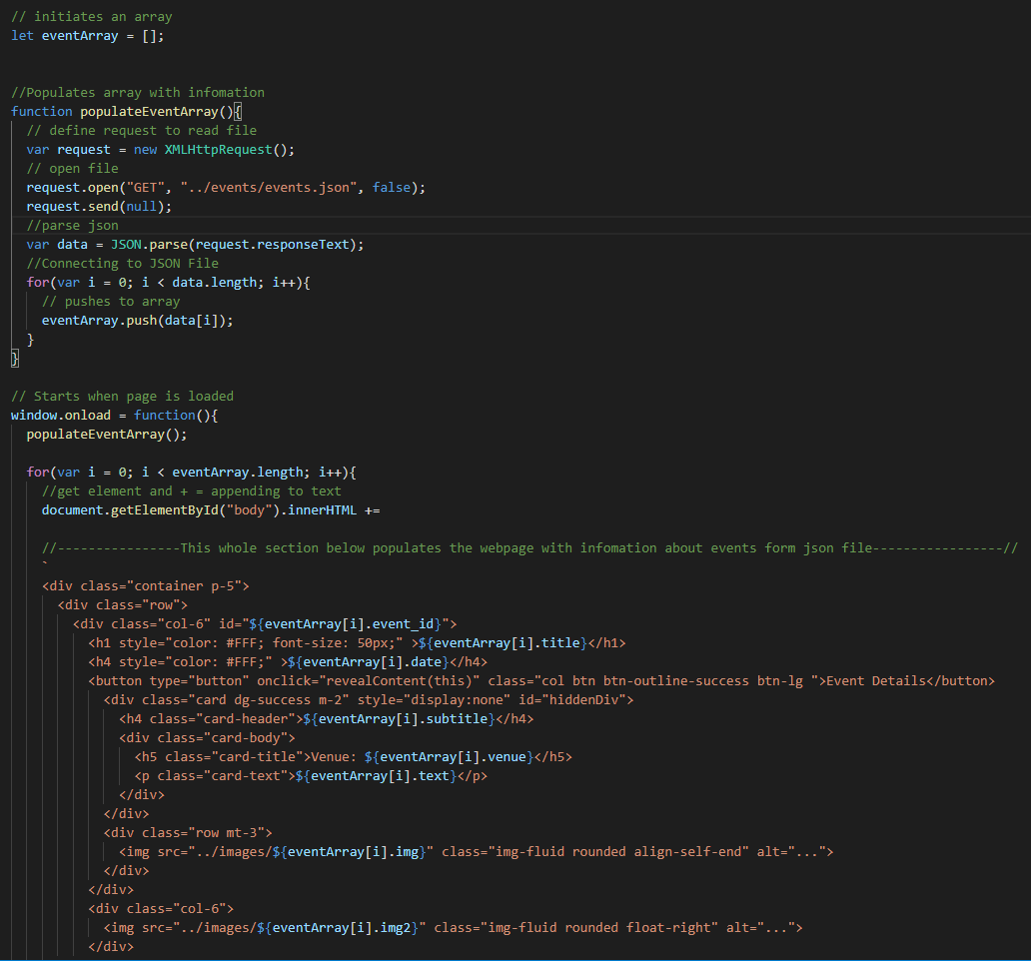
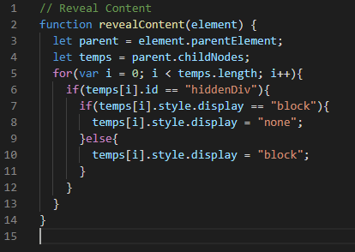
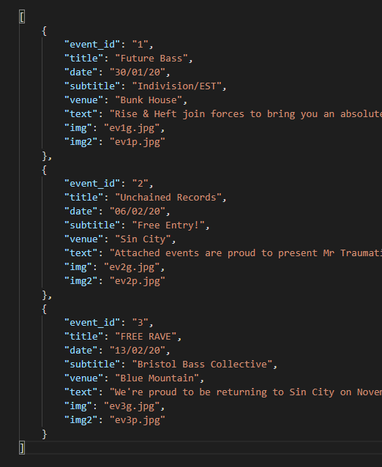
Second component

In the second component it starts off with a JSON file that stores all the data, the information is then pulled from the file and converted to text and put into an array, this function is then called the moment the page is opened. The array is then put through a loop which appends the text and displays it between all the HTML elements.

Within each event is a button (highlighted in red) which then calls upon another function, this function gets the current element that the function is ran on, it then goes to the parent element and gets an array of all the child elements, a loop is then initiated to loop over all the child elements, it will then look for an id of “hiddendiv”, once found it will enter an if statement to decide whether or not to display the element.

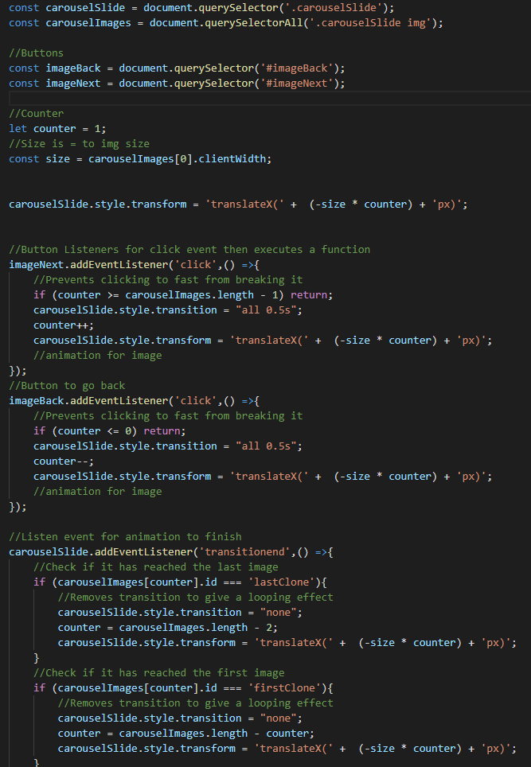
Third component

The third which is the image carousel, first sets variables and grabs all the images. A counter is also started to keep track of which image it is on. A translation is then done to make sure that the user is on the correct image (because there is a clone of the first and last image to give a looping effect.

An event listener waits for either the forward or backwards button to be used and once it is used, a check is done to see the position of the image once checked it will transition to the next image and add or subtract the counter depending on which button is pressed.

Finally an event listener listens for an animation to finish, once finished it will check to see if its on the first or last clone images and if it is on either it will move to the last image if it was the first and vise versa.

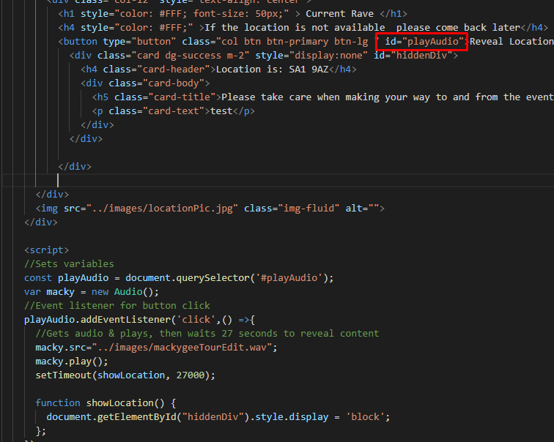
Fourth component
My fourth component was a music button that showed content after 27 second, the function is first initiated when the user click on the button which is done by an event listener, that event listener then runs a function that plays the audio, a timer is set to 27 seconds which will then go to the show location function which then displays content.

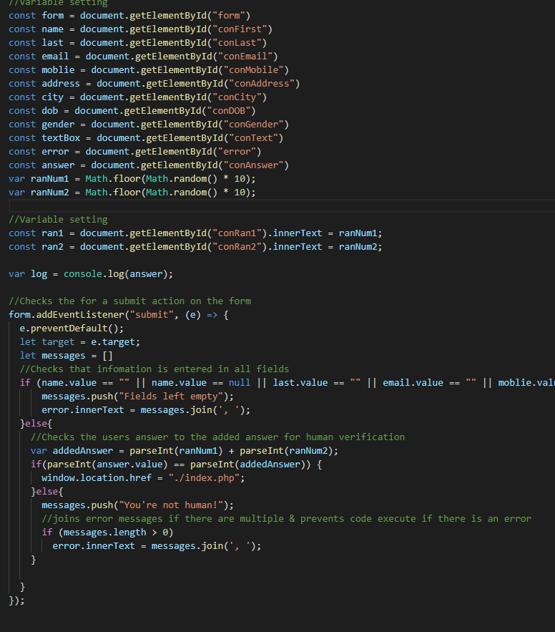
Fifth component

For the final component variables are first set which indicate a path to each individual element of the form, 2 random number are generated for the human verification which are then displayed on the webpage.

Then an event listener wait for the user to press the submit button, once pressed the preventDefault function is ran which stop the event from happening normally if a certain action is not met, a check is then done to see if each field is empty, if it gets past that it will then check the number that the user entered is correct.
Conclusion
In conclusion I am very happy with the website, it taught me more about java; arrays specifically and really helped me to gain a ‘coding way of thinking’, I will continue to develop the website after my assignment to gain further knowledge.

Bibliography
https://www.w3schools.com/ - Help with general HTML and JS

