Milena Andonova (2115611)
Lachezar Dimitrov (1915922)
Aysidora Asenova Stavreva (2030536
Sajor Jalloh (19208018)
Maya Angelova Boteva (2112590)

LECTURE: DR SADEQUE IMAM SHAIKH

British Airlines is leading flights provider in UK and also world wise. The company is created in 1974 after registration of the company board in to the government authorities. Currently the company is operating under the International Airlines Group (IAG). The British Airways is very popular and respectful brand name which has popularity with high quality flights and quality food and drinks provided during the flights. The company is proud with 100+ years service and 30 000 employees from all arounf the world.
Regrettably, the last few years haven't exactly been kind to the airlines. Even though it experienced profitability in 2019, the BA still felt the effects of Brexit and COVID-19. Comparing to other UK airlines, the BA actually manage to handle these difficulties more skillfully, so bravo to them. The current calendar year might be crucial in deciding the airline's future action plan. Luckily, there haven't been many safety incidents or accidents for the airline. Since the airline's founding in 1974, there have been three hull-loss incidents, two attempting to hijack makes an attempt, and just one fatal accident. British Airways has a strong reputation for safety and is frequently listed among the top 20 airlines in the world. This position strengthens British Airways' advantage over rivals.
The most important asset at any company's discretion is likely its human resources. British Airways is aware of the value of having a human resources
department, but they have run into some problems over time. Notable case from 2019 when commercial pilots went on strike and it resulted in a court case. Such incidents have an impact on both the airline's reputation and the retention of its staff. British Airways primarily generates sales revenues in the UK market, which can be an unsteady source of funding given how COVID-19 and Brexit have affected these sales. Since almost half of the organization's corporate profits come from home industries, initiatives to boost sales in international markets must be launched.
Being a sustainable brand is something British Airways has been strategically focusing on. They have been investing money in key areas of focus like growing their global network, enhancing advanced technologies, and enhancing the greater portion for both clients and staff. This sustainability policy includes environmental sustainable development as well. By making investments in fuel economy, the business has attempted to lower its carbon footprint. They aim to minimize careless fuel use and achieve maximum intentional use. By making investments in the digital revolution of all functional departments, the business has quickened its work rate. British Airways' emphasis on technological innovation has allowed it to increase organizational excellence. All systems, including sales, advertising, customer satisfaction, have already begun to see the benefits of these investment portfolios. Both the app and the website have been continued to improve.
Over through the centuries, British Airways has formed alliances with organizations like American Airlines, Iberia, or Finnair. These alliances have been productive, and they also assisted the business in better meeting the demands of its clients. As a consequence, it increased effectiveness and adapted the expansion of the business strategy for the organization.
British Airways reportedly has more than 183 international flights, spread all over 70 locations and 6 continents. BA's enormous market size constantly draws in new clients. The business consistently updates its lists of travel destinations. The company's primary market, nevertheless, continues to be the UK, and its flight contractors are London Heathrow airports.
British Airways has never been hesitant to invest in and use cutting-edge technological innovations. It has consequently assisted the business in increasing the effectiveness of numerous operations throughout the entire company, including marketing, sales, consumer experience, webpage, mobile phone app, etc. IAG, the parent organization of BA, is spending a lot of money on business intelligence, deep learning, and artificial intelligence. The goal is to expand the industry's technological prowess. The business does this to take advantage of technological advancement for its benefit and advancement.
Because British Airways is concerned about the environment, the business is using its assets, system, and impact to create a environmentally friendly brand. In reality, the company has undertaken numerous efforts, such as cutting fuel use, to lessen its carbon emissions. By the year 2050, BA hopes to have zero carbon emissions. In order to accomplish its objectives, the business has been fostering relationships with businesses that promote renewable and clean energy sources. Because of this, the business is bringing new, fuel-efficient aircrafts to the industry.
Over the years, British Airways has garnered numerous honors. Among others, the World's Brand Award in 2018, 2017, 2016, and 2014. It demonstrates the constant, comprehensive quality products of the business's goods and services. England Rugby, Tom Kerridge and Speedbird Café, Team GB and Paralympics GB, Dettol, Feast Box, KidZania, Flying Star and Comic Relief, i360, ELEMIS, Union Coffee, The White Company, Bremont, Hattingley Valley, Ozwald boating, Brewdog, Aston Martin, Ambassador Theatre Group, and numerous others have all benefited from sponsorships from British Airways.

Background of Organization

British Airways is the largest British airline company. It is formed 1974 after the British government joint together British Overseas Airways Corporation (formed 1939) and British European Airlines (formed 1964). 1987 the British government offered British Airways stocks on the World Stock Marked selling it to the public. Making the public major owner of the British Airways. 2011 British Airways merged with the Spanish Airline company Iberia, but both decide to keep their original names.

Type of organization

British Airways it is a Public Limited Company (PLC). Which means that the company shares are offered to the public and the public will profit or lose depends on the company performance.

Six Leaders

The company is leaded by six leaders which are:
Commercial Director
Chief Information Director
Director of Engineering
Director of Investment and Alliances
Director of People and Organizational Effectiveness

These six roles are responsible for all the executive decisions and are supported by 11 Directors.

Headquarters

The Headquarters are located near Heathrow in the London Council of Harmondsworth. The building is worth 200 million pounds and its name is Waterside. The building is located over 9000 square feet, it has a street with trees which separates the offices on your left-hand side and your right-hand side. The building it is holding over 4000 employees. Within the premisses of the headquarters you can also find supermarket, hairdressers, two caffes and a restaurant by the lake.

Mission and Vision

The Airline company as a world leading air transport provider on a first place is positioned the customer satisfaction. This is achieved by providing first-class on-board assistance to is customers. Food on board. First time flyers help, the stuff is always keen to help and assist to the people flying for a first time. Safety and security during every landing and take-off making sure that all their customers will reach their destination safe. Another feature that makes British Airways standing out from the other companies is their premium services. Where businesspeople and wealthy customers can find premium services and flights for up to 10000 pounds.

Types of Organizational Structure
Within the organizational structures we are able to see four types of structure. These four types are: Flat Structure, Hierarchy Structure, Span of Control and Chain of Command.

Flat Structure:
Is a structure where the organization have a layer of employees and one manager. This type of structure is used mainly in small organizations where are not many people employed. A flexible structure allowing manager and people to make quick decisions on the move. Usually, organizations with these types of structure employees could not be very qualified due to the direct management intervention. It also benefits from quick information transfer. The downside is miscommunication if any of the employees do not report on time.

Hierarchy Structure:
As the name suggests is a structure with many layers of employees. The structure is resembling a pyramid where on the bottom line you have the employees followed by supervisors, mangers, CEO and etc. This type of structure is usually used within larger organizations where teams and departments has to work together to achieve their mission. This type of structure is not the most flexible one because the information has to travel through the difference layers, it makes it well prepared. This makes the decision making slower but more accurate. In this type of structure employees are able to see the higher layers which motivates them for a career development.

Span of Control:
It is hierarchical type of structure where the employees are reporting to one specific manager. The information travels only one way which is only up.

Chain of Command:
It is a structure in which the information (the command) travels only one way which is down, and it is expected to be fulfilled. This type of structure is usually used in the military or any similar organization.

Due to its high number of employees and services provided, British Airways has adopted Hierarchy Structure.

Performance with Hierarchy Structure

As a performance we are going to look in to three specific years. For 2020 British Airways has gained a revenue of £3.9 billion. 2019 the company has gained an impressive revenue of £5.5 billion, which makes 70% more than the year 2020. 2021 the Corona Virus has started its breakout from China and after a few months has managed to spread all over the world. The out brake had a negative impact on all travelling companies due to the restrictions imposed from the governments and The World Health Organization. The restrictions were implemented with the purpose to gain control over the breakout. The impact for British Airways has been measured with £1.9 billion loss.

Communication Issues within Hierarchy Structure

The first issue is demotivation. It can persist especially when employee is assigned to work with another team. The problem is that the team will work fully synchronized and the new employee might struggle to adapt. In this case a leader needs to be assigned which could create situation of a conflict.
Another issue is the communication between departments and business units. In case only leader communicate between each other not employee to employee. This creates a biased decision making and slow decision making. The solution for this problem is to use an online communication platform which will serve to connect the employee and more often team building meetings.
The Hierarchy structure it is very time-consuming decision-making structure because the information must travel through all the different layers to reach the top and then travel all the way back with the leader decision. This makes it the most appropriate structure for organization with a Centralized Decision Making like British Airways.
Management British Airways
Definition:
Strategic capability is the adequacy and suitability of an organization's resources and competencies to survive and prosper.
Johnson, Scholes and Whittington (2006). Corporate Strategy Research, p. 117.
Organizational skills :
Dynamic capabilities are the organization's abilities to develop and change competencies to meet the needs of rapidly changing environments.
Johnson, Scholes and Whittington (2006). Corporate Strategy Research, p 132.
In 1916, Fayol published his greatest work - the book "Industrial and General Administration". In it, he reveals the five functions of management that every manager should perform.
The five functions are:
1.Planning;
2.Organizing;
3.Disposition;
4.Coordination;
5.Controlling.
Let's take a closer look at each this five functions of management.
Planning is the first function of management. Planning is an attempt to foresee the near and far future of the organization and to determine measures necessary to transition to this new state.
At the heart of the planning process is the development of a formal action plan. This plan should rest on the resources available to the organization and on the likely trends that may occur in the future.
He believes that planning is one of the most important and difficult tasks for management, in which the entire organization must take an active part.
The ideal plan should combine:
purposefulness - the general plan to be supported by the separate plans of the smaller structures and units in the organization;
continuity - planned actions to be considered as elements of a continuous development process;
flexibility - the plan takes into account possibilities for the occurrence of unexpected circumstances;
accuracy - the plan should be as accurate as possible.
Forecasting is also important, without which planning is impossible.
Organizing is the second function of management. Organizing is the activity by which the company obtains everything it needs for its functioning - raw materials, tools, capital and personnel.
Fayol pays serious attention to the so-called "organizational structure" and assumes that the form of the organization depends mostly on the amount of personnel. As the number of
as the number of people employed increases and the variety of functions performed in the organization increases, the need to control people's work increases accordingly.
All this leads to the famous organizational pyramid or hierarchy model.
Disposition is the third function of management. It aims to achieve an optimal effect of the efforts of the workers, in the interest of the whole organization.
Success in management depends on the combination of personal qualities and knowledge of general principles of management. According to Fayol, a manager should remember and follow these rules:
To try to get to know his subordinates better;
To combat incompetence;
To be aware of all important details regarding the contracts concluded between the company and the employees.
To set a personal example that is good;
To revise the organization periodically;
to organize meetings together with the leading associates, to which he gives guidelines for action and emphasizes the main priorities of the company;
Not to get into too many small details;
To strive to create one
a suitable working atmosphere among the collective to stimulate the unity of the staff, the energy, the initiative and the loyalty of the workers.
With regard to the function of “Ordering”, Fayol places great importance on the importance of motivation as well as the delegation of rights to staff. Fayol believes that:
"The leader can stimulate the initiative of his subordinates by delegating rights to them, thereby providing them with opportunities to fully realize their potential and skills."
Coordination is the fourth function of management. Coordination aims to ensure optimal harmony between the various activities of the organization.
Good coordination makes work easier and makes the organization function more successfully. This function balances the different aspects of the work, for example to observe proportional expenditure of funds in view of the available financial resources, production needs, inventory and market demand.
For the purposes of good coordination, daily meetings are recommended.
Controlling is the fifth function of management. Controlling is designed to ensure compliance between everything that happens in the organization with pre-determined standards, principles and work plans.
In this context, controlling aims to detect weaknesses and errors weaknesses in the work, to neutralize them and not give them the opportunity to manifest again in the future. As Fayol writes:
"Control affects everything - products, people and work operations."
Manager mast to be like Sean Doyle BA CEO
• A person who achieves results through the efforts of other people. It purposefully unites their actions to achieve excellent professional results.
• Be responsible for the actions and results of other people's work. This is especially important now in the time of financial crisis after Covid-19.
• Very clannishness motivates subordinates. So it gets the best out of them to realize the goals of the organization.
• Responsibility for the organization's results is always borne by the manager. In good times and bad, he must be able to take responsibility, thus showing his high professionalism.
• Makes decisions (shakes up his executive team, creating new operations, technologies and customer service). With the new changes in the team, it aims to renew it, to find solutions after the crisis during the pandemic. He appoints new people:
1. new person for head of digital and transformation officer Dirk John.
2. a new person for chief customer officer Calum Lamming.
3. new person for chief Technical Officer Jason Mahoney.
4. a new person for the chief of general operations.
With these 4 new positions that he reveals, he aims to find a way out of the crisis after the pandemic and renew the company with new ideas and solutions.
Problems
• New goals and social responsibility in a time of financial crisis after the global pandemic. Company policy must be adapted to the new situation. To seek new paths is to set new achievable goals.
• Competition and strategies of companies in the global economy must be adapted to the constantly changing world economic situation. The company and its policies must be flexible to cope with the new challenges of the global market.
• Management of changes and their use for the successful management of the company.
• Total Quality Management is British Airways' management style.
• Organizing perfect production and customer service because this is the key to success for the airline.
• The influence of information technologies on management in all aspects of modern business, they are widely represented. Without them, it is unthinkable.
• Motivate staff without using fear as a means of influence to get the best out of them.
• Teamwork and quality of work are an integral part of successful business in a multicultural environment and in the global market.
• Management in the non-production sphere and the sphere of services of the air carrier.
British Airways Management stile
• Total Quality Management is the trademark of British Airways management. This is their style at every managerial level.
• Quality is important to the company because it ensures security, safety and comfort for customers and employees throughout the process of their relationships and for the teams between them.
• Strict rules for safety and quality service, safety management, which is the basis of all rules for working in the company. His excellent reputation is due to him.
• Excellent IT management that underpins British Airways' successful business in the 21st century.
• Global management because the company is global and operates on the world market. Without it, successful development is unthinkable.
• Flexible management, which is mandatory because it is required by the rules of the world market and the constantly changing conditions in the sphere of global business. This ensures the success and prosperity of British Airways.
•Risk assessment ensures the safety of flights and service.
Everything listed up to here makes the company successful and profitable in the global aviation market.

Table of Contents
Introduction 2
Relationship Between Organisational Structure and Organisational Performance 3
Task and Skills to Increase Operational Effectiveness 3
Strategies of Leadership to Motive Staff Members to Improve Performance 4
Promote Teamwork 4
Opportunities for Growth and Development 5
Democratic Leadership Theory 5
Factors Influencing Group and Team Behaviour 6
Behavioral Theory 6
Conclusion 7
References 8

Introduction
British Airways has been the official flag carrier of the United Kingdom for more than a century, bringing people to their destinations (O’Neill, 2018). The airline connects Great Britain to the rest of the world and the rest of the world to Great Britain. The airline strives to deliver excellent service while putting its customers and the environment first (Li and Cui, 2018). Additionally, this report will analyse the relationship between organisational performance and structure by identifying the skills and tasks of the manager to increase the effectiveness of British Airways operations. Further, this report will examine the Leadership strategies and styles which can inspire and motivate British Airways staff members to improve performances. This report will also investigate factors which influence Group and team behaviours.

Relationship Between Organisational Structure and Organisational Performance
An organisational structure is demonstrated by a system that defines how certain duties are delegated to achieve an organisation's goals. It has been shown that an organisation’s structure influences the performance of its personnel. On the other hand, a badly constructed organisational structure results in low productivity, limited task delegation, few incentives, and centralised decision-making (Rehman et al., 2019).
In contrast, British Airways has a “flat structure,” indicating that the corporation has few management levels but a wide range of duties. The airline's divisional structure stems mostly from its customer-centric nature (Berberoglu, 2018). Due to its flat organisational structure, British Airways has a better awareness of its own operational processes and the performance of its personnel. British Airways can rapidly determine which workers actively contribute to the company’s performance and which play a more passive role according to the organisation’s structure. This organisational structure has also helped British Airways boost its customer relationships (Ali et al., 2018).

Task and Skills to Increase Operational Effectiveness
British airways managers can increase the different tasks and skills to increase the operations of the firm mentioned below:
Risk assessment and mitigation are essential factors to consider while creating new goods or launching new enterprises (Gekara and Thanh Nguyen, 2018). British Airways operations managers need to conduct a study of specific aspects of their organisation’s procedures in order to identify potential obstacles and give remedies in the event that unfavourable situations materialise. The manager must be capable of analysing the elements that affect British Airways’ operations and developing plans to reduce the risks connected with the organisation’s most vital activities (Martin et al., 2019).
The majority of an operations manager’s responsibilities centre upon employee interactions. This necessitates that they are able to connect successfully with other senior management professionals, as well as internal and external stakeholders (Ali et al., 2018). To handle complex interpersonal interactions with other people, a British Airways operations manager must be able to connect, listen, and communicate successfully with their colleagues on both a professional and personal level (Efthymiou et al., 2018). The operations manager of British Airways is responsible for demonstrating tolerance and understanding for the company’s employees and customers, given the many cultural backgrounds of the company’s employees. Additionally, the British Airways manager should be able to settle conflicts and find answers to problems that emerge between employees and senior management (Li and Cui, 2018).

Strategies of Leadership to Motive Staff Members to Improve Performance
Effective Leadership strategies can motivate and inspire British Airways staff members to improve their performance by promoting teamwork and providing effective opportunities (Manzoor et al., 2019).

Promote Teamwork
British Airways’ management must emphasise teamwork or collaboration more to increase efficiency. Employees perceive a deeper relationship with the organisation as a whole and with their colleagues. This may also be achieved by engaging in team meetings where members speak and get to know one another (Alrowwad and Abualoush, 2020).

Opportunities for Growth and Development
Members of the team believe that as they grow their knowledge and abilities, the team benefits more (Alrowwad and Abualoush, 2020). Leaders at British Airways should create opportunities for the personal and professional development of their people in order to inspire and motivate them to generate exceptional results. These opportunities might take the shape of more training, the development of challenging goals, or a meeting with British Airways’ management, and they should be customised to the specific requirements of each employee (Wiboonrat, 2020).

Democratic Leadership Theory
In this manager, British airways need to adopt a democratic leadership style in order to motivate its team members. Democratic leadership, often known as participatory management, is a method of leadership that actively involves those being led. Staff members are often asked for recommendations and ideas by democratic leaders (Alrowwad and Abualoush, 2020). They promote discussion and participation in the decision-making process. Democratic leaders encourage employee participation in decision-making and, in many instances, withhold from making key decisions without their input first. In the decision-making process, democratic leaders utilise inclusiveness as a method to enhance staff morale (Manzoor et al., 2019). This guarantees that employees have a say in how the company is managed. This style of leadership helps British Airways to effectively motivate and inspire its employees, hence helping the organisation to meet its performance objectives (Wiboonrat, 2020).

Factors Influencing Group and Team Behaviour
The factors influencing the group and team behaviour are human resource management issues over the last four years that have posed the greatest danger to its competitive position in the aviation industry. Despite the airline's technical leadership, several management changes, for instance, have not enhanced the airline’s competitiveness (Schmutz et al., 2019). According to some observers, such modifications are unnecessary and unjust to employees. Changes to the management structure, for instance, contributed to tension between managers and their workers. Consequently, the airline had several strike actions during this time period. Strikes by employees have a significant influence on the airline’s financial performance and operational efficiency (Yu and Liang, 2021).
In this manner, British Airways need to consider that the more employees realise and accept the necessity for organisational transformation, the more positively they will respond to the change process (O’Neill, 2018). British Airways personnel need to invest in commercial activities and management stability drivers. In addition to their financial stability and professional growth, keep in mind that their abilities may have a substantial impact on their feeling of self, a sense of purpose, self-confidence, and professional progression. Changes in the workplace may have a substantial impact on both the personal and professional life of the employees (Wiboonrat, 2020).

Behavioural Theory
British Airways must apply behavioural theory to properly manage the elements that impact the behaviour of its workers and employees (Yu and Liang, 2021). Behavioural management theory is often known as the human relations movement because it emphasises the interaction between employees and their employers. Behaviour theorists believed that the key to a more productive workplace was a deeper understanding of human behaviour at work, including motivation, conflict, expectations, and group dynamics (Schmutz et al., 2019).

Conclusion
British Airways are one of the aviation firms in the UK which operate for more than 100 years. However, this report has examined the link between organisational performance and structure by identifying the managerial abilities and responsibilities that have to boost the efficiency of British Airways’ operations. This research has also analysed the Leadership techniques and styles that have to inspire and encourage British Airways employees to enhance their performance. This report has also explored the elements that impact group and team dynamics.

Introduction This reflective report focuses on the point the fifth point of the group assignment. It analyses the factors that influence the group and the team behaviors, using British Airways, which is the 2 company of choice in the group assignment. The British airways employees' team and group are influenced by different factors affecting their efficiency as well as productivity as the group. From British Airways, factors that include the formal leadership, roles of the teams, motivational factors such as the incentives, promotions, bonuses; both financial and non-financial, sizes of the group or teams, cohesiveness, norms of the groups, the working environment, organization structures as well as communication influences the group and team behaviors (Robbins et al., 2017). These can be discussed below: Formal leadership Formal leadership affects the behavior of the groups and teams at British airways Airlines Company. The common titles that include the department managers, general manager, managing directors, and supervisors are all coordinated such that they can collect the view and perception of the British airways employees' teams and groups and scale to the organization (Ayoko and Ashkanasy, 2019). Many times this is not possible. British Airways use autocratic leadership; this is where the leaders make decisions without consulting their teams. On many occasions, the teams are unsatisfied and not motivated that their ideas are not incorporated into the decision-making process by the company. This has caused the ineffectiveness and poor retention of the teams and groups at British airways (Buchanan and Huczynski, 2019). This paradigm shift in company culture is partially attributable to the leaders themselves waking up and exhibiting behavior that inspires people to follow it in their unique way. Apple, Facebook, and Google are just a few examples of well-known corporations that have leaders at the head who inspire and encourage innovation at every level. Because of this efficient mode of leadership, their teams and groups can flourish through innovation and expansion. Where British airways could adopt democratic leadership, teams would be mostly involved in decision-making and motivated. 3 Roles of the teams/ groups This is the second factor that influences the team or the group behavior in British airways Airlines Company. The teams' roles are made formal in British airways Airline Company. They are also assigned based on the individuals' strengths and specialization. This increases team members' ability to understand what needed, hence higher productivity (Chitale et al., 2019). The British company also considers four main fundamentals in the teams. This includes the tea leaders who ensure that tasks and the responsibilities given for the team is achieved without compromise; he/ she also solve conflicts and ensure a positive relationship among the team members. The teams also have facilitators and a coach that guides the team members on how the set plan's objectives of both the company and the team can be achieved (Bratton, 2020). over and above, British airways assign the team roles based on the skills, knowledge, and experience s. where the teams are given roles that they are familiar with, have skills and knowledge and interest, then they are likely to be motivated, work efficiently and increase productivity. Motivational factors such as incentives, promotions, bonuses, appreciation, and recognition The motivation factors that include incentives, promotion bonuses, and other financial and nonfinancial incentives also influence the teams and the group behaviors at British airways (Wilson, 2017). Recognition and gratitude are two of the most important components British airways use to motivate people in an organization. Providing praise and recognition to employees makes them feel loved and appreciated, reinforces their outstanding performance, and encourages them to continue the behaviors that lead to their good performance. When an employee's action is met with a positive response, it is more likely that the employee will continue to behave in this manner and remain motivated at work. Additionally, British Airways also provides bonuses and promotions to the teams and the individuals in the teams; this makes retention possible, reduces team resistance, 4 and motivates the teams (Kondalkar, 2020). These can be summarized as recognition and rewards, professional development to motivate the team productivity, health and wellness, bonuses and raises, fun gifts, and additional time- off. Cohesiveness Where the team or the group is not cohesive, it will tend to be ineffective. This also influences the behavior of the teams or groups on the British airways (Karami, 2017). When everyone feels; like the overall success of the team and the group work is contributed by everyone, they feel motivated, less conflicts between the teams, and motivated towards achieving the common team or group goal. Due to the team cohesiveness of the British airways groups, they feel more positive about the group tasks. It also leads to group members' trust and similarities (Lyubovnikova et al., 2017). Due to everyone's shared goals, there is a strong sense of camaraderie among the group members. Group cohesiveness, or social cohesion, makes the British airways' teams relate freely. A stronger sense of team cohesion at British airways has contributed to an increase in workplace success, job satisfaction, self-esteem among team members, and a reduction in anxiety. Team cohesion has enabled the group/ teams to work together toward accomplishing a common objective. Norms of the groups The group and team norms of the British airways teams are guided by the surrounding company culture, rules, and policies. The behavior of the teams or the groups is influenced by the attitudes and values of the groups, which are all components of group norms. These are written or spoken guides on how the team members work effectively, collaborate effectively and interact; they control behavior as they agree on the rules and standards of the behavior by groups/teams. Examples are the British airways performance norms on how the group members should perform 5 on the given tasks and the type of results or output required by the company (Wilson, 2018). Other norms include appearance norms that guide the team members on their physical appearance and resource allocation norms that focus on allocating resources such as raw materials and time.

APPENDIX

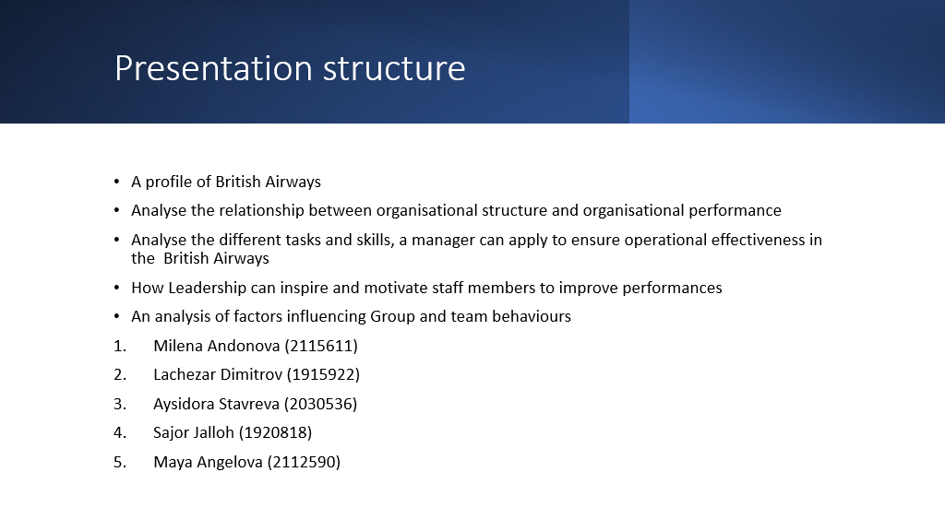
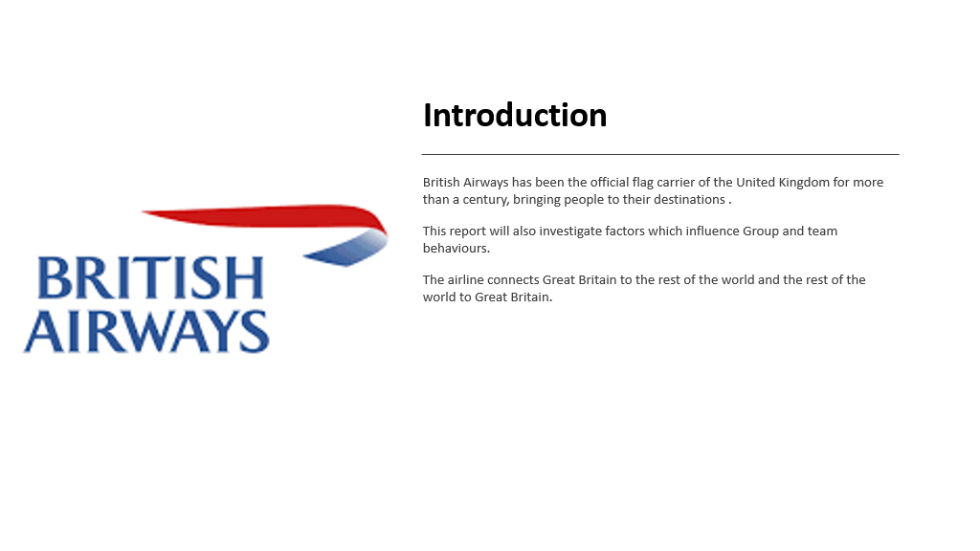
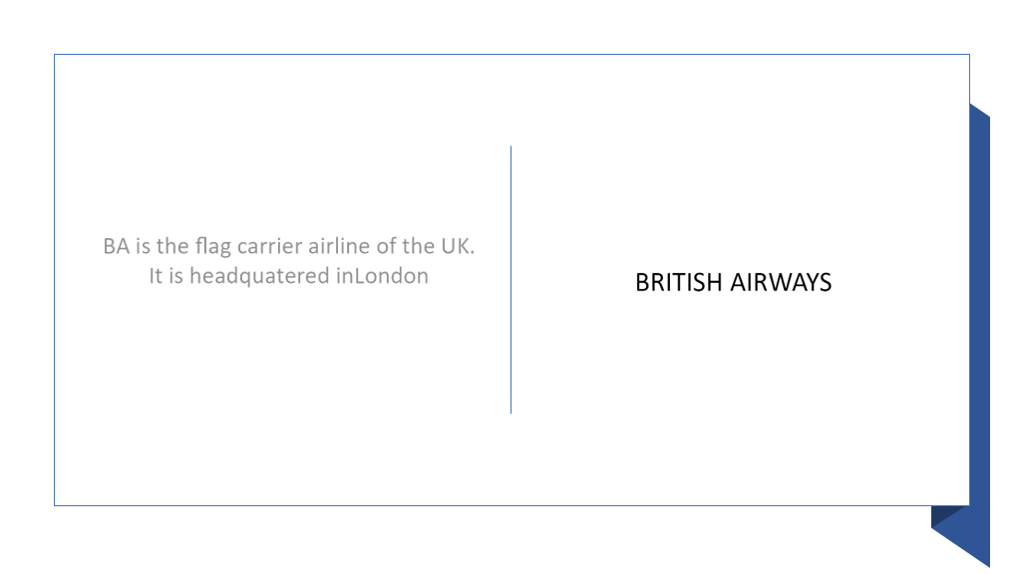
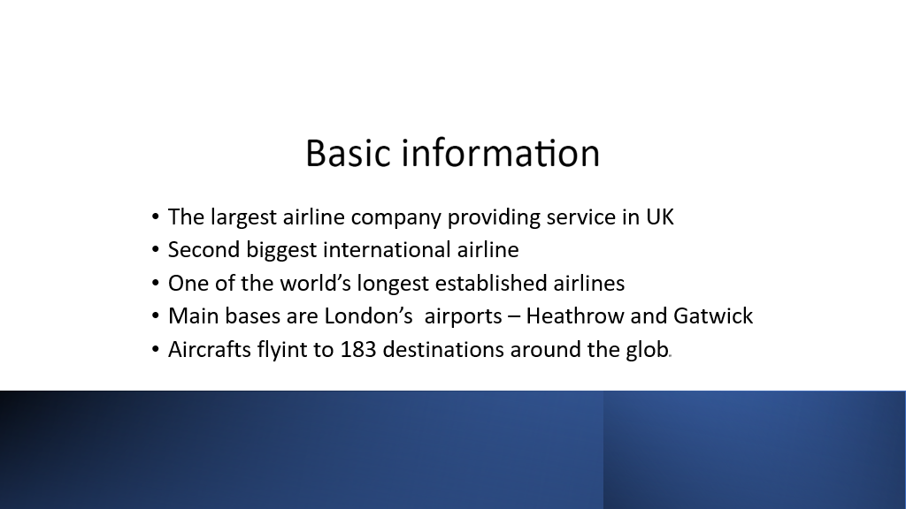
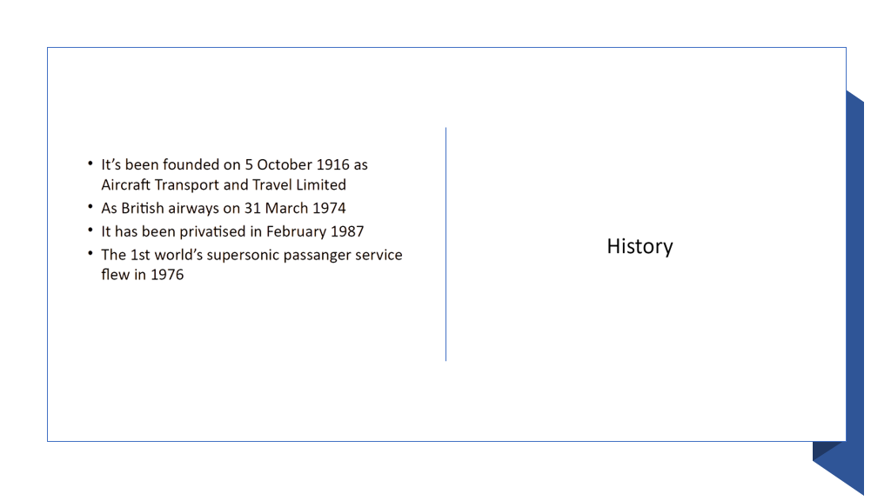
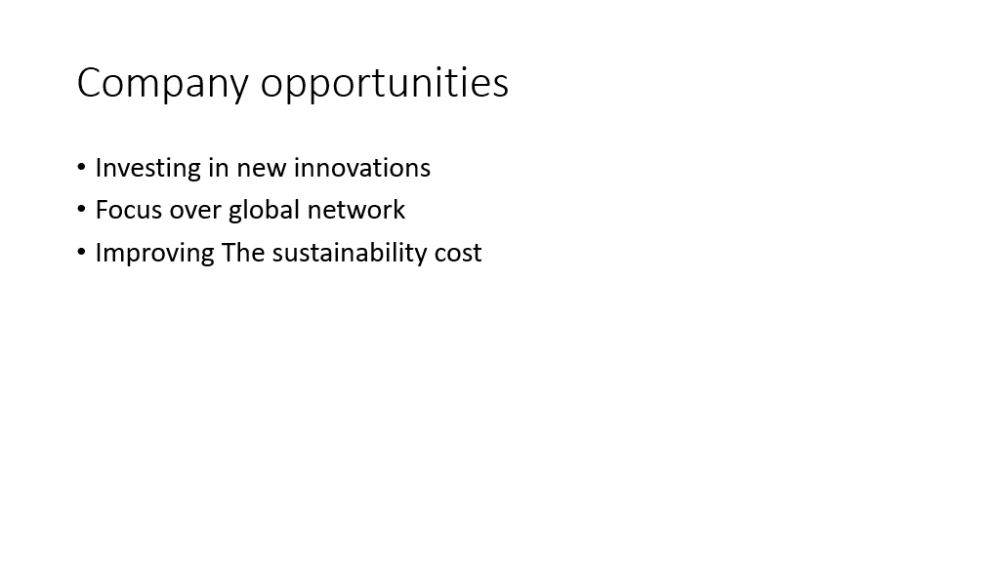
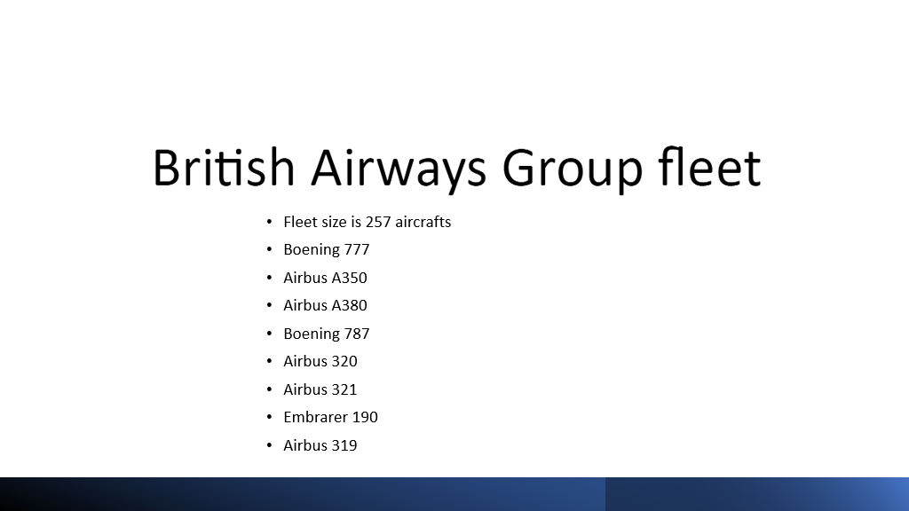
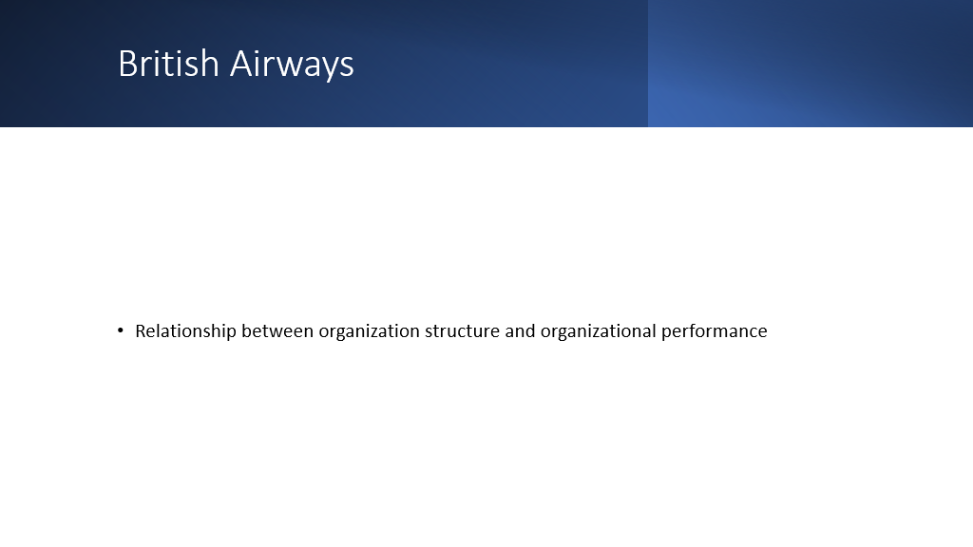
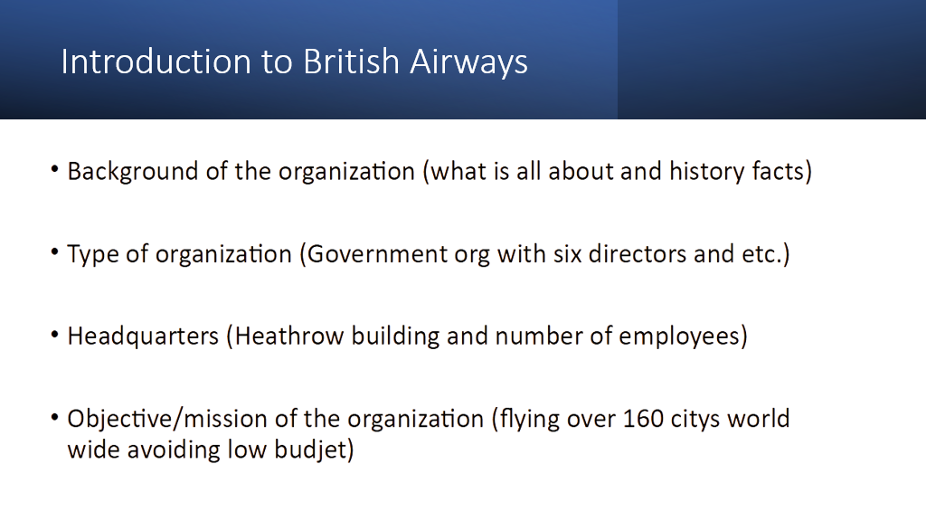
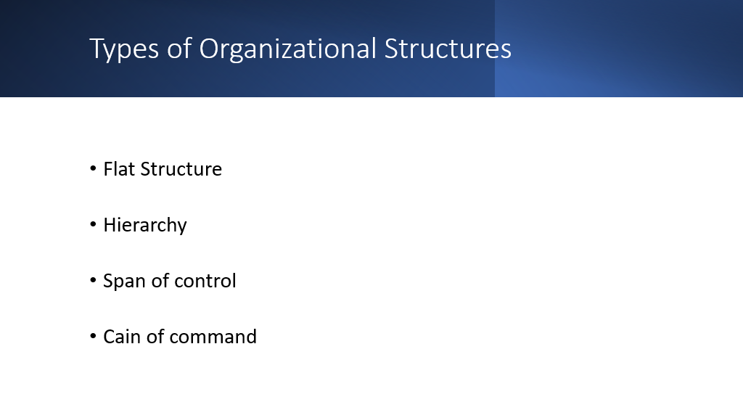
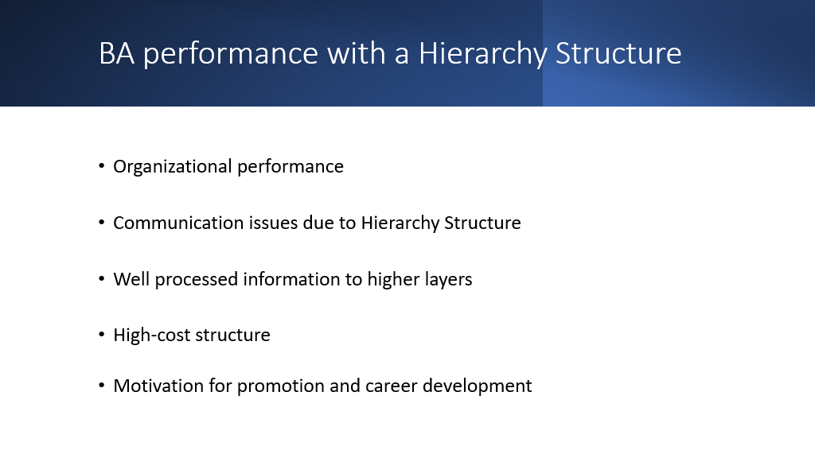
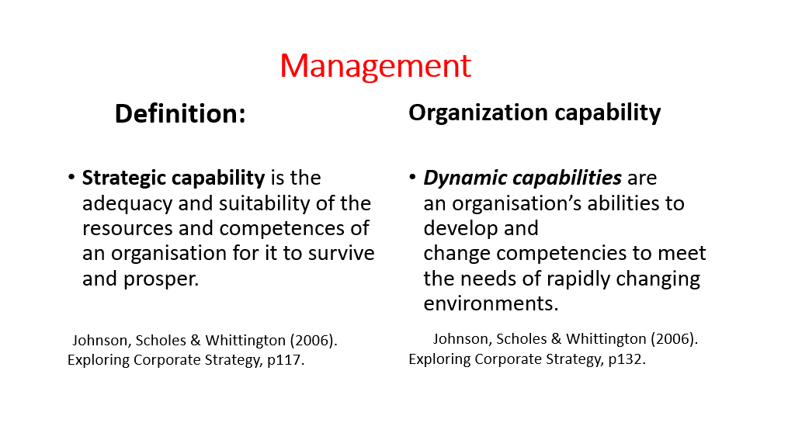
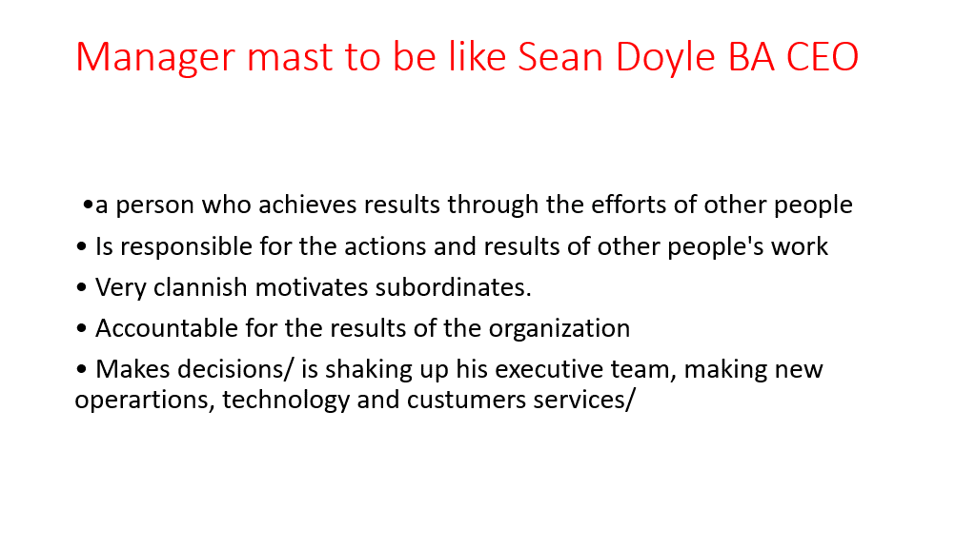
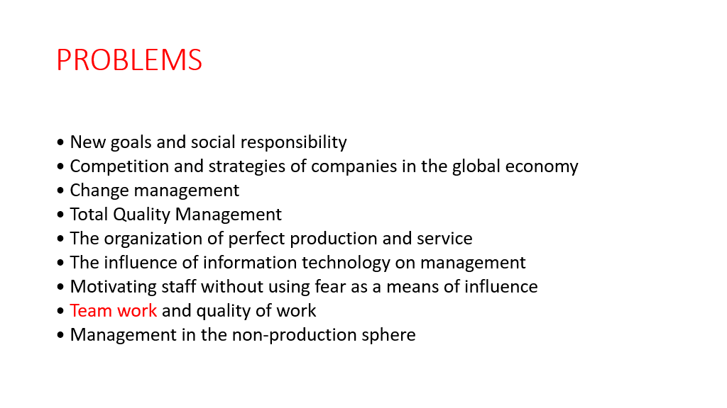
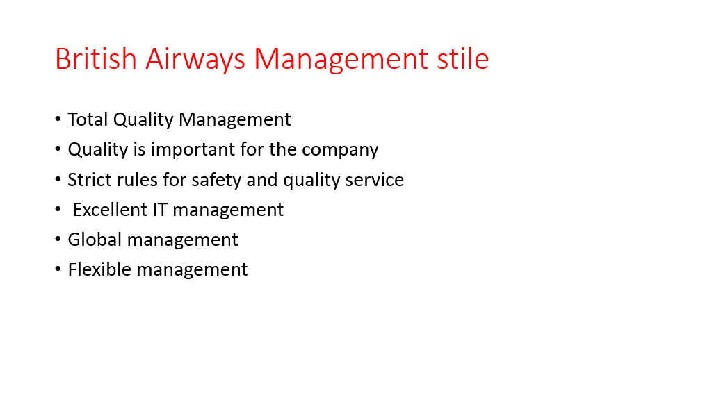
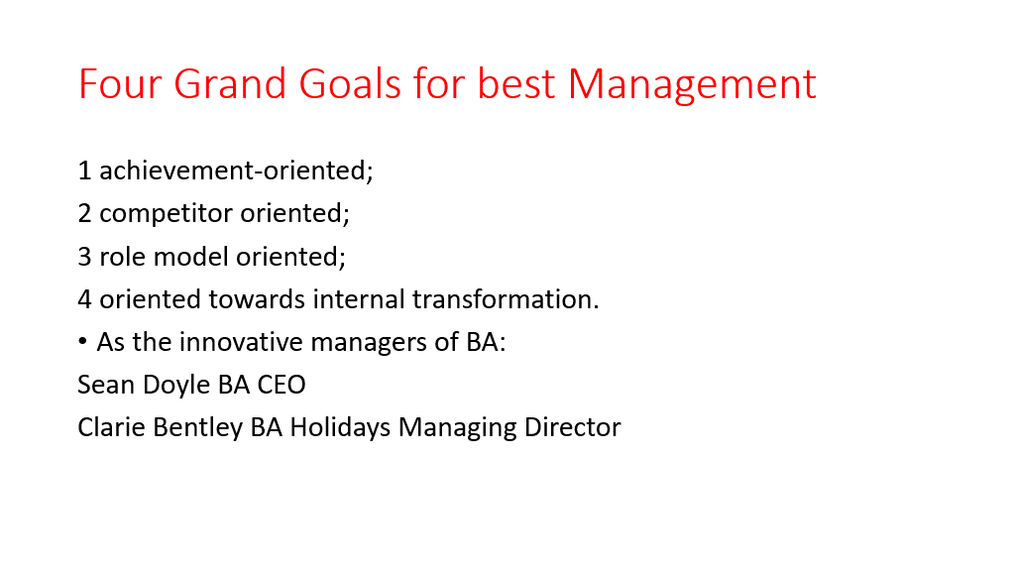
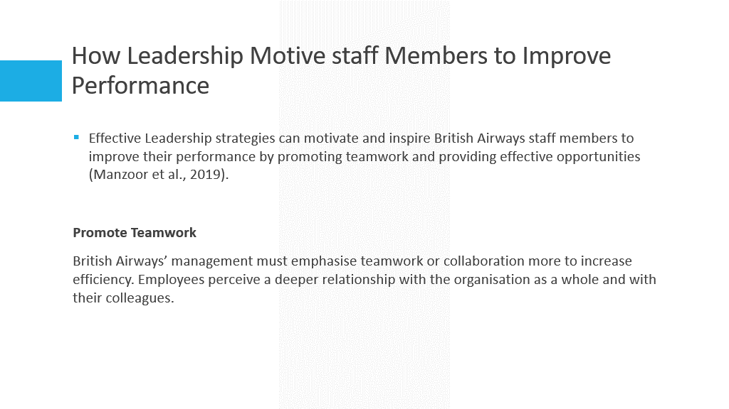
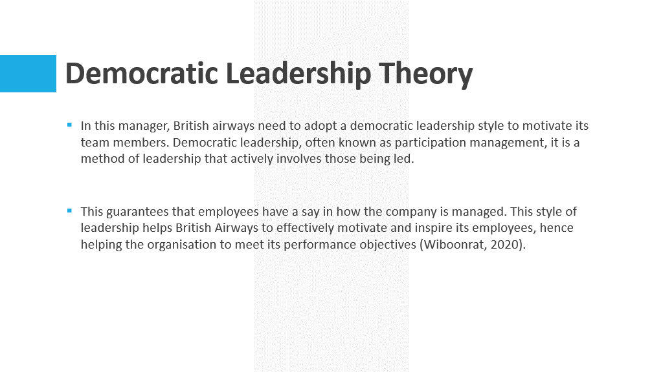
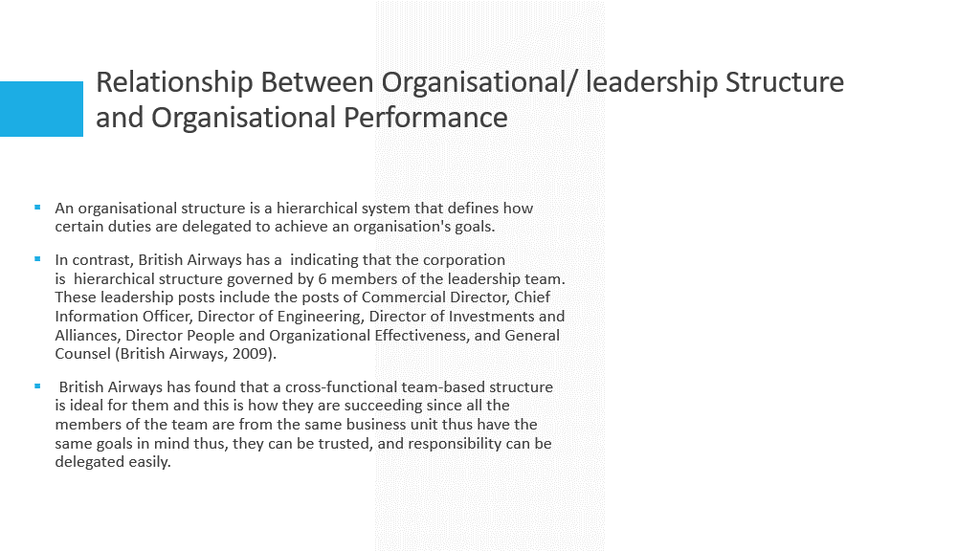
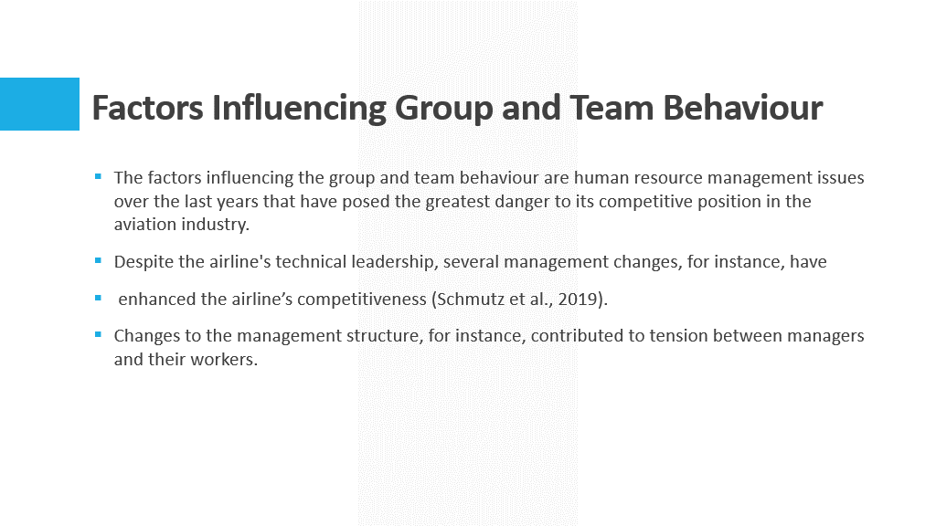
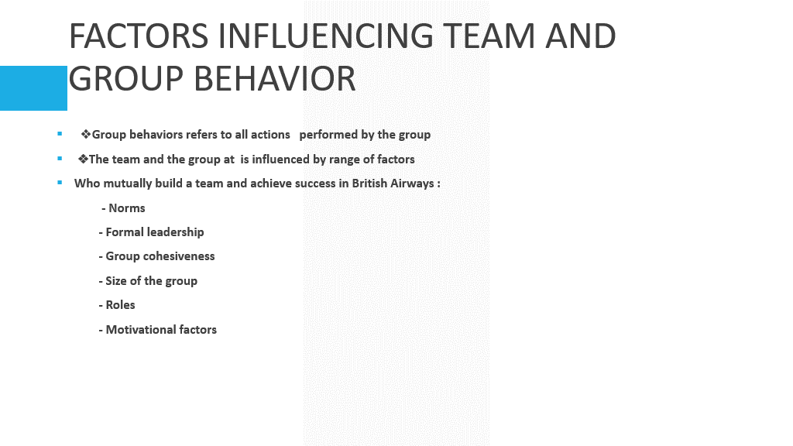
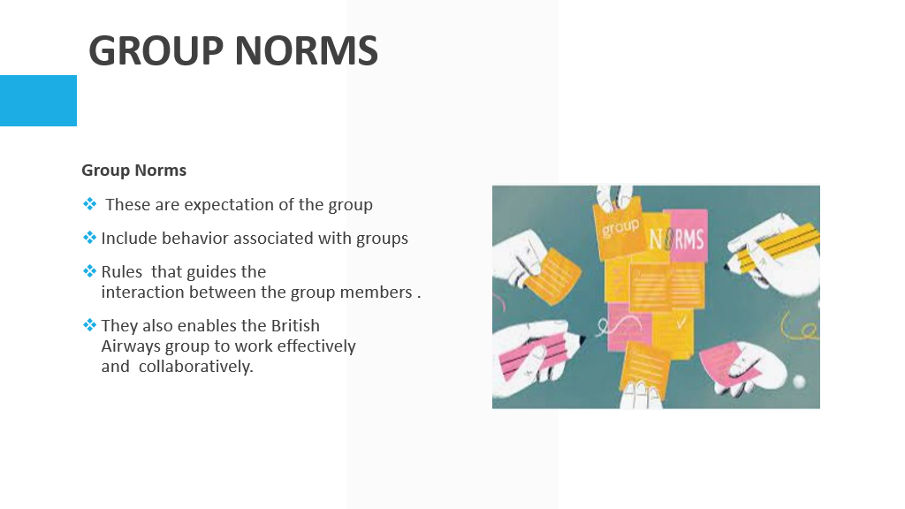
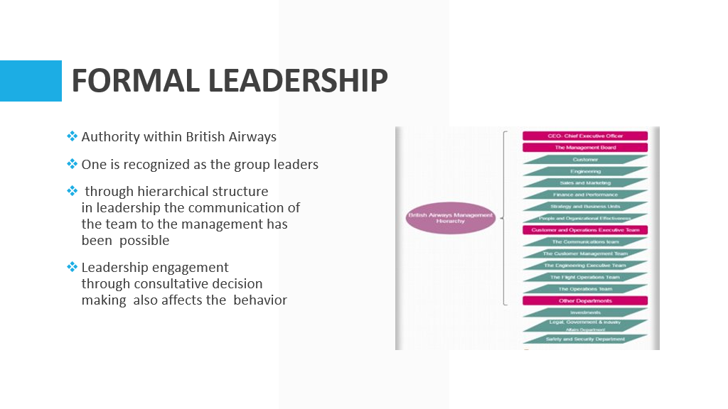
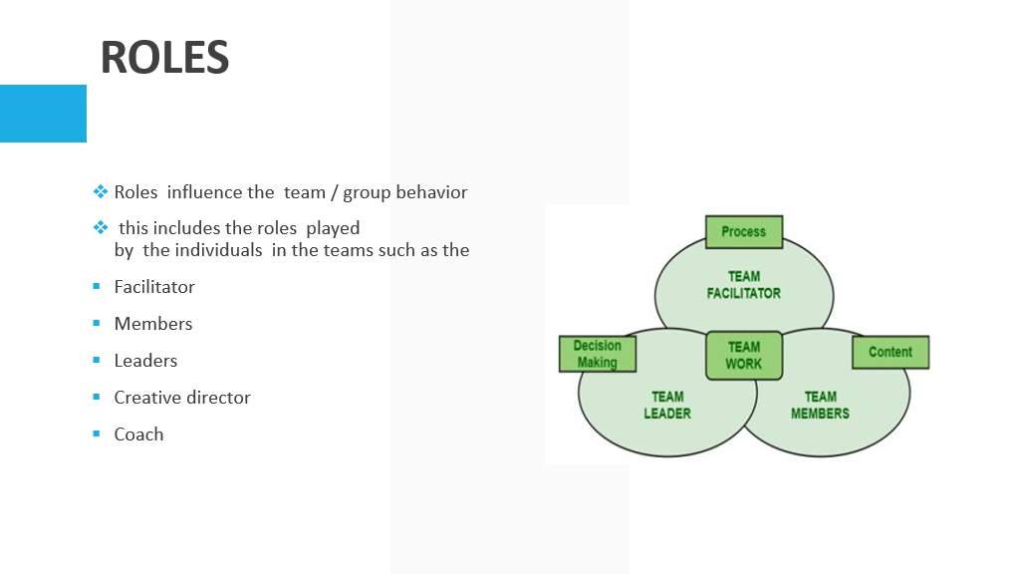
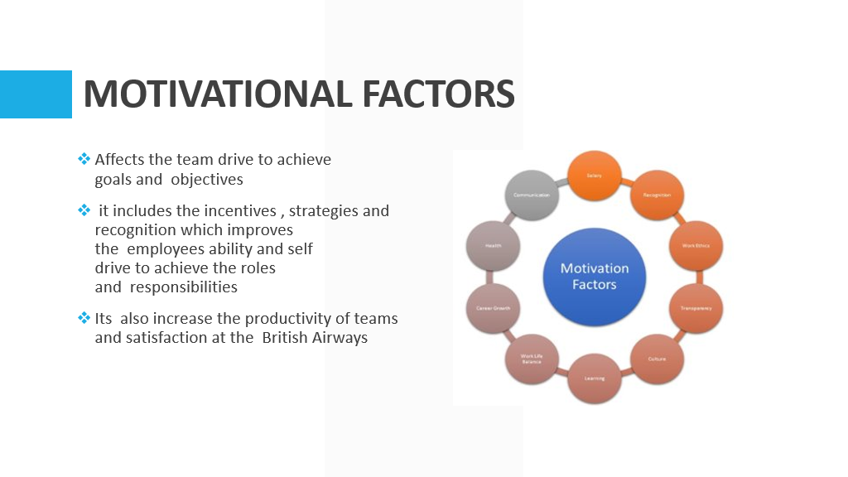
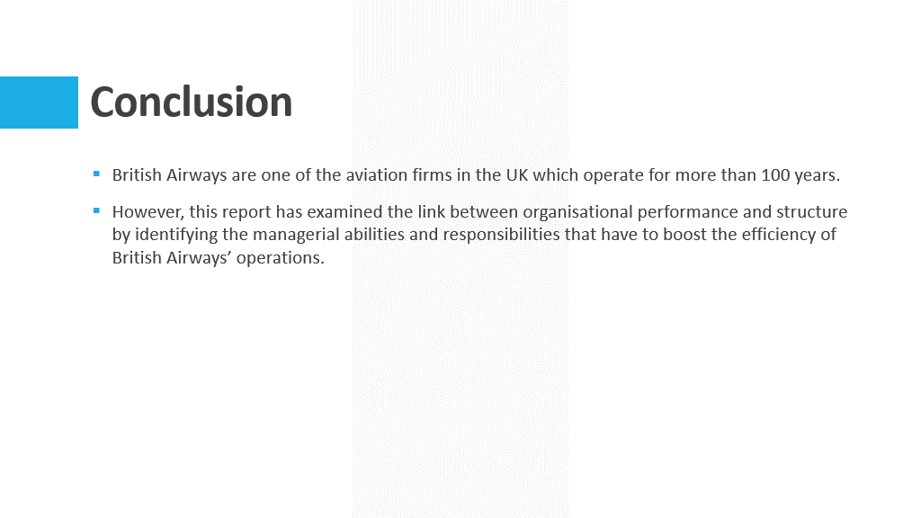

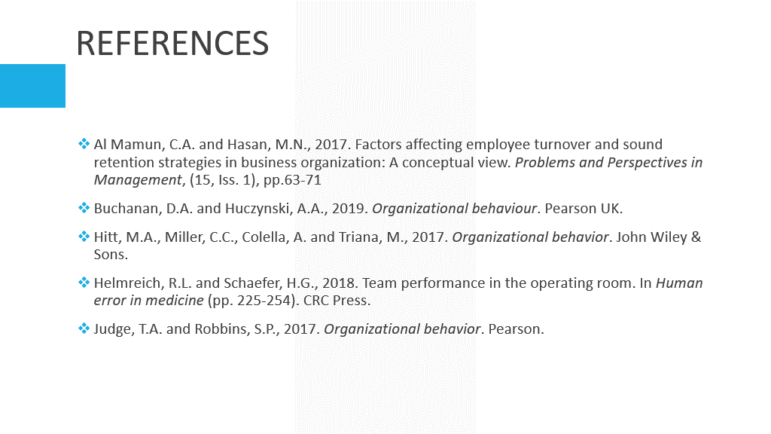
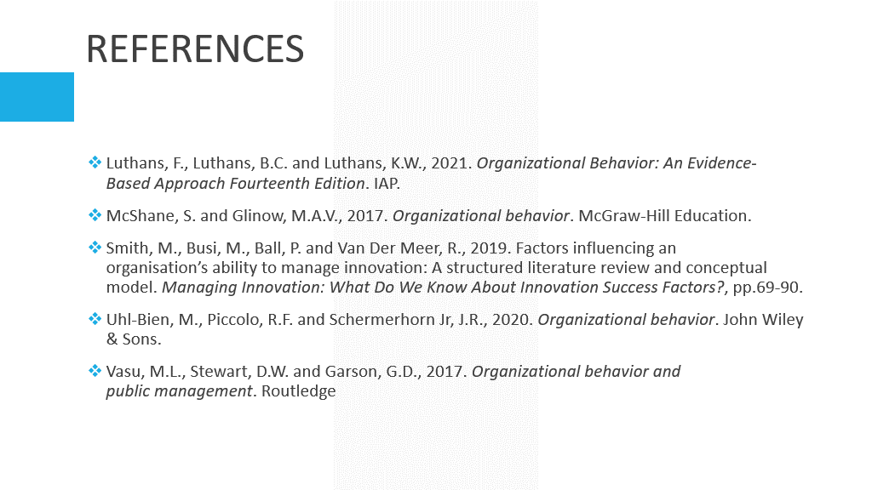
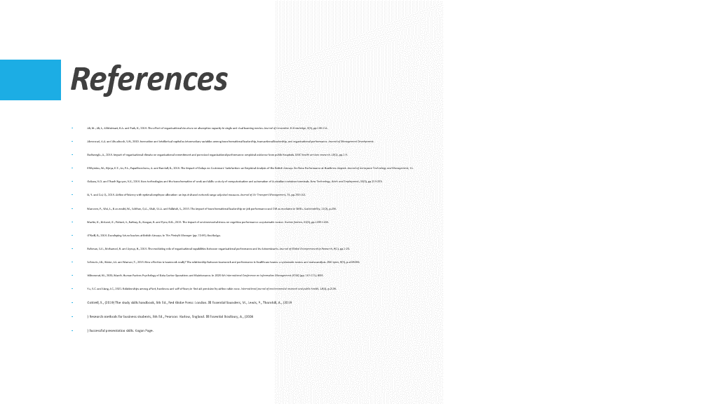
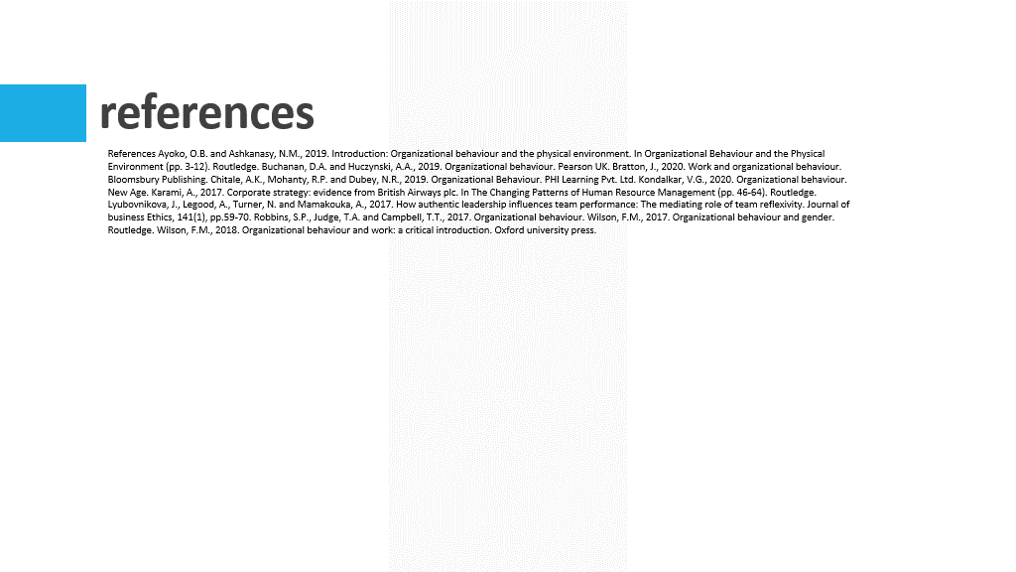

References
Ali, M., Ali, I., Al-Maimani, K.A. and Park, K., 2018. The effect of organisational structure on absorptive capacity In single and dual learning modes. Journal of Innovation & Knowledge, 3(3), pp.108-114.
Alrowwad, A.A. and Abualoush, S.H., 2020. Innovation and intellectual capital as intermediary variables among transformational leadership, transactional leadership, and organisational performance. Journal of Management Development.
Berberoglu, A., 2018. Impact of organisational climate on organisational commitment and perceived organisational performance: empirical evidence from public hospitals. BMC health services research, 18(1), pp.1-9.
Efthymiou, M., Njoya, E.T., Lo, P.L., Papatheodorou, A. and Randall, D., 2018. The Impact of Delays on Customers' Satisfaction: an Empirical Analysis of the British Airways On-Time Performance at Heathrow Airport. Journal of Aerospace Technology and Management, 11.
Gekara, V.O. and Thanh Nguyen, V.X., 2018. New technologies and the transformation of work and skills: a study of computerisation and automation of Australian container terminals. New Technology, Work and Employment, 33(3), pp.219-233.
Li, Y. and Cui, Q., 2018. Airline efficiency with optimal employee allocation: an input-shared network range adjusted measure. Journal of Air Transport Management, 73, pp.150-162.
Manzoor, F., Wei, L., Nurunnabi, M., Subhan, Q.A., Shah, S.I.A. and Fallatah, S., 2019. The impact of transformational leadership on job performance and CSR as mediator in SMEs. Sustainability, 11(2), p.436.
Martin, K., McLeod, E., Périard, J., Rattray, B., Keegan, R. and Pyne, D.B., 2019. The impact of environmental stress on cognitive performance: a systematic review. Human factors, 61(8), pp.1205-1246.
O’Neill, B., 2018. Developing future leaders at British Airways. In The Photofit Manager (pp. 72-89). Routledge.
Rehman, S.U., Mohamed, R. and Ayoup, H., 2019. The mediating role of organisational capabilities between organisational performance and its determinants. Journal of Global Entrepreneurship Research, 9(1), pp.1-23.
Schmutz, J.B., Meier, L.L. and Manser, T., 2019. How effective is teamwork really? The relationship between teamwork and performance in healthcare teams: a systematic review and meta-analysis. BMJ open, 9(9), p.e028280.
Wiboonrat, M., 2020, March. Human Factors Psychology of Data Center Operations and Maintenance. In 2020 6th International Conference on Information Management (ICIM) (pp. 167-171). IEEE.
Yu, Y.C. and Liang, J.C., 2021. Relationships among affect, hardiness and self-efficacy in first aid provision by airline cabin crew. International journal of environmental research and public health, 18(4), p.2108.
Kassem, R., Salama, A. and Ganepola, C.N., 2022. CSR, credibility, employees' rights and legitimacy during a crisis: a critical analysis of British Airways, WizAir and EasyJet cases. Employee Relations: The International Journal, (ahead-of-print).
Tiemeyer, P., 2021. Cabin Crew Conflict: The British Airways Dispute 2009–11 by Phil Taylor and Sian Moore. Labour/Le Travail, 87(1), pp.208-210.
Hamawandy, N.M., Ali, R., Bewani, H.A.W.A., bdulmajeed Jamil, D., Rahman, S.K. and Othman, B.J., 2021. The financial Impacts of (COVID-19) on financial reporting quality Airlines Companies: British Airlines. Journal of Contemporary Issues in Business and Government Vol, 27(2).
Bennett IV, E.R. and Soylu, A., 2021. Overcoming the Obstacles in Corporate Change Management. Journal of Business and Social Science Review Issue, 2(2), pp.23-29.
1.Fayol, H. Industrial and General Administration.p84
Reviewed Work: General and Industrial Management by Henri Fayol
Review by: Nancy M. Carter
The Academy of Management Review Vol. 11, No. 2 (Apr., 1986), pp. 454-456 (3 pages)
Published By: Academy of Management
6
Ayoko, O.B. and Ashkanasy, N.M., 2019. Introduction: Organizational behaviour and the physical
environment. In Organizational Behaviour and the Physical Environment (pp. 3-12).
Routledge.
Buchanan, D.A. and Huczynski, A.A., 2019. Organizational behaviour. Pearson UK.
Bratton, J., 2020. Work and organizational behaviour. Bloomsbury Publishing.
Chitale, A.K., Mohanty, R.P. and Dubey, N.R., 2019. Organizational Behaviour. PHI Learning
Pvt. Ltd.
Kondalkar, V.G., 2020. Organizational behaviour. New Age.
Karami, A., 2017. Corporate strategy: evidence from British Airways plc. In The Changing
Patterns of Human Resource Management (pp. 46-64). Routledge.
Lyubovnikova, J., Legood, A., Turner, N. and Mamakouka, A., 2017. How authentic leadership
influences team performance: The mediating role of team reflexivity. Journal of business
Ethics, 141(1), pp.59-70.
Robbins, S.P., Judge, T.A. and Campbell, T.T., 2017. Organizational behaviour.
Wilson, F.M., 2017. Organizational behaviour and gender. Routledge.
Wilson, F.M., 2018. Organizational behaviour and work: a critical introduction. Oxford
university presss

