

Data analysis and Visualisation
  - Assessment 1

Georgiana Ramona Anghel (1914799) | BSc Could Computering –
Lecturer Koushik Modak| 04.04.2022

Contents
1.Introduction 3
1.1 Brief Analysis of Task 1 3
2 Information presented on the infographic 3
3.Evaluation 4
3.1 Identifying the message 4
3.2 Assess the way color is used 5
3.3 Assess the way text is used 5
3.4 Assess the suitability of the graph. 5
3.5 Assess the way graphics are incorporated. 6
3.6 Cognition 6
3.7 Improving the infographic 6
4 Conclusion 6
5.References 7

1.Introduction

1.1 Brief Analysis of Task 1
In this assessment we need to present the new skills acquired in this course, which is data analysis and visualisation. Data analysis helps us to centralize the known data to process them through different filters to get a clear and more accurate analysis, of any data. By analysing the data, we can make our work easier we can grow our business, and we can use it in our day-to-day life. In present, the data of the analysis can be found in many areas, but most recently and your life, as the corner of the social media.
In this assessment we need to write a short description, in which we have to analyze the infographic, through hour own point of view. Any problems that we have identified, and ideas for improving the design autographic, complying the requirements color, text, graphics, and graphs. [1]

2 Information presented on the infographic
In this infographic is presenting the “Physical activity for adults in UK” the data found is effective for detailed analysis and interpretation. With the help of this infographic, we transmit all the information in a most compact way, more exactly in the graphics. [2]
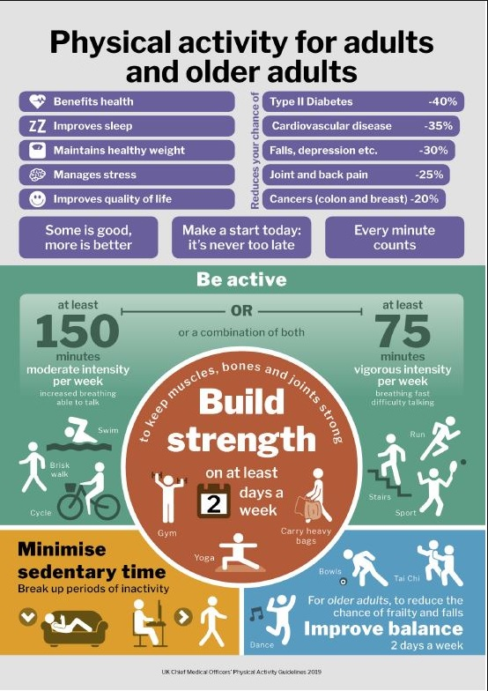

3.Evaluation

3.1 Identifying the message
Identifying the message in this infographic is very easy the message is clearly concise. “Physical activity for adult and older adults” is the title of this info graphic, this message is very, important and common nowadays. Every person is very interested in how they look physically, but also, they are concerned about the health. Diseases that they were very rare 10 years ago and now is part of everyday life. It is easier to prevent diseases then to cure them. Full studies are aimed at these incurable diseases that are very difficult to treat all these studies show that physical and mental activity have a major impact on the occurrence of these diseases. That is why the current messages is much more relevant to the society. [3]

3.2 Assess the way color is used

The use of colors in an infographic it makes it much more attractive, it highlights the dangers off sedentary life. The colors used in this case are colors that stand out, they try to give important to the message. The color-coded red, blue, purple, orange, and green which are a good way to show the data presented. But using all these colors in a visual infographic is a bit of hassle, too much. In the symbolism the colour red it is a colour of action, or danger, determination and is all about strength and physical needs, but also is aggressive and dominant. In symbolism the colours blue is considered a colour of responsibility, calmness, relaxing that's why most of the company’s logos are blue. The colour blue is the most used in advertising, it represents serosity end calmness. Purple in symbolism is considered the royal colour. It is derived from half red and half blue we could say that it is the balance of the tooth good and bad. The colour orange represents the danger just that's why the colour is used for safety equipment and to indicate areas where we need to exercise caution. Green is a symbol of patriotism and conveys hope. In this info graphic I feel that’s to many dominant colours used, and there are not in harmony, for the brain and eyes is too much overload. The orange colour It doesn't really fit it well in this image.

3.3 Assess the way text is used
The text used in this infographic it is motivational, it stimulates adults, to live more actively, to take care of themselves. Uses words with a strong emotional impact, to highlight the dangers of illnesses. The words that are meant to be important, there are used in bold text, and different font sizes. A major visual problem is the misuse of the small characters, there are not easy to read. Most likely the choice of text colours is not appropriate in relation to the font sizes (the font colour being light purple and the text white. Too much colour in the text can be confusing, and it's not easy to read for everybody, it lowers the interest for the information.

3.4 Assess the suitability of the graph.
The graphics character used in this infographic represents the message very suggestively. The graphics make the infographic much more attractive it stimulates our attention. Human figures doing various physical activities are a very smart choice, they have a much greater impact than a text. When we have the first eye contact with this info graphic these human figures arouse our interest, instantly, they capture attention.

3.5 Assess the way graphics are incorporated.
The graphics incorporate page layout. Information is very well structured to define the benefits but also the disadvantages of a life without physical activity. Human silhouettes doing physical activities such as swimming, yoga, cycling, walking, running, doing different sports have a big impact arouse our interest and together with the safe message will have a positive impact on the population. As the author says, “Be active, every minute counts”.

3.6 Cognition
The word strong message such as cancer cardiovascular disease et cetera from a cognitive point of view have a major impact today, this choice is very smart. Also works with a positive message such as: “Some is good more is better”, “Make a start today, it’s never too late”, “Every minute counts”, “Be active” strong words that stimulate you to do physical activities.

3.7 Improving the infographic
After all this visual analysis of the info graphic can submit the following messages boiled well chosen words attract attention information is very useful for the century in which we live. From my perspective I would change the colour. The info graphic green, red, orange and blue are too eye-catching. All this colour and information is very compact to loaded is very difficult to understand. The bottom part of the info graphic has too much information which to overloading the brain. From the point of view of the text I would choose only two colours, to be more visible and understandable for the viewer.

4 Conclusion
The subject of physical activity of adults and adults age is very important for all of us. This info graphic highlights this once again.
In the analysed infographic the message is impactful but the arrangement in the page is a faulty one, very loaded, more exactly at the top has clear information, well-structured but at the bottom everything is crowded, you can find text incorporated, end graphics. The partial written size is defective and colour. Overlapping colours clutter the infographic making it less attractive, less understandable, it makes the viewer lose the interest. Sometimes less is more.
The graphics with human silhouettes doing physical activities in the info graphic, are the main attraction. With a strong positive message, you can lower even negative impact of diseases make this infographic a very interesting one.

5.References

[1] | J. H. Kranzler, Statistics for the terrified, Lanham, Maryland: Rowman & Littlefield, 2018.
[2] | Deutsche Statistische Gesellschaft, "Advances in statistical analysis.," Advances in statistical analysis, 2007.
[3] | Department of Statistics Science Faculty Yarmouk University; Università del Salento Coordinamento SIBA, "Electronic journal of applied statistical analysis," Electronic journal of applied statistical analysis, no. Department of Statistics Science Faculty Yarmouk University; Università del Salento Coordinamento SIBA, 2008.

