Student Name: Robert Ionut Antofie
Student ID: 2011970
Data Handling and Business Intelligence
Assessment 2
Lecturer Name: Joy Botu

Table of Contents
Introduction 3
Part 1: Analysis and evaluation of Crime Data 3
Brief description data 3
Evaluation: Use of Excel in data preprocessing, analysis and visualisation 8
Part 2: Data Analysis through SPSS 8
Data Analysis of the Survey data and presentation of the results 8
K-means Clustering on responses of the respondents 15
Explanation of common Data Mining and Text Mining methods 16
Discussion: Advantages and Disadvantages of using SPSS and Excel in Data Analysis 17
Conclusion 17

Introduction
Data analysis is a critical tool for the decision making process and guides the same with the backing of proper justification and statistical and mathematical interpretations. There are many tools and software available for analysing data.
In the paper, some of the analytical tools are going to be used. The arena of data analysis and business intelligence and the proper and meaningful interpretation is going to be made. Here the power of SPSS and Excel have been extensively used to properly process and analyse given data.
In the paper, crime data will be analysed with the help of MS Excel and the survey data will be processed with SPSS finally evaluate the use of both of the applications and compare their power to help analyse data.

Part 1: Analysis and evaluation of Crime Data

Brief description data
In the given dataset the crime data has been presented with the help of an excel spreadsheet that shows the number of offences reported per million people in the country. In the data set, 27 columns are describing different features about the scenario of the data. From the initial introduction, the data looks huge and many of the variables do not seem to have any importance in case of the analysis and extracting important information from the meaningless raw data. Again, many of the columns have repetitive names and as the data is particularly focusing on deriving the crime rate in the society of the country some of the features from the data have been adopted and accepted and the further and deeper analysis will be initiated.
Furthermore, for this reason, some of the features of the data set have been removed to ease the structure of the data so that the process of analysis can be optimised and the result extraction process can be optimised. The following table is the final that is going to be used and proceed for the further and more complex nature of the analysis.
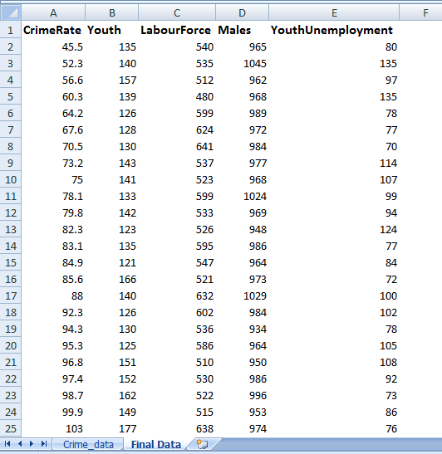
Table 1: Final Data Table
(Source: Created by the author)
The process of removal of the columns of the data is known as the data pre-processing technique and it is one of the useful and critical stages of data analysis. It is also very useful in data mining and the information retrieval process. It helps the analysts to process the data in such a way so that the meaningless data can be transformed into the meaningful and useful information. There are five major stages in data pre-processing techniques and all of them plays crucial, roles in data analysis and they are:
- Quality evaluation of data
- Cleaning of Data
- Transformation of Data
- Data Reduction techniques
In the cleaning process, the null values and their presence have been analysed and evaluated in the data set. And if any null value or blank space in the data is present then they need to be removed strategically so that the meaning of the data and the inbuilt calculations can not be hampered. After accessing the data set in the aspect it is seen that no null value is present in the concerned and the interesting columns.
Having completed this stage, the transformation of data comes into play and here the data needs to be transformed and transferred in terms of the features and rows. It is particularly done to transform the data in such a way so that the analysis and the information extraction process can be optimised and justified in the given context (Liu and Yang, 2021). Many times data does not come in such a manner that is desired and in the proper format and the columns and their contents are also evaluated and changed if necessary. Here, in the stage, the categorical and the presence of strings of the data set have been transformed into a proper format or numerical format so that the analysis can be more appealing and easy. In this case, no data in the columns of interest have come in an undesired manner so that no change in the format of the contents of the columns has been performed.
Data reduction techniques are one of critical and useful techniques that are responsible for the proper and justifiable representation of data. In some cases of data, there is so much information packed in the same data set and much of the information is not crucial and important for the process of the analysis and they neither play a decisive role nor a particular and important role in the information extraction process. Those columns and the features can be removed with the help of the correlation determination techniques. Then in the process, the features are removed whose correlation scores are low with the dependent variable. The process further reduces the size of the data set and presents a concise amount of data that displays and represents all the information of the data set. There are several techniques in the data reduction process and "Principal Component Analysis or PCA” and “Linear Discriminant Analysis or LDA” is one of the most popular techniques (Li et al., 2018). So, in the present data set none of the techniques needed to be used as some of the columns has the desired and effective information in the data set and in the final selection of the columns all those data and the features are being selected and extracted so that a proper representation of the data can be built and no information can be lost in the process.
The final data is then analysed and assessed and some of the statistical measures and concepts are also been employed and utilised in the data set so that some of the critical information can be retrieved so that a proper picture regarding the data can be caught. Here for the description of the data, some of the descriptive statistical measures have been adopted and analysed so that the description of the data can be done properly. Descriptive statistics is the wing of statistical analysis that uses basic statistical concepts so that the distribution of the data and the description of the information and the features can be discussed and addressed. The following table explains the descriptive statistical measures of the data:
The measure of the descriptive Statistics | Values
Mean of the crime rate | 102.809
Median of Crime rate | 103
the standard deviation of crime data | 28.8933
Mean unemployment rate for youth | 95.4681
Median of the Unemployment rate for youth | 92
The standard deviation of the unemployment for the Youth | 18.0288
Mean of the labour force | 561.191
Median of the labour force | 560
Mean of the number of Males | 983.021
Median of the number of Males | 977
Table 2: Measures of descriptive Statistics
(Source: Created by the author)
Mean is the mathematical average of a data series containing a set of continuous variables. It is one of the other measures of central tendency that presents an idea about the central point of the data set. Median is also the measure of the central tendencies of the data set and it is determined by identifying the central point of the data series after proper sorting of the series in ascending or descending order. Standard deviation is another measure that is used in the table and it is the measure of the dispersion of the data series and provides an idea about the distribution of the data.
Data visualisation is a technique by which the data can be shown visually so that the proper understanding of the data can be reciprocated (Lowe and Matthee, 2020). The following curve of the data shows the crime rate of the data:
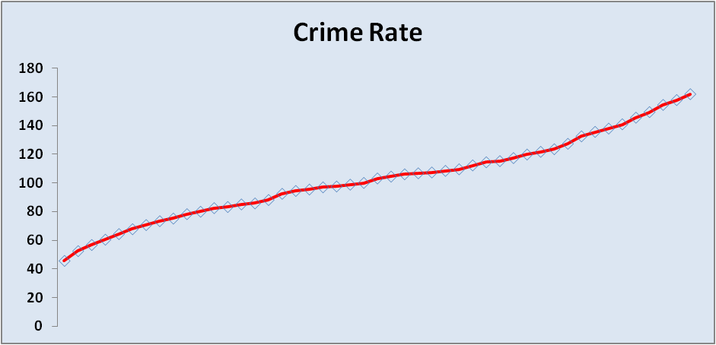
Figure 1: Crime rate
(Source: Created by the author)
The following curve is the unemployment of the youth and the crime rate of the data. The following curve further shows the relationship between them:
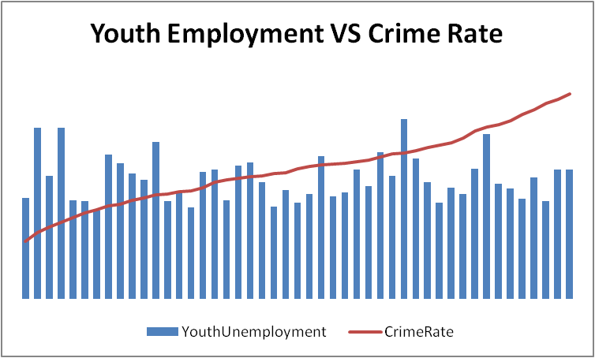
Figure 2: Relationship between crime rate and Unemployment n of the youth
(Source: Created by the author)
Determination of Crime Rate from the Dataset
So, after the description of the data set, the mean crime rate of the data is “102.809”.

Evaluation: Use of Excel in data pre-processing, analysis and visualisation
Here, the “VLOOKUP()” function has been used so that the value of the Crime rate “112.1” can be found in the data series. And it is done in the F2 cell.
After that, the Pivot Table function of the MS Excel software is going to be used and utilised and the visualisation of the data is as follows:
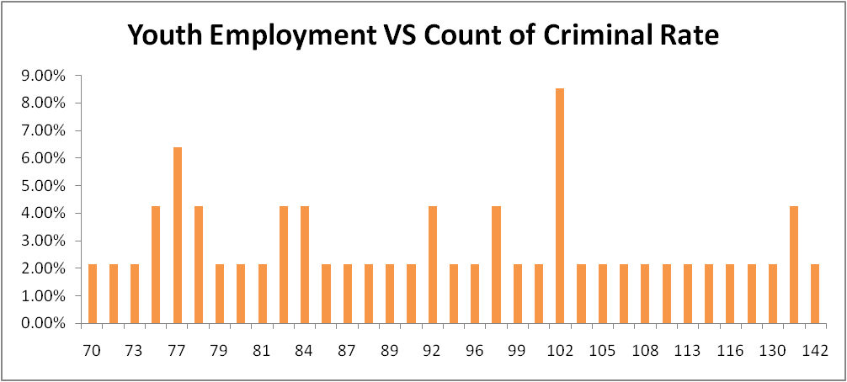
Figure 3: Youth employment VS Criminal Rate
(Source: Created by the author)

Part 2: Data Analysis through SPSS

Data Analysis of the Survey data and presentation of the results
In the dataset, a survey report and the collected data have been presented on the students of a high school. Here, five columns are there containing “‘id’, ‘female’, ‘ice-cream’, ‘video’ and ‘puzzle’". Here, 'video' and 'puzzle' explain scores in the video game and puzzle. The 'female' column represents two of the genders using 0 for Males and 1 for Females. The 'ice-cream' feature explains three categories of flavours 1 is Vanilla, 2 is Chocolate and 3 is Strawberry. First of all, the first containing the student id numbers do not hold any importance in data analysis. As in the process of analysis, the principal question is to ask and determine the number of students who like what type of ice cream and the distributions of the data in terms of gender. This dataset is also required to calculate and show the statistical measures of the number of students who like one type of ice cream.
Before further and deeper analysis begins, the first column named ‘id’ containing the student identification numbers of the school is to be repealed. So, the final data set contains only four of the columns. Data filtration is the process used in pre-processing and properly getting ready the data set so that future planning of the analysis can be satisfied easily. It consists of several; techniques and strategies that allow analysts to clean and test the data in an initial stage. This process further helps the analysts in planning and determining the proper future paths and strategies to break the data into multiple pieces and torture bit well enough at the limit where it begins to yield information (Pallant, 2020). Here the data analysis will be done with one of the powerful statistical software SPSS. After proper analysis and judgement regarding the columns and their meaning, the following is the data set:
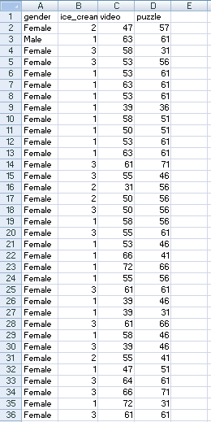
Table 3: Final Data table
(Source: Created by the author)
After imputation of the data set in the SPSS application, the following table has been found and here all the statistical concepts and ideas will be applied so that proper and meaningful information can be extracted from the raw data of the survey results:
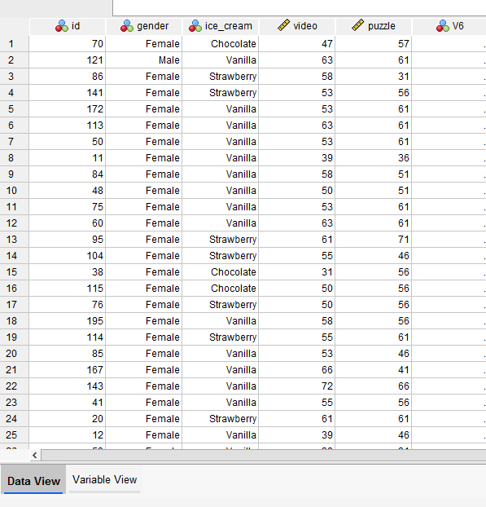
Table 4: Data Representation through SPSS
(Source: Created by the author)

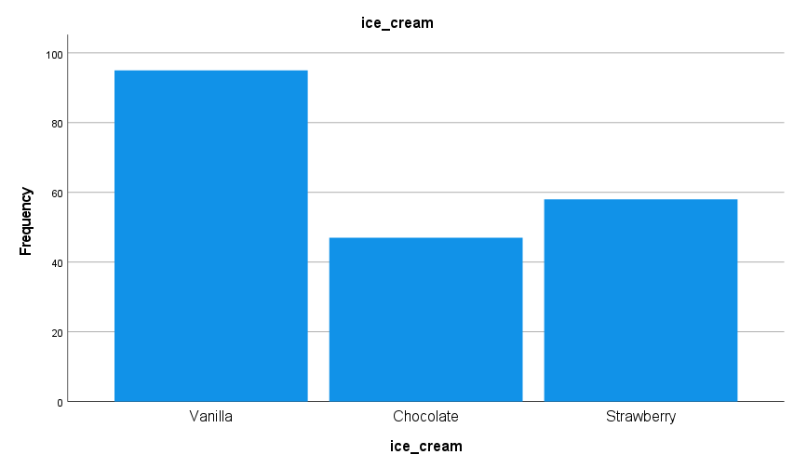
Figure 4: Distribution of the number of respondents depending upon the flavour of ice cream
(Source: Created by the author)
Determination of several respondents like vanilla flavoured ice cream:
Here in the question, the number of the respondents who like vanilla flavoured ice cream is going to be determined. After carefully accessing the scenario, the following are the tables by which the number of respondents like vanilla ice cream can be answered. The following tables are showing the same:

Statistics
Ice-cream
N | Valid | 200
N | Missing | 0

Ice-cream
 |  | Frequency | Per cent | Valid Percent | Cumulative Percent
Valid | Vanilla | 95 | 47.5 | 47.5 | 47.5
Valid | Chocolate | 47 | 23.5 | 23.5 | 71.0
Valid | Strawberry | 58 | 29.0 | 29.0 | 100.0
Valid | Total | 200 | 100.0 | 100.0
Table 5: Determination of respondents like Vanilla ice cream
(Source: Created by the author)
So, from the above table, it can be commented and evident that out of 200 students in the high school, 95 individuals like vanilla flavoured ice cream.
Determination of the respondents in terms of gender:
Here in the question, the respondents needed to be counted in terms of gender and show the result related to the number of males and females in the survey. For this, the power of SPSS will be used and utilised and the table that are showing the outcome of the same is as follows:

Statistics
gender
N | Valid | 200
N | Missing | 0

gender
 |  | Frequency | Per cent | Valid Percent | Cumulative Percent
Valid | Male | 109 | 54.5 | 54.5 | 54.5
Valid | Female | 91 | 45.5 | 45.5 | 100.0
Valid | Total | 200 | 100.0 | 100.0
Table 6: Determination of the respondents in terms of Gender
(Source: Created by the author)
As the above table mentioned there are 200 respondents and no null value is present in the column. From the outcome of the table, it can be commented and evident that there 109 number Male respondents present and the rest is Female that is 91. If converted in the percentages in terms of frequency, 54.5% of the respondents are Male and the rest 45.5% of respondents are Females. Here, a pie chart is going to be shown where the distribution of gender of the respondents is going to be shown. The desired chart is as follows:
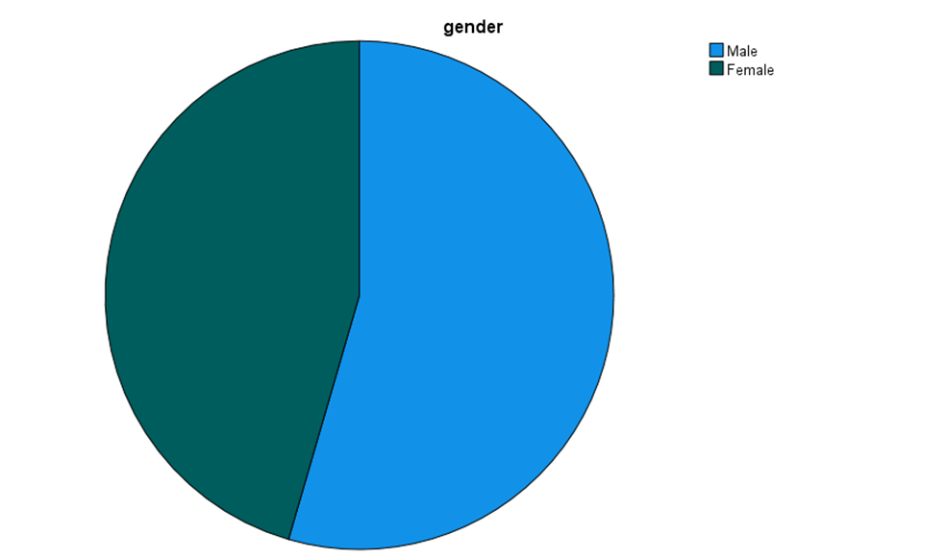
Figure 4: Pie chart showing the distribution of the respondents in terms of gender
(Source: Created by the author)
So, from the visualisation of the data and the representation of the same through the pie chart, it can be commented that there are more Males than females in the survey.
Descriptive statistical calculation of flavour liking of the respondents:
Here the mean and median of the number of respondents like Chocolate and Strawberry flavoured iced cream are needed to be calculated. The following table shows the result:

Statistics
Ice-cream
N | Valid | 200
N | Missing | 0
Mean |  | 1.82
Median |  | 2.00
Mode |  | 1
Minimum |  | 1
Maximum |  | 3

Ice-cream
 |  | Frequency | Percent | Valid Percent | Cumulative Percent
Valid | Vanilla | 95 | 47.5 | 47.5 | 47.5
Valid | Chocolate | 47 | 23.5 | 23.5 | 71.0
Valid | Strawberry | 58 | 29.0 | 29.0 | 100.0
Valid | Total | 200 | 100.0 | 100.0
Table 7: Descriptive statistical measures of flavours of chocolate and strawberry ice cream
(Source: Created by the author)

K-means Clustering on responses of the respondents
Clustering is an art of analysis and segregation of data points that are used to segregate and divide the data in terms of certain characteristics. The nature and characteristics of the data points in one group are more similar and identical than the data points of the other groups. So, it can be commented that Clustering is a process in data analysis and discussing the nature of the data as well as finding and determining the nature and the similarity among the instances in the dataset. There are several clustering techniques available and K-mean clustering is one of those kinds of clustering that is widely used.
K-Means clustering is one of the unsupervised algorithms used in labelling and classifying the unlabelled data into some particulate clusters. It is the most widely used and popular clustering algorithm that works in an unsupervised manner to label the unlabelled data and K denotes the number of pre-defined clusters. Finally, this algorithm divides and segregates the data points in a data set into some of the groups so that the similarity between the instances can be built and maintained.
Here the flavours of ice cream are going to be clustered in terms of the gender of the respondents and there would be only 3 of the clusters built and will show how the flavours of the ice creams are to be correlated with the gender of the respondents.
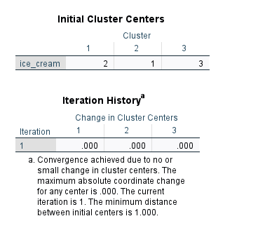
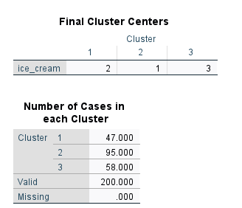
Table 8: K-means clustering of the data
(Source: Created by the author)
From the above output table, it can be commented that in the first cluster there are 47 numbers of data points, in the second cluster, 95 numbers of data points belong and finally, in the third cluster the rest 58 data points reside. From the point of view of the flavours of the ice cream, in the first cluster the respondents with the like of chocolate, in the second group the people with Vanilla and the third clutter people with a linking in the Strawberry flavour is going to be classified.

Explanation of common Data Mining and Text Mining methods
Data mining is the process that is used to pre-process the raw data and convert them into useful information. It is mainly used to determine and extract meaningful information from the boring looking data and the management of the company uses the procedure so that they can properly understand the characteristics of the data and effectively access the situation of a company. The methods include:
- Classification algorithms
- Regression analysis
- Clustering techniques
- Anomaly detection procedure
In the country, Text mining is the procedure that is used to identify and supervise the machine with the help of the Natural Language Processing for NLP and this process is responsible for managing the databases. The following are the methods:
- Categorisation
- Summarisation
- Information Extraction

Discussion: Advantages and Disadvantages of using SPSS and Excel in Data Analysis
Use of SPSS in Data Analysis:
Advantages:
- SPSS is a statistical software
- The complex nature of the statistical problems can be solved easily
Limitations:
- Data visualisation is not easy
- SPSS is not free to use software
Use of MS Excel in Data Analysis:
Merits:
- Data organisation and handling is easy
- Calculation in the software is very easy to manage
Demerits:
- Excel formulas are syntax sensitive and take time to understand
- Data Security is not up to the mark

Conclusion
In the paper, the use and importance of MS Excel and SPSS have been shown and the efficiencies of the data analysis have also been addressed. The data visualisation and the analysis and the interpretations of the statistical and analytical results have been described. Again, in the paper, the data mining and the text mining tools also have been addressed and discussed along with the employment of the concept of clustering in the data. The advantages and the limitations of the use of excel and SPSS in data analysis also have been evaluated and presented.

Reference list and Bibliography
Aldrich, J.O., 2018. Using IBM SPSS statistics: An interactive hands-on approach. Sage Publications.
Aleem, A. and Gore, M.M., 2020, April. Educational data mining methods: A survey. In 2020 IEEE 9th International Conference on Communication Systems and Network Technologies (CSNT) (pp. 182-188). IEEE.
Antons, D., Grünwald, E., Cichy, P. and Salge, T.O., 2020. The application of text mining methods in innovation research: current state, evolution patterns, and development priorities. R&D Management, 50(3), pp.329-351.
Athab, N.A., 2019. An analytical study of cervical spine pain according to the mechanical indicators of the administrative work staff. Indian Journal of Public Health, 10(5), p.1349.
Babbie, E., Wagner III, W.E. and Zaino, J., 2022. Adventures in social research: Data analysis using IBM SPSS statistics. Sage Publications.
Cheng, Q. and Lui, C.S., 2021. Applying text mining methods to suicide research. Suicide and Life‐Threatening Behaviour, 51(1), pp.137-147.
Denis, D.J., 2018. SPSS data analysis for univariate, bivariate, and multivariate statistics. John Wiley & Sons.
Denis, D.J., 2021. Applied Univariate, Bivariate, and Multivariate Statistics: Understanding Statistics for Social and Natural Scientists, With Applications in SPSS and R. John Wiley & Sons.
Dumas, D., Organisciak, P., Maio, S. and Doherty, M., 2021. Four text‐mining methods for measuring elaboration. The Journal of Creative Behavior, 55(2), pp.517-531.
Favero, L. and Belfiore, P., 2019. Data science for business and decision making. Academic Press.
Gibert, K., Izquierdo, J., Sànchez-Marrè, M., Hamilton, S.H., Rodríguez-Roda, I. and Holmes, G., 2018. Which method to use? An assessment of data mining methods in Environmental Data Science. Environmental modelling & software, 110, pp.3-27.
Govender, P. and Sivakumar, V., 2020. Application of k-means and hierarchical clustering techniques for analysis of air pollution: A review (1980–2019). Atmospheric Pollution Research, 11(1), pp.40-56.
Kumari, K. and Yadav, S., 2018. Linear regression analysis study. Journal of the practice of Cardiovascular Sciences, 4(1), p.33.
Li, S., Marsaglia, N., Garth, C., Woodring, J., Clyne, J. and Childs, H., 2018, September. Data reduction techniques for simulation, visualization and data analysis. In Computer Graphics Forum (Vol. 37, No. 6, pp. 422-447).
Liu, R. and Yang, Z., 2021. Single cell metabolomics using mass spectrometry: Techniques and data analysis. Analytica chimica acta, 1143, pp.124-134.
Lowe, J. and Matthee, M., 2020, April. Requirements of data visualisation tools to analyse big data: A structured literature review. In Conference on e-Business, e-Services and e-Society (pp. 469-480). Springer, Cham.
Pallant, J., 2020. SPSS survival manual: A step by step guide to data analysis using IBM SPSS. Routledge.
Sileyew, K.J., 2019. Research design and methodology. In Cyberspace (pp. 1-12). Rijeka: IntechOpen.
Wazarkar, S. and Keshavamurthy, B.N., 2018. A survey on image data analysis through clustering techniques for real world applications. Journal of Visual Communication and Image Representation, 55, pp.596-626.
Xie, Y., Shekhar, S. and Li, Y., 2022. Statistically-robust clustering techniques for mapping spatial hotspots: A survey. ACM Computing Surveys (CSUR), 55(2), pp.1-38.

