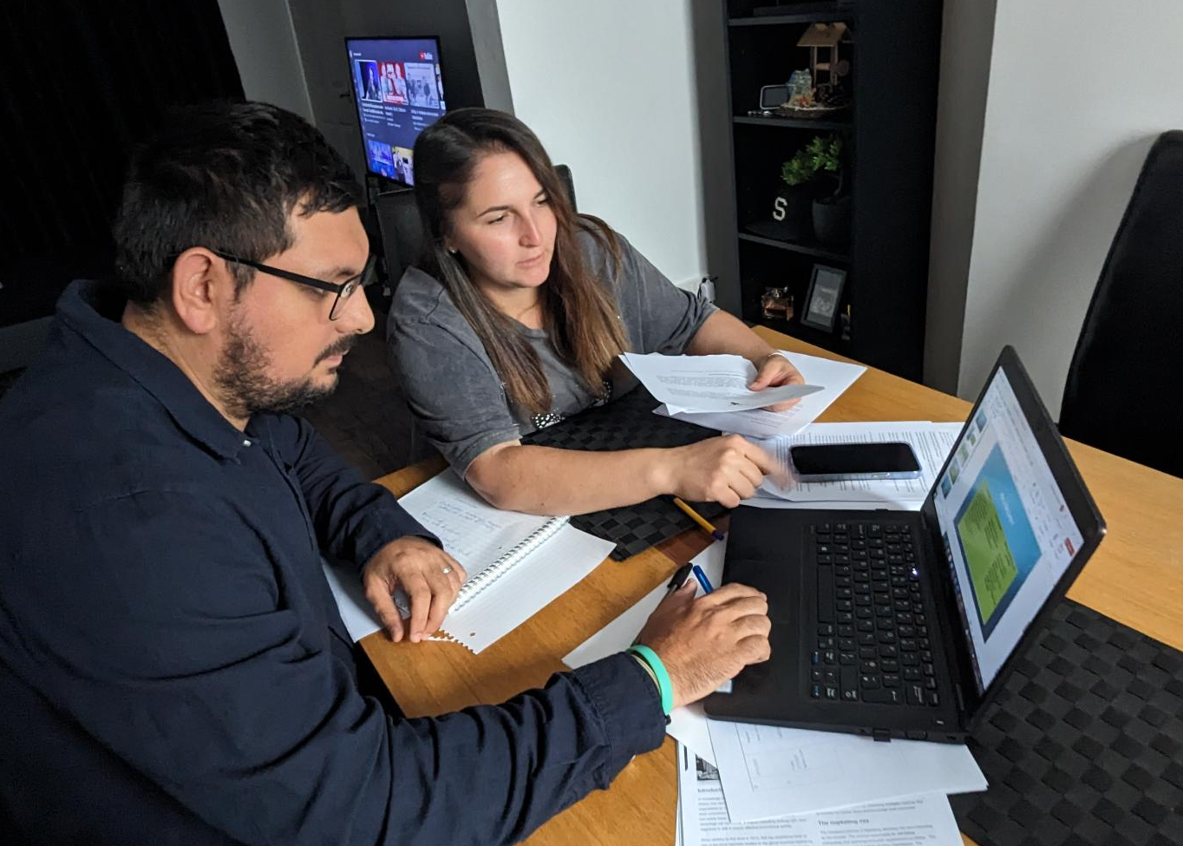
Book Lockers revolutionizes the traditional book-sharing system by introducing secure lockers at the bus station. Commuters can borrow, exchange, or return books at their convenience, creating a community of avid readers. With the project being introduced to the Bus Station Authority, the primary objective was to enhance the overall passenger experience and foster a culture of literacy among travellers.
As a specialist on the project, I was responsible for leveraging my expertise to ensure the successful implementation of the Book Lockers. Drawing upon my skills in logistics and inventory management, I worked closely with the team to develop efficient strategies for book circulation and maintenance. Additionally, my proficiency in technology allowed me to recommend and oversee the implementation of a user-friendly digital interface to streamline the borrowing and return process.
Throughout the project, effective communication and collaboration were key (Suter et al. 2009). Despite being a specialist, I recognized the importance of a well-rounded team and made efforts to actively interact with colleagues from various backgrounds. By leveraging my strong analytical and problem-solving skills, I contributed to brainstorming sessions and offered insights to enhance the functionality and security of the lockers. Moreover, I provided the necessary training and support to ensure a smooth transition for the team and the users.

Reference
Suter, E., Arndt, J., Arthur, N., Parboosingh, J., Taylor, E. and Deutschlander, S., 2009. Role understanding and effective communication as core competencies for collaborative practice. Journal of interprofessional care, 23(1), pp.41-51

