Learner name: Angela Ionescu
Learner’s University Registration Number: 2320022

Dissertation: Public Perception of the Police: Between Principle and Practice

Chapter 4: Analysis of Results
This chapter presents the findings of the two mirrored surveys and seeks to examine how members of the public and serving police officers each experience and understand the police encounter. Findings should be read within the scale of the study: with 25 participants on each side, these findings indicate patterns worth examining further rather than conclusions representative of policing as a whole. Full quantitative breakdowns and verbatim responses are reproduced in Appendix A and Appendix B.

4.1 Quantitative Findings
The nine subsections below present the closed-question findings from both surveys, organised by theme and reported side by side. Each subsection is accompanied by a bar chart. Percentages show direction and concentration of response rather than statistical significance.

4.1.1 Respect
Officers consistently describe respect as central or important, while public responses spread across the full range, with a clear minority feeling not very respected or dismissed, as illustrated in Figure 4.1.1. This shows that holding a value does not guarantee its uniform translation into practice.
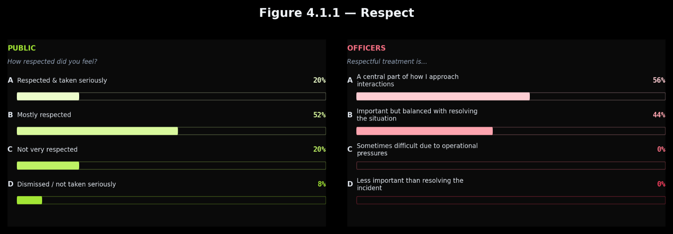

4.1.2 Empathy
Most officers describe empathy as key to their approach. Public responses cluster around only partial empathy, with a minority feeling genuinely cared for and a further minority feeling treated as a case rather than a person, as shown in Figure 4.1.2. A proportion of officers acknowledge empathy is hard to maintain consistently and this comes across as the dimension where the distance between principle and practice is most visible to the public.
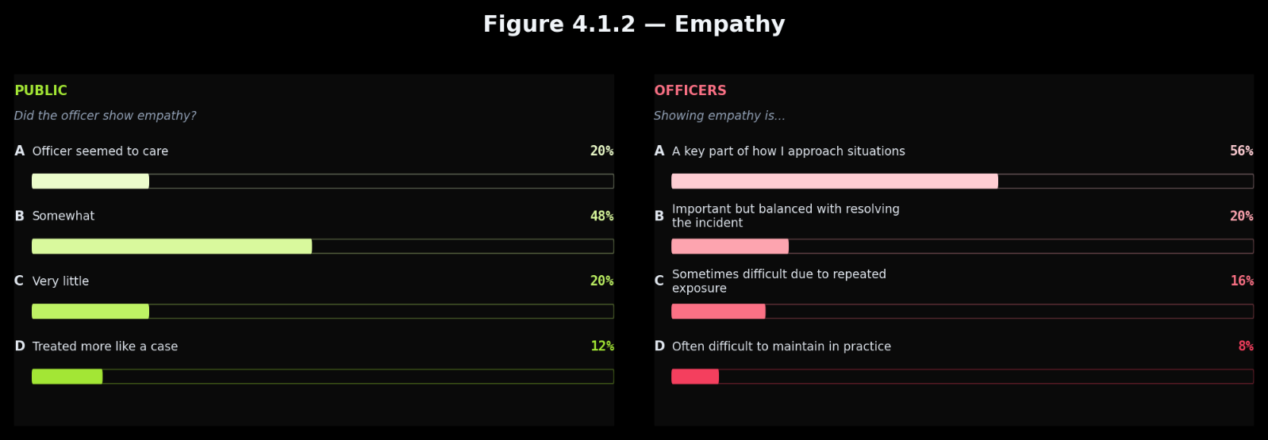

4.1.3 Listening
Officers are split between those describing listening as central and those describing it as limited by time, while public responses concentrate in the middle, with only a minority feeling clearly listened to, as presented in Figure 4.1.3. Both groups point to a pattern of partial listening in practice.
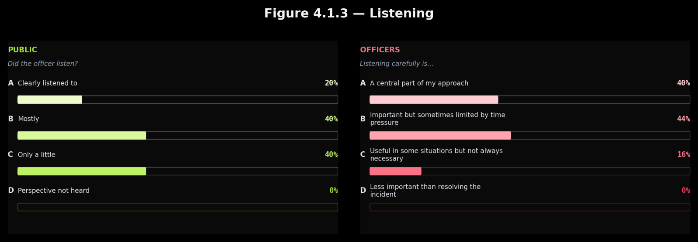

4.1.4 Explaining Decisions
Officer views on explanation spread across all four options. Public responses show a similar spread, with a significant proportion receiving very little or none, as displayed in Figure 4.1.4. Both surveys independently point to inconsistent delivery on this dimension.
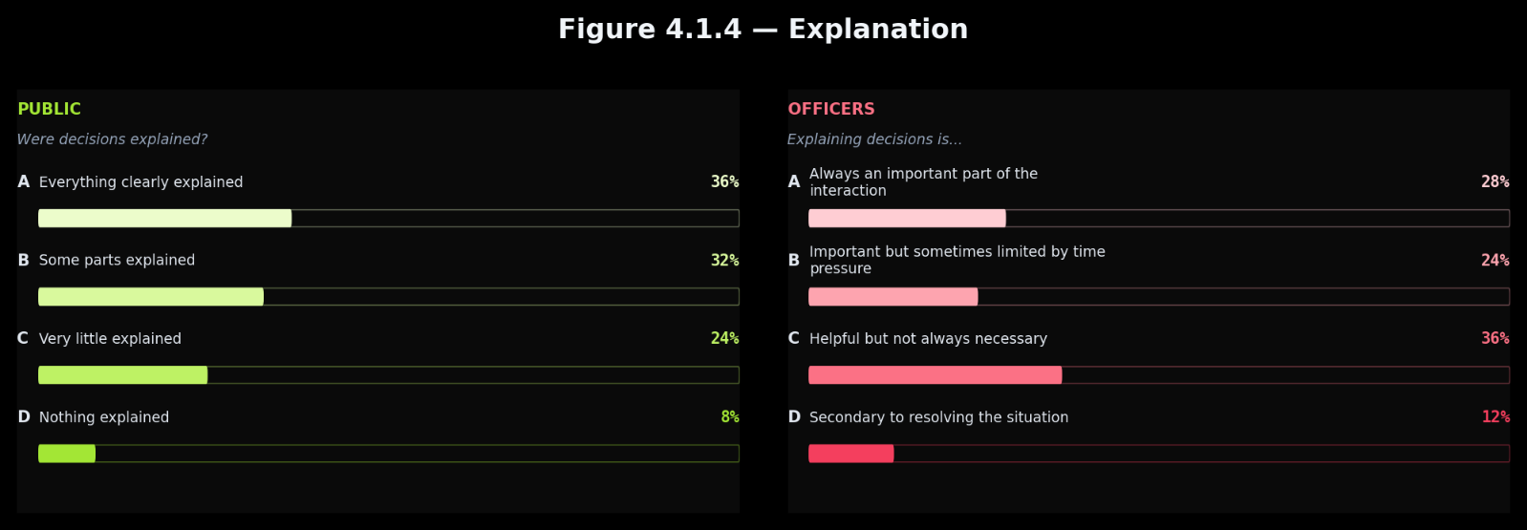
4.1.5 Fairness
Fairness is where the two surveys align most clearly. Officers overwhelmingly describe it as central or important, and the public overwhelmingly feel fairly treated, as shown in Figure 4.1.5. Consistency of professional support appears reflected in consistency of public experience.
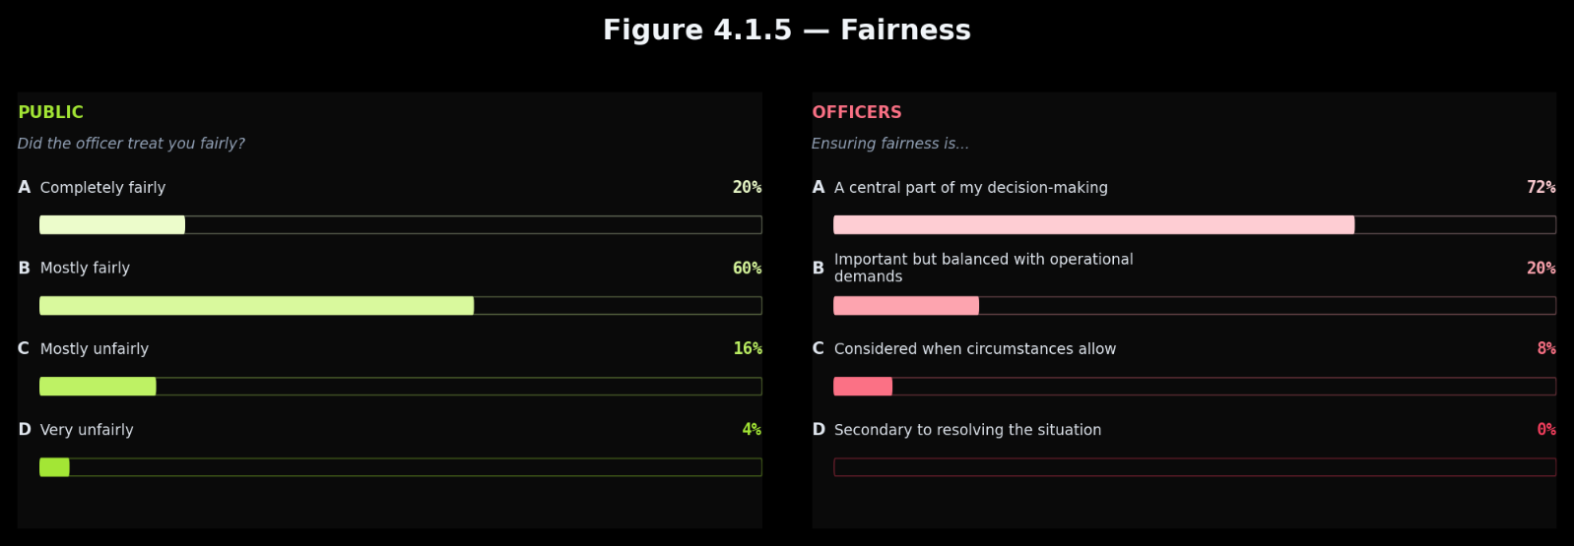

4.1.6 Time
Most officers report time pressure affecting their interactions, yet the majority of the public felt the officer had enough time for their situation, as displayed in Figure 4.1.6. This is one of the clearest divergences in the study.
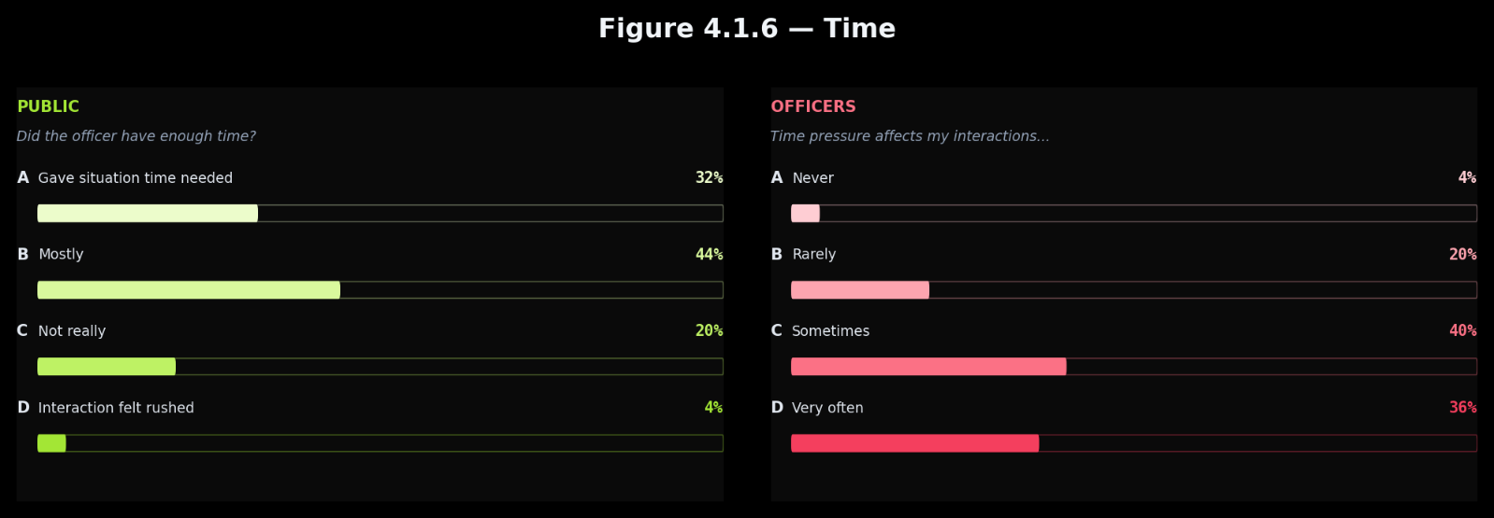

4.1.7 Follow-up
Officers describe follow-up as a regular part of their role less uniformly than other dimensions. Public responses show a notable proportion feeling forgotten or receiving very little after initial contact, as illustrated in Figure 4.1.7.
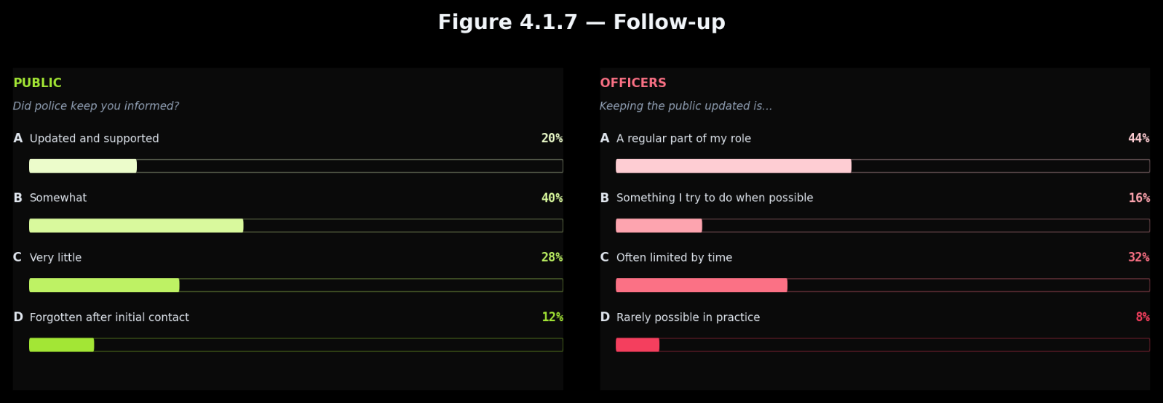

4.1.8 Media
Officers overwhelmingly agree that media shapes public perception. Yet the public found their direct experience more positive than media portrayals suggested, rather than being driven by them, as shown in Figure 4.1.8.
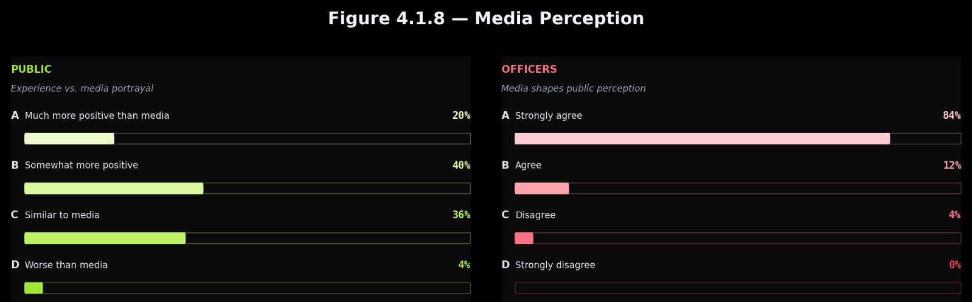

4.1.9 Expectations
Officers entered the role predominantly expecting crime response and enforcement, while no public respondent expected primarily enforcement and the majority expected a balance or primarily support, as presented in Figure 4.1.9.
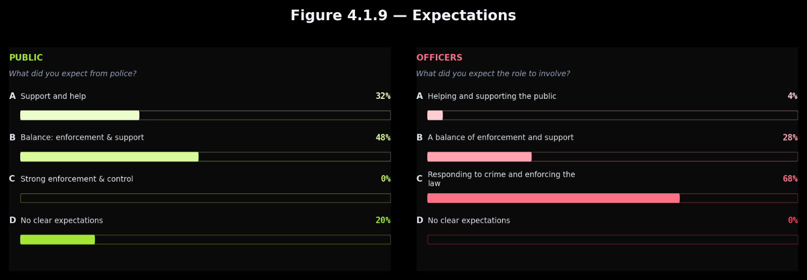

4.2 Qualitative Findings
The qualitative responses show how each group understands what the encounter is fundamentally for. The coding framework is set out in Appendix C.

4.2.1 Public Themes
Five themes emerge from the public responses, with some being present in more than one: the individual officer as the reference point for judgement, empathy as absent or partial, concerns about tone and conduct, positive interactions, and a broader institutional view.

The most pervasive theme is the individual officer as the reference point for judgement. Respondents describe perception as determined by which officer they encountered, some going above and beyond, others treating them as guilty from the outset, as presented in Figure 4.2.1a. Perception sits at the level of the officer rather than the institution.
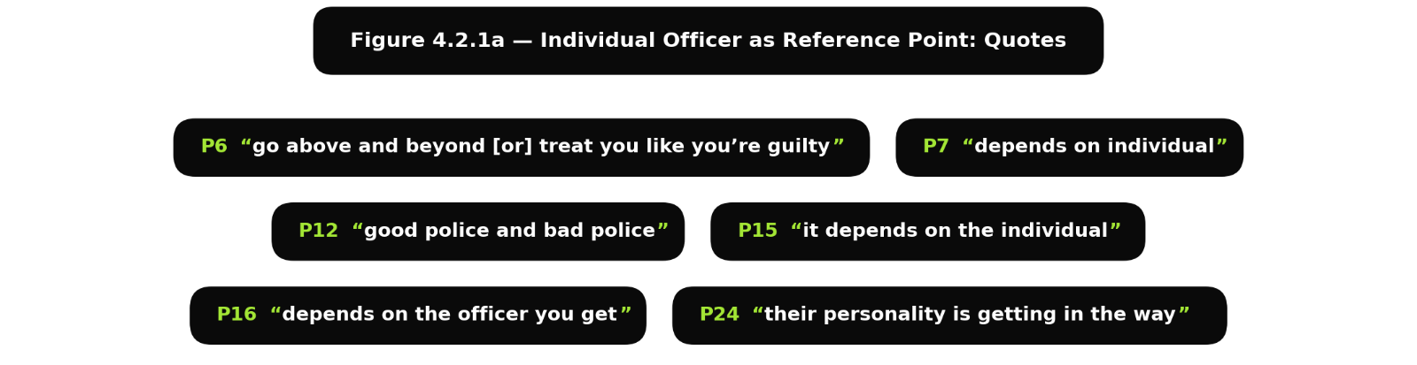

Closely connected is empathy as absent or partial. Respondents describe empathy as missing, only partly present, or limited in degree, with several explicitly asking for more understanding in future interactions, as shown in Figure 4.2.1b. This reinforces the quantitative finding and identifies empathy as the dimension respondents most wanted to see strengthened.
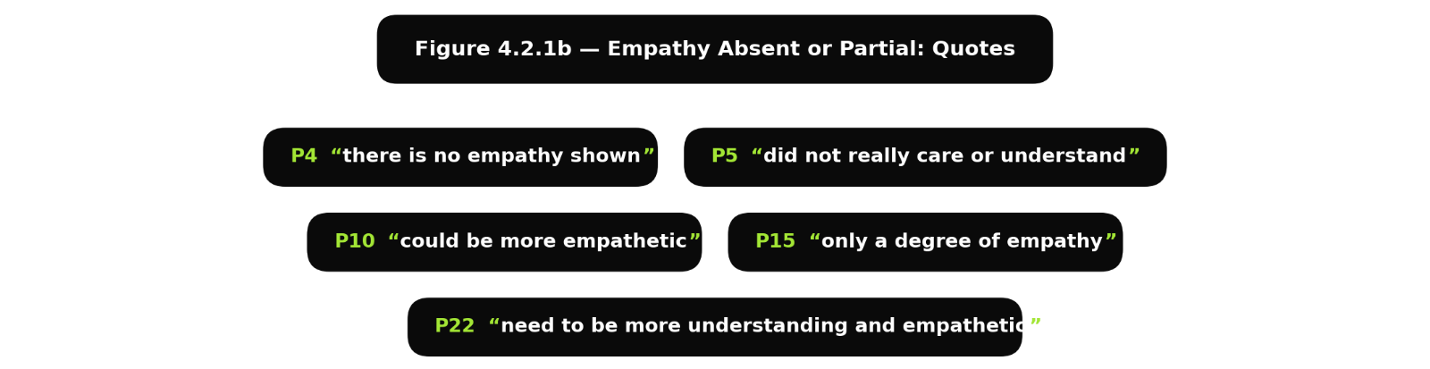

Alongside the empathy deficit, respondents raise concerns about tone, aggression and conduct. Descriptions centre on pressure, intimidation, dismissiveness or aggression, with some reporting being threatened or spoken down to, as illustrated in Figure 4.2.1c. Several associate conduct directly to loss of trust, including the perception that officers enforce rules they do not always follow themselves.
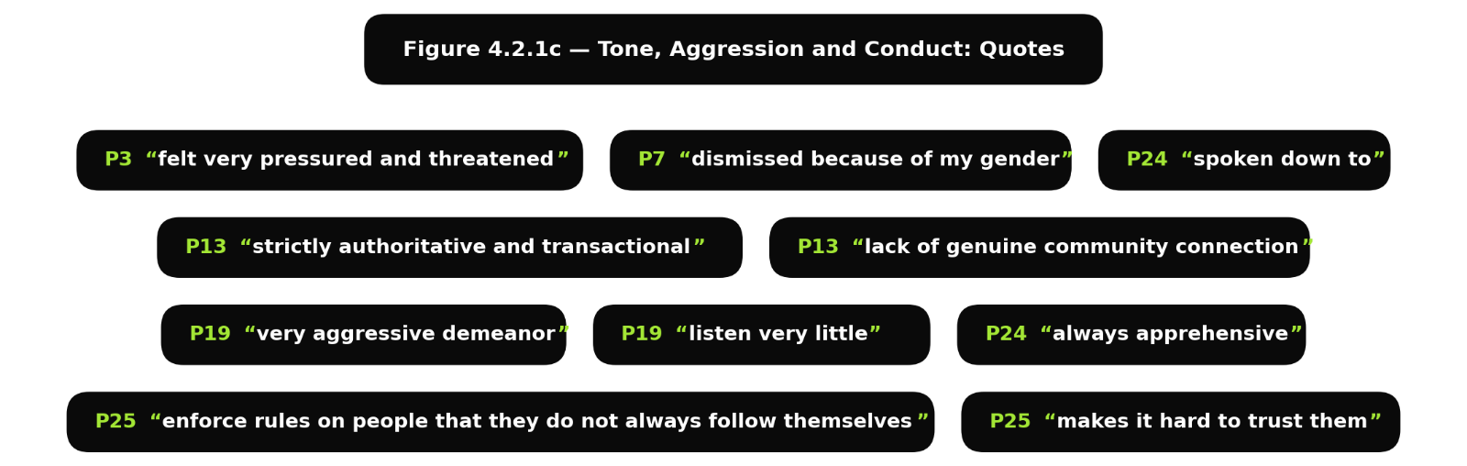

A substantial number of respondents describe positive interactions with the officer they encountered, ranging from brief affirmative statements to specific accounts of officers who were professional, attentive, fair, helpful, kind or instrumental in resolving a serious situation, as presented in Figure 4.2.1d. Public perception is not uniformly negative but conditionally so, dependent on the officer was they met.
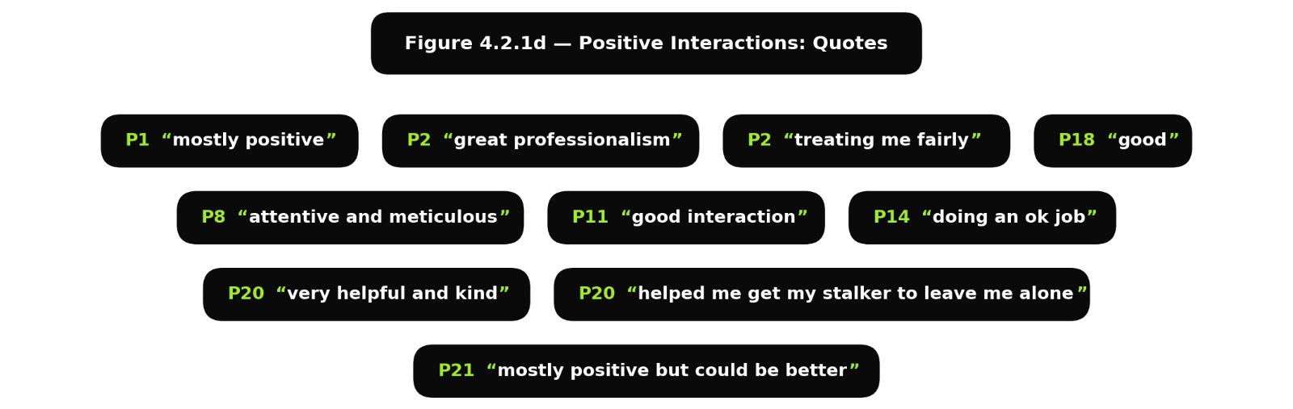

A smaller group frame perception around the police as an institution, describing policing as a necessary service, at times inefficient or distant, producing mixed feelings that cannot be resolved by a single interaction, as shown in Figure 4.2.1e.
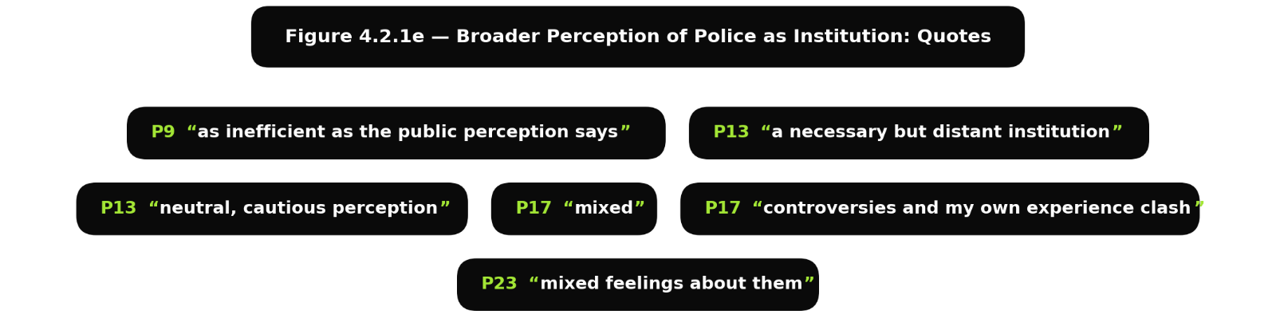

4.2.2 Officer Themes
Six themes emerge from the officer responses, with some being present in more than one: structural exhaustion, administrative burden, contested role scope, public misunderstanding, leadership and organisational failure, and a smaller thread of persistent commitment.

The most dominant theme is structural exhaustion. Officers describe the role as relentless, chaotic and thankless, with demand exceeding capacity and resources stretched beyond what the service can sustain, as illustrated in Figure 4.2.2a. The working environment, rather than the will of the officer, is positioned as the primary constraint on what the encounter can deliver.
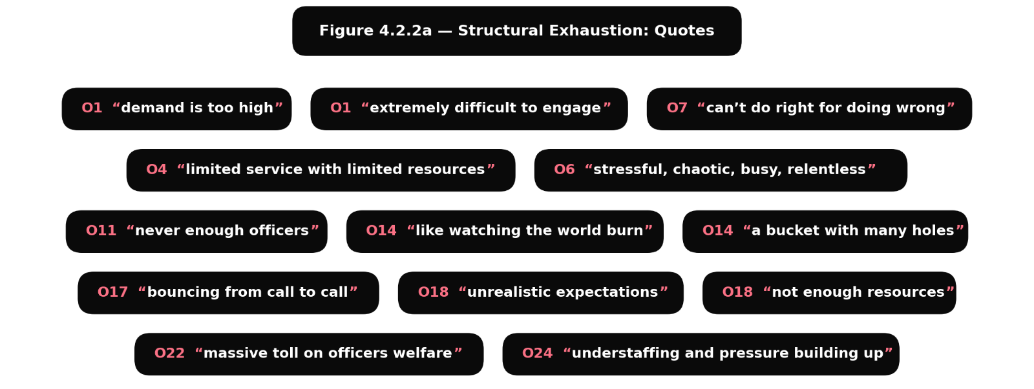

Reinforcing this is the weight of administrative burden. Paperwork, duplication and administrative justification are described as significant constraints on time available for direct service, as shown in Figure 4.2.2b. Officers experience a disconnection between how the role is publicly described and how it is operationally lived.
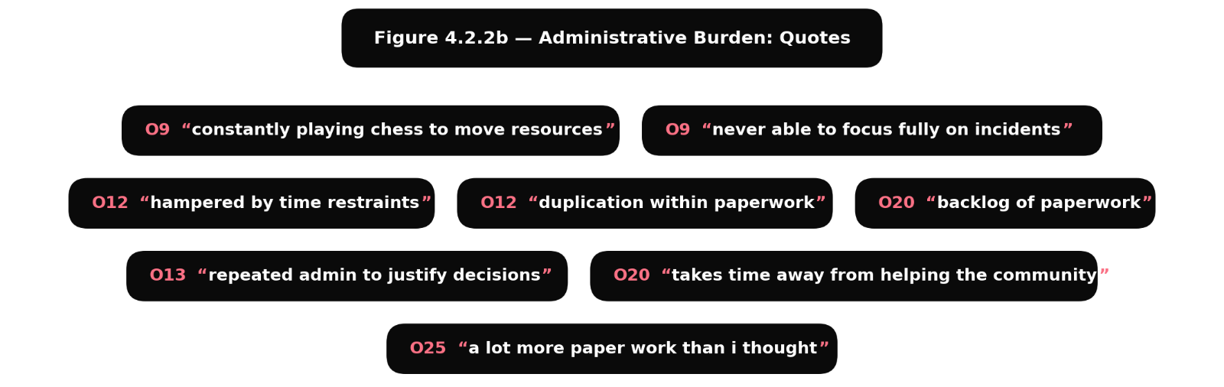

Further concerns arise about what the role involves. Mental health calls and welfare interventions are framed as work outside the role officers understood themselves to be entering. Some responses draw a distinction between those deserving of officer time and those who are not, formed before the encounter begins, as presented in Figure 4.2.2c.
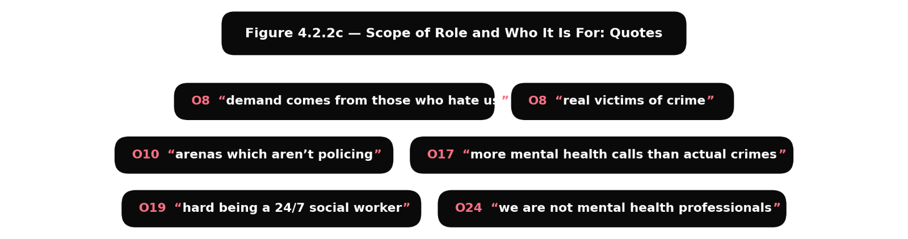

Running alongside is the perception that the public does not understand the role. Officers describe being unable to do right for doing wrong, as displayed in Figure 4.2.2d. This sits as a counterweight to the public’s account of empathy and tone.
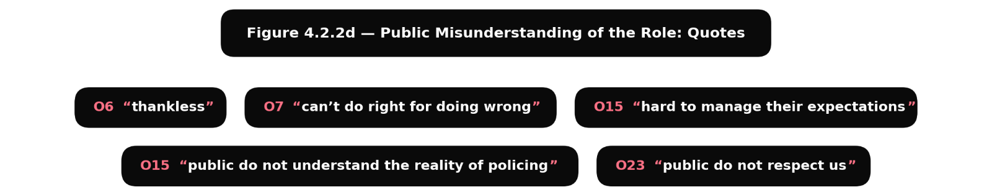

Perceived leadership and organisational failure is also identified, with officers reporting team culture and promotion as obstacles to delivering the role well, as illustrated in Figure 4.2.2e.
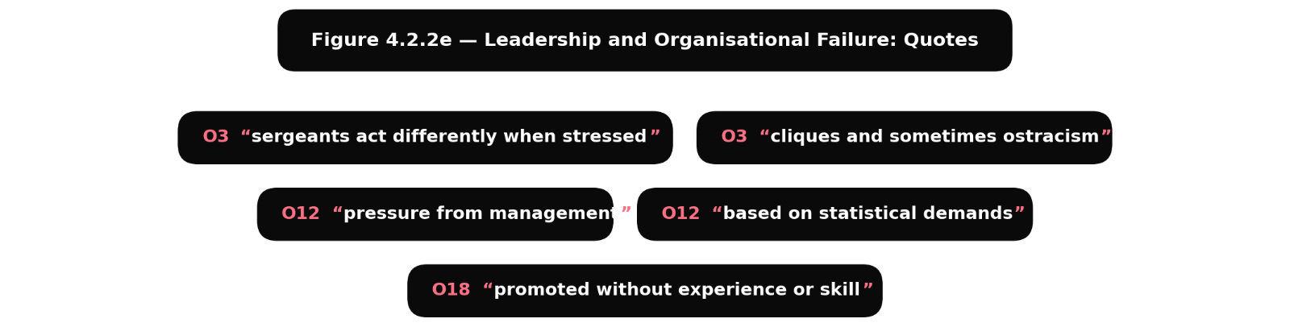

More notably, a persistent commitment to public service runs against the dominant pattern. A smaller group describe sustained commitment to the values the role requires, affirming that officer attitudes should not vary under pressure, as shown in Figure 4.2.2f. The conditions described do not uniformly displace commitment to the principles of the role.
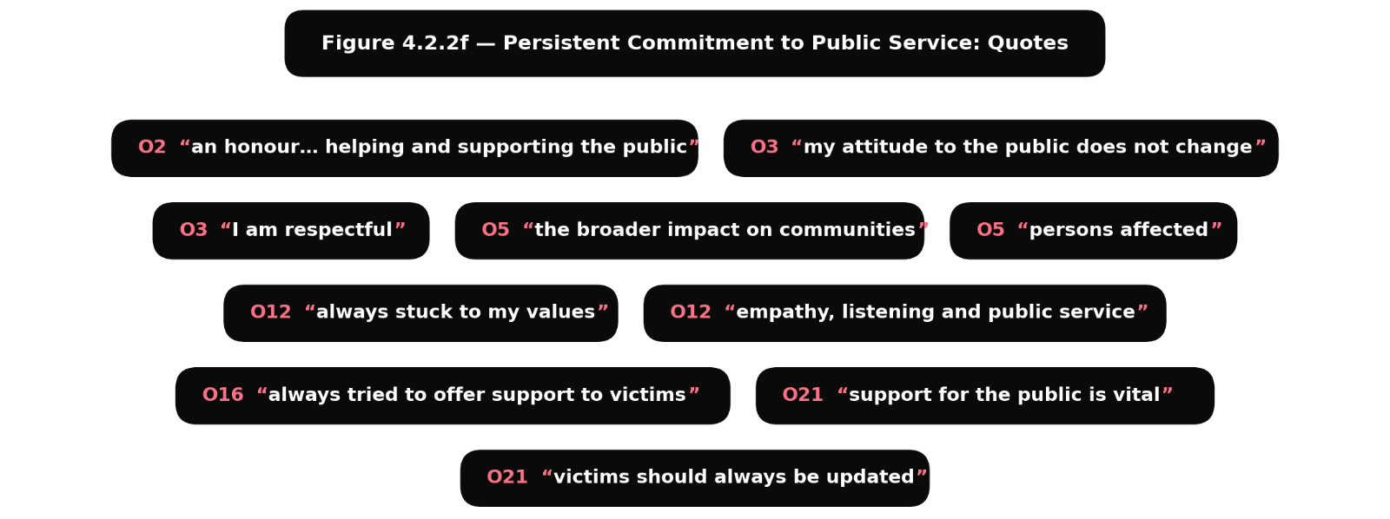

4.2.3 The Contrast
The five public themes and the six officer themes do not map directly onto each other. The public themes organise around what the encounter delivered: how the officer behaved, whether empathy was present, how the tone landed, whether trust was built or weakened. The officer themes organise around the conditions under which the role is performed: exhaustion, administrative burden, contested role scope, public misunderstanding and leadership failure, alongside a smaller thread of persistent commitment.

Public respondents describe what they received, while officers describe the conditions they worked under. These are not two perspectives on the same event but two accounts of what produced the encounter and what was received from it. The responses from the public suggest that public perception of the police is often formed at the encounter, while the responses from the officers show that the encounter they deliver is shaped by the conditions that they describe.

4.3 Summary
The two surveys reveal a clear and recurring discrepancy between what policing frameworks require and what members of the public report receiving from the police. The discrepancy is widest where the encounter demands most: empathy, genuine listening and meaningful follow-up. It is narrowest in fairness and basic procedural conduct. Three bar charts aggregate overall response tone across the closed questions, the open question, and both data sources side by side.

The quantitative aggregate shows the public’s responses weighted toward positive and partially positive experiences, with the clearest negative experiences concentrated around empathy, listening, follow-up and explanation. Officers place near-universal importance on respect and fairness, and are more mixed on explanation and follow-up, as summarised in Figure 4.3a. The areas where officers are most consistent are the areas where the public reports the most consistently positive experience. The data suggests a relationship between how consistently officers support a value and how consistently the public experiences it.
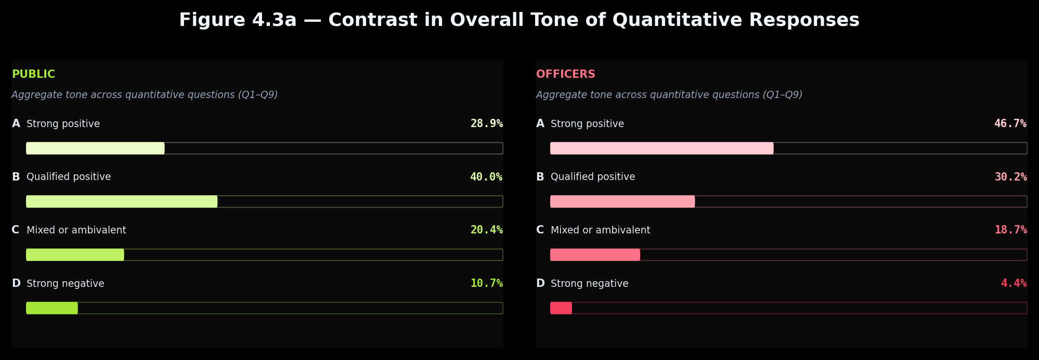

The qualitative responses tell a more complicated story, as shown in Figure 4.3b: public qualitative responses differ only modestly from the quantitative picture, while officer qualitative responses move substantially, combining strong support for professional values with a predominantly negative account of day-to-day policing.
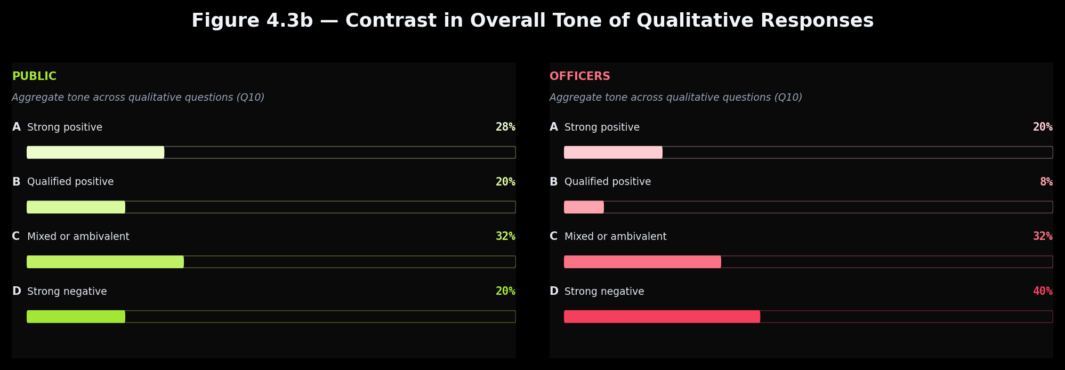

The comparison shows each group is describing something different. Public respondents focus on what happened to them, while officers explain why those encounters unfolded as they did, as presented in Figure 4.3c.
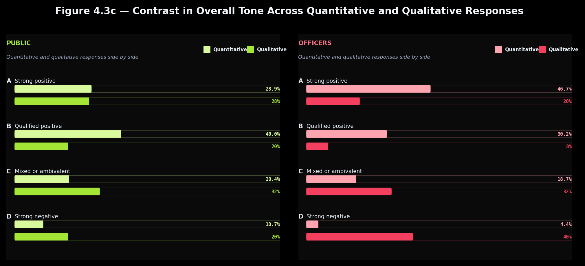
The dimensions where officer responses are most consistent, respect and fairness, are where public experience is most consistently positive. The dimensions where officer responses are more mixed: empathy, explanation and follow-up, are where public experience is most variable. Variation in public experience reflects variation in the conditions shaping the encounter rather than variation in individual officers alone. Alternative explanations may sit alongside this reading rather than displacing it: pre-entry disposition, occupational trauma, and media influence. None fully explains the overall pattern on its own, requiring the discussion to be further developed in the concluding chapter, where findings from wider literature will be analysed next to these findings.

The public perception that emerges from the analysis at hand is mixed, conditionally positive, and shaped at the point of the encounter. Public respondents describe policing as a necessary service, broadly fair and reliable on procedural conduct, but inconsistent on the relational dimensions many encounters depend on: empathy, active listening, explanation and sustained follow-up. Direct experience was often described more positively than media portrayal. Rather than contradicting that picture, the officer survey helps explain it. Officers point to the principles as central to their approach, name the conditions that limit delivery, and a smaller group sustain a commitment to public service under the same conditions. Across both surveys, the picture is of a service whose principles are recognised but whose practice is experienced as falling unevenly short of them. That unevenness appears closely linked to the conditions officers describe working under when engaging with the public.

Appendix A – Public Survey

A.1 Introduction
This appendix contains the full public survey: the complete quantitative results, and the 25 verbatim responses to the open-ended question. Respondents are numbered P1 to P25 in the order their responses were recorded on the SurveyMonkey platform.

A.2 Participant Information
Participants were presented with the following information before beginning the survey:
This survey is intended for individuals aged 18 or over who have had direct interaction with UK police in a situation where police intervention was required. Please answer the following questions based on that interaction and your experience of how you were treated. All responses are anonymous and will be used only for academic research.

A.3 Survey Results
The survey contained 10 questions: 9 closed questions with 4 response options labelled A to D, and 1 open-ended question. Results are reported as percentages with raw frequencies in parentheses, n = 25.

Q1 | During your interaction with the police, how respected did you feel? | % | n
A | I felt respected and taken seriously | 20% | 5
B | Mostly respected | 52% | 13
C | Not very respected | 20% | 5
D | I felt dismissed or not taken seriously | 8% | 2

Q2 | During your interaction with the police, did you feel the officer showed empathy towards your situation? | % | n
A | Yes, the officer seemed to care about my situation | 20% | 5
B | Somewhat | 48% | 12
C | Very little | 20% | 5
D | No, I felt treated more like a case than a person | 12% | 3

Q3 | Did you feel that the officer listened to what you had to say? | % | n
A | Yes, I felt clearly listened to | 20% | 5
B | Mostly | 40% | 10
C | Only a little | 40% | 10
D | No, I felt my perspective was not really heard | 0% | 0

Q4 | Did the officer clearly explain what was happening and why certain decisions were being made? | % | n
A | Yes, everything was clearly explained | 36% | 9
B | Some parts were explained | 32% | 8
C | Very little was explained | 24% | 6
D | Nothing was explained | 8% | 2

Q5 | Did you feel the officer treated you fairly during the interaction? | % | n
A | Completely fairly | 20% | 5
B | Mostly fairly | 60% | 15
C | Mostly unfairly | 16% | 4
D | Very unfairly | 4% | 1

Q6 | Did you feel the officer had enough time to properly deal with your situation? | % | n
A | Yes, they gave the situation the time it needed | 32% | 8
B | Mostly | 44% | 11
C | Not really | 20% | 5
D | No, the interaction felt rushed | 4% | 1

Q7 | After the initial interaction, did you feel the police kept you informed or supported regarding your situation? | % | n
A | Yes, I felt updated and supported | 20% | 5
B | Somewhat | 40% | 10
C | Very little | 28% | 7
D | No, I felt forgotten after the initial interaction | 12% | 3

Q8 | Thinking about what you see or hear about the police in the media and on social media, how does your own experience compare? | % | n
A | My experience was much more positive | 20% | 5
B | My experience was somewhat more positive | 40% | 10
C | My experience was similar to what I see or hear | 36% | 9
D | My experience was worse than what I see or hear | 4% | 1

Q9 | Before interacting with the police, what did you expect most from police officers? | % | n
A | Support and help | 32% | 8
B | A balance between enforcement and support | 48% | 12
C | Strong law enforcement and control | 0% | 0
D | I did not have clear expectations | 20% | 5

Q10 Based on your experience, how would you describe your overall perception of the police?

Please describe in your own words how you view the police and your experience of interacting with them. The 25 verbatim responses are reproduced below exactly as submitted, with no edits to grammar, spelling or punctuation.

ID | Verbatim Response
P1 | Mostly positive
P2 | Great professionalism was seen in my encounter with the police, as well as treating me fairly and making sure I understand everything.
P3 | I felt very pressured and threatened
P4 | I think most of the times there is no empathy shown in the interaction with the police, but of course I cannot make this a general perception because it depends on the situation and on each human being how he/she considers to manage certain things
P5 | The experience had a positive outcome in the end, but I felt that the police did not really care or underdtand my specific situation and wanted to do things their way without considering the impact this would have on my life
P6 | Some officer's go above and beyond to help you and other officer's just treat you like your guilty
P7 | Depends on individual as well i have had multiple interactions with police and many time i was dismissed completely because of my gender other time they were generally respectful and curt
P8 | It's great. The police are attentive and meticulous, and they don't just give perfunctory answers. Sometimes they even offer advice on how to avoid similar problems in the future.
P9 | I felt they are as inefficient as the public perception says
P10 | I feel they could be more a bit more empathetic, however they were still somewhat respectful and tried to do their best with the law regulations
P11 | I had a good interaction with the police officer last time.
P12 | I feel that there are good police and bad police. I know bad police exist and just because i've had a positive experience doesn't mean thats how all of the police are.
P13 | I view the police as a necessary but distant institution. My perception isn't shaped by any specifically bad or traumatic experiences, but I wouldn't describe my view as very positive either. In my limited interactions, the tone has been strictly authoritative and transactional. While they were professional, there was a lack of genuine community connection or approachable helpfulness, which leaves me with a more neutral, cautious perception overall.
P14 | Doing an ok job
P15 | It depends on the individual but in the main they show a degree of empathy and try to resolve the situation
P16 | They are okay sometime not always it dpends on the policie offier you get doesnt matter gender.
P17 | I would say that my overall perception was mixed. Recent controversies as well as my own experience clash in opposite directions on how i feel. I think that making police more community focused and oriented would allow for better experiences on how they are percieved.
P18 | good
P19 | They have a very aggressive demeanor, and listen very little. They are quick to respond and never listen much.
P20 | I think they are vary helpful and kind. They helped me get my stalker to leave me alone.
P21 | mostly positive but could be better
P22 | i view the police as helpful but i think they need to be a bit more understanding and empathetic of situations
P23 | Mixed feelings about them
P24 | Negative experiences have led to negative perceptions. Many events where I am spoken down to, yet with all due respect, I am simply stating what my opinion is regarding a matter. My experiences have been one of those with ego and rather than dealing wit the case objectively, their personality is getting in the way. Whilst having a personality is essential in a public facing role… it isn't essential to come across as condescending or as "the law" when the actions they are taking are contrary to those fundamentals. Because of these reasons I am always apprehensive when speaking to the police, and my conversation is always limited and controlled.
P25 | The police enforce rules on people that they do not always follow themselves, and that makes it hard to trust them or feel comfortable opening up to them.

A.4 Notes
The quantitative distributions reported in A.3 are illustrated in Figures 4.1.1 to 4.1.9 of the analysis of results, reported side by side with the officer sample. The verbatim responses to Q10 were subjected to thematic analysis, with the resulting themes and verbatim quotes presented in Figures 4.2.1a to 4.2.1e. The coding framework grouping these responses into themes is shown in Appendix C.

Appendix B — Officer Survey

B.1 Introduction
This appendix contains the full officer survey instrument, the complete quantitative results, and the 25 verbatim responses to the open-ended question. Respondents are numbered O1 to O25 in the order their responses were recorded on the SurveyMonkey platform.

B.2 Participant Information
Participants were presented with the following information before beginning the survey:
This survey is intended for serving police officers in UK who work in operational roles involving direct public interaction. Please answer the following questions based on your experience of those interactions. All responses are anonymous and will be used only for academic research.

B.3 Survey Results
The survey mirrored the structure of the public survey: 9 closed questions with 4 response options labelled A to D covering identical themes, and 1 open-ended question. Results are reported as percentages with raw frequencies in parentheses, n = 25.

Q1 | When interacting with members of the public, respectful treatment is: | % | n
A | A central part of how I approach interactions | 56% | 14
B | Important but balanced with resolving the situation | 44% | 11
C | Sometimes difficult due to operational pressures | 0% | 0
D | Less important than resolving the incident quickly | 0% | 0

Q2 | When dealing with members of the public who are distressed or vulnerable, showing empathy is: | % | n
A | A key part of how I approach situations | 56% | 14
B | Important but balanced with resolving the incident | 20% | 5
C | Sometimes difficult due to repeated exposure to similar situations | 16% | 4
D | Often difficult to maintain in practice | 8% | 2

Q3 | During interactions with the public, listening carefully before acting is: | % | n
A | A central part of my approach | 40% | 10
B | Important but sometimes limited by time pressure | 44% | 11
C | Useful in some situations but not always necessary | 16% | 4
D | Less important than resolving the incident quickly | 0% | 0

Q4 | Explaining decisions and actions to members of the public during incidents is: | % | n
A | Always an important part of the interaction | 28% | 7
B | Important but sometimes limited by time pressure | 24% | 6
C | Helpful but not always necessary | 36% | 9
D | Secondary to resolving the situation | 12% | 3

Q5 | When making decisions during incidents, ensuring fairness for those involved is: | % | n
A | A central part of my decision-making | 72% | 18
B | Important but balanced with operational demands | 20% | 5
C | Considered when circumstances allow | 8% | 2
D | Secondary to resolving the situation | 0% | 0

Q6 | Time pressure affects how I interact with members of the public: | % | n
A | Never | 4% | 1
B | Rarely | 20% | 5
C | Sometimes | 40% | 10
D | Very often | 36% | 9

Q7 | After the initial interaction, keeping victims or members of the public updated is: | % | n
A | A regular part of my role | 44% | 11
B | Something I try to do when possible | 16% | 4
C | Often limited because I do not have enough time to provide as many updates as I should | 32% | 8
D | Rarely possible in practice | 8% | 2

Q8 | Public perceptions of the police are strongly influenced by media and social media: | % | n
A | Strongly agree | 84% | 21
B | Agree | 12% | 3
C | Disagree | 4% | 1
D | Strongly disagree | 0% | 0

Q9 | Before joining the police, what did you expect your role would involve most? | % | n
A | Helping and supporting members of the public | 4% | 1
B | A balance between enforcement and support | 28% | 7
C | Responding to crime and enforcing the law | 68% | 17
D | I did not have clear expectations | 0% | 0

Q10 Based on your experience, how would you describe the reality of policing in everyday practice?

The 25 verbatim responses are reproduced below exactly as submitted, with no edits to grammar, spelling or punctuation.

ID | Verbatim Response
O1 | At the moment, policing is a job where demand is too high and it is extremely difficult to engage with members of the public. It is well known that the public wish to see more officers out and about however, due to low numbers on shift and demand it is difficult to conduct
O2 | With great power comes great responsability that I am honoured to undertake by helping and supporting the public as best as I can.
O3 | There is often not enough time to complete enquiries in a timely manner, which disappoints victims and puts stress on officers. Officers taken on more and more work, without the time to progress it. That is the downside of the role. My attitude to the public does not change, I am respectful. However, other officers and sergeants often act differently when stressed. Attitudes towards other officers are also sometimes negative, with cliques and sometimes ostracism, including from sgts
O4 | Providing a limited service with limited resources
O5 | As a supervisor I not only have to balance how I interact with members of the public, but also reviewing how my team are dealing with members of the public and victims of crime. There is pressure as demand is high and as in most work streams we are very low staffed. Policing also sometime requires swift action to prevent further risk to the public and it may not be prudent to communicate your immediate actions as the threat to life/infrastructure must be dealt with immediately. It is important to where possible take time after the immediate actions have been taken to consider the broader impact on communities and persons affected by any event and communicate information that is accurate.
O6 | Stressful, chaotic, busy, relentless and thankless
O7 | Impossible – cant do right for doing wrong
O8 | Unfortunately our biggest demand comes from those who hate us and do not appreciate us. This allows us less time to support the "real" victims of crime
O9 | Admin, paperwork, constantly playing chess to move resources and never able to focus fully on incidents
O10 | Far different from what it should be – dealing with mental health calls and arenas which aren't policing
O11 | never enough officers to deal with the demand
O12 | I have been a police officer in both the 1990s and 2000s as well as in the 2020s – the emphasis on victim care is excellent compared to those earlier decades, however, as a service I was better placed to provide the public with a positive experience and build relations in the community I served at the time. I have always stuck to my values regarding empathy, listening and public service. These were taught me in the 90s when the responsibility of policing was taken very seriously and the budget and government support was significantly better. I have found that I have been criticised for the time I spent getting good quality statements and giving victims and the public a good quality of service, because of time restraints. Ultimately, in my experience the rhetoric is much more positive now, there are definitely better support services and systems in place, but in practice officers are significantly hampered by time restraints, the huge amount of duplication within paperwork and the pressure from management, which is based on statistical demands
O13 | A lot of repeated admin to 'justify' decisions. More streamline regarding this is needed to allow a more forward facing force which is connected to the community.
O14 | Like watching the world burn around you and all you have been given to stop it, is a bucket with many holes in it.
O15 | Members of the public do not understand the reality of policing and therefore it is sometimes difficult to manage their expectations even if it is explained to them.
O16 | Every incident is different. Some are slow paced such as a person reporting a neighbour dispute and others are fast flowing such as a domestic ongoing, or serious rtc. One size doesnt fit all approach is not the answer you have to be respectful to the vicitm and update as much as you can but sometimes those updates have to be slow time due to the drmatic and fast flowing issues your are faced with at the time of the incident, in my 31 years of policing experience, i have always tried to offer support to vicitms but have to balance that up with dealing with the incident to hand.
O17 | I am dealing with more Mental health calls than actual crimes and that i have no time to progress any of my workloads due to no officers in to actual help with demand and the stress of the job when i am bouncing from call to call and then getting emails saying that i am not progressing my crimes
O18 | not enough resources to deal with the demand/expectation, lack of understanding from rank/senior officers to the demand, unrealistic expectations set by senior officers/government on policing, officers being promoted without experience/skill.understanding of policing but promoted because of passing an exam and an interview with not much service/experience
O19 | DIFFICULT BEING A 24/7 SOCIAL WORKER
O20 | A backlog of paperwork which takes time away from actually helping the community and being pro-active
O21 | Support for the public is a vital part of policing and victims should always be updated especially when dealing with an arrest. Officers should always deal with the public in an respectful manner however officers often need to change the way the interact with the public depending on the circumstances and the majority of the time officers are not able to explain the exact circumstances to the public and this will often cause divide between officers and the public.
O22 | Daily work load of response police officers can take a massive toll on officers welfare. In turn this can lead to a decreased service to the wider public as there is less time to complete tasks
O23 | 2 – public do not respect us and this makes our job even more difficult.
O24 | Very challenging due to under staffing and pressure building up. A lot of unnecessary work being added. Having to deal with mental health calls even if we are not mental health professionals.
O25 | A lot more paper work than i thought

B.4 Notes
The quantitative distributions reported in B.3 are illustrated in Figures 4.1.1 to 4.1.9 of the analysis of results, reported side by side with the public sample. The verbatim responses to Q10 were subjected to thematic analysis, with the resulting themes and verbatim quotes presented in Figures 4.2.2a to 4.2.2f. The coding framework grouping these responses into themes is shown in Appendix C.

Appendix C — Thematic Coding Framework

C.1 Introduction
This appendix presents the coding framework developed through thematic analysis of the open-ended qualitative responses from both surveys. Initial codes were generated from the verbatim responses reproduced in Appendix A and Appendix B, refined and grouped into the themes reported in Chapter 4.2.

C.2 Public Survey: Thematic Coding Framework
The following tables present the five themes identified from the public survey. Each table lists the respondent identifier, the verbatim extract as recorded in Appendix A, and the initial code applied during analysis. Respondents are labelled P1–P25.

Figure 4.2.1a
Respondent | Verbatim Extract | Code Applied
Theme 1: Individual Officer as Reference Point
P6 | "go above and beyond [or] treat you like you're guilty" | Outcome framed as officer-dependent; polarised expectations
P7 | "depends on individual" | Perception attributed to individual officer, not institution
P12 | "good police and bad police" | Binary categorisation of officers; inconsistency noted
P15 | "it depends on the individual" | Consistency of service perceived as officer-contingent
P16 | "depends on the officer you get" | Interaction quality linked to chance of officer assigned
P24 | "their personality is getting in the way" | Officer personality identified as obstacle to professional conduct

Figure 4.2.1b
Respondent | Verbatim Extract | Code Applied
Theme 2: Empathy Absent or Partial
P4 | "there is no empathy shown" | Complete absence of empathy reported in interaction
P5 | "did not really care or understand" | Lack of empathy and understanding perceived
P10 | "could be more empathetic" | Partial empathy; improvement desired
P15 | "only a degree of empathy" | Empathy present but qualified; insufficient
P22 | "need to be more understanding and empathetic" | Empathy and understanding identified as improvement areas

Figure 4.2.1c
Respondent | Verbatim Extract | Code Applied
Theme 3: Tone, Aggression and Conduct
P3 | "felt very pressured and threatened" | Aggression or intimidation experienced in interaction
P7 | "dismissed because of my gender" | Perceived discrimination; dismissal on identity grounds
P13 | "strictly authoritative and transactional" | Interaction style described as cold and functional
P13 | "lack of genuine community connection" | Absence of relational engagement with community
P19 | "very aggressive demeanor" | Officer demeanour experienced as hostile
P19 | "listen very little" | Poor listening; procedural disregard for public voice
P24 | "spoken down to" | Condescension perceived; power imbalance felt
P24 | "always apprehensive" | Persistent unease around police; negative emotional association
P25 | "enforce rules on people that they do not always follow themselves" | Perceived hypocrisy; double standard in rule application
P25 | "makes it hard to trust them" | Conduct undermines trust in police

Figure 4.2.1d
Respondent | Verbatim Extract | Code Applied
Theme 4: Positive Interactions
P1 | "mostly positive" | Generally favourable experience reported
P2 | "great professionalism" | High professional standard noted by respondent
P2 | "treating me fairly" | Fairness experienced in direct encounter
P8 | "attentive and meticulous" | Officer perceived as careful and thorough
P11 | "good interaction" | Direct experience rated positively
P14 | "doing an ok job" | Moderate satisfaction; acceptable performance acknowledged
P18 | "good" | Brief but positive overall assessment
P20 | "very helpful and kind" | Helpfulness and kindness noted as key qualities
P20 | "helped me get my stalker to leave me alone" | Concrete positive outcome from police intervention
P21 | "mostly positive but could be better" | Broadly positive with reservations; improvement expected

Figure 4.2.1e
Respondent | Verbatim Extract | Code Applied
Theme 5: Broader Perception of Police as Institution
P9 | "as inefficient as the public perception says" | Institutional inefficiency acknowledged; public narrative confirmed
P13 | "a necessary but distant institution" | Police seen as structurally needed but relationally remote
P13 | "neutral, cautious perception" | Guarded institutional view; neither trust nor distrust
P17 | "mixed" | Ambivalent overall view of police as institution
P17 | "controversies and my own experience clash" | Tension between media/public narrative and personal encounter
P23 | "mixed feelings about them" | Ambivalence in institutional perception; unresolved view

C.3 Officer Survey: Thematic Coding Framework
The following tables present the six themes identified from the officer survey. Each table lists the respondent identifier, the verbatim extract as recorded in Appendix B, and the initial code applied during analysis. Respondents are labelled O1–O25.

Figure 4.2.2a
Respondent | Verbatim Extract | Code Applied
Theme 1: Structural Exhaustion
O1 | "demand is too high" | Demand exceeds capacity; systemic overload
O1 | "extremely difficult to engage" | Structural barriers to meaningful public engagement
O4 | "limited service with limited resources" | Resource scarcity constrains service delivery
O6 | "stressful, chaotic, busy, relentless" | Working conditions experienced as unrelenting and overwhelming
O7 | "can't do right for doing wrong" | Perceived no-win environment; structural impossibility of success
O11 | "never enough officers" | Chronic understaffing identified as structural failure
O14 | "like watching the world burn" | Sense of helplessness in face of systemic breakdown
O14 | "a bucket with many holes" | Service delivery described as fundamentally flawed and leaking
O17 | "bouncing from call to call" | Reactive policing with no recovery time between demands
O18 | "unrealistic expectations" | Public and institutional demands exceed operational reality
O18 | "not enough resources" | Resource deficit undermines effective policing
O22 | "massive toll on officers welfare" | Structural exhaustion causes harm to officer wellbeing
O24 | "understaffing and pressure building up" | Cumulative effect of understaffing on operational pressure

Figure 4.2.2b
Respondent | Verbatim Extract | Code Applied
Theme 2: Administrative Burden
O9 | "constantly playing chess to move resources" | Resource management experienced as complex and consuming
O9 | "never able to focus fully on incidents" | Administrative demands fragment attention from operational priorities
O12 | "hampered by time restraints" | Time pressures imposed by bureaucratic systems
O12 | "duplication within paperwork" | Inefficiency identified within administrative processes
O13 | "repeated admin to justify decisions" | Accountability mechanisms experienced as excessive and repetitive
O20 | "backlog of paperwork" | Administrative work accumulates; operational time reduced
O20 | "takes time away from helping the community" | Bureaucracy displaces public-facing work
O25 | "a lot more paper work than i thought" | Volume of administration exceeds officer expectations on joining

Figure 4.2.2c
Respondent | Verbatim Extract | Code Applied
Theme 3: Scope of Role and Who It Is For
O8 | "demand comes from those who hate us" | Demand perceived as coming from hostile or non-legitimate sources
O8 | "real victims of crime" | Prioritisation of genuine victims contrasted with other demand
O10 | "arenas which aren't policing" | Role perceived as extending into non-policing functions
O17 | "more mental health calls than actual crimes" | Mental health demand dominates operational caseload
O19 | "hard being a 24/7 social worker" | Social care function experienced as burdensome and inappropriate
O24 | "we are not mental health professionals" | Boundary drawn between policing and mental health specialism

Figure 4.2.2d
Respondent | Verbatim Extract | Code Applied
Theme 4: Public Misunderstanding of the Role
O6 | "thankless" | Public appreciation perceived as absent; effort goes unrecognised
O7 | "can't do right for doing wrong" | Public criticism felt as unavoidable regardless of conduct
O15 | "hard to manage their expectations" | Gap between public expectations and operational reality
O15 | "public do not understand the reality of policing" | Public perceived as ignorant of operational constraints
O23 | "public do not respect us" | Perceived lack of public respect undermines officer experience

Figure 4.2.2e
Respondent | Verbatim Extract | Code Applied
Theme 5: Leadership and Organisational Failure
O3 | "sergeants act differently when stressed" | Leadership inconsistency under pressure noted
O3 | "cliques and sometimes ostracism" | Exclusionary internal culture identified within organisation
O12 | "pressure from management" | Downward managerial pressure experienced by frontline officers
O12 | "based on statistical demands" | Decision-making driven by metrics rather than operational need
O18 | "promoted without experience or skill" | Promotion processes perceived as inadequate; meritocracy questioned

Figure 4.2.2f
Respondent | Verbatim Extract | Code Applied
Theme 6: Persistent Commitment to Public Service
O2 | "an honour... helping and supporting the public" | Vocational identity framed around service and civic duty
O3 | "my attitude to the public does not change" | Consistent conduct maintained regardless of public reception
O3 | "I am respectful" | Personal commitment to respectful engagement affirmed
O5 | "the broader impact on communities" | Officer mindful of community-level consequences of actions
O5 | "persons affected" | Victim-centred awareness underpins officer approach
O12 | "always stuck to my values" | Values maintained under structural and organisational pressure
O12 | "empathy, listening and public service" | Core service values named explicitly by officer
O16 | "always tried to offer support to victims" | Active commitment to victim welfare in practice
O21 | "support for the public is vital" | Public support framed as central purpose of policing
O21 | "victims should always be updated" | Communication with victims identified as professional obligation

