Ecad6013: Core Studies: The learner: who am I teaching?
Word count: 5007
Georgia Cox
2004047

PART 1

Targets | How have you worked on this? | An example can be found on
Continue to read relevant book, journal articles as well as OECD, EEF, Estyn and Government documentation. | Throughout this assignment, I have referred to ESTYN and Welsh Government documentation. | Pages 5 & 7
Continue to further develop a supported critical approach throughout offering and opposing view whenever possible. | Using the academic phrasebook and previous tutorial sessions, I have gained better understanding of how to be critical throughout my assignment. | Reference to the academic phrasebook has continuously been used throughout this assignment, relating to sentence starters and being critically reflective.

Supporting your discussion with theory, practice, and evidence from literature, critically reflect on how you would support an individual learner whose progress is being affected by specific barriers to his/her learning during one transition period (horizontal and vertical).
David is a seven-year-old boy who has moved into a school in Neath Port Talbot. The name of the child has been fictionalised to protect the rights of the child (BERA,2018). David has been in the school for a few weeks after being away from formal education for several months whilst his family and himself fled from their home in Ukraine. To protect the school, for this assignment it has been referred to as an imaginary school as YBC. Himself and his family have now secured a home within the local area. For nearly a year, David has suffered several traumatic events, some of which include the current situation Ukraine has been battling and living in a warzone. While moving from home leaving friends and family behind to move to Wales, not only are there concerns for the cognitive development of David, adapting to our curriculum and culture. But the emotional impact these traumatic experiences have had on David. Additionally, David has been learning English as an additional language (EAL).
School transitions are life changing events for learners. Even though, learners experience continuous transitions from birth to death, research seems to indicate that school transitions could be intensely social resulting learner’s to become anxious and worried (Synmonds,J, 2015, pp-1-15). When relating David to these findings, David has experienced multiple transitions in his life, both vertical and horizontal. Dealing with changes of environment, resources, curriculum, institutional culture, pedagogical approaches, and styles of classroom interaction. Multiple studies by Cox, Bishop et al have seemed to identify that these transitions have the potential to impact David’s progression and development negatively. (Cox, Kennedy, Bishop & Porteners, 2005; shachar, suss & Sharan, 2002). In addition, many studies have been developed on the formulation of interventions for transition difficulties. Interventions are programs which are developed to fill gaps in learner’s progression by targeting individual needs (Tullis,C.A, et al., 2015, pp-91-102).
The Curriculum for Wales (CfW) (2022) places a big emphasis on learners and their holistic development and progression as a learner. It has been reported by the CfW, that progression is a process of skills and knowledge being developed over time. Teachers need deep understanding of how learners progress to support and help learners make links across their learning and deal with new challenges. In comparison to research from inside education systems, who focus more on holistic development (Dodds, J & Blake, R., 2005). Which state, that holistic development is a partnership between the learner, teacher and the parents and carers. The CfW emphasizes the importance of holistic teachers and learning (Welsh Government, 2020). Other researchers have argued that children could learn better and be happier in school if their emotional needs are addressed before their cognitive needs. This could then help learners to develop to their full potential (Crandall,2005, pp-270-281, Blankson, A.N.,2013, pp-346-360; Jarvis, M., 2005). Therefore, this paper will attempt to explore emotional development rather than academic development of David.

From observations carried out at home and in class, David’s teacher and parents have become concerned of his well-being since transitioning into the school, several weeks ago. David’s peers and teacher have attempted to discuss his feelings regarding his transition and trauma, but David is reluctant to open his worries to anyone. Therefore, a meeting involving the learner, David’s parents, teacher, translator from the local community (Neath Port Talbot Council, 2022), senior leaders of the school and the school’s special educationalist needs coordinator (SENCo). The meeting contained a discussion stating David would benefit greater support to increase his emotional literacy, referring David to the school’s emotional literacy support assistant intervention (ELSA). The meeting also provided David the opportunity to produce a one-page profile (Part 2) with his teacher and parents, supported by a translator. One-page profiles are considered important to support teachers personalise learning for learners with different needs and provide a chance for parents and carers to share their knowledge with the school on how best to support their child (Poulter, G., 2016). Information was gathered with parents using activities from ‘It’s great to be me’ (Sanderson, H et al, 2010) (See Appendix 1).
Trauma is defined as an occurrence an individual perceives such as an event or circumstance which is considered extremely harmful and frightening (Bartlett, J.D., 2019). When relating these findings to David, the learner has had several negative impacts from moving from war such as stress, anxiety, and worry. This is perhaps echoed in literature to be the result of school transition (Howard & Johnson, 2000; Synmonds,J., 2015; Perry,B.D., 1995; Smith,S., 2021). However, recent researchers have explored the negative impacts traumatic experiences can have on an individual in later life. Research implies that David is at risk to Adverse Childhood experiences (ACEs) (Haynes, E et al., 2020; ESTYN 2020). Public Health Wales suggests that learners who experience stressful childhoods are more likely to experience poor self-image and mental health (2021). Similar research reports by the Welsh Government (2022b) states that without the presence of protective factors from stress and trauma which ACEs cause can potentially change a child’s brain development. These findings suggest that David could experience long-term physical problems and challenging behaviour if these barriers are not removed.
Supporting well-being Additionally, Dr. Daniel Siegel (2007), introduced a study on the negative impact of ACEs on a child; he identified that learners needed a balance of several nutrients to progress and develop. Siegel also agreed with previous literature the long-term implications the traumatic experiences can have on the brain. At present, David’s likelihood of experiencing these implications is minimal. However, by placing an intervention in early could potentially prevent deeper implications in the future.
The ELSA intervention which was originally developed by Educational Psychologist Sheila Burton, aims to support David’s well-being and emotional literacy (McEwen, S., 2019, pp-289-306; Wilding, L., 2016, Krause,N., 2020). This is achieved through training teaching assistants to deliver individualised support programmes to meet learners’ emotional literacy needs (ELSA Network, 2017). Sharp (2000) defines emotional literacy as “the ability to recognise, understand, handle and appropriately express emotions”. ELSA supports learners to develop relationships, new skills, and coping strategies for their feelings in addition to helping learners to understand and manage their emotions (Hill, T., 2013; Bravery & Harris, 2009). ELSA’s have a quiet and calm dedicated room which creates a sense of security for learners, free from any interruptions. The intervention rooms need to be comfortable enough for learners to be able to share their thoughts and feelings. Research suggests that teachers can work with posters, relevant pictures, soft furniture, and a home like environment to allow the room to provide learners a nurturing feel (Hampshire County Council, 2020).
YCB’s ELSA room the “Cwtch” will be the intervention room that David will attend for his sessions for 6 weeks. These sessions will support David on managing and understanding strong feelings and finding coping mechanisms to relax. ESTYN (2019) have a wide range of literature supporting the use of ELSA, it is suggested that the provision could support David through difficult times, providing a calm period for David, preparing him for the school day ahead. Furthermore, several studies have reported similar findings to ESTYN stating the provision can possibly improve academic outcomes and the capacity of learning for David (Sharp 2000; Elias et al, 1997). These findings can also support those identified by Asmussen, K et al (2019, pp-425-434) who implies that even though the interventions do not completely eradicate trauma, their research seems to imply that ELSA intervention strategies could reduce the impact of trauma, later in life.
Studies have shown interest in parent engagement in ELSA programmes, stating parents are the key to a successful emotional and social intervention (Weissberg, Walberg, 2007). From an ecological perspective, Bronfenbrenner (1977) implies through his ecological theory that ELSA programmes must recognise the importance of the community, home systems and the school for emotional and social development to be successful (Darling,N., 2007, pp-203-217). Whilst Bowlby (1969) argues that academic achievement is developed through attachment, where if a learner does not have one main primary care attachment, the child would suffer long-term negative impacts to their development (Holmes, 2006). Stakeholders in David’s environment understand how vital parent involvement is through the intervention. Therefore, intervention activities have been planned and prepared for family involvement in both school and at home. If parents were to come into school to complete activities relating to the intervention. An interpreter could come in to support the parents and ELSA teacher in communicating effectively. However, recent studies have identified potential complications to this such as funding, and the availability of interpreters within the community. Studies by the council identify that there are not enough interpreters in the local community (Neath Port Talbot, Council, 2021). These findings could suggest that it would make it harder for David’s parents to get involved with the intervention. However, ELSA teachers could investigate using technology to remove the communication barrier if interpreters were not available. Further depth into complications of the intervention will be mentioned later in the assignment.
Another strategy which can be used to develop emotional well-being of learners is introducing a whole school approach. A case study carried out by Rougemont School identified that learners face several different pressures from modern world which could potentially affect their well-being. Research indicates by encouraging a whole-school culture could promote well-being and encourage a feeling of belonging. The school introduced a wide range of mindfulness and classroom approaches to contribute towards children’s social and emotional development. The school identified learners felt a part of the wider school community, learners had a high level of participation across all aspects of the school and were generally happier and more confident going into the school (ESTYN,2017). Recent evidence suggests similar reports stating that using a whole school approach develops opportunities for learners to develop a supportive community and adapt whole school thinking (Emery,H & Stirling,S. , 2016). Relating to YCB, as part of the school ethos, the school promotes a whole-school community within their curriculum. The school takes part in mindfulness activities every day such as a 30-minute walk in afternoon, participating in mindfulness activities and circle time. The schools current term topic is ‘one town’ which relates to learners having a deeper understanding about the community they are apart of. Findings suggest that this approach can provide learning experiences and help learners improve resilience and enhance well-being (Welsh Government, 2020).
As opposed to Maslow (1943,1954), who suggested in his motivational theory of hierarchy of needs. Needs lower down the pyramid need to be satisfied before learners can attend to needs higher up the pyramid (refer to Appendix 2). When relating the theory to David, the learner needs feelings of belongingness and acceptance. These findings could indicate that cognitive needs come last. A learner is unlikely to achieve or feel motivated if their psychological needs lower down the pyramid are not met (McLeod,S., 2007). However, no attempt has been made to determine whether the cognitive and aesthetic needs could potentially alter depending on the needs of a learner. Nevertheless, Psychologists John Mayer and Peter Salovey (2004) seem to have similar suggestions stating that learners needed to use their emotions to guide their cognitive thinking. Other researchers influenced by the work of Mayer and Salovey seem to propose similar studies finding that emotional development was just as important as academic development. Daniel Goleman (2020) seems to have similar suggestions in his theory of in the brain and emotional intelligence. The theorist seems to imply emotional intelligence develops before entering the classroom. Goleman (1995) suggests emotions can swamp the brain relating in feelings of frustration and cause overwhelming thoughts. This is known as a “amygdala hijack”. The amygdala is an area in the brain that is the centre of emotional behaviour and emotions. Resulting in the brain going into overdrive causing us to obsess with our distress. This finding was unexpected and suggests that due to the amygdala going into overdrive, it can potentially make it harder for a learner to be able to think and process any other information.
Another theoretical background on emotional development and well-being was developed by Erik Erikson (1995), who identifies psychosocial development in ages and stages. The theorist implies that learners go through several developmental stages allowing learners to find their own sense of regulation, learning to grapple instincts, and creating a balance of self (Batra, 2013, pp-249-278). Like the structure of Maslow’s theory of hierarchy, Erikson’s introduced the eight stages of development. The theorist implies that there are specific tasks which must be accomplished in each stage for a child to develop onto the next (refer to Appendix 3 for each stage). Furthermore, Erikson believed learners who have negative experiences during childhood, could potentially result in complex implications in adulthood (Mooney, 2013). In Erikson’s model, David is at the fourth psychosocial crisis. Known as industry vs inferiority. This stage relates to peers and teachers being an important role in a child’s self-esteem (Scheck,S., 2014). However, when relating the stages of development to David, he has lacked the role of peers and teachers for a period due to the result of war, therefore has not been able to accomplish the tasks needed to develop onto the next psychosocial crisis. Furthermore, the ELSA sessions would provide opportunities for David to build upon Erikson’s stage of development.
In addition, cognitive theorists such as Piaget found no relationship between emotions, feelings, and forms of consciousness in learners. But instead, implies that learners mature intellectually and emotionally at different rates (Pulaski, M. 1971). Therefore, suggesting that teachers need to be aware of the different stages of development and to treat the stages accordingly (Aubery,K & Riley, A , 2022; Jarvis and Chandler, 2001).Piaget was influenced by the work of Maria Montessori, particularly relating to cognitive development. However, Montessori suggested emotions are a new-born’s first spontaneous expression. Identifying as learners grow, they gradually grow in maturity through carrying out specific activities (Aubery,K and Riley, A, 2022). Steiner (1996) however, disagrees with the ideas developed by Montessori and states that learners progress through participation, stating learners develop best from experience, producing and creating (Sawyer,R,K et al, 2003).
Whilst Maslow (1970) suggests for learning to become effective, children’s physiological and emotional needs should come first. In contrast to recent research, which seems to identify several barriers which could introduce complications to the intervention running accordingly. Firstly, research seems to indicate that one possible implication to the intervention is availability and consistency (Denham, A. et al, 2020), for example. Relating to David’s school, there is only one ELSA teacher available. Therefore, if the teacher is absent, it results in learners missing out on the intervention. However, a possible strategy to overcome this barrier would be to train a few staff members in the school to ensure there is always a teacher there to support. Secondly, another implication to the intervention could be training. The need for funding to complete training could be a barrier. Schools could potentially find it difficult to fund the constant training for the programme (Krause et al, 2020, pp-17-31). According to several resources the cost of ELSA could vary between £350-£500, with extra charges for supervision and support for following years (Welsh Government, 2020; Southeast Psychology, 2019). A strategy David’s school could use to remove the potential issue of funding for training is to carry out fundraising activities in the school for parents and the community to get involved in. According to research by DeSpain et al (2018) family and community engagement is considered as a critical approach to success of learners, bringing the community together to provide the best outcome for all learners.
Thirdly, A study carried out by Bonnie Wong (2020) interviewed a group of primary school learners involved in an ELSA programme in their school to get a better perspective of the intervention from a learner’s point of view. The learners all stated they were worried and upset about the prospect of their ELSA sessions ending. This could be seen as a barrier as learners are anxious about not returning to their sessions once a week. However, if a teacher was to communicate with learners constantly highlighting the purpose of ELSA sessions, some children could potentially benefit from this approach to help them feel more confident. There is little research of the programme from a child’s view, for future research, questionnaires could be handed out to learners involved in the intervention to identify implications from a child’s point of view.
Effective pedagogy is central to the CfW, Schools should seek and to develop a strong vision of learning and teaching which considers ‘how’ and ‘why’ and ‘what’. Effective pedagogy relates to in-depth understanding of learners and adolescent development (Welsh Government, 2022, c). Relating to David’s school, pedagogy is placed at the centre of their school curriculum. The school’s ethos places well-being at the heart of learning. Learners are encouraged become resilient, strong individuals who can manage their challenges demonstrating integrity and kindness. The development of these qualities within the curriculum encourages learners to contribute to society being happy and confident individuals (Ysgol Cwm Brombil, 2021). In the ELSA intervention, David needs to be supported with his social and emotional development, supporting David to develop positive relationships (Welsh Government, 2022, c). Assessing learners is important to provide individuals an insight of what steps need to be taken next and to consider whether the strategies taken have been effective on the pupil progress. When assessing the emotional and social needs of David, EXCEL assessments will be carried out to track David’s progress and will help identify the impact the intervention has had on the learner’s progression. The EXCEL assessments involve a pre-assessment, post-assessment, profile sheet, summary, and graph summary (ELSA Support, 2021). These assessments will allow the ELSA, teacher, and parents to identify whether David would benefit from more intervention sessions or has progressed emotionally enough to be able to continue developing to his full potential.
Lastly, there is a wide range of policy and legislation which promotes emotional and mental well-being in children and young people. Learners’ wellbeing and emotional development is an important role in learning and progression (Welsh Government, 2021, d). The Health and Well-being Area of Learning and Experience provides professionals support in understanding these needs. In addition, the legislation and policy in Wales similar reported by the CfW demonstrates the importance of emotional well-being in learners and their development. UNICEF (2021) and the Mental Health Act 2007, support the wellbeing of children and young people and always identify the importance of supporting learners’ mental health and safety. Furthermore, there has been an increase of research relating to the emphasis of well-being in schools (NSPCC, 2022). For example, the Child and Families Act (2014), highlights the importance of schools supporting all children’s, emotional, social, and mental health alongside educational provision.

In conclusion, this study set out to gain a better understanding of emotional development and trauma, implementing an intervention which would support David with his progress. As mentioned previously, emotional, and social abilities, potentially can influence intelligence and cognitive development (Gardner, 1983). Recent studies have identified that children’s social and emotional well-being is gradually being recognised as a key factor in determining how well learners progress in schools (National Institute for Health and Clinical Excellences, 2009). The CfW, provides a holistic structure for teachers to support understanding of health and well-being, where the curriculum recognises good well-being enables successful Learning (Welsh Government, 2021, a). One interesting finding within the CfW is that emotional well-being for learners is not considered as a cross-curricular area across the framework. Thus, maybe a possible development could be to place emotional well-being as a cross-curricular theme through the framework.
Weave (2015) Implies that teachers who demonstrate knowledge and understanding of emotional well-being and constantly place pupil well-being at the heart of learning result in happy, confident learners promoting success and support a positive well-being approach across a school environment. It is also outlined as a statutory professional teaching standard, relating to the standard ‘Pedagogy’, ‘teachers should raise awareness of how high-quality learning and experiences and performance outcomes lead to improved learning and a heightened sense of well-being’ (Welsh Government, 2021, f). This could suggest as a student teacher, I need to have deep understanding of the four purposes for learners and how to achieve them in terms of promoting progress and well-being. Another standard which emotional development and the ELSA intervention could apply to is ‘Differentiation’, where as a student teacher I would need to demonstrate understanding and effective practice in meeting the needs of all learners. This can relate to David and the intervention of ELSA, identifying that emotional needs must be met to help David progress to his full potential. In addition, this assignment has provided me a deeper understanding on trauma, development, and the progression through the ELSA programme. A possible improvement for future practice could be to demonstrate higher levels of community and parent involvement. This could involve getting parents in the ELSA sessions in school or taking learners out for well-being sessions in the community.

Part 2

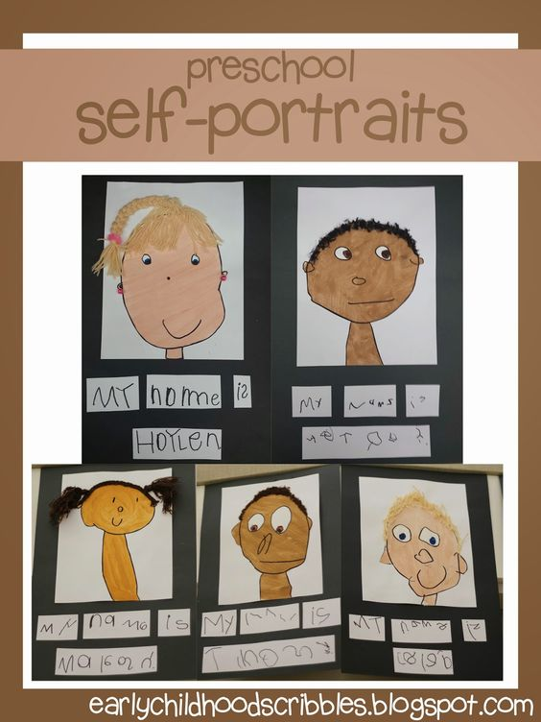

How I like to be supported:
Як мені подобається, коли мене підтримують:
- Opening my feelings and emotions is hard for me, if I seem worried or anxious, let me go to my ELSA teacher, or comfort me in times of sadness.
- I might require visual aids to help others understand my feelings
- I am still struggling with English, and I find words hard. So please be patient and pay attention to my body language.
- I am shy and can be anxious in certain situations, I like to be comforted when I am feeling down.
- I love to have one to one time with others
• Відкрити свої почуття та емоції мені важко, якщо я здаюся стурбованим або тривожним, дозвольте мені піти до свого вчителя ELSA або втіште мене в часи смутку.
• Я все ще борюся з англійською мовою, і мені важко знайти слова. Тому, будь ласка, наберіться терпіння і зверніть увагу на мову мого тіла.
• Я сором'язлива і можу відчувати тривогу в певних ситуаціях, мені подобається втішатися, коли я відчуваю себе пригніченою.
• Я люблю мати один до одного час з іншими

What I don’t like:
що мені не подобається:
- Making my friends sad / засмучувати моїх друзів
- Being alone playing / бути на самоті, граючи
- When I lose my teddy / коли я втрачаю свій плюшевий
- When my mummy is sad / коли моїй матусі сумно,

What is important to me:
що для мене важливо :
- My family / родина
- My teddy / Мій плюшевий
- To be happy / Бути щасливим

What people like about me:
- I am kind / Я добрий
- I have a nice smile / У мене приємна посмішка
- I am curious / Мені цікаво

My one-page profile
David

Social and Emotional Intervention
(Week 1 to 6) ELSA / mindfulness
“Cwtch” – ELSA intervention
Our ELSA (Emotional Literacy Support Assistant intervention is designed to support the emotional needs for our pupils within our own resources. The rationale behind these interventions and approaches is to target the emotional factors first before the cognitive. Once the emotional side starts to develop, aspects of cognitive development will be integrated in. The interventions and approaches will be integrated to develop confidence and support the child overcome trauma and anxiety which has been experienced during the transition of moving school. The term plan will be closely linked to the new curriculum for Wales.
Our ELSA interventions normally run as small groups or 1:1 session. The groups will be devised depending on the strategies which will be implemented in the classroom. The sessions run every Monday Morning for approximately 45 minutes, where learners go straight onto the yard after the session for play, returning to their classrooms afterwards.
Parental involvement
Parents will be actively involved with the school and work within the school community, The community does not only involve the child and the teacher, but it also involves parents and any outside organisations. Relating to ELSA, parents will be actively involved. Projects will be sent home for parents to complete. The school places emotional well-being at the heart of our curriculum where each class participates in mindfulness activities every day. Parents can also access our twitter page to see photos of what the children get up to throughout the week
Parents will be able to communicate to teachers via our dojo class charts. These apps allow parents to interact with teachers privately and safety. Interpreters can be implemented in meetings during our open-door policy if a parent has any concerns relating to the progression and development of the learner. Letters which will be sent out will be written in a bilingual approach

Assessment
When assessing the emotional and social needs of our learners we use EXCEL assessments, which are carried out before the intervention starts, during the intervention and once the interventions have finished. These assessments will allow and parents/carers to identify whether the intervention is benefitting the needs of our learners or to record emotional progress our learners are making to determine if the sessions need to be continued or stopped.

Managing strong feelings
Week | Lesson Focus  (Activities 30 mins – 1 hour) | Who is involved? | Curriculum for Wales 2022 | What will we be doing in this session? | Next steps / parental involvement
Week 1 | Intervention – Emotional Literacy Support assistant programme (ELSA) | Teaching Assistant | Area of Learning and Experience  Health and Wellbeing  What matters  ‘How we process and respond to our experiences affects our mental health and emotional well-being’.  Progression step 1 (PS1): I can notice and communicate how I am feeling  ‘Healthy relationships are fundamental to our well-being’.  Progression step 1 (PS1): I am begging to recognise that I have the right to be treated fairly and respectfully. | Task- to feel a part of the group and promote belonging  - Circle time – going round introducing each other / getting to know the group  - Giving learners an emotion fan and ask them to find an emotion they feel today, can they say, ‘I feel….’ And say why?  - Explain the objectives of the session – show them emblems from fast food chains- they are going to design their own emblem for their group – how does it feel to belong in a group? Learners vote for an emblem to represent the group. | Continue sessions once a week, where the next session will focus on worries and fears – what worries the child and ranking them from 1 to 5 and discussing body feelings.
Week 1 | Well-being carousel – yoga / mindfulness colouring / Lego challenges / reading / what well-being means to you (display)  ***ROTATES EACH DAY**
Week 2 | E.L.S.A | Teaching assistant | What matters  ‘Developing physical health and well-being has lifelong benefits’  (PS1) I am beginning to recognise the connection between the physical and emotional changes that can occur in different contexts. | Task- Worry wobbles  - Emotional register – welcome pupils, and circle time and talk about how they feel today. Discuss session objectives  - Activity – Worries and fears lapbook. Focusing on learners worries and scaling them. Body feelings – cut out a body shape ask the child to explain where they feel their anxiety and worries and mark the areas on the body.  - I can tell you if my worry is big or small / I know some ways to calm myself down  - Relaxation/mindfulness – focusing on relaxation skills before going back to class. | To continue the session weekly, learners will be sent home a pack ready for the next session based on happiness – learners will take an express yourself art doodling book home and engage with parents through drawing.
Week 2 | Well-being carousel – yoga / mindfulness colouring / Lego challenges / reading / what well-being means to you (display)  ***ROTATES EACH DAY***
Week 3 | E.L.S.A  (individual) | Teaching assistant | ‘How we process and respond to our experiences affects our mental health and emotional well-being’  PS2: I am beginning to notice when I need to help manage my feelings  PS2: I can reflect on my experiences | Task – what if monsters  - Circle time – how are we feeling – identify what it means to be shy  - You will find your mind and thoughts are just full of monsters and it is hard to do anything else  - Discussion about letting go of those monsters  - Letting the monsters go  - Encouraging learners to think about… happy things, relaxing things, places you want to go. | For next session, try out the coping strategies at home with family/ do they work? What else can I do to help me?
Week 3 | Well-being carousel – yoga / mindfulness colouring / Lego challenges / reading / what well-being means to you (display)  ***ROTATES EACH DAY***
Week 4 | E.L.S.A | Teaching assistant |  | Task – what is your happy place?  - Developing on last sessions learners will be asked to think about a place which makes them happy which helps them overcome worries and stress.  - Is it a real place? Is it made up or imaginary place? Using all their senses can they tell you what they see, feel, taste and hear?  Whenever they feel a bit angry or upset can go into their happy place to feel better. | Learners have the choice to complete two activities with their parents:  Option 1 – learners can create a photo album of their happy place using a large A3 sheet, or small photo album.  Option 2- memory box, learners can create a memory box with all the things that make them happy. E.g photographs / favourite toy / sentimental item
Week 4 | Well-being carousel – yoga / mindfulness colouring / Lego challenges / reading / what well-being means to you (display)  ***ROTATES EACH DAY***
Week 5 | E.L.S.A | Teaching assistant | What matters  How we process and respond to our experiences affects our mental health and emotional well-being.  PS3- I can self-regulate my emotions in a healthy way using strategies which can help promote positive mental health and emotional wellbeing. | Task- a good mental health  - Circle time – mention session objectives, general conversation and how are we feeling today?  - Activity – mindfulness cube and display  - Asking questions – what you do if you can’t sleep (good mental health questions)  Learners help with creating display | Self-esteem and strengths, from now until next session learners must consider their strengths and what they like about themselves.
Well-being carousel – yoga / mindfulness colouring / Lego challenges / reading / what well-being means to you (display)

***ROTATES EACH DAY***

Week 6 | E.L.S.A | Teaching assistant | ‘How we process and respond to our experiences affects our mental health and emotional well-being.’  PS3:I can reflect on the way that past events and experiences have affected my thoughts, feelings and actions.  ‘Healthy relationships are fundamental to our well-being.’  PS2: I can make friends and seek support when needed. | Task - Emotions and calming down chain  - Circle time  - Discuss the objectives of the session.  - Deepening on previous sessions and bringing them altogether  - Self-care potion – learners create their own self-care potions.  - Cutting out droplets, learners can create a self-care list on ways to relax and calm themselves down from their worries and stresses. | A review will be taken place on whether the E.L.S.A sessions will come to an end or continue within the new term.
Well-being carousel – yoga / mindfulness colouring / Lego challenges / reading / what well-being means to you (display)

***ROTATES EACH DAY***

Extra classroom approaches
Mindfulness activities carousel (15 minutes every day)
This involves the whole class being involved in wellbeing activities first thing in the morning. These activities involve a rotation of yoga, colouring, Lego challenges, reading and working on a well-being display in the classroom.

Circle time
Every Friday afternoon before home time, the class participate in circle time as a class to discuss anything they want to relate to plans they have for the weekend, things that have made their week in school, feelings and any potential class worries or concerns they have.

Reference list
Asmussen, K., McBride, T and Waddell, S. (2019) ‘The Potential of Early Intervention for Preventing and Reducing ACE-Related Trauma, Social Policy and Society’. Cambridge University Press, 18(3), pp.425-434. DOI: 10.1017/S1474746419000071.
Aubrey, K. and Riley, A. (2019) Understanding & using educational theories. 2nd edition. London: SAGE Publications.
Bartlett, J.D., and Sacks, V.A.N.E.S.S.A., (2019). ‘Adverse childhood experiences are different than child trauma, and it’s critical to understand why’. Child Trends.
Batra, S., 2013). ‘The psychosocial development of children: Implications for education and society—Erik Erikson in context’. Contemporary Education Dialogue, 10(2), pp.249-278.
BERA (2018) ‘Ethical Guidelines for Education Research, Fourth Edition’. Available at: Ethical Guidelines for Educational Research, fourth edition (2018) | BERA (Accessed 27th October 2022).
Blankson, A.N., O’Brien, M., Leerkes, E.M., Marcovitch, S., Calkins, S.D. and Weaver, J.M., 2013. Developmental dynamics of emotion and cognition processes in preschoolers. Child Development, 84(1), pp.346-360.
Bowen, G.L., Woolley, M.E., Richman, J.M. and Bowen, N.K., (2001). ‘Brief Intervention in Schools: The School Success Profile’. Brief Treatment & Crisis Intervention, 1(1).
Crandall, A. et al. (2020) ‘Maslow’s Hierarchy of Needs as a Framework for Understanding Adolescent Depressive Symptoms Over Time’, Journal of child and family studies, 29(2), pp. 273–281. Available at: https://doi.org/10.1007/s10826-019-01577-4.
Cox, S., Kennedy,S. , Bishop, F., Porteners, S. (2005) ‘A study of students, transition from primary to secondary schooling: A work in progress’. Wellington, New Zealand: Ministry of Education
Darling, N., (2007) ‘Ecological systems theory: The person in the centre of the circles. Research in human development, 4(3-4), pp.203-217.
Denham, A., Rowley, J., Walshe, L., De Carvalho, E., Higgins, B. (2020) ‘An Evaluation of the Emotional Literacy Support Assistant (ELSA) Programme’. Swindon Educational Psychology Service; Swindon Borough Council
DeSpain, S.N., Conderman, G. and Gerzel-Short, L., (2018) ‘Fostering family engagement in middle and secondary schools’. The Clearing House: A Journal of Educational Strategies, Issues, and Ideas, 91(6), pp.236-242.
Erikson, E.H. (Erik H. (1995) ‘Childhood and society’. Rev. [2nd edit] ed. London: Vintage.
Emery,H & Stirling,S (2016) A Whole school framework for emotional well-being and mental health. [Online] Available at: NCB School Well Being Framework Leaders Resources_0.pdf (Accessed 7Th November 2022)
ESTYN (2020) ‘Adverse childhood experiences (ACEs) – how can schools support children and young people who live in difficult circumstances?’ [Online] Available at: Adverse childhood experiences (ACEs) - how can schools support children and young people who live in difficult circumstances? | Estyn (gov.wales) (Accessed 31st October 2022).
ESTYN (2017) A preventative approach to support wellbeing. [Online] Available at: A preventative approach to support wellbeing | Estyn (gov.wales) (Accessed 7Th November 2022).
ESTYN (2019) ‘Using wellbeing activities to nurture pupils’ [Online] Available at: Using wellbeing activities to nurture pupils | Estyn (gov.wales) (accessed 4th November 2022).
ELSA Support (2021) ‘Social and Emotional Support EXCEL assessments’. [Online] Available at: Social and Emotional Support EXCEL assessments - Item 195 - ELSA Support (elsa-support.co.uk) (Accessed 1st November 2022).
Elias, M. J., Zins, J. E., Weissberg, R. P., Frey, K. S., Greenberg, M. T., Haynes, N. M., . . . Shriver, T. P. (1997). ‘Promoting social and emotional learning: Guidelines for educators.’ Virginia, USA: Ascd.
ELSA Network (2017) ‘About ELSA’. [Online] Available at: About ELSA – ELSA Network (Accessed 6th November 2022).
Fabian, H., & Dunlop, A-W. (2002). ‘Transitions in the Early Years: Debating continuity and progression for young children in early education.’
Fraser, M.W., Richman, J.M., Galinsky, M.J., & Day, S.H. (2009). ‘Intervention research: Developing social programs.’ New York, NY: Oxford University Press.
Government (2014) ‘Children and Families Act 2014’. [Online] Available at: Children and Families Act 2014 (legislation.gov.uk) (Accessed 1st November 2022)
Goleman, D. (1995) ‘Emotional Intelligence’. New York, New York: Bantam Dell
Goleman, D., 2020. ‘Emotional intelligence’. Bloomsbury Publishing.
Haynes, E., Crouch, E., Probst, J., Radcliff, E., Bennett, K. and Glover, S., (2020) ‘Exploring the association between a parent’s exposure to Adverse Childhood Experiences (ACEs) and outcomes of depression and anxiety among their children’. Children and youth services review, pp-113.105013.
Hampshire County Council (2020) ‘Emotional Literacy Support Assistant (ELSA) Intervention’. [Online] Available at: Emotional Literacy Support Assistant (ELSA) intervention | Hampshire County Council (hants.gov.uk) (Accessed 6th November 2022).
Holmes, J. (2006). ‘John Bowlby and Attachment Theory’. United Kingdom: Taylor & Francis.
Howard, S., & Johnson, B (2000). ‘Programs for students in transition from primary to high school’. Sydney, NSW:NSW Department of Community Services/ NSW Department of Education and Training.
Hill, T., O’Hare, D. and Weidberg, F. (2013). ‘” “He’s always there when I need him”: Exploring the perceived positive impact of the Emotional Literacy Support Assistant (ELSA) programme’. University of Bristol, England. Retrieved from the Internet On, 30, p.14.
Jarvis, M. (2005) ‘The psychology of effective learning and teaching’. Cheltenham: Nelson Thornes. Pp-
Jarvis,M and Chandler, E. (2001) ‘Angles on Child Psychology’. Cheltenham: Nelson Theatre
Krause, N., Blackwell, L. and Claridge, S. (20200. ‘An exploration of the impact of the Emotional Literacy Support Assistant (ELSA) programme on wellbeing from the perspective of pupils’. Educational Psychology in Practice, 36(1), pp.17-31.
Klinkner, J., Ramminger, A., Riley, D., San Juan, R. (2007) ‘Social & Emotional Development: Connecting Science and Practice in Early Childhood Settings’. United States: Redleaf Press.
McEwen, S. (2019) ‘The Emotional Literacy Support Assistant (ELSA) programme: ELSAs’ and children’s experiences’, Educational psychology in practice’, 35(3), pp. 289–306. Available at: https://doi.org/10.1080/02667363.2019.1585332.
McLeod, S. (2007) ‘Maslow's hierarchy of needs’. Simply psychology, 1(1-18).
McLeod, S. (2018) Erik Erikson’s Stages of Psychosocial Development [Picture] Available at:
Mooney, C. G. (2013). ‘Theories of Childhood, Second Edition: An Introduction to Dewey, Montessori, Erikson, Piaget & Vygotsky’. United States: Redleaf Press.
Neath Port Talbot Council (2021) ‘Supporting the people of Ukraine’. [Online] Available at: Supporting the people of Ukraine – Neath Port Talbot Council (npt.gov.uk) (Accessed 31st October 2022).
NSPCC (2022) ‘Child Mental Health’. [Online] Available at: Child mental health: recognising and responding to issues | NSPCC Learning (Accessed 4th November 2022).
Perry, B.D. et al. (1995) ‘Childhood trauma, the neurobiology of adaptation, and “use-dependent” development of the brain: How “states” become “traits”’, Infant mental health journal, 16(4), pp. 271–291. Available at: https://doi.org/10.1002/1097-0355(199524)16:4<271::AID-IMHJ2280160404>3.0.CO;2-B.
Pulaski, M.A.S. (1971) ‘Understanding Piaget: An introduction to children's cognitive development’.
Poulter, G. (2016) ‘Using one page profiles to improve person centred care on the inpatient unit (ipu)’, BMJ supportive & palliative care, 6(Suppl 1), p.54–. Available at: https://doi.org/10.1136/bmjspcare-2016-001245.146.
Public Health Wales (2021) ‘Adverse Childhood Experiences’. [Online] Available at: Adverse Childhood Experiences - Public Health Wales (nhs.wales) (Accessed 31st October 2022).
Sanderson,H., Smith,T. , Wilson, W., (2010) ‘One Page Profiles in Schools; a guide’. Stockport; Julie Barclay HSA PRESS Available at: One-Page-Profile-school-guide.pdf (haltonchildrenstrust.co.uk)
Salovey, P., & Mayer, J. D. (2004) ‘Emotional intelligence. In P. Salovey, M. A. Brackett, & J. D. Mayer (Eds.), Emotional intelligence: Key readings on the Mayer and Salovey model’ (pp. 1–27). Dude Publishing.

Scheck, S. (2014). ‘The Stages of Psychosocial Development According to Erik H. Erikson. Germany: GRIN Verlag’.

Sawyer, R.K., John-Steiner, V., Moran, S., Sternberg, R.J., Feldman, D.H., Csikszentmihalyi, M., Gardner, H. and Nakamura, J. (2003). ‘Creativity and development’. Counterpoints: Cognition, Memo.

Sharp, P. (2000) ‘Promoting emotional literacy: emotional literacy improves and increases your life chances’. Pastoral Care in Education, 18(3), pp.8-10.
Siegel, D.J. (2007) ‘The mindful brain: Reflection and attunement in the cultivation of well-being’ (Norton series on interpersonal neurobiology). WW Norton & Company.
Smith, S. and Conti, G. (2021) ‘Memory: What every language teacher should know’. Place of publication not identified: Independently Published.
Steiner, R (1996) The Child's Changing Consciousness: As the Basis of Pedagogical Practice: 16 (Foundations of Waldorf Education) Paperback
Southeast Psychology (2019) ELSA Training. [Online] Available at: ELSA Training - South East Psychology (sepsychology.co.uk) (Accessed 5th November 2022).
Symonds, J (2015) Understanding School Transitions. Oxon: Routledge. Pp 7-35.
Tullis, C.A., Cannella-Malone, H.I. & Payne, (2015) ‘Literature Review of Interventions for Between-Task Transitioning for Individuals with Intellectual and Developmental Disabilities Including Autism Spectrum Disorders’. Rev J Autism Dev Disord 2, pp91–102 DOI: https://doi.org/10.1007/s40489-014-0039-0
UNICEF (2021) ‘The Convention on the Rights of the Child: The child-friendly version’. [Online] Available at: The Convention on the Rights of the Child: The child-friendly version | UNICEF State of Palestine (Accessed 4th November 2022).
Weare, K. (2015) ‘What works in promoting social and emotional well-being and responding to mental health problems in schools’. London: National Children’s Bureau, pp.1-15.
Welsh Government (2020) Learner well-being and assessment: mutual support systems. [Online] Available at: learner-well-being-and-assessment-mutual-support-systems.pdf (gov.wales) (Accessed 7th November 2022).
(a) Welsh Government (2021) ‘Health and Well-being’. [Online] Available at: Health and Well-being: Statements of what matters - Hwb (gov.wales) (accessed 31st October 2022).
(b) Welsh Government (2021) ‘Trauma and ACE (TrACE) informed Organisations Toolkit; Supporting organisations to embed ACE Awareness and Trauma and ACE Informed Practice’ [Online] Available at: TrACE-Organisation-Toolkit-Guidance-September-2021-Version-1b-1.pdf (gov.wales) (Accessed 31st October 2022).
© Welsh Government (2022) ‘Implementation and practical considerations’. [Online] Available at: Implementation and practical considerations - Hwb (gov.wales) (Accessed 1st November 2022).
(d) Welsh Government (2021) ‘Curriculum for Wales: The Journey to curriculum roll-out’. [Online] Available at: Curriculum for Wales: the journey to curriculum roll-out - Hwb (gov.wales) (Accessed 4th November 2022).
(e) Welsh Government (2020) ‘The ELSA Programme’. ELSA Network. [PDF] Available at: Emotional Literacy in Schools The ELSA Project (gov.wales) (Accessed 5th November 2022).
(f) Welsh Government (2021) ‘Professional standards for teaching and leadership’. [PDF] Available at: professional-standards-for-teaching-and-leadership-interactive-pdf-for-pc.pdf (gov.wales) (Accessed 5th November 2022).
Wong,B, Cripps,D., White,H. Young,L. Kovshoff,H. Pinkard,H. & Woodcock,C. (2020) Primary school children’s perspectives and experiences of Emotional Literacy Support Assistant (ELSA) Support, Educational Psychology in Practice, 36(3), pp-313-327. DOI: https://doi.org/10.1080/02667363.2020.1781064
Wilding, L. and Claridge, S. (2016) ‘The Emotional Literacy Support Assistant (ELSA) programme: parental perceptions of its impact in school and at home’. Educational Psychology in Practice, 32(2), pp.180-196.
Ysgol Cwm Brombil (2021) Ethos. [Online] Available at: Ysgol Cwm Brombil (npted.org) (Accessed 1st November 2022).
Zare, M., Narayan, M., Lasway, A., Kitsantas, P., Wojtusiak, J. and Oetjen, C.A. (2018) ‘Influence of adverse childhood experiences on anxiety and depression in children aged 6 to 11 years’. Pediatric Nursing, 44(6).

Appendices
Appendix 1 – ‘It is great to be me’ – activity completed by parents and teacher support
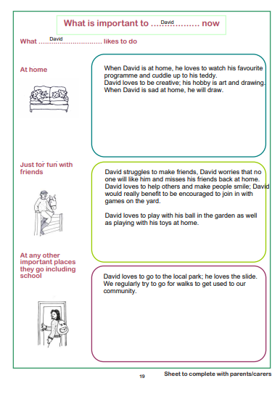
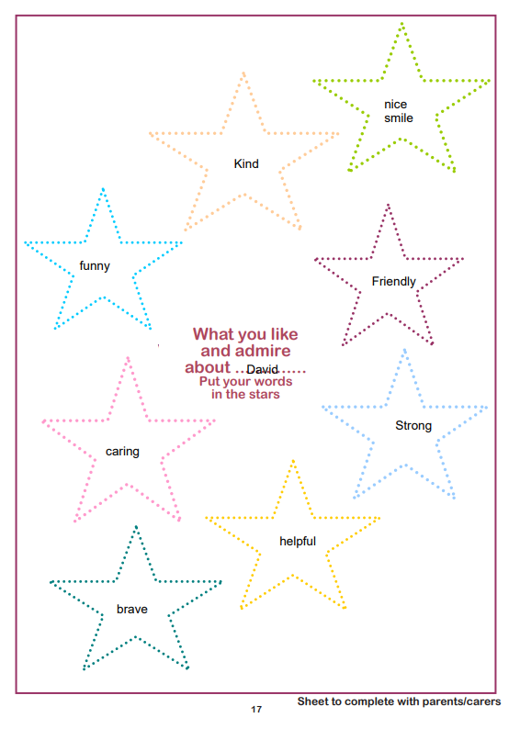

Appendix 2
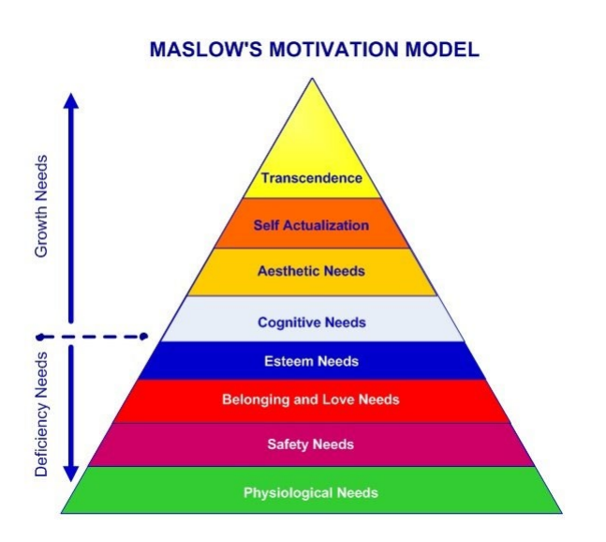
Malow’s Hierarchy of needs motivation model
Maslow’s (1943,1954) five-stage model has been expanded to include cognitive and aesthetic needs.

Cognitive needs – relating to a learner’s knowledge and understanding. Their curiosity to explore and the need for meaning.
Aesthetic needs- the relation to appreciation and search for balance, form and beauty

(McLeod, S., 2007)

Appendix 3
Erikson’s eight stage of development
Stage | Psychosocial Crisis | Basic Virtue | Age
1. | Trust vs. Mistrust | Hope | 0 - 1½
2. | Autonomy vs. Shame | Will | 1½ - 3
3. | Initiative vs. Guilt | Purpose | 3 - 5
4. | Industry vs. Inferiority | Competency | 5 - 12
5. | Identity vs. Role Confusion | Fidelity | 12 - 18
6. | Intimacy vs. Isolation | Love | 18 - 40
7. | Generativity vs. Stagnation | Care | 40 - 65
8. | Ego Integrity vs. Despair | Wisdom | 65+

(McLeod, 2018)

