ACCB6017 Usability Engineering
Component 1
UWTSD Pandemic
A Co-operative Campus Outbreak Game
User Requirements and Prototype
Student name
Student ID
Programme | BSc Applied Computing
Module | Usability Engineering (ACCB6017)
Assignment | User Requirements and Prototype (50%)
Lecturer | Dr Osman Elgawi
Submission deadline | Friday 3rd July 2026
Word count (body) | ~2,500 – 2,800

Contents
1. Introduction 3
2. Test Personas and Their Requirements 3
3. Research Methods 5
3.1 Rationale 5
3.2 Method 1: Online questionnaire 5
3.3 Method 2: Semi-structured interviews 6
3.4 Sampling: covering the persona range 6
3.5 Summary and critical analysis of findings 6
3.6 From findings to requirements 6
4. Designing for Usability 7
4.1 Usability issues addressed 7
4.2 Recommendations from the literature applied 7
5. Wireframe Storyboards 7
5.1 Game setup and role selection 8
5.2 The main game board (hub screen) 8
5.3 Interruptions and accessibility 9
5.4 Movement between screens 10
6. Evaluating the Prototype and Peer Feedback 11
6.1 Collecting feedback on the prototype 11
6.2 Peer evaluation 11
7. Conclusion 12
References 13
Appendix A: MoSCoW Requirements 14
Appendix B: Research Instruments 15
B.1 Questionnaire 15
B.2 Semi-structured interview script 15
B.3 Consent / ethics note (read aloud before each session) 16
Appendix B: Complete Wireframe Storyboard Set 17

1. Introduction
This report documents the initial user research and interface design for UWTSD Pandemic, a co-operative mobile game in which up to six players each take on a role from a different part of the university (for example Estates, the Students' Union, IT Services or a Wellbeing Lead) and work together to contain a campus outbreak before it spreads out of control. The work follows a human-centered design process [1], [4]: rather than designing from assumption, potential users were consulted first, their needs were translated into prioritized requirements, low-fidelity wireframes were produced, and those wireframes were then evaluated with users and peers. The report presents four research-based personas, the methods used to elicit requirements, the usability principles applied, the wireframe storyboards, and the feedback gathered on them.

2. Test Personas and Their Requirements
Personas are evidence-based archetypes that keep design decisions anchored to real user goals rather than to the designer's own habits [5]. Four personas were developed, each grounded in a specific questionnaire respondent or interviewee (see Section 3). The set was deliberately diversified across age, university role, technical confidence, gaming experience and accessibility need, in direct response to the brief's reminder that students are not all able-bodied 18–21-year-olds and that not all have disabilities. The scenarios below describe a realistic moment of use, and the key UX requirements flow directly from each person's goals and frustrations.
PERSONA 1 - Aisha, 20
Name & age | Aisha, 20
University role | Second-year BSc Computing student, lives in student halls
Tech confidence | High - owns a smartphone and a laptop, switches between apps fluidly
Gaming experience | Regular mobile gamer; plays Among Us and card games socially
Accessibility needs | None identified
Goals | Wants a game she can drop into between lectures without re-reading instructions; enjoys the social aspect of co-op play.
Frustrations | Unskippable tutorials; screens that require scrolling to find the main action; waiting without knowing what other players are doing.
Scenario | Aisha has a ten-minute gap between lectures and rejoins a game her flatmates started the previous evening. She glances at the board, immediately sees it is her turn, checks what the last two players did in the action log, makes her move and locks her phone - all before walking to her seminar.
Key UX requirements | - Learn-by-doing onboarding that can be skipped and replayed  - Always-visible turn indicator and a short summary of recent team actions  - Large, uncluttered tap targets suited to one-handed phone use

PERSONA 2 - Dyied, 47
Name & age | Dayied, 47
University role | Mature student, part-time MSc in Data Management, works full-time in local government
Tech confidence | Low–medium - comfortable with Microsoft 365 and basic apps; cautious with anything unfamiliar
Gaming experience | Rarely plays digital games; enjoys Scrabble and occasional board games with his children
Accessibility needs | Mild dyslexia; finds dense paragraphs slow to parse; prefers icon-supported labels
Goals | Wants to feel competent quickly and not slow down younger teammates; needs clear guidance that does not overwhelm.
Frustrations | Dense on-screen text; game jargon with no explanation; fear of tapping the wrong button and ruining the game for others.
Scenario | Dayied joins a game with three postgraduate classmates. He is unsure what the “Research” action does, so he taps the help icon next to it and reads a two-sentence plain-English explanation. He selects the action and, before committing it, sees a confirmation screen that summarizes what will happen — he taps Confirm and feels in control.
Key UX requirements | - Plain-language labels with supporting icons, not text alone  - An undo / confirm step before committing an action  - Adjustable text size and generous line spacing

PERSONA 3 - Chloe, 28
Name & age | Chloe, 28
University role | PhD student (year two), School of Art and Design; also a part-time graduate teaching assistant
Tech confidence | Medium-high confident with design software; games less frequently but picks up interfaces quickly
Gaming experience | Plays co-operative card games; has played the physical Pandemic board game twice at gaming nights
Accessibility needs | Deuteranopia (red–green color vision deficiency); identified during the interview when she described difficulty distinguishing “the red and green bits” in apps
Goals | Wants to communicate with teammates and easily see what is happening in the game without needing to call on color cues that she can’t reliably see.
Frustrations | Any interface where the only distinction between states is a red/green color swap; she described missing critical alerts in other apps for this reason.
Scenario | Chloe is the team’s strategist in a five-player session. She has to find the two most dangerous areas of the campus in a hurry, so that the team can prepare the next two turns. The zones are numbered for an infection threat rating, and are tinted with a color as well as having a warning icon, so she reads the threat level from the numbers and calls out the plan without hesitation.
Key UX requirements | - Status conveyed by icon + text + shape, never color alone [3]  - A board overview that supports planning across multiple zones  - Clear feedback after every action so consequences are understood

PERSONA 4 - Marcus, 31
Name & age | Marcus, 31
University role | Final-year undergraduate BSc Software Engineering; also works twelve hours a week as a library assistant
Tech confidence | High: builds his own Android apps as a hobby; very comfortable with settings and accessibility menus
Gaming experience | Regular gamer; plays turn-based strategy games and enjoys co-op titles with friends online
Accessibility needs | Moderate low vision (wears glasses, uses OS-level large text at 140%); reduced grip strength in his right hand following a sports injury, affecting tap precision
Goals | Wants a game that is still fully usable at large text sizes and with generous tap targets, without sacrificing strategic depth.
Frustrations | Tiny action buttons; layouts that break or overflow when text is enlarged in system settings; anything that requires a precise double-tap.
Scenario | Marcus is playing with the size of his text on his cell phone at 140% of normal. He spreads the game board and all are legible labels and all buttons are within reach with his thumb. He accidentally pushes the PASS button, but the confirm dialog stops the mistake from being made, and he chooses another option without the mistake having any impact on the game.
Key UX requirements | - Minimum 44×44 px tap targets [8] and forgiving hit areas  - Reflowing layout that does not break at large text sizes  - No time-pressured inputs; actions confirmed, not rushed

3. Research Methods

3.1 Rationale
Without consulting the users of the interface, its design can easily be for assumptions instead of needs [1], [4]. It was therefore decided to use a user-centred approach, which involved a breadth-first method (online questionnaire) and a depth-first method (semi-structured interviews). In line with the common practice of interaction design, this mixed-methods design is recommended because quantitative, breadth-oriented data complements the qualitative, depth-oriented data from the interviews: The brief is given to a large number of people in a short time and patterns emerge, whereas the interviews provide explanations for the patterns and the emotional response, which the brief asks for [2].

3.2 Method 1: Online questionnaire
A brief questionnaire with 12 questions was created in Microsoft Forms Central and was sent via the module teams channel, BSc Computing Students WhatsApp group and direct message to 5 non-computing students to ensure that the sample was a cross section. The responses were collected over 10 days which gave N = 23 responses. The demographics and confidence was collected in the first part, the multiple choice and scaled information on the priorities of the features in the second part and the free text responses for the emotional response in the third part. For obtaining this kind of information from several respondents, a questionnaire was selected as the preferred method, and is suitable for identifying patterns of requirements early in the design process [2]. The complete instrument can be found in Appendix B.1.

3.3 Method 2: Semi-structured interviews
Four semi-structured interviews were held by Microsoft Teams where the conversations took approximately 25 minutes. To gain richer, qualitative information, four semi-structured interviews were held, each around 25 minutes in length, using Microsoft Teams. The semi-structured format was chosen because using fixed anchor questions ensures the questions are comparable and the open-ended follow up questions (Why? Can you give an example?) ensure unexpected questions and feelings are raised [2]. To enhance the diversity of the questionnaire sample, interviewees were selected to include all of the following: Dayied (mature part-time student, dyslexia); Chloe (PhD student, red–green color-vision defect); Marcus (undergraduate, low vision, reduced grip strength); Aisha (confident young gamer with no access need, baseline perspective). Interviews were only recorded with permission and notes were anonymized (Appendix B.3). The interview script can be found in Appendix B.2.

3.4 Sampling: covering the persona range
Participants were recruited purposively to map onto the diversity the brief demands. The sample spanned ages from 19 to 42; included undergraduate, mature, postgraduate and staff roles; ranged from daily mobile gamers to people who rarely game; and included participants with dyslexia, a red–green color-vision deficiency, and low vision. Recording which participant mapped to which persona category provides the evidence of coverage; this mapping is summarized in Appendix B alongside the instruments.

3.5 Summary and critical analysis of findings
Coding the open responses and interview notes produced four recurring themes. First, clarity of game state was near-universal: most participants rated 'clearly seeing whose turn it is and what teammates did' as essential; 19 of 23 respondents (83%) rated it 4 or 5; implying a permanent turn indicator and an action log. Second, low-friction onboarding: participants split between wanting a short tutorial and wanting to learn by doing, so onboarding must be skippable and repayable rather than mandatory. Third, accessibility is not optional: the color-blind interviewee could not distinguish the prototype's status colors, confirming that status must be carried by icon, text and shape as well as color [3]; the low-vision participant required large, reflowing layouts. Fourth, it was exciting when things went well and slow; some participants reported giving up on a co-op game in minutes if it seemed overly rushed, too complicated, or if a single mistake seemed insurmountable. There were two surprising results. It is the mature game player who really appreciated an undo step, more so than the younger gamers who barely commented upon it; a reminder that confidence in the game, not just age, determines the need for reversibility. While most literature considers tutorials a standard good, a number of participants were very critical about forced tutorials and the requirement was changed from 'a tutorial' to 'a skippable tutorial'. The points of agreement did not have as strong an influence on final priorities as did these tensions.

3.6 From findings to requirements
Each theme was translated into one or more requirements and prioritized using the MoSCoW method (Must, Should, Could, Won't have), a prioritization technique from the DSDM/Agile tradition [6]. Anything most participants called essential, or that addressed an accessibility need, became a *Must*; strongly-wanted features became *Should*; nice-to-haves became *Could*; and features out of scope for this first version became *Won't*. The complete categorized list is given in Appendix A. The three highest-priority requirements are: a permanent, unambiguous turn indicator (from the clarity theme); status cues that never rely on color alone (from the accessibility theme [3]); and tap targets of at least 44 px for one-handed and low-precision use (from Persona 4 and [8]).

4. Designing for Usability
The storyboards were designed to pre-empt the usability problems most likely to affect a small, dense, co-operative mobile interface. Design decisions are justified against established principles rather than personal taste.

4.1 Usability issues addressed
- Visibility of system status: players must always know whose turn it is, how many actions remain, and the threat level. The game board (Figure 1) keeps the turn, an action-pip counter and an outbreak counter permanently on screen, satisfying Nielsen's first heuristic [3].
- Small touch targets and the 'fat finger' problem: controls follow the ≥44 px guidance for touch [8] and are spaced to reduce mis-taps, applying Fitts's Law (acquisition time grows as targets shrink and distance grows) [7].

4.2 Recommendations from the literature applied
The post-action confirmation messages were designed to be visible, visible affordances, and have immediate feedback, in line with Norman's principles [1]. It was designed with Nielsen's ten heuristics [3] as a design checklist and for each screen the layout was driven by the consistency heuristic: the status bar is at the top and the key actions at the bottom. This report is part of a loop which can be characterized as an overall iterative process for the specification of context, statement of requirements, design, and evaluation of designs against requirements, as described in ISO 9241-210 [4]. The concrete numbers were given by mobile-specific guidance on target size and accessibility [8] and by WCAG 2.1 accessibility criteria [9]. The decisions are reevaluated in light of user input in Section 6.

5. Wireframe Storyboards
The prototype was created as a greyscale wireframe (not full colour design as per brief) to allow focus on structure, layout and flow rather than aesthetics during evaluation. The full function of the eleven screens, from launch to setup, play to interruptions and to end state, is discussed in Appendix C, and here is a discussion of the principal screens. The frame of all screens is consistent with the consistency heuristic [3]: status bar & title in the upper part of the screen and primary controls in the lower part of the screen.

5.1 Game setup and role selection
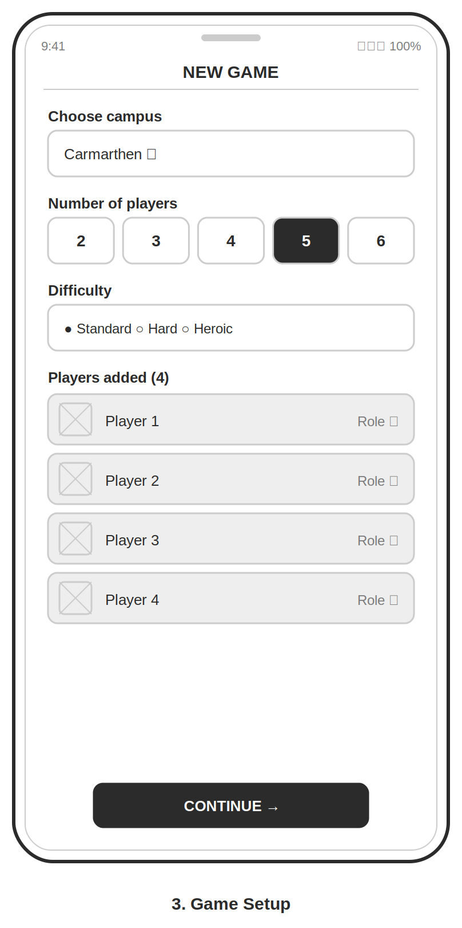
Figure 1: Game setup: choosing campus, player count, difficulty and roles.
Game set up: campus, number of players, difficulty and roles (shown in figure 1). There is no 'all at once' screen for setup because the player selects a campus, a player count (2–6) and difficulty before inviting players. Fill and label are used to indicate selection, rather than colour changes, and the one primary action ('Continue') is placed at the bottom for easy single-handed access [8].

5.2 The main game board (hub screen)
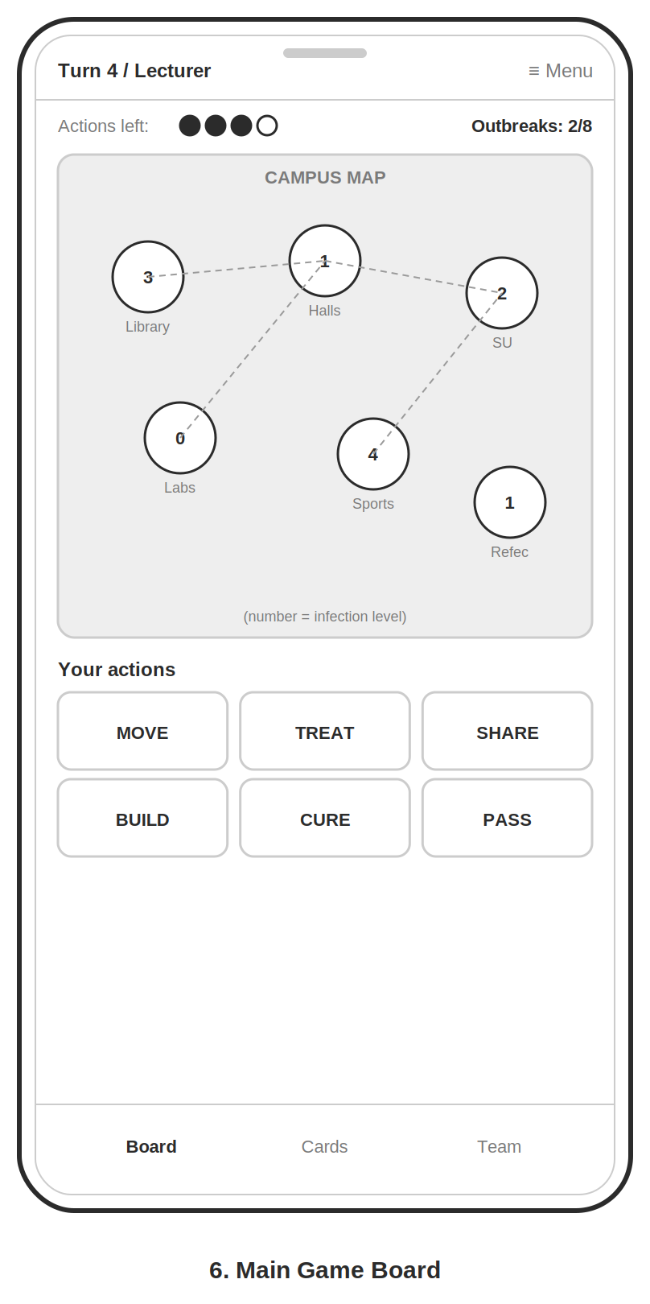
Figure 2: Main game board: persistent status, campus map and action grid.
The board is the central of the interface. The turn owner, actions left (filled/empty pips) and the outbreak counter are always displayed for continuous system status [3]. Campus zones are nodes with names and numeric infection levels, so threat is based on the numeric level, and location, not just on the color, directly speaking to Persona 3. The six core actions are in a labelled grid at the bottom, which offers support for recognition over recall [3] and large, well-spaced targets [7], [8].

5.3 Interruptions and accessibility
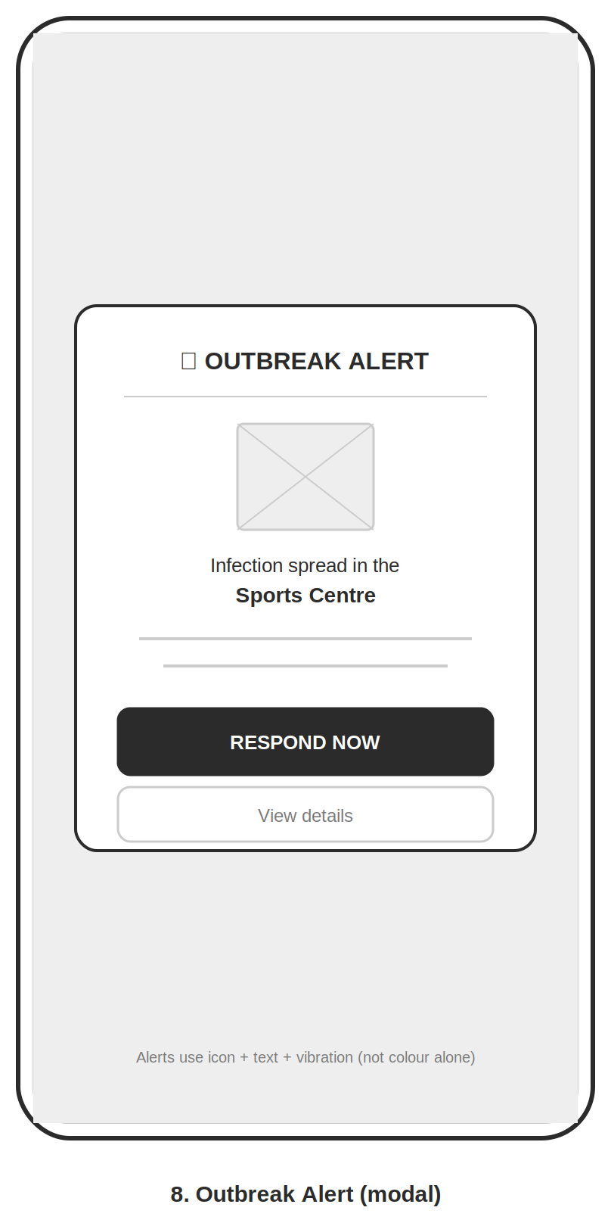
Figure 3: Outbreak alert: a modal using icon, text and vibration, not color alone.
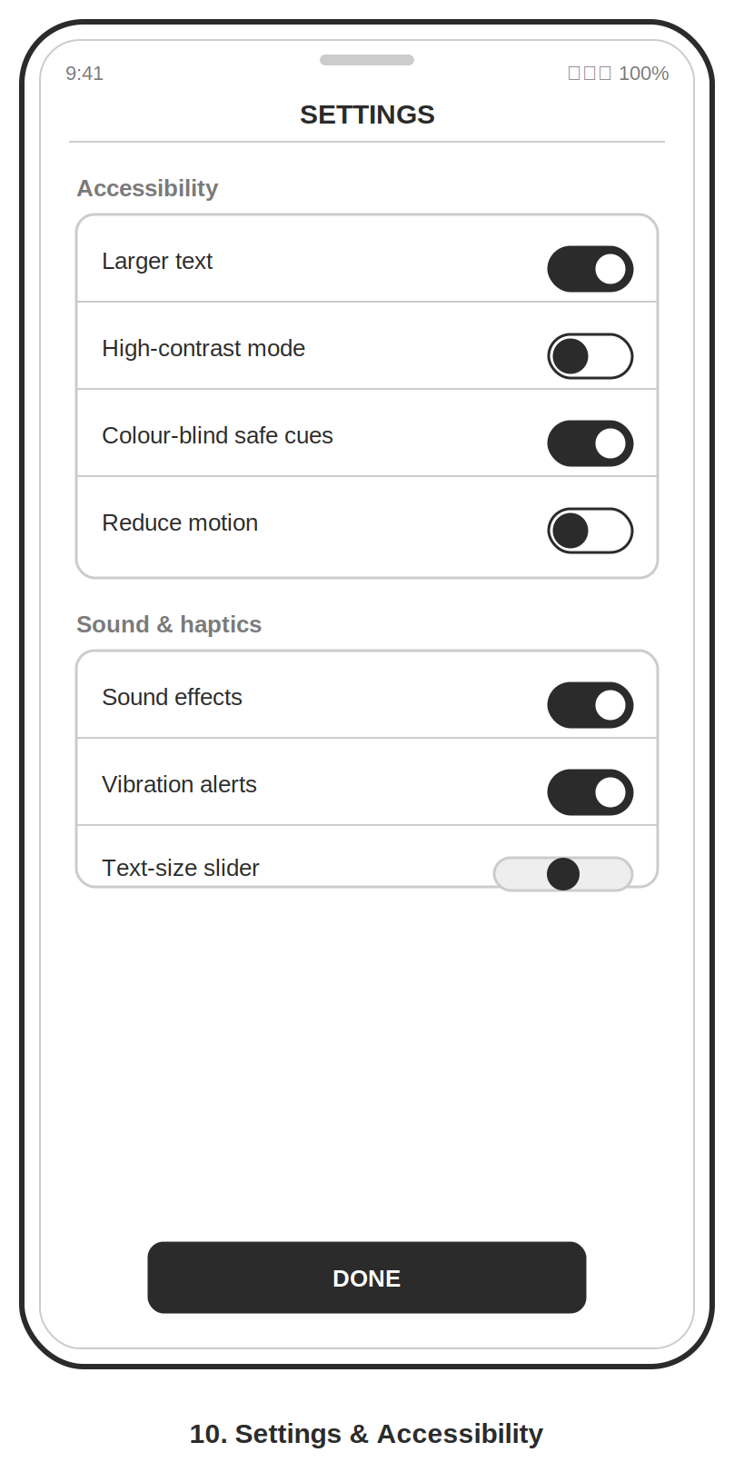
Figure 4: Settings screen exposing accessibility controls.
Outbreak alert: a modal with icon, text and vibration, not color. The settings screen showing accessibility controls. A modal interrupting the play with a warning icon, plain text and an optional vibration makes it perceivable even when color vision is impaired [9].

5.4 Movement between screens
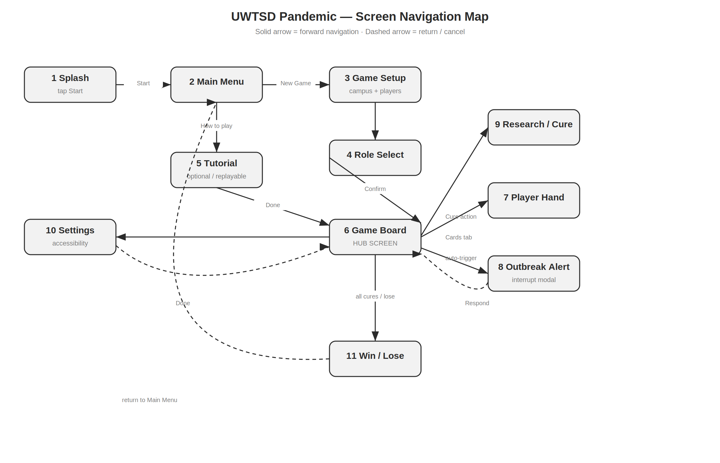
Figure 5: Navigation map. Solid arrows are forward navigation; dashed arrows are return/cancel paths.
Figure 5 shows how the screens connect. Solid Arrows indicate forward moving paths, Dashed Arrows indicate return/cancel paths. The connections of the screens are presented in figure 5. The Game Board is a central hub, from which the player can get to their hand, the 'cure/research' screen and the settings, and which always has an escape route (dashed) so that this player is never 'trapped' [3]: The launch flow (Splash → Menu → Setup → Role Select) leads into it. Any alerts of outbreak will bring the player back to the board, and the end screen will bring the player back to the menu. The complete set of screens is in Appendix C.

6. Evaluating the Prototype and Peer Feedback

6.1 Collecting feedback on the prototype
The wireframes were tested with a small group of users using a think-aloud protocol [2, 10] where each user tried to play three typical games (set up 4 player game, take a turn on the board, and answer to an outbreak alert). Sessions were run on a phone-sized frame so layout judgements were realistic. One participant for each persona type was recruited to ensure the test subjects covered the personas defined above – a confident young gamer (P1), a cautious mature learner (P2), a strategy-minded participant with a color vision deficiency (P3) and a participant who uses enlarged text (P4). Usability (task success, errors, hesitation) and emotional response (short rating and open comments) were recorded.
Positive feedback around the always visible turn indicator and the action grid with labelled actions. Aisha finished the 'take a turn' task without any prompting and said that the layout was 'obvious' because 'I looked at the bottom and the buttons just jumped out at me'. Chloe said that reading the infection levels by the numeric badges alone was accurate: “I didn't even have to read the color, the number was everything.” In terms of emotion, three of the four testers said words such as “calm” or “not too busy,” which is a reflection of the design intent with minimal clutter. Negative feedback resulted in three tangible problems. One of the first instances of this came when Dayied did not realize that the cure progress bar was actually a loading spinner, and stopped his game and waited for the “the page to finish loading”. Second, PASS and CURE were so close in the action grid that when Marcus was trying to perform the CURE action he mis-tapped PASS and caught the mistake on the confirmation screen but remarked that it “broke his rhythm.” Third, Dayied wasn't aware of the Undo button until he was told about it, meaning that it did not stand out enough. The two findings were surprising that were made against expectations. Aisha was hired as the no-access-need baseline and was the loudest voice in favor of fewer on-screen instructions and closed down the tooltips right away, which further confirmed the call for making guidance opt-in. The modal's big close button helped Marcus finish the routine of an outbreak alert quicker than anyone else, even though he had the most access needs. The results lead to three concrete fixes: the cure tracker should be labeled to not be confused with a loading indicator, more horizontal space should be made for PASS and CURE in the action grid [7] and the Undo button should be made persistent and visually significant.

6.2 Peer evaluation
The prototype and supporting artefacts were also reviewed by peer evaluators against a shared heuristic checklist [3]. Two course mates each conducted an independent heuristic walkthrough of the complete eleven-screen storyboard set, working from a printed copy of Nielsen’s ten heuristics [3] and recording issues against each heuristic number. Sessions were conducted asynchronously; each evaluator took approximately thirty minutes and returned written notes. Peers highlighted strong consistency across screens and clear status visibility, but flagged that the role-select list could exceed one screen for six roles (requiring a clear scroll affordance) and that the event-card iconography needed to be more distinct. This was largely consistent with the user-test findings, though the scroll-affordance issue was a genuine surprise — during my own walkthroughs I had always assumed users would scroll naturally, but neither peer had noticed a scroll indicator was absent. The most useful divergence from my own assessment was one evaluator pointed out that the Settings screen had no visible route back to the game board during an active session; only a generic “back” chevron with no label; which violated the “user control and freedom” heuristic [3] in a way I had not spotted because I always navigated by muscle memory during my own tests, which I will address by adding a persistent “Return to Game” button on the Settings screen, labelled with both text and a game-board icon, and adding a visible scroll-position indicator (a small dot row) beneath the role-select list when six roles are displayed. Conversely, where a peer comment conflicted with a user-research finding, the user evidence was prioritized, and that justification is recorded against the relevant requirement in Appendix A.

7. Conclusion
User research with a deliberately diverse sample produced four grounded personas and a prioritized set of requirements, in which clarity of game state and accessibility emerged as non-negotiable. These made up a uniform, minimalist user interface with design decisions which were made in accordance with known usability guidelines [1, 3, 4]. Testing by users and other practitioners validated the general structure and suggested specific, concrete improvements. These are validated wireframes to be developed into a full color, higher fidelity design in the next assignment.

References
[1] D. A. Norman, The Design of Everyday Things, revised ed. New York: Basic Books, 2013.
[2] H. Sharp, J. Preece and Y. Rogers, Interaction Design: Beyond Human-Computer Interaction, 5th ed. Chichester: Wiley, 2019.
[3] J. Nielsen, "Enhancing the explanatory power of usability heuristics," in Proc. CHI '94, ACM, 1994, pp. 152–158. (See also the 10 Usability Heuristics.)
[4] International Organization for Standardization, ISO 9241-210:2019 Ergonomics of human-system interaction — Part 210: Human-centered design for interactive systems. Geneva: ISO, 2019.
[5] A. Cooper, R. Reimann, D. Cronin and C. Noessel, About Face: The Essentials of Interaction Design, 4th ed. Indianapolis: Wiley, 2014.
[6] DSDM Consortium, The DSDM Agile Project Framework, 2014. (MoSCoW prioritization; commonly attributed to D. Clegg and R. Barker, Case Method Fast-Track: A RAD Approach, Addison-Wesley, 1994.)
[7] P. M. Fitts, "The information capacity of the human motor system in controlling the amplitude of movement," Journal of Experimental Psychology, vol. 47, no. 6, pp. 381–391, 1954.
[8] Apple Inc., Human Interface Guidelines: Accessibility and Layout (minimum 44 pt touch targets). [Online].
[9] W3C, Web Content Accessibility Guidelines (WCAG) 2.1, 2018 — esp. 1.4.1 Use of Color and 1.4.4 Resize Text. [Online].
[10] Sánchez, J.L.G., Zea, N.P. and Gutiérrez, F.L. (2022) ‘Playability guidelines for mobile games: a systematic review and reinterpretation’, International Journal of Human–Computer Interaction, 38(10), pp. 931–943. https://doi.org/10.1080/10447318.2021.1980255

Appendix A: MoSCoW Requirements
Priority | Requirement | Justification (finding + reference)
MUST | Permanent indicator of whose turn it is + recent-action log | Clarity theme; 19/23 (83%) rated “seeing whose turn it is” as essential; visibility of status [3]
MUST | Status by icon + number + shape, never color alone | Chloe (interview) could not distinguish red from green status in the prototype; [9], [3]
MUST | Tap targets ≥ 44 px, well spaced | Marcus (interview) uses 140% text and reduced grip; Fitts’s Law [7]; [8]
MUST | Confirm / undo before a destructive action | Dayied (interview) feared irreversible mistakes; confirmed in user test (mis-tap caught by confirm dialog); error prevention [3]
MUST | Adjustable text size with reflowing layout | Marcus plays at 140% text size; layout must reflow without overflow; [9]
SHOULD | Skippable, replayable onboarding tutorial | Questionnaire split: 11/23 wanted a tutorial, 9/23 preferred learn-by-doing; Aisha (user test) closed tooltips immediately — forced tutorial would alienate confident users
SHOULD | High-contrast display mode | Requested by Marcus (interview and user test); 7/23 questionnaire respondents listed contrast as an important factor; [9]
SHOULD | Plain-language labels supported by icons | Dayied (dyslexia) found icon-only buttons confusing during interview; recognition over recall [3]
COULD | Optional sound and haptic feedback | Some users valued it; not essential to play
COULD | University-role player avatars | Adds engagement / theme; low priority
WON'T | Online multiplayer with strangers (this version) | Out of scope; users prioritized local co-op
WON'T | In-app purchases | Out of scope for a coursework prototype

Appendix B: Research Instruments

B.1 Questionnaire
Section A: About you (persona mapping)
- Which best describes you? (Undergraduate / Mature student / Postgraduate / University staff / Other)
- How often do you play games on a phone? (Daily / Weekly / Occasionally / Rarely / Never)
- How confident are you using new apps? (Very / Fairly / Not very / Not at all)
- Do you have any access needs an app should consider? (Open text — e.g. text size, color contrast, none)
Section B: Preferences (drive requirements)
- When you start a new mobile game, what helps you most? (Short tutorial / Learn by doing / Tooltips / I figure it out myself)
- In a co-op game, how important is it to clearly see whose turn it is and what teammates did? (1 = not important … 5 = essential)
- Rank these by importance: clear turn indicator / readable text & icons / tutorial / sound & vibration / customizable avatar / undo a move
- How important is being able to adjust text size or colors? (1–5)
- On a phone screen, what frustrates you most? (small buttons / cluttered screens / unclear icons / too much reading / hard to go back / other)
Section C: Emotional response
- What makes a game feel enjoyable rather than just usable? (Open text)
- What would make you stop playing a co-op game within the first 10 minutes? (Open text)
- Anything else you'd want in a university-themed team game? (Open text)

B.2 Semi-structured interview script
Read the consent note (C.3) first. Use these as anchors and follow up naturally with "why?" and "can you give an example?".
- Warm-up: Tell me about a mobile or co-op game you've enjoyed recently. What made it work for you?
- Usability: When you open a new game for the first time, what do you expect to happen? What helps you get going?
- Usability: Think about a time an app was confusing or frustrating on your phone — what went wrong?
- Usability: In a team game, how do you like to see what's happening — whose turn it is, what others are doing?
- Accessibility: Is there anything about how apps look or are laid out that makes them easier or harder for you to use?
- Emotional: What makes a game feel fun or rewarding, beyond just working properly?
- Emotional: What would make you give up on a game early?
- Concept: This is a co-op 'save the campus from an outbreak' game where players take university roles. What would you want from it? What would put you off?
- Close: Anything you'd change about games you've played that we haven't covered?

B.3 Consent / ethics note (read aloud before each session)
"Thank you for taking part. This is for a university coursework project designing a mobile game. I'll ask about how you use mobile games and what you'd want from one. There are no right or wrong answers. Your responses are anonymous, won't be shared beyond this assignment, and you can stop or skip any question at any time. Is it okay to take a few notes / record audio for my own reference?"
Participants gave verbal consent and all data were anonymized before analysis.

Appendix C: Complete Wireframe Storyboard Set
All eleven screens are shown below at mobile size, followed by the navigation map (also reproduced as Figure 5).
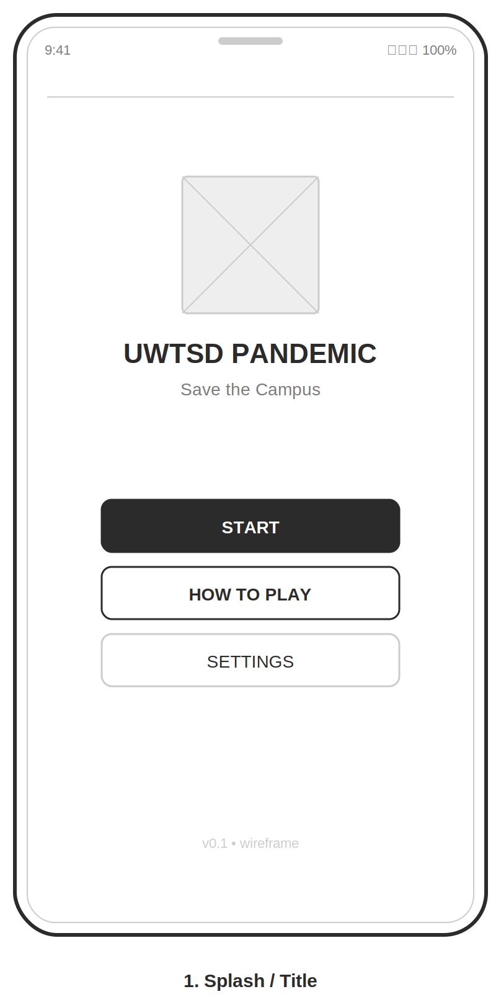 | 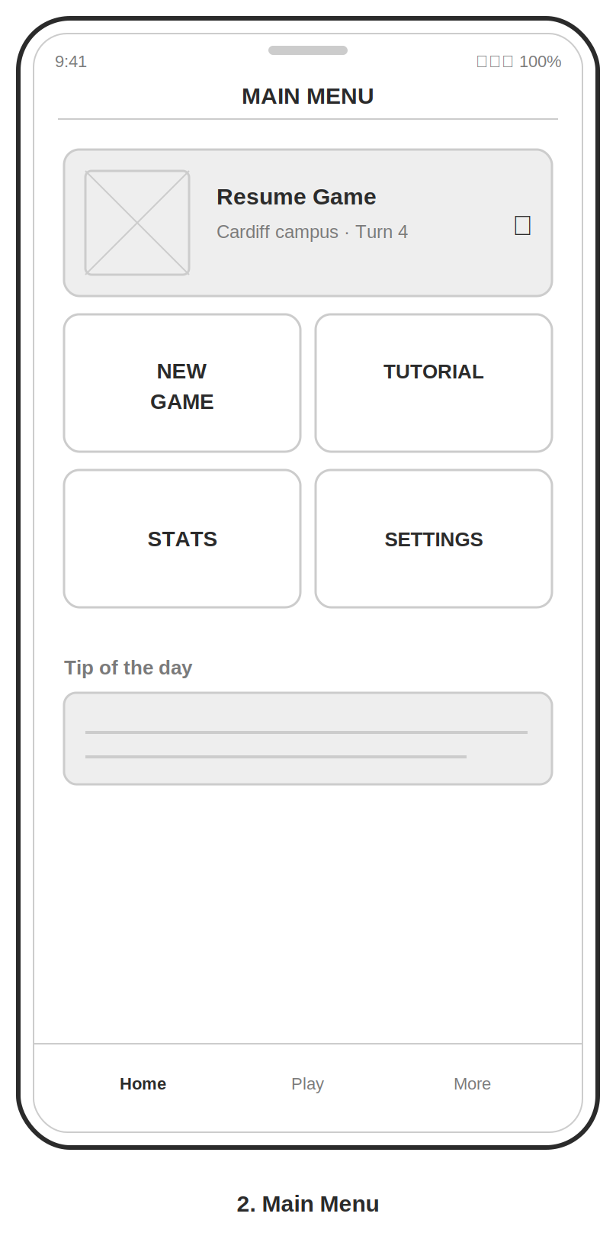
 | 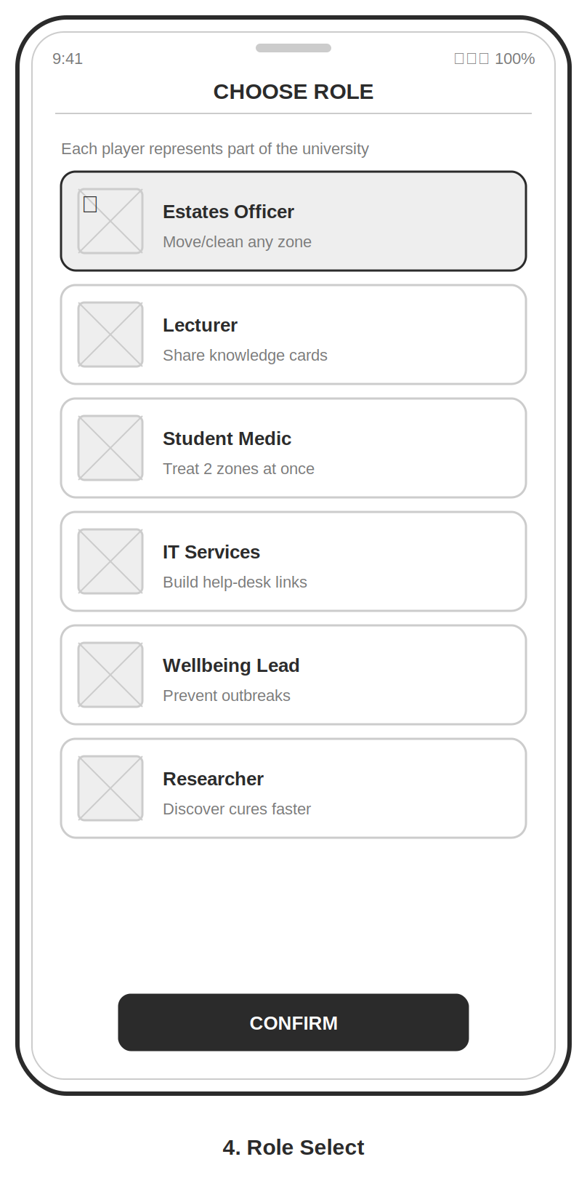
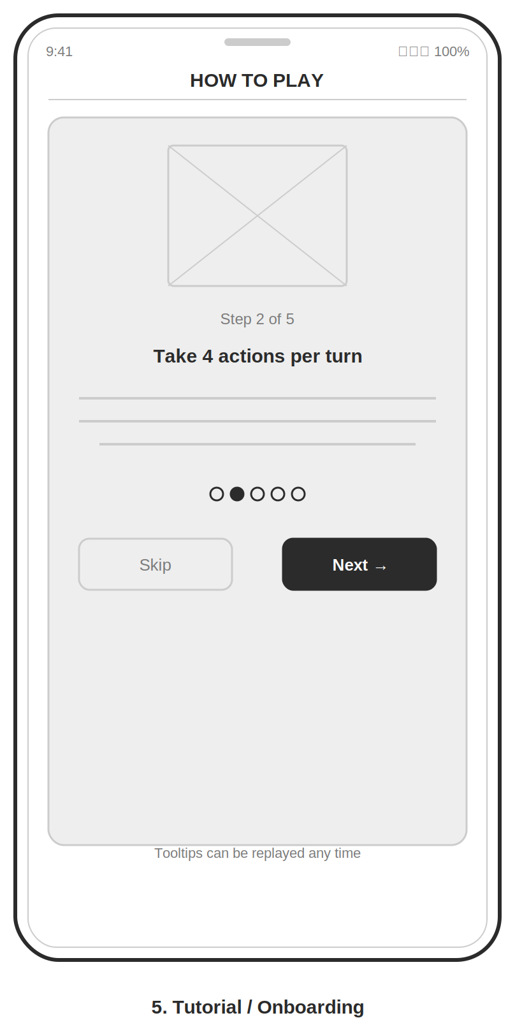
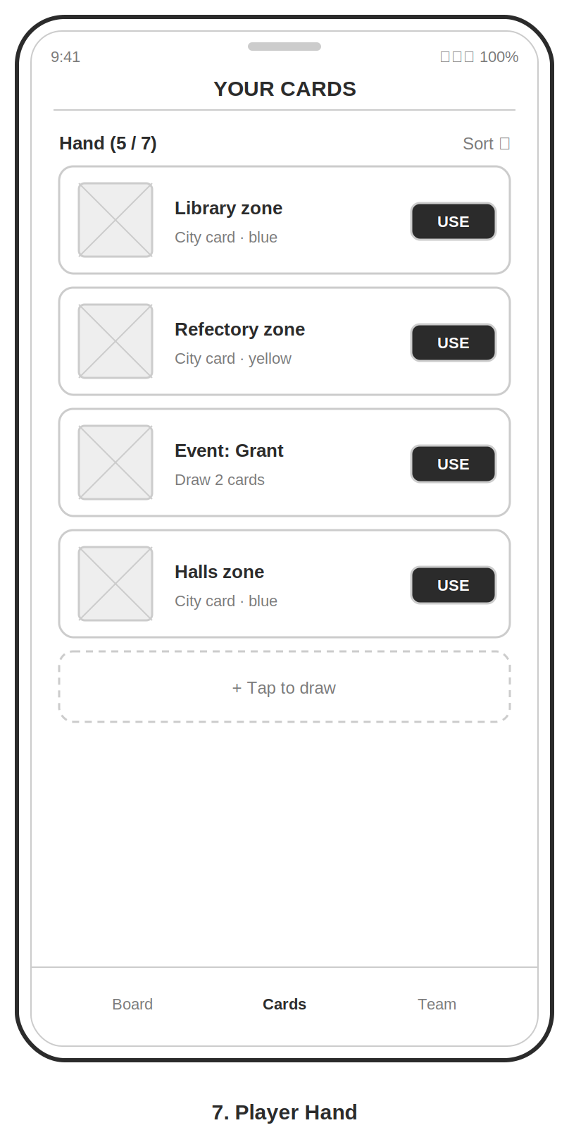
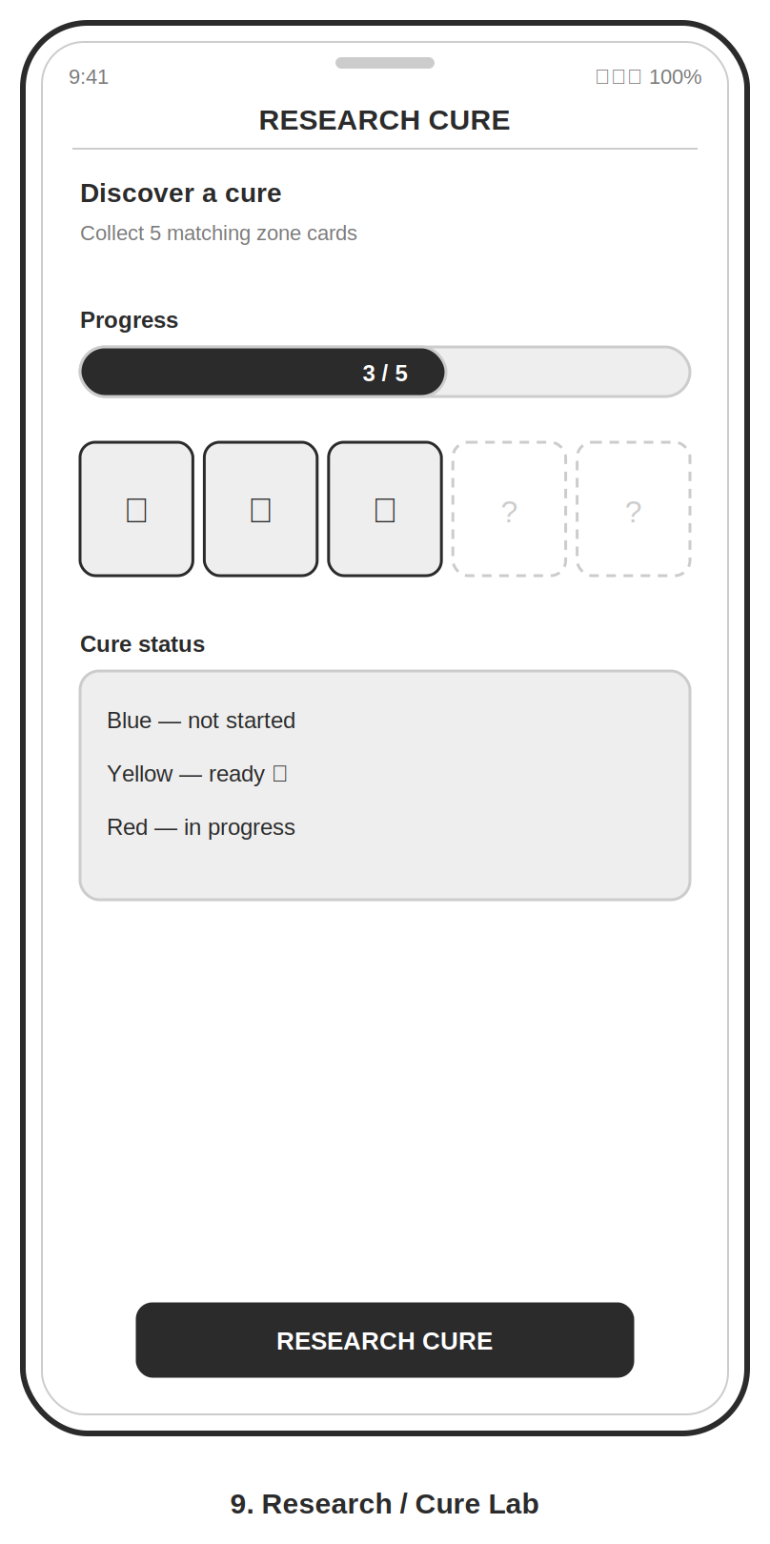
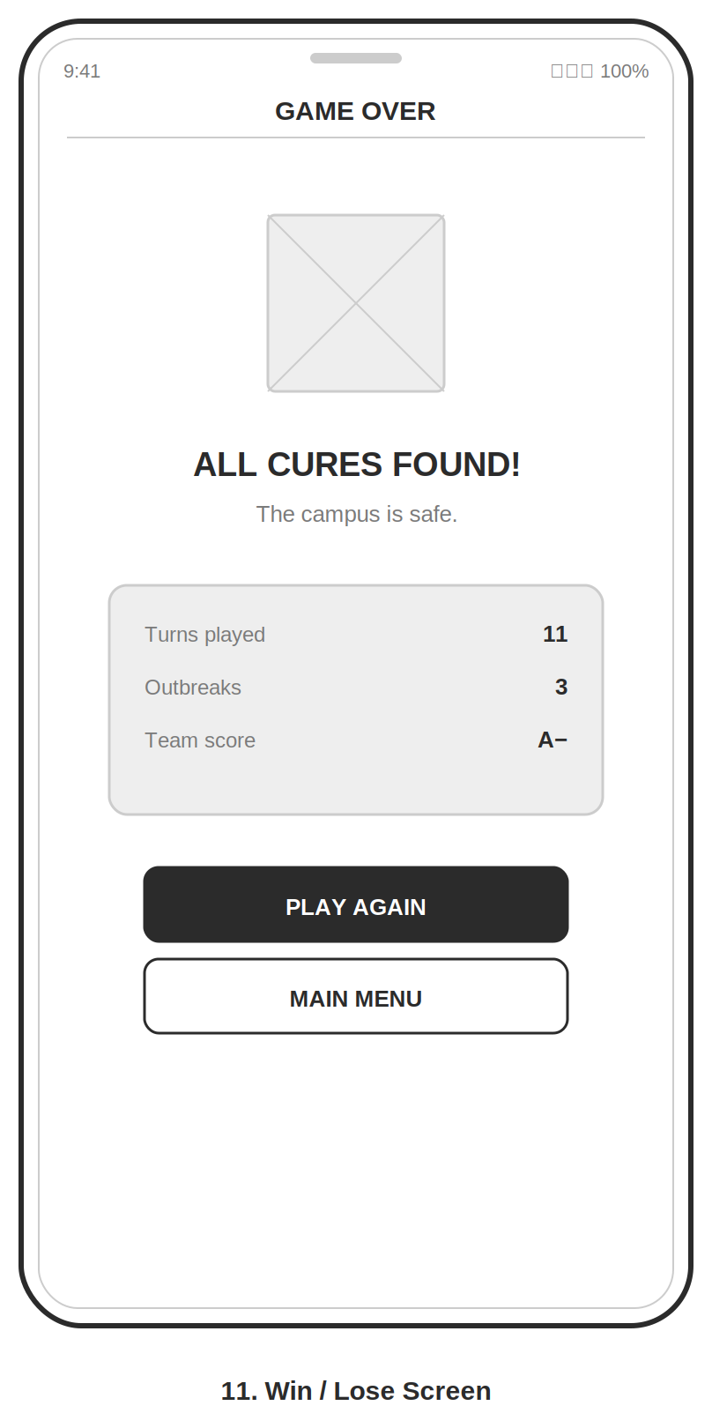
Navigation map (full set).

