Chapter four, DATA COLLECTION AND ANALYSIS

Introduction
As set out in chapter three, in this chapter, the data collected from forty questionnaires is analysed and presented.
Forty questionnaires were sent to various individuals via message on the phone after being created on an online database, these surveys are attached in the following link: SurveyMonkey Analyze - Vulnerabilities surrounding county lines. This quantitative survey was created via Survey Monkey, and the link was sent to a variation of members of the public and police officers. It consisted of ten multiple choice questions about vulnerabilities surrounding county lines, and what people’s perspectives are regarding ways that the problem is being tackled. The findings have been analysed using SPSS. The aim of this data was to fill the gaps found previously regarding vulnerabilities surrounding county lines, and how well this is being addressed and prevented. To complete the picture and attempt to fill the gaps when present, Saunders et al (2015) established the theory of analysis of completing the jigsaw puzzle. Therefore, it was found that by combining several different pieces of data and research, a clearer and fuller picture can be created and examined.
Creswell (2014) found that an approach that is consistent and accurate is vital for research to be reliable. Throughout this piece of research, each participant has remained anonymous, and they have all been provided the same questions and options to answer. The questions and topic of research was based upon the gap found in previous research surrounding vulnerabilities surrounding county lines. Horn (2012) found that previous research and findings can inspire and encourage readers to do further research to prove or disprove the picture created.
The findings of this research will be presented in graphs and tables to demonstrate patterns and trends identified, and to categorize themes. One barrier faced initially when creating the questionnaires, was that they could not be distributed in hand to individuals for them to remain anonymous, therefore, the decision was made to utilise Survey Monkey, as all participants had mobile devices, therefore the link was sent to them individually, and each person was able to complete it anonymously. Each finding will be compared to previous studies, and similarities and differences will be addressed. The validity and reliability will be ensured by complying with the UWTSD ethics, and ethics form has been completed previously. No questions regarding individuals age, gender or race was asked, therefore all participants were free from harm because there was no methodological requirement for these characteristics to be mentioned.

Content
The target audience was a mixture of police officers and civilians, this was with the aim to draw comparisons between the police’s perception of county lines, and civilian’s perception. Question one asked for the participant to select which category they were from. The second question asked participants to select on a scale how aware of county lines they are, giving the participant five options to select from. Question three asked the opinion of the participant, this question was whether the participant believed those with drug misuse problems to be categorised as vulnerable. The fourth question was if the participant believed children to be classified as vulnerable. The fifth question addressed whether the participant had any awareness of Adverse Childhood experiences. The answers in relation to this question would determine the reliability and validation of the following two questions. Question six providing a statistic in relation to adverse childhood experiences and questioning how surprised the participant to be. The seventh question queried whether the participant believed those suffering adverse childhood experiences to be more likely to become involved in county lines. The eighth question related to how helpful the police are. Number nine asking who the participant believed the onus to be on to address county lines regarding the local authorities. The final question asked if the participant believed youths involved in county lines to be criminal or victimised.

Analysis of Quantitative Data

The researcher has used Survey Monkey to complete ten questions for the participants to answer. All of which were closed questions with multiple choice answers. The questionnaires were sent via WhatsApp to forty individuals, of which, there were twenty-nine respondents. This way of gathering data was easily accessible for the participants and was not time consuming. Each person who volunteered to participate had the option to not complete the questionnaire and remained anonymous when completing the questionnaire.
Question one asked for the participant to state whether they were a civilian, or a member of the public. This question was asked, as the initial intention of the questionnaire was to compare the views of police officers, specialist drug officers and civilians. When analysing the data, it was found that 68.97% of participants were police officers, and 31.03% were members of the public. The aim of the questionnaires was for all categories to be evenly spread. However, the researcher failed to ask about specialist drugs officers. Also, there is no way to analyse whether to results and opinions of police officers differed to those of the members of the public, because all questionnaires were anonymous and had the same questions to answer. The table below demonstrates the findings:
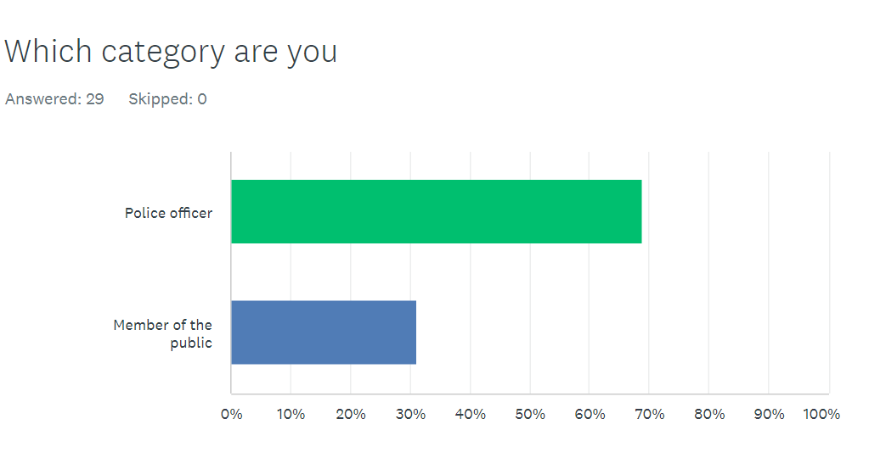
Table 1: Question 1: What category are you?

The decision was made to involve police officers heavily, as the child safeguarding practice review panel (2020) reviews serious incidents whereby police and local authorities have attended. Their findings ruled that children needed stability and consistency when being dealt with by the criminal justice system (Maxwell et al, 2019). Therefore, police involvement into this project was vital to look at their view on county lines.
Question two found that 41% of participants would believe that they are very aware of county lines. Due to the almost 69% of participants being police officers, this raise concerns as to how they are dealing with those targeted and exploited by gang members leading the county lines. The national Crime Agency Report 2017 found that 88% of police forces have an issue with County Lines in their policing area. This research found that potentially at least 28% of police officers were not very aware of county lines, therefore this would have an impact when trying to approach juveniles consistently in the criminal justice system as Maxwell et all (2019) stated is needed. The duty of the police is to detect and deter crime, however ignorance towards county lines and warning signs of potential grooming and cuckooing prevents police from addressing it.
Only 89.66% of participants believed people with drug misuse habits to be vulnerable, however 96.55% believed children to be vulnerable, meaning that one participant did not believe that children are vulnerable.
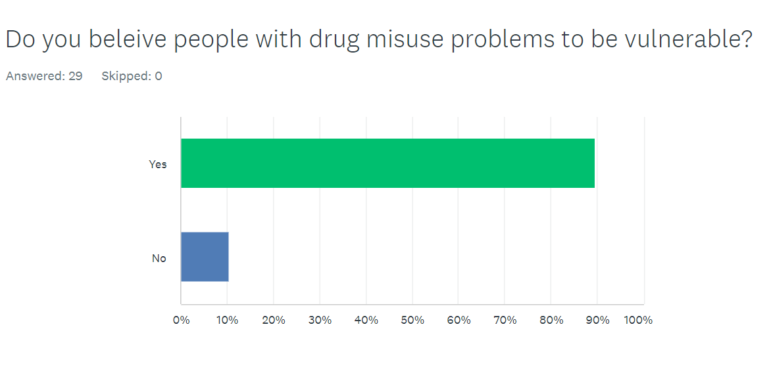
Table 2: Question 3: Do you believe people with drug misuse problems to be vulnerable?

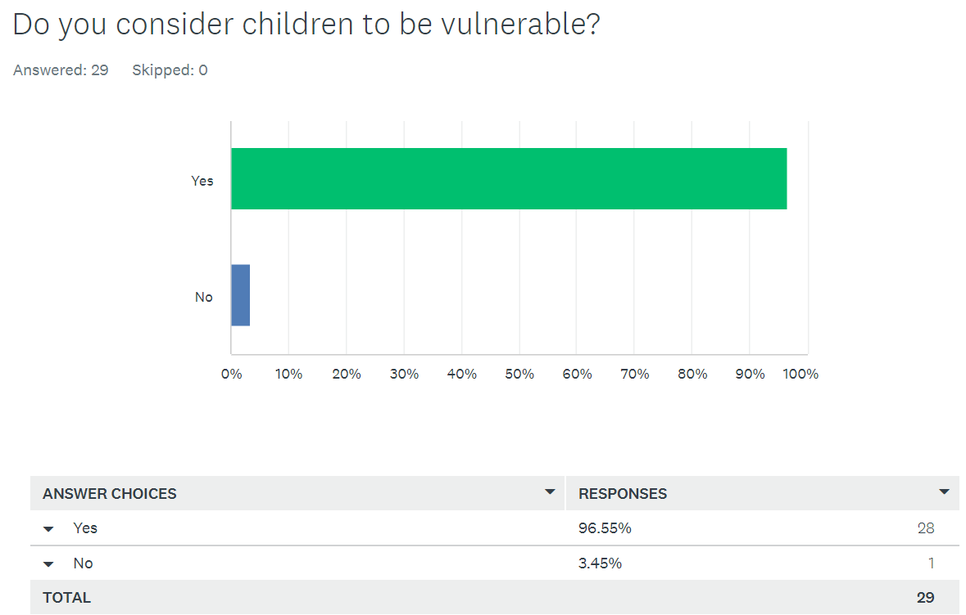
Table 3: Question 4: Do you consider children to be vulnerable?
The Public Health England (2022) found that gang members will groom and exploit children and vulnerable adults to transport and store drugs and money across the United Kingdom. The National Crime Agency (2018) states that gang members often target vulnerable adults who already have drug misuse habits of their own. These findings suggest that those who participated in the research find children to be more vulnerable than adults who have drug misuse problems. The National Crime Agency (2017) categorised adults with drug misuse problems as vulnerable, and report that 61% of regions found exploitation of those with drugs misuse problems. However, the findings of their studies showed that 65% of regions reported exploitation in children. This is a narrow gap, which also mirrors that of the questionnaire completed.
The National Crime Agency (2019) found that 11% of those involved in County lines were juvenile, the National Crime Agency (2019) went on to state that communities are ignorant to youth becoming involved in County lines and the vulnerabilities that lie with these youths. The Guardian further found evidence that suggested the public’s perception of youths involved in county lines was causing them to be labelled as ‘evil’ gang members, rather than acknowledging these individuals as vulnerable children who are being exploited. The National Crime Agency Report (2017) found that 58% of police forces reported that those vulnerable individuals being exploited by gangs for county lines initially saw county lines as a business investment, not that they were a victim or being exploited.

6.9% of participants had no awareness of adverse childhood experiences, therefore, their answers to the following two questions makes the statistics slightly less reliable. However, in question six, when the participants were provided statistics that 25% of adults have suffered three or more adverse childhood experiences, 75.86% stated that they were not surprised of these findings. The chart below shows the findings:
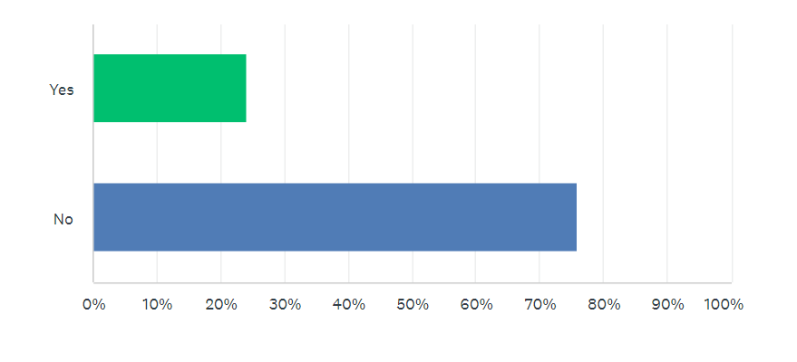
Table 4: Question 6: 25% of adults suffer three of more ACEs, are you surprised?
The NPCC (2017) found that gangs used young females to recruit and groom children who are vulnerable and have suffered adverse childhood experiences. It was found that children were predominantly targeted if they were at crisis, had boarder line mental health difficulties, or complex home lives. 15% of police forces reported children in care being involved in County Lines (NPCC, 2017). When participants in the questionnaire were asked if they believed those who have suffered three or more adverse childhood experiences to be more likely to be involved in County Lines, the same amount of people stated yes, 75.86% stated they would be more likely. The UK Government (2022) agrees with the findings that those who have suffered three or more adverse childhood experiences are more likely to be involved in county lines. They found that gang members target youths from deprived backgrounds of chaotic homelives, all adverse childhood experiences are related to issues surrounding the family home dynamic.
Question seven asked if participants believed the police to be doing enough to tackle county lines and drug misuse issues. 51.72% of participants stated yes, and 48.28% of participants believed the police were not doing enough, showing a split response. Bourdieu, Mason (2019) stated that police forces need to utilise statutory interventions rather than criminalising youths and labelling them as ‘evil gang members’. The National Crime Agency Report (2017) found that 65% of police forces recognised exploitation of children in county lines, however the public do not appear to believe the police are doing enough to address these issues in the community.

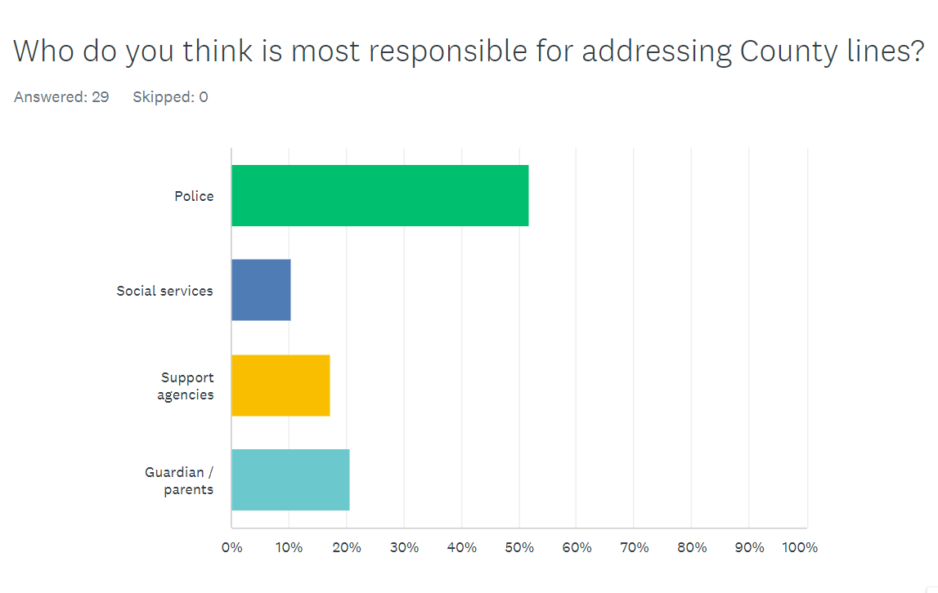
Table 5: Question 9: Who do you think is most responsible for addressing county lines?
Table five shows that just over half of the participants believe that the police are still mostly responsible for addressing county lines. County lines is a criminal offence when considering the exploitation and coercion that victims are subjected to (national Crime Agency Report, 2017). However, few participants found social services responsible, but the NPCC (2017) found that children are often recruited to run or ‘plug’ drugs for county lines, and the average age for child involvement in county lines is 14 years old, meaning that social services and parents should take ownership and intervene to help prevent the ‘social harm theory’ lens (Dorling et al, 1995). A 2019 Home Affairs Select Committee on ‘Serious Youth Violence’ (Home Affairs Select Committee, 2019) stated that there is no strategic approach and response to young people impacted by county lines. It argues that the responsibility falls upon the youth justice system and child protection agencies, combined with the voluntary sector as they can build the best rapport and trust with youths
The below table shows that 75.86% of participants believed youths to be victims of exploitation rather than criminals. The other 24.14% is possible to be police officers who are hardened to dealing with repeat missing youths and delinquent children. However, Setter and Baker (2019 argues that police do not use youth referrals and strategies to support victims enough.

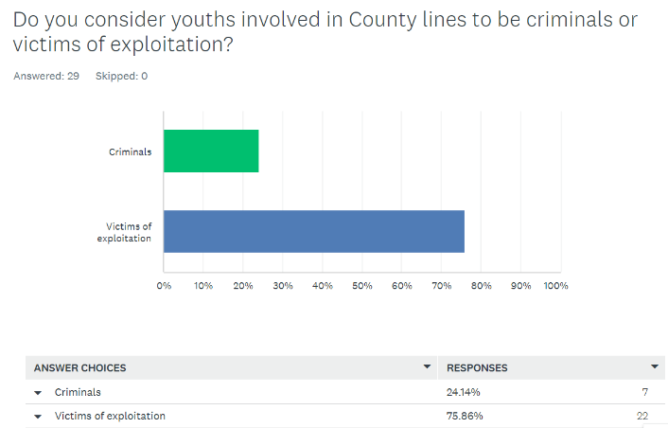
Table 6: Question 10: Do you consider youths involved in county lines to be criminals or victims of exploitation?

Conclusion:
The National Crime Agency Report is a good source of qualitative data research, it evidences facts and findings from police forces, who are the people that are involved front line in detecting and disturbing criminal activity (College of Policing, 2016). Whereas this research project was a quantitative research project that distributed the questionnaire to a mixture of police officers and members of the public, making it a more wholistic and representative finding. The Child Safeguarding Practice Review Panel, The National Crime Agency Report and this research project all found that the child is labelled as the victim in all cases. Bourdieu, Mason (2019) believe that police forces need to utilise intervention pathways more so than criminalising youths, and this is apparent in the findings of this questionnaire as participants believed children to be vulnerable, however the participants also believed the police to be most responsible for tackling county lines and drugs misuse issues over partner agencies and social services. The police’s role is to tackle crime, which is not necessarily taking a preventative approach.

Word count: 2130

