Williams, Jordan
CONTINENTAL tEVES | 2115209
Project Proposal
acma6013

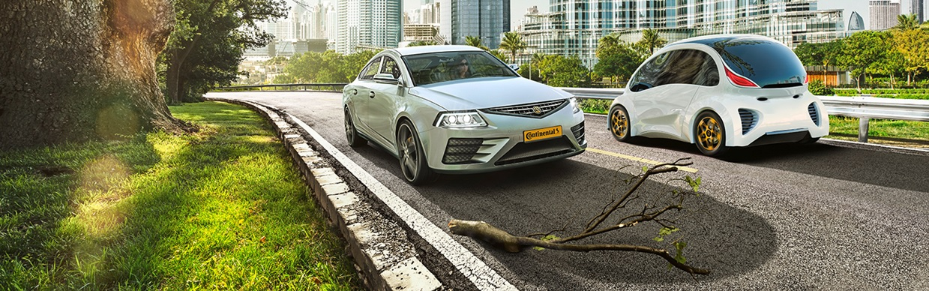

Reasons and Relevance of The Project
The projection for a Jaguar brake caliper produced at Continental is set to increase, the current rate of production will not be sufficient to meet customer demand. The current process machines the first operation on a 4-axis twin spindle CNC machine, this operation machines the bore details, disk clearance, spring holes, and fixing holes. The cycle time of this operation is around 7 minutes and produces two parts. The parts are then moved to a 5-axis twin-spindle CNC machine to machine the final operation. This operation involves drilling and tapping the bleed port and inlet port and drilling and tapping a hole to hold a wear indicator, this operation is roughly 6 minutes and produces four parts at a time.
To increase the production of this product it will be moved to an automated cell. This cell consists of two 5-axis CNC machines and a 3-axis CNC which are loaded by a Fanuc robot, shown in the image below. To produce a finished part on the cell the machining operations will need to be changed. The first operation will complete all the operations excluding the bleed port. The bleed port cannot be machined on this operation as it is at an angle that can be reached on a 4-axis machine. The bleed port will machined on the 3-axis machine in the cell on a fixture that will hold the part at the correct orientation. This will allow me to produce a finished product in the cell. The automated cell set to run a different product is shown in the image below.
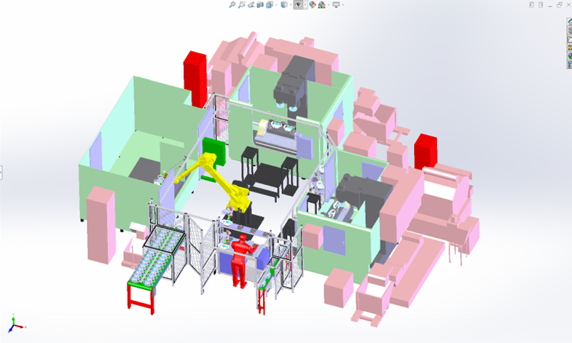
Moving the product to this automated cell should significantly increase production as it will be produced on two machines simultaneously. This would also produce a finished part, eliminating the need for two separate operations.
Aims of The Project
Move Jaguar D7A to the automated cell to increase production, this will include.
- Ordering a second set of fixture details and tooling, the brake caliper will now be machined on two 4-axis CNC machines. The image below shows a similar fixture design, quotes from numerous companies will need to be obtained before an order is placed.
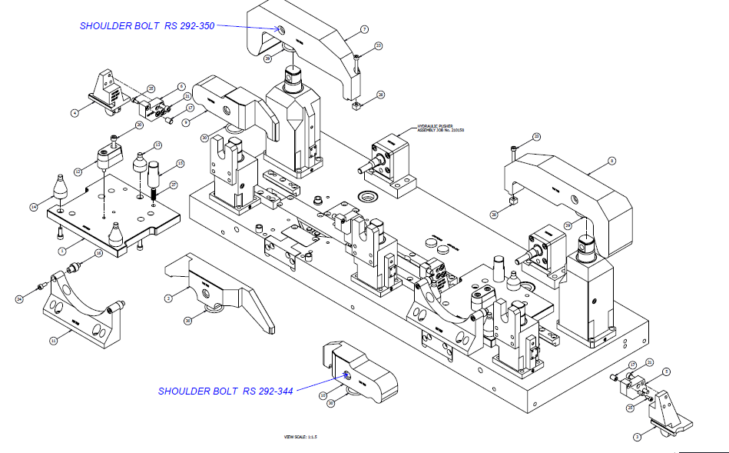

- Write a new CNC program, a new program is required as the product will be moved from a machine using a Siemens operating system to Fanuc.

- Program Fanuc robot, the robot will need to be programmed to pick the parts from the loading bay and place them correctly on the fixture in the CNC machine, aligning the datum points. When the first operation has been completed the robot will pick the parts up and transfer them to the next machine for the bleed ports to be machined, when this operation is complete the robot will place the complete part on the unloading conveyor.

- Design a new gripping function on solid works, this will need to safely hold the part while it is being transported to and from the machine. An initial design for the gripper is shown below. Prototypes can be produced in-house using a 3D printer.
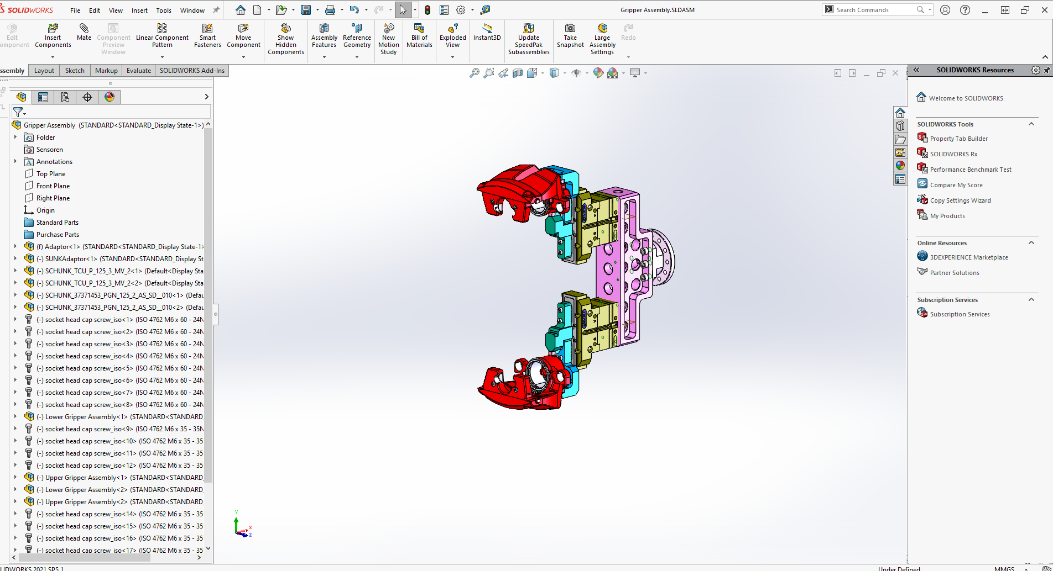

- Design fixture for Stama 3-axis CNC machine. The position of the port means the bleed port must be machined in a separate operation. A fixture will need to be designed to hold the part at the correct orientation.
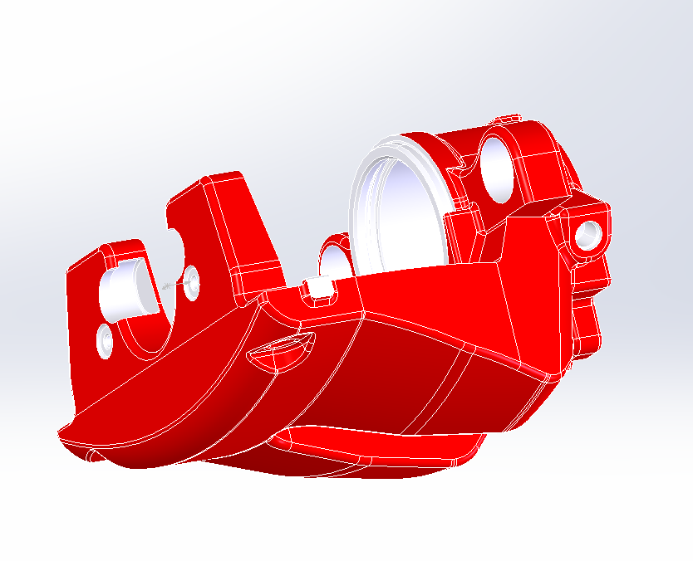
- Design new loading nests, a loading table with 12 nests is displayed in the image below. These will be manufactured in-house using a 3D printer.
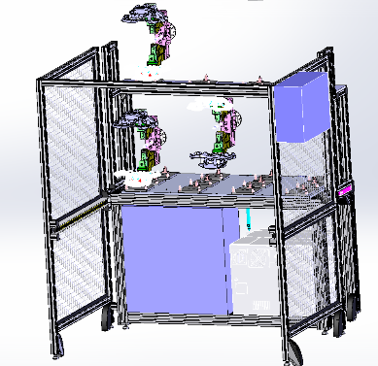

Provisional Work Plan
Goal 1: Design New Components
Key Action | Timescale | Outcome | Comments
Robot gripping function | 11/2023 | The final design of the robot gripper must be complete.
Port fixture | 11/2023 | All components of the port fixture must be designed.
Loading nests | 11/2023 | Leading nests must be designed and ready to be 3D printed.
Goal 2: Order / Produce New Components
Key Action | Timescale | Outcome | Comments
Produce prototypes for relevant parts | 01/2024 | Use a 3D printer to produce prototypes and make relevant changes if necessary.
Obtain quotes for relevant parts | 01/2024 | Get quotes for all required components. | Get multiple quotes before ordering
Manufacture in-house parts | 01/2024 |  | Anything that can be manufactured in-house will be to reduce cost.
Goal 3: Change Cell to Run Jaguar Brake Calipers
Key Action | Timescale | Outcome | Comments
Install new components | 02/2024 | Install new loading nests, robot gripper, and port fixture | Must be complete for robot can be programmed
Prove new CNC programs | 02/2024 | Prove all CNC programs in automatic.
Program Fanuc robot | 02/2024 | When everything is in place the robot can be programmed to automate the cell.

List of Software
Solidworks 2021
AutoCAD Mechanical 2022
CIMCO Edit v6.2
FANUC Series oi-MD
Siemens 840C
FANUC R-30iB
Ultimaker Cura

List of Hardware
M-20iA/35M FANUC Robot.
AMS Gemini MAX 4-axis CNC milling machine.
Stama-530 3-axis CNC milling machine.
Ultimaker 3D Printer.

