Assignment 1

Essay

Module Name: Management Economics
Module code: LCBB5008

Student: Marius Scorcea (1921886)
Lecturer: Dr. Taye Osadiya

Contents
Introduction 3
1a. Fundamental Economic Problems 3
Covid-19 pandemic and Brexit impact on economy 3
1b. Various ways of solving the challenges 5
2a. Relevance of Demand and Supply 8
Prices strategies to control demand and supply 8
Marketing is playing an important role for the supply and demand chain 9
2b. The difference between elasticity and inelasticity of demand 10
Elasticity of demand 11
Inelasticity of demand 11
2c. The laws of supply and demand 13
The Law of Supply 13
The Law of Demand 13
The Law of Supply and Demand 13
Four Main Laws of supply and demand 14
Conclusion 14

Introduction

COVID-19 pandemic together with the Brexit transition period had a significant impact on UK’s intern and extern business environment, the supply and demand chain being deeply affected. (Husain, 2022)
Starting with 2020 and going further the shortages registered on the labour market and products determined the inability of the business to respond promptly to the changes in goods and services demand.
Nevertheless, there were efforts made to address all these fundamental economic problems created by COVID-19 pandemic and Brexit and the Government and Businesses through the laws, rules, and regulations they implemented managed to attenuate to a certain extent the knock-down effect on the economy.

1a. Fundamental Economic Problems

Covid-19 pandemic and Brexit impact on economy

The UK economy and labour market were significantly impacted structurally by the COVID-19 pandemic and its aftermath. The crisis intensified certain established trends, like the transition to e-commerce, and encourage the development of other trends, like population expansion.
Transportation, entertainment, hospitality, and tourism are among the industry’s most negatively impacted financially by the coronavirus.
The industries most impacted by Brexit are transportation equipment, automobiles, chemicals and chemical products, textile manufacture, and services like banking and communications. (TUC, 2020)

COVID-19 has led to the closure of many businesses, causing disruptions in commerce across various sectors. Retailers face challenges such as health and safety, supply chain interruptions, cash flow limitations, and sales and marketing obstacles. (Donthu & Gustafsson, 2020)
Businesses had to ensure that all the employees have access to PPE equipment that is in line with COVID-19 regulations: face coverings, gloves, visors etc.
In sectors were working from home was effective, this measure was adopted to contain the virus.
Businesses which were selling foods and drinks, social clubs, funfairs, theme parks, cinemas were closed during pandemic and some of them, due to the economic impact went bankrupt.
Displaying NHS QR-code, hand gels, hand washing regulation become mandatory for many companies. (Cabinet Office, 2020)
Since the summer of 2021, there have been widespread disruptions to supply chains that have attracted widespread attention around the world, including in the UK. This disruption has led to a variety of supply-related issues, including delivery delays, price hikes, noticeable gaps in supermarket shelves, and empty gas stations. Well-known companies such as Greggs, IKEA and BP have all reported these challenges.
Labour shortages, Brexit trade barriers, global supply chain challenges and instances of panic buying are all contributing to the supply chain disruption.
There is a dearth of skilled individuals in various fields throughout the United Kingdom, including transportation, food and beverage, hospitality, and construction industries, all of which have been significantly impacted. Over the period of November 2021 to January 2022, the total number of available positions soared to an unprecedented level of almost 1.300.000. According to recent data from the Office for National Statistics (ONS), 37% of major corporations participating in their business survey reported encountering difficulties in recruiting the necessary talent.
All this were effect of both COVID-19 and Brexit situation.
The pandemic has had an unprecedented impact on consumer behaviour.
With everything shut down, no amount of government support programs can prevent the collapse of global consumption, and that's what happened.
Service-related businesses closed during COVID-19, but public attitudes towards public spaces for service consumption still impact demand. People are spending more on cooking and appliances, creating a niche for the goods transportation industry and resulting in a rise in freight demand. (Snider, 2020)
The use of consumer credit has increased since the pandemic. Studies also reveal that consumers are turning to debt to cover rising living expenses; around one in four adults report having taken out more loans or used more credit between June and July of 2023.
Business leaders are struggling to cope with the financial impact of COVID-19 and Brexit. COVID-19 has had a significant impact on balance sheets and cashflows, with a decline in profitability and a sharp increase in corporate debt.

1b. Various ways of solving the challenges

According to new official data, the UK economy has bounced back faster than expected from Covid-19 and is no longer the worst-performing G7 economy. (Romei, 2023)
Brexit as well determined the decline of the Economy, especially regarding the trading area. That is why the government together with the businesspeople had to work together to tackle the effect of Covid-19 and Brexit upon UK’s Economy.
The pandemic led to significant disruptions in society and the economy. After the initial nationwide lockdown in March 2020, the UK and devolved governments introduced a range of financial measures to lessen the impact of restrictions. These policies were maintained, with some adjustments, during subsequent Covid waves in the autumn and winter of 2020-21.
Service-related businesses closed during COVID-19, but public attitudes towards public spaces for service consumption still impact demand. People are spending more on cooking and appliances, creating a niche for the goods transportation industry and resulting in a rise in freight demand. There were some temporary measures adopted by Government:
- Extended delivery and drivers’ hours – The regulation of delivery times and drivers were relaxed to allow a better service.
- UK competition law was relaxed for grocery retailers and suppliers to collaborate effectively to prepare for potential disruptions related to specified activities, allowing for open discussion on stock levels, item limits, and store hours. Dairy sector also saw a temporary relaxation for further collaboration in the supply chain.
- The government supported businesses that had to deal with increased costs and cash flow issues because of COVID. The government supported businesses through a range of schemes, including Coronavirus Jobs Retention Scheme Small and large business interruptions loan schemes CBILS / CLBILS Bounce Back Scheme SMEs.
- The Trade Credit (TCI) Reinsurance Scheme business to business transactions were supported by government with 10 billion pounds.
The government will continue to review food as a CNI sector and prioritize business continuity planning due to COVID-19 and EU Brexit risks. Larger agri-food companies are more likely to prioritize planning than SMEs.
Additional small-scale support measures were implemented, including a temporary reduction in the VAT rate for hospitality businesses, which was effective from July 2020 to March 2022. Additionally, in August 2020, the government launched the Eat Out to Help Out scheme to encourage spending in the hospitality sector.
Another way to tackle COVID-19 challenges was to relax the COVID-19 regulation. Locking measures were first lifted in England on 8 March 2021. The four-step approach, known as the ‘roadmap out of lockdown’, was intended to ‘calmly but irretrievably’ lift lockdown restrictions. Unlike previous tiered systems, the government announced its intention to lift all restrictions at once, as infection levels were broadly consistent across the country. (Baker et al, 2021)
Also, to minimise the risk and disruption for the Supply Chain the business managers can use different strategies like:
- Develop contingency plans based on scenarios for several demand environments.
- Lessen supply shock working closer with suppliers as well as enriching the supply base.
- Manage demand volatility taking a responsible supplier attitude to manage panic buying circumstances.
- Create a safe work environment through a sustained investment in protective equipment for supply chain employers and use apps to plan and organize time, availability, and safety.
- Make work safe Invest in protective gear for supply chain workers and communicate via apps to manage time, availability, and safety.
- Use digital twins to enhance demand and supply within and across the organizations as on longer term it is beneficial for the companies.
As a result of the pandemic, panic buying became the order of the day. Not only did we run out of toilet paper, hand sanitizer and other essentials, but we also went back to using things that are bad for the planet. We even went back to using plastic bags. Therefore, one of the main concerns was to reduce waste using methods that help people reusing the items.
In order to reduce inflation and attenuate the effect of pandemic and Brexit on price rising, Government is engaged to collaborate with food retailers and producers to make sure the food is affordable for everybody, and they are working towards maintaining value ranges, price matching and price freezing strategies.

2a. Relevance of Demand and Supply

Supply and demand in economics determine a product's price. The equilibrium price is the price at which producers agree to sell goods to consumers. In equilibrium, the amount produced by producers equals the amount demanded by consumers. The COVID-19 pandemic has led to one of the biggest GDP drops in history in the UK and many European economies. While the path to recovery is still unclear, many of the knock-on effects are expected to be short-term, although there may be longer-term socio-economic effects that are hard to forecast, such as supply chain disruptions or how people and organisations will respond.
In contrast, Brexit is expected to bring more gradual and predictable changes to the UK's trade structure with the EU and some other trading partners, but these changes will be long-lasting, and supply will be affected by both economic shocks, often in different ways, and can be influenced by each other. The biggest impacts will likely be across different sectors, affecting the overall economy.

Prices strategies to control demand and supply

Lower wages lead to lower demand and prices, but prices have increased due to rising average costs in the manufacturing sector. Input costs have increased more than product prices, with many production inputs and transportation costs increasing due to the pandemic. Brexit may lead to further increases in input costs due to increased trade barriers with the EU.
More than half (55%) of UK businesses say they have increased efforts to develop pricing strategies to support demand and manage margins. More than 6 in 10 (66%) say they want their pricing efforts to help them track complex price changes at every stage of their supply chain. 92% of UK businesses say Covid and the impact of Brexit have had a significant impact on their ability to manage pricing across product lines. (Monnerat, 2022)
Competition-driven prices are set based on how others are pricing products and services in the marketplace, with prices between competitors varying. Competitive pricing can bring in more customers and revenue, but also the risk of starting a price war among rival companies. Price wars can lead to short-term revenue increases or longer-term strategies for market share. (Kenton, 2019)

Marketing is playing an important role for the supply and demand chain

The Covid-19 pandemic has changed the way people seek information, communicate, and purchase, forcing brands to rethink marketing and building loyalty. Remote and hybrid working have also forced companies to reassess communication and teamwork for business success.
In a post-pandemic society, there are several strategies that an organization can adopt to maintain its position on the market:
- E-commerce as a factor which determines the success of a brand - Online sales in the UK reached £10 billion in July 2021 as 40% of people shopped from home. Shopify reached its first $1 billion in a quarter on record.
- Industries must pivot and reinvent themselves - Hospitality and tourism sectors saw a drop in profits during lockdowns, highlighting the importance of thinking outside the box during external factors.
- Local Marketing vs. Global Marketing – The Value of Community
Travel restrictions during the pandemic led to people staying in their localities, revitalizing neglected areas and building a sense of community. A Facebook survey found a surge in online community groups during Covid, providing marketers with an opportunity to connect with niche audiences and build a loyal community base.
- Paid search and brand marketing must combine forces
Brands use paid search marketing on platforms like Google, Amazon, and Facebook for cost-effective customer targeting. Covid-19 led to increased online traffic and a competitive environment for marketing teams, with global advertising spending set to reach $790 billion in 2022.
- Customer experience is crucial
During the pandemic, customers changed their online behaviours and expectations. Brands need to provide valued experiences through online chat and messaging. Curb side pick-up and delivery services have been successful for retailers.
- Social Commerce is sky rocketing
Social media platforms are becoming more sophisticated and ideal for brands to promote and sell their products, especially among younger generations who use them for shopping inspiration. Brands should consider in-app purchases.

2b. The difference between elasticity and inelasticity of demand
The elasticity of demand is the degree to which demand responds to a change in a particular economic factor. The most common economic factor to measure elasticity is price. Other economic factors to measure elasticity include income level and substitute product availability. Elasticity measures how demand responds to changes in economic factors. When demand for a good or a service is constant, it is called inelastic. When demand changes because of changes in economic factors, it is said to be elastic. (Investopedia, nd)

Elasticity of demand
Elastic demand is observed when the percentage change in quantity demanded surpasses the percentage change in price. In other words, consumers respond to alterations in price.
FORMULA
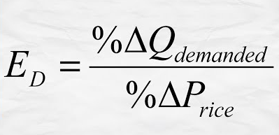
Luxury goods and consumer discretionary items are frequently cited as prime examples of highly elastic products. These may include well-known cereal brands or popular candy bars. Food items can be easily substituted, and consumers often opt for less costly alternatives, leading to the facile replacement of branded products.

Inelasticity of demand
The fact that demand remains constant, even when prices change, suggests that inelasticity is present. Inelastic goods are essential items that lack substitutes. Examples of such goods include utilities, prescription drugs and tobacco products. Businesses selling these products have the benefit of being able to adjust prices with greater flexibility, as demand is not affected by price changes. Essentials and medical treatments tend to be inelastic, while luxury goods are more flexible.
FORMULA

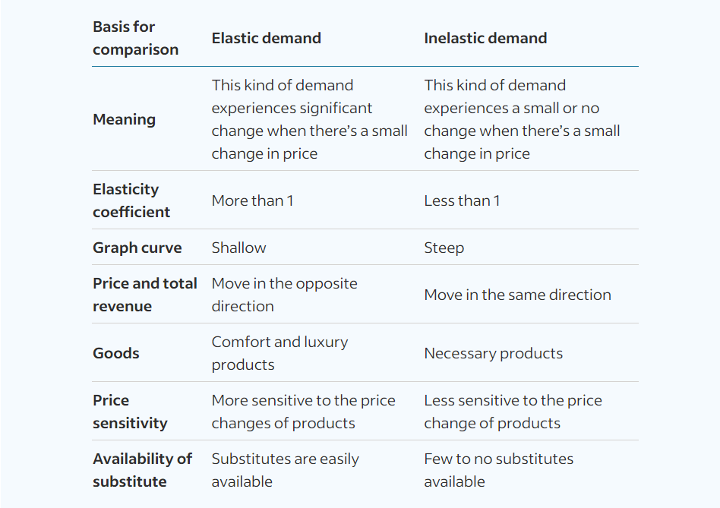
The difference between inelastic demand and elastic demand given by how easily things can impact consumption habits. Please see below some key differences between inelastic and elastic demand.

2c. The laws of supply and demand

Supply and demand are two laws of economics that affect prices. If prices are too high, items may stay on the shelf, while low prices may lead to lower returns on investment.

The Law of Supply

The law of supply states that pricing and supply are inversely related. Suppliers will increase their production in response to increasing prices of goods and services, as long as the profit margin for each additional unit produced is greater than the cost of manufacturing. New suppliers will enter the market when they see a higher profit margin.

The Law of Demand

According to the law of demand, demand drops by rising prices. Customers consequently buy less when prices rise. This is particularly accurate if they can substitute less expensive products.

The Law of Supply and Demand

The equilibrium price is the point at which demand and supply balance. Suppliers produce only enough of a product or service at that price to meet demand. Anyone who wants to purchase the product can do so. Balancing supply and demand in real life is more challenging. The equilibrium price may fluctuate over time as demand and supply changes. The supply and demand balance is also affected by other factors. Supply and demand balance is based on the assumption that no other factors can affect price. This is often not the case. For example, changes in manufacturing costs or supply chain issues can have a significant impact on pricing. (Luther, 2022)

Four Main Laws of supply and demand
- When supply goes up and demand remain constant, prices decrease.
Supply increases without demand changes, leading to surpluses. Suppliers lower prices to move excess stock, especially for pending expiration dates.
- Prices drop when supply remains constant and demand decreases.
Lower prices may result from surpluses, and this occurs when customers desire a smaller quantity of an item or service.
- When supply declines and demand stays unchanged, prices rise.
Supply shortages can lead to higher prices for goods and services, but prices usually return to their baseline once supply is restored.
- Prices increase when supply stays constant but consumer demand rises.
A product shortage occurs when demand and supply don't match, causing prices to fluctuate. When supply catches up, prices stabilize.

Conclusion

Covid-19 pandemic and Brexit were two important factors that influenced the UK economy in the last 3 years.
The restriction imposed by Covid-19 towards suppliers alongside the decision of the government to withdraw the protection and the Covid loans repayments may lead imminently to a cash-flow crisis.
Also, Brexit and new immigration laws are determining labour shortages in many important areas as transport, constructions and the external trade is also affected by this factor.
All this combined are affecting the supply and demand chain and that is why suppliers and Government should take into consideration new ways to address further issues in order to bring forward UK’s economy.

‌

‌REFERENCES
Anderson, H. (n.d.), Four Strategies for Supply Chain Risk Management, Available at: https://www.publicissapient.com/insights/coronavirus-and-managing-the-supply-chain-amid-a-crisis, (Accessed 04 DEC. 2023)
Baker, C., Brown, J., Barber, S. and Kirk-Wade, E. (2021). Coronavirus: A history of English lockdown laws. commonslibrary.parliament.uk, [online] 1(1), Available at: https://commonslibrary.parliament.uk/research-briefings/cbp-9068/, (Accessed 03 DEC. 2023)
Britannica (2023). Supply and demand | Definition, Example, & Graph | Britannica Money. [online] www.britannica.com. Available at: https://www.britannica.com/money/topic/supply-and-demand, (Accessed 09 DEC. 2023)
Cabinet Office, (2020), Coronavirus (COVID-19): What has changed – 22 September, Available at:
https://www.gov.uk/government/news/coronavirus-covid-19-what-has-changed-22-september, (Accessed 03 DEC. 2023)
Deloitte (2021). Tackling Brexit and COVID-19 together | Deloitte UK. [online] Deloitte United Kingdom. Available at: https://www2.deloitte.com/uk/en/pages/global-markets/articles/tackling-brexit-and-covid-19-together.html, (Accessed 03 Dec. 2023).
Donthu, N. and Gustafsson, A. (2020) ‘Effects of COVID-19 on business and research’, Journal of Business Research, 117, pp. 284–289. doi: 10.1016/j.jbusres.2020.06.008.
Husain, E. (2022), Early insights into the impacts of the coronavirus (COVID-19) pandemic and EU exit on business supply chains in the UK: February 2021 to February 2022, Available at: https://www.ons.gov.uk/businessindustryandtrade/internationaltrade/articles/earlyinsightsintotheimpactsofthecoronaviruspandemicandeuexitonbusinesssupplychainsintheuk/february2021tofebruary2022, (Accessed on 03 DEC. 2023)
Investopedia. (n.d.). Elasticity vs. Inelasticity of Demand: What’s the Difference? [online] Available at: https://www.investopedia.com/ask/answers/012915/what-difference-between-inelasticity-and-elasticity-demand.asp#:~:text=The%20price%20elasticity%20of%20demand, (Accessed on 03 DEC. 2023)
Kenton, W. (2019). Competition-Driven Pricing. [online] Investopedia. Available at: https://www.investopedia.com/terms/c/competition-driven-pricing.asp#:~:text=Competition%2Ddriven%20prices%20are%20often, (Accessed on 03 DEC. 2023)
Luther, D. (2022) Law of supply and demand defined, Oracle NetSuite. Available at: https://www.netsuite.com/portal/resource/articles/erp/law-of-supply-demand.shtml (Accessed: December 25, 2023).
N Gregory Mankiw and Taylor, M.P. (2014). Economics. Andover: Cengage Learning.
Monnerat, (2022), UK business profit margins hit hard as pricing strategies struggle to keep pace with supply chain disruption - Factory & Handling Solutions. [online] factoryandhandlingsolutions.co.uk. Available at: https://factoryandhandlingsolutions.co.uk/uk-business-profit-margins-hit-hard-as-pricing-strategies-struggle-to-keep-pace-with-supply-chain-disruption/, (Accessed 14 Dec. 2023)
O’Brien, C. (2021). The Future of Marketing After Covid-19 | Blog | Online Digital Marketing Courses. [online] Digital Marketing Institute. Available at: https://digitalmarketinginstitute.com/blog/the-future-of-marketing-after-covid-19, (Accessed on 03 DEC. 2023)
Romei, V. (2023), UK economy makes stronger recovery from pandemic than previously estimate, Available at: https://www.ft.com/content/9de96bf8-1ca2-4937-9ef7-44a44d44e0b9,(Accessed 03 DEC. 2023)
Save, D. (2020). 3 Ways to Reduce Waste and Save Money During the COVID-19 Pandemic. [online] CleanRiver. Available at: https://cleanriver.com/3-ways-to-reduce-waste-and-save-money-during-the-covid-19-pandemic/, (Accessed 03 Dec. 2023).
Snider, M. (2020), How Shifting Consumer Spending From Services To Goods Impacts Freight, Available at:
https://www.breakthroughfuel.com/blog/consumer-spending-impacts-freight/, (Accessed 03 DEC. 2023)
Spencer, M. (2022), Question for Department for Environment, Food and Rural Affairs, Available at:
https://questions-statements.parliament.uk/written-questions/detail/2022-12-09/107162, (Accessed 03 Dec. 2023).
TUC, (2020), Impact of Covid-19 and Brexit for the UK economy, Available at:
https://libertystreeteconomics.newyorkfed.org/2022/01/a-new-barometer-of-global-supply-chain-pressures/, (Accessed 03 DEC. 2023)
UK Health Security Agency, (2022), Reducing the spread of respiratory infections, including COVID-19, in the workplace, Available at: https://www.gov.uk/guidance/reducing-the-spread-of-respiratory-infections-including-covid-19-in-the-workplace#who-this-information-is-for, (Accessed 03 DEC. 2023)

‌
‌

‌

