

Level 6 Assessment
Cloud Computing Administration
Module Code:
ACCB6025
Assignment Title:
Aspire Retailers Cloud Management with Azure
Lecturer:
Dr Khadija Hanga
Student Name:
Aleksandar Kushlev
Student ID:
2028393

Table of contents:

Introduction

Task A: Guide the Aspire Retailers about moving to the Cloud. Describe features of load balancing
Task B: Cloud Service Providers Comparison and Analysis
Task C: Azure Pricing Calculator & TCO
Task D: Explain the uses of Azure AD to configure different accounts and demonstrate with screenshots
Task E: Cloud Governance Strategy & Policy

Task F: Disaster Recovery Plan

Conclusion

Introduction

Aspire Retailers is a growing retailer which currently utilises on-site premises for storage, management, and hosting of its IT operations. Since the company is looking forward to developing into new markets, the management decides to pursue a cloud-based solution for their IT services. The need for that decision arises due to the advantages of having computer services and capabilities immediately available for application development, updates, scaling up/down horizontally/vertically with no disruptions or downtime. Another reason for considering moving to the cloud is that the IT administrator will be focused on essential IT operations instead of being involved in the procurement of hardware installation/maintenance, deployment, and configuration of software.
Task A: Guide the Aspire Retailers about moving to the Cloud. Describe features of load balancing
By moving to the cloud the company will avoid the time- and capital-consuming challenges which are associated with having on-site premises. Aspire Retailers can harness the following benefits by adopting a cloud-based IT environment for its operations:
- Increased Scalability
- Increased Availability and Reliability
- Reduced Capital Expenditure
Increased Scalability
By providing pools of IT resources along with tools and technologies designed to leverage them collectively, clouds can instantaneously and dynamically allocate IT resources to cloud consumers based on their direct configuration or on demand. This enables cloud users to automatically or manually scale their cloud-based IT resources to accommodate processing fluctuations and peaks. As processing demands decrease, cloud-based IT resources can be released (automatically or manually).
In the case of Aspire Retailers, increased scalability will prove to be a very important benefit from moving to the cloud as this will allow the organization to utilise flexible resources based on their needs.

Increased Availability and Reliability
There is a direct correlation between the availability and dependability of IT resources and tangible business benefits. Outages restrict the amount of time a company's IT resources can be "open for business" to its clients, thereby reducing their utility and revenue-generating potential. Runtime failures that are not promptly resolved can have a greater impact during periods of high usage volume. In addition to being unable to respond to customer requests, the IT resource's unanticipated failure can reduce overall customer confidence.
As a growing business seeking to attract more clients, especially through its website, it cannot risk to have long periods of downtime which is more probable in the case of using on-site premises.

Reduced Capital Expenditure
One of the most important reasons for Aspire Retailers to move to the cloud is the elimination of expenditures on hardware/software purchases and maintenance. Moving to the cloud allows the organization to access powerful IT infrastructure without the need to own it. The benefits that the company will harness when moving to the cloud include:
• On-demand access to pay-as-you-go computing resources on a short-term basis (such as hourly processors) and the ability to discharge these computing resources when they are no longer required.
• The perception that computing resources are unlimited and available on demand, reducing the need for provisioning preparation.
• The ability to add or remove IT resources at granular levels, such as modifying available storage disc space in increments of one gigabyte.
• Abstraction of the infrastructure so that applications are not tethered to specific devices or locations and can be simply relocated as necessary
The above advantages of using a cloud-based platform are essential to making the decision to move to the cloud and Aspire Retailers’ plans to expand its business correspond very well with that decision.

Load Balancing Features
Load balancing is another advantage that Aspire Retailers will benefit from as compared to continuing to use its on-site premises. With on-site premises, when a server experiences higher loads, this can affect network performance, efficiency, and latency,
Load balancing is the distribution of computational duties across multiple computers. Load balancing is frequently used to distribute network traffic across multiple servers on the Internet. This reduces the load on each server and increases server efficiency, thereby accelerating performance and decreasing latency. Load balancing is essential for the correct operation of the majority of Internet applications.
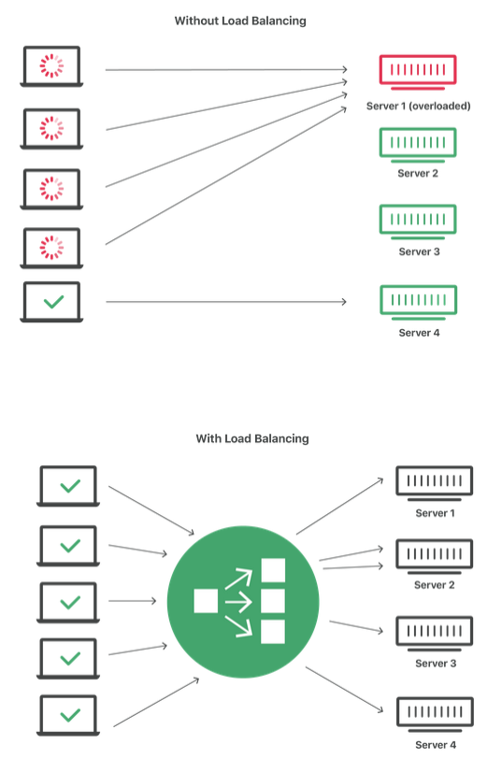
Figure 1: Network with and without load balancing
Source: Cloudflare.com
Load balancing is the simplest form of partition-based scalability. It randomly assigns customers to participating servers in order to distribute the total burden. Static partitions are also possible. A system may, for instance, partition consumers based on their geographical location and route them to regional servers.

Task B: Cloud Service Providers Comparison and Analysis
For an organization like Aspire Retailers which is considering using cloud-based services for the first time, the platforms that offer cost-efficiency, reliability and best range of cloud services are AWS (Amazon Web Services), GCP (Google Cloud Platform), and Microsoft Azure.
Each of the above major cloud service providers has its strengths and unique features which attract their respective users needing a specific service. Nowadays, companies using a variety of cloud services within their IT operations might choose two or more providers depending on the services needed.

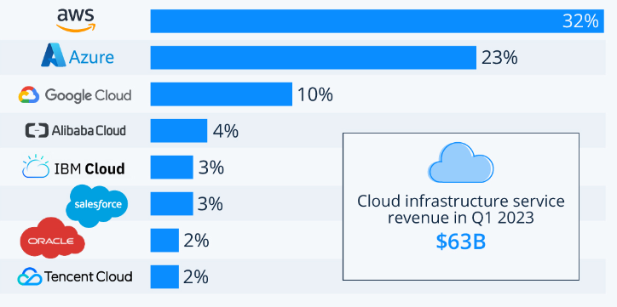
Graph 1: Worldwide market share of leading cloud infrastructure service providers in Q1’2023
Source: Statista.com
As can be noticed from Graph 1 above, AWS is the absolute leader providing cloud services and the primary strength of the market leader, is the breadth and depth of its platform spanning across more than 175 services within compute, storage, database, analytics, networking, mobile, developer tools, management tools, IoT, security, and enterprise applications, as of the most recent count.
AWS (Amazon Web Services)
Amazon AWS provides almost everything in terms of Distributed computation. AWS is dominant in a number of areas, including design and monitoring. AWS is generally preferred in the business sector due to its extensive and vast contributions, project-friendly administrations, global reach, and open and adaptable features.

Microsoft Azure
Azure offers a comprehensive range of services and solutions for individuals and organisations relating to foundation, process capacity, storage, organisation, etc. A significant advantage of Microsoft Azure is its registering capability. Microsoft enables the sending and management of virtual machines on a scale that can accommodate any required limit within minutes. It is unique compared to Amazon and Google. Microsoft Azure additionally enables seamless integration with Microsoft tools, offers open-source support, and hybrid cloud services.
GCP (Google Cloud Platform)
The specific knowledge of Google, as well as its industry-leading technologies for deep learning and automated reasoning. For engineers, Google Cloud provides a selection of cloud administrations. Open-source support, shifting flexibility, savings, and flexible contracts are all provided by Google Cloud. The DevOps expertise of Google Cloud is specifically geared toward cloud-based enterprises. Given that Google's foundation is analytical, GCP offers more advantages and adaptability to research and scientific tools.
Pricing
Amazon prices are the most competitive of all cloud providers. Amazon provides hourly instalments for the highlights function. Amazon also offers a free service with limited storage and registration, which could be useful for individuals and new businesses prior to a purchase. AWS offers four pricing models: pay-as-you-go, pay less by using more, save when you reserve, free usage tier.
Microsoft's evaluation varies based on the types of components employed by the development team. Microsoft provides Pay-in-advance and recurring payments at a rate per minute of use. Microsoft's adaptability should be self-evident, and it is valued based on demand for temporary responsibilities.
Google Cloud has a very competitive pricing among the three specialist companies. GCP has a pay-as-you-go pricing model that charges per minute or per second of use.

Summary
Amazon has been in the Cloud advertising industry for approximately 14 years, and its developers and architects are the most skilled and experienced in the world. Amazon Web services provide fierce competition to its rivals. However, AWS infrastructure pricing can be difficult to comprehend. This expertise makes Amazon the most endeavour-generous cloud specialist cooperative, enabling anyone to utilise AWS without difficulty.
Microsoft Azure is the earliest cloud service currently available. It is suitable for large-scale business development due to its high computing capacity and its integration of other Microsoft features into a single framework and procedure, which provides more power. Microsoft Azure is another formidable rival to AWS. Microsoft Azure has a Windows-supporting effort foundation. It strives to achieve interoperability with them and the integration of Office365 offers a very attractive package for enterprises.
GCP provides one of the industry's best cloud security. It offers a different level of cloud security than its competitors and has more than 500 security engineers working on it. For activities requiring the highest level of security, such as banking, finance, and defence applications, GCP will be the best option.

Cloud Service Provider | Benefits | Limitations
Amazon Web Services | • Breadth and depth of its services  • Developer functionality  • Economic benefits for customers  • Gold standard for reliability and security  • Control market position  • Sizeable , develop fully offerings  • Help for huge organisations  • Worldwide reach | •Cost prohibitive  • Usage is not facile  • Stewardship of price  • Overcoming  • Technical support fee
Microsoft Azure | • Adjustable billing  • Platform-as- Service (PaaS) is a well-defended suit of Microsoft  • Accuracy and expandable. • High level availability  • Price-effective differentiate to the competition  • After the first biggest provider  • Combination with Microsoft devices and software  • Integrated public and private cloud  • Help for open source | • Consequences with documentation  • Imperfect management devices  • Comparatively hard to use  • Expensive  • Data transfer cost  • Require platform expertise
Google Cloud Platform | • Deep expertise technology • Current innovation, well- authorise in cloud computing  • Adjustable pricing model  • Advance costing than Competitors  • Live Migration of Virtual Machines  • Delegation to  • Continued | • Safety and privacy  • Bounded control and flexibility  • Vendor pin- down  • Insufficient characters or services  • Historically not as enterprise focused
Table 1: Comparison chart of cloud service providers: Amazon Web Services (AWS), Microsoft Azure and Google Cloud Platform
Source: Mufti, T., Mittal, P., Bulbul, G., “A Review on Amazon Web Service (AWS), Microsoft Azure & Google Cloud Platform (GCP) Services”., New Delhi, Department of Computer Science and Engineering

Task C: Azure Pricing Calculator & TCO
Cloud providers transfer development costs from the capital expense (CapEx) of constructing and maintaining infrastructure and facilities to the operational expense (OpEx) of renting infrastructure as customers require it, including computing, storage, and networking.
There are 6 main factors influencing the cost of a cloud service:
- Resource Type - Costs are resource-specific and depend on the type of resource used
- Services - Azure rate for usage and types of billing can vary between CSP, Web Direct, and Enterprise customers
- Azure Hybrid Use benefit - it allows users to use their on-premise license on Azure at a reduced cost
- Location - The Azure infrastructure is distributed globally and usage costs will vary between regions
- Bandwidth - this is the sum of inbound and outbound data transfers and Azure pricing depends on the amount of bandwidth. Some inbound data transfers are free.
- Reserved Instances - the user can use Azure Reservations and commit to purchasing a 1-year or a 3-year plan which can significantly reduce the cost (up to 72%) compared to the pay-as-you-go price
The Pricing Calculator displays categories of Azure products. The user can add these categories to their estimate and configure them per user’s needs. They will then receive a consolidated cost estimate with a comprehensive summary of the costs associated with each resource added to the solution. The user can export, share, or save this estimate for later use.
The TCO Calculator enables the user to estimate the cost savings associated with operating their solution on Azure as opposed to on-premises. The user will input the details of their on-premises workloads into the TCO Calculator. Then, they can examine the suggested industry-average cost (which can be altered) for operational costs associated with their business. Included in these expenses are electricity, network maintenance, and IT labor. The report is then displayed side-by-side. Using the report, the user can compare these costs to those of identical Azure workloads.
Azure Pricing Calculator
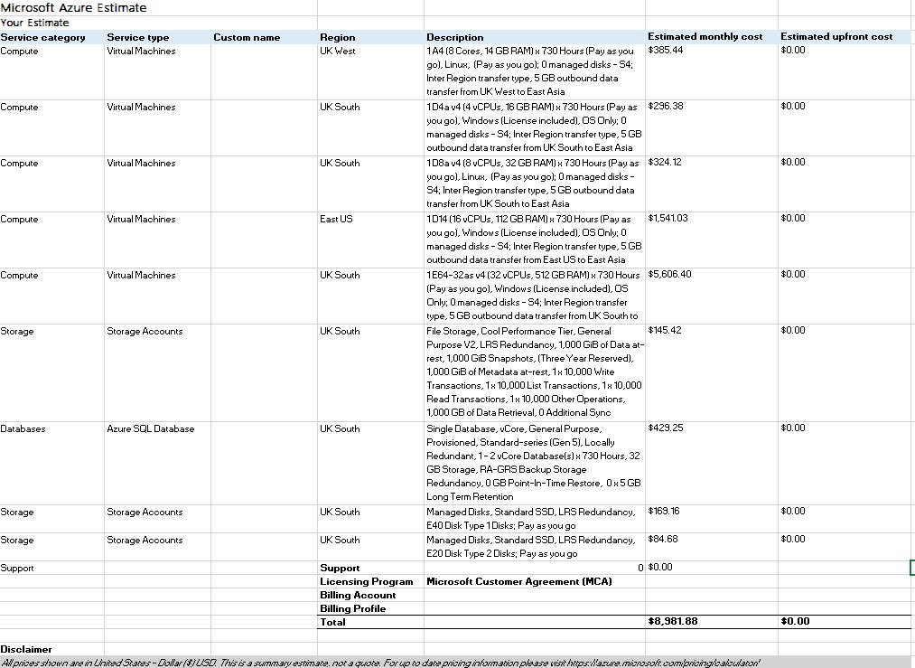
Resources included: 5x VMs (according to assignment specifications), 1x Azure SQL Database, 2x SSD + 1x HDD Storage

TCO - Total Cost of Ownership Calculation
Assumptions:
5 VMs (according to assignment specifications)
1 Microsoft SQL database
4 TB HDD storage + 2 TB backup and archive
2 TB SSD storage + 1 TB backup and archive

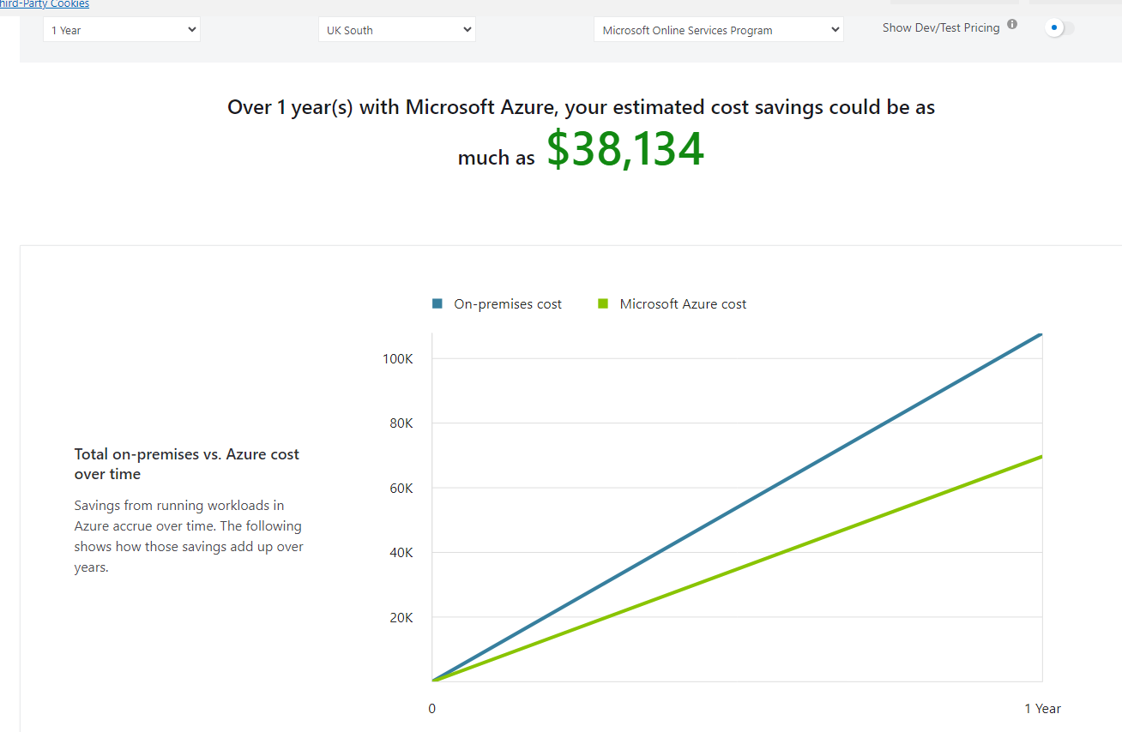
1-year cost savings on using Azure vs on-premises: 38,134 USD

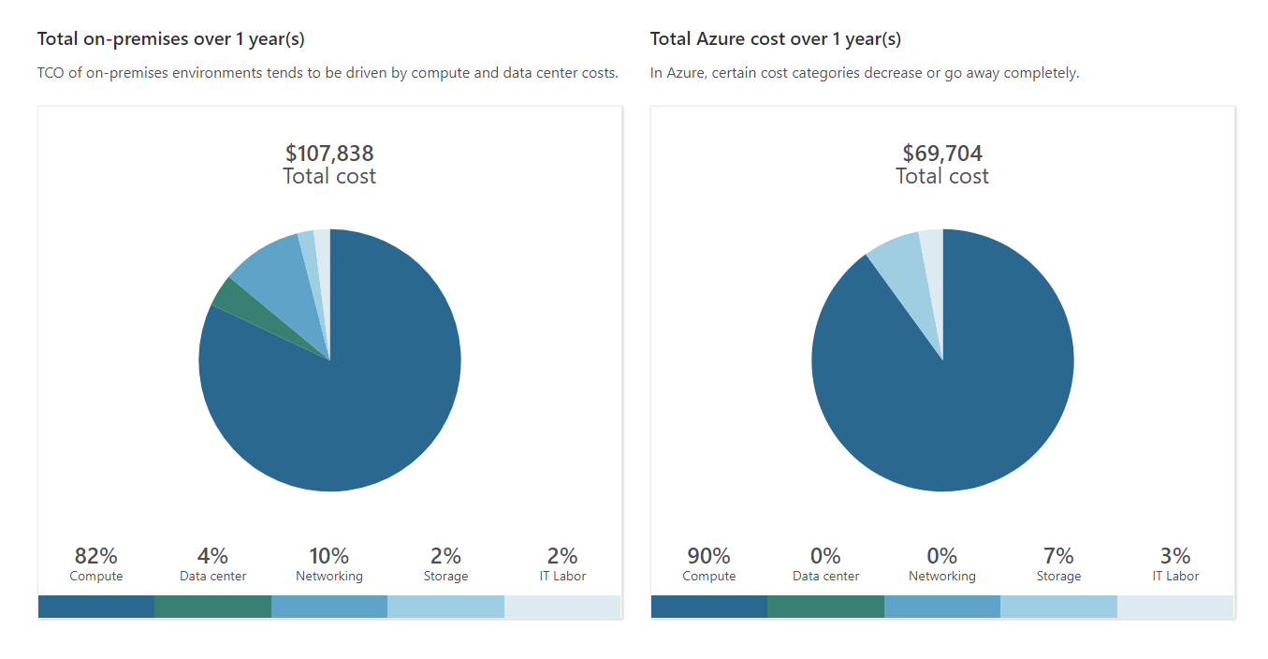
Cost comparison
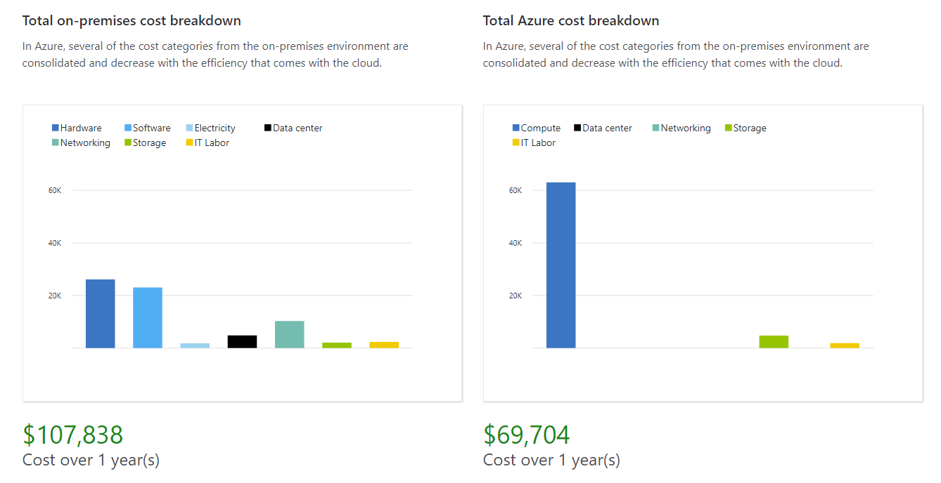
Cost breakdown
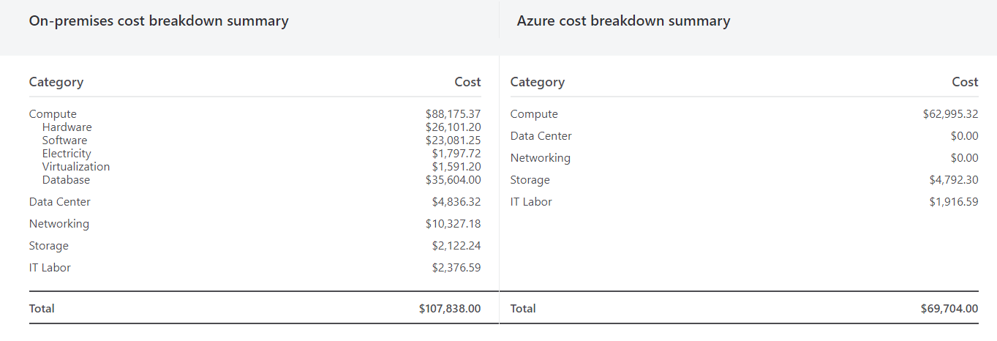
Cost breakdown summary
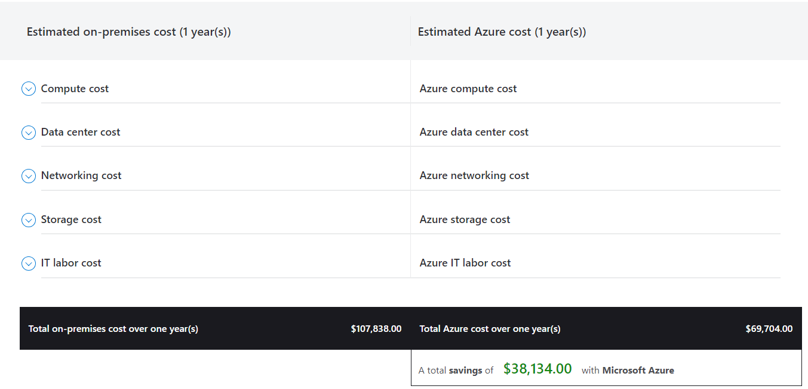
As can be seen from the image above, cost savings from moving to Azure from on-premise would save the company approximately 38000 USD / year.

Task D: Explain the uses of Azure AD to configure different accounts and demonstrate with screenshots
Azure AD is a cloud-based identity and access management service and servers as a central point of control for managing user accounts, groups, tenants, and access to different resources within the Azure environment. The primary uses of Azure AD for configuring user accounts are as follows:
- Centralized User Management: add, delete or edit user accounts and their features such as names, contact details, group memberships.
- Collaboration with external users such as vendors or partners by granting them limited access
- Manage access to cloud-based applications
- RBAC (Role-based Access Control): administrators can assign users to roles based on their position in the organization and grant them permissions within the cloud
- MFA (Multi-factor authentication): adding another level of security by prompting users to add additional authentication factor (fingerprint, phone number etc)
- SSO (Single sign-on): enables users to access multiple applications and resources with a single log in

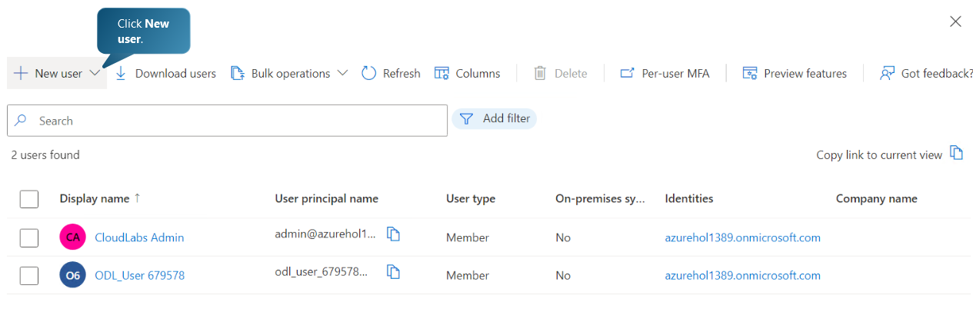

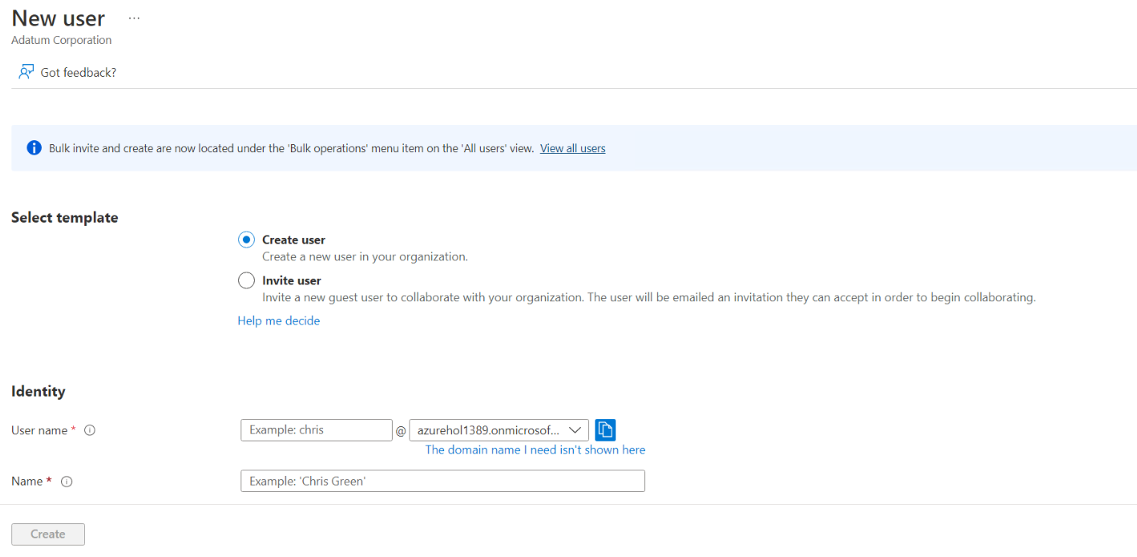

Creating new user in Azure AD

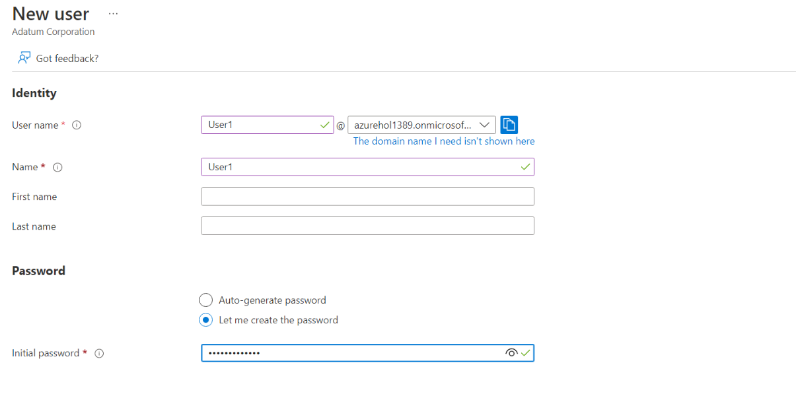
Creating new user in Azure AD
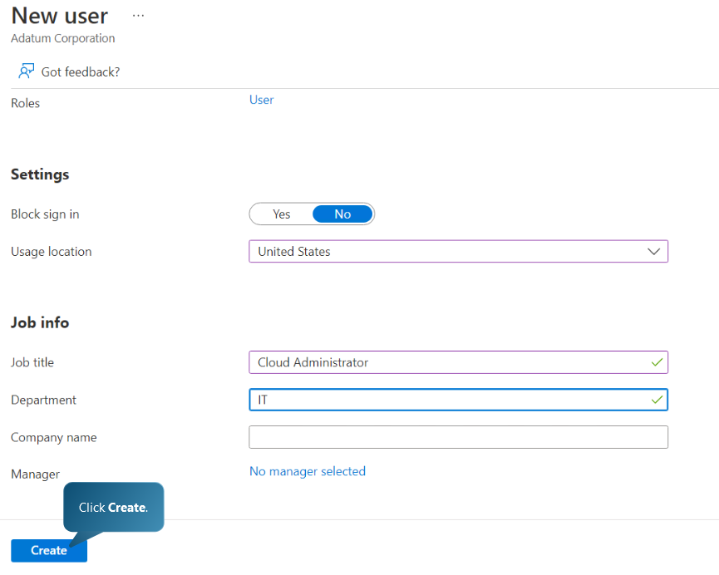
Providing User job Information – Job title is Cloud Administrator in IT department. For a user to become a Global user, the user must be assigned a role Global Reader.

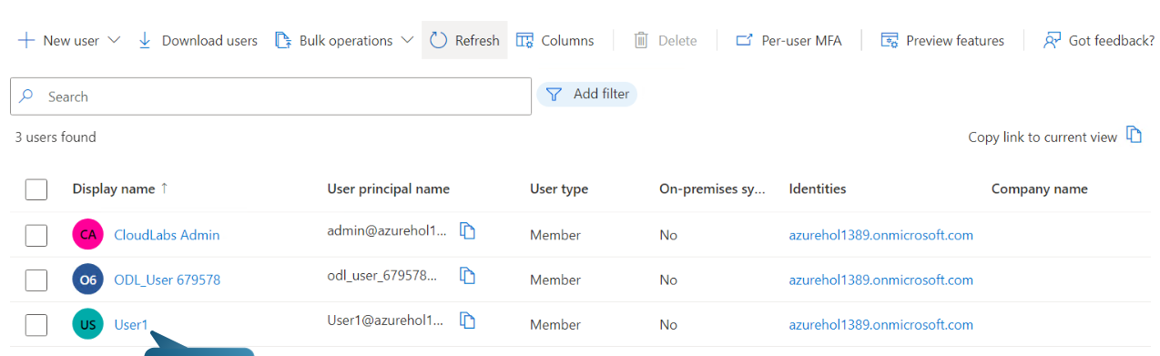
Refreshing users list and clicking on the new user account

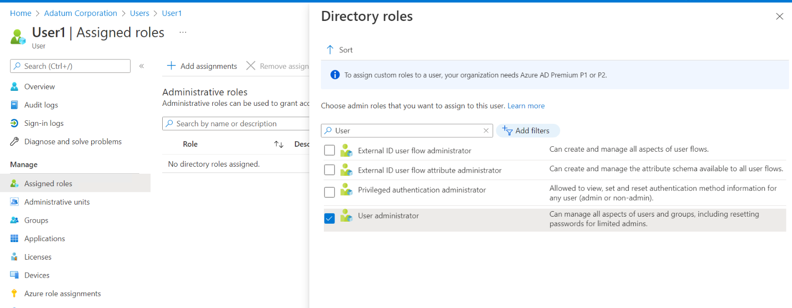
Assigning User Administrator Role to the new user account
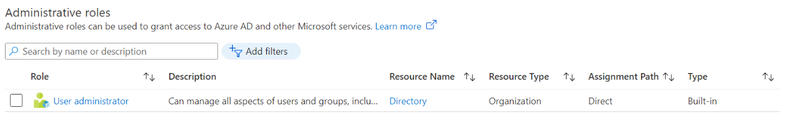
User Administrator role assignment to the new user
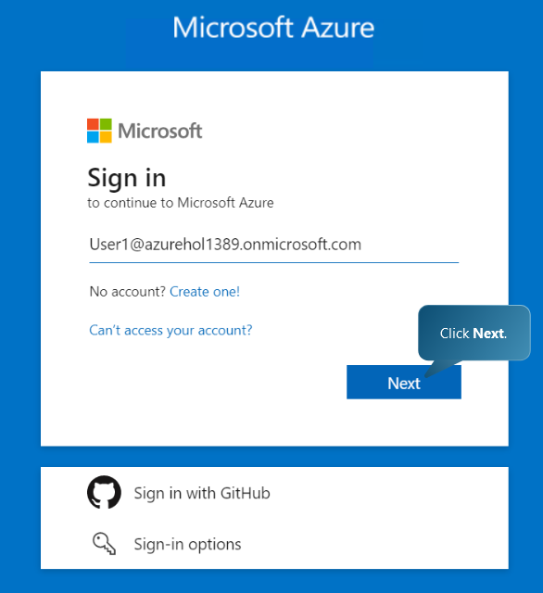
Logging in to Azure Portal in a new browser window
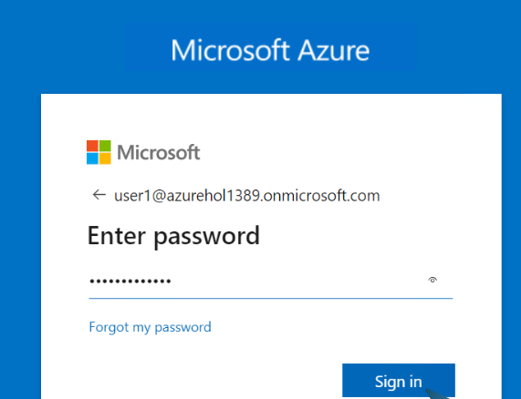
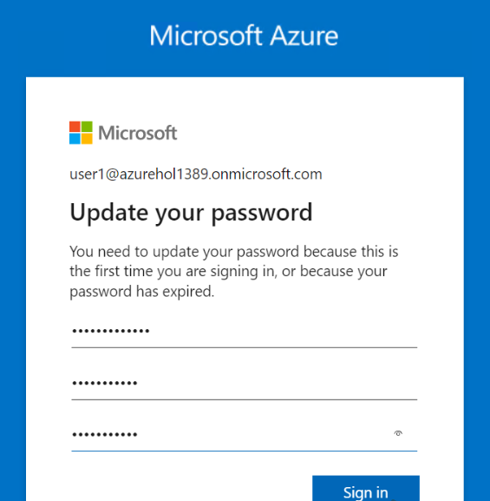
Signing in to the azure account portal with the new user account, changing the password to a secure password.
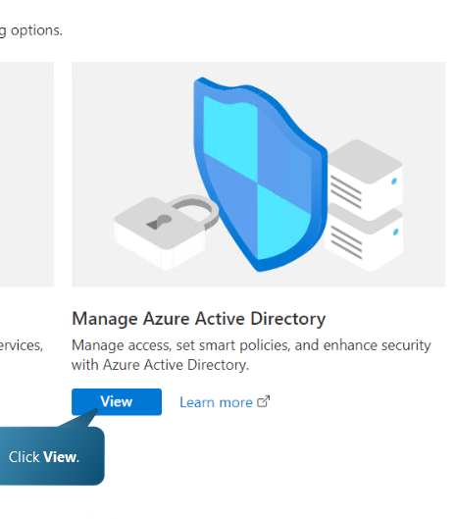

Choosing the view option on the Manage Azure Active Directory
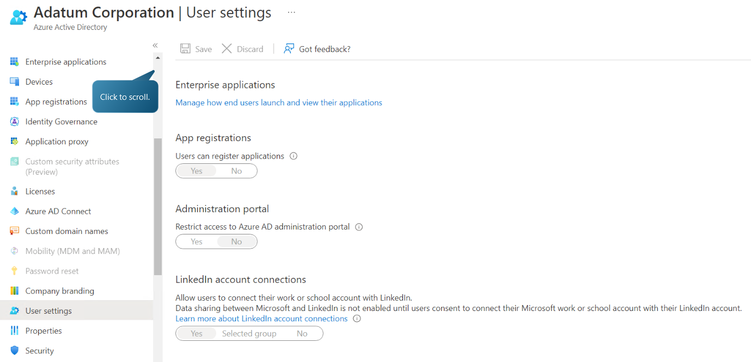
User1 does not have permission to modify any options on the user settings
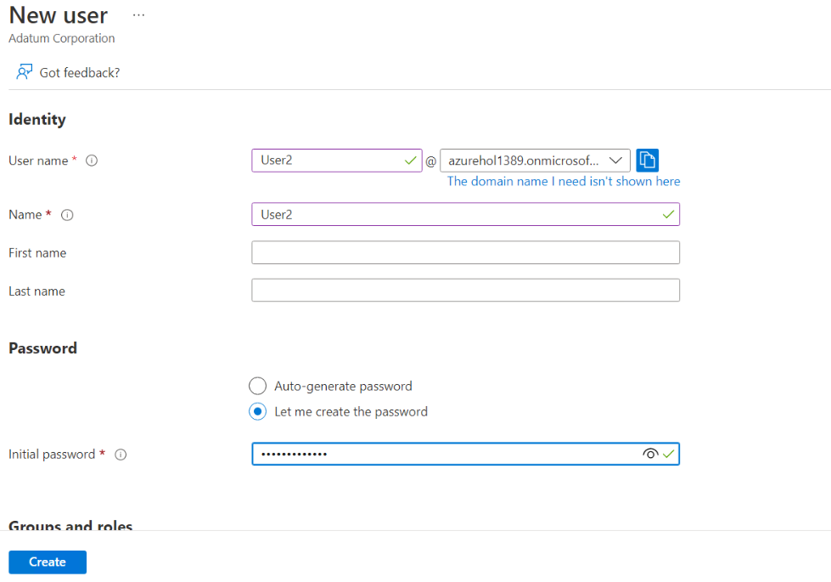
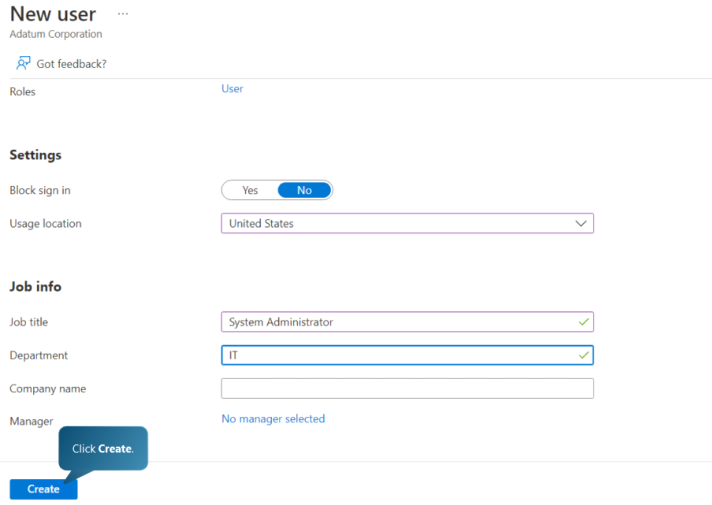
Creating a new user – User2 with Job title System Administrator in IT department
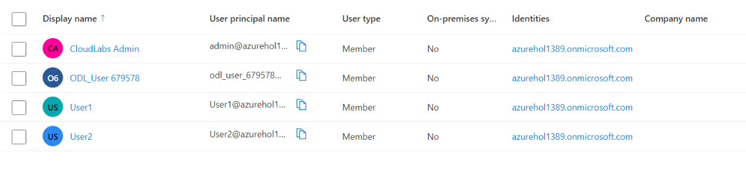
New user created
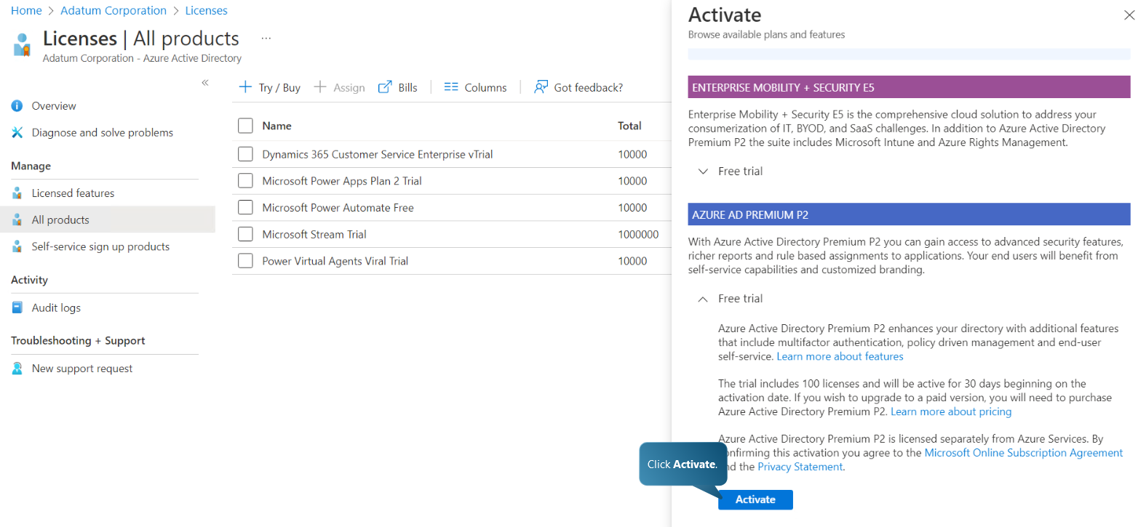
Activating Azure AD Premium P2

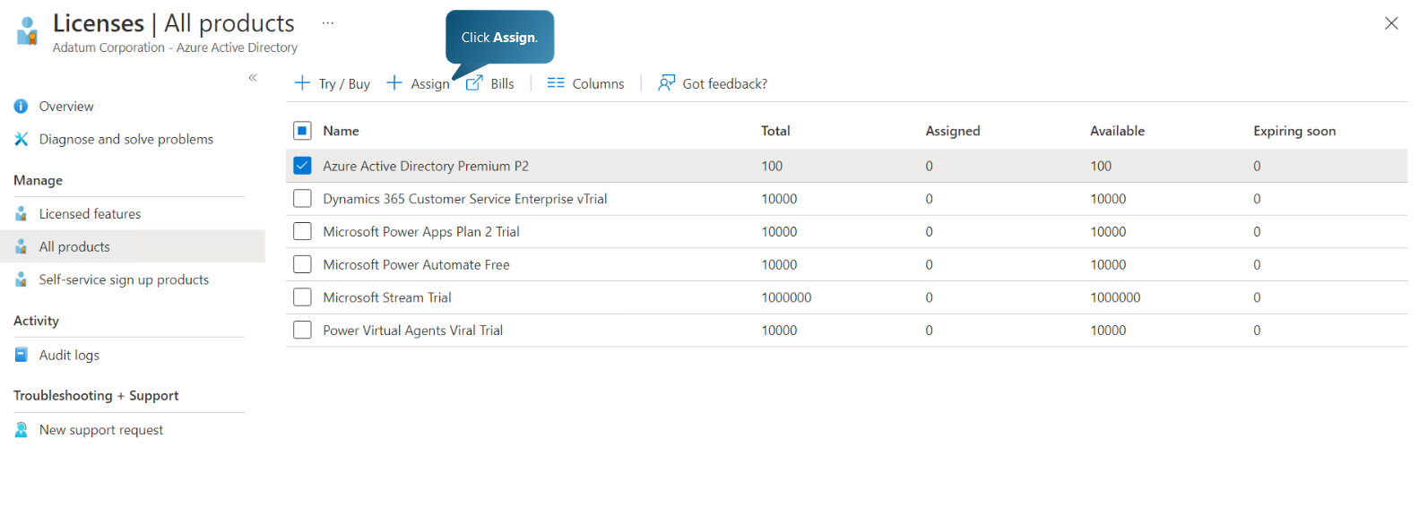
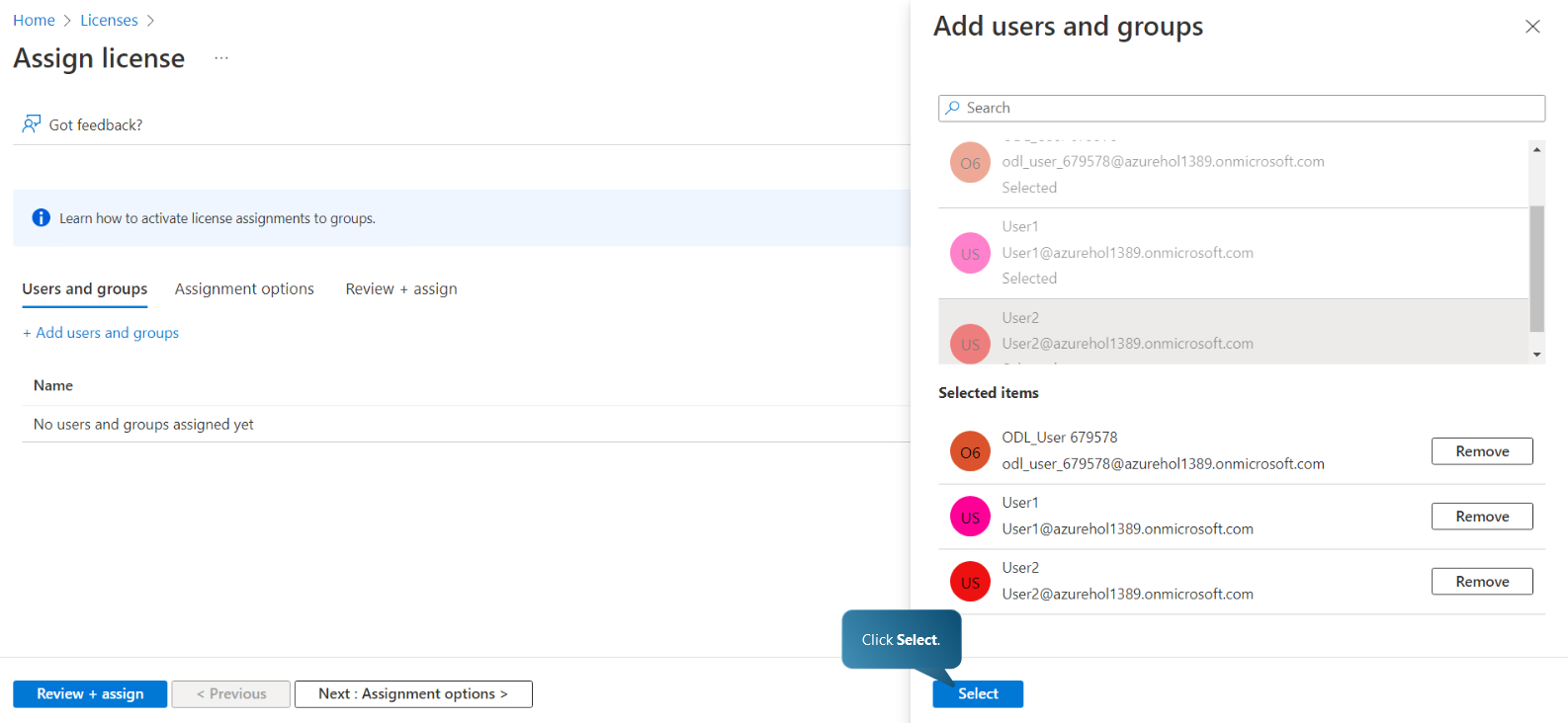
Assigning license options to original user account and newly created User1 and User2 accounts
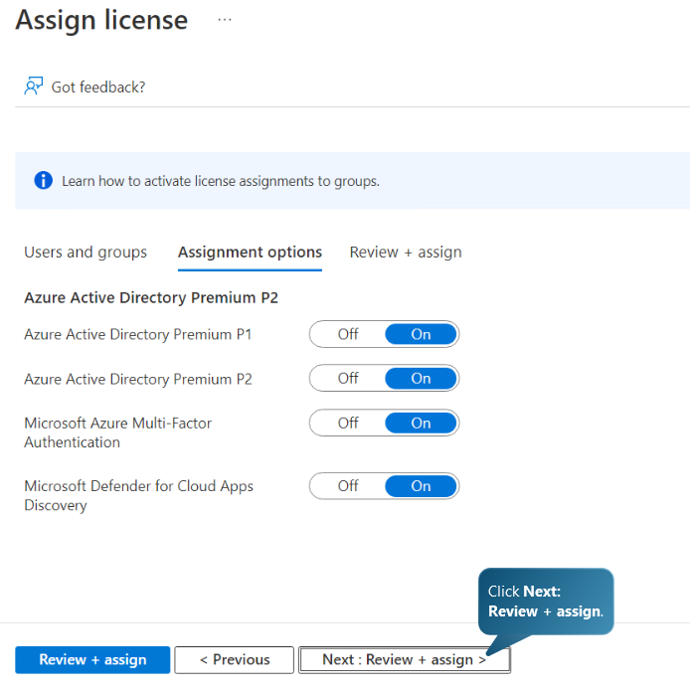
Choosing license assignment options
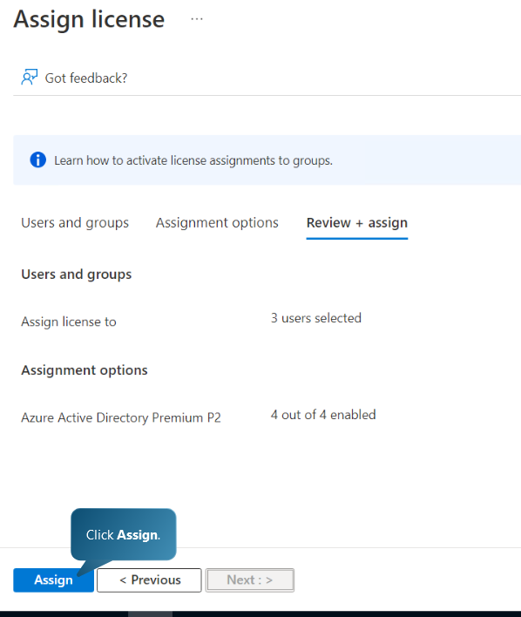
Assigning license to users

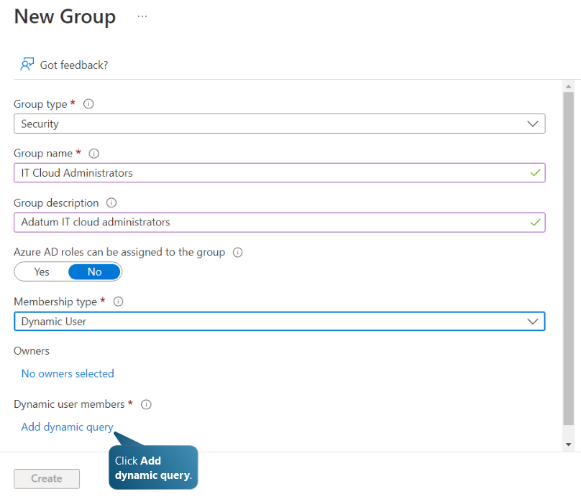
Creating a new group: IT Cloud Administrators and adding a dynamic query
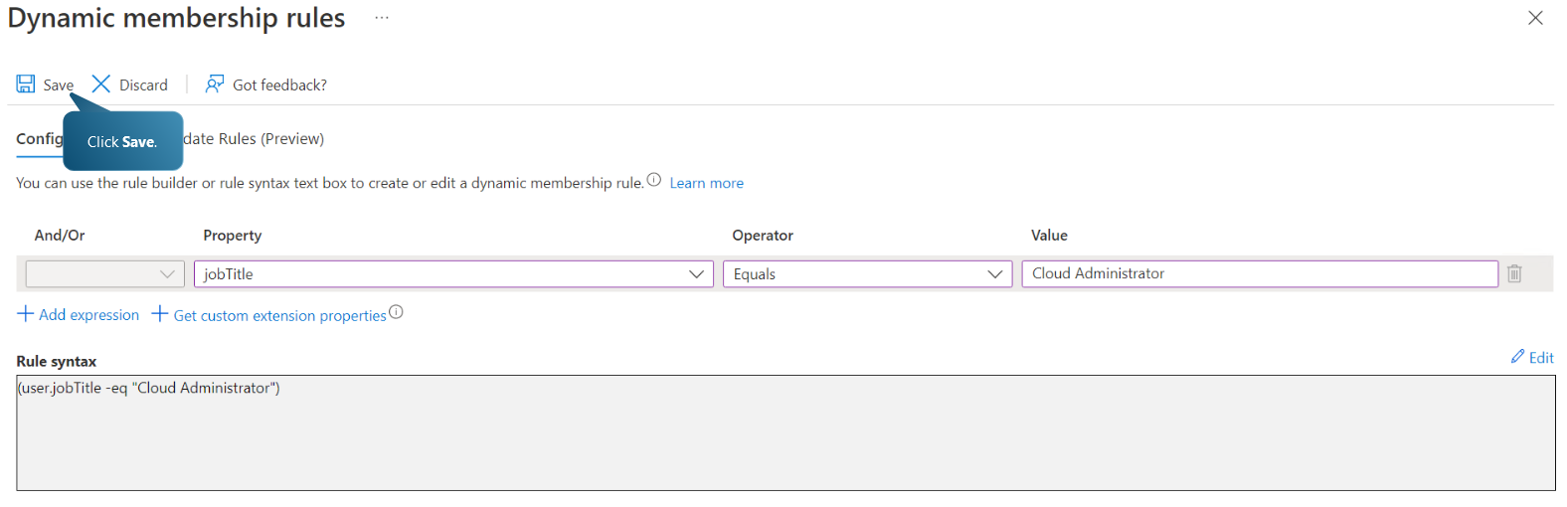
Crating a group dynamic membership rule which requires the job title to match “Cloud Administrator” for all users that will be added to the group. In the case of Aspire Retailers, a new group “Marketing Department” can be created with a dynamic rule which includes all users matching a job title with value “Marketing”.

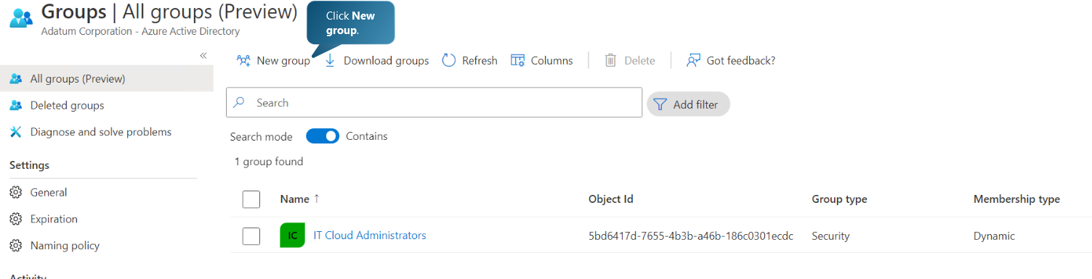
New group created and listed in Group after refreshing
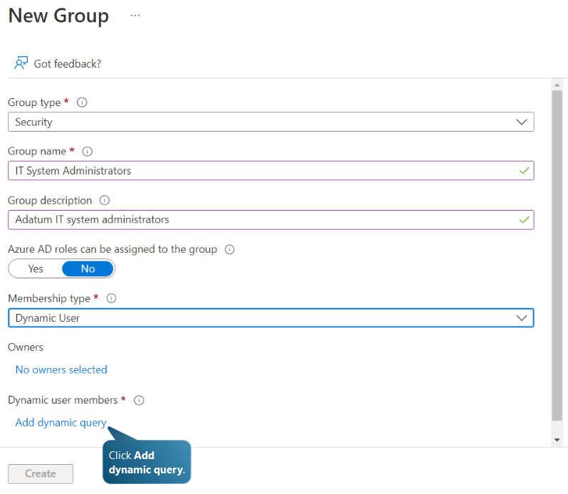
Creating “IT System Administrators” group and adding a dynamic query/rule.

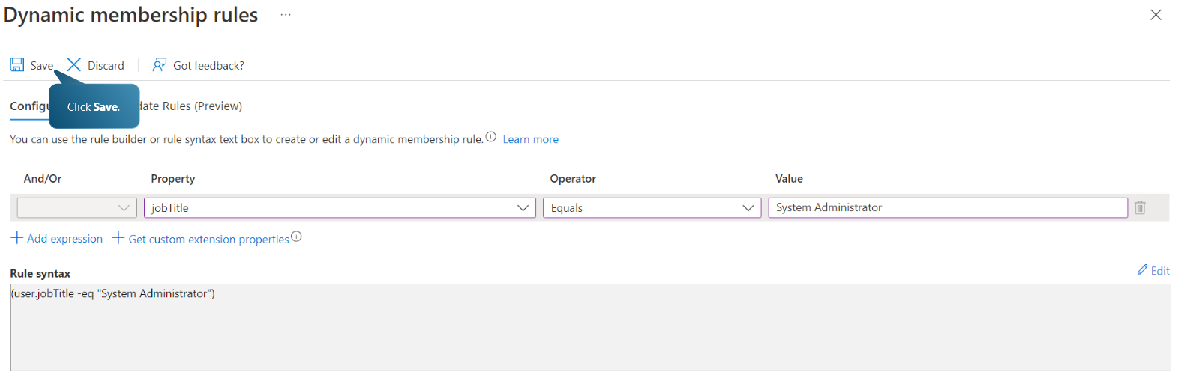
Adding a dynamic membership rule with the value “System Administrator” in the job title.
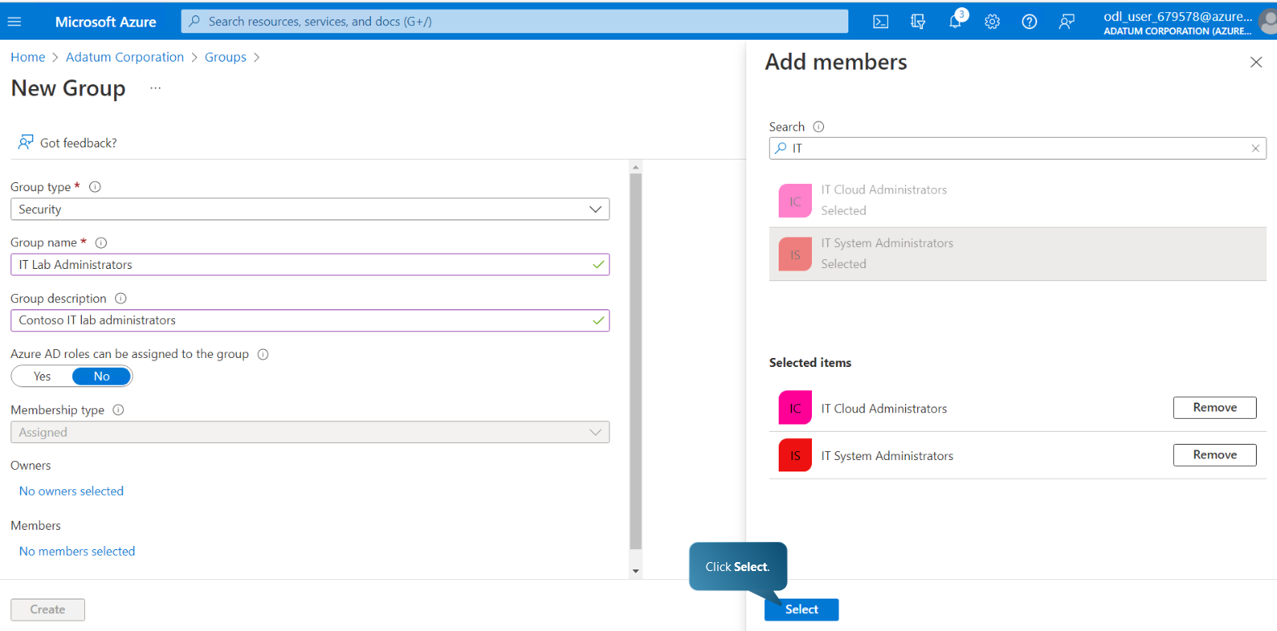
Creating a group “IT Lab Administrators” and adding users from IT Cloud Administrators and IT System Administrators groups.
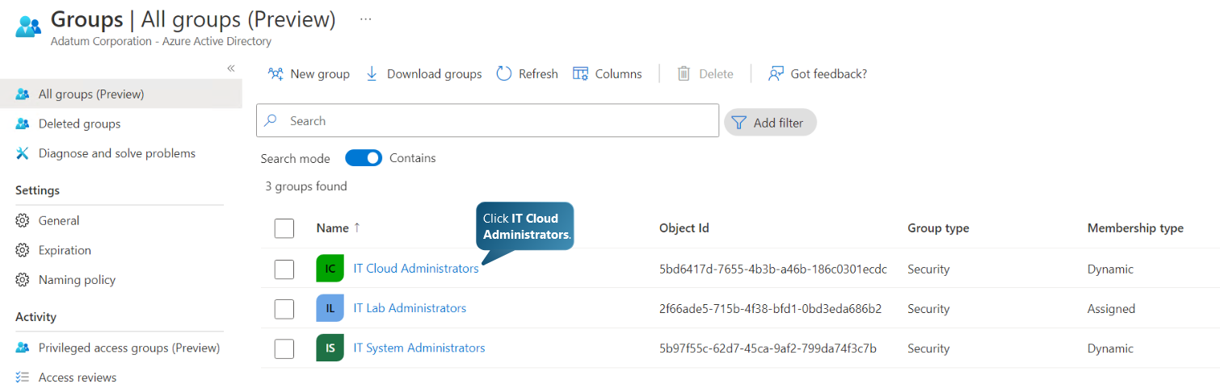
The three groups have been created and listed in the Groups list
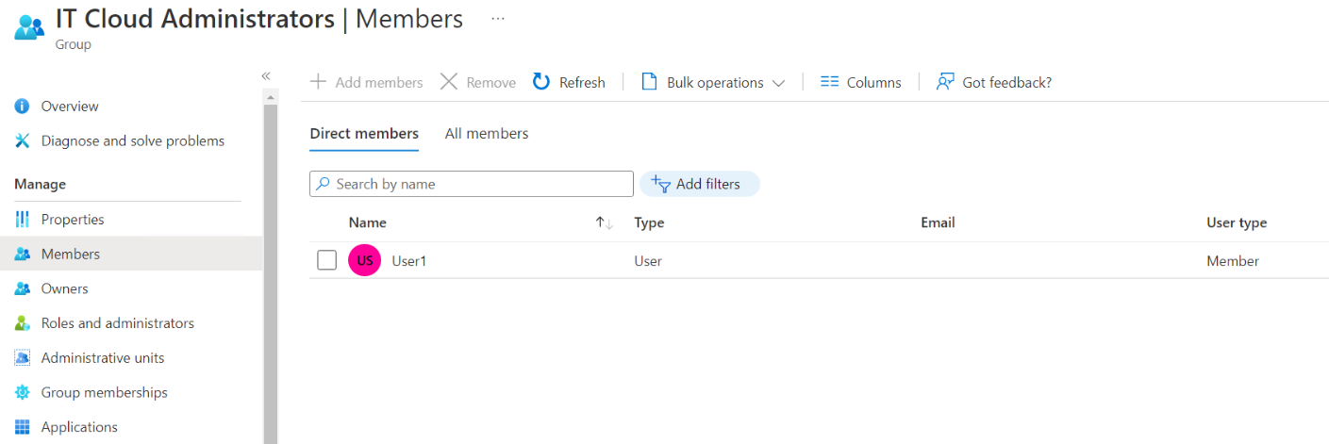
Verifying that User1 has been added to the IT Cloud Administrators Group as a result of the dynamic membership rule setting for the value of the job title
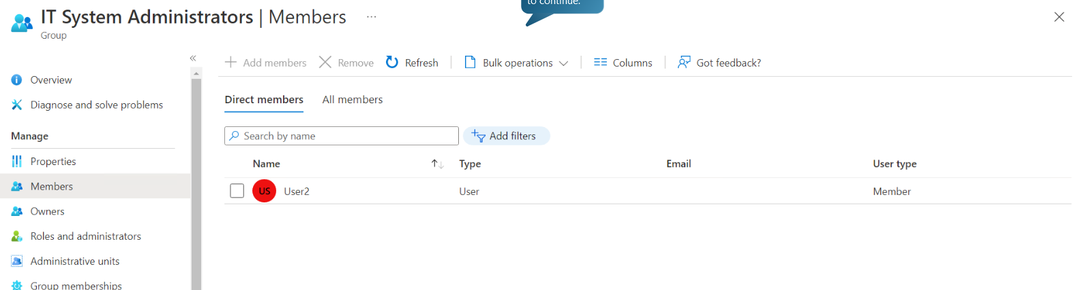
Verifying that User1 has been added to the IT System Administrators Group as a result of the dynamic membership rule setting for the value of job title
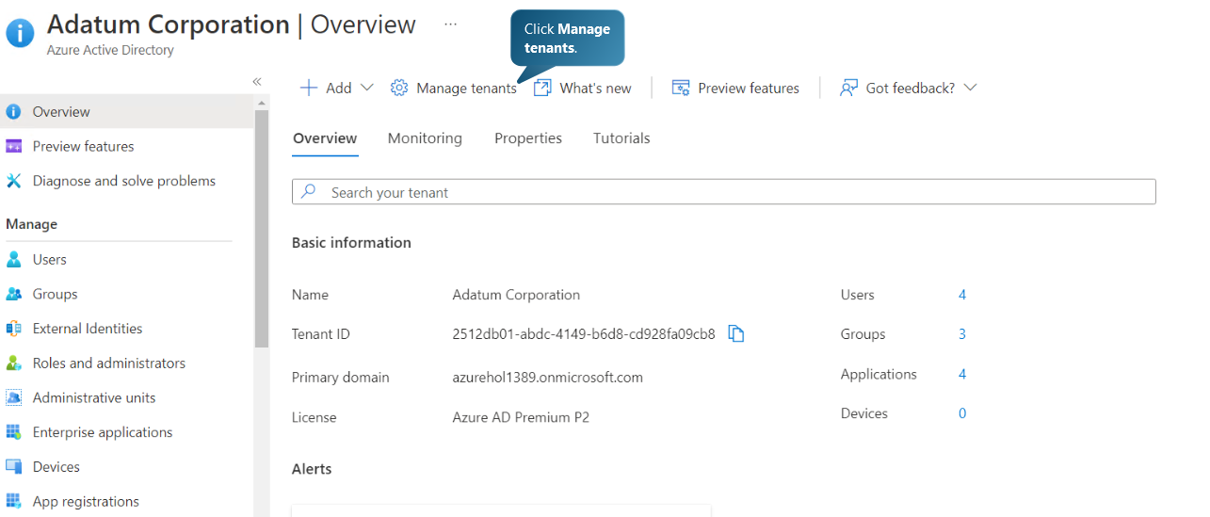
Creating a new tenant in Azure AD
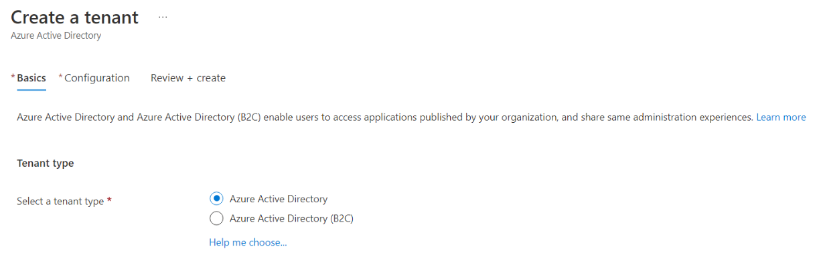
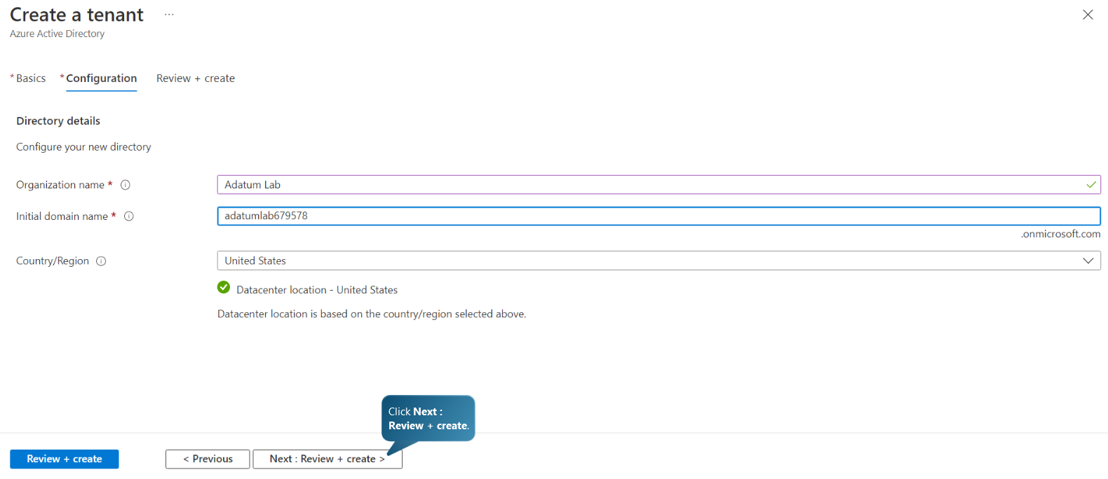
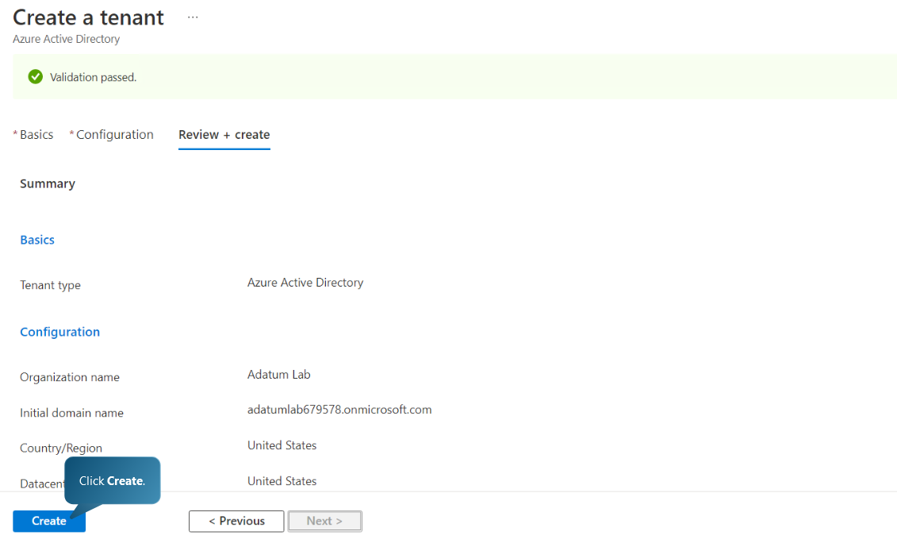
Creating a new tenant Adatum Lab. In the case of Aspire Retailers, a new tenant can be created as “Marketing Department” so that the department’s employees/users have their own AD settings and permissions within the organization.
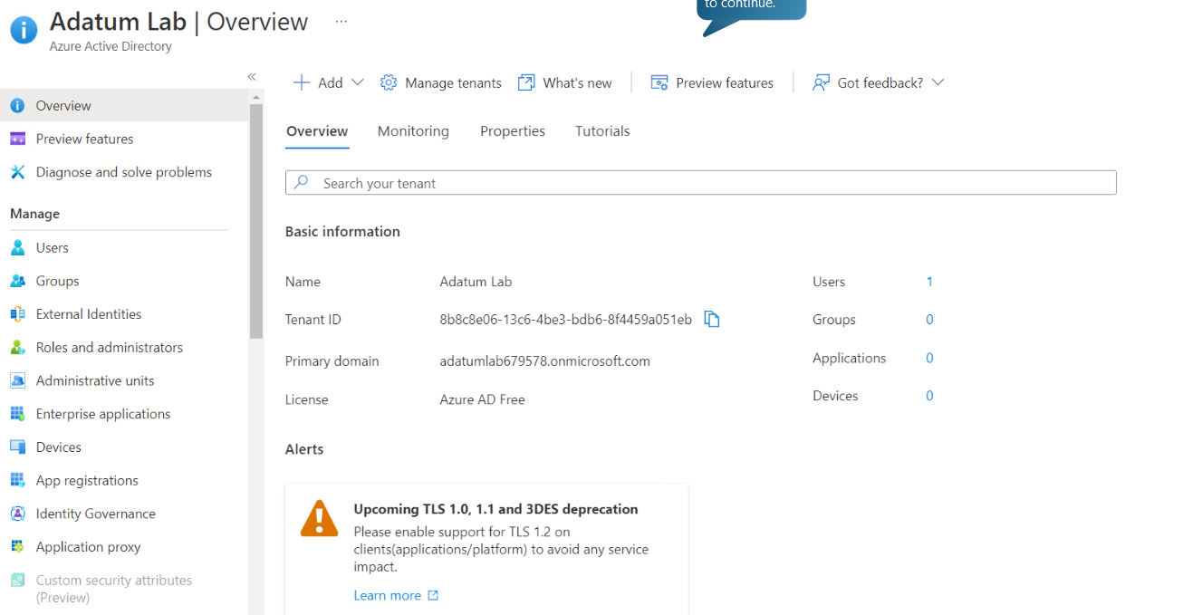
New tenant has been created
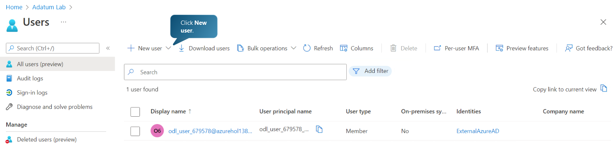
Creating a new user under the newly created tenant
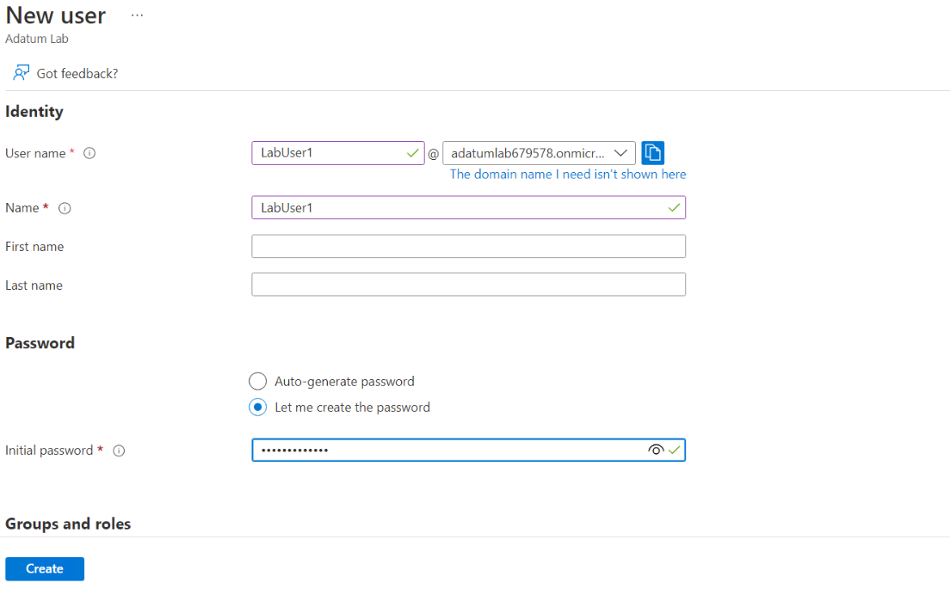
Creating a new user – LabUser1 under the Adatum Lab tenant

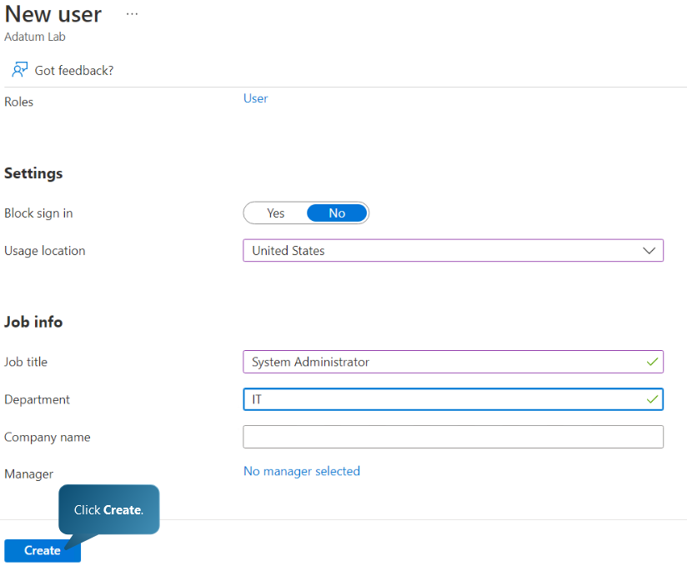

Setting the job title of the new user as System Administrator in IT department
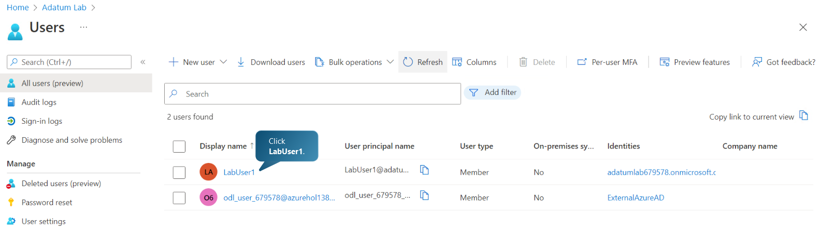
New user listed under the new tenant.
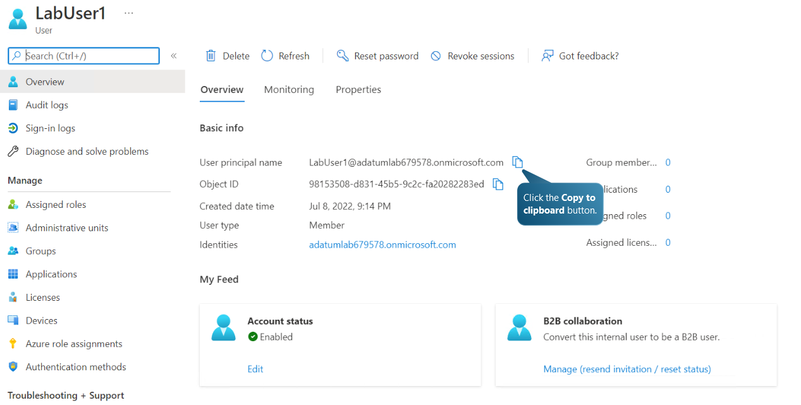
Copying user principal name to the clipboard
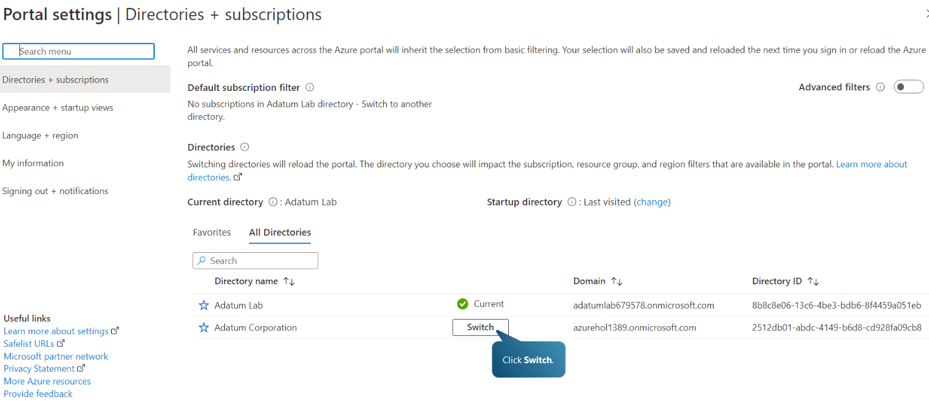
Switching back to the default Azure AD tenant
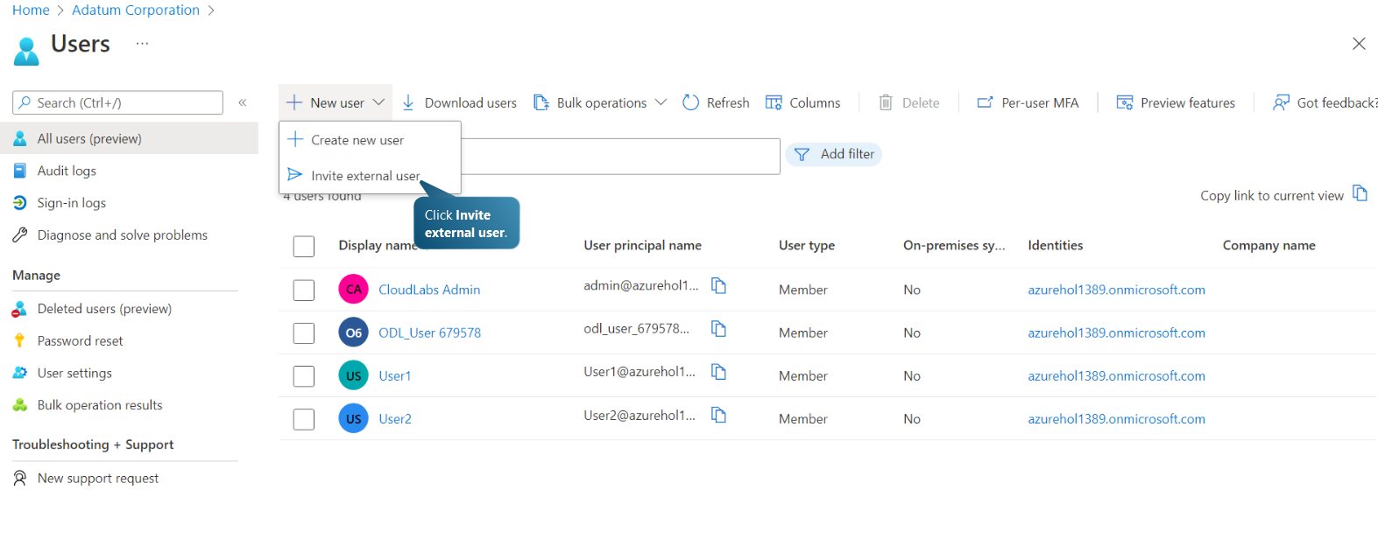
Adding new user under the default tenant by selecting the option to Invite external user.
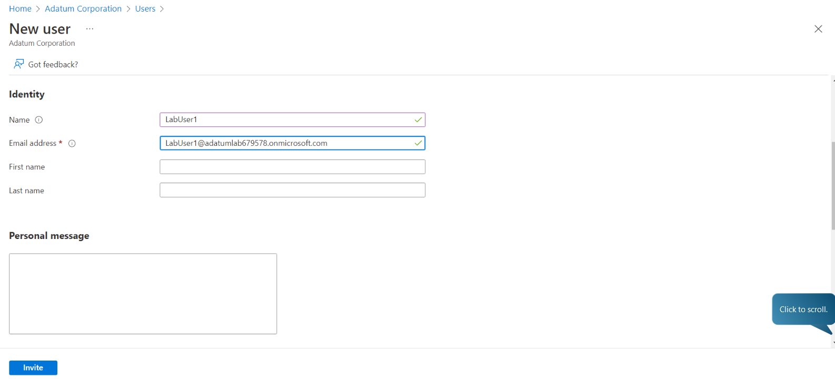
Completing profile for guest user

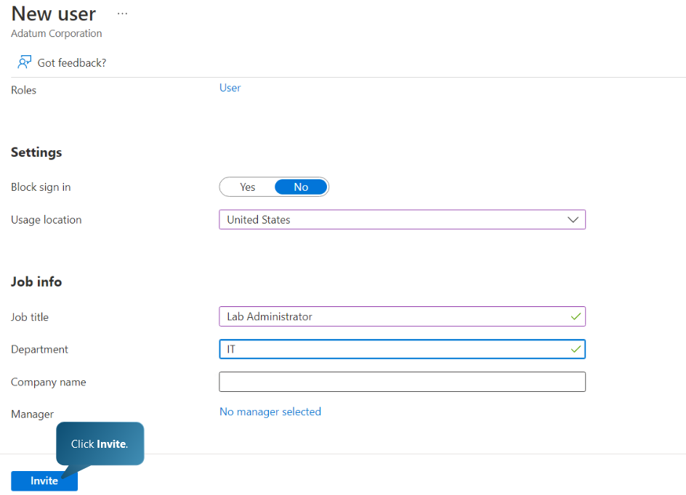
Completing profile and inviting new user under the default tenant
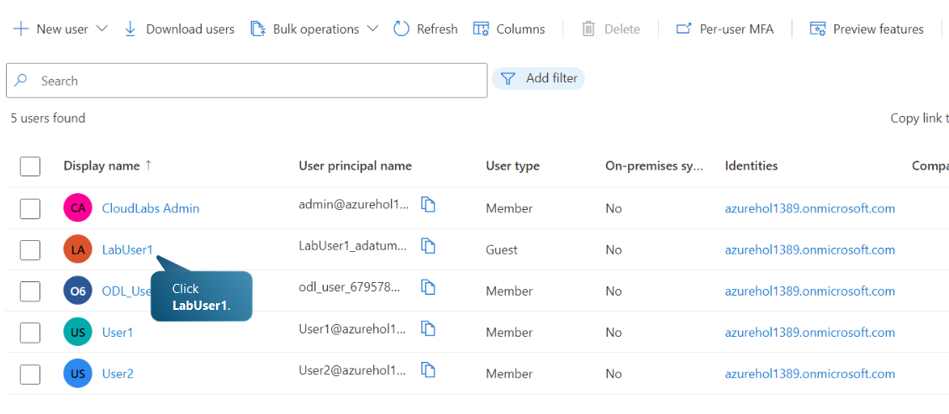
Guest user account added to default tenant users list

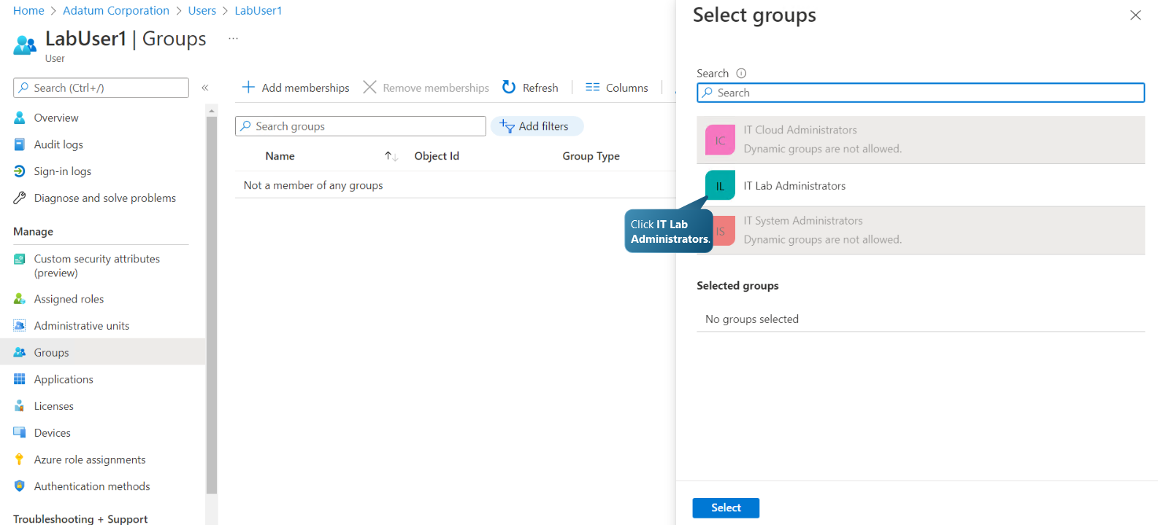
Adding LabUser1 to the IT Lab Administrators group under the default tenant Adatum Corporation
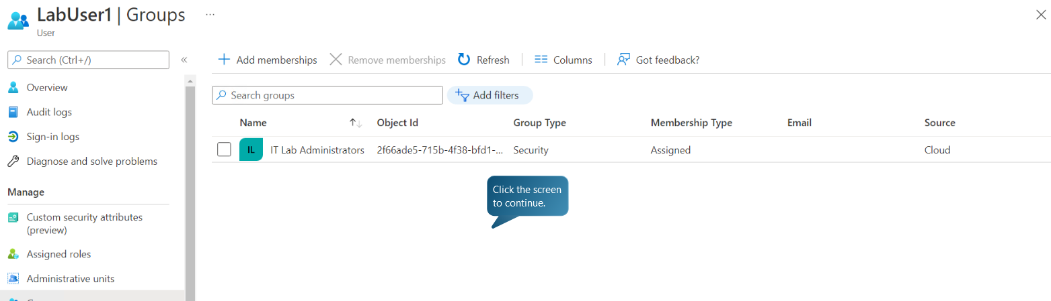
User added to the IT Lab Administrators group
For a user to become a Global user, the user must be assigned a role Global Reader

Task E: Cloud Governance Strategy and Policy
What cloud governance strategy is and analyse how Microsoft Azure can help Aspire Retailer to secure access of cloud resources?

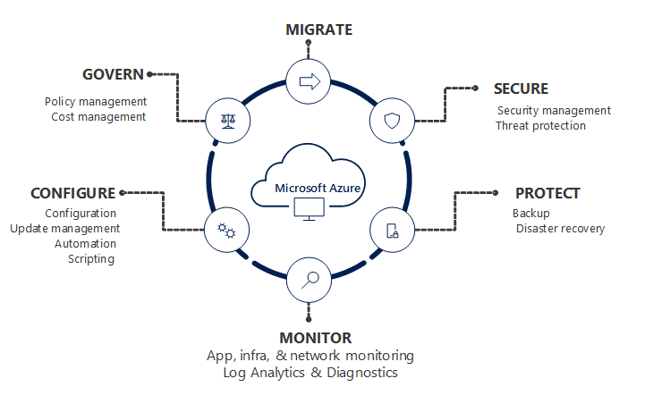
Figure 2: Areas of cloud management required to maintain an application or resource
Source: Microsoft.com

Governance offers mechanisms and protocols for controlling organization’s Azure applications and resources. It entails organising initiatives and establishing strategic priorities. Governance in Azure is implemented predominantly through two services. Azure Policy enables the creation, assignment, and management of policy definitions to enforce norms for resources. This feature ensures that these resources adhere to your organization's standards. Azure Cost Management enables the organization to monitor cloud consumption and expenses for Azure and other cloud providers.

Azure Policy facilitates the enforcement of organisational standards and compliance assessment at scale. Through its compliance dashboard, it provides an aggregated view to evaluate the environment's overall state, with the ability to filter down to the per-resource, per-policy level. In addition, it helps bring resources into conformance through remediation in bulk for existing resources and remediation on demand for new resources. Implementing governance for resource consistency, regulatory compliance, security, cost, and administration are typical use cases for Azure Policy.

Specifically, the organization can enforce the following governance actions with Azure Policy:
• Ensuring that your team only deploys Azure resources to permitted regions
• Enforcing the consistent use of taxonomic identifiers
• Demanding that diagnostic logs be sent to a Log Analytics workspace
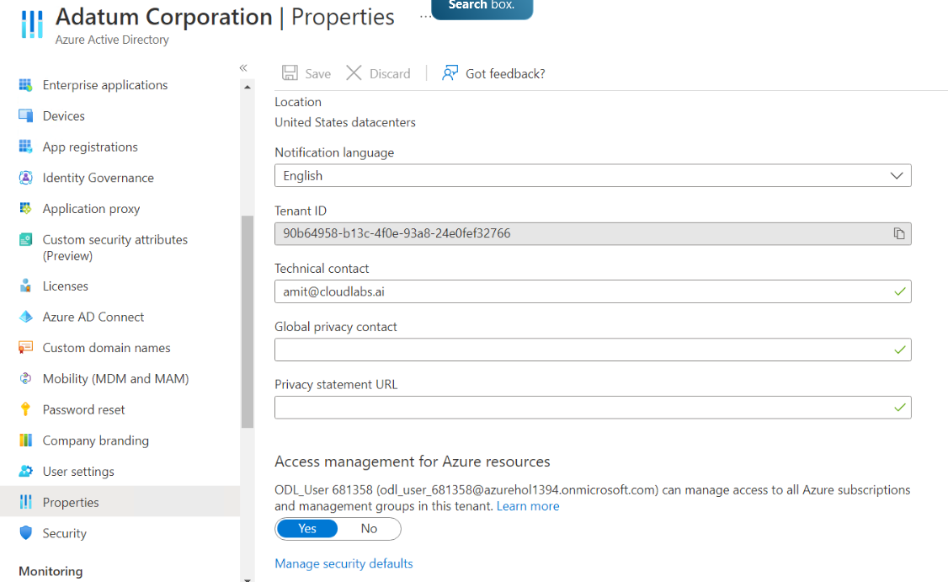

Activating Access Management for Azure Resources for a tenant

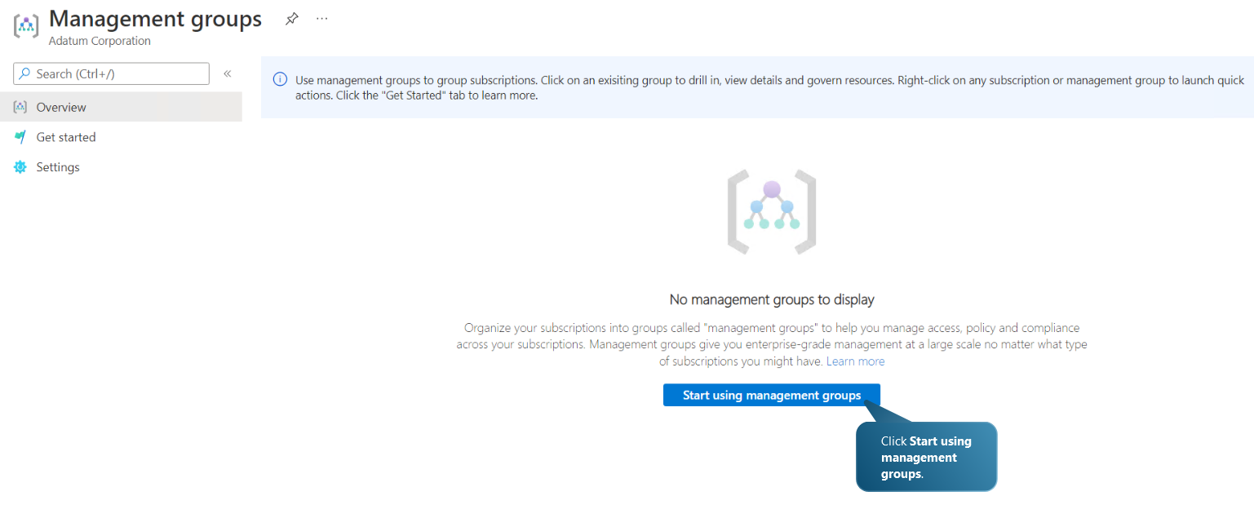
Using management groups

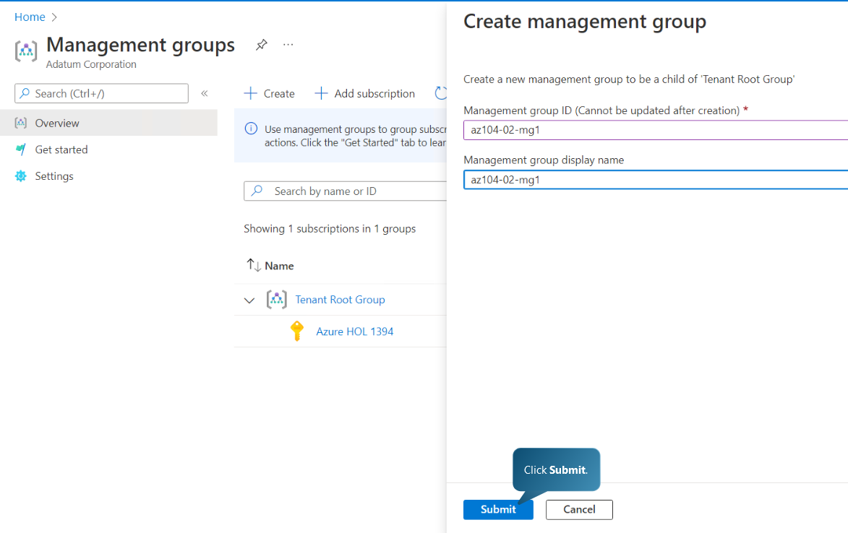
Creating a new management group
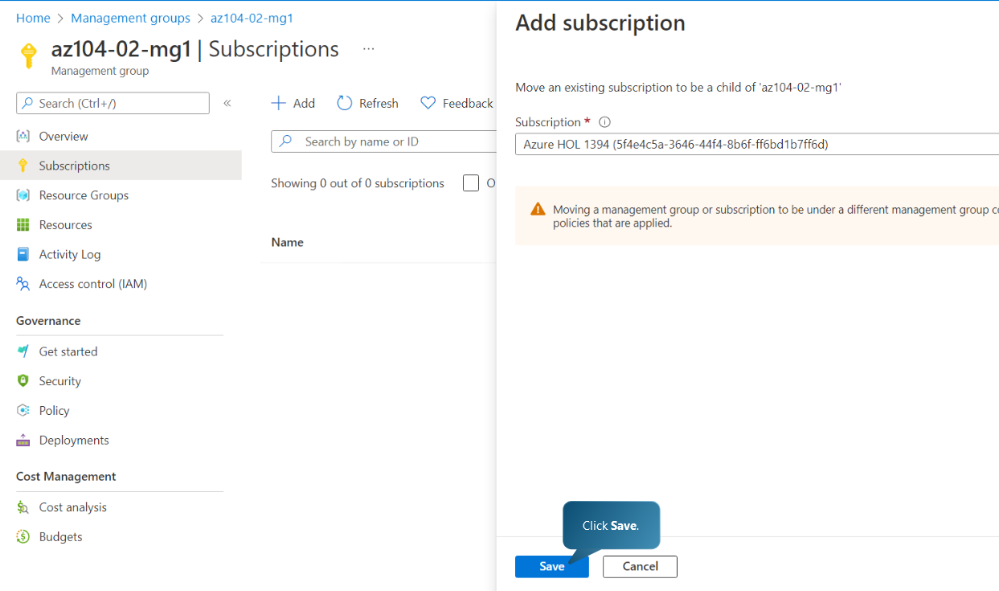
Adding a subscription to a new management group
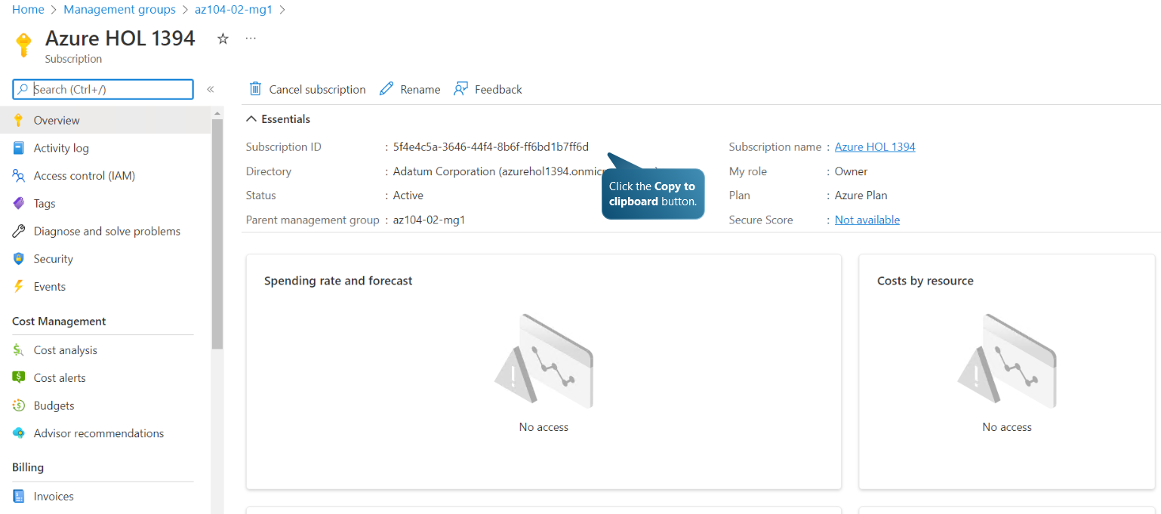
Copying the subscription ID of the subscription in the new management group
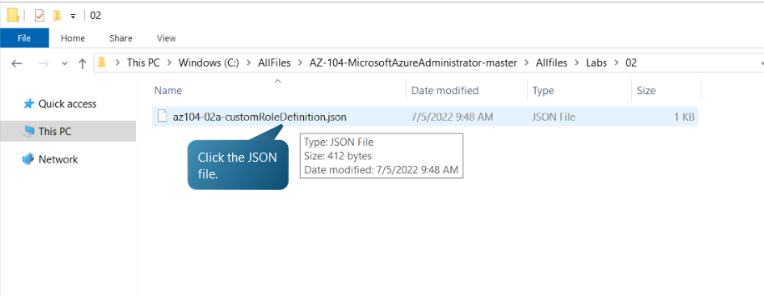
Opening a role definition JSON file in notepad

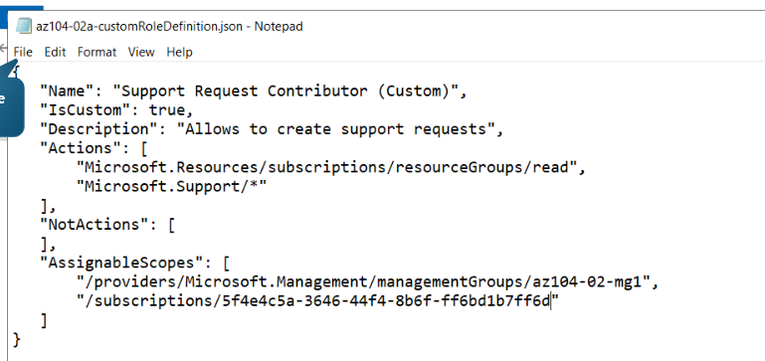
Replacing the subscription ID placeholder with the subscription ID copied previously and saving the file
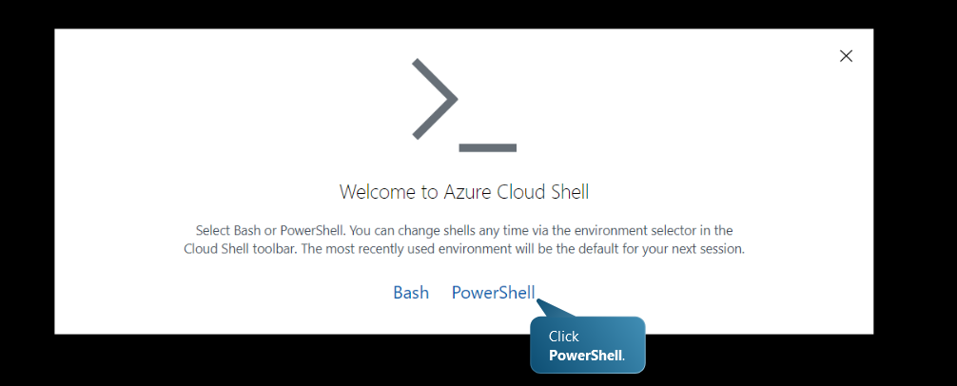
Opening Azure Cloud Shell and selecting the PowerShell option
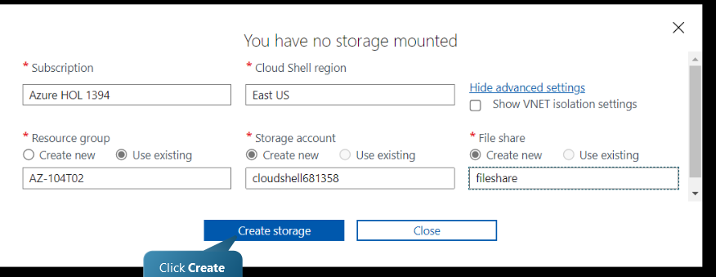
Creating storage since there is no storage mounted
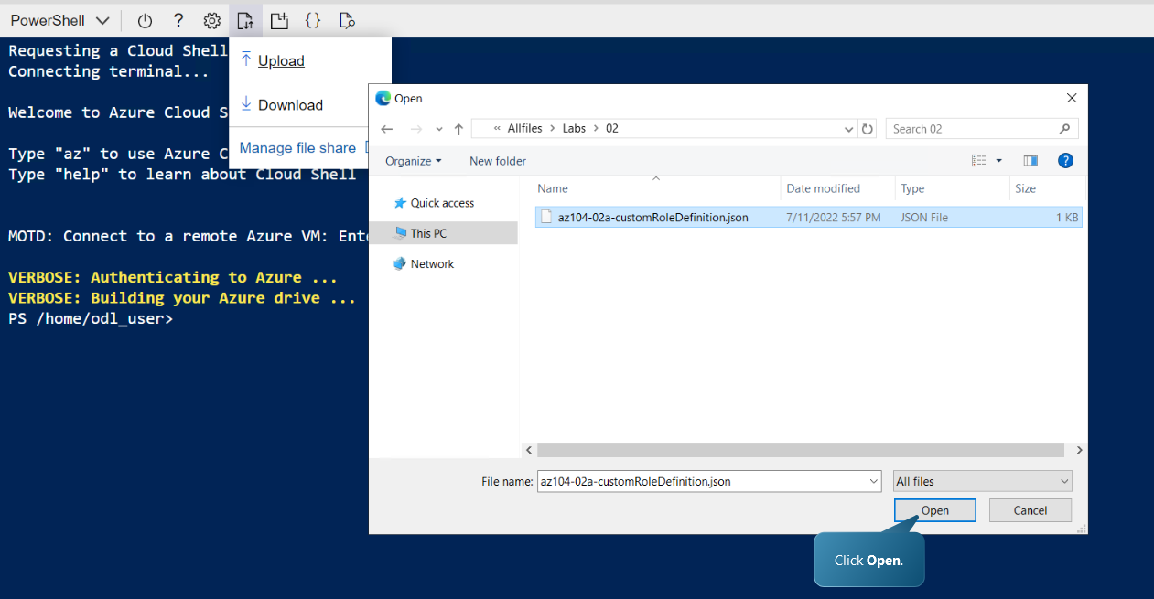
Opening the JSON file with the newly saved subscription ID in PowerShell
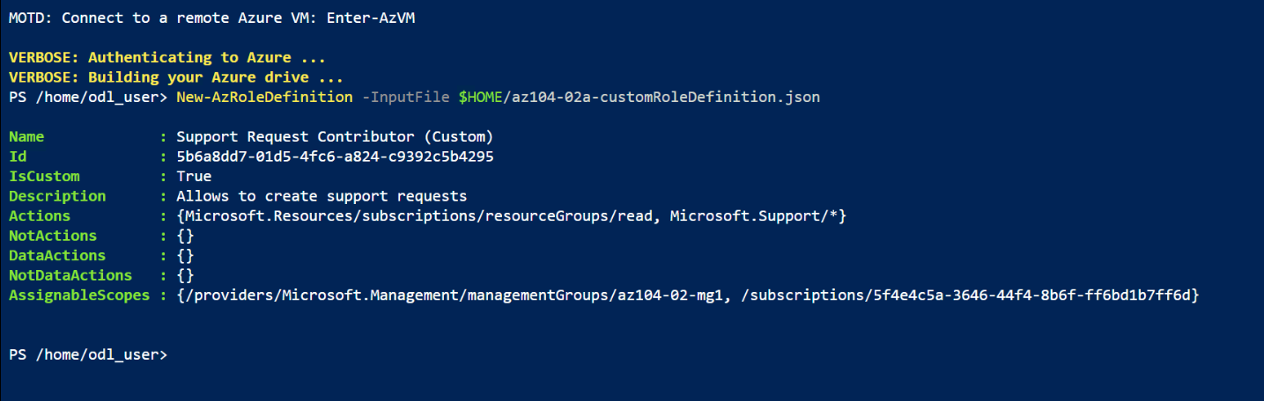
Running a command to create the custom role definition
Assigning RBAC (Role-Based Access Control) roles
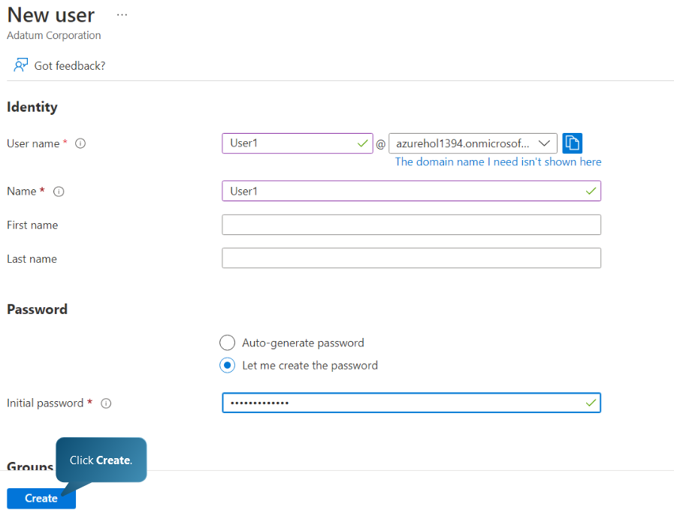
Creating a new user
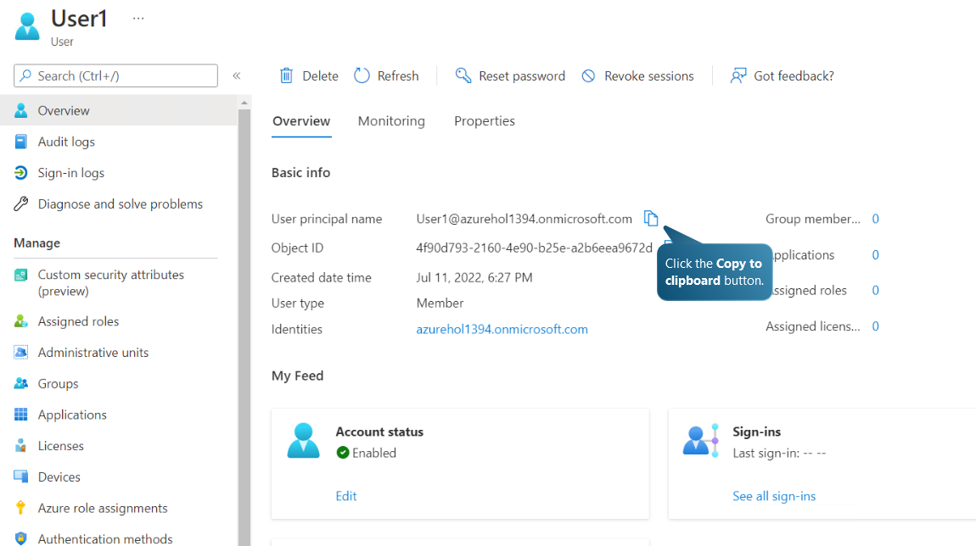

Copying the user principal name
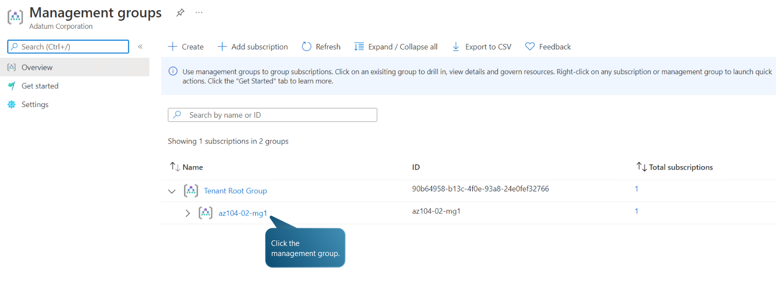
Selecting the previously created management group
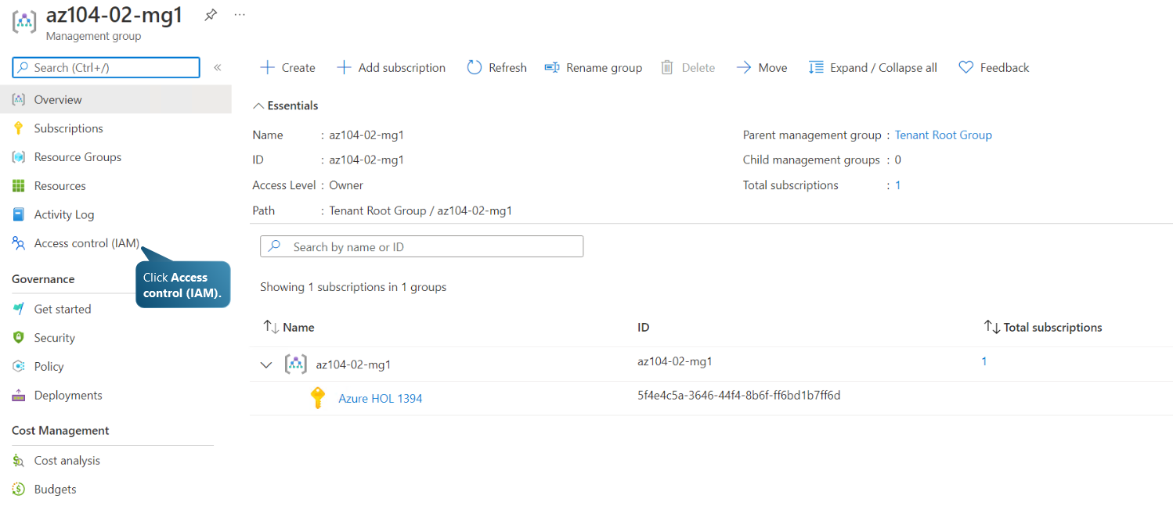

Selecting Access Control (IAM)
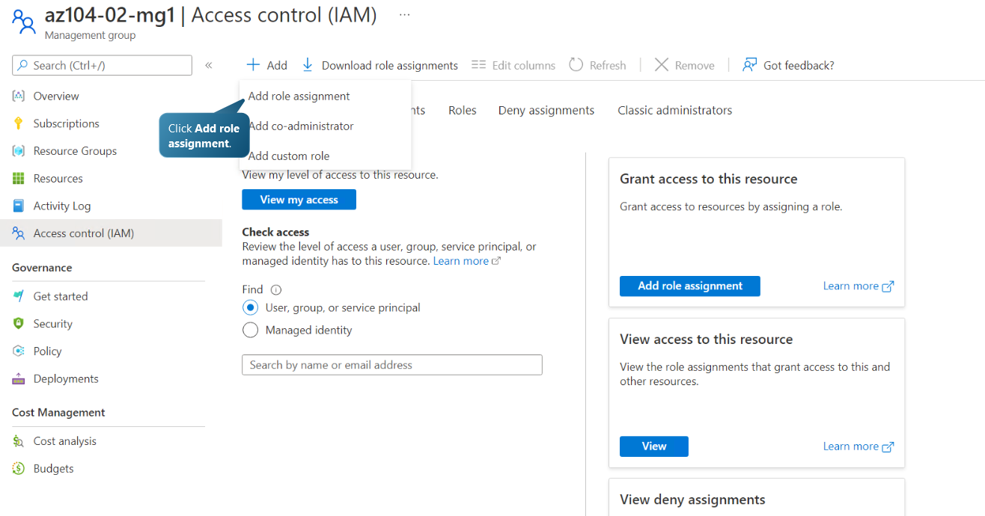
Selecting Add Role Assignment

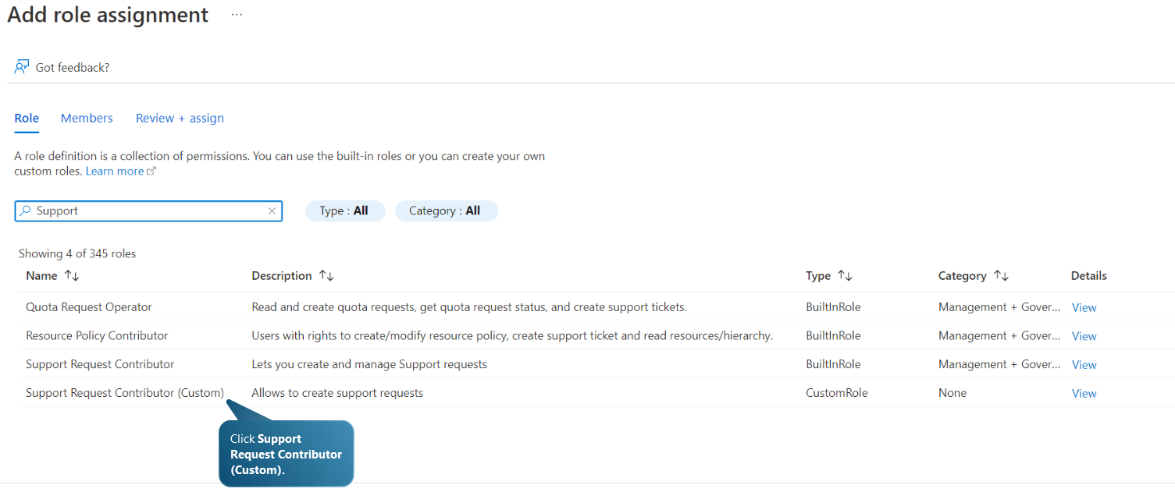
Searching and selecting the Support Request Contributor Custom Role which allows to create support requests
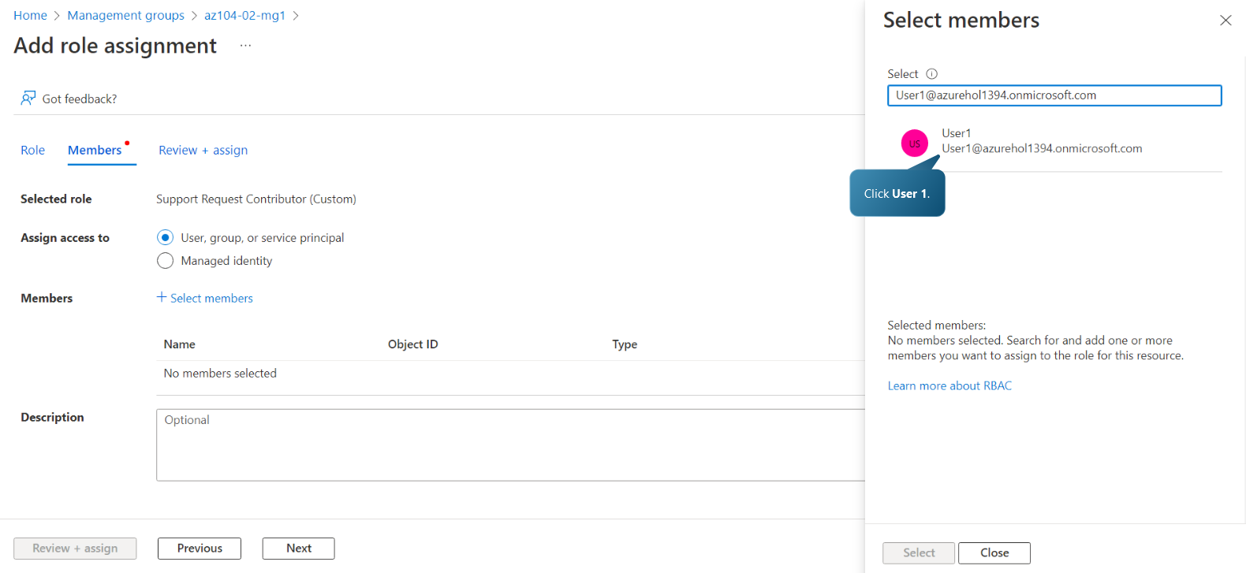

Searching for and selecting the newly created user
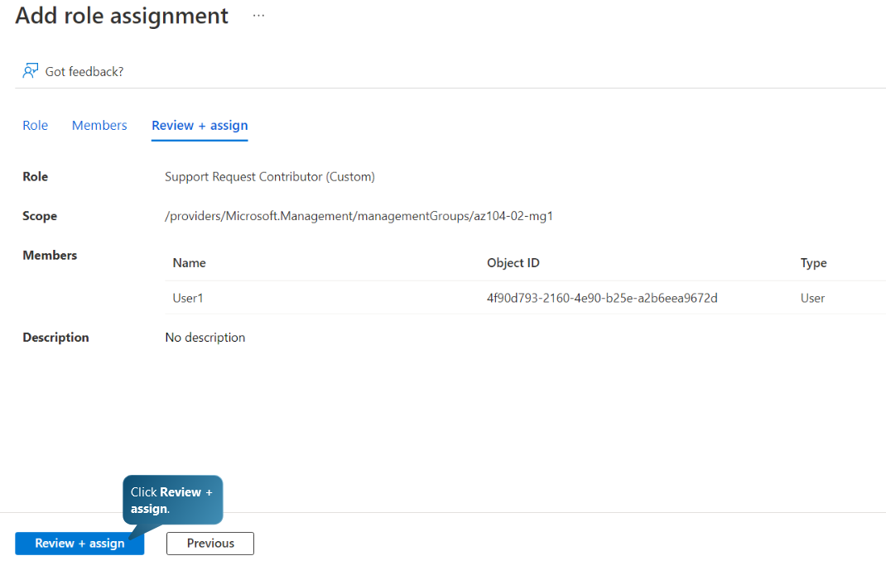
Reviewing and assigning the new role to the user account
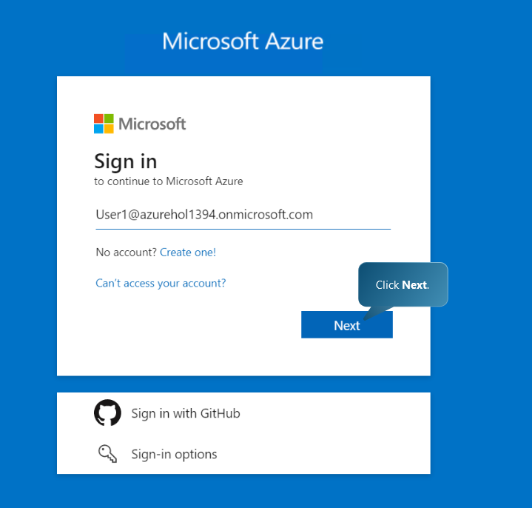
Signing into Azure Portal with the newly created principal ID
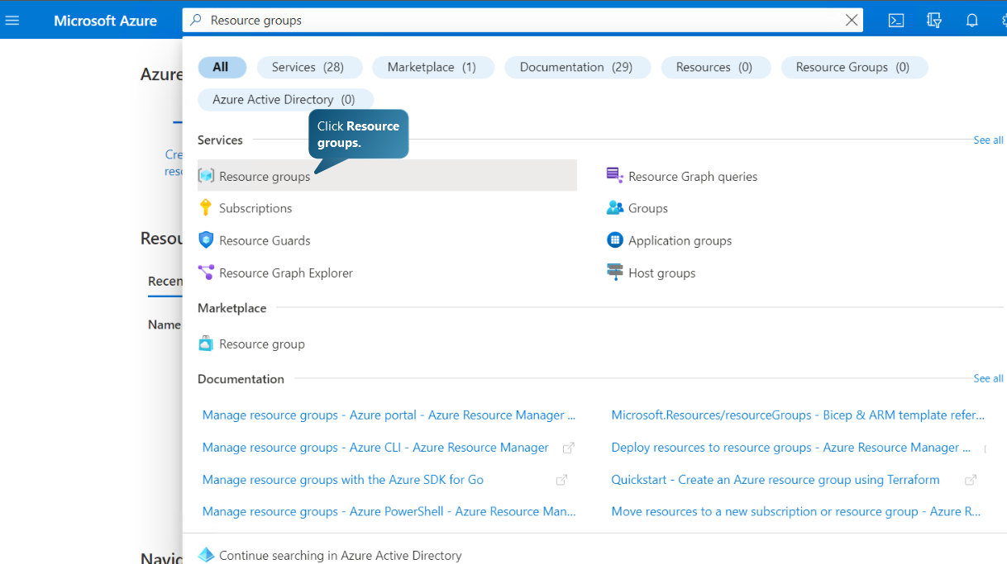

Selecting Resource Groups
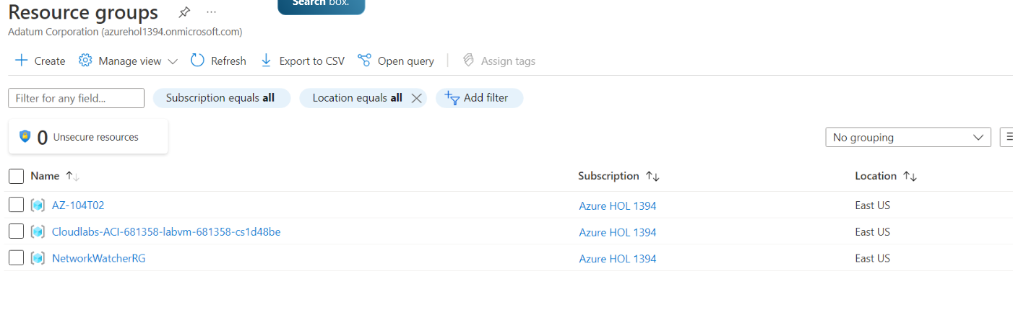
The user is able to see all Resource Groups
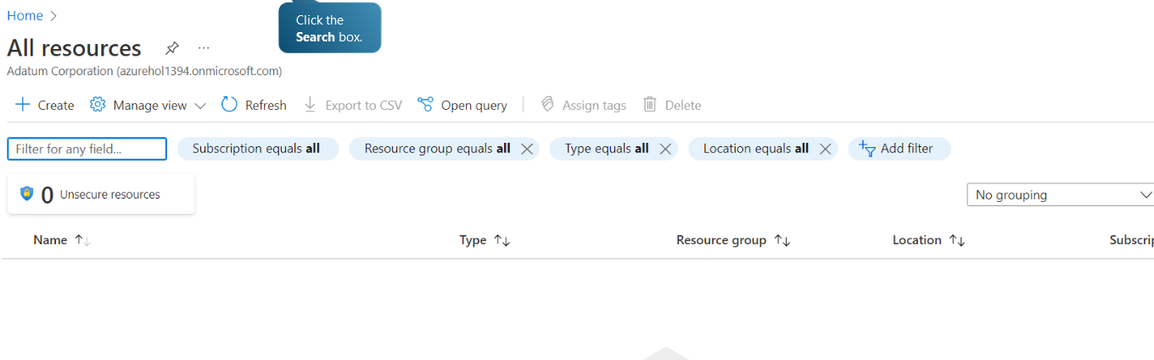
The user cannot see any Resources

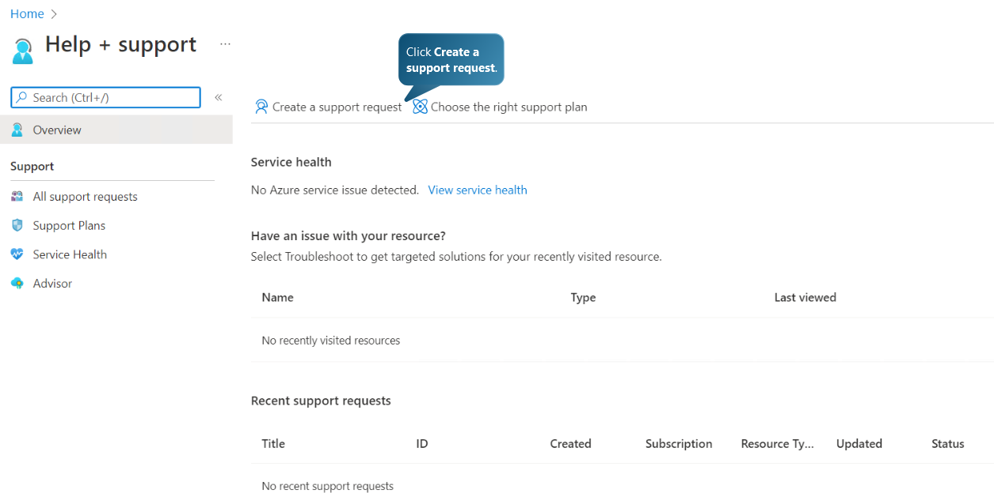
Navigating to Help + Support and selecting to Create a support request
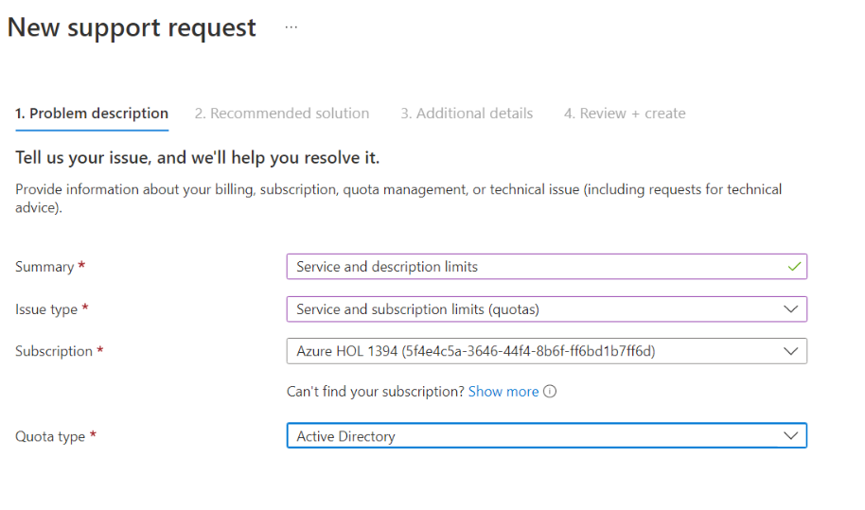
The user is able to create a Subscription specific support request

Suggest at least one policy to assist the Aspire Retailers

For security reasons, Aspire Retailers can apply a lock on Azure subscription, resource group, or resource so that they are protected against modification or deletion by accident.
Administrators can restrict a subscription, resource group, or resource to prevent accidental deletions or modifications. The safeguard supersedes any user privileges.
The administrator can establish barriers to prevent deletions or modifications. These restrictions are labelled Delete and Read-only in the portal. These restrictions are referred to in the command line as CanNotDelete and Readonly.
CanNotDelete indicates that authorised users may read and modify a resource but cannot eliminate it.
ReadOnly indicates that authorised users can view a resource but cannot modify or delete it. This restriction is analogous to restricting all authorised users to the permissions provided by the Reader role.
Management locks, unlike role-based access control (RBAC), impose a restriction to all users and roles.
When a lock is applied to a parent scope, all child resources inherit the same lock. Even additional resources inherit the same parent lock. The inheritance's most restrictive lock takes precedence.
If there is a Delete lock on a resource and there is an attempt to delete its resource group, the entire delete operation is blocked. Even if the resource group or other resources within it are released, the resource is not deleted. There is no partial deletion.
When a subscription is terminated in Azure:
- A resource restriction does not prevent cancellation of a subscription.
- Azure preserves the resources by deactivating them rather than deleting them immediately.
- Azure only irrevocably deletes the resources after a waiting period.

Task F: Disaster Recovery Plan
Disaster Recovery is a set of procedures, policies, and tools in place to assure business continuity in the event of a power outage, cyberattack, natural disaster, or infrastructure failure. Any cause of system failure can result in data loss and a negative end-user experience.
Recommended Disaster Strategy for Aspire Retailers can include the following actions:
- Identify important systems
- Determine RTO and RPO values for each system.
- Determine potential hazards to each system or system group.
- Develop a preventive measure
- Formulate a response plan
- People involvement
- Evaluate the target site or premises
- Describe the essential requirements
RPO
A recovery point objective is intended to serve as a goal The RPO is the utmost period of time that data (transactions) may be lost from an IT service as a result of a major incident. The RPO is the utmost acceptable data loss duration during a disaster. With an hourly database backup or file server application, the RPO is sixty minutes.
RTO
The recovery time objective (RTO) is the duration of time and service level within which a business process must be restored following a disaster. For instance, if the RTO is unavailable for more than 30 minutes, the application must be restored to a running state within 30 minutes of the onset of a calamity. In the event of a low RTO, we must have a toasty standby operating a DR site to prevent any outages.

Conclusion
Aspire Retailers has decided to move to the cloud due to the wide variety of benefits that the cloud platforms offer. In addition to cost of ownership reduction, the cloud services present a very convenient platform for organizations to optimize their IT processes by using the scalability and elasticity of the cloud.
As this report has shown, using the Azure cloud services has proven to be more affordable than using on-site premises for IT infrastructure. Moreover, the Azure governance (and especially the RBAC) capabilities of the cloud allow organizations to manage the users of the cloud and set boundaries of access for different roles.
Last but not least, it is important for every organization using cloud services to adopt a Disaster Recovery Strategy in case of an unexpected event.
References:
[1] Erl, T., Mahmood, Z., Puttini, R., “Cloud Computing: Concepts, Technology & Architecture”, Massachusetts, Prentice Hall, 2013, p. 74

[2] Erl, T., Mahmood, Z., Puttini, R., “Cloud Computing: Concepts, Technology & Architecture”, Massachusetts, Prentice Hall, 2013, p. 75

[3] Erl, T., Mahmood, Z., Puttini, R., “Cloud Computing: Concepts, Technology & Architecture”, Massachusetts, Prentice Hall, 2013, p. 72

[4] “What is load balancing? How load balancers work?”, Cloudflare.com, URL: https://www.cloudflare.com/en-gb/learning/performance/what-is-load-balancing/ [ Accessed on: 18/07/2023]

[5] Bai, H., “Zen of Cloud: Learning Cloud Computing by Examples”, 2nd ed., Boca Raton, FL, CRC Press, 2019, p. 49

[6] S. Carey, “AWS vs Azure vs Google Cloud: What’s the best platform for enterprise?”, Computerworld.com, URL: https://www.computerworld.com/article/3429365/aws-vs-azure-vs-google-whats-the-best-cloud-platform-for-enterprise.html , (Accessed: 20/07/2023)

[7] Kamal, M., Hafiz, R., et al., “Highlight the features of AWS, GCP, and Microsoft Azure that Have an Impact when Choosing a Cloud Service Provider”, International Journal of Recent Technology and Engineering (IJRTE), Volume-8 Issue-5, pp.4127-4128, January 2020

[8] Kamal, M., Hafiz, R., et al., “Highlight the features of AWS, GCP, and Microsoft Azure that Have an Impact when Choosing a Cloud Service Provider”, International Journal of Recent Technology and Engineering (IJRTE), Volume-8 Issue-5, pp.4127-4128, January 2020

[9] Kamal, M., Hafiz, R., et al., “Highlight the features of AWS, GCP, and Microsoft Azure that Have an Impact when Choosing a Cloud Service Provider”, International Journal of Recent Technology and Engineering (IJRTE), Volume-8 Issue-5, pp.4127-4128, January 2020

[10] Kamal, M., Hafiz, R., et al., “Highlight the features of AWS, GCP, and Microsoft Azure that Have an Impact when Choosing a Cloud Service Provider”, International Journal of Recent Technology and Engineering (IJRTE), Volume-8 Issue-5, p.4127

[11] Kamal, M., Hafiz, R., et al., “Highlight the features of AWS, GCP, and Microsoft Azure that Have an Impact when Choosing a Cloud Service Provider”, International Journal of Recent Technology and Engineering (IJRTE), Volume-8 Issue-5, p.4127

[12] “Purchase Azure Services”, Microsoft.com, URL: https://learn.microsoft.com/en-us/training/modules/plan-manage-azure-costs/4-purchase-azure-services (Accessed on: 20/07/2023)

[13] “Compare costs by using the Total Cost of Ownership Calculator”, Microsoft.com, URL: Compare costs by using the Total Cost of Ownership Calculator - Training | Microsoft Learn (Accessed on 20/07/2023)

[14] “What are the Azure Management areas?”, Microsoft.com, URL: https://learn.microsoft.com/en-us/azure/governance/azure-management (Accessed on: 18/07/2023)

[15] “Lock your resources to protect your infrastructure”, Microsoft.com, URL: https://learn.microsoft.com/en-us/azure/azure-resource-manager/management/lock-resources?tabs=json (Accessed on 18/07/2023)

Erl, T., Mahmood, Z., Puttini, R., “Cloud Computing: Concepts, Technology & Architecture”, Massachusetts, Prentice Hall, 2013, p. 74
Erl, T., Mahmood, Z., Puttini, R., “Cloud Computing: Concepts, Technology & Architecture”, Massachusetts, Prentice Hall, 2013, p. 75
Erl, T., Mahmood, Z., Puttini, R., “Cloud Computing: Concepts, Technology & Architecture”, Massachusetts, Prentice Hall, 2013, p. 72
“What is load balancing? How load balancers work?”, Cloudflare.com, URL: https://www.cloudflare.com/en-gb/learning/performance/what-is-load-balancing/ [ Accessed on: 18/07/2023]
Bai, H., “Zen of Cloud: Learning Cloud Computing by Examples”, 2nd ed., Boca Raton, FL,CRC Press, 2019, p. 49
S. Carey, “AWS vs Azure vs Google Cloud: What’s the best platform for enterprise?”, Computerworld.com, URL: https://www.computerworld.com/article/3429365/aws-vs-azure-vs-google-whats-the-best-cloud-platform-for-enterprise.html , (Accessed: 20/07/2023)
Kamal, M., Hafiz, R., et al., “Highlight the features of AWS, GCP, and Microsoft Azure that Have an Impact when Choosing a Cloud Service Provider”, International Journal of Recent Technology and Engineering (IJRTE), Volume-8 Issue-5, pp.4127-4128, January 2020
Kamal, M., Hafiz, R., et al., “Highlight the features of AWS, GCP, and Microsoft Azure that Have an Impact when Choosing a Cloud Service Provider”, International Journal of Recent Technology and Engineering (IJRTE), Volume-8 Issue-5, pp.4127-4128, January 2020
Kamal, M., Hafiz, R., et al., “Highlight the features of AWS, GCP, and Microsoft Azure that Have an Impact when Choosing a Cloud Service Provider”, International Journal of Recent Technology and Engineering (IJRTE), Volume-8 Issue-5, pp.4127-4128, January 2020
Kamal, M., Hafiz, R., et al., “Highlight the features of AWS, GCP, and Microsoft Azure that Have an Impact when Choosing a Cloud Service Provider”, International Journal of Recent Technology and Engineering (IJRTE), Volume-8 Issue-5, p.4127
Kamal, M., Hafiz, R., et al., “Highlight the features of AWS, GCP, and Microsoft Azure that Have an Impact when Choosing a Cloud Service Provider”, International Journal of Recent Technology and Engineering (IJRTE), Volume-8 Issue-5, p.4127
“Purchase Azure Services”, Microsoft.com, URL: https://learn.microsoft.com/en-us/training/modules/plan-manage-azure-costs/4-purchase-azure-services (Accessed on: 20/07/2023)
“Compare costs by using the Total Cost of Ownership Calculator”, Microsoft.com, URL: Compare costs by using the Total Cost of Ownership Calculator - Training | Microsoft Learn (Accessed on 20/07/2023)
“What are the Azure Management areas?”, Microsoft.com, URL: https://learn.microsoft.com/en-us/azure/governance/azure-management (Accessed on: 18/07/2023)
“Lock your resources to protect your infrastructure”, Microsoft.com, URL: https://learn.microsoft.com/en-us/azure/azure-resource-manager/management/lock-resources?tabs=json (Accessed on 18/07/2023)

