The Levels of Sensation Seeking and the Tempo of Music Effects on Time Perception

Robyn Trubey (1708724)

The study was conducted to investigate the effects of the levels of sensation seeking and the tempo of music can have on an individual’s perception of time. Participants completed a sensation seeking questionnaire and a time perception task whilst listening to either a slow or fast tempo of music, or no music. A visual stimuli (pink oval) was displayed for either 400, 800, 1000, 1200, or 1600 millisecond intervals. Participants were required to press keys in relation to whether they thought the stimuli appeared for a long or short period of time. The study demonstrated the results to be non-significant, with the interaction effect between sensation seeking and the tempo of music was shown to be f (2, 54) = .306, p = .737. Therefore, the findings gathered from the study were inconsistent with similar perception of duration studies; which suggested emotional factors play a role in an individual’s perception of time.

Introduction
In recent years, levels of sensation seeking and the tempo of music have been suggested to effect an individual’s perception of time. Despite a number of studies considering how emotional factors have a part to play in human cognitive activity, there is a limited amount of research conducted into how various levels of sensation seeking and the tempo of music can impact an individual’s perception of time. There are numerous factors which can be seen to affect how a person can perceive duration periods, such as the levels of attention and amount of information processing. It has been proposed that when an individual engages in a time judgement task, the attentional resources that are now assigned to the said stimulus are withdrawn from the attentional resources a person would typically dedicate to their perception of time. Furthermore, when an intriguing or demanding stimulus is presented during the time judgement task, a smaller number of time units are processed, meaning a person is likely to underestimate the period of time. A study conducted by Angrilli, Cherubini, Pavese and Manfredini (1997) investigated the effects of emotional stimuli on time perception through implementing psychophysiological measures. In this study, photographic slides that had been rated for emotional valence and arousal were put in front of two groups of participants for either two, four or six seconds. The results demonstrated that in all conditions, significant valence and arousal interaction affected a person’s time perception; causing the amount of time to be greatly underestimated. A further study was conducted to investigate an individual’s perception of the duration of emotional events. In this instance, participants were trained on a temporal bisection task, where a visual stimuli (pink oval) was displayed for either 400 or 1600 milliseconds at a time, which were to be considered to be either long or short intervals. Participants were presented with comparison time intervals between 400 or 600 milliseconds, represented by faces exhibiting either feelings of anger, happiness or sadness, alongside a neutral facial expression. The results gathered from the study demonstrated that the duration of either one of the three of the emotional facial expressions were typically overestimated, in comparison to the neutral face (Droit-Volet, Brunot & Niedenthal, 2004). This study aims to identify the effects that fast or slow tempos of music and levels of sensation seeking can have on a person’s perception of time. The proposed hypothesis for this research suggest that high levels of sensation seeking, alongside a high tempo of music will cause an individual to overestimate a period of time.

Method
Participants
Participants were 60 (33 men and 27 women) students studying at the University of Wales Trinity Saint David. The age of participants’ ranged between 18 and 55 (M = 25.83, SD = 10.21). Participants were recruited at random whilst at the university; they were asked to take part on an entirely voluntary basis.

Design
The study was of a between-subjects, multifactorial design. The study involved two independent variables; sensation seeking and the tempo of music. Levels of sensation seeking were categorised into two groups of either high or low, through the use of a paper-based sensation seeking questionnaire where participants responded using a five-point Likert scale. The tempo of music was equally divided into three separate groups, which involved a fast tempo, a slow tempo and a silence group. The dependent variable was time perception. This was measured using a computer-based task where participants were required to press keys, to determine whether they thought the stimulus had appeared for either a short or long period of time. In order to demonstrate the results, a 2 x 3 between-subjects ANOVA was used for analysis purposes.

Materials
For the explicit measures of sensation seeking, participants responded to a Brief Sensation Seeking Questionnaire (BSSS) (Hoyle, et al. 2002) using a five-point Likert scale, from one = ‘strongly disagree’ to five = ‘strongly agree’ (see Appendix A). The questionnaire consisted of eight statements such as “I would like to explore strange places” and “I like wild parties”, which required a response from participants. A reliability analysis was conducted to determine the reliability of the BSSS, where the Cronbach’s Alpha presented a value of .68. With only values of seven or above considered adequate, this value demonstrated the questionnaire used in this study was unreliable.
SuperLab software was used to create a time perception experiment, where participants were provided with instructions on to successfully partake. A practice trial was included at the beginning, to introduce the pink oval (see Appendix B) for 400 and 1600 millisecond intervals. Both intervals were each displayed five times, alternating between the long and short period. During the experimental phase, the pink oval was displayed for either 400, 800, 1000, 1200, or 1600 millisecond intervals. The timed displays were randomised, with 22 displays in total. The 1000 millisecond display was presented a total of 10 times, which was used to measure whether participants either underestimated or overestimated time. Between displaying the pink oval for timed intervals, participants were presented with a black fixation cross and then a blank screen, before again displaying the pink oval. During the experiment, two pieces of music were used to address the effects of fast and slow tempos. After completing the BSSS, participants were required to wear a set of headphones to listen to the music. Participants were equally divided into three groups; one group listened to the fast tempo of music, one listened to the slow tempo, and a third group remained in silence. The song ‘Lost Without You’ by Freya Ridings was used for the slow tempo of music, which is 150 BPM. Alternatively, a song named ‘The Dog Days Are Over’ by Florence and The Machine was used for the fast tempo of music, which was 162 BPM.

Procedure
Firstly, it was essential to gain ethical approval which required completing a form about the ethical issues the study may encounter. Participants were then recruited through personally asking students to take part. They were asked at random at the university on an entirely voluntary basis. On agreement, participants were escorted to the psychology labs where they were provided with a consent form (see Appendix C) to read. If after reading the consent form they were willing to participate, they were asked to provide a signature. Participants were then required to complete a paper-based BSSS, where they responded to statements using a five-point Likert scale. On completion, the researcher collected the questionnaire and set the computer ready for the second part of the study. Participants were instructed to put their headphones on and begin the time perception task on the computer. Participants were required to press keys in relation to whether they thought the pink oval was displayed for either a long or short period of time. Once they had finished, participants were provided with a debrief form (see Appendix D). The debrief form explained the key objectives of the study, whilst providing participants with the opportunity to withdraw their data if desired.

Results
The study intended to measure how the tempo of music and sensation seeking can effect an individual’s perception of time. The mean score of sensation seeking is 28.1 and has a standard deviation of 4.96. Likewise, the mean score of time perception is 3.2, with a standard deviation of 3.5. The main effect of the tempo of music shows to be signification f (2,54) = 2.15, p = .126. The main effect of high and low tempos of music shows to be significant f (1, 54) = .242, p = .625. The interaction effect between sensation seeking and the tempo of music was shown to be non-significant f (2,54) = .306, p = .737 (see Appendix E). Therefore, the results gathered from the study reject the hypothesis which is stated above, as they state to be non-significant.

Discussion
In this instance, the hypothesis must be rejected as the results were found to be non-significant. The findings gathered from this study suggest that high levels of sensation seeking, along with a fast tempo of music have no effect on a person’s perception of time. With pervious research suggesting that emotional stimuli can effect a person’s perception of time, levels of arousal have been found to effect a person’s perception of time. One limitation of this study would be the choice of music. When choosing the music, a greater deal of attention should have been paid to the beats per minute (BPM) for each song. In this instance, the BPM for the song used to address the fast tempo of music was only 12 BPMs more than the song used for the slow tempo. In order to produce more exclusive results between a slow and fast tempo of music, the BPM should have been widely ranged between the two song choices. Therefore, a more diverse tempo should have been chosen. Another limitation of the study would be the individual’s emotional response to the song that was played. If the song brought about negative connotations for a person, they may have responded differently. However, if an individual obtained positive feelings about the song in question, they too could have responded differently. As emotional factors has been suggested to impact a person’s perception of time, this could have been a factor which influenced responses in this study. If this study was to be conducted again, it would be vital to take more consideration into choosing the mood and tempo of the music used to address this variables.
Reference List

Angrilli, A., Cherubini, P., Pavese, A., & Manfredini, S. (1997). The influence of affective factors on time perception. Perception & psychophysics, 59(6), 972-982.

Droit‐Volet, S., Brunot, S., & Niedenthal, P. (2004). BRIEF REPORT Perception of the duration of emotional events. Cognition and Emotion, 18(6), 849-858.

Hoyle, R. H., Stephenson, M. T., Palmgreen, P., Lorch, E. P., & Donohew, R. L. (2002). Reliability and validity of a brief measure of sensation seeking. Personality and individual differences, 32(3), 401-414.

Appendix
- Brief Sensation Seeking Scale Questionnaire (BSSS)
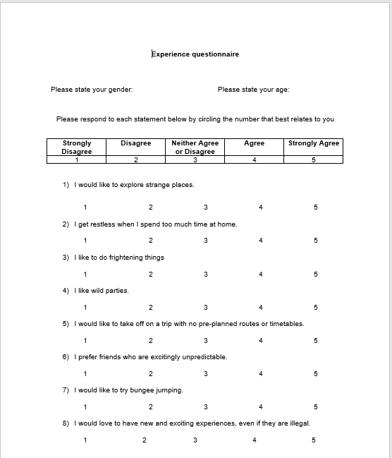

- Pink oval.
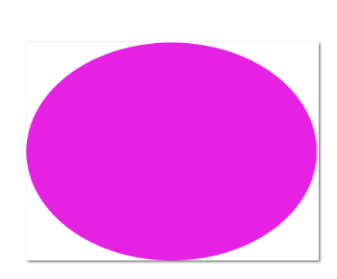

- Consent form.
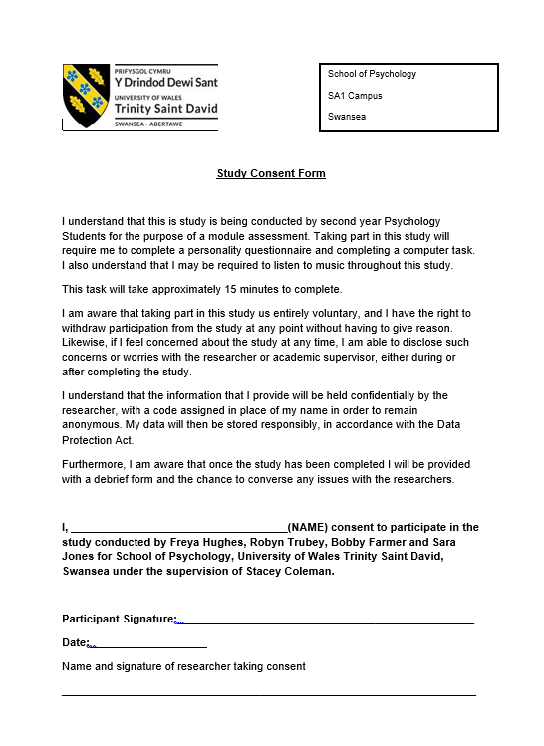

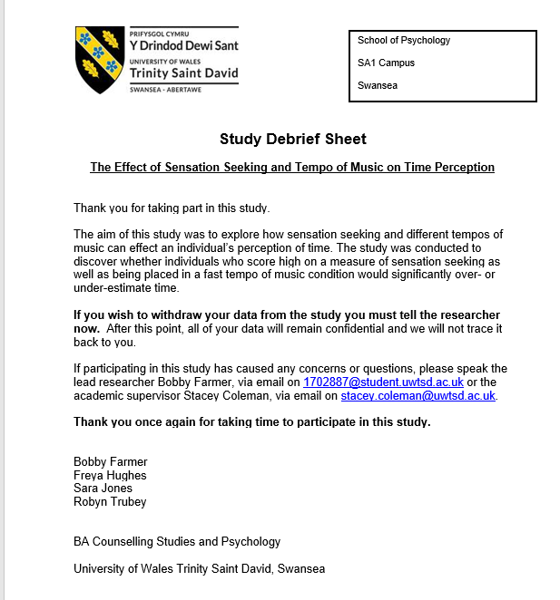
- Debrief form.

- SPSS results.


