Enterprising and Creative Teaching and Learning
The aim of this paper is to identify what teaching creatively and teaching for creativity is and why it is important to education. Additionally, it critically assesses my enterprise and creativity skills using the Entrecomp Framework and how I can develop learner’s enterprise and creative skills using divergent thinking.
There are many definitions of creativity. Medina (2012) believes there is no definition for creativity as it is different for everyone. This is supported by N.A.C.C.E (1999, pg. 6) who says, “All people have creative abilities and we all have them differently”. Martin & Wilson (2017) and Simonton (2018) suggest that creativity is defined by accessing someone’s idea based on a chosen criterion, usually originality and value. In 2011, assessment of creativity was created by the Centre for Real-World Learning (CRL) designing a five-dimensional model to assess creativity, including: Imaginative, Persistence, Discipline, Collaborative, and Inquisitive (Spencer, Lucas & Claxton, 2012). Torrence (1968, cited in Tuğrul et al., 2014), Bruce (2011), Robinson (2015) and Marlow et al (2018) believe creativity is creating original and new ideas. However, Götz (1981) portrayed the idea that to be creative does not mean creating something completely new. In 1971, Bob Eberle created a technique called “SCAMPER” which is based on the idea that nothing is new it is just a modification of existing things (Elmansy, 2015, pg.1). Although this information was found a lot earlier, it is still a popular method for developing creativity in learners today (Elmansy, 2015). This information suggests that no ideas are completely new, so we should not assess someone’s creativity based on the originality of the idea. However, it could be argued that adapting an idea into something else can make it an original idea. Education Scotland (2013, pg.3) define creativity as
“Creativity is a process which generates ideas that have value to the individual. It involves looking at familiar things with a fresh eye, examining problems with an open mind, making connections, learning from mistakes, and using imagination to explore new possibilities.”
This definition suggests that creativity is individual and using your imagination to create new ideas based on adapting old ideas. The writer believes creativity is preparing children to recognise opportunities and use their imagination to generate new ideas that add value.
Brant & Wales (2009) suggest there are two types of enterprise education; one is entrepreneurship and preparing children to start a business, and the other is to develop children’s ability to take initiative in any situation. For the purpose of this paper we will be focusing on the second definition. Quality Assurance Agency (2012) believe enterprise education is providing pupils with the mindset and skills to create original ideas. So, creativity and enterprise education together are the process of developing pupils to be able to identify opportunities, generate ideas, and prepare them with the skills to create something original.
There are two types of enterprising and creative teaching in education: teaching for creativity and teaching creatively (N.A.C.C.C.E, 1999). Brickman (2010) and N.A.C.C.E (1999) suggest that teaching creatively is to use imaginative approaches that makes learning more exciting and engages the pupils’ interest. Engaging the learners in lessons can improve their achievement (Nagro, Fraser & Hooks, 2019) having overall benefits for the students, teachers, and school. Teaching creatively is something that can be down in all lessons, yet many teachers keep creative teaching for the art, music, and drama lessons (Lucas, Claxton & Spencer, 2013). This could be due to the lack of knowledge and pedagogy to teach creatively (Cremin et al., 2018). The EntreComp Framework (Bacigalupo et al., 2016, pg. 7) has been designed to help individuals identify their level of creativity and enterprise skills and what they can do to improve them; it has “3 competence areas, 15 competences, 60 threads, an 8-level progression model and 442 learning outcomes”. The 3 competence areas are: Ideas and Opportunities, Resources and Into Action. Within the Ideas and Opportunities competence area is the competency “creativity” which can be a useful tool for teachers to assess their level of creativity. However, the framework does not only assess creativity and enterprise skills but also entrepreneurial skills, so teachers must keep in mind that some of the framework might be not be applicable to education. Another limitation to the framework is that there are not always clear progression steps on how to improve to the next level. It jumps from one idea to another, sometimes not having a gradual progression of one idea; this can make it difficult to assess what level you are at. But it does highlight the skills you need to develop creativity which can be a good start at identifying what you need to do to improve your own creativity skills. The following part discusses my own evaluation of enterprising and creative skills using the EntreComp Framework.
Within the competency “creativity” are five threads which include: “Be curious and open”, “Develop ideas”, “Define problems”, “Design value” and “Be innovative” (Bacigalupo et al., 2016, pg.24). It could be argued that there are other qualities to creativity as Lucas, Spencer, and Claxton (2013, pg.16) believe the 5 qualities to a creative person are “inquisitive, persistent, imaginative, collaborative and disciplined”. Being persistent is an important element to any project as it allows for the person to keep going and not give up when things go wrong. Persistence is a habit of mind (Teach Thought, 2019) which has been created from what successful people believe are qualities you need to be successful. Although Lucas, Spencer, and Claxton (2013) believed persistence is a quality needed for a creative person, the EntreComp framework (Bacigalupo et al., 2016) has placed persistence under motivation and perseverance in the resources area. Persistence is a quality you need throughout ever task or challenge you face, not just when you are being creative, so it could be believed that the EntreComp framework has placed persistence correctly.
Be curious and open
To develop children’s creativity and enterprise skills, teachers should be creating an environment that encourages children’s curiosity as Dewey (1952, cited in Pound, 2014) believed that children learn through curiosity. Improving pupil engagement improves achievement which can be achieved by encouraging children’s curiosity through using stimulating lesson starters as suggested by Estyn (2018) and Piaget (1980, cited in Pound, 2014). Blaengwawr Primary School (Estyn, 2017, pg.1) use “wow starters” to plan engaging lesson hooks and activities to excite and inspire all their learners. This has resulted in many benefits such as more pupils achieving outcome 6 and nearly all learners having a positive attitude to their learning. When on teaching practice, I would always try to start a new topic with an exciting lesson starter to grab the children’s interests which often kept their engagement and wanting to find out more. I would always look for new ideas to start the lesson with so I would evaluate myself as being at level 1 on the EntreComp framework (See appendix 1a for a lesson observation). This is linked with the competency Motivation and perseverance, in the resources area, under the thread “Stay driven” (Bacigalupo et al., 2016, pg.28) which is being motivated by the idea of creating value for myself and others. I believe I am motivated by the idea of creating value for others as I am always looking for a new exciting and engaging ways to engage the learners; therefore, I would assess myself as being at level 2 for this thread (appendix 1b).
On the other hand, it could be argued that children learn best by following their own interests as suggested by Barnes (2015) and Dewey (1952, cited in Pound, 2014). Additionally, Estyn (2018) and Liberto (2016) believe that child-led learning is effective. Ynystawe are a primary school that have child-led learning at the heart which provide excellent learning experiences for their learners (Estyn, 2014). Additionally, Estyn (2019) are now assessing schools based on pupil voice so pupils following their own interests and leading their learning could be the next step for effective learning.
Fostering curiosity and engagement is an effective way for enterprise and creative teaching. To reach level 2 on the EntreComp framework I must “explore new ways to make use of existing products” (Bacigalupo et al., 2016, pg.24). So, I will do this by using the classroom in different ways by overcoming functional fixedness. Functional fixedness is the inability to see an object work in any other way than what it was created to do (Cherry, 2019). Mccaffrey (2012) and Camarda et al (2018) suggests that functional fixedness inhibits problem solving. To overcome functional fixedness, I will use objects in the classroom environment for something other than their intended use to teach in a more creative way and improve my enterprising and creative teaching pedagogy.
Develop ideas
When on teaching practice, I worked alone and closely with the class teacher to generate lesson ideas that were engaging and exciting for the learners to learn. Beirne & Velsor (2012) indicate children and teachers should be working together to engage the pupils with the learning process. Pupil voice is becoming more prominent in planning (Barnes, 2015) due to the United Nations Conventions on the Rights of the Child (Unicef, 1992). Additionally, Estyn (2016) suggests that pupil voice benefits pupils. Every two weeks we would change the enhanced provision and use pupil voice to assist with our planning. This allows pupils to have a choice and engage with their learning. Therefore, I would assess myself as being at level 2 on the EntreComp framework as I have demonstrated working alone and as part of a team to develop ideas. Appendix 1c is a mind map of planning that was done with the children when planning the enhanced provision for the following week.
However, when the children were thinking of ideas many would suggest the same ideas they had already done as they did not have the vocabulary or experiences to think of something new. It is the Welsh Governments (2019) priority to reduce the attainment gap and raise standards in Literacy. Although pupil voice is an effective strategy to use in schools, it will take time for some children to have the experience and vocabulary to effectively offer ideas they want to do. Piaget (1980, cited in Pound, 2014) believed learning happens when knowledge and ideas occur from an experience. So, teachers should be proving pupils with enriched experiences, so they are able to improve their vocabulary and ideas.
To foster enterprise and creative learning it is important to develop effective ideas that the learners have been involved in. To reach level 3 I must “use available resources in an effective way” (Bacigalupo et al., 2016, pg.24). I will reach this target by overcoming functional fixedness as discussed above.
Define problems
It is important to be reflective on your practice to identify what you have done well and what you will improve in the future. Hargreaves & Page (2013) suggest that reflective practice can help professionals to develop and evaluate their own practice as supported by Schon (1983, cited in Roffey-Barentsen & Malthouse, 2017). Estyn (2018) suggest that the best schools encourage teachers to reflect on their practice to improve pupils progress. When on teaching practice, I often tried lesson ideas that did not go how I had planned them too. Each day I would fill out a reflection on my practice and identify multiple solutions on how I can improve in the future. See appendix 1d for an example. Therefore, I would evaluate myself as being at level 2 on the EntreComp framework as I have demonstrated the ability to generate multiple solutions to a problem.
In contrast teachers time is limited, and it can sometimes be difficult to find the time to reflect on your practice as Horng (2010, cited in Khalil, 2016) suggests that time management is an important element for teachers to be effective. This reflects one of my first targets on placement to be more effective with my time management as seen in appendix 1e. Once I achieved this target I found better uses of my time and my performance increased.
Being able to reflect is an important skill needed in enterprise and creative teaching. To reach level 3 on the EntreComp framework I must “take part in group dynamics” (Bacigalupo et al., 2016, pg.24). I will do this by working in collaboration with others. Working in collaboration is one of the professional teaching standards (Welsh Government, 2019a) and sharing good practice is something that most schools are now doing (Estyn, 2015). I will achieve this by working closely with other class teachers and including outside schools and agencies where appropriate.
Design value
I would often use objects to support learning in my lessons. Haylock & Cockburn (2008) suggests that children learn mathematics by using the connections model to understand and make connections. In this model, children connect concrete objects with symbols, language, and pictures to understand the concept. It could be argued that this model also works for other areas of learning as Piaget (1980, cited in Pound, 2014) and Dewey (1952, cited in Pound, 2014) believe children learn by doing and making connections. On teaching practice, I would often have resources available to support the learning which can be seen in a lesson observation in appendix 1f. As I would often use objects in my lessons, I would evaluate myself as being at level 1 on the EntreComp framework.
However, Dewey (1943, cited in Pound, 2014) championed the multiple intelligence theory which suggested that everyone learns in different ways. This suggests that the same lesson would not suit all learners as Piaget (1980, cited in Pound, 2014) suggested that children learn by doing. This reflects one of my targets from PTE to use more practical activities to support learners instead of allowing them to do work with support from concrete objects which can be seen in appendix 1g.
To reach level 2 I must “improve existing products” (Bacigalupo et al., 2016, pg.24). I will do this by using the SCAMPER method as mentioned previously to adapt existing products and make better use of them to support the learning in the classroom. SCAMPER is a mnemonic for Substitute, Combine, Adapt, Modify, put to other purposes, Eliminate and Rearrange/reverse (Frey, 2017). You use this method by identifying an existing product and then using the SCAMPER technique to change it into something different. I will include this strategy in my lessons to improve my own creative teaching but also to improve the children’s imagination to create original ideas.
Be innovative
Donaldson (2015), Wright, Staggs & West (2012) and Johnson (2010, cited in Convert, 2011) portray the idea that innovation is a process of discovery and an important skill we should be developing in children. During a science lesson about electricity in Key Stage 2 we were discussing renewable energy and the importance of it to the environment. The learners were aware of solar panels, but few knew exactly what they were for and how they have been a useful tool to society, so we did some research on them (see appendix 1h for the lesson plan). This allowed children to see how a new innovative project has benefited society and hopefully foster their own curiosity to develop their own ideas to help the environment. So, I would assess myself at level 2 on the EntreComp framework. The following levels are more from an entrepreneurial point of view by identifying innovative products. Although the next levels are not applicable to education it is important to develop innovation skills in learners to prepare them for the 21st century. Additionally, it is a professional standard to the teacher provides an innovation outlook on education (Welsh Government, 2019a). However, Lucas, Claxton & Spencer (2013), Foray & Raffo (2014) and Looney (2009) suggest allowing for innovation in education can be difficult as it is not something that can easily be assessed. Despite this, many schools are making great efforts to adopt an ethos in school that fosters change and innovation in learners (Estyn, 2018). I will ensure to create a learning environment that promotes innovation and change for my learners in the classroom to equip them for the future.
Within the into action area under the competency learning through experience is the thread “learn from experience” (Bacigalupo et al., 2016, pg. 35) which is about reflecting on your ideas and learning from it. As previously discussed, I always reflect on my practice and look for ways to improve. I always reflect on interactions with my mentors and take on board the feedback they give me which can be seen in my observation in appendix I. Therefore, I would evaluate myself at level 4. To improve I must include lifelong learning into my personal development strategy. I will do this by improving on the feedback given and include it into my learning passport and continue my professional development (Education Wales, 2019a).
To sum up, teaching creatively can improve child engagement which could lead to an increase in their achievements. As it is suggested that creative teaching is not something that happens in all lessons, teachers should increase their understanding of effective pedagogy strategies to ensure they are teaching children effectively to allow them to become enterprising and creative individuals which is supported by Donaldson (2015) four purposes of the new curriculum. The EntreComp framework (Bacigalupo et al., 2016) can be a useful tool for teachers to start assessing their own levels of enterprise and creative skills to begin to improve their own practice which is a professional teaching standard (Education Wales, 2019a).
N.A.C.C.C.E (1999) believe that teaching for creativity is teaching that develops children’s own creative thinking. Meyer (2012, pg.54) suggests teaching for creativity can be done in any lesson by adapting it to develop creativity in learners and doing so “students improve critical-thinking skills, motivation, and engagement”. Enterprising and creative skills should be developed in learners to prepare them for the 21st century. Donaldson (2015) suggests that creativity and enterprise skills are skills needed for modern life and should be developed throughout school. Soffel (2016), Applied Educational Systems (2019), Trilling & Fadel (2009), Nesta (2018) and World Economic Forum (2016) believe creativity is a skill needed for the 21st century. This is because we are preparing children for jobs that do not exist yet (Trilling and Fadel, 2009). However, in the current curriculum, creativity is not seen as important as other subjects. Donaldson (2015) suggests that creative culture in school has been diminished as schools focus on Literacy and Numeracy and preparing for tests and qualifications. As observed on teaching practice, English and Mathematics are taught every day with other subjects being taught once a week. In the Foundation Phase Curriculum (Education Wales, 2015) the Creative Development area of learning sits at the end of the framework with very few skills compared to Language, Literacy and Communication and Mathematical Development. Additionally, there is a non-statutory Skills Framework (Welsh Government, 2008, pg.10) which has creativity imbedded within the “Developing Thinking” section. Therefore, it is suggested that the current curriculum is not balanced and does not provide enough opportunities to develop children’s creativity even though it is deemed by many as an important skill needed for the 21st Century. The Draft Curriculum for Wales 2022 (Education Wales, 2019, pg.1) has made a greater effort to provide more opportunities to develop children’s creativity and enterprise skills as reflected in one of the four purposes “Enterprise, Creative, Contributors”.
Heindel & Furlong (2000, cited in Lucas, Claxon & Spencer, 2013) suggest that Torrence believed creativity is a skill we can teach to children, however Csikszentmihalyi disagreed and believed creativity is something that can be produced through an encouraging environment. The writer believes that both these statements are true; with an encouraging learning environment and an awareness of appropriate methods enterprising and creativity can be taught and developed in learners. Robinson (2015) suggests that schools are killing creativity which can be supported by research from Land & Jarman (1993) showing that as children get older many of them become less creative. However, the Dorsolateral Prefrontal Cortex part of the brain develops in later life and can stop creative thinking (Peña et al., 2019) but with improvisation it stops that part of the brain from working. Therefore, it could be suggested that people lose their creativity due to this part of the brain developing not because of the way schools are teaching. To overcome this, teachers should allow more time for children to improvise which can be done through a learning environment that encourages them to do so. Robinson (2015) and Bruce (2011) suggest that a teacher’s job is to create an environment that inspires and engages children to want to learn. Smidt (2013) and Bruce (2011) believe that children are engaged in their learning when they are learning through play which is also supported by Piaget, Vygotsky, and Bruner (cited in Pound, 2014). Donaldson (2015) suggests that the Foundation Phase (FP) philosophy is a strength to the current education practice and in the FP, children learn a lot through play. During play children do a lot of improvisation, especially in the role play areas. As the Draft Curriculum for Wales 2022 (Education Wales, 2019) comes into action, schools should all be adopting more of the Foundation Phase philosophy and allow children to learn more through play which will hopefully improve their creative abilities in later life.
Alongside an appropriate learning environment, a solution to develop teaching for creativity is to allow more time for divergent thinking. Guilford (1967, cited in Cayirdag & Acar, 2010) championed divergent thinking as an important element to creativity as it is the ability to generate multiple ideas to a scenario or problem. It is a strategy used when problem solving (Webb et al., 2017). When we defined enterprising and creativity above, the ability to generate many ideas was part of it. So, we should be allowing children to the opportunity to generate ideas supported by Penaluna (2018), N.A.C.C.E (1999) and Donaldson (2015). Bergland (2015) suggests that stimulating alpha brain waves can boost creativity and idea generation; Your brain is stimulating alpha brain waves when it is in a relaxed state such as in the shower or when you are in bed. However, Idea Sandbox (unknown) suggest you may not always think of ideas every time your brain is in this state. In contrast, Oppezzo and Schwartz (2014) conducted four experiments that shown walking can boost creativity and generating ideas. OKGO are a band who are well known for their creative music videos (TED, 2017) and they champion going out and finding ideas rather than waiting for an idea to come to you. These should be kept in mind and incorporated within your teaching. Regular breaks and a walk before generating ideas could improves idea generation.
However, if we just used divergent thinking, we would never reach one solution to our scenario or problem (Webb et al., 2017). This is why convergent thinking is also important when using divergent thinking as Gilford (1967, cited in Japardi, et al., 2018) suggests that convergent thinking is bringing together all the ideas generated to find the single best solution to the problem. Japardi, et al. (2018) and Martin (2015) believe that both divergent and convergent thinking are important processes for enterprising and creative thinking as (Heilman, 2016) and Martin (2015) suggest that neither convergent nor divergent thinking can exist without the other. To sum up, divergent thinking is an important element to develop in children to think creatively however, if we just encourage children to be divergent thinkers they will never reach a solution; thus it is equally as important to allow children to think convergently after divergent thinking has taken place.
There are 8 elements to divergent thinking (Martin, 2015) which are: Complexity, Curiosity, Flexibility, Fluency, Risk-taking, Elaboration, Imagination, and Originality. Having an awareness of the 8 elements to divergent thinking could suggest that you can teach them to children. However, it could be argued that not all of these elements can be taught to children as Torrence (1968, cited in Tuğrul et al., 2014) believed there are 4 elements to creativity which you can assess children on and these are: Fluency, Flexibility, Elaboration, and Originality. This leaves Complexity, Curiosity, Risk-taking and Imagination. As previously suggested above, enterprise and creativity can be developed in children through direct teaching methods and an appropriate learning environment. Therefore, it can be suggested that the other elements to divergent thinking can be developed in children through a learning environment that encourages them to be curious, take risks, use their imagination, and develop their complexity; this can be done through planning appropriate enhanced provisions for the children to explore (Bruce, 2011).
Assessing children’s ability on fluency, flexibility, elaboration, and originality means we can teach these skills to children and help them to improve using assessment for learning strategies (Black & Wiliam, 1998). The following part discusses how I will develop these 4 elements within the classroom.
Black & Wiliam (1998) champion assessment for learning which assesses where a child is at, what they need to do to improve, and gives instant feedback of how they can get there. So, to begin the children will have a test to assess where they are for their enterprising and creative skills. Guilford (1967, cited in Heilman, 2016) created the Alternative uses test to test children’s ability to be divergent thinkers. This involves having an object and finding as many different uses possible for that object within 3 minutes. Thus, the children will be presented with an object, the teacher will use a brick in this example, and they will have to think of as many different uses for the brick that they can. Prior to starting the test, the children will be taken for a 5-minute walk as suggested above that walking can help generate ideas, therefore can stimulate divergent thinking.
The following weeks will involve a series of lessons which will improve children’s fluency, flexibility, elaboration, and originality skills. A constructive approach to learning supported by Piaget (1980, cited in Pound, 2014), Vygotsky (1934, cited in Pound, 2014) and Bruner (1915, cited in Pound, 2014) is to learn by doing and building on knowledge based on previous knowledge they already have and making connections between them. However, the Behaviourist theory to learning supported by Skinner (--) believed that children learn behaviours through modelling and rewarding and sanctioning good and bad behaviours. The writer believes that to develop enterprising and creativity should be done through a constructivist learning approach, so children have a deeper understanding of what they are learning. Pink (2011) suggests that having incentives for children to be creative can inhibit their ability to be creative. Therefore, it could be argued that the Behaviourist approach to learning would not work to develop enterprising and creative skills.
Fluency is being able to think of as many ideas as possible (Martin, 2015) so to develop children’s fluency the children will continue to practice the game how many uses for a … as discussed previously.
Flexibility is looking at categories and thinking of many ideas relating to the same thing (Martin, 2015). The children will develop this by looking at their mind map of different ideas and try to identify any categories to things; they will then think of even more ideas relating to those categories.
Elaboration is by adding to a product or idea (Martin, 2015) which can be developed in learners by using the SCAMPER method to allow them think differently about things.
Finally, Originality is the ability to think of completely new ideas that have not been done before (Martin, 2015). This can be done by allowing children time to explore through play and encourage them to create new things.
After the series of lessons there will be a final test to assess how the children’s enterprise and creative skills have developed. Similar to the first activity they completed to test what level they are at, the teacher will choose an item in the class that is no longer used, for example: a chair, a pair of curtains, a boat, or a box. This could be used for any item in the class. The teacher will then ask the children to think of as many different uses for that item as they can. Afterwards, the children hopefully will have thought of a lot more ideas showing their skills of the 4 elements they have previously learnt. It could be argued that some of the children will not perform well on this if they think it is a test as the humanistic approach (Grigg, 2015) disagrees with testing suggesting that children’s emotional wellbeing interferes with their ability, not showing their full potential. To overcome this, you can foster excitement in the children by setting a context that you need help to think of a new idea, so they do not see it as a test. Finally, they will use their convergent thinking to find the best possible use for the item. Each child will choose one from their list and then they will complete a class vote for their favourite one. This develops children’s convergent thinking as well as their divergent thinking.
To sum up, teaching for creativity is an important element that needs to improve within education to prepare children for the 21st century and prepare teachers for the Draft Curriculum for Wales 2022 (Education Wales, 2019). To be successful, it is important to teach enterprising and creative skills to children but also to provide an appropriate learning environment that allows them the opportunity to be creative and adopt a positive attitude towards thinking creatively. Divergent and convergent thinking are one strategy of many that can be used in the classroom to develop children’s enterprising and creativity skills. I would recommend teachers research into creative strategies to update their professional learning as it is one of the professional standards (Education Wales, 2019a) to regularly update our professional learning.
To conclude enterprising and creativity is identifying as an important skill needed for the 21st century. As suggested the current curriculum is failing to develop children’s enterprising and creativity skills despite there being clear benefits of doing so. With the Draft Curriculum for Wales 2022 (Education Wales, 2019) coming into action, schools and teachers are having to reassess how they are teaching children. Teachers need to update their practice to teach creatively to help engage their learners and increase achievements; they can use the EntreComp framework (Bacigalupo et al., 2016) to identify what level they are at for their own creativity and how they can improve it. Once they have improved their own creativity skills and developed creative pedagogy, they can help learners develop their enterprising and creative skills by teaching for creativity. There are many strategies to develop creativity in learners, but divergent and convergent thinking is one method that can be used. Alongside developing children’s skills, teachers should be creating a learning environment that encourages their curiosity and allows them to experiment with their creative abilities to create original ideas. As part of my own practice, I will ensure to research into creative teaching methods and theory behind developing creativity within learners and include it into my teaching practice. Education is changing and it is important for teachers to update their practice to prepare students for the 21st century.
Word count – 5230

Reference list
Applied Education Systems. (2019) What are the 21st Century Skills? Available at: https://www.aeseducation.com/career-readiness/what-are-21st-century-skills (Assessed: 28th December 2019)
Bacigalupo, M., Kampylis, P., Punie, Y. & Van den Brande, G. (2016) EntreComp: The Entrepreneurship Competence Framework. Luxembourg: Publication Office of the European Union
Barnes, J. (2015) Cross-curricular learning 3-14. 3rd edition. Sage: London.
Beirne, D. & Velsor, K. (2012) ‘Engaging students using the unit in comprehensive lesson planning’ Lanham, Maryland: Rowman & Littlefield Education.
Bergland, C. (2015) Alpha Brain Waves Boost Creativity and Reduce Depression. Available at: https://www.psychologytoday.com/intl/blog/the-athletes-way/201504/alpha-brain-waves-boost-creativity-and-reduce-depression (Assessed: 1st January 2020)
Black, P. & Wiliam, D. (1998) Inside the black box. Department of Education: London
Brant & Wales. (2009) ‘New skills for a new century? Challenging the orthodoxy: the role of citizenship and enterprise education in promoting effective learning.’ Citizenship, pp.Citizenship, Social and Economics Education , 8 (1) pp. 32–41.
Brinkman, D., (2010) ‘Teaching Creatively and Teaching for Creativity.’ Arts Education Policy Review, 111(2), pp.48–50.
Bruce, T. (2011) Cultivating Creativity. 2nd Edition. London: Hodder Education.
Camarda, A. et al. (2018) ‘Neural basis of functional fixedness during creative idea generation: An EEG study.’ Neuropsychologia, 118(Pt A), pp.4–12.
Cayirdag, N. & Acar, S. (2010) ‘Relationship between styles of humor and divergent thinking.’ Procedia - Social and Behavioral Sciences, 2(2), pp.3236–3240.
Cherry, K. (2019) Functional Fixedness as a Cognitive Bias. Available at: https://www.verywellmind.com/what-is-functional-fixedness-2795484 (Assessed: 1st January 2020)
Covert, J. (2011) ‘WHERE GOOD IDEAS COME FROM: THE NATURAL HISTORY OF INNOVATION.’ Corporate Report Wisconsin, 26(4), p.7.
Cremin et al. (2018) Learning to teach in the primary school. Fourth edition. London: Routledge
Donaldson, G. (2015) Successful Futures. Available at: https://dera.ioe.ac.uk/22165/2/150225-successful-futures-en_Redacted.pdf (Assessed: 28th December 2019)
Education Scotland. (2013) Creativity across learning 3-18. Livingston: Crown.
Education Wales. (2015) Foundation Phase Framework. Cardiff: Welsh Government.
Education Wales. (2019) Draft Curriculum for Wales 2022. Cardiff: Welsh Government.
Elmansy, R. (2015) A Guide to the SCAMPER Technique for Creative Thinking. Available at: https://www.designorate.com/a-guide-to-the-scamper-technique-for-creative-thinking/ (Assessed: 28th December 2019)
Estyn. (2014) A report on Ynystawe Primary School. Cardiff: Crown.
Estyn. (2015) Education other than at school: a good practice survey. Cardiff: Crown.
Estyn. (2016) ‘Pupil voice’ benefits pupils and helps schools to improve. Available at: https://www.estyn.gov.wales/news/‘pupil-voice’-benefits-pupils-and-helps-schools-improve (Assessed: 2nd January 2019)
Estyn. (2017) Encouraging independent and inquisitive learners in the Foundation Phase. Available at: https://www.estyn.gov.wales/effective-practice/encouraging-independent-and-inquisitive-learners-foundation-phase (Assessed: 1st January 2019)
Estyn. (2018) Curriculum innovation in primary schools. Cardiff: Crown.
Estyn. (2019) Supplementary guidance: listening to learners on inspection. Cardiff: Crown.
Foray, D. & Raffo, J. (2014) ‘The emergence of an educational tool industry: Opportunities and challenges for innovation in education.’ Research Policy, 43(10), pp.1707–1715.
Frey, C. (2017) SCAMPER: How to use the world’s most valuable brainstorming technique. Available at: http://chuckfrey.com/scamper-brainstorming-technique/ (Assessed: 2nd January 2020)
Gonen-Yaacovi, G. et al. (2013) ‘Rostral and caudal prefrontal contribution to creativity: a meta-analysis of functional imaging data.’ Frontiers in Human Neuroscience, 7, p.465
Götz, I., (1981) ‘On Defining Creativity.’ The Journal of Aesthetics and Art Criticism, 39(3), p.297.
Grigg, R. (2015) Becoming an Outstanding Primary School Teacher. 2nd Edition. Routledge: London.
Hargreaves, J. & Page, L. (2013) Reflective Practice. Cambridge: Malden.
Haylock, D. & Cockburn, A. (2008) Understanding Mathematics for Young Children. London: Sage
Heilman, K. (2016) ‘Possible Brain Mechanisms of Creativity,’ Archives of Clinical Neuropsychology, Volume 31, Issue 4, Pages 285–296
Idea Sandbox. (unknown) Idea Generation: Great Ideas Are Looking Up. Available at: https://idea-sandbox.com/blog/idea-generation-great-ideas-looking-up/ (Assessed: 1st January 2020)
Japardi, K. et al. (2018) ‘Functional magnetic resonance imaging of divergent and convergent thinking in Big-C creativity.’ Neuropsychologia, 118(Pt A), pp.59–67
Khalil, A. (2016) ‘Exploring Relationship of Time Management with Teachers' Performance.’ Bulletin of Education and Research, 38(2), pp.249–263.
Land, G. & Jarman, B. (1993) Breaking Point and Beyond. San Francisco: HarperBusiness
Liberto, G. (2016) ‘Child-Led and Interest-Inspired Learning, Home Education, Learning Differences and the Impact of Regulation.’ Cogent Education, 3(1), p.10.
Looney, J. (2009), "Assessment and Innovation in Education", OECD Education Working Papers. Paris: OECD
Lucas, B., Claxton, G. & Spencer, E. (2013) Progression in Student Creativity in School: First Steps Towards New Form of Formative Assessments. OECD.
Marlow, S.L. et al. (2018) ‘Training Creativity in Teams.’ In Team Creativity and Innovation. Oxford University Press, pp. Team Creativity and Innovation, Chapter 11
Martin. (2015) Idea Generation: Divergent vs. Convergent thinking. Available at: https://www.cleverism.com/idea-generation-divergent-vs-convergent-thinking/ (Assessed: 6th January 2020)
Martin, L. & Wilson, N. (2017) ‘Defining Creativity with Discovery.’ Creativity Research Journal, 29(4), pp.417–425.

Mccaffrey, T. (2012)’ Innovation Relies on the Obscure: A Key to Overcoming the Classic Problem of Functional Fixedness.’ Psychological Science, 23(3), pp.215–218.
Medina, A. (2012) ‘Defining Creativity.’ Display & Design Ideas: DDI, 24(4), p.8.
Meyer, A.A. (2012) ‘Teaching for Creativity.’ Science Teacher, 79(5), pp.54–56.
N.A.C.C.C.E. (1999) All our Futures: Creativity, Culture and Education. London: DfEE.
Nagro, S.A., Fraser, D.W. & Hooks, S.D. (2019) ‘Lesson Planning With Engagement in Mind: Proactive Classroom Management Strategies for Curriculum Instruction.’ Intervention in School and Clinic, 54(3), pp.131–140.
Nesta. (2018) Creativity and the Future of Skills. Available at: https://www.nesta.org.uk/report/creativity-and-future-skills/ (Assessed: 28th December 2019)
Oppezzo, M. & Schwartz, D.L. (2014) ‘Give Your Ideas Some Legs: The Positive Effect of Walking on Creative Thinking.’ Journal of Experimental Psychology: Learning, Memory, and Cognition, 40(4), pp.1142–1152.
Peña, J. et al. (2019) ‘Improvement in creativity after transcranial random noise stimulation (tRNS) over the left dorsolateral prefrontal cortex.’ Scientific Reports (Nature Publisher Group), 9(1), pp.1–9.
Penaluna, A. (2018) Enterprise and Entrepreneurship Education. Gloucester: QAA.
Pink, D. (2011) Drive. Penguin: United States.
Quality Assurance Agency. (2012) Enterprise and entrepreneurship education: Gloucester: QAA.
Robinson, K. (2015) Creative Schools. UK: Penguin.
Roffey-Barentsen, J. & Malthouse, R. (2017) Reflective practice in education and training. Second edition. Thousand Oaks, CA : Sage
Simonton, D.K. (2018) ‘Defining Creativity: Don't We Also Need to Define What Is "Not" Creative?’ Journal of Creative Behavior, 52(1), pp.80–90
Soffel, J. (2016) What are the 21st-century skills every student needs? World Economic Forum. Available at: https://www.weforum.org/agenda/2016/03/21st-century-skills-future-jobs-students/ (Assessed: 28th December 2019)
Spencer, E., Lucas, B., & Claxton, G. (2012) Progression in creativity – Developing new forms of assessment: A literature review. Newcastle: CCE.
Teach Thought. (2019) What are the habits of mind. Available at: http://www.teachthought.com/pedagogy/what-are-the-habits-of-mind/ (Assessed:3rd January 2020)
TED. (2017) How to find a wonderful idea. [Video] Available at: https://www.ted.com/talks/ok_go_how_to_find_a_wonderful_idea#t-687363 (Assessed: 1st January 2020)
Trilling, B. & Fadel, C. (2009) 21st century skills learning for life in our times 1st ed., San Francisco: Jossey-Bass.
Tuğrul, B. et al. (2014) ‘Picture of the Creativity.’ Procedia - Social and Behavioral Sciences, 116, pp.3096–3100
Unicef. (1992) United Nations Conventions on the right of the child. Available at: https://downloads.unicef.org.uk/wp-content/uploads/2019/10/UNCRC_summary-1_1.pdf?_ga=2.16039540.331954030.1575722348-579202020.1555439112 (Assessed: 1st January 2020)
Webb, M.E. et al. (2017) ‘The contributions of convergent thinking, divergent thinking, and schizotypy to solving insight and non-insight problems.’ Thinking & Reasoning, 23(3), pp.235–258
Welsh Government. (2008) Skills Framework for 3 to 19-year-olds in Wales. Cardiff: Department for Children, Education, Lifelong Learning and Skills.
Welsh Government. (2019) Our National Mission: A Transformational Curriculum. OGL: Cardiff.
Welsh Government. (2019a) Professional standards for teaching and leadership. OGL: Cardiff.
World Economic Forum. (2016) The New Vision for Education. [Video] Available at: https://www.youtube.com/watch?v=6p0VM-yUpGk (Assessed: 28th December 2019)
Wright, G., Skaggs, P. & West, R. (2012) ‘Teaching Innovation in High School Technology Classes.’ Technology and Engineering Teacher, 72(4), pp.18–23

Appendices
1a – Lesson observation showing I can use lesson hooks to engage learners
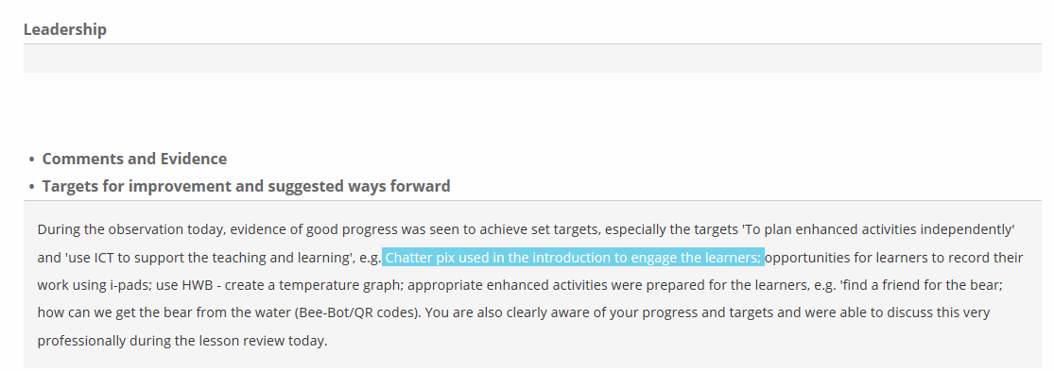

1b- creating value for others – using emoji exit cards
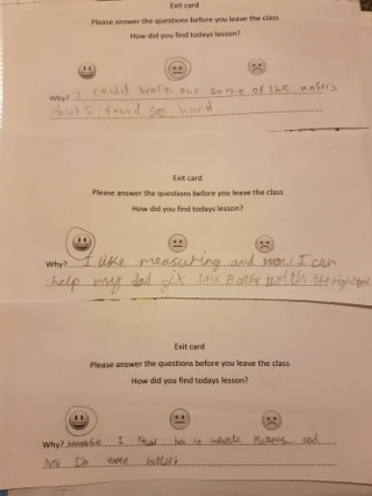

1c -Mind map created with the children
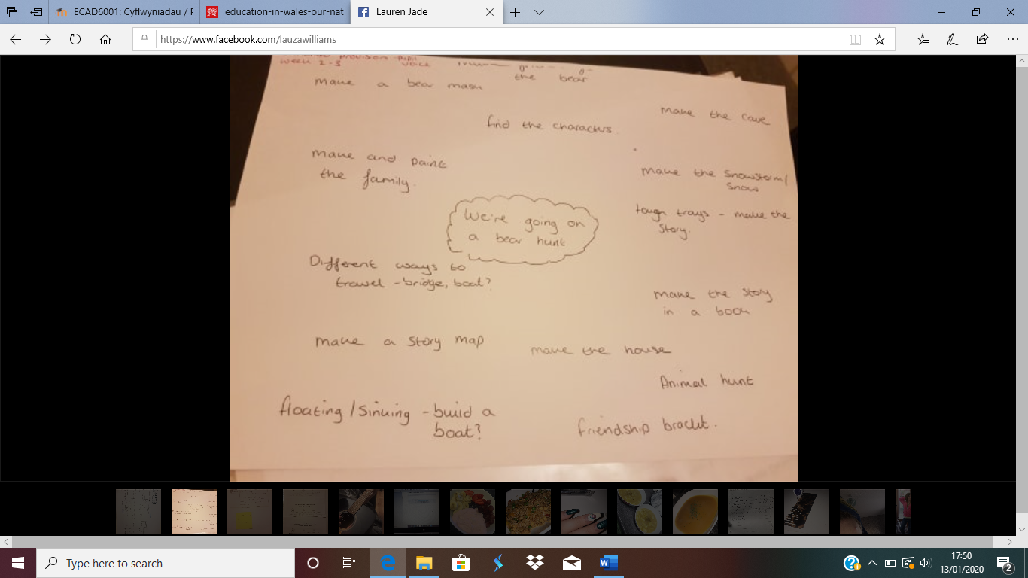

1d- Reflection ARC
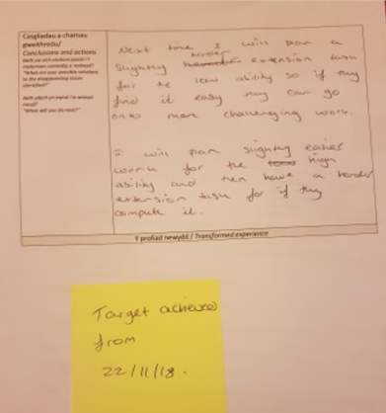

1e – Time management target from PTE

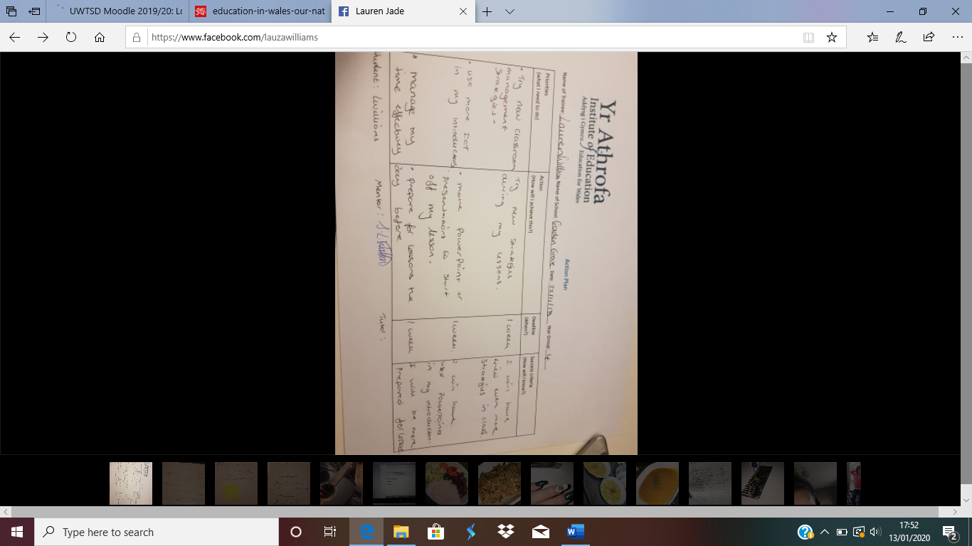
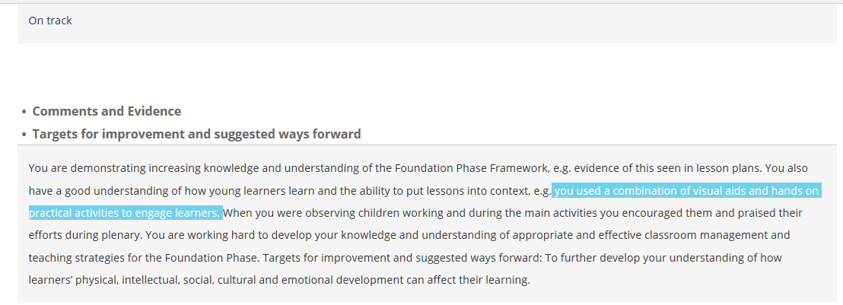
1f – Lesson observation showing I can use resources to support learning

1g- Target from PTE to use practical activities to support all learners needs
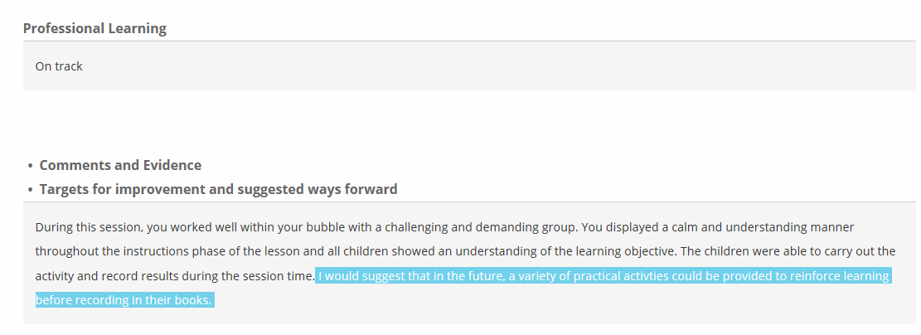

1h – Science lesson plan from KS2

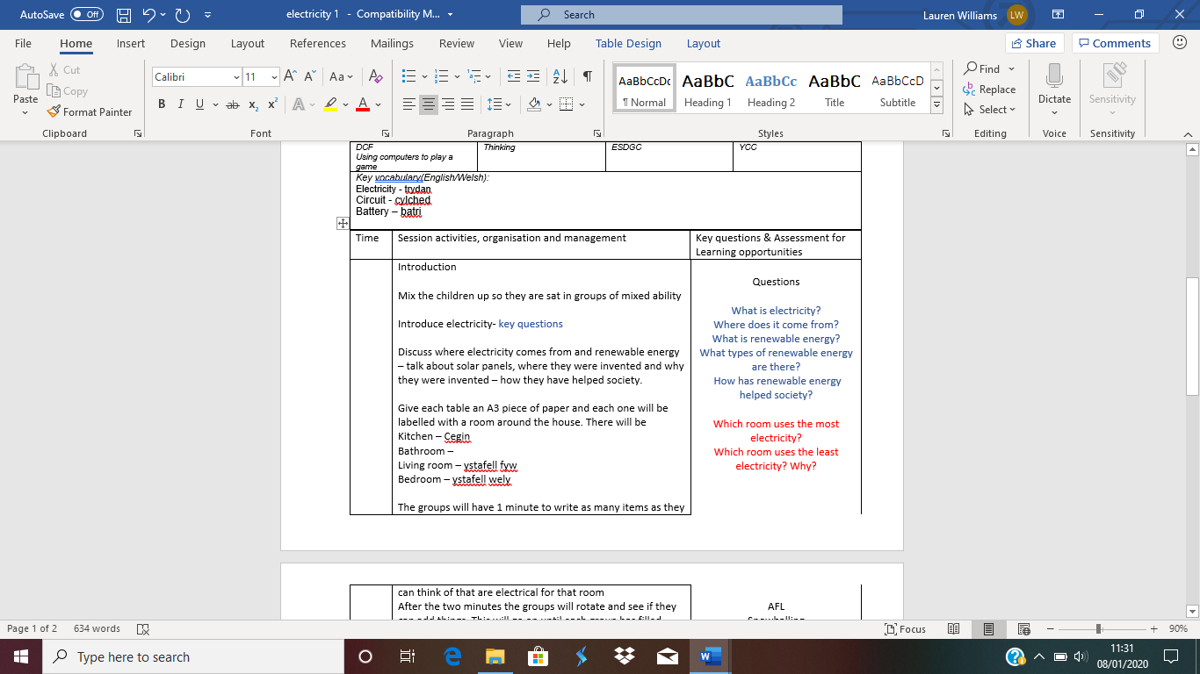

1I- lesson observation showing I can accept feedback from tutors


