Reflective Report

Student Name: Natalie Doran
Student ID: 2025905
Module code: BMSW4001_BIRM
Assignment section: Reflective report
Lecturer's name: Ade Olubukola

Table of Contents
Introduction 2
Gibb's Reflective Cycle 2
Description 3
Feelings 4
Evaluation 5
Analysis 5
Action Plan 6
Conclusion 7
References 8
Appendices 9
Appendix 1 10
Appendix 2 11
Appendix 3 11
Appendix 4 12

Introduction
This paper is based on my reflective report, in which I will explain the educational and employability abilities that I have achieved throughout this module. I intend to use the Gibbs Reflective Cycle to draw attention to my learning experiences and the transferable skills I have gained throughout the course. I have prepared various research reports through the skills gained from this course; I have also gained academic talents and leadership abilities through the 4D time management tool. Compiling all this information is also beneficial for completing the employability skills section (Hanks, Marples, and Wall, 2016). Job seeking is becoming more competitive, and having a diverse range of skills helps distinguish me from the competition. For my reflective report, I will use Gibbs Reflective Cycle to guide me through six stages of exploration of my experience: description, feelings; evaluation; analysis; conclusion; and action plan. I will also reflect on my critical thinking skills, time management, and teamwork skills.

Gibb's Reflective Cycle
I have shown the effectiveness of developing academic and employability skills in this module's various activities. The Gibbs Reflective Cycle will assist me in analyzing and evaluating concerns while also taking into account my feelings about the situation both during and after the event. I believe that as a result of this module, I have gained a better understanding of the technique by which I perform my duties, and I have also been able to develop my time management, teamwork skills, and critical thinking skills. My understanding of Gibbs' model assisted me in determining the steps that needed to be taken to significantly improve my academic and employable skills (Adeani, Febriani, and Syafryadin, 2020). The primary components of the Gibbs model are as follows: a description of the situation, identification of associated emotions, appraisal of the situation, conclusion, and development of an action plan for future skill improvement. The Gibbs model is based on the theory of cognitive behavior. Using this methodology at all levels will assist me in developing an accurate and consistent assessment of my perspective throughout the learning module. I will apply the 4Ds time management tool to understand when to delete, delegate, defer, and do different activities. I believe the tool will motivate me to spend more time on the things that need improvement (Chavada, Dawood, and Kassem, 2012); I look forward to increasing my productivity through this experience.

Description
Critical thinking is essential in both the classroom and the workplace. Attending my classes and participating in related activities regularly have helped me improve my critical thinking skills. I have gained more insight into how my evaluations and learned lessons relate to the effectiveness of learning assessments (Adeani, Febriani, and Syafryadin, 2020). Take, for example, what I have learned throughout the module and how it will be conveyed on the exam paper. This can assist me in better comprehending and reflecting on the information I have gained from my professors. I will be able to achieve greater success in my academic module due to finding evidence, observing, and forming arguments that have given me guidance and assistance in understanding my academics and will help in my working environment. During this module, I learned about the most effective methods for motivating and inspiring employees.
My critical thinking skills have increased due to my ability to articulate the distinct activities in Quiz Navigation, especially activity three, which needed logical reasoning. My teamwork abilities are improving because of working within groups that have diverse reasoning. Along with learning several methods for motivating an organization's employees while writing the task 1 report, I also gained knowledge of several methods for motivating an organization's leadership. I have learned about gathering and arranging information comprehensively (Hanks, Marples, and Wall, 2016). Therefore, I have learned how to design a professional CV and what I could include in my CV to make it more logical, which would help me acquire the job position I desired (Suarta et al., 2017). I gained knowledge of critical thinking and teamwork abilities when I participated in a project with other members in which we were required to complete a research activity. All the activities in this coursework have assisted me in determining my critical skills and have influenced me in implementing the do element in 4D time management, which enables me to embark on a single task rather than
The Gibbs model has enabled me to establish a strong connection between critical thinking and experience which has enabled me to evaluate every situation and action other members and I take during group activities enabling a possible best course of action for dealing with a potential incident (Adeani, Febriani, and Syafryadin, 2020). The application of Gibbs' model has explained why some activities I performed during the coursework seemed challenging, and my performance during the academic module, which I believe are necessary to acknowledge for me to know where to improve. As a direct result of the coursework, I am now better equipped for my career. My efforts have improved my teamwork abilities as I may be able to improve teamwork cohesion due to delegating and directing everyone toward a common goal and completing it in time. A thorough description of an event through my critical thinking and the associated experience can now be provided to improve time management techniques. I can now reduce project completion times by using teamwork abilities to critically interpret project progress and status, increasing my chances of being hired by any organization.

Feelings
The ability to recognize and analyze one's emotions is essential for success in both academic and professional endeavors. As a result, I believe it has assisted me in establishing and articulating my thoughts on the lessons learned and the experiences I have gained through different activities in the coursework, as will be shown in the appendices. I have employed this method's critical thinking skills for those around me. After accomplishing this lesson, I have realized that my ability to think critically and analyze information is vital to everyone's ability to function effectively. Learning the proper format for writing academic reports that I implemented in my task 1 report helped me feel more confident in my writing abilities. While I was doing this, I was thrilled to learn about new topics and, even more importantly, I was delighted to learn about new techniques that would help me improve my critical thinking abilities. I also had developed my time management, critical thinking, and teamwork abilities using the 4D tool, which had excited me during the group discussion when I was delegating tasks to my classmates.
After learning about the 4D tool, I tried to put it into practice as much as possible; I believe this will enable me to realize where I need to improve. My ability to improve my performance has been aided by extensive exposure to developing employable skills in my organisation through the 4D tool (Chavada, Dawood, and Kassem, 2012). Undertaking task 1 also taught me the importance of grammar, vocabulary, and paraphrasing, which I will apply in my professional life while documenting projects, among other tasks. The 4D tool has motivated me to start because I am getting closer to entering the corporate world (Garcia-Palao et al., 2016). Using the 4D tool, I considered writing my daily activities to gain experience with reflective writing before embarking on the reflective report. While writing about my everyday life thoughtfully, I realized how many minor activities I had picked up daily slowed the rate I performed activities.

Evaluation
Evaluation of the Gibbs cycle comprises what went smoothly and what did not, and both the bad and the good aspects of the event are included in this process. I initially struggled to cope with academic writing and article researching methods. After some time, I became familiar with the procedures and protocols and was able to complete the tasks without difficulty (Adeani, Febriani, and Syafryadin, 2020). One reason for my success in these activities is that they have motivated me to improve my critical abilities. They have reinforced my bonds with my colleagues by allowing me to learn more about who they are as individuals. The only thing that went wrong was that I failed to respond to a few questions and comments. Using the 4D tool, I improved my critical thinking abilities and changed how I studied for my gain. What went wrong was that I could not provide sufficient evidence to support several of the arguments made during the exercise. The reason for this is that I was completely absorbed and distracted. The activities that have been going well have been those in which I have learned how to present myself in front of a prospective employer, which I have gained through being a leader in my group work. Although in the group work initially, I made a mistake because I lacked relevant teamwork skills and experience and had not participated in many activities before, I learned from the 4D to delegate and defer some tasks. This will highlight my resume week (Chavada, Dawood, and Kassem, 2012). One of the things that went well was that I learned the proper way to write reflective writings and the importance of such writings in the everyday learning process. I found writing reflections to be a difficult assignment because I did not know how much information to include and how much information to exclude.

Analysis
What the analysis is trying to accomplish is to make sense of what happened. This includes how the situation makes sense to the individual and what information they obtain that aids them in understanding it (Adeani, Febriani, and Syafryadin, 2020). I have gradually gained an understanding of the procedures for writing academic reports, as well as the procedures for conducting research for related papers. The most important thing I took away from the class is a presentation and language that I can use to improve my critical thinking abilities in the future for my group. Task one, quiz navigation in class, sharpened my critical thinking skills by challenging the rationales presented by my professors and attempting to apply what I had read to my own experiences in the real world. After completing task one, I realized that improving my critical thinking skills would assist me in increasing my creativity as well as my ability to reflect on myself (Hanks, Marples, and Wall, 2016). I changed my reading method using the 4D concept, which helped me become more imaginative. The most important thing I took away from the class was how to include things like specific duties, increased responsibility, and experience in my Curriculum Vitae to make it more appealing to potential employers and employers.

Action Plan
After reflecting on my learning process using Gibb's model, I have decided to have an action plan with a strategic planning process for continuing to pursue future improvements systematically (Adeani, Febriani, and Syafryadin, 2020). As a result, I can be more productive in my academics and career in the future. In addition, I feel having a plan in place helps me close the gap between my professional and personal skills, which helps coordinate my life uniformly. I have also attached activities performed throughout this module in the appendices
Goals | Actions to be considered | Resources | Present Score
Improving time management and self-managing | I will use the 4D tool to make a schedule and follow it strictly. I will write down all the tasks I am supposed to accomplish daily. Then I will divide the tasks into segments and have breaks in between so that I do not exhaust myself. | I will use the Work Breakdown Structure application, which will help me in allocating tasks and periods (Siami-Irdemoosa et al.,2015) | Moderate
Improving my team working skill | I will focus on improving patience and emotional intelligence, which will enable me to understand my own emotions and my teams and influence them from an emotional perspective. | I will continue taking leadership roles in my group discussion to have direct experience and note my strengths and weaknesses. I will also use online articles to learn more about emotional intelligence. | High
Improving my critical thinking skills | Participating in various types of critical thinking practices to develop connections between my thinking and the surrounding situation | Practicing by solving challenging situations, which I will retrieve in online resources which will help me develop a conventional personality | Moderate

Conclusion
The Gibbs Reflective Cycle has proven to be a useful tool for determining how I should approach critical thinking in a given situation. It has enabled me to streamline my learning experiences. The cycle has also identified areas for improvement in my critical thinking skills, collaborating with others, and effectively managing my time. The Gibbs reflective cycle has assisted me in better understanding the factors that must be considered when developing academic skills to increase one's employability. In the workplace, academic and employability skills are essential to success. Critical thinking skills are essential in reflecting an excellent management approach when it comes to management. Academic abilities obtained through the skills discussed provides the fundamental information that allows me to survive in today's job market. Additionally, it aids in becoming more informed about current events and provides a high level of learning without confusion. Employability skills have given me the ability to apply knowledge in a specific way, following established standards in the workplace. These abilities contribute to developing my professional development perspective and the work environment.

References
Adeani, I.S., Febriani, R.B. and Syafryadin, S., 2020. USING GIBBS'REFLECTIVE CYCLE IN

MAKING REFLECTIONS OF LITERARY ANALYSIS. Indonesian EFL Journal, 6(2),

pp.139-148.

Chavada, R., Dawood, N. and Kassem, M., 2012. Construction workspace management: the

development and application of a novel nD planning approach and tool. Journal of

Information Technology in Construction, 17, pp.213-236.

De Guzman, A.B. and Choi, K.O., 2013. The relations of employability skills to career adaptability

among technical school students. Journal of Vocational Behavior, 82(3), pp.199-207.

Garcia-Palao, C., Oltra-Mestre, M.J. and Coughlan, P., 2019. Improving teamworking

competence through action learning. Experiences in operations management education.

Action Learning: Research and Practice, 16(3), pp.205-222.

Hanks, S., Marples, C. and Wall, E., 2016. Reflections on learning and enhancing communication

skills through community engagement: a student perspective. British Dental

Journal, 221(2), pp.81-85.

Siami-Irdemoosa, E., Dindarloo, S.R. and Sharifzadeh, M., 2015. Work breakdown structure

(WBS) development for underground construction. Automation in construction, 58, pp.85-

94.

Suarta, I.M., Suwintana, I.K., Sudhana, I.F.P. and Hariyanti, N.K.D., 2017, September.

Employability skills required by the 21st century workplace: A literature review of labor

market demand. In International Conference on Technology and Vocational Teachers

(ICTVT 2017) (pp. 337-342). Atlantis Press.

Appendices
The appendices show the activities that I have been able to perform during the module

Appendix 1
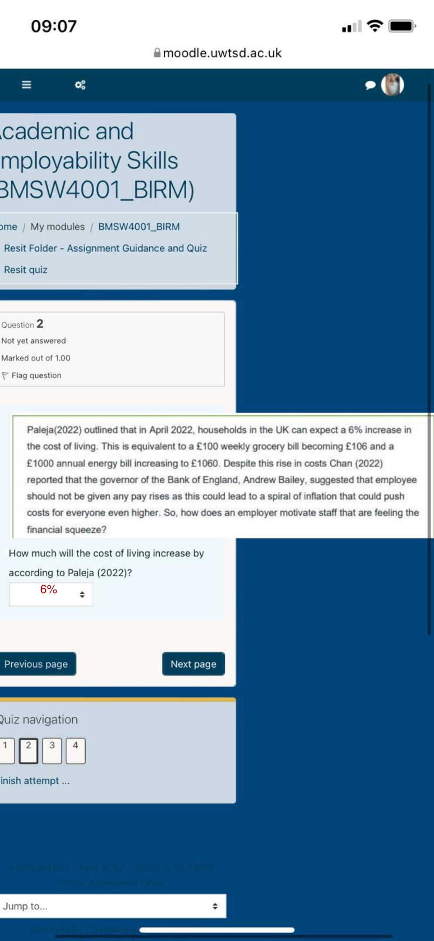

Appendix 2
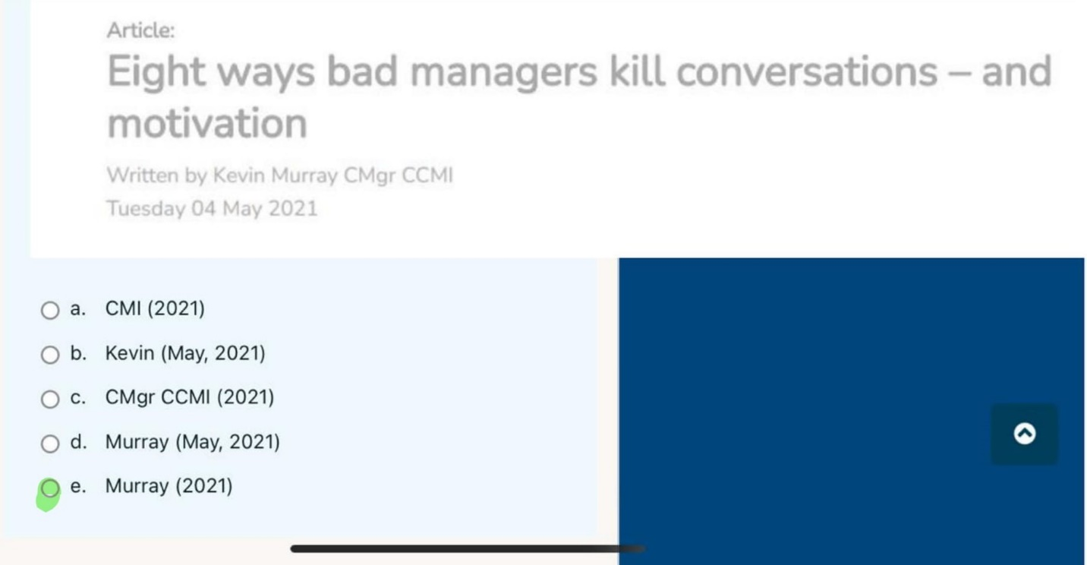

Appendix 3
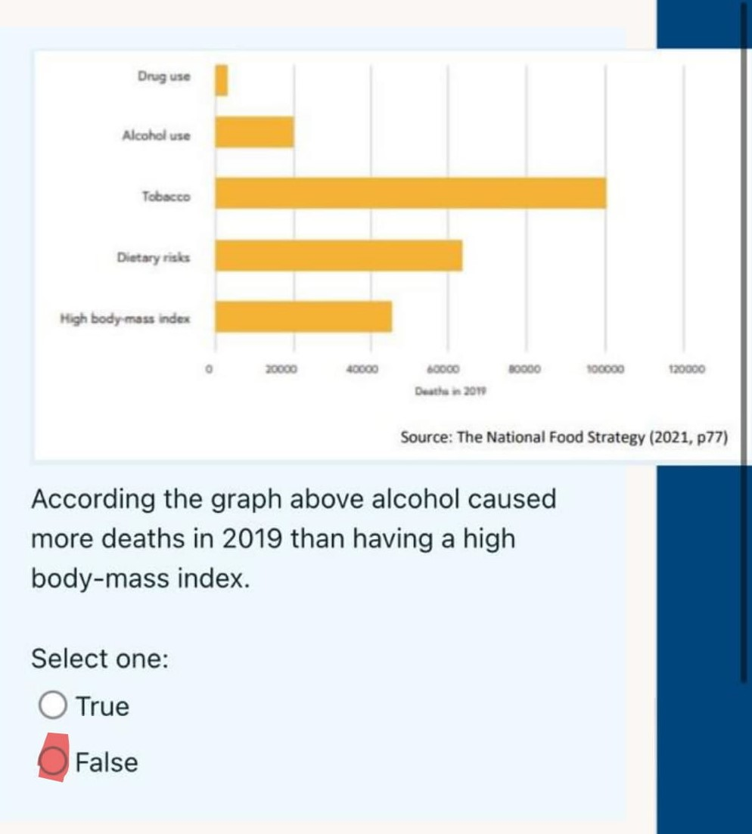

Appendix 4


