PROBLEM SOLVING AND DECISION MAKING
BMSW4004
Shefali Begum (1918219)
Lecturer: Charles Nimoh

Executive Summary
The current study focuses on the implication of apprehensive problem solving and decision-making skills referring to the case of NHS. Moreover, the report consists of two tasks have been processed to discuss the matter on the topic of the workplace of the health care organisation in the UK. PESTEL analysis has been performed to identify the external factors in the health care organisations of the UK. The scope and the impact have been described in the report. The activities have been predicted by PMI analysis. The main purpose of the project is to provide knowledge on problem solving and decision making in health care sector.

Table of Contents
Task 1 3
Introduction 3
Research-informed discussion on the nature [presenting the plan] 3
Impact of the complex problem on employees and their organisations 4
PESTLE analysis of the macro-environmental factors contributing to the complex problem 5
Research-informed cause-and-effect analysis [fishbone diagram] 6
An evaluation of alternative solutions to staff shortage with an aim of choosing the most appropriate solution among these alternatives [measuring effectiveness] 7
Conclusion 7
References 9
TASK 2 10
Introduction 10
Its Scope and Impact 10
Analysis of the organisation and problem 10
Propose alternative solutions 12
Evaluation 12
Plan for implementing the solution, Monitoring and Review Process/System 13
Conclusion 13
References 14

Task 1

Introduction
- NHS hospitals and mental health and community service providers have reported a shortage of more than 100,000 FTE employees and it was represented by one in eleven posts.
- In this presentation, a plan will be presented to mitigate workforce-related challenges.
- The impact of this complex problem on health care staff, patients and the organisation itself will be discussed.
- If this shortage of workforce will continue, healthcare quality will deteriorate and the future sustainability of health care service will be undermined.
Few alternative solutions will be provided in the assignment and a cause-and-effect analysis will be done by using a fishbone diagram. A PESTEL analysis is done in the project to indicate factors which impact the health care sector.

Research-informed discussion on the nature [presenting the plan]
- A successful workforce management plan consists of several things like vision, planning, strategy, humanity and empathy.
- Workforce challenges are a major challenge the UK's health sector is facing and patients and staff both are facing the consequences of the situation.
- It is a major requirement to address major cultural and also professional issues which contribute to ineffective mental health mainly among individuals (Alloh et al. 2018).
- The plan is presented to meet specific health care centre’s objectives and the organisation should apply a talent management system in their HR process.
- A workforce will need to be built properly which is suitable for this particular sector and a plan is given below in this section.

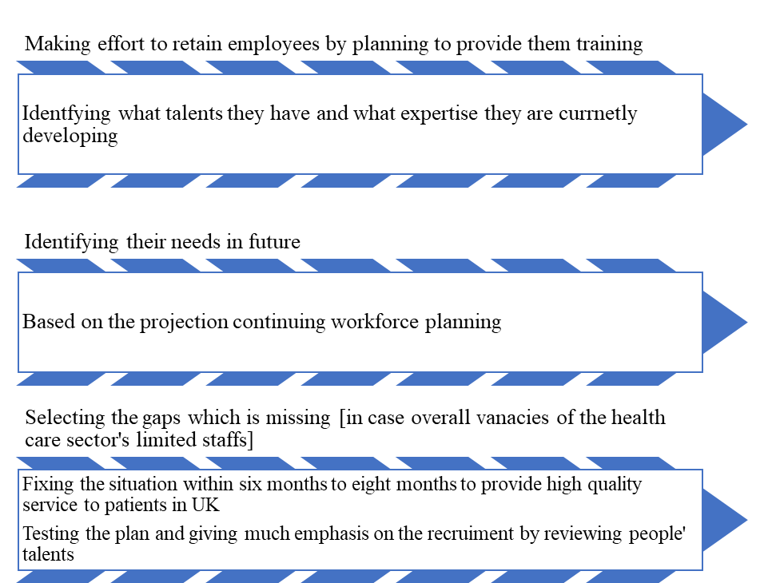
Figure 1: Workforce management plan
(Source: Developed by the learner)
A plan is given in this slide to build effective workforce management and the plan is kept simple and made by reviewing this realistic situation of scenario. If NHS and health care service providers recruit talented people to employ and distribute work accordingly, no problems will appear in the healthcare context. In order to sort talents, the organisation will need to take initiative at crucial times and the authority should take control of the situation. From six to eight months can be taken to implement the plan to control the situation. Specific vacancies should be identified and equally that quantity of people can be employed.

Impact of the complex problem on employees and their organisations
- Limited workforces in the healthcare sector of the UK is considered one of the major complex problems in the UK because as per people's demands, there is a limited staff.
- It is a horrible situation that staff and patients are facing because of ineffective workforce management and ineffective leadership.
- This has a negative impact on employees and due to unequal working hours, employees go through psychological stress (Dixit and Ghosh, 2019).
At first complex problems are identified which the UK's health industry is currently facing. 1 in 8 posts in nursing is vacant and around 41,000 nurse vacancies are identified in the scenario. In the case of the adult social care industry, medical issues are the same and the vacancy is estimated at 110,000 posts. Workforces’ challenges have a strong negative impact on the UK healthcare sector and how it affects patient care, is described. By implementing the plan these major issues will be mitigated and patients and staff, both will be evidence of the positive impact.

PESTLE analysis of the macro-environmental factors contributing to the complex problem
Political factor | Economic factor | Social factor | Technological factor | Environmental factor | Legal factor
- Doctors and healthcare professionals will need to pay a high amount of tax to HMRC (HM Revenue and Customs) because of a strict tax policy. | - After Brexit, the cost of living increased and for this reason, the NHS has lost numerous European staff (Burdett and Fenge, 2018). | - The UK population is increasing yet comparatively there are fewer staff in the health care sector. | - The industry is dependent on automated machines which create fewer jobs and students have limited job opportunities. | - Climate change becomes a typical and major factor which threatens the foundation of “good health”. | - UK health rules are quite strict and if any NHS staff accidentally makes an error, it can result in unemployment.
Table 1: PESTEL Analysis
(Source: Developed by the learner)
From the above PESTEL analysis, it can be seen that there are no scopes and so opportunities left for UK health care staff. That is the reason for leaving jobs in the healthcare sector in the UK and all macro-environmental factors are creating barriers for the staff which lead to "staffs shortages”

Research-informed cause-and-effect analysis [fishbone diagram]
- Workforce management of the health care sector of the UK is under pressure because of ineffective workforce management.
- For COVID 19 pandemic, NHS staff are facing challenges to enforce social distancing (Nyashanu et al. 2020).
- The cause-and-effect analysis shows major reasons for the UK's health sector’s failure to retain staff and it is resulting in poor patent management as well.
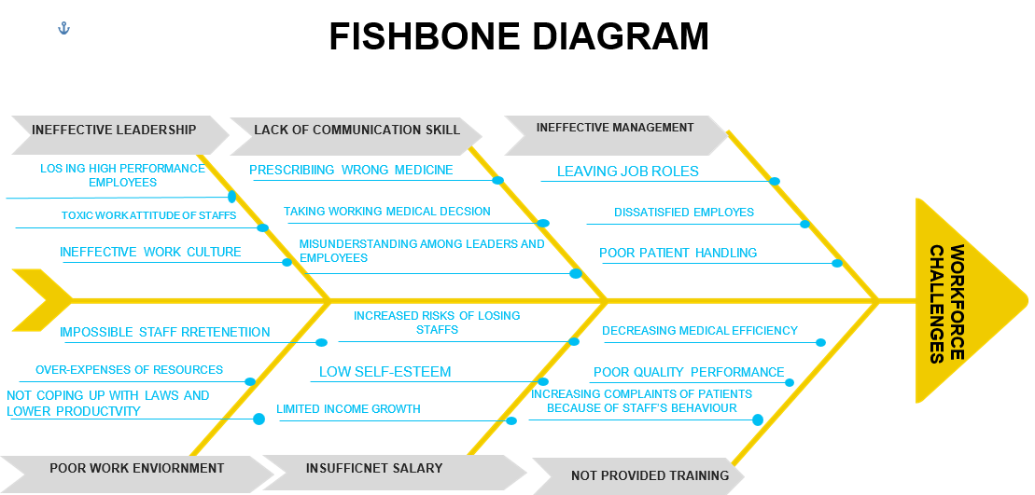
Figure 2: Cause and effect analysis using fishbone diagram
(Source: Self-developed)
Ineffective health organisation leadership, lack of proper communication skills, ineffective management, poor work environment, insufficient salary and insufficient training are major reasons which are identified throughout this time. In July 2017 and July 2018, 1,584 EU nurses and health visitors left their job roles and for these reasons, the number of workforces is decreasing.

An evaluation of alternative solutions to staff shortage with an aim of choosing the most appropriate solution among these alternatives [measuring effectiveness]
- A larger amount can be paid to NHS staff for their hard work and extra hours which they put in for patients.
- An additional training can be provided to new staff who are talented to embrace their skills (Tabah et al. 2020).
- The leader can take appetencies for helping NHS’s staff to gain new insight.
They should attract young workers and the leader will need to encourage them by giving practical implementation. The NHS authority should recruit the right people and they will need to make the person comfortable in the team.

Conclusion
- Staff shortage in the UK's health care sector is highlighted in this presentation.
- If the sector and the NHS organisation apply the workforce management plan properly, they can get positive outcomes.
- A PESTEL analysis is conducted in the project to analyse macro-environmental factors.
The nature of the healthcare sector is defined in the assignment and what challenges NHS and thor patents are currently facing are demonstrated in this assessment. The negative impact of the complex problem on patients and staff has been defined in the presentation.

References List
Alloh, F.T., Regmi, P., Onche, I., van Teijlingen, E. and Trenoweth, S., 2018. Mental health in low-and middle income countries (LMICs): going beyond the need for funding. Health Prospect: Journal of Public Health, 17(1), pp.12-17.
Burdett, T. and Fenge, L.A., 2018. Brexit: the impact on health and social care and the role of community nurses. Journal of Community Nursing, 32(4), pp.62-65.
Dixit, V. and Ghosh, S., 2019. Analyze impact of occupational stress in healthcare professionals: A critical review. Invertis Journal of Management, 11(1), pp.30-37.
Nyashanu, M., Pfende, F. and Ekpenyong, M., 2020. Exploring the challenges faced by frontline workers in health and social care amid the COVID-19 pandemic: experiences of frontline workers in the English Midlands region, UK. Journal of Interprofessional Care, 34(5), pp.655-661.
Tabah, A., Ramanan, M., Laupland, K.B., Buetti, N., Cortegiani, A., Mellinghoff, J., Morris, A.C., Camporota, L., Zappella, N., Elhadi, M. and Povoa, P., 2020. Personal protective equipment and intensive care unit healthcare worker safety in the COVID-19 era (PPE-SAFE): an international survey. Journal of critical care, 59, pp.70-75.

TASK 2

Introduction
“Problem-solving” is defined as the skill that acts to define a problem by relying on the use of exceptional decision-making skills. The problem will be identified and the individual will try to find the reason for the problem. Several problems will be situated in the area and therefore prioritisation is necessary for selecting the problems. Alternatives for the selected problems will be defined and implemented as soon as possible to solve the problem. “Decision-making” is another keyword that helps the individual in making the choices about the activities by gathering the information and assessing “alternative resolutions”. The report will highlight the problem of recent staff shortages in the care home situated in the UK.
Define the problem
NHS hospitals have currently reported that the staff shortages in the care home are high alert in the overall UK. Not only the lack of retention of FTE jobs and nurse jobs, but problems have also arisen in the medical supplies, especially in particular areas of the UK. The BBC's report of BBC has stated that “Southmead Hospital” in Bristol has faced a lot of shortages in equipment like “syringe drivers”, “infusion pumps” and “oxygen cylinders” (Reed, 2022). “Brexit” has transformed the situation worse as “the net inflow of nurses from the EU” has turned into a “net outflow of nurses”. 1584 nurses have left their roles and the UK government has invested in providing more training seasons to employ about “10000 young generations”. The number of undergraduate students in the medical sector has fallen up to 4% in FY 2018 [Refer to the scenario]. The problem is improving more due to the decrease in care quality.

Scope and Impact of the Identified Problem
The staff shortages in the UK have been regarded as a “long-term” problem. Over “10000 FTE Staff” shortages have severely affected the operations of the care homes. The challenging part of NHS hospitals is more in the nursing sector as “41,000 vacancies” have been already reported [Refer to the scenario]. Due to the rise in the percentage rate, the vacancies of the care staff (12%) the different groups of care staff as well as the vulnerable patients have been affected for the previous reason [Refer to the scenario]. The care staff are getting high pressure in the sector but low paid. Many patients are lodging complaints against the inadequate treatment in the sector.

Analysis of the organisation and problem
According to Georgieva (2020), “PESTEL analysis” is the framework to study different external factors that impact organisational behaviour. These external factors are “political”, “economical”, “sociological”, “technological”, “legal” and “environmental”.
Political | The care staff finds difficulties in serving the care of the patients as they have to pay a large amount of tax to HMRC and get lower annual wages. “Brexit” has an impact on the care sector as many doctors have returned to their native countries.
Economical | The care staff cannot manage properly in the UK as the inflation rate has recently increased and the “cost of living” has increased but remained the same in the annual wages.
Sociological | Due to the extreme growth in the population of the UK about 4% of the care staff has to look after more patients at the same time and less retainment in the staff causing high pressure in the workplace (Worldbank, 2022). The retirement of old care staff gives problems to the young staff in maintaining the care operation.
Technological | High automation in the NHS leads the care staff to get the high qualification in the medical course and that is the reason for achieving fewer NHS jobs.
Legal | Many Care staff have lost their jobs due to accidental mistakes and fall into “healthy and safety laws”.
Environmental | Climate change in the workplace of NHS gives a negative impact on the satisfaction of the care homes and the prime reason is the less free time between operations.
Table 2: PESTEL Analysis
(Source: self-developed)
According to Coccia (2018), the fishbone diagram is a “graphical technique” to analyse the causes of a specific phenomenon and analyse these causes and effects are investigated. The cause of the underlying report was “improper workload management”, “less annual wages” and “lack of communication skills” due to less knowledge”. The effects of the phenomenon were “the dissatisfaction of the parents” and “the high resignation of the care staff NHS”.

Propose alternative solutions
- The young staff have not got enough experience during their medical studies and alternatives can be taken as “the training and development” plan to overwhelm them.
- The apprentices will help the young staff to get an insight into “how it is to work”.
- Improvement in the salary is of utmost importance as the staff of the emergency sector work for a long-time to care for their patients and take duty when applicable.
- Time-shifting is another solution for the care workers as they can get sufficient time for other operations.
- Hiring the right people is the alternative solution as they can communicate effectively and the NHS can arrange every resource for the comfortability of the workers.

Evaluation
As opined by Sudarto (2020), “PMI” is helpful in “problem-solving” as well as “decision making” to critically think about experiences and phenomena. Using this analysis, the organisation can pick some plus points that can be implemented and at the same time, the minus points can be observed. The interesting points can be noted by the organisation for further implication.
PMI ANALYSIS
PLUS | MINUS | INTERESTING
The employment of young generations in the workplace | Investment in the hiring process requires a lot of training | NHS can give a better experience to their patients.
The incentive for the additional work | NHS has to take monitory measures to count the activities of care staff | The care staff can give high attention to the patients.
Implementation of digital technology | NHS has to invest much time and increase the operation cost | NHS can take the help of the UK government to raise the funding.
Table 3: PMI Analysis
(Source: Self-developed)

Plan for implementing the solution, Monitoring and Review Process/System
The suitable plan for mitigating the issues of staff shortages in the care home of the UK is to increase the staff number by the HRM. Investing the funding in the training enhances the skill of the care staff effectively. The care staff can communicate with the other member for the proposed operation. They can make better decisions in providing medical supplies to the patients. Hereby, the patients can get treatment quickly and the staff can be retained for a long-time due to the distributed workload.

Conclusion
“Problem-solving” and “Decision-making” have been discussed in the report to take steps on mitigating the issues. “The staff shortage in the care homes” of the UK has been prioritised in the report as the issue has not been observed as minor. The issue has been well-defined in the report and “PESTEL analysis” has been performed to identify the external factors that impact the activities in the UK care homes. Along with this, several solutions have been identified in the report. The possible solutions have been evaluated and the plan has been added to implement “the solution, monitoring and review process/system”.

References List
Coccia, M., 2018. The Fishbone diagram to identify, systematize and analyze the sources of general purpose Technologies. Journal of Social and Administrative Sciences, 4(4), pp.291-303.
Georgieva, M. and Abdelazim, A., 2020. Strategic Mergers and Acquisitions in Higher Education: A Case Study from the UK. European Journal of Business and Management, 12(33), pp.1-15.
Reed, J., 2022. NHS in England facing worst staffing crisis in history, MPs warn. [online] BBC News. Available at: <https://www.bbc.com/news/health-62267282> [Accessed 21 July 2022].
Sudarto, N. and Inggriantara, A., 2020. Business Strategy for PT Finansindo Mikro Facing Competition in Microfinance Business. International Journal of Research in Engineering, Science and Management, 3(11), pp.121-124.
Worldbank, 2022. Population growth (annual %) - United Kingdom | Data. [online] Available at: <https://data.worldbank.org/indicator/SP.POP.GROW?locations=GB> [Accessed 21 July 2022].

