

Major Project:
Disposal of Legacy Warheads Post-Environmental Testing & Long-Term Storage
Student:
Creighton Rees - 1910564
Lecturer:
Jenni Steen
Course:
Ordinance Munitions and Explosives: ACDA60200: Major Project

Abstract
‘During a site wide inspection at a large munitions factory two warheads that had been in long term deep storage were found in extremely poor condition. The warheads were found inside an un-conditioned storage unit with little information available on their history, date of manufacture, functional design, and energetic materials contained within.
Due to the lack of information and history on the warheads, combined with the fact both are development trial items there is no transport classification in place to allow the shipment of the munitions to an established Explosive Ordinance Disposal (EOD) site. The site where the warheads were found currently has no capability or explosive license in place to allow for the disposal of highly hazardous large munitions
There are various approaches that can be taken to dispose of high hazard munitions, such as full-order detonation, low-order detonation, incineration, and remote breakdown of the munition [1]. The mitigations in place during the disposal activity must be suitable to ensure full containment of a full-order detonation and its associated hazards including, blast, fragmentation, thermal flux and Jet propagation.
A detailed Risk Assessment for the disposal activity has been produced and shown in Annex A1, with the risk scoring matrix shown in Annex A2.
Prior to any mobilisation activities commencing, formal approval of a temporary explosive disposal licence for the Mitigated Disposal Area (MDA) from the Heath & Safety Executive (HSE) was required. In additon to the HSE, the local government and coast guard were informed of the planned disposal date.
The MDA consisted of large shipping containers double stacked as inner walls, around a central 10M X 10M Disposal Area. All outer walls were doubled buttressed with earth mounding up to the mid-point of the upper container. The central disposal area was lined and filled with an infill of multiple 1 tonne sandbags up to 800 tonnes in total.
Both high-order detonations took place as planned with no residual un-exploded material remaining on completion, this was confirmed by EOD personnel after following a 24-hour stand-down period, with re-entry authorised after EOD inspection.
When all scap metal waste was collected, it was placed into an appropriate stillage and transported to the Original Equipment Manufacturers (OEM) facility proving oven to Certified Free From Explosive(CFFE). All sand waste was treated as hazardouse waste and was disposed of through the appropirate disposal routes. The shipping containers were dissassembled and transported from the OEM site by EOD contractor for future use.
For the purpose of this report, precise design details of the warheads, specific locations of the munitions manufacturer and names of relevant stakeholders have been omitted for security reasons. Some theoretical values and locations have been used within this report for illustration purposes, although some information can be made available on request if required.’

Table of Contents
Contents
1 Introduction 5
2 Legistlation & Regulation For Ordinance Disposal 6
3 Disposal Munition Design 10
4 Assessment of Risk 16
5 Disposal Process 24
6 Discussion 31
7 Conclusion 32
References 33
Annex A – Risk Assessment 37
Annex A1 – General Risk Assessment 34
Annex A2 – Risk Scoring Matrix 41
Annex B – Disposal Project Estimated Cost 45
Annex C – Disposal Project Estimated Timeline 46

Table of Tables
Table 1 – Article 1 – CBF Warhead Component Description [10] 11
Table 2 – ExRAB Hazard Properties [13] 12
Table 3 – ExRAB RE Factors [16] 13
Table 4 – Article 2 – SC Warhead Component Description [9] 14
Table 5 – ExHB Hazard Properties [13] [17] 15
Table 6 – ExHB RE Factors [16] 15
Table 7 – Blast Parameters of Article 1 (CBF) Warhead at 50m [21] 18
Table 8 – Blast Parameters of Article 2 (SC) Warhead at 50m [21] 18
Table of Figures
Figure 1 – STANAG 4518 – Demilitarization and Disposal Process [6] 9
Figure 2 – Article 1 – Configured Blast Fragmentation (CBF) Warhead [10] 11
Figure 3 – Article 2 – Shaped Charge (SC) Warhead [9] 14
Figure 4 – MDA – Rectangular Destruction Area with Four Containing Faces & Open Roof [7] 17
Figure 5 – Effects of Blast Pressure on Structures and the Human Body [22] 19
Figure 6 – Site Overview 25
Figure 7 – Overview of Disposal Route to MDA 25
Figure 8 – Overley of Hazard Zones on MDA 26
Figure 9 – Disposal Process Flow 27
Figure 10 – Side View MDA with SC Warhead Present 29
Figure 11 – Plan View of Complete MDA with SC Warhead 30
Figure 12 – Side View of MDA with CBF Warhead 31
Table of Equations
Equation 1 – TNTe by RE Factor & Mass Fraction [14] 13
Equation 2 – TNTe of ExRAB Explosive 13
Equation 3 – TNTe of ExHB Explosive 16
Equation 4 - Hopkinson-Cranze scaling law [19] 17
Equation 5 – Article 1 CBF Warhead Scaled Distance at 50m 18
Equation 6 – Article 2 SC Warhead Scaled Distance at 50m 18
Equation 7 – Idealised Hydrodynamic Penetration [16] 19
Equation 8 – National Defence Research Committee (NDRC) Modified Formula [23] 20
Equation 9 – Gurney Equation Fragment Velocity [24] 20
Equation 10 – CBF Warhead Fragment Velocity 21
Equation 11 – SC Warhead Fragment Velocity 21
Equation 12 – Kinetic Energy [16] 21
Equation 13 – Fragment Mass 22
Equation 14 – Fragment Kinetic Energy 22
Equation 15 – Typical Synthetik© Blast FEM Simulation Output [26] Error! Bookmark not defined.

Introduction
  - This major project details the disposal activity conducted on two legacy warheads at a large munitions factory, including the approach taken, a detailed review of the munition’s designs, including their functional effects and the appropriate mitigations to allow for their safe disposal. The appropriate disposal method will be followed and the overview of the process captured within this report.
  - During a site wide inspection at a large munitions factory two warheads that had been in long term deep storage were found in extremely poor condition. The warheads were found inside an un-conditioned storage unit with little information available on their history, date of manufacture, functional design, and energetic materials contained within. Both munitions were found secured, individually, to wooden pallets and displayed heavy corrosion on all visible surfaces including fasteners. [2]
  - Due to the lack of information and history on the warheads, combined with the fact both are development trial items there is no transport classification in place to allow the shipment of the munitions to an established Explosive Ordinance Disposal (EOD) site. The site where the warheads were found currently has no capability or explosive license in place to allow for the disposal of highly hazardous large munitions on-site. [2]
  - The disposal of high-hazard munitions is a complex task which requires extreme caution and carful, precise planning. Safety of staff and the public is paramount when considering the appropriate disposal method as there are several approaches available each with their suitability determined by the environment and condition that the munition is found in.
  - Environmental impacts to local ecosystems must also be considered and any risks mitigated through preventative measures. A brief overview of the approach taken to this task has been shown below [1]:
- Assessment Phase
- Review munition design & history
- Understand local environment & relevant hazards
- Engauge with EOD & relevant business stakeholders
- Assess risk associated with movement & handling of munitions
- Assess available disposal methods and associated risks
- Review regulatory requirements and environmental obligations
- Mobilisation Phase
- Select suitable disposal method & location
- Procure items required for disposal
- Engauge with Health & Safety Executive (HSE)
- Plan disposal activities
- Disposal Phase
- Conduct pre-disposal activities
- Conduct movement of munitions to disposal area
- Conduct disposal of munitions
- Conduct post-disposal activities
- De-mobilisation & Reporting Phase
- Certify disposal area and waste Free-From Explosive (CFFE)
- Dispose of residual waste through approved waste streams
- Disassemble and remove disposal area
- Produce report on the conduct and findings of disposal activity
  - The approach outlined in para 1.4 has been developed in accordance with both the CBI Explosives Industry Group (EIG) Guidance for the Safe Management of the Disposal of Explosives [1], and the Health & Safety Executive (HSE) Explosives Regulations 2014 (ER14) Safety Provisions Guidance on Regulations. [3]
  - For the purpose of this report, precise design details of the warheads, specific locations of the munitions manufacturer and names of relevant stakeholders have been omitted for security reasons. Some theoretical values and locations have been used within this report for illustration purposes, although some information can be made available on request if required. From herein the munition manufacturer will be referred to as the Original Equipment Manufacturer (OEM).

Legistlation & Regulation For Ordinance Disposal
  - As discussed in para 1.5, there are key documentation which outline the legal obligation for the conduct of any disposal activity, while the ER14 [3] detail the legal, mandated obligations, ref [1] provides guidance for several approaches to the safe disposal of munitions.
  - Additionally, Ministry of Defence (MoD) Policy Joint Service Publication (JSP) 762 Section 9 Policy and Procedures for Munition Disposal [4], JSP 520 Safety and Environmental Management of Ordnance, Munitions and Explosives over the Equipment Acquisition Cycle [5], STANAG 4518 Design Principles, Requirements, and Safety Assessment for the safe disposition of Munitions [6] must be adhered to.
  - As this disposal activity falls outside of standard company practices, an external Explosive Ordinance Disposal (EOD) company was contacted to support the operation. In addition to the key governing bodies and associated publications outlined above in para 2.3, a guidance document published by The Institute of Explosive Engineers (IExpE), Guidance Notes for Commercial Explosive Ordinance Disposal (EOD) Operations in Great Britain [7], was critical in ensuring adherence to current regulations and standard practices throughout this disposal project.
  - ER14 – HSE
    - Some of the key requirements of ER14 [3] have been outlined below, although there are further considerations in particular instances which are not listed each disposal activity must be assessed on a case-by-case basis.
- Ensure the safe disposal of munitions that prevents inadvertent fire, explosion or environmental harm.
- Conduct in-depth peer-reviewed risk assessments with traceability and ownership maintained throughout the process.
- Ensure disposal activities are conducted by Suitably Qualified and Experienced Persons (SQEP) who’s competency has been proven and documented through appropriate training and experiences.
- Implement robust emergency and mis-fire procedures.
- Document all disposal activities and gain the necessary approvals or dispensations required to allow their conduct.
- Prohibit the use of banned methods of munition disposal, such as marine dumping.
  - EIG – Confederation of British Industry (CBI) Guidance
    - Some of the key requirements of the EIG guidance document [1] have been outlined below, although there are further considerations in particular instances which are not listed, each disposal activity must be assessed on a case-by-case basis.
- Follow a robust Safety Management System (SMS).
- Conduct in-depth peer-reviewed risk assessments to establish suitable safety distances.
- Open detonation should only be considered as a last resort, when no safer disposal options are viable.
- Maintain and document clear and defined Standard Operating Procedures (SOPs) which include suitable recovery plans.
- Assess, monitor and limit all environmental impacts throughout the disposal activity, such as air pollution, soil contamination and harm to aquatic life or environments.
  - JSP 762 and JSP 520 – MOD
    - Some of the key requirements of JSP 762 [4] and JSP 520 [5] have been outlined below, although there are further considerations in particular instances which are not listed, each disposal activity must be assessed on a case-by-case basis.
- Embed munition disposal into Life Cycle Management of products with considerations for disposal at the design phase.
- Ensure compliance with environmental and safety standards and further ensuring sub-contractor adherence.
- Appoint a Disposal Manager to conduct activities and manage the disposal process ensuring ongoing experience.

  - Standardization Agreement (STANAG) 4518 – North Atlantic Treaty Organization (NATO)
    - Some of the key requirements of STANAG 4518 [6] have been outlined below, although there are further considerations in particular instances which are not listed, each disposal activity must be assessed on a case-by-case basis.
- Details design safety principles and assessment processes for the safe disposal and demilitarization of munitions.
- Encourages a transition from destructive disposal methods to Re-use, Recycle and Recover (R³) methodologies where appropriate. Reducing the environmental impacts of munition disposal.
- Appoint a Disposal Manager to conduct activities and manage the disposal process ensuring ongoing competence and experience.
    - A typical process flow for munition demilitarization and disposal as outlined within STANAG 4518 has been shown below in Figure 1 [6].
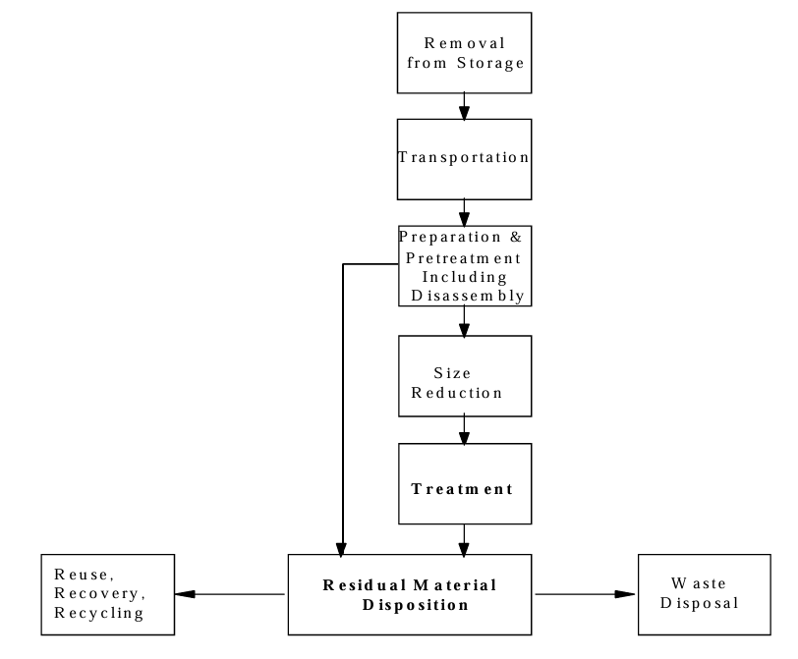
Figure 1 – STANAG 4518 – Demilitarization and Disposal Process [6]
  - Guidance Notes for Commercial Explosive Ordinance Disposal (EOD) Operations in Great Britain – IExpE
    - Some of the key aspects of the Guidance Notes for Commercial EOD Operations in Great Britain [7] have been outlined below, although there are further considerations in particular instances which are not listed, each disposal activity must be assessed on a case-by-case basis.
- Covers the full life cycle of EOD tasks from detection and identification, assessment of risk and associated planning, Render Safe Procedures (RSPs) to recovery and final disposal.
- Aligned with ER 14 regulations and the Health and Safety at Work Act 1974.
- Provides practical guidance to EOD Operators for the safe, legal and efficient disposal of Ordinance Munitions and Explosives.
- Details and emphasises the importance of working to keep risks As Low As Reasonably Practical (ALARP) throughout the disposal process.
Render Safe Procedure - The portion of the explosive ordnance disposal procedures involving the application of special explosive ordnance disposal methods and tools to provide for the interruption of functions or separation of essential components of unexploded explosive ordnance to prevent an unacceptable explosive event. [7]
  - Hazardous Waste Regulations – HSE
    - Some of the key requirements of Hazardous Waste Regulations [8] have been outlined below, although there are further considerations in particular instances which are not listed, each disposal activity must be assessed on a case-by-case basis.
- Apply appropriate classification to munition waste.
- Ensure no harm occurs to the health of an individual or the environment.
- Only use licensed disposal facilities and carriers.
- Maintain disposal certificates and consignment notes for a minimum of 3 years.
- Apply Controls of Chemicals Hazardous to Health (CoSHH)

Disposal Munition Design

Article 1 - Configured Blast Fragmentation (CBF) Warhead
    - General Configuration
      - Refered to as a Configured Blast Fragmentation (CBF) Warhead, the design is based on 1974 US patent 3,853,059. A general view of the CBF warhead is shown below in Figure 2 and component identification shown in Table 1, the warhead is designed for a guided missile for air-to-air applications which has several preformed fragmenting layers within the alloy shroud (case). [9]
      - Additionally, the warhead has multiple points of initiation allowing the user to select the point of initiation to vary the dispertion of the fragmention depending on the target type, ultimutley increasing the warheads leathality. [10]
      - The energetic materials contaied within Article 1 and its current build state are detailed in section 3.1.2.
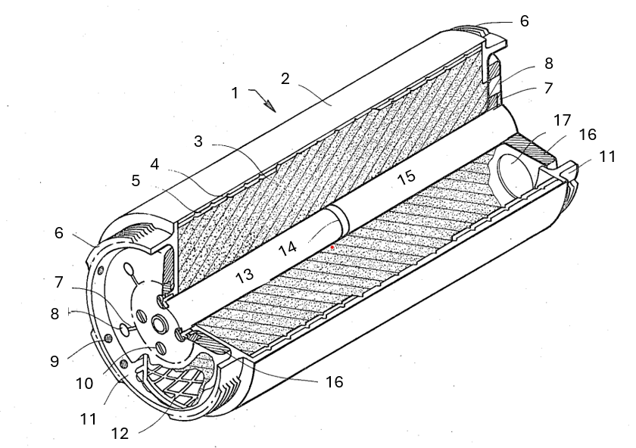
Figure 2 – Article 1 – Configured Blast Fragmentation (CBF) Warhead [10]
Item ID | Description | Item ID | Description
1 | Configured Blast Fragmentation (CBF) Warhead | 10 | Restraint Fasteners
2 | Aluminium Alloy Shroud | 11 | Shroud End Piece
3 | High Explosive (H.E.) Filling | 12 | Fragmentation Layer Pattern
4 | Full Length Fragmentation Layer | 13 | Central Booster Cavity
5 | Second Fragmentation Layer fore and aft | 14 | Booster
6 | Missile Interface Shroud | 15 | Safe Arming Unit (SAU)
7 | Detonation Trains (Stemming) | 16 | Shroud End Plate
8 | Detonator Locations | 17 | Missile Integration Port
9 | Missile Interface Dowel Holes
Table 1 – Article 1 – CBF Warhead Component Description [10]
    - Energetic material
      - The H.E. filling of the CBF Warhead consists of a 40Kg Aluminised Polymer-Bonded Explosive with the key energetic compound being Cyclotrimethylenetrinitramine also know as Research Development Explosive (RDX). The composition contains 70% RDX, 20% Aluminium, and 10% Hydroxyl-Terminated Polybutadiene (HTBP) and from hearin shall be refered to as ExRAB.
      - RDX provides the main energetic output of the composition and with the addition of aluminium powder as a fuel increasing the blast effect of the explosive considerably. [11]
Aluminum powder, a commonly used fuel additive with low cost and high energy density, is widely used to increase the calorimetric heat of explosion and expansion work of aluminized explosive. Moreover, adding aluminum powder to the explosive within a certain range can provide energy upon the shock wave energy and bubble energy for the underwater explosion. [11]
      - Table 2 [12] [13] below shows the hazard propeties of the ExploRAB composition. The CBF warhead requiering disposal does not have any other energetics present, although the finalised product does contain additional Detonators, Stemming and Boosters fitted these have been removed previously and only the main charge is preset during the disposal activity.
Note: As the CBF warhead requiring disposal was found in a poor condition following environmental trials and inadequet storge, hazard properties can only be used as reference due to the posibility of explosive degredation and increased sensitivness.
ExRAB Hazard Properties
Figure of Insensitiveness (FoI) | Figure of Friction (FoF) | Electro-Static Sensitivity (ESS) | Temperature of Ignition (TI) | Velocity of Detonation (VoD) | Hazard Classification (HC)
90 | 3.1 | 0.25J | 205°C | 7242m/s | 1.1D
Table 2 – ExRAB Hazard Properties [12] [13]
    - Trinitrotolulene Equivilance (TNTe) of ExRAB
      - Several different approches are available to calculate the TNTe of an explosive composition, using specific characteristics of the energetic in question such as Velocity of Detonation (VoD), Heat of Detonation, and Chapman-Jouguet (CJ) Pressure of Detonation to name a few. Comparing these values with the equivilent values of TNT the TNTe can be derived. [14]
      - For the purpose of this dispsoal project, the calclated method used to derive the TNTe of ExRAB applied a weighted Relative Effectivnes (RE) factor to the ingredients of the composition and compaires it with that of TNT.
‘Relative effectiveness factor, or R.E. factor, is a numerical value which relates an explosive’s demolition power to that of TNT in units of the TNT equivalent/kg (TNTe/kg). The R.E. factor is the amount of TNT to which 1 kg of an explosive is equivalent; the higher the R.E., the more powerful the explosive. This enables engineers to use different explosives when calculating blasting equations designed specifically for TNT.’ [15]
      - Table 3 below show the RE factors for the ExRAB composition. [16]
Constituent | Mass Fraction | RE Factor (approx.)
RDX | 0.7 | 1.6
Aluminium | 0.2 | 0.5
HTPB | 0.1 | 0.25
Table 3 – ExRAB RE Factors [16]
      - Using the information shown in Table 3, in addition to Equation 1 [14] shown below the TNTe can be determined for the ExRAB composition.
$${TNTe}_{{RE}_{i}}=\sum_{i=1}^{n}{f_{i}×{RE}_{i}}$$
Equation 1 – TNTe by RE Factor & Mass Fraction [14]
Where $f_{i}$ = The mass fraction of component i.
${RE}_{i}$ = Relative Effectiveness factor of component i compared to TNT.
n = Number of components.
${TNT}_{e}$= TNT Equivalence.
      - The TNTe for the ExRAB composition is show in Equation 2 below. Meaning that for every 1kg of ExRAB explosive, the blast output is equivilant to 1.25kg of TNT.
$${TNTe}_{ExRAB}= \left(0.70×1.60\right)+\left(0.20×0.50\right)+\left(0.10×0.25\right)=1.25$$
Equation 2 – TNTe of ExRAB Explosive
      - The TNTe for the ExRAB composition is show in Equation 2 below. For the 40Kg CBF Warhead requiring disposal its Net Explosive Quantity (NEQ) by weight is 40 x 1.25 = 50kg NEQ.

Article 2 - Shaped Charge (SC) Warhead

General Configuration
      - Refered to as a Shaped Charge (SC) Warhead with mechanical means for preventing rotation, the design is based on 1980 US patent 4,342,261. A general view of the SC Warhead is shown below in Figure 3 [9] and component identification shown in Table 4 [9].
      - The intention of introducing this development was to prevent deterioration of the SC jet formation, and ultimately its performance. The mechanical means of locking features address the difficulties of maintaining symmetry by preventing rotation, to increase the effectiveness of the collapse of the copper liner, maximise target penetration. [9]
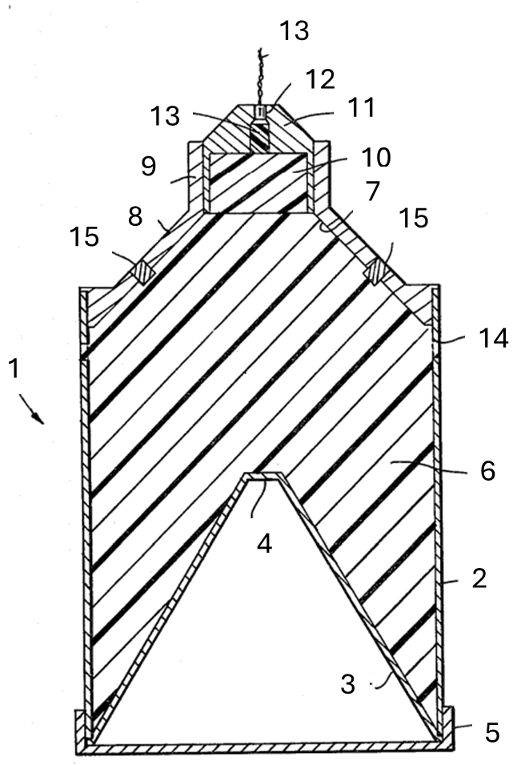
Figure 3 – Article 2 – Shaped Charge (SC) Warhead [9]
Item ID | Description | Item ID | Description
1 | Shaped Charge Warhead | 9 | Booster Retaining Cell
2 | Steel Case | 10 | Booster Charge
3 | Copper Conical Liner (42°) | 11 | Booster Centraliser
4 | Liner Truncated Apex | 12 | Booster Centralising Blank
5 | Liner Retaining Ring | 13 | Detonation Cord
6 | High Explosive (H.E.) Filling | 14 | Locking Holes
7 | Machined Surface | 15 | Locking Pins
8 | Rear Body Section
Table 4 – Article 2 – SC Warhead Component Description [9]
    - Energetic Material
      - The H.E. filling of the SC Warhead consists of a 40Kg Polymer-Bonded Explosive with the key energetic compound being Cyclotetramethylene Tetranitramine or High Melting Explosve (HMX) commonly known as octogen although there are several other names for the composition. [17] The composition contains 90% HMX and 10% Hydroxyl-Terminated Polybutadiene (HTBP) and from hearin shall be refered to as ExHB.
      - HMX is another powerful H.E with a very high VofD and detonation pressures, in part due to its higher density, but also due to its chemical stucture. Its use is typical where high performance is required such as directed energy weapons, SC Warheads, and implosion devices for Nuclear Warheads. Only until recently, HMX was known as the most powerful explosive in the world. [17]
      - Table 5 below shows the hazard propeties of the ExHB composition. The SC warhead requiering disposal does not have any other energetics present, although the finalised product does contain additional detonator cord and booster charges fitted, these have been removed previously and only the main charge is preset during the disposal activity.
Note: As the SC warhead requiring disposal was found in a poor condition following environmental trials and inadequet storge, hazard properties can only be used as reference due to the posibility of explosive degredation and increased sensitivness.
ExHB Hazard Properties
Figure of Insensitiveness (FoI) | Figure of Friction (FoF) | Electro-Static Sensitivity (ESS) | Temperature of Ignition (TI) | Velocity of Detonation (VoD) | Hazard Classification (HC)
69 | 3.3 | 0.45J | 302°C | 9020m/s | 1.1D
Table 5 – ExHB Hazard Properties [13] [17]
    - TNTe ExHB
      - For the purpose of this dispsoal project, the calclated method used to derive the TNTe of the ExHB composition contained within the SC warhead is to apply the weighted Relative Effectivnes (RE) as conducted wirh the CBF warhead.
      - Table 6 below shows the RE factors for the ExHB composition. [16]
Constituent | Mass Fraction | RE Factor (approx.)
HMX | 0.9 | 1.85
HTPB | 0.1 | 0.25
Table 6 – ExHB RE Factors [16]
      - The TNTe for the ExHB composition is show in Equation 3 below. Meaning that for every 1kg of ExHB explosive, the blast output is equivilant to 1.69kg of TNT.
$${TNTe}_{ExHB}= \left(0.90×1.85\right)+\left(0.10×0.25\right)=1.69$$
Equation 3 – TNTe of ExHB Explosive
      - For the 40Kg SC Warhead requiring disposal its Net Explosive Quantity (NEQ) by weight is 40 x 1.69 = 67.6kg NEQ.

Assessment of Risk
  - General overview
    - When munitions are stored in an unconditioned magazine the energetic compositions within will degrade faster than in a conditioned magazine due to the temperature cycling taking place with the addition of moisture which can increase their sensitiveness. During the manufacture process of explosives one of the critical measures is its sensitivity to external stimuli, these are identified in the Explosive Hazard Data Sheet (EHDS) which are obtained by conducting a series of EMTAP [18] tests which give a result to compare with other known explosives, generally RDX. [2]
‘The Energetic Materials Testing Assessment Policy Manual of Tests (EMTAP) is one of several standards relevant to the qualification of energetic materials and associated technical assessment for military explosives classification.’ [18]
Note: EMTAP data can be used for reference only in this instance, as both warheads have undergone considerable aging through environmental trials with the addition of unsuitable storage. The sensitiveness of explosive compositions in this state has likely increased.
    - There are various approaches that can be taken to dispose of high hazard munitions such as full order detonation, low order detonation, incineration, and remote breakdown of the munition [1]. The mitigations in place must be suitable to ensure full containment of a full order detonation and its associated hazards including, blast, fragmentation, thermal flux and Jet propagation.
    - As a minimum standard the MDA design solution must meet the following requirements. [7] Figure 4 [7] below shows the layout of the MDA.
- Be temporary in nature.
- Prevent escape of blast, debris, fragmentation, and other effects.
- Ensure a guaranteed minimum safe area around the MDA – Governed by location and surrounding facilities and storage.
- Provide the ability to re-set and allow disposal of two warheads to the same safety standard.
    - A detailed Risk Assessment for the disposal activity has been produced and shown in Annex A1, with the risk scoring matrix shown in Annex A2.
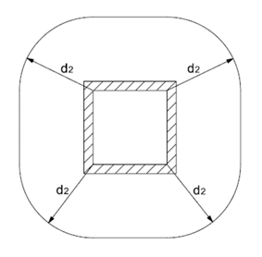
Figure 4 – MDA – Rectangular Destruction Area with Four Containing Faces & Open Roof [7]
  - Theoretical Calculations for Seperation Distances
    - Blast
    - Before a suitible MDA can be established first there must be an understanding of the expected blast, fragmetation, jet propergation and thermal effects a full order detonation of each warhead could produce in a Maximum Credibal Event (MCE).
‘It is essential that before any disposal activity takes place the potential likely and maximum credible events are identified i.e. any explosion or fire that could occur should all the procedural controls in place to prevent or mitigate against an event fail.’ [1]
    - Using the TNTe values derived for both warheads in para 3.1.3.6 and 3.2.3.4, 50kg TNTe and 67.6kg TNTe respectively, Hopkinson-Cranz’s Scaling Law can be applied to estimate blast overpressure and impulse at various distances for an unmitigated event. Thus, allowing safety distances to be determined for this specific disposal activity.
    - To reduce risk further a factor of safety of 20% should be applied to the calculated TNTe, therefore for blast analysis Article 1 CBF Warhead TNTe = 60kg and Article 2 SC Warhead TNTe = 81.2kg.
    - Equation 4 below shows the Hopkinson-cranze scaling law, which states under the same atmospheric conditions an explosive charge of equal dimentions and NEQ will produce proportionate blast overpressure and impulse effects at the same scaled distance [19] where:
$$Z=\frac{R}{W^{\frac{1}{3}}}$$
Equation 4 - Hopkinson-Cranze scaling law [19]
Z = Scaled Distance
R = Distance from Explosion (m)
W = TNTe Charge Weight (NEQ) (kg)
    - When the NEQ values shown in para 4.2.3 are applied to Equation 4, the scaled distances at various distances can be tertermined, see Equation 5 and Equation 6 below for the scaled distance at a distance of 50m from th point fo detonation.
$$Z=\frac{50}{{60}^{\frac{1}{3}}}=12.77m/{kg}^{\frac{1}{3}}$$
Equation 5 – Article 1 CBF Warhead Scaled Distance at 50m
$$Z=\frac{50}{{82}^{\frac{1}{3}}}=11.48m/{kg}^{\frac{1}{3}}$$
Equation 6 – Article 2 SC Warhead Scaled Distance at 50m
    - When Equation 5 and Equation 6 are compared, Article 2 has a lower value for Z than Article 1, meaning that a stronger blast effect would be witnessed at the same location. Which is intuitive as Article 2 has the larger NEQ. [20]
    - From Equation 4, the peak overpressure and impulse can be derived by using Kingery-Bulmash empirical data. There are several scenarios to which the data has been applied, for spherical surface bursts, to cylindrical airburst, to underwater explosions. Hemispherical surface burst data was used for simplicity during the analysis. Table 7 and Table 8 below shows the blast parameters at 50m for Article 1 and Article 2 respectively. [21]
Note: This is for an unconfined surface burst of a hemispherical charge which is not the case, this has been used for illustration purposes only.
Parameter | Estimated Value
Peak Overpressure | Approx. 1.4 kPa
Positive Phase Duration | Approx. 25-20 ms
Impulse | Approx. 25-25 Pa/s
Table 7 – Blast Parameters of Article 1 (CBF) Warhead at 50m [21]
Parameter | Estimated Value
Peak Overpressure | Approx. 1.6 kPa
Positive Phase Duration | Approx. 30-35 ms
Impulse | Approx. 30-40 Pa/s
Table 8 – Blast Parameters of Article 2 (SC) Warhead at 50m [21]
    - Figure 5 below shows the Effects of blast pressure on structures and the human body [22], as the peak overpressure is increased from 1psi (6.89kPa) to 20psi (137.90kPa).
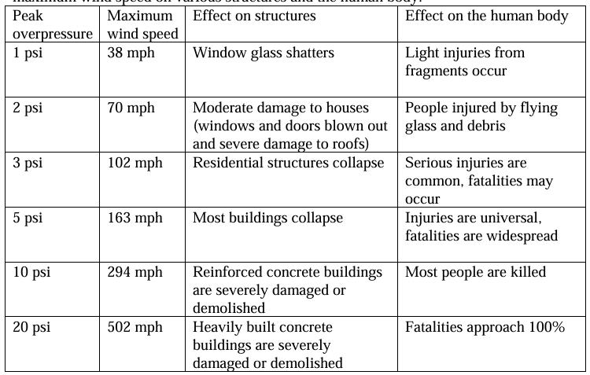
Figure 5 – Effects of Blast Pressure on Structures and the Human Body [22]
    - When the blast parameters shown in Table 7 and Table 8 are compared with Figure 5, an un-mitigated detonation of both, Article 1 and Article 2 (separately) at 50m there would be minimal blast hazard. However, blast is only one aspect of the explosive hazard associated with this disposal activity.
    - Both Article 1 and Article 2 have different end-effects, for the CBF warhead, fragmentation is the main concern as blast dissipates quickly over a distance, fragments remain a hazard over much larger ranges. For the SC warhead, jet propagation is the immediate hazard, both effects can be calculated using empirical formulae to allow for the appropriate mitigations to be applied.
  - Jet propagation
    - Using hydrodynamic penetration theory, multiple aspects of the SC jet behaviour can be determined using empirical calculation. Equation 7 and Equation 8 below show two formulae to calculate SC jet penetration into a target, although there are several formulae available considering different aspects of the SC jet formation.
$$P=L_{j}{\left(\frac{ρ_{j}}{ρ_{t}}\right)}^{\frac{1}{2}}$$
Equation 7 – Idealised Hydrodynamic Penetration [16]
Where:
P = Penetration Depth, Ρ_{j} = Jet Density, Ρ_{t} = Target Density and L_{j} = Jet Length.
$$P=K×{\left(\frac{M}{d^{2}×f_{c}}\right)}^{\frac{1}{3}}×V_{0}^{\frac{2}{3}}$$
Equation 8 – National Defence Research Committee (NDRC) Modified Formula [23]
Where:
P = Penetration depth (m), M = Projectile mass (kg), Projectile diameter (m), f_{c} = Concrete compressive strength (MPa), V_{o} = Impact velocity (m/s), K = Empirical constant.
    - In their design mode, SC warheads require a suitable Stand-off Distance from the target to allow for optimum jet formation and target penetration. During this disposal activity the SC will be orientated with the jet propagating into the ground with minimal Stand-off Distance to inhibit jet formation and propagation.
    - For this reason, calculations for the SC warhead jet propagation hazard have not been included in this report, as the greatest hazard present during the disposal activity for both Articles will be fragmentation.
  - Fragmentation
    - Fragmentation theory predominantly relies on Mott, Gurney and Taylors equation to calculate mass & distribution, velocity, and angle from point of initiation respectively. These equations form the basis of fragmentation theory. Equation 9 below shows the Gurney equation for initial fragment velocity, for the purpose of this report, only fragment velocity has been calculated.
‘The Gurney Equations are a range of formulae used in explosives engineering to predict how fast an explosive will accelerate a surrounding layer of metal or other material when the explosive detonates.’ [24]
$$V=\sqrt{2E}×\left(\frac{1}{\sqrt{1+\frac{M}{C}}}\right)$$
Equation 9 – Gurney Equation Fragment Velocity [24]
Where:
V = Velocity of fragment or casing
$\sqrt{2E}$ = Gurney Constant (E = Gurney Energy)
C = Mass of explosive
M = Mass of casing
Note: For explosive compositions ExRAB and ExHB an estimation of their gurney constant has been made by comparing them with similar compositions and has been estimated to be 2.6mm/µs and 2.9mm/µs.
    - Using the Gurney constant value of 2.6 for the CBF warhead with a casing mass of 12Kg, the following equation was used to derive the initial fragment velocity, see Equation 10 below.
$$V=2.6×\left(\frac{1}{\sqrt{1+\frac{12kg}{40kg}}}\right)=2,280m/s$$
Equation 10 – CBF Warhead Fragment Velocity
    - Using the Gurney constant value of 2.9 for the SC warhead with a casing mass of 8Kg, the following equation was used to derive the initial fragment velocity, see Equation 11 below.
$$V=2.9×\left(\frac{1}{\sqrt{1+\frac{8kg}{40kg}}}\right)=2,650m/s$$
Equation 11 – SC Warhead Fragment Velocity
Note: The equations shown above are based on a cylindrical charge with a natrually fragmenting case, the CBF warhead consists of pre-formed fragments of uniform geometry and mass, improving effiency through drag reduction, and less energy lost to break up the case, the velocities and distances of fragmentation are expected to be higher, this can be confirmed through modeling.
    - As the CBF warhead consists of a pre-formed fragmentation design, we can deduce the K.E of a fragment using the standard formula shown below in Equation 12.
$$K.E=\frac{1}{2}×mV^{2}$$
Equation 12 – Kinetic Energy [16]
Where:
K.E = Kinetic Energy
m = Mass (Fragment)
V = Velocity
    - Knowing that the pre-formed fragments are made of a carbon-steel cube of dimensions 10mm x 10mm, and the density of carbon steel used for the calculation was 7,850kg/m³ using Equation 13 below the mass of the fragment was calculated.
$$Mass=Volume×Density$$
$$Mass=1×{10}^{-6}m^{3}×7,850kg/m^{3}=7.85×{10}^{-3}kg=7.85grams$$
Equation 13 – Fragment Mass
    - Using the information calculated above and in previous sections the fragments kinetic energy can be calculated as shown below in Equation 14.
$$K.E=\frac{1}{2}×7.85×{10}^{-3}×{\left(2.28×{10}^{3}\right)}^{2}$$
$$K.E=\frac{1}{2}×7.85×{10}^{-3}×5.21×{10}^{6}$$
$$K.E=\frac{1}{2}×40.948×{10}^{3}$$
$$K.E=20.474×{10}^{3}=20.474kJ$$
Equation 14 – Fragment Kinetic Energy
  - Safety modelling (Software)
    - Initial calculations should always be followed with numerical simulations as there are many other aspects of the explosion to consider such as fragment velocity decay, soil heave and accuretly applies the geometry of the munition under test. Explosive saftey modeling is an extreamly valuable tool that allows the user to simulate blast overpresures, thermal radiation, SC jet propergation and fragmentation effects with a very high degree of accuracy.
    - The modeling software has the ability to modify charge type, geometry and yield, additionally the effects to structures can also be added to the simulation in a 3D enviroment to allow analysis of real-world senarios and determaning Quantity Distances (QDs).
    - Some of the key simulation packages used within the industry for this analysis are Safety Assessment For Explosive Risk (SAFER) model, Death and Injury Resulting from Explosion (DIRE) and CONWEP .Using this information we can calculate the safety distances required for the disposal activity. [25]
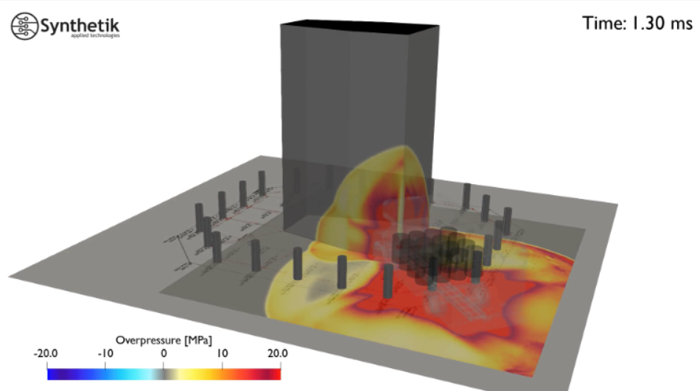
Figure 6 – Typical Synthetik© Blast FEM Simulation Output [26]
    - Through inputting the relevent parameters into the safety model, a fragmentation hazard zone has been generated and applied to the MDA as shown in Section 5. Figure 6 above shows a typical output of explosive safety modeling software.
    - There are typically two key terms when discussing fragment hazard zones and that is the Lethal Fragmentation Radius (LFR) and Maximum Fragment Range (MFR). The LFR is the distance within which there is a high probabilty of lethal fragmentation, where the MFR is the farthes a fragment is expected to travel, still with enough energy to cause damage or injury, this can be over 1000m. [27]
‘Lethal radius is here defined as the distance from the detonation point where the effective fragment (80 J) density is 1 frag/m².’ [27]
    - Five distinct hazard zones have been generated by the simulation as detailed below: [24]
Zone 1 – Lethal Fragment Radius 0-15m
– Heavy structural damage and collapse
– Blast overpressures more than 100kPa
– Extremely high fragment density
– Fatal to personnel
Zone 2 – Severe Injury Zone 15-50m
– Mild structural damage, glass shatter, vehicle damage
– Blast overpressures from 20-100kPa
– Lethal fragments are still present
– High risk of penetrating injuries to personnel
Zone 3 – Fragmentation Hazard Zone 50-120m
– Shelter in place advised
– Blast impulse may cause minor injuries, ear damage
– Lethal fragments still possible
– Specific Personal Protective Equipment (PPE) required
Zone 4 – Injury Risk Zone 120-300m
– Low blast overpressure, less than 10kPa
– Non-Lethal fragments possible
– Risk of lacerations and eye injury
Zone 5 – Injury Risk Zone 300-1000m
– Low probability of injury to personnel
– High-velocity fragments possible but rare
– Will be used as the minimum exclusion zone during disposal
Note: This is for an un-mitigated full-order detonation of the CBF warhead, considered the worst-case scenario or MCE during the disposal activity. The hazard zones described above have been shown in relation to the MDA and the OEM production facilities in Section 5 of this report.
  - Environmental Considerations
    - The environmental impact of ordinance disposal is considerable, from air polution, soil and waterway contamination, noise, and also the impact to wildlife. However, due to the hazardous nature of some operations there are times when dispensations are made by the HSE and applicibile governing bodies.
    - For example, the most widely used disposal method for bare charge explosive is through Open Burning (OB), which creates heavily polluted, toxic smoke. Siting of an explosive buring ground or MDA must adhear to strict environmental controls. [1]
‘The disposal of explosives by burning is currently subject to the provisions of the Clean Air (Emission of Dark Smoke (Exemption) Regulations 1969 (SI/1969/1263).’ [1]
    - All chemicals used during the disposal activity must have suitible Control of Substances Hazardous to Health (CoSHH) assessments produced, this will ensure that the correct PPE is worn by personal and the appropriate exposure times follwed. CoSHH assessments produed for the disposal activity have not been included in this report.
    - All waste generated during the disposal activity will be Certified Free From Explosive (CFFE) prior to entering the relevent waststreams, ensuring at no point is there contamination of any waterways or public waste streams. Soil from the immediate disposal area (within MDA) will be tested removed, disposed and replaced if necessery.

Disposal Process

Site Overview
    - Figure 7 below shows an arial view of the production area (purple) and the storage area where both the SC warhead and CBF warhead were found (Red).
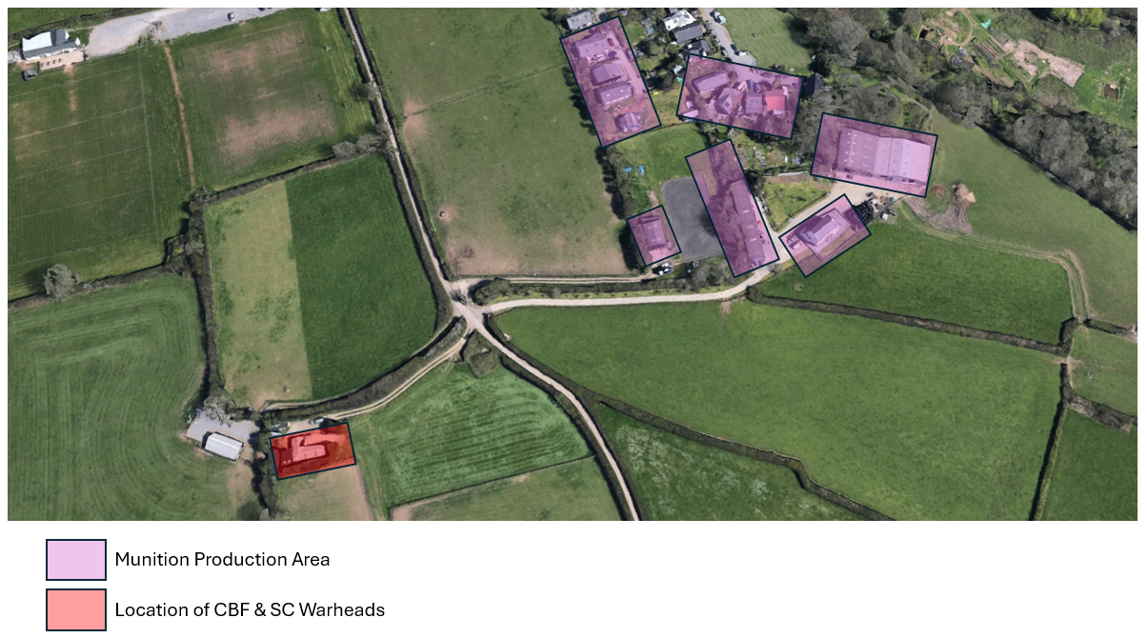
Figure 7 – Site Overview [28]
Note: This location has been used for illustration purposes only and is not the location of a munition production facility.
    - Figure 8 below shows an arial view of the production area (purple), where both the SC warhead and CBF warhead were found (Red), location of the MDA (yellow), and the transport route to the MDA approx. 1100m (blue dotted).
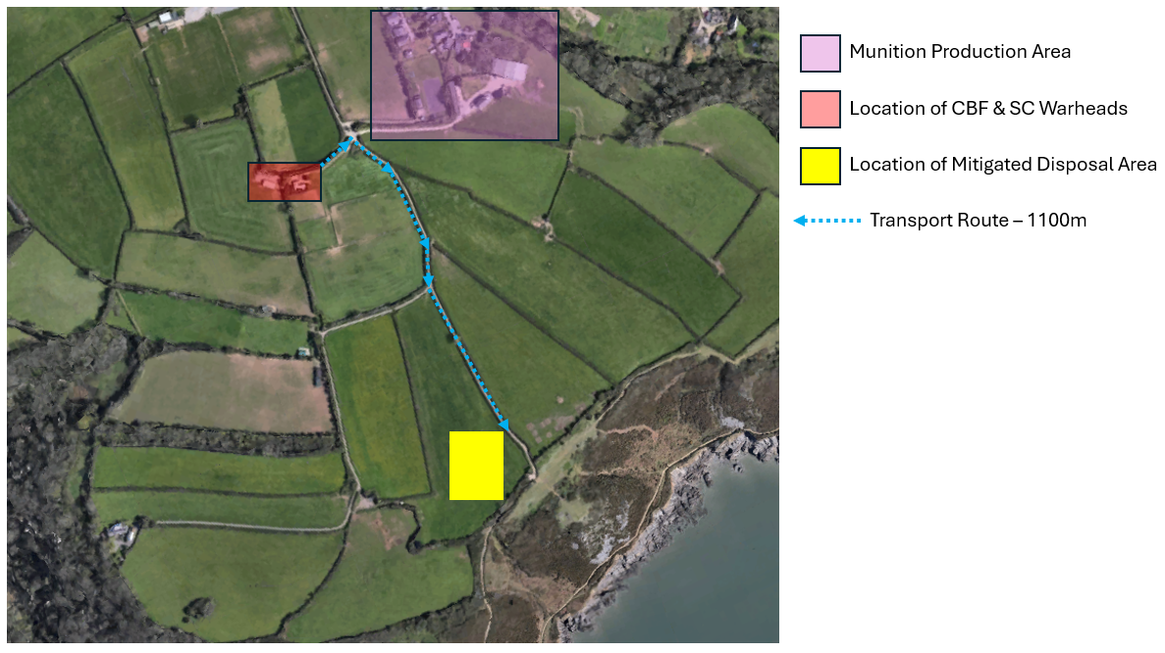
Figure 8 – Overview of Disposal Route to MDA [28]
    - Figure 9 below shows an arial view of the MDA (yellow checkered), with the simulated hazard zones specified in para 4.5.5 overlayed.
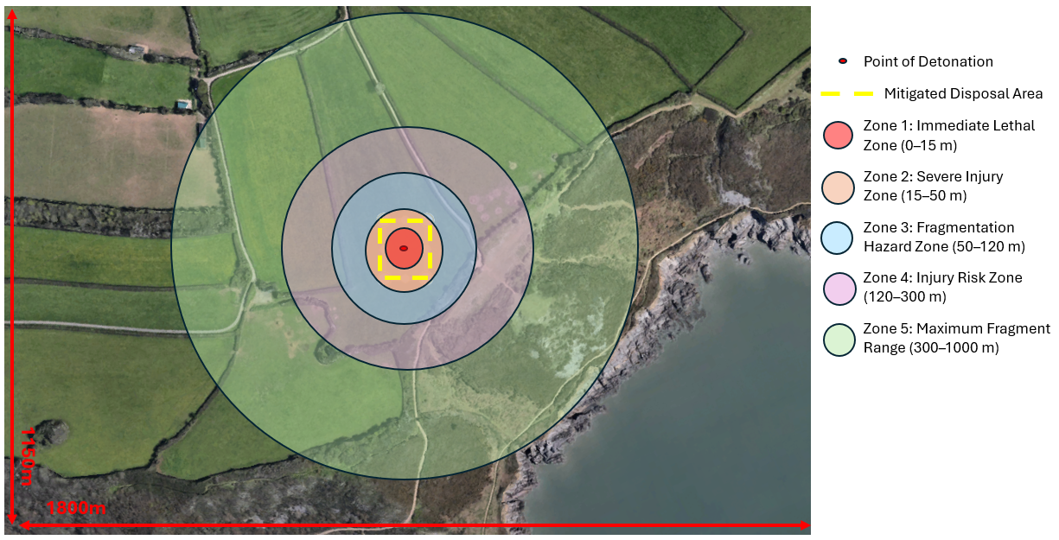
Figure 9 – Overley of Hazard Zones on MDA [28]
  - Process Flow
    - A top-level process flow of the disposal has been shown below in Figure 10.
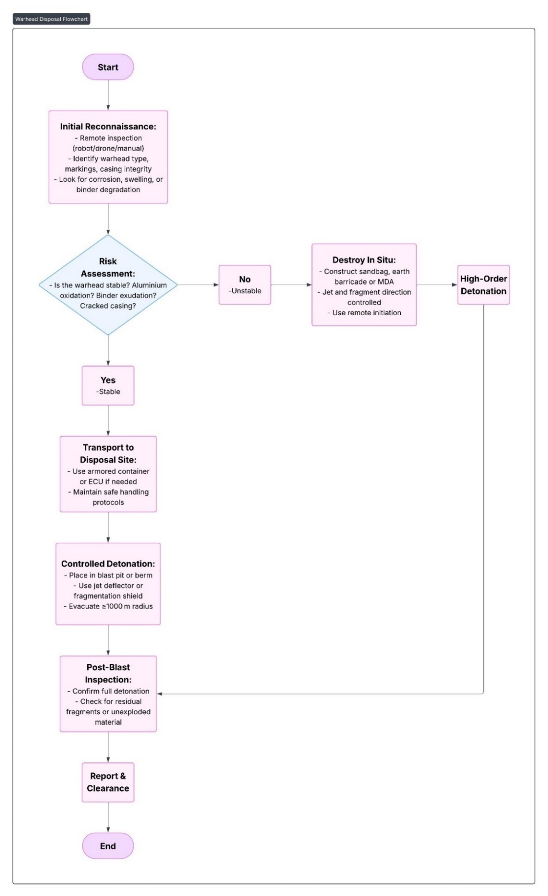
Figure 10 – Disposal Process Flow
  - Mobilisation
    - Prior to any mobilisation activities commencing, formal approval of a temporary explosive disposal licence for the MDA from the HSE was required. As the HSE and EOD have been engauge with throughout this process, approval was given and the mobilisation activites commenced. In additon to the HSE, the local government and coast guard were informed of the planned disposal date.
    - The Mitigated Disposal Area (MDA) was sited at the location shown in Figure 9. The MDA consisted of large shipping containers double stacked as inner walls, around a central 10M X 10M Disposal Area.
    - All outer walls were doubled buttressed with earth mounding up to the mid-point of the upper container. The central disposal area was lined with an infill of multiple 1 tonne sandbags during the disposal, up to 800 tonnes in total. [7]
    - Three of the four sides of the disposal area remained in place for both detonations; the front face was assembled and reassembled after placement and detonation of the warheads within the central location.
    - As the site is on private land, there is no entry point to general public near to the MDA, additionally the airspace above the MDA is a registered no-fly zone so there is no need to inform the Civil Aircraft Authority (CAA) to request any diversions on the day of disposal, all areas were confirmed clear prior to the disposal of the munitions.
  - Disposal activity
    - Firstly, all arears were confirmed clear with inter-site roads blocked to allow safe transport of the warheads from the point of their storage location to the MDA. A detailed Standard Operating Procedure (SOP) was produced for the disposal operation but has not been included in this report. The following sections are an overview of the task.
    - The first warhead for disposal was the SC warhead, as discussed previously, to limit the effectivnes of its jet perfomance, the warhead was orientated with the SC liner facing into the ground with minimal stand-off distance give to try and inhibit jet formation and propergation.
    - All MDA assembly was complete prior to any warhead movment, three faces of the MDA were assembled with internal area filled with 1 tonne sandbags, with a central area prepared for the warhead to arrive banded to a pallet. An ilustation of the MDA side on view with the SC warhead present has been shown in Figure 11 below.
    - When the warhead was transported by forklift truck to the cental MDA, a donor charge consisting of 300g of Plastic Explosive (PE 8) was supplied by the OME production facitily. The donor charge was applied to the side face of the warhead, the intention is always to preven the warhead detonating in its design mode, where it is at its most lethal. In addition to the donner charge a L2A2 electrical detonator was inserted into the doner charge and firing circuit to allow connection to a shrike remote firing device.
‘The established disposal techniques for conventional munitions or unexploded ordnance (UXO) typically involve high-order, sympathetic detonation caused by bare donor charges.’ [29]
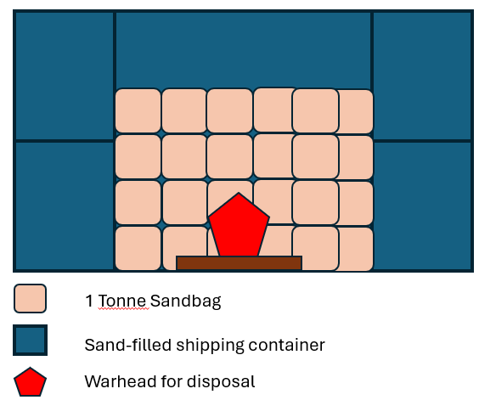
Figure 11 – Side View MDA with SC Warhead Present [28]
    - Figure 12 below shows an ilustration of an areal view of the SC warhead within the MDA prior to initiation, all clear was given and EOD personnel intiated the firing sequence to complete the detonation. High-resolution recordings were made during the disposal activity to asses initial estimations, no images have been included within this report for security reasons.
    - A stand-down period of 24 hours was applied to the MDA and surrounding hazard zones prior to re-entry of any personnel.
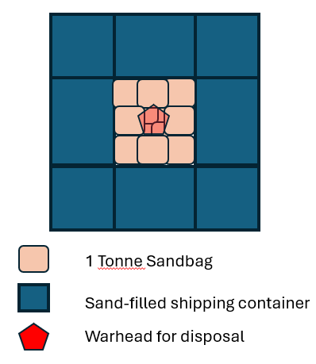
Figure 12 – Plan View of Complete MDA with SC Warhead [28]
    - After the 24 hour stand down period was followed, EOD personnel approached the MDA wearing appropriate PPE to inspect the area. Confirmation was received that there was no clear indication of un-exploded material and that the disposal of the SC warhead was succsesfull.
    - Following confirmation it was safe to proceed, the MDA was repositions with additional sandbags to replace any lost during the previous warhead disposal. The MDA was reassembled with the CBF warhead as shown below in Figure 13.
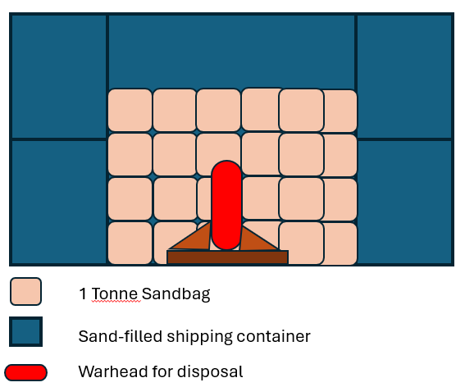
Figure 13 – Side View of MDA with CBF Warhead [28]
    - The same process that was applied to the SC warhead was followed for the CBF warhead disposal, donner charge and detonator was applied to the side face of the warhead, with the warhead positioned virtically to direct any fragmentation into the surrounding MDA instead of virtically.
    - After all clear was received, EOD personnel initiated the donor charge for disposal of the CBF warhead, again a stand-down period of 24 hours was applied to the MDA and surrounding hazard zones prior to re-entry of any personnel.
    - After the 24 hour stand down period was followed, EOD personnel approached the MDA wearing appropriate PPE to inspect the area. Confirmation was received that there was no clear indication of un-exploded material and that the disposal of the CBF warhead was succsesfull.
  - Waste treatment
    - Following confirmation it was safe to proceed, the MDA was slowly dismantled with the use of ‘Atmosphères Explosibles’ (ATEX) metal detection on all sandbags throughout the process to capture all metalic waste produced during the activity.
    - When all scap metal waste was collected, it was placed into an appropriate stillage and transported to the OEM facility proving oven to CFFE. All sand waste was treated as hazardouse waste and was disposed of through the appropriate disposal routes. The shipping containers were dissassembled and transported from the OEM site by the EOD contractor for future use.
    - Soil testing was conducted of the top layer of soil in the immiediate MDA and was found to contain trace contamination, therefore no replacement was made.

Discussion
  - Considerable effort must first be made to understand the ordinance which requires disposal, their energetic compositions, end-effects, NEQ and history to name a few. If the article cannot be transported to a suitable disposal site due to no transport classification or that it is too hazardous for road travel, detonation in-situ must take place.
  - Empirical formulae are useful as a quick indication of potential hazards and their severity, although computational models are much more accurate and consider multiple aspects of the explosion process. Factors such as fragmentation shape, its drag coefficient, fragmentation densities are accounted for during the simulation, which intern produces highly accurate information in visual models that can be used to apply suitable safety measures during real-world scenarios such as munition disposal.
  - The location of the MDA took substantial consideration and discussion with the OEM and the HSE to ensure the selected area was suitable. Using information calculated through explosive safety modelling software the MDA was selected to pose a minimal threat to the OEM facility, and to any near-by public access areas.
  - A fundamental requirement for the disposal activity to take place was the written approval of the request to apply for permission of a temporary explosive licence for disposal of munitions up to an NEQ of 85kg. If this was not granted by the HSE, the disposal activity would not be authorised to take place and further mitigations, or relocation of the MDA may have been required.
  - Careful construction of the MDA took a considerable amount of time to ensure the area was fully secure and suitable for the following disposal activities. Final checks were made prior to transportation of the warhead to the MDA, EOD staff conducted placement of the donor charge and applicable firing circuit. Final assembly of the MDA was carried out with extreme caution not to disrupt the warhead and explosive chain.
  - Both high-order detonations took place as planned with no residual un-exploded material remaining on completion, this was confirmed by EOD personnel after following 24 hours stand-down period, with re-entry authorised when it was safe.
  - A review was held of the high-resolution footage taken during the disposal of both warheads and was confirmed that although there was a clear visible reaction at the point of detonation, no blast, fragmentation, shrapnel, or debris was ejected from the MDA. The resulting disposal activity was conducted safely and successful with the correct level of mitigations applied.
  - The de-mobilisation phase of the programme took considerable effort to ensure that no breach of any environmental regulations occurred, all waste removed from within the MDA was managed under strict control to ensure all articles had been CFFE with the appropriate certification issued. Soil contamination testing was conducted within the MDA with no abnormal readings found.

Conclusion
  - The legal, safety, ethical and regulatory obligations associated with the disposal of Ordinance Munitions and Explosives (OME) is substantial and requires SQEP for the initial assessment and through the disposal process. EOD engagement is strongly advised when a disposal situation of this nature occurs, open and frequent conversation with the HSE will support and drive the progress to gaining approval for the disposal activity to take place.
  - A detailed review of each munition requiring disposal must be conducted to understand the current build state, its history, dimensions, geometry, materials, weight, and NEQ of the energetic compositions contained within to allow for accurate hazard analysis to be made on a full-order detonation event.
  - Several empirical formulae are available to determine several aspects of the disposal process from determining the NEQ of a munition, determining fragmentation velocities and energies to anticipated penetration depth of a SC warhead. However, since the dawn of Computational Fluid Dynamics (CFD) software, there are many tools available to calculate energetic outputs to allow for accurate hazard analysis and suitable mitigations determined to allow for safe disposal.
  - EOD personnel must be present and lead OD disposal activities; their training and expertise are crucial to the safe and professional conduct of the activity. OEM senior leadership team must approve of the intended disposal method and location at the soonest opportunity to ensure site compliance prior to proceeding with HSE approval.
  - All surrounding areas to the MDA were evacuated prior to the transport of the warhead for disposal, a pre-fire check was conducted to ensure no personnel or public had inadvertently approached the MDA. All clear was received when all areas were confirmed vacant, and fire signal was given to initiate detonation.
  - Other methods of disposal are available but due to the condition of both warheads, OD was the most suitable method to ensure the entire activity risk was ALARP. The project was complete in line with the project proposed timeline, although the cost of the project exceeded the initial estimate as additional support was needed from the EOD during the initial investigation phase.
  - This report has only scratched the surface of the considerations required for the safe disposal of high-hazard large munitions. Many aspects of the process have not been included for practical reasons. Legislation and requirements detailed within this report are not an exhaustive list and many more areas of the disposal activity would be included in a full disposal report on completion of all activities.

References

[1] | C. E. I. Group, “Guidance for the Safe Management of the Disposal of Explosives,” EIG, UK, 2020.
[2] | C. Rees, “Major Project Proposal,” University of Wales Trinity St Davids (UWTSD), Swansea, UK, 2024.
[3] | Health & Safety Executive (HSE), Explosives Regulations 2014 - Guidance on Regulations – Safety provisions, Norwich, UK: Health & Safety Executive (HSE), 2014.
[4] | M. o. D. (MoD), “JSP762 Section 9 - Policy and Procedures for Munitions Disposal,” 15th November 2014. [Online]. Available: https://assets.publishing.service.gov.uk/government/uploads/system/uploads/attachment_data/file/491739/20150427_FOI_03698_JSP762_Ch9_Annex-O.pdf. [Accessed 28 06 2025].
[5] | M. o. D. (MoD), “JSP520 Safety and Environmental Management of Ordnance, Munitions and Explosives over the Equipment Acquisition Cycle,” 08th July 2015. [Online]. Available: https://assets.publishing.service.gov.uk/government/uploads/system/uploads/attachment_data/file/481279/20150813-JSP520_Pt2_Vol01_Introduction_Issue4.2_Final-U.pdf. [Accessed 28 06 2026].
[6] | North Atlantic Treaty Orginization (NATO), “DESIGN PRINCIPLES, REQUIREMENTS, AND SAFETY ASSESSMENT FOR THE SAFE DISPOSITION OF MUNITIONS (An Overview of STANAG 4518),” North Atlantic Treaty Orginization (NATO), Virginia, USA, 1998.
[7] | K. A. C. M. C. FIExpE, “Guidance Notes for Commercial Explosive Ordinance Disposal (EOD) Operations in Great Britain,” The Institute of Explosive Engineers, Stafford, UK, 2023.
[8] | Legislation.gov.uk, “The Hazardous Waste (England and Wales)Regulations 2005,” Legislation.gov.uk, 01 01 2005. [Online]. Available: https://www.legislation.gov.uk/uksi/2005/894/contents. [Accessed 27 05 2025].
[9] | J. N. Majerus, “Shaped Charge Warhead With Mechanical Means For Preventing Rotation”. Maryland, USA Patent 4,342,261, 3rd August 1982.
[10] | R. G. Moe, “Configured Blast Fragmentation Warhead”. California, USA Patent 3,853,059, 11th January 1971.
[11] | Alicia E. Ares, “Effect of Aluminum Powder Content on Air Blast Performance of RDX-Based Explosive Grenade Charge,” Advances in Material Science & Engineering, vol. 2022, no. 1, p. 7, 22 January 2022.
[12] | S. K. K. &. T. T. Tsonev, “Aluminized Enhanced Blast Explosive Based on Polysiloxane Binder,” Propellents, Explosives & Pyrotechnics, p. 13, 3rd December 2021.
[13] | P. A. B. a. D. S. G. Murray, Explosives, Propellents & Pyrotechnics, Shrivingham: Brassey's (UK) LId , 1989.
[14] | M. K. M. T. Robert Panowicz, “Analysis of Criteria for Determining a TNT Equivalent,” Journal of Mechanical Engineering, vol. 10, no. 554, p. 7, 2017.
[15] | Tanner Metzko, “How TNT Equivalent is Applied in Blast Containment,” Total Shield, 16th August 2022. [Online]. Available: https://totalshield.com/blog/how-tnt-equivalent-is-applied-in-blast-containment/?form=MG0AV3. [Accessed 15th 05 2025].
[16] | P. W. Cooper, Eplosives Engineering, New Mexico, USA: Wiley-VCH, 1996.
[17] | P. P. &. N. M. Michael K. Stenstrom, “Treatment and Biodegradation of the High Explosives HMX, RDX, and TNT : A litrature Review,” School of Engineering and Applied Science, University of California , Los Angeles, USA, 1996.
[18] | Health and Safety Executive, “Explosives Testing,” Health and Safety Executive, 01 01 2022. [Online]. Available: https://www.hsl.gov.uk/product-and-process-validation-testing/explosives-testing. [Accessed 22 05 2022].
[19] | T. a. H. M. Wei, “A new blast wave scaling,” Shock Wave, vol. 31, no. 1007, p. 203, 2021.
[20] | W. E. Baker, “Blast Pressure Effects: Chapter 1 - An Overview,” in Blast Pressure Effects, San Antonio, Wilfred Baker, 1987, p. 56.
[21] | U. Nations, “Kingery-Bulmash Blast Parameter Calculator,” United Nations - International Ammunition Technical Guidlines (IATG), 21 April 1984. [Online]. Available: https://unsaferguard.org/un-saferguard/kingery-bulmash. [Accessed 01 06 2025].
[22] | J. P. P. K. L. C. R. Karl Zipf, “Explosions and Refuge Chambers - Effects of blast pressure on structures and the human body,” 01 01 2025. [Online]. Available: https://www.cdc.gov/niosh/docket/archive/pdfs/NIOSH-125/125-ExplosionsandRefugeChambers.pdf. [Accessed 15 06 2025].
[23] | S. a. T. H.-K. K. Kim, “Development of Energy-Based Impact Formula—Part I: Penetration Depth,” Applied Sciences, p. 14, 19th July 2020.
[24] | The International Ammunition Technical Guidelines (IATG), “Formulae for ammunition management,” The International Ammunition Technical Guidelines (IATG), p. 50, 8th January 2021.
[25] | Department of Defense Explosives Safety Board , “USER’S REFERENCE MANUAL FOR THE SAFETY ASSESSMENT FOR EXPLOSIVES RISK SOFTWARE,” Department of Defense Explosives Safety Board , Virginia, USA, 2007.
[26] | Synthetik Applied Technologies, “Blast FEM,” Synthetik Applied Technologies, 01 01 2025. [Online]. Available: https://www.synthetik-technologies.com/modeling-and-simulation. [Accessed 25 06 2025].
[27] | E. K. Alan C, “Application of a terminal-ballistics model for estimating munition lethal radius on mortar projectiles and rocket warheads,” The Journal of Defense Modeling and Simulation: Applications, Methodology, Technology, vol. 16, no. 4, pp. 601-612, 2022.
[28] | C. Rees, “MDA Powerpoint,” University of Wales Trinity St David (UWTSD), Swansea, 2025.
[29] | W. Bagley, “Disposal of Insensitive Munitions,” Defence Systems Information Analysis Center, vol. 6, no. 3, p. 4, 2019.
[30] | Yourdictionary, “Magazine definition,” Yourdictionary Lovetoknow Corp, Florida, 2021.
[31] | United Nations Office for Disarmament Affairs (UNODA), “Ammunition International Technical Guidline - Surveillance & In-service Proof,” 01 02 2015. [Online]. Available: https://s3.amazonaws.com/unoda-web/wp-content/uploads/2019/05/IATG-07.20-Surveillance-and-In-Service-Proof-V.2.pdf#:~:text=Surveillance%20is%20the%20systematic%20method%20of%20evaluating%20the,the%20reliability%2C%20safety%2C%20and%20operational%20effecti. [Accessed 27 06 2024].

Annex A – Risk Assessment
Annex A1 – General Risk Assessment
General Risk Assessment
Reference Number: Major_Project_Disposal_Risk_Assessment_10_12_2024
Site: OEM | Work Area: Local Mitigated Disposal Area (MDA)
Assessor’s Name(s):  Creighton Rees, A Other. | Review Date:  10/01/2025
Related Risk Assessments:  OMESite_RA_General_Disposal | Related Work Instructions:  Major_Project_Disposal_Work_Instruction_10_11_2024
Description of Task/Process:

Open Detonation (OD) of one Configured Blast Fragmenting (CBF) Warhead and one Shaped Charge (SC) Warhead at a large munition manufacturing site within a purpose-built Mitigated Disposal Area (MDA). Both assets are legacy warheads that have been stored in unconditioned magazines after being returned from Environmental Testing.
Assessor’s Signature:  Creighton Rees – C. Rees  Anton Other – A, Other | Date:  10/12/2024

Risk Assessment Scoring
Identified Hazard | Persons at Risk | Existing Control Measures | Severity | Probability | Existing Risk Level | Additional Controls | Severity | Probability | Final Risk Level
Detonation  Impact | Engineer, Local Workers | -Only one item will be present in the MDA during disposal.  -The MDA will be reassembled after the first OD with mitigations reapplied in readiness for the second item requiring disposal.  -Mitigations will be applied to contain any blast/fragmentation/fire ball/Jet effect produced by item 1 and 2 during OD.  -Sufficient Blast-mats, sandbags and containment will be used to prevent any fragmentation or blast effect escaping the MDA.  -Item 1 the CBF warhead will have blast-mats positioned above and around the warhead preventing propagation of fragments outside of MDA.  -Item 2 the SC warhead, will be orientated with the liner facing down into the ground.  -All general site activities will be ceased during the day of OD activities. | 4 | 3 | 12 | -Donner charge and detonator will be applied to warhead requiring disposal at the last moment, prior to evacuation of MDA and ultimately firing to achieve disposal.  -A 24 hour stand down period will be applied to the MDA post-firing to ensure all flames have extinguished, heat has subsided, and that no residual/uninitiated explosive remain a hazard. Confirmed during post-firing inspection of MDA conducted by EOD officer.  -Explosives contained within the warheads, and energetics used for the disposal activity have been deemed insensitive to impact.  -Remote radiography has been conducted on both Item 1 and Item 2 with the results showing no severe degradation of the fillings. | 4 | 2 | 8
Detonation  Friction | Engineer, Local Workers | -Only one item will be present in the MDA during disposal.  -The MDA will be reassembled after the first OD with mitigations reapplied in readiness for the second item requiring disposal.  -Mitigations will be applied to contain any blast/fragmentation/fire ball/Jet effect produced by item 1 and 2 during OD.  -Sufficient Blast-mats, sandbags and containment will be used to prevent any fragmentation or blast effect escaping the MDA.  -Item 1 the CBF warhead will have blast-mats positioned above and around the warhead preventing propagation of fragments outside of MDA.  -Item 2 the SC warhead, will be orientated with the liner facing down into the ground.  -All general site activities will be ceased during the day of OD activities. | 4 | 3 | 12 | -Donner charge and detonator will be applied to warhead requiring disposal at the last moment, prior to evacuation of MDA and ultimately firing to achieve disposal.  -A 24 hour stand down period will be applied to the MDA post-firing to ensure all flames have extinguished, heat has subsided, and that no residual/uninitiated explosive remain a hazard. Confirmed during post-firing inspection of MDA conducted by EOD officer.  -Explosives contained within the warheads, and energetics used for the disposal activity have been deemed insensitive to friction.  -Remote radiography has been conducted on both Item 1 and Item 2 with the results showing no severe degradation of the fillings. | 4 | 2 | 8
Detonation  Static | Engineer, Local Workers | -Only one item will be present in the MDA during disposal.  -The MDA will be reassembled after the first OD with mitigations reapplied in readiness for the second item requiring disposal.  -Mitigations will be applied to contain any blast/fragmentation/fire ball/Jet effect produced by item 1 and 2 during OD.  -Sufficient Blast-mats, sandbags and containment will be used to prevent any fragmentation or blast effect escaping the MDA.  -Item 1 the CBF warhead will have blast-mats positioned above and around the warhead preventing propagation of fragments outside of MDA.  -Item 2 the SC warhead, will be orientated with the liner facing down into the ground.  -All general site activities will be ceased during the day of OD activities. | 4 | 3 | 12 | -Donner charge and detonator will be applied to warhead requiring disposal at the last moment, prior to evacuation of MDA and ultimately firing to achieve disposal.  -A 24 hour stand down period will be applied to the MDA post-firing to ensure all flames have extinguished, heat has subsided, and that no residual/uninitiated explosive remain a hazard. Confirmed during post-firing inspection of MDA conducted by EOD officer.  -Explosives contained within the warheads, and energetics used for the disposal activity have been deemed insensitive to static.  -Remote radiography has been conducted on both Item 1 and Item 2 with the results showing no severe degradation of the fillings. | 4 | 2 | 8
Detonation  Confinement | Engineer, Local Workers | -Only one item will be present in the MDA during disposal.  -The MDA will be reassembled after the first OD with mitigations reapplied in readiness for the second item requiring disposal.  -Mitigations will be applied to contain any blast/fragmentation/fire ball/Jet effect produced by item 1 and 2 during OD.  -Sufficient Blast-mats, sandbags and containment will be used to prevent any fragmentation or blast effect escaping the MDA.  -Item 1 the CBF warhead will have blast-mats positioned above and around the warhead preventing propagation of fragments outside of MDA.  -Item 2 the SC warhead, will be orientated with the liner facing down into the ground.  -All general site activities will be ceased during the day of OD activities. | 4 | 3 | 12 | -Donner charge and detonator will be applied to warhead requiring disposal at the last moment, prior to evacuation of MDA and ultimately firing to achieve disposal.  -A 24 hour stand down period will be applied to the MDA post-firing to ensure all flames have extinguished, heat has subsided, and that no residual/uninitiated explosive remain a hazard. Confirmed during post-firing inspection of MDA conducted by EOD officer.  -Remote radiography has been conducted on both Item 1 and Item 2 with the results showing no severe degradation of the fillings. | 4 | 2 | 8
Detonation  External heat | Engineer, Local Workers | -Only one item will be present in the MDA during disposal.  -The MDA will be reassembled after the first OD with mitigations reapplied in readiness for the second item requiring disposal.  -Mitigations will be applied to contain any blast/fragmentation/fire ball/Jet effect produced by item 1 and 2 during OD.  -Sufficient Blast-mats, sandbags and containment will be used to prevent any fragmentation or blast effect escaping the MDA.  -Item 1 the CBF warhead will have blast-mats positioned above and around the warhead preventing propagation of fragments outside of MDA.  -Item 2 the SC warhead, will be orientated with the liner facing down into the ground.  -All general site activities will be ceased during the day of OD activities. | 4 | 3 | 12 | -Donner charge and detonator will be applied to warhead requiring disposal at the last moment, prior to evacuation of MDA and ultimately firing to achieve disposal.  -A 24 hour stand down period will be applied to the MDA post-firing to ensure all flames have extinguished, heat has subsided, and that no residual/uninitiated explosive remain a hazard. Confirmed during post-firing inspection of MDA conducted by EOD officer.  -Remote radiography has been conducted on both Item 1 and Item 2 with the results showing no severe degradation of the fillings. | 4 | 2 | 8
Powder and Solids Ignition  Impact | Engineer, Local Workers | -No powders or solids from warheads will be exposed during activity. OD will be conducted on assemblies.  -Explosives contained within the warheads, and energetics used for the disposal activity have been deemed insensitive to impact.  -Donner charge and detonator will be applied to warhead requiring disposal at the last moment, prior to evacuation of MDA and ultimately firing to achieve disposal.  -A 24 hour stand down period will be applied to the MDA post-firing to ensure all flames have extinguished, heat has subsided, and that no residual/uninitiated explosive remain a hazard. Confirmed during post-firing inspection of MDA conducted by EOD officer. | 4 | 1 | 4
Powder and Solids Ignition  Static | Engineer, Local Workers | -No powders or solids from warheads will be exposed during activity. OD will be conducted on assemblies.  -Explosives contained within the warheads, and energetics used for the disposal activity have been deemed insensitive to static.  -Donner charge and detonator will be applied to warhead requiring disposal at the last moment, prior to evacuation of MDA and ultimately firing to achieve disposal.  -A 24 hour stand down period will be applied to the MDA post-firing to ensure all flames have extinguished, heat has subsided, and that no residual/uninitiated explosive remain a hazard. Confirmed during post-firing inspection of MDA conducted by EOD officer. | 4 | 1 | 4
Event Transmission and Enhancement  Confinement (Leading to enhancement of effects) | Engineer, Local Workers | -Only one item will be present in the MDA during disposal.  -The MDA will be reassembled after the first OD with mitigations reapplied in readiness for the second item requiring disposal.  -Mitigations will be applied to contain any blast/fragmentation/fire ball/Jet effect produced by item 1 and 2 during OD.  -Sufficient Blast-mats, sandbags and containment will be used to prevent any fragmentation or blast effect escaping the MDA.  -Item 1 the CBF warhead will have blast-mats positioned above and around the warhead preventing propagation of fragments outside of MDA.  -Item 2 the SC warhead, will be orientated with the liner facing down into the ground.  -All general site activities will be ceased during the day of OD activities. | 4 | 1 | 4
Contact  Stationary Objects | Engineer, Local Workers | -All personnel will be familiar with the area.  -Good house-keeping practices applied to MDA. | 2 | 2 | 4
Contact  Tripping | Engineer, Local Workers | -All personnel will be familiar with the area.  -Good house-keeping practices applied to MDA. | 2 | 2 | 4
Contact  Moving Parts | Engineer, Local Workers | -No persons will be present in the MDA when forklift truck is delivering the item requiring disposal.  -No moving parts to consider during activity other than detonation effects such as blast wave and fragmentation throw which is covered separately above. | 1 | 1 | 1
Entrapment  Parts of the Body | Engineer, Local Workers | -All personnel will be away from warheads when being lifted and transported to MDA by forklift Truck. | 1 | 2 | 2
Manual Handling  Excessive Weight | Engineer, Local Workers | -No manual handling greater than 15kg required during the disposal activity, all item movements will be conducted using a forklift truck. | 1 | 2 | 2
Traffic  Movement of items to MDA | Engineer, Local Workers | -Both items which require disposal are currently secured to a pallet in a suitable condition to allow for the inter-site transport via fork-lift truck. | 5 | 3 | 15 | -On the day of disposal activity taking place, all inter-site traffic will be stopped to allow the safe movement of the items from magazine to the Mitigated Disposal Area (MDA).  -OD activities to be conducted during silent hours, reducing personnel in proximity to hazard. | 4 | 2 | 8
Human Factors  Human Error | Engineer, Local Workers | -A detailed process flow has been produced to clearly define process steps reducing the probability of error.  -A pre-start meeting will be held with all stakeholders to ensure the process is agreed and clearly defined prior to commencement of disposal activities.  -The task will be undertaken by a SQEP Engineer familiar with the site emergency procedures and the product requiring disposal.  -Firing will be conducted by EOD officer only. | 4 | 1 | 4
Human Factors  Training | Engineer, Local Workers | -The task will be undertaken by a SQEP Engineer familiar with the site emergency procedures and the product requiring disposal.  -Firing will be conducted by EOD officer only. | 4 | 1 | 4
Human Factors  Supervision | Engineer, Local Workers | -Where necessary supervision will be provided by relevant person i.e. Senior Engineer & EOD officer. | 4 | 1 | 4
Process Conditions  Non-Routine Operation | Engineer, Local Workers | -The task will be undertaken by a SQEP Engineer familiar with the site emergency procedures and the product requiring disposal.  -Firing of donner charge will be conducted by EOD officer only. | 4 | 1 | 4

Annex A2 – Risk Scoring Matrix
Risk Matrix
Severity | Multiple fatalities >5 | 5 | 5 | 10 | 15 | 20 | 25
Severity | Fatalities <5 | 4 | 4 | 8 | 12 | 16 | 20
Severity | Severe life-threatening injuries requiring immediate hospitalisation | 3 | 3 | 6 | 9 | 12 | 15
Severity | Serious non-life-threatening injuries requiring medical treatment | 2 | 2 | 4 | 6 | 8 | 10
Severity | Minor injuries requiring first aid treatment | 1 | 1 | 2 | 3 | 4 | 5
Frequency |  |  | 1 | 2 | 3 | 4 | 5
 |  |  | Remote | Unlikely | Occasional | Likely | Frequent

Assessment to evaluate the suitability of control measures.
Key | Risk = Severity x Frequency
 | 12 - 25 Intolerable | The risk is too high; the activity should cease until control measures are improved.
 | 4 - 10 Tolerable if ALARP | The level of protection from the activity is only acceptable when the risks are ALARP
 | 1 - 4 Broadly Acceptable | The level of protection for the activity is considered acceptable

Frequency Rating for Risk Matrix
Frequency | Frequency Rating | Occurrence During Operational Life | Frequency P/A
Frequent | 5 | Likely to occur several times a year | F > 10
Likely | 4 | Likely to occur a few times in the plant lifetime | 10 > F > 10⁻¹
Occasional | 3 | Could occur in the plant lifetime | 10^{-1 >} F > 10⁻³
Unlikely | 2 | Unlikely to occur | 10⁻³ > F > 10⁻⁵
Remote | 1 | Highly unlikely but may exceptionally occur | 10⁻⁵ > F > 10⁻⁷

Annex B – Disposal Project Estimated Cost

Annex C – Disposal Project Estimated Timeline

