Stakeholder Management
Housing redevelopment project
LCBB4013_BIRM

University of Wales Trinity Saint David (UWTSD)
Student name: Juliana Kotlarova
Student number: 2326556
Lecturer name: Ivan Rodriguez Hernandez

Table of Contents
Introduction 2
Application in Order to Include Stakeholder Engagement Strategies 3
Influence, Power and Interest Table 3
Stakeholder Map 4
Consultation Strategy and Communication Plan 6
To Whom to Communicate 6
What Information to Share 6
When to Communicate 7
Means of Communication 7
Ethical Considerations in Stakeholder Participation, Consultation and Feedback 8
Consultation methods 8
Ethical considerations 9
DEI (Diversity, Equity and Inclusion) 9
Feedback Collection and Review 10
Conclusion and Reflection 11
Conclusion 11
Reflective Account 11
References 13

Introduction
Redefining in the housing initiative intends to fix the designs of the infrastructure of the old city center while trying to transform civics into modern and eco-friendly housing solutions. The Housing redevelopment project aims to take place in the city of Gloucester which lies in southwest region of England, which is also known for its historical relevance and further urban regeneration efforts. Construction of public housing units and supporting social infrastructures having modern public and civic spaces will be added to the center of the city as a stepping stone in socially redeveloping the region. This undertaking will provide civics with resolving the added demand of budget housing units and fulfilling the basic auto requires needs of the civics. The flooring and old buildings will be replaced with modern public and civic spaces along with green spaces and residential units having natural surroundings, roads, utility system and civic amenities in close vicinity. This endeavor supersedes the houses restructuring, as the edge of decaying regions of Gloucester, while the shift of budget civics will improve the finance of the town. This aims to increase the set budget civics of the area by raising the estimated leverage intended which allows the units to offer. This is a reinforced requirement as the infrastructure seems obsolete and thus requires adjustments to the needs of the town.
The local government, along with the community, builders, funders, small enterprises, and conservation charities, are the most important stakeholders for this project. From urbanization, the local government appreciates the increase in business activity leading to additional tax revenue. New public amenities together with modern housing will make the residents' living standards improve significantly. The residential construction will also create business opportunities builders and their subcontractors. Furthermore, the housing project with its anticipated market demand will return revenue to its investors. The additional occupants to the area will, as a result, increase spending which will benefit local businesses. Finally, the community will benefit from the project as the builders will use energy-saving construction, sustainable materials, and design, construction, and aesthetics green spaces. Thus, the conservation groups can achieve their purpose which in return improves the living standards for the community which fulfils the conservation group’s ultimate purpose.

Application in Order to Include Stakeholder Engagement Strategies

Influence, Power and Interest Table
The power-interest matrix is an analytical tool used to classify project stakeholders in return to the power, influence, and interest in the housing redevelopment project. Stakeholders in distinct categories becomes easier to define their management, communication, and project engagement. The matrix has four distinct categories, which include High Power-High Interest, High Power-Low Interest, Low Power-High Interest, and Low Power-Low Interest (Maqbool, Rashid and Ashfaq, 2022). High Power-High Interest category is where we place stakeholders who have a vested interest in the outcome success and have the authority to affect its outcome. In this project, the local government and investors are in this category. The local government has interest in the urban development and economic growth that the project promises. Local government holds significant power due to the regulatory role and the capable of influencing planning permissions (Bai, Wu and Zhang, 2023). Investors, on the other hand, has high power as financial backers and a direct interest in the profitability of the project.
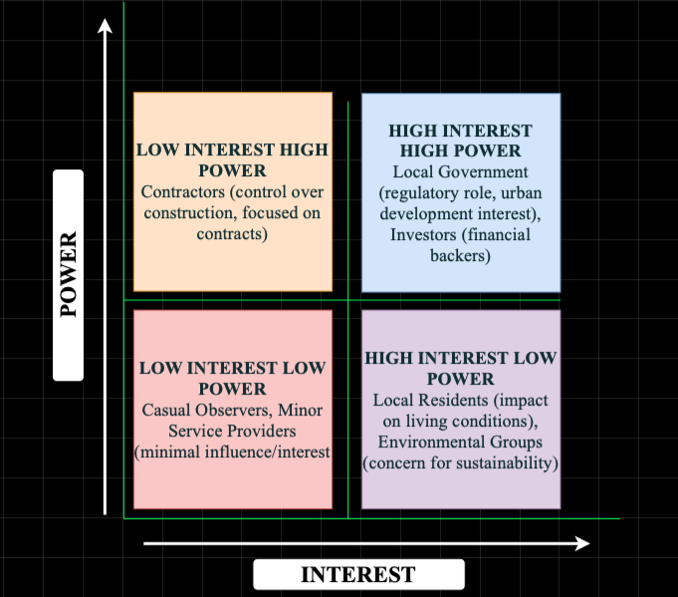
Figure 1: Power Interest Matrix - Redevelopment Project; (Source: Author)
Contractors in a particular situation, might be classified in the High Power-Low Interest category. The interest of the contractors is more focused on their control over construction and project timelines, rather than their long-term impact to the community (Osifo, 2024). Local citizens and environmental advocates are placed in the Power/Interest Matrix as having Low Power as well as High Interest. As much as the residents and the environmental advocates do not have much power in making the decisions, their interest concerning the redevelopment is still impactful in the case of their living standards, the level of sustainability of the environment, and the wellbeing of the community (Rowland, 2024). Finally, as far as stakeholders who are placed in the category of Low Power-Low Interest are concerned, we have casual onlookers or service providers at the bottom of the chain. Their influence on the project is marginal, as is their interest which is one of sporadic engagement.

Stakeholder Map
A stakeholder map is created to show how stakeholders are divided based on their projected power, interest and influence on the project. The stakeholder map enables the use of the power-interest matrix to guide the decision-making process on how to approach each of the groups strategically. For this instance, the Local Government is located at the very High Power-High Interest quadrant because of their great regulatory control and active participation in the approval of the project. The local government can Containment to the project's local infrastructure and economy, they can modify zoning laws and project funding, and, being very enthusiastic on the project, they have the power to control its funding and they active interest on the overall project (Oroniyi et al., 2024). There is also great interest from the government to improve the local economy and infrastructure. This interest from the government is also an interest from the investors. This makes the engagement with the Local Government, powerless to negotiate on supportive, non-competition to the project, decision-maker.
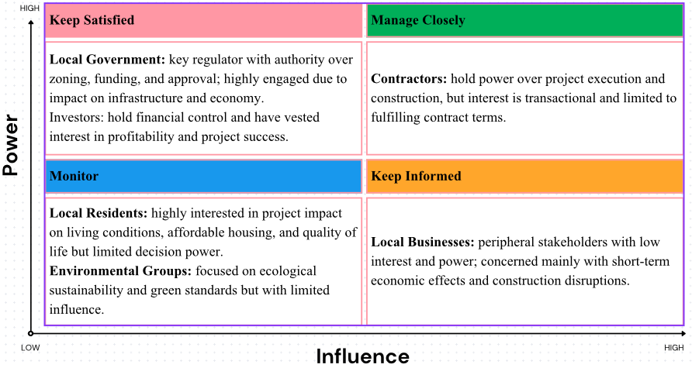
Figure 2: Stakeholder Mapping; (Source: Author)
Investors as well occupy the High Power-High Interest quadrant. This is because they also possess the great financial resources and have direct interest on the profitability of the project. Investors are deeply interested in the project in hopes to gain their investments back, and as debt-investors, they are able to greatly influence on the budget set for the project, the timelines, and all the decisions concerning its scopes (Voland, Saad and Eicker, 2022). In the High Power-Low Interest quadrant lie the Contractors. They have the overwhelming interest in the construction and project execution, and therefore possess a great deal of power, though, in their own work, have a great deal of power and great interest, yet only care about fulfilling the scope of work (Ebekozien, Aigbavboa and Ramotshela, 2023). They also care more about the “bang for your buck” phrase and project completion, rather than the downsides of cost efficiency.
In the Low Power-High Interest quadrant lie Local Residents and Environmental Groups. Residents have no say in the decision made yet always seem to be concerned about how the redevelopment impacts their lives, infrastructure, and overall amenities. They advocate for a project hoping meets their criteria, primarily for lower cost housing and shelter provision, with the additional plus of also caring for the environment (Liu and Liu, 2023). Environmental Groups function in the same manner. As for Local Businesses, they sit in the Low Power-Low Interest quadrant. They might enjoy some economic opportunities from the increase in residents, however, the project's influence over them is quite minimal and their interest is quite narrow and usually restricted to short-term scenarios such as construction disruptions or consumer traffic (Bai, Wu and Zhang, 2023). Local Businesses are peripheral stakeholders with little to no engagement.

Consultation Strategy and Communication Plan
Of great significance in the stakeholder engagement aspect of the housing redevelopment project is the communication strategy and its structural elements. To attain all members’ transparency trust and collaborative efforts during the project, it is crucial for them all to receive the right information in the right time and in the right context.

To Whom to Communicate
The communication strategy must include the following core partners:
Residents: Likely the main users of the redevelopment, and hence in need of continuous information concerning its development, estimated completion, and construction periods, and any relevant interruptions.
Contractors: Responsible for the actual implementation of the project, and hence, need elaborate and consistent information concerning timelines, resource allocation, and any other shifts to the scope of work.
Local Politicians: Critical for the approval of the project, and hence need regular reports concerning the progress, potential problems, and compliance to the local policies.
Interest Groups: Under focus of concerning the impacts of the project, sustainability, and instances of ‘green’ construction, therefore need regular reports on impacts and compliance with its terms.
Stakeholders: Require periodic changes on cost and expected return and general updated feasibility of the project.
Local Entrepreneurs: Likely to witness heightened business activities due to the project, hence need accurate information regarding anticipated relative inactivity and available local sponsorship possibilities.

What Information to Share
Each stakeholder group needs specialized information:
Residents: Periodic updates on progress, disruptions to services, and completion estimates, as well as feedback opportunities on the project's impact on the community.
Contractors: Construction timelines, needed resources, project and safety scope changes, and other information restricted to project-related meetings or emails.
Local Government: Progress vs. regulatory requirements, budget vs. spend, and any other factors fulfilling the support or intervention needs.
Environmental Groups: Sustainability, waste, energy, and any other emissions monitoring and mitigating environmental concerns information.
Investors: Key project milestones, timelines, scope changes, or other increases to project expenditures, alongside ROI, expense, and other financial projection updates.
Local Businesses: Anticipated delays, construction, and disruptions to customer footfall due to other stream opportunities, along with project milestones.

When to Communicate
Responsively proactive both in the timing and the cadence of communication:
Monthly Updates: All stakeholder progress, contractors, and residents’ general updates, along with the local government.
Special-purpose Meetings: To resolve certain issues such as delays, problems with the regulations, or pressing concerns from the community. These might be of interest to the community, contractors, and the municipality the most.
Notifications of Construction: Notices provided to the residents and businesses about the disturbance, the noise, or the changes to the traffic pattern the of the construction.

Means of Communication
Communication with the stakeholders is an important process which still has to be worked on.
Emails: Emails are an economical and timely method which best serves contractors, other local authorities, and investors. They are able to send and receive documents in a matter of seconds.
Letters: This is a method of formal communication with residents and ecological societies mostly useful with legal documents, consultations, or other formal reports.
Phone Calls: This is the method of direct communication resting especially on urgent issues or interaction with contractors, investors, and other important officials from the local government.
Newspapers: This is a way of communication which serves the public notifying residents and local businesses and the general public especially during milestones, public consultations, or other scheduled activities.

Ethical Considerations in Stakeholder Participation, Consultation and Feedback

Consultation methods
The Gloucester Train Station at Bruton way, Metz way, and other major transport interchange and connectors make this area geographically this redevelopment's most transport efficient and connective location. The inclusion of Kingsholm Road and Estcourt Rd into this redevelopment project extends this effectiveness even further. Support and participation from all relevant parties under public and private roles will be sought and actively encouraged in regard to the housing re-development project. To this end to get a breadth of qualitative information from residents and the local business community stakeholders in the community primary will undertake a survey. Because of the sheer size and scope of the project this is the most cost-effective and time-efficient strategy that will also provide critical and relevant information (Prebanić and Vukomanović, 2023). Public meetings will be aimed mostly at stakeholders to provide them with a mechanism to freely express their views on the project and to ask a range of clarifying questions in particular regard to the project helping in the bid to be more transparent and encouraging community participation. Focus groups will be held to clarify on some of the stakeholder questions that have been raised and to provide some more in-depth secondary information to those stakeholders (Xegwana, Twum-Darko and Tengeh, 2025). Primary stakeholder associates such as contractors, investors, and public government representatives will be brought in to offer more in-depth information and discussion on particular areas that need more concentrated focus and particular attention to (Chisumbe et al., 2022). All the techniques are more relevant to the participants in regard to costs, different perspectives, and in ease of collecting information from stakeholders.

Ethical considerations
When defining stakeholder data, a number of ethical aspects need to be addressed first:
Informed Consent: Due to the infrastructural changes and the housing redevelopment coming to the area, Gloucester Quays Shopping Centre, The King’s Head Hotel, and Bristol Road Retail Park will see many new customers. Local companies will gain greatly from the improved infrastructure and new residents coming to the area. Stakeholders shall be informed of the scope of the consultations as to what information is to be collected, the purpose of the consultations, the outcome/s, and that participation is voluntary (Kituuka et al., 2023). This allows the stakeholder the opportunity to decide on the basis of the information presented in order to participate in the consultations.
Confidentiality: Participants in the consultations are guaranteed that there collected personal information which will be kept private and will only be used in case where their identify is protected. Their views and identity will be kept confidential.
Transparency: Stakeholders will be given information about the purpose of the consultation and how their comments will be used to influence the decision of the project. This will be carried out by showing how their comments have been addressed, as this will enhance trust by demonstrating transparency.

DEI (Diversity, Equity and Inclusion)
As ascribed in the concerning documentation, there will be proactive intentional measures to conduct the consultation in a manner to avoid bias which may include lack of proper inclusion in the discussions. Measures will be taken to protect equity, inclusion, and diversity principles by reaching out to the marginalized communities which include socio-economically disadvantaged communities, ethnical minority communities, and the physically disabled communities. There will be design consultation strategies which will ensure the articulation of all voices in the discussion, and the wearing of discussion is embraced. For instance, inquiries which the public will be able to answer constructively will be prepared in a number of different languages, and the public discussions will be held in venues which will be easily accessible to the physically disabled (Chukwudi and Eusebius, 2023). Moreover, some consultation strategies will be aimed at equity participants in the equity discussion, which will help to gather representatives of the wider viewpoint. Intervention is bias caused by lack of differing strategies of which one or more will be chosen. These include closing the communication gap by offering different option such as online surveys, phone interviews, and physical in-person sponsored free meetings or gatherings.

Feedback Collection and Review
The feedback will be gathered using digital forms as well as through meetings and focus groups. For online stakeholders, surveys will be a quick and easy way to express their opinions, whereas for in-person stakeholders, meetings will be a more interactive and personal way to discuss. After the feedback is collected, it will be analyzed and reviewed by the project team, who will highlight the themes and concerns. The final feedback will be reviewed by the stakeholders and will be used to compose follow-up reports which will be publicly presented. This will bring the participants back to the project and show them how their input made an impact. Supporting stakeholders and demonstrating how their insights were valuable will sharpen the community's focus and improve the trust.

Conclusion and Reflection

Conclusion
Having regular conversations and updating all parties of interest relative to concerns of the housing expansion project is important to fulfilling these parties’ expectations. Having effect stakeholders improves project collaboration, improves the level of trust, and improves chances of project success. Having identified local residents, builders, city hall, lenders, and ecology activists key to the success of the project simplifies the tasks put to the correct communication frameworks. All these stakeholders will be consulted and made contours of the project through visibility and through consultations organized as surveys, public consultations, and discussions. Elements for inclusion are the approvals or permits to be given for the participants to be a part of the consultations. There is a strong focus in Education which ensures equitable representation of all organization members to participate in the survey.
Through efficient stakeholder management, we can reduce the chances of unmet expectations and prevent misunderstandings which allows for the smoother implementation of the project. Early buy-in supports in mitigating potential resistance and conflict which allows for the project to leverage community opposition and strengthen support. Open communication coupled with concerns resolution helps in smoothing the project flow. The project will progress without any interruptions. The consultations and feedback will lead to improved head of stakeholder's decision which reflects the project's concerns. The project will become more successful. In total, the stakeholders should be part of the project's communication to mitigate opposition and bolster support with stakeholder managed objectives to help fulfil the social, economic, and environmental goals of the project.

Reflective Account
Engagement with a number of different stakeholders is important for the success and sustainability of the housing redevelopment project. This is because it ensures the participation, listening, and the respectful treatment of stakeholders during the project. Engaging with stakeholders is often challenging for reasons including expectations versus reality, equal participation issues, and competing interests needing to be balanced. All stakeholders such as residents, contractors, local government, and even environmental groups tend to have different opinions that could be counterproductive. Nevertheless, this statement is true that the woven-in communication strategies designed for specific stakeholder needed to be optimized to their needs. As to the situation, constructive communication is the answer to... trust is the goal. It is easier to gain the trust of the community and the stakeholders by providing necessary information and project updates, listening to their needs, and being consistently transparent than it would be to lose that trust during... project implementation.
In addition, ethical involvement guarantees that all the stakeholders are treated with dignity, preserved their rights, and their inclusivity and variety are appreciated. While ethical actions: obtaining consent and granting confidentiality do l. sustain the project beyond its longevity, it is built on trust, which is proactively socially sustainable by addressing the concerns of neglected and marginalized people at all levels which makes the project a win-win scenario for the whole society. Having been through the planning processes, one major takeaway I have had is that continuous stakeholder engagement is not a one-off activity. Ongoing communication of value is essential for keeping all the stakeholders engaged with the set goals of the project and addressing concerns as they come. A different takeaway point is valuing the project goal and its intended impact to the people by welcoming changes to the initial project structure or promoting stakeholder ownership especially from the targeted population, the state of the project guarantees its success and sustainability.

References
‌Bai, Y., Wu, S. and Zhang, Y. (2023). Exploring the Key Factors Influencing Sustainable Urban Renewal from the Perspective of Multiple Stakeholders. Sustainability, [online] 15(13), p.10596. doi:https://doi.org/10.3390/su151310596.
Bai, Y., Wu, S. and Zhang, Y. (2023). Exploring the Key Factors Influencing Sustainable Urban Renewal from the Perspective of Multiple Stakeholders. Sustainability, [online] 15(13), p.10596. doi:https://doi.org/10.3390/su151310596.
Chisumbe, S., Aigbavboa, C., Mwanaumo, E. and Thwala, W. (2022). A Measurement Model for Stakeholders’ Participation in Urban Housing Development for Lusaka: A Neo-Liberal Perspective. Urban Science, 6(2), p.34. doi:https://doi.org/10.3390/urbansci6020034.
Chukwudi, O.A. and Eusebius, A. (2023). Diversity, Equity, and Inclusion (DEI): Exploring the Effectiveness of Human Resource Strategies and Practices in Fostering Diversity, Equity, and Inclusion in the Workplace and Understanding the Benefits of a Diverse Workforce in Nigeria. Journal for Studies in Management and Planning, 9(9), pp.1-22. [online] Available at: https://track2training.com/2023/09/24/diversity-equity-and-inclusion-dei-exploring-the-effectiveness-of-human-resource-strategies-and-practices-in-fostering-diversity-equity-and-inclusion-in-the-workplace-and-understanding-the-bene/.
‌Ebekozien, A., Aigbavboa, C.O. and Ramotshela, M. (2023). A qualitative approach to investigate stakeholders’ engagement in construction projects. Benchmarking: An International Journal, [online] 31(3). doi:https://doi.org/10.1108/bij-11-2021-0663.
Kituuka, O., Munabi, I.G., Mwaka, E., Galukande, M., Harris, M. and Sewankambo, N. (2023). Informed consent process for emergency surgery: A scoping review of stakeholders’ perspectives, challenges, ethical concepts, and policies. SAGE Open Medicine, [online] 11(11). doi:https://doi.org/10.1177/20503121231176666.
Liu, Z. and Liu, M. (2023). Critical barriers and countermeasures to urban regeneration from the stakeholder perspective: a literature review. Frontiers in sustainable cities, 5. doi:https://doi.org/10.3389/frsc.2023.1115648.
Maqbool, R., Rashid, Y. and Ashfaq, S. (2022). Renewable Energy Project success: Internal versus External stakeholders’ Satisfaction and Influences of Power‐interest Matrix. Sustainable Development, 30(6), pp.1542–1561. doi:https://doi.org/10.1002/sd.2327.
Oroniyi K. T, Taiwo, N., Arayela, O. and Ajayi, N. (2024). Assessment of Stakeholders’ Engagement and Participation in Mass Housing Development. Deleted Journal, 15(1), pp.37–50. doi:https://doi.org/10.62154/5fpymz90.
Osifo, E. (2024). INTEGRATING COMPLIANCE AND COST CONTROL IN PUBLIC INFRASTRUCTURE AND AFFORDABLE HOUSING CONSTRUCTION CONTRACT MANAGEMENT. International Journal of Engineering Technology Research & Management. 8(12), [online] Available at: https://ijetrm.com/issues/files/May-2024-07-1746641537-DEC202447.pdf.
‌Prebanić, K.R. and Vukomanović, M. (2023). Exploring Stakeholder Engagement Process as the Success Factor for Infrastructure Projects. Buildings, 13(7), p.1785. doi:https://doi.org/10.3390/buildings13071785.
‌Rowland , E. (2024). To What Extent does Planning Law Listen to Communities Affected by Large Scale Inner City Redevelopment Projects. University of Oxford. [online] Available at: https://ora.ox.ac.uk/objects/uuid:8b784c95-4155-470a-8f2f-2cc787b219f9/files/dnz8060477.
Voland, N., Saad, M.M. and Eicker, U. (2022). Public Policy and Incentives for Socially Responsible New Business Models in Market-Driven Real Estate to Build Green Projects. Sustainability, [online] 14(12), p.7071. doi:https://doi.org/10.3390/su14127071.
Xegwana, M.S., Twum-Darko, M. and Tengeh, R.K. (2025). Stakeholder engagement framework to improve public housing delivery: A Stellenbosch case study. Journal of Local Government Research and Innovation, 6. doi:https://doi.org/10.4102/jolgri.v6i0.224.

