James Dexter (1907923)
Tutor: Jessica Shore
Developing Social Enterprise
Digital and Social Marketing

Marketing plan for Experience Workshops

Marketing plan submitted to: University of Wales Trinity Saint David’s



The Organisation chosen for this marketing plan: The Riot Urban Sports Park Project
Address: Park place, Tumble, Llanelli SA14 6EW

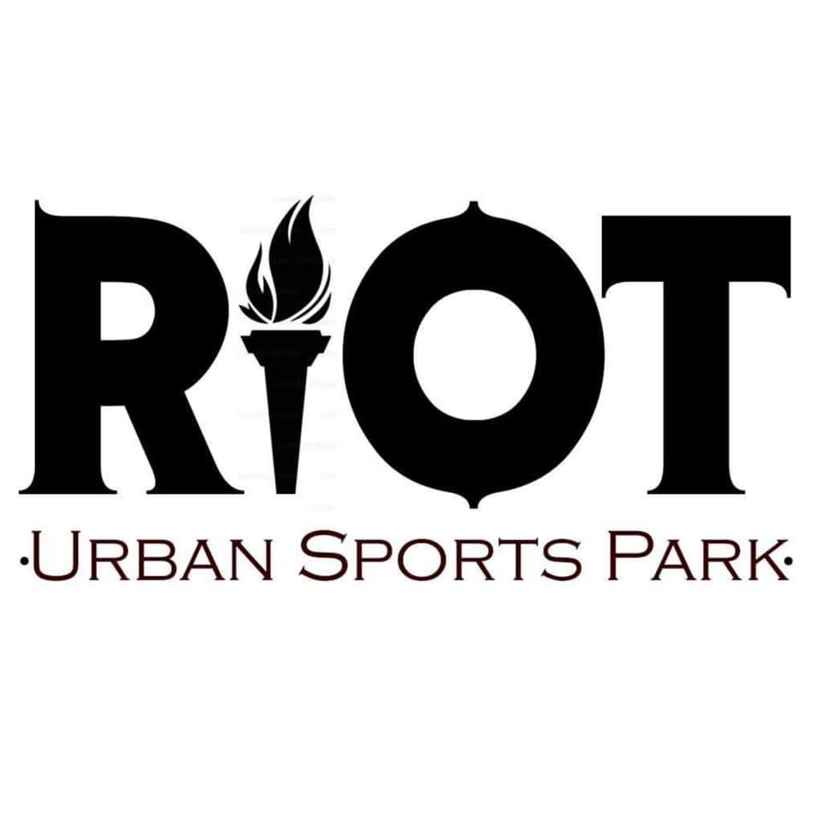

Contact information: James T Dexter
mobile number: 07498615603
Email: jamesdexter2@hotmail.co.uk

Marketing plan summary

This marketing plan is to raise awareness for a mobile skateboarding experience workshop projects in rural and neglected area hoping to be run by The Riot Urban Sports Project.

In an area called Tumble there is a new project that has been created based on the result of the communities asking for a skatepark. Tumble is an old mining village that since the colliery’s have been closed has been left to stand still with minimal number of things to do. The Riot Urban Sports Park Project came together to help provide a new facility for everyone to enjoy. With the main project being a facility, this will help relieve stress from antisocial behaviour along with social exclusion in the local area and possibly surrounding areas. The urban sports park caters for everyone included the disabled allowing more of a community feel and allow more engagement.

“There are many issues facing communities all across the UK some of which are antisocial behaviour and socially excluded individuals. Social exclusion can define as "what can happen when people or areas suffer from a combination of linked problems such as unemployment, poor skills, low incomes, poor housing, high crime, bad health and family breakdown" (Batty, 2002). Antisocial behaviour is a big problem and can be defined as “'behaviour by a person which causes, or is likely to cause, harassment, alarm or distress to persons not of the same household as the person'” (Thames valley police,2020).” (Dexter, 2020).

Riot becoming what it is to help tackle these issues can make a big impact for people and being able to see the benefits it can have want to be able to bring skateboarding to rural areas similar to tumble. This will include primary and secondary schools, youth clubs and parties.

Contents page

Page 1. Title page……………………………………………………………………………..

Page 2. Summary………………………………………………..……………………………

Page 3. Contents page……………………………………………………………………….

Page 4. Marketing context. ………………………………………………………………

Page 5-7. Marketing …………………………………………………………………………….

Page 8. Measuring success………………………………………………………………….

Page 9. references ……………………………………………………………………………..

Marketing context

This Social Enterprise marketing plan will help gain awareness for a mobile skateboarding experience workshop held by The Riot Urban Sports Park Project. With correct marketing methods the workshops will be advertised across the UK allowing engagement from all communities and areas. This will lead to more people being involved in skateboarding that do not have the access. Being a mobile service will enable a wider interest as the service will be able to go wherever it is needed. Some communities do have facilities to practice this sport, but some may have been left neglected making the equipment unusable, this can lead to being put off the sport but also have risks. These sessions will involve all the equipment and safety protection provided for all participants so no additional need or expense to join in. this will also help minimalize risks of equipment that may not be suitable for the sessions.

Skateboarding workshops can be a great tool to engage people into a sport that individuals may take more interest in if they are not interested by sports offered or accessible to them by schools, facilities or youth clubs. Sessions will include all equipment such as skateboards protective gear from helmets to knee pads, skate ramps and rails to engage all aspects of the sport. This being a sport that is focused all on you can be difficult when it comes to learning new skills, these sessions with qualified skateboarding coaches can help mentor anyone into improving these skills and help progression within the sport. Rural communities in many cases have a very select number of things to do due to where the area is leading to social issues arising. This sport can engage all different types of people into putting their creative energy into something productive and fulfilling.

If these sessions become booked and successful, the money made will be reinvested back into the brand to help with more marketing and for further purchase of equipment. This can be for more suitable ramps and rails for the sessions being held, with sessions being rebooked this sort of equipment will help the more experienced participants the option to progress their skills further. There are other ways to reinvest the money such as purchasing another transportation vehicle to hold multiple sessions a day and different places. This plan can help get Riot’s message across to as many people as possible to make a difference in so many ways. Riot Being able to offer this service can give some people something to look forward to bringing some positivity into their lives. Social exclusion is a massive issue Riot want to tackle so bringing people together through skateboarding session means a huge amount to any community and to Riot. Participants may get their own equipment to start practicing at home or with friends enabling people to put their energy from doing nothing and being anti-social turning into something positively productive.

Marketing

Market audience & Venues

The attended market and venues have been briefly discussed during this report, going into more depth on the market audience will help know who exactly these sessions are aimed for and the ways in which Riot will Market these sessions.

Schools

Collins Dictionary (2020) defines school as “a place where children are educated”, this is commonly known as primary and secondary schools for children of various ages. Schools can be for anything and for anyone of all ages some may have to be paid for if it’s a personal skills or course. Schools are the main learning environment for children from an early age, schools offer all kinds of different topics of educations including physical education. Schools may only have a few sports on their criteria given to them meaning there are limitations to what activities are on offer.

Riot will be able to introduce these children in school to a completely new different option to their current ones. Some schools will offer workshops and afterschool clubs for parents and students giving opportunities for new ideas. This is something Riot would like to be a part of and engage with young people, skateboarding teaches children many things such as balance, patience and health due to exercise.

Youth clubs

Youth clubs can be found across the UK’s communities although not every-where is lucky enough to have one. Youth clubs can be considered to be place where young people can gather and participate in various activities (Merriam-Webster, 2020).

These types of facilities are able to offer lots of different activities due to its nature to helping the young people aging up to 18. Providing activities can help reduce social issue in communities by offering a safe environment to meet up with others and enjoy themselves. Some centres will arrange day trips for people to book onto taking them out of their area.

Offering this sport to this age range of young people and children allows them to look into something different, many youngsters attending these clubs may have been in trouble before, skateboarding has so many different stories in how it has changed people’s lives by putting their efforts into skateboarding than hanging around being antisocial. Mental health has been a big topic for a long time and these sessions can help give people something to look forward to learning or trying something new. As it is an individual sport people don’t have to be relying on others for their progression, but coaches can help in areas they want a hand.

Rural communities

All over the UK there are places that are located far away from big built up areas such as towns or cities. Rural communities are made up of a small number of houses and buildings also with a small population (National Geographic,2020).

Rural areas have always been known to have limitations to anything they can do in their community. With having small amount of buildings and population could indicate the need to introduce something new to them. Rural areas have the potential to grow skateboarding within their communities as everyone could become involved in learning skateboarding and helping others learn a new skill too even progress their current ones. Including everyone could help tackle to social exclusion and bring more people together.

Parties

Parties is something that Riot would consider as I side expansion if there was enough interest. This could then cater for people who would like private sessions or one on one training. Allowing another avenue for revenue and engagement to be made.

Marketing tools

When it comes to marketing these skateboarding workshops there are so many various channels in which to get the message across. Technological advances over the years has allowed anyone to transmit information with better physical and digital methods. Below will be listed the tools in which Riot will use to market the skateboard experience workshops. I believe these will be the best routes to take when trying to engage as many people and facilities as possible.

The Internet

The internet is now one of the biggest platform for the transmission of information with being able to send a message across the world in a matter of seconds. The internet being introduced to mobile devices has led to social media becoming on the most popular apps to be downloaded. Social media are technology that has been created that enables people to share anything from idea and thoughts to networking communities (Dollarhide, 2019).

Riot has an online presence already due to the popularity of the main project being the biggest and first disabled friendly Olympic standard urban sports park. Riot has gained a lot of attraction and even from local the local council which has also invested into this project. This gave a big boost to help bring something to the community and using social medias such as Facebook, Youtube, Instagram, used regularly to keep anyone up to date with the brand and the urban sports park. Adding an additional page for the sessions to link with the main project will help organise marketing for the separate projects but also allow people to see why it has been made and see what it can be doing for people who would like to take it up or recommend others. This method of marketing is a very important and useful tool to use as so many people can be reached especially to rural areas or communities in need. Facebook does give an option to pay for any advertisements or boosts that allows to spready the message of the sessions to more of a confined audience targeting people more specifically. An initial cost of £100 would be a good starting point to get this information as far as possible from the get-go. Youtube is a free service that can be monetised and used to promote the sessions with an introduction video and also videos of sessions held.

Emails to targeted audience

Emails are used on the internet as a form of communication similar to sending letters but without any paperwork to be sent via mail order but at the click of a button and within seconds. Emails do not cost anything to set up so this wouldn’t be any cost to Riot to do. With this being available it would be wise to use the Riot email to start offering local schools and youth clubs the option to book a workshop or to request further information about the sessions. Emails sent can also be forwarded to others allowing the spread of the sessions for people who may not have originally been contacted.

Physical marketing

This part means more with physical information to advertise anything. This can also include face to face meetings with people interested like school departments or youth workers. For marketing the best methods to get the workshop details across would be in the form of leaflets, posters and cards. Having physical copies enables members of riot or others to advertise anywhere being in shops, schools, clubs, centres pretty much anywhere that they’re legally able to. In populated areas people will be able to take a copy for themselves to read and hopefully engage in.

Looking into a company called Just Print (2020) they are able to offer the printing services for this type of marketing. The prices are as follows:
Posters – 150 X A3 posters come to £87
Leaflets - 100 X A5 copies come to £41
Business cards – 1000 X business cards come to £33

The total amount for physical advertisements would be: £161

Measuring success

The three methods used for the marketing of this project will allow some sort of measurement of success and engagements. Through Facebook once a page is set up, the page admin is able to look up the statistics for the week and monthly and also previous. These include engagements with posts, likes and views on content allow a more accurate measurement of success. Gathering email information as to how many was sent and who may have been received and with what responses will find a area of need.

Youtube’s success would be measured by the amount of interaction the channel would get. What’s meant by interaction is the number of views, subscriptions and comments the channel receives, the more interaction the more people the message can spread to.

Physical marketing is harder to track the success of, some leaflets and cards can go missing or thrown away meaning some people may not check out the information on offer.
After the workshop’s surveys can be handed out on paper to participants to allow feedback on the session and gain information on how they found out about us. These will be collected and sorted and posted on the website as a thank you.

References

University of Wales Trinity Saint Davids picture University of Wales Trinity Saint David’s, 2020, https://www.uwtsd.ac.uk/undergraduate/

Riot Urban Sports Park Project, 28/06/2019, https://www.facebook.com/riot.usp/photos/a.1664330873630171/2387939401269311/?type=1&theater

David Batty, The Guardian, Social exclusion: the issue explained, 15/01/2002, https://www.theguardian.com/society/2002/jan/15/socialexclusion1

Thames Valley Police, what is antisocial behaviour, 2020, https://www.thamesvalley.police.uk/advice/advice-and-information/asb/af/antisocial-behaviour/

Dexter, J (2020), ‘Riot Urban Sports Experience Workshops’
, funding and finance, University of Wales Trinity Saint David’s, Unpublished essay.

Collins dictionary, 2020, definition of school, Collins dictionary, https://www.collinsdictionary.com/dictionary/english/school

Merriam-Webster, 2020, definition of youth club, Merriam-Webster, https://www.merriam-webster.com/dictionary/youth%20club

National Geographic, 2020, Rural Area, resource library, National Geographic, https://www.nationalgeographic.org/encyclopedia/rural-area/

Dollarhide, E(02/05/2019), social media definition, Investopedia, https://www.investopedia.com/terms/s/social-media.asp

just print, 2020, https://just-print.co.uk/50-posters

