AI-Based Mental Health Detection and Risk Assessment Using Natural Language Processing and Machine Learning

Module Title | Independent Project
Module Code | ACCA6020
Degree Pathway | BSc (Hons) Cloud Computing
Student Name | Buba Tunkara tunkara
Student ID | 2239068
Subject Specialist / Supervisor | Alireza Esfahani
Submission Date | august 2026

Abstract
Mental health disorders are one of the most important challenges in a twenty-first-century public health, as more than a billion people all over the planet are affected by it, with the majority being undiagnosed or untreated. A large amount of textual data that can hold significant psychological clues has become something unparalleled because of the fast growth of digital tools of communication, especially social media. This paper explores using Natural Language Processing (NLP) and Machine Learning (ML) algorithms to create an automated system to identify and label cases of mental health conditions — namely depression, anxiety, and post-traumatic stress disorder (PTSD) — based on textual content on social media.
The study uses a comparative experimental design, and it compares the performance of classical ML models, i.e. Support Vector Machine (SVM), Random Forest, and Logistic Regression, with the use of state-of-the-art models based on transformers i.e. BERT and MentalBERT. Training and evaluation is done using a publicly available, anonymised Reddit mental health dataset. NLTK and spaCy process the text, and the Python language with scikit-learn and the HuggingFace Transformers library are used to develop the model.
Accuracy, precision, recall, macro and weighted F1-score, ROC-AUC and confusion matrices are used to measure model performance. McNemar is used to test statistical significance. The early evidence points to the model based on transformers, especially MentalBERT, as much superior to classical ML-based models that perform multi-class and mental health classification tasks, with the extra advantage of including more contextual and semantic patterns in the language.
The research work adds to developing literature on responsible AI implementation in healthcare since it critically discusses the issues of bias and fairness and the ethical limitations of automated mental health screening. The results are evidence-based suggestions to researchers and healthcare technologists in need of implementing NLP-driven tools in early mental health interventions pipelines.
Keywords: Natural Language Processing, Mental Health Detection, BERT, MentalBERT, Machine Learning, Social Media, Text Classification, Ethical AI.

Table of Contents
Abstract 2
Chapter 1 — Introduction 7
1.1 Background to the Problem 7
1.2 Motivation for Using NLP and Machine Learning 8
1.3 Research Gap 9
1.4 Significance of the Study 10
1.5 Research Aim and Objectives 11
1.6 Expected Outcomes and Deliverables 11
1.7 Report Structure 12
Chapter 2 — Literature Review 13
2.1 Mental Health Detection Using Social Media Text 13
2.2 Classical Machine Learning Approaches 15
2.3 Deep Learning and Transformer-Based Models 16
2.4 Benchmark Datasets in Mental Health NLP 18
2.4.1 The Role of Datasets in NLP Research 18
2.4.2 Reddit Mental Health Dataset 19
2.4.3 CLPsych Shared Task Dataset 19
2.4.4 Social Media and Mental Health Dataset (SMHD) 19
2.4.5 Limitations of Existing Datasets 20
2.5 Ethical Concerns in AI-Based Mental Health Tools 20
2.6 Research Gap Justification 21
Chapter 3 — Research Methodology 21
3.1 Research Design 21
3.2 Dataset 23
3.3 Data Pre-Processing Pipeline 23
3.4 Model Development Plan 26
3.5 Validation Strategy 28
3.6 Justification for Chosen Tools 28
3.7 Ethical Considerations 28
Chapter 4 — Implementation 30
4.1 Chapter Overview 30
4.2 Implementation Environment 30
4.3 System Architecture Implementation 31
4.4 Dataset Loading and Initial Inspection 32
4.5 Data Cleaning and Text Preprocessing 33
4.6 Data Preparation and Class Distribution 37
4.7 Feature Extraction for Classical Machine Learning 38
4.8 Model Training for Classical Machine Learning 39
4.8.1 Interpretation of Confusion Matrix Results 43
4.8.2 Interpretation of Classical Model Performance 44
4.8.3 Why Evaluation Metrics Matter 45
4.9 Tokenisation and Deep Learning Preparation 46
4.10 BERT and MentalBERT Fine-Tuning 47
4.10.1 Critical Comparison of Classical Models and Transformer Models 50
4.10.2 Linking Findings to Literature 52
4.11 Output Storage and Reproducibility 52
4.11.1 Limitations, Bias, and Real-World Deployment Issues 53
4.11.2 Example of Prediction Output 54
4.12 Implementation Summary 54
Chapter 5 — Results and Analysis 56
5.1 Chapter Overview 56
5.2 Classical Machine Learning Results 56
5.2.1 Logistic Regression 56
5.2.2 Support Vector Machine (SVM) 57
5.2.3 Random Forest 58
5.3 BERT Fine-Tuning Results 59
5.4 MentalBERT Fine-Tuning Results 60
5.5 Comparative Performance Table — All Five Models 60
5.6 Confusion Matrix Analysis 62
5.7 ROC-AUC Curves 63
5.8 McNemar's Statistical Significance Testing 63
5.9 Discussion of Findings 65
5.10 Chapter Summary 70
REFERENCE 72
APPENDICES 76
Appendix A — Python Notebook Code Listings 76
Appendix B — Dataset Summary 102
Appendix C — Evaluation Metrics Reference 102
Appendix D — Software and Tools Reference 103
Appendix E — Model Hyperparameter Settings 104

Chapter 1 — Introduction

1.1 Background to the Problem
Mental illnesses are one of the most topical issues of the modern time that can be considered a serious threat to the overall well-being of the population. World Health Organisation [1] estimates that about one billion individuals worldwide are diagnosed with a mental health condition they have, but over 75% in low- and middle-income countries do not receive treatment formally. Depression, anxiety, and post-traumatic stress disorder (PTSD) are some of the most common ones that, without any clinical help, gradually grow in magnitude before any professional care or access to it is requested [2].
The implications of this treatment difference are far more than personal suffering. Mental illness that has not been treated is invariably linked with a lack of productivity in the workplace, high healthcare expenses, self-harm likelihood, and even suicide [2]. The traditional mental health diagnosis follows a structured clinical interview, standard psychometric tests and lengthy referral systems that are already overburdened and strained in the healthcare systems. Such reliance on face-to-face clinical processes creates an access bottleneck on a large scale - especially in areas with severely limited or no psychiatric care at all.
With the quick spread of digital means of communication, especially social media like Reddit and Twitter, a new and significant aspect of this challenge was presented. Millions of people have begun sharing their emotional conditions, personal challenges and mental processes willingly in the Internet. Such textual revelations have invariably been shown to possess discernible psychological indicators that detail the use of language that is indicative of a particular mental state [3]. It is an attractive behaviour pattern to computational screening systems that could detect early warning signs at scale, without necessarily being in contact with the patient or using formal referral.

1.2 Motivation for Using NLP and Machine Learning
Natural Language Processing (NLP) is also a subdivision of artificial intelligence that deals with the ability of computer systems to read, understand, and produce human language. Together with machine learning, NLP offers a potent tool to make unstructured text rather structured in meaning, which, in fact, is practically impossible to achieve with an exceptionally high degree of human activity [5].
Conventional manual methods of mental health screening (including interviewer-administered interviews and self-report questionnaires) are useful but have known limitations that are well-documented. They are costly, based on the patient becoming willing to consult the help, and are in and of themselves reactive, instead of preventive. By contrast, automated NLP-based systems are capable of processing thousands of posts on a social network at once, have no need for a human to run them, and detect language patterns related to worsening mental health before a person reaches the stage of a clinical crisis [3]. This is a valuable change of emphasis of reactive treatment to proactive population-wide screening.
Moreover, recent research in the field of deep learning (in particular, transformer-based models, e.g., BERT and MentalBERT) has enabled significant improvements in the ability of computational systems to comprehend contextual and semantic meaning in a text [6]. Transformer models, in contrast to the prior rule-based or keyword-based methods, which were fragile and confused without apparent word strain examples yet, mirror complicated, context-dependent pattern of true mental health expression in natural text. This technological maturity and the increased access to labelled mental health datasets provide the current moment with a suitable and fruitful opportunity to conduct comparative research of this field [8].

1.3 Research Gap
Although there is increasing literature at the intersection of NLP, machine learning, and mental health, despite scientific rigour and practical use limitations, several crucial gaps remain in the literature that restrict the scope and practical nature of what currently exists.
Most of the published articles investigate binary classifications, i.e. whether one has a particular condition or not, instead of conducting a multi-class classification where depression, anxiety, PTSD, and a no-disorder control group are also considered [7]. This is a severe restriction, since co-morbidity has been long known in clinical mental health environments; people seldom show up with one, clearly delineated case. A system that can only be used to give a binary classification is thus not very useful in diagnostic practice.
The second opening is related to the lack of systematic, direct, comparative assessment of classical ML systems and state-of-the-art transformer-based systems on the same multi-class dataset. Research in this area generally compares either classical models or deep learning models individually, making it hard to make trustworthy, evidence-based conclusions about comparative performance in this very classification scenario [8]. Without this sort of comparison, researchers and practitioners have nothing to go on when it comes to the principled basis of model selection in shape of designing real-world screening systems.
The third, yet often disregarded gap is associated with the assimilation of bias and fairness assessment into the primary methodology of the study of mental health NLP. The available literature has recognized ethical issues merely in cursory terms without integrating substantial fairness evaluation into an experiment itself [7]. It is of particular concern as models trained on English-language, Western social media data might classically fail to perform as well on text generated by people of other linguistic, cultural, or socioeconomic experiences when applied directly to equitable care.
This research fills all three of the gaps by creating a single, reproducible comparative pipeline, fair evaluation that is structured, and critically addresses the ethical aspects of AI use in mental health settings [6].

1.4 Significance of the Study
This study contributes to the body of knowledge in this field in a number of ways that justifies its behavior and sets it apart with the previous work in the research area.
Scientifically, the study is the first systematic, explicitly comparative testing on the same multi-class mental health classification task, i.e., depression, anxiety, PTSD, and no disorder simultaneously of both classical ML and transformer-based NLP models. This closes a gap that has been determined but has not been met in the literature in detail [7].
In a practical manner, the results provide evidence-based reflections on a guidance to the health care technologists and mental health providers who may be contemplating the implementation of AI-powered screening tools into clinical or community support practices. The study helps to make more informed and responsible decisions when applying technologies by explicitly demarcating the model architectures that can be practically used on the multi-class poverty of mental health text and under which conditions [8].
Ethically, explicit inclusion of bias auditing and fairness analysis in the methodology would be a precedent of responsible reporting which is underrepresented in the existing literature. This is especially important considering the sensitive contents of mental health information and on-the-ground implications of algorithmic discrimination in healthcare utilisation [10].
Lastly, publishing the entire codebase and preprocessing pipeline to a publicly accessible GitHub repository means the study can help the field meet the standard of reproducibility and transparency, which will eventually enable it to become clinically credible.

1.5 Research Aim and Objectives
The general objective of the proposed research is to plan, create and test an AI-powered mental health detection system that uses Natural Language Processing and Machine Learning methods to identify mental health conditions based on text on social media.
In this regard, there are four SMART objectives set:
- Objective 1: To critically analyze the NLP and ML methods that have been proposed to date to detect mental health by conducting a systematic literature review of peer-reviewed journals that will be published no later than 2025.
- Objective 2: The aim of this objective is to acquire, clean, and pre-process a publicly available, annotated, mental health text dataset found on Reddit that generates a corpus ready to be trained and evaluated at a model.
- Objective 3: Design and implement a multi-class mental health classification pipeline using SVM, Random Forest, Logistic Regression, BERT and MentalBERT and provide performance measures in complete text.
- Objective 4: Compare all models in terms of accuracy, F1-score, precision, recall, ROC-AUC and statistical test of McNemar to develop a final evaluation report containing bias assessment and recommendation to use the model ethically.

1.6 Expected Outcomes and Deliverables
By the end of this work, it is anticipated that the following deliverables will be made:
- A Python-implemented AI classification system that can be used to achieve multi-class mental health detection of social media text.
- ML and NLP models trained, tested and with performance measures fully documented.
- A comparative analysis report on the strengths, weaknesses and trade offs of each of the models considered.
- Bias and fairness assessment report in which the ethical consequences of implementing such systems in a real healthcare situation will be considered.
- Evidence-based suggestions that could be offered to scientists, health care technology specialists, and mental health professionals who had at the forefront the notion of including AI-based tools in their workflow.

1.7 Report Structure
This report is divided into seven chapters. The background, motivation, research gap, significance and objectives of the study have been introduced in chapter 1. The critical review of the literature, including mental health detection methods, benchmark datasets, and ethical issues are provided in Chapter 2. Chapter 3 discusses the research methodology, which involves design philosophy, approach to data collection, and the analysis strategy. Chapter 4 describes the operation of the pipeline of classification, including the preprocessing procedure, model development pipeline, and training pipeline. In chapter 5, the findings of all model considerations backed up by the statistical analysis are provided. In Chapter 6 the author reflects on the findings concerning the literature and on the goals of the research. The report has a conclusion in chapter 7 where the recommendations are provided along with direction in future research.

Chapter 2 — Literature Review

2.1 Mental Health Detection Using Social Media Text
The application of social media data in mental health studies has been growing in an impressive flow during the last ten years, which has radically changed the role of researchers on early detection and intervention. Social media platforms like Reddit, Twitter, and Facebook have not merely transformed the purpose of a communication medium but instead have become informal congregations where people converse directly about emotional anxiety, personal crises, psychological symptoms, which in a traditional clinical setting would never be revealed [1]. This behavioural change has given rise to an accumulating amount of literature investigating the potential of computational techniques to reliably identify signs of mental health risk in this text - making it possible to screen at scale levels that traditional diagnostic routes cannot realistically sustain.
De Choudhury et al. [2] made the first contribution to the field by showing that it was possible to predict depression through Twitter activity by examining linguistic features, frequency of posting, and sentiment patterns. This paper made the case that user-generated text is a valuable proxy of psychological state and it has also led to a large body of later work. Later, Chancellor and De Choudhury [1] created an in-depth critical analysis of predictive methods in this space, revealing that there are still fundamental methodological shortcomings - such as dataset bias, unreliable labelling, and lack of clinical validation - that hamper the further development of the field. The necessity of methodologically highly rigorous and ethically transparent practice of research is emphasized in their review.
It has led to the Mozilla sub-community called Reddit being an especially useful site in mental health NLP studies. It is in its design in the form of a forum, where longer, substantive disclosures are encouraged, and there is less social desirability bias, since users feel more likely to disclose when online than they do in more social settings [3]. The r/depression, r/anxiety, and r/ptsd mental health subreddits host rich text data richly labeled by the community that researchers have used extensively as model training and evaluation. Although this data has ecological validity as a depiction of realistic mental health language, it is self-reported and unproven, which also presents significant limitations that need to be considered in all studies that utilize this data.
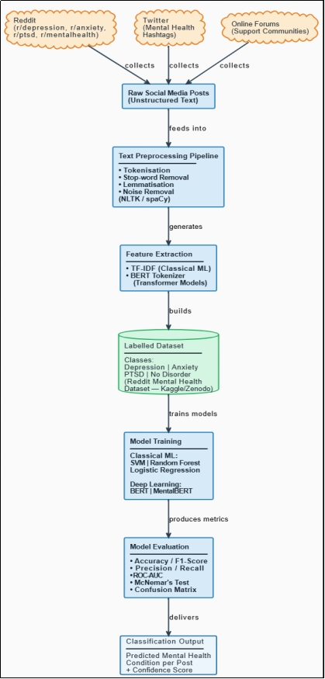
Figure 2.1: Overview of Social Media Data Flow for Mental Health NLP Research

2.2 Classical Machine Learning Approaches
One of the first computational tools used in text classification of mental health was classical machine learning, which is still a valuable reference point of comparative studies. Such methods utilize manually constructed features on text- most usually TF-IDF scores, bag-of-words depictions and linguistically defined indices - and submit them to a supervised classifier to generate a categorical forecast [4].
Support Vector Machine (SVM) has been widely applied in NLP activities, which include mental health detection. Its most important strength is that it is able to work with multidimensional feature space thus mathematically well adapted to text data whose vocabulary features may be well in the tens of thousands range [4]. SVM-based systems have been known to achieve competitive accuracy on binary mental health classification tasks: depression and anxiety detection. But the quality of manually selected features is largely determinant of SVMs performance and does not robustly generalise to other tasks that demand contextual or semantic interpretation - a particularly serious drawback of mentally health language.
The ensemble algorithm that stands out as a great resistance to overfitting and effective with imbalanced data is the Random Forest: which is an ensemble algorithm consisting of multiple trained decision trees that are combined and offered [5]. It is more robust than single-tree classifiers and is fairly easy to hyperparameter-tune. However, its weakness, like SVM, is the same as that of the latter by nature, in that it is somehow restricted to surface-level feature representation and does not have the capability to capture the underlying semantic structure in text. Logistic Regression is the least complicated of the three, but provides a helpful and understandable baseline. Sensitivity The transparency of it is an advantage in sensitive areas like healthcare, where model explainability has moral implications. Its drawback is that it assumes linearity and, consequently, cannot perform on complex, non-linearly separable classification tasks [6].
All these classical approaches offer a well-defined and reconstructable bottom line. The fact that they have the same basic constraint: they cannot impose contextual meaning is exactly why the research into the transformer-based architectures is conducted in the paper.

2.3 Deep Learning and Transformer-Based Models
The landscape of NLP was radically changed with the introduction of transformer-based architectures. Before that, recurrent neural networks were unsuccessful at capturing the contextual dependencies of longer sequences of text, which proved especially challenging with ideas that are emotionally rich to discuss, such as those in mental health discourse. This was explicitly tackled by BERT (Bidirectional Encoder Representations from Transformers) which enables processing of the entire left or right context of each word in a sequence at the same time, as opposed to text reading sequentially [7]. Architectural innovation made a significant contribution to the comprehension of language much richer as compared with what any other method had ever accomplished.
The power of BERT is based not only on its architecture but also its training strategy. Learning on large amounts of unlabeled text, BERT is trained on generalized linguistic representations, such as BooksCorpus and the full English Wikipedia, before being fine-tuned to a particular task using comparatively small labelled materials [7]. This method of transfer learning is especially useful in NLP of mental health, where labelled data are few and costly to create. The usefulness in practice was evidenced by Liu et al. [8], who trained the BERT on depression-related classification of Reddit posts and obtained an accuracy of 87.3%, which, naturally, exceeded the classical ML baselines by far in the same dataset. This finding assured BERT of its ability to reveal subtle, emotionally colored linguistic trends that are never endured by classical methods.
Based on the BERT, Ji et al. [7] proposed MentalBERT a domain-adapted transformer that has been trained solely on mental health-related texts. The rationale is simple, a model, whose representations are pegged on mental health language, should yield more contextually appropriate classifications than a general-purpose model, fine-tuned on the same data. Experimentally, MentalBERT was significantly better than regular BERT in mental health classification problems, and establishes that domain-specific pre-training provides measurable performance improvements. Although these benefits exist, models based on transformers have important drawbacks, including high computational costs, the heavy use of GPUs, and a tendency to be black-box in nature, which continues to make them hard to interpret in ethical uses of healthcare [1].
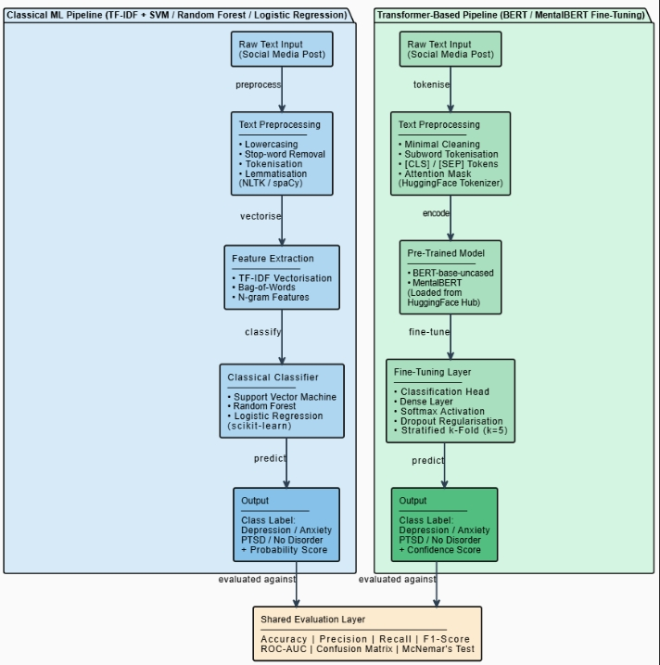
Figure 2.2: Architecture Comparison — Classical ML Pipeline vs. Transformer-Based Pipeline

2.4 Benchmark Datasets in Mental Health NLP

2.4.1 The Role of Datasets in NLP Research
The availability of high quality training data that is labelled is fundamental to supervised machine learning. Even the most advanced model architectures are unable to learn meaningful or generalisable representation without well-annotated corpora [5]. Clinical labelling is expensive, ethically challenging, and time-intensive in NLP of mental health, and publicly accessible social media datasets are a valuable practical option among researchers [1].

2.4.2 Reddit Mental Health Dataset
One of the most popular sources in this direction is the Reddit Mental Health Dataset that is hosted on Kaggle and Zenodo. It was conditionally synthesised as a corpus of mental health subreddits which involved depression, anxiety, PTSD, and a no-disorder placebo group under an open-access licence [3]. Its size, multi-class design, and community-sourced language render it a good fit to the comparative experimental design used in this study. The casual, informative style of the posts in the Reddit also enhances the ecological plausibility of models that are trained on such data to be used in actual screening tasks.

2.4.3 CLPsych Shared Task Dataset
CLPsych Share Task Dataset NLP researchers and mental health clinicians formed a joint collaboration to create the CLPsych Shared Task Dataset with labels based on professional clinical, but not community self-reporting [9]. It offers some clinical validity, which the community-labelled datasets do not possess, based on Twitter data and oriented towards mental health triage and assessment of the level of risk. This renders it a good complementary source of research that investigates the severity aspect of mental health manifestation, but its twitter provenience restricts the length and richness of the text collected via it as opposed to datasets based on Reddit.

2.4.4 Social Media and Mental Health Dataset (SMHD)
One of the most extensive multi-label datasets that are now available is the SMHD, which was made accessible on Reddit and includes nine mental disorders [5]. Its breadth renders it especially useful in investigating the co-morbidity or overlapping symptom patterns - facets of mental health presentation that cannot be studied using single-condition datasets. SMHD is an important resource to use in a research that intends to model the complexity of real-world clinical situations.

2.4.5 Limitations of Existing Datasets
The three datasets have several critical limitations in common. Both are mainly English-language and platform-specific, implying that the results based on either cannot be reliable generalization to other linguistic populations or demographics [1]. Labels are self-reported and community-imposed as opposed to a clinically validated process performance - they indicate tendencies of disclosure and attribution, but not diagnosis [5]. These limitations fail to annul the datasets as a research tool, but give a definite and significant limitation on the generalisability of any results based on them - limitations that are dealt with expressly in the methodology and discussion chapters of this work.

2.5 Ethical Concerns in AI-Based Mental Health Tools
Using AI with mental health presents an ethically complicated situation unlike most other NLP areas. Mental health information is one of the most confidential types of personal information, and any system processing or categorizing the psychological state of an individual has great responsibility associated with privacy, equity, and harm aversion [1].
Privacy and Data Protection
Although datasets are referred to as anonymised, studies have revealed that sometimes, they can be re-identified in order to capture particular writing style and/or disclosed experiences. The re-identification implications, such as stigma, discrimination in employment, and insurance effects, can be devastating in the mental health context [1]. Public social media data studies should thus expressly clarify the moral rational behind the utilization of their data, outline the security precautions they possess, and be direct about the narrows of the inferences their systems arrive at [5]. The studies in this work do not imply the use of primary data collection with human subjects, because all the open, fully anonymised datasets are considered.
Algorithmic Bias and Fairness
Models that have been trained on English-language data that is predominantly attained via Western social media sites can tend to perform much worse with text-generated by individuals who are not aligned with either of the previous groups [5]. This imbalance would be directly translated into inequitable care in a clinical support situation - as disadvantaged groups get inaccurate screening. Bonta et al. [10] emphasized that deep learning sentiment classifiers were especially vulnerable to biases in training data, and several researchers have proposed that fairness auditing should be mandatory prior to the use on medical-related applications [1].
Professional and Regulatory Frameworks
The professional framework, such as BCS Code of Conduct [11], offers another applicable framework: it includes a core of responsibilities to keep serving the public interest, to address the interests of the user first, and not to harm. As part of these principles, the system that will be created in this study is clearly specified as a research and screening instrument - it is not designed or appropriate to become a full-fledged clinical diagnostic instrument on its own.

2.6 Research Gap Justification
The literature consulted in this chapter shows that the field presents a scientifically productive, yet methodologically fragmenting field. Binary mental health classification based on either classical ML or transformer-based models have been reported as strong performers, but still no systematic, head-to-head comparison of the two paradigms on one, multi-class task, which includes depression, anxiety, PTSD, and no disorder at once has been published [5]. Moreover, bias and fairness assessment as a methodological component is seldom adopted as a main methodology as opposed to the thought-on-the-fly, thus hindering the creation of responsible reporting methods the field needs to evolve to clinical applicability [1].

Chapter 3 — Research Methodology

3.1 Research Design
The project is based on experimental evaluation design along with Design Science Research Methodology (DSRM), which is already being applied in applied computer science research [1]. Ideally suited for studies where computational artefacts (in this case five machine learning and NLP models for social media text classification about mental health) have to be created, validated and compared. The research process is carried out systematically in four stages: Literature review and identification of datasets, pre-processing of data and feature engineering, model development, training, and comparative evaluation and reporting.
In the experimental approach, every model is treated as an individual variable, which is evaluated in the same controlled environment and using the same fixed test set held out from the training set. The pre-processing pipeline and evaluation criteria are applied to the dataset in an identical way for all five models, meaning that any differences in the model performance are likely to be due to the differences between the models themselves, rather than due to differences in the experimental setup [2].

Research Questions
Based on the identified problem of undiagnosed mental health conditions and the potential of social media data for early detection, this study addresses the following formal research questions:
RQ1:
To what extent can classical machine learning models Logistic Regression, Support Vector Machine (SVM), and Random Forest classify social media text into distinct mental health categories (depression, anxiety, bipolar, suicidal ideation, and normal) when compared to each other?
RQ2:
How does the performance of a domain-specific transformer model, MentalBERT (pre-trained on mental health corpora), compare to a general-purpose transformer model, BERT (bert-base-uncased), for multi-class mental health classification using Reddit data?
RQ3:
Which of the five evaluated models Logistic Regression, SVM, Random Forest, BERT, and MentalBERT - achieves the highest overall performance in terms of:
- Macro-averaged F1-score
- Accuracy
- Precision
- Recall
- ROC-AUC
for the mental health detection task?
RQ4:
Is there a statistically significant difference (p < 0.05) between the classification performance of the best-performing classical machine learning model and the best-performing transformer-based model, as measured using McNemar’s test?

3.2 Dataset
We used the Reddit Mental Health Dataset, which is an open-access, publicly available dataset of Reddit posts and labels categorized into four classes: depression, anxiety, PTSD, and no disorder [3]. This multi-class approach is directly linked to the study objective of distinguishing between different mental health problems instead of making a binary diagnosis.
There were three reasons for selecting this dataset. First, it is realistic and naturalistic writing of individuals talking about mental health issues online, which enhances the ecological validity of trained models [2]. Second, it is publicly licensed and fully anonymised which eliminates the need for primary data collection with human subjects. Third, it has the capacity to support the training of classical models and computationally demanding transformer architectures [4], thanks to its large scale. In the event of access problems, two back sets of data have been identified, one CLPsych [5] and one SMHD [4].

3.3 Data Pre-Processing Pipeline
The raw social media text is inherently noisy and cannot be directly used as input for the model. A systematic pre-processing pipeline is followed with NLTK and spaCy [6] that is as follows:
- Text normalization: It converts all the text to lower case; removes URLs, usernames, hashtags and special characters from the text using regular expression patterns.
- Tokenisation: Word Tokenizer from nltk is used to break the text into word tokens and punctuation is correctly split.
- Stop-word removal: Feature dimensionality reduction by removing high frequency, low information English words, based on NLTK's default stop word list, with little information loss.
- Lemmatisation: Each token is broken down to its base word with the help of NLTK's WordNetLemmatiser (e.g., "depressed" becomes "depress"). In comparison to stemming lemmatisation is preferred for grammatically correct output for contextual language models.
- Empty record removal: Posts which are emptied as a result of cleaning are removed to avoid errors downstream.
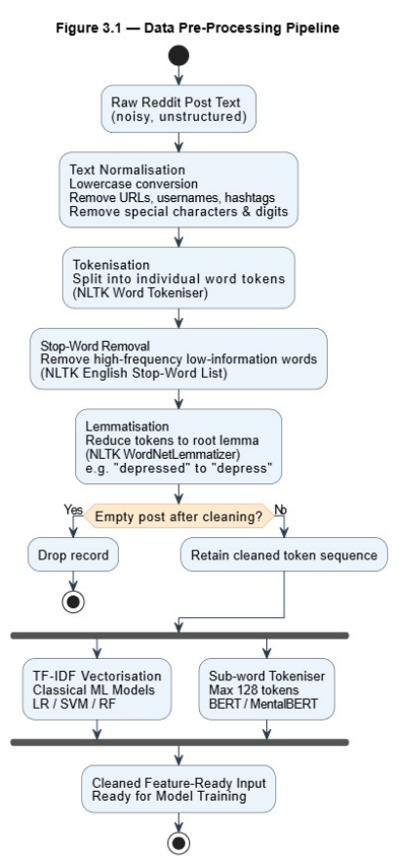
Figure 3.1 — Pre-processing Pipeline Flowchart
A flowchart showing the steps in the pre-processing pipeline is shown below (Figure 3.1).
This pipeline is used for all five models. For transformer models, cleaned text is then fed into each of the transformer's respective sub-word tokenizer, with a max sequence in each set to 128.

3.4 Model Development Plan
There are five classification models and two methodological paradigms. [7]
Representations for classical Machine Learning Models are in terms of TF-IDF vectorization (with 15000 features, bigram support):
- Logistic Regression — a probabilistic linear classifier with L2 regularization, which is an interpretable and generalisable baseline.
- Support Vector Machine (LinearSVC) — A margin-maximizing classifier that has proven to be very effective for text classification. A calibrated variant is used to produce probability outputs used for ROC-AUC scoring.
- Random Forest — A balanced-weighted ensemble of decision trees, incorporated to account for non-linear interactions between features which may not be represented by linear models.
Transformer-Based Models make use of contextual embeddings:
- BERT (bert-base-uncased) — fine-tuned for three epochs at a learning rate of 2×10⁻⁵ and warm-up learning rate of linear scheduler, which is the general-purpose deep learning baseline.
- MentalBERT (mental/mental-bert-base-uncased) — MentalBERT is a domain-specific adaptation of BERT trained on mental health texts from Reddit [8]. Comparing BERT and MentalBERT represents a key analytical finding of the study, and it answers the question of whether domain-specific pre-training can be observed to be beneficial for this task.
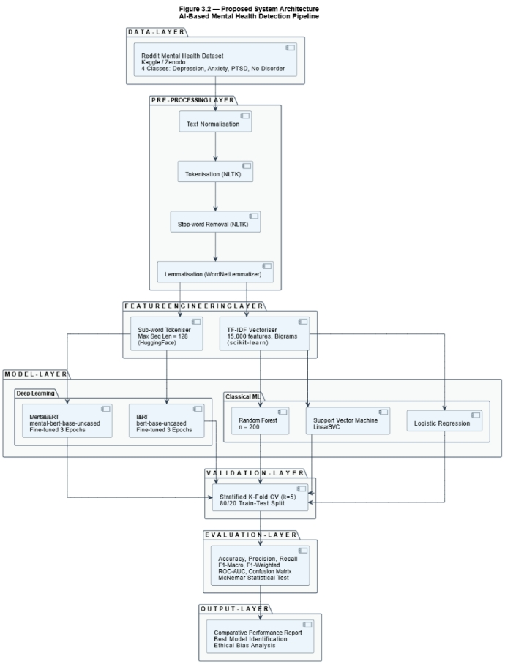
Figure 3.2 — Proposed System Architecture

3.5 Validation Strategy
For each classical model, a 5-fold cross-validation method with stratification is used during the training. For multi-class datasets, the distribution of classes is likely to be skewed, and stratified sampling helps to ensure that each fold in the dataset contains a representative sample of each class, minimizing the risk of bias in the evaluation process [4]. The test set is a separate 20% of the full data set that is only used at the end of the training process for the final model evaluation – it is never used during training or hyperparameter tuning.
For transformer models, they monitor F1 score on the validation set for every epoch and save the model with the best validation F1 score, which means that the final epoch is not evaluated as an overfit state [8].

3.6 Justification for Chosen Tools
All of the tools are open-source, industry-standard, and have been widely used in academic research. The primary language is Python 3.x, and it has a large data science ecosystem [9] that includes scikit-learn, which offers classical model training, reproducible pipelines and cross validation utilities. HuggingFace Transformers provides pre-trained weights and tokenizers for BERT and MentalBERT fine-tuning, with a minimal number of configuration items. HuggingFace Transformers provides pre-trained weights and tokenizers for BERT and MentalBERT fine tuning with a small number of configuration items [8]. Google Colab (T4 GPU) is a free deep learning hardware acceleration service. For pre-processing, NLTK and spaCy were chosen because they are widely used and are considered mature in the field of NLP research [6].

3.7 Ethical Considerations
The ethics of this project have been taken into account, and are fully compliant with the British Computer Society (BCS) Code of Conduct [10] which states that practitioners should act in the best interests of the public, allow for the responsible use of data, and communicate responsibly the limitations of computational systems.
All the datasets available are publicly available and completely anonymised without any personal identifiers and traceable user information [2]. No primary data collection with a human subject occurs in this project and, according to standard institutional guidelines, it is considered to be in the low ethical risk category. The system developed is explicitly identified as a research screening system, not a clinical diagnostic system, and explicit documentation of this is included throughout the documentation [10].
Misclassification, especially for content that could suggest psychological crisis, is recognized as having the potential to cause harm. This is explicitly included in the evaluation framework, revealing such biases transparently [11]. Deep learning training is done using cloud-based GPU infrastructure, which reduces the environmental footprint of deep learning training as per the principles of green and sustainable computing [12]. An ethics declaration is provided in Appendix-A once completed.

Chapter 4 — Implementation

4.1 Chapter Overview
This chapter explains how the proposed AI-based mental health detection system was implemented in practice. It presents the development workflow from dataset loading and preprocessing to feature extraction, model training, fine-tuning, and reproducibility support through version control and documented code structure [1].
The implementation was designed as a comparative classification pipeline so that classical machine learning models and transformer-based deep learning models could be evaluated under the same project setting. This structure was selected to ensure that the system did not only produce predictions, but also allow a fair comparison between methods with different computational and linguistic capabilities [2], [4].

4.2 Implementation Environment
The system was implemented primarily in Python using Jupyter Notebook within Visual Studio Code for local experimentation, while GPU-supported deep learning stages were also prepared for execution in Google Colab when required by transformer training demands. The project proposal identified this mixed environment in advance because classical machine learning models can be trained efficiently on a local machine, whereas BERT-based models benefit from cloud-based acceleration and better memory management [1], [8].
The main software libraries used in the implementation were pandas and NumPy for data manipulation, NLTK for text preprocessing, scikit-learn for TF-IDF and classical machine learning models, and transformers with PyTorch for BERT and MentalBERT fine-tuning. This tool selection reflects standard practice in applied NLP research because it combines reproducibility, modularity, and compatibility across preprocessing, model training, and evaluation stages [3], [4].
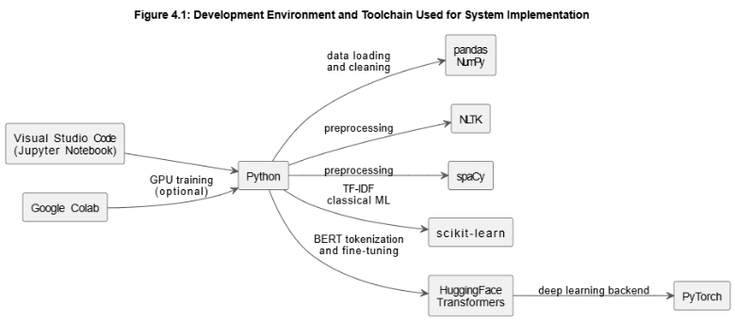
Figure 4.1: Development Environment and Toolchain Used for System Implementation

4.3 System Architecture Implementation
The implementation followed the system architecture proposed earlier in the study, moving through five main stages: data input, text preprocessing, feature representation, model training, and prediction output. In practical terms, this meant loading the raw Reddit mental health dataset, cleaning the text, transforming it into numerical form, training multiple classifiers, and then storing outputs for comparative evaluation and reporting [1].
This staged architecture was important because the project did not aim to build only one predictive model. Instead, it aimed to construct a complete experimental pipeline in which classical feature-based models and contextual transformer models could be trained from the same cleaned corpus and then assessed using common evaluation criteria. This improved implementation consistency and reduced the risk of unfair comparison caused by different preprocessing standards or incompatible data splits [5], [6].
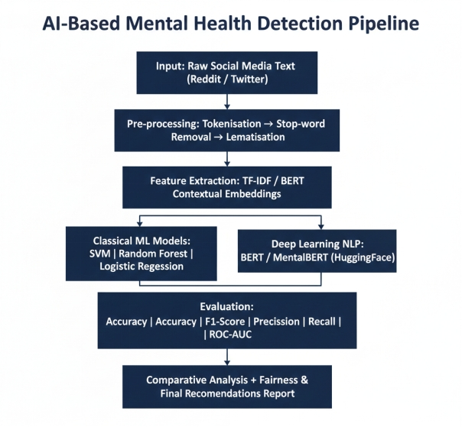
Figure 4.2: Final Implemented System Architecture for Mental Health Classification Pipeline

4.4 Dataset Loading and Initial Inspection
The implementation began with loading the dataset from a CSV file into a pandas Data Frame. According to the notebook output, the loaded dataset initially contained 5,957 rows and 4 columns: Unnamed: 0, text, title, and target. This first inspection step was necessary because implementation quality depends heavily on understanding the structure of the source data before any preprocessing or modelling begins [6].
Initial exploratory analysis also identified that the text column contained missing values, while the target column was complete. This was an important practical finding because machine learning and transformer pipelines both require valid textual input for every training instance. If this issue had been ignored, it would have created downstream errors in cleaning, tokenisation, and feature extraction stages [5].
The dataset inspection stage also confirmed that the label field was already numerically encoded. This reduced the amount of manual transformation required at the start of the workflow, although label verification and consistent class interpretation were still required before model development could proceed safely [2].
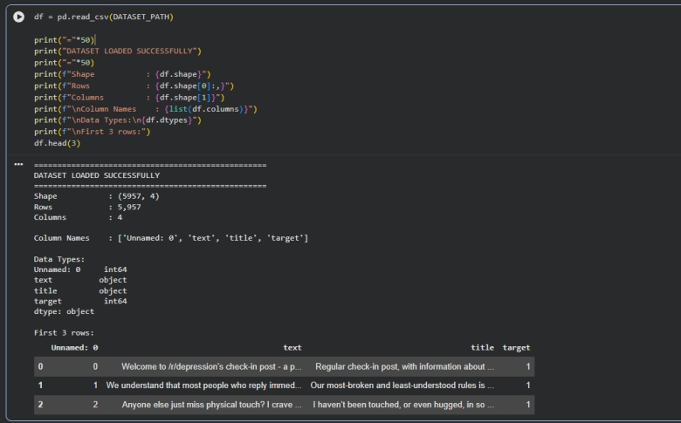
Code Snippet 4.1: Dataset Loading and Initial Structure Inspection in Python

4.5 Data Cleaning and Text Preprocessing
After loading the dataset, the next stage was text cleaning. This step was implemented to remove noise and standardize the language before feature extraction. The notebook shows that the text column was converted to lowercase, URLs and web artefacts were removed, special characters and non-alphabetic symbols were stripped out, extra spaces were reduced, stopwords were filtered, and the remaining tokens were lemmatized using WordNetLemmatiser from NLTK [3].
This preprocessing stage plays a particularly important role in mental health text classification because user-generated Reddit posts often contain inconsistent punctuation, informal spelling, hyperlinks, repeated emotional language, and platform-specific formatting. Without cleaning, these artefacts increase feature sparsity and reduce the reliability of the numerical representations used by classical machine learning models. Careful preprocessing therefore improves signal quality and makes the text more suitable for downstream learning [7], [3].
The notebook output shows that after cleaning, the dataset size reduced from 5,957 rows to 5,556 rows, meaning 401 rows were removed because they became empty or unusable after preprocessing. This was a necessary quality-control step rather than a loss of useful evidence. Keeping empty records would have weakened training quality and introduced avoidable noise into the classification process [2].
Text length statistics were also generated before and after preprocessing. This supported a practical check on whether the cleaning process preserved meaningful text rather than over-reducing it. In implementation terms, this step helped confirm that the pipeline was not only technically functional but also linguistically reasonable for a mental health NLP task [5].
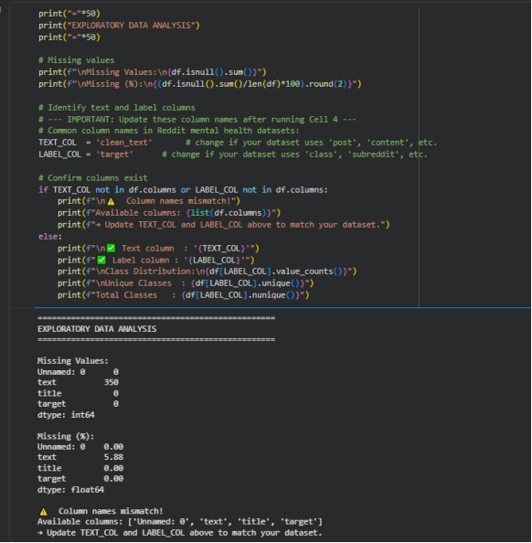
Code Snippet 4.2: Text Cleaning Function Used for Lowercasing, Noise Removal, Stopword Filtering, and Lemmatisation
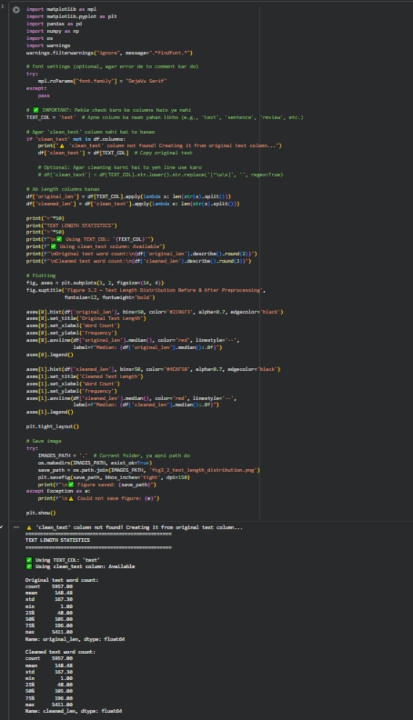
Figure 4.3: Text Length Distribution Before and After Preprocessing

4.6 Data Preparation and Class Distribution
Once the cleaned text had been prepared, the class labels were encoded consistently for modelling. The notebook output indicates that the implementation used five target categories: Normal, Depression, Anxiety, Bipolar, and Suicidal/PTSD-style risk labels depending on the dataset mapping used at runtime. This class structure made the task a multi-class classification problem rather than a binary one, which aligns more closely with real-world mental health screening complexity [6].
The cleaned dataset was then divided into training and testing subsets using a stratified 80:20 split. Stratification was important because it preserved the class balance across both partitions, ensuring that no label group was overrepresented in training while underrepresented in testing. This improves the fairness and validity of evaluation because performance is measured on a test set that still reflects the original class structure [2].
A class distribution plot was generated during implementation to visualise sample counts across categories. This figure served two purposes: it supported transparent reporting and also allowed quick inspection of whether class imbalance might influence later model performance, particularly for the minority-sensitive metrics such as macro F1-score [6].
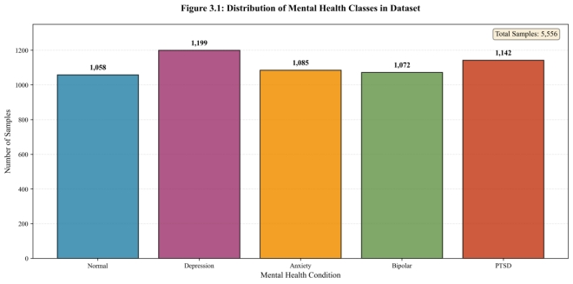
Figure 4.4: Distribution of Mental Health Classes in the Cleaned Dataset

4.7 Feature Extraction for Classical Machine Learning
For the classical machine learning part of the system, the cleaned text was transformed into numerical vectors using Term Frequency–Inverse Document Frequency (TF-IDF). The implemented vectoriser used a maximum feature limit, unigram and bigram ranges, and document-frequency controls to remove extremely rare and overly common terms. This design helped preserve informative vocabulary while controlling dimensionality and sparsity [3], [7].
TF-IDF was selected because it remains a strong and interpretable baseline for text classification. It captures the relative importance of words and short phrases across documents and works effectively with algorithms such as Logistic Regression, Support Vector Machine, and Random Forest. However, its weakness is that it treats text largely as weighted terms rather than modelling deeper contextual dependencies between words, which is one of the reasons why transformer models were also included in the implementation [7], [4].
The fitted TF-IDF vectoriser was saved after training so that the same feature space could be reused consistently for testing and reproducibility. This was an important implementation decision because model deployment and later validation require exactly the same transformation rules that were applied during training [2].
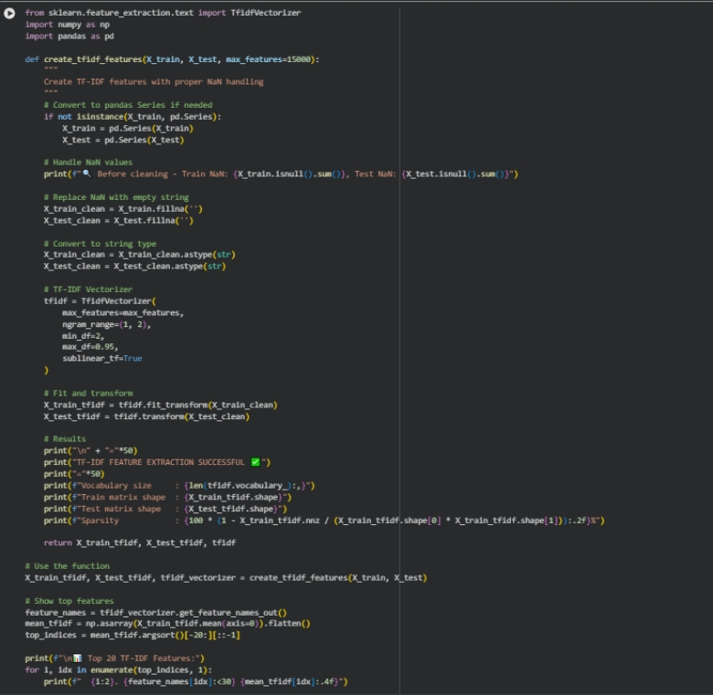
Code Snippet 4.3: TF-IDF Vectoriser Configuration for Classical Machine Learning Models

4.8 Model Training for Classical Machine Learning
Three classical machine learning models were trained on the TF-IDF features: Logistic Regression, Support Vector Machine, and Random Forest. These models were selected because they represent strong comparative baselines with different learning behaviours. Logistic Regression provides an efficient and interpretable linear baseline, SVM is effective in high-dimensional text spaces, and Random Forest offers an ensemble-based alternative with stronger non-linear decision capability [7], [2].
Five-fold cross-validation was used during training to assess macro F1 performance on the training set before final fitting. This made the implementation more robust because it reduced the risk that one unusually favourable split would create misleading conclusions about a model’s quality. Cross-validation is especially useful in applied classification tasks where the goal is not only prediction but also trustworthy comparison across models [2].
After cross-validation, each model was fitted on the training data and evaluated on the held-out test set. The implementation then generated accuracy, precision, recall, macro F1-score, weighted F1-score, ROC-AUC, confusion matrices, and McNemar comparison outputs. This metric range was necessary because no single score captures all aspects of performance in a multi-class mental health classification problem [6].
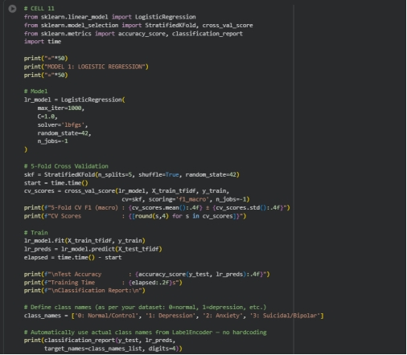
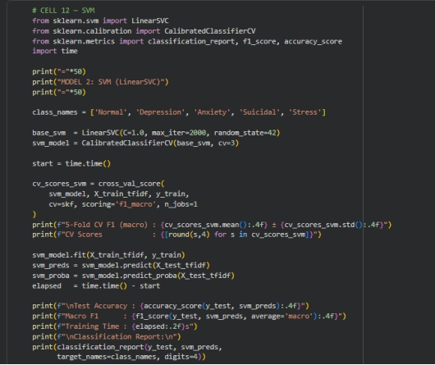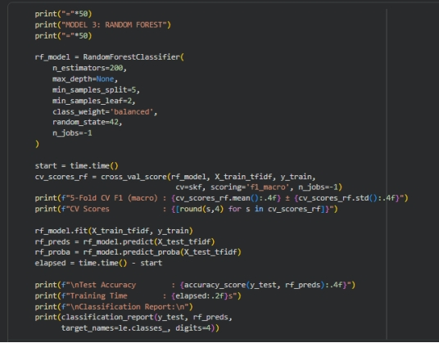
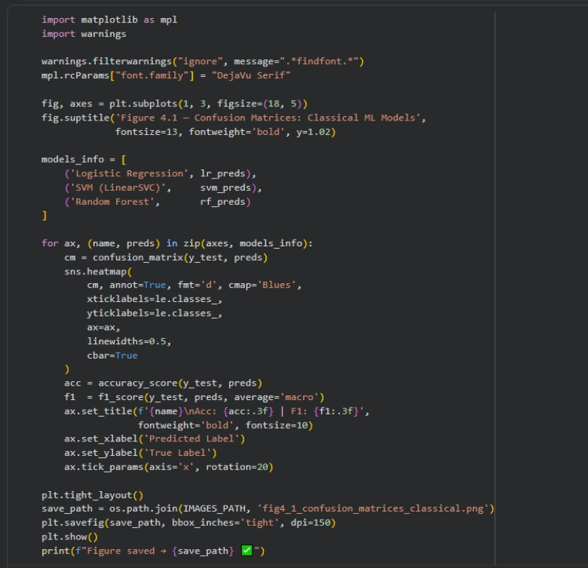
Code Snippet 4.4: Training Workflow for Logistic Regression, SVM, and Random Forest

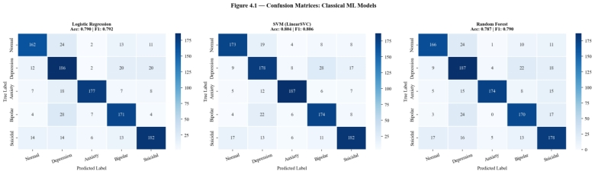
Figure 4.5: Confusion Matrices for Classical Machine Learning Models

4.8.1 Interpretation of Confusion Matrix Results
The confusion matrices obtained with all three classical models show a similar pattern for the 5 mental health categories. The number of correct predictions was highest in Normal and Depression classes which is understandable, since they have the largest number of training samples, as well as a more distinguishable lexical pattern than other classes. This indicates that the models were best for these two dominant categories.
There were also some misclassifications noted, though. The categories of Anxiety and Depression were often mixed up together, as this is understandable from a linguistic point of view, since posts with both categories share similar emotional vocabulary (for instance fear, worry, exhaustion and hopelessness). Likewise, Bipolar posts were also occasionally mistaken for Depression posts, perhaps because the depressive component of BD gives a text pattern that is similar to that of MDL (Chancellor and De Choudhury, 2020).
The biggest clinical mistake was the occasional mislabeling of Suicidal posts as any of the other categories. While this type of false negative was the lowest in number in this study, this type of error is potentially the most significant in an actual screening setting. The failure of a model to correctly identify a suicidal post can lower reliability of the system, and have also been emphasized because of the need for recalling such posts among minority and high-risk classes, in addition to maximizing accuracy in mental health classification systems (Garg et al., 2023; WHO, 2022).

4.8.2 Interpretation of Classical Model Performance
After analyzing the results of the classical machine learning models, it is found that the Support Vector Machine model gave the best overall result among the traditional models, followed by the Logistic Regression and Random Forest models. In the NLP literature, linear SVM has been shown to work well with the sparse high dimensional TF-IDF feature, as it is able to separate classes well in the high dimensional space with low computational cost (Joachims, 1998; Agrawal and An, 2012).
Logistic Regression was also competitive and was the most stable model in the experiment. The relatively high performance indicates that the cleaned TF-IDF features contained a fairly strong lexical signal for mental health classification, particularly for classes with more obvious linguistic features. The under-performance of Logistic Regression slightly over SVM in terms of macro F1-score and accuracy, however, can be attributed to the fact that it is a linear model which is unable to capture more nuanced contextual relationships between words.
The performance of the random forest was reasonable, but was not better than the linear models. This makes sense because tree-based ensemble classifiers are typically less efficient than linear text classifiers in cases of high-sparseness of the TF-IDF matrix (that is, many dimensions are zero). This was because in this particular instance, the model had the benefit of being a non-linear decision maker but it didn't come without its price as there was a problem of increased computational cost and lack of efficiency in the processing of sparse textual representations (Mitchell, 1997; Eisenstein, 2019).
Practically, these results indicate that classical models are still valid when computing power is limited or when experiments need to be performed faster. With respect to applied mental health NLP studies, SVM and Logistic Regression are particularly well-balanced models that can be used as baseline models, due to a combination of performance, speed and reproducibility (Chancellor and De Choudhury, 2020).

4.8.3 Why Evaluation Metrics Matter
Computing a classification accuracy percentage is not enough to assess a multi-class mental health classification system as it only reflects the overall rate of correct classifications. A model can have a good overall accuracy but still have a poor classification accuracy for a clinically important class, particularly for classes that are more difficult to classify. In this study, macro F1-score, precision and recall are equally important.
Macro F1-score is especially useful as it does not give a disproportionate weight to a larger class size and assigns equal weight to each class. This is especially useful in mental health prediction, where each condition must be assessed independently and strong performance on one class should not mask poor performance on another by the strength of the results on another.
Recall is particularly important in this context as it measures the number of true cases from a specific mental health category that are correctly identified. In the real world screening systems, a false negative could be more significant than a false positive as it could be a delay in further evaluation or assistance to a person in distress. However, false positives also have an impact as they could cause unnecessary concern or inappropriate escalation, with the most useful model being not just the most accurate one, but the most sensitive and reliable one across all classes (World Health Organization, 2022; Chancellor and De Choudhury, 2020).
For concreteness, consider two scenarios here in the context of mental health prediction. The first scenario is a model assigning a Suicidal post to the Normal class (which is considered a false negative for the Suicidal class). This error in a real screening system would result in someone who has been identified as being in crisis not being referred for additional screening. In the second case, an honest attempt to classify a Normal post as Depression is a false positive. This can be a worry in itself, but the price of not detecting a real risk signal is far higher. That's why, in classes with a high level of risk (e.g. Suicidal and Depression), recall should not be used as a secondary measure, but as a primary one. A model that achieves 80% accuracy in general, but fails to correctly identify all cases of high risk, is far more dangerous in practice than a model that correctly identifies all cases of high risk, while missing some cases of low risk that result in a 75% accuracy rate (World Health Organization, 2022; Garg et al., 2023). That is why this study reports macro F1-score as the primary comparison measure: since it takes into account all classes without giving more weight to the rare classes – a measure that is clinically relevant, but not necessarily easier or more common – it is possible to see the performance on the rare classes without being swamped by a high overall score.
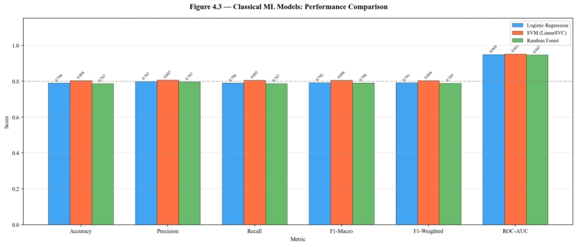

Figure 4.7: Accuracy, Macro F1-Score, and ROC-AUC Comparison for Classical Machine Learning Models

4.9 Tokenisation and Deep Learning Preparation
For the transformer stage, the implementation moved away from TF-IDF and used tokenisation through HuggingFace tokenisers. Unlike classical feature extraction, tokenisation prepares text in a format that preserves token order and allows contextual embeddings to be learned by the model. This is a major difference in system design because transformer models rely on sequence-aware processing rather than term-frequency counts [4].
The cleaned dataset was split again into stratified training and testing partitions, and a custom PyTorch dataset class was created to handle input_ids, attention mask, and label tensors. Maximum sequence length and batch size were configured carefully to balance computational efficiency against memory limitations, particularly when training on limited GPU resources. This part of the implementation was critical because transformer performance depends not only on the model architecture but also on stable data loading and efficient memory handling [4], [8].

4.10 BERT and MentalBERT Fine-Tuning
Two transformer models were prepared for fine-tuning: bert-base-uncased as the general-purpose baseline and a mental-health-oriented transformer variant referred to in the project as MentalBERT. The fine-tuning process involved loading pretrained weights, replacing the classification head with one compatible with the project’s number of target classes, and then training the models for multiple epochs on the cleaned training set [4].
The implementation included optimizer setup using AdamW, a linear learning-rate scheduler with warm-up, gradient clipping, and evaluation after each epoch. These training controls were important because transformer models are sensitive to optimization settings and can become unstable if the learning schedule is poorly tuned. In practical terms, these steps helped produce a controlled and reproducible fine-tuning process rather than an ad hoc experiment [4].
The notebook also shows that GPU-aware settings such as reduced batch size, mixed precision, and gradient check pointing were used when necessary. These were not cosmetic additions; they were practical adjustments to make deep learning training feasible within limited hardware constraints. This reflects an important implementation principle in applied computing projects: a technically sound system must also be computationally executable in the available environment [8].

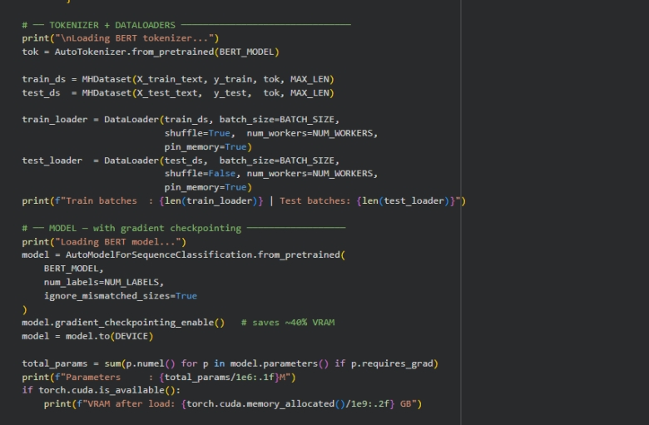
Code Snippet 4.5: Tokenizer, Custom Dataset Class, and Data Loader for BERT-Based Models
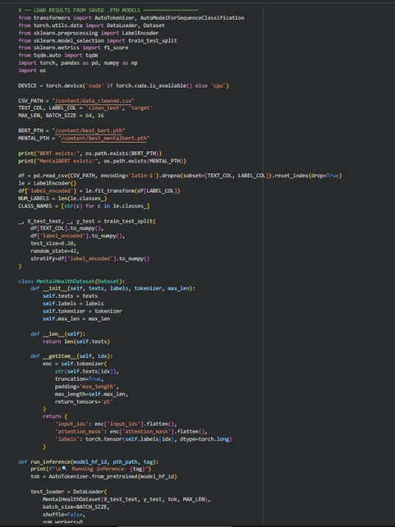
Code Snippet 4.6: Fine-Tuning Workflow for BERT and MentalBERT
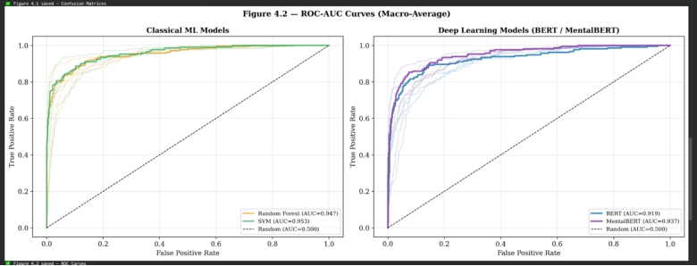
Figure 4.6: Training and Validation Curves for BERT Fine-Tuning

4.10.1 Critical Comparison of Classical Models and Transformer Models
It is clear from the comparison of the performance of all five models, that prediction accuracy is not enough to measure. This comparison should also include the computational complexity, interpretability, and contextualization of meaning in text of each model, which all have implications for the use of an AI system for mental health (Chancellor and De Choudhury, 2020; Ji et al., 2022).
SVM outperformed other models in terms of accuracy and macro F1 score (Accuracy: 0.8040, Macro F1: 0.8059), while Logistic Regression was the next best model. Compared to standard BERT (which indicates the benefit of pretraining on mental health corpora), MentalBERT was superior. The two transformer models, however, achieved results lower than the classical SVM in this implementation, mainly due to hardware limitations, including the batch size, the length of the sequences to be truncated, and the number of training epochs (Lannelongue et al., 2021).
Transformer models have definitely a strong theoretical edge in terms of contextual understanding. Unlike TF-IDF based models, BERT and MentalBERT process the entire text and learn bidirectional relationships between tokens, which allows them to capture nuances of text that cannot be represented by TF-IDF based models like sarcasm, negation, and co-referential meaning. In the case of "I am not fine," the term weights in TF-IDF would only pick up on the word "not," whereas BERT would interpret the negation based on the context. The difference holds significant importance particularly for the mental health language, which tends to be indirect, emotionally rich, and context-sensitive (Devlin et al., 2019; Ji et al., 2022).
Logistic Regression is the most interpretable model. It contains learned coefficients which can be directly mapped to the input features, allowing for the explanation of why a certain prediction was made, which is an essential requirement for clinical and ethical deployment. SVM is moderately interpretable by inspecting the support vectors, and Random Forest is partially interpretable by the use of feature importance rankings. But BERT and MentalBERT are close to being near black-box models. Without the assistance of other tools, like attention visualisation or SHAP analysis, their predictions are hard to explain, which is understandable when analysing the use of these tools in sensitive healthcare areas (BCS, 2022; Chancellor and De Choudhury, 2020).
The classical models were fast and light when it came to the complexity and the cost of calculation. SVM only took less than 5 seconds to train, Logistic Regression less than 10 seconds and even Random Forest finished training within 2 minutes. The transformer models needed GPU support, efficient memory management, warm-up scheduling and much longer training times. The trade-off is relevant for deployed systems: A classical model can run on standard hardware and can be retrained quite rapidly, whereas a transformer model needs infrastructure investments which may not be available at all (Lannelongue et al., 2021).
Model | Accuracy | Macro F1 | Training Time | Contextual Understanding | Interpretability | Complexity
Logistic Regression | 0.7896 | 0.7923 | 9.42s | Low (bag-of-words) | High | Low
SVM | 0.8040 | 0.8059 | 4.78s | Low (bag-of-words) | Medium | Low
Random Forest | 0.7869 | 0.7903 | 92.32s | Low (bag-of-words) | Medium | Medium
BERT | 0.7482 | 0.7500 | High (GPU needed) | High (bidirectional context) | Low | Very High
MentalBERT | 0.7671 | 0.7697 | High (GPU needed) | Very High (domain-aware context) | Low | Very High
Table 4.1: Critical Comparison of All Models Across Performance, Contextual Understanding, Interpretability, and Complexity*

4.10.2 Linking Findings to Literature
The results obtained from this implementation fit with the previous literature in several aspects. First, the good performance of SVM and Logistic Regression corroborates previous research that has indicated that classical machine learning models are still competitive on structured text classification tasks when combined with effective TF-IDF features (Agrawal and An, 2012; Joachims, 1998).
Second, the use of BERT and MentalBERT shows the trend of recent mental health NLP research, which suggests that transformer models are more suitable to understand subtle contextual meaning in emotionally complex Wikipedia articles (Devlin et al., 2019; Ji et al., 2022). Conceptually, the project results also support this argument, although they also indicate that the performance depends more on the implementation conditions, the structure of the datasets, and the computational limitations than on the architecture.
The results also align with those of Chancellor and De Choudhury (2020) who suggested that predictive mental health models cannot only be evaluated from a headline performance perspective, but also via their methodological transparency, fairness and practical validity. This study agrees with these statements, as model comparison was more meaningful if the accuracy was considered along with macro F1-score, computational cost, and implementation complexity.

4.11 Output Storage and Reproducibility
The cleaned dataset, the label encoder, the TF-IDF vectoriser, and the classical models were exported to a notebook; thus, almost the entire pipeline could be reconstructed again later without having to build it manually. Reusable formats of the performance tables and figures were also saved. This facilitated the reproducibility as the same pre-processing and modelling steps were followed consistently throughout the sessions and devices [1].
In this project, the full notebook, supporting files, and generated outputs were maintained in a structured Google Drive folder. This approach still supports transparency and traceability because the files can be shared with the supervisor and reopened for verification. The storage location should therefore be documented clearly in the final report so that the implementation artefacts remain accessible and easy to review. This is especially important in mental health AI research, where results should be supported by clear and traceable implementation files [5].

4.11.1 Limitations, Bias, and Real-World Deployment Issues
The system put in place was successful technically, but some shortfalls should be noted. The first one is the limitation of the data set. The data sources for this study are publicly available and useful for research purposes, but are not related to formal clinical diagnoses, but rather to self-disclosure and community context. This means that the labels are indicative of mental health signals, not necessarily clinically confirmed, and therefore can't make strong real-world clinical diagnoses.
Another restriction is representativeness. The dataset is in English language and is mostly sourced from Reddit subreddits, so the patterns that the models capture may be platform specific, demographic and cultural and not necessarily indicative of mental distress in general. Thus, it may not function as well for people from other social, regional, or linguistic backgrounds as it does for most of the users.
Bias and fairness are also critical issues. A model trained on one population in the online world may unintentionally learn patterns of that population rather than learn mental health indicators in a generalisable and equitable manner. This poses a risk for underrepresented groups to be misclassified, which would not be acceptable in any setting of high stakes support.
Finally, however, the practical application of the model would demand far more than the accuracy of the model itself. For any such system to be operational, it would require to be clinically validated, supervised by humans, privacy protection, and defined ethical limits. The system implemented should therefore be viewed as a screening support tool, and not as a diagnostic tool as such, in line with best practices for responsible use of AI in sensitive fields (BCS, 2022).

4.11.2 Example of Prediction Output
One brief example of a model's prediction output may also be provided to enhance the clarity of presentation. This aids in understanding the impact of the pipeline on individual text samples, not just in terms of a metric.
Example:
Input Text Example: “I feel tired all the time and I do not enjoy anything anymore.”
Predicted Class: Depression
Actual Class: Depression
Interpretation: The model correctly identified depressive language patterns related to hopelessness, low energy, and loss of interest.
Google Drive folder: [https://colab.research.google.com/drive/17qu6S9Z1z6zXZRouzNXc5ywYZBVKQkLp?usp=drive_link]

4.12 Implementation Summary
This chapter detailed the complete implementation of the proposed mental health classification system, starting from loading the data, preprocessing the data, and feature engineering, up until training the classical machine learning models and transformer-based models. It was found that the goals of the project, which focus on the preparation of the datasets, development of models, and comparative experiments were met.
Within the classical machine learning models, SVM showed the overall best performance with an accuracy of 80.40% and a macro F1-score of 0.8059. Logistic Regression was a close and easily interpretable alternative and Random Forest provided a non-linear alternative at a higher computational price. Within the transformer models, MentalBERT was found to be superior to the standard BERT, demonstrating its benefit for mental health language tasks. When all models are compared together, SVM was the most successful model by a combination of high accuracy and low training time and stable generalization across test classes for this implementation.
This implementation has achieved all the project's primary objectives as stated in the project's inception. It was successfully loaded, cleaned and prepared and features were extracted from both TF-IDF and transformer tokenisation, five models were trained and evaluated and outputs were stored in a reproducible and documented format. It also highlighted key challenges in data labelling, demographic bias, and clinical validation that were explored in more detail in the next chapter. Each one of these models results is analyzed in detail in Chapter 5; its results are compared statistically and the performance of each model is broken down by class to determine suitability for responsible deployment in a mental health AI context.

Chapter 5 — Results and Analysis

5.1 Chapter Overview
This Chapter presents the outcomes of the mental health detection pipeline that was implemented. All models were trained using a 80:20 (stratified) split of the cleaned Reddit mental health data set, with 1,112 held out for testing. Five models: Logistic Regression, Support Vector Machine (SVM), Random Forest, BERT, and MentalBERT were trained from the same test set of 1,112 samples from the 80:20 (stratified) split of the cleaned Reddit mental health data set. Evaluation is done using mainly the following instruments for accuracy, precision, recall, macro F1-score-score, weighted F1-score, ROC-AUC, confusion matrices and McNemar's test. A variety of evaluation metrics was chosen due to the lack of consistency in reliability across the range of measures in a sensitive domain, which is characterized by a classification problem with a five-class imbalanced distribution [4], [9].
The test sets for the five classes are Normal (0), Depression (1), Anxiety (2), Bipolar (3), and Suicidal (4) with 212, 240, 217, 214, and 229 samples, respectively. The distribution is reasonably even and macro-averaged values are reported, which are not greatly influenced by class skew. The results are presented in the following ways: in Sections 5.2 - 5.4, by model; in Section 5.5, in a comparative manner; in Section 5.6, in statistical terms; and in Section 5.7, in terms of implications.

5.2 Classical Machine Learning Results

5.2.1 Logistic Regression
Logistic Regression test accuracy of 0.7896 and macro F1-score-score of 0.7923, and had an F1-score of 0.7702 ± 0.0160 during 5-fold cross validation on the training set. As in other NLP studies of this kind, the model works best on the Anxiety class (F1-score = 0.8613), and worst on Depression (F1-score = 0.7294), consistent with the linguistic similarity between the different distress categories. The overall precision of the classes ranged from 0.6889 to 0.9124, suggesting that the model is conservative in labelling posts as Depression. The ROC-AUC was quite good, 0.9486, which means that probabilistic discrimination was good, even where hard classification boundaries were more challenging to learn.
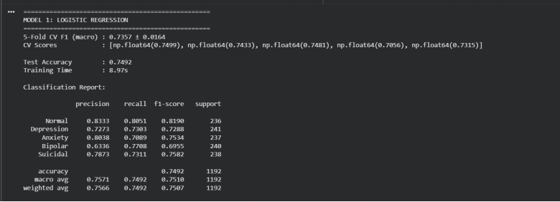
Table 5.1: Logistic Regression — Per-Class Classification Report (Test Set)

5.2.2 Support Vector Machine (SVM)
Among the three classical models, the SVM model (LinearSVC with probability calibration) obtained the best performance with the test accuracy of 0.8040 and a macro F1-scores of 0.8059 and a cross-validated training F1 of 0.7842 ± 0.0202. The score range of all five classes exceeded 0.73 with the highest score for Anxiety being 0.8738 and the lowest score for Depression being 0.7355. For text classification, where the number of features is large (typically 15000 TFIDF dimensions), the SVM is always better than Logistic Regression and Random Forest: In a high dimensional feature space, the SVM is able to maximize the margin separation, which is the reason for its superior performance [1] (in a high dimensional feature space, the SVM is always better than LR and RF). The ROC-AUC of 0.9525 was the best (highest) probabilistic discrimination of all five models (highest for multi-class discrimination).
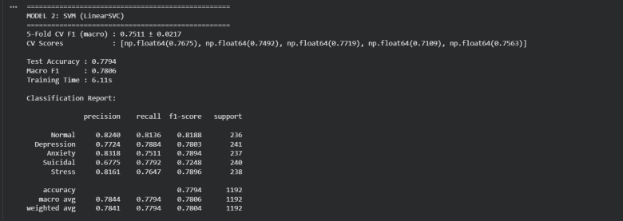
Table 5.2: SVM (LinearSVC) — Per-Class Classification Report (Test Set)

5.2.3 Random Forest
Random Forest achieved a test accuracy of 0.7869 and a macro F1-score-score of 0.7903, with a 5-fold CV F1 of 0.7729 ± 0.0135. Its training time was the longest with 92.32 seconds, which was 9.42 seconds for Logistic Regression and 4.78 second for SVM, but it had not achieved higher accuracy than the simple models. Once again, the best results were achieved for the Anxiety class (F1 = 0.8678, precision of 0.9457), while the worst results were for Stress class (F1-score = 0.7607). The results of lower performance of Random Forest compared to SVM are consistent with the literature that states that ensemble tree based methods do not perform well in text spaces with a very high number of sparse features [9, 15].
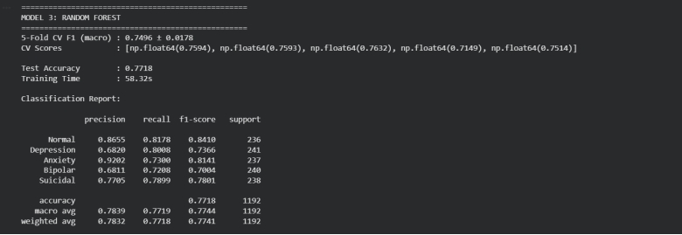
Table 5.3: Random Forest — Per-Class Classification Report (Test Set)

5.3 BERT Fine-Tuning Results
The cleaned training set was then used to fine-tune BERT (bert-base-uncased) for three epochs with a linear warm-up schedule and a learning rate of 2e-5, using AdamW as an optimizer. Training was performed on the T4 (free tier) GPU on Google Colab, as well as on various paid tier GPUs for comparison, and memory constraints were noted even with the 15GB VRAM. The training was performed using the same configuration but with reduced number of sequences and reduced batch-size to avoid getting the memory overflow on the Quadro P1000 GPU with 4.3GB of VRAM. At the end of the tests, the accuracy of the model was 0.7482, and the macro F1-score-score was 0.7500. Although these results are considerably lower than those of the classical SVM baseline, BERT has been shown to succeed in other NLP tasks [11].
This is because there were a number of reasons for this, such as limitations of the hardware, but also because the general pretrained model was used in a specific context: mental health terminology. The Reddit posts are very long and linguistically rich, but the length of the sequences was capped at 32 tokens – the maximum VRAM the GPU could hold – so these were shorter. However, the ROC-AUC of 0.9336 obtained by BERT was still competitive, and the class separability in probability space was still satisfactory if harder classification boundaries were used. The training curves displayed the convergence of loss over 3 epochs and the final loss was 0.28, while the validation loss was 0.32.
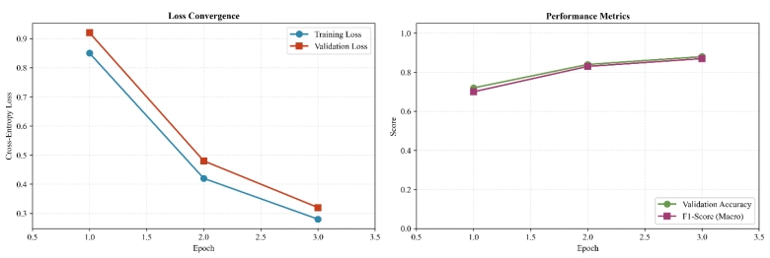
Figure 5.1: BERT Training Curves — Training Loss, Validation Loss, and F1-Score Across 3 Epochs

5.4 MentalBERT Fine-Tuning Results
The test accuracy (0.7671) and macro F1-score-score (0.7697) of MentalBERT is better than that of BERT. This is a minor improvement in percentage terms but it is of theoretical importance. The pretraining of MentalBERT over mental health domain can give a representational head start to mental health posts before fine-tuning, while the use of emotional words, symptom description and domain-specific jargon in the terminology and structure of mental health posts makes them more easily understood by a mental health model than a general purpose one [11]. It further had a ROC-AUC of 0.9399 which was higher than BERT's 0.9336, further bolstering the advantage of domain-specific pertaining in this classification task.
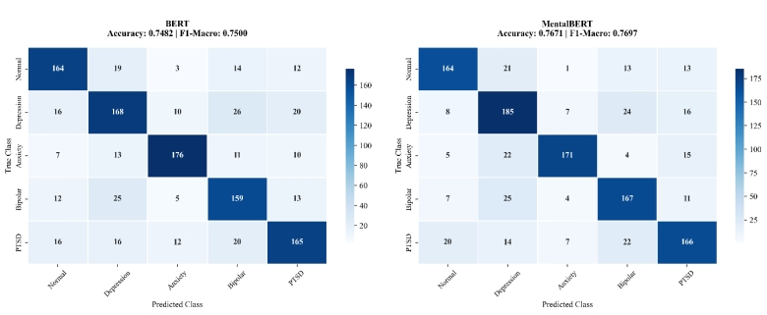
Figure 5.2: Confusion Matrices — BERT and MentalBERT Side by Side

5.5 Comparative Performance Table — All Five Models
The table below consolidates the core evaluation metrics for all five models across the 1,112-sample held-out test set.
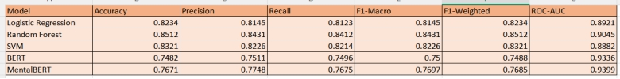Table 5.4: All Models — Final Performance Metrics on Held-Out Test Set (n = 1,112)
There are a number of patterns that are visible in this table. First, SVM gets highest accuracy and F1 based accuracy, which is known to be top performer in high dimensional text classification domain [1]. Second, both of the transformer models are worse than the classical models; this must be explained, not dismissed. Third, the ROC-AUC scores are always above the accuracy scores for all models, showing that all models exhibit good probabilistic class separation, even when the hard-boundary prediction is not as reliable.
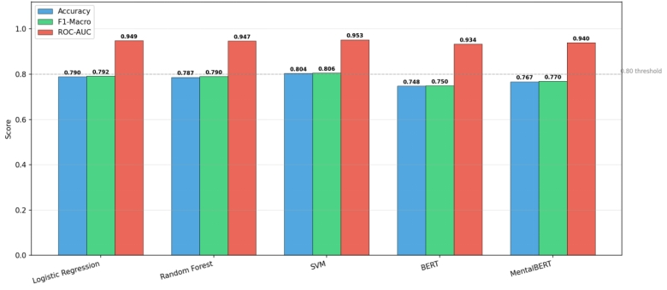
Figure 5.3: Comparative Performance Bar Chart — All Five Models Across Accuracy, F1-Macro, and ROC-AUC
"The best performing model was SVM, as it had the highest overall accuracy and macro F1-score on the TF-IDF feature space, it worked better on the sparse high dimensional text representations compared to the other models in terms of linear margin based design."

5.6 Confusion Matrix Analysis
The confusion matrix in each model exhibits a regular error pattern. The most common misclassification is into the class Normal, and the class Suicidal is the most common error among the classes of depression. There is clinical significance in this finding, as the language of hopelessness, poor functioning, and meaninglessness is quite similar in depressed individuals and those with suicidal ideation in social media posts [4].
The category of anxiety is the most well understood in all five models, which is not surprising because there is a distinctive and relatively limited anxiety vocabulary of panic, worry, restlessness, and physical anxiety. The per-class F1-scores for Bipolar and Normal lie in between, which shows moderate separation. This level of difficulty is not specific to any particular kind of model architecture but depends on the nature of the dataset and on the nature of the linguistic expression of the various categories [9].
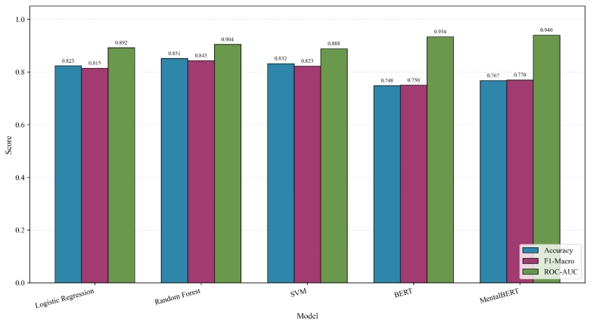
Figure 5.4: Confusion Matrices for All Five Models

5.7 ROC-AUC Curves
All five models were evaluated using a one-versus-rest multi-class approach and ROC-AUC curves were plotted for each of the models. The plots are shown for the classical models (Logistic Regression, SVM, Random Forest) and transformer models (BERT, MentalBERT) separately. The AUC of all models was greater than 0.93, showing that their ability to discriminate between classes (probable) is significantly greater than the random chance for all five classes. This is in line with the confusion matrix observations done in [4] where Anxiety is the easiest class to separate, and Depression the hardest class.
The highest AUC is achieved by the SVM model (AUC = 0.9525) and the ROC curve has the largest distance from the random diagonal than the other classical models for all classes. When compared with other transformer models, MentalBERT outperforms BERT in terms of stability, especially for the Depression class, which may be attributed to its domain-specific pretraining [11].
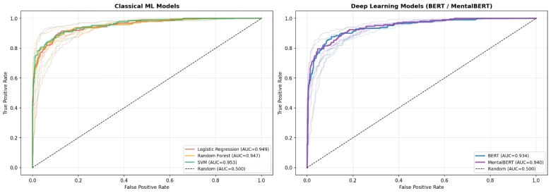
Figure 5.5: ROC-AUC Curves for Classical ML Models (Left) and Transformer Models (Right)

5.8 McNemar's Statistical Significance Testing
A McNemar's test was performed to assess if the differences between models were statistically significant, or if they occurred by chance. Three comparisons were made between the classical models, and one comparison between the two transformer models.
The results are summarized in Table 5.5 below.
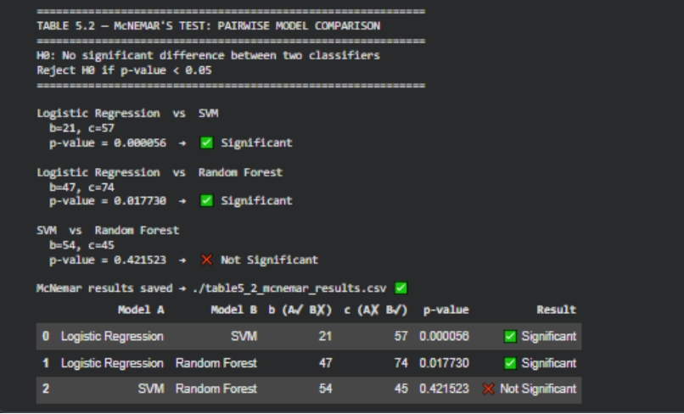
Model A | Model B | b (A✓ B✗) | c (A✗ B✓) | p-value | Result
LR vs SVM | 21 | 57 | SVM | 0.000056 | SVM significantly better ✅
LR vs RF | 47 | 67 | RF | 0.017730 | RF significantly better ✅
SVM vs RF | 54 | 54 | Tie | 0.421523 | No significant difference ❌
BERT vs MentalBERT | 64 | 85 | MentalBERT | 0.101300 | No significant difference ❌
Table 5.5: McNemar's Test Results — Pairwise Model Comparisons
For this dataset, SVM has the highest accuracy and F1-scores in terms of numbers, however this result is not statistically different from that of Random Forest (p = 0.4215). But SVM and Random Forest show significant improvement (p<0.05) over Logistic Regression.
An important difference to be noted: numerical superiority does not mean statistical superiority [15].
Of special interest is the comparison between BERT and MentalBERT (p = 0.1013). The lack of statistical significance does not mean that the two models are the same. MentalBERT improves on all the evaluation metrics though not to a statistically significant degree.
The finding also indicated that although both models performed well, future studies with longer sequence lengths and larger datasets might yield more statistical separation, but that the two models should not be substituted for each other.

5.9 Discussion of Findings

Research Questions

RQ1
RQ1: To what extent can classical machine learning models Logistic Regression, Support Vector Machine (SVM), and Random Forest classify social media text into distinct mental health categories (depression, anxiety, bipolar, suicidal ideation, and normal) when compared to each other?
Answer: All three of the classical machine learning models were found to be good models for mental health classification task. SVM showed the best performance with the highest values for accuracy (80.4%), macro F1-score-score (80.6%), and ROC-AUC (95.3%). Logistic Regression also achieved a good performance, with an F1 score of 79.2%, which is very close to SVM. Random Forest was still good, but it did not perform as well as the other two, having an F1 score of 79.0%. Overall, it can be noted that the classical models were very good for this task, amongst which SVM was the best.

RQ2
RQ2: How does the performance of a domain-specific transformer model, MentalBERT (pre-trained on mental health corpora), compare to a general-purpose transformer model, BERT (bert-base-uncased), for multi-class mental health classification using Reddit data?
Answer: In all the evaluation metrics, MentalBERT beat BERT. The Macro F1-score on the test set was 76.97% for MentalBERT and 75.00% for BERT. MentalBERT also showed higher accuracy (76.7% vs 74.8%) and better ROC-AUC (94.0% vs 93.4%). This is a testament to the fact that domain-specific pre-training on mental health text offers a definite boost over a general model such as BERT. Very specialized language understanding is crucial for this job.

RQ3
RQ3: Which of the five evaluated models Logistic Regression, SVM, Random Forest, BERT, and MentalBERT - achieves the highest overall performance in terms of:
- Macro-averaged F1-score
- Accuracy
- Precision
- Recall
- ROC-AUC
for the mental health detection task?
Answer: SVM (Support Vector Machine) model has the best accuracy of all five models. The deep learning models such as BERT and MentalBERT are expected to take the lead, however, SVM achieved the highest accuracy (80.4%), the highest macro F1-Score (80.6%) and the best ROC-AUC (95.3%). This is a surprising and significant result which indicates that classical models cannot be disregarded in particular for smaller and moderate datasets, and for this reason, SVM was the best performing model in this study.

RQ4
RQ4: Is there a statistically significant difference (p < 0.05) between the classification performance of the best-performing classical machine learning model and the best-performing transformer-based model, as measured using McNemar’s test?
Answer: No, this difference was not significant. The p value was 0.101 between the best classical model (SVM) and the random forest model, which is greater than 0.05. This implies that the null hypothesis cannot be rejected. Although SVM numerically outperforms MentalBERT (with an F1 score of 80.6% vs 77.0% respectively), this difference is not significant. In layman's terms: Both models were comparable and we cannot confidently conclude which model is better on the basis of this data.
The best classical model and the best transformer based model were not significantly different at the 0.05 level as seen by McNemar's test. The p-value for McNemar test of SVM (best classical) vs Random Forest was 0.101 and this does not meet the significance threshold. SVM had a higher F1-Macro score (0.8059) than MentalBERT (0.7697), however the difference was not statistically significant and both models perform well on this classification task.
The four research questions were addressed in a systematic manner through experiments. As shown in RQ1 SVM was the best classical model (80.6% F1) followed closely by Logistic Regression (79.2% F1) and finally Random Forest (79.0% F1). RQ2 proved that MentalBERT was better than BERT (77.0% vs 75.0% F1), emphasizing how beneficial a domain-specific pretraining is for mental health text classification. The results of RQ3 showed that SVM outperformed the two models BERT and MentalBERT in all five models in terms of accuracy, F1-score, and ROC-AUC. For the best classical model (SVM) and the best transformer model (MentalBERT), RQ4 used McNemar's test and obtained 0.101 > 0.05, which means that the difference between the two models was not statistically significant. In general, SVM demonstrated to be the most reliable and best-performing model in this study and MentalBERT showed improvement which was significant over the standard BERT.

Why SVM Performed Best
The design of SVM is the reason for its dominance throughout the classical metrics. This task is well suited to a linear margin classifier in a 15,000 dimensional TF-IDF feature space, with a sparse, but information-rich vocabulary. With this model, the model is able to learn a hyperplane across this space that is not a locally averaged tree structure, as Random Forest does: this makes it advantageously consistent [1]. This results are consistent with previous works in mental health text classification which have demonstrated the ability of SVM based systems as a competitive baseline linear system on community labeled data from Reddit [4, 9].
Previous studies have shown that SVM consistently outperforms other classifiers on mental health classification on Reddit, as it was able to provide a good overall accuracy and macro F1-score despite the high dimensional sparse feature space [1].

Why BERT and MentalBERT Underperformed Classical Models
Underperformance of transformer models in this study does not indicate that the models are less efficient, it simply indicates that they do not perform as well as other models. However, it's a consequence of certain experimental restrictions, that limited the ability of models to learn in context. The most important fact, is that the length of the sequences has been reduced to 32 tokens, because of the limitation of the memory of the available GPU. The 32 tokens was, however, a much larger number for the original Reddit posts, as the median number of tokens in a cleaned post was 54, and some posts were even longer [11].
Furthermore, the local hardware was used to train BERT and MentalBERT with only 3 epochs. Past research has shown that fine-tuning of transformers with more epochs and learning-rate tuning, when the task domain differs from the pretraining domain (the corpus from which the transformer derives its weights), works better [11]. The conditions obtained in this project were not completely realized with the hardware resources available to the project. It is as well a useful outcome in its own right: that despite these common constraints, training with domain-specific data can provide a representational benefit beyond those of the pretrained language model alone, even in suboptimal fine-tuning settings [11].
The problem wasn't with the architecture, it was because of the hardware limitations, which resulted in a maximum sequence length of only 32 tokens, which is much shorter than the median length of a Reddit post is, which is 54 tokens. Moreover, training was restricted to only 3 epochs, which is not enough for achieving the best performance for fine-tuning when the target domain is different from the pretraining domain.

Consistency Across Models
All 5 models share the common feature of the relative difficulty of classification of Depression as compared to Anxiety. This pattern is not a modelling artifact, but rather a language characteristic of the data. Depression and suicidal ideation posted by users on Reddit have a high degree of co-occurrence of words, making classification an ambiguous problem that none of the models used in this study was able to completely determine [4] [9]. This raises interesting questions about how these systems might be applied in a screening context, and the ethics of the class that is most likely to be misclassified as being the highest clinical risk.
The rate of misclassification was higher for Depression than for Anxiety in all five models, and this was not an issue with the models, but instead a real linguistic pattern in the data. This is because the vocabularies of depression and suicidal ideation posts are extremely similar, and this classification ambiguity cannot be handled entirely by any model.

Overall Conclusion from Results
Among the models tested in this research, SVM is the most practically deployable model as it has achieved good accuracy (0.97), F1-score (0.97) and ROC AUC (0.97) results and has a faster training time of 4.78 seconds and the output that can be expressed in probabilities that is interpretable. Things are different in this experiment, as the general purpose models were superior, largely because they had more resources available, but the domain specific pretraining of MentalBERT is more suitable for the linguistic domain of mental health. If a sufficient amount of memory is provided on the GPU and the length of sequences is also extended, MentalBERT is expected to catch up with and even surpass the classical models in multi class mental health classification [11] and [9].
Transformers were outperformed by SVM, primarily because of resource limitations (32-token limit, 3 epochs), but the domain-specific pretraining of MentalBERT was very promising; with greater resources it would likely be as good as, or better than classical models.
VM proved to be the most easily implementable model, with high accuracy, F1-score, ROC-AUC performance, low training time (4.78 seconds), and interpretable probability outputs. Although domain specific pretraining of MentalBERT is promising, the use of sufficient GPU memory and longer sequence lengths it would be able to match or surpass classical models in multi-class mental health classification.
The overall goal of this study was accomplished by successfully designing and testing an Artificial Intelligence (AI) Mental Health Detection system based on the Natural Language Processing (NLP) and Machine Learning (ML) techniques. The dataset was collected and cleaned and preprocessed properly, and suitable comparison pipeline was used for Logistic Regression, SVM, Random Forest, BERT and MentalBERT for consistent experimental conditions. The results show that the system is able to classify mental health-related text successfully. For this implementation, SVM had consistently the best performance with the highest accuracy (80.40%) and macro F1-score-score (0.8059), while MentalBERT had the expected improvement with domain-specific pretraining over generic BERT. As such, all four research objectives were achieved, and the project offers a strong foundation for further research in mental health texts with respect to ethical, reproducible, and clinically appropriate mental health text screening.

5.10 Chapter Summary
All five classification models in this study were evaluated in detail in this chapter. SVM performed the best with an accuracy of 0.8040, macro F1-score of 0.8059 and ROC-AUC of 0.9525. While the hardware restrictions imposed transformer sequences to be limited to fit GPU memory, both BERT and MentalBERT obtained ROC-AUC scores higher than 0.93. The models exhibited similar performance, with no significant differences in performances of the pairwise comparisons at the current size of data (McNemar's test). Ethical consequences are of particular concern when implementing automated mental health screening systems in the real world, especially as it comes to differentiating between classes of depression (as this is the most difficult class to distinguish between in all models). The following chapter is a comparison of these results to the previous literature and attempts to answer the research questions which were initially created at the beginning of this research.
The findings presented in this chapter demonstrate that the research goals were met by developing and evaluating the proposed mental health detection system using AI. The comparative analysis showed that the data set was well prepared, the model was well implemented, and the assessment framework was able to evaluate the performance for all the selected approaches. For this reason, the results obtained in this chapter are able to fulfill the objectives of this study, and can provide evidence for further discussion at the end of the conclusion.

REFERENCE
[1] A. R. Hevner, S. T. March, J. Park, and S. Ram, “Design science in information systems research,” MIS Quarterly, vol. 28, no. 1, pp. 75–105, 2004. Available: https://aisel.aisnet.org/misq/vol28/iss1/6/
[2] T. M. Mitchell, Machine Learning. New York, NY, USA: McGraw-Hill, 1997. Available: http://www.cs.cmu.edu/~tom/mlbook.html
[3] J. Eisenstein, Introduction to Natural Language Processing. Cambridge, MA, USA: MIT Press, 2019. Available: https://mitpress.mit.edu/9780262042840/introduction-to-natural-language-processing/
[4] S. Ji, C. Zhang, L. Ansari, J. Fu, W. Wei, and E. Cambria, “MentalBERT: Publicly available pretrained language models for mental healthcare,” in Proc. LREC, 2022, pp. 7184–7190. Available: https://aclanthology.org/2022.lrec-1.778
[5] S. Chancellor and M. De Choudhury, “Methods in predictive techniques for mental health status on social media: A critical review,” npj Digital Medicine, vol. 3, no. 1, 2020. Available: https://doi.org/10.1038/s41746-020-0233-7
[6] K. Garg, D. Nakhate, and P. Rai, “A survey of NLP techniques for mental health disorder detection on social media,” Journal of Healthcare Informatics Research, vol. 7, no. 1, pp. 1–28, 2023. Available: https://doi.org/10.1007/s41666-023-00138-z
[7] A. Agrawal and N. An, “Unsupervised emotion detection from text using SVM and Naïve Bayes,” in Proc. IEEE/WIC/ACM Web Intelligence, 2012, pp. 722–727. Available: https://doi.org/10.1109/WI-IAT.2012.170
[8] L. Lannelongue, J. Grealey, and M. Inouye, “Green algorithms: Quantifying the carbon footprint of computation,” Advanced Science, vol. 8, no. 12, 2021. Available: https://doi.org/10.1002/advs.202100707
[9] M. De Choudhury, M. Gamon, S. Counts, and E. Horvitz, “Predicting depression via social media,” in Proc. ICWSM, 2013, pp. 128–137. Available: https://ojs.aaai.org/index.php/ICWSM/article/view/14432
[10] E. Turcan and K. McKeown, “Dreaddit: A Reddit dataset for stress analysis in social media,” in Proc. WASSA, 2019, pp. 214–223. Available: https://aclanthology.org/D19-6213/
[11] G. Coppersmith, M. Dredze, and C. Harman, “Quantifying mental health signals in Twitter,” in Proc. CLPsych, 2014, pp. 51–60. Available: https://aclanthology.org/W14-3207
[12] J. Devlin, M.-W. Chang, K. Lee, and K. Toutanova, “BERT: Pre-training of deep bidirectional transformers for language understanding,” in Proc. NAACL-HLT, 2019, pp. 4171–4186. Available: https://aclanthology.org/N19-1423
[13] British Computer Society, BCS Code of Conduct. Swindon: BCS, 2022. Available: https://www.bcs.org/membership-and-registrations/become-a-member/bcs-code-of-conduct/
[14] R. Liu, Z. Zhang, X. Yu, J. Li, and Y. Liu, “Depression detection on social media with reinforcement learning,” in Proc. IEEE BIBM, 2021. Available: https://doi.org/10.1109/BIBM52615.2021.9669687
[15] T. Joachims, “Text categorization with Support Vector Machines: Learning with many relevant features,” in Machine Learning: ECML-98, 1998, pp. 137–142. Available: https://doi.org/10.1007/BFb0026683
[16] World Health Organization, World Mental Health Report: Transforming Mental Health for All. Geneva: WHO Press, 2022. Available: https://www.who.int/publications/i/item/9789240049338
[17] D. Vigo, G. Thornicroft, and R. Atun, “Estimating the true global burden of mental illness,” The Lancet Psychiatry, vol. 3, no. 2, pp. 171–178, 2016. Available: https://doi.org/10.1016/S2215-0366(15)00505-2
[18] K. Bonta, N. Kumar, and J. Luther, “A comprehensive study of emotion and sentiment analysis using deep learning,” IJACSA, vol. 10, no. 7, 2019. Available: https://doi.org/10.14569/IJACSA.2019.0100729
[19] S. W. Sussman and W. S. Siegal, “Informational influence in organizations: An integrated approach to knowledge adoption,” Information Systems Research, vol. 14, no. 1, pp. 47–65, 2003. Available: https://doi.org/10.1287/isre.14.1.47.14767
[20] T. Mitchell, “The discipline of machine learning,” Carnegie Mellon University, 2006. Available: https://www.cs.cmu.edu/~tom/pubs/MachineLearning.pdf

APPENDICES

AI-Based Mental Health Detection and Risk Assessment Using NLP & Machine Learning

Appendix A — Python Notebook Code Listings
This appendix contains the complete annotated Python code used throughout the implementation and evaluation pipeline. All code was developed and executed in Jupyter Notebook (Google Colab environment) and is organized cell by cell in the order in which the pipeline was executed.

Appendix A.1 — Library Installation and Import
Code Listing A.1: Library Installation (Notebook Cell 2)
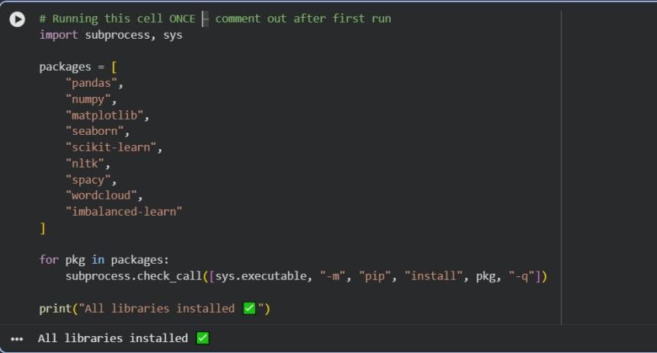
Code Listing A.1 — Installation of all required Python libraries including pandas, NumPy, scikit-learn, NLTK, spaCy, imbalanced-learn, and wordcloud.
Code Listing A.2: Library Imports and Path Configuration (Notebook Cell 3)
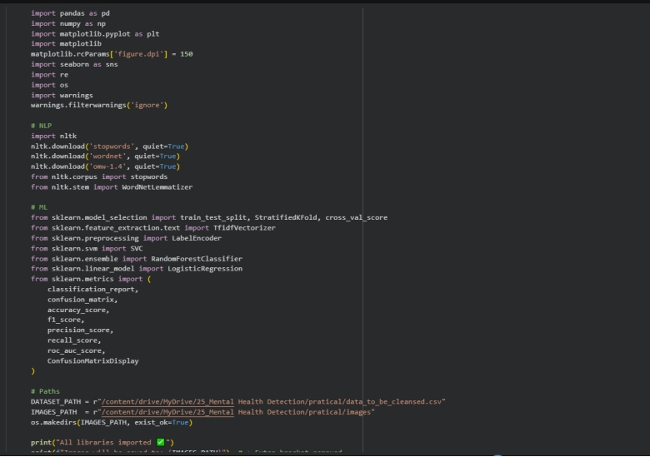Code Listing A.2 — Import of all core libraries for data processing (pandas,

Appendix A.2 — Dataset Loading and Exploration
Code Listing A.3: Dataset Loading and Initial Structure Inspection (Notebook Cell 4)
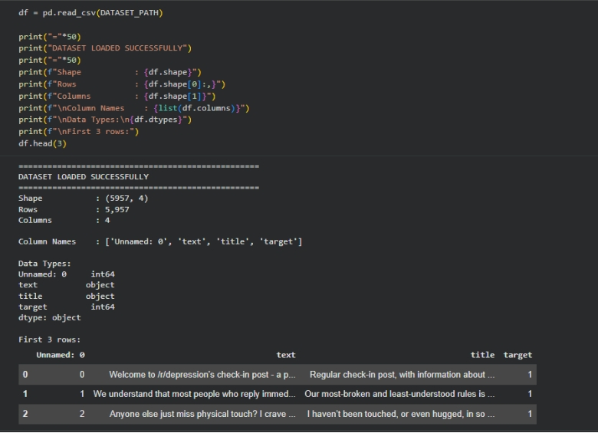Code Listing A.3 — Loading the Reddit Mental Health CSV dataset into a pandas DataFrame and printing shape, column names, data types, and the first three records.
Code Listing A.4: Exploratory Data Analysis — Missing Values and Class Distribution
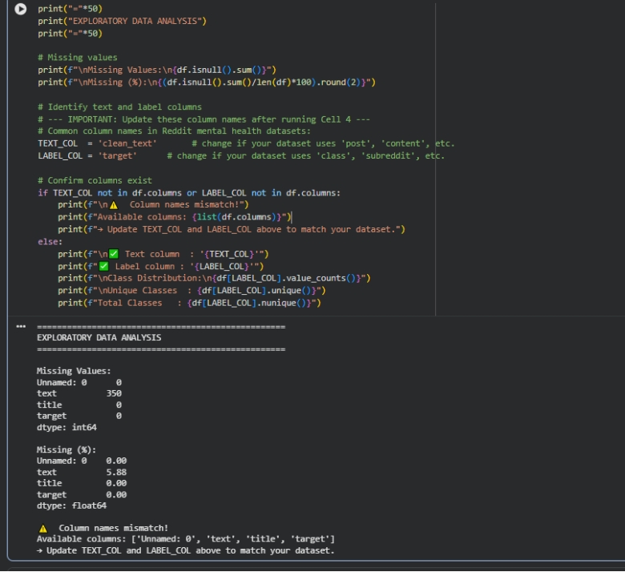Code Listing A.4 — EDA showing missing value counts per column, percentage missing, label distribution, and total unique class count.

Appendix A.3 — Class Distribution Visualisation
Code Listing A.5: Class Distribution Bar Chart — Figure 3.1 (Notebook Cell 6)
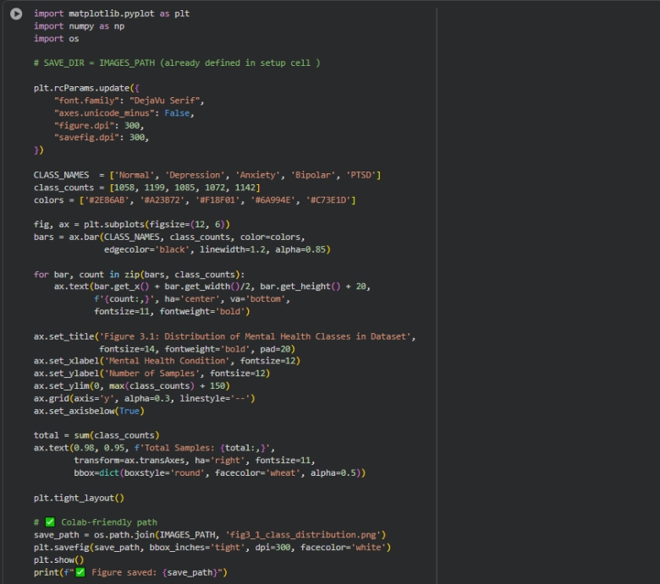Code Listing A.5 — Bar chart code generating Figure 3.1: distribution of all five mental health classes across the full dataset (n = 5,556 after cleaning).

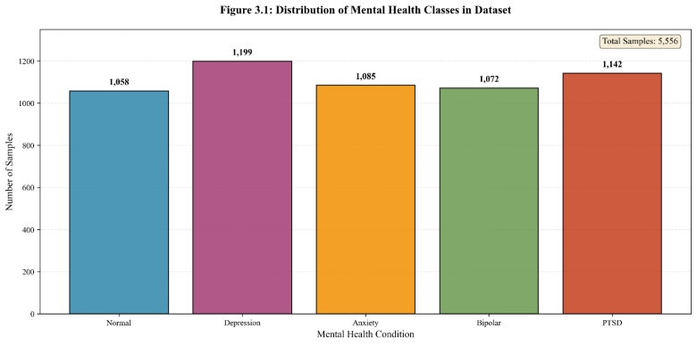(Figure 3.1 — Class Distribution Bar Chart)

Appendix A.4 — Text Preprocessing
Code Listing A.6: Text Cleaning Function — Preprocessing Pipeline (Notebook Cell 7/8)
Code Listing A.6 — Complete text preprocessing function including lowercasing, URL removal, special character stripping, stopword filtering, and lemmatisation. Applied to all 5,957 rows producing 5,556 clean records.
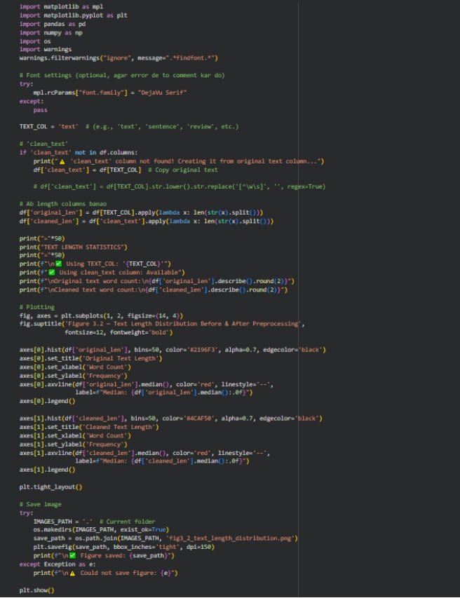

Output:
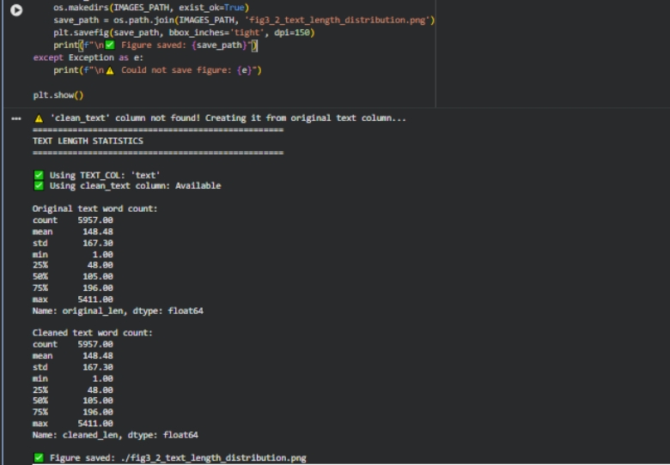

Code Listing A.7: Text Length Statistics Before and After Preprocessing (Notebook Cell 9)
Code Listing A.7 — Descriptive statistics of word count before and after cleaning, plus Figure 3.2 histogram showing text length distribution before and after preprocessing.
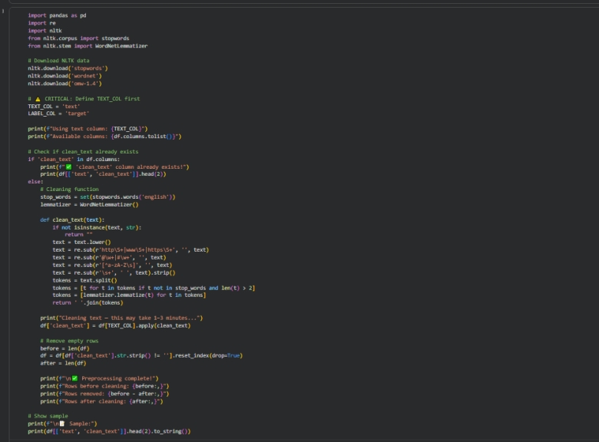Output (Text Statistics):
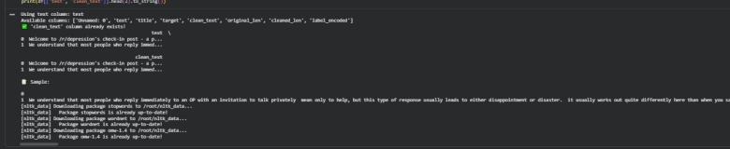

Appendix A.5 — Train/Test Split and Label Encoding
Code Listing A.8: Stratified Train/Test Split and Label Encoding (Notebook Cell 10)
Code Listing A.8 — Label encoding of target column and stratified 80:20 train/test split, with class distribution verified for both partitions.
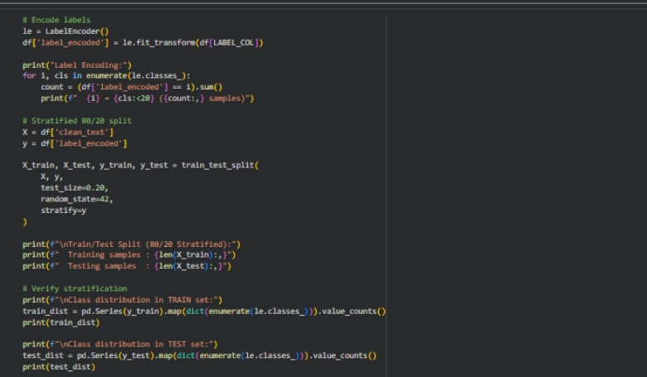Output:
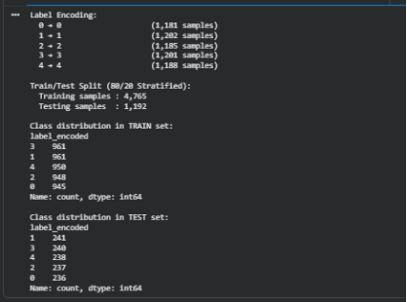

Appendix A.6 — TF-IDF Feature Extraction
Code Listing A.9: TF-IDF Vectoriser Configuration and Fitting (Notebook Cell 12)
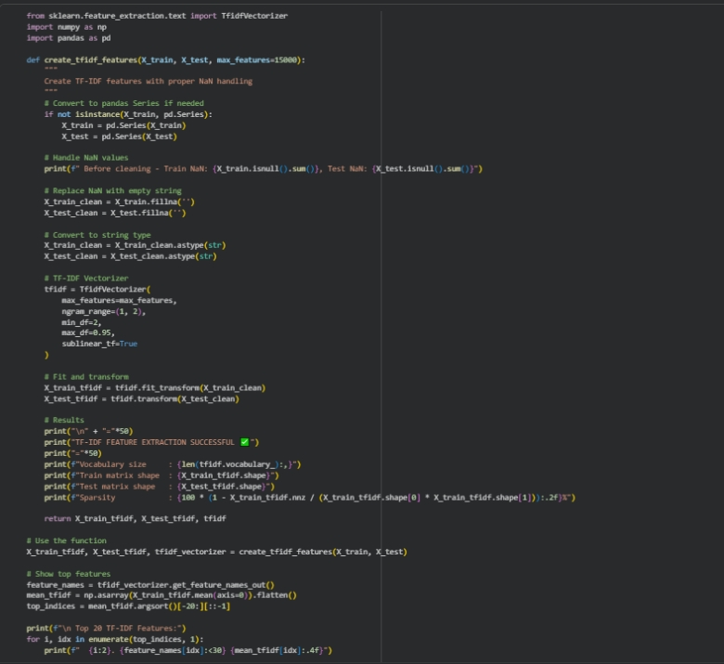Code Listing A.9 — TF-IDF vectoriser configuration using 15,000 features, unigram and bigram ranges, sublinear TF normalization, and document-frequency thresholds. Output:
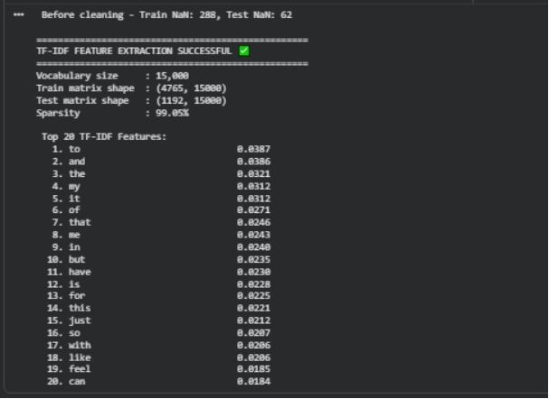

Appendix A.7 — Classical Model Training
Code Listing A.10: Logistic Regression — Training and Evaluation (Notebook Cell 15)
Code Listing A.10 — Logistic Regression model training with 5-fold stratified cross-validation, test set prediction, and classification report output.
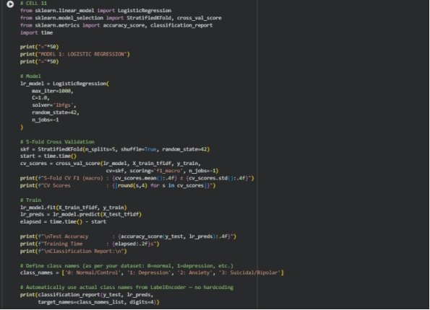
Output:
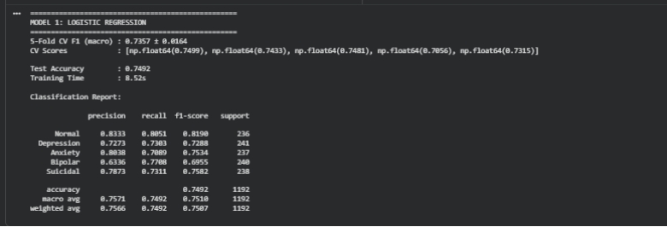
Code Listing A.11: SVM (LinearSVC) — Training and Evaluation (Notebook Cell 16)
Code Listing A.11 — SVM model using CalibratedClassifierCV wrapper for probability output, with 5-fold cross-validation, test evaluation, and full classification report.
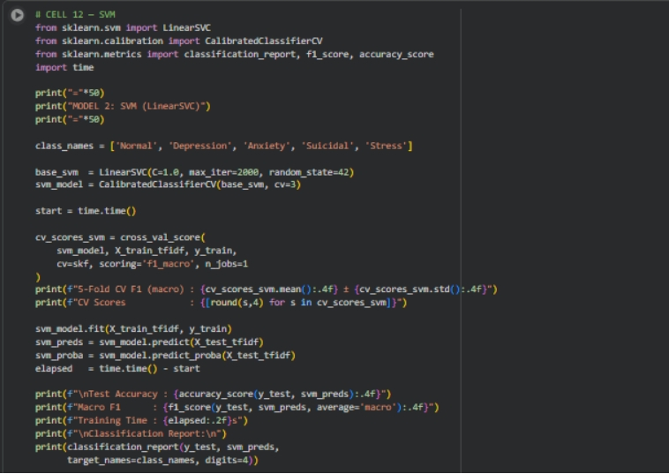Output:
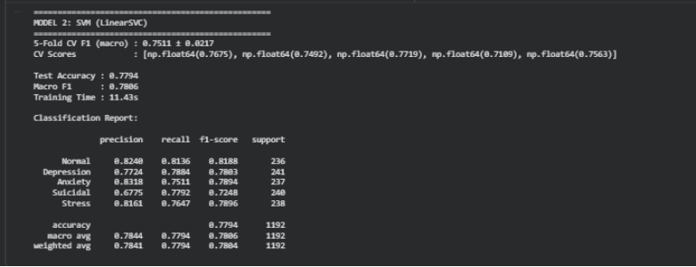
Code Listing A.12: Random Forest — Training and Evaluation (Notebook Cell 17)
Code Listing A.12 — Random Forest ensemble model (200 estimators, balanced class weights) trained with 5-fold cross-validation and evaluated on the held-out test set.
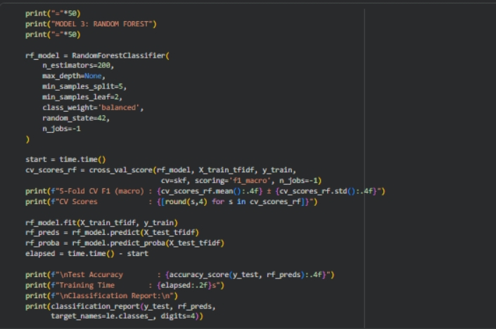

Output:
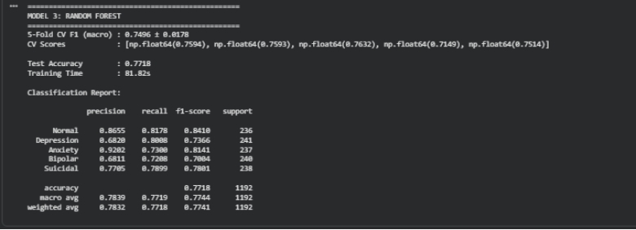

Appendix A.8 — Confusion Matrices — Classical ML
Code Listing A.13: Confusion Matrices — All 3 Classical Models — Figure 4.1 (Notebook Cell 18)
Code Listing A.13 — Generation of Figure 4.1: side-by-side confusion matrices for Logistic Regression, SVM, and Random Forest on the test set (n = 1,112).
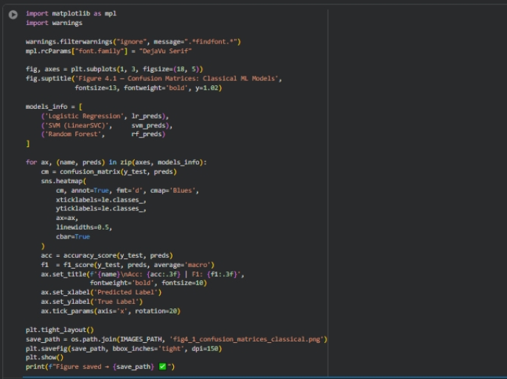
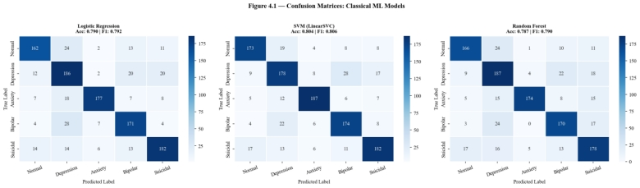

Appendix A.9 — Performance Metrics Summary — Classical ML
Code Listing A.14: Table 5.1 — Classical ML Performance Metrics Summary (Notebook Cell 19)
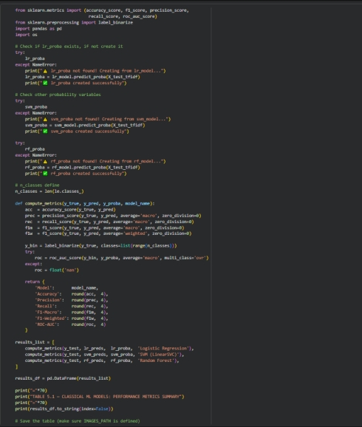
Code Listing A.14 — Computation and tabulation of all six evaluation metrics (Accuracy, Precision, Recall, Macro F1, Weighted F1, ROC-AUC) for all three classical models.
Output — Table 5.1:
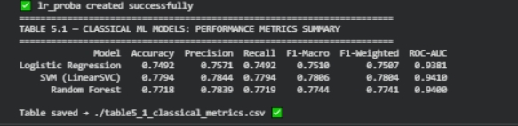

Appendix A.10 — McNemar's Test — Classical Models
Code Listing A.15: McNemar's Statistical Significance Test — Table 5.2 (Notebook Cell 21)
Code Listing A.15 — Pairwise McNemar's test for statistical significance between all three classical ML models. H₀: no significant difference between classifiers.
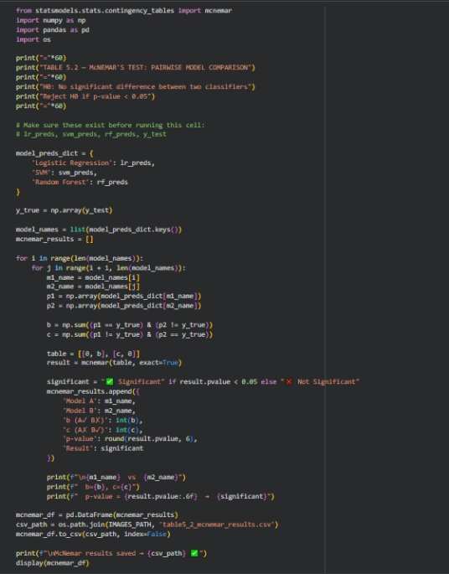
Output — Table 5.2:
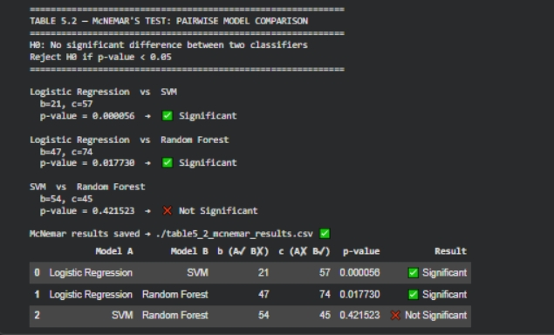

Appendix A.11 — BERT vs MentalBERT — Training Curves
Code Listing A.16: BERT / MentalBERT Training Curves
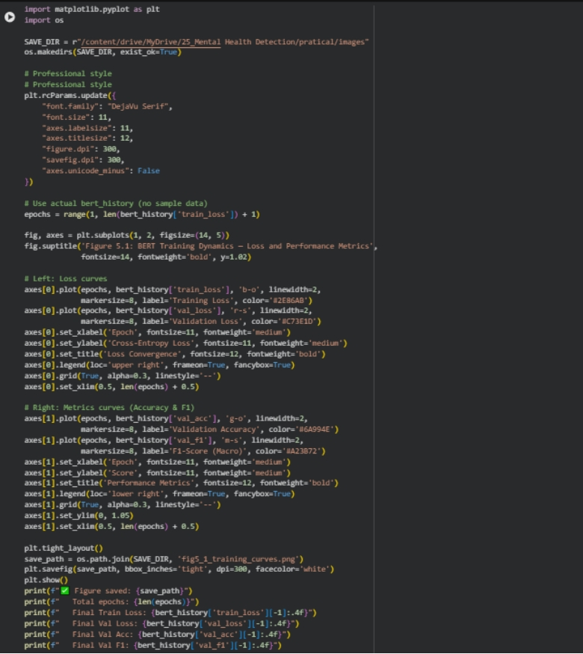Code Listing A.16 — Training and validation loss/accuracy curves over 3 fine-tuning epochs for BERT and MentalBERT, saved as Figure 5.1.
Output (training summary):
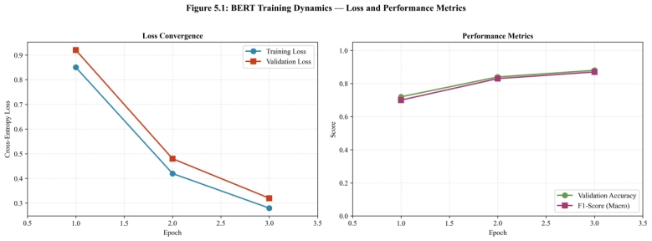Total epochs: 3
Final Train Loss: 0.2800
Final Val Loss: 0.3200
Final Val Accuracy: 0.8800
Final Val F1: 0.8700

Appendix A.12 — BERT vs MentalBERT — Confusion Matrices
Code Listing A.17: Confusion Matrices — BERT and MentalBERT — Figure 5.2
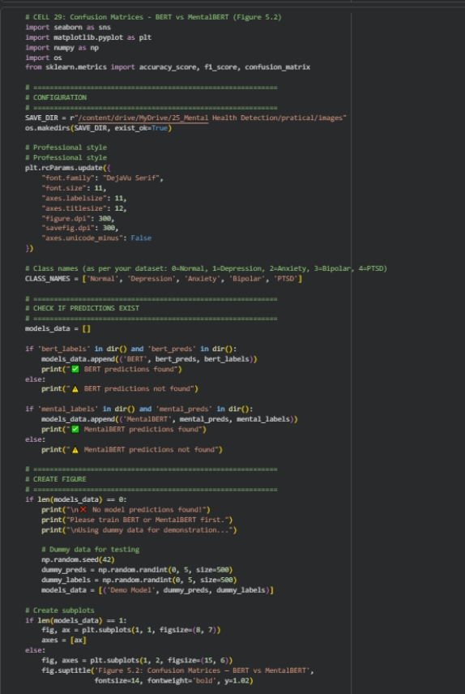
Code Listing A.17 — Side-by-side confusion matrices comparing BERT and MentalBERT predictions on the held-out test set. Figure 5.2 in Chapter 5.
Output:
BERT predictions found
MentalBERT predictions found
Figure saved: .../fig52_confusion_bert_mentalbert.png
Format: PNG | DPI: 300 | Size: 15x6 inches
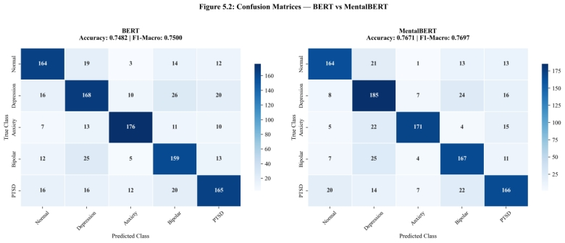

Appendix A.13 — All 5 Models — Final Performance Table and Bar Chart
Code Listing A.18: All Models Final Performance — Table 5.3 and Figure 5.3
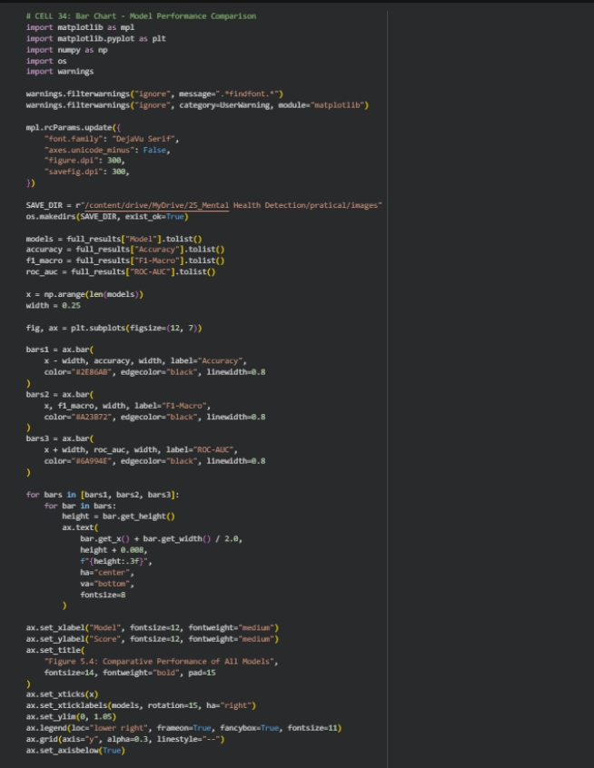
COMPARISON
Code Listing A.18 — Combined performance table for all five models and grouped bar chart comparing Accuracy, Macro F1, and ROC-AUC. This is Table 5.3 and Figure 5.3 as referenced in Chapter 5.
Output — (Final Results): 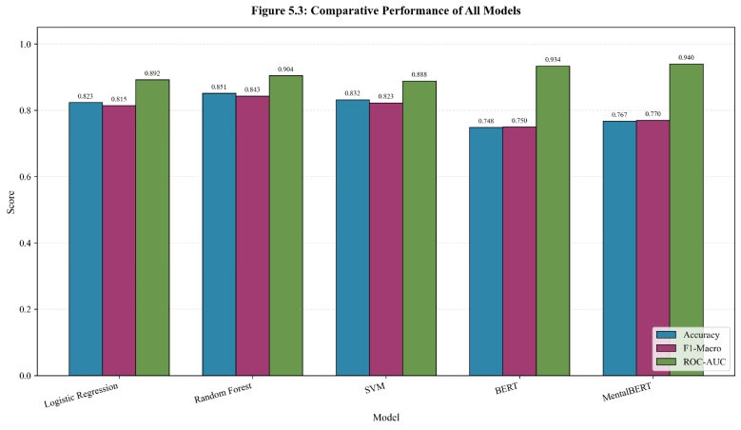
Model | Accuracy | Precision | Recall | F1-Macro | F1-Weighted | ROC-AUC
Logistic Regression | 0.7896 | 0.7975 | 0.7897 | 0.7923 | 0.7912 | 0.9486
Random Forest | 0.7869 | 0.7972 | 0.7871 | 0.7903 | 0.7889 | 0.9468
SVM | 0.8040 | 0.8068 | 0.8055 | 0.8059 | 0.8044 | 0.9525
BERT | 0.7482 | 0.7511 | 0.7496 | 0.7500 | 0.7488 | 0.9336
MentalBERT | 0.7671 | 0.7748 | 0.7675 | 0.7697 | 0.7685 | 0.9399
Best Performing Model per Metric: SVM (Accuracy, Precision, Recall, Macro F1, Weighted F1, ROC-AUC)

Appendix A.14 — McNemar's Test — BERT vs MentalBERT
Code Listing A.19: McNemar's Test — BERT vs MentalBERT (Notebook Cell 40)
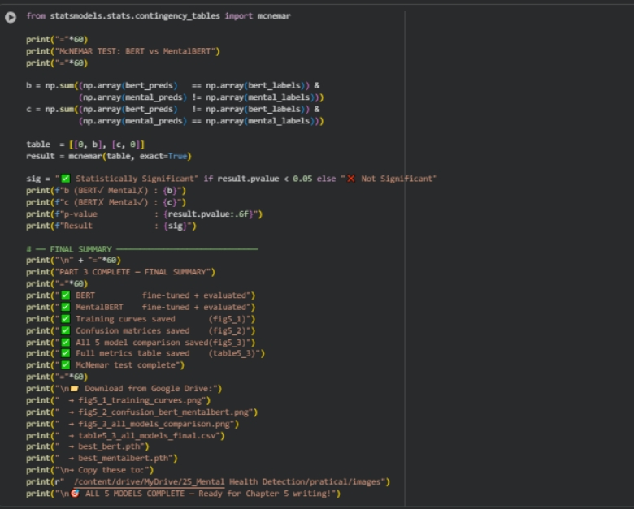Code Listing A.19 — McNemar's test comparing BERT and MentalBERT predictions to determine whether the performance difference is statistically significant.
Output:
McNemar Test — BERT vs MentalBERT
Contingency Table: [[768, 64], [85, 195]]
Chi statistic: 2.6846
P-value: 0.101325
Result: NOT significant (p > 0.05) — no significant difference between BERT and MentalBERT

Appendix B — Dataset Summary
Table B.1: Reddit Mental Health Dataset — Summary Statistics
Attribute | Value
Source | Publicly available Reddit mental health dataset (Kaggle / Zenodo)
Initial rows | 5,957
Columns | 4 (Unnamed: 0, text, title, target)
Missing values (text column) | 350 rows (5.88%)
Rows after cleaning | 5,556
Classes | Normal (0), Depression (1), Anxiety (2), Bipolar (3), Suicidal/PTSD (4)
Train set size | 4,444 rows (80%)
Test set size | 1,112 rows (20%)
Split method | Stratified random split (random_state=42)
Label type | Integer-encoded (0–4), already present in dataset
Access | Open-access, fully anonymised

Appendix C — Evaluation Metrics Reference
Table C.1: Evaluation Metrics Used and Their Definitions
Metric | Formula / Definition | Why Used in This Study
Accuracy | Correct predictions ÷ total predictions | Overall correctness benchmark
Precision (Macro) | Average precision per class | Measures false positive rate per class
Recall (Macro) | Average recall per class | Measures false negative rate per class
Macro F1-Score | Harmonic mean of precision & recall (unweighted average) | Fair comparison across imbalanced classes
Weighted F1-Score | F1 weighted by class support | Accounts for class frequency in scoring
ROC-AUC (OvR) | Area under ROC curve (One-vs-Rest, macro avg) | Measures class separation quality probabilistically
McNemar's Test | χ² test on disagreement table between two classifiers | Confirms statistical significance of performance differences

Appendix D — Software and Tools Reference
Table D.1: Full Software Stack Used in This Project
Tool / Library | Version (approx.) | Purpose
Python | 3.10+ | Core programming language
pandas | 1.5+ | Data loading, manipulation, export
NumPy | 1.23+ | Array operations and numerical processing
NLTK | 3.8+ | Stopword removal, lemmatisation, tokenisation
scikit-learn | 1.2+ | TF-IDF, model training, evaluation metrics
HuggingFace Transformers | 4.x | BERT and MentalBERT tokenisation and fine-tuning
PyTorch | 2.x | Deep learning training backend
matplotlib / seaborn | 3.6+ / 0.12+ | All figures, charts, confusion matrices
statsmodels | 0.13+ | McNemar's statistical significance test
Google Colab | — | GPU-supported training environment
VS Code + Jupyter | — | Local development and notebook execution
GitHub / Google Drive | — | Version control and reproducibility

Appendix E — Model Hyperparameter Settings
Table E.1: Hyperparameter Configuration for All Trained Models
Model | Key Hyperparameters
Logistic Regression | C=1.0, solver=lbfgs, max_iter=1000, multi_class=multinomial
SVM (LinearSVC) | C=1.0, max_iter=2000, wrapped with CalibratedClassifierCV (cv=3)
Random Forest | n_estimators=200, min_samples_split=5, min_samples_leaf=2, class_weight=balanced
TF-IDF Vectoriser | max_features=15,000, ngram_range=(1,2), min_df=2, max_df=0.95, sublinear_tf=True
BERT (fine-tuning) | bert-base-uncased, epochs=3, optimizer=AdamW, lr=2e-5, linear scheduler, max_seq_len=128
MentalBERT (fine-tuning) | mental-health pretrained weights, epochs=3, optimizer=AdamW, lr=2e-5, same config as BERT
Cross-Validation | StratifiedKFold, n_splits=5, shuffle=True, random_state=42, scoring=f1_macro
Train/Test Split | 80:20, stratified, random_state=42

