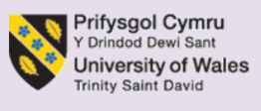
TASK 1: INDIVIDUAL WRITTEN BUSINESS PLAN
STUDENT'S NAME: Gianina Rosalinda Serban
STUDENT ID:2438242
Executive Summary
The aim of the report was to introduce a new business plan that has high growth potential in the UK market in order to sustain in future. Sparkling Shine is the selected business that will offer app-based sustainable cleaning services to commercial and residential places in London and Birmingham initially, following effective management and legal structure. Therefore, market research has been made through PESTLE and Porter’s Five Forces. Additionally, it analyses marketing strategies and financial plans to improve the long-term growth of the new venture.

Table of Contents
Introduction
Overview of business idea
Service offering
Management Structure and Legal Format
Market research
PESTLE framework
Porter Five Forces
Marketing communications
Target customers through the STP Model
Marketing strategies
Financial
Funding sources and why they are beneficial
Main start-up expenses during the first month of operations
5.3 Budgets, cashflow and breakeven calculations
Conclusion
Reference list

Introduction
The cleaning service market in the UK is expected to generate 39 billion USD by 2033, reflecting 9.4% growth. It demonstrates the continuous growth of the market, which helps to identify the business idea related to this industry (Grandviewresearch, 2026). Sparkling Shine is the selected online business app, which will offer cleaning services for both commercial places and homes to leverage this growth. The new business ideas, such as the service it will offer, management structure and legal format will be discussed. However, before making strategic directions, the business needs to make an appropriate plan, such as market research, including the influence of the external market through the PESTLE framework, competitive analysis through Porter’s Five Forces, and identification of the target market. Additionally, analysis of marketing communications and financial planning is also essential to deal with challenges and seize opportunities to make the business successful.
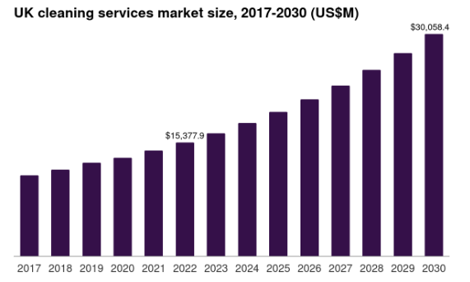
Figure 1: Cleaning service market growth in the UK
(Source: Grandviewresearch, 2026)

Overview of business idea

Service offering
The proposed startup Sparkling Shine is an online cleaning service platform that offers on-demand and convenient cleaning services, considering sustainable practices for both residential and commercial clients who value professional cleaning services and prefer subscription-based services. It will keep service affordable compared to competitive markets, such as £10-£12.5 dollar per hour, while online subscription and booking orders make the app accessibility better, as in the UK there are over 59 million e-commerce users (Forbes, 2026). It reflects the benefits of the new app to target those customers to influence their intentions. In the initial period, it will give services in London and Birmingham, and later will expand over time. Moreover, to control the budget, it decided to make an online presence over a physical presence, which requires more resources. Key services are:
- Residential cleaning
- Commercial cleaning
- Value-added features
- Subscription packages
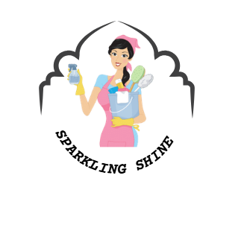
Figure 2: Business Logo
(Source: Self-created)

Management Structure and Legal Format
It will operate as a lean SME consisting of the Chief Executive Officer (CEO), operations management, finance manager, marketing and sales manager, chief technology officer and supported staff who ensure cost, scalability and overall operations (Bendig et al. 2023). It will be a private limited company that has limited liability protections, along with other benefits like making business appealing to attract investors, and the legal format brings tax flexibility, ensuring growth and long-term sustainability.

Market research

PESTLE framework
PESTLE frameworks evaluate the external business environment of Sparkling Shine by evaluating six factors discussed below:
PESTLE | Discussion
Political | - Corporate tax rate for SMEs are 19% (Gov, 2025)  - British Business Bank delivered business start-up loans (British-business-bank, 2026)  - Supports funding generations of Sparkling Shine
Economic | - The inflation rate was 3% in February 2026 (Statista, 2026)  - Bank interest was 3.75% (Bankofengland, 2026)  - Reduce the financial burden of the business
Social | - Reduce household incomes by 2% (Parliament, 2026)  - In 2022, people are ready to pay 10% extra on sustainable items (Statista, 2026)  - Supports sales of Sparkling Shine
Technological | - The government invested £3.5 billion in future tech and science (Gov, 2023)  - Strengthen the digital infrastructure of Sparkling Shine
Legal | - Consumer Rights Act established in 2015 (Legislation, 2026)  - National living wage £12.71 from April 2026 (Gov, 2026)  - Ensure to avoid legal complexities
Environmental | - Redeveloped Environment Act in 2021 (Legislation, 2026)  - Target net zero by 2050 (Parliament, 2026)  - Ensure sustainable practices align with brand reputation and customer engagement
Table 1: PESTLE analysis.
(Source: Self-developed)
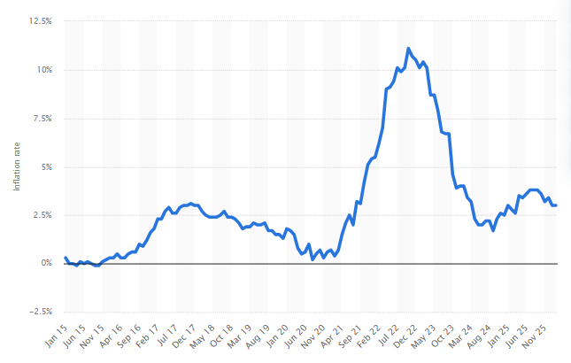
Figure 3: UK inflation rate
(Source: Statista, 2026)
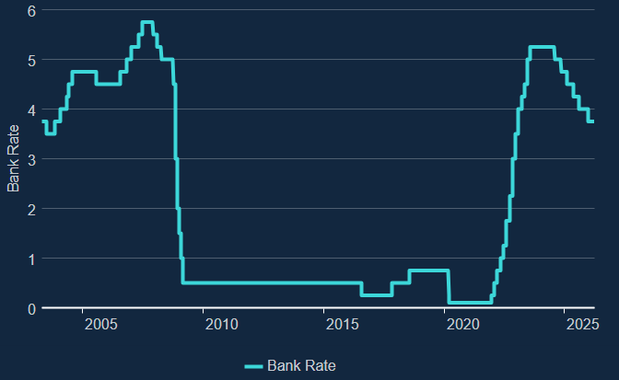
Figure 4: Bank interest rate
(Source: Bankofengland, 2026)

Porter Five Forces
Porter’s five forces help to identify the market competitiveness for Sparkling Shine:
Factors | Discussion | Impact
Bargaining power of buyers | A large number of customers with various options of cleaning services | High
Bargaining power of suppliers | Marketplace has various cleaning equipment suppliers, while sustainable cleaning product suppliers are limited | Moderate
Competitive rivalry | Britshine, Fantastic Services, Cleanology and ServiceMarter Clean will be the top rivals in the marketplace (Britshine, 2026) | High
Threats of substitute | Automated technologies and in-house clearing options, while they are unable to do deep clearing | moderate
Threats of new entrants | The UK welcome new entrants and delivers financial support to grow the new business (Parliament, 2025) | High
Table 2: Porter Five Forces analysis
(Source: Self-developed)

Marketing communications

Target customers through the STP Model
Segmentation | Demographic: Age of 25-60 years, with middle to high income, who are working, would be the potential target customers.  Geographically: Initially in London and Birmingham, and later Manchester and other major UK cities (Statista, 2024).  Psychographic: Following lifestyle, the busy, convenience-seeking and tech-savvy customers, while considering value, the customers who emphasise quality-oriented, sustainable and digital-first services.  Behavioural: Flexible scheduling, professionalism and reliability ensure strengthen brand loyalty.
Targeting | Size: Startup SME with the aim to increase size over the period.  Difference: Sparkling Shine will offer sustainable and quality services by skilled professionals with affordable prices and service diversification to make it different.  Reachability: Can reach through its app, websites and social platforms like Facebook, Instagram and TikTok (Kingsnorth, 2025).
Positioning | A highly competitive market with competitors like Cleanology, Carpet Bright UK, and so on would put pressure on constant innovation to remain competitive.
Table 3: STP analysis
(Source: Self-developed)

Marketing strategies
Social media marketing
Besides its app and website, Sparkling Shine will adopt social media platforms such as Facebook, Instagram, TikTok and YouTube as it would like to reach a large UK customer base because 5.4.8 million UK people are active on social media (Statista, 2026). Therefore, it has been found that 50.7% of UK people purchase from Facebook (Forbes, 2026). It reflects the popularity of social platforms where the business can interact, deliver potential messages and assess customer feedback to make further growth.
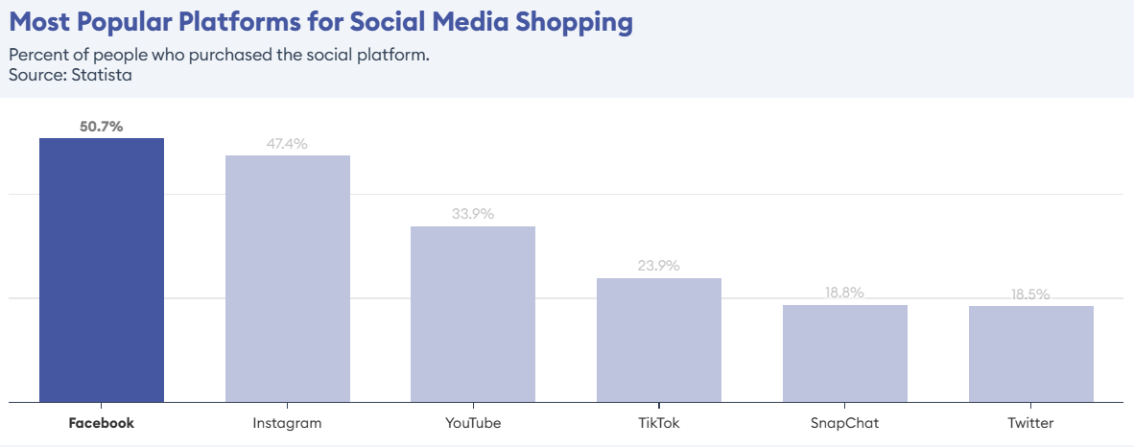
Figure 5: Most popular social media platform for shopping
(Source: Forbes, 2026)
Email marketing
The UK e-mail market has achieved moderate and noticeable growth. Therefore, 81% of companies in the UK use email as their marketing platform, which reflects its benefits (Forbes, 2026). An email will send effective information of the new startup Sparkling Shine’s opening dates with effective discount information in a fast and cost-effective way to attract potential customers' interest.
Influencer marketing
UK influencer advertising reached 917 million in 2024, which tripled compared to 2019 and is expected to reach 1 billion by 2025 (Statista, 2026). Developing collaborations with local influencers to develop an effective and emotional connection with customers by delivering them effective product information.

Financial

Funding sources and why they are beneficial
The budget would be £110,000 for the new startup, and it will ensure survival beyond 4-5 months. The funding sources would be angel investors and government grants. Angel investors invest their own capital in small businesses in exchange for minority stakes. They invested £5000 to £500,000 in one business while offering mentorship and support to work closely with the business for at least five years (British-business-bank, 2026). In contrast, government grants offer non-payable funding options to new start-up businesses in the marketplace. In large-scale projects, the government grants offer large-scale funding at a time without any hidden charges.

Main start-up expenses during the first month of operations
Operational areas | Expense
App maintenance | £2000
Digital marketing | £6000
Equipments cost | £1000
Transportation cost | £1000
Staff salaries | £4000
Website optimisation and SEO | £2500
Customer relationship management and customer support tools | £1000
Insurance and legal compliance | £1000
Staff training | £3700
Miscellaneous expenses | £700
Equipment’s | £500
Transportation cost | £800
Total | £25,200
Table 4: Start-up expenses analysis
(Source: Self-developed)

5.3 Budgets, cashflow and breakeven calculations
Opening Balance | £110,000
Receipts | £2500
Customer Receipts | £2000
Other Receipts | £500
Payments | (£25,200)
Salaries & Benefits | £8700
Marketing & Acquisitions | £7500
Rents & Utilities | £1800
Software & Subscriptions | £6500
Other Operational Expenses | £700
Net Cash Flow | (£22,700)
Closing Balance | £87,300
Figure 5: Cash Flow Statement
(Source: Self-Created)

Conclusion
In conclusion, it can be said that proper planning and market research are essential to tailor effective strategies in order to launch new business ideas in the highly competitive UK market. The Sparkling Skyline app will cover London and Birmingham services, where commercial and residential houses can access value-added, subscription-based and individual services. It will follow a prime, limited, and lean management structure. Through PESTLE and Porter’s Five Forces, the market opportunities and challenges are identified. Therefore, target customers, marketing strategies, and financial plans have been tailored to increase business reach and ensure financial growth.

Reference list
Bankofengland, (2026). What are interest rates? Available at https://www.bankofengland.co.uk/explainers/what-are-interest-rates [Accessed on 31.03.2026]
Bendig, D., Wagner, R., Piening, E.P. and Foege, J.N., (2023). Attention to digital innovation: exploring the impact of a chief information officer in the top management team. MIS Quarterly, 47(4), pp.1487-1516.
British-business-bank, (2026). Angel investors. Available at https://www.british-business-bank.co.uk/business-guidance/guidance-articles/finance/angel-investment [Accessed on 31.03.2026]
British-business-bank, (2026). Start Up Loans. Available at https://www.british-business-bank.co.uk/business-guidance/guidance-articles/finance/start-up-loan [Accessed on 31.03.2026]
Britshine, (2026). Top 10 Cleaning Companies in the UK: What to Look For. Available at https://britshine.co.uk/blog/top-cleaning-companies-uk/ [Accessed on 31.03.2026]
Forbes, (2026). 32 Top E-Commerce Statistics. Available at https://www.forbes.com/advisor/uk/business/ecommerce-statistics/ [Accessed on 31.03.2026]
Gov, (2023). Government commits up to £3.5 billion to future of tech and science. Available at https://www.gov.uk/government/news/government-commits-up-to-35-billion-to-future-of-tech-and-science [Accessed on 31.03.2026]
Gov, (2025). Corporation Tax rates. Available at https://www.gov.uk/government/publications/rates-and-allowances-corporation-tax/rates-and-allowances-corporation-tax [Accessed on 31.03.2026]
Gov, (2026). National Minimum Wage and National Living Wage rates. Available at https://www.gov.uk/national-minimum-wage-rates [Accessed on 31.03.2026]
Grandviewresearch, (2026). UK Cleaning Services Market Size & Outlook, 2026-2033. Available at https://www.grandviewresearch.com/horizon/outlook/cleaning-services-market/uk [Accessed on 31.03.2026]
Kingsnorth, S., (2025). Digital marketing strategy: an integrated approach to online marketing. Kogan Page Publishers.
Legislation, (2026). Consumer Rights Act 2015. Available at https://www.legislation.gov.uk/ukpga/2015/15/contents [Accessed on 31.03.2026]
Legislation, (2026). Environment Act 2021. Available at https://www.legislation.gov.uk/ukpga/2021/30 [Accessed on 31.03.2026]
Parliament, (2025). Support for small businesses. Available at https://commonslibrary.parliament.uk/research-briefings/cbp-7690/ [Accessed on 31.03.2026]
Parliament, (2026). High cost of living: Impact on households. Available at https://commonslibrary.parliament.uk/research-briefings/cbp-10100/ [Accessed on 31.03.2026]
Parliament, (2026). The UK’s plans and progress to reach net zero by 2050. Available at https://commonslibrary.parliament.uk/research-briefings/cbp-9888/ [Accessed on 31.03.2026]
Statista, (2024). UK cities with the highest popularity ratings Q4 2024. Available at https://www.statista.com/statistics/898803/most-popular-british-cities/?srsltid=AfmBOornpfOIV4Zh8E1OyQApJFztnKUradHpueIzPWT72ZEIFtViu0Sx [Accessed on 31.03.2026]
Statista, (2026). Active social media audience in the United Kingdom (UK) in February 2025. Available at https://www.statista.com/statistics/507405/uk-active-social-media-and-mobile-social-media-users/?srsltid=AfmBOorq671x9tBRHqBN2VJAmjJzF8KNiCPhC_69tRLDIXkv0twCZeOw [Accessed on 31.03.2026]
Statista, (2026). Inflation rate for the Consumer Price Index (CPI) in the United Kingdom from January 2015 to February 2026. Available at https://www.statista.com/statistics/306648/inflation-rate-consumer-price-index-cpi-united-kingdom-uk/?srsltid=AfmBOoqbvpcVwTGYfBzY-Pbu-HbgkzX_dV6dRorZIDF9zFwNY5jKP8aC [Accessed on 31.03.2026]
Statista, (2026). Influencer marketing in the United Kingdom (UK) - statistics & facts. Available at https://www.statista.com/topics/7119/influencer-marketing-in-the-uk/?srsltid=AfmBOorJG7B56jvvT2Pmk_Uj4aq2Blp6a_5MDFvpML1-LicS0EK5uwAM#topicOverview [Accessed on 31.03.2026]
Statista, (2026). Willingness of consumers to spend more on sustainable products in the United Kingdom (UK) in 2022, by generation. Available at https://www.statista.com/statistics/1318317/willingness-to-spend-more-on-sustainability-by-generation/?srsltid=AfmBOoonj3SSCD8Pb7K6nsHjALUsdNMSPVtBAuoPP1Se5B2hI3MHccdS [Accessed on 31.03.2026]

