Changemakers: Building your Personal Brand for Sustainable Employment
Assignment 2: Promotional Portfolio
ACCA5035 // R Morgan - A Head
Hamza A. Qasim // 2103929
University of Wales Trinity Saint David

The Brand
My company is used mainly to provide customers and 3D printer enthusiasts with on demand 3D printed files based on what is available on the website or their own custom STL/OBJ files. The logo itself is trying to promote 3D printing as a whole. It will be featured on the leaderboard which will be within the header of the website (mobile leaderboard for the header of the mobile version of the site) and the logo without the text will be used as the site icon.

The Logo

Iteration #1:
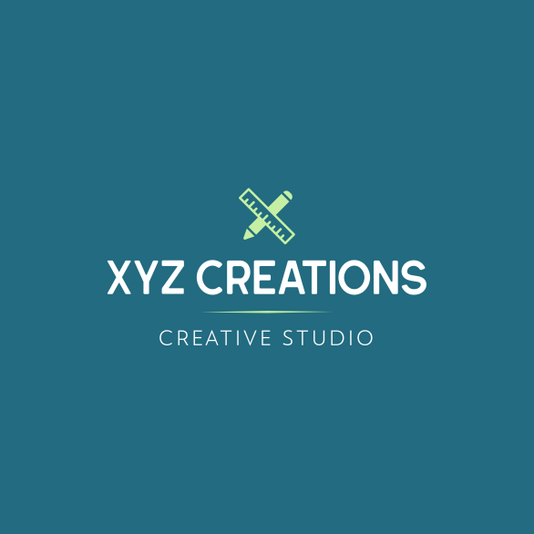
The Font - Hillstown Sans for the heading and RNS Miles for the tagline. Hillstown was selected because it was clean, tall and the individual letters were quite close to each other. RNS Miles was selected for the tagline as it gave some depth and spacing between the letters, if it was too condensed, it wouldn't have looked as good.
The Colour - The background colour is a deep blue #226B80, used because it's easy on the eyes. The text itself is white as it is the easiest to read on the background. The accent colour is #C5F0A4 - it is a tetradic colour to that of the background, it was fine tuned to what it is using colour tints (adding white to the colour) and shades (adding grey).
The Composition - The icon was selected as a pencil represents creativity and the ruler represents precision. The name XYZ comes from that of the X, Y and Z axis when 3D modelling. The icon logo itself represents the X in XYZ Creations. I, however, thought that as a creative studio it didn't quite show that this was specifically for 3D printing.

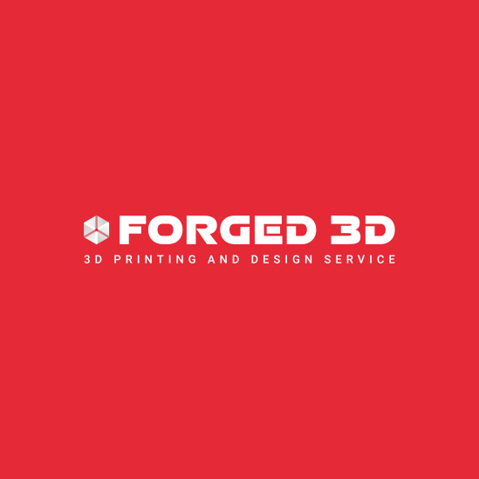
Iteration #2:
The Font - Aerospace for the heading and Heebo for the tagline. Aerospace was selected because it is big, bold and quite in your face. Heebo was selected for the tagline as it shows a stark difference between the heading. This is needed as it is very clear and tells whoever is looking at the logo exactly what the brand is about.
The Colour - The background colour is a bright red #E52937, used because it grabs attention. The text itself is white as it is the easiest to read on the red background.
(The accent colour used on the website as a background is #F6B5BA - it is a tetradic colour to that of the background on the logo, it was fine tuned to what it is using colour tints (adding white to the colour)).
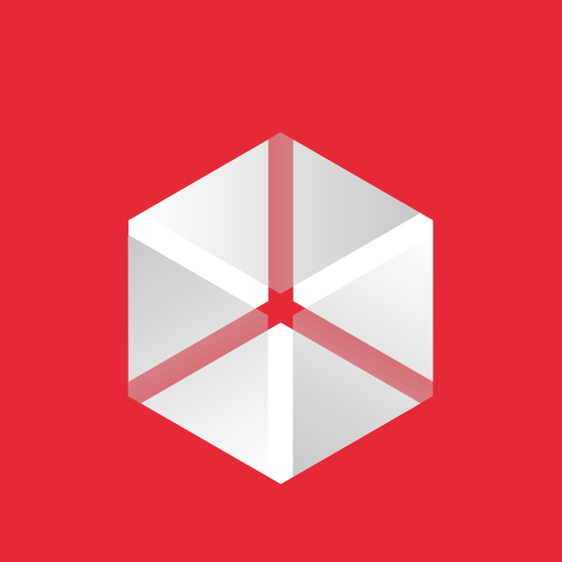
The Composition - The icon was selected because the cube is a basic polygon that is used so much in 3D modelling. The spaces in the cube represent it being in a 3D space. The name Forged 3D comes from those ideas being forged into creations with 3D printing. The square in the logo combines with that of the font to show that ideas are being forged from one of the most basic shapes in 3D modelling and printing as a whole.

Mind map
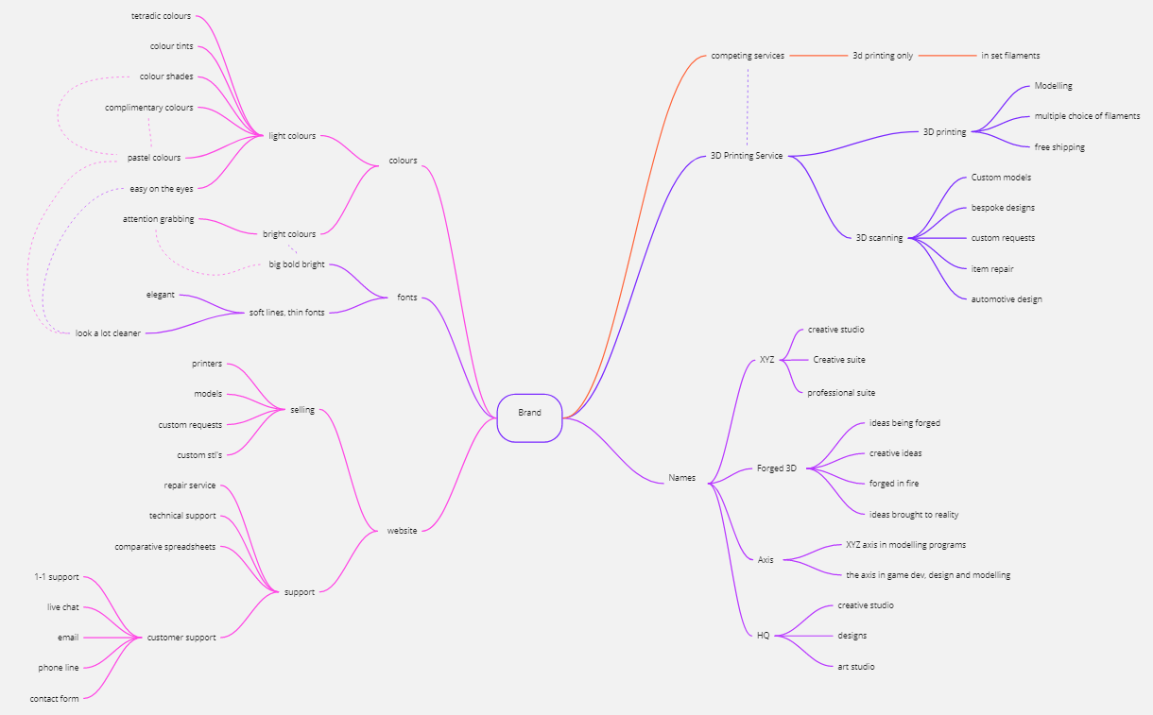
This section contains a mind map of the brand’s purpose.

Banner Ads
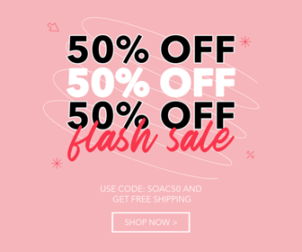
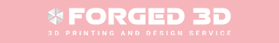
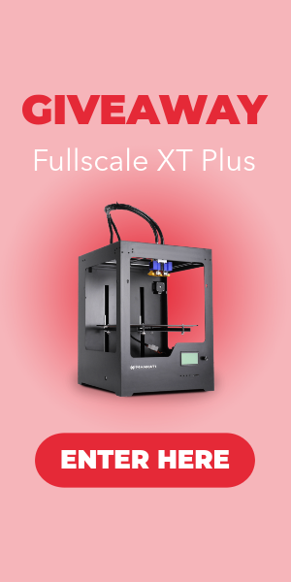
This section contains a series of five small banner advertisements designed to compliment my logo and promote my venture. From left to right these include the Large Skyscraper, Large Rectangle, Medium Rectangle, Mobile Leaderboard and Leaderboard.
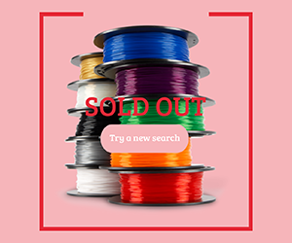

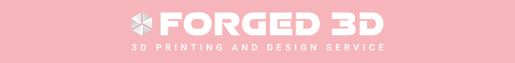

Motion Graphic Sequence
I created several motion graphic sequences for the brand. After showing them to my peers for review, it boiled down to two sequences. This is the one majority of people voted for as they see the lasers in the sequence as more of something 3D printing related. I however, will be using this as I see the brand “Forged 3D” being more represented by the fire and flames, you can only forge things in fire and the fire is a big part of the brand itself. This iteration of the motion graphic sequence is also not as long and grabs attention a lot quicker than the initial design. I hope this conclusion is what the consumers see as well when looking at the motion graphic sequence.

Links are below in case hyperlinks do not work:
Link 1: https://www.youtube.com/watch?v=2i-qqGISQmQ
Link 2: https://www.youtube.com/watch?v=W2ovhMxovtE

Bibliography

Fonts

Logo Iteration #1
Hillstown Sans [LINK] , RNS Miles [LINK]

Logo Iteration #2 as well as Leaderboard and Mobile Leaderboard
Aerospace [LINK] , Heebo [LINK]

Large Skyscraper
Montserrat [LINK] , Avenir Next [LINK]

Large Rectangle
Avenir Next [LINK] , Delight Place [LINK]

Medium Rectangle
Bree Serif [LINK]

Mind Mapping Tool
Miro Mind Mapping [LINK]

Assets / Images

Large Skyscraper
Mankati 3D Printer Transparent PNG [LINK]

Medium Rectangle
3D Printer Filament Transparent PNG [LINK]

Background Music for the Motion Graphic Sequence
Link #1: Michael Ramir C. - What's Up Today? [LINK]
Link #2: Alejandro Magaña (A. M.) - Slow Drive [LINK1] [LINK2]

