

A Study of Malnutrition in the Medical Environment

Student Name | Bianca Ioana Terza
Student Number | 2009067
Module Number | BMSW4004_LON
Module Title | Problem Solving and Decision Making
Lecturer Name | Mary March
Date of submission | 28th of April 2021

Table of Contents:

- Overview of the problems in Health and Social Care page 3
- Understanding of malnutrition in clinical settings page 3
- What is the impact of the stakeholders on the patients’ alimentation? page 5
- An analysis of malnutrition through the existing legislations page 6
- Recommendations to prevent malnutrition in the clinical environment page 9
- Conclusion page 12
- Reference page 13
- Appendix page 17

1. Overview of the problems in Health and Social Care

In 2017, the National Health Service, (NHS) was rewarded as the best healthcare system in 11 wealthy countries due to its affordability and efficiency (Triggle, 2017). The challenging years have, however, brought in the public eye different cracks in the English medical organization.
Population health has improved through the last decades and it is a common aspiration of the different healthcare systems to obtaining equality in it.
Although this desire is shown, the authorities are recognizing different gaps in the distribution of medical support in society. Those with smaller profits, different education, or part of ethnic minorities have difficulties benefiting from all the facilities available (Morris, Sutton, and Gravelle, 2005).
In 2002, Graham acknowledges different meanings of inequality, he explains how focusing on the unprivileged groups is not sufficient and the gap could be narrowed only if the health system acting in these areas improves faster than the one running in the well-off’s regions.
The current worldwide medical emergency has also presented the workforce’s insufficient experience in the NHS institution. In 2011, the practice period was reduced by 10% and in 2017 a limited percentage of nurses completed their training; this brought the UK healthcare system to rely on international recruitment to reduce the staff shortage as at the end of 2018 more than 3000 medical assistants came to form the EU to work in the UK (The Health Foundation, 2019).
A different problem is presented in 2017, as the founds result insufficient to support the population’s needs (Montgomery et. al., 2017). In the past months, due to the global pandemic, a budget of more than £60 billion was spent on buildings and equipment or transferred to other national institutions to support public health during the COVID-19 emergency (The king’s Founds,2021).

2. Understanding of malnutrition in clinical settings

The previous paragraph has introduced how the Government has provided the NHS with a new budget to implement the staff recruitment, the rental of multiple facilities for hospitalization purpose, and the development of new technologies to face the international emergency, yet different departments in the clinics remain in a precarious state, such as the patient’s accommodation in these structures and their nutritional needs.

PESTLE analysis of a food industry
Political Impact | Nowadays all the industries must follow legislation and regulations in order to maintain their stability through time.
Economic Impact | Food industries need external suppliers which provide the industry with the needed equipment, goods, personnel, etc., to deliver the service.
Sociological Impact | The food industries must think of the public they are selling the product at, special dietary requirement, eating habits and preferences, or religious restrictions has to be considered once the activity is producing the goods. The activity has to analyze the social perception of healthy eating as well and the general lifestyle of the buyers.
Technological Impact | The food industry should be able to maintain a marketing campaign. It should be also able to adapt the staff working habits to the new technologies which help reducing human errors and facilitate the making process.
Legal Impact | The law ensures the creation of acts, like hygiene standards and food quality to deliver safe products to the service user, it is a legal requirement to have periodical pieces of training that allow a major control on the delivery of the products.
Environmental Impact | The food industry should consider the impact that the activity has on the environment. It should use recyclable products and ensure the correct disposal of the wastage. It should also consider the impact of the methods used by the external business to produce the raw goods.

The PESTLE analysis shows how food industries, including the ones operating in hospitals, should be able to support the different dietary demands, clinical environments must be able to provide patients with adequate nutritional support to maintain their well-being. Understanding the patient’s needs, monitor their condition during the stay-in, and observe the ongoing illnesses they may be subject to can be challenging but it would prevent cases of malnutrition, defined by W.H.O. as an “imbalanced intake of energy and nutrients” from food (2020).
The British Association for Parental and Enteral Nutrition (BAPEN) launches, in 2003, the “Malnutritional Universal Screening Tool” (“MUST”) to identify and provide appropriate treatment to patients at risk in hospitals and in 2006 this procedure got extended to all the care facilities, including General Practitioner, establishing the magnitude of the problem.
In 2008, 40% of the Health Care expenses were supporting the problem of malnutrition in clinics.
(Russell and Elia, 2010)
A “MUST” study, in 2011, shows how malnutrition cases decreased yet 1 in 4 adults on hospital admission, 1 in 3 in care home admission and 1 in 5 in mental health units result at risk, with greater exposure for women (28%) than men (22%). (Emerald Group Publishing Limited, 2012).
An American study conduct in 2016, identifies several reasons behind this issue, the main cause is due to protein-calorie malnutrition, lack of proteins and energy absorption, (63.9%), followed by failure to thrive (21.6%) and cachexia, ongoing weight loss due to chronic illnesses (8.3%), which leads to a higher morbidity and mortality rate. (Weiss et al, 2016)

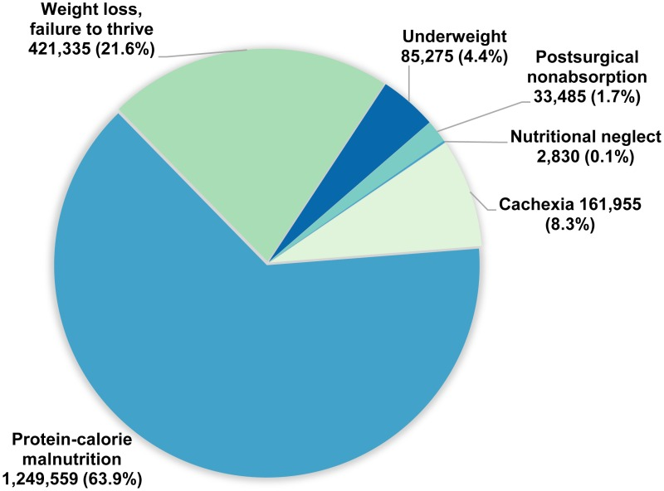
(Statistical Brief, Weiss, et al., 2016)

This paper will focus on how the patients’ nutritional needs impact the hospital industry and, considering existing legislation and regulation, propose a range of suggestions that would help to reduce malnutrition cases in clinics.

3. What is the impact of the stakeholders on the patients’ alimentation?

In 2003 Schenker carried out a research and the results show that 40% of the patients in English hospitals are malnourished and 60% are at risk, the author affirms also that less than 75% of the recommended intake is absorbed from the food received, being more noticeable among elderly.
The high percentages can be explained by the patient’s opinion on the food received during their stay-in, the hospitals’ mealtimes composition, and the impact that external businesses have on the product distributed.
In 2006, Walton, Williams, and Tapsell analyzed the patients’ opinion on the food received during their life in hospital showing the discontent of receiving prepacked food as multiple facilities don’t have specific areas and equipment to provide freshly cooked ones. The selection was also considered minimal and unable to support the patients’ medical conditions with their specific nutritional diets, forcing the nurses to compensate for the shortcomings through medications and supplements. Another significant problem regarded the size of the portions, which were either excessive for older patients or insufficient for the average adult, caused by the low budget reserved to the food industry operating in hospitals.
In 2012, Wong et al. demonstrates that 52% of patients don’t eat the food served and 34% of them are missing a meal, while the majority (90%) don’t get a snack which contributes to malnutrition. The Council of Europe established “protected mealtimes” to support the “Food and Nutritional Care” in hospitals and the UK’s “Improving National Care” adapted to it immediately, as suggested by the Government, even so, the project had hardly a little improvement, questioning its efficiency.
Thanks to a study carried out by Baron et al., in a hospital, they confirmed that patients would be able to receive adequate nutritional values from the food provide yet over 40% of the meals gets wasted and this contributes to the continued weight-loss registered. For this reason, dietitians’ assistance is required, to support the patient’s needs and avoid malnutrition. The patients confirm that having personalized diets is more effective and helpful, they are also pleased with having a periodical consultation either by telephone or in-person, which helps them continuing with the alimentation plans and checking the progress obtained (Mohammed et al., 2020)
Heaven et al., (2012) also affirm that the feeding assistance is largely appreciated and considered an important factor preventing malnutrition and emotional labor, interpersonal care, and tactic knowledge are fundamental to support the assistance during mealtimes.
Another important factor that has an impact on the patient’s alimentation is shown by Mathew, Barlett, and Hall (2007) in a report where they analyze the difficulty to open packaging, discouraging the patients to eat, contributing to the malnutrition among elderly and disabled in hospitals. As showed by Schenker (2003), more than 75% of the hospitalized patients are relying on hospital food as the sole source of nutrition but dishearten by the containers.
Yoxall et al., (2006) suggest the use of more accessible packages for the elderly, disabled, and left-handed, as the product should be available to most users. They also propose to change the packets in which the food is served in hospitals, but this would have a major impact on the Health Service finance and so it quickly got rejected.

4. An analysis of malnutrition through the existing legislations

Sanders and Smith, (2010) define malnutrition as a common yet underestimated problem in the health system. They affirm that a reduced dietary intake (decrease of appetite), reduced absorption of nutritional values, mostly noticeable among patients with intestinal failure, the necessity of different nutritional requirements, are some of the causes of malnutrition. They also expose some consequences of a dietary deficiency, one of the most common is the loss of muscle mass as the body, deprived of nutrients, access the reserves in tissues, this leads to a change in the body structure, the cardio-respiratory system struggles with the daily function, affecting also the renal activity, pancreatic and gastrointestinal functions are limited, immunity system gets weaker, the risk of infection is higher and the healing time longer, mental health is affected as the patient may suffer from apathy, depression or self-neglection.
To avoid this, NICE (National Institute for Health and Care Excellence) declares, in 2012, that all patients considered malnourished must have a monitoring plan and a personalized dietary schedule, the association suggests that all information should be kept and made available for other structures in case of need.
The CQC (Care Quality Commission) publishes Regulation 14 (2014), assuring adequate nutrition and hydration treatment during the stay-in.
Later, in 2016, the NHS Scotland create the Food Standards Scotland (FSS) to ensure transparency of the food delivered and declaring a consumer-focused plan, to shield the public from health risk and offer personalized nutritional plans.
Supported by the British Dietetic Association (BDA), the Scottish NHS created a weekly meal plan able to integrate a large consumption of starchy food, fruits, and vegetables, moderate consumption of milk, dairy products, and proteins, and limited consumption of salt, sugar, and saturated fats. (NHS, Nutritional Specifications in Scotland, 2016)

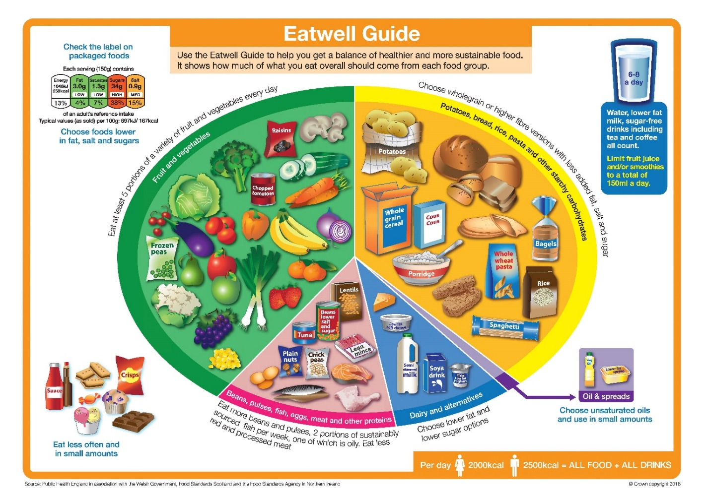
(Food Standards Agency, 2020)

The NHS Scotland made available menus that consider not only allergies, intolerances, and patient’s condition, by offering modified texture menus, but also some to support the different cultural and religious backgrounds.

SPECIAL DIETS
VEGETARIAN AND VEGAN | Due to an exclusion of animal products or derived by some nutritional values such as proteins have to be reintroduced in the body and well-planned diets can add the right nutritional needs through fruits and vegetables.
HALAL | Halal food (lawful food), consumed by the Muslim Faith followers, prohibits pork meat and derivates, blood use and derivates, cuts of meat that haven’t used a Halal Method, and alcohol in all the forms.
HINDU | A diet which prohibits the consumption of cow, considered sacred, generally Lacto-vegetarian diet, with no consumption of meat (yet not forbidden) and eggs
KOSHER | Food consumed by Judaism Faith followers, characterized by a strict maintenance of food hygiene, and prohibits the mix with non-kosher aliments.

Another tool utilized by the NHS was launched in 2003, by the British Association for Parental and Enteral Nutrition, BAPEN, a Charitable Association, focused on malnutrition (BAPEN, 2018)
The project is a 5-steps analysis of patients with risk of malnutrition, MUST (Malnutritional Universal Screening Tool).
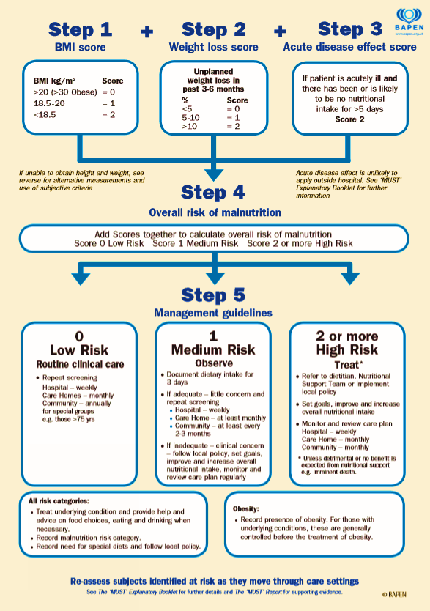
(BAPEN, 2011)

The first step consists of a control of the BMI (Body Mass Index) to understand the risk of malnutrition. The graph, [1] is a scored-based chart.
The second step is a check of unplanned weight loss. The graph [2] is also a scored-based chart.
The thirst step is an analysis of the impact of an acute disease (long-lasting illnesses that affect eating habits).
The fourth step consists of the simple addition of all the scores accumulated.
The fifth step is developing a personalized meal plan.
A dietitian’s help can lead to a different approach to the nutritional needs of a patient, their role is important to develop programs to prevent and manage malnutrition by establishing self-management plans and minimizing the risk of the patient. (BDA, n.d.)

5. Recommendations to prevent malnutrition in the clinical environment

Although different legislations have been enacted by different institutions, malnutrition remains a visible problem that includes different root problems as shown in the fishbone analysis [3].
This paper presented the difficulty of some patients to receive adequate nutritional intake from the meals served, for this reason, hospitals and care centers have introduced food supplements into their diets.
Fletcher, 2016, describes the Oral Nutritional Supplements (ONS) as liquids or powders which help the absorption of nutrients, these are mainly supplied to patients unable to receive the nutritional values needed. The ONS must receive the approval of the Advisory Committee on Borderline Substances (ACBS) before the commercialization, their use must be limited, and the individual must stop the use once the nutritional requirements are obtained, or they reached a healthy BMI. (Fletcher, 2016)
BAPEN, 2013, suggests the use of ONS in contemporary with a correct alimentation, and remain under the guidance of a dietitian for a better outcome.
Clinics have also included the use of fortified food. Fortification is the addition of different nutrients to food. (www.nutrition.org.uk, n.d.) In order to improve the community’s nutrition, the Government approved the fortification of certain aliments (white bread, milk, flour, etc…) and listed which vitamins and minerals may be added to them. (GOV.UK, 2021)
In 2018, Mills et al, analysed different studies where fortification and supplementation got compared to the nutritional intake from standard menus, demonstrating that the difference of nutritional values is minimal, suggesting then to incorporate the use of protein and energy-based fortified aliments to the meals, in order to maximize the intake.
Another issue identified is the inadequate training and the lack of feeding assistance during mealtimes.
The catering assistant should promote warmth, security, and reliability by establishing a relationship with the patient; through eye contact, appropriate use of the tone of the voice, smile, and delivering positive energy, the person will feel welcomed and in good care. Despite the good relationship achieved, the assistant should never provide false hope or set the patients’ expectations without proof. The waiter should also keep in mind that the person in treatment may be exceptionally unwell for this reason they have to remind of C.A.R.E., an acronym of “Connection, Awareness, Respect, and Empathy”, this would increase the patients’ satisfaction and would help the team to shape and improve to meet their expectations. (All the information provided in the paragraph have been gathered from different Catering Toolbox Talks from the workplace)
In 2004, Simmons and Schnelle, studied the importance of feeding assistance, demonstrating that the majority of the patients reacted positively to the individualized service.
A personalized diet maximizes the nutritional intake, improves the individuals’ satisfaction, and reduces the cases of malnutrition, therefore different menus have been created.

Special Diets
NGCI | No Gluten Containing Ingredients (NGCI) menus contain aliments without gluten due to the patients’ allergy or intolerance. | The catering assistant must be familiar with the different menus available, maintain communication with nurses, dietitians, and Speech and Language Therapists, avoid cross-contamination and they should never switch between menus without authorization.
Clear Fluid and Free Fluid | The menu is used for patients following an operation.  Usually, the transition from Clear Fluid to Free Fluid takes a day.  Clear Fluid menu is a strict selection of juices with no bits, black drinks, and preserves mixed with water, the Free Fluid menu also includes milk, ice cream, and custard.
Light diet | Menu with food easy to digest, low in fibre, no fatty or spicy, created for patients with bowel surgery. Minimize the intake of starchy food, fruits, and vegetables.
Low fibre | In the case of bowel surgery, the patient has to minimize the fibre in the diet. The menu doesn’t allow wholemeal or seeded aliments and the fruits are discouraged.
Oncology dietary Guideline | Patients with cancer who receive treatment may have a low level of white blood cells, for this, there is a higher exposure to infections. To minimize the risk, all the food must be well-cooked, and salads, vegetables, and fruits well-washed.
Renal | The menu is used for patients with kidney failure. The kidneys’ role is to eliminate waste and fluid excess but if there is a problem, the levels of potassium, phosphate, and salt may be dangerous. The patient will have a reduced intake of drinks and portions of food.
Low-Fat MCT (Chylothorax) | There are 2 specialized menus, one for adults and one for children, and are characterized by a severe fat restriction. The menu excludes butter, margarine, semi-skimmed milk and limits the intake of low-fat yoghurts. The portion size depends on the patients’ age and weight.
Modified Texture | Menus used in case of difficulty to swallow (dysphagia) and a high risk of choking. These menus are requested by the Speech and Language Therapist. Have different levels [4] and are provided by an external company.
Low Iodine | This is a specialized menu for a particular type of cancer (mainly thyroid) treatment that uses radioactive iodine. A diet rich in iodine may interfere. The menu eliminates seafood, eggs, and dairy products.
(All information provided have been gathered from Special Diet Training from the workplace.)

6. Conclusion

ADKAR model of change
Awareness of the issue | Malnutrition is a problem that affects a high percentage of patients, particularly the elderly. Undernutrition develops complications during the treatment, slowing down the healing time, and extending the hospitalization period.  (Mills et al., 2018)
Why there is a Desire to change? | Malnutrition can lead to immune dysfunctions and increase the risk of infection. An excessive intake of food may cause obesity and a higher risk of diabetes and heart disease.  (Mark et al., 2020)
Knowledge of the motivations behind malnutrition | Different problems have been exposed in the report. The patients’ reluctance to eat the meals provided in care facilities, the high level of food wastage, and the difficulty to absorb the right nutritional values are some of the reasons why the patients suffer from malnutrition.
Ability to implement change | The use of personalized diets raises the patients’ satisfaction and individualized care that supports them will prevent cases of malnutrition.
Reinforcement | Patients would have a better choice of meal thanks to an individualized plan supported by nurses, dietitians, and Speech and Language Therapists

As shown in the ADKAR model of change, society is aware of the existence of malnutrition and of the consequences it may lead to however, the intervention of specialists help to prevent malnutrition and achieve a healthy lifestyle described by Cojocarul, Dima-Cozma, and Gavrilut, 2014, as an indicator of the well-being of the population with a high quality of life.

This report analysed some of the causes behind the malnutrition in hospitals and care clinics, it presented different legislations, approved by the Government, which have contributed to a better distribution of personalized diets in order to support the needs of the hospitalized patients in the Health Care system, and presented a range of solution to implement the changes.

7. References

- BAPEN (2011). Malnutrition Advisory Group A Standing Committee of BAPEN MAG “Malnutrition Universal Screening Tool.” [online]. Available at: https://www.bapen.org.uk/pdfs/must/must_full.pdf [Accessed on 20th of April 2021].
- Barton, A.D., Beigg, C.L., MacDonald, I.A. and Allison, S.P. (2000). High food wastage and low nutritional intakes in hospital patients. Clinical Nutrition, [online] 19(6), pp.445–449. Available at: https://www.sciencedirect.com/science/article/pii/S026156140090150X [Accessed on 11th of April 2021].
- Bell, A.F., Walton, K., Chevis, J.S., Davies, K., Manson, C., Wypych, A., Yoxall, A., Kirkby, J. and Alexander, N. (2013). Accessing packaged food and beverages in hospitals. Exploring experiences of patients and staff. Appetite, [online] 60, pp.231–238. Available at: https://www.sciencedirect.com/science/article/pii/S0195666312004278 [Accessed on 11th of April 2021].
- Brotherton, A., Cheema, K., Holdoway, A., Todorovic, V. and Stroud, M. (2017). Nutritional Care Tool Report 2017 A Report by the BAPEN Quality and Safety Committee On behalf of the Quality and Safety Committee. [online]. Available at: https://www.bapen.org.uk/images/pdfs/nutritional-care-tool/bapen-nutrional-care-tool-report-2017.pdf [Accessed on 20th of April 2021].
- Cojocarul, D.C., Dima-Cozma, C. and Gavriluta, C. (2014). The impact of health lifestyle in modern society: a medical social and spiritual perspective. European Journal of Science and Theology, 10(3), pp.111–120. [Online] Available at: (PDF) The importance of healthy lifestyle in modern society: a medical, social and spiritual perspective (researchgate.net) [Accessed on 21st of April 2021].
- CQC (2014). Regulation 14: Meeting nutritional and hydration needs | Care Quality Commission. [online] Cqc.org.uk. Available at: https://www.cqc.org.uk/guidance-providers/regulations-enforcement/regulation-14-meeting-nutritional-hydration-needs [Accessed on 20th of April 2021].
- Do Rosario, V.A. and Walton, K. (2020). Hospital Food Service. Handbook of Eating and Drinking, [online] pp.1007–1033. Available at: https://link.springer.com/referenceworkentry/10.1007%2F978-3-030-14504-0_74 [Accessed 12th of April 2021].
- Emerald Group Publishing Limited (2012). Malnutrition. Nutrition and Food Science, 42(5). Available at: Malnutrition | Emerald Insight. [Accessed on 10th of April 2021].
- Europe, W.H.O.R.O. for, Policies, E.O. on H.S. and and Boyle, S. (2011). United Kingdom (‎‎‎England)‎‎‎: health system review. apps.who.int. [online] Available at: https://apps.who.int/iris/handle/10665/330328 [Accessed on 10th of April 2021].
- Fletcher, J. (2016). Oral Nutritional Supplements (ONS). [online] Bapen.org.uk. Available at: https://www.bapen.org.uk/nutrition-support/nutrition-by-mouth/oral-nutritional-supplements [Accessed on 21st of April 2021].
- FOOD IN HOSPITALS National Catering and Nutrition Specification for Food and Fluid Provision in Hospitals in Scotland. (2016). [online]. Available at: https://www.nss.nhs.scot/media/1097/1479818118-food-in-hospitals-revised-march-2016.pdf [Accessed on 20th of April 2021].
- Food Standards Agency. (2020). The Eatwell Guide and Resources. [online] Available at: https://www.food.gov.uk/business-guidance/the-eatwell-guide-and-resources [Accessed on 20th of April 2021].
- GOV.UK. (2021). Great Britain register on the addition of vitamins and minerals and of certain other substances to foods. [online] Available at: Great Britain register on the addition of vitamins and minerals and of certain other substances to foods - GOV.UK (www.gov.uk) [Accessed on 21st of April 2021].
- Grosios, K., Gahan, P.B. and Burbidge, J. (2010). Overview of healthcare in the UK. EPMA Journal, [online] 1(4), pp.529–534. Available at: s13167-010-0050-1.pdf (springer.com) [Accessed on 10th of April 2021].
- Heaven, B., Bamford, C., May, C. and Moynihan, P. (2012). Food work and feeding assistance on hospital wards. Sociology of Health & Illness, 35(4), pp.628–642. Available ta: Food work and feeding assistance on hospital wards - Heaven - 2013 - Sociology of Health &amp; Illness - Wiley Online Library [Accessed on 11th of April 2021].
- Hunter, D.J. and Killoran, A. (2004). ackling health inequalities: turning policy into practice? ResearchGate. Tackling health inequalities: Turning policy into practice? (researchgate.net) [Accessed on 11th of April 2021].
- Mark, H.E., Costa, G.D. da, Pagliari, C. and Unger, S.A. (2020). Malnutrition: the silent pandemic. BMJ, [online] 371. Available at: https://www.bmj.com/content/371/bmj.m4593 [Accessed on 21st of April 2021].
- Mills, S.R., Wilcox, C.R., Ibrahim, K. and Roberts, H.C. (2018). Can fortified foods and snacks increase the energy and protein intake of hospitalised older patients? A systematic review. Journal of Human Nutrition and Dietetics, [online] 31(3), pp.379–389. Available at: https://onlinelibrary.wiley.com/doi/full/10.1111/jhn.12529 [Accessed on 21st of April 2021].
- Mohammad, A., Zaid, Z., Chiou, H., Ibrahim, Z., Azuan, Z., Daud, M., Baizura, N., Yusop, M., Jamhuri, N., Nuraini, S., Samwil, M. and Rahman, Z. (2020). Impact of Dietitian Delivered Intensive Nutrition Intervention on Dietary Intake and Weight Outcome Among Gynecology Cancer Outpatient Prior to Surgery. Malaysian Journal of Medicine and Health Sciences, [online] 16(SUPP6), pp.2636–9346. Available at: https://medic.upm.edu.my/upload/dokumen/2020081208271616_MJMHS_0009_L.pdf [Accessed on 12th of April 2021].
- Montgomery, H.E., Haines, A., Marlow, N., Pearson, G., Mythen, M.G., Grocott, M.P.W. and Swanton, C. (2017). The future of UK healthcare: problems and potential solutions to a system in crisis. Annals of Oncology, 28(8), pp.1751–1755. Available at: The future of UK healthcare: problems and potential solutions to a system in crisis - ScienceDirect [Accessed on 9th of April 2021].
- Morris, S., Sutton, M. and Gravelle, H. (2005). Inequity and inequality in the use of health care in England: an empirical investigation. Social Science & Medicine, 60(6), pp.1251–1266. Available at: Inequity and inequality in the use of health care in England: an empirical investigation - ScienceDirect [Accessed on 10th of April 2021].
- NursingAnswers.net. (2020). Importance of Nutrition in Patient Care. [online] Available at: Importance of Nutrition in Patient Care (nursinganswers.net) [Accessed on 9th of April 2021].
- Russell, C.A. and Elia, M. (2010). Malnutrition in the UK: where does it begin? Proceedings of the Nutrition Society, 69(4), pp.465–469. Available at: Malnutrition in the UK: where does it begin? | Proceedings of the Nutrition Society | Cambridge Core [Accessed on 10th of April 2021].
- Saunders, J. and Smith, T. (2010). Malnutrition: causes and consequences. Clinical Medicine, [online] 10(6), pp.624–627. Available at: https://www.ncbi.nlm.nih.gov/pmc/articles/PMC4951875/ [Accessed on 20th of April 2021].
- Simmons, S.F. and Schnelle, J.F. (2004). Individualized Feeding Assistance Care for Nursing Home Residents: Staffing Requirements to Implement Two Interventions. The Journals of Gerontology Series A: Biological Sciences and Medical Sciences, 59(9), pp.M966–M973 Available at: Individualized Feeding Assistance Care for Nursing Home Residents: Staffing Requirements to Implement Two Interventions | The Journals of Gerontology: Series A | Oxford Academic (oup.com) [Accessed on 21st of April 2021].
- Spence, C. (2017). Hospital food. Flavour, 6(1). Available at: Hospital food | SpringerLink [Accessed on 20th of April 2021].
- The Health Foundation. (2019). Health and social care workforce. [online] Available at: https://www.health.org.uk/publications/long-reads/health-and-social-care-workforce [Accessed on 11th of April 2021].
- The King’s found. (2021). The NHS budget and how it has changed. [online] Available at: https://www.kingsfund.org.uk/projects/nhs-in-a-nutshell/nhs-budget [Accessed on 11th of April 2021].
- The Management of Malnourished Adults in All Community and All Health and Care Settings Policy Statement. (n.d.). [online] . Available at: https://www.bda.uk.com/uploads/assets/fd662e80-a9a2-4882-857e73faa78c589c/managementmalnutritionadultspolicystatement2017.pdf [Accessed on 20th of April 2021].
- Triggle, N. (2017). NHS ranked “number one” health system. BBC News. [online] 14 Jul. Available at: NHS ranked 'number one' health system - BBC News [Accessed on 10th of April 2021].
- Walton, K., Williams, P. and Tapsell, L. (2006). What do stakeholders consider the key issues affecting the quality of foodservice provision for long-stay patients? Journal of Foodservice, 17(5-6), pp.212–225.Available at: What do stakeholders consider the key issues affecting the quality of foodservice provision for long‐stay patients? - Walton - 2006 - Journal of Foodservice - Wiley Online Library [Accessed on 12th of April 2021].
- Weiss, A.J., Fingar, K.R., Barrett, M.L., Elixhauser, A., Steiner, C.A., Guenter, P. and Brown, M.H. (2016). Characteristics of Hospital Stays Involving Malnutrition, 2013: Statistical Brief #210. Agency for Healthcare Research and Quality (US). Available at: Characteristics of Hospital Stays Involving Malnutrition, 2013: Statistical Brief #210 - Abstract - Europe PMC. [Accessed on 10th of April 2021].
- Wong, S., Graham, A., Green, D., Hirani, S.P., Grimble, G. and Forbes, A. (2012). Meal provision in a UK National Spinal Injury Centre: a qualitative audit of service users and stakeholders. Spinal Cord, [online] 50(10), pp.772–777. Available at: https://www.nature.com/articles/sc201243#citeas [Accessed on 11th of April 2021].
- World Health Organization (2020). Malnutrition. [online] www.who.int. Available at: https://www.who.int/news-room/q-a-detail/malnutrition [Accessed on 12th of April 2021].
- www.bapen.org.uk. (2018). BAPEN - Who we are, The 4 Tenets of Good Nutritional Care. [online] Available at: https://www.bapen.org.uk/about-bapen/about-us/who-we-are [Accessed on 20th of April 2021]
- www.bapen.org.uk. (2013). Government spending more on nutritional supplements for patients than on hospital meals. [online] Available at: https://www.bapen.org.uk/news-and-media/news/366-government-spending-more-on-nutritional-supplements-for-patients-than-on-hospital-meals [Accessed 21st of April 2021].
- www.nice.org.uk. (2012). Overview | Nutrition support in adults | Quality standards | NICE. [online] Available at: https://www.nice.org.uk/guidance/QS24 [Accessed on 20th of April 2021].
- www.nutrition.org.uk. (n.d.). Fortification - British Nutrition Foundation. [online] Available at: https://www.nutrition.org.uk/nutritionscience/foodfacts/fortification.html [Accessed on 21st of April 2021].

8. Appendix

BMI Control [1]
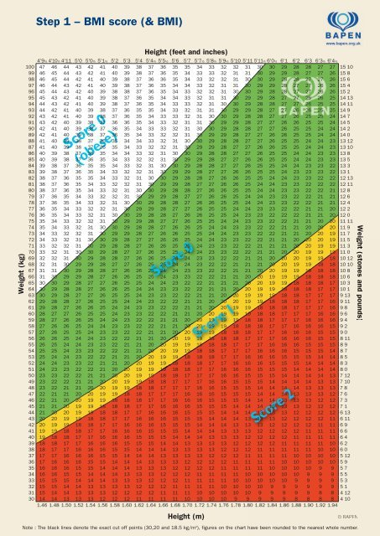
(BAPEN, 2011)
Unplanned weight loss graph [2]
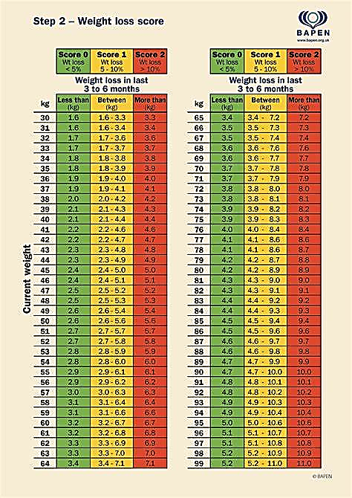
(BAPEN, 2011)
Fishbone analysis of a food industry in a hospital environment [3]
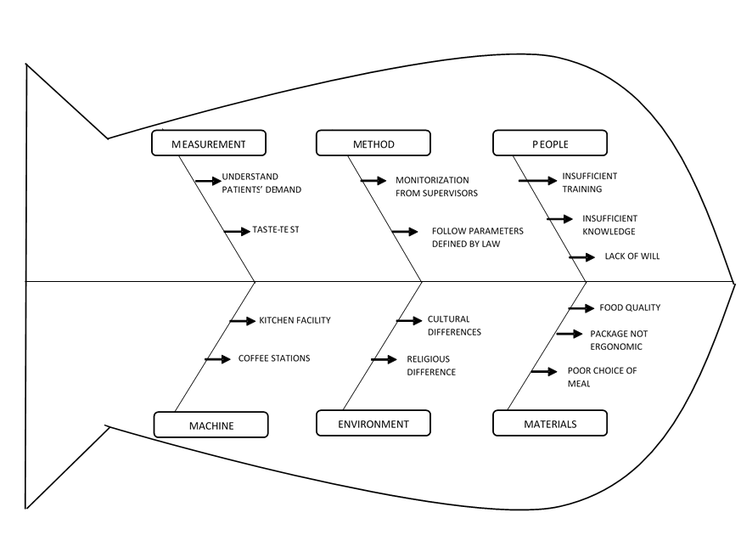
Modified Texture menu chart [4]
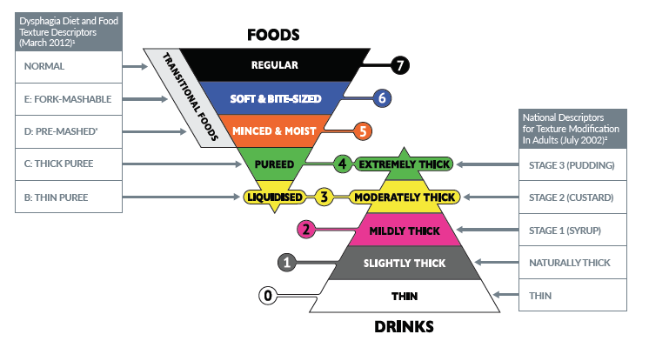
(Wiltshire Farm Foods, 2019)

