Project Management tips, techniques & Tools
Brendan Parker

Contents
Introduction: 1
What is a project? 1
Project lifecycle 3
Tools applied to project management 5
Stakeholders Management 8
Conclusion: 12

Introduction:
Throughout this report, a brief overview of how to implement project management from beginning to end. Primarily, referring to tactical approaches applied to practice, in outcome of leading a successful project. Outlining tools, techniques and methods to establish supporting objective. This includes definitions of project and stakeholder management with reflection to risks.
Management is a dynamic field of professional expertise, aimed in assisting a team to perform useful requirements for the project. Management must record and contemplate the use of resources whilst meeting project deadlines. Project Management Institute defines project management as “the application of knowledge, skills, tools, and techniques to project activities to meet the project requirements.” (Guthrie- Jensen).

What is a project?
A project is a set plan to improve a product or service by establishing objectives to achieve goals whilst considering feasibility. Projects are usually a representation of corporal growth, innovation and expanse and is segmented into stages that are monitored to analyse performance. Visibly, management follow the project plan and procedures to minimise error applying tools that identify, evaluate and create assumptions based on resources, timing, costs services provided saves time rather than manually estimating. The criteria of a project is usually identified in four phases:

- Planning & organisation
- Scheduling and Monitoring
- Implementation &Build evaluation
- End
Following methods allow assistance in project phases such as, planning or executing project developments. Project phases act as a guide that authenticate step by step classifications . A popular project phases known as the project lifecycle, this offers a structure on how to plan and implement project objectives.

The environment of a project are usually organised districts devised monitor of execution, in addition practice setting allows analysation of performance which is useful data when inform stakeholders of developments. For instance, scheduling cost. As a significant factor, planning in any form of a project will help to establish goals or whether the project is worthwhile. This means management require planned agreements with internal and external sources to clarify, design, impact of change, cost of materials, duration of services or marketing promotions.
Project managements role is to maintain productivity andmeeting targets, taking Into Consideration, risks and probabilities to each fragment of the model.
The administrative ability to co-ordinate between components is desirable when selecting managers for projects. in various terms having ability to plan, monitor, lead, instruct and communicate successfully promotes constructive reflection when selecting management to control tasks at hand. Yet, management require tools that will identify, track and calculate accordingly. Additionally, in order to function management effectively, having a clear plan exceeds being organised, expecting the unexpected. (Chris croft, 2010).

Project lifecycle

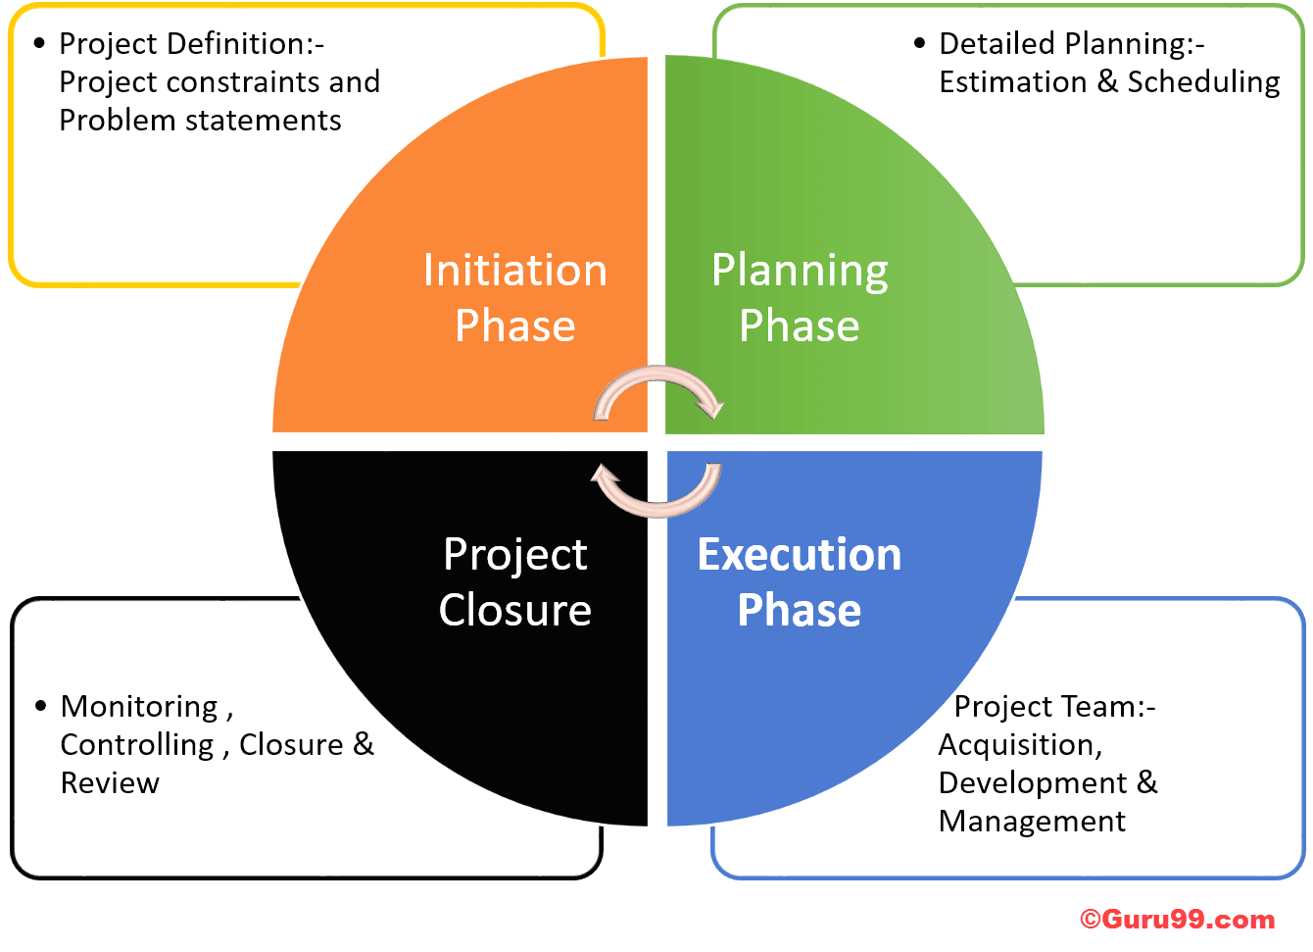
The project lifecycle is a sequence of four phases on how to initiate, plan and execute a project. These phases represent a route of where a project commences to the overall end result.
firstly, initiation. The beginning stage of starting a project, aims to define the purpose and mission of the project, elaborating on business requirements to issue whether needs can be met, solved or seized into future opportunities alongside understanding of possible constraints. This phase represents project objectives and needs to be identified. This phase is a handy guide when locating variables and scope deliverables to recognise stakeholders.
The next during lifecycle development phase is planning the purpose of the project, Brainstorming solutions that collectively gather information in detail, whilst checking feasibility, is It fundable? Typically providing the three fundamentals of the project costs of budget, time scale and accounting resources. This phases is the construction of the project plan detailing project activities, it is critical that a plan provides clear objectives, to execute effectively, to ensure task objectives are being met.
Execution is the practical phase that relates to the previous stage by following the plan, setting movement into motion. This stage is usually the longest phase, Managers will monitor the execution of tasks to offer defined information for tasks and responsibilities. whilst providing high standard of communication with project team and stakeholders.
Finally, closure. – This stage represents the overall completion of the project. however, this stage is to evaluate performance gathering an overview of whether requirements have been met. Closure of a project is to discover whether implementation has gone according to plan. This evaluation of the closure phase is recording what worked and what did not. – for instance, analysing teams’ performance, Failure can also link into closure, and commonly used as a tool, hence not following the last plan that failed will benefit the outcome of the new plan in accordance to knowing what failed and what worked.
The structural competent of the project lifecycle fundamentally guides initiation of how to plan and perform projects. Analysing principles, in this concept is essentially understanding values and highlighting clear objectives with high-level awareness to identifying risk. lifecycle process can be applied to business by exhibiting development stages. For example, initiation is the understanding of whether requirements can be met, which relates to all businesses contemplating the expanse of a project by concentrating on whether they can deliver.

Tools applied to project management
The definition of project management in a nutshell, tis the collection of planning, monitoring and execution through achievable goals, whilst applying tools and techniques to improve product. Furthermore, managing resources, funds and communications besides observing tasks at hand. A project is a temporary development of a unique product or service with a set purpose. Quoting Roger Atkinson implies the definition of project management is the objective of a set goal against components like time, resources and funds. “project is a human activity that achieves a clear objective against a time scale” indicating project management is a combination of goals and limited resources like budget, time and quality. (Roger Atkinson, 1999).
Combining managers experiences and recommendations of utilities present a common functions that require adaptable tools addressed during projects phases. The overall target is to locate advanced tools and use them accordingly to implement successful management. Considering, project developments are consistently proactive, the key is getting more done with less, by taking lead of agility and portability utilizing available resources at low cost-effective approach. in excess words obtaining constant access is important, thus leading to the below related tools to be mainly online based. (Jennifer Bridges, 2012). Tools are applied to simplify project task’s, therefore usefulness of versatile facilities in practice are to exceed objectives..
Equipment for management roles particularly in planning activities are fundamentally vital when estimating duration of tasks. The Gantt chart is a diagram of a bar chart that illustrates project schedules, this tool is applied on management by recording duration of activities. Simply, the chart is used as a timeline of improvements and progressed activities over a given period, along with visual representation of tasks. An objective of a Gantt chart is being able to monitor growth of the project, this method can have several charts at any time. corresponding to the book based on Gantt chart allegedly the idea was developed in by Henry Gantt (1861–1919) (Wallace Clarke, 2015). The Gantt chart is used for tracking interdependencies between activities. A tool which is used to milestone developments and to trace resources. Using this process will display growth of the project, helping to schedule future tasks from start to end dates. Maylor, H. (2001).

Project instruments differ in how they can be used for project management considering there’s not much point having tools that do the same thing. However, this tool engages management through completion and the sustainability of tasks. For example, PBS. Product Breakdown Structure, used as a diagram of components, that can break up a project in segments. Supporting clarification in what is to be expected of a project, this tool is designed for counterchecking project phases. Offering a structural form of constraints for areas that lack in context, applying this tool is purposely for scanning and analysing anything that could be improved, such as focusing on where additional work could be developed, the Breakdown Structure is to methodically investigates the use of resources and break down a constructed overview of project tasks reviewing what has already been implemented and in due preparation for future developments. project managers often use a Product Breakdown Structure during project management to usually allow reassurance of organizational achievement during phases. (Globerson, S. 1994).
Aforementioned, introducing a plan of action is essential to validate requirements, online planning tool hold useful necessities in accessing data. This means constant access to portfolios which offers flexibility towards time management, with the power to manage projects remotely. A Resourceful tool known as Optimistic Schedule, is an approach that approximates the use of resources and length of activities. Consisting of three steps, the first step is to determine what needs to be performed. Secondly to define who will implement tasks, considering availability to external sources. Thirdly, to establish the length of activities, these stages include understanding of estimated time, cost and resource control, which provides support for delivering objectives on time. If the deadline exceeds the project closure date, then there is little use in using the optimistic schedule tool, as the purpose is to meet deadlines so adding additional resources would be useless. Though, to apply optimistic schedules a plan of action is thought necessary before the movement of resources can be fulfilled. Chang, A. S. T. (2002).
financial tools, for planning cost supportmanagerment calculations, in terms of expense like, calculations of manufacturing, however using programs such as Excel and Microsoft Project . straightforwardly offer rapid calculations that intern result in a useful tool to project management. To illustrate, planning of costs or contacting stakeholders, to demonstrate the use of finances at a moment’s reach to keep stakeholders informed of costly decisions.
Demonstrating a high level of communication is vital when discussing project goals, equipment that can aid distribution of project information to increase interactive skills between departments is a tool that should be regularly used. Since, communication is the most developed tools known to man, with large online streaming mechanisms that have the ability to contact others anywhere from the click of a button. Multiple messaging functions can be of great advantage when managing interaction with International stakeholders. For example, conference calls can be arranged through platforms such as skype, Facebook or Whatsapp. These cost-effective services allow all parties to connected and up to date.
Project managers are constantly on the go! so finding tools that are productive, light and transportable are essential. transportable technology is a normality, portable devices are frequently looked over, particularly in management aspects. Fashionable devices such as Apple, Hawaii or Samsung provide tools that persist to be useful for managing projects. How can resourcing mobiles as a benefactor to managing a project? Well, Using apps installed allows full capacity of resources applied , however functions such as calendars, camera, maps, access to social media platforms. An example of mobiles being useful in project management could be as simple as adding a project event in the calendar, retrieving emails or capturing an image through the camera to be shared, referred to or even adjusted without the use of adding further notes. Additionally, the impact of devices is that wherever those engaged in the project, they can always be reached through instant connection. Basically, decreasing error and expands on cooperative team work .
Project management require cognizant tools that ought to offer collaboration and calculation features particularly when implementing a project; Software and hardware services have overall effected time management, However, not every project manager uses the same services but they all have a similarity to being compatible within other properties, that promote project managers that are constantly on the go.

Stakeholders Management
Abraham Maslow a theorist proposed a theory in 1943, which he later published in his book in 1954. It came to be known as “Maslow’s hierarchy of needs”. Maslow’s philosophy represented a pyramid of five layers. With basic needs at the bottom and higher requirements are the top. Self-actualization, esteem, belonging, safety and physiological in this order. Maslow meant that looking after project involvers will give motivation for the task at hand. This relates to project management in the same way as it would during business environment. By looking out for those involved in the project will allow motivated individuals to reach full potential during tasks. McLeod, S. (2007).

. “A theory of project management should be prescriptive: it should reveal how action contributes to the goals set to it” (Koskela, L. J., & Howell, G. (2002) this indicates that contribute theories in relation to project management, hold a similarity which holds valid point in relation that projects tend to be goal orientated. Although, there are numerous functions that to relate to PM theories, for instance procedure, design, productivity, supervising and observation of production. All hold an impact towards the project so to summaries the overall theory of project management is to achieve targets.
There are five major types of stakeholders ranging from project manager, project team, operational management, sponsors and customers. a stakeholder is a group or individual that is involved in the project or has invested an interest to its success or failure (Tomica Bonner, 2019). different stakeholders within a project are categorized as internal and external sources. internal stakeholders are owners, investors and stakeholders’ parties that sponsor the project and the project team. External stakeholders are suppliers, media the general public, customers, the definition of external parties are those interested in the project however, they are not a part of the project. yet their input could indirectly affect the objective. (PMI) The Project Management Institute are popular known organizers that promote standardization of project management, they suggest how to implement and plan a project under successful management “We have here a field of professionals, virtually flourishing, which attracts an increasing amount of members, who, as it seems, require standards, techniques and certification programs for their professional development” (De Bakker, K., Boonstra, A., & Wortmann, H. (2010). PMI suggests there institute is open to all users searching for project knowledge.
Referring to (PMI) project management institute, the term stakeholder during project organisation is an organisation or group who can be affected or affected by decisions of a project. (Cleland,1986). Stakeholder Risk management identifies threats and opportunities in reliance to sponsors, development strategies focus on minimizing threats. Well-thought-out tactical planning on an organisational level can implement a variety of tools to recognise and comprehend the expectations of key interests internally and externally of project environment.

When applying stakeholder management, it is important to identify who has the most input, (Leung, M. Y., & Olomolaiye, (2010). Enabling comprehension of stakeholders’ necessities and ensuring they are informed of progressions. There are multiple functions, tools and techniques that can be applied to scope out stakeholders. A common stakeholder recognition is the power of interest grid, which is a combination of four quadrants.
- Low priority quadrant is the monitoring of stakeholders that generally lists low priority holders, although communication still needs to be sufficient to inform stakeholders of updates.
- Manage closely, is to prioritize stakeholders and discuss decisions about the project working on maintaining relationships, if prioritised stakeholders are disregarded then this could lead to project failure.
- Keep satisfied, this enables management to repeat benefits towards stakeholders, keeping them satisfied and meeting their demands.
- Keep informed, maintaining communication should be implied to all stakeholders although according to prioritization.
Basically, the power grid identifies low and high power stakeholders, the diagram will highlight several stakeholders that share an objective and or internally represent a key investment. This tool maximises the ability to track stakeholders in order to construct a risk analysis. When stakeholders are identified, they are then categorised, analysed and prioritised either by project team or management, this allows familiarisation of stakeholder power. Risk analysis towards to probabilities are preparing impact investors could have on the project.
Managing stakeholder’s input requires a high level of communication when discussing pursuits, either orally, in written form or through the use of video meetings. Moreover, showing devotion that their needs are being met will maintain stakeholders satisfaction. This is to prevent operational shut down, as if key stakeholders goods are not accounted for, then the repercussions for the project could consequent negatively. Key stakeholders are influenced upon financial power within a project, and not addressing requirements can apparently mean the project objectives were not successful. It is known, that not all stakeholders share the same project ideas. But, monitoring the demands of key stakeholders can financially avert sponsors departure to prevent closure of operational functions in further development of projects. (Smith, 2009).
Risk management is a process of hazard awareness that recognises threats before they become an issue, this method can define project priorities within stakeholder affairs. By this it’s meant who has financially invested and shows most interest, to the project.
The definition of risk management is to locate a problem before it affects the project, obtaining systematic risk checks minimise threat, yet can be applied with three steps, beginning with identifying risk, analysing impact of risk. Thirdly, be preparation in building a response to possible risks, this stage allows prepared personalised responses in case a stakeholder displays sign of abandonment of the project, managers imply the risk management procedure, responding with an equipped reply, to persuade stakeholders and ease doubts. for instance, a reminder highlights of the benefits and an in-depth discussion to win over encouragement from potential extractors, Therefore, it is an important to identify and prioritise big investors as soon as possible to engage good communication and sustainability throughout productivity. A tool that can link in with identifying stakeholder risk, would predominately be the power of interest grid, meant to scope out key investors to prioritise their requirements are being met along with defending the project at all costs.

On a positive note, stakeholders can have a positive impact on project management For example, if a stakeholder has tried to implement something similar and already knows the outcome of a strategy, they may push forth a different plan, which can make the difference between disaster and victory.

Conclusion:

To conclude project management is ability to instruct, monitor and implementation of tasks, whilst efficiently applying useful tools that aid the project objective. Basically, this report is a collection of sourced information from managers experience, that embody useful tools in practice. The input from management led exceptionally well when composing a report constructed on experience. thus, a summary that project management as a whole is the expertise to complete project goals, in favour of meeting deadlines and requirements. To highlight main management procedures is according to prioritizing tasks of planning, control, communication and organisation. An article found online from (Chris croft, 2010) suggests that “planning, monitoring and reviewing” is the most common process when implementing projects. Analysing the project Lifecyle, it essentially proposes a basic guide on how to demonstrate ability to deliver.

- Burke, R. ((2013) Project management: Planning and control techniques (p.26).
- Actime. (2018/09).Project Management - Retrieved from https://www.actitime.com/project-management/project-management-tools-and-techniques/
- Jennifer Bridges, (2012, May 22). Tools in management. Retrieved from https://www.projectmanager.com/training/top-5-tools-to-manage-your-project
- Cleland, D. I. (1986). Project Management Journal, 17(4), 36–44. Stakeholder management, (36 – 44).
- Gutherie Jensen. - (n.d.). project approaches - Retrieved from: https://guthriejensen.com/blog/top-project-management-approaches-visual-guide/
- Hass, K. B. (2007).The blending of traditional and agile project management, (1-8). Sourced from: http://syberspawn.itgo.com/it/docs/AgileBlend_PM.pdf
- Smith, L. W. (200). Stakeholder analysis, a pivotal practice of successful projects. p.7.
- Wallace Clark, W. N. (2015). The Gantt Chart: A Working Tool of Management . Scholar's Choice. Christofol, H. , Aoussat, A. , & Duchamp, R. (1993). Jayaratna, N. (Eds.) Project. pp. 336–345.
- Phillips, R., Freeman, R. E., & Wicks, A. C. (2003). What stakeholder theory is not. Business ethics quarterly, 13(4), 479-502.
- De Bakker, K., Boonstra, A., & Wortmann, H. (2010). Does risk management contribute to IT project success? A meta-analysis of empirical evidence. International Journal of Project Management, 28(5), 493-503. Sourced from: https://www.sciencedirect.com/science/article/pii/S0263786309000787
- Smith, L. W. (2000). Stakeholder analysis: a pivotal practice of successful projects. Paper presented at Project Management Institute Annual Seminars & Symposium, Houston, TX. Newtown Square, PA: Project Management Institute. Sourced from: https://www.pmi.org/learning/library/stakeholder-analysis-pivotal-practice-projects-8905
- Koskela, L. J., & Howell, G. (2002). The underlying theory of project management is obsolete. In Proceedings of the PMI Research Conference (pp. 293-302). PMI. Sourced from http://usir.salford.ac.uk/id/eprint/9400/1/2002_The_underlying_theory_of_project_management_is_obsolete.pdf
- McLeod, S. (2007). Maslow's hierarchy of needs. Simply psychology, 1. https://www.pmexamsmartnotes.com/motivational-theories-for-project-manager/
- Project Management in 8 minutes - by Chris Croft, 28 May 2010 sourced from: https://www.youtube.com/watch?v=Es4IKP_pQh0&feature=youtu.be
- RogerAtkinson Volume 17, Issue 6, December 1999, Pages 337-342 Sourced from : https://www.sciencedirect.com/science/article/pii/S0263786398000696#aep-section-id15
- Killen, C. P., Jugdev, K., Drouin, N., & Petit, Y. (2012). Advancing project and portfolio management research: Applying strategic management theories. International Journal of Project Management, 30(5), 525-538.
- KnowledgeHut, 02//2019) sourced from: https://www.youtube.com/watch?v=N3N9-RLSbvo
- Chang, A. S. T. (2002). Reasons for cost and schedule increase for engineering design projects. Journal of Management in Engineering, 18(1), 29-36. https://ascelibrary.org/doi/abs/10.1061/(ASCE)0742-597X(2002)18:1(29)
- Warburton, Roger David Hand | Cioffi, Denis Felix, 29 July 2014 project management theory. Sourced from https://www.pmi.org/learning/library/updating-project-management-theory-1917
- Globerson, S. (1994). Impact of various work-breakdown structures on project conceptualization. International Journal of Project Management, 12(3), 165-171. Sourced from: https://www.sciencedirect.com/science/article/abs/pii/0263786394900329
- Photo project management, Lifecycle (GURU99) retrieved from https://www.bing.com/images/search?view=detailV2&id=DE9443B8178703945C4981E7844A9299849FBED4&thid=OIP.v8VpqvkSC_eaWldkyeymHgHaFX&mediaurl=https%3A%2F%2Fcdn.guru99.com%2Fimages%2Fprojmgmt.png&exph=971&expw=1340&q=porject+lifeclycle&selectedindex=1&ajaxhist=0&vt=0&eim=1,6
- Tomica Bonner( 2019) Project Management, Explaining the Different Types of Stakeholders. project planning for PMS https://www.brighthubpm.com/project-planning/93262-stakeholders-in-project-management/
- Somasundaram, S., & Badiru, A. B. (1992). Project management for successful implementation of continuous quality improvement. International Journal of Project Management, 10(2), 89-101. https://www.sciencedirect.com/science/article/abs/pii/026378639290061D
- Baccarini, D. (1996). The concept of project complexity—a review. International journal of project management, 14(4), 201-204.
- Maylor, H. (2001). Beyond the Gantt chart:: Project management moving on. European management journal, 19(1), 92-100.https://www.sciencedirect.com/science/article/abs/pii/S0263237300000748
- Leung, M. Y., & Olomolaiye, P. (2010). Risk and construction stakeholder management. Construction stakeholder management, 75-98.
- Rupen Sharma, Power of interest grid prioritization Sourced from: https://www.brighthubpm.com/resource-management/80523-what-is-the-powerinterest-grid/
- (Tomica Bonner, 2019) sourced from: https://www.brighthubpm.com/project-planning/93262-stakeholders-in-project-management/

