

Changemakers: Creativity and Value Creation
Student name: Melisa Mehmed
Student number: 2430334
Lecturer’s name: Caroline Salami

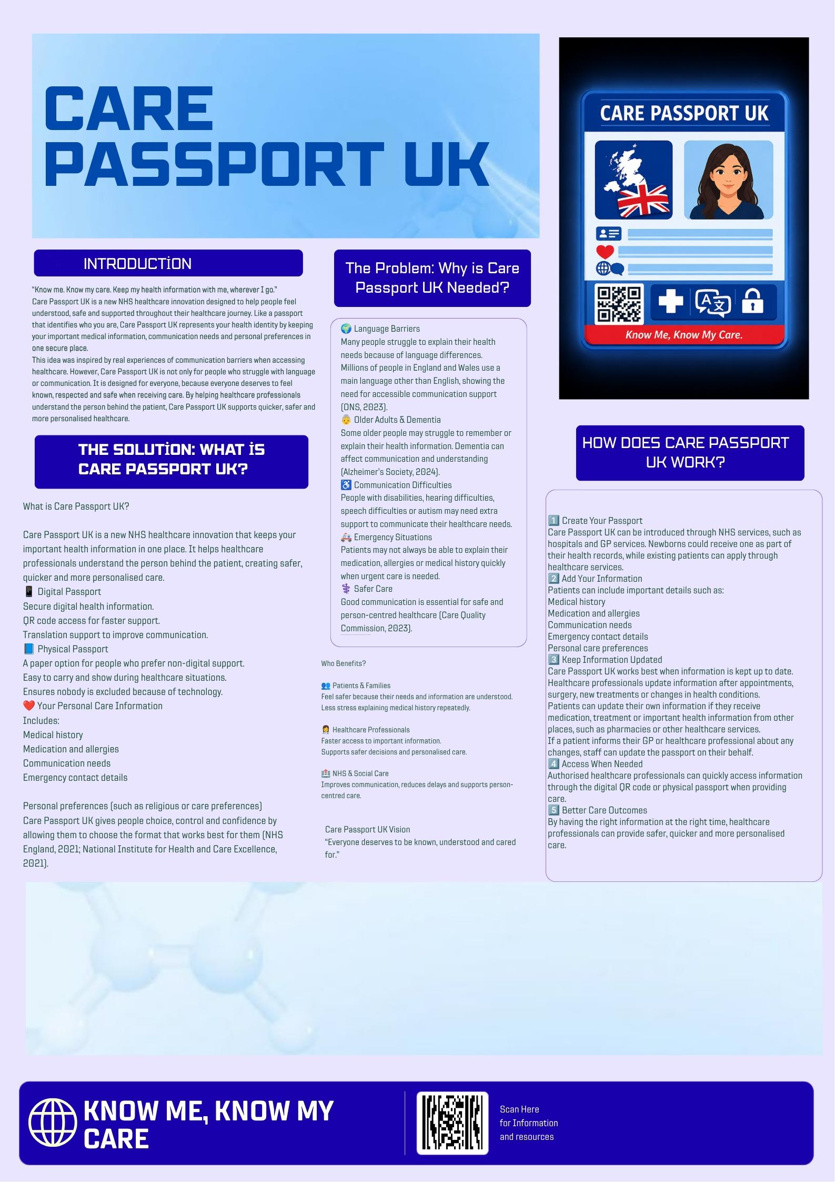

Introduction

Care Passport UK is an innovative health and social care solution designed to improve communication, accessibility and person-centered care within the UK healthcare system. The idea is based on creating a physical and digital healthcare passport that allows individuals to store important information about their health history, communication needs and personal preferences in one secure place. The main purpose of Care Passport UK is to support people who may experience difficulties communicating their healthcare needs, including people with language barriers, disabilities, older adults and individuals who may struggle during emergency situations. The slogan “Know Me, Know My Care” represents the aim of helping healthcare professionals understand the individual, not only their medical condition. This innovation focuses on improving safety, dignity, choice and quicker access to appropriate care.

Background: The Health and Social Care Issue

Communication is an essential part of safe and effective healthcare. However, many people experience difficulties when trying to explain their health problems, medical history or personal needs. This can happen because of language barriers, disability, hearing or speech difficulties, learning difficulties, dementia, anxiety or stressful healthcare situations.
The UK has a diverse population, with many people using languages other than English as their main language. According to the Office for National Statistics (ONS) (2023), there are millions of people in England and Wales who use a main language other than English, showing the importance of accessible communication support within public services.
The NHS recognizes that some people require information in different formats or additional communication support. The Accessible Information Standard requires health and social care organizations to identify, record and meet the communication needs of individuals (NHS England, 2023). This demonstrates that communication barriers are already recognized as an important issue within healthcare.
People with conditions such as dementia may also experience difficulties communicating their needs. Alzheimer’s Society (2024) highlights that dementia can affect a person’s ability to understand information and express themselves clearly. This shows why having healthcare information already available can help professionals provide more appropriate and personalized support.
When patients cannot explain important information such as allergies, medication, previous surgeries or health conditions, healthcare professionals may spend additional time collecting information. Care Passport UK aims to reduce these difficulties by allowing essential information to be accessed quickly and safely.

Innovation Description: What is Care Passport UK?

Care Passport UK is a physical and digital healthcare passport designed to keep an individual’s important health information together in one accessible place. Like a normal passport that identifies a person, Care Passport UK acts as an identity record for an individual’s healthcare needs. It includes important information such as name, photograph, medical history, medication, allergies, previous surgeries, GP details, emergency contact information, blood type (if known), communication needs and personal care preferences.
The digital version would include a secure application where individuals and healthcare professionals can update information safely, following data protection requirements such as the UK General Data Protection Regulation (UK GDPR) and Data Protection Act 2018 (UK Government, 2018). It would also include a QR code that allows authorized healthcare professionals to quickly access information when needed. The digital version could provide translation support, allowing individuals to communicate in their preferred language and helping reduce language barriers.
However, Care Passport UK is not limited to digital technology. A physical passport booklet would also be available for people who may not use smartphones or digital systems, such as some older adults or individuals with accessibility difficulties. The physical version would contain essential information and include a QR code as an additional option.
What makes Care Passport UK different is that it combines medical information with personal preferences. Individuals can include preferences such as preferred communication methods, cultural or religious considerations, and where possible, preferences regarding healthcare professionals. This supports personalized care by recognizing that each person has different needs and choices (NHS England, 2021).
Care Passport UK supports the principles of person-centered care by giving individuals control over their information and allowing healthcare professionals to understand the whole person, not only their medical condition (National Institute for Health and Care Excellence, 2021).

Impact on Health and Social Care
Care Passport UK could have a positive impact on patients, healthcare professionals and the wider health and social care system by improving communication, safety and accessibility. The main beneficiaries would be people who experience communication difficulties, including individuals with limited English proficiency, older adults, people with dementia, autism, disabilities, hearing or speech difficulties, and people who may struggle to communicate during emergency situations.
For patients, Care Passport UK can reduce anxiety because individuals would not have to repeatedly explain their medical history, medication or personal needs. Having important information available quickly can help patients feel understood, respected and involved in decisions about their care. This supports the principle of person-centered care, where services should consider the individual’s needs, preferences and choices (NHS England, 2021).
For healthcare professionals, the passport can save time by providing essential information quickly, especially in emergency situations. Doctors, nurses and other professionals would have access to information such as allergies, medication and previous health conditions, helping them make safer decisions. This could reduce misunderstandings and improve the accuracy of treatment, supporting safe and effective care that meets quality standards (Care Quality Commission, 2023).
Care Passport UK could also support equality within healthcare by helping people who face communication barriers access services more effectively. The Equality Act 2010 highlights the importance of preventing discrimination and ensuring reasonable adjustments for individuals with different needs (UK Government, 2010). By providing both physical and digital options, the system gives people choice instead of limiting them to one method of communication.
Overall, Care Passport UK aims to create a safer and more inclusive healthcare experience where individuals are recognized as a person with unique needs rather than only as a patient with a medical condition.

Public and Stakeholder Involvement

Care Passport UK would be developed through co-production, involving patients, carers, older adults, people with disabilities and different language communities. Healthcare professionals, including doctors, nurses, social workers and IT teams, would also provide feedback to ensure the system works effectively.
Before implementation, the system could be tested in NHS settings and improved through user feedback. This supports person-centered care because individuals are involved in decisions about their healthcare (NHS England, 2021). It also supports personalized care by giving people choice and control over decisions about their health and wellbeing (NHS England, 2024).

Policies, Services and Professional Links

Care Passport UK links with existing UK health and social care policies. It supports the Equality Act 2010 by helping reduce communication barriers and promoting equal access to healthcare (UK Government, 2010). It also supports the Care Act 2014, which focuses on wellbeing, dignity and person-centered support (UK Government, 2014). The NHS Accessible Information Standard also supports the need for accessible communication (NHS England, 2023). Care Passport UK could be introduced through NHS hospitals, GP services and social care settings, supported by healthcare professionals and IT teams.

Conclusion

Care Passport UK aims to make healthcare safer, quicker and more personalized by helping professionals understand everyone’s needs. By improving communication, supporting patient choice and reducing barriers, it can create a more inclusive healthcare experience where every person feels recognized, respected and cared for.

Reference List

Alzheimer’s Society (2024) Communication and dementia. Available at: https://www.alzheimers.org.uk/about-dementia/symptoms-and-diagnosis/symptoms/communication ⁠ (Accessed: 3 August 2026).

Care Quality Commission (2023) What we do. Available at: https://www.cqc.org.uk/about-us/what-we-do ⁠ (Accessed: 3 August 2026).
Care Quality Commission (2023) The state of health care and adult social care in England 2022/23. London: Care Quality Commission. Available at: https://www.cqc.org.uk/publications/major-report/state-care/2022-2023c ⁠ (Accessed: 6 August 2026).
National Institute for Health and Care Excellence (2021) Shared decision making: NICE guideline NG197. Available at: https://www.nice.org.uk/guidance/ng197 ⁠ (Accessed: 3 August 2026).

NHS England (2021) Comprehensive model of personalized care. Available at: https://www.england.nhs.uk/personalisedcare/comprehensive-model-of-personalised-care/ ⁠ (Accessed: 3 August 2026).
NHS England (2023) Accessible Information Standard. Available at: https://www.england.nhs.uk/accessible-information-standard/ ⁠ (Accessed: 3 August 2026).
NHS England (2024) Personalized care and support planning. Available at: https://www.england.nhs.uk/personalisedcare/pcsp/ ⁠ (Accessed: 3 August 2026).
Office for National Statistics (2023) Language in England and Wales: Census 2021. Available at: https://www.ons.gov.uk/peoplepopulationandcommunity/culturalidentity/languageandtheenglishlanguage/bulletins/languageenglandandwales/census2021 ⁠ (Accessed: 3 August 2026).
UK Government (2010) Equality Act 2010. Available at: https://www.legislation.gov.uk/ukpga/2010/15/contents ⁠ (Accessed: 3 August 2026).
UK Government (2014) Care Act 2014. Available at: https://www.legislation.gov.uk/ukpga/2014/23/contents ⁠ (Accessed: 3 August 2026).
UK Government (2018) Data Protection Act 2018. Available at: https://www.legislation.gov.uk/ukpga/2018/12/contents ⁠ (Accessed: 3 August 2026).

Image Acknowledgement
Images used within this poster were created or edited using AI tools and Canva design features for educational purposes. The background image was sourced from Google Images and used for visual design purposes.

