Task 1: Locating Sources
Identify and locate three different sources (a report, a journal article, and a website) related to the question
“What employability skills do business graduates need to succeed in the modern workplace?”
Show how you used keywords, search terms, and Boolean operators to find them, and explain how you know which type of source each one is and why it is appropriate for the research question.

Source Type & Why It Is Appropriate | URL/DOI | What search engine did you use? Google/Online Library/Library AI Assistant | Keywords/Boolean Operators Used
Article  Appropriate because it investigates the perception of employers in retail Islamic banks of Bahrain on newly graduated business students | https://librarysearch.uwtsd.ac.uk/permalink/44WHELF_UWTSD/lrq2gq/cdi_emerald_primary_10_1108_HESWBL-09-2019-0117 | Online Library | employability skills and graduates and workplace
Website  Appropriate because it is about graduates who are ready for work | https://www.managers.org.uk/knowledge-and-insights/research/building-employability-skills/ | Google Search | Employability skills for graduates on workplace search

Task 2: Evaluating Information (CRAAP Test)
Your colleague has forwarded you a source from a peer reviewed journal, and they are not sure whether it is appropriate to use and has asked for your help. Your task is to evaluate the source by using the CRAAP Test to assess its appropriateness.
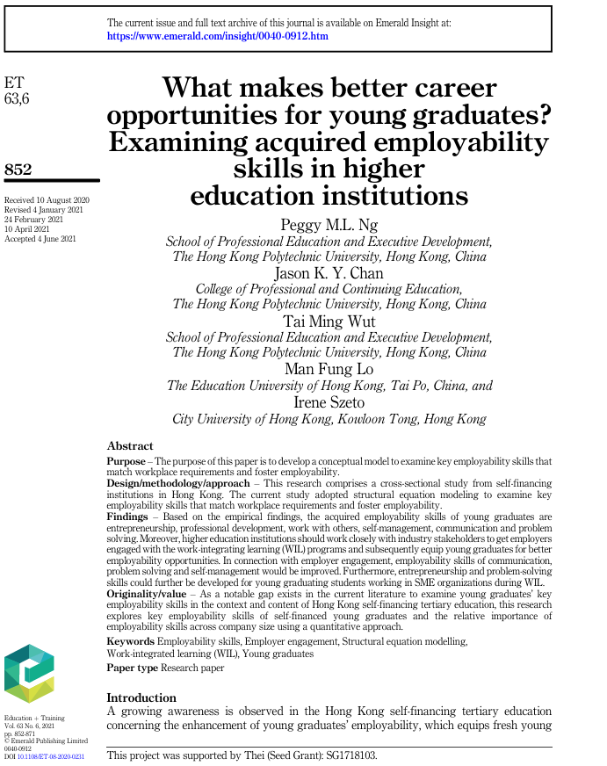

CRAAP Test
Currency | The article was published on 10 August 2020 which makes it fresh enough to use.
Relevance | It directly matches topic. It studies employability skills for young graduates looking for career opportunities.
Authority | It was written by 4 authors from well-known universities so we can say by experts.
Accuracy | The information is very reliable. It is a peer reviewed research, what means other experts checked it before it was published.
Purpose | The purpose is educational. Purpose is to examine key employability skills that match workplace requirements. Perfect for our topic.

Task 3: Source Analysis
Your manager has provided you with a short extract from a source and has asked you to analyse the source by Identifying one strength, one weakness, and providing a brief explanation of the strength and weakness identified.
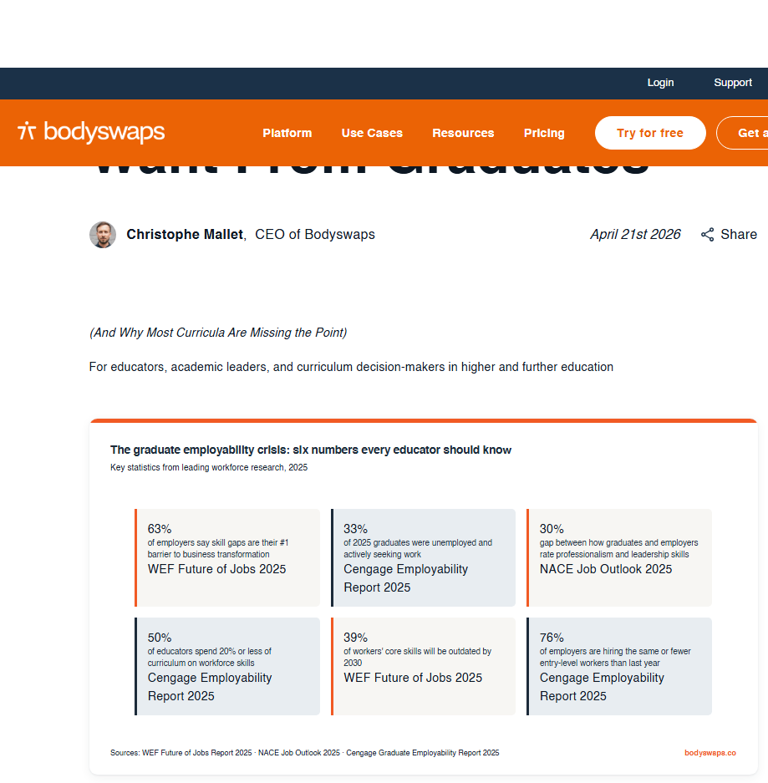
.

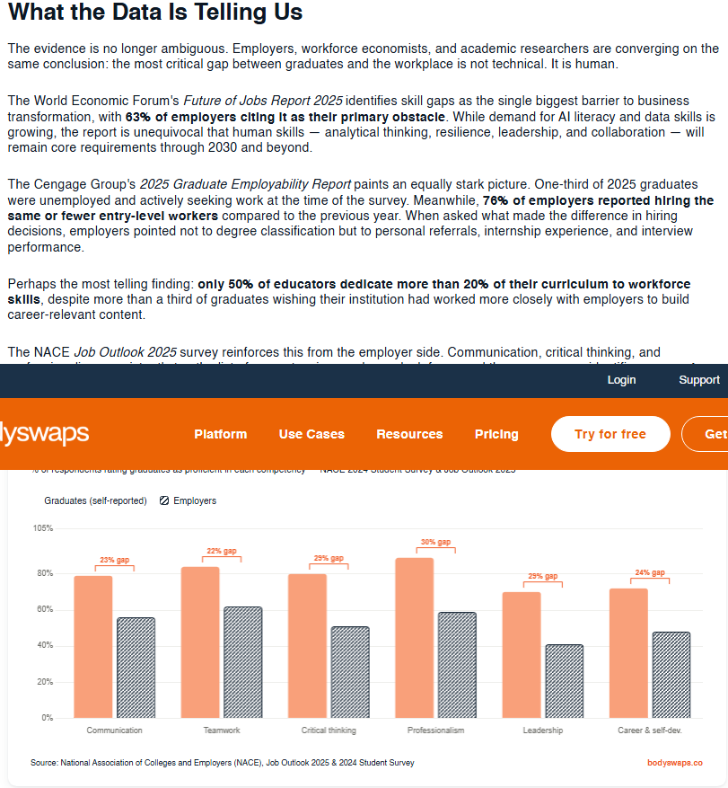

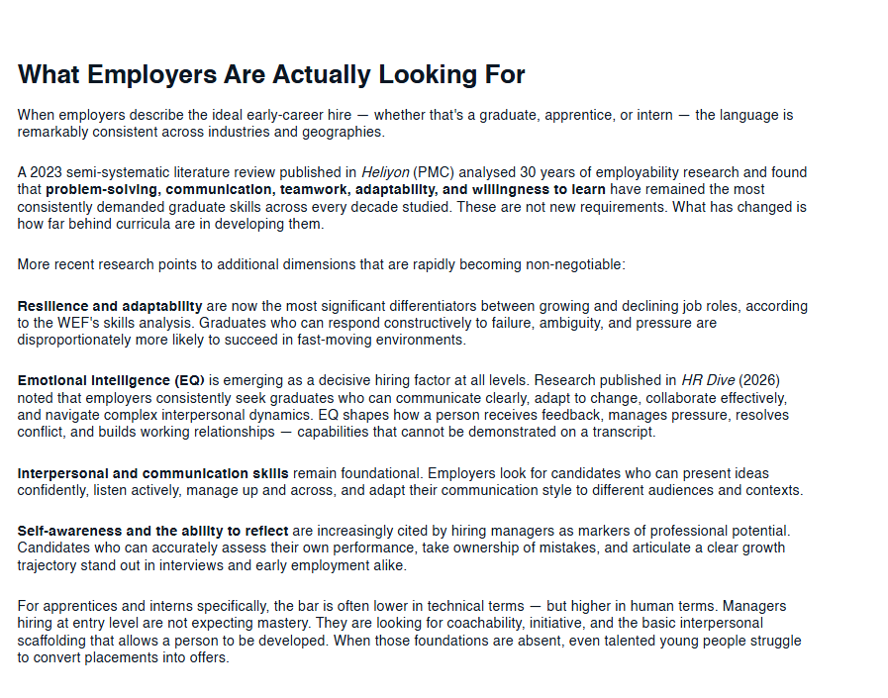

Please click the link, if you wish to read the article online.
What Employers Actually Want From Graduates

Strength of the Source:

It uses reliable data from very respected global organisations

Weakness of the Source:

It is a blog post written by the CEO of the company, a company that sells virtual reality training software to schools. In my opinion it is not enough to be super reliable authority.

