4/28/2026
Assessment
Portfolio Report on Contemporary Software Applications for Business


Cesar Enrique Cepero Nina (2237352)
Student ID:2237352

Module NaMe: Software solutions for business
Module Code: ACCA 4026
Lecturer: Amitave Banik
Trinity saint david University of Wales (London Campus)

Table of Contents
Introduction 2
Main Body 3
e-Commerce Website builders/software solutions 3
Task 2 5
Mind-map of Contemporary Software Applications 5
Task 3 7
Office Applications for Creating, Storing, Presenting, and Analysing Data 7
a. 7
b. 8
Task 4 14
Communication and Collaboration applications 14
a. 14
b. 16
Conclusion 20
References 21

Introduction

Welcome Here in this Project, you will see two e-Commerce Website builders in which I chose Wix and Shopify. and I will explain why I used these two tools and the solutions they bring to E-commerce. I'll also show you information about Mind Map what it's for, how it's used, and what tool I use to create it, we’ll also talk about office applications that we'll use like Word, Excel, Access, and power point. Then I will make an analysis about Ms team and One Drive, all the possible information about these two tools, after that I will explain how Mail Merge and IF Function are used in their respective platforms and I will end with a brief conclusion of the whole process.

Main Body

e-Commerce Website builders/software solutions

Customer Requirements
1 Good look website
2 Automation stock (plugin)
3 Secure payments
4 Drop shipping

Wix is practically a website builder, which allows me to create pages, stores, blogs in an easy way.
Shopify is all about e-commerce, with many tools for creating online stores. It can be for small or large businesses

Solutions you need to know to choose an Ecommerce

Why choose Wix:
Wix is very easy to use, you don't need to know how to program, or be a computer engineer, the animations are on another level, it is very intuitive, it is perfect for small businesses or beginners, it is cheaper, the design is much more beautiful, you have incredible templates, very dynamic, all responsive, without a doubt this is the best option[1].

Why choose Shopify:
Although Wix has many good things but in some things Shopify is better, if your goal is to improve grow in the job market, a bigger sales system, It is more powerful, Shopify creates amazing online stores, you have a very large number of stores to choose from, very dynamic and too easy, maybe it is a little more expensive, But it's worth it, because you want the customer to be able to pay in a faster and more effective way, all responsive as well and has a more comfortable inventory automation[2].

Let's talk about Wix vs Shopify
Which one should I choose and which one suits me best for my type of business, starting with the fact that both platforms are very friendly.
Wix is simpler and more intuitive than Shopify , because Wix is designed for people who do not have much knowledge of the digital world, however with Shopify it is more complex but you can still create your page without knowing anything about code and has a customer service that helps you a lot 24 hours, any questions you have they can solve you, The biggest difference is that Shopify is made to sell products online, if you have a business and you want to scale it Shopify is perfect for you, it is an Ecommerce Platform focused on selling physical products, I dare to say that it is the Amazon of web pages, on the other hand Wix with a super simple super friendly page perfect for sharing content for people who perhaps have a service, A blog, in addition to the fact that the range of templates and designs they offer you is much larger than that of Shopify comparing prices, the basic package of Wix starts at $16 and the basic package of Shopify starts at $26, which is worse or which is better, depends on your service or your product, If you want to sell something physical I recommend using Shopify and if you have a service with Wix advisories it can help you perfectly[3].

My Personal Opinion
Choosing Wix over Shopify depends on what level of control and features you need, mainly what type of business you have, and how much you want to invest in building and managing your online store and secure payments in both cases.

Task 2

Mind-map of Contemporary Software Applications
Mind maps are about organizing your ideas in a non-linear way, you put the theme or idea in the center and around other topics or concepts associated with similar concepts in which visually it is more attractive because you can put colors, edit the text, put icons, change the background, Move ideas and customize it as you want, it is a good tool that is used both academically and business, if you need to study or make notes or explain a project and you are looking for it to be easy to understand and explain without a doubt the mind map is your best choice. It is excellent if you have difficulties memorizing because this tool is the right one to use in that type of case, personally I did not know this tool until I was taught it in a class, I tried it and I saw that it is very effective, let's not confuse it with an outline, because an outline is linear, although both are to organize information the difference is in its structure, An outline has no drawings and is not visually appealing. Han Wei pointed out: Mindmaps can establish the connection between topics and knowledge points[4].

Benefits
- Mind maps can enhance our creativity and facilitate our memorization.
- Mind maps help us in the ease of thinking when making decisions, we can better analyse the good and the bad in a faster and more accurate way.
- It also helps us to become more creative because by customizing our content, we change the visual aspect in the most beautiful and clear way that we see fit and that makes it different from others and unique.
- It improves our communication when it comes to exposing our ideas with colleagues and the entire work team, you can also make groups of 4 or 5 people for example and 4 or 5 people can work on the same project at the same time, each one develops what they need to do and everything is automatically saved in the same project without having to download it because everything is in the cloud[5].

To create Mind map we have these applications: Whimsical, Miro, Xmind, Canva, Mindomo, Git Mind, Mapify, Lucidchart, etc. They are all very useful because they serve to do the same thing, my chosen one, one of my favorite tools to create mind map is MindMeister, here I will show them below. To begin with, I had to register, I created my user account. It can be done online for free and shared with the people you want, whether it is from your academic team or your entire company in the workplace, I chose DropShipping as the central theme and my subtopics were Customer service, Order process, Profit, products, Suppliers, Online Store, Marketing, I decorated them with colors, I put images and icons in each one to make it more visually beautiful, and in each of them I put about 3 or 4 ideas marked with colored lines, of course I could do better, but for me it is the first time I use it and I will definitely use it again as it makes my life easier [6].

My Dropshipping MindMap
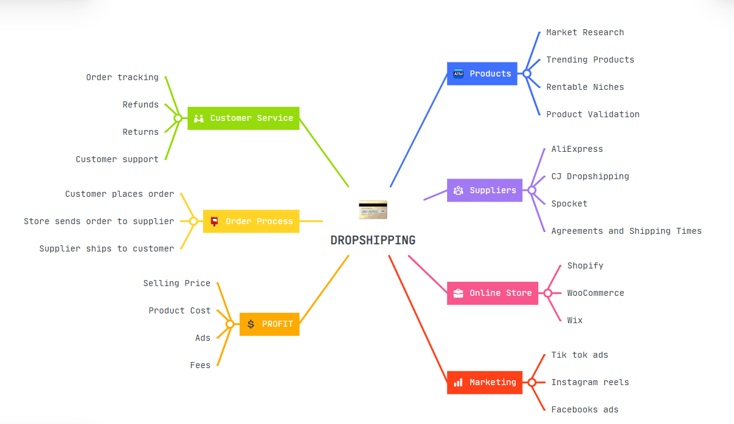
Figure 1: Dropshipping MindMap
https://mm.tt/map/3958773881?t=IOw9WcGgJd
Tools: Mind Meister

Task 3

Office Applications for Creating, Storing, Presenting, and Analysing Data

a. MS Word
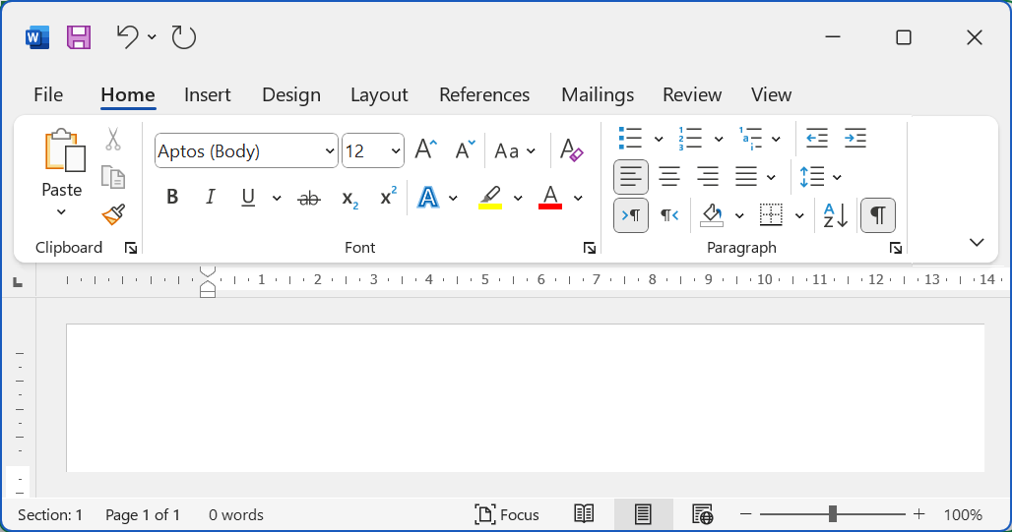
Figure 2: ms word
Word is a word processor and a widely used tool worldwide, it has many benefits and limitations, without a doubt it is working in every office that exists [7].
Benefits
Easy to use, it can certainly be used by any type of person and you don't need great knowledge clearly as a standard user, because advanced users can do great wonders with this program
It is in all languages
This helps especially students and people who work with computers, teachers, people from a different country.
You can also make any type of letters invitations cv professional documents.
Within Ms Word you can create modify the format for example font, color, size, aligned tables, images, spell checker, page header, etc.
In addition, you can change the design to a more dynamic or more professional form without any problem since the Word program offers you many tools.
MS Word also offers us the word count that comes installed because it helps us a lot just by selecting the words we want it automatically starts counting us and the tool starts counting and you can know the exact amount of the entire document or also the parts that you select. On the other hand, it has its own application and works on the mobile whether it is Appel or Android, it works on any device

Limitations
It is integrated into the office 365 package so it is paid.
You have limitations for example it is not useful to do more complex analyses, when the card is very overloaded with a lot of content and images it becomes slow.
We can also see the prices that can range from $35 to $70 dollars per year, of course it comes with the entire office package, but you need to pay for it to have the license.
Another limitation is that when you save the document and want to open it again on another computer with another more up-to-date version, your words or design moves and you waste time arranging everything again.

MS Excel

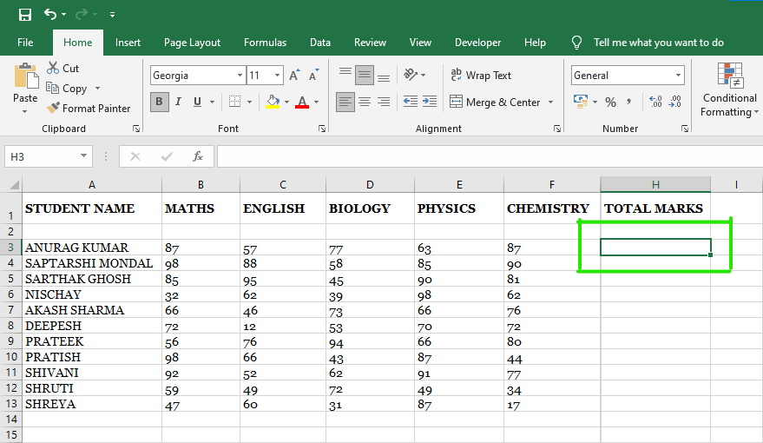
Figure 3: ms excel
They are spreadsheets for organizing and analyzing your data. The format for this type of program is .xls it is important to know it in order to differentiate it from other programs when saving it [8].
Benefits
Flexinility: This is a tool especially for office work, although you can use it in an educational way and to organize your accounts and payments as personal use.
Visually appealing, it makes the graphics look and interpret better.
It has many features like pivot tables, graphs, etc.
Automation and all the formulas it has, it can be like a calculator, you can add, subtract, multiply, divide, until you make very complex calculations
As it is in the same office package you can export it to Ms Word or MS power point whenever you want
Limitations
It is difficult to use, for example for people who are starting to use this program, this person must be accompanied by someone or receive an appropriate instruction to this program to work in an office because a small error in a formula can cause a big problem in all the results, having to look in detail where the error is to solve the error.
It is for smaller databases because for large databases there are other specialized programs.
MS PowerPoint
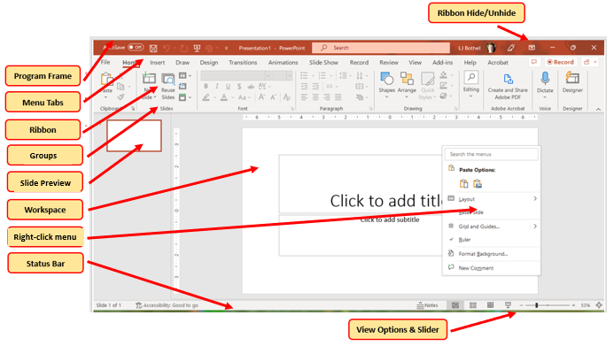
Figure 4: ms power point
This program is the most used to create slideshows since it has a wide number of designs to modify it to your liking. There are millions of people who use it daily, without a doubt it is my favorite [9].
As Benefits :
You can include videos, audios, images, any multimedia element
Create animations, in each presentation in different ways that you can
change the entire background or parts
change the style of the formatting of all text to make it look more visually pleasing, align it to your liking
Add screenshots of each step you take in a process so you can explain it
It has a wide variety of professional templates for companies, teachers and schools,
It is easy to use although at first it may seem difficult, these programs can be used even by a child as long as it is guided by an adult,
Limitations
It is a program that belongs to the office package so you have to pay for the complete package, this is not sold separately, so you need to buy it, many universities and colleges ask for projects in MS power point. It is recommended to use about 7 to 10 slides per project because otherwise it can be a lot, although you have the option to use more sometimes people use it too much, and abuse it.
MS Access

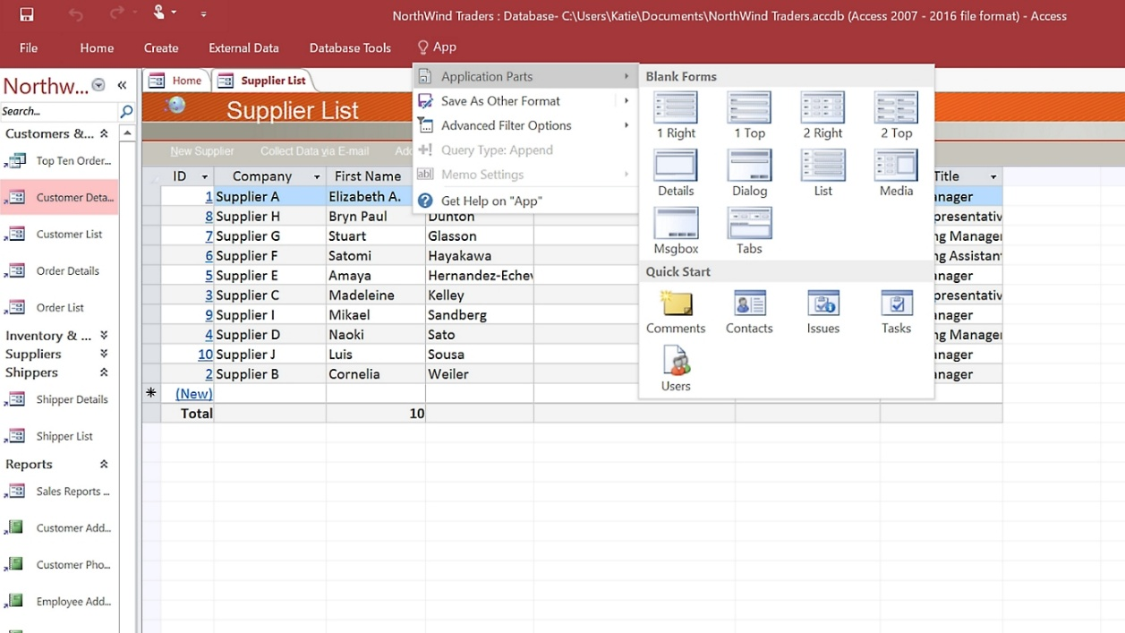
Figure 5: ms access
This tool is for creating relational database for companies or small businesses [10].
Benefits
It is easy to use for small environments for non-expert users,
You can create tables, forms, reports, tables very quickly
It connects easily with MS power point, MS Excel, MS Word because they are in the same Office package
As it is included in the office package it is cheaper than any database
It has good automation that works well with macros and you can do various repetitive tasks,
Limitations
It has a capacity of only 2 gb maximum, if my database is large, then it would not serve me
It becomes slow if you have a lot of programs open the network starts to fail
It's security is safe, but not as secure as other stronger database programs
Compatibility is limited, it only works on Windows.

b.
1.MailMerge
We'll start by creating a letter in a Word document.Because we need to fill in data first to start with the example | 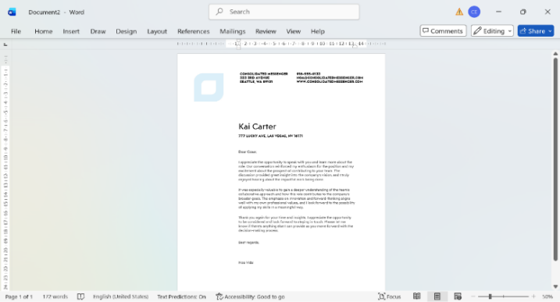
Then we will go to the menu bar and select the Mailings option and within it we choose the select Recipients option and click on Type a New List. | 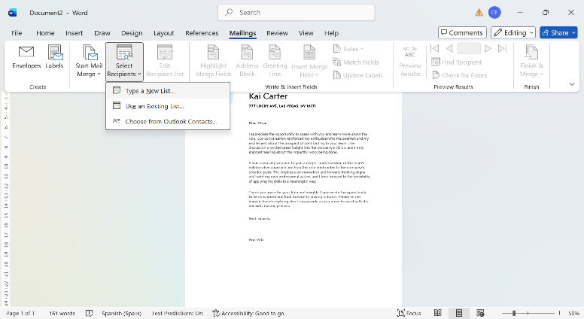
Then we will go to the Customize Columns option and in the next window we can add, edit or delete the address list. | 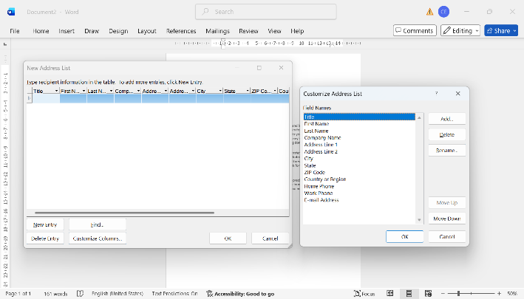
Once edited and leaving only the names I need, I click ok and then I will complete my new address list with the data I need as seen in the image. | 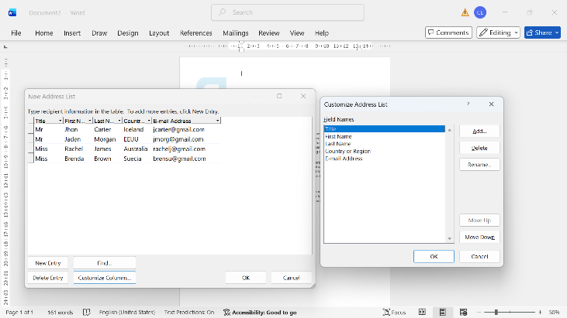
When I finish filling in my data, I must save my data, I can save it with any name and in the place, I want preferably near my document. | 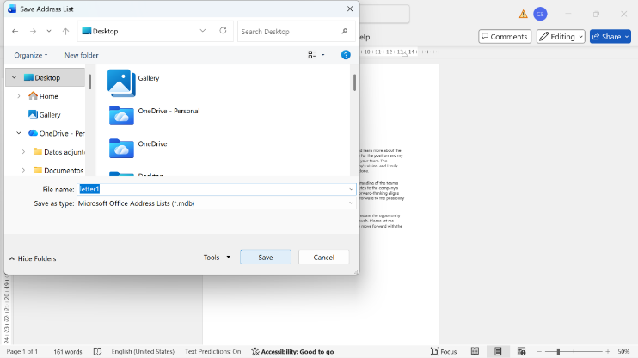
Now I can use my saved data by heading to the Insert Merge field button and placing it where I need it. | 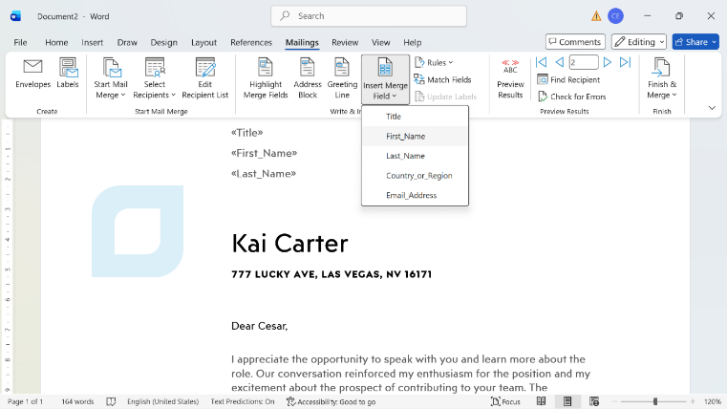
Then, to be able to visualize our data, we will go to the toolbar and click on the ABC Preview Results button and with the left and right buttons we can quickly change people. | 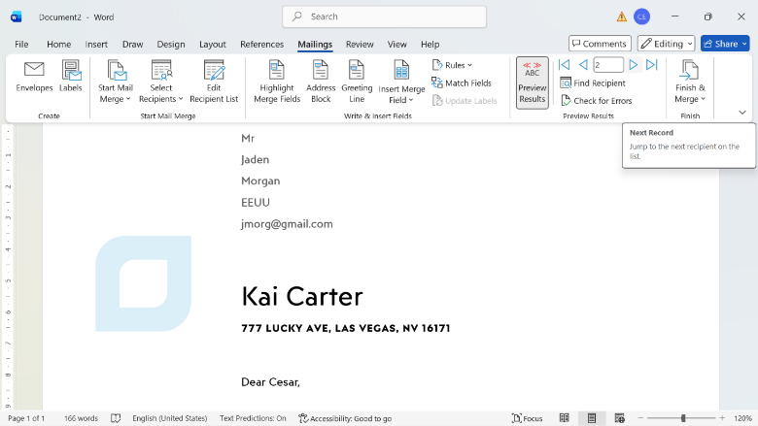
To finish we will go back to the toolbar and click on Finish & Merge and choose the Send Email Messages option and thus send the letter to all the people who need it. | 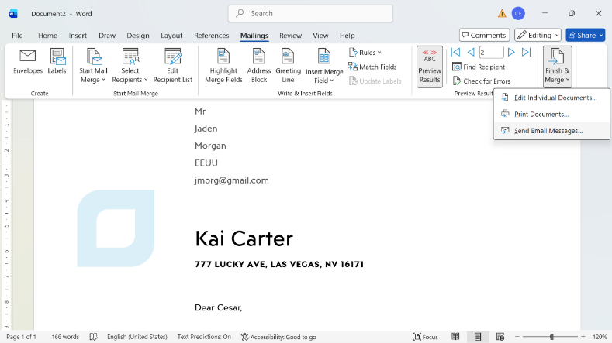

2.IF Function
We start by opening our excel | 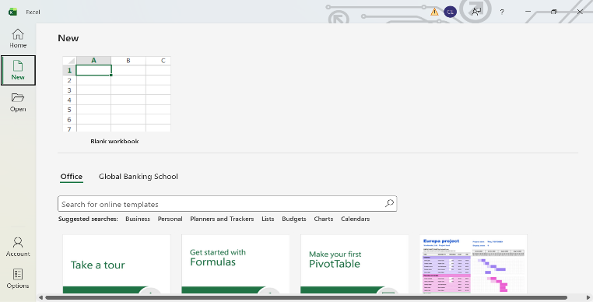
We will create our first excel sheet , no olvidemos guardar nuestros datos para no perder ninguna información importante | 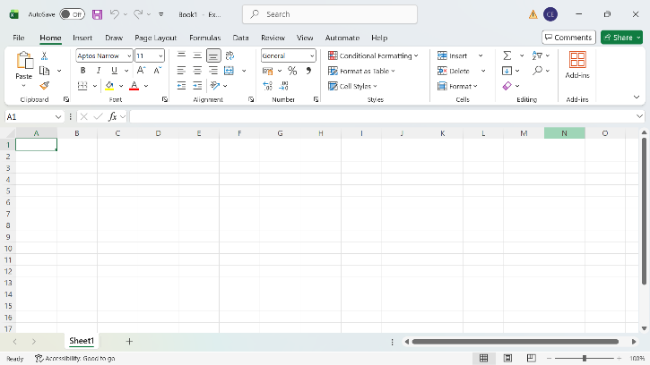
Now we will create a table with some values, in my case I put 6 ids with some notes,is something basic to proceed below to explain how If function works | 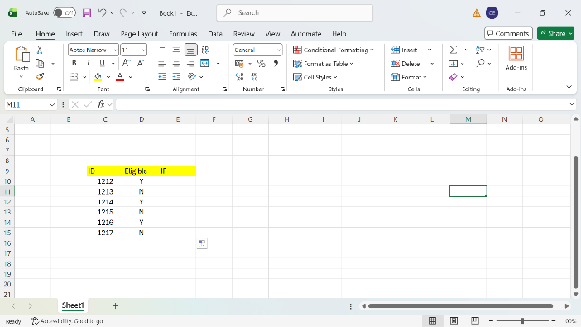
Now I'll put some notes on the formula that I'm going to apply, so you can see, I'll apply the formula.  If Eligible=Y , then get 500  If Not Eligible=N, then get 0  That will be the formula that I am going to apply in this Excel sheet. | 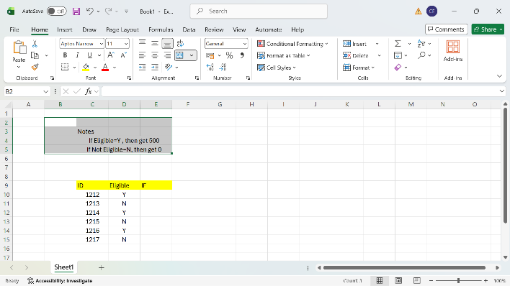
In box E10 I will apply the following formula using IF function : IF(D10="Y",500,0)This means that if box D10 has a letter Y it will give me the amount 500 and if it were not a letter Y and it was another letter it would give me 0, that means this function | 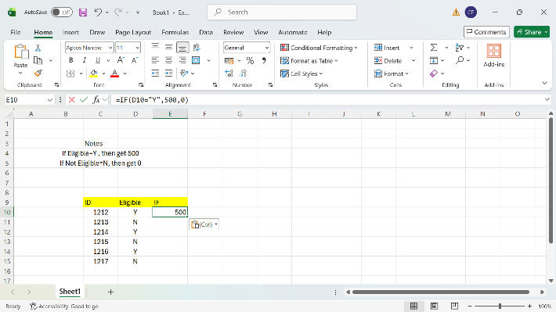
If I drag with the mouse from the corner of the cell where I applied the formula as seen in the image, the formula will be applied to all those cells where I am dragging. | 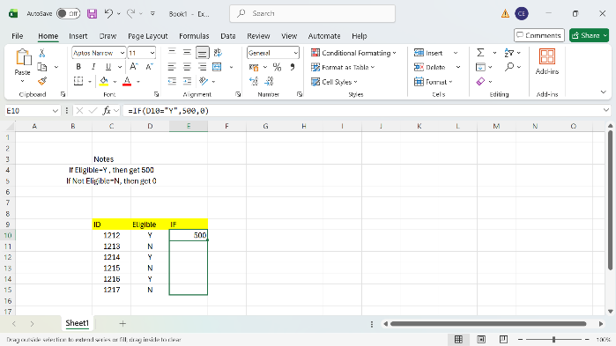
As you can see now, the formula was applied to all the cells automatically without having to put the formula in each cell, it is a faster and more functional way that Excel has to increase the speed and productivity of my goal to do. | 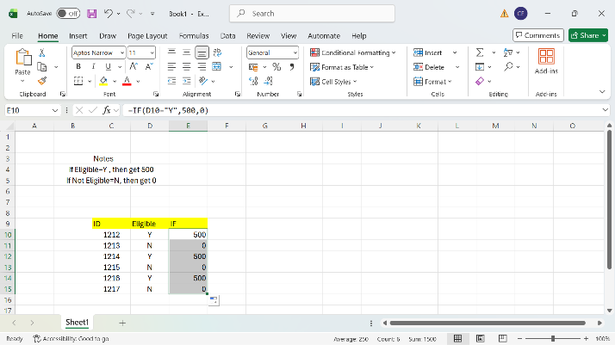
You can also put colors on the table and give other types of values such as putting yes or not, you can edit it as you like so that it can be seen in a more attractive way as well. | 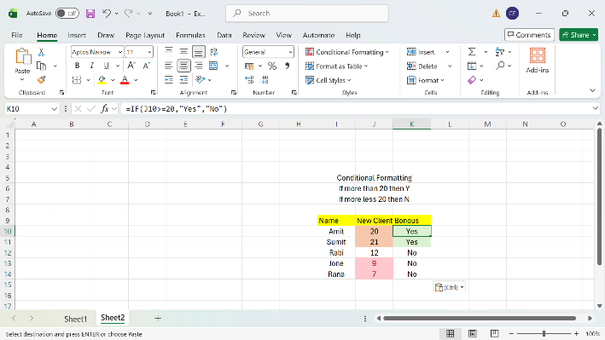
A very important thing to keep in mind is always save the changes so that you do not lose your information, you can do it this way by going to file and selecting the save as option to choose where to save it. | 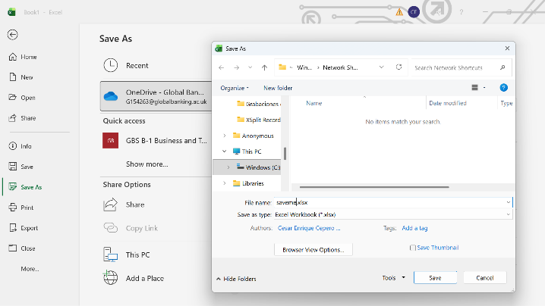

That was it, so far 2 very useful tools for day to day in your office work, thank you very much for your patience and for your attention.

Task 4

Communication and Collaboration applications
a.
Microsoft Teams
One of the most used contemporary communication applications in my opinion is Microsoft Teams works in the cloud created by Microsoft, it is currently used at an educational and business level, if you realize this application is used to make videoconferences in schools, institutes, universities, companies, it is very functional, and it also has chat and audio calls for meetings or seminars all in real time, You can share screen, files, and a wide distribution of themes in any field. It can be used on the mobile or also on the computer, every time we use this tool it can be online you do not need to create an account, it is optional, you share a code and a password, and you can add hundreds of participants in your conference. It is included in the office 365 package, there is the free version and the paid version. You can also record the conference, and it has the transcription function, it is one of the most used tools in all de world [11].

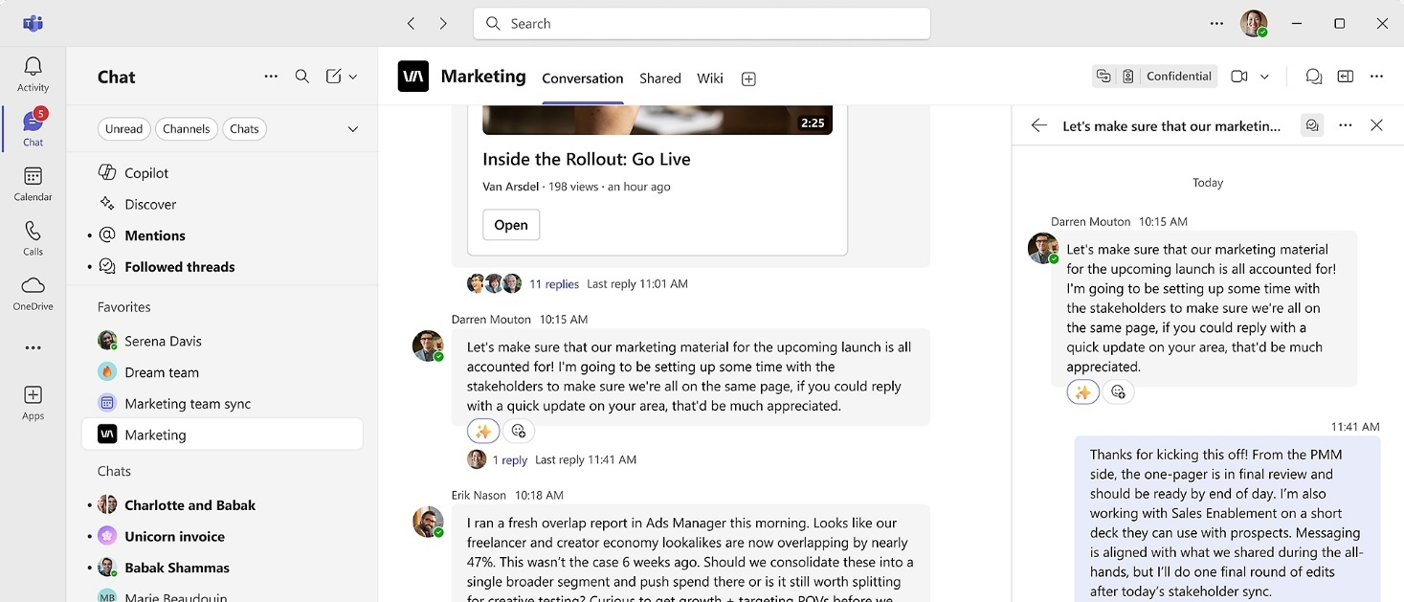
Figure 6: Ms Teams

One Drive
And a collaboration application in a work team very frequently used in today's business world I choose One drive because it allows you to store your files somewhere in the cloud, you don't need to fill your computer with files and documents, even photos, videos and applications you can also save in your cloud, it can be private or also share it with the people you want, You only need to register to create your account and then you can access it from anywhere in the world at any time from any device, that is the best because you can use it from your mobile and your PC, you have the free option which is somewhat more limited or you also have the paid option perhaps it is the best option because the amount of storage you get with this option is much higher up to 6 TB and it pays to pay for it because you will get good results, with good security without being afraid that your files will leak, get viruses or get lost.
The way to use it is very simple is just to enter your account and synchronize your device with the cloud, to upload files you can drag them or click on where you see upload file from the web or you can also do it in the phone application, as they are synchronized, when you upload something or delete something, it is automatically updated and you see it updated on any device that has your account, you only need to have internet working, it has multiplatform access, that means you can access your account from Windows, Linux, MacOS, IOS, Android[12].

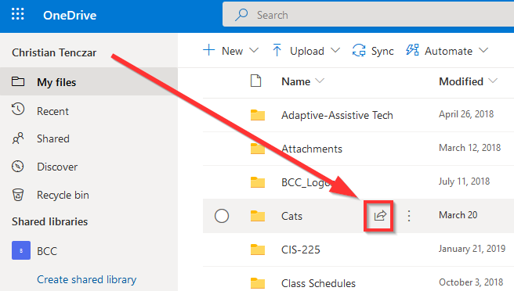
Figure 7: One Drive
b.
Outlook
First, we start by searching for our outlook program on Google on the official page to download it | 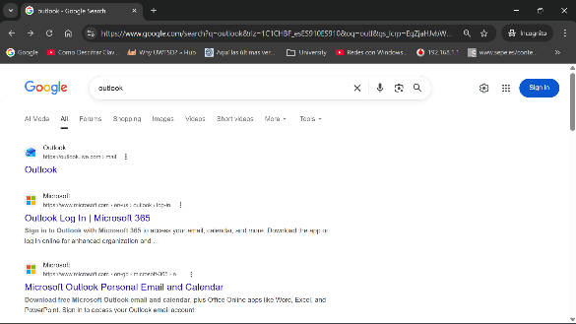
Now we are on the official website, once here we look inside the page for the download option | 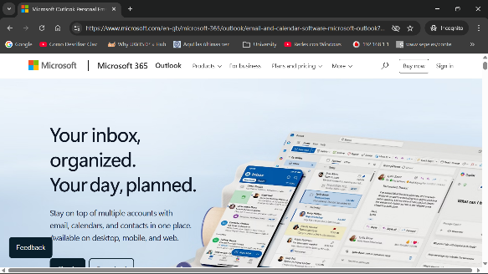
We have already found it, now we just click on the blue button to download it to our computer | 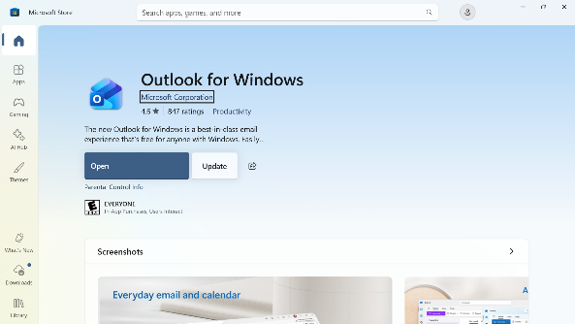
Once downloaded, we will go to open the Outlook program and when we want to open it, the program will ask us for an account where we will have to create a new account or if we already have a previously created account, it can use it | 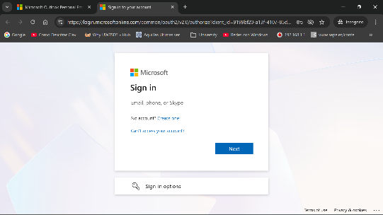
Once inside the application it will look like this and this is where we can start using the outlook email account | 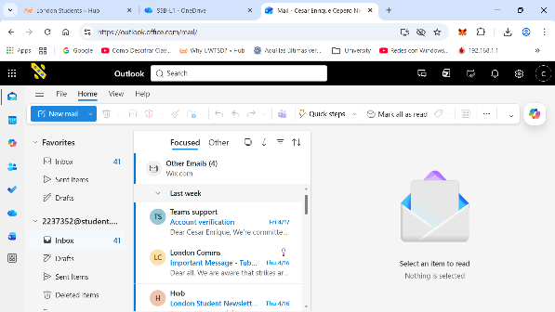
Here we can prepare to send the message to the recipient of my choice | 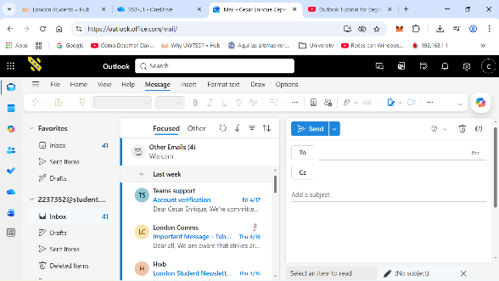
Here I made an example of the message of how to send | 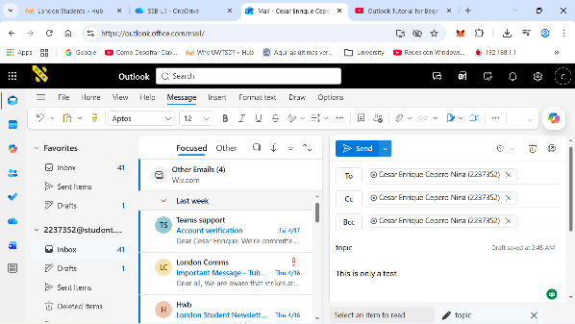
Here I already received the message in my inbox, that's where all the messages will arrive as you can see | 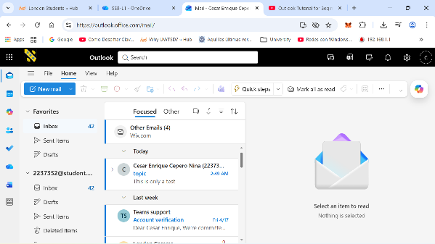

MS Teams
First, we start by searching for Our Ms Teams program on Google on the official page to download it | 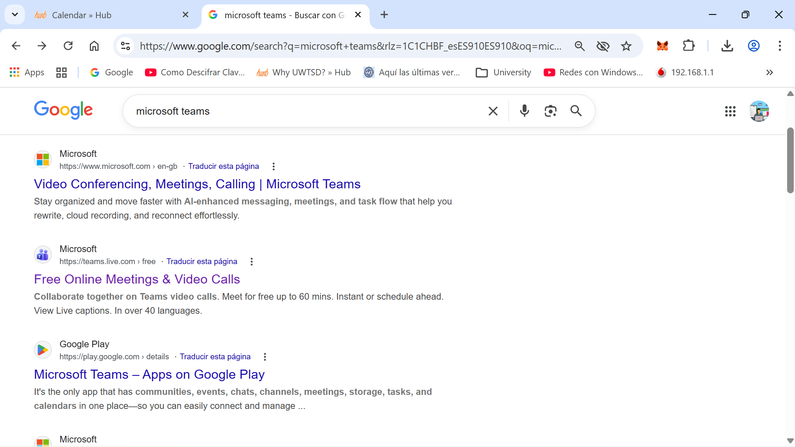
Now we are on the official website, once here we look inside the page for the download option | 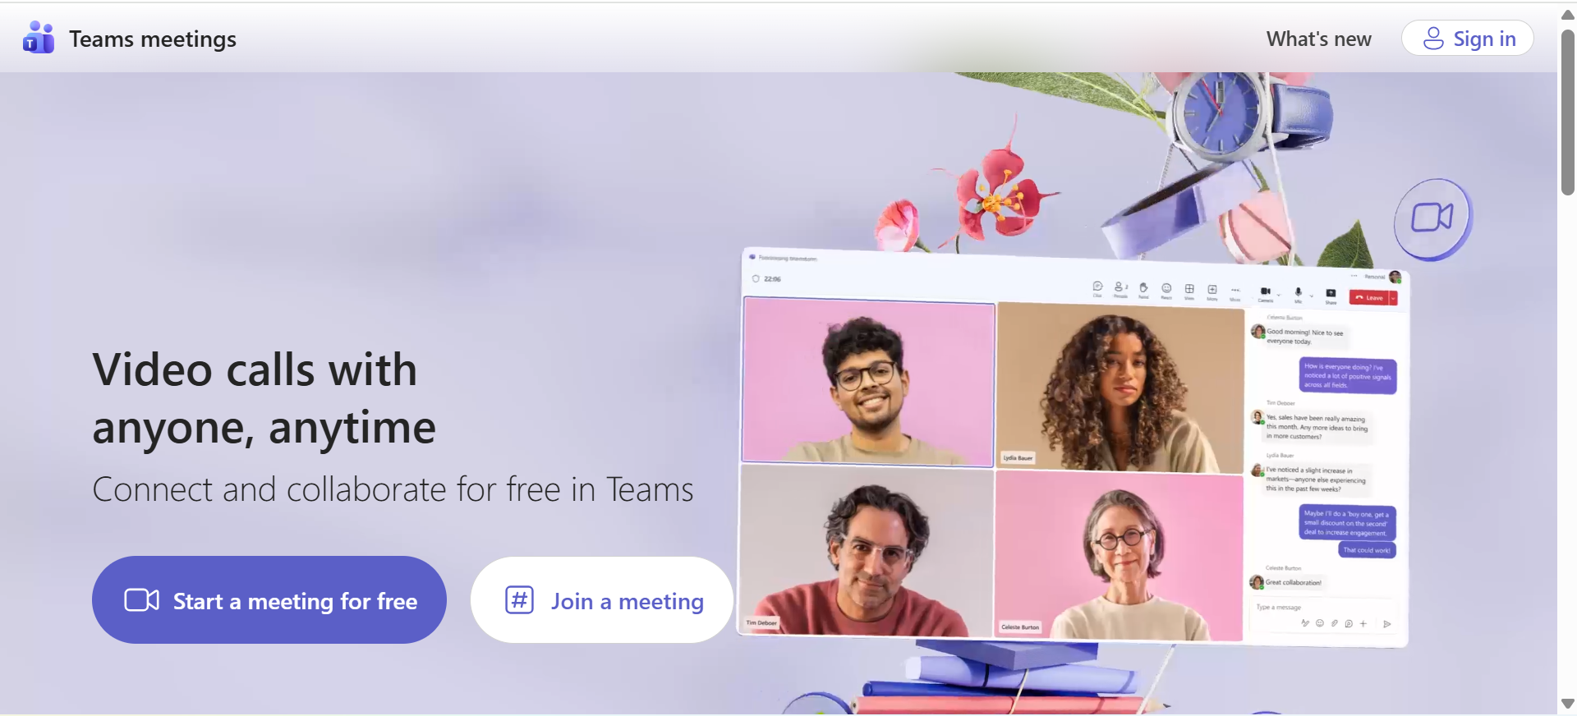
We have already found it, now we just click on the blue button to download it to our computer | 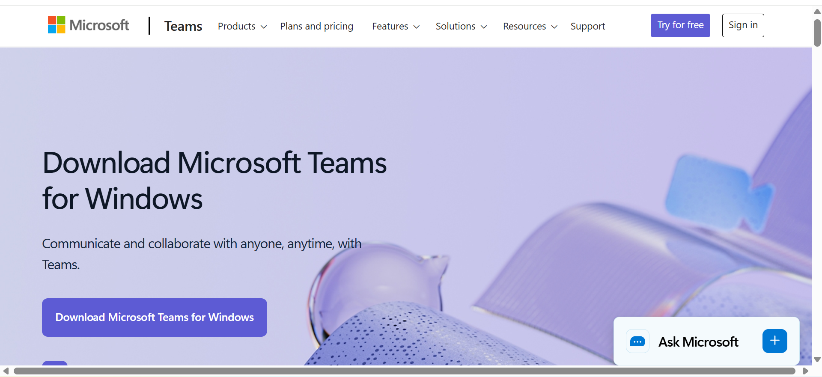
Once downloaded and installed we will proceed to search and open the program to start using it, for that we will click on Open | 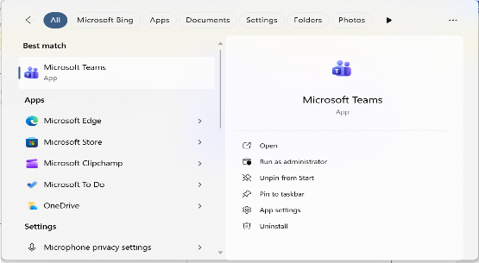
Once we are inside the application we will enter with our email account or we can also enter any meeting as long as they have given me a username and password to join | 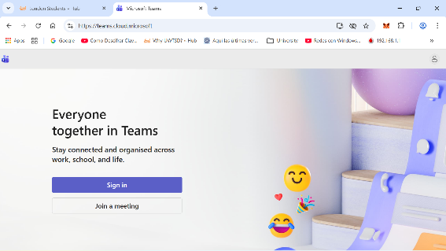
Now we will wait a few minutes while our logged in account is set up,We can use it from the downloaded application or from the web without downloading it as well | 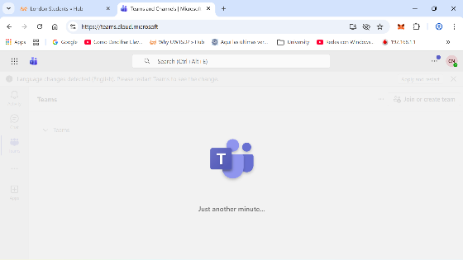
We are already inside our account, now we can join a group | 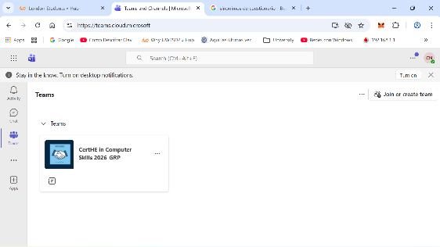
Here we can even start writing and sending messages to our co-workers | 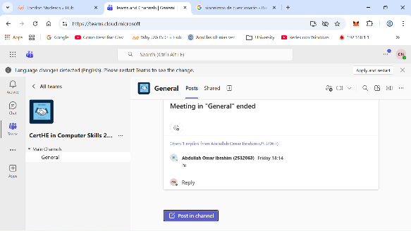

Conclusion

In conclusion, these tools such as Ms Word Excel, PowerPoint, Access, OneDrive, Ms Teams and Outlook, is fundamental in work and academic environments, each one has its function Ms Word is to create Excel, analyzes organizes and visualizes data, Power point is a key tool for project presentations, Access creates a database with secure data structures and management, Outlook to send emails, Teams to work in a team and make video conferences and one drive to store large capacity files online without the need to download it, tools like mindMeister to create much-needed mind maps, I also used If function and Mail Merge, these programs are basically very important in daily life in the office because it is used in every situation that we need it ,with all this we can be better in various aspects of life related to academics and professionals

References
[1] J. Holland, "Learn how to create a wix website: Current best practices," vol. 8, no. 2, pp.50–58, 2020,
[2] G. Dushnitsky and B. K. Stroube, "Low-code entrepreneurship: Shopify and the alternative path to growth," vol. 16, pp.e00251, 2021,
[3] J. P. F. d. A. Pais, "Shopify equity research-staying ahead of the market," 2022,
[4] M. J. Somers, K. Passerini, A. Parhankangas and J. Casal, "Using mind maps to study how business school students and faculty organize and apply general business knowledge," vol. 12, no. 1, pp.1–13, 2014,
[5] B. G. Wilson, Exploration of mind mapping as an organizational change tool, Pepperdine University, 2016.
[6] T. Boskov and S. Lazaroski, "Mind mapping for business planning and marketing plans," 2010,
[7] K. Pírková, Microsoft Word 2010, Computer Press, 2013.
[8] I. Elmakaty, "Mastering meta‐analysis in Microsoft Excel with MetaXL add‐in: A comprehensive tutorial and guide to meta‐analysis," J.Eval.Clin.Pract. vol. 31, no. 2, pp.e14138, 2025,
[9] E. Firdaus, A. F. D. Kusnanda and N. Tankira, "Development of Interactive Microsoft Power Point Learning Media Based on Motion Graphics on Social Studies Subject Pluralism Material", International Joint Conference on Arts and Humanities 2024 (IJCAH 2024), pp. 851–863.
[10] J. Sundaramoorthy, et al., "A Blockchain-Enabled CMS for Transparency and Data Integrity in E-Commerce Applications", 2025 International Conference on Intelligent Computing, Information and Control Systems (ICOIICS), pp. 659–666.
[11] R. Melati, "Analysis of the advantages of Microsoft Teams as a corporate communication tool in supporting employee performance," vol. 5, no. 3, pp.2893–2899, 2025,
[12] Á M. R. Noblecilla, A. C. H. Peña, J. A. D. Capa, A. M. S. Castro and K. D. C. Pazmiño, "Análisis comparativo de seguridad y gestión de archivos en herramientas Cloud: Google Drive vs. Microsoft OneDrive vs. Dropbox," vol. 13, no. 1, pp.1813–1830, 2026,

