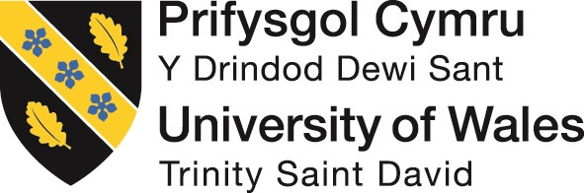

MODULE CODE:M4X01915

Hospitality and Guest Services

Written Assignment 2000 words essay
Lecturer: Dale Clark
Student number: 1813330
Student name: Shahzia Ahmed

You are required to produce a 2,000 words evaluative report, based on a hotel organisation of your choice. In your report, you will discuss the service provided in the chosen hotel, quality management (Continuous improvement), how the hotel adapts to changing consumer preference and how these changes impact guest service management.

The Marriot hotel groups is the hotel organisation I have chosen to evaluate and report on, The Marriot group has always been an innovator and market leader in guest services, the company was formed and established by J.W. and Alice S. Marriott in 1927. This was not a hotel but a root beer stand, this was the first step in to the hospitality sector for the couple extending to serving food cooked by Mrs Marriott in their apartment several blocks away. They bought their first hotel, the hotel was the Twin Bridges Motor Hotel, which opened in Arlington, Virginia, in 1957. This was a risk for the couple, there Entrepreneurial spirit paid of the Marriot group now boasts 6400 plus hotels internationally in 125 countries. Marriott hotels are still growing at the rate of one new Marriott opens every seven days. Marriott International was formed in 1993 when "Marriott Corporation split into two companies, Marriott International and Host Marriott Corporation. In 1995, Marriott was the first hotel company worldwide to offer guests the option to book reservations online, via the company's implementation of MARSHA (Marriott's Automatic Reservation System for Hotel Accommodations” (Marriotthotelsnews.com accessed on 26/03/2019)
The Marriott have been at the fore front of advancing consumer needs and integrated technology within their business to constantly offer the highest level of customer services.
With technology advancing and consumer engagement being the most prevalent objective in securing and retaining the customer, guest or even make you a family member as some corporations would like you to believe. Corporation's Identifying with the target market and generously rewarding them for their loyalty. With such large advances in technology every consumer need can be met in today's market place.
As identified in the state of customer experience the “experience is the product” and the ability to offer the best experience and service is the only way to overall success.
The expectation of the consumer has increased and what is expected from the hospitality sector is now constantly evolving, a more personalised and induvial experience is desired. This has created a need for a higher quality of experience made easily assessable to the consumer, consumer expectations have led to an ever-increasing demand from the consumer.
The hospitality sector identifies with its target market and embraces the advances of our new digital era and future promote their eagerness to interact with its consumers. The hospitality sector has look outside of its sector and associate itself to leading brands.
The association of hospitality and brands has proven to increase the appetite of the consumer and large everyday brands such as Starbucks and Amazon introduce innovative promos daily helping to increase the demand and interaction from consumers, thus increasing the bar for consumer brand experiences, This has led to a fusion of Hospitality-Retail and Hospitality-Brands and any other sector, as being open and focused to consumer needs favour's all. (Customer Experience for Hospitality accessed 01/04/2019)
Consumer Demands and catering to the demands has led to the increased use of self service via digital aids web and mobile self-service, automated chatbots being one of the latest trends. Consumers demand a fast and intelligent service, the imminent use of wristbands and electrical devices produce a more sophisticated service, resulting in a greater guest experience.
In most Marriott hotels you will enter a reception lobby with a conventional reception desk and a warm welcome alongside a smart screen also welcoming and serving guests with consistency throughout the guest’s experience. According to Forrester reporting in 2017 self-service use in hotels is on the increase and phone usage shows a decline of 12% “customers of all ages are moving away from phones and their preference is self-serve options” (Forrester accessed 23/03/2019)
“Looking forward, Marriott’s strategy focuses on activating public spaces with technology. One example is the 6 Degrees table that Marriott developed in partnership a couple years ago with MIT. When people sign up for the 6 Degrees app, they can find like-minded people at the table based on sensors below the table surface that reads social media profiles.” (swift.com2016)

Self-service has become popular and mostly all the large hoteliers have adopted this as working practice and given it a space in their hotel’s reception, this is the first point of contact for the guest their experiences represent the implementation of this method being adopted even in the smallest of establishments to increase revenues and keep their customers satisfied.
The Marriott group have integrated technology and offered the highest and most advance technologies to their customers, the following services are offer at most of the destinations and if booked in advance, the customer can even plan their wildest desired experiences. The most recent and rewarding scheme the Marriott have launched it the replacement of their previous loyalty programme with Bonvoy rewards reimagined this is a direct link of big brands interfacing with hospitality offering reward experiences for example Mercedes Benz Marriott Bonvoy

Racing Fans Finish First as Marriott International Extends Marketing Partnership With Mercedes-AMG Petronas Motorsport
For the upcoming F1 season, beginning March 17, Marriott International is revving up and expanding its marketing partnership with Mercedes-AMG Petronas Motorsport. The big winners will...
Marriottnews.com(acsessed27/03/2019)
Bonvoy rewards are offered to all customers who use any of the Marriott groups properties of franchises. Listed below
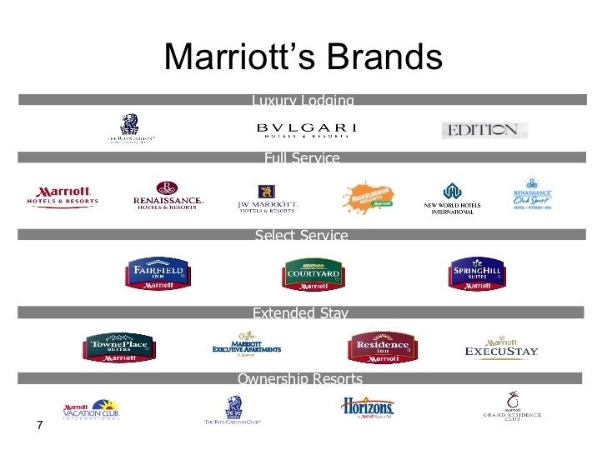
Marriott.com2019

As established the consumer preference is being taken most seriously by hoteliers and the leisure industries. The latest innovations and Height of comfort and familiarity is offered so guests can have the best possible experience. The following services have been implemented a Marriott hotel.
- Traditional guest welcome face to face contact direct customer service
- Using and accessing customers data from all channels thus enabling the Marriott group to constantly update Makro and micro systems
- Track and update personal consumer data via software
- The use of automated software systems to manage and administer marketing promos direct and daily to the consumer, Bonvoy Marriott’s rewards program.
- Geolocation- the use of voice activated device usage.
- Implementing real time 24x7 marketing the ability to offer service at any time, constant use of Marketing through the web, social media and search engines.

Quality Management systems and investment into ongoing development in guest services at the Marriott are taken very seriously here is an example of questionnaires and staff survey of indivual guests to produce this ongoing development for the establishment and contiuious guest development of likes, prefrences and tastes. All guest are asked or emailed regarding their stay and facilities at the establishment.
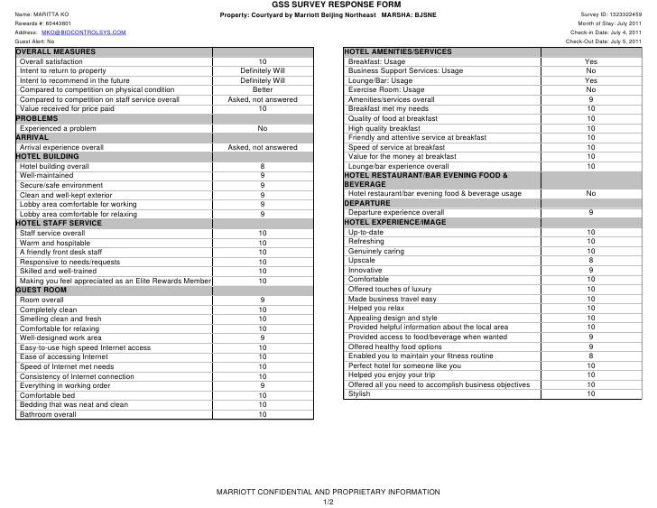

I have chosen to outline the facilities and ongoing customer service offered at the Marriott Forest of Arden, geographically it is set on the outskirts of Birmingham in Meriden neighbouring Coventry, It is has excellent transport links, it is 3 miles from Birmingham airport and is situated of the A45 and M42. The cross which stands in the Meriden square marks the centre of England. The hotel is situated on Packenham estate which is over 500years old.
The Hotel was developed in the early 80’s and in 1986 the land and planning for a golf course and hotel was sold. The Forest of Arden was built and opened on the 1st of September 1989 it was the eighth hotel in the country club hotels part of the Whitbread group, the development cost 13.5 million pounds.
The second eighteen-hole golf course was opened due to the popularity of the hotel and services provided in 1991, designed by acclaimed designer Donald steel. In 1992 the original course was given a 1million pound redevelopment standardising to the PGA standards for use on championship courses.
The English Opens have been hosted at Arden several times and is well established on a International platform boasting to be one off the best courses in the world offering a outstanding guest experience.
In 1986 the hotel won an award for business enterprise Award for increased sales and profits and following Whitbread’s acquisition of the franchise rights to the Marriott name in retain the hotel was rebranded Marriott Forest of Arden. An extension to the hotel was made between 1992 and 1996 at a cost of 5 million pounds, adding a new Arden suite attributing to larger conferencing facilities, adding an additional 60 bedrooms bringing the total to 214 bedrooms.
The Hotel celebrates its 30th anniversary this year, the hotels revenues were recorded at 3million pounds in its first year this has constantly grown since and according to staff at the Arden is in the 15 million pound a year mark as of last year.
The Marriott forest of Arden provides a wide range of facilities as follows:
- Golf course (award winning)
- 30 single rooms 200 plus double witch can be made in to suites adjoining rooms.
- Swimming pool
- Sauna/steam room
- Three gyms/classes evadable
- Spa/beauty parlour/salon
- Function/conferencing suites to accommodates 30 people to 800
- Coffee shop/ restaurant zest
- Restaurant/bar cast irons
The hotel is recognised as an investor in people and won this award in 1996 and since retained for the highest possible level of service and development to all their associates. They employ over 250 dedicated employees and is in the daily mail 100 best companies to work for as well as securing a reputation as one of the top hotels and leisure venues in England.
Guest Service management at the Forest of Arden is based on the blueprint, which is developed at Head office, the outline is dedicated to future development of guest experiences and to be constantly upgrading a guest experience. I was told by employees at Forest of Arden ongoing guest focus and interaction to constantly collate information is prevalent as I outlined earlier, this approach is standardised across all hotels ensuring the smooth and efficient delivery of information’s is essential
To conclude this evaluation, I feel the Marriott group have there finger on the pulse, and are invested in ongoing development of their associates as well as their guests relations. They prove to be investors in the evolution of progress, allowing the brand to merge and grow steadily growing a brand that will be able to withstand economical, political and social diversity’s or dicline that may occur. Strength is in unity and increasingly adverse sectors are teaming up to secure a consumer experience. Consumer awareness is at its Hight, a constantly exceeding consumer expectation is constantly demand, the ongoing development of technology, associates and consumer experience is set to increase and so will the standards and service offered by the Marriott.

References

https://skift.com/2016/02/03/marriott-executives-explain-the-brands-internal-strategy-shift-at-mit/ (accessed on 29/03/19)

marriotthttp://news.marriott.com/2019/03/racing-fans-finish-first-as-marriott-international-extends-marketing-partnership-with-mercedes-amg-petronas-motorsport/(acsessed on 27/03/2019)
https://www.infor.com/content/executive-briefs/state-of-customer-experience-in-hospitality.pdf/ (acsessed 01/04/2019)
https://cdn5.loyaltylobby.com/wp-content/uploads/2016/04/700x687xMarriott-1-700x687.png.pagespeed.ic.DRdaUviP8C.png (accessed 29/03/19) “2017 travel and hospitality industry outlook,” Deloitte Development LLC, 2017.
https://www2.deloitte.com/content/dam/Deloitte/us/Documents/consumer-business/us-cb-2017-
Top Trends for Customer Service in 2017: Operations Become Smarter and More Strategic,” Forrester Research, Inc. January 31, 2017
https://go.forrester.com/blogs/17/03/19
Lisa Terry, “6 Mega-Trends in Hotel Technology,” Hospitality Technology, April 11, 2016. Link: The Good. The Bad. The Opportunity,” Forrester Consulting, June 2016.
Hadwick, “Understanding the travel consumers’ path to purchase,” Eyefortravel.com. 2017. Travel & Hotel Booking Statistics,” StatisticBrain, May18, 2017. (accessed 21/03/19)
http://www.statisticbrain.com/internet-travel-hotel-booking-statistics/ 11 Giselle Abramovich, “15 Mind-Blowing Stats About Digital Trends in Travel and Hospitality,” CMO.com, June 2, 2017. (accessed 20/03/19)
Hotels is Only Getting Sharper,” BloombergMarkets. November 14, 2016. (19/03/19).
Room Experience For Guests,” geomarketing.com. October 2, 2017. (21/03/19)
http://www.geomarketing.com/how-marriott-plans-to-use-amazon-alexa-to-improve-the-in-room-experience-for-guests?(21/03/19)

