MANAGING PROJECTS IN THE ORGANISATION
MODULE CODE: BMSW5009_SWAN
STUDENT NAME: DRE STEELE
STUDENT NUMBER:2332005
LECTURER: GIULIA CHIFARI



TABLE OF CONTENTS
EXECUTIVE SUMMARY 3
INTRODUCTION 4
FINDINGS & PROJECT MANAGEMENT TOOLS 5
PROJECT MANAGEMENT TOOLS & TECHNIQUES 8
PROJECT LIFECYCLE AND APPLICATION OF TOOLS 9
PROJECT MANAGEMENT TOOLS USED THROUGHOUT THE PROJECT 10
COMMUNICATION AND STAKEHOLDERS 11
CONCLUSION 12
FUTURE IMPROVEMENTS 14
REFERENCE LIST 15
APPENDIX SCREENSHOTS 19

EXECUTIVE SUMMARY

This report carefully assesses the planning, management, execution, and evaluation of the St Thomas Church Food Donation Project undertaken by a student project team. The project aimed to support St Thomas Church by collecting food and monetary donations from local stakeholders, including Tesco, Amazon colleagues, and community donors. The project followed the full project lifecycle, including initiation, planning, execution, monitoring and control, closure, and evaluation.
The report analyses the project management tools and techniques used throughout the project, including Belbin Team Roles, SMART objectives, stakeholder analysis, the Power Interest Grid, Work Breakdown Structure (WBS), Gantt charts, Agile principles, and risk management practices. The effectiveness and limitations of these tools are critically assessed against relevant project management literature.
Findings confirm that while the selected tools provided structure and improved coordination, project success depended largely on effective communication, stakeholder engagement, adaptability, and teamwork. For example, the team secured a large quantity of non-perishable food items and raised monetary donations from Amazon colleagues and community donors. Additionally, Tesco provided a 10 percent employee discount to support the project. Stakeholder reactions from St Thomas Church were positive, with their coordinator expressing appreciation for both the timing and the quality of the donations collected. Several challenges surfaced, including stakeholder withdrawal after Amazon limited its involvement following initial discussions, periodic communication delays with external contacts, and uncertainty about the total value and timing of donations until late in the project. Despite these issues, the project was completed on time, and all donations were delivered to St Thomas Church as planned.
The report concludes that project management tools are valuable enablers of project success however, their effectiveness depends upon the team's ability to apply them flexibly and respond to changing circumstances. Recommendations are provided to improve future project delivery by strengthening communication planning, risk management, stakeholder engagement, and leadership development.

INTRODUCTION

Project management is a structured process through which organisations and teams plan, organise, and control resources to achieve specific objectives within defined constraints of time, cost, scope, and quality (Heagney, 2016; Heerkens, 2015). Traditional project management literature has long associated project success with achieving targets relating to time, cost, and quality, often referred to as the ‘Iron Triangle’, although more recent studies have argued that broader stakeholder and value-based outcomes should also be considered (Atkinson, 1999; Clegg, Skyttermoen and Vaagaasar, 2020).
The purpose of this project was to support St Thomas Church by collecting non-perishable food items and monetary donations to assist local community members experiencing hardship. Initially, the team considered alternative community projects, including a litter-picking campaign. Following a feasibility assessment and stakeholder consultation, the team selected the food donation project for its greater likelihood of impact and stronger stakeholder support.
The objectives of the project were to:
- Collect suitable food donations for St Thomas Church.
- Raise monetary contributions from Amazon colleagues.
- Engage key stakeholders effectively.
- Deliver donations within the allocated timeframe.
- Apply project management tools and techniques across the project lifecycle.
- Evaluate project outcomes and identify lessons for future projects.
This report thoroughly assesses the project throughout its lifecycle and reflects on the effectiveness of the project management tools and techniques used. To understand how the project was delivered, the following section evaluates the key project management tools and techniques applied throughout the project lifecycle.

FINDINGS & PROJECT MANAGEMENT TOOLS

BELBINS TEAM ROLES
The project initiated with team formation and role allocation. To support this process, the team used Belbin's Team Role Theory to identify individual strengths and preferred working styles (Belbin, 2010).
According to Belbin (2010), balanced teams require a combination of complementary behavioural roles. My assessment identified me as a Team Worker, a role associated with collaboration, communication, and relationship-building. This role fits closely with my responsibilities for stakeholder communication and managing the project's Facebook campaign.
The primary benefit of Belbin's framework was its ability to establish role clarity during project initiation. Early role allocation reduced ambiguity and helped ensure responsibilities were distributed appropriately. Research suggests that clarity regarding individual responsibilities can improve team integration and effectiveness (Kozlowski and Ilgen, 2006).
While Belbin (2010) suggests that balanced teams improve performance through the combination of complementary behavioural roles, Aritzeta, Swailes and Senior (2007) question the model's validity, arguing that team effectiveness may depend more heavily on interpersonal relationships and contextual factors than prescribed behavioural roles.
However, the project revealed limitations within the model. Team members occasionally worked beyond their designated roles as requirements evolved. Any overlap in responsibilities was resolved through team discussions and task redistribution, helping minimise conflict and maintain progress.

SMART OBJECTIVES

The team utilised SMART objectives to assess project feasibility and to select between the litter-picking project and the food donation initiative. SMART goals improve project clarity by ensuring objectives are specific, measurable, achievable, relevant, and time-bound (Doran, 1981).
The framework helped the team identify realistic project outcomes and ensure objectives aligned with available resources and timescales. This supported knowledgeable decision-making during project initiation and planning.
Although our project achieved positive outcomes such as community engagement and social impact, these were difficult to measure using SMART criteria alone. This reflects a common limitation of SMART objectives, which often emphasise measurable outputs over wider social outcomes (Hollister, 2017). To address this, future projects could incorporate complementary evaluation methods, including stakeholder interviews, focus groups, or beneficiary feedback, to capture broader impacts and richer perspectives. Combining quantitative and qualitative approaches would strengthen critical awareness of evaluation challenges and provide a more comprehensive understanding of project success.

WORK BREAKDOWN STRUCTURE (WBS)

The Work Breakdown Structure was used during planning to divide the project into manageable work packages. Tasks were organised into phases, including initiation, stakeholder engagement, food collection, purchasing, delivery, and closure.
The WBS improved project visibility by clarifying deliverables and supporting task allocation. Research shows the WBS as one of the most effective planning tools for reducing complexity and improving scope definition (Kidston, Haward and APM, 2015; Lock, 2020).
However, while the WBS provided structural clarity, it required regular updating as project conditions changed. New stakeholder requirements and unforeseen activities could not always be anticipated during planning, highlighting the limits of traditional planning tools in dynamic environments. While the WBS established what work needed to be completed, the Gantt chart was subsequently used to determine when these activities should take place and how they would be monitored.

GANTT CHART
The team also developed a Gantt chart to schedule and monitor project activities. Gantt charts remain one of the most widely used project scheduling tools due to their ability to visually present project timelines and task dependencies (Wilson, 2003).
Within this project, the Gantt chart improved accountability by assigning responsibilities and tracking milestone completion. It also supported monitoring and control activities by enabling regular comparisons between planned and actual progress.
Although these advantages exist, Gantt charts can be difficult to maintain when projects undergo significant changes (Verzuh, 2021). While the limited scope of this project reduced such challenges, more complex projects would likely require additional scheduling and monitoring methods.

PROJECT MANAGEMENT TOOLS & TECHNIQUES

Project management literature frequently emphasises the importance of planning and control tools for successful project delivery (Burke, 2017; Meredith and Mantel, 2009). However, contemporary scholars increasingly argue that project success depends upon both technical competence and interpersonal capabilities (Crawford, 2005).
The St Thomas Church project demonstrated that project management tools provided structure but did not guarantee success. For example, the WBS identified project tasks, while the Gantt chart established deadlines. However, neither tool could independently address stakeholder withdrawal or communication problems.
The project also incorporated Agile principles, although Agile was not formally implemented. Agile methodologies emphasise flexibility, responsiveness, and ongoing adjustment rather than strict adherence to predetermined plans (Highsmith, 2013; Rigby, Sutherland and Takeuchi, 2016). Highsmith (2013) argues that project teams should embrace change and adapt their approach as new information emerges. This proved particularly valuable when stakeholder circumstances changed.
For example, Amazon's withdrawal from direct involvement created uncertainty about project support. Rather than continuing with the original approach, the team adapted and redirected efforts towards stakeholders who demonstrated stronger commitment and engagement. This flexibility is consistent with findings from Serrador and Pinto (2015), who argue that Agile approaches improve project outcomes in dynamic environments.
This experience suggests that project management tools should be viewed as decision-support mechanisms rather than solutions in themselves. Effective project delivery calls for balancing structured planning with adaptability and stakeholder responsiveness.

PROJECT LIFECYCLE AND APPLICATION OF TOOLS

Throughout the project lifecycle, different project management tools were utilised to support specific stages of project delivery. The practical application of these principles can be observed across the different stages of the project lifecycle, as discussed in the next section.
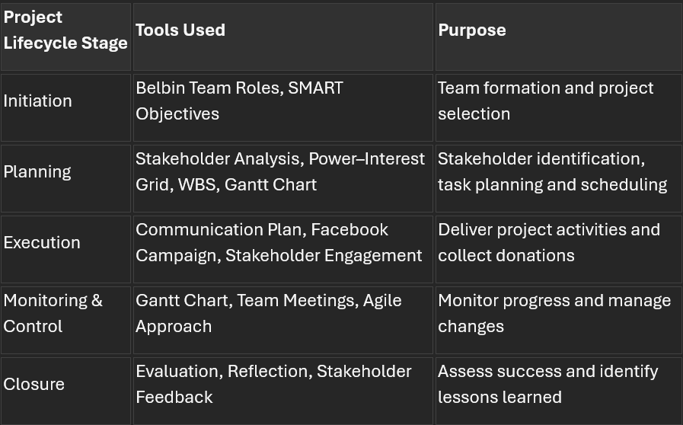

PROJECT MANAGEMENT TOOLS USED THROUGHOUT THE PROJECT

Throughout the project lifecycle, tools were selected and applied appropriately to support the project's objectives.
During initiation, Belbin Team Roles facilitated team formation and role allocation. The team also used SMART objectives and feasibility assessments to compare project options before selecting the food donation initiative.
During planning, stakeholder analysis became increasingly important. Stakeholder engagement is widely recognised as an important determinant of project success because stakeholders influence resources, decision-making, and project outcomes (Freeman, 2010; Olander and Landin, 2005).
To support decision-making, the team developed a Power–Interest Grid to assess stakeholder influence and commitment levels. Stakeholder mapping enables project teams to prioritise communication efforts and tailor participation strategies according to stakeholder needs and influence (Eskerod and Jepsen, 2013; Bourne, 2016). The analysis identified St Thomas Church and Tesco as high-power, high-interest stakeholders requiring close collaboration throughout the project. Following Amazon's withdrawal, it was categorised as a high-power, low-interest stakeholder because it retained potential influence but demonstrated limited engagement. Community donors and project team members were classified as low-power, high-interest stakeholders, whereas the local mindfulness practitioner was classified as low-power, low-interest due to limited involvement. This analysis provided helpful insights that supported the team's decision to prioritise the food donation project, which offered greater stakeholder commitment, reduced uncertainty, and increased feasibility within the project timescale (Yang et al., 2011; Aaltonen, 2011).
The WBS and Gantt chart were subsequently used to organise activities and monitor progress. Together, these tools improved project coordination and helped ensure delivery deadlines were achieved. Although some updates were required during implementation, both tools contributed positively to project control and visibility.

COMMUNICATION AND STAKEHOLDERS

Communication emerged as one of the most important factors influencing project success. Effective communication is consistently identified as a critical success factor within project management literature because it facilitates coordination, stakeholder engagement, and decision-making (Pinto and Slevin, 1987; Heagney, 2016).
Internal communication occurred primarily through regular discussions and digital messaging platforms. These channels enabled team members to share updates, coordinate activities, and address emerging issues.
External communication included interactions with St Thomas Church, Tesco representatives, Amazon colleagues, donors, and community supporters. Facebook promotions and printed flyers were used to increase public awareness and encourage donations.
Several communication challenges developed during the project. Attempts to engage a local mindfulness practitioner were unsuccessful, despite multiple attempts to communicate. Furthermore, delays in stakeholder responses occasionally affected planning activities. These experiences highlighted the importance of diverse communication strategies and contingency planning.
Regardless of these challenges, stakeholder engagement generally remained positive. Tesco provided support through employee discounts, donors contributed resources, and St Thomas Church maintained ongoing communication regarding requirements and delivery arrangements. Research indicates that stakeholder engagement improves project outcomes by strengthening trust, commitment, and collaboration (Yang et al., 2011; Bourne, 2016).

CONCLUSION

The St Thomas Church Food Donation Project successfully achieved its primary objectives through effective teamwork, stakeholder engagement, and adaptive project management. Food and monetary donations were collected, additional resources were purchased, and all donations were delivered to St Thomas Church within the agreed timeframe.
The project demonstrated the value of project management tools such as Belbin Team Roles, SMART objectives, stakeholder analysis, the Power–Interest Grid, WBS, and Gantt charts. These tools provided structure and supported planning, communication, monitoring, and control.
Findings suggest that project success depended not only on the use of project management tools but also on effective interpersonal and stakeholder management practices. The project successfully progressed through all stages of the project lifecycle, initiation, planning, execution, monitoring and control, and closure, with project management tools providing support at each stage of delivery. Alongside evaluating the overall project outcome, it is important to consider individual learning and professional development gained from participation in the project.

REFLECTION

Using Rolfe et al.’s (2001) reflective model, I evaluated my contribution to the project by considering what happened, its significance, and how I can improve in future projects.
What? My role included supporting stakeholder communication and managing the Facebook campaign. As a Team Worker, I contributed to collaboration, communication, and team integration throughout the project (Belbin, 2010).
So What? A key benefit of my contribution was maintaining positive relationships and supporting effective teamwork, which helped the project run smoothly. However, I sometimes relied on others to lead discussions and make decisions in uncertain situations, revealing a lack of confidence in taking initiative despite having valuable ideas. To improve, I plan to seek feedback after meetings, volunteer to lead smaller tasks or agenda items, and set personal goals to contribute verbally to every discussion. I will also pursue workshops or training on leadership and communication. Research shows that shared leadership and psychologically safe environments encourage more active participation and enhance team performance (Edmondson, 1999; Nicolaides et al., 2014).
Now What? In future projects, I intend to develop greater confidence in decision-making and take a more proactive leadership role when challenges occur. By building on my strengths in communication and teamwork while improving my leadership skills, I can become a more effective contributor to project success (Turner and Müller, 2005). This demonstrates the key benefit of Rolfe et al.'s (2001) model, as it transforms experience into practical learning and future action.

FUTURE IMPROVEMENTS

Firstly, a formal communication plan should be developed at project initiation. This would establish communication channels, stakeholder responsibilities, and reporting procedures, reducing uncertainty and improving stakeholder engagement.
Secondly, a risk register should be implemented earlier in the project lifecycle. Effective risk management is strongly associated with improved project performance (Hillson and Murray-Webster, 2007; Carvalho and Rabechini Junior, 2015). Earlier identification of stakeholder withdrawal, communication delays, and donation uncertainty would have enabled stronger contingency planning. Hillson and Murray-Webster (2007) argue that proactive identification and management of risk improve decision-making and organisational preparedness when project conditions change.
Thirdly, the success criteria should be made more measurable. While the project achieved its objectives, clearer quantitative indicators would improve evaluation and provide stronger evidence of project impact.
Fourthly, project documentation should be maintained more formally. Recording decisions, stakeholder interactions, and project changes would improve accountability and support future learning.
From a personal perspective, continued leadership development will help strengthen my future project contributions and professional competence (Kolb, 2015; Megginson and Whitaker, 2017)
The project demonstrated that the successful application of project management tools depends not only on technical knowledge but also on communication, adaptability, and stakeholder engagement. These lessons will provide a valuable foundation for future academic and professional projects.

REFERENCE LIST

Aaltonen, K. (2011) ‘Project stakeholder analysis as an environmental interpretation process’, International Journal of Project Management, 29(2), pp. 165–183. Available at: https://doi.org/10.1016/j.ijproman.2010.02.001.
Aritzeta, A., Swailes, S. and Senior, B. (2007) ‘Belbin’s Team Role Model: Development, validity and applications’, Journal of Management Studies, 44(1), pp. 96–118. Available at: https://doi.org/10.1111/j.1467-6486.2007.00666.x.
Atkinson, R. (1999) ‘Project management: cost, time and quality, two best guesses and a phenomenon, it’s time to accept other success criteria’, International Journal of Project Management, 17(6), pp. 337–342. Available at: https://doi.org/10.1016/S0263-7863(98)00069-6.
Belbin, R.M. (2010) Team Roles at Work. Oxford: Butterworth-Heinemann.
Bourne, L. (2016). Stakeholder Relationship Management. London: Routledge.
Burke, R. (2017). Project Management: Planning and Control Techniques. 6th edn. Chichester: Wiley.
Carvalho, M.M. and Rabechini Junior, R. (2015) ‘Impact of risk management on project performance: the importance of soft skills’, International Journal of Production Research, 53(2), pp. 321–340. Available at: https://doi.org/10.1080/00207543.2014.919423
Clegg, S.R., Skyttermoen, T. and Vaagaasar, A.L. (2020) Project Management: A Value Creation Approach. London: Sage.
Crawford, L. (2005) ‘Senior management perceptions of project management competence’, International Journal of Project Management, 23(1), pp. 7–16. Available at: https://doi.org/10.1016/j.ijproman.2004.06.005
Doran, G.T. (1981) ‘There’s a S.M.A.R.T. way to write management’s goals and objectives’, Management Review, 70(11), pp. 35–36.
Edmondson, A. (1999) ‘Psychological safety and learning behaviour in work teams’, Administrative Science Quarterly, 44(2), pp. 350–383. Available at: https://doi.org/10.2307/2666999
Eskerod, P. and Jepsen, A.L. (2013) Project Stakeholder Management. Farnham: Gower.
Freeman, R.E. (2010). Strategic Management: A Stakeholder Approach. Cambridge: Cambridge University Press.
Heagney, J. (2016). Fundamentals of Project Management. 5th edn. New York: AMACOM.
Heerkens, G. (2015). Project Management. 2nd edn. New York: McGraw-Hill Education.
Highsmith, J. (2013). Adaptive Leadership in Agile Projects. Boston, MA: Addison-Wesley.
Hillson, D. and Murray-Webster, R. (2007). Understanding and Managing Risk Attitude. Aldershot: Gower.
Hollister, S. (2017). Project Management: A Quick Start Beginner’s Guide for the Serious Project Manager. Scotts Valley, CA: CreateSpace Independent Publishing Platform.
Hülsheger, U.R., Anderson, N. and Salgado, J.F. (2009) ‘Team-level predictors of innovation at work: a comprehensive meta-analysis spanning three decades of research’, Journal of Applied Psychology, 94(5), pp. 1128–1145. Available at: https://doi.org/10.1037/a0015978.
Kidston, P., Haward, K. and Association for Project Management (APM) (2015) Planning, Scheduling, Monitoring and Control. Buckinghamshire: Association for Project Management.
Kolb, D.A. (2015). Experiential Learning: Experience as the Source of Learning and Development. 2nd edn. Upper Saddle River, NJ: Pearson Education.
Kozlowski, S.W.J. and Ilgen, D.R. (2006) ‘Enhancing the effectiveness of work groups and teams’, Psychological Science in the Public Interest, 7(3), pp. 77–124. Available at: https://doi.org/10.1111/j.1529-1006.2006.00030.x.
Lock, D. (2020). Project Management. 11th edn. London: Routledge.
Megginson, D. and Whitaker, V. (2017) Continuing Professional Development. 2nd edn. London: Chartered Institute of Personnel and Development.
Meredith, J.R. and Mantel, S.J. (2009) Project Management: A Managerial Approach. 7th edn. Hoboken, NJ: Wiley.
Nicolaides, V.C., LaPort, K.A., Chen, T.R., Tomassetti, A.J., Weis, E.J., Zaccaro, S.J. and Cortina, J.M. (2014) ‘The shared leadership of teams: a meta-analysis of proximal, distal, and moderating relationships’, The Leadership Quarterly, 25(5), pp. 923–942. Available at: https://doi.org/10.1016/j.leaqua.2014.06.006.
Olander, S. and Landin, A. (2005) ‘Evaluation of stakeholder influence in the implementation of construction projects’, International Journal of Project Management, 23(4), pp. 321–328.
Pinto, J.K. and Slevin, D.P. (1987) ‘Critical factors in successful project implementation’, IEEE Transactions on Engineering Management, EM-34(1), pp. 22–27.
Reiss, G. (2015) Project Management Demystified. London: Routledge.
Rigby, D.K., Sutherland, J. and Takeuchi, H. (2016) ‘Embracing Agile’, Harvard Business Review, 94(5), pp. 40–50.
Rolfe, G., Freshwater, D. and Jasper, M. (2001) Critical Reflection for Nursing and the Helping Professions. Basingstoke: Palgrave Macmillan.
Senior, B. and Swailes, S. (2016). Organisational Behaviour. 5th edn. Harlow: Pearson.
Serrador, P. and Pinto, J.K. (2015) ‘Does Agile work? A quantitative analysis of Agile project success, International Journal of Project Management, 33(5), pp. 1040–1051.
Turner, J.R. and Müller, R. (2005) ‘The project manager’s leadership style as a success factor on projects: a literature review’, Project Management Journal, 36(2), pp. 49–61.
Verzuh, E. (2021). The Fast Forward MBA in Project Management. 6th edn. Hoboken, NJ: Wiley.
Wilson, J.M. (2003) ‘Gantt charts: a centenary appreciation’, European Journal of Operational Research, 149(2), pp. 430–437.
Yang, J., Shen, G.Q., Ho, M., Drew, D.S. and Xue, X. (2011) ‘Stakeholder management in construction: an empirical study to address research gaps in previous studies’, International Journal of Project Management, 29(7), pp. 900–910. Available at: https://doi.org/10.1016/j.ijproman.2010.07.013.

APPENDIX SCREENSHOTS

GANTT CHART
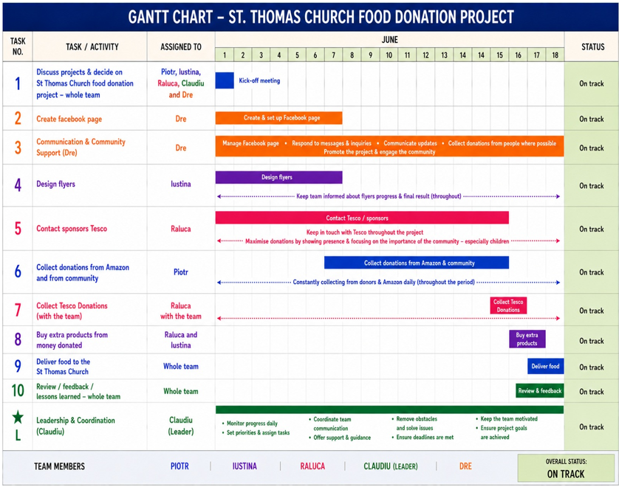

POWER INTEREST GRID


