Computer System Screenshots

Server Log On Details: -
Username: Administrator
Password: Mogsapril28
Creating a virtual network
In this assignment readers will learn how to create a virtual Pc with evidence one being set up properly. The below screenshots represent somebody setting up and installing an operating system correctly onto a computer system.
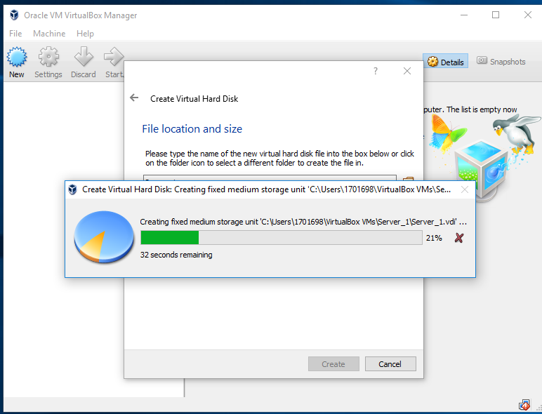
The first thing to do is create the virtual hard disk. This image represents the creation and setting up of a virtual computer using Oracle VM VirtualBox. This image shows the Virtual hard disk being set up and the file location. It is important to keep check on the amount of storage that will be taken up to ensure how much memory will be required. The server has been set to be stored and positioned within the computer’s hard disk.
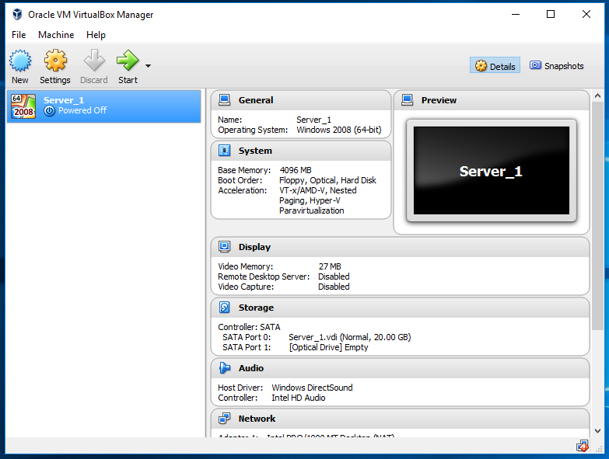

As you can see “Server_1” has created. The creator installed the Windows 2008 (64 bit) operating system. The operating system is required to use a computer. The image also shows the specs.
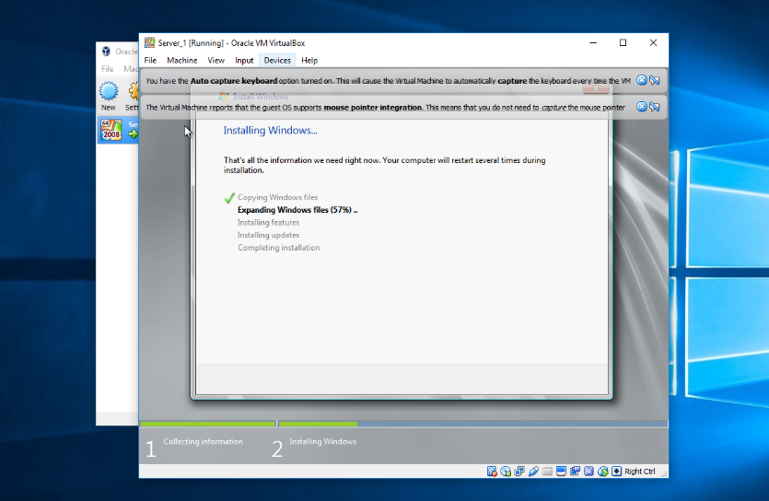
At this point the virtual machine has been given the Windows 2008 operating system to install. This screenshot helps show the someone carrying out the installations so required the computer can run and be used correctly.
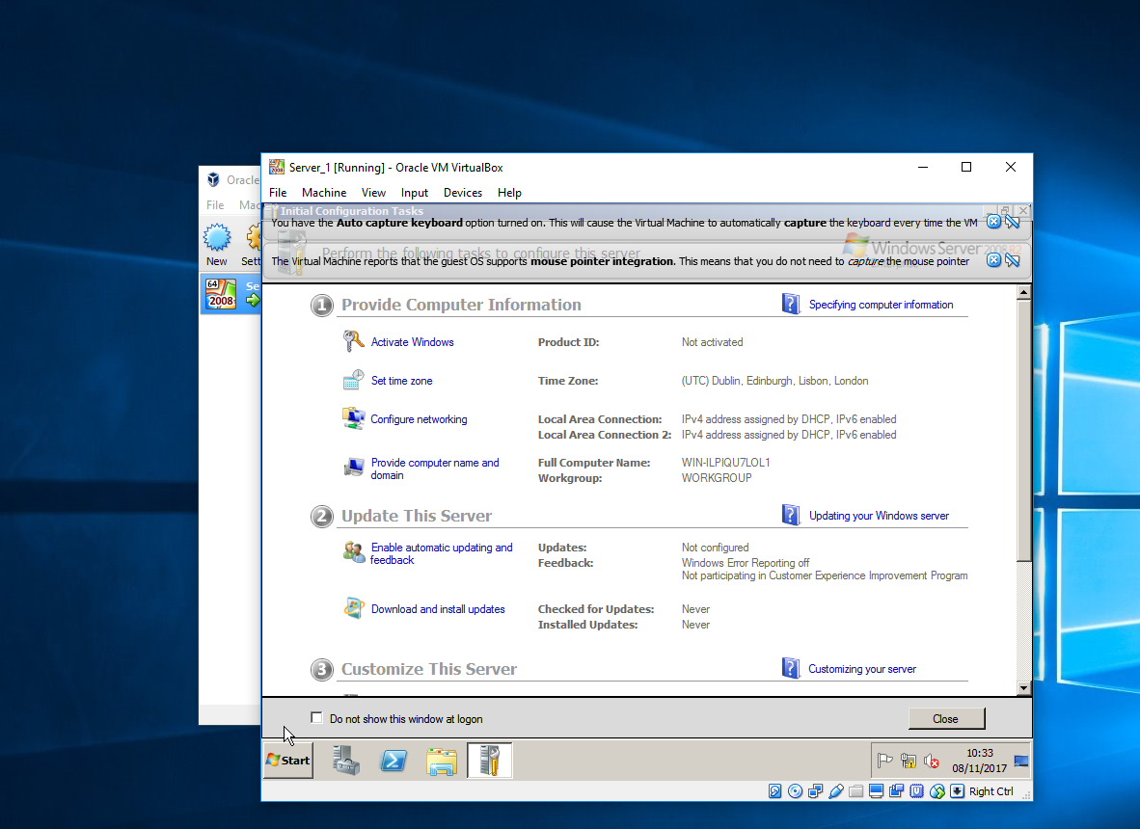
This show the current time zone as this helps proves that windows 2008 server has been installed and set on the starter menu. This will be helpful as you can set up various clients

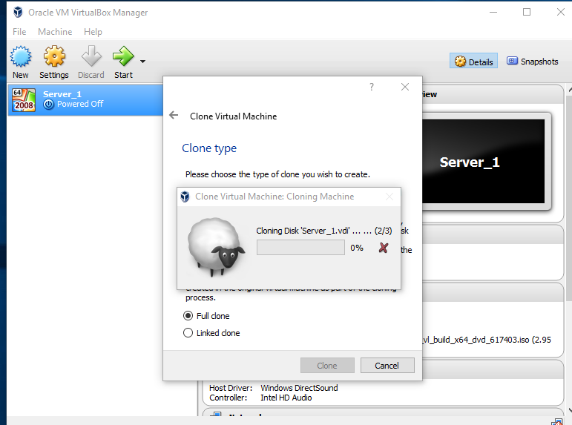
Here the shows the virtual machine being cloned to create a exact copy of the system as this can help save a lot of time but can sometimes also cause information to be incorrect for example if there is a mistake the original then it will be copied over to the copy.
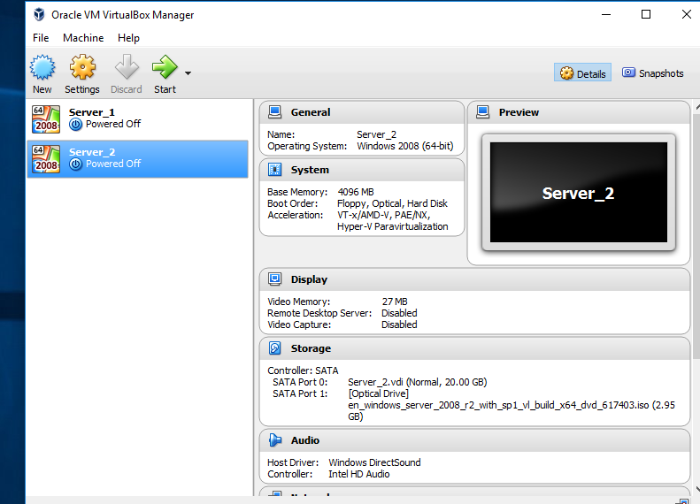
This is “Server_2”. The creator has install a Windows 2008 (64 bit) operating system on this server. The screenshot specs. both servers are showing power off which proves neither are currently activate yet.

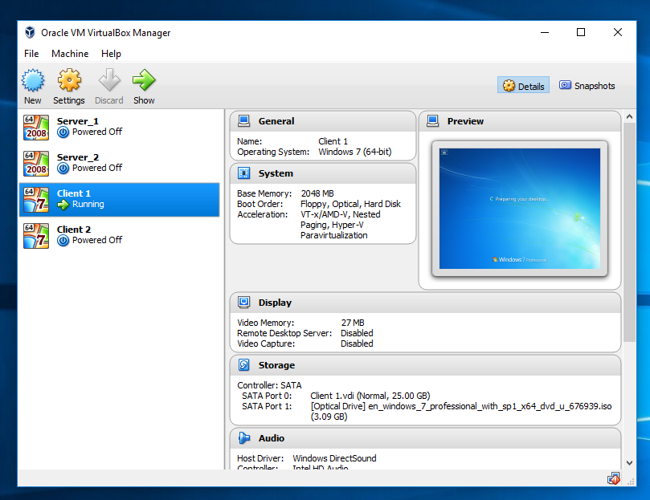
As shown above Client 1 is currently running. This system running and using a windows 7 64 bit operating system. in the left hand corner the screen displays that the system is loading up. The quote is “Preparing your desktop” which tells us the desktop is being finalised so it can run correctly.

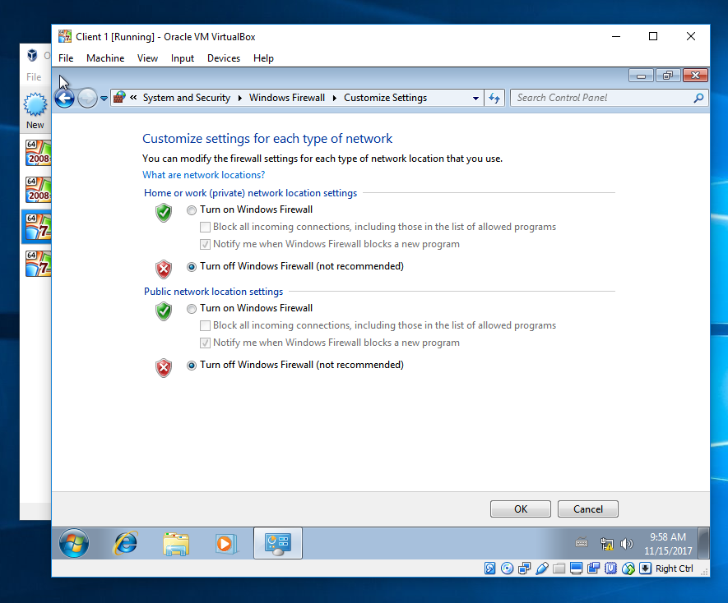
the firewalls have been turned off allowing us ti attempt to connect to the internet. All should be turned off completely because the system will not allow the procedure to take place. This can affect overall performance.

I can see that Client 1 is running without issues. The os that was chosen Windows 7 (64 Bit). system is being prepared.

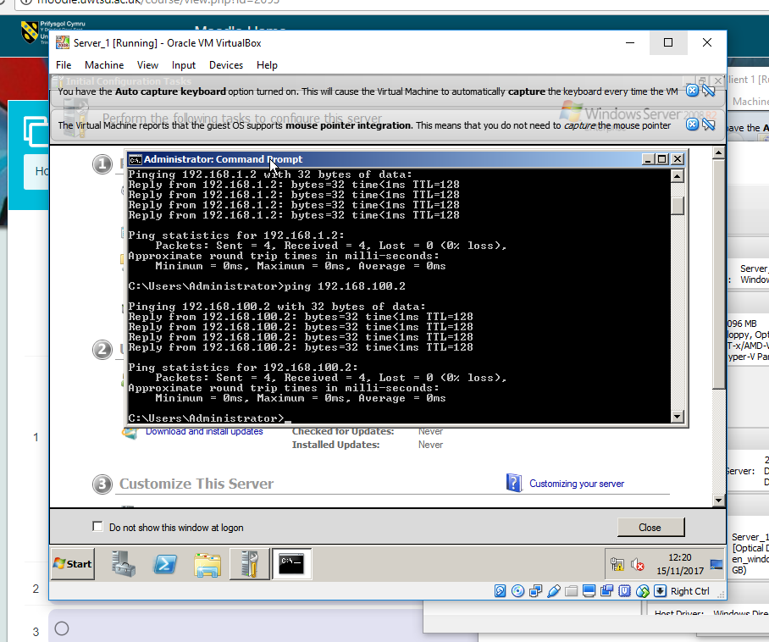
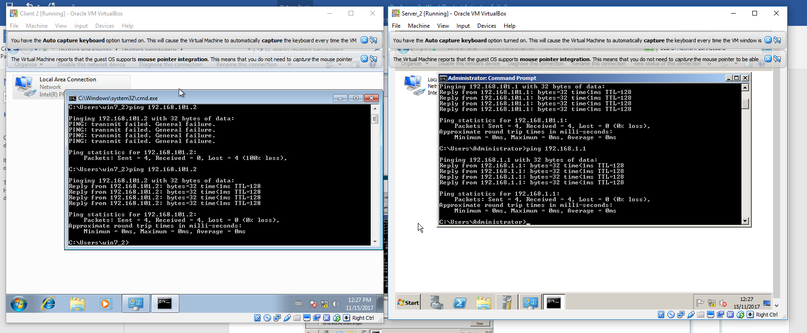
Server 1 is confirming communication to Client 1. This shows that the server and the client have joined together and are communicating. The administrators can ping the servers to check if they are joined.
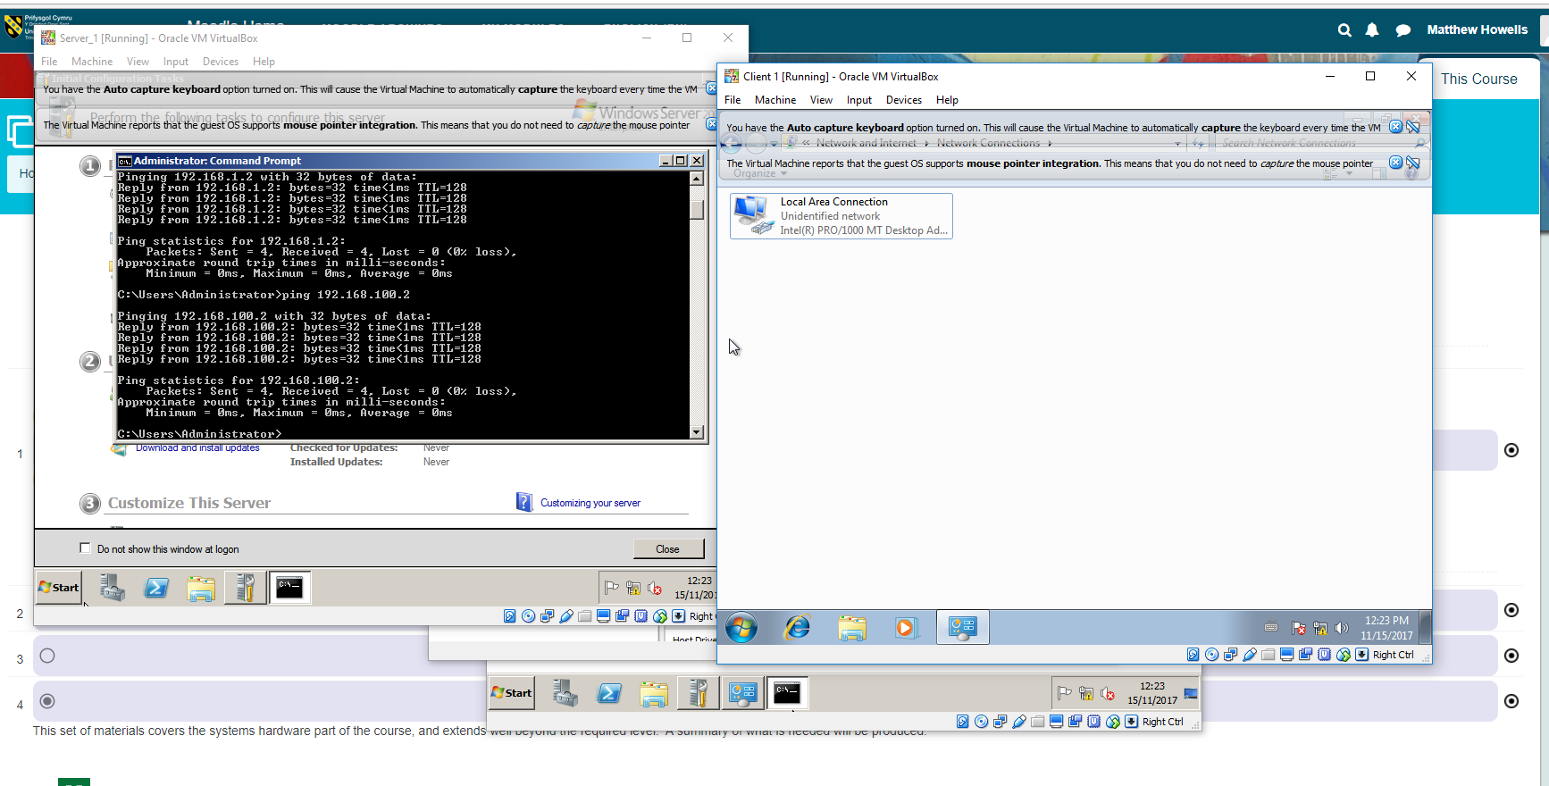
These screenshots show and prove to me that Server 2 and client 2 are communicating. This is done using coding to represent the Communication.

This show Server 1 communicating and these also show the system running successfully. A Local Area Network or LAN has now been established and is active
Configuring virtual networking and using the dcpromo tool to upgrade a member server to a Domain Controller
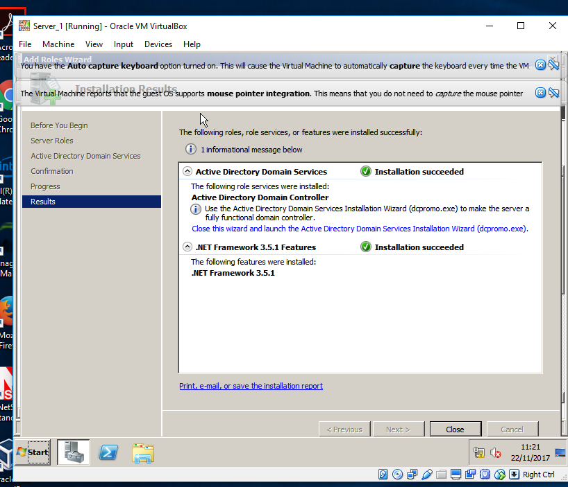

Part 2
Creating an active directory domain
all the required installs has been started and completed.
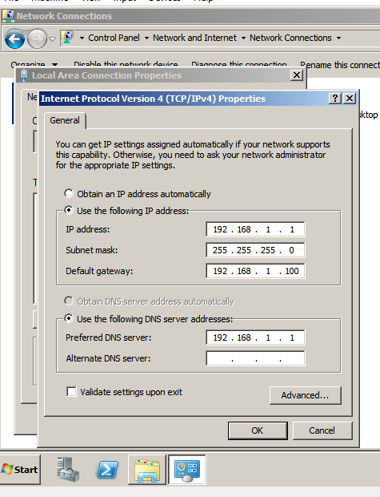

the IP Addresses are set up for the server. Which were manually configured the same as the other servers. This allows a connection to be made

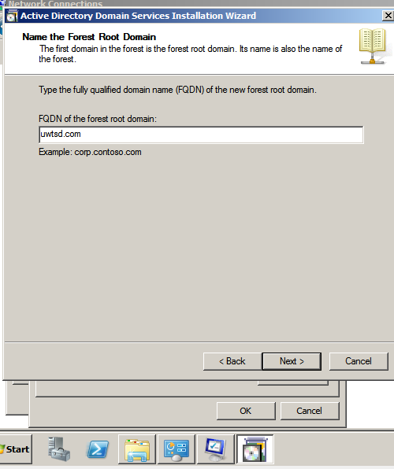

The one of the domains in the forest is the forest root domain. The domain for the forest is called uwtsd.com

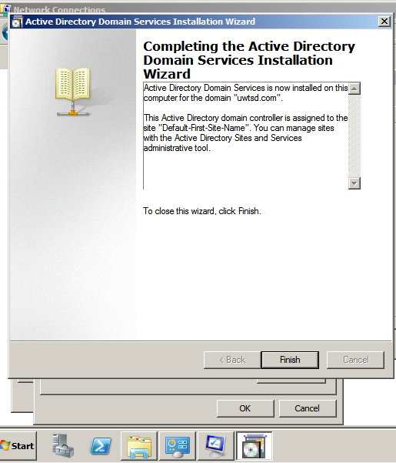
This is evidence to prove that the active directory domain service installed onto the pc.
On the next screen you are asked to specify a folder on the computer that will hold the Active Directory database and the Active Directory log (the database holds all the information; the log holds the usage statistics). A default folder is specified for both the database and the log, so why mess with it? Go with the defaults by clicking Next.

Observational Tasks 1
A). State the benefits of using Type 2 Hypervisor virtualisation software in your design. Comment on the strengths and weaknesses of the Virtual Box platform used in your network
Benefits | Weaknesses
No need to pay for use of virtual box | Corruption during installations
Process of memory is low even with added applications | Understanding the software at first time use
Opportunity to maintain multiple machines | Connecting machines can be difficult to understand if not undertook previously.

B). Explain, with use of diagrams, the significance of the following terms: Active Directory Forests, Trees, Parent and Child Domains
An example of an Active Directory forest. This is significant as the domain controller you won’t be able to link up with anything. the domain is linked up to the domain controller. The domain controller establishes, creates a connection link. The lower level is with the user, computers and a secure server. All these connect to form a diagram.
The domain is known as a tree which is linked to the parent. The parent looks after the bottom three known as child’s.
Tree
Domain
Child
Child
Child
Parent
User
Domain Controller

Controller
Secure Server
Computers

C). Investigate and document the main roles and responsibilities of an Active Directory Domain Controller
The Active directory domain controller provides a point as the computers and servers are able to communicate within a domain. This provides security and authorisation. it provides user information which is stored on the server and runs through the domain.
D). What actions could we take in the event of a Domain Controller becoming unavailable?
An account with Administrative access could assign an alternative domain as a backup in case anything does goes wrong. We could also set up alternative controllers. This could be configured within administrator services by adding a secondary DNS or alternative DMS.

Installing and configuring the DHCP Service



