Student name: Justin Frantisek Bock
ID: 2111822

Unit name: BMSW4003_Digital Skills and Research MethodsAssignment Title: Component 2 Research Meth

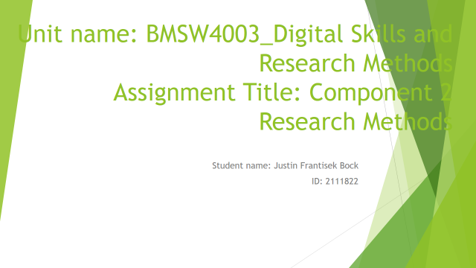


In the academic research, there are different data source need to use to get more depth analysis over the content and concept. CRAAP analysis can be breaking as currency, relevance, authority, accuracy and purpose. On the other hand, DIKW model define the model of a systematic process of data, information, knowledge and wisdom. In the academic research, it is more important to use the solid research strategy as primary and secondary data uses process need to learn in effective way. This paper describe over different academic research related skills. To do the further academic research, it is important to have skill of using secondary and primary data. Also, to reflect with the presentation slides, it is important to understand the structure of the presentation. Death by Power point test is one of the effective video tutorial that helps to underline the structure of the effective presentation and make further use in the academic term. In this paper, different Excel document, PowerPoint documents and word documents blended to settle a unique piece of research for reaching the objectives of the module
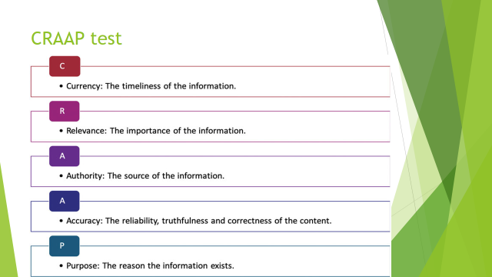
CRAAP test starts with the currency that shows the exact time of information that published or posted. For the secondary data collection, it is important to understand the time of publication. There are many updates and changes that makes on certain issues’ or example, b business condition after Pandemic is not the same so the PESTLE analysis should be different before and during the pandemic time. It is important to understand the time of publication and justify the information that revised or updated in recent time or not. There are different information or practice of business can be outdated as they are starting the new process that need to concern to make effective use of the source (Mike, 2018)
Relevance is the second issue of CRAAP test that shows define the relevance of information to the topic. Differed secondary data can be available but it is important to check the relevancy of these with the research topic. Writer should concern over the audience of the topic and should concern that these data should not be elementary according to the need of paper.
Authority shows the source of information that name of writer and author’s credentials also need to check. URL relates with .eds, .go and .org are more valid and these shows different value like .org means organizational data, .go means the governmental data
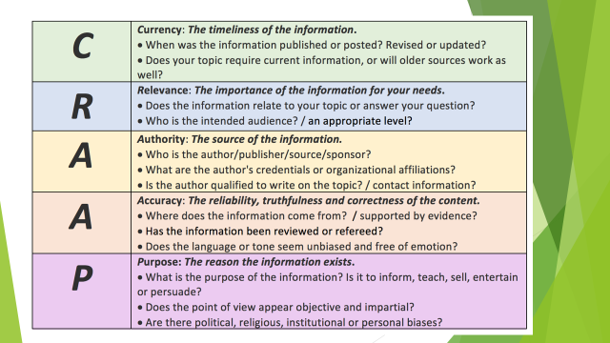
Accuracy is one of the concerning test of CRAAP that shows where does the information comes from that reflects the support of the evidence (Rebecca, 2018). It is important to check the information that supported from the evidence of not. Different statistics data need to check and also validity of these data and the writing should support these data properly. All the information should be reviewed or referred. It is more effective to verify the information by using personal knowledge to check form other website or any data sources. Data should be free from emotion and should show the logical presentation only. There are different grammar, spelling issue need to check while proof of writing helps to check these errors before making final use.
Purpose is the last portion of CRAAP test. It is important to define the purpose of all the information and defiant eh fact of information. Point of view need to clear to each the objectives. There are different issues like cultural, religious, political or any kind of issues cannot be bias to the information that need to check and concern in terms of use these data
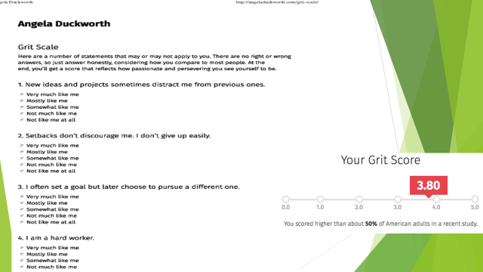
Angela Duckworth is an assistant professor at the University of Pennsylvania that shows the grit test practices. It is an important to reflect with intelligence that will be the best way to measure the treat to deal with different challenges and conditions. She shows the Grit scale where individual can measure the 8 to 12 items question to define own skills and traits. Different questions like, individual need to understand the new project and ideas perception that is the idea of project distract or motivate the individual. This analysis shows setbacks issue that encourage of discourage to the individual. Individual should not give up easily and should ties with the goal. Sometime, it happens that individual sets the goal but later pursue to the different one and there are such reasons behind thetas can be influence form different external environment and situation. Individual need to judge that how much hard worker are they. There are certain time frame does the project is having this grit test shows individual faces difficulties to maintain focus on longer version project. Individual should measure the progress by defining the finishing line of them from eh beginning of the research
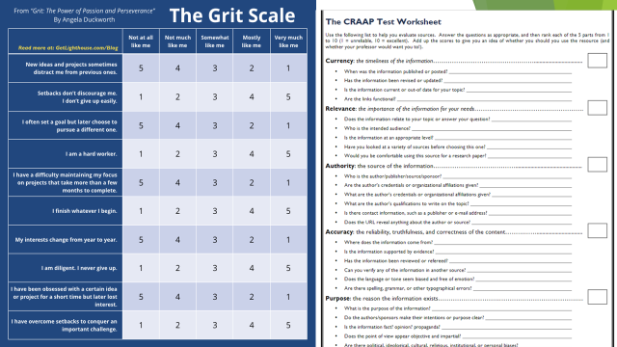
Grit test is more effective rather than CRAAP test. Grit test shows the best strategy to define the own attachment with the research by reflecting different skills and interest. It is more effective than the CRAAP test as CRAAP test gives focus on the secondary data research mostly. Grit test is having combined facility that shows effective attachment with researcher. It shows own traits to do the research as it is more important to use intelligence rather than system only. Intelligence and system nee do combines that will help to reach the objective of work. Due the project and research, it is important for the individual to understand the own intelligence. Grit analysis shows that how much people are diligent, interest over change from year to year. It shows the positive approaches of researcher. It is also shows the motivation of own to face the challenges and make further progress. On the other hand, CRAAP test shows using the secondary research data that helps to make effective growth of the research and make control over these issues while it only concern the secondary research but Grit test makes outperformed CRAAP test with the intelligence that individual need to use in project and research to reach the goal rather than using the strategy or system only (Nugroho, 2019)
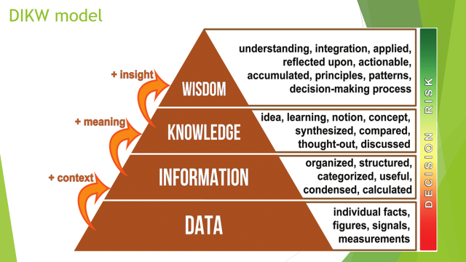
DIKW is one of the effective model for knowledge management and data value extraction. This model define as a pyramid that shows 4 stages that started with data then information, knowledge and finally wisdom (Vandergriff, 2008). It is one of the effective model that discuss over insights and also value different sorts of data. Different data category like, big data, small, smart, fast, slow, unstructured data that need to concern over the research time. It start with the data that shows the observation over the certain topic and collected the data as factors, signal, and symbols over the certain facts. It is the context of the primary stage of research. Information is the structured form than data. Different signal, symbols, facts, figures that researcher reached that need to organize in an information form. It passes to the knowledge as researcher getting knowledge over analysing the knowledge as ideas, cope understand, discussion, comparing the data or the factors to the alternative one that helps to understand the meaning to get through for the next stage of wisdom. It shows the clear understanding and reflecting over the whole knowledge to set decision making
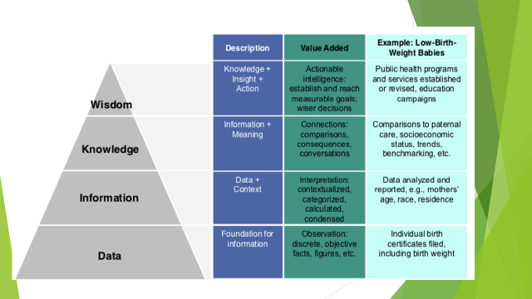
DIWK is one of the effective model that shows different stages as hierarchy model to ensure better growth of the research work. It started with the data that shows formulation of the information. For example, to conduct a research over the study skill, differnet skills like communication, time management, critical thinking, and note-taking are the symbol of study skills data can be defines as the symbol of the study skills. Information is the next stage that shows the importance of these study skills. 4Ds time management skills, Cornell note-taking strategies are the relevant information over these skills that increase knowledge over the concept. It is also important to concern over the information meaning that shows proper connection with the model and strategies and also use the trends and benchmarking too. Knowledge input action defines as the wisdom. Differnet theories nee do analysis and need to make implement of these theories and knowledge with reflection of own ideas. It shows the actionable intelligence of the individual to make effective progress of the research understanding. It shows a complete set of activities and hierarchy that need to maintain in the research to reach the goal of the project (Rowleym 2007)
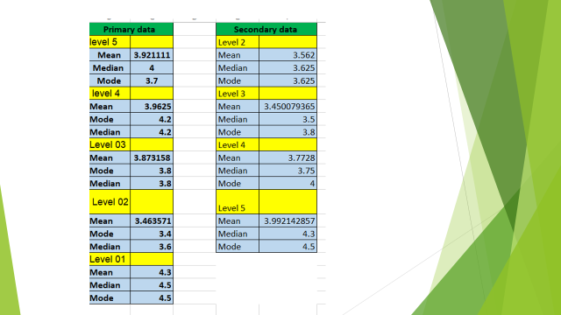

There are certain strategy that use to determine the grit test result, it shows I use the Grit test survey data that provides in the class and it is important to analyse the data. To analyse the large data, I use the median, mode and mean analysis. Mean calculates by adding up the rating number of each students in each level and divide with the number of students participate on the survey. It is same strategy to define the mean for al level data. For median it helps to define the middle number that means all the number need to arrange in smaller to largest form and apply the theory and n+1/2 that helps to define the median number that shows the middle value from the overall data. Mode shows the number of frenzy that shows the similar data used in how many times. By set the ascending order city can be justify the number. While analysis done through MS excel that helps to sought out the large data is few number and result generates by applying theories of MS excel over Mean, median and mode.

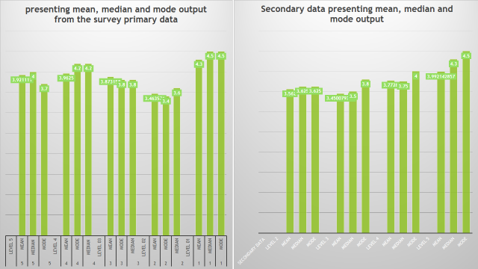
This graph represent the whole data in a visual form. This is a column bar chart that helps to represent the data over the excel file. It shows grit skills of level 2 and level 4 is quite upper position rather than other level. Mean, median and mode in the level 1 for the primary data is in higher ide rather than others while level 2 shows the lowest one that need to concern. On the other hand, the secondary data output shows the level 5 with the higher output. It shows perception and knowledge and also decision margin strategies and abilities are changes due to the change of differnet level of study. Sometime students become brow with running the project and also feeling less motivated to work or read the same issue. On the other hand, some students getting highly motivated as the level 2 in the secondary data research get some higher position rather than primary data survey. Different data collection method are available and it is important to increase understanding over the data collection method and perform efficiently to make effective decision making and reach the higher growth of the career. Grit is also changes according to the primary and secondary data collection process
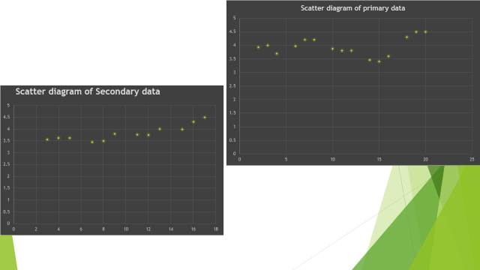
Scatter diagram is one of the effective term that helps to determinate relationship between two variable. In here each level and primary and sectary data output with mean, median and mode data is using as the two variable and try to understand the relationship these two variables. These relation can be discuss between two causes and can be against a cause and an effect (Uddin, 2021). In here, level 5 can treat as a cause and the output of the primary and secondary data can be reveal as the effective. One of the variable is independent and level 5 in the independent and output is dependent as changes of level makes changes of output. It helps to define the non-linear pattern between two variables and also the range of data slow that contains with the minimum and maximum value. It helps to observe all the patterns and potting makes the diagram simple and understanding

References
- Caulfied, M (2018). "A Short History of CRAAP". hapgood.us
- Fahad, U (2021). Scatter diagram. PM study circle
- Nugroho, P (2019). Validity test for short grit scale Duckworth. Journal is educational health and community
- Renirie, R. (2018). "Research Guides: Website Research: CRAAP Test"
- Rowley, J. (2007). The wisdom hierarchy: Representations of the DIKW hierarchy. Journal of Information Science, 33(2), 163–180
- Vandergriff, L. J. (2008). Welcome to the intelligence Age: an examination of intelligence as a complex venture emergent behaviour. VINE: The Journal of Information and Knowledge Management System

