Name: Ash Toner

Student Number: 2514500
__________________________________________________________

WORKSHEET 5 – TESTING (Hunting for Treasure)

For this worksheet, the program can be implemented in a number of different ways and demonstrate different features.
Create your own test set to demonstrate strengths and/or limitations of your solution. Use as many of the template boxes below as you need.

Test: 1D or 2D array input can only have correct values entered.

Screenshot(s) of output:

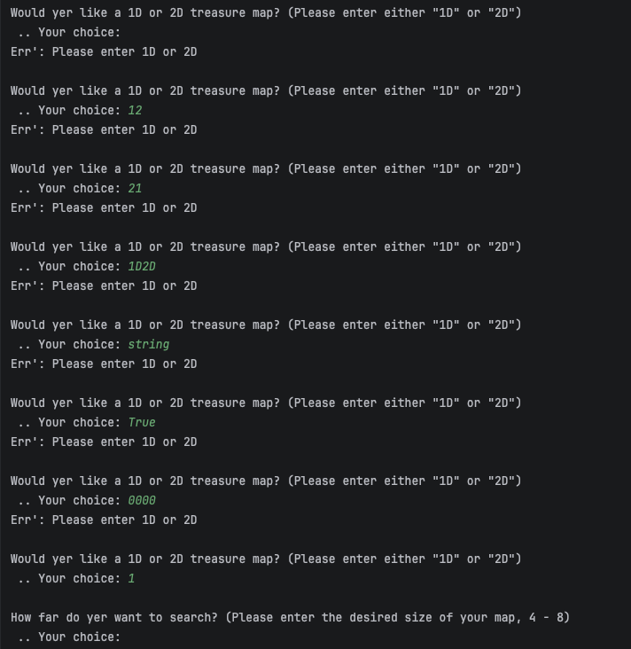

Result: Did the programme behave as expected ie syntactically and logically correct?
YES
Comment: This check only accepts the following:
acceptable_dimensions = '1', '1d', '1D', '2', '2d', '2D'
So null values, strings not in that list and booleans aren’t allowed. The system passed this test.

Test: Size of grid is between minimum and maximum boundaries specified
Screenshot(s) of output:

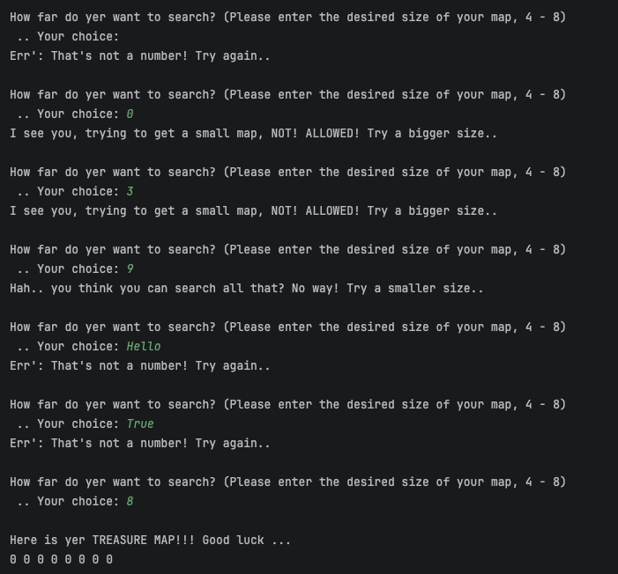

Result: Did the programme behave as expected ie syntactically and logically correct?
YES
Comment: As shown in the screenshot above, the program only accepted integers that were between 4 and 8 inclusive as expected. The program does not accept strings, booleans or null values. The system passes this test.

Test: Grid is generated correctly for user

Screenshot(s) of output:

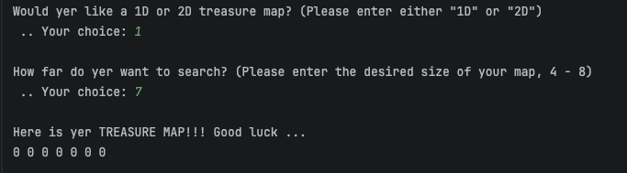

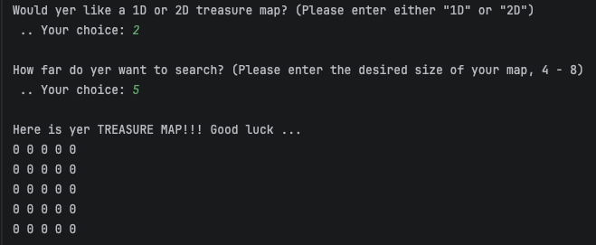

Result: Did the programme behave as expected ie syntactically and logically correct?
YES
Comment: Screenshots include a successful 1D and 2D grid with no markings to indicate where the treasure is. The system correctly generates a readable grid for the user and so passes this test.

Test: Game must have calculated correct number of maximum guesses

Screenshot(s) of output:

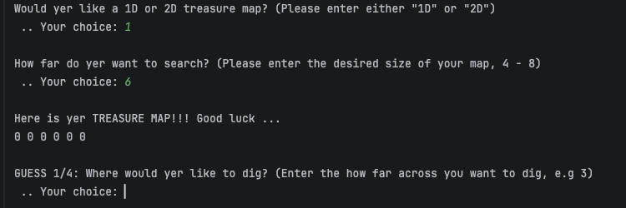

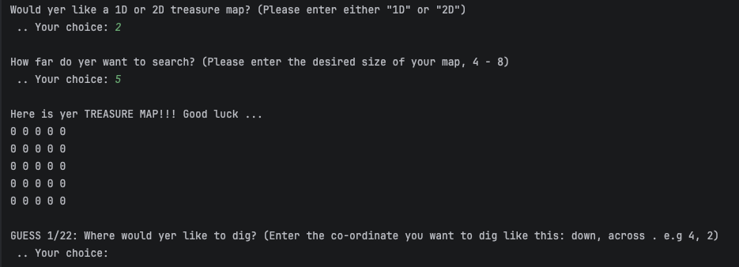

Result: Did the programme behave as expected ie syntactically and logically correct?
YES
Comment: The formula decided for number of guesses are as follows:
1D maps: Length – 2
2D maps: (Length * Length) – 3
Considering both screenshots depict this formular working (1/4 and 1/22), the system passes this test.

Test: Only acceptable array positions/map positions can be entered for dig spots

Screenshot(s) of output:

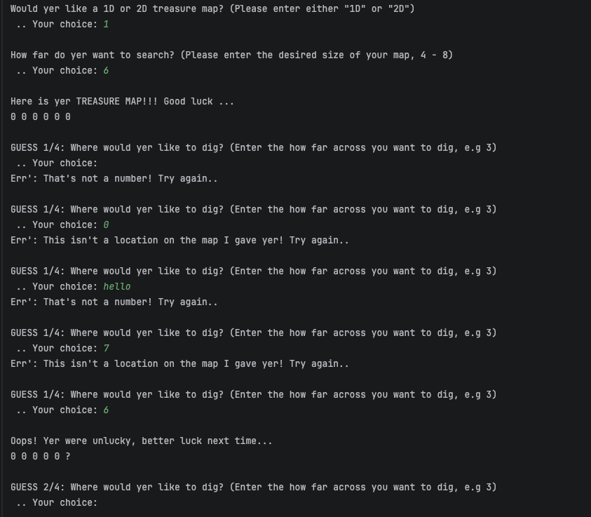

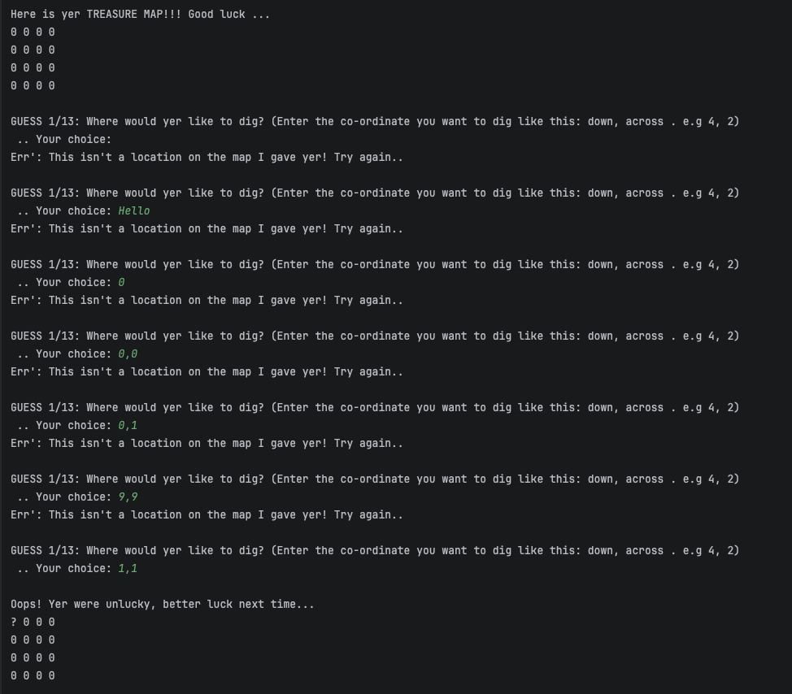

Result: Did the programme behave as expected ie syntactically and logically correct?
YES
Comment: Both 1D and 2D don’t accept null inputs, letters and map locations out of range. 2D woks slightly differently by needing an X and Y co-ordinate separated by a comma (which is explained to the user) but both screenshots prove that the system passes this test.

Test: No two same dig spots can be entered and count as a valid guess

Screenshot(s) of output:

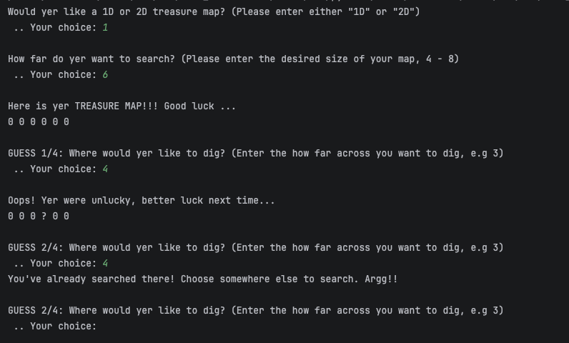

Result: Did the programme behave as expected ie syntactically and logically correct?
YES
Comment: This functionality means that a guess is not able to be counted as a valid guess if that spot on the map has already been guessed. As shown in the screenshot, 4 was not able to be searched a second time and guess number 2 was not used up. The system passes this test.

Test: Game must end - win

Screenshot(s) of output:

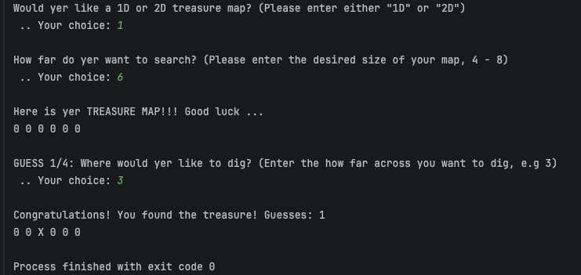

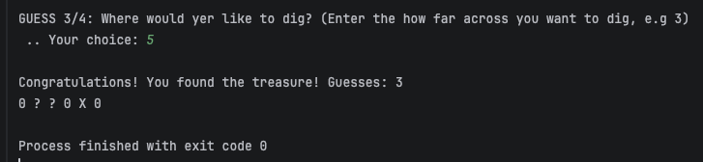

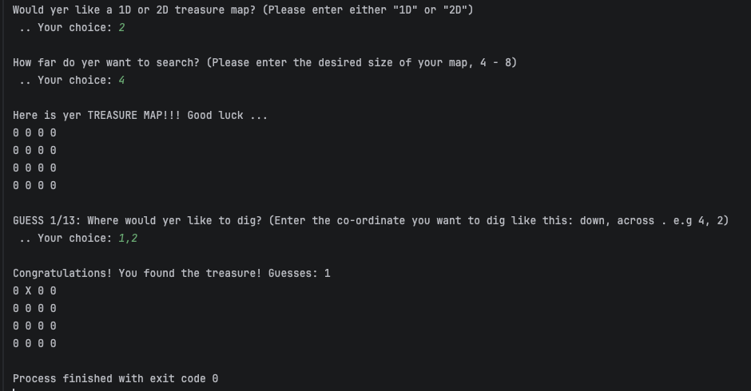

Result: Did the programme behave as expected ie syntactically and logically correct?
YES
Comment: The 3 screenshots above depict 3 winning games, 2 of which won on the first try. As seen above, when the user enters a valid guess that matches the treasure location the game registers this as a win, prints out the user’s map with their guesses on and stops the program. The system passes this test.

Test: Game must end - loss

Screenshot(s) of output:

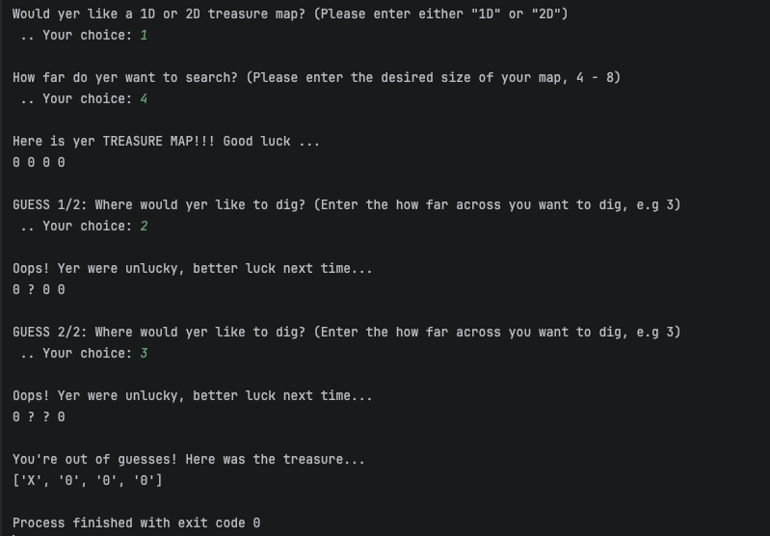

Result: Did the programme behave as expected ie syntactically and logically correct?
YES
Comment: For both 1D and 2D maps, when the guess count reaches its maximum and the treasure is not found, the program will tell the user that they lost and print out the winning map. The system passes this test.

Final code:

import random
import time
class GameParams:
TreasureMap = []
UserMap = []
# -----
OneDArray = False
TwoDArray = False
TreasureFound = False
# -----
CurrentGuessCount = 1
MaxGuessCount = 1 # will change
# -----
MinMapLength = 4
MaxMapLength = 8
CurrentLength = 0 # will change
# -----
TreasureMarker = "X"
GuessMarker = "?"
def check_dimension_input(dimension):
acceptable_dimensions = '1', '1d', '1D', '2', '2d', '2D'
if dimension not in acceptable_dimensions:
print("Err': Please enter 1D or 2D")
return False
return True
def check_number(valid_input):
try:
int(valid_input)
return True
except ValueError:
print("Err': That's not a number! Try again..")
return False
def check_grid_size(valid_input):
if not check_number(valid_input):
return False
valid_num = int(valid_input)
small_map_text = 'I see you, trying to get a small map, NOT! ALLOWED! Try a bigger size..'
big_map_text = 'Hah.. you think you can search all that? No way! Try a smaller size..'
if valid_num < GameParams.MinMapLength:
print(small_map_text)
return False
if valid_num > GameParams.MaxMapLength:
print(big_map_text)
return False
return True
def generate_map(dimension, size):
col_treasure_location = int(random.randint(0, size - 1))
row_treasure_location = int(random.randint(0, size - 1))
GameParams.CurrentLength = size
acceptable_dimensions = '1', '1d', '1D'
if dimension in acceptable_dimensions:
GameParams.OneDArray = True
GameParams.TreasureMap = (['0' for _ in range(size)])
GameParams.UserMap = (['0' for _ in range(size)])
GameParams.TreasureMap[col_treasure_location] = GameParams.TreasureMarker
else:
GameParams.TwoDArray = True
GameParams.TreasureMap = [['0' for _ in range(size)] for _ in range(size)]
GameParams.UserMap = [['0' for _ in range(size)] for _ in range(size)]
GameParams.TreasureMap[col_treasure_location][row_treasure_location] = GameParams.TreasureMarker
generate_guesses()
def print_user_map():
time.sleep(1)
if GameParams.OneDArray:
print(*GameParams.UserMap)
if GameParams.TwoDArray:
for row in GameParams.UserMap:
print(" ".join(map(str, row)))
def generate_guesses():
if GameParams.OneDArray:
GameParams.MaxGuessCount = GameParams.CurrentLength - 2
if GameParams.TwoDArray:
GameParams.MaxGuessCount = (GameParams.CurrentLength * GameParams.CurrentLength) - 3
def check_guess_location(guess):
current_guess = guess.strip()
error_message = "Err': This isn't a location on the map I gave yer! Try again.. "
already_guessed = "You've already searched there! Choose somewhere else to search. Argg!!"
if GameParams.OneDArray:
if not check_number(current_guess):
return False
number_guessed = int(current_guess)
if number_guessed > GameParams.CurrentLength or number_guessed <= 0:
print(error_message)
return False
if GameParams.UserMap[int(current_guess) - 1] == GameParams.GuessMarker:
print(already_guessed)
return False
if GameParams.TwoDArray:
split_guess = current_guess.split(",")
if len(split_guess) != 2:
print(error_message)
return False
if not check_number(split_guess[0]) or not check_number(split_guess[1]):
return False
if (int(split_guess[0]) > GameParams.CurrentLength or int(split_guess[0]) <= 0
or int(split_guess[1]) > GameParams.CurrentLength or int(split_guess[1]) <= 0):
print(error_message)
return False
if GameParams.UserMap[int(split_guess[0]) - 1][int(split_guess[1]) - 1] == GameParams.GuessMarker:
print(already_guessed)
return False
return True
def guess_location(guess):
current_guess = guess.strip()
if GameParams.OneDArray:
if GameParams.TreasureMap[int(current_guess) - 1] == GameParams.TreasureMarker:
GameParams.TreasureFound = True
GameParams.UserMap[int(current_guess) - 1] = GameParams.TreasureMarker
else:
GameParams.CurrentGuessCount += 1
GameParams.UserMap[int(current_guess) - 1] = GameParams.GuessMarker
if GameParams.TwoDArray:
split_guess = current_guess.split(",")
if GameParams.TreasureMap[int(split_guess[0]) - 1][int(split_guess[1]) - 1] == GameParams.TreasureMarker:
GameParams.TreasureFound = True
GameParams.UserMap[int(split_guess[0]) - 1][int(split_guess[1]) - 1] = GameParams.TreasureMarker
else:
GameParams.CurrentGuessCount += 1
GameParams.UserMap[int(split_guess[0]) - 1][int(split_guess[1]) - 1] = GameParams.GuessMarker
def main():
map_choice_text = "Would yer like a 1D or 2D treasure map? (Please enter either \"1D\" or \"2D\")"
map_size_text = ("How far do yer want to search? "
"(Please enter the desired size of your map, "
f"{GameParams.MinMapLength} - {GameParams.MaxMapLength}) ")
choice = " .. Your choice: "
print(map_choice_text)
map_choice = input(choice)
while not check_dimension_input(map_choice):
print()
print(map_choice_text)
map_choice = input(choice)
print()
print(map_size_text)
map_size = input(choice)
while not check_grid_size(map_size):
print()
print(map_size_text)
map_size = input(choice)
generate_map(map_choice, int(map_size))
print()
print("Here is yer TREASURE MAP!!! Good luck ...")
print_user_map()
# ----
if GameParams.OneDArray:
help_message = "Enter the how far across you want to dig, e.g 3"
else:
help_message = "Enter the co-ordinate you want to dig like this: down, across . e.g 4, 2"
time.sleep(1)
while not GameParams.TreasureFound:
# Check valid guess location
guess_text = (f"GUESS {GameParams.CurrentGuessCount}/{GameParams.MaxGuessCount}: Where would yer like to dig? "
f"({help_message})")
print()
print(guess_text)
guess = input(choice)
while not check_guess_location(guess):
print()
print(guess_text)
guess = input(choice)
# Check guess success
time.sleep(1)
guess_location(guess)
print()
if GameParams.TreasureFound:
print(f"Congratulations! You found the treasure! Guesses: {GameParams.CurrentGuessCount}")
print_user_map()
exit()
else:
print("Oops! Yer were unlucky, better luck next time...")
print_user_map()
if (GameParams.CurrentGuessCount - 1) == GameParams.MaxGuessCount:
print()
print("You're out of guesses! Here was the treasure...")
print(GameParams.TreasureMap)
exit()
main()

