Sustainable Hospitality & Tourism Management
Module Code BMIH5006
Name- MD ZAHIDUL ALAM
Student Number 2127518
Lecturer: Kathryn Roberts

Table of Contents
INTRODUCTION: 2
GREEN WASHING OF PREMIER INN 2
Areas where it could be construed that they are greenwashing 3
Self-Evaluate 4
Companies self-evaluate 6
‘Green’ technology being used and is it more sustainable 7
Instead of self-evaluating 8
CONCLUSION: 9
REFRENCES 10

Premier Inn

INTRODUCTION:
Premier Inn is renowned for its exceptional hospitality, establishing a unique position in the highly competitive hotel business. Premier Inn, with its long-established heritage, has become a prominent provider of comfortable and affordable accommodations, gaining the confidence of global travelers. Established based on the idea of delivering outstanding service and value, this prestigious hotel brand has become associated with a dedication to ensuring guest contentment. Premier Inn has created a web of lodgings that meets the varied demands of a worldwide clientele by strategically placing itself across the UK and beyond. The contemporary amenities, carefully crafted rooms, and staff that exemplify hospitality represent the brand's steadfast commitment to making guests feel at home while they're away. Premier Inn's commitment to visitor satisfaction sets it apart. A warm and inviting atmosphere greets tourists as they enter, setting the stage for a great stay. The rooms' modern design merges functionality and elegance, providing a peaceful retreat after a day of sightseeing or business. Premier Inn has adopted technological innovation to improve the overall visitor experience. Online booking platforms, smartphone apps, and tailored services are designed to meet the changing requirements of contemporary travelers, guaranteeing a smooth and convenient experience from the moment of reservation until check-out (Madden and Bawany 2013).

GREEN WASHING OF PREMIER INN
Third-Party Certifications:
Look for premier Inn hotel that have received reputable third-party evaluations from organizations like LEED, Green Key, or Earth Check. These certifications guarantee that the hotel's sustainability initiatives undergo external verification and adhere to set criteria. It enhances the credibility of their assertions and showcases a sincere dedication to environmental care (George 2021).
Transparency and Detail:
A premier Inn hotel that is truly committed to sustainability will give you a lot of information about its programs, goals, and the results of these efforts. Reporting that is clear and includes numbers on things like energy use, trash reduction, and other important metrics helps guests see how the hotel's actions actually affect them. When a hotel makes claims about being environmentally friendly but doesn't back them up with specific facts, this can make people doubt their claims (Brookes and Marissen 2016).
Community Engagement:
A premier Inn hotel that is truly sustainable interacts with the community and makes constructive contributions. The hotel ought to engage in partnerships and community projects that support social responsibility and environmental protection in addition to its own operations. This involvement shows a comprehensive dedication to sustainability that extends beyond the insignificant gestures made inside the hotel (Bower 2018).

Areas where it could be construed that they are greenwashing
Yes, there are a few instances where it may be believed that hotels are greenwashing. When a business or organization exaggerates or falsifies its environmental efforts to appear more sustainable than they actually are, this is known as "greenwashing." The following are some possible domains in which greenwashing within the hospitality sector could be detected:
Token Sustainability Measures:
A hotel may priorities superficial sustainability measures, such as avoiding washing towels daily, while disregarding more significant and influential initiatives. This might give the appearance of environmental accountability while failing to tackle broader concerns (Giousmpasoglou and Hua 2020).
Lack of Third-Party Certifications:
A hotel may come under scrutiny if it makes environmental claims but does not have reputable third-party certifications (such as LEED or Green Key). A hotel's certifications serve as external validation of its sustainability practices (McCaskey and Campus).
Exaggerated Marketing Claims:
Hotels may be guilty of greenwashing if their marketing materials employ overly generalized language that fails to provide specific information or quantifiable results (Brotherton 2004).
Selective Highlighting:
Greenwashing happens when a hotel emphasizes some of its eco-friendly measures while minimizing or disregarding the less favorable parts of its business. Sincere dedication to sustainability necessitates an all-encompassing strategy (Jones and Parker 2008).
Unsubstantiated Eco-Friendly Labels:
The use of environmentally conscious labels or emblems lacking explicit elucidations or verified substantiation can serve as a warning sign. Clear and quantifiable data should support genuine environmental initiatives (Bas and Siva prasad 2022).

Self-Evaluate
Yes, premier Inn hotel often look at their own sustainability methods and rate themselves on them. Businesses that want to keep an eye on and improve their environmental performance often do self-evaluations. To evaluate and improve their eco-friendly efforts, hotels can set up internal sustainability groups, hire consultants, or run specific programs (Freeman 2020).
Internal Sustainability Teams:
A premier Inn hotel set up sustainability teams or groups whose job it is to keep an eye on and judge environmental efforts. Staff from different areas may be on these teams to make sure they take a comprehensive approach (Dickens and Timberlake 2013).
Environmental Management Systems (EMS):
Premier Inn hotel adopt environmental management systems, such as ISO 14001, to organize and standardize their approach to sustainability. These systems frequently incorporate routine internal audits and assessments to pinpoint areas that might be enhanced (Chatbot 2016).
Key Performance Indicators (KPIs):
Premier Inn hotel establish quantifiable Key Performance Indicators (KPIs) that are directly linked to their sustainability objectives. Periodically assessing their progress against these metrics enables companies to monitor their environmental performance over time (Newman 2014).
Energy and Resource Audits:
Premier Inn hotel can find ways to have less of an effect on the earth by doing audits of how much energy, water, trash, and other resources they use. Often, these audits lead to the creation of plans for making things run more smoothly (FILE 2013).
Guest Feedback and Surveys:
Premier Inn hotel actively ask their guests to give them feedback on how they can be more environmentally friendly. This can give useful information about what might need to be fixed and how happy guests are with the hotel's environmental efforts (George 2021).
Regular Reporting:
Premier Inn hotel have the option to compile and share sustainability reports that detail their progress toward objectives and strategies for the future. Included in these reports are assessments of the hotel's own performance as well as its impact on the environment (Bower 2014).
Continuous Improvement Programs:
Premier Inn hotel that are serious about being green have improvement initiatives in place. To achieve this goal, they must continually assess and update their procedures, keep up with emerging technology, and adjust to changing industry norms (Siddique and Shukla 2016).
Self-assessment is a crucial internal procedure, but it is also important for hotels to undertake external evaluations, such as third-party certifications, to enhance credibility and transparency. External evaluations serve to validate sustainability claims through the assessment of independent experts, thereby fostering trust among customers and stakeholders. The integration of both internal and external evaluations enhances a comprehensive and responsible strategy towards sustainability in the hotel sector (Tarrant 2018).

Companies self-evaluate
Companies undertake self-evaluation as a complex and essential technique to promote ongoing growth, flexibility, and long-term success in the ever-changing corporate environment of today. Self-evaluation fundamentally offers a thorough comprehension of a company's internal workings, strategic placement, and overall effectiveness. By engaging in methodical self-reflection, firms can discern and exploit their areas of expertise, acknowledge areas that require enhancement, and synchronize their goals with current market circumstances. This method is crucial for improving operational efficiency since it allows firms to identify inefficiencies, simplify processes, and improve resource allocation. Strategic planning relies heavily on self-evaluation since it helps businesses define reasonable objectives and remain aware of changing market conditions. It acts as a proactive tool that enables businesses to adapt ahead of time to shifting consumer tastes, technical developments, and governmental regulations. Through continuous evaluation of their competitive environment and market positioning, businesses can develop flexible strategies that establish them as leaders in their respective fields. Self-assessment is essential for maintaining a customer-focused approach. Companies carefully analyze consumer feedback, satisfaction levels, and market demands to ensure that their products or services align with changing expectations. By prioritizing the needs and preferences of customers, companies may enhance brand loyalty and gain valuable insights for driving innovation and developing new products (De Brisbois and Fennell 2011).

Self-evaluation includes more than just internal processes and outside market factors. It also includes environmental and corporate social responsibility (CSR) projects. Companies think about how their actions affect the world, their communities, and society as a whole in this day and age when social and environmental issues are very important. This dedication to moral and environmentally friendly actions not only benefits society, but it also appeals to a growing number of concerned customers. Self-assessment is an essential component in the process of talent management and employee growth. Performance evaluations, evaluations of training requirements, and studies of skill deficiencies enable firms to invest in their workforce, guaranteeing that employees acquire the necessary skills and knowledge to achieve organizational goals. Consequently, this adds to a staff that is motivated and highly skilled, thereby promoting a culture that encourages innovation and ongoing enhancement (Bottorff 2013).
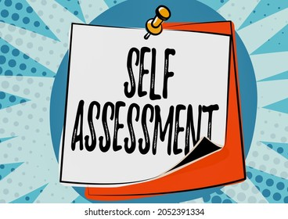

Fig 01 : self-assessment

‘Green’ technology being used and is it more sustainable
There is a noticeable trend in the modern hospitality industry toward the use of "green" technology as lodging establishments—including well-known brands like Premier Inn—realize the value of environmentally friendly operations. Green technology, which includes a range of eco-friendly technologies, has been implemented in different aspects of hotel operations and has led to increased efforts towards sustainability. Hotels frequently incorporate energy-efficient lighting systems, such as LED lights, which not only consume less energy but also have longer operational lifespans, into their operations. Hotels are able to reduce their dependency on non-renewable power by utilizing clean and sustainable energy through the increasing use of renewable energy sources like wind turbines and solar panels. Smart building systems play a crucial role in the effort to achieve sustainability. These systems, which utilize automation and sophisticated sensors, allow hotels to manage their heating, ventilation, and air conditioning (HVAC) systems by considering current occupancy and ambient conditions in real-time. As a result, energy waste is minimized. Hotels are using water-saving technologies such as dual-flush toilets, low-flow faucets, and water recycling systems as part of their green programs. These innovations support appropriate water management techniques in addition to lowering water usage (Snyder and Bernhard 2013).
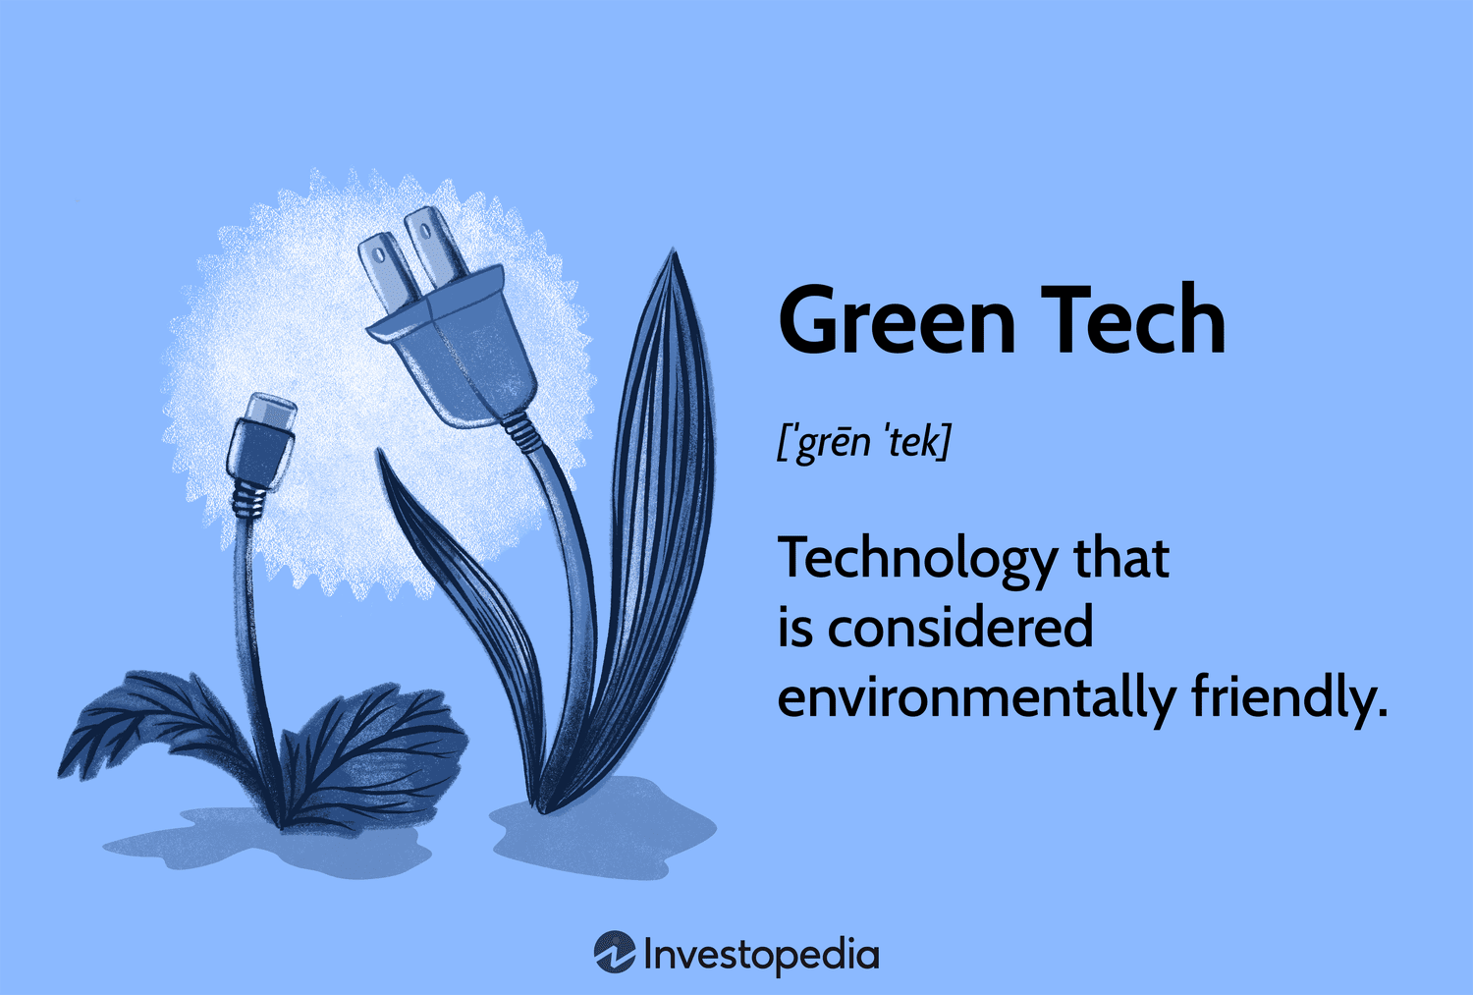

Fig 02: green tech
Green technology adoption often includes waste reduction and recycling efforts. In order to reduce their environmental impact, hotels take part in recycling programs for common household items like paper, glass, and plastic. In order to keep an eye on energy consumption, find out where it may be better used, and then put those suggestions into action, energy management systems are used. Some hotels work toward green building certifications such as LEED, which set standards for sustainable design, construction, and operation in the field of infrastructure. The use of eco-friendly furnishings and materials lessens the environmental impact of resource extraction and manufacturing, supporting eco-conscious actions (Buttle and Bowie 2016).

Instead of self-evaluating
Premier Inn and other firms like it can improve their sustainability efforts by combining internal evaluations with external assessments and partnerships. Third-party assessments and certifications from reputable organizations further support their environmental claims. Organizations can prove their dedication to sustainability with these certifications, which include ISO 14001 and LEED, which are the result of third-party evaluations. By working with sustainability consultants and specialists, you can have access to new viewpoints, best practices, and individualized suggestions for growth. A more inclusive review process is facilitated by engaging with external stakeholders, including communities, customers, and environmental groups. This helps to capture varied opinions and discover areas for enhancement that might not be visible internally. Businesses may see how they stack up in terms of sustainability when they participate in industry benchmarking programs. This creates a sense of healthy rivalry and helps to identify areas where companies can improve. Companies can strengthen their environmental initiatives, validate their commitment, and contribute to a more sustainable future by participating in industry-wide sustainability initiatives. Environmental impact assessments, guided by experts, provide a thorough analysis of the company's ecological footprint and identify opportunities for further reduction. Adopting global reporting standards, such as the Global Reporting Initiative (GRI), can enhance transparency and accountability by providing stakeholders with clear and standardized information about sustainability efforts. In summary, integrating external evaluations and partnerships into sustainability strategies helps companies achieve shared goals, encourages knowledge exchange, and promotes collaboration (George 2021).

CONCLUSION:
In summary, Premier Inn is a well-known industry leader in the hospitality sector, defined by its dedication to providing excellent service and reasonably priced lodging. Travelers all around the world have come to trust Premier Inn because of its strong tradition and global reach, which have allowed it to effectively carve out a niche in the cutthroat hotel industry. The brand's thoughtfully placed accommodations, cutting-edge amenities, and friendly, welcoming atmosphere make visitors feel at home. Premier Inn has adopted technological advancements to improve the whole guest experience, showcasing an innovative mindset to fulfill the changing demands of modern visitors. There is a growing need to assess the environmental assertions made by hotels like Premier Inn in light of the growing focus on sustainability in the hospitality sector. Despite allegations of "greenwashing" (the practice of inflating or fabricating environmental efforts), hotels must support their sustainability claims with evidence-based policies and third-party certifications. To establish credibility and demonstrate a sincere dedication to environmental responsibility, it is essential to have third-party certifications, participate in community activities, and provide thorough reports.
Hotels need to do more than just self-evaluation to make sure that their sustainability efforts aren't just empty words. They need to actively seek outside assessments. Working with sustainability experts, involving stakeholders, and taking part in industry projects all help to make the method completer and more responsible. If other businesses follow these steps, like Premier Inn, they can not only show that they care more about the earth, but they can also set an example for others to follow. External reviews, openness, and proactive sustainability measures will play a big role in shaping the future of responsible and eco-friendly hospitality as the hospitality industry changes.

REFRENCES
Snyder, D., Bernhard, B., Campbell-Ouchida, R., Gatling, A., Dhanis, E., Hancock, G., Madden, T. and Bawany, A., 2013. Premier.
George, R., 2021. Tourism and Hospitality Marketing Principles. In Marketing Tourism and Hospitality: Concepts and Cases (pp. 3-31). Cham: Springer International Publishing.
Buttle, F., Bowie, D., Brookes, M. and Marissen, A., 2016. Hospitality Marketing. Taylor & Francis.
Bower, J., 2018. Whitbread: Routines and resource building on the path from brewer to retailer. Management & Organizational History, 13(1), pp.1-23.
Giousmpasoglou, C. and Hua, T.T., 2020. The use of self-service technologies in budget hotels: the case of Bournemouth. European Journal of Tourism, Hospitality and Recreation, 10(3), pp.251-261.
McCaskey, D. and Campus, C., TRAVEL INN BY WHITBREAD. Ibis, 23, pp.2-677.
Brotherton, B., To cite this document: Bob Brotherton, (2004)," Critical success factors in UK budget hotel operations", International Journal of Operations & Production Management, Vol. 24 Is 9 pp. 944-969.
Jones, P. and Parker, A., 2008. Strategy execution and implementation—achieving strategic goals through operations. Handbook of hospitality strategic management, pp.334-353.
Bas, T. and Siva prasad, S., 2022. An Exploratory Insight into the Impact of COVID-19 on the Travel and Tourism Sector: UK Evidence. Bas, T. & Siva prasad, S. (2022). An exploratory insight into the impact of COVID-19 on the travel and tourism sector: UK evidence. In S. Karabulut (Ed.), Economic and Financial Analysis of Global and National Developments, pp.355-369.
Freeman, J., 2020. On Determining the Value of Online Customer Satisfaction Ratings–A Case‐based Appraisal. Data Analysis and Applications 3: Computational, Classification, Financial, Statistical and Stochastic Methods, 5, pp.195-214.
Dickens, A. and Timberlake, S., 2013. Proposed Premier Inn Site, Victoria Road, Chelmsford, Essex: A Desk Based Assessment.
Chatbot, P.K., 2016. Historical evolution of hotel chains. The Routledge Handbook of Hotel Chain Management, pp.53-66.
Newman, R., 2014. Proposed Premier Inn Site, Victoria Road, Chelmsford, Essex. An Archaeological Evaluation.
FILE, F., 2013. Basingstoke.
George, R., 2021. Marketing tourism and hospitality: concepts and cases. Springer Nature.
Bower, J., 2014, September. What was the Whitbread Umbrella protecting? From brewing to coffee via pub retailing. In British Academy of Management Conference Proceedings.
Siddique, A. and Shukla, A., 2016. An Analytical Study of Red Ocean and Blue Ocean Strategy with Special Reference to Indian Premier League Twenty-20 Cricket. Available at SSRN 2772558.
Tarrant, C., 2018. Never mind the love, smell the money: What is the ‘value-add ’of a brand?. Journal of Brand Strategy, 7(1), pp.54-68.
De Brisbois, D. and Fennell, D., 2011. Carbon footprint of the global hotel companies: Comparison of methodologies and results. Tourism Recreation Research, 36(3), pp.231-245.
Bottorff, T., 2013. Hospitality management: a guide to key reference works. Reference services review, 41(4), pp.605-622.

