Module Title: THE GLOBAL BUSINESS ENVIRONMENT
ASSESSMENT 2
Student name: Nikolay Valeri Zorov
Student ID:1920421

Table of Contents
Introduction 3
1 The changes that Volkswagen have made in the last few months in light of the COVID 19 Pandemic 4
SWOT analysis 4
2 Sustainability of the changes and recommendations 7
Recommendations 8
Conclusion 10
References 11

Introduction
Most of the sectors in the world have been terribly affected by Covid 19. Many went out of business while many businesses are devising new ways to sustain in the business. the automobile and aircraft industry faced the worst situation. Volkswagen is however returning to the pre-pandemic state. The company sale decreased to 9 million cars in 2020 from 10.9 million in 2019. But now it is showing real growth quarter by quarter. There are some strategies working behind the revive. The company has established more than 85 years ago. It has been the largest company in 2016 and 2017.

1 The changes that Volkswagen have made in the last few months in light of the COVID 19 Pandemic
The automobile industry has seen a major downturn due to pandemic. Automobile sales fell by 14% in 2020 worldwide (Jim, 2021). The automobile sector is important to the world economy since it generates a variety of commercial service areas and influences a large supply chain. The automobile industrial subsectors alone employ more than 2.5 million people and accounts for 8.5% of manufacture-related jobs in the EU (Jan, 2021). The McKkinsey Global Survey said their firms have saved 36 to 48 months by digitising their buyer and supply-chain contacts, as well as their business processes (McKinsey, 2020). To compete globally in this changing corporate and business situation, new tactics and practices are required. Volkswagen (VW) has brough several changes in this pandemic. It has changed how it was looking at its strength and weakness as well as the external environment. The SWOT analysis will explain more.

SWOT analysis
Customers have shifted substantially to internet outlets during this epidemic which was followed by the businesses too. According to McKinsey, global consumer interaction by digital means has increased to 58% (McKinsey, 2020). VW has revised its operations and supply chain to cope up with the changes.
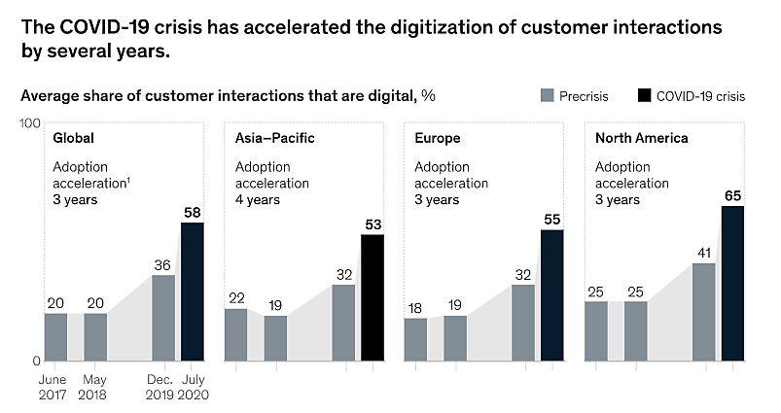
Figure 1: Global consumer interaction( McKinsey, 2020)
Strengths and Weaknesses: The key strengths that VW had developed for this pandemic were significant for the company. Volkswagen's production plants feature a community-like, close-knit family atmosphere (Gaim, Clegg and Cunha, 2021). The community helps all employees in different levels. It has enhanced VW’s job performance. This have motivated the employees to work more efficiently during the pandemic too. Since the start of the epidemic, VW designers have been focusing on virtual reality (VR) more (Volkswagen, 2021). A large number of work travels are not required anymore. This makes modern automobile designs digitised as well as environment friendly. Many strategies are devised by the company on direct meeting which became a taboo because of the crisis. Meanwhile, the employees have learnt to exchange a significant amount of their trip with the digital sessions (Volkswagen, 2021). The technology is getting advanced day by day. The adoption of technology faster has proved that VW is evolving to a more digitised and sustainable corporation in the face of the epidemic. VW has formed collaborations with the global top leading technological firms, including Amazon and Microsoft, to create e-mobility services along with new technologies of self-driving, connectivity and so on (Volkswagen, 2020). VW has a global automobile business realm that spans more than 160 nations. The automotive brand, on the other hand, has 124 production plants in over ten countries across Asia, America, and Africa. Volkswagen's market value in 2020 is 70.4 billion dollars which is 8th highest globally (Volkswagen, 2020). The company however saw 21% decrease in the car sales. But the company retaliated with rigorous cost control and a great sales strategy. The company has devised accelerated strategy for that. The company has focused on the downstream value chain to find out new sources of revenue. It already earned more than EUR 450 million in 2020 by those investments (Volkswagen, 2021). Volkswagen does not use effective marketing techniques to promote its goods, particularly outside of the Europe. The company mainly focuses on the collaboration with other automobile businesses. For example, the firm collaborated with JAC to build cost effective electric vehicles in China. 6 years ago, VW faced a controversy alleging that the company had installed various apps and software to fraud the carbon assessment (Jacobs and Singhal, 2020). The court ruled the business guilty which caused it 30 billion Euros compensation across many nations. The event seriously harmed the company's status.

Opportunities and threats: Increasing use of internet and rate of digitisation is a great opportunity for the company. VW will be investing around EUR 16,000 million in digitisation and automatic cars. The new strategy of the company called ‘ACCELARATE’ has opened door of many opportunities (Volkswagen, 2021). The company is integrating the software in the cars along with gaining access to digitised users experience. The heart of the business ecosystem is now the users. The scalability of the software is confirmed by the firm’s huge volume. New technology of over the air will ensure the products of the company updated all the time. 0.5 million connected cars will be available by 2023 (Volkswagen, 2021). VW is laying the groundwork for new, data-driven business models aimed at decreasing the rate of new comers to e-mobility while providing extremely appealing servicing offers to users by transforming their offerings to software-based cars. This way, VW intends to earn extra income during the car's product life for charging and energy services, software-related features that users may preserve as per required, or autonomous drive. The company is also introducing the service of customisation. The users can modify the vehicles by choosing preferred functions. The vehicles will be presented through VR which will reduce the complexities of the manufacturing unit as well as configurations. Through the investment on digital platforms, the company has opportunity to raise margin by 6%, productivity by 5%, reduce fixed expenditure by 5%. By this, the company can make profits in North and South America even with a drop in sales of 15% and 30% respectively (Volkswagen, 2021). The threat of the ride-hailing service sector has been reduced since individuals are not leaving home now (Bai, 2021). Sharing a vehicle with unfamiliar people in the midst of an epidemic is not an option anymore. The same is true for public transportation. According to experts, the automobile ownership will continue to rise. The ownership in New York City has already increased by 40% (Sean, 2021). The major threats are the decreasing disposable income of the people. The UK faced 3% decline in the sales of cars (Nikitina and Velychko, 2020). Though the company do not have financial issues, but the situation can affect its liquidity. As the sales has decreased, it will affect the available cash for the company. The supply chain is another issue as the company has sites in different countries and has to import different parts (Oxford, 2020). Many companies like Nissan had to stop operation only after 48 hours because of these issues.

2 Sustainability of the changes and recommendations
No doubt that VW has brought several changes in their operations and plans. But those changes must be sustainable for the company. The key changes were-
- VW has moved to digitised design of the vehicles for autonomous and connected cars. It is also planning to make large investments on these. This is a sustainable change for the company. By 2030, the company will increase its market share to 35% in Europe which is 70% higher than now (Volkswagen, 2020). In the UK, more than 20% produced cars are electric cars. Electric vehicles have the potential to expand its market to more than 10% in the European auto market (Jan, 2021). The company is also hoping to capture 50% of the electric cars’ market (David, 2021). The graph shows that 55% of the global products have already been digitised after this pandemic. So, digitisation is a sustainable approach of the company.
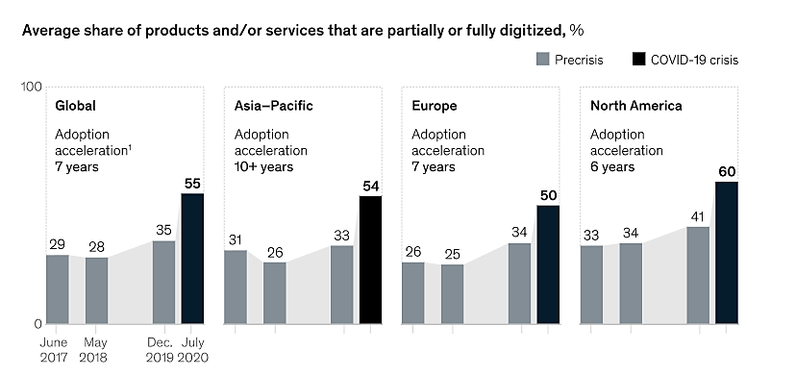
Figure 2: Percentage of digitised products and services (McKinsey, 2020)
- The company has developed two new core competencies through the new strategies. These are the integrated software-based vehicles and user experience through digital platforms. The life cycle of the vehicles has increased by this. Because of technology advancement, the life cycle of automobile decreased by 1.9 years. As the pandemic has hit the income of the people, the increased life-cycle can go a long way. Through these new services, the users will get any new update automatically and also will be able to customise their products. The company will be earning revenue for use of charge and energy. It is indeed a sustainable change for VW.
- VW has indeed faced a loss because of the pandemic but still it made a successful turn. It made more than 8% more sales and increased margin by 6% in first six months of this year (David, 2021). It has focused on the special items of the company to earn more profits. It is diversifying its revenue stream which is a very smart move. Relying on one stream can bring many troubles to any company. Analysing the value chain and business model was a must in the pandemic (Nevzorova, 2020). The company has successfully devised new business model. By following it, the company will be offering data driven services to the users. Another key reason to increase profitability was the cost structure (Aichner et al, 2020). Because of pandemic, VW focused on the online meetings which saved a lot of time, expense and reduced use of electricity and carbon emission of both of the company and its employees. It helped them to have a balance work life. The company is planning to shift to such system for a long time. It is sustainable as well as profitable for it.

Recommendations
VW has obviously taken some effective strategies. Most of those are sustainable but few needed to be revaluated for the sake of the future of the company.
The company has decided to go for few versions of their new vehicles as they have lengthened the life cycle of the cars. But it will only attract a specific market like businesses. People always think new is better. Also, electric vehicles have different parts. The users may need advanced and updated parts of the vehicles for better services. Fewer versions can affect the image of the company and make it a cheap brand.
The company must focus on the manufacturing costs and supply chain more. As the pandemic has affected the income of the people, the distributors will want to provide discounts to clear the inventory. It can put extra pressure to the company. It must use automation in its production sites to save costs so that it can sustain the post-pandemic situation (David, 2021). Also, by using technologies like IoT in the manufacturing, the productivity will increase significantly. Supply chain is a crucial factor. Globalisation has made many companies rely on others countries so much that pandemic stopped the manufacturing totally. Along with such natural phenomena, politics and economy have influence on the supply chain. The company must manage alternative sources of parts, way of production and so on (Oxford, 2020). VW should collaborate with not only the tech giants, but also local businesses to get immediate support.
Though the company is looking for different sources of revenue, still it is in the business of vehicles and related product. The company must diversify its business. Nissan has done it through its finance services. Also, people are becoming health conscious which is leading them to walk or use bicycles. VW can also enter business like financial service, grocery, bicycle and so on.

Conclusion
Few strengths community-like, close-knit family work atmosphere, focusing on virtual reality (VR), digitised as well as environment friendly products, online sessions with employees, e-mobility services along with new technologies of self-driving, connectivity, downstream value chain and so on. But ineffective marketing techniques, controversy and installation of software to fraud the carbon assessment etcetera has affected its strengths. Its new ‘ACCELARATE’ strategies, integration of the software in the cars, digitised users experience, scalability of the software, data-driven business models and others are its new opportunity now. However, decreasing disposable income, liquidity and dependent supply chain can create threats. Most of the changes are sustainable but the company must focus on independent supply chain, diversification and autonomous production.

References
Aichner, T., Coletti, P., Jacob, F., & Wilken, R. (2020). Did the Volkswagen Emissions Scandal Harm the “Made in Germany” Image? A Cross-Cultural, Cross-Products, Cross-Time Study. Corporate Reputation Review, 1-12.
DAVID McHUGH (2021) Volkswagen earnings beat pre-pandemic levels on luxury makes [online] Available at: https://abcnews.go.com/Business/wireStory/volkswagen-earnings-beat-pre-pandemic-levels-luxury-makes-79135762 (Accessed on: 10 August 2021)
Gaim, M., Clegg, S., & Cunha, M. P. E. (2021). Managing impressions rather than emissions: Volkswagen and the false mastery of paradox. Organization Studies, 42(6), 949-970.
Jacobs, B. W., & Singhal, V. R. (2020). Shareholder value effects of the Volkswagen emissions scandal on the automotive ecosystem. Production and Operations Management, 29(10), 2230-2251.
Jan Maarten de Vet (2021) Impacts of the COVID-19 pandemic on EU industries [online] Available at: https://www.europarl.europa.eu/RegData/etudes/STUD/2021/662903/IPOL_STU(2021)662903_EN.pdf (Accessed on: 10 August 2021)
Jim Davis (2021) The New Auto Industry: Change And Innovation For A Sustainable World [online] Available at: https://www.forbes.com/sites/sap/2021/01/12/the-new-auto-industry-change-and-innovation-for-a-sustainable-world/?sh=1cb9738456c7 (Accessed on: 10 August 2021)
McKinsey & Company (2020) How COVID-19 has pushed companies over the technology tipping point—and transformed business forever [online] Available at: https://www.mckinsey.com/business-functions/strategy-and-corporate-finance/our-insights/how-covid-19-has-pushed-companies-over-the-technology-tipping-point-and-transformed-business-forever# (Accessed on: 10 August 2021)
Nevzorova, O. (2020). Analysis of the impact of the coronavirus pandemic on the global economy: consequences, risks and forecasts.
Nikitina, A. V., & Velychko, K. Y. (2020). Consequences of the impact of the coronavirus pandemic on the global economy.
Oxford Analytica. (2020). Pandemic triggers European rethink on supply chains. Emerald Expert Briefings, (oxan-db).
Sean Szymkowski (2021) New York car ownership jumps nearly 40% as pandemic creates mass transit worries [online] Available at: https://www.cnet.com/roadshow/news/new-york-car-ownership-jumps-nearly-40-as-pandemic-creates-mass-transit-worries/ (Accessed on: 10 August 2021)
Volkswagen (2020) Volkswagen designers are creating even more digitally [online] Available at: https://www.volkswagen-newsroom.com/en/stories/volkswagen-designers-are-creating-even-more-digitally-6483 (Accessed on: 10 August 2021)
Bai, Y. (2021, March). Analysis of Overseas Management Strategy of the Volkswagen Group. In 6th International Conference on Financial Innovation and Economic Development (ICFIED 2021) (pp. 229-234). Atlantis Press.

