BLOGGING TO COMMUNICATE on ROLLS ROYCE | STUDENT: MADALINA VERONICA POPESCU  MODULE:MARKETING FUNDAMENTALS  MODULE NUMBER:LCBB4004  LECTURER’S NAME:TUSHARA BALENDRAN

Table of Contents
Introduction 3
Product 6
Features and Benefits 8
Meaning of the logo/brand name 10
Price 3/4 varieties/pricing 11
Place and distribution 12
World map where the product is available 13
Promotion 14
Encourage the readers 15
Conclusion 15
References 16
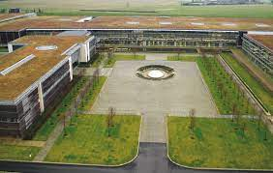
Introduction

ROLLS ROYS is a British Multinational luxury car manufacturing company established in 1904. The headquarters of the company is in Derby, UK and it became a state-owned company in the year 1971. Charles Rolls and Henry Royce are the main owners of the organisation and the products that are offered to the customers are Automobiles, Civil and military aero-engines, Marine propulsion systems and Power generation equipment,the organisation pioneers cutting-edge technologies that help customers get the benefit of using automobiles (Royce, 2018). Also is a very competitive in the market where they try to make sure that the cars which are builded are able to meet the needs of its premium set of customers. The brand image of the company is very strong which makes it easier for us to attract the customers.
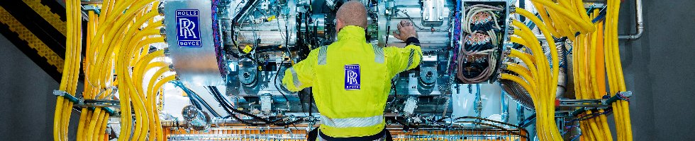
The main vision of the Rolls Royce is to bring luxury into the autonomous motor car that they are producing for their customer bas,the vehicles that are offered,are usually enduring and durable which makes it easier for the customers to find comfort and luxury in the different cars that they are investing in. The vision of the organisation leads to a future where technology can be merged with luxury to offer a unique experience to customers (Jung, 2022).At Rolls Royce heavily believe in the transformation of technology into the cars that they are building. The mission is to make sure that the needs of tomorrow are considered within their products so that they can pioneer the power that matters in the automobile industry and hold their position in the market. Trying to work on the mission to obtain and hold onto a highly skilled and professional workforce that can help the organisation make the cars with the quality that we are known for with adding changes as the technological changes are emerging in the market (Randell, 2018).

Product
The main production bases that is offered to the customers at Rolls Royce are as follows.
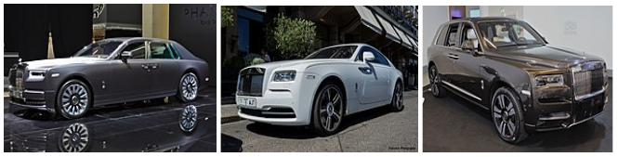
Automobiles - The Car has been known for the luxury cars that they manufacture making them one of the world's largest automobile sellers. We even have a strong base for the quality and luxury that they offer to the customers which makes them hold a loyal set of customers that get attracted to the brand image that they have (Barik and Behera, 2022). Phantom, Wraith, Cullinan etc are certain luxury cars that Rolls Royce has manufactured and gained huge success for it.
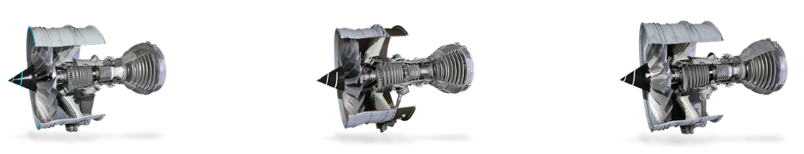
Civil and military aero-engines - Aerospace engines are the product through which we try to establish efficiency, value and innovation. The aircraft engines that have been built by us have achieved over 100 million flying hours. The Airbus A330, A340, A350, and A380 are certain aerospace flights that have engines manufactured by us at Rolls-Royce (Royce, 2015). Rolls Royce leads the way with cutting-edge technology for engines that can support the aircraft successfully. We are also using sustainable aviation fuel that enhances its social contribution. The main engines that are built are named with Trent as their model.
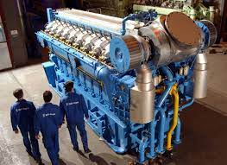
Marine propulsion systems - An advanced system of solutions are provided through these systems to their customers worldwide. We at Rolls Royce offer the capability to design, build, and deliver so that the support they can give to the naval systems is tailored to meet specific needs. Gas turbines, diesel engines, propulsion etc are offered by us at Rolls Royce. The ship's propulsion systems included the "Controllable-Pitch Propellers (CPP)" and "Fixed-Pitch Propellers and Water Jets''. Diesel propulsion is the most common product that they offer to the naval system.
Power generation equipment - The Power Generation systems that are created by Rolls Royce are based on sustainable, climate-neutral solutions. A certain amount of energy transition can be brought about with the help of environmentally-friendly technologies. The power for the safety-critical plants, ships and heavy-duty land vehicles. Rolls Royce specialises in the MTU systems where the largest yachts have been powered by these systems (Rolls-Royce, 2020).

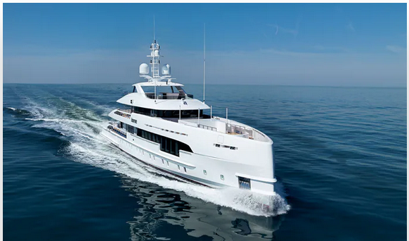
Features and Benefits
The luxury automobiles that are manufactured by Rolls Royce can be further discussed. Luxury cars have been a strong area where the features that are being offered are meeting the needs of the customers. There are a number of features that are offered by us in our cars like the passenger airbags, Anti Lock Braking System, automatic climate control, Alloy Wheels etc that can provide a strong luxury and smooth ability to use the car. The Power Windows Front is another feature that the cars have to offer to the customers. The most important feature that is being offered by Rolls Royce is the custom-made features for the owner of the car (Rolls-Royce, 2019). The changes that the owner needs can be put in the luxury car that can make the experience luxurious for the customers.
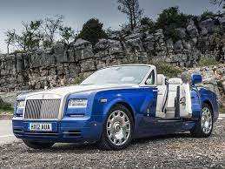
There are three main elements that we at Rolls Royce believe in order to make sure that the automobile business can continue having the customer base that they have. The first element is delivering on the commitments made by the organisation to make sure that the promises that are being made through their advertisement can be kept and followed further to achieve customer satisfaction. Also, we at Rolls Royce heavily focus on the maximisation of the value from existing capabilities that they have. Rolls Royce also has expertise in seizing opportunities for growth that can help them reach a wider selection of customers.
The benefits of the products that the customers can have are as follows.
- The owners of the cars can have a strong relationship with Goodwood which includes the world's greatest craftspeople and technicians.
- The owners of the cars can get the “Whispers” membership where they can successfully gain access to private events and experiences for the Rolls Royce.
- The owners of the cars can also gain access to the application along with a 24/7 concierge. The application can provide all the services that the owners need to make sure that the fractures that they seek access to can be achieved successfully.
- The Bespoke helps in making sure that the personalisation of the Rolls-Royce can be given to the user's specific needs (Smith-Gillespie et al., 2019).
- A geo-targeted system is also given to the owners of the Rolls Royce so the tracking process can be effective.

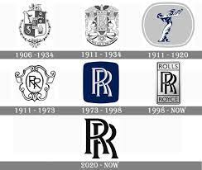
Meaning of the logo/brand name
The Rolls Royce car logo can be understood as the Spirit of Ecstasy and is depicted as a bonnet ornament. The logo is a "sculpture of a woman leaning forward with her arms stretched back". The logo is based on the grace, beauty and energy of the women shown in the Rolls-Royce cars (Gray, 2018). The double R logo is based on the goodwill and boldness shown by us in meeting its objectives of the organisation. A young woman in fluttering robes is shown in the logo that depicts the idea of freedom and boldness that the owners can have from purchasing the cars.

Price 3/4 varieties/pricing
The pricing strategy has to be made premium because the customer base that they have are premium. The prices of cars are very high which makes it very difficult for the middle class people to purchase cars. There are a number of pricing strategies that can be used to make sure that the target customer base that they have can be understood successfully.
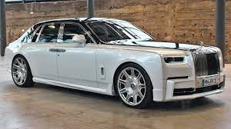
Cost-plus pricing - This pricing strategy is based on the costs that are incurred by us at Rolls Royce to make sure that the prices that are set for the cars can help them in gaining profit in the long run during the sales.
Competitive Pricing - Competitive pricing is based on the competition that a business organisation is currently facing in the market. The pricing of the products is set on the basis of the price that has been set by the competitors (Gupta et al., 2021).
Price skimming - Price skimming is based on the market changes and the change in price brought to satisfy the customers with it.
Value-based pricing - The value-based pricing is focused on the value that the product is having in the market. The value-based pricing strategy is used by Rolls Royce as it depicts the value that luxury cars have (Kienzler, 2018).

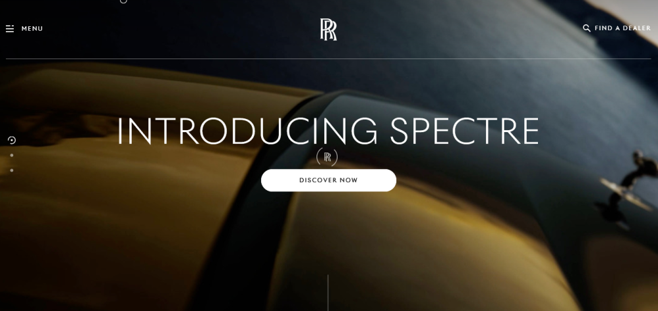
Place and distribution
Rolls Royce has branches across 50 different countries where they try to operate to sell their luxury cars. People across 150 countries have made purchases of cars due to its brand image. The company has certain administrative and production facilities for their valuable customers and the distribution is very strong for the organisation because they have a limited number of employees that are attached to us for a long time.Rolls Royce even offer a doorstep delivery process where the cars are delivered directly to the customers upon their order. Rolls Royce even has a website that allows the customers to successfully understand the features that the car has and whether they are being able to relate to those features (Kong, 2022). The organisation deals with exclusive distribution.

World map where the product is available
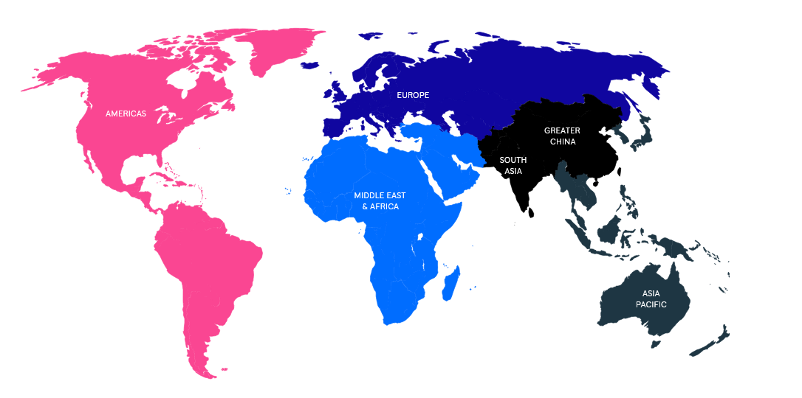
Figure 11: World map of where the Rolls Royce products are available
(Source: Kong, 2022)

Promotion
The company is heavily focused on the word of mouth advertisement that helps them in making sure that the customers that have been satisfied with the service from Rolls Royce will try to convince other known people about the organisation and the strong brand they have offering quality and value for the luxury cars. The marketing approaches for the company usually take place in high-profile events, expensive hotels and exclusive vehicle shows. We at Rolls Royce can successfully gain access to the customers that they need to sell their cars (Thießen, 2022). The digital presence they have also contributed to the strong promotional strategy they use to reach customers online.

Encourage the readers
You can easily gain access to the features of the Rolls Royce Car that are being given on the website. As the customer's purchase patterns are considered on the basis of the segmentation process. The digital presence of the company helps the customers in understanding the new launches that are there for the customers to buy and verify. Rolls Royce does not have any youtube links as they do not promote their product through digital media.

Conclusion
The above report was based on understanding the efforts that Rolls Royce takes to penetrate the market and successfully offer its premium cars to customers. The product range of the Rolls Royce was mentioned along with the pricing strategy that they use. The dominance they have in the market was determined by the number of places they operate and their cars are being purchased too. The promotion that Rolls Royce does is based on word of mouth so that the cars can be known to a premium set of customers.

References
Barik, L. and Behera, A., 2022. Smart 3D Nano-Printing in the Automobile Industry. In Smart 3D Nanoprinting (pp. 43-72). CRC Press.
Cordova, N., 2021. Servotronics, Inc. v. Rolls-Royce PLC. Harv. JL & Pub. Pol'y Per Curiam, p.1.
Gray, A., 2018. Strategic benchmarking. In The Game Changer (pp. 109-127). Routledge.
Gupta, V., Ivanov, D. and Choi, T.M., 2021. Competitive pricing of substitute products under supply disruption. Omega, 101, p.102279.
Jung, F., 2022. Developing Quiet Hybrid and Electric Cars. ATZ worldwide, 124(7), pp.14-15.
Kienzler, M., 2018. Value-based pricing and cognitive biases: An overview for business markets. Industrial Marketing Management, 68, pp.86-94.
Kong, R., 2022. Dig deep into Rolls-Royce´s s true value (Doctoral dissertation).
Randell, P., 2018. Drive: The home of Rolls-Royce motor cars. Medicus, 58(9), pp.46-47.
Rolls-Royce, X.T., 2020. Empowered JV Gets Coal Contract.
Rolls-Royce., 2019. Home. [online] Rolls-roycemotorcars.com. Available at: https://www.rolls-roycemotorcars.com/en_GB/home.html.
Royce, R., 2015. The jet engine. John Wiley & Sons.
Royce, R., 2018. Rolls Royce. Rolls Royce, Derby, UK, accessed Aug, 8, p.2018.
Smith-Gillespie, A., Muñoz, A., Morwood, D. and Aries, T., 2019. ROLLS-ROYCE: A Circular Economy Business Model Case.
Thießen, F., 2022. Manufacturers, Research and Infrastructure. In Air Transport and its Subsidies (pp. 71-77). Springer, Wiesbaden.

