
The Business of Sport Template
Assignment 1

Student Name Kenzi vickers

P Number2 2501019

Event Title

Word Count

Task A – Definition 1 (Plus 2+ Academic References) (Circa 400 words)

The Women’s Rugby World Cup (WRWC) has undergone a radical commercial transformation, moving from a niche sporting event to a premier global asset. This evolution is driven by sophisticated marketing frameworks that prioritize commercial viability, digital-first engagement, and a sustainable social legacy. According to World Rugby’s 2025 "Blueprint for Growth," modern marketing strategies have successfully shifted the tournament from a "targeted intervention" to a "sustainable financial model," evidenced by a staggering 330% increase in sponsorship revenue for the 2025 edition compared to 2021.
A primary driver of this impact is the "digital-first storytelling strategy" quantified in World Rugby’s 2026 Legacy Report. This report identifies over 1.1 billion social media impressions and a 336% increase in global broadcast viewing hours. This digital reach has fundamentally altered the fan demographic; Pulselive (2025) notes that 49% of the current fan base engaged with the sport only within the last two years, highlighting the success of "fluid fandom" marketing in capturing younger, digitally native audiences. This shift is not merely aesthetic but financial, as Deloitte (2025) projects that women’s elite sport will generate £1.8 billion globally by 2025, with the WRWC serving as a central pillar of this growth.
The impact of marketing also extends to the "social legacy" and grassroots participation. The Women’s Sport Trust (2026) notes that marketing visibility has reached new highs, with women's sport now accounting for 13% of all prime-time viewing hours. This visibility creates a "virtuous cycle" where elite marketing fuels local participation. For instance, the marketing of the 2025 tournament in England led to a 35% increase in registered age-grade girls. By positioning players as relatable icons, marketing has moved beyond ticket sales to influence cultural perceptions of gender in sport. Collectively, these sources demonstrate that marketing is the foundational engine for the WRWC’s global legitimacy and long-term financial independence.
World Rugby. (2025). A Blueprint for Growth — Women's Rugby: Commercial Analysis.
World Rugby. (2026). Women’s Rugby World Cup 2025 Legacy Report.
Pulselive. (2025). A Blueprint for Growth - Data Appendix: Fluid Fandom.
Deloitte. (2025). Women’s Elite Sport Revenue Projections and Global Forecasts.
Women’s Sport Trust. (2026). The Visibility of Women's Sport: Annual Report.

Task A – Definition 2 (Plus 2+ Academic References) (Circa 400 words)

In the high-stakes environment of the National Football League (NFL), human resource management specifically recruitment and retention is the cornerstone of organizational performance. In elite sports talent is the primary capital; thus, the ability to identify and keep top-tier employees determines long-term competitive advantage. ResearchGate (2025) evaluates this through an Industrial-Organizational (I-O) psychology lens, defining recruitment in the NFL as a rigorous process of assessment and selection that must align with a "high performance" culture to ensure on field success.
However, recruitment in the NFL faces significant hurdles regarding diversity and systemic equity. The National Institutes of Health (2022) highlights a critical need for Chief Diversity Officers within NFL teams to address barriers in the hiring and retention of minority coaches and executives. This is supported by Taylor & Francis (2023), who define diversity and inclusion management not just as a social goal, but as a strategic tool for retention; inclusive cultures suffer significantly less from "talent flight" and internal friction.
Retention is also deeply tied to the Employee Value Proposition and organizational culture. The Salford Repository (2018) notes that modern HRM in professional football has shifted from a "personnel" focus to a "human capital" focus, where employee well-being is paramount. Organizations that fail to address burnout a common issue in the intense NFL season—risk losing institutional knowledge. Finally, Manchester Metropolitan University (2021) explores the role of "strong ties" and trust-based networks in recruitment. While these networks can ensure cultural fit the study warns that an over-reliance on closed networks can stifle innovation and limit the talent pool. In summary, effective HRM in the NFL requires a balance between traditional "scouting" methods and modern, inclusive retention strategies to maintain a championship-caliber organization.
ResearchGate. (2025). Talent Management in Elite Sports: Assessing and Selecting Talent in the NFL.
National Institutes of Health. (2022). The Need for Chief Diversity Officers in Professional Football.
Taylor & Francis. (2023). Diversity and Inclusion Management in Sport Organizations.
Salford Repository. (2018). Human Resource Management in Professional Football.
Manchester Metropolitan University. (2021). Recruitment in Elite Football: A Network Approach.

Task A – Definition 3 (Plus 2+ Academic References) (Circa 400 words)

Pep Guardiola is widely regarded as one of the most influential managers in football history. His leadership style is centred on a clear tactical philosophy, often referred to as positional play, which emphasises maintaining possession and controlling the game through structured movement. As a manager, Guardiola takes on multiple roles, including strategist, coach, and leader. He is responsible for planning training sessions, analysing opponents, and making key in-game decisions. Additionally, he plays a crucial role in developing players both technically and mentally, ensuring they understand and execute his system effectively. His attention to detail and high standards reflect core management functions such as organisation, performance monitoring, and continuous improvement.
In contrast, Jürgen Klopp is known for his charismatic and motivational leadership style. Klopp’s approach, often described as transformational leadership, focuses on building strong relationships with players and fostering a positive team environment. His tactical philosophy, particularly “gegenpressing,” requires intense teamwork, discipline, and collective effort. As a manager, Klopp not only implements tactics but also inspires and motivates his players to perform at their highest level. He is highly effective in communication, often using emotional intelligence to connect with his squad and create a sense of unity. This demonstrates key managerial roles such as motivation, leadership and team cohesion.
Both managers highlight different but equally important aspects of football management. Guardiola represents a more strategic and methodical approach, while Klopp exemplifies motivational and people-centred leadership. Together, they illustrate that successful football managers must balance tactical knowledge with strong leadership skills to achieve sustained success.
Bridgewater, S. (2010) Football Management. Basingstoke: Palgrave Macmillan.
Carter, N. (2006) The Football Manager: A History. London: Routledge.

Task B – Stakeholder Diagram (with appropriate communication channels selected for each stakeholder) and referenced material detailing role, emphasis, funding and performance of organisation (Internal and External) – Diagram + Circa 600 Words (References 5+)

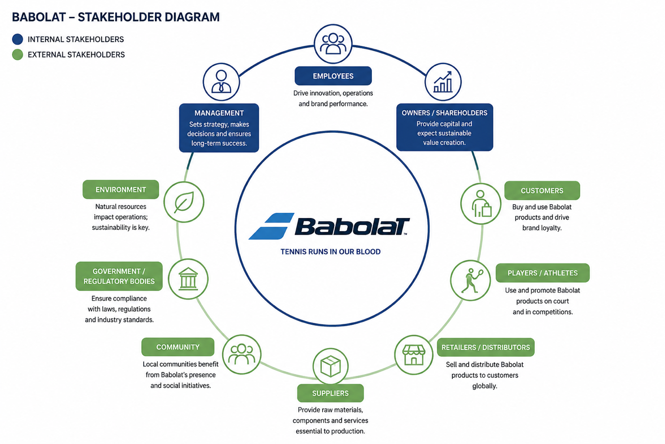

Task C – Complete Operational Planning Document for your Event (Fill, 2006) (1200 words)

Title of Event | Football tournament kids aged 6-11
Event Purpose Link to Case study and (Fill, 2006)  Think Why? | The purpose of this event is to promote youth participation in sport, encourage physical activity and foster community engagement through football.  This tournament aims to:  Support local grassroots football development.  Provide inclusive opportunities for children of all abilities.  Strengthen partnerships between schools, local clubs, and community organizations.  Link to Case Study: The event mirrors the approach used in the Swansea Foundation Youth Sport Initiative, which successfully increased participation by 25% through community-led tournaments.
Event Description  Think What?  What is your USP? | A one-day football tournament featuring mixed teams of boys and girls aged 6–11. Each team will represent local schools or community clubs. The event will include:  Group-stage matches followed by knockout rounds.  Skills workshops led by coaches from Swansea Foundation and rockspur  Family friendly activities and refreshments.  A focus on inclusive participation and skill development not just competition. The event integrates fun learning sessions with great coaching making it distinct from standard youth tournaments.
Overall Funding Required (Financial Statement) | The Case study Organisation gives a Fixed grant of £10,000.  Forecasted Profit/ Loss =  £0 spent for equipment, venue as we will use rockspur facilities.  £500 on ice cream van selling food etc  £150 making leaflets  £250 on face paining, hair spray and sweet stalls,  Entry will be £10 each team to get as many teams involved possible looking to make £1500  Sponsorships will be the main source of income estimated income £2500 from sponsors.  £900 on wages
Partners | Rockspur fords  Swansea foundation
Strategic Impacts (Government, Local Authority, NGB’s) | Government & Local Authority: Supports Sport Wales and UK Government’s School Sport and Activity Action Plan by promoting youth sport participation.  NGBs Aligns with FAW Grassroots Development Strategy to nurture young talent and inclusivity.
Venue/ Facility (Justify) | Venue will be Clwyd primary school this is chosen for its safe accessible environment, multiple pitches and it meets FAW standards also offering facilities for spectators and families.
Marketing Plan (Segmentation, Competition, Media, Sponsorship and Promotional Activities) | Segmentation- Families with chidlren ages 6-11, local schools and clubs.  Competition- Other tournaments in south wales  Media- Social media, school newsletter and leaflets handed out.  Sponsorships- Local businesses.,  Promotional activities- Early registration discounts, social media challenges, leaflets handing out.
Staffing Requirements (Duties, Technical Certificates etc.) | - Coaches: FAW Level 1 Certificate  - Volunteers: Crowd management and hospitality  - Medical Staff: First aid certified  - Event manager- overall coordination
Equipment Required | - Footballs, bibs, cones, goals  - PA system for announcements  - First aid kits  - Cabins for refreshments and signage
Key Legislation | - Health and Safety at Work Act (1974)  - Children Act (2004) – safeguarding responsibilities  - Equality Act (2010) – inclusivity and non-discrimination  - Data Protection Act (2018) – participant information handling
Health and Safety Risks | - Minor injuries (sprains, cuts) - On-site first aid  - Weather conditions -Contingency plan for indoor backup  - Crowd control - Barriers and volunteer marshals  - Safeguarding - DBS-checked staff and clear child protection policy
Economic and Operational Considerations | - Economic Impact: Boosts local economy through visitor spending.  - Operational Efficiency: Streamlined registration, digital scoring system and volunteer coordination ensure smooth delivery.  - Sustainability: Reusable materials and recycling stations reduce environmental footprint.

Financial Statement / Profit and Loss Forecast Accounts (Insert from Excel) (Adapt version on Moodle based on your event which considers Revenue, Expenditure, Anticipated Profit or Loss

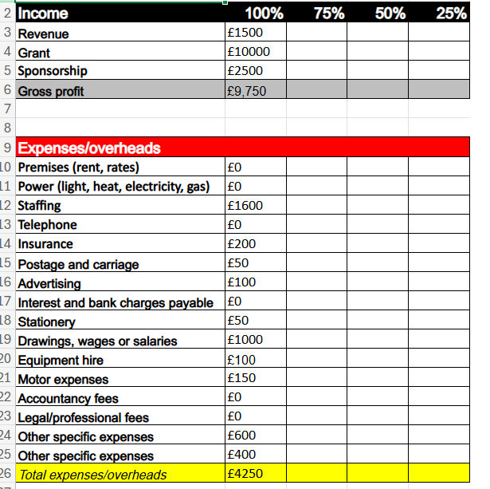
Gantt Chart (Insert from Excel)



Eventbrite Page for your event (Screenshot from Website page and insert into table below)

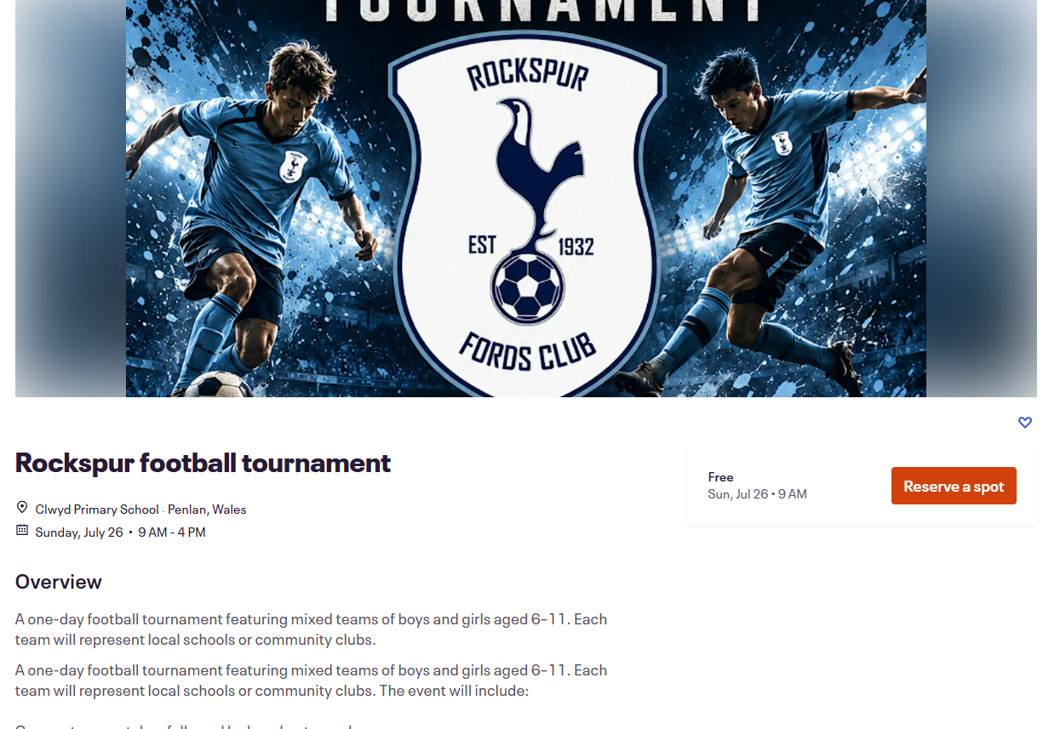

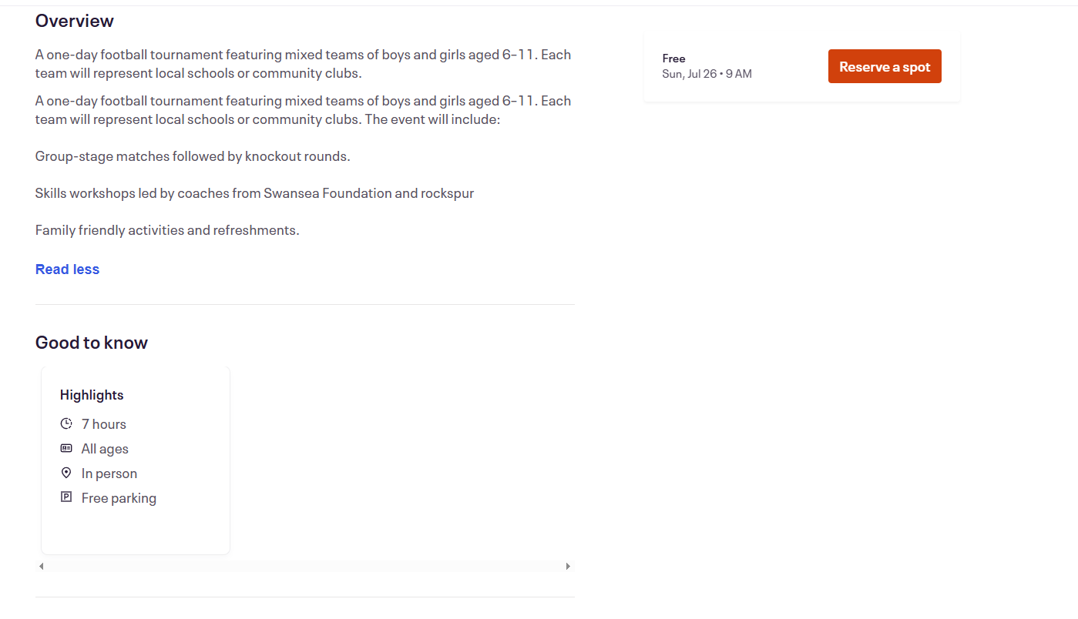

Survey Monkey Audit of relevant questions, consider grouping questions to ask into 3 categories - before, during and after the event. (Screenshot from Website page and insert into table below)

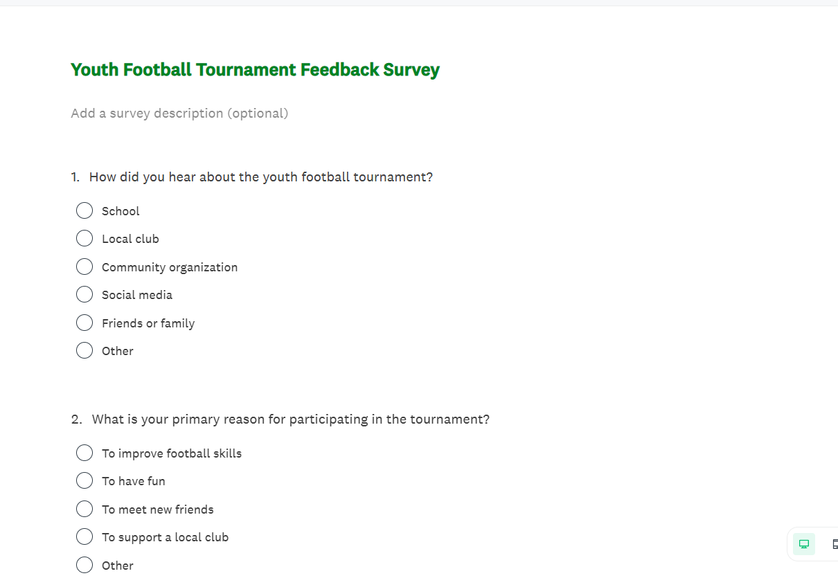
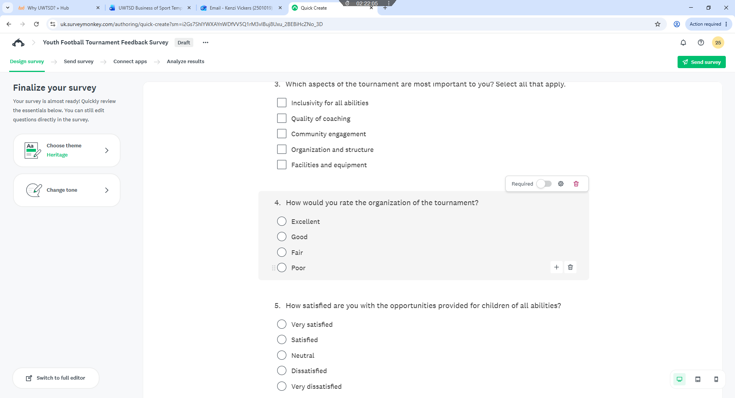
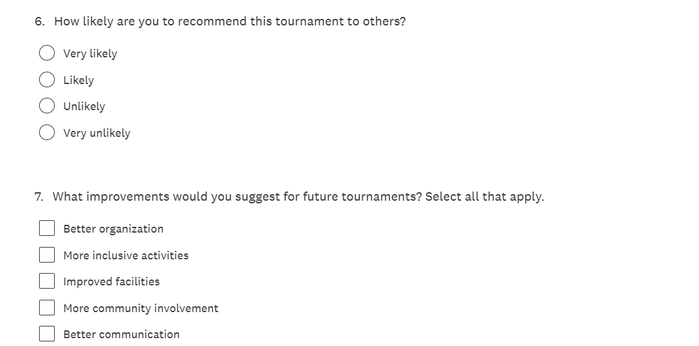
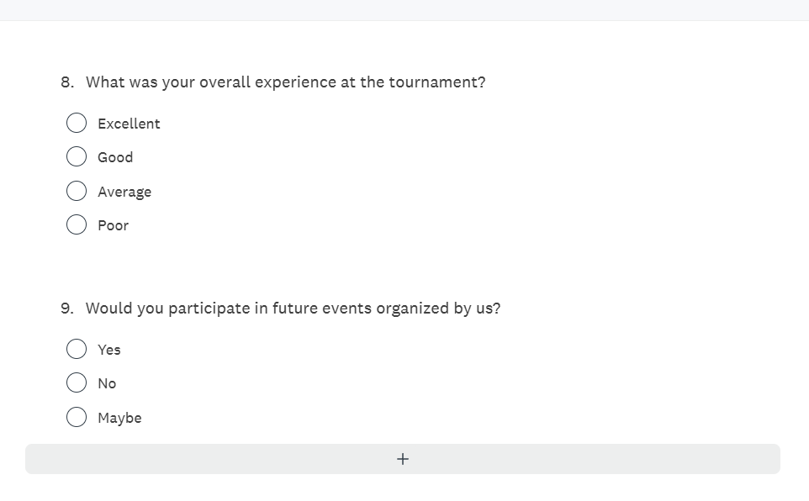

Event Floorplan (Screenshot from PC or Picture Drag and Drop into table below)

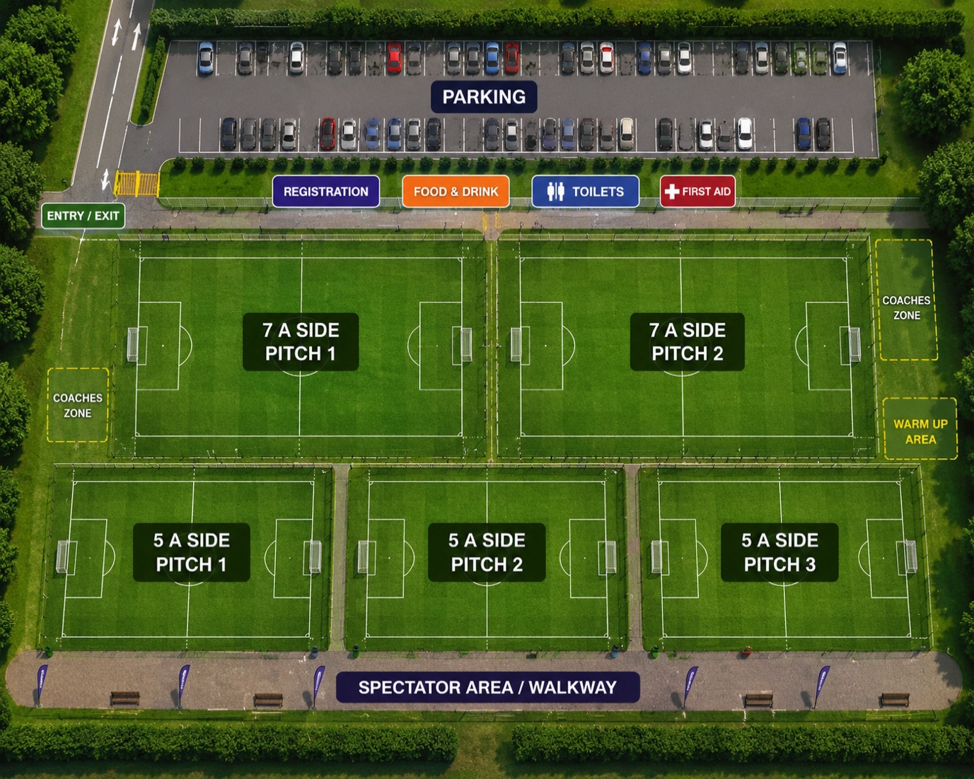

Event Poster (Screenshot from PC or Picture Drag and Drop into table below)
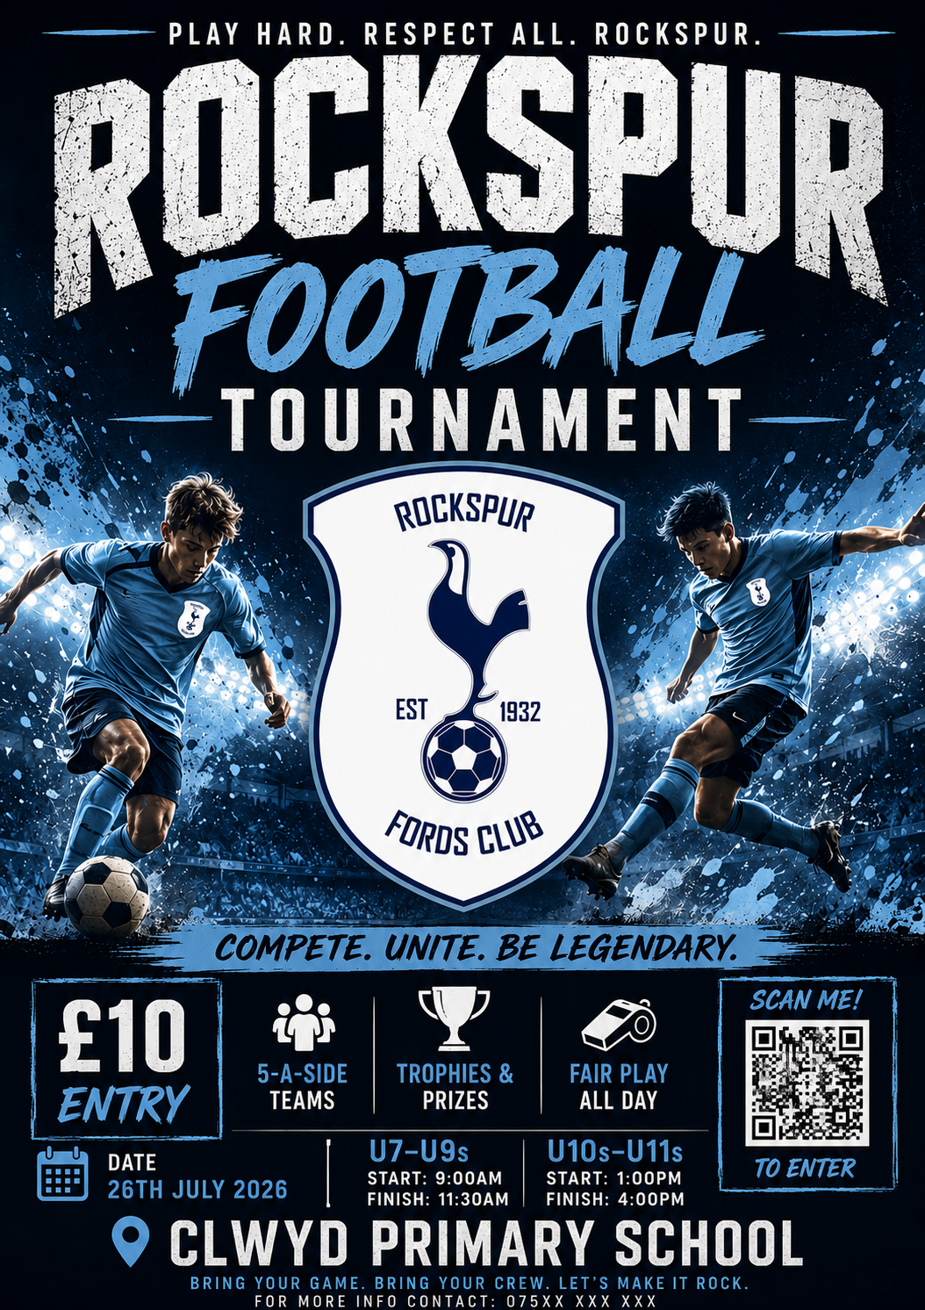

Reference List and Bibliography

ResearchGate. (2025). Talent Management in Elite Sports: Assessing and Selecting Talent in the NFL.
National Institutes of Health. (2022). The Need for Chief Diversity Officers in Professional Football.
Taylor & Francis. (2023). Diversity and Inclusion Management in Sport Organizations.
Salford Repository. (2018). Human Resource Management in Professional Football.
Manchester Metropolitan University. (2021). Recruitment in Elite Football: A Network Approach.
World Rugby. (2025). A Blueprint for Growth — Women's Rugby: Commercial Analysis.
World Rugby. (2026). Women’s Rugby World Cup 2025 Legacy Report.
Pulselive. (2025). A Blueprint for Growth - Data Appendix: Fluid Fandom.
Deloitte. (2025). Women’s Elite Sport Revenue Projections and Global Forecasts.
Women’s Sport Trust. (2026). The Visibility of Women's Sport: Annual Report.
Bridgewater, S. (2010) Football Management. Basingstoke: Palgrave Macmillan.
Carter, N. (2006) The Football Manager: A History. London: Routledge.

Appendix (Add Screenshot evidence here of any online costings etc.)

Appendix (Add Screenshot evidence here of any online costings etc.)

Affordable Food Van Hire | Get Mobile Food Truck Quotes & Prices Today
Hire Professional Face Painters for Your Event | Book Now!



UWTSD SPORT

