Questionaire analysis- Ewa Zdziarska-Grzyb (1712720)
Team members
Ewa Zdziarska-Grzyb (1712720)
Abu Ahmed Eusuf (1710574)
Shazul Miah (1712428)
Raj Ahmed (???)
Gezim Rrapi (???)
LINK TO QUESTIONNAIRE
https://docs.google.com/forms/d/e/1FAIpQLSfFgOuJmEs0bh6KqTgD8PIBF49ZCwCMlBi6qD_qLaWoVA7ZOQ/viewform

Brief introduction
We asked questions such as
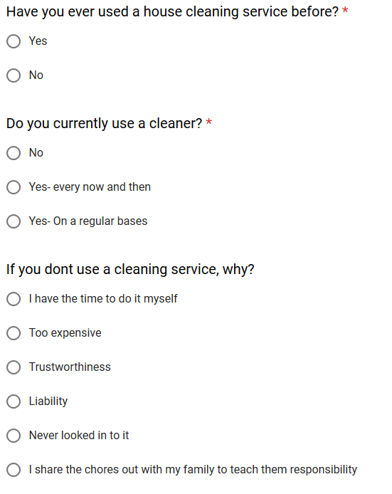
I had trouble login into the questionnaire that my team has created so I have created my own questionnaire. Therefore, my questionnaire is different to my group partners. I’m so sorry for the inconvenience I tried my best to make this work.

Result analysis
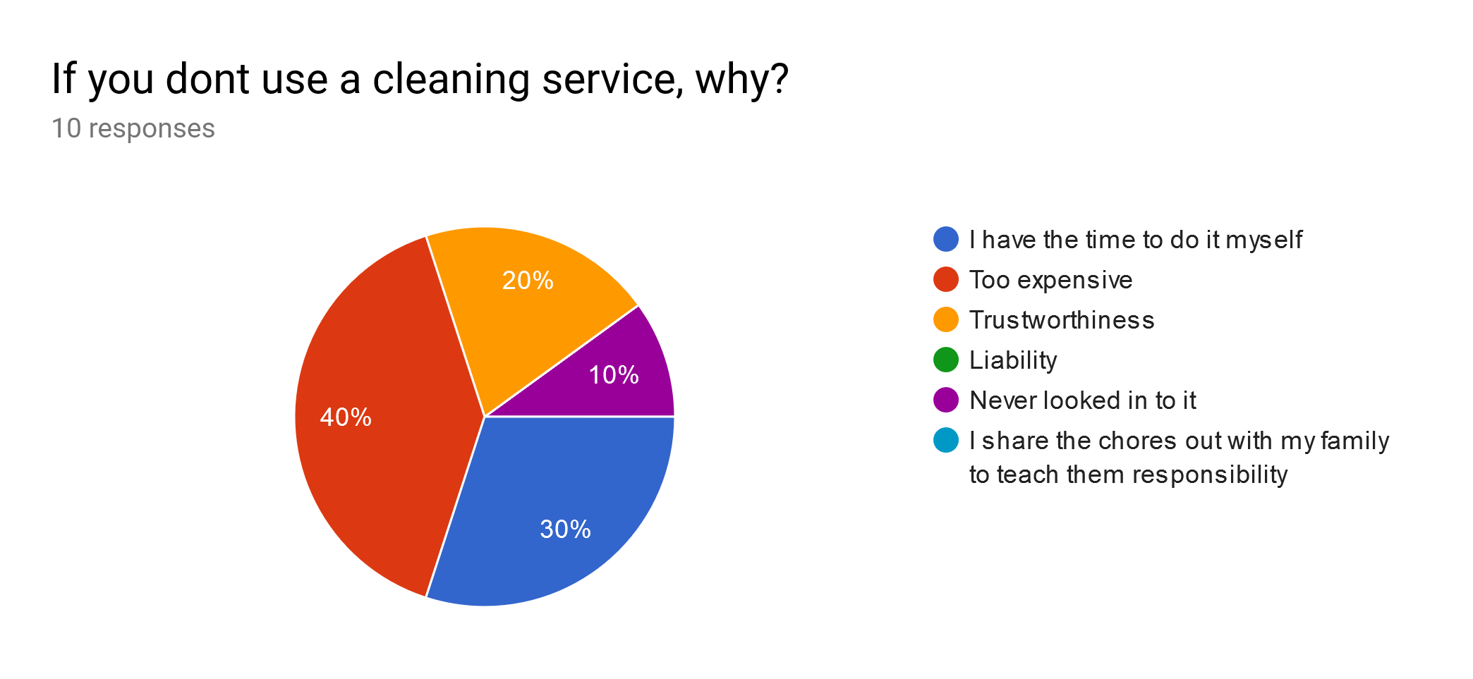
From this I can tell several things such as, that 40% of the people that took my questionnaire said the reason why they “don’t use a cleaning service” is because it’s too expensive. I can also tell that 10% of the people that took my questionnaire think that it is because they “never looked into it”. This is all shown in a pie chart just like all the other multiple answer questions. A way that my area of criteria fits into this is how I analysed all our final expenses. For example, our service cost £300 and I understand that this is on the expensive side however not only can you spread this out for monthly payment you are also receiving outstanding and high-quality services that use fantastic top of the line machinery.
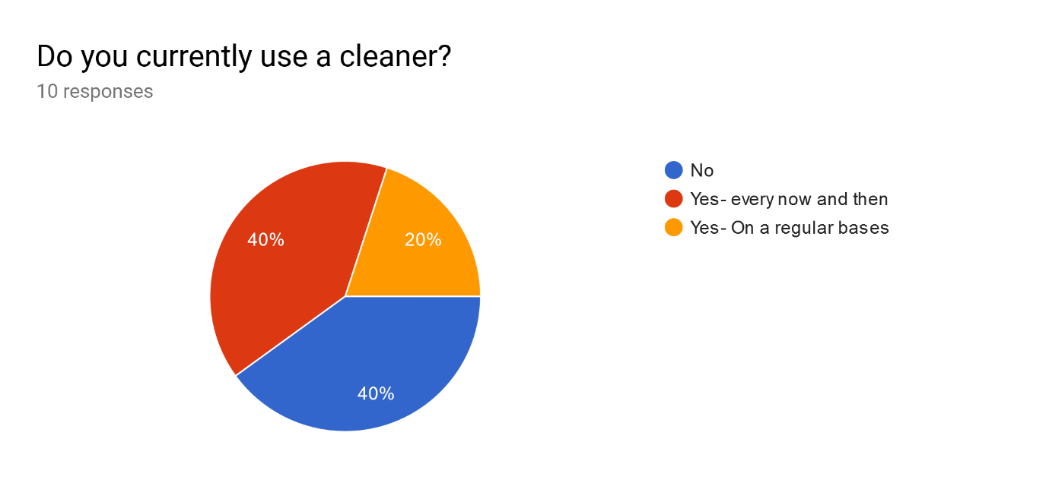
This is another example of the pie chart analysis. 40% of people voted for “no” also 40% of people voted for “yes- every now and then”. And 20% of people voted for “yes- On a regular basses” I am in charge of finance this means I need to make sure that the money that goes into advertisement is well spend and convincing. This question allows me to use statics in my advertisement to make it more convincing and lore in more customers.

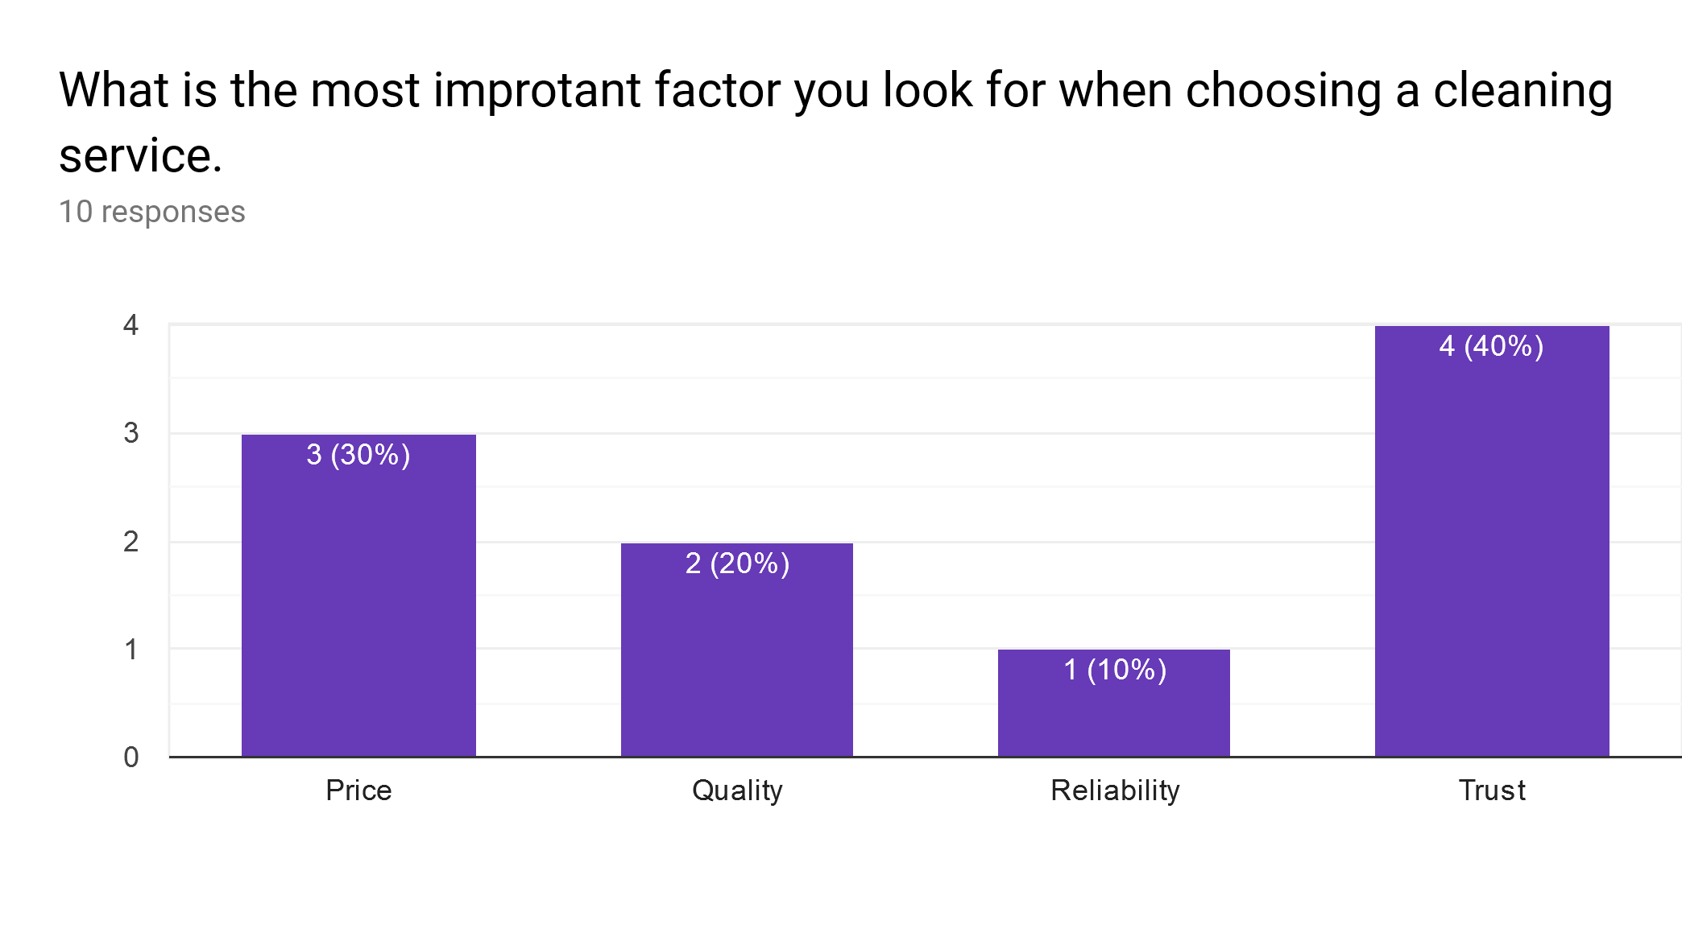

This analysis is different to the pie chart as this analysis is done in columns. This is because the answers were Radom as I gave the reader the ability to choose their own reason why. 10% of the people that voted said that it’s because of “Reliability”. As to 40% of people voted that “Trust” is the main thing they look for. This is very important information to me because as a financial manager I need to know what people are looking for in this orientation of business. I can use this information to upgrade our service, as well as I will know what our advertisement should say to get people sold on our business. I made sure that we can afford all our high-quality equipment.


